Original REVISED Research Article
Exploitation of Heterosis in Brinjal (Solanum melongena L.) for Growth and Yield Traits
ABSTRACT
Brinjal is a widely cultivated vegetable across the world, and the crop has made extensive use of heterosis for the development of high-yielding hybrids. The present study was conducted at ICAR-Indian Institute of Horticultural Research, Bengaluru, using six parental lines and nine hybrids, evaluated in a Randomized Block Design (RBD) with three replications. The cross IIHR-824 × VI046101, exhibited highly significant positive heterosis for plant height, with 30.38% and 53.15% heterosis over the mid parent and better parent, respectively. Significant positive heterosis was also recorded for the number of primary branches per plant in IIHR-824 × IIHR-766 (25.91%) and VI046103 × IIHR-766 (26.60%) over both mid-parent and better parent values. A significant negative heterosis for days to 50% flowering, indicating early flowering, was observed in the crosses IIHR-824 × IIHR-766 (-27.16%) and VI046103 × IIHR-766 (-31.63%) over the better parent. For yield components, IIHR-824 × VI046101 showed significant positive heterosis for the number of fruits per plant (82.35%) over the mid parent and highly significant heterosis over mid parent for fruit yield per plant in the crosses viz., IIHR-824 xVI046101 (66.34 %) and IIHR-B-BR-54 xVI046101 (62.97 %). The heterosis observed in this study can be effectively utilized in future crop improvement programs for the development of superior hybrids.
Keywords: Brinjal, Heterosis, Parents, Hybrids, Growth, Yield and yield attributes.

Introduction
Brinjal (Solanum melongena L.; 2n = 24), a significant vegetable crop in the family Solanaceae, is believed to have originated in the Indo–Burma region, with secondary centers of origin in China and Southeast Asia (Vavilov, 1931). It is known by various vernacular names across India, including Baigan (Hindi), Badanekai (Kannada), Vangi (Marathi), Katharikai (Tamil), and Vankai (Telugu). Globally, it is commonly referred to as eggplant or aubergine. Brinjal is widely cultivated in both tropical and subtropical regions of the world (Ismael et al., 2017). According to FAO (2021), the global cultivation area spans approximately 1.8 million hectares, producing around 59.60 million tonnes. In India, it is cultivated over an area of approximately 676.70 thousand hectares, yielding about 12.78 million tonnes, with an average productivity of 18.90 MT/ha (Indiastatagri, 2023). The crop contributes approximately 8.1% to India’s total vegetable production. Major brinjal-producing states in India include West Bengal, Odisha, Andhra Pradesh, Gujarat, Bihar, Maharashtra, Chhattisgarh, Karnataka, Madhya Pradesh, Haryana, Jharkhand, and Assam.
Botanically, Solanum melongena exhibits three distinct varietal groups based on fruit shape and colour. The large or egg-shaped fruit types are classified as S. melongena var. esculentum, while the long, slender types fall under S. melongena var. serpentinum, and the dwarf types are categorized as S. melongena var. depressum. Consumer preferences for brinjal vary significantly across different regions and localities, necessitating the characterization of genotypes with broad adaptability and market acceptance. India possesses a rich genetic diversity in brinjal, providing considerable potential for genetic improvement through heterosis breeding. Enhancing productivity in brinjal can be effectively achieved via heterosis breeding, which is both feasible and promising in this crop (Kakikazi, 1931). Heterosis plays a critical role in improving both yield and quality and is commonly assessed using parameters such as relative heterosis, heterobeltiosis, and standard heterosis. Ramesh, K., & Pugalendhi, L. (2023) and Suryawanshi, S. S., & Kale, P. N. (2023). Estimating heterosis for yield and its associated traits is essential to identify superior hybrid combinations for commercial exploitation. Parental selection is a crucial step in heterosis breeding to develop hybrids exhibiting significant and commercially viable heterosis. In eggplant, the exploitation of hybrid vigour has emerged as a powerful tool for crop improvement (Bavage, 2005). The ease of hybridization and high seed set in brinjal further facilitate the practical application of heterosis breeding. The present study was undertaken to assess the nature and magnitude of heterosis for yield and its component traits across various crosses, with the aim of identifying promising hybrids for future crop improvement programs. The exploitation of heterosis in brinjal provides valuable insights into genetic mechanisms that enhance yield, quality, and adaptability, contributing to more efficient breeding strategies. It enables the development of superior hybrids with improved productivity and resistance to stresses, ensuring sustainable vegetable production. For the scientific community, these findings help in understanding genetic diversity, parent selection, and hybrid performance, forming a basis for future molecular and genomic research in crop improvement. The exploitation of heterosis in vegetable crops is a key strategy to develop superior hybrids, as it reflects phenotypic superiority over the parents and suggests the predominance of non-additive genetic effects.

Materials and Methods
Experimental site
This research was carried out in the research plot of Department of Vegetable Crops, Indian Institute of Horticultural Research (IIHR) is located in Southern India on the Deccan Plateau an elevation of 930 m above the mean sea level at 13º 13” N latitude and 77º 49” E longitudes.

Development of F₁hybrids
Crossing was carried out during the Kharif season in line x tester mating design. The healthy buds were emasculated and covered in the evening hours between 4.00 pm to 6.00 pm and pollination was done in the next day morning during anthesis time (6.30 am to10.00 am). The pollinated flowers were tagged and covered with butter paper bags to avoid contamination. Six parents 3lines (IIHR-824, IIHR-B-BR-54 and VI046103) & 3 testers (IIHR-766, IIHR-835 and VI046101) and resulting nine hybrids were raised under Randomized Block Design with two replications.

The heterosis was calculated for seven characters viz., plant height (cm), number of primary branches, days to 50% flowering, fruit width (cm), fruit length (cm), average fruit weight (g), number of fruits per plant and fruit yield per plant (kg) studied in the nine hybrid combinations and expressed in percentage over mid parent i.e., relative heterosis and better parent i.e., heterobeltiosis. Plant height (cm) was recorded as the distance from the soil surface to the apical growing point using a measuring tape, and the mean of five plants per plot was taken (Cebeci, 2024; Abraham and Abraham, 2024). The number of primary branches per plant was counted at flowering by recording branches arising from the main stem and averaging per plot. Days to 50% flowering were calculated as the number of days from transplanting to when half the plants in a plot had at least one fully open flower. Fruit width was measured as the maximum equatorial diameter using a digital vernier caliper, while fruit length was measured from calyx to blossom end, both based on 3–5 representative fruits per sampled plant and averaged per plot. Average fruit weight was determined by weighing harvested marketable fruits individually on a digital balance and computing the mean per plant. The number of fruits per plant was recorded by counting all marketable fruits harvested from each plant across all pickings. Finally, fruit yield per plant (kg) was obtained by summing the total fruit weight across the season for each sampled plant and converting the total to kilograms (Martínez-Ispizua et al., 2021).
Relative heterosis = | F₁ – Mid Parent | x100
Relative heterosis = | Mid Parent | x100
Hetero beltiosis = | F₁ – Better parent | x100
Hetero beltiosis = | Better parent | x100

Where, Mid parent refers to the mid value of the parents mean and better parent refers to mean of the better parent.

Statistical analysis

The significance at both 5% and 1% levels were tested statistically for all traits by using GRAPES software package and mean was calculated accordingly (Gopinath, 2020).

Results

Heterosis refers to the phenomenon where the offspring resulting from the crossing of different varieties within a species or between species display enhanced traits such as increased biomass, accelerated growth, and improved fertility compared to both parent lines (Birchler, 2010). It is commonly defined as the superiority of hybrids over their parents and serves as a key measure for evaluating hybrid advantages. Table 1 presents the six parental lines sourced from IIHR, Bengaluru and World Vegetable Centre, Taiwan. The extent of heterosis was observed to be higher when the parental lines originated from genetically diverse regions rather than from a common geographical source (Hayes, 1965). Table 2 illustrates the relative heterosis and heterobeltiosis, observed for various traits across nine hybrids.

1.Plant Height (cm)
Plant height is an important trait reflecting growth and vigour. Relative heterosis over mid-parent was positive and significant in four out of nine hybrids. Crosses viz. IIHR-824 × IIHR-766, IIHR-824 × VI046101, VI046103 × IIHR-766, VI046103 × VI046101, IIHR-B-BR-54 × IIHR-766, and IIHR-B-BR-54 × VI046101 exhibited positive heterosis over mid-parent. Other crosses ranged from 4.04% (VI046103 × IIHR-356) to 10.56% (IIHR-B-BR-54 × IIHR-356). IIHR-824 × VI046101 showed highly significant positive heterosis over both mid-parent and better parent. Heterobeltiosis ranged from 0.12% (VI046103 × IIHR-356) to 11.45% (IIHR-B-BR-54 × VI046101). The significance of [h] and [l] components in IIHR-824 × VI046101 likely contributed to heterosis over both parents.
2. Number of Primary Branches per Plant
Relative heterosis ranged from 4.71% (IIHR-824 × IIHR-356) to 35.26% (IIHR-824 × VI046101), while heterobeltiosis ranged from 1.69% to 26.60%. Crosses IIHR-824 × IIHR-766 and VI046103 × IIHR-766 exhibited significant heterosis over both mid-parent and better parent, whereas IIHR-824 × VI046101 and VI046103 × VI046101 were significant only over mid-parent. The significance may be attributed to [h] and [l] components.
3. Days to 50% Flowering
Earliness, a desirable trait, was assessed by days to 50% flowering. Negative heterosis, indicating earliness, was significant over mid-parent and better parent in IIHR-824 × IIHR-766, VI046103 × IIHR-766, and IIHR-B-BR-54 × IIHR-766. Heterobeltiosis ranged from -4.26% (VI046103 × VI046101) to -27.16% (IIHR-824 × IIHR-766) and was significant in IIHR-824 × IIHR-766, IIHR-824 × IIHR-356, VI046103 × IIHR-766, VI046103 × IIHR-356, and IIHR-B-BR-54 × IIHR-766. Relative heterosis varied from 2.11% (VI046103 × VI046101) to -20.98% (IIHR-B-BR-54 × IIHR-766).
4. Number of Fruits per Plant
All crosses exhibited significant positive heterosis over mid-parent, ranging from 26.91% (VI046103 × IIHR-356) to 82.35% (IIHR-B-BR-54 × IIHR-766). IIHR-B-BR-54 × IIHR-766 showed highly significant heterosis. Heterosis over better parent was generally non-significant, suggesting mid-parent improvement in fruit number.
5. Average Fruit Weight (g)
Crosses IIHR-824 × IIHR-766, VI046103 × IIHR-766, and IIHR-B-BR-54 × IIHR-766 showed significant negative heterosis over both parents. Positive heterosis over mid-parent was observed in VI046103 × VI046101 and IIHR-B-BR-54 × VI046101. VI046103 × IIHR-356 exhibited heterobeltiosis (-18.41%) over the better parent. The [h] and [l] components may explain the observed heterosis.
6. Fruit Length (cm)
Significant positive heterosis over mid-parent was recorded in IIHR-824 × IIHR-766, IIHR-824 × VI046101, and IIHR-B-BR-54 × VI046101. Other crosses ranged from 5.90% (VI046103 × IIHR-356) to 19.38% (VI046103 × IIHR-766). Heterosis over better parent was non-significant, varying from 3.69% to 27.21%.
7. Fruit Diameter (cm)
Crosses VI046103 × IIHR-766, IIHR-B-BR-54 × IIHR-766, and IIHR-B-BR-54 × IIHR-356 showed significant positive heterosis over both parents. Relative heterosis over mid-parent ranged from 25.60% (VI046103 × IIHR-766) to 94.73% (IIHR-824 × IIHR-766). VI046103 × IIHR-356 exhibited a negative trend over the better parent.
8. Fruit Yield per Plant (kg)
Significant positive heterosis over mid-parent was observed in all crosses except IIHR-824 × IIHR-766, IIHR-824 × IIHR-356, VI046103 × IIHR-766, and IIHR-B-BR-54 × IIHR-766, ranging from 8.00% (VI046103 × IIHR-766) to 66.34% (IIHR-824 × VI046101). Heterosis over better parent was non-significant, varying from 2.18% (IIHR-B-BR-54 × IIHR-766) to 18.18% (IIHR-824 × VI046101).

Table 1. Source and plant characters of parents
S.No. | Genotypes | Source
Lines
1 | IIHR-824 | IIHR, Bengaluru
2 | VI0 46103 | IIHR, Bengaluru
3 | IIHR-B-BR-54 | IIHR, Bengaluru
Testers
4 | IIHR-766 | IIHR, Bengaluru
5 | VI0 46101 | World Vegetable Center, Taiwan
6 | IIHR-356 | IIHR, Bengaluru

DISCUSSION
Heterosisbreedingexploitshybridvigorincrossbreedingtosignificantlyincreasecrop production and productivity Farinati et al., (2023). The assessment of relative heterosis is important for investigating the genetics of heterosis, although it has limited practical applications. However, it is quite practicable to quantify heterosis over the better parent. One of the best ways that genetics has been applied to the field of plant breeding is through the commercial use of heterosis. It has been successfully exploited in many crops, including tomato, brinjal, chilli, radish, bottle gourd and bitter gourd Yu et al. (2021). The current study, estimated the heterosis over better and mid-level parents as well as the relative heterosis and heterobeltiosis for each of the nine crossings in relation to various horticultural traits.
Heterobeltiosis (heterosis over better parent) for different traits was ranging from-12.16 % to 163.19 % and highest heterobeltiosis was recorded in fruit diameter (163.19 %in IIHR-B-BR-54 x IIHR-356), the results were confirmed with Ali et al., (2022) in tomato, meanwhile heterosis over mid parent (relative heterosis) ranges from 14.14 % to 249.35 %. The highest relative heterosis (heterosis over mid parent) also recorded in fruit diameter (249.35 % in IIHR-B-BR-54 x IIHR-356). Similar results were observed by Sharma et al., (2016) in brinjal.
Negative heterobeltiosis and relative heterosis indicating earliness was observed for days to 50% flowering of the hybrids. The maximum significant values over better parent and mid parent in desirable direction were recorded in the hybrid VI046103 × IIHR-766, which was followed by IIHR-B-BR-54 × IIHR-766 and IIHR-824 × IIHR-766. Similar negative heterosis was observed in brinjal by Kalaiyarasi et al. (2018). Regarding plant height (cm), positive heterosis over mid parent and better parent was observed in IIHR-824 × VI046101, but only relative heterosis was noticed in IIHR-824 × IIHR-766, VI046103 × IIHR-766, VI046101 × VI046101, IIHR-B-BR-54 × IIHR-766 and IIHR-B-BR-54 × VI046101. The report of Muthuvel (2003) supports the present findings on positive heterosis.
Regarding number of primary branches per plant, significant positive relative heterosis and heterobeltiosis were exhibited in IIHR-824 × IIHR-766 and VI046103 × IIHR-766. Only two hybrids viz., IIHR-824 × VI046101 and VI046103 × VI046101 showed significant positive relative heterosis. These results were in confirmation with the reports of Gopalakrishnan et al. (1987b) and Nikhila (2022).
In this study, all nine crosses showed positive significant relative heterosis for number of fruits per plant. Out of nine crosses, maximum significant relative heterosis was recorded in the hybrid IIHR-B-BR-54 × IIHR-766, which was followed by IIHR-824 × IIHR-766, but all nine crosses were non-significant over better parent. Heterosis over mid parent was reported by Makani et al. (2013) and Mistry et al. (2018) in brinjal. Negative heterosis over mid parent and better parent was observed for average fruit weight in hybrids viz., IIHR-824 × IIHR-766, VI046103 × IIHR-766 and IIHR-B-BR-54 × IIHR-766. Only one hybrid, IIHR-824 × IIHR-356, was negatively significant over better parent but non-significant over mid parent. Two crosses viz., VI046103 × VI046101 and IIHR-B-BR-54 × VI046101 were positively significant over mid parent but non-significant over better parent.
Positive significant heterosis over mid parent for fruit length (cm) was observed in IIHR-824 × IIHR-766, IIHR-824 × VI046101 and IIHR-B-BR-54 × VI046101, but remaining all crosses were non-significant for both mid parent and better parent. In this present study, maximum significant positive heterosis for fruit diameter over mid parent and better parent was observed in the hybrid IIHR-B-BR-54 × IIHR-356, followed by IIHR-824 × IIHR-356 and IIHR-B-BR-54 × IIHR-766. Negative heterobeltiosis for fruit diameter over better parent was observed in VI046103 × IIHR-356 but was non-significant over mid parent. High magnitude of relative heterosis for fruit yield was recorded by IIHR-824 × VI046101, IIHR-B-BR-54 × VI046101, VI046103 × VI046101, VI046103 × IIHR-356 and IIHR-B-BR-54 × IIHR-356. Remaining all crosses were non-significant over better parent and mid parent.
Several researchers have also reported heterosis in the desired direction for various characteristics of brinjal such as Hazra et al. (2010) and Ramesh et al. (2013). Biswas et al. (2013) also revealed significant and desirable mid parent heterosis for total fruit yield per plant. Vidhya (2015) reported significant heterosis for plant height, days to 50% flowering, fruit length and fruit yield per plant over mid parent. Furthermore, Chowdhary et al. (2011) also revealed significant heterosis for days to 50% flowering over mid parent and better parent. Similarly, Sharma et al. (2016) recorded desirable positive heterosis over better parent for plant height, plant stem girth, fruit yield, number of fruits per plant, fruit length and average fruit weight, and significant negative heterosis over better parent and standard check for earliness for days to 50% flowering. Mistry et al. (2018) observed positive and significant heterobeltiosis and relative heterosis for fruit length and fruit yield per plant in brinjal.

Table 2 Heterosis percentage over better parent (BP) and mid parent (MP) for various traits of brinjal

$Crosses | PH(cm) |  | NPBPP |  | DFF(50%) |  | NFPP |  | AFW(g) |  | FL(cm) |  | FDM(cm) |  | FYPP(kg)
$Crosses | BP(%) | MP  (%) | BP  (%) | MP  (%) | BP  (%) | MP  (%) | BP  (%) | MP  (%) | BP  (%) | MP  (%) | BP  (%) | MP  (%) | BP  (%) | MP  (%) | BP  (%) | MP  (%)
1 | 0.77 | 14.14** | 24.87* | 25.91** | -27.16** | -15.48** | 2.48 | 69.09** | -78.50** | -63.28** | 3.69 | 29.78** | 31.17 | 94.73** | 3.75 | 14.96
2 | 30.38** | 53.15** | 18.66 | 35.26** | -10.95 | -2.95 | 10.06 | 45.25** | 7.35 | 18.20 | 5.70 | 29.01** | -7.88 | 33.39 | 18.18 | 66.34**
3 | 1.06 | 8.25 | 4.29 | 4.71 | -12.16* | -6.95 | 5.23 | 33.70** | -18.41* | -9.58 | -7.53 | 19.38 | 134.57** | 159.90** | 8.77 | 26.97
4 | -0.19 | 16.18** | 26.60* | 29.92** | -31.63** | -19.12** | 2.89 | 67.69** | -76.88** | -61.97** | -19.16 | -7.86 | 6.75 | 25.60* | 5.23 | 8.00
5 | 1.29 | 15.81** | 18.43 | 32.91** | -4.26 | 2.11 | 0.69 | 29.77** | 6.25 | 29.01** | -2.02 | 14.82 | -4.05 | 16.92 | 6.70 | 57.24**
6 | 0.12 | 4.04 | 11.40 | 13.85 | -12.42* | -5.18 | 2.46 | 26.91** | 0.95 | 1.71 | -3.54 | 5.90 | -24.35* | 26.41 | 3.58 | 29.06*
7 | -1.55 | 31.72** | 1.69 | 8.53 | -30.07** | -20.98** | 13.65 | 82.35** | -77.76** | -63.46** | -9.82 | 4.77 | 50.70** | 93.84** | 2.18 | 8.71
8 | 11.45 | 16.13* | -9.59 | 9.69 | -11.34 | -0.66 | 9.18 | 36.56** | 3.02 | 25.51** | 27.21 | 51.87** | 15.65 | 44.05* | 12.87 | 62.97**
9 | -3.53 | 10.56 | -16.39 | -10.40 | -10.50 | -7.96 | 10.65 | 32.74** | 0.37 | 1.56 | -19.76 | -10.10 | 163.19** | 249.35** | 11.09 | 34.45*
(PH–plant height; NPBPP–number of primary branches per plant; DFF–days to first flowering; FL–fruit length; FW–fruit width; AFW–Average fruit weight t; FDM-fruit diameter; NFPP–number of fruits per plant; FYPP– fruit yield per plant).
*Significantat5%and**Significantat1%level. BP: Better parent MP: Mid parent

$Crosses:
1. IIHR-824 x IIHR-766, 2. IIHR-824 xVI046101, 3. IIHR-824 x IIHR-356, 4.VI046103 x IIHR-766, 5.VI046103 xVI046101, 6.VI046103 x IIHR-356, 7. IIHR-B-BR-54 x IIHR-766, 8. IIHR-B-BR-54 xVI046101, and9.IIHR-B-BR-54 x IIHR-356

CONCLUSION
Heterosis is an important criterion in developing superior hybrids with good yield. The present results clearly depicts that all the growth and yield characters showed higher heterosis value which indicates the non-additive genetic effects in their expression. In order to enhance yield characters, studies should be focused on suitable breeding programmes to produce hybrids of high heterosis and combining ability which in turn results in yield improvement. The best performing hybrids for fruit yield contributing parameters viz., VI046103 x IIHR-766 and IIHR-824 x IIHR-766 might be studied for specific combining ability in the further research for commercially exploiting the hybrid vigour of the above hybrids

Data availability statement
The data sets and plant material are available from Division of Vegetable Crops, ICAR-IIHR, Bengaluru, upon reasonable request.
Conflict of interest disclosure
We, the authors, contributed fairly and substantively to this study, and we state that we have no competing interests.
Ethics approval statement
The manuscript was not submitted elsewhere, and the findings were provided without distortion, falsification, or data manipulation. There is no risk to public health or national security from research.
Patient consent statement
Not applicable
Permission to reproduce material from other sources
Not applicable
Clinical trial registration
Not applicable
Disclaimer (Artificial intelligence)
Option 1:
Author(s) hereby declare that NO generative AI technologies such as Large Language Models (ChatGPT, COPILOT, etc.) and text-to-image generators have been used during the writing or editing of this manuscript.
Option 2:
Author(s) hereby declare that generative AI technologies such as Large Language Models, etc. have been used during the writing or editing of manuscripts. This explanation will include the name, version, model, and source of the generative AI technology and as well as all input prompts provided to the generative AI technology
Details of the AI usage are given below:
1.
2.
3.

REFERENCES
- Ali, M.I., Hassan-Khojah, A., Mohsen, M., & Murie (2022). Combining ability and heterosis for yield and some fruit traits of tomato. Applied Science, 3: 15-23.
- Bavage, M.S., Madalageri, M.B., & Mulge, R. (2005). Hybrid performance of round fruited brinjal (Solanum melongena L.). The Karnataka Journal of Horticulture, 1: 95-97.
- Birchler, J.A., Yao, H., Chudalayandi, S., Vaiman, D., & Veitia, R.A. (2010). Heterosis. The Plant Cell, 22(7): 2105–2112.
- Farinati, S., Scariolo, F., Palumbo, F., Vannozzi, A., Barcaccia, G., & Lucchin, M. (2023). Heterosis in horticultural crop breeding: combining old theoretical bases with modern genomic views. Frontiers in Horticulture, 2: 1250875.
- Gopalakrishnan, T.R., Nair, C.S., Joseph, J.S., & Peter, K.V. (1987b). Heterosis and combining ability analysis in chilli. Indian Journal of Genetics, 47: 205-209.
- Gopinath, P.P., Parsad, R., Joseph, B., & Adarsh, V.S. (2020). GRAPES: General Rshiny Based Analysis Platform Empowered by Statistics. version 1.0.0. DOI: 10.5281/zenodo.4923220.
- Hayes, H.K. (1965). A Professor’s story of hybrid corn. Minneapolis: Burgess Publishing Company.
- Kakikazi, Y. (1931). Hybrid vigour in eggplant and its potential utilization. Journal of Heredity, 21: 253-258.
- Kalaiyarasi, S., Ranjith, R.R., & Saravan (2018). Studies on heterosis for yield in brinjal (Solanum melongena L.). Horticultural Biotechnology Research, 4: 35-38.
- Makani, A.Y., Patel, A.L., Bhatt, M.M., & Patel, P.C. (2013). Heterosis for yield and its contributing attributes in brinjal (Solanum melongena L.). The Bioscan, 8(4): 1369-1371.
- Mistry, Chintan R., Keshubhai B., Kathiria, Srikanth Sabolu, & Sushil Kumar (2018). Heterosis and inbreeding depression for fruit yield attributing traits in eggplant. Current Plant Biology, 16: 27-31.
- Muthuvel, I. (2003). Studies on evaluation of F1 hybrids and exploring the possibilities of utilizing induced male sterility and natural self-incompatibility system in chilli (Capsicum annuum L.) [Ph.D. thesis]. Tamil Nadu Agricultural University, Coimbatore, India.
- IndiaStatAgri. (2023). [Online]. Available: https://www.indiastatagri.com/table/agriculture/area-production-productivity-brinjal-india-1987-19/14880.
- Ismael, J.H.S., Sulaiman, S.M., Muhidden, A., Faraj, S.M., & Abdul-Khaliq, H. (2017). Control of root-knot nematode of eggplant and its effect on plant growth and yield under plastic house condition. International Journal of Forestry & Horticulture, 2: 28-34.
- Nikhila, Jyoti P., Jirankali, Gowda Thand, & Dushyanthkumar (2022). Heterosis studies for yield and yield-attributing traits in brinjal (Solanum melongena L.). The Pharma Innovation Journal, 11(5): 738-741.
- Sharma, T.K., Pant, S.C., Kumar, K., Kurrey, V.K., Pandey, P.K., & Bairwa, P.L. (2016). Studies on heterosis in brinjal (Solanum melongena L.). International Journal of Bioresource and Stress Management, 7(5): 964-969.
- Vavilov, N.I. (1931). The role of Central Asia in origin of cultivated plants. Bulletin of Applied Botany, Genetics and Plant Breeding, 26(3): 3-44.
- Yu, D., Xingfang Gu, Shengping Zhang, Shaoyun Dong, Han Miao, Kiros Gebretsadik, & Kailiang Bo (2021). Molecular basis of heterosis and related breeding strategies reveal its importance in vegetable breeding. Horticulture Research, 8: 120.
- Ramesh, K., & Pugalendhi, L. (2023). Studies on heterosis and combining ability in brinjal (Solanum melongena L.) for yield and yield-contributing traits. International Journal of Plant and Environment, 9(3), 275–282. https://ijplantenviro.com
- Suryawanshi, S. S., & Kale, P. N. (2023). Estimation of heterosis and combining ability in eggplant hybrids for growth and fruit yield traits. International Journal of Environment and Climate Change, 13(6), 739–748. https://journalijecc.com
- Cebeci, E. (2024). Comparative evaluation of eggplant genotypes with their wild relatives under gradually increased drought stress. Bragantia 83, e20230246. doi: 10.1590/1678-4499.20230246.
- Abraham, Y and Abraham, S (2024). Growth, yield and quality response of Eggplant (Solanum melongena L.) to blended NPSB fertilizer rates and intra-row spacing in Boloso Bombe district, Wolaita zone, South Ethiopia. Heliyon. 1-12.
- Martínez-Ispizua, E., Calatayud, Á., Marsal, J. I., Mateos-Fernández, R., Díez, M. J., Soler, S., Valcárcel, J. V., & Martínez-Cuenca, M.-R. (2021). Phenotyping local eggplant varieties: Commitment to biodiversity and nutritional quality preservation. Frontiers in Plant Science, 12, 696272. https://doi.org/10.3389/fpls.2021.696272.

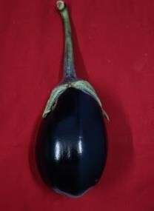

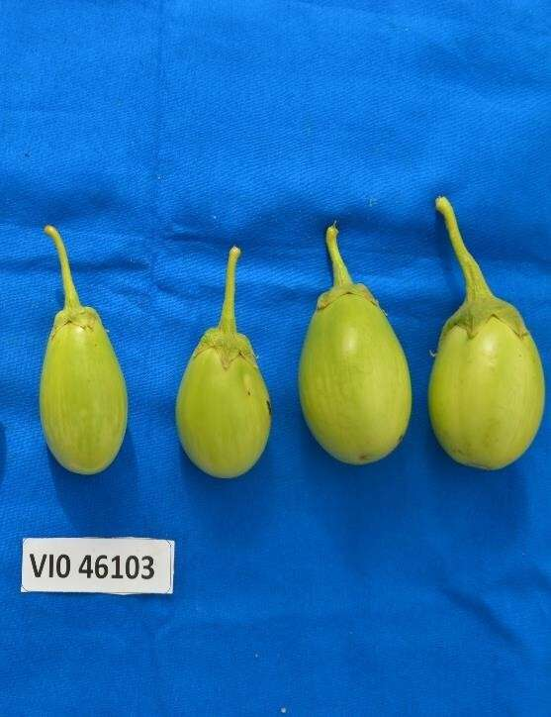
IIHR-766

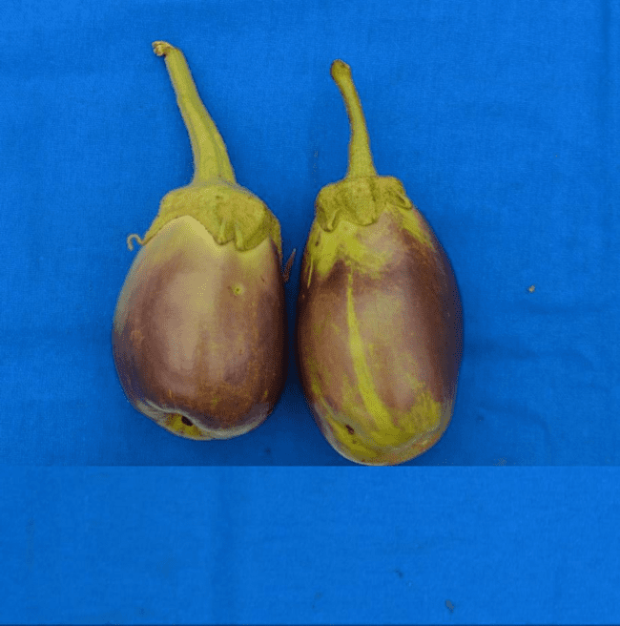
X
VI046103xIIHR-766

Plate1.a Best performing hybrid:VI046103x IIHR-766

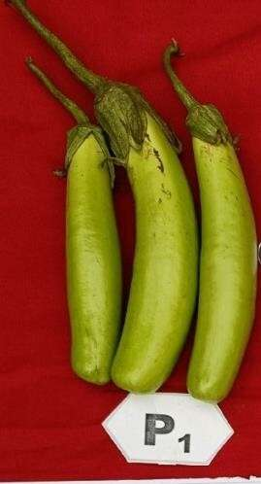
IIHR-824

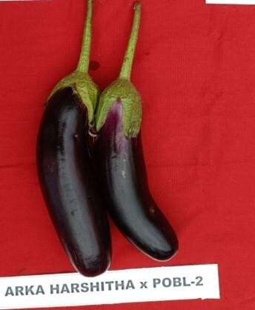
X

Plate1.b Best performing hybrid: IIHR-824xIIHR-766
IIHR-766

