INCIDENCE OF CONGENITAL GOITRE IN GOATS,
IN AND AROUND HYDERABAD, INDIA

ABSTRACT

Background: Goitre can affect all domestic mammals, birds, and other vertebrates; it is most commonly reported in goat kids, particularly in endemic areas. The pathogenesis of goitre involves multiple etiological factors, including primary iodine deficiency, secondary goitrogen exposure, excessive dietary iodine, and, rarely, inherited enzymatic defects affecting thyroid hormone synthesis.
Aim:
The present study was conducted to determine the incidence, clinical features, diagnostic findings, and therapeutic response of congenital goitre in goats.
Study Design: The goats that were presented to C.V.Sc, Rjendranagar and referred from various dispensaries in and around Hyderabad with swelling at ventral neck formed the material for the study. The incidence of goitre based on breed, age and gender was analyzed.
Place and Duration of Study:
The study was carried out in goat populations presented to Veterinary Clinical Complex (VCC), College of Veterinary Science, Rajendranagar, Hyderabad, from April 2024 to April 2025.
Methodology:
A total of 1,762 goats were screened for thyroid enlargement. Clinical examination, fine needle aspiration, haematological and serum biochemical analyses, thyroid hormone assays (T₃, T₄, and TSH), radiography, ultrasonography, and histopathology were performed in affected animals. Goitrous kids were treated with sodium levothyroxine (20 µg/kg body weight orally, once daily) and potassium iodide (0.2 mg/kg body weight orally, once daily) for 10 days, and the therapeutic response was evaluated.
Results:
Out of 1,762 goats examined, 18 were found to be affected with congenital goitre, yielding an incidence of 1.02%. The condition was more frequent in males (61.11%) and in goats below 6 months of age (66.67%). Breed-wise, Malabari goats showed the highest occurrence (38.89%). Clinically, all affected animals exhibited bilateral thyroid enlargement, with common signs including failure to thrive (61.11%), dyspnea (50%), weakness (38.89%), sparse hair coat (33.33%), alopecia (27.78%), and myxedema (5.55%). Haematology revealed significantly lower haemoglobin and erythrocyte counts, while serum cholesterol levels were significantly elevated. Thyroid function tests showed significant (p < 0.05) decrease in serum T₃ and T₄ with elevated TSH levels, indicating hypothyroidism. Radiographs revealed increased soft tissue opacity in the ventral neck, and ultrasonography demonstrated bilateral thyroid enlargement with heterogeneous echotexture, hypoechoic areas, and increased vascularity. Histopathology confirmed hyperplastic changes with multilayered follicular epithelium, colloid depletion, papillary projections, and hyperchromatic columnar cells. Therapeutic management with levothyroxine and potassium iodide resulted in marked clinical and hormonal improvement in 16 out of 18 (88.89%) treated animals.
Conclusion:
Congenital goitre in goats is primarily associated with iodine deficiency leading to hypothyroidism. Comprehensive diagnosis based on clinical, biochemical, and imaging findings along with histopathology is essential for confirmation. Combined therapy with sodium levothyroxine and potassium iodide proved effective in restoring thyroid function and reversing clinical signs in the majority of affected goats.

Keywords: Congenital Goitre, Goats, thyroid function, etiological factors

INTRODUCTION:

Goitre is defined as a non-inflammatory, non-neoplastic enlargement of the thyroid gland (Lafta et al., 2023). Although it can affect all domestic mammals, birds, and other vertebrates, it is most commonly reported in goat kids, particularly in endemic areas (Ani et al., 1998). The pathogenesis of goitre involves multiple etiological factors, including primary iodine deficiency, secondary goitrogen exposure, excessive dietary iodine, and rarely, inherited enzymatic defects affecting thyroid hormone synthesis (Radostits et al., 2007).Primary goitre results from iodine-deficient diets, whereas secondary goitre arises from the ingestion of goitrogenic substances—such as brassica plants, soybean by-products, and water high in calcium or nitrates—which interfere with thyroid hormone synthesis (Constable et al., 2016). Iodine is essential for the synthesis of thyroxine (T₄) and triiodothyronine (T₃); these hormones are formed by iodination of tyrosine residues in thyroglobulin, a process stimulated by thyroid-stimulating hormone (TSH). In cases of iodine deficiency, inadequate production of T₃ and T₄ leads to increased TSH secretion by the fetal pituitary gland. This chronic stimulation causes hyperplasia and hypertrophy of the thyroid follicular epithelium, resulting in visible enlargement of the gland (Puls, 1994;).
Congenital goitre is often linked to maternal iodine deficiency during gestation. In such cases, not only does the fetus suffer from thyroid hormone deficiency, but complications such as prolonged gestation, dystocia, and myxedema may also occur (Constable et al., 2016). Iodine deficiency is frequently associated with selenium and vitamin A deficiencies, which can exacerbate the clinical impact (Pearce et al., 2013). Clinically, affected kids present with visibly enlarged thyroid lobes often more than twice their normal size with a soft, dark-red appearance. In severe cases, the enlarged thyroid may compress the trachea or esophagus, causing respiratory distress and difficulty swallowing. Systemic signs include impaired thermoregulation, poor growth, generalized weakness, and high neonatal mortality (Pugh & Baird, 2012). In advanced cases, signs such as hypotrichosis, alopecia, and skin edema may develop (Constable et al., 2016). Diagnosis of congenital goitre is based on clinical enlargement of the thyroid gland, supported by laboratory findings such as reduced serum T₃ and T₄ levels and elevated TSH concentrations. Treatment primarily involves prompt iodine supplementation to newborn kids to restore thyroid hormone synthesis, along with administration of sodium levothyroxine in clinically affected animals to correct hypothyroid status. Management of pregnant does through dietary iodine supplementation and avoidance of goitrogen-rich feeds forms the cornerstone of preventing this disorder.As no clinically documented cases of congenital goitre in goats have been reported so far from Hyderabad, Telangana, and considering its rarity and significance as an important endocrine disorder, the present study was undertaken to determine the incidence of congenital goitre in goats in and around Hyderabad.
MATERIALS AND METHODS

Study Area and Population
The study was conducted at the Veterinary Clinical Complex (VCC), College of Veterinary Science, Rajendranagar, Hyderabad, from April 2024 to April 2025 on goats that were presented or referred from various veterinary dispensaries in Hyderabad. A total of 1762 animals were screened for congenital goitre over a period of one year. Animals were selected based on clinical signs of congenital goitre, including thyroid enlargement, hair loss, and lethargy in newborn kids. Data on breed, age, and sex were recorded for all animals. Six
apparently healthy animals were taken as a control.

Clinical Examination and Data Collection
Information on management practices, including deworming and vaccination status, feed and water intake, defecation, and urination patterns, was systematically documented. A

detailed physical and clinical examination was carried out on all animals, and the observations were recorded methodically. Selected animals were subjected to various diagnostic investigations, including haemato-biochemical analysis, thyroid hormone profiling, radiography, ultrasonography, and histopathological examination. The findings were recorded and analyzed accordingly.
Sample Collection and Analysis
Blood samples were collected aseptically from the jugular vein of affected goats into sterile vials, both with and without EDTA. Serum was separated by centrifugation at 3000 rpm for 10 minutes and stored at –20°C until further analysis.Hematological parameters were estimated using an EDAN hematology analyzer, while biochemical parameters were analyzed with an EXIGO Veterinary Biochemistry Analyzer. Serum thyroid hormone concentrations, triiodothyronine (T₃), thyroxine (T₄), and thyroid-stimulating hormone (TSH) were determined using Semi Automatic VET Chroma Immunoassay Analyzer.

Fine Needle Aspiration Cytology (FNAC)

Fine needle aspiration cytology was performed under aseptic conditions using a 22 G needle to differentiate thyroid enlargement from other swellings such as caseous lymphadenitis, abscesses, or cysts.

Ultrasonographic Examination
Ultrasonographic evaluation of the thyroid gland was performed on both lobes after clipping and cleaning the area. B-mode imaging combined with color Doppler flow assessment was carried out using a 10 MHz linear transducer using Mindray Vetus E7 Veterinary Ultrasound machine to assess tissue characteristics, lobe margins, and vascularization patterns.

Histopathological Examination
Thyroid tissue samples were collected from affected animals and also form deceased kids during necropsy though percutaneous biopsy punch instrument (4.0mm) (NETCARE Instruments) (Figure 1 & 2) and subsequently fixed in 10% neutral buffered formalin. The tissues were dehydrated through ascending grades of alcohol, cleared in benzene, impregnated in molten paraffin, and sectioned at 5 µm thickness using a rotary microtome. The sections were stained with hematoxylin and eosin (H&E) as per the standard protocol described by Luna (1968), and examined microscopically for histopathological alterations.
Treatment

All affected goats were treated with sodium Levothyroxine at a dose rate of 20 µg/kg body weight once daily along with supplementation of oral potassium iodide (KI) at 0.2 mg/kg body weight daily for 10 days.

Statistical Analysis
Independent sample t-test was employed to compare the haematological and serum biochemical parameters between healthy and affected animals. The thyroid parameters recorded before and after therapy within the affected animals were analysed using a paired t-test. All statistical analyses were carried out using SPSS software (version 20.0).

RESULTS

A total of 1,762 goats were screened, out of which 18 goats were found to be affected with congenital goitre, yielding an overall incidence of 1.02%. Among the affected animals, 11 were males and 7 were females. Based on age, 12 goats were below 6 months of age, while 6 goats were above 6 months. Breed-wise distribution of affected goats revealed the following: Malabari (7/18; 38.89%), Jamunapari (5/18; 27.78%), Barbari (3/18; 16.67%), Osmanabadi (2/18; 11.11%), and non-descript goats (1/18; 5.55%).
On physical examination, the swellings were non-painful on palpation, and vital parameters remained within normal physiological limits. Fine needle aspiration of the thyroid swelling revealed no evidence of pus or fluid accumulation, ruling out abscess or cystic lesions.The predominant clinical sign observed was bilaterally enlarged thyroid gland presenting as a palpable swelling in the ventral neck region in all affected goats (18/18; 100%). Other clinical manifestations included failure to thrive (11/18; 61.11%), dyspnea (9/18; 50%), weakness (7/18; 38.89%), sparse hair coat (6/18; 33.33%), alopecia (5/18; 27.78%), and myxedema (1/18; 5.55%) (Figure 3).
Haematological analysis revealed a significant (p < 0.05) decrease in haemoglobin concentration and total erythrocyte count (RBC) in goats affected with congenital goitre when compared to healthy controls (Table 1).Serum biochemical analysis showed a significant (p < 0.05) increase in cholesterol levels, while the differences observed in other biochemical parameters were non-significant (p > 0.05) between affected and healthy animals (Table 2).Thyroid function testing demonstrated a significant (p < 0.05) decrease in serum thyroxine (T₄) and triiodothyronine (T₃) concentrations, accompanied by a significant (p < 0.05) increase in thyroid-stimulating hormone (TSH) levels in goats with goitre, indicating hypothyroid status (Table 3).
Radiographic examination was performed on seven animals, all of which exhibited increased soft tissue opacity in the ventral neck region, consistent with thyroid gland enlargement.Ultrasonographic examination of the thyroid gland was carried out in ten animals. The major sonographic findings included marked bilateral enlargement of the thyroid lobes (100%), heterogeneous echotexture with hypoechoic areas within the gland (80%), increased echogenicity (20%), and increased vascularity on colour Doppler imaging (40%) (Figure 4).
Histopathological examination was conducted on thyroid tissues from six animals to confirm the diagnosis and evaluate microscopic alterations.Histopathological examination of thyroid tissues revealed marked variation in the size of thyroid follicles accompanied by pronounced hyperplastic changes in all examined samples (6/6; 100%). In several sections, the follicles were lined by multiple layers of follicular epithelial cells forming papillary projections into the follicular lumen (4/6; 66.67%). Disruption of normal follicular architecture was observed in three cases (3/6; 50%), along with depletion of colloid material within the follicles (3/6; 50%). In two samples (2/6; 33.33%), the follicular epithelium exhibited columnar cell with hyperchromatic nuclei, indicative of increased cellular activity and hyperplasia (Figure 5).
Goitrous goat kids were treated with sodium levothyroxine at a dose rate of 20 µg/kg body weight once daily, along with oral supplementation of potassium iodide (KI) at 0.2 mg/kg body weight daily for 10 days. Following therapy, marked clinical improvement was observed in 16 animals, characterized by a reduction in thyroid gland size, alleviation of clinical signs, and normalization of serum thyroid hormone levels. However, two animals succumbed during the course of treatment despite of therapy.

Figure 1: Collection of tissue sample though percutaneous biopsy
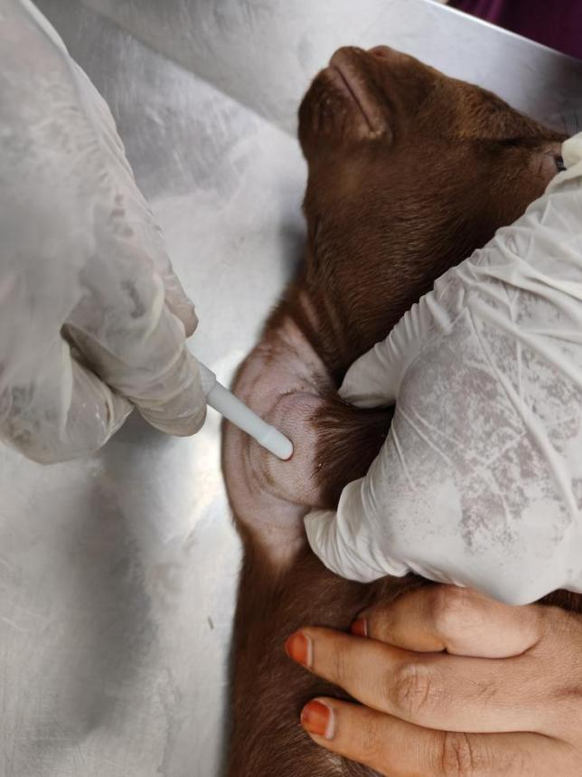
Figure 2: Thyroid gland from a goitre-affected deceased kid showing the right and left lobes.
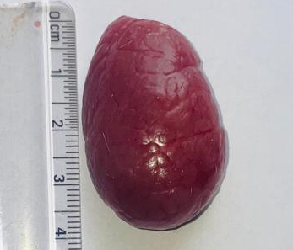 | 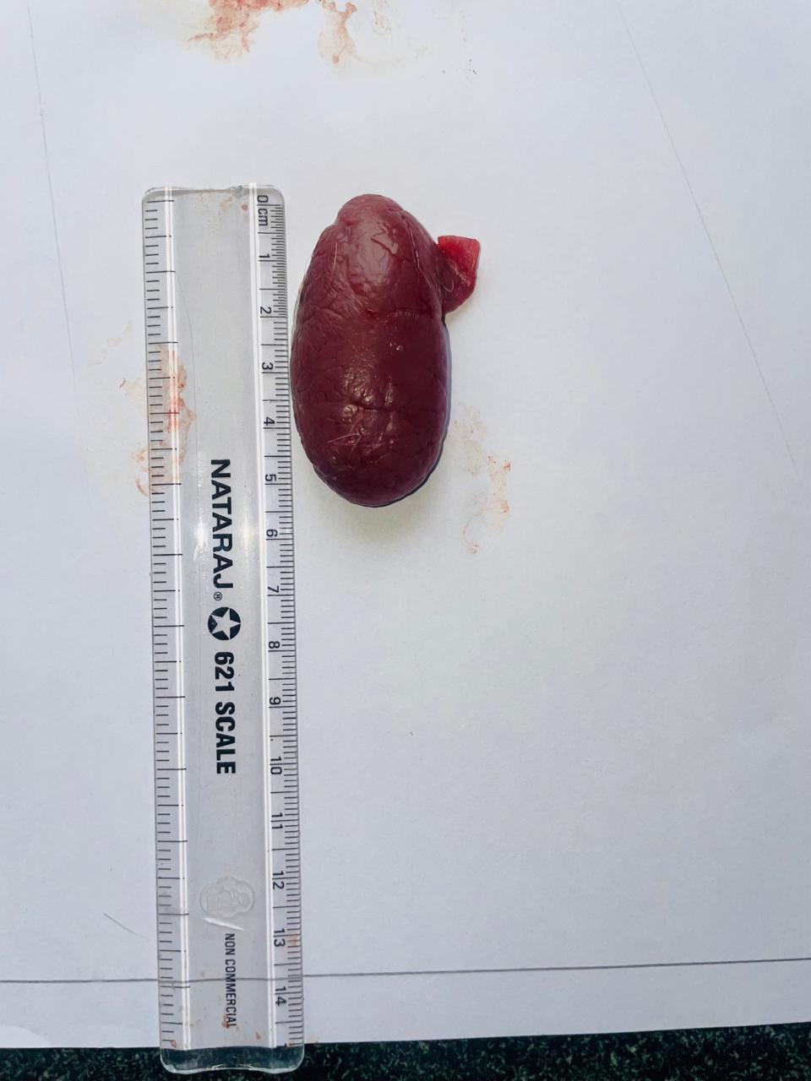
Right lobe | Left lobe

Figure 3: Clinical presentation of goats affected with goitre showing varying
degrees of thyroid enlargement
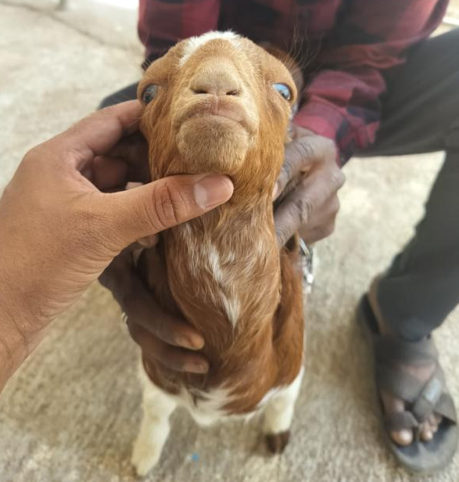 | 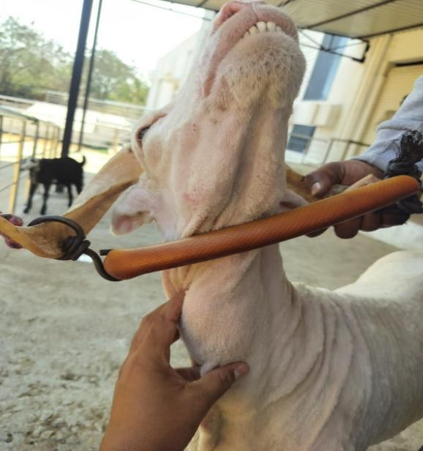
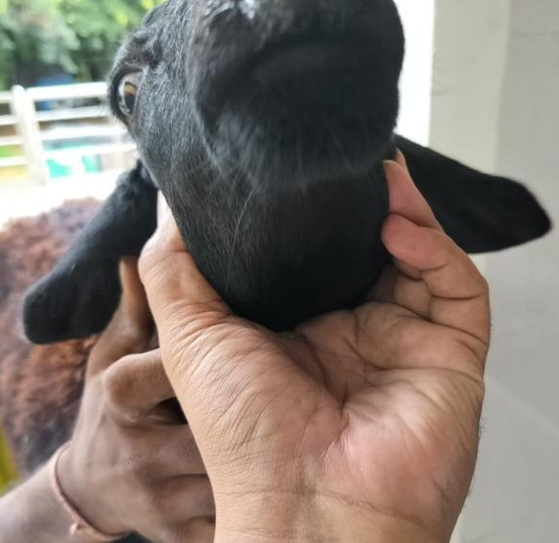 | 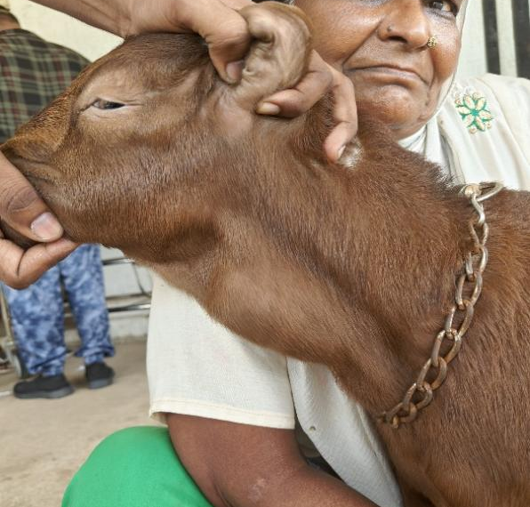
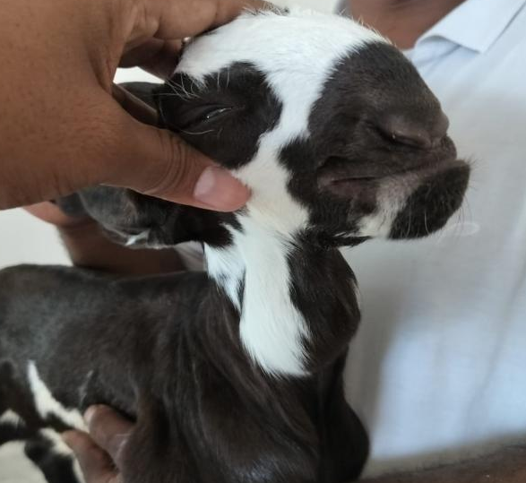 | 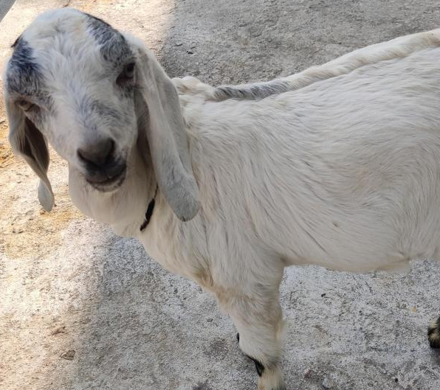

Table 1: Haematological findings in Goitre affected kids.

Parameter | Healthy kids  (Control) (n=6) | Goitre affected kids  (n=18)
Hb (g/dl) | 11.26 ±0.90ª | 7.97 ± 0.68^{b}
RBC (10⁶/cmm) | 10.36±0.52ª | 4.01± 0.20^{b}
PCV (%) | 29.33±0.89ª | 32.96±0.62ª
WBC (10³/cmm) | 12.88±0.16ª | 12.01±0.23ª
PLT (x10⁹/uL) | 202.13±3.45ª | 200.38 ±2.45ª
NEUTROPHILS (%)- | 39.23±0.50ª | 37.38 ±1.57ª
LYMPHOCYTES (%) | 59.50±0.75ª | 62.67±0.89ª
MONOCYTES (%)- | 2.10±0.62ª | 1.98±0.47ª
EOSINOPHILS (%)- | 0.63±0.11ª | 0.59±0.15ª

Values bearing different superscripts in a row differ significantly (P< 0.05)
Values bearing similar superscripts in a row did not differ significantly (P >0.05)

Table 2: Serum biochemical findings in Goitre affected kids.

Parameter | Healthy kids  (Control) (n=6) | Goitre affected kids  (n=18)
ALT (U/L) | 18.19±7.04ª | 14.19±7.04ª
AST (U/L) | 174.87±3.21ª | 179.20±3.92ª
ALP (U/L) | 191.11±7.15ª | 193.78± 5.72ª
Total bilirubin (mg/dL) | 0.07±0.03ª | 0.06±0.01ª
Total protein (g/dL) | 6.97±0.45ª | 6.27±0.31ª
Creatinine (mg/dL) | 1.05±0.04ª | 1.06±0.05ª
BUN (mg/dL) | 19.81±1.12ª | 17.20±1.11ª
Cholesterol (mg/dL) | 64.87±1.92^{b} | 112.23±2.01ª

Values bearing different superscripts in a row differ significantly (P< 0.05)
Values bearing similar superscripts in a row did not differ significantly (P >0.05)

Table 3. Serum T₃, T₄, and TSH levels in goitre-affected goat kids.

Parameter | Before treatment (n= 18) | After treatment  (n =18) | Reference intervals*
T3 (ng/dl) | 118.31± 9.79^{b} | 263.81± 6.79ª | 282 ± 1.01
T4 (µg/dl) | 4.49 ± 0.47^{b} | 8.19 ± 0.78ª | 8.65 ± 1.86
TSH (µIU/ml) | 0.023± 0.23ª | 0.014± 0.11^{b} | 0.01–0.10

(*Refrence intervals taken from Paulíkova et al., 2011)
Figure 4: Imaging findings in goitre affected goats

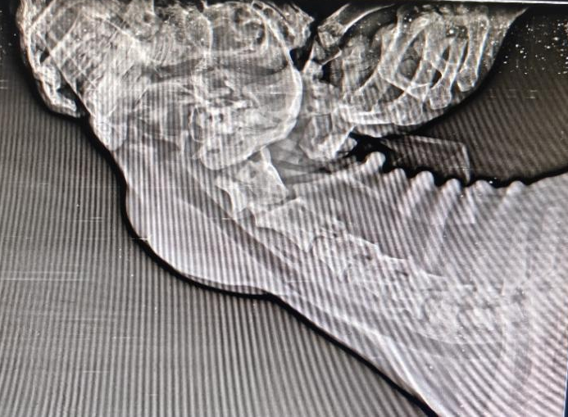 | 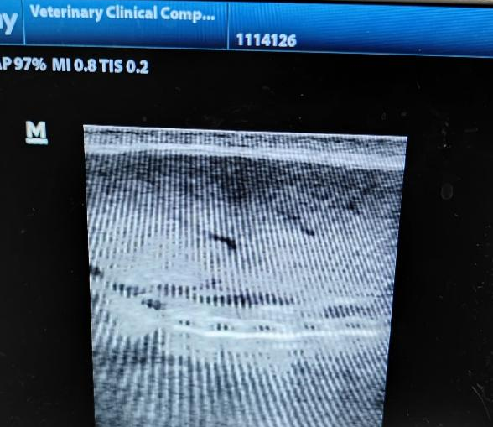
Skiagram showing increased soft tissue opacity at ventral neck region | Sonogram showing a hyperechoic appearance of the thyroid gland.

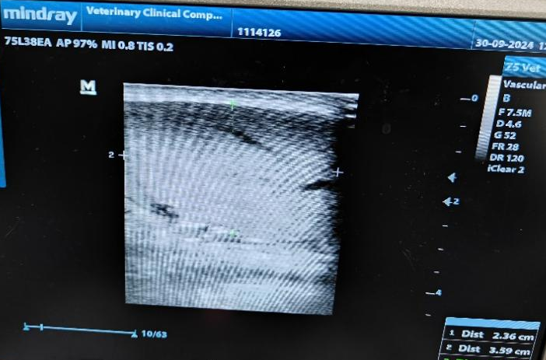 | 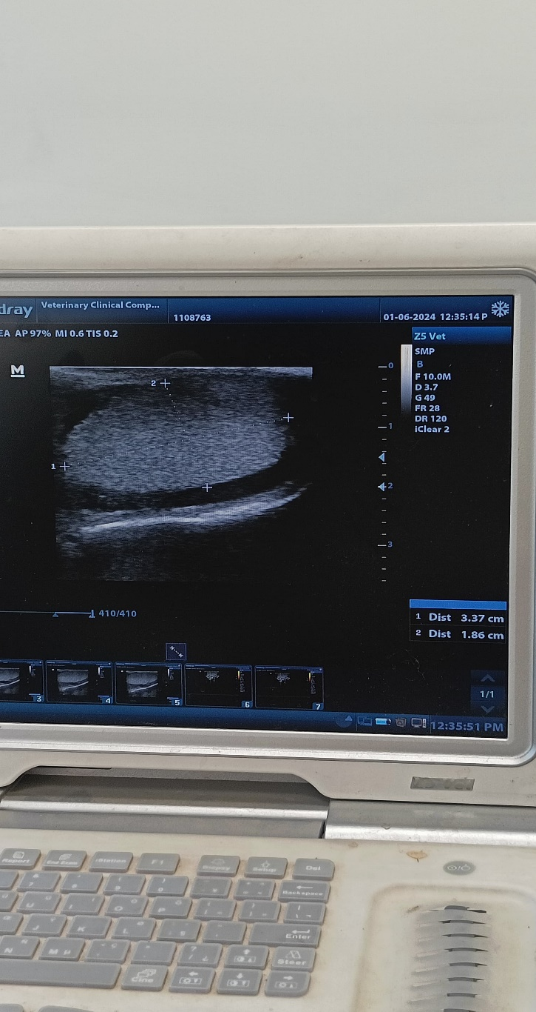
Sonogram showing an enlarged left lobe of the thyroid gland measuring 3.59 cm in length and 2.36 cm in width, suggestive of thyroid gland hypertrophy. | Sonogram showing enlargement of the right lobe of the thyroid gland measuring 3.37 cm in length and 1.86 cm in width, suggestive of thyroid gland hypertrophy.
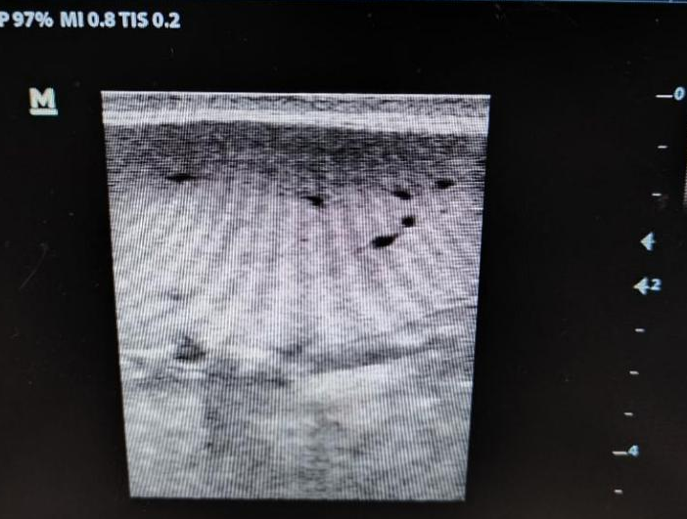 | 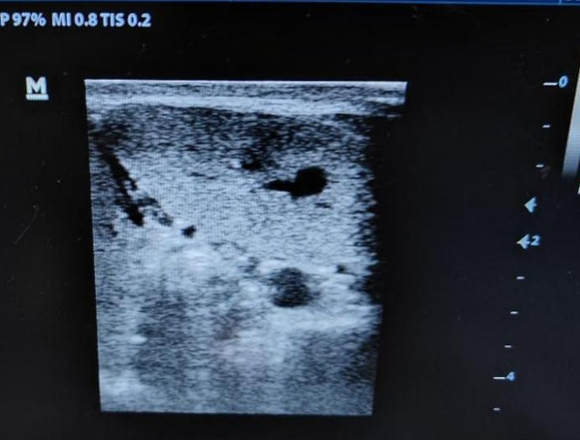
Sonogram showing heterogeneous echotexture with hypoechoic areas within the thyroid gland | Sonogram showing a heterogeneous echotexture of the thyroid gland with increased vascularity..

Figure :5 Histopathological findings in goitre affected goats

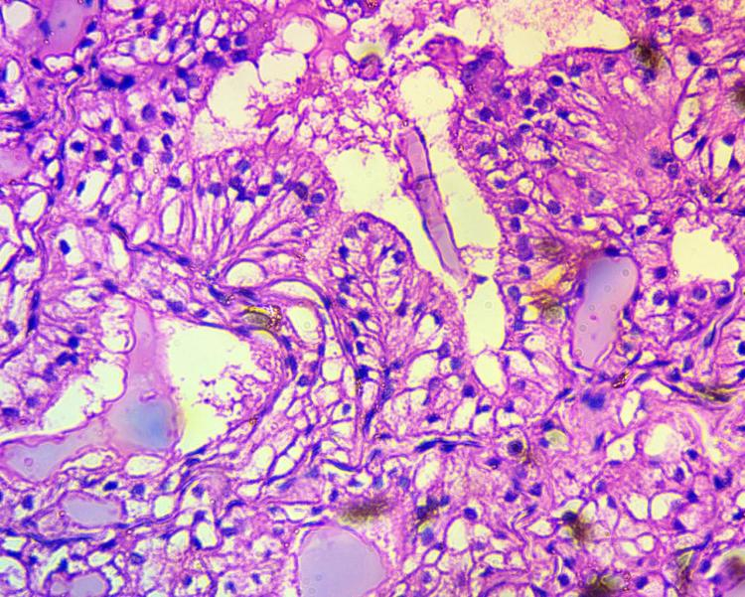 | Histopathological section of the thyroid gland showing follicles lined by single to multiple layers of hyperplastic follicular epithelial cells, with some follicles exhibiting papillary projections into the lumen. The lining epithelial cells are columnar with hyperchromatic nuclei, and areas of follicular atrophy and separation are evident. (Haematoxylin and Eosin, ×100)
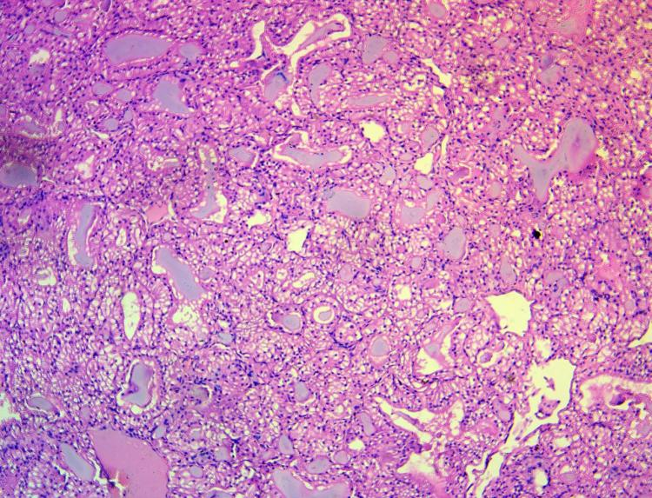 | Histopathological section of the thyroid gland showing follicles lined by single to multiple layers of hyperplastic follicular epithelial cells. Many follicles appear partially collapsed with colloid depletion and disruption of the normal follicular architecture. (Haematoxylin and Eosin, ×10)
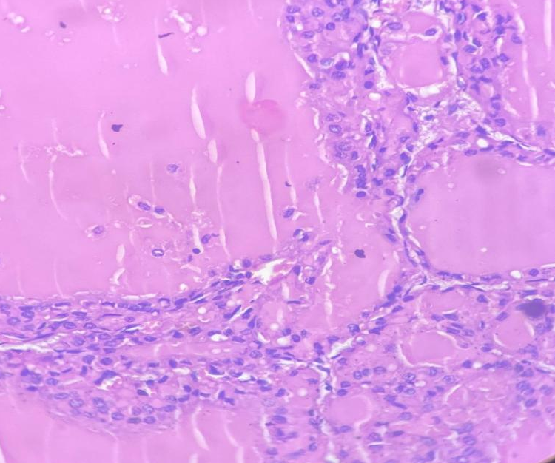 | Histopathological section of the thyroid gland showing columnar epithelial cells exhibiting hyperplastic changes with hyperchromatic nuclei, indicative of increased cellular activity. (Haematoxylin and Eosin, ×100)

DISCUSSION
In the present study, the incidence of congenital goitre in and around Hyderabad was found to be 1.02%. This relatively low but notable incidence may be attributed to geographical and environmental factors. Rajendranagar is situated on the Deccan Plateau, characterized by undulating terrain, rocky or lateritic soils, and seasonal monsoon rainfall. Although the region is not mountainous, these soil and rainfall characteristics reduce iodine retention capacity, increasing the likelihood of iodine-deficient forage and water sources. Consequently, in the absence of dietary iodine supplementation, livestock in such regions are predisposed to iodine deficiency disorders. Rainfall-induced leaching of soil iodine further exacerbates this condition (Zicker & Schoenherr, 2012).
Similar reports of thyroid hypertrophy in lambs and kids affected by congenital goitre have been documented in earlier studies (Sahan et al., 2025; Bhardwaj & Kukovics, 2018; Singh et al., 2002). Goats are considered particularly susceptible to iodine deficiency, as they are browsers rather than grazers—feeding primarily on leaves and branches, and ingesting less soil compared to other ruminants. This feeding behavior limits their exposure to soil-derived iodine (Nourani & Sadr, 2023).
In the current investigation, Malabari goats (38.89%) were most frequently affected, followed by Jamunapari (27.78%) and Barbari (16.67%) breeds. The predominant clinical manifestation was bilateral enlargement of the thyroid gland in the ventral neck region (100%), consistent with the classical hallmark of iodine deficiency in goats, where the thyroid lobes are enlarged at least twofold compared to normal size (Smith & Sherman, 2023).
Other clinical signs observed included failure to thrive (61.11%), dyspnea (50%), lethargy (38.89%), sparse hair coat (33.33%), and alopecia (27.78%). Comparable findings have been reported by Sahan et al. (2025), Davoodi et al. (2022), and Tufani et al. (2018). The failure to thrive may be attributed to a reduction in basal metabolic rate (BMR) resulting from decreased thyroid hormone levels. Severe thyroid enlargement can also exert mechanical pressure on the trachea and larynx, leading to airway obstruction and dyspnea (Ankita et al., 2023). Furthermore, thyroid hormones play an essential role in hair follicle cycling and keratin synthesis; thus, hypothyroidism leads to sparse hair coat and alopecia( Constable et al. 2016).
In the present study, a significant decrease in serum triiodothyronine (T₃) and thyroxine (T₄) levels, along with a significant increase in cholesterol and thyroid-stimulating hormone (TSH) concentrations, was observed in goitrous goats compared to healthy controls. These findings are in agreement with the observations of Jarad et al. (2023), who reported a similar hormonal pattern characterized by elevated TSH and cholesterol levels and reduced T₃, T₄, and FT₄ concentrations in goitrous kids. The increased TSH secretion is a compensatory response to iodine deficiency, wherein the pituitary gland stimulates the thyroid to enhance hormone synthesis. However, due to inadequate iodine availability, this stimulation results in thyroid follicular cell hypertrophy and hyperplasia, leading to glandular enlargement (Davoodi et al., 2022).
Radiographic examination in the current study revealed increased soft tissue opacity in the ventral neck region, consistent with thyroid enlargement. Similar radiographic features were also described by Davoodi et al. (2022), who reported soft tissue opacities anterior to the trachea in goitrous kids, corroborating the present findings.Ultrasonographic evaluation demonstrated enlargement of the thyroid gland with heterogeneous echotexture, suggestive of thyroid hyperplasia. Comparable sonographic findings have been reported in iodine deficiency–related goitre by Agrawal et al. (2016).
According to the literature, the most frequently reported form of congenital goitre is the hyperplastic type, characterized by excessive proliferation of thyroid follicular epithelial cells, leading to the formation of solid cellular clusters and slit-like follicles. These follicles often exhibit papillary projections or villous infoldings into the follicular lumen (Bires et al., 1996). The epithelial cells in such cases are typically columnar in shape, and the colloid content within the follicles is minimal (Maxi, 2007; Bhardwaj & Kukovics, 2018).Similarly, Ong et al. (2014), in their study on hyperplastic goitre in two adult dairy cows, reported disruption and atrophy of thyroid follicles, separation of follicular structures, and morphological alterations in the follicular epithelial cells.In agreement with these previous reports, the histopathological findings in the current study revealed marked variation in follicular size accompanied by pronounced hyperplastic changes (100%). The follicles were lined by multiple layers of follicular epithelial cells forming papillary projections into the lumen (66.67%), along with disruption of follicular architecture (50%) and colloid depletion (50%). In some cases, columnar follicular epithelial cells with hyperchromatic nuclei (33.33%) were also observed. These microscopic alterations confirm the hyperplastic nature of congenital goitre observed in the affected goats.
In the present study, all goitrous goat kids were treated with a combination of levothyroxine sodium and potassium iodide administered orally, resulting in marked clinical recovery. As congenital goitre in kids primarily arises due to iodine deficiency, which leads to reduced synthesis of thyroid hormones, combination therapy was initiated to correct both hormonal insufficiency and iodine deficiency. Following treatment, significant (p < 0.05) increases in serum thyroid hormone (T₃ and T₄) levels were observed in all treated animals, and 88.89% of the affected goats exhibited complete clinical recovery, evidenced by regression of thyroid enlargement and normalization of clinical parameters.
Levothyroxine sodium, widely used in humans, has also been found effective in veterinary species including dogs and kids (Ommaty, 2000; Özmen et al., 2005). Potassium iodide serves as a safe, inexpensive, and readily available source of iodine, making it a suitable supplement for the prevention and treatment of iodine deficiency disorders. Sahan et al. (2025) similarly reported marked clinical improvement in goitrous goat kids following levothyroxine therapy. In addition, Constable et al. (2017) documented successful recovery in lambs with goitre treated with 20 mg potassium iodide administered orally once. Özmen et al. (2005) further recommended dietary supplementation of potassium iodate in pregnant dams, especially when fed goitrogenic feeds such as cabbage, to prevent congenital goitre in offspring.
Despite therapeutic intervention, two kids (11.11%) died during the treatment period. The poor survival rate in these cases could be attributed to complications associated with severe hypothyroidism, including reduced cardiac output, arrhythmias, inadequate surfactant production, and impaired thermoregulation, as reported in previous studies (Davoodi et.al 2022).
Although estimation of iodine levels in biological samples or feed is considered a confirmatory diagnostic tool for congenital goitre, it was not undertaken in the present study due to financial constraints set by the owners. However, the diagnosis was supported by the characteristic clinical presentation, thyroid enlargement, and alterations in thyroid hormone profile (low T₃ and T₄ with elevated TSH), which are widely accepted diagnostic indicators in field conditions. Additionally, the response to iodine and levothyroxine therapy further strengthened the clinical diagnosis.
CONCLUSION
Goitre is an iodine deficiency disorder characterized by non-neoplastic hypertrophy and hyperplasia of the thyroid gland, commonly affecting neonatal and juvenile animals. In the present study, the overall incidence of congenital goitre in goats was found to be 1.02%. Diagnosis can be effectively established through estimation of serum thyroid hormone concentrations (T₃, T₄, and TSH), supported by clinical and imaging findings. The combination therapy of levothyroxine sodium and potassium iodide proved effective in the management of affected kids, resulting in marked clinical improvement and normalization of thyroid hormone levels.

Disclaimer (Artificial intelligence)
Author(s) hereby declare that NO generative AI technologies such as Large Language Models (ChatGPT, COPILOT, etc.) and text-to-image generators have been used during the writing or editing of this manuscript.

REFERENCES

Agrawal, P., Philip, R., Saran, S., Gutch, M., Razi, M. S., Agroiya, P., & Gupta, K. (2015). Congenital hypothyroidism. Indian Journal of Endocrinology and Metabolism, 19(2), 221–227.
Ani, A. F. K., Khamas, W. A., Qudah, K. M. A., & Rawashdah, O. A. (1998). Occurrence of congenital anomalies in Shami breed of goats. Small Ruminant Research, 28, 225–232.
Ankita, Kumar, R., Jamwal, S., Verma, A., Choudhary, S., Patil, R. D., & Asrani, R. K. (2023). Pathology of congenital goiter in a goat kid. Haryana Veterinarian, 62(SI-2), 174–175.
Bhardwaj, R. K., & Kukovics, S. (2018). Iodine deficiency in goats. IntechOpen, Rijeka.
Constable, P. D., Hinchcliff, K. W., Done, S. H., & Grünberg, W. (2016). Veterinary medicine: A textbook of the diseases of cattle, horses, sheep, pigs and goats. Elsevier Health Sciences.
Davoodi, F., Zakian, A., Rocky, A., & Raisi, A. (2022). Incidence of iodine deficiency and congenital goitre in goats and kids of Darreh Garm region, Khorramabad, Iran. Veterinary Medicine and Science, 8(1), 336–342.
Jarad, A., & Al Saad, K. (2023). Goiter in crossbreed goat kids at Basrah Province, Iraq. Archives of Razi Institute, 78, 531.
Lafta, M. H., Jarad, A., & Al Saad, K. M. (2023). Goiter in crossbreed goat kids at Basrah Province, Iraq. Archives of Razi Institute, 78(2), 531–538.
Luna, L. G. (1968). Manual of histologic staining methods of the Armed Forces Institute of Pathology (3rd ed.). McGraw-Hill, New York, pp. 32–39.
Maxie, M. G. (2007). Jubb, Kennedy and Palmer’s pathology of domestic animals (5th ed., Vol. 3). Saunders Elsevier, New York, USA.
Nourani, H., & Sadr, S. (2023). Case report of congenital goitre in a goat kid: Clinical and pathological findings. Veterinary Medicine and Science, 9, 2796–2799.
Ommaty, R. (2000). Tiroid hormon preparatlarý. In Vademecum (p. 673). Hacettepe Publishing, Istanbul.
Ong, C. B., Herdt, T. H., & Fitzgerald, S. D. (2014). Hyperplastic goiter in two adult dairy cows. Journal of Veterinary Diagnostic Investigation, 26(6), 810–814.
Ozmen, O., Sahinduran, S., & Sezer, K. (2005). Clinical and pathological observations and treatment of congenital goitre in kids. Bulletin of the Veterinary Institute in Pulawy, 49, 237–241.
Paulíková, I., Seidel, H., Nagy, O., Tóthová, C., & Kovác, G. (2011). Concentrations of thyroid hormones in various age categories of ruminants and swine. Acta Veterinaria, 61(5–6), 489–503.
Pearce, E. N., Andersson, M., & Zimmermann, M. B. (2013). Global iodine nutrition: Where do we stand in 2013? Thyroid, 23(5), 523–528.
Pugh, D. G., & Baird, A. N. (2012). Sheep and goat medicine (2nd ed.). Elsevier Health Sciences.
Puls, R. (1994). Mineral levels in animal health: Diagnostic data. Sherpa International.
Radostits, O. M., Gay, C. C., Hinchcliff, K. W., & Constable, P. D. (2007). Veterinary medicine (10th ed.). Saunders Elsevier, New York, USA.
Sahan, A., Gülersoy, E., Balıkcı, C., Günal, İ., & Kısmet, E. (2025). Clinical diagnosis and management of a congenital goiter in a kid. Journal of Veterinary Case Reports, 5(1), 15–19.
Singh, J., Sharma, M., Kumar, M., Rastogi, S., Gupta, G. C., Singh, S. P., Sharma, L. D., Gandhi, V. K., & Kalicharan. (2002). Assessment of therapy in goitrous goats through some cardiac function tests. Small Ruminant Research, 44(2), 119–124.
Smith, M. C., & Sherman, D. M. (2023). Iodine. In Goat medicine (3rd ed., pp. 80–84). Wiley-Blackwell, Hoboken, NJ.
Zicker, S., & Schoenherr, B. (2012). The role of iodine in nutrition and metabolism. Compendium: Continuing Education for Veterinarians, 34, 1–4.

