Sustainable Agriculture Practices: A way to Enhance Crop Productivity and Environmental Health

Abstract:
Plant-based sustainable agricultural methods of integration have become central in curbing the challenges of food security in the world as well as maintaining the integrity of the environment. This critical analysis of literature focuses on modern plant strategies that can increase crop production by improving ecological intensity. These systems include the cover cropping systems, polyculture practices, use of biofertilizers and the integrated pest management systems with the use of botanical extracts. Recent data have proven that cover crops enhance soil organic matter by 12-23 percent in addition to minimising erosion by 80 percent. The land equivalent ratios in polyculture systems are 15-30 percent greater than in monocultures and the pest suppression and nutrient cycling efficiencies are higher. Biofertilizers that include Rhizobium spp, Azotobacter spp as well as mycorrhizal fungi increase crop yields by 10-25, and decrease the use of chemical fertilisers by 25-50. Bio pesticides made out of Azadirachta indica, Chrysanthemum cinerariaefolium and other botanical sources are effective bio pesticides that do not have any serious environmental effects. The review brings together the results of 2015-2025 and it was found that combined plant-based practices can sustain or even surpass traditional systems in productivity, in addition to lowering the reliance on synthetic inputs by 40-60 percent. The obstacles of implementation would cover the start-up costs, transfer of knowledge, and local-specific requirements. The research needs of the future are to come up with climate-resilient cultivar mixes, to be more effective in maximizing interaction between plants and microbes, and to work out successful models at different agroecological locations. This review offers evidence-based advice on how to move towards sustainable intensification by plant-based agricultural innovations.
Keywords: Sustainable Agriculture, multiculture, pesticide, biofertilizer, polyculture, biofertilizer, Biopesticide, agroecology, environmental sustainability.
Introduction
The agriculture industry plays a major role in the global economy's growth. Due to rising population and associated food security issues, developing nations still confront the most serious challenges. Increasing agricultural productivity using external inputs like pesticides and mineral fertilisers was the only way to increase food production in the 20thcentury (Kumari et al., 2024). The global agricultural systems are confronted with unmatched challenges of satisfying the food needs of an estimated 9.7 billion individuals by the year 2050 and at the same time, tackle the challenges posed by global warming and environmental degradation and resource depletion. The traditional agricultural paradigm, which is typified by intensive production of monocultures, extensive use of synthetic inputs and the use of machine labour has led to soil erosion, loss of biodiversity, pollution of water bodies and emission of greenhouse gases. The resulting environmental impacts require a paradigm shift to sustainable agriculture that will restore ecological processes and remain productive (Chandel et al., 2024).
Sustainable agriculture aims to tackle these difficulties by using techniques that reduce the negative environmental effects of farming while improving crop yields and soil vitality. Crop yields are critical for global food security, and soil health is fundamental in maintaining resilient and productive agricultural systems (Kumar, and Pathak, 2025). The plant-based methods of sustainable agriculture are a new approach based on the paradigm shift in management that is more search-based on inputs. These strategies use the processes, interactions and diversity of natural plants to increase the health of the soil, nutrient cycling, regulation of pests and resilience of the system. Plant-based sustainability has a scientific basis, which relies on agroecology, systems biology, and the ecological intensification paradigm in which agriculture is viewed as an integrated human-natural system which needs interdisciplinary approaches to be managed (Ewert et al., 2023).
The situation in the Indian subcontinent, where 17.7% of the global population lives on 2.4% of the land area, can be seen as both the urgent necessity of the sustainable agricultural transformation and an opportunity. Traditional Indian agricultural systems had practices practiced traditionally which involved the following: crop rotation, intercropping, green manures, as well as botanical pest management. Nevertheless, the focus of the Green Revolution on high-yielding varieties and the use of chemicals resulted in the use of simplified production systems by most people. Modern issues such as the disappearance of groundwater, soil erosion, resistance to pesticides, and economic stress of farmers have revived the concern of sustainable plant-based substitutes that enhance traditional knowledge with modern scientific knowledge (Souto et al., 2021).
Materials and Methods
Literature Search Strategy
A systematic literature review was done based on various scientific databases such as Web of Science, Scopus, PubMed, and Google Scholar. The search terms were a combination of the terms sustainable agriculture, plant-based practices, cover crops, polyculture, intercropping, biofertilizers, biopesticides, and agroecology. It was restricted to peer-reviewed articles published between 2015 and 2025 with further inclusion of landmark earlier works to provide a historical background (Banusri et al., 2023).
Selection Criteria
The criteria used to include studies were as follows: (1) they had to focus on agricultural practices based on the use of plants, (2) they had to contain empirical evidence regarding productivity and/or environmental outcomes, (3) they had to be relevant to the objectives of sustainable intensification, and (4) they had to be methodologically sound. The exclusion criteria were based on purely theoretical papers that were not empirically validated, articles that were solely genetic modification oriented and studies that were solely limited to controlled laboratory set-ups without being able to validate them in the field (Zheng et al., 2024).
Data Analysis
Results of quantitative research of sampled studies were pooled to find patterns, effect sizes, and inter-context consistency. Where adequate similar information was available, meta-analytical methods were used. Qualitative synthesis studied the implementation barriers, knowledge gaps and mechanisms. To determine how the results could be generalized to non-target agroecological areas, the regional differences and context were considered (Xing et al., 2025).
Cropping Systems to Improve Soil Health.
Soil Improvement mechanisms.
Cover crops promote soil health by interacting in a number of different interconnected ways across both spatial and temporal scales. When cover crops are rooted, they poke holes on the compacted soil layers and therefore, these holes form macropores that enhance water infiltration and aeration. Other species, such as Raphanus sativus var. longipinnatus (tillage radish) have taproots 30 cm or longer in depth, which effectively crack hardpans created by the repeated action of tillage. Grasses like Secale cereale (cereal rye) and Avena sativa (oats) have fibrous root systems that form massive networks that hold the soil together to avoid erosion (Chandel et al., 2024).
Table 1: Soil Health Improvements from Cover Crop Implementation
Parameter | Cover Crop Type | Improvement Range (Soil Improvement) | Time Frame | Reference
Organic Matter | Legume mix | 12-18% increase | 3-5 years | (Swarnam et al., 2024)
Water Infiltration | Grass-legume | 45-65% increase | 2-3 years | (Mgendi, 2024)
Aggregate Stability | Brassica blend | 25-35% increase | 2-4 years | (Wenzel et al., 2024)
Microbial Biomass | Diverse mix | 40-80% increase | 1-3 years | (Sharma et al., 2024)
Erosion Reduction | Cereal rye | 75-85% decrease | Immediate | (Karthik et al., 2024)
Nitrogen Availability | Legume species | 40-90 kg/ha | Following season | (Samanta et al., 2024)
Carbon Sequestration | Multi-species | 0.3-0.8 t/ha/yr | Continuous | (Sharma et al., 2024)
Figure 1: Nitrogen Cycling Pathways
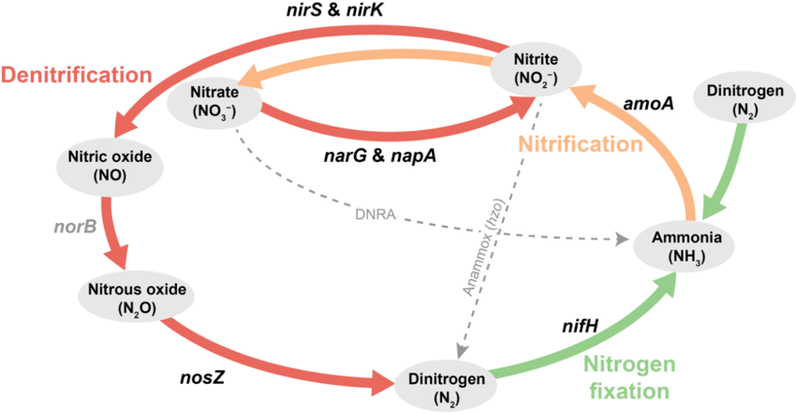
Nutrient Cycling and Availability
Cover crops basically alter the nutrient regimes on the biological fixation, scavenging, and mineralization of nutrients. Leguminous cover crops Vica villosa (hairy vetch), Trifolium incarnatum (crimson clover) and Vigna unguiculata (cowpea) develop symbiotic associations with Rhizobium species, which fix atmospheric nitrogen at a rate of between 50-200kg N/ha depending on species, environmental conditions and management. Such a fixation process of nitrogen in biology will reduce the dependence on artificial nitrogen pesticides, and will result in the release of nutrients to crops that will follow it.
The nutrient scavengers are non-leguminous cover crops, and they absorb the remaining nutrients that are likely to be lost through leaching. Brassica species have an extremely high ability to extract phosphorus in the soil by secreting organic acid through the roots, which dissolve phosphorus compounds that are bound. Root deep species access the nutrients at their subsoil levels and move them to the surface by decomposing the biomass (Datta et al., 2023).
Water Management Benefits
Cover crops have a number of impacts on the field water. Living cover reduces the energy of the raindrops, which achieves 85-95 percent of the energy, preventing the sealing of the soil surface and preserving the infiltration capacity. The root channels of cover crops are 50-300 percent saturated with hydraulic conductivity, which improves deep percolation and recharge of the groundwater. Terminated cover crops on bestow surfaces reduce loss of evaporation by 20-40 percent and even out the variations in soil temperature (Ewert et al., 2023).
Table 2: Water Conservation Effects of Cover Crop Residues (add reference)
Residue Type | Surface Coverage | Evaporation Reduction | Moisture Retention | Temperature Moderation | References
Cereal Rye | 80-90% | 35-40% | 25-30% increase | 3-5°C reduction | (Griffiths et al., 2021)
Hairy Vetch | 60-75% | 25-30% | 18-22% increase | 2-4°C reduction | (Tully & McAskill, 2019)
Mixed Species | 75-85% | 30-38% | 22-28% increase | 3-4°C reduction | (Griffiths et al., 2021)
Crimson Clover | 65-70% | 20-28% | 15-20% increase | 2-3°C reduction | (Çerçioğlu et al., 2025)
Annual Ryegrass | 85-95% | 38-45% | 28-35% increase | 4-6°C reduction | (Dehkordi et al., 2021)
Brassica Blend | 70-80% | 28-35% | 20-25% increase | 3-4°C reduction | (Dille et al., 2021)
Oat-Pea Mix | 75-85% | 32-38% | 24-30% increase | 3-5°C reduction | (Sharma et al., 2024)
Polyculture Systems for Enhanced Productivity
Ecological Principles of Plant Diversity
Polyculture systems use complementarity and facilitation between plant species in order to maximize their resource use and ecosystem services. Ecological background is based on the niche differentiation in which the species having different root architecture, nutrient needs and phenological use different resource pools. Classic examples are cereal-legume intercrops in which grasses are able to use soil nitrogen and legumes are able to use atmospheric nitrogen in a manner that generates synergistic interactions to increase the productivity of the overall system (Gamage et al., 2024).
Figure 2: Root Architecture Complementarity
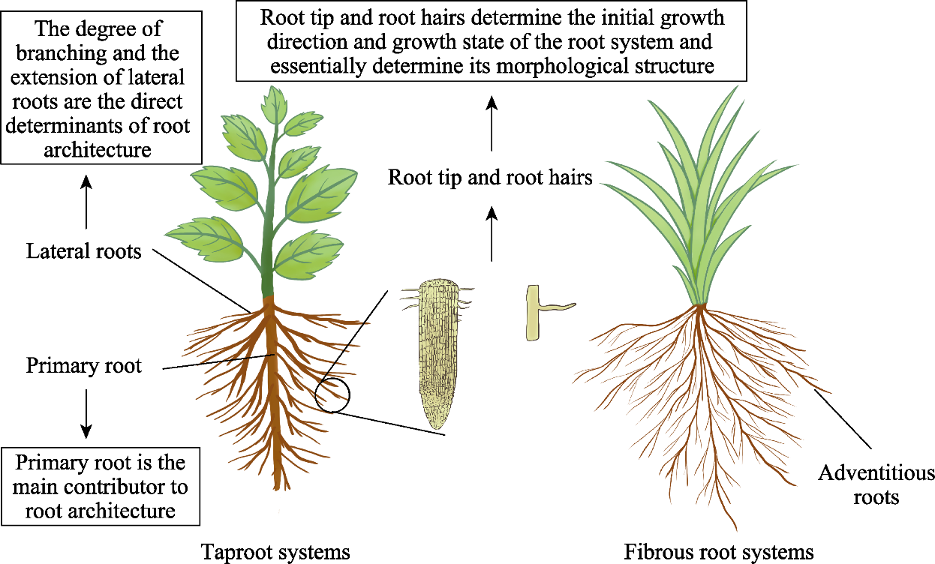
The advantages of polycultures of the kind that are temporally complementary include extended growing seasons and workforce dispersal. Ecological design is high in the fact that Zea mays (maize) is used followed by Phaseolus vulgaris (common bean) and Cucurbita pepo (squash) in the use of the traditional milpa systems. Squash planted early will provide a ground cover which prevents weeds and vertical maize formation will encourage climbing bean species that fix nitrogen and will benefit all three species (Gawande et al., 2023).
Yield Advantages and Ratio of Land Equivalent to Ratios.
Polyculture is also more productive than monoculture systems in the ratio of land equivalent (LER). Meta-analyses indicate an average LER of two-species mixture of 1.15-1.30 and a more mixed of 1.25-1.45. Less intraspecific competition and greater capturing efficiency of resources and positive interspecific interaction are the causes of the overyielding phenomenon (Getahun et al., 2024).

Table 3: Productivity Comparison of Polyculture Systems (add reference)
Cropping System | Component Crops | LER Value | Yield Advantage | Economic Benefit | References
Maize-Bean | Zea mays + Phaseolus vulgaris | 1.25-1.35 | 25-35% | 30-40% increase | (Kaspar & Singer, 2013)
Rice-Fish | Oryza sativa + Aquaculture | 1.40-1.55 | 40-55% | 45-60% increase | (Sharma et al., 2025)
Millet-Groundnut | Pennisetum glaucum + Arachis hypogaea | 1.18-1.28 | 18-28% | 22-32% increase | (Dabney et al., 2001)
Wheat-Mustard | Triticum aestivum + Brassica juncea | 1.15-1.22 | 15-22% | 18-25% increase | (Coyne et al., 2004)
Sugarcane-Pulse | Saccharum officinarum + Cajanus cajan | 1.30-1.42 | 30-42% | 35-48% increase | (Doran et al., 1984)
Cotton-Pigeonpea | Gossypium hirsutum + Cajanus cajan | 1.22-1.32 | 22-32% | 28-38% increase | (Eash et al., 2021)
Cassava-Maize | Manihot esculenta + Zea mays | 1.28-1.38 | 28-38% | 32-42% increase | (Sharma et al., 2024)
Pest and Disease Suppression
The polyculture of plant diversity provides undesirable conditions to the population explosion of pests in various ways. The resource concentration hypothesis is used to describe the decreased pest loads due to the spatial dilution of host plants amid non-hosts. The natural enemy hypothesis is the reason that pest control is caused by an increased diversity of beneficial arthropods that is facilitated by both floral resources and microhabitats (Kerr et al., 2023).
Figure 3: Pest Density in Mono vs Polyculture
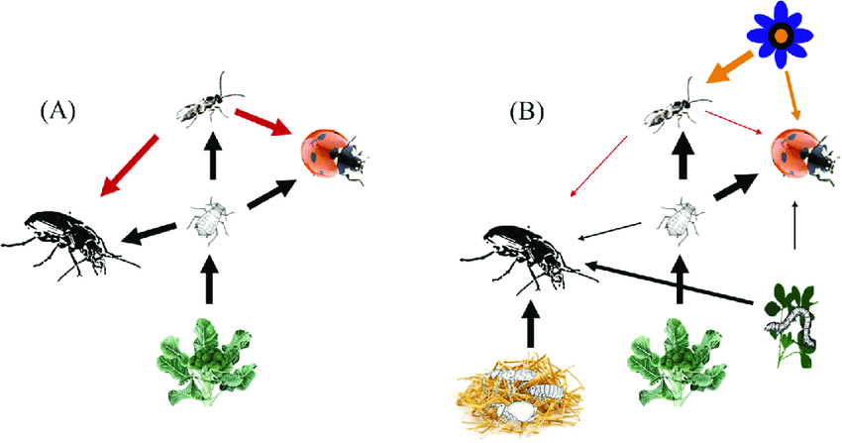
The combinations of plants are amazingly pest-suppressing. Intercropping Brassica oleracea (cabbage) with Allium sativum (garlic), or Allium Cepa (onion) reduces by 60-75 percent of the infestation of diamondback moth (Plutella xylostella). Push-pull technologies that involve inter-crop of Desmodium uncinatum and Pennisetum purpureum as border plants reduce 80-90 percent of stem borers in maize and increase soil fertility (Khan, 2024).
Biofertilizers: Plants-Microbes Synergies.
Nitrogen-Fixing Biofertilizers
Among the most significant nitrogen fertilizers alternatives that are sustainable is biological fixation of nitrogen. Symbiotic interactions between legumes and Rhizobium species can fix 50-300 kg/ha/year of N/year, which depends on the compatibility between the host and the strain, the soil conditions, and management. Complicated inoculant recipes are added to a number of strains that are selected to be effectively utilized in environmental conditions (Lafontaine & Jannoyer, 2014).
Table 4: Nitrogen Fixation Potential of Different Legume-Rhizobia Associations
Host Plant | Rhizobium Species | N-Fixation Rate | Yield Increase | Fertilizer Saved | References
Soybean (Glycine max) | Bradyrhizobium japonicum | 150-250 kg/ha | 15-25% | 60-80 kg urea/ha | (Wendling et al., 2017)
Chickpea (Cicer arietinum) | Mesorhizobium ciceri | 80-140 kg/ha | 12-20% | 40-60 kg urea/ha | (Li et al., 2023)
Common Bean (Phaseolus vulgaris) | Rhizobium leguminosarum | 60-120 kg/ha | 10-18% | 30-50 kg urea/ha | (Su et al., 2023)
Groundnut (Arachis hypogaea) | Bradyrhizobium sp. | 100-180 kg/ha | 15-22% | 50-70 kg urea/ha | (Wendling et al., 2017)
Pigeon Pea (Cajanus cajan) | Rhizobium sp. | 120-200 kg/ha | 18-28% | 55-75 kg urea/ha | (Manevski et al., 2022)
Lentil (Lens culinaris) | Rhizobium leguminosarum | 50-100 kg/ha | 8-15% | 25-45 kg urea/ha | (Magda et al., 2008)
Black Gram (Vigna mungo) | Bradyrhizobium sp. | 70-130 kg/ha | 12-18% | 35-55 kg urea/ha | (Malézieux et al., 2008)

Figure 4: PSB Action on Soil Phosphorus
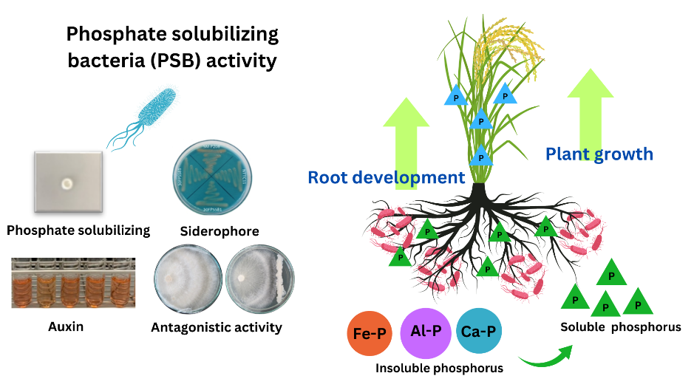
Additional sources of nitrogen include free-living nitrogen fixers such as Azotobacter spp, Azospirillum spp and Gluconacetobacter diazotrophicus which fix nitrogen and form plant growth-promoting compounds. These symbiotic organisms sequester 20-40 kg N/ha in non-leguminous crops and at the same time produce phyto hormones, siderophores and antimicrobial compounds that improve the growth and well being of the plant (Lichtfouse, 2013).
Phosphate-Solubilizing Microorganisms
Availability of phosphorus restricts the yield of crops in most soils even though the total amount of phosphorus is high but has been stored in insoluble mineral forms. PSB phosphate-solubilizing bacteria (Bacillus spp., Pseudomonas spp., and Enterobacter spp) release organic acids, phosphatases, and chelating compounds which loosen bound phosphorus (Liu et al., 2024).
Mycorrhizal Associations
AMF (Arbuscular mycorrhizal fungi) establish symbiosis with 80 percent of terrestrial plants and significantly increase root surface area to obtain nutrients. The networks of hyphae grow 10-100 cm farther than the root zones and tap into phosphorus, zinc, copper and other nutrients that the roots alone cannot reach in soil volumes. The AMF inoculation enhances phosphorus uptake by 50-300 percent and has improved the ability of drought tolerance by enhancing water absorption (Mahmood et al., 2024).

Table 5: Crop Response to Mycorrhizal Inoculation
Crop Species | AMF Species | P Uptake Increase | Yield Enhancement | Water Use Efficiency | References
Maize (Zea mays) | Glomus intraradices | 80-150% | 15-30% | 25-35% improvement | (Ikbal et al., 2017)
Wheat (Triticum aestivum) | Glomus mosseae | 60-120% | 12-25% | 20-30% improvement | (Wilson et al., 2021)
Rice (Oryza sativa) | Glomus fasciculatum | 50-100% | 10-20% | 15-25% improvement | (Kebede, 2021)
Tomato (Solanum lycopersicum) | Mixed AMF | 100-200% | 20-40% | 30-45% improvement | (Mendoza‐Suárez et al., 2024)
Onion (Allium cepa) | Glomus versiforme | 120-250% | 25-45% | 35-50% improvement | (Wilson et al., 2021)
Potato (Solanum tuberosum) | Glomus etunicatum | 70-140% | 15-28% | 22-32% improvement | (Zhang et al., 2025)
Sorghum (Sorghum bicolor) | Mixed AMF | 90-170% | 18-32% | 28-38% improvement | (Kolomiiets et al., 2024)
Botanical Pest Management Strategies
Plant-Derived Insecticides
Other alternatives that are less damaging to the synthetic pesticides are the botanical insecticides, which are the fastest biodegraded and have minimal impact on non-targets. The most researched source Azadirachta indica (neem), contains azadirachtin and other related limonoids that disrupt insect feeding, growth and reproduction. Neem preparations control over 200 species of pests with LC 50 or LD 50 values of 0.1 -10ppm to unsusceptible species (Mamatha et al., 2024).
Chrysanthemum cinerariaefolium produces pyrethrins which cause rapid knockdown due to interruption with sodium channels in insect nervous systems. The pyrethrin extracts employed in nature are also degradable in hours under the sun, eliminating issues of environmental persistence. The significant substitute sources of botanical insecticides include Derris spp. (rotenone), Nicotian tabacum (nicotine) and Ryania speciosa (ryanodine) (Mohanty et al., 2024).
Antifeedants/ Repellents Plants.
Strategic use of repellent plants as a strategy of pest management without the use of lethal techniques is a behaviour change. Tanacetum vulgare (tansy), Artemisia absinthium (wormwood), and Rosmarinus officinalis (rosemary) are the plants that release volatile compounds which discourage various pest species. With these aromatic species planted as border plantation or intercrop with the adjacent crops, the population of pests attaching to the crop is reduced by 40-70 percent as a result (Nath, 2024; Oberč & Schnell, 2020).

Table 6: Efficacy of Botanical Pest Management Approaches
Botanical Source | Active Compounds | Target Pests | Efficacy Range | Application Method | References
Neem (Azadirachta indica) | Azadirachtin, Nimbin | Lepidoptera, Hemiptera | 70-90% control | Foliar spray | (Khan, 2024)
Pyrethrum (Chrysanthemum) | Pyrethrins | Flying insects | 80-95% knockdown | Contact spray | (Song et al., 2024)
Garlic (Allium sativum) | Allicin, Diallyl disulfide | Aphids, Thrips | 60-80% repellency | Extract spray | (Ansari et al., 2023)
Tobacco (Nicotiana tabacum) | Nicotine | Soft-bodied insects | 75-85% mortality | Aqueous extract | (Mohanty et al., 2024)
Custard Apple (Annona) | Annonaceous acetogenins | Stored grain pests | 70-85% control | Seed powder | (Chandrasekaran, 2024)
Lantana (Lantana camara) | Lantadenes | Mosquitoes, Flies | 65-80% repellency | Leaf extract | (Sun & Shahrajabian, 2023)
Marigold (Tagetes) | Thiophenes, Limonene | Nematodes, Whitefly | 55-75% reduction | Intercropping | (Rasouli et al., 2023)
Trap Crops and Banker Plants
Trap cropping takes advantage of preferences of the pests to accumulate them around the primary crops. Indian mustard (Brassica juncea) planted as a border crop benefits the crops of diameterback moth, aphids and flea beetles and thereby mitigates infestation of main crops by 60-80%. Targeted interventions can be applied to trap crops or the crops destroyed before the pest can disperse as much as possible reducing the application of pesticides (Ojadi, 2023; Piñeiro et al., 2020).
Figure 5: Spatial Arrangement for Pest Management
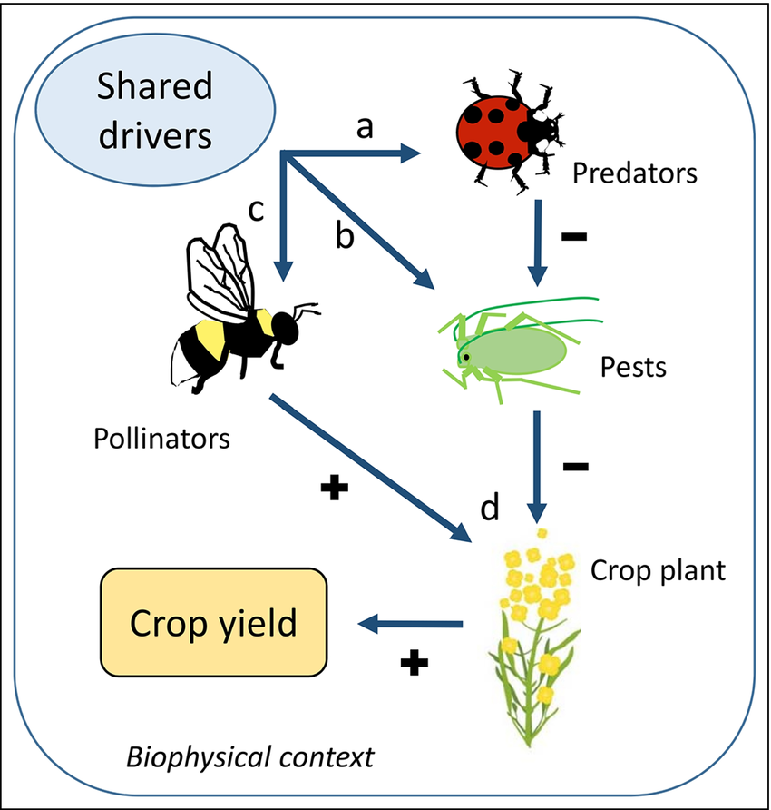

Banker plants contribute to the maintenance of desirable populations of arthropods, which have been the source of biological control. In Lobularia maritima (sweet alyssum), Fagopyrum esculentum (buckwheat), and Phacelia tanacetifolia, predators and parasitoids feeding on pest species are found growing. Natural enemies’ abundance during growing seasons can be boosted by 3-5 folds with the planting of banker plants strategically that can boost pest control (Sekhar et al., 2024). Integration and Synergies
Systems-Level Benefits
The shareholder impacts of the components are not as great as the leverage of the synergies of different plant-based practices. Poly culture rotations and using cover crops build up soil organic matter and also diversification of production and revenue streams. Leguminous cover crops provide soil with nitrogen to the subsequent intercrops in addition to improving the soil structure to allow intricate root systems. This is because the applications of biofertilizers enhance the formation of biomass covers and nitrogen fixation rates ( Sharma et al., 2024).
Economic Considerations
Sustainable practices in plants are long-term investments that are pegged on initial investment in seeds, inoculants, and education. However, the low price of input and access to the high-end market tends to be recouped within 2- 3 seasons. Economic analyses indicate that integrated sustainable systems are 15-40% more profitable than conventional monocultures would in respect to overall costs of production and worth of ecosystem services.
Figure 6: Cumulative Benefits of Integration
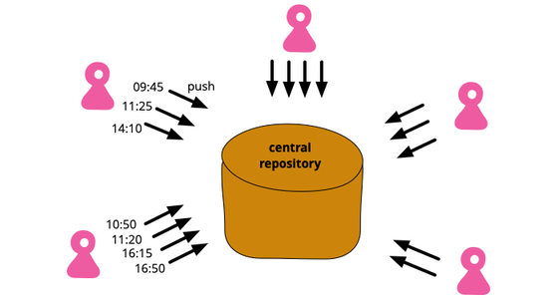
Table 7: Economic Analysis of Sustainable Practice Adoption
Practice Combination | Initial Investment | Payback Period | Net Return Increase | Risk Reduction | References
Cover Crop + Polyculture | $150-250/ha | 2-3 years | 25-35% | 30-40% | (Deliklitas & Gökbulut, 2025)
Biofertilizer + Botanicals | $80-120/ha | 1-2 years | 20-30% | 25-35% | (Deliklitas & Gökbulut, 2025)
Full Integration | $200-350/ha | 2-4 years | 35-45% | 40-50% | (Deliklitas & Gökbulut, 2025)
Polyculture + Trap Crops | $100-180/ha | 1-3 years | 22-32% | 28-38% | (Javaid et al., 2024)
AMF + Cover Crops | $120-200/ha | 2-3 years | 28-38% | 32-42% | (Gamage et al., 2024)
Green Manure + Biocontrol | $90-150/ha | 1-2 years | 18-28% | 22-32% | (Mamphogoro et al., 2021)
Complete System | $300-450/ha | 3-5 years | 40-55% | 45-60% | (Sharma et al., 2024)
Challenges and Future Directions
Implementation Barriers
Though proven to be beneficial, the implementation of sustainable practices grounded in plants is limited by various limitations. Knowledge-intensive management needs education for the farmers and technical assistance, which is usually not offered in the rural regions. Cover crop and traditional varieties of seeds and their systems must be fortified to guarantee the quality availability of germplasm. Market systems that are inclined towards monoculture commodities will not support diversification unless there is a policy in place (S. Sharma & K.C., 2024).
Figure 7: Pathways to Overcome Constraints
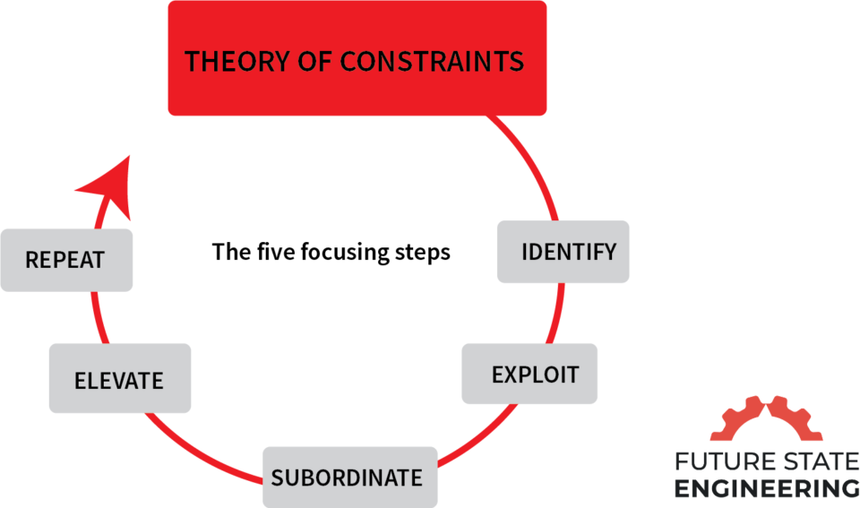
Figure 8: Multi-stakeholder Scaling Approach
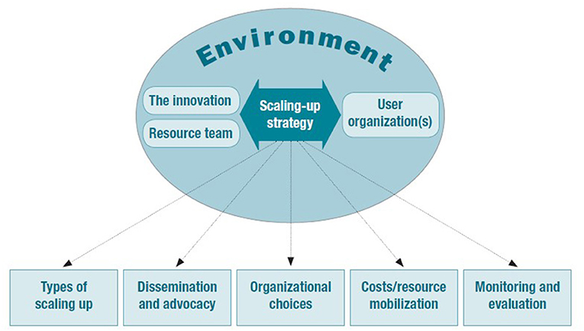
Climate Change Adaptation
There is also a weakness in the agricultural systems to the climatic variability, and thus, resilient practices are being used. Plant heterogeneity helps to reduce extremes in weather because of stress variation and maturity epochs. Planted cover crops access the tap water during dry seasons and planting mulches reduces the heights and lows of the temperature. Among the research priorities is the selection and breeding of climate-adaptive cultivars so as to have systems that produce sustainability (Singh et al., 2024).
Scaling Mechanisms
A proper scaling should be both technically and socially and on a policy level. The mechanisms of efficient knowledge transfer and the adoption rates of the participants of Farmer field schools are higher than 60 due to the institutions of these schools. The electronic media are increasingly proving effective in terms of information exchange and market connections. The policy support through the payment of ecosystem services and sustainable certification programs motivates and renders it cost-effective.
Research Priorities
The paper needs to be expanded in future research by the context-specific optimization of the plant mixes to apply them to different agro-ecological regions. Understanding of interactions between plants, soil and microbes at the molecular scale will aid in taking certain actions that will enhance positive interactions. Proper mechanization to various cropping systems should be developed to become efficient with regards to labor. The evidence on policy supports will be furnished by the provision of ecosystem services and economic sustainability to the long-term studies (Valavi et al., 2025).
Conclusion
Sustainable agriculture practices based on plants provide possible solutions towards food security and the recovery of environmental resources. Individual and synergistic advantages are shown in terms of productivity, profitability and ecology with cover crops, polycultures, biofertilizers and botanical pest management. The implementation issues have to be solved by the concerted work of the scientists, extension services, farmers and policy-makers. The key to success is adaptation, management, and favorable institutional structures which are specific to the context. The indications have been overwhelming in support of a shift in agricultural systems to be plant-based to ensure a sustainable intensification that satisfies the demands of the human population and planetary toxins. The further development requires further innovation, collaboration with multiple stakeholders, and adherence to the principles of ecology used to transform agriculture.
Disclaimer (Artificial intelligence)
Option 1:
Author(s) hereby declare that NO generative AI technologies such as Large Language Models (ChatGPT, COPILOT, etc.) and text-to-image generators have been used during the writing or editing of this manuscript.
Option 2:
Author(s) hereby declare that generative AI technologies such as Large Language Models, etc. have been used during the writing or editing of manuscripts. This explanation will include the name, version, model, and source of the generative AI technology and as well as all input prompts provided to the generative AI technology
Details of the AI usage are given below:
1.
2.
3.

References
- Banusri, M., Bharath, H. R. R., G, G. K., & P, A. (2023). Impact of CSR Activities on the Enhancement of Income of Farmers in Sustainable Agriculture. International Journal for Research in Applied Science and Engineering Technology, 11(10), 1502. https://doi.org/10.22214/ijraset.2023.56237
- Chandel, N., Kumar, A., & Kumar, R. (2024). Towards Sustainable Agriculture: Integrating Agronomic Practices, Environmental Physiology and Plant Nutrition. International Journal of Plant & Soil Science, 36(6), 492. https://doi.org/10.9734/ijpss/2024/v36i64651
- Datta, S., Hamim, I., Jaiswal, D. K., & Sungthong, R. (2023). Sustainable agriculture. BMC Plant Biology, 23(1). https://doi.org/10.1186/s12870-023-04626-9
- Ewert, F., Baatz, R., & Finger, R. (2023). Agroecology for a Sustainable Agriculture and Food System: From Local Solutions to Large-Scale Adoption. Annual Review of Resource Economics, 15(1), 351. https://doi.org/10.1146/annurev-resource-102422-090105
- Gamage, A., Gangahagedara, R., Subasinghe, S., Gamage, J., Guruge, C., Senaratne, S., Randika, T., Rathnayake, C., Hameed, Z., Madhujith, T., & Merah, O. (2024). Advancing Sustainability: The Impact of Emerging Technologies in Agriculture. Current Plant Biology, 100420. https://doi.org/10.1016/j.cpb.2024.100420
- Gawande, V., Saikanth, D. R. K., Sumithra, B. S., Aravind, S. A., Swamy, G. N., Chowdhury, M., & Singh, B. V. (2023). Potential of Precision Farming Technologies for Eco-Friendly Agriculture. International Journal of Plant & Soil Science, 35(19), 101. https://doi.org/10.9734/ijpss/2023/v35i193528
- Getahun, S., Kefale, H., & Gelaye, Y. (2024). Application of Precision Agriculture Technologies for Sustainable Crop Production and Environmental Sustainability: A Systematic Review [Review of Application of Precision Agriculture Technologies for Sustainable Crop Production and Environmental Sustainability: A Systematic Review]. The Scientific World JOURNAL, 2024(1). Hindawi Publishing Corporation. https://doi.org/10.1155/2024/2126734
- Kerr, R. B., Postigo, J. C., Smith, P., Cowie, A., Singh, P. K., Rivera‐Ferre, M. G., Tirado, C., Campbell, D., & Neufeldt, H. (2023). Agroecology as a transformative approach to tackle climatic, food, and ecosystemic crises. Current Opinion in Environmental Sustainability, 62, 101275. https://doi.org/10.1016/j.cosust.2023.101275
- Khan, N. (2024). Unlocking Innovation in Crop Resilience and Productivity: Breakthroughs in Biotechnology and Sustainable Farming. Innov Discov, 1, 28. https://doi.org/10.53964/id.2024028
- Lafontaine, H. O., & Jannoyer, M. (2014). Sustainable Agriculture Reviews 14. In Sustainable agriculture reviews. Springer International Publishing. https://doi.org/10.1007/978-3-319-06016-3
- Lichtfouse, É. (2013). Sustainable Agriculture Reviews. In Sustainable agriculture reviews. Springer International Publishing. https://doi.org/10.1007/978-94-007-5961-9
- Liu, M., Chen, X., & Jiao, Y. (2024). Sustainable Agriculture: Theories, Methods, Practices and Policies. Agriculture, 14(3), 473. https://doi.org/10.3390/agriculture14030473
- Mahmood, H., Hassan, M. S., Meraj, G., & Furqan, M. (2024). Agriculture’s Role in Environmental Sustainability: A Comprehensive Review of Challenges and Solutions [Review of Agriculture’s Role in Environmental Sustainability: A Comprehensive Review of Challenges and Solutions]. Challenges in Sustainability, 12(3), 178. Librelloph. https://doi.org/10.56578/cis120302
- Mamatha, B., Mudigiri, C., Ramesh, G., Saidulu, P., Meenakshi, N., & Prasanna, C. L. (2024). Enhancing Soil Health and Fertility Management for Sustainable Agriculture: A Review [Review of Enhancing Soil Health and Fertility Management for Sustainable Agriculture: A Review]. Asian Journal of Soil Science and Plant Nutrition, 10(3), 182. Sciencedomain International. https://doi.org/10.9734/ajsspn/2024/v10i3330
- Mohanty, L. K., Singh, N. K., Raj, P., Prakash, A., Tiwari, A. K., Singh, V., & Sachan, P. (2024). Nurturing Crops, Enhancing Soil Health, and Sustaining Agricultural Prosperity Worldwide through Agronomy. Journal of Experimental Agriculture International, 46(2), 46. https://doi.org/10.9734/jeai/2024/v46i22308
- Nath, S. (2024). A vision of precision agriculture: Balance between agricultural sustainability and environmental stewardship. Agronomy Journal, 116, 1126. https://doi.org/10.1002/agj2.21405
- Oberč, B. P., & Schnell, A. A. (2020). Approaches to sustainable agriculture: exploring the pathways towards the future of farming. https://doi.org/10.2305/iucn.ch.2020.07.en
- Ojadi, F.-X. I. (2023). Sustainable Agricultural Practices: Value Chain of Egusi, A Local Soup Condiment in Nigeria. In IntechOpen eBooks. IntechOpen. https://doi.org/10.5772/intechopen.109854
- Piñeiro, V., Arias, J., Dürr, J., Elverdin, P., Ibáñez, A. M., Kinengyere, A. A., Opazo, C., Owoo, N. S., Page, J., Prager, S. D., & Torero, M. (2020). A scoping review on incentives for adoption of sustainable agricultural practices and their outcomes [Review of A scoping review on incentives for adoption of sustainable agricultural practices and their outcomes]. Nature Sustainability, 3(10), 809. Nature Portfolio. https://doi.org/10.1038/s41893-020-00617-y
- Sekhar, M., Rastogi, M., M, R. C., Saikanth, D. R. K., Rout, S., Kumar, S., & Patel, A. K. (2024). Exploring Traditional Agricultural Techniques Integrated with Modern Farming for a Sustainable Future : A Review. JSRR, 30, 185. https://doi.org/10.9734/jsrr/2024/v30i31871
- Sharma, P., Sharma, P., & Thakur, N. (2024). Sustainable farming practices and soil health: a pathway to achieving SDGs and future prospects. Discover Sustainability, 5(1). https://doi.org/10.1007/s43621-024-00447-4
- Sharma, S., & K.C., B. (2024). Sustainable Agriculture and It’s Practices: A Review [Review of Sustainable Agriculture and It’s Practices: A Review]. Turkish Journal of Agriculture - Food Science and Technology, 12(12), 2631. Turkish Science and Tecnology (TST). https://doi.org/10.24925/turjaf.v12i12.2631-2639.6622
- Singh, A., Pandey, A. K., Santhosh, D., Ganavi, N. R., Sarma, A., Deori, C., Das, J., & D, S. K. (2024). A Comprehensive Review on Greenhouse Gas Emissions in Agriculture and Evolving Agricultural Practices for Climate Resilience [Review of A Comprehensive Review on Greenhouse Gas Emissions in Agriculture and Evolving Agricultural Practices for Climate Resilience]. International Journal of Environment and Climate Change, 14(5), 455. Sciencedomain International. https://doi.org/10.9734/ijecc/2024/v14i54206
- Sithole, A., & Olorunfemi, O. D. (2024). Sustainable Agricultural Practices in Sub-Saharan Africa: A Review of Adoption Trends, Impacts, and Challenges Among Smallholder Farmers [Review of Sustainable Agricultural Practices in Sub-Saharan Africa: A Review of Adoption Trends, Impacts, and Challenges Among Smallholder Farmers]. Sustainability, 16(22), 9766. Multidisciplinary Digital Publishing Institute. https://doi.org/10.3390/su16229766
- Souto, A. L., Sylvestre, M., Tölke, E. D., Tavares, J. F., Barbosa‐Filho, J. M., & Cebrián‐Torrejón, G. (2021). Plant-Derived Pesticides as an Alternative to Pest Management and Sustainable Agricultural Production: Prospects, Applications and Challenges [Review of Plant-Derived Pesticides as an Alternative to Pest Management and Sustainable Agricultural Production: Prospects, Applications and Challenges]. Molecules, 26(16), 4835. Multidisciplinary Digital Publishing Institute. https://doi.org/10.3390/molecules26164835
- Valavi, A. R. J., Raj, M. S. S., & Sebastian, A. (2025). Examining the possibility of Integrating Sustainable Agricultural Practices into Laws for safeguarding the rights of farm animals. Derecho Animal Forum of Animal Law Studies, 15(1), 83. https://doi.org/10.5565/rev/da.659
- Xing, Y., Wang, X., & Mustafa, A. (2025). Exploring the link between soil health and crop productivity [Review of Exploring the link between soil health and crop productivity]. Ecotoxicology and Environmental Safety, 289, 117703. Elsevier BV. https://doi.org/10.1016/j.ecoenv.2025.117703 (not fount in text )
- Zheng, H., Ma, W., & He, Q. (2024). Climate-smart agricultural practices for enhanced farm productivity, income, resilience, and greenhouse gas mitigation: a comprehensive review [Review of Climate-smart agricultural practices for enhanced farm productivity, income, resilience, and greenhouse gas mitigation: a comprehensive review]. Mitigation and Adaptation Strategies for Global Change, 29(4). Springer Science+Business Media. https://doi.org/10.1007/s11027-024-10124-6.
- Ansari, M., Satnami, L., Jailani, A. A. K., Devi, B. M., Sarkar, A., Choudhary, M., Shahid, M. A., Chattopadhyay, A., & Balu, P. (2023). Microbial Exudates as Biostimulants: Role in Plant Growth Promotion and Stress Mitigation. Journal of Xenobiotics, 13, 572. https://doi.org/10.3390/jox13040037
- Çerçioğlu, M., Udawatta, R. P., & Anderson, S. H. (2025). Use of cover crops for sustainable management of soil condition and health: A review [Review of Use of cover crops for sustainable management of soil condition and health: A review]. Soil Security, 18, 100177. Elsevier BV. https://doi.org/10.1016/j.soisec.2025.100177
- Chandrasekaran, M. (2024). The role of arbuscular mycorrhizal fungi in refining plant photosynthesis and water status under drought stress: a meta-analysis. Plant Soil and Environment, 70(8), 502. https://doi.org/10.17221/27/2024-pse
- Coyne, P., Erhart, A. B., James, A., Conard, L., City, N., Witt, M. D., Schlegel, A. J., Stone, L. R., & Bond, H. D. (2004). Southwest Research-Extension Center Field Day 2004. Kansas Agricultural Experiment Station Research Reports, 4. https://doi.org/10.4148/2378-5977.3358
- Dabney, S. M., Delgado, J. A., & Reeves, D. W. (2001). USING WINTER COVER CROPS TO IMPROVE SOIL AND WATER QUALITY. Communications in Soil Science and Plant Analysis, 32, 1221. https://doi.org/10.1081/css-100104110
- Dehkordi, E. A., Surki, A. A., Pajouhesh, M., & Tahmasebi, P. (2021). Straw Checkerboard Barriers Improve Soil Characteristic and Growth Performance of Winter Cover Crops and Protect Sloping Land. Research Square (Research Square). https://doi.org/10.21203/rs.3.rs-408774/v1
- Deliklitas, K., & Gökbulut, C. (2025). Prevention and detoxification of mycotoxins in food and feed: A review. Food Bioscience, 73, 107667. https://doi.org/10.1016/j.fbio.2025.107667
- Dille, J. A., Chism, L. I., & Sassenrath, G. F. (2021). Using Cover Crops to Suppress Weeds and Improve Soil Health. Kansas Agricultural Experiment Station Research Reports, 7(2). https://doi.org/10.4148/2378-5977.8052
- Doran, J. W., Wilhelm, W. W., & Power, J. F. (1984). Crop Residue Removal and Soil Productivity with No‐Till Corn, Sorghum, and Soybean. Soil Science Society of America Journal, 48(3), 640. https://doi.org/10.2136/sssaj1984.03615995004800030034x
- Eash, L., Berrada, A. F., Russell, K., & Fonte, S. J. (2021). Cover Crop Impacts on Water Dynamics and Yields in Dryland Wheat Systems on the Colorado Plateau. Agronomy, 11(6), 1102. https://doi.org/10.3390/agronomy11061102
- Gamage, A., Gangahagedara, R., Subasinghe, S., Gamage, J., Guruge, C., Senaratne, S., Randika, T., Rathnayake, C., Hameed, Z., Madhujith, T., & Merah, O. (2024). Advancing Sustainability: The Impact of Emerging Technologies in Agriculture. Current Plant Biology, 100420. https://doi.org/10.1016/j.cpb.2024.100420
- Griffiths, M., Delory, B. M., Jawahir, V., Wong, K. M., Bagnall, G. C., Dowd, T. G., Nusinow, D. A., Miller, A. J., & Topp, C. N. (2021). Optimisation of root traits to provide enhanced ecosystem services in agricultural systems: A focus on cover crops [Review of Optimisation of root traits to provide enhanced ecosystem services in agricultural systems: A focus on cover crops]. Plant Cell & Environment, 45(3), 751. Wiley. https://doi.org/10.1111/pce.14247
- Ikbal, I., Jangra, M. R., Sarim, K. Mohd., & Sikka, V. K. (2017). Development of promiscous rhizobia for diverse rabi legumes (Chickpea, Pea and Lentil). Journal of Applied and Natural Science, 9(1), 215. https://doi.org/10.31018/jans.v9i1.1176
- Javaid, A., Hameed, S., Li, L., Zhang, Z., Zhang, B., & Rahman, M. (2024). Can nanotechnology and genomics innovations trigger agricultural revolution and sustainable development? [Review of Can nanotechnology and genomics innovations trigger agricultural revolution and sustainable development?]. Functional & Integrative Genomics, 24(6). Springer Science+Business Media. https://doi.org/10.1007/s10142-024-01485-x
- Karthik, R., Ramana, M. V., Kumari, Ch. P., Prakash, T. R., Goverdhan, M., Naik, D. S., Chandra, M. S., Kumar, M. S., Kumar, N. V., Raising, L. P., Baral, K., Bhatt, R., Al‐Ansari, N., Elhindi, K. M., & Mattar, M. A. (2024). Designing a productive, profitable integrated farming system model with low water footprints for small and marginal farmers of Telangana. Scientific Reports, 14(1). https://doi.org/10.1038/s41598-024-66696-5
- Kaspar, T. C., & Singer, J. W. (2013). The Use of Cover Crops to Manage Soil. In Soil Science Society of America eBooks (p. 321). Soil Science Society of America. https://doi.org/10.2136/2011.soilmanagement.c21
- Kebede, E. (2021). Contribution, Utilization, and Improvement of Legumes-Driven Biological Nitrogen Fixation in Agricultural Systems. Frontiers in Sustainable Food Systems, 5. https://doi.org/10.3389/fsufs.2021.767998
- Khan, N. (2024). Unlocking Innovation in Crop Resilience and Productivity: Breakthroughs in Biotechnology and Sustainable Farming. Deleted Journal, 1(4), 28. https://doi.org/10.53964/id.2024028
- Kolomiiets, Y., Буценко, Л., Yemets, А. І., & Blume, Ya. B. (2024). The Use of PGPB-based Bioformulations to Control Bacterial Diseases of Vegetable Crops in Ukraine. The Open Agriculture Journal, 18(1). https://doi.org/10.2174/0118743315283724231220104524
- Li, C., Stomph, T. J., Makowski, D., Li, H., Zhang, C., Zhang, F., & Werf, W. van der. (2023). The productive performance of intercropping [Review of The productive performance of intercropping]. Proceedings of the National Academy of Sciences, 120(2). National Academy of Sciences. https://doi.org/10.1073/pnas.2201886120
- Magda, D., Girardet, N., Gascouat, P., & Lassalle, D. (2008). Combining agroecological knowledge and empirical knowing to build pastoral management guidelines within multipurpose land use. HAL (Le Centre Pour La Communication Scientifique Directe). https://hal.inrae.fr/hal-02753655
- Malézieux, É., Crozat, Y., Dupraz, C., Laurans, M., Makowski, D., Ozier‐Lafontaine, H., Rapidel, B., Tourdonnet, S. de, & Valantin‐Morison, M. (2008). Mixing plant species in cropping systems: concepts, tools and models. A review [Review of Mixing plant species in cropping systems: concepts, tools and models. A review]. Agronomy for Sustainable Development, 29(1), 43. Springer Science+Business Media. https://doi.org/10.1051/agro:2007057
- Mamphogoro, T. P., Kamutando, C. N., Maboko, M. M., Aiyegoro, O. A., & Babalola, O. O. (2021). Epiphytic Bacteria from Sweet Pepper Antagonistic In Vitro to Ralstonia solanacearum BD 261, a Causative Agent of Bacterial Wilt. Microorganisms, 9(9), 1947. https://doi.org/10.3390/microorganisms9091947
- Manevski, K., Hellwing, A. L. F., Andersen, H. M.-L., Knudsen, M. T., Steenfeldt, S., Kongsted, A. G., Jørgensen, U., Delaby, I., Beaumont, R. A., Brocard, V., Lemauviel‐Lavenant, S., Plantureux, S., Vertès, F., & Peyraud, J.-L. J.-L. (2022). Agroforestry reduces nitrogen surplus of organic poultry and pig production. Research Portal Denmark, 653. https://local.forskningsportal.dk/local/dki-cgi/ws/cris-link?src=au&id=au-61d9cb05-1d27-491c-909a-bb5c84e48dfd&ti=Agroforestry%20reduces%20nitrogen%20surplus%20of%20organic%20poultry%20and%20pig%20production
- Mendoza‐Suárez, M., Akyol, T. Y., Nadzieja, M., & Andersen, S. U. (2024). Increased diversity of beneficial rhizobia enhances faba bean growth. Nature Communications, 15(1), 10673. https://doi.org/10.1038/s41467-024-54940-5
- Mgendi, G. (2024). Unlocking the potential of precision agriculture for sustainable farming. Discover Agriculture, 2(1). https://doi.org/10.1007/s44279-024-00078-3
- Mohanty, L. K., Singh, N. K., Raj, P., Prakash, A., Tiwari, A. K., Singh, V., & Sachan, P. (2024). Nurturing Crops, Enhancing Soil Health, and Sustaining Agricultural Prosperity Worldwide through Agronomy. Journal of Experimental Agriculture International, 46(2), 46. https://doi.org/10.9734/jeai/2024/v46i22308
- Rasouli, F., Amini, T., Škrovánková, S., Asadi, M., Hassanpouraghdam, M. B., Erċışlı, S., Bučková, M., Mrázková, M., & Mlček, J. (2023). Influence of drought stress and mycorrhizal (Funneliformis mosseae) symbiosis on growth parameters, chlorophyll fluorescence, antioxidant activity, and essential oil composition of summer savory (Satureja hortensis L.) plants. Frontiers in Plant Science, 14. https://doi.org/10.3389/fpls.2023.1151467
- Samanta, S., Maji, A., Das, M., Banerjee, S., Bhattacharjee, A., Pal, N., Bhowmik, P., Banerjee, S., & Mukherjee, S. (2024). An Updated Integrated Pest Management System: A Footprint for Modern-Day Sustainable Agricultural Practices. UPJOZ, 45, 71. https://doi.org/10.56557/upjoz/2024/v45i83998
- Sharma, P., Sharma, P., & Thakur, N. (2024). Sustainable farming practices and soil health: a pathway to achieving SDGs and future prospects. Discover Sustainability, 5(1). https://doi.org/10.1007/s43621-024-00447-4
- Sharma, R. K., Nwosu, N. J., Singh, L., Kramer, A., Singh, H., Bheemanahalli, R., & Dhillon, J. (2025). Agricultural sustainability under unpredicted atmospheric changes—strategies to enhance crop resilience and system efficiency: a narrative review [Review of Agricultural sustainability under unpredicted atmospheric changes—strategies to enhance crop resilience and system efficiency: a narrative review]. Discover Agriculture, 3(1). Springer Science+Business Media. https://doi.org/10.1007/s44279-025-00287-4
- Song, H., Chang, Z., Hu, X., Li, Y., Duan, C., Yang, L., Wang, H., & Li, T. (2024). Combined Application of Chemical and Organic Fertilizers Promoted Soil Carbon Sequestration and Bacterial Community Diversity in Dryland Wheat Fields. Land, 13(8), 1296. https://doi.org/10.3390/land13081296
- Su, Y., Yu, R., Xu, H., Sun, J., Jian-hua, Z., Zhang, W., Yang, H., Surigaoge, S., Callaway, R. M., & Li, L. (2023). Crop cultivar mixtures stabilize productivity, partly via facilitation, when conditions are less benign. Field Crops Research, 302, 109046. https://doi.org/10.1016/j.fcr.2023.109046
- Sun, W., & Shahrajabian, M. H. (2023). The Application of Arbuscular Mycorrhizal Fungi as Microbial Biostimulant, Sustainable Approaches in Modern Agriculture [Review of The Application of Arbuscular Mycorrhizal Fungi as Microbial Biostimulant, Sustainable Approaches in Modern Agriculture]. Plants, 12(17), 3101. Multidisciplinary Digital Publishing Institute. https://doi.org/10.3390/plants12173101
- Swarnam, T. P., Velmurugan, A., Subramani, T., Ravisankar, N., Subash, N., Pawar, A. S., Perumal, P., Jaisankar, I., & Dam Roy, S. (2024). Climate smart crop-livestock integrated farming as a sustainable agricultural strategy for humid tropical islands. International Journal of Agricultural Sustainability, 22, 2298189. https://doi.org/10.1080/14735903.2023.2298189
- Tully, K. L., & McAskill, C. P. (2019). Promoting soil health in organically managed systems: a review [Review of Promoting soil health in organically managed systems: a review]. Organic Agriculture, 10(3), 339. Springer Science+Business Media. https://doi.org/10.1007/s13165-019-00275-1
- Wendling, M., Büchi, L., Amossé, C., Jeangros, B., Walter, A., & Charles, R. (2017). Specific interactions leading to transgressive overyielding in cover crop mixtures. Agriculture Ecosystems & Environment, 241, 88. https://doi.org/10.1016/j.agee.2017.03.003
- Wenzel, B., Winkler, J., Kirchner, S., Junge, S., Mendonça, P. M. de M., Alvés, F., & Kehlenbeck, H. (2024). Improving ecosystem services through applied agroecology on German farms: costs and benefits. Agricultural and Food Economics, 12(1). https://doi.org/10.1186/s40100-024-00326-6
- Wilson, G., Ulzen, J., Abaidoo, R. C., Opoku, A., Adjei‐Nsiah, S., & Osei, O. (2021). Native Rhizobia Strains Enhance Seed Yield of Groundnut Varieties in Northern Ghana. Frontiers in Agronomy, 3. https://doi.org/10.3389/fagro.2021.653044
- Zhang, X., Meng, Y., & Xu, L. (2025). Lactic acid bacteria additives effectively regulate nitrogen compounds and related bacterial communities in silage infected with leaf spot disease. Frontiers in Animal Science, 6. https://doi.org/10.3389/fanim.2025.1577383
- Niru Kumari, Amit Kumar Pandey, Akhilesh Kumar Singh, and Ashutosh Singh. 2024. “Sustainable Agriculture: Balancing Productivity and Environmental Stewardship for Future Generations”. Journal of Scientific Research and Reports 30 (8):629–639. https://doi.org/10.9734/jsrr/2024/v30i82284.
- Ajeet Kumar, and Khanindra Pathak. 2025. “Sustainable Farming Practices: A Comprehensive Review of Their Impacts on Crop Productivity and Soil Health”. International Journal of Environment and Climate Change 15 (8):372–383. https://doi.org/10.9734/ijecc/2025/v15i84981.

