Short Research Article

Assessment of the Shelf Life and Mycoflora of Peanut Pastes Sold in the Markets of Daloa (Central-West, Côte d'Ivoire)

ABSTRACT

Background: Peanut butter is a widely consumed staple in Côte d’Ivoire and is frequently produced by traditional artisanal methods. Inadequate processing, handling and storage conditions can promote contamination by diverse microbial agents and compromise product quality and safety
Aims: This public health-oriented study assessed the microbiological risks linked to consumption of peanut butter sold in the markets of Daloa.
Place and Duration of Study: A survey followed by sampling was conducted in February 2024 among nine peanut‑paste vendors at the markets and 90 households in the Lobia, Main market, and Orly neighborhoods.
Methodology: Hygiene conditions at peanut‑paste sales points in the three busiest markets of Daloa were assessed using a survey questionnaire. Thirty-six (36) peanut‑paste samples collected from the investigated markets were analyzed to determine fungal diversity. The evolution of enterobacteria, total aerobic mesophilic flora, and moulds was monitored for four weeks in 24 peanut‑paste samples produced under laboratory conditions to evaluate microbiological shelf life.
Results: In the surveyed markets, 95.6% of peanut butter vendors practiced proper hygiene, including handwashing and cleaning of their selling environment. Microbiological analysis revealed a fungal diversity of 21 species, distributed across eight genera: Aspergillus, Cladosporium, Mucor, Neurospora, Penicillium, Rhizopus, Scytalidium, and Scedosporium. During a 4‑week follow‑up period, the mould load decreased from 2.9×10² to 1.1×10² CFU/g. In contrast, total aerobic mesophilic flora and enterobacteria showed a progressive increase, rising from 1.4×10³ CFU/g and 1.4×10² CFU/g to 6.9×10³ CFU/g and 3.9×10² CFU/g, respectively. The estimated best before date/period of peanut butter is 128 days post-production.
Conclusion: Peanut butter marketed in Daloa harbors diverse fungal communities, posing a risk of mycotoxin contamination. The best before date for this product is 128 days post-production. These findings contribute to vendors and consumers awareness, and supports safer choices in peanut butter consumption.

Keywords: Peanut past, hygiene, fungal contamination, shelf life, Daloa
1. INTRODUCTION

Groundnut (Arachis hypogaea L.), commonly called peanut and a member of the Fabaceae family, is an important annual oilseed crop, widely distributed across tropical, subtropical, and warm temperate regions. With average global seed production reaching approximately 53.9 million tonnes in 2021 as indicated the International Crops Research Institute for the Semi-Arid Tropics (ICRISAT), this plant produces pods that are valuable protein sources high in lysine, which complement cereal-based diets (Boli et al., 2013; Ngulube & Kaimoyo, 2023; ICRISAT, 2025). It is a legume whose seeds typically contain at maturity about 1.8% moisture, 18.4% protein, 49.7% total lipids, 21.3% carbohydrates, 4.9% total sugars, 8.4% dietary fiber, and notable mineral levels including calcium (92 mg), magnesium (168 mg), phosphorus (376 mg) and iron (4.6 mg) (Ngulube & Kaimoyo, 2023). Peanuts are processed into a wide array of products and by-products that are popular worldwide. From peanut butter, oil, flour and cake to processed snacks and beyond, these items feature prominently in the diets of populations in both high-income and low-income regions (Arya et al., 2016; Gbétokpanou et al., 2025). Its diversity of uses, combined with the nutritional richness of peanuts, contributes to reinforce their commercial value. In 2021 the global peanut butter market was valued at USD 3.4 billion and is projected to grow at a moderate annual rate of about 4.4% to 10% through 2027 (Sithole et al., 2022).
In Côte d’Ivoire, peanuts are predominantly cultivated in the northern and central regions, with annual pod production estimated at about 88,000 tonnes, contributing to agricultural GDP (Fofana et al., 2023). Beyond their economic importance, peanuts are a staple of the Ivorian diet, consumed fresh, boiled, roasted, or processed into products such as peanut butter, flour, oil, and oilcake meal. Peanut butter, produced by grinding roasted peanut seeds to a smooth or coarse paste, is one of the most widely consumed forms, used as a spread or as a base for dishes like peanut sauces (Boli et al., 2024). Production is largely artisanal and household based, relying on diverse seed varieties and carried out by unregulated small-scale producers. The artisanal production, packaging, storage, and sale of peanut butter frequently fall short of food hygiene and safety standards, allowing microbial contamination that lowers product quality and endangers consumers (Boli et al., 2020; Bondom et al., 2025). Salmonella spp. and aflatoxin contamination are the primary food safety hazards in peanut butter, given their high prevalence and significant public health impact. The Codex standards for peanut consumption specify a maximum aflatoxin level of 0.5 to 15 µg/kg (Sithole et al., 2022). In developing countries, the predominance of unregulated producers, combined with favourable climatic conditions in subtropical regions, promotes the proliferation of Aspergillus moulds in peanut shells and increases the risk of aflatoxin poisoning (Gbétokpanou et al., 2025; Jacques et al. 2025). In Daloa, as elsewhere in Côte d’Ivoire, peanut paste is commonly sold in markets until stocks run out. Unlike some foods where spoilage is obvious from unpleasant odors or visible rot, peanut paste can remain deceptively unchanged despite prolonged storage, yet still pose toxic risks when consumed past its best before date (after long storage) (Ngulube & Kaimoyo, 2023). Moreover, artisanal production methods and inadequate storage at points of sale favour contamination by local fungal flora. Understanding the storage stability and mycological profile of peanut paste produced and sold in Daloa is therefore essential to assess its potential health impact on the local population. This study, conducted within a public‑health framework, aims to elucidate the health risks associated with consumption of peanut pastes sold in the markets of Daloa. The specific objectives were to assess, through a survey, the sanitary and hygiene conditions in the markets (points of sale of peanut paste) and in households in Daloa, evaluate the effect of storage duration on the quality of peanut pastes and determine the fungal diversity present in these peanut pastes.

2. material and methods

2.1 Study site

The research was carried out in Daloa, a major urban center in the Haut-Sassandra region of central-western Côte d'Ivoire. With a population of 261,789 inhabitants and an area of 5,305 km², it ranks as the nation's fourth most populous city (RGPH, 2023). The sites investigated in Daloa are Orly Market, Lobia Market and Main Market, which are heavily frequented and located in areas of high activity.

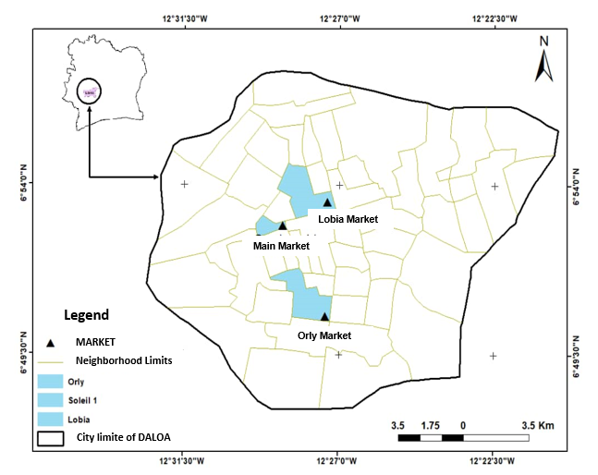
Fig 1. Geographic distribution of survey and sampling sites

2.2 Material

The study materials consisted of peanut paste (PPM) purchased from Orly Market, Lobia Market and Main Market, and artisanal household-produced peanut paste (PPH) (Figure 2).
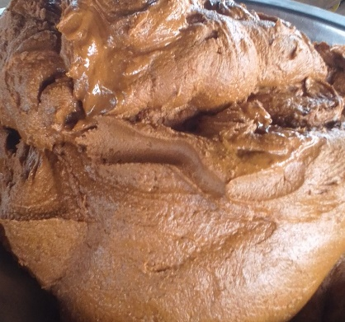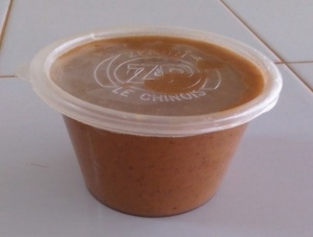
a
2.5 cm
b
1.5 cm

Fig. 2: Photography of peanut paste
a: household-produced peanut paste (PPH); b: Peanut Paste from Market (PPM)
2.3 Methods

2.3.1 Preliminary Survey

A survey was carried out in February 2024 across i) the Lobia market, Main market, and Orly market, among 9 peanut‑paste vendors (at the rate of 3 vendors per market) and ii) 90 households in neighbourhoods housing Lobia market, Main market, and Orly market (30 households per neighbourhood). This survey was conducted using the method observed by Ouina et al. (2025) with some modifications regarding the distance between points of sale. Its purpose was to evaluate health and hygiene conditions in the peanut‑butter sales environment in Daloa that might pose risks to consumers. Data were collected by questionnaire to document vendors’ production and selling practices and to gather information on health issues related to peanut‑paste consumption.

2.3.2 Sampling

Sampling was conducted one week after the survey phase to collect household-produced peanut paste (PPH) and peanut paste from market (PPM) for laboratory analysis. PPM sampling took place in March–April 2024 in the Lobia market, main market and Orly market. In each market, 3 vendors located at least 100 m apart were selected. From each selected vendor, 4 individual portions of approximately 100 g were purchased at intervals of five days. PPH sampling was carried out in March 2024 at production sites and consisted of collecting three 100 g portions of peanut paste twice weekly (Monday and Thursday) from the production stock for four consecutive weeks (which corresponds to eight collection phases P1, P2, P3, P4, P5, P6, P7 and P8). All samples (36 PPH samples obtained by purchase and 24 PPM samples obtained from production) were placed in sterile bags and transported to the laboratory in a cooler with dry ice for subsequent analysis.

2.3.3 Microbiological analysis

Different culture media namely buffered peptone water, Sabouraud with chloramphenicol, Plate count agar (PCA), Violet red bile glucose (VRBG) agar were used for analysis. They were prepared according to the manufacturers' instructions.
The stock suspension was prepared from peanut past samples followed by decimal dilutions in accordance with the applicable standard methods (ISO 6887-2:2017 and "reglement" (CE) n° 2073/2005). Briefly, 10 g of each peanut past samples were aseptically mixed in 90 mL of buffered peptone water (Difco, Becton Dickinson, Sparks, MD, USA); the whole were stirred for 30 minutes, then allowed to stand for 15 minutes. One volume (1 mL) of stock suspension or tenfold serial dilutions were inoculated into the depth on PCA, VRBG and Sabouraud with chloramphenicol respectively for isolation of total aerobic mesophilic germs (ISO 4833-1 (2013)), enterobacteria and fungi (ISO 21527-1 (2008)). Cultural conditions were 30°C/24h for PCA, 37°C/24h for VRBG and 30°C/3-5 days for Sabouraud with chloramphenicol. After isolation phase, micro-organisms were enumerated according to ISO 21527-1 (2008).
Fungi were purified and phenotypically identified based on their macroscopic characteristics (shape, relief and colour of the colonies, surface characteristics, pigmentation, culture time) and microscopic characteristics (hyphal partitioning, presence of chlamydospores, shape and size of conidia, phialides) (Domsch et al., 1980). The isolation frequency (IF) of identified fungi was calculated according to Walder (1996)

2.3.4 Microbiological stability of peanut paste samples

As part of the stability assessment, PPH peanut paste samples taken from production stock twice weekly over four consecutive weeks (at P1 to P8) were subjected to microbiological analysis. Total aerobic mesophilic germs, enterobacteriaceae and fungi were enumerated for each sample. Measured counts were compared with predefined reference criteria to assess product safety. Results were interpreted according to a three-class scheme recommended by the Codex Alimentarius: counts ≤ m were classified as satisfactory (compliant); counts > m but ≤ M were classified as acceptable; and counts > M were classified as unsatisfactory (non‑compliant). The reference values (m and M) applied to each microorganism in this study are listed in Table 1.

Table 1. Microbiological criteria applied to peanut paste PPH
Micro-organisms | Microbiological limits  (CFU/g) |  | Source
 | m | M
Total aerobic mesophilic germs | 10⁴ | 10⁵ | Official Gazette of the Republic of Algeria N° 39
Enterobacteria | 10² | 10³ | Official Gazette of the Republic of Algeria N° 39
Fungi | 10² | 10³ | Burkina standard NBF 01-215:2019

2.3.5 Statistical analysis

Data obtained from the survey and microbial counts were analysed using Statistica 7.1 (Statsoft Inc, Tulsa-USA Headquarters) software. A one-factor analysis of variance with a 5% significance level was performed to compare the mean fungal isolation frequencies among PPH samples from markets.

3. RESULTS

3.1 Sanitary and hygiene aspects of households and the peanut paste sale environment

The survey of households and peanut‑paste vendors in the Lobia market, Orly market and main market yielded the characteristics summarized in Table 2. Most household respondents were female (95.6%). A majority reported a high level of education (58.8%), while 41.2% were illiterate. Peanut paste was most commonly consumed as a peanut sauce, and cases of gastrointestinal discomfort following consumption were frequently reported. Regarding hygiene practices, over 95% of respondents indicated that they maintained a clean working environment and practiced hand washing before cooking (households) or before serving peanut paste (market vendors).

Table 2. Social, health and hygiene characteristics of households and peanut paste sellers
Modality | Frequency (%)
Respondents in households  - Men  - Women | 4.4%  95.6 %
Educational level  - Illiterate  - Primary  - Secondary  - Post‑secondary | 41.20%  23.30%  24.40%  11.10%
Mode of consumption of peanut paste  - Raw peanut paste  - Peanut sauce | 20%  100%
Discomfort after consumption  - Observed  - Not observed | 21.10%  78.90%
Handwashing  - Observed  - Not observed | 95.60%  4.40%
Regular cleaning of market stalls and kitchens for households  - Observed  - Not observed | 97.6%  2.20%

3.2 Evolution of certain microbiological parameters during storage of PPH peanut paste

Different microbial groups —fungi, enterobacteria, and total aerobic mesophilic germs— were sought and enumerated in household-produced peanut paste (PPH) samples. Their counts were monitored over a 4‑week period. The study showed that, unlike fungi, counts of total aerobic mesophilic germs and enterobacteria increased over time during the 4 weeks after an initial stationary level observed in the first week (collecting phases P1 and P2) (Figure 3). Evolution of enterobacteria counts during the study period is showed in figure 3-a. Starting counts at the beginning of the growth were 1.4 × 10² CFU/g and 1.2 × 10² CFU/g for sampling phases P1 and P2, respectively. At the end of the experiment (P8), enterobacteria abundance was approximately 3.9 × 10² CFU/g. Figure 3-b shows the evolution of total aerobic mesophilic germs load. At the start of monitoring, loads were 1.4 × 10³ CFU/g for P1 and 1.6 × 10³ CFU/g for P2, rising to 6.9 × 10³ CFU/g by the final sampling (P8). Two recurring growth cycles are visible: the pattern observed from P1 to P4 is reproduced from P5 to P8. Figure 3-c presents the fungal growth kinetics in PPH samples over four weeks. Three distinct phases were identified: an exponential increase from P1 to P2 (from 2.9 × 10² to 5.4 × 10² CFU/g), a stationary phase between P2 and P3, and a decline from P3 to the end of the study, reaching 1.1 × 10² CFU/g at P8.

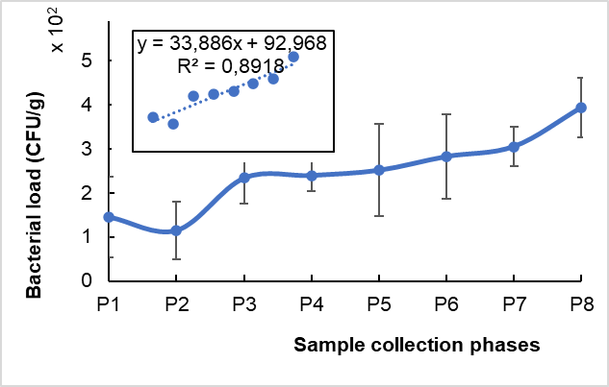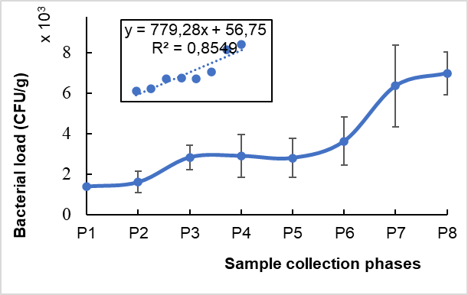

a- Enterobacteria b- Total aerobic mesophilic germs

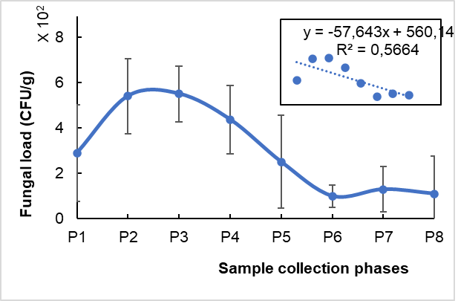

c- Fungi

Fig. 3. Microbial growth monitoring in peanut butter samples over 4 weeks
a- Enterobacteria, b- Total aerobic mesophilic germs, c- Fungi

3.3 Estimation of shelf‑life for peanut butter samples

Analysis of the microbiological parameters measured in the PPH samples allowed to relate microbial loads to product shelf life. Applying the derived mathematical regressions and the applicable microbial standards for each tested microflora enabled estimation of storage duration for the PPHs peanut butter and associated quality (Table 3).

Table 3. Estimated shelf life (in days) of PAD peanut pastes and associated quality
Microbiological quality of peanut paste | Germs and Linear regressions
Microbiological quality of peanut paste | Enterobacteria | GAM | Fungi
Microbiological quality of peanut paste | y = 33,886x + 92,968  R² = 0,8918 | y = 779,28x + 56,75  R² = 0,8549 | y = -57,643x + 560,14  R² = 0,5664
Satisfactory quality | - | ≤ 12 days | -
Acceptable quality | Up to 26 days | 12 – 128 days | -
Unsatisfactory quality | > 26 days | > 128 days | -

3.4 Fungal diversity of peanut paste (PPM) samples

3.4.1 Fungal flora distribution in PPM samples across the surveyed markets

Microbiological analysis of peanut paste samples from the Lobia market, Orly market, and main market revealed a diverse fungal profile. A total of eight mould genera—Aspergillus, Cladosporium, Mucor, Neurospora, Penicillium, Rhizopus, Scytalidium, and Scedosporium—were identified, with varying isolation frequencies across the markets (Figure 4). The Orly market exhibited the highest fungal diversity, notably with Rhizopus showing the highest isolation rate (57.14%), alongside Aspergillus, Cladosporium, Mucor, Neurospora, and Scytalidium. Among these, Aspergillus was consistently present in all three markets, with particularly high frequencies in Lobia market and main market.

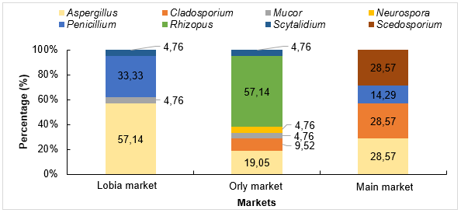

Fig. 4. Fungal richness of peanut paste samples by market

3.4.2 Fungal contamination rates across markets

Analysis of PPM peanut paste samples from all surveyed markets revealed statistically significant differences in micromycete isolation frequencies (P < 0.05). Aspergillus was the most prevalent genus, detected in 35% of samples, followed by Rhizopus (19.04%), Penicillium (15.87%), and Cladosporium (12.7%). The remaining genera showed isolation frequencies below 10%. Based on these patterns, three distinct fungal groups were identified: Group 1: Aspergillus, Group 2: Scedosporium, Cladosporium, Penicillium, Rhizopus, Group 3: Neurospora, Mucor, Scytalidium (Figure 5). Figure 6 illustrates the contamination levels of PPM samples by market. Despite exhibiting lower fungal diversity, the Lobia market showed the highest contamination rate at 67%. This was followed by the Orly market with 22%, and the Grand Marché with 11%.

Fig. 5. Occurrence of fungi in peanut paste samples
Asperg. : Aspergillus, Clados. : Cladosporium, Neuros. : Neurospora, Rhizo. : Rhizopus, Scytal. : Scytalidium, Scedos. : Scedosporium

Fig. 6. Contamination level of PPM peanut paste samples sold in the surveyed markets

3.4.3 Species-level diversity of micromycetes in analyzed peanut paste samples

Microbiological analysis (culture on Sabouraud-chloramphenicol at 30°C) of PPM peanut paste samples collected from the Lobia market, Orly market, and main market revealed a richness in fungal species, with 21 species discriminated and presented in table 4.
 | Table 4. Fungal flora isolated in peanut paste
 | Molds |  | Macroscopic description |  | Microscopic description
 | Aspergillus sp_{1.} |  | 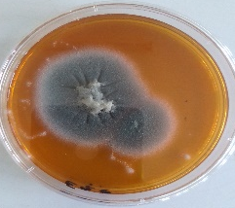 | Grayish colony with a powdery appearance; low mycelium; moderate growth (4 cm diameter on the 5th day) | 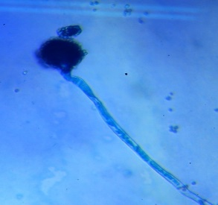 | Long conidiophore ending in a swollen head; septate mycelium
 | Aspergillus sp_{2.} |  | 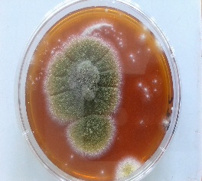 | Yellow-green colony with a powdery appearance; low mycelium; moderate growth | 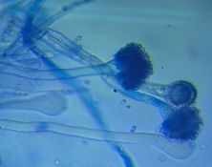 | Long conidiophores ending in swollen heads; mycelium bearing numerous erect conidiophores
 | Aspergillus sp_{3.} |  | 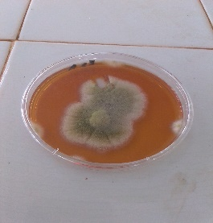 | Yellow-green colony with a powdery appearance; low mycelium; moderate growth | 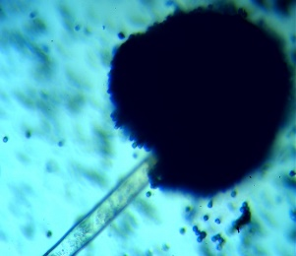 | Smooth conidiophores ending in a blackish aspergillar head at maturity
 | Aspergillus sp_{4.} |  | 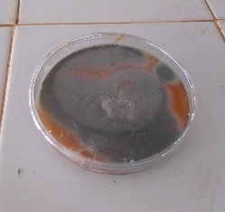 | Grayish colony with a powdery appearance; low mycelium; rapid growth | 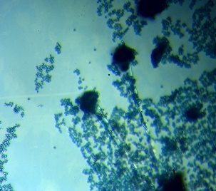 | Long conidiophore ending in a swollen head; septate mycelium
 | Aspergillus sp_{5.} |  | 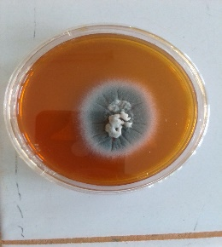 | Grayish colony with a powdery appearance; low mycelium; moderate growth | 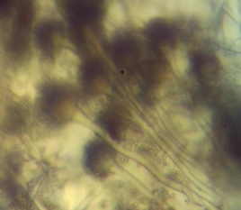 | Long conidiophores ending in swollen heads; mycelium bearing numerous erect conidiophores
 | Aspergillus sp_{6.} |  | 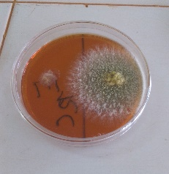 | Yellow-green colony with a powdery appearance; low mycelium; moderate growth | 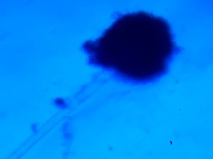 | Smooth conidiophores ending in a blackish aspergillar head at maturity.
 | Aspergillus sp_{7.} |  | 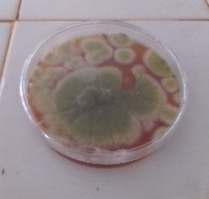 | Yellow-green colony with a powdery appearance; low mycelium; rapid growth | 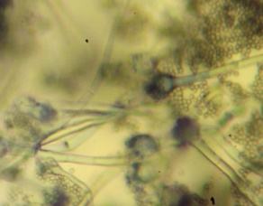 | Presence of brush-like structures associated with aspergillar heads.
 | Aspergillus sp_{8.} |  | 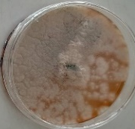 | Grayish colony with a powdery appearance; low mycelium; rapid growth | 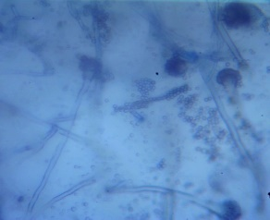 | Presence of aspergillar head; densely grouped phialides; flared conidiophores.
 | Aspergillus sp_{9.} | 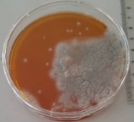 |  | Grayish colony with a powdery appearance; low mycelium; moderate growth | 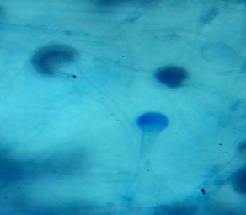 | Presence of aspergillar head; densely grouped phialides; flared conidiophores
 | Aspergillus sp_{10.} | 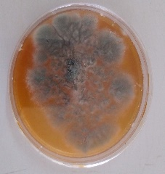 |  | Grayish colony with fluffy appearance; low mycelium; rapid growth | 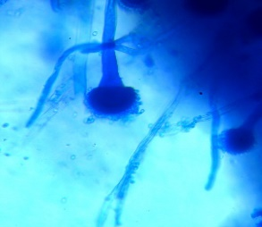 | Presence of aspergillar head; densely grouped phialides; flared conidiophores
 | Aspergillus sp_{11.} | 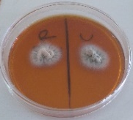 |  | Grayish colony with fluffy appearance; low mycelium; moderate growth. | 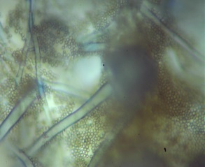 | Smooth conidiophores ending in a blackish aspergillar head at maturity
 | Aspergillus sp_{12.} | 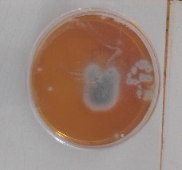 |  | Grayish colony with powdery appearance; low mycelium; slow growth | 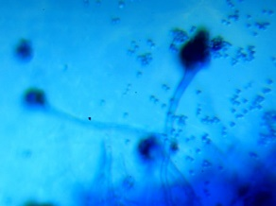 | Presence of brush-like structures associated with aspergillar heads
 | Aspergillus sp_{13.} | 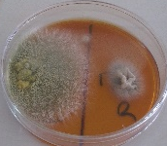 |  | Yellow-green colony with powdery appearance; low mycelium; moderate growth | 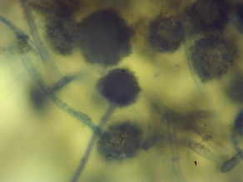 | Smooth conidiophores ending in a blackish aspergillar head at maturity
 | Aspergillus sp_{14.} | 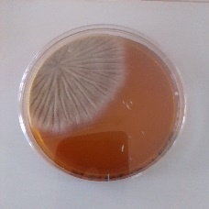 |  | Grayish colony with a downy appearance; low mycelium; moderate growth | 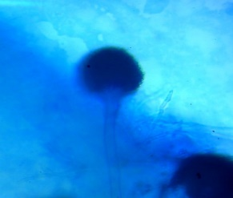 | Smooth conidiophores terminating in aspergillar heads
 | Neurospora |  | 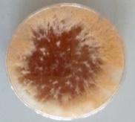 | Orange colony with a cottony appearance; high mycelium; rapid growth | 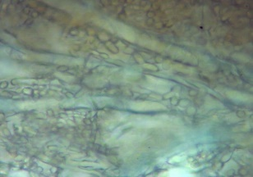 | Septate thallus with the presence of an articulated chain of arthrospores
 | Scedosporium |  | 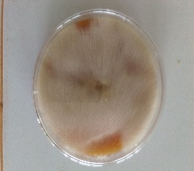 | Whitish colony with a cottony appearance; high mycelium; rapid growth | 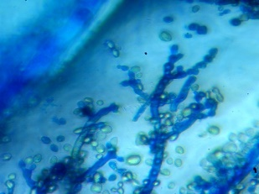 | Conidiophores with branches; conidia arranged in chains
 | Rhizopus |  | 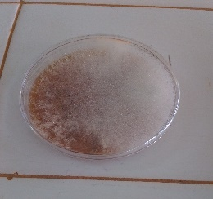 | Whitish colony with a cottony appearance; high mycelium; rapid growth | 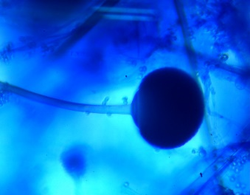
 | Mucor |  | 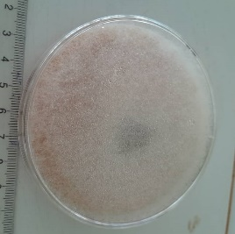 | Whitish colony with a cottony appearance; high mycelium; rapid growth | 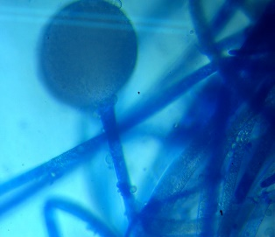 | Septate filaments; globose sporocyst; round spores.
 | Cladosporium |  | 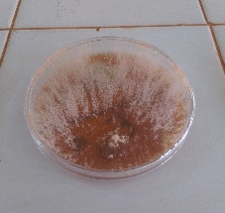 | Orange colony with a cottony appearance; high mycelium; rapid growth | 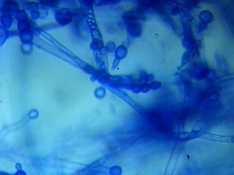 | Conidiophores with branches; conidia arranged in chains
 | Neurospora | 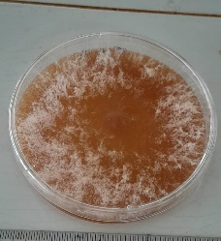 |  | Whitish colony with cottony appearance and high mycelium; rapid growth | 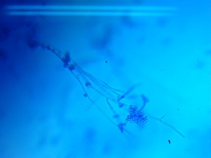 | septate hyphae, phialides arranged in verticils, presence of metulae
 | Scytalidium | 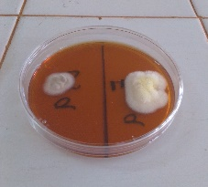 |  | Dark brown colony, dry, felt-like texture | 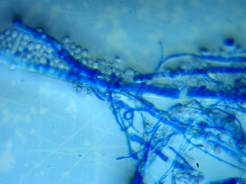 | Septate hyphae with rectangular arthroconidia, often pigmented

4. DISCUSsion

Food safety has become a marketing requirement, as it is a determining factor in human health. This requirement is even more pronounced when it comes to artisanal food products. Indeed, the methods used to obtain such products are subject to little or no control, and their shelf life is difficult to assess or unknown. This can sometimes result in products of variable quality with risks of food poisoning for consumers (Koffi-Nevry et al., 2011). Peanut butter is produced artisanally and sold until production stocks are exhausted.

An investigation into the social, health, and hygiene characteristics of households and women engaged in the sale of peanut paste in the markets of Daloa revealed that the majority of respondents (95.6%) were women within household settings. This finding reflects the predominant role of women in food preparation at the household level. Moreover, a relatively high proportion of these women (58.8%) possessed formal education, which constitutes an important asset for understanding and adhering to hygiene practices in food handling. Peanut sauce, commonly consumed as an accompaniment to staple dishes such as rice and foutou, was reported to be highly popular among the population. Survey data further indicated that peanut paste is primarily consumed in households in the form of peanut sauce. However, the occurrence of illness following the consumption of peanut paste suggests that multiple contributing factors may be involved, warranting closer examination of production, handling, and storage practices. Observations indicate that certain household food preparers and market vendors do not consistently adhere to recommended hygiene practices, such as regular hand washing and maintaining cleanliness of their work environments (e.g., kitchens and market stalls). Furthermore, peanut paste is frequently packaged in settings where insects and rodents—known vectors of microbial contamination—are present (Mbata et al. 2024). The utensils employed for handling and scooping peanut paste are often left exposed to ambient air, thereby increasing the risk of contamination. Collectively, these conditions contribute to the susceptibility of peanut butter to spoilage and the introduction of pathogenic microorganisms at multiple points along its distribution chain, from production and sale to eventual consumption (Mukhurov et al., 2022). The resulting contaminants form part of the resident and transient microbial flora associated with peanut butter.
The ageing study conducted on peanut pastes enabled validation of their microbiological shelf life, thereby facilitating determination of an appropriate best-before date. Microbial monitoring over a four-week period revealed growth kinetics characterized by a latency phase followed by exponential proliferation of enterobacteria and total aerobic mesophilic flora, consistent with classical bacterial growth models. In PPH peanut butter, the populations of enterobacteria and total aerobic mesophilic flora remained stable during the first week, reflecting the adaptation of these microorganisms to the peanut butter matrix. As described by Tollerson et al. (2020), bacterial adaptation involves the synthesis of enzymes and primary metabolites that facilitate substrate degradation within the ecological niche. In this context, the enzymes and metabolites produced during the latency phase contributed to the breakdown of organic matter present in peanut butter, supporting subsequent microbial growth. The exponential growth observed in enterobacteria and total aerobic mesophilic flora is consistent with classical microbial kinetics. In addition to the latency and exponential phases characteristic of bacterial populations, fungi exhibited periods of linear growth followed by decline, which may be attributed to inhibition of mycelial development. Theoretically, filamentous microorganisms display exponential growth; however, the occurrence of linear growth can be explained by the presence of specific inhibitors or by nutrient limitation within the substrate (Latgé & Moletta, 1983; Dimpal et al., 2014). Microbial load measurements at the beginning and end of the experiment indicated values of 1.4 × 10³ CFU/g and 6.9 × 10³ CFU/g for total aerobic mesophilic flora, 1.4 × 10² CFU/g and 3.9 × 10² CFU/g for enterobacteria, and 2.9 × 10² CFU/g and 1.1 × 10² CFU/g for fungi, respectively. These values comply with the microbiological specifications applicable to peanut paste. Nevertheless, the microbial loads recorded during the monitoring period were higher than those reported by Compaoré et al. (2020) in peanut paste produced in Burkina Faso.
Peanut butter stability over time was evaluated using microbial indicators—Enterobacteria, total aerobic mesophilic flora, and yeasts and moulds. Based on the three-class quality plan associated with these microorganisms, organoleptic deterioration of PPH peanut butter begins around 128 days (approximately four months) post-manufacture. Beyond this threshold corresponding to best before date, structural and functional changes in the organic constituents of the peanut paste become evident. Research by Prabhakar et al. (2025) demonstrated that during a six-month storage period, the acid value increased significantly, indicating enhanced lipid degradation. Concurrently, protein and oil content declined, reflecting nutritional loss. Moreover, as highlighted by Boli et al. (2020), prolonged storage may lead to the presence of pathogens, toxins, or mycotoxins, posing risks of foodborne infections.

Peanut paste samples from the Lobia market, Orly market, and main market were found to contain eight types of mould: Aspergillus, Cladosporium, Mucor, Neurospora, Penicillium, Rhizopus, Scytalidium, and Scedosporium, along with various other species. These microfungi are common environmental contaminants, forming part of the natural flora found on peanut seeds (Wagacha et al., 2013) and on substrates such as dust, air, and surfaces that may come into contact with the paste during market handling (Le Gallou & Lepelletier, 2017). The moulds can be classified into three functional categories. Toxin-producing moulds (Aspergillus, Penicillium), known for producing highly carcinogenic mycotoxins such as aflatoxins, ochratoxin A, patulin, and citrinin (Nyirahakizimana et al., 2013). These pose serious food safety risks. Spoilage moulds (Mucor, Rhizopus, Cladosporium, Neurospora), exhibit strong enzymatic activity, leading to the degradation of organic matter and deterioration of product quality. Clinically relevant moulds (Scytalidium, Scedosporium): Less significant in food spoilage but associated with opportunistic infections in humans (Willey et al., 2013).
The Orly market exhibited the highest fungal abundance, with Rhizopus showing the greatest isolation frequency (57.14%), followed by Aspergillus, Cladosporium, Mucor, Neurospora, and Scytalidium. Among these, Aspergillus was detected in all three markets, with particularly high frequencies in Lobia market and main market. This widespread presence underscores the need for microbiological surveillance to mitigate the infectious risks associated with this genus. Aspergillus includes several toxinogenic species—notably A. flavus, A. parasiticus, and A. ochraceus—which are known to produce aflatoxins and ochratoxin, potent mycotoxins with serious health implications (Hassan et al., 2018; Pandey et al., 2023). These findings align with those of Margareta & Setyowati (2023), who reported a predominance of A. niger and A. flavus in peanut paste samples from Indonesia. The highest mould contamination rate (67%) was recorded in WFP samples from the Lobia market, likely due to its open-air layout and proximity to a public roadway, both of which increase the risk of environmental contamination.

4. Conclusion

Peanut butter is a widely consumed food in Daloa, particularly in the form of sauce, and appreciated across all social strata. To safeguard consumer health, this study aimed to assess the impact of sales and storage conditions on the quality of peanut butter. In the markets where peanut butter is sold, basic hygiene practices, such as handwashing and cleaning of the sales environment, are often neglected. Analysis of peanut paste samples from the Lobia, Orly, and Grand Marché markets revealed a fungal diversity of 21 species, grouped into eight genera: Aspergillus, Cladosporium, Mucor, Neurospora, Penicillium, Rhizopus, Scytalidium, and Scedosporium. Among these, Aspergillus was present in all surveyed markets, with a marked predominance of Aspergillus sp., highlighting its widespread contamination. The estimated shelf life or best before period of peanut butter is 128 days post-production. Beyond this period, structural and functional degradation of organic components may occur, potentially leading to the formation of toxic substances, which pose risks to consumer health. These findings on fungal diversity highlight potential health risks and may assist consumers in selecting safer peanut butter products.

DISCLAIMER (ARTIFICIAL INTELLIGENCE)

Author(s) hereby declare that NO generative AI technologies such as Large Language Models (ChatGPT, COPILOT, etc) and text-to-image generators have been used during writing or editing of this manuscript.

References

- Arya, S. S., Salve, A. R., & Chauhan, S. (2016). Peanuts as functional food: a review. Journal of Food Science and Technology, 53(1), 31-41. https://doi.org/10.1007/s13197-015-2007-9
- Boli, Z. A., Zoue, L. T., Alloue-Boraud, W. A. M., Kakou, C. A., & Koffi-Nevry, R. (2013). Proximate composition and mycological characterization of peanut butter sold in retail markets of Abidjan (Côte d’Ivoire). Journal of Applied Biosciences, 72, 5822-5829. https://doi.org/10.4314/JAB.V72I1.99667
- Boli, Z. A., Zoue, L. T., Koffi-Nevry, R., & Koussémon, M. (2014). Fungal contamination and mycotoxins’ occurrence in peanut butters marketed in Abidjan district (Côte d’Ivoire). Food and Environment Safety, 13(3), 267-275. https://www.fia.usv.ro/fiajournal/index.php/FES/article/view/267
- Boli, Z. B. I. A., Kambire, O., Zoue, L. T., & Koffi-Nevry, R. (2020). Fungal Variation during Peanut Paste Storage. International Journal of Microbiology. https://doi.org/10.1155/2020/8836726
- Bondom, R. L., Lango-Yaya, E., Kolokaté, M., N'yetobouko, S., Moulo-Oli, A. T., Dalenga, Z. V., Djeintote, M., & Koffi, B. (2025). Bacteriological profile of contamination of artisanal peanut pastes sold in the city of Bangui in the Central African Republic. Health, 17, 200-212. https://doi.org/10.4236/health.2025.173015
- Compaoré, C. S., Douamba, Z., Zongo, S., Zagré, M. B., & Sawadogo-Lingani, H. (2023). Technologie et caractéristiques chimiques des pâtes d'arachide vendues dans quelques marchés de la ville de Ouagadougou. *Sciences Naturelles et Appliquées*, *39*(1), 183-196. https://revuesciences-techniquesburkina.org/index.php/sciences_naturelles_et_appliquee/article/view/1085
- Mahanta, D. J., Borah, M., & Saikia, P. (2014). A study on kinetic models for analysing the bacterial growth rate. American International Journal of Research in Science, Technology, Engineering & Mathematics, 1(8), 68-72. http://iasir.net/AIJRSTEMpapers/AIJRSTEM14-724.pdf
- Domsch, K. H., Gams, W., & Anderson, T. H. (1980). Compendium of soil fungi volume 1. Academic Press. https://www.cabidigitallibrary.org/doi/10.1079/CABICOMPENDIUM.19811962574
- Fofana, I. J., Yao, S. D. M., & Koffi, E. B. Z. (2023). Genetic diversity and structure in groundnut (Arachis hypogaea L.) accessions collected in central and northern Côte d’Ivoire based on agro-morphological traits. Research in Plant Sciences. https://doi.org/10.12691/plant-11-1-1
- Gbétokpanou, C. S., Jonard, C., Mehinto, O. A., Gofflot, S., Adjéniya, M. J. M., Iko Afe, O. H., Anihouvi, D. G., Boutaleb, S., Bragard, C., Azokpota, P., Mahillon, J., Sindic, M., Scippo, M-L., Madodé, Y. E., & Douny, C. (2025). Peanut and peanut-based foods contamination by toxigenic fungi and mycotoxins: potential risks for Beninese consumers. *Toxins*, *17*(11), 532. https://doi.org/10.3390/toxins17110532
- Hassan, Z.U., Al-Thani, R.F., Migheli, Q., & Jaoua, S. (2018). Detection of toxigenic mycobiota and mycotoxins in cereal feed market. Food Control, 84, 389-394. https://doi.org/10.1016/j.foodcont.2017.08.032
- ICRISAT. (2024). Groundnut overview. https://www.icrisat.org/crops/groundnut/overview
- Jacques, P., Azima, S., & Doyon, M. (2025). How to incentivize peanut producers to adopt post-harvest aflatoxin control measures: A field experiment in Haiti. Food Policy, 130, 102771. https://doi.org/10.1016/j.foodpol.2024.102771
- Koffi-Nevry, R., Ouina, T.S.T., Koussemon, M., & Brou, K. (2011). Chemical composition and lactic microflora of Adjuevan, A traditional Ivorian fermented fish condiment. Pakistan Journal of Nutrition, 10(4), 332-337. https://doi.org/10.3923/pjn.2011.332.337
- Latgé, J.-P., & Moletta, R. (1983). Mycelial growth kinetics of Conidiobolus obscurus. Annals of Microbiology, 134 (3), 267-279.
- Le Gallou, F., & Lepelletier, D. (2017). Contrôles particulaires et microbiologiques de l’air et contrôles microbiologiques des surfaces dans les établissements de santé. EMC Biologie Médicale, 12(4), 1-11. https://doi.org/10.1016/S2211-9698(17)74812-1
- Margareta, A., & Setyowati, A. (2023). Isolation and Identification of Mold Contaminants in Peanut Paste from the Cengkareng Market of West Jakarta. EduHealth, 14(3), 1259-1264. https://doi.org/10.54209/jurnaleduhealth.v14i3.2662
- Mbata, G. N., Danso, J. K., & Holton, R. L. (2024). Peanut aflatoxin: Impact of postharvest insect infestation and storage systems. Insects, 15(11), 836. https://doi.org/10.3390/insects15110836
- Mukhurov, N.I., Khodin, A.A., & Kim, Y.-J. (2022). Devices and Methods for Measuring of the Ambient Air Dust. Short Review. Devices and Methods of Measurements, 13(1), 7–16. https://doi.org/10.21122/2220-9506-2022-13-1-7-16
- Ngulube, M., & Kaimoyo, E. (2023). Microbial quality of peanut butter manufactured by small-scale producers at two popular open-air markets in Lusaka. International Science and Technology Journal of Namibia, 16, 40–51. https://repository.unam.edu.na/bitstream/handle/11070/3900/Ngulube_Kaimoyo_2023_ISTJN_16_40-51.pdf?sequence=1&isAllowed=y
- Nyirahakizimana, H., Mwamburi, L., Wakhisi, J., Mutegi, C. K., Christie, M. E., & Wagacha, J. M. (2013). Occurrence of Aspergillus Species and Aflatoxin Contamination in Raw and Roasted Peanuts from Formal and Informal Markets in Eldoret and Kericho Towns, Kenya. Advances in Microbiology, 3, 333-342. https://doi.org/10.4236/aim.2013.34047
- Ouina, T. S. T., Kouassi, K. C., Ya, K. C., Diegai, J. O. L., Kouassi, K. A., & Koussemon-Camara, M. (2025). Risk assessment of Staphylococcus aureus food poisoning associated with pork barbecues in Daloa, Côte d’Ivoire. Microbiology Research Journal International, 35(11), 138-149. https://doi.org/10.9734/mrji/2025/v35i111660
- Pandey, A.K., Samota, M.K., Kumar, A., Silva, A.S., & Dubey, N.K. (2023). Fungal mycotoxins in food commodities: present status and future concerns. Frontiers in Sustainable Food Systems https://doi.org/10.3389/fsufs.2023.1162595
- Prabhakar, B., Mallela, R.R., & Shaik, K. (2025). Effect of natural preservatives on shelf-life extension and quality parameters of Peanut butter. International Journal of Advanced Biochemistry Research, 9(2), 257-265. https://doi.org/10.33545/26174693.2025.v9.i2Sd.3730
- Agence Nationale de la Statistique et de la Démographie (ANSD). (2023). 5th General Population and Housing Census (RGPH-5). https://www.ansd.sn/recensement/rgph-5-2023
- Sithole, T. R., Ma, Y.-X., Qin, Z., Wang, X.-D., & Liu, H.-M. (2022). Peanut butter food safety concerns—prevalence, mitigation and control of Salmonella spp., and aflatoxins in peanut butter. Foods, 11, 1874. https://doi.org/10.3390/foods11131874
- Tollerson, R., & Ibba, M. (2020). Translational regulation of environmental adaptation in bacteria. Journal of Biological Chemistry, 295(30), 10434–10445. https://doi.org/10.1074/jbc.REV120.012742
- Wagacha, J. M., Mutegi, C. K., Karanja, L. N., Kimani, J., & Christie, M. E. (2013). Fungal species isolated from peanuts in major Kenyan markets: Emphasis on Aspergillus section Flavi. Crop Protection, 52, 1-9. https://doi.org/10.1016/j.cropro.2013.05.004
- Walder, M. (1996). Statistique et calcul des probabilités. 7ème édition Dalloz Paris.
- Prescott, L. M., Willey, J. M., Sherwood, L. M., & Woolverton, C. J. (2013). Microbiologie (4e éd.). De Boeck Supérieur.

