Original Research Article

Hygienic quality of amaranth (Amaranthus hybridus L.) produced in urban market gardens of N'Djamena (Chad)

.
ABSTRACT

In N'Djamena, amaranth, a leafy vegetable, plays a vital role in providing a healthy, balanced, and sustainable diet for city dwellers. It also generates income for producers located within the city. However, due to certain constraints, its production is subject to increasing pressures on land and public health. The main objective of this study was to assess the degree of microbial contamination of amaranth (Amaranthus hybridus L.) from urban market gardens in N'Djamena. The study was conducted between April and June 2025. The samples consisted of 30 amaranth specimens. The microbiological quality of the samples was assessed by counting the Colony Generating Units (CGUs) of total coliforms, Escherichia coli, Staphylococcus aureus, and Salmonella spp Microbiological analyses revealed contamination rates of 70% for coliforms, 63.33% for E. coli, 13.33% for Staphylococcus aureus, and 23.33% for Salmonella spp. These results reflect the sanitary conditions of the environment in which amaranth is produced, as well as the hygiene practices of producers and certain agricultural practices. Despite its nutritional importance, amaranth poses significant health risks that must be prevented and controlled to ensure its safety and prevent foodborne illnesses. Therefore, it is necessary to improve the production environment and train producers on basic hygiene rules and good agricultural practices.

Keywords: Amaranthus hybridus L, market gardening, microbial contamination, hygienic quality, N'Djamena, Chad.

1. INTRODUCTION

Fresh vegetables from urban farms play a vital role in improving the food and nutritional security of city dwellers. They are very important and essential foods for a healthy, balanced, and sustainable diet (Florent et al., 2023). They are considered a source of many nutrients, particularly antioxidants and dietary fiber, which are necessary for maintaining normal physiological functions in humans, and their consumption is very useful in several diseases (Ngweme et al., 2020; 2021a; 2021b; Azzi & Khineche, 2018; Boeing et al., 2012). Epidemiological studies indicate that a high consumption of fruits and vegetables is associated with a lower risk of chronic diseases, particularly cardiovascular diseases (Mirriran et al. 2009; Hung, et al., 2004; Rissanen, et al., 2003), type 2 diabetes (Harding, et al., 2008) and some cancers (WCRF, 2007).
Amaranth is among the most consumed market garden vegetables in South Asian and sub-Saharan African countries (Ngweme and al., 2020; 2021a). It is the most consumed and traded green vegetable in sub-Saharan Africa due to its texture and mild flavor (Mariama and Ayouba, 2023). Amaranth is a traditional vegetable whose leaves and seeds are consumed in various forms (Písaříková et al., 2005; Mburu et al., 2012). This leafy vegetable is an excellent source of trace elements and some vitamins. It is a very important vegetable for the human diet because it is an excellent source of trace elements, manganese, magnesium, phosphorus, and vitamin C (Mukeba et al., 2023). Amaranth has a caloric value of 43.4 kcal, crude protein of 2.1%, a moisture content of 87.9%, a carbohydrate content of 7.7%, crude fiber of 1.93%, and crude fat of 0.47% (Mukeba et al., 2023; Azi et al, 2018).
Amaranth leaves are rich in protein, beta-carotene, iron, and calcium, and are recommended for improving the diet of individuals deficient in provitamin A or vitamin C (Agré et al., 2016). However, throughout the production chain, amaranth can be contaminated by pathogenic microorganisms. Exposure to pathogenic microorganisms through the consumption of this contaminated produce can have serious health consequences for city dwellers. In the city of N'Djamena, it is not uncommon to find that some farming practices are carried out under unsatisfactory conditions with regard to hygiene standards (Nazal et al., 2019). This is often compounded by an unsanitary production environment. The objective of this study is to assess the degree of microbial contamination of amaranth from urban market gardening in N'Djamena in order to propose control measures and control of the sanitary quality of this product.
2. materialS and methods

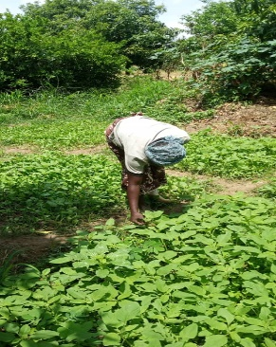
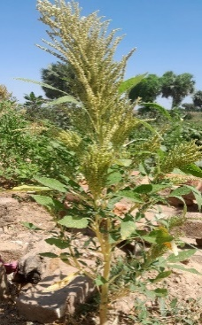
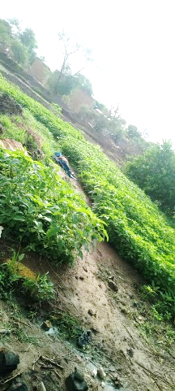
The study was conducted in the city of N'Djamena. This city is located between 12° and 13° North latitude and between 15° and 16° East longitude, at an altitude of between 287 and 303 meters. The city covers 354.7 km², or 35,470 hectares (Bayang, 2023). Its population is estimated at 1,655,618 inhabitants in 2024. The climate is Sahelian, characterized by alternating dry and rainy seasons. The average annual rainfall is 556 mm, and the average annual temperature is 27.8°C. The hydrographic network consists of the Chari and Logone rivers and numerous streams, fed by rainwater. The study focuses on market gardens producing amaranth in the city of N'Djamena.

Fig. 1. Amaranth in the market gardens of N'djamena
The samples, collected under sterile conditions, consisted of 30 fresh amaranth samples taken from all the market gardens producing this vegetable in the city of N'Djamena. The amaranth samples were collected under sterile conditions using sterile, single-use gloves to prevent external contamination.
The microbiological quality of the samples was assessed by counting Colony Forming Units (CFU) of total coliforms, Escherichia coli, Staphylococcus aureus and Salmonella spp.
A 25g aliquot of each sample was diluted in 225 mL of buffered peptone water and then ground in a stomacher. After revitalization of the stock solution, 1 mL was taken and returned to 9 mL of buffered peptone water to establish the initial dilution (10⁻¹). A series of cascading decimal dilutions were performed under aseptic conditions from 1 mL of each stock suspension and used for microorganism enumeration.
Coliforms bacteria at 37°C were detected on VRBL medium by incubation at 44-47°C for 24 hours. Enumeration of all characteristic colonies was performed according to ISO 4832 (2006).
For the determination of Escherichia coli, TBX culture medium was incubated at 44°C ±1°C for 18 to 24 hours. Enumeration of all characteristic colonies was performed according to ISO 16649-2 (2001).
Coagulase positive Staphylococcus aureus enumeration was counted in accordance with ISO 6888-1 (2018) on CHAPMAN selective medium after incubation at 37 °C for 24 to 48 hours.
Salmonella spp testing was performed according to standard NF EN ISO 6579 (December 2002). Isolation was performed on Xylose Lysine Deoxycholate (XLD) and Hektoen selective media, which inhibit the growth of competing bacteria and allow for visual examination of presumptive Salmonella spp. colonies. Petri dishes were incubated at 37°C for 24 ± 3 hours for XLD and 24 to 48 hours for Hektoen. API E20 strips were used for confirmatory testing.
The results obtained were expressed in colony forming units per plate. The bacterial load N (CFU/g) of the sample was calculated according to ISO 7218 (2007). To assess the microbiological quality or conformity of the analyzed amaranth samples, a two-class sampling plan was used.
Table 1: Microbiological tolerance criteria relating to amaranth produced
Microorganisms | Methods | Microbiological criteria in CFU/g
Coliforms at 37°C | NF ISO 4832 (2006) | ≤ 10³
Escherichia coli | NF ISO 16649-2(2001) | ≤ 10²
Staphylococcus aureus | NF ISO 6888-1 (2018) | ≤ 10³
Salmonella spp | NF ISO 6579 (2017) | Absent in 25 g
The analysis data were coded and entered into Excel 2016. Descriptive statistics were used for the variables.

3. results

3.1 Contamination of amaranth by coliforms at 37 °C
The results of the coliform count at 37°C in samples of amaranth produced in the city of N'Djamena are given in Figure 2. In general, 30% of the samples were not contaminated by coliforms and 70% of the samples were contaminated by coliforms.

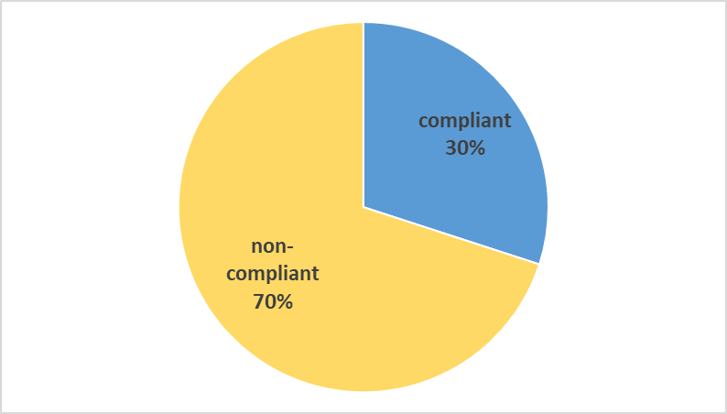

Fig. 2. Coliform conformity rate at 37°C in amaranth
3.2 Contamination of amaranth by Escherichia coli

Figure 3 shows the levels of contamination of amaranth produced by E. coli. The results of the E. coli count showed that 63.33% of the amaranth samples were of non-compliant microbiological quality, according to the defined standard, and 36.67 % of the samples were compliant.
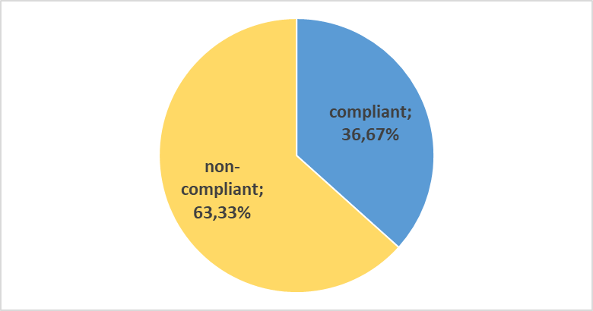

Fig.3. Escherichia coli conformity rate in amaranth

3.3 Contamination of amaranth by Staphylococcus aureus

The enumeration of presumed pathogenic Staphylococcus aureus in amaranth produced on market gardens in N'Djamena showed that 13.33 % of the samples were contaminated (non-compliant). 86.67% of the samples were free of this pathogen (compliant).
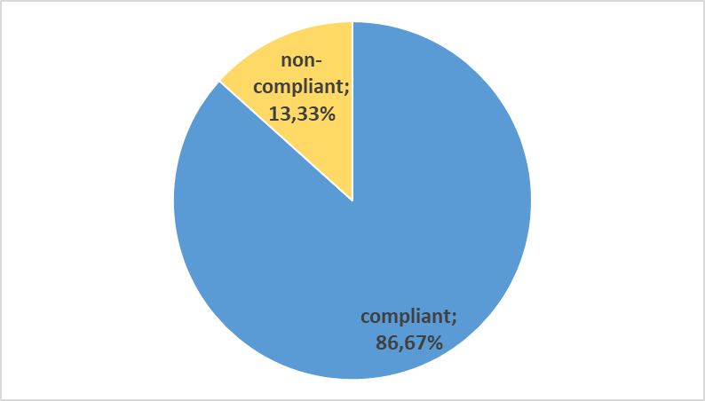

Fig. 4. Staphylococcus aureus conformity rate in amaranth

3.4 Contamination of amaranth by Salmonella spp

Figure 5 shows the results of the Salmonella count in amaranth from the study area. Salmonella was detected in 23.33% of the samples analyzed. This bacterium was absent in more than two-thirds of the samples (76.67%).

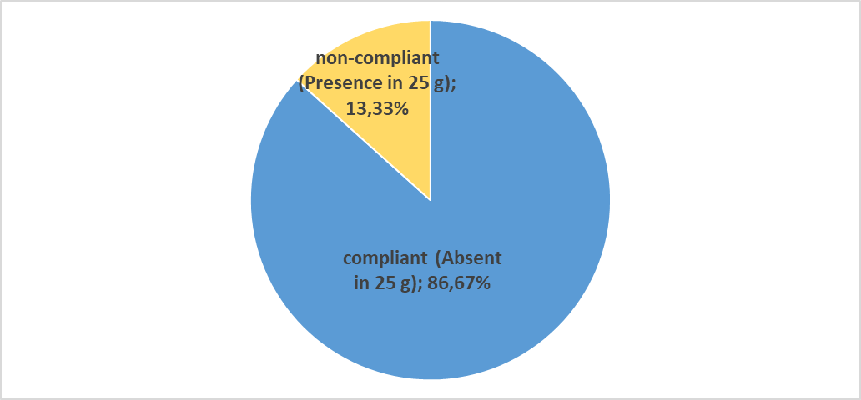

Fig. 5. Salmonella spp. conformity rate in amaranth

4. discussion

This study highlighted the presence of total coliforms, Escherichia coli, Staphylococcus aureus, and Salmonella spp. in amaranth from market gardens in N'Djamena. The presence of these bacteria in this leafy vegetable could be explained by certain practices that pose a risk of biocontamination. Studies conducted by Toé (2018), Koffi-Nevry et al. (2011), and Wognin (2014) have shown that manure used for soil amendment, irrigation water, and the soil in which vegetables are grown in Abidjan are veritable breeding grounds for virulent strains of E. coli and Salmonella serotypes.
Coliforms at 37°C were detected in 70% of the amaranth samples analyzed. The majority of the samples analyzed (63.33%) were contaminated with Escherichia coli. The presence of coliforms and Escherichia coli in market garden produce indicates poor hygiene in production, which may stem from the producer (or labor), production equipment, and/or the immediate environment of the production site. The presence of Escherichia coli confirms fecal contamination, likely from human sources, and therefore from the producer or passersby, especially since the sites are not protected (Nazal, 2021). According to Louise et al. (2016), the presence of fecal coliforms and Escherichia coli in the samples indicates poor hygiene in processing, which may stem from the processor, the equipment in contact with the product, and/or the immediate environment of the product. The high microbial load of the registered products could be attributed to factors such as poor hygiene among producers and a lack of adequate waste disposal and sanitation facilities in markets (Steele and Odumeru, 2004). This high load of fecal coliforms and Escherichia coli promotes product spoilage and poses a risk of pathogenic bacteria (Ogbonna et al., 2010).
Like Escherichia coli, Staphylococcus aureus was also present in some analyzed samples, with a non-satisfactory rate of 13.33%. The presence of this germ most often stems from environmental factors such as wind or dust, and also from contamination by the producers themselves. Poor hygiene practices among producers are frequently the cause of contamination: skin scratching, lack of handwashing, dirty and untied hair, sneezing on the product, and the absence of dressings on wounds (Nazal, 2021). Staphylococci are found in the nostrils and throats of vendors or those who prepare food (Ramasastry, 1999).
The presence of staphylococci in food is often due to contamination by handlers who, through skin scratching, sneezing, or unkempt hair, can contaminate raw materials and meals, especially during distribution, with their hands and hair. It is therefore necessary for all producers to undergo regular health checks through medical visits to prevent such contamination.
Salmonella was present in 23.33% of the samples analyzed. The study conducted by Samaké et al. (2011) in the urban and peri-urban areas of Bamako (Mali) detected Salmonella on all plants from all the sites studied, with levels ranging from 47 ± 4.3 to 4 ± 2.8 depending on the location. The identification of Salmonella spp. confirms the direct contamination of these leafy vegetables by irrigation water (Nazal et al., 2023). This detection of Salmonella spp. in amaranth constitutes a serious health concern. The presence of Salmonella and Staphylococcus in food indicates its unsafe condition (Sylla & Seydi, 2003).
The results of this study confirm the need for good hygiene and agricultural practices in urban market gardens, particularly those producing amaranth. Inadequate hygiene policies will lead to increased biological contamination, potentially resulting in the development of pathogenic microorganisms (salmonella, streptococci, clostridium, coliforms, staphylococci) and a risk of foodborne illness (Barro et al., 2002)
5. Conclusion

This study shows that the amaranths produced are contaminated with total coliforms, Escherichia coli, Staphylococcus aureus, and Salmonella spp. The presence of these bacteria, exceeding established limits to protect consumer health, affects the microbiological quality of this leafy vegetable, resulting in substandard microbiological quality. Samples with substandard microbiological quality reflect the sanitary conditions of the environment in which they were produced, as well as the hygiene of producers and some agricultural practices. The sanitary quality of this leafy vegetable is therefore questionable and poses a danger to consumers. Consequently, the risk to consumer health is significantly increased when this vegetable is consumed. Producing amaranth of good microbiological quality requires adherence to numerous hygiene rules for producers and the production environment, as well as good agricultural practices. At the market garden level, it is necessary to improve the production environment. Furthermore, it is urgent to train producers, who are often unaware of basic hygiene rules and good agricultural practices. From a research perspective, it would be very interesting to investigate further the source of amaranth contamination.
DISCLAIMER (ARTIFICIAL INTELLIGENCE)

Author(s) hereby declare that NO generative AI technologies such as Large Language Models (ChatGPT, COPILOT, etc) and text-to-image generators have been used during writing or editing of this manuscript.

COMPETING INTERESTS DISCLAIMER:
Authors have declared that they have no known competing financial interests OR non-financial interests OR personal relationships that could have appeared to influence the work reported in this paper.

References

Agré, A. P., Sanoussi, A. F., Dossou-Aminon, I., Dassou, A., Dansi, A., Rudebjer, P., Hall, R., & Vodouhe, R. (2016). Strategic action plan for promoting the amaranth (Amaranthus spp.) value chain in Benin. International Journal of Neglected and Underutilized Species (2016) 2: 33–41.
Azi, F., Odo, M.O., Okorie, P.A., et al. (2018). Heavy metal and microbial safety assessment of raw and cooked pumpkin and Amaranthus viridis leaves grown in Abakaliki, Nigeria. Journal of Food Science and Nutrition, 6, 1537–1544.
Azzi, H., & Khineche, F. (2018). Contribution to the study of the microbiological quality of black pepper (Piper nigrum). Master's thesis, Mohamed Khider University of Biskra.
Barro N, Ouattara CAT, Nikiema P, Ouattara AS, Traoré AS, (2002). Evaluation of the microbiological quality of some street foods in the city of Ouagadougou, Burkina Faso. Santé; 12: 369-74.
Bayang, S. (2023). Impacts of flooding in Boutalbagar II, east of the N'Djamena region (South-Central Chad). International Journal of Science Academic Research, 4(2).
Boeing, H., Bechthold, A., Bub, A. (2012). Critical review: vegetables and fruit in the prevention of chronic diseases. European Journal of Nutrition, 51, 637-663.
Harding A.H., Wareham N.J., Bingham S.A., Khaw K.T., Luben R., Welch A. and Forouhi N.G. (2008). Plasma vitamin C level, fruit and vegetable consumption, and the risk of Newton and type 2 diabetes mellitus: The European prospective investigation of cancer Norfolk prospective study. Archives of Internal Medicine 168(14):1493-1499.
Hung H.C., Joshipura K.J., Jiang R., Hu F.B., Hunter D., Smith-Warner S.A., Colditz G.A., Rosner B., Spiegelman D. and Willett W.C. (2004). Fruit and vegetable intake and risk of major chronic disease. Journal of the National Cancer Institute 96(21):1577-1584.
Koffi-Nevry, R., Assi-Clair, B. J., Koussemon, M., Wognin, A. S., Coulibaly, N. (2011). Potential Enterobacteria risk factors associated with contamination of lettuce (Lactuca sativa) grown in the peri-urban area of ​​Abidjan (Côte d’Ivoire). International Journal of Biology and Chemical Sciences, 5(1):279–290.
Louise A. A., Patrice D. Y. A. Y., Yapo T. M., Marie-Ange Y. Y., Chantal L. S., K.A. Kouakou K. (2016). Microbiological Evaluation and Origins of Contamination of 4th Range Products Sold in the Markets of Abidjan, Côte d'Ivoire. European Scientific Journal, December 2016 edition, vol. 12, no. 36, ISSN: 1857-7881 (Print), e-ISSN 1857-7431, p. 273. URL: http://dx.doi.org/10.19044/esj.2016.v12n36p273.
Mariama I. and Ayouba A.D. (2023). Technical sheet: Producer practices for amaranth cultivation. Niamey Regional Chamber of Agriculture and RECA-NIGER. 4 pp.
Mburu M.W., Gikonyo N.K., Kenji G.M., Mwasaru A.M. (2012). Nutritional and functional properties of a complementary food based on Kenyan amaranth grain (Amaranthus cruentus). African Journal of Food Agriculture, Nutrition and Development, 2(2): 1-19.
Mirmiran P., Noori N., Zavareh M.B. and Azizi F. (2009). Fruit and vegetable consumption and risk factors for cardiovascular disease. Metabolism 58 (4): 460-468.
Mukeba, F. B., Ngweme, G.N., Poté J., (2023). Vegetable consumption and health risks in Kinshasa: an evaluation applied to amaranth. Congolese Journal of Human and Social Sciences. https://www.doi.org/10.59189/crsh506080.
Nazal A.M., Abdelsalam T., Abdelsalam A. D., Djamalladine M. D., Ibrahim A. & Balla A. (2019). Analysis of Health Risk Factors in the Vegetable Production Chain in the City of N'Djamena, Chad. Journal of Food Research; 8(3); 2019.
Nazal A.M., (2021). Quality assurance approach in the plan for managing microbiological risks related to vegetable production from urban and peri-urban agriculture in the city of N'Djamena. Doctoral thesis in Agronomy, Faculty of Agronomy, Abdou Moumouni University of Niamey (Niger).
Nazal A.M., Nadlaou B., Abdoullahi H O, Roumane M., Amine A S and Tidjani A., (2023). Biochemical and AntiBiogramic Study for Resistance Strains of Salmonella spp. Isolated from Leafy Vegetables in the Market Garden in N'Djamena, Chad. Journal of Advances in Medicine and Medical Research 35 (8). DOI: 10.9734/JAMMR/2023/v35i84991.
Ngweme, G., Al Salah, D., Laffite, A., et al. (2021a). Occurrence of organic micropollutants and human health risk assessment based on consumption of Amaranthus viridis, Kinshasa in the Democratic Republic of the Congo. Science of the Total Environment 754 (2021).
Ngweme, G., Atibu, E., Al Salah, D., et al. (2020). Heavy metal concentration in irrigation water, soil and dietary risk assessment of Amaranthus viridis grown in peri-urban areas in Kinshasa, Democratic Republic of the Congo. Watershed Ecology and the Environment 2 (2020), 16-24.
Ngweme, G., Konde, G., Laffite, A., et al. (2021b). Contamination levels of toxic metals in marketed vegetable (Amaranthus Viridis) at Kinshasa, Democratic Republic of the Congo. J Food Sci, 7, 087.
Ogbonna, O. I., Ahmed, A. H., Waba, H. S., Bello, S. H. and Akinmusere, O. O. (2010). Bacteriological Quality of Fruits and Vegetables Sold in Maiduguri, and their effects of some antimicrobial agents on the bacterial load. Nig J. Exp. Appl. Biol. 11(1): 63-68.
Písaříková B., Zralý Z., Kráčmar S., Trčková M., I Herzig. (2005). Nutritional value of amaranth (genus Amaranthus L.) grain in diets for broiler chickens. Czech J. Anim. Sci., 50(12): 568–573
Rissanen T.H., Voutilainen S, Virtanen J.K., Venho B., Vanharanta M., Mursu J. and Salonen J.T. (2003). Low intake of fruits, berries and vegetables is associated with excess mortality in men: the Kuopio Ischemic Heart Disease Risk Factor (KIHD) Study. Journal of Nutrition 133(1):199-204.
Samaké F., Babana A H., Yaro F K., Cissé D., Traoré I., Kanté F., Koné S., Diallo A., Touré H., Touré O., Sako M., and Ag Iknane A. (2011). Health risks associated with the consumption of market garden produce grown in the urban and peri-urban area of ​​Bamako. Mali Public Health, Volume 1, No. 001.
Steele, M., and Odumeru, J. (2004). Irrigation water as a source of foodborne pathogens on fruit and vegetables. Journal of Food Protection; 67(12):2839-49.
Sylla KSB, Seydi MG, (2003). Study of the hygienic quality of fish used in university catering in Dakar (Senegal). RASPA; 1: 17-23.
Toé E., (2018). Evaluation of risk factors for biocontamination by virulent Salmonella and Escherichia coli in the vegetable food chain in Abidjan, Côte d'Ivoire. Doctoral thesis in Food Science and Technology, Nangui Abrogoua University, Côte d'Ivoire.

WCRF, (2007). Food, Nutrition, Physical Activity, and the Prevention of Cancer: A Global Perspective. World Cancer Research Fund, Washington, DC, USA.

Wognin S. (2014). Risk factors for contamination and virulence genes associated with Escherichia coli in the vegetable farming environment: the case of lettuce (Lactuca sativa) in the peri-urban area of ​​Abidjan. (Doctoral thesis in microbiology and molecular biology) Nangui Abrogoua University, Abidjan, Côte d'Ivoire. 183p

