Original Research Article
Global Research Trends on Socio-Economic Constraints Faced by Women in Fisheries: A Bibliometric Analysis

ABSTRACT
Background and Aim: Gender dynamics within the fisheries value chain vary significantly across regional, economic, and cultural contexts, shaping women’s participation and the constraints they encounter. This study provides a comprehensive bibliometric analysis of global research trends on the socio-economic constraints faced by women in fisheries from 1990 to 2025, with a focus on activities such as fish processing and marketing.
Research Methodology: Using the Scopus database, 307 publications were identified and analyzed following PRISMA screening procedures. Bibliometric tools such as the Bibliometrix R package and VOSviewer were employed to map author collaborations, keyword co-occurrences, and thematic evolution in the field.
Results: The analysis reveals an average annual growth rate of 11.42%, highlighting increasing scholarly attention to gendered inequalities in fisheries. Early research (1990–2005) showed limited output, followed by gradual increases from 2009-2016 influenced by global development agendas, and a rapid surge post-2017, peaking at 44 publications in 2025. India contributed 52% of publications, followed by the USA and the Philippines. Key themes include gender, small-scale fisheries, livelihoods, food security, resilience, climate change, and post-harvest labour. Recent trends emphasize intersectional research linking gender with climate adaptation, value-chain inequities, occupational health, market digitalization, and household food systems. Author collaboration networks reveal three major global clusters, indicating enhanced interdisciplinarity and international connectivity.
Conclusion: Research on socio-economic constraints faced by fisherwomen has progressed from being overlooked to becoming a prominent field of study. This evolution holds significant implications for advancing gender-equitable policies, inclusive fisheries governance, and sustainable development.
Keywords: Women in fisheries; socio-economic constraints; small-scale fisheries; bibliometric analysis; research trends
1. INTRODUCTION
Women play significant roles in the fisheries sector worldwide, contributing to both small-scale and large-scale operations, as well as to related activities such as processing and marketing. According to FAO women’s contribution to fisheries and aquaculture is steadily increasing, particularly in developing countries. Globally, nearly 500 million people depend on small-scale fisheries for their livelihoods, and approximately 113 million are directly engaged in fisheries-related activities, with women constituting nearly half of this workforce (FAO, 2024). Their involvement spans a wide spectrum of paid and unpaid tasks across the pre-harvest, harvest, and post-harvest phases, including liaison work with institutions and agencies. Recent estimates suggest that about 27% of women workers are engaged in pre-harvest tasks such as net repair and gear preparation, around 18% participate in commercial harvesting, and a substantially larger share, about 55%, are involved in post-harvest activities such as fish processing, value addition, marketing, distribution, and subsistence fishing (FAO and WorldFish, 2023).
In India, women constitute nearly half of the total population and about one-third of the national labour force, underscoring their importance in socio-economic development strategies. Their contributions are particularly significant in coastal and inland fishing communities, where they perform diverse and indispensable roles across the fisheries value chain. According to CMFRI (2010) marine fisheries census reported that approximately 5.4 million people were fully engaged in marine fisheries-related activities, including about 3.8 million fishermen and 1.6 million fisherwomen. Women are especially active in the post-harvest segment; in marine fisheries, they are estimated to constitute nearly 75% of the fish marketing workforce.
Across Asia, Africa, and Latin America, studies consistently reveal that fisherwomen are concentrated in low-paid, labour-intensive post-harvest tasks such as cleaning, drying, salting, and retail marketing, while men dominate more profitable segments like commercial harvesting and bulk trade (Gul et al., 2024). In marine fisheries, women processors and vendors frequently report low wages, price instability, middlemen dependence, and high transaction costs for transportation and market fees (Harsha et al., 2024). Research from Ghana and Egypt indicates that women fish retailers operate at smaller scales than men, earn lower profits, possess weaker bargaining power, and face greater livelihood insecurity (Ameyaw et al., 2020). Limited access to formal credit and financial services further constrains women's investments in improved processing technologies, storage facilities, or enterprise expansion, perpetuating a cycle of low returns.
Occupational health challenges among fisherwomen are extensively documented across regions. Post-harvest work often entails long hours, exposure to harsh weather, smoke inhalation from drying and smoking processes, repetitive handling, and heavy manual loads (Bhargavi et al., 2020; Panicker & Reejo, 2024). Indian studies report a high prevalence of musculoskeletal disorders, headaches, and fatigue among fisherwomen carrying head-loads over long distances and labouring in poorly ventilated processing sheds (Harsha et al., 2024). Comparable issues prevail in West and East Africa, where women frequently lack protective gear, sanitation facilities, or social protection despite their pivotal value-chain roles (UN Women, 2024). Additionally, the double burden of unpaid domestic duties and paid fisheries labour curtails time for rest, skill training, or entrepreneurial pursuits.
Across India, extensive research has documented socio-economic constraints faced by women in fish processing and marketing nearly 60% of fisherwomen engage in post-harvest activities and contribute substantially to household incomes, they remain confined to low-income, high-drudgery roles with limited social security (Sudhakara et al., 2003). In Kerala, studies on fisherwomen empowerment through processing and marketing identified persistent barriers including inadequate capital, lack of cold storage and drying facilities, intermediary dependence, low literacy, and weak bargaining power, mechanization and market expansion have disproportionately burdened women with intensified workloads and competition from male traders, further excluding them from decision-making (Salim et al., 2011).​
Region-specific analyses reinforce these patterns. In Tamil Nadu, Tharuvaikulam village, fisherwomen self-help groups face inadequate working capital, price fluctuations, poor transport, absent market infrastructure, wholesaler exploitation, and restricted institutional credit (Jayaraman, 2017); Chennai vendors report poverty, indebtedness, market harassment, limited legal awareness, and vulnerability to local intimidation (Jegadeswari and Kumar, 2021). Andhra Pradesh women involved in auctioning, transport, drying, and marketing endure irregular incomes, seasonal unemployment, high household dependency, limited assets, and poor welfare scheme access (Datta et al., 2025).​
Recent studies from Karnataka's Uttara Kannada district highlight fisherwomen facing low incomes, unhygienic conditions, absent cold chains, and intermediary price controls, limiting their economic viability in post-harvest activities (Gunakar & Bhatta, 2016). In Maharashtra's Mumbai region, fisherwomen encounter restricted mobility, poor housing, health issues, and low savings despite their essential roles in fish processing and vending, underscoring persistent marginalization. Coastal-wide challenges including inadequate infrastructure, official harassment, high fees, and childcare deficits further exacerbate workloads and impede enterprise growth for these women (Das et al., 2024).
Global policies seek to empower fisherwomen through gender-inclusive frameworks in small-scale fisheries, promoting equitable resource access and recognition of their value-chain roles. The FAO's Voluntary Guidelines for Securing Sustainable Small-Scale Fisheries (SSF Guidelines) prioritize gender equity by advocating women's equal participation in decision-making, resource access, and capacity building, with Chapter 8 dedicated to gender equality and targets to reduce post-harvest losses through women-led innovations (Kleiber et al., 2017). UN Sustainable Development Goal 5 (Gender Equality) incorporates fisheries via Indicator 5.5.2 on women's representation in decision-making, while SDG 14 (Life Below Water) advances gender-responsive blue economy strategies. Gender in Aquaculture and Fisheries (GAF) forums repeatedly call for improved visibility, working conditions, and recognition, stressing enhanced access to resources, markets, training, and institutional platforms for equitable small-scale fisheries development (Williams et al., 2025).​ These frameworks collectively address enduring challenges by mainstreaming gender across governance, sustainability, and human rights in fisheries.
Despite their significant contributions, fisherwomen continue to face a range of socio-economic constraints that limit their participation, productivity, and access to benefits within the sector. Although research on gender issues in fisheries has grown over the past decades, the global knowledge base remains scattered, uneven, and insufficiently synthesized making it difficult to track thematic progress, identify recurrent challenges, or understand emerging research priorities. Therefore, this bibliometric study systematically analyses the global research on socio-economic constraints faced by women in fisheries, specifically activities like processing and marketing (1990 - 2025), mapping keyword co-occurrence, author networks, and publication trends to identify knowledge gaps, persistent challenges, and research priorities. These insights aim to deepen understanding of gendered inequalities in fisheries and provide a reference for researchers and policymakers advancing inclusive, sustainable development.
2. MATERIAL AND METHODS
2.1. Bibliometric Analysis
2.1.1. Data Source
This bibliometric study employed Scopus as the primary database, retrieving documents published from 1990 to 2025. As the largest abstract and citation database of peer-reviewed literature, Scopus provides comprehensive coverage of high-quality research across disciplines (Goodman, 2005). Search combined keywords such as “fisherwomen*”, “socio-economic*”, “fisheries*” “constraints*”, “challenges*”, “fish processing*”, “fish marketing*” with Boolean truncation (“*”) capturing all variations of these terms.
2.1.2. Research Method
The initial Scopus search yielded 358 documents (1990 - 2025). To enhance the quality and relevance of the dataset, the Preferred Reporting Items for Systematic Reviews and Meta-Analyses (PRISMA) protocol was applied. During the systematic screening process, duplicates and conference submissions were excluded, and only English-language publications with complete titles, abstracts, and original research or review articles were retained. After refinement, a total of 307 records were selected for further analysis (Fig. 1). The retrieved documents were analyzed using VOSviewer (version 1.6.20), developed by the Centre for Science and Technology Studies, Leiden University. This software is specifically designed for constructing and visualizing bibliometric networks and facilitated the exploration of relationships among authors, publications, keywords, and other key components of the literature (Casillas & Acedo, 2007; Thelwall, 2008; Quan & Jin, 2024).
VOSviewer was employed to visualize international author’s collaboration patterns. This facilitated the mapping of cross-national research linkages, thereby highlighting the global structure of knowledge production in this domain. Additionally, the study employed Biblioshiny, the web-based interface of the Bibliometrix R package, to conduct a comprehensive bibliometric analysis of research publications. The analysis encompassed several components, including the assessment of annual publication temporal trends and the identification of major publishing sources or journals and Keyword co-occurrence analysis further enabled the identification of dominant themes, conceptual structures, and thematic interrelationships within the field. Finally, recent research trend-topic analysis was conducted to explore emerging research directions, with particular emphasis on evolving socio-economic and gendered dynamics in fisheries (Wang et al., 2023).
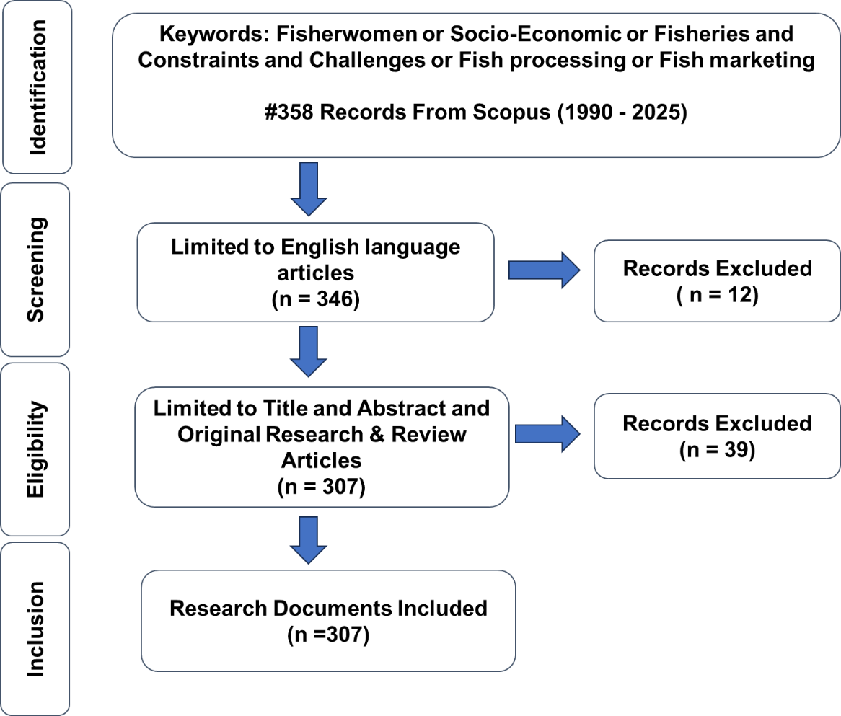
Fig. 1 Prisma Protocol

3. RESULTS AND DISCUSSION
3.1 Overview of Publication
The bibliometric summary (Table 1) shows that research on socio-economic constraints on women in fish processing and marketing has expanded substantially over the past three decades, with a steady average annual growth rate of 11.42%. A total of 307 documents published between 1990 and 2025 were identified from 176 journals and other scholarly sources. The dataset reflects a well-developed and increasingly collaborative research domain, comprising 1381 authors, of whom nearly 40% have engaged in international co-authorship. The high number of Keywords Plus (1390) and Author Keywords (930) indicates a wide thematic spread that encompasses economic, gender, livelihood, and value chain issues within small-scale fisheries. The average of 17.86 citations per document further suggests appreciable academic influence and growing recognition of this topic.

Table 1 Summary of the Research Publications
Description | Results
Main Information
Timespan | 1990:2025
Sources (Journals, Books, etc) | 176
Documents | 307
Annual Growth Rate % | 11.42
Document Average Age | 6.19
Average citations per doc | 17.86
References | 2431
Document Contents
Keywords Plus (ID) | 1390
Author's Keywords (DE) | 930
Authors
Authors | 1381
Authors of single-authored docs | 1
Authors Collaboration
Single-authored docs | 1
Co-Authors per Doc | 8.26
International co-authorships % | 39.74
Document Types
article | 292
review | 15

3.2 Annual Scientific Publications
The annual scientific publication trend offers a valuable lens through which to trace the evolution of academic engagement with the socio-economic constraints faced by women in fisheries. As illustrated in Fig. 2, the 35-year trajectory reveals a gradual yet compelling shift in research attention. In the first decade (1990-2000), publication output was extremely limited, with only one or two articles appearing each year. This sparse academic interest reflects the gender blindness that dominated early fisheries scholarship and the limited visibility afforded to fisherwomen’s socio-economic challenges during that era (Baral et al., 2025).
A remarkable shift occurred during the 2009-2016 period, when research activity began to strengthen and annual publications increased to between three and eight articles. This growth coincides with the momentum generated by global development agendas particularly the Millennium Development Goals (MDGs) which broadened scholarly attention to issues of inequality and helped position gender as an essential analytical dimension within fisheries research. The first major spike in publication volume occurred in 2015, with 12 Scopus-indexed articles marking a turning point in the field.
The most significant transition, however, is observed after 2017. During this period, research output expanded rapidly and consistently, rising from 12 articles in 2015 to 26 articles in 2019. This surge aligns with growing academic and policy interest in gender-inclusive fisheries governance, livelihood vulnerability, value-chain inequities, and resilience-building within small-scale fisheries. The FAO Small-Scale Fisheries Guidelines likely played a catalytic role by elevating the need for gender-sensitive approaches in both research and policy frameworks.
The years 2020 to 2025 represent the most dynamic and productive phase in the field. Publication output increased sharply from 17 articles in 2020 to an unprecedented 44 in 2025. This dramatic rise reflects expanding interdisciplinary collaborations, improved access to socio-economic datasets, and the emergence of new research priorities in the wake of the COVID-19 pandemic particularly those concerning occupational health risks, market digitalization, and women’s expanding roles in climate adaptation and community resilience.

Fig. 2 Trends on Annual Scientific Publications
3.3 Analysis of Publishing sources
The analysis of publishing sources reveals that research on the socio-economic constraints faced by fisherwomen is distributed across a diverse mix of high-impact, interdisciplinary, and fisheries-focused journals (Fig. 3). The most productive outlets are Marine Policy (24 documents) and Maritime Studies (23 documents), reflecting the prominence of policy-oriented, governance-driven, and socio-cultural analyses within this field. The dominance of these journals highlights the increasing integration of fisherwomen’s issues into global dialogues on marine governance, social justice, and the sustainability of coastal livelihoods.
Ocean and Coastal Management, with 11 publications, emerges as another key contributor, consistent with its focus on integrated coastal management, community resilience, and gendered interactions with marine and coastal resources. Additionally, journals such as Gender, Technology and Development and Sustainability (Switzerland) each contributing eight documents demonstrate the growing engagement of broader development and sustainability research communities. These journals play a vital role in advancing discussions on gender equity, empowerment, and socio-environmental transformations affecting resource-dependent communities.
Generalist scientific platforms like PLOS One, alongside fisheries-specific journals such as Asian Fisheries Science, Fish and Fisheries, Fisheries Research, and Frontiers in Marine Science, each publishing five papers, further underscore the interdisciplinary nature of the field. Their involvement signals a clear shift toward more empirical, data-rich, and methodologically diverse approaches. Collectively, these journals support research spanning biological sciences, economics, public health, gender studies, and socio-ecological assessments at both community and value-chain levels.

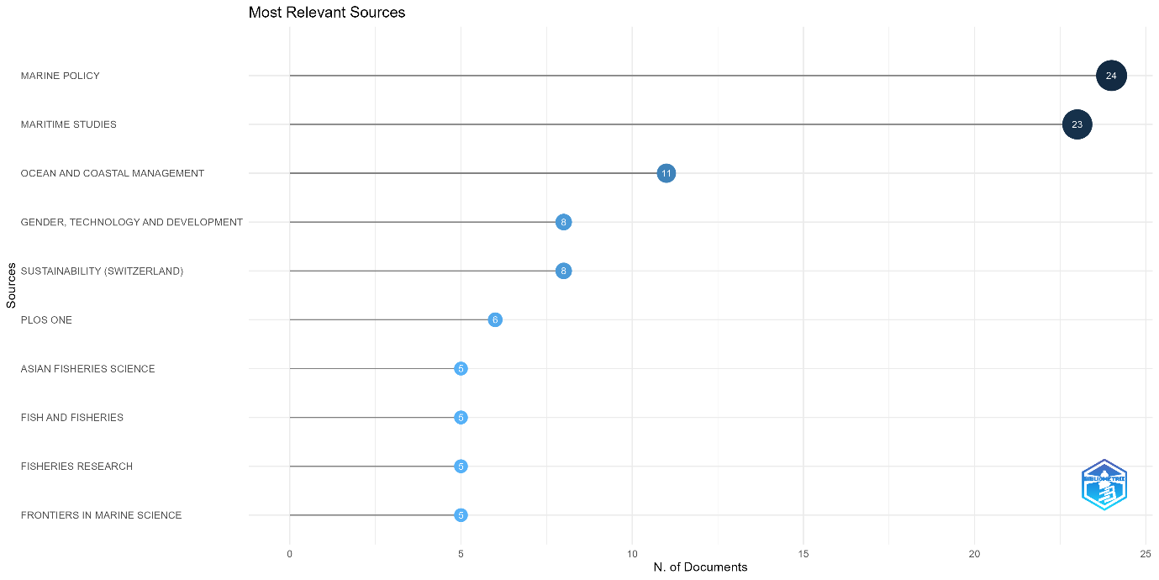
Fig. 3 Top 10 Journal-wise Publication Analysis

3.4 Author’s Collaboration Network
Figure 4 illustrates the VOSviewer-generated author collaboration network, revealing a well-defined and interconnected scholarly landscape that underscores the emergence of distinct research communities shaping global discourse on the socio-economic constraints faced by fisherwomen. The network is characterized by three major clusters, each representing a cohesive body of scholarship with strong internal collaboration.
The largest and most influential cluster is centered around Cynthia McDougall, whose extensive collaborations with researchers such as Sarah Lawless, Philippa Jane Cohen, Sangeeta Mangubhai, Meryl J. Williams, and Margaret Fox highlight her pivotal contribution to advancing work on gender equity, participatory governance, and institutional transformations in small-scale fisheries. The density and strength of linkages within this cluster reflect its leadership in steering global gender-focused fisheries research.
A second prominent cluster is led by Steven M. Cole, whose network includes collaborators such as Marinda Pamela A., Alexander M. Kaminski, Sloan K. Chimatiro, and Alex Dennis Chilala. This group represents a strong regional focus on African small-scale fisheries, aquaculture development, and gendered livelihood challenges. Their collective scholarship significantly contributes to understanding socio-economic dynamics, rural livelihood systems, and development-oriented fisheries research across the African continent.
The third major cluster is anchored by Shakuntala Haraksing Thilsted, a globally recognized expert in nutrition-sensitive fisheries. Her collaborations with researchers including Jessica Rose Bogard, Mostafa Ali Reza Hossain, Derek Stephen Johnson, and Joeri Scholtes reflect an interdisciplinary research emphasis on food security, nutrition pathways, and women’s roles in aquatic food value chains, particularly across South and Southeast Asia. The thematic orientation of this cluster highlights the growing recognition of women’s contributions to nutrition, health, and community resilience through fisheries and aquaculture.
Beyond the three dominant clusters, the presence of smaller peripheral nodes and bridging authors indicates increasing interdisciplinarity and expanding cross-regional knowledge exchange. These emerging connections suggest a dynamic and evolving research landscape that encourages collaboration across thematic, methodological, and geographic boundaries.

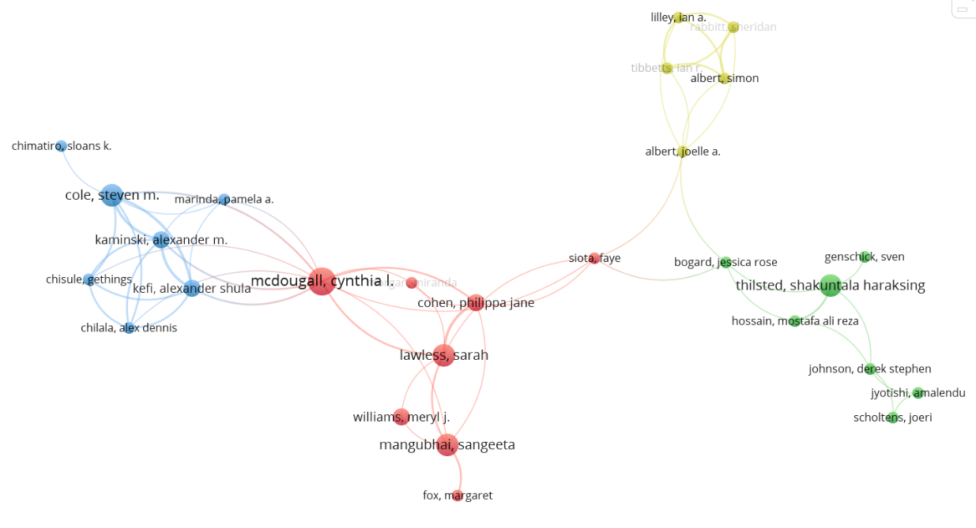
Fig. 4 Author’s Collaboration Network

3.5 Spatial Distribution of Scientific Publications
As stated earlier, it is not only that the academic understanding of the role and conditions of women in the fisheries sector is a recent trend, but the spatial distribution of the scientific temper in this field is also distributed across the globe. Figure 5 illustrates the country-wise distribution of Scopus-indexed publications, based on the affiliations of corresponding authors. Darker shades of blue on the map represent higher publication outputs, thereby highlighting regions with strong academic activity in gender and fisheries research.
Of the 69 countries contributing to the corpus of 307 publications, India emerges as the most dominant contributor, accounting for 52% of all Scopus-indexed papers in this field. This remarkable concentration underscores India’s central role in advancing knowledge on fisherwomen’s socio-economic challenges. The country’s strong representation is primarily driven by prominent national research institutions such as the ICAR–Central Marine Fisheries Research Institute (CMFRI), the Central Institute for Women in Agriculture (CIWA), and the Central Inland Fisheries Research Institute (CIFRI). These institutions have systematically documented gendered labour patterns, socio-economic vulnerabilities, and women’s empowerment pathways across diverse fisheries contexts.
The United States ranks second, contributing 101 publications, though this figure remains less than half of India’s output. The Philippines follows as the third-largest contributor, with 74 publications, reflecting its robust scholarship in coastal livelihoods, community resilience, and gendered fisheries practices. Other notable contributors include Brazil, Canada, and the United Kingdom, each of which has made meaningful but comparatively smaller contributions to the field.
Despite the growing participation of both developed and developing nations, the overall geographical distribution remains highly skewed. Much of the global scholarly attention continues to originate from regions where fisheries play a critical socio-economic role, and where gendered labour contributions are increasingly recognised and studied (Baral et al., 2025). The pattern also reflects differential research capacities, funding availability, and institutional priorities across countries.
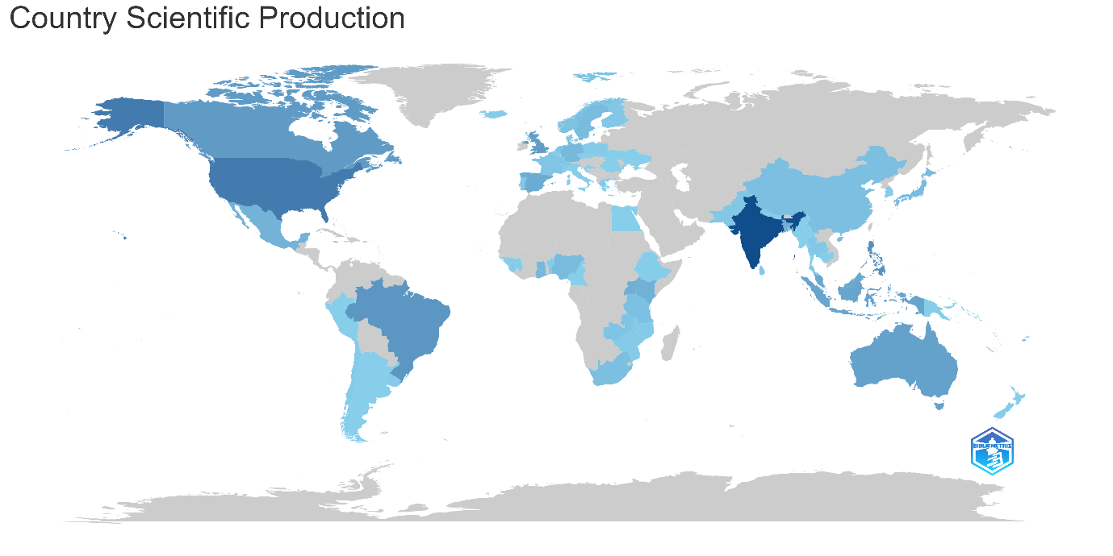
Fig. 5 Country wise scientific production

3.6 Keywords Cloud Map Analysis
The keywords cloud map illustrates the conceptual landscape and dominant themes shaping contemporary scholarly discourse on the socio-economic constraints faced by women in fisheries (Fig. 6). The prominence of terms such as “small-scale fisheries,” “gender,” “women,” “fisheries,” and “food security” reflects the strong research emphasis on gendered roles within artisanal and subsistence fishing systems, where women’s contributions remain essential yet frequently undervalued.
Equally notable are the keywords “livelihoods,” “resilience,” and “adaptation,” which underscore growing academic concern regarding the vulnerability of fisherwomen to socio-economic shocks, environmental change, and fluctuating market conditions. The appearance of terms such as “climate change,” “pandemic,” “COVID-19,” “vulnerability,” and “sustainability” signals a recent shift toward examining the impacts of global stressors—particularly those that disproportionately affect women due to structural barriers in access to resources, decision-making spaces, and social protection mechanisms.
The presence of keywords including “value chains,” “fish processing,” “aquaculture,” “co-management,” and “participation” highlights increasing recognition of women’s diverse and often overlooked roles across post-harvest activities, aquaculture systems, and local governance arrangements. These terms point to the expanding analytical focus on women’s contributions along the entire fisheries value chain and their participation in community-level resource management.
Regional identifiers such as “Ghana,” “Bangladesh,” “Lake Victoria,” and “India” demonstrate the geographical concentration of research within developing-country contexts, where small-scale fisheries form the socio-economic backbone of coastal and inland communities (Kleiber et al., 2014; Weeratunge et al., 2014). These regions are also where gendered vulnerabilities and labour disparities are most pronounced, making them central sites for empirical exploration.
Collectively, the keyword cloud reveals that the literature has evolved to embrace a multidimensional perspective, linking gender, socio-economic well-being, environmental change, and food system resilience.
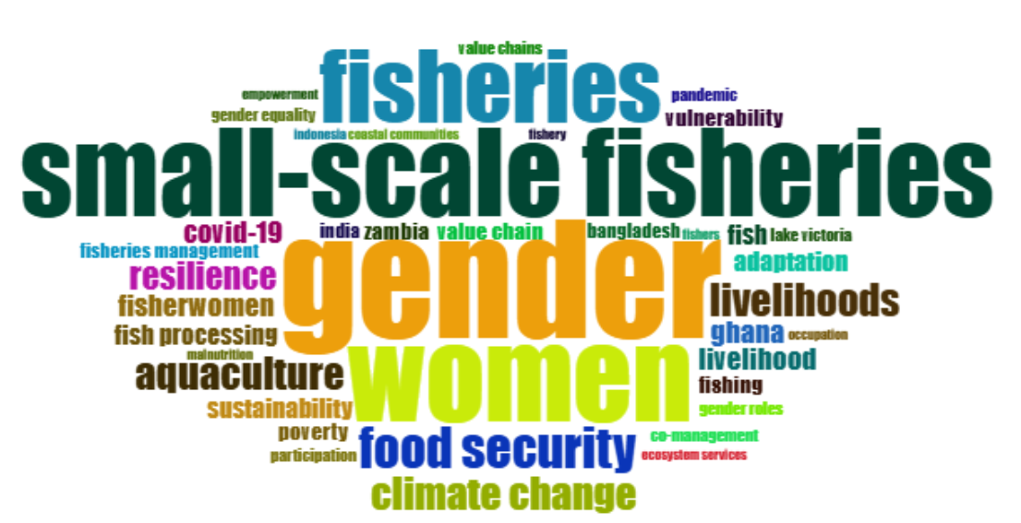
Fig. 6 Keywords Cloud Map
3.7 Research Trend Analysis (2015 - 2025)
The evolution of research topics from 2015 to 2025 reveals a clear shift in scholarly priorities relating to women in fisheries, reflecting broader socio-economic transitions and emerging environmental challenges. During the early phase (2015-2017), dominant themes such as sustainability, aquaculture, livelihoods, and small-scale fisheries indicate that academic attention initially centered on the structural and economic dimensions of fisheries systems. These foundational topics highlight an early focus on the functioning of fisheries institutions, resource use patterns, and livelihood dynamics, with gender forming only a peripheral component.
As research progressed into the 2018-2020 period, themes including fish processing, fisherwomen, gender, and vulnerability began to gain prominence (Jadhav, 2018; Johnson et al., 2018). This shift signals a growing awareness of gendered inequities and the socio-economic constraints embedded within post-harvest value chains particularly in processing, trading, and informal labour roles dominated by women. The increasing visibility of terms such as women, food security, and adaptation during this period reflects the recognition of women’s central roles in ensuring household nutrition and in sustaining resilience amid resource scarcity and livelihood uncertainties.
A significant thematic expansion occurred after 2020. Global disruptions most notably the COVID-19 pandemic triggered a pronounced rise in research focusing on COVID-19, resilience, climate change, and gender equality as central concerns (Mangubhai et al., 2024). These trends demonstrate heightened scholarly interest in understanding how systemic crises exacerbate pre-existing vulnerabilities among fisherwomen, especially those working in informal and small-scale sectors with limited access to markets, safety nets, and institutional support.
From 2022 to 2025, research themes continued to consolidate around gender roles, food security, adaptation, and resilience, indicating deepening engagement with intersectional and socio-ecological dimensions of gendered fisheries (Mahmud et al., 2025). The emergence of region-specific terms such as Ghana and South Asia suggests increasing geographic diversification and a growing interest in comparative and context-specific studies across the Global South.
Despite this expansion, the persistent prominence of core terms gender, small-scale fisheries, livelihood, and women throughout the decade highlights the consolidation of gender-sensitive approaches within fisheries social science. Collectively, the research trend analysis reflects a transition from broad, system-level perspectives to more nuanced, intersectional scholarship that integrates gender, climate risks, household food systems, socio-economic resilience, and social-ecological systems thinking (Chambon et al., 2024). This evolution affirms the growing maturity and policy relevance of research on fisherwomen’s socio-economic constraints (Fig. 7).
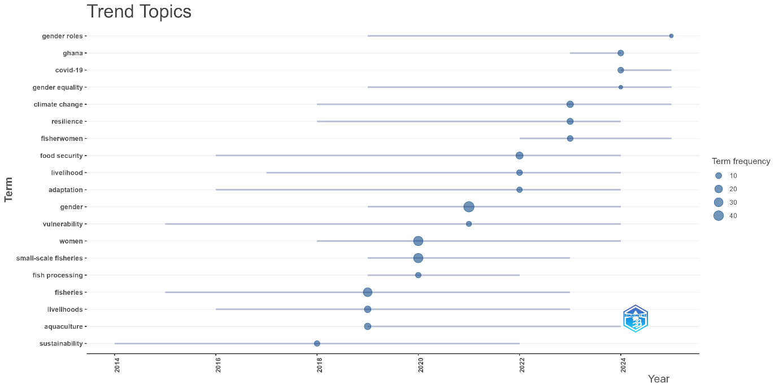
Fig. 7 Recent Research Trend Topics

4. CONCLUSION
This bibliometric analysis of global research on the socio-economic constraints faced by women in fisheries demonstrates a marked evolution from a historically marginal topic to a well-established and rapidly expanding field of inquiry. Over the past three decades, scholarly engagement has increased substantially, influenced by global development agendas, gender equity frameworks, and growing recognition of women’s vital yet often overlooked contributions to small-scale fisheries. India stands out as the most dominant contributor, reflecting strong institutional commitment and a vibrant research community dedicated to understanding and addressing fisherwomen’s socio-economic challenges. Across the literature, core themes such as gender, livelihoods, food security, and resilience have progressively broadened to include intersectional concerns encompassing climate change, occupational health, and market digitalization. The analysis of author collaboration networks further reveals a steadily maturing research landscape characterized by interdisciplinarity, regional diversity, and enhanced global connectivity. The insights deepen the understanding of persistent and emerging socio-economic barriers faced by fisherwomen and highlight the critical need for gender-responsive policies and inclusive governance mechanisms in fisheries management. The growing body of research provides an essential foundation for strengthening women’s empowerment, improving their socio-economic well-being, and advancing equitable, climate-resilient, and sustainable fisheries systems worldwide.
COMPETING INTERESTS
The authors declare that they have no known competing financial interests, non-financial interests, or
personal relationships that could have influenced the work reported in this paper.
DATA AVAILABILITY
No additional datasets were generated or analysed in the preparation of this article
COMPETING INTERESTS DISCLAIMER
Authors have declared that they have no known competing financial interests.

DISCLAIMER (ARTIFICIAL INTELLIGENCE)
Author(s) hereby declares that NO generative AI technologies such as Large Language Models (ChatGPT, COPILOT, etc.) and text-to-image generators have been used during the writing or editing of this manuscript.
5. REFERENCES
- Ameyaw, A. B., Breckwoldt, A., Reuter, H., & Aheto, D. W. (2020). From fish to cash: Analyzing the role of women in fisheries in the western region of Ghana. Marine Policy, 113, 103790. https://doi.org/10.1016/j.marpol.2019.103790
- Baral, K., Baral, R., & Priyadarshani, B. (2025). Navigating the discourse: A bibliometric overview of research on fisherwomen in traditional marine fisheries. Marine Policy. https://doi.org/10.1016/j.marpol.2025.106797
- Casillas, J. C., & Acedo, F. J. (2007). Evolution of the intellectual structure of family business literature: A bibliometric study of FBR. Family Business Review, 20(2), 141–162. https://doi.org/10.1111/j.1741-6248.2007.00092.x
- Central Marine Fisheries Research Institute. (2010). Marine Fisheries Census 2010 - India. http://eprints.cmfri.org.in/6437
- Chambon, M., Miñarro, S., Alvarez Fernandez, S., Porcher, V., Reyes-Garcia, V., Tonalli Drouet, H., & Ziveri, P. (2024). A synthesis of women’s participation in small-scale fisheries management: why women’s voices matter. Reviews in Fish Biology and Fisheries, 34(1), 43-63. https://doi.org/10.1007/s11160-023-09806-2
- Das, S., Naik, B., Kumar, V., Soni, S., Prakash, S., Yadav, V. K., Kurmi, R., & Sharma, A. (2024). Socio-economic profile of women fish workers in Mumbai. International Journal of Agriculture Extension and Social Development, 7(5), 201-205. https://doi.org/10.33545/26180723.2024.v7.i5c.621
- Das, S., Sharma, A., Ghosh, A., Yadav, V.K., Kripa, V., Kumar, V., & Katre, N. (2025). Socio-economic Indicators are Linked to Ecological Outcomes: Insights into the Lives of Fish and Shrimp Farm Workers in West Bengal. https://assets.researchsquare.com/files/rs-4290000/v1/86a8a76576dbbc47b49adf5f.docx?c=1709894400
- Datta, H. S., Sarmah, R., Buragohain, R., & Saikia, B. (2025). Chapter 6: Women entrepreneurs -Key to mitigating postharvest loss and waste. In *Dynamic agriculture: Problems and way forward*. https://doi.org/10.62778/int.book.599
- FAO, Duke University, & WorldFish. (2023). Illuminating hidden harvests: The contributions of small-scale fisheries to sustainable development. https://doi.org/10.4060/cc4576en
- Food and Agriculture Organization of the United Nations. (2024). Gender in fisheries and aquaculture. https://www.fao.org/gender/learning-center/thematic-areas/gender-in-fisheries-and-aquaculture/en
- Goodman, A. J., McIntyre, J., Smith, A., Fulton, L., Walker, T. R., & Brown, C. J. (2021). Retrieval of abandoned, lost, and discarded fishing gear in Southwest Nova Scotia, Canada: Preliminary environmental and economic impacts to the commercial lobster industry. Marine Pollution Bulletin. https://doi.org/10.1016/j.marpolbul.2021.112766
- Gul, S., Mir, S. A., Iqbal, G., Lone, H. Q., & Shafiq, U. (2024). The role of women in small-scale fisheries: A comprehensive review. International Journal on Emerging Technologies. https://researchtrend.net/ijet/volume-15-issue-2-2024/
- Gunakar, S., & Bhatta, R. (2016). Socioeconomic status of Fisher-women in segmented fish markets of coastal Karnataka. Agricultural Economics Research Review. https://doi.org/10.5958/0974-0279.2016.00052.5
- Harsha, G. S., Sankangoudar, S., & Patil, M. (2024). Constraints faced by the fisherwomen involved in post-harvest activities of marine fisheries in Bapatla district of Andhra Pradesh. International Journal of Advanced Biochemistry Research. https://doi.org/10.33545/26174693.2024.v8.i9Sd.2131
- Jayaraman, R. (2017). Production and marketing constraints of fisherwomen self help groups in Thoothukudi District, Tamil Nadu. Indian Journal of Fisheries, 64(1), 106-110. https://doi.org/10.21077/ijf.2017.64.1.41896-20
- Jegadeswari, J. J., & Kumar, E. A. (2021). A Study on the Challenges Faced by the Women Fish Vendors with Special Reference to Chennai. International Journal of Law Management & Humanities. https://doi.org/10.10000/IJLMH.11538
- Kleiber, D., Frangoudes, K., Snyder, H. T., Choudhury, A., Cole, S. M., & Soejima, K. (2017). Promoting gender equity and equality through the small-scale fisheries guidelines: Experiences from multiple case studies. In S. Jentoft, R. Chuenpagdee, M. J. Barragán-Paladines, & N. Franz (Eds.), The small-scale fisheries guidelines: Global implementation (pp. 737-759). Springer International Publishing. https://doi.org/10.1007/978-3-319-55074-9_35
- Kleiber, D., Harris, L., & Vincent, A. C. J. (2014). Gender and small-scale fisheries: A case for counting women and beyond. Fish and Fisheries. https://doi.org/10.1111/faf.12075
- Mangubhai, S., Olguín-Jacobson, C., Charles, A., Cinner, J., de Vos, A., Graham, R. T., ... & Micheli, F. (2024). COVID-19 highlights the need to improve resilience and equity in managing small-scale fisheries. npj Ocean Sustainability, 3(1), 61. https://doi.org/10.1038/s44183-024-00100-7
- Quan, Y., & Jin, J. (2024). A bibliometric review on marine ecological environment governance: Development and prospects (1990–2022). Environmental and Sustainability Indicators, 22, 100406. https://doi.org/10.1016/j.indic.2024.100406
- Salim, S. S., Antony, B., & Geetha, R. (2011). Women Empowerment and Fisheries Sector in Kerala. Central Marine Fisheries Research Institute. https://eprints.cmfri.org.in/id/eprint/7900/1/Women_in_Fisheries_Text__Shyam.pdf
- Sudhakara, N. S., Khader, V., Sathiadhas, R., Kasim, H. M., Narayanakumar, R., Dhanapal, K., Lakshmi, J., & Hassan, F. (2003). Participation of women in post-harvest fisheries sector. Workshop on Empowerment of Fisher Women, 13-14 October 2003, Hyderabad. https://eprints.cmfri.org.in/8616/
- Thelwall, M. A. (2008). Bibliometrics to webometrics. Journal of Information Science. https://doi.org/10.1177/0165551507087238
- UN Women. (2020). Women's economic empowerment in fisheries in the blue economy of the Indian Ocean Rim: A baseline report. https://www.unwomen.org/sites/default/files/Headquarters/Attachments/Sections/Library/Publications/2020/Womens-economic-empowerment-in-fisheries-in-the-blue-economy-of-the-Indian-Ocean-Rim-en.pdf
- Wang, L., Niu, W., Ding, L., Zhao, Z. (2023). A bibliometric review on marine economy: Current status, development and future directions. Marine Policy. https://doi.org/10.1016/j.marpol.2023.105705
- Weeratunge, N., Béné, C., Siriwardane, R., Charles, A., Johnson, D., Allison, E. H., Nayak, P. K., & Badjeck, M. C. (2014). Small-scale fisheries through the wellbeing lens. Fish and Fisheries, 15(2), 255-279. https://doi.org/10.1111/faf.12016
- Williams, M. J., Gopal, N., Kusakabe, K., & Fakoya, K. (2025). Women work in fisheries too: the Gender in Aquaculture and Fisheries Section story. Frontiers in Ocean Sustainability, 3, 1599625. https://doi.org/10.3389/focsu.2025.1599625
- Mahmud, K. T., Zaman, F., & Haque, A. B. M. M. (2025). Gender disparities and barriers for fisherwomen in the fisheries value chain system: a review of global perspectives. Gender, Technology and Development. https://doi.org/10.1080/09718524.2025.2509194
- Jadhav, A. (2018). Undefining small-scale fisheries in India: Challenging simplifications and highlighting diversity and value. In D. Johnson, T. G. Acott, N. Stacey, & J. Urquhart (Eds.), Social wellbeing and the values of small-scale fisheries (pp. 147–173). Springer International Publishing. https://doi.org/10.1007/978-3-319-60750-4_7
- Johnson, D. S., Acott, T. G., Stacey, N., & Urquhart, J. (Eds.). (2018). Social Wellbeing and the Values of Small-scale Fisheries. Springer International Publishing. https://doi.org/10.1007/978-3-319-60750-4
- Bhargavi, K., Chirwatkar, B. B., Das, A., Behera, S., & Bhakta, D. (2020). Socio-economic status of fisherwomen community in coastal Vizianagaram district of Andhra Pradesh, India. Journal of Fisheries, 8(1), 741-745. https://doi.org/10.17017/j.fish.10
- Panicker, R. C., & Reejo, R. J. (2024). An Examination of Livelihood Initiatives for Women in Fishery Communities: Perspectives From India. In Impact of Women in Food and Agricultural Development (pp. 260-282). https://doi.org/10.4018/979-8-3693-3037-1.ch014

