Original Research Article
Low-Cost Egg Incubator-cum-Hatchery Technology for Small Farmers: Design, Evaluation and Impact on Rural Backyard Poultry Production

ABSTRACT
Artificial incubation is an essential requirement for improved backyard poultry breeds due to their lack of broody behaviour. However, commercially available incubators are costly and inaccessible to small farmers. This study developed and evaluated a low-cost egg incubator-cum-hatchery constructed from a discarded Thermocol fish box integrated with a digital thermostat, exhaust fan, and filament bulbs. The total fabrication cost was ₹1,740 excluding inverter and battery (₹15,240 with full backup system). The incubator has a capacity of 50–80 eggs depending on egg size. Artificial incubation was carried out following the principles of temperature, humidity, ventilation, and turning (THVT). Hatchability trials using eggs from four poultry breeds—Local, Sonali, Srinidhi and Kamrupa—yielded hatchability percentages of 72%, 78%, 70%, and 76%, respectively. Economic analysis showed that although standalone operation with a single incubator is less profitable, profitability significantly increases when one battery–inverter system supports five incubators simultaneously. At full-capacity cluster use, the system generated an annual net income of ₹1,14,022.56.
This innovation provides an affordable, farmer-operated hatchery technology capable of ensuring continuous chick supply in remote rural areas, thus strengthening backyard poultry production and rural livelihoods.
Keywords: Low-cost incubator, backyard poultry, hatchability, frugal innovation, rural technology, THVT principles, improved poultry breeds.

1. INTRODUCTION
Incubation is an indispensable biological process through which a fertilized egg develops into a chick under optimum environmental conditions. In natural incubation, broody hens regulate temperature, humidity, air exchange and turning (Deeming, 2002). Artificial incubators replicate these conditions, generally maintaining a temperature of 37–38°C, humidity of 55–70%, adequate ventilation for gas exchange, and egg turning at 2–10 times per day (Tullett, 1990; French, 1997).
Improved backyard poultry breeds such as Vanaraja, Giriraja, Srinidhi, Sonali and Gramapriya have been widely disseminated across India to enhance rural livelihood and nutrition security (Rao et al., 2017). However, these breeds lack natural brooding instinct due to genetic selection for egg and meat production (ICAR-DPR, 2019). As a result, farmers face challenges in maintaining continuous replacement stock, especially in remote tribal areas where access to commercial hatcheries is limited.
Commercial incubators cost between ₹1–5 lakh and are not economically feasible for smallholder farmers. Therefore, development of a low-cost, farmer-friendly incubator that can maintain essential THVT parameters is critical for strengthening backyard poultry systems (FAO, 2013).
The present study aimed to:
(1) develop a low-cost incubator using locally available materials;
(2) evaluate hatchability with different poultry breeds;
(3) assess economic feasibility for rural households.
2. MATERIALS AND METHODS
2.1 Design and Fabrication of the Low-Cost Incubator
A discarded thermocol fish box served as the main chamber (65 × 46 × 33 cm). Thermocol provides excellent insulation and minimises temperature fluctuation (King’ori, 2011).
Components included:
- Digital thermostat (AS-1500)
- Exhaust rotary fan (4.75 inches)
- Two filament bulbs (60 W each)
- Bulb holders, wiring, black tape, binding wire
- Battery (150 Ah) and inverter (12 V) for uninterrupted power
Total construction cost excluding battery/inverter was ₹1,740.
2.2 Functional Description of Components
Temperature regulation, ventilation, heating redundancy (dual-bulb system), and moisture retention were managed according to THVT standards (French, 1997; Deeming, 2002). Details are retained from the original documentation.
2.3 Electrical Setup
Thermostat input was connected to DC power supply and the output connected to bulbs and fan. A sensor probe was positioned inside the chamber to continuously monitor internal temperature.
2.4 Incubator Management Protocol
- Temperature: 37.5–37.9°C
- Humidity: 50–60% (Days 1–18); 70–75% (Days 19–21)
- Turning: Twice daily by hand
- Ventilation: Continuous via exhaust fan
- Candling: Days 3, 5 and 7 for fertility assessment
Management procedures align with FAO (2013) and ICAR-DPR poultry incubation guidelines.
2.5 Hatchability Trials
Four poultry breeds were tested:
- Local
- Sonali
- Srinidhi
- Kamrupa
Eggs were candled and monitored until hatching on Day 21.
Calculation of Fertility and Hatchability
Fertility (%) = (Fertile eggs / Total eggs) × 100
Hatchability (%) = (Hatched chicks / Fertile eggs) × 100
2.6 Economic Analysis
Costs were divided into fixed and recurring cost components. Additional profitability assessment was conducted for shared-system use (one battery supporting five incubators), assuming 16 incubation cycles per year.
3. RESULTS
3.1 Hatchability Performance
The hatchability performance of the low-cost egg incubator was evaluated using four commonly reared backyard poultry breeds—Local, Sonali, Srinidhi, and Kamrupa (Table 1). A total of 170 eggs were set across the breeds, of which 140 eggs were confirmed fertile. Hatchability varied from 70% to 78%, demonstrating the reliability of the incubator under smallholder operational conditions.
For the Local breed, 30 eggs were initially set, yielding 25 fertile eggs. Out of these, 18 successfully hatched, resulting in a hatchability of 72%. This value is within the expected range for indigenous breeds, which often show moderate fertility and hatchability due to variable egg size and shell characteristics.
In the Sonali breed, which is a popular dual-purpose improved strain, 60 eggs were set with 52 fertile eggs. A total of 41 chicks hatched, giving a hatchability of 78%, the highest among all the tested breeds. This higher hatchability may be attributed to better genetic uniformity, higher egg quality, and improved fertility rates compared to local/native birds.
The Srinidhi breed recorded the lowest hatchability among the four. Of the 50 eggs set, 37 were fertile, and 26 chicks hatched, resulting in 70% hatchability. Although this percentage is slightly lower, it still falls within acceptable biological limits for rural incubation systems. The reduced hatchability may be associated with slightly higher embryonic mortality or variations in egg weight.
For the Kamrupa breed, 30 eggs were set, with 26 fertile eggs and 20 chicks hatched, giving a hatchability of 76%. Kamrupa, being a composite bird developed for backyard conditions, generally performs well under rural incubation, and the result aligns with its known robustness.
Overall, the observed hatchability values (70–78%) are consistent with findings reported by King’ori (2011) and FAO (2013), which documented hatchability ranges of 65–80% for small-scale, non-automated or semi-automated rural incubators. These findings confirm that the developed low-cost incubator performs comparably to standard rural incubation systems and is suitable for adoption by small and marginal farmers.

Table 1. Hatchability of Different Breeds
Breed | Eggs Set No. | Fertile Eggs | Hatched Chicks | Hatchability (%)
Local | 30 | 25 | 18 | 72
Sonali | 60 | 52 | 41 | 78
Srinidhi | 50 | 37 | 26 | 70
Kamrupa | 30 | 26 | 20 | 76
Values of 70–78% are consistent with hatchability ranges reported for small rural incubators (King’ori, 2011; FAO, 2013).
  - Economy details of lowcost incubator cum hatching machine

Table 2.Fixed cost (Economic of low-cost incubator machine)
Sl | Equipments | Specification/size | Model | Rate | No. | Total Amounts (RS)
1 | Digital Thermostat | AC 220V | AS-1500 | 1000 | 1 | 1000.00
2 | Exhaust rotary fan | 4.75 inches | SE-123038ASL | 500 | 1 | 500.00
3 | Filament light bulb | 60 Watt. |  | 20 | 2 | 40.00
4 | Holder (light bulb) | - | - | 20 | 2 | 40.00
5 | Electric wire | 4 mtr | - | 20 | 4 | 80.00
6 | Binding wire | 2 ft | - | 2 | 2 | 4.00
7 | Black tape | 1 pics | - | 26 | 1 | 26.00
8 | Fish box (Thermocol) | 1 | - | 50 | 1 | 50.00
9 | Battery | 150 ah | Exide | 10000 | 1 | 10,000.00
10 | Inverter | 12V | Microtek | 3500 | 1 | 3,500.00
 | Total |  |  |  |  | 15,240.00

The equipment list presented forms the core components required for assembling a functional, low-cost thermocol-based egg incubator designed for rural and smallholder use. The digital thermostat (AS-1500, AC 220V) is the most critical component, responsible for regulating the internal temperature within the optimal incubation range of 37.5–38°C. Accurate temperature control is essential for embryo development, and this thermostat ensures minimal fluctuation.
The exhaust rotary fan (4.75 inches) promotes uniform air circulation, preventing hot or cold spots inside the chamber and maintaining consistent humidity—an important determinant of hatchability. The heating system is powered by 60-watt filament bulbs, chosen for their simplicity, affordability, and ability to produce steady radiant heat. The accompanying holders, electric wires, binding wire, and black tape are basic electrical accessories required for safe installation and secure wiring within the incubator.
The thermocol fish box serves as the chamber body due to its excellent insulation capacity, which minimizes heat loss and reduces electricity consumption. This makes the incubator energy-efficient and suitable for regions with unstable power supply.
The inclusion of a 150 Ah Exide battery paired with a 12V Microtek inverter provides an essential backup system. This ensures uninterrupted power during electricity outages, protecting embryos from temperature drops that could compromise hatchability.
Overall, the total cost of ₹15,240 reflects a highly economical design, making the incubator accessible to rural households while providing performance comparable to commercially available small incubators.
Table 3. Recurring cost (Economy of power consumptions in low cost hatchery unit for 21 days/ 1 batch hatching)
Sl | Appliance | Watt | Hours/day | Total watt | 21 days | Total watt (21 days) | Units (watt/1000) | 0-100 units (Rs 3/unit) | Total (Rs)
1 | Filament light bulb | 60 | 14 | 840 | 21 | 17640 | 17.64 | 3 | 52.92
2 | Exhaust rotary fan | 23 | 14 | 322 | 21 | 6762 | 6.762 | 3 | 20.286
3 | Digital Thermostat | 1 | 24 | 24 | 21 | 504 | 0.504 | 3 | 1.512
 | Total | 84 | 52 | 1186 | 21 | 24,906 | 24.906 | 3 | 74.718

The recurring cost calculation for the low-cost hatchery unit is based on the total electricity consumed by three essential components: the filament light bulb, exhaust rotary fan, and digital thermostat. These appliances together ensure a stable incubation environment by providing heat, ventilation, and temperature regulation.
The 60-watt filament bulb, functioning for 14 hours per day, contributes the major portion of energy consumption since it serves as the primary heat source. Over 21 days, it consumes 17.64 units, resulting in a cost of ₹52.92 at a rate of ₹3 per unit. Its high wattage and long operational hours justify its dominant share in total power usage.
The exhaust rotary fan, operating at 23 watts for 14 hours daily, ensures uniform air circulation inside the incubator. Proper ventilation prevents temperature stratification and maintains optimal humidity levels, both crucial for embryo development. Over the incubation period, the fan consumes 6.762 units, costing ₹20.286.
The digital thermostat consumes the least power, operating continuously at just 1 watt. Its total consumption of 0.504 units over the 21-day cycle costs only ₹1.512, yet its functional role is critical as it regulates the heating system and ensures precise temperature control.
Combined, the total power consumption for one hatching cycle is 24.906 units, costing only ₹74.718. This demonstrates the remarkable energy efficiency of the thermocol-based incubator, making it economically suitable for rural households with limited resources.

Table 4. Total recurring cost (Economy of power consumptions in low-cost hatchery unit for 21 days/ 1 batch hatching)
Sl | Items | Rs | No. /units | Total Rs
 | Expenditure
 | Egg cost | 15/egg | 60 | 900
 | Electric unit consumed | 3/unit | 24.906 | 74.718
 | Total |  |  | 974.718

Table 5. Income from Low-cost incubator cum hatchery
Sl | Items | Rs | No. /units | Total Rs
A | Expenditure
A.1 | Fixed cost
 | Digital Thermostat | 1000 | 1 | 1000.00
 | Exhaust rotary fan | 500 | 1 | 500.00
 | Filament light bulb | 20 | 2 | 40.00
 | Holder | 20 | 2 | 40.00
 | Electric wire | 20 | 4 | 80.00
 | Binding wire | 2 | 2 | 4.00
 | Black tape | 26 | 1 | 26.00
 | Fish box (Thermocol) | 50 | 1 | 50.00
 | Battery | 10000 | 1 | 10.000.00
 | Inverter | 3500 | 1 | 3,500.00
 | Total |  |  | 15,240.00
A.2 | Recurring cost
1 | Egg cost | 15/egg | 60 | 900
2 | Electric unit consumed | 3/unit | 24.906 | 74.718
 | Total |  |  | 974.718
 | Grand total exp. A (A1+A2) |  |  | 16,214.718
B | Income
1 | Chicks (Hatchability 80% of 60 eggs) | 48 | 50 | 2400
 | Total |  |  | 2400
 | Net income (B-A) |  |  | -13814.718
Since battery and inverter can support 5 incubators at a time, therefore economic analysis at 21 days, 90 days (3 months) and 365 days (1 year)
Table 6.Economic analysis for21 days, 90 days and 365 days
Sl | Particular | Unit cost/income | 21 days | Total | 90 days (3 months) 4 batches | Total in 3 months | 365 days (1 year) 16 batches | Total in 1 year
A | Expenditure
A1. | Fixed cost
1 | Equipments cost | 15,240.00 | 1 | 15,240.00 | - | - | - | -
A2 | Recurring cost
1 | Egg cost | 900 | 5 | 4500.00 | 4 | 18,000.00 | 16 | 72,000.00
2 | Electric unit consumed cost | 74.718 | 5 | 373.59 | 4 | 1494.36 | 16 | 5977.44
 | Total (A) | 16,214.718 |  | 20,113.59 |  | 19,494.36 |  | 77,977.44
B | Income
 | Income for chicks | 2400 | 5 | 12,000.00 | 4 | 48,000 | 16 | 1,92,000.00
 | Total (B) | 2400 |  | 12,000.00 |  | 48,000 |  | 1,92,000.00
C | Net Income (B-A) | -13814.718 |  | -8113.59 |  | 28,505.64 |  | 1,14,022.56

NB: in 90 days 4 batches of incubation can be done @ 21 days x 4 = 84 days with gap periods of 1.5 days between each successive incubation setting. Similarly in 365 days 16 batches of incubation can be done @ 21 days x 16 = 336 days with gap periods of 1.5 days between each successive setting egg in incubator.
The economic analysis evaluates the financial performance of the thermocol-based low-cost incubator over different time horizons—one incubation cycle (21 days), a 3-month period (approximately four batches), and a one-year period (16 batches).
During a single 21-day cycle, the total expenditure amounts to ₹16,214.72, which includes both recurring costs (egg and electricity) and fixed costs (equipment). The income generated from the sale of chicks is ₹12,000, resulting in a net loss of ₹13,814.72 for the first cycle. This loss is expected because the entire fixed cost is being accounted for within a single incubation batch.
Over a period of 90 days (4 batches), the recurring expenditure is ₹19,494.36, while the income generated totals ₹48,000. Since the fixed cost does not recur in subsequent cycles, the net income becomes positive, amounting to ₹28,505.64 for the 3-month period.
Over the course of one year (16 batches), the recurring expenditure increases to ₹77,977.44, while the total income rises substantially to ₹1,92,000. The annual net income is ₹1,14,022.56, demonstrating strong long-term profitability.
3.4 Summery of Cost and Economic Evaluation
- Fixed cost: ₹15,240 (with power backup)
- Recurring cost per batch: ₹974.71
- Income from chick sales (48 chicks): ₹2,400
In single-unit mode, net profit is negative; however, in cluster operation (5 incubators using the same inverter and battery):
- Net profit in 90 days: ₹28,505.64
- Net profit in 1 year: ₹1,14,022.56

4. DISCUSSION
Economic Viability and Long-Term Profitability of the Thermocol-Based Low-Cost Incubator
The economic analysis undertaken for the thermocol-based low-cost incubator clearly reveals that its financial viability improves significantly when examined over multiple incubation cycles rather than being confined to a single 21-day batch. This is a characteristic trend observed for most capital-intensive technologies where the largest cost component consists of fixed expenditures borne initially. In the present case, the principal contributors to fixed cost include the digital thermostat, the exhaust rotary fan, the fish-box thermocol chamber, the inverter, and the battery backup system. These components represent foundational investments and remain functional over several years with minimal depreciation. Therefore, allocating the entire fixed cost to a single production cycle artificially inflates the per-cycle cost and results in the appearance of a substantial financial loss in the first instance. The calculated loss of ₹13,814.72 in the initial 21-day batch is, in reality, not an operational drawback but rather a representation of the capital recovery phase.
From a financial perspective, no technology owning fixed assets can reasonably be expected to become profitable within the very first cycle. Instead, profitability is expected to emerge progressively as the fixed cost is amortized over time. In the case of the thermocol-based incubator, the results strongly align with this principle. Once the initial investment is distributed across subsequent batches, the recurring cost structure—which primarily includes egg procurement and electricity consumption—becomes the dominant determinant of production cost. These recurring costs are relatively low compared to the income generated from chick sales, creating a favorable cost–income balance in continued use. This economic pattern indicates that operational continuity is key to unlocking the full profitability potential of the incubator.
A more structured examination of the 3-month economic performance shows a marked improvement. Over four incubation cycles (equivalent to a 90-day period), the fixed cost no longer affects the cost per batch because it has already been accounted for in the first cycle. The total recurring expenditure of ₹19,494.36 across four cycles is significantly lower than the income of ₹48,000 generated from chick sales within the same period. The resulting net income of ₹28,505.64 within the first three months demonstrates that the incubator begins generating a positive cash flow much earlier than many other small-scale rural technologies. By the end of the fourth cycle, not only is the initial investment fully recovered, but additional profit begins to accumulate. This short payback period is a highly desirable feature in rural technologies where farmers often operate with limited capital and require quick returns to sustain continuous investment.
The one-year evaluation provides an even more compelling case for the incubator’s economic sustainability. With a total of 16 batches completed within 365 days, the recurring expenditure amounts to ₹77,977.44 while the annual income reaches ₹1,92,000. The net income of ₹1,14,022.56 illustrates a robust and substantial profitability margin, surpassing many traditional agricultural livelihood activities within the same investment bracket. Considering the initial cost of only ₹15,240, the annual return on investment (ROI) is extraordinarily high. This indicates that the thermocol-based incubator is not just marginally profitable but can become a core income-generating asset for rural households, self-help groups (SHGs), women’s collectives, and small-scale poultry entrepreneurs.
One of the critical insights emerging from the analysis is the dominance of egg procurement cost in the recurring expenditure structure. Eggs represent the primary raw material in incubation, and their cost directly influences the scale of investment required per batch. Therefore, strategic sourcing of fertile eggs becomes crucial for optimizing profitability. Rural communities that produce their own fertile eggs or cooperatives that engage in bulk procurement from breeder units can significantly lower input costs. Reducing egg costs by even 10–15% can enhance net income substantially across multiple cycles. This observation underscores the importance of integrating incubator-based enterprises with existing village-level poultry units, which can serve as suppliers of fertile eggs while simultaneously creating a local market loop that reinforces economic resilience.
Electricity consumption, on the other hand, constitutes a minor portion of recurring costs. The thermocol chamber’s excellent insulating capability contributes significantly to energy efficiency by reducing heat loss and stabilizing internal temperature. This is especially relevant in rural India, where electricity supply is often erratic. The low wattage of filament bulbs used for heating further minimizes operating expenses. In areas with frequent power cuts, the presence of a battery and inverter system ensures uninterrupted incubation, thereby maintaining hatchability rates without drastically increasing costs. The minimal energy requirement of the system also implies that it can be adapted easily for solar-powered operations, which could further reduce recurring expenditures and enhance adoption in off-grid regions.
Income derived from chick sales remains the main driver of profitability. The economic model assumes an 80% hatchability rate, which is consistent with field-level reports for thermocol-based or semi-automatic rural incubators when temperature and humidity are maintained properly. At a selling price of ₹50 per chick—a common market rate in rural and peri-urban areas—the income potential per batch is considerable. Moreover, rural markets often exhibit higher demand during the onset of cropping seasons or festival periods, during which chick prices can rise to ₹70–90. Such seasonal price variations can significantly increase profit margins for farmers who plan their hatching cycles strategically. The ability to time production with market demand is an important entrepreneurial skill that incubator users can develop to maximize financial returns.
Another key component of long-term viability lies in the scalability of the enterprise. The analysis shows that when batches are conducted regularly, income becomes steady and predictable. A household or farmer group earning ₹1.14 lakh per year from chick production gains a stable income source that complements crop-based seasonal earnings. This diversification of income is critical for strengthening household financial stability, especially in rainfed or risk-prone agricultural zones. The revenue can also support reinvestment in additional incubators, expansion of breeder flocks, or development of parallel enterprises such as chick rearing, feed mixing, or poultry marketing.
Beyond individual entrepreneurship, the thermocol-based incubator shows exceptional potential in cooperative or shared-resource models. When the incubator is maintained as a community asset—whether by a self-help group, farmer producer organization (FPO), youth club, or local cooperative—the economic advantages multiply. Shared operational costs significantly reduce the per-user financial burden. Bulk purchase of eggs becomes easier and more cost-efficient. Collective marketing of chicks results in larger volumes and better price negotiation opportunities. Additionally, cooperative ownership encourages regular usage of the incubator, ensuring maximum utility and faster cost-recovery. The shared-backup system also enhances operational reliability, as group members can monitor batches collectively, ensuring timely intervention during power failures or temperature fluctuations. This collective approach strengthens social capital within the village, encourages skill dissemination, and promotes inclusive economic growth.
The incubator’s frugal design further contributes to its long-term success. Constructed primarily from thermocol, inexpensive bulbs, basic wiring, and locally available materials, the system embodies the principles of frugal innovation: affordability, simplicity, and functionality. These characteristics make it particularly suitable for low-income, resource-constrained settings. Unlike commercial incubators, which are often expensive and require technical expertise, the thermocol-based model is easy to construct, maintain, and repair locally. This reduces dependency on external technicians or spare parts, thereby supporting self-reliance and promoting rural entrepreneurship.
The economic analysis provides compelling evidence that the thermocol-based low-cost incubator transitions from initial loss to significant profitability when assessed across multiple cycles. While the first cycle reflects the burden of fixed investment, subsequent cycles show rapid recovery and strong income generation. Within three months, the incubator becomes financially self-sustaining, and within one year, it generates substantial profit that can meaningfully contribute to rural livelihoods. The combination of low operational cost, high income potential, scalability, and suitability for cooperative models positions this incubator as a transformative tool for rural development, women’s empowerment, and small-scale poultry enterprise expansion. With strategic planning, training, and community engagement, this frugal technology has the potential to significantly enhance income security and promote sustainable rural entrepreneurship.
Hatchability Performance and Technological Significance of the Thermocol-Based Low-Cost Incubator
The hatchability outcomes achieved in the present study, ranging between 70% and 78%, provide strong evidence for the operational efficiency and practical viability of thermocol-based incubators when they are integrated with essential regulatory mechanisms. These mechanisms—thermostatic temperature control, regulated humidity, and periodic egg turning—play critical roles in replicating the natural incubation environment provided by broody hens. The performance of the thermocol incubator closely parallels that of commercially available small-scale incubators, indicating that the external construction material is not the sole determinant of incubation success. Instead, it is the stability of the microenvironment surrounding the developing embryo that primarily governs hatchability. This finding aligns with the conclusions drawn by Deeming (2002) and French (1997), both of whom demonstrated that precise thermal conditions, adequate ventilation, and controlled humidity are indispensable for successful embryogenesis, irrespective of the incubator’s structural design.
The present results reconfirm this scientific foundation, highlighting that even low-cost materials such as thermocol (expanded polystyrene) are capable of maintaining stable incubation conditions when combined with simple, locally sourced heating and control components. Thermocol’s innate insulating capacity allows it to minimize heat loss, creating a conducive thermal environment with minimal energy input. This insulation property becomes particularly important when considering rural areas where voltage fluctuations are common, and uninterrupted heating cannot always be guaranteed. Thus, the thermocol incubator’s design effectively addresses one of the key constraints in rural poultry production—temperature instability—which directly contributes to embryonic mortality in poorly regulated incubators.
Beyond technological factors, biological and management-related variables also exert significant influence on hatchability outcomes. Egg quality remains one of the foremost determinants of embryo survival and eventual chick emergence. Factors such as shell thickness, porosity, and internal quality (yolk index, albumen height) vary across breeds and nutritional levels, impacting embryonic growth. Breed-specific traits also play a role, as indigenous breeds often produce eggs with more variable characteristics compared to improved strains. In the current study, breed-associated differences in hatchability were consistent with these biological trends. For instance, variations among Local, Sonali, Srinidhi, and Kamrupa breeds reflected differences in fertility, egg size uniformity, and shell structure—factors previously reported by Tona et al. (2004) to influence both embryonic development and hatchability percentages.
Pre-incubation factors, such as duration and conditions of egg storage, further contribute to variability in hatchability outcomes. Extended storage periods can lead to deterioration in egg albumen quality and weakening of the blastoderm, adversely affecting early embryonic cell division. The importance of storing eggs at optimal temperatures and humidity levels prior to incubation cannot be overstated, as even minor deviations can reduce fertility and hatchability by significant margins. Tona et al. (2004) documented clear relationships between storage duration and embryonic mortality, illustrating that prolonged storage increases late embryonic death and reduces overall hatchability. These findings help contextualize the observed variations in the present study, emphasizing that hatchability is influenced by a combination of incubator performance and egg-related biological parameters.
From a design and technological standpoint, the thermocol-based incubator represents an innovation that harmonizes affordability with functional efficiency. By using expanded polystyrene—an easily available, lightweight, and low-cost insulating material—the system ensures minimal temperature fluctuation, even in environments with erratic power supply. This thermal stability reduces the energy required for heating, thus lowering operational costs. The simple heating mechanism, often comprising incandescent bulbs connected to a thermostat, ensures that the temperature remains within the optimal incubation range of 37.5°C to 38°C. The ease of assembly and maintenance further enhances the incubator’s suitability for widespread adoption among smallholder farmers who lack access to sophisticated equipment or technical expertise.
The thermocol incubator not only offers technical simplicity but also encourages local manufacturing. Rural artisans and farmer groups can be trained to assemble the incubators using readily available materials, promoting self-reliance and reducing dependency on commercial suppliers. This aligns with the principles of frugal innovation—a developmental philosophy that prioritizes cost-effectiveness, accessibility, and the use of local resources to address community-level challenges. In agricultural contexts, frugal technologies such as this incubator play a pivotal role in democratizing technology access and enabling marginalized communities to participate in value-added activities such as chick production.
Another important dimension of this technology is its potential for enabling cooperative or shared-backup models. When a single household owns an incubator, the economic benefits may remain limited due to the scale of operation. However, when the incubator is used as a shared community asset, operational efficiency and economic viability increase considerably. Shared usage ensures that the incubator is utilized more frequently, minimizing idle time and maximizing total chick output. Operational costs such as electricity, maintenance, or replacement of bulbs can be shared among users, reducing per-user expenditures. Furthermore, farmer groups can source fertile eggs collectively, enabling bulk procurement discounts and improving the overall cost–benefit ratio.
The shared model also facilitates income diversification. Members may rotate usage based on need or market demand, ensuring continuous chick production throughout the year. Revenue can be generated either through direct chick sales or by providing incubation services to non-group members at a nominal fee. Such cooperative arrangements transform the incubator from a household device into a micro-enterprise that contributes to rural economic development. The steady income generated from chick sales offers financial resilience in communities that depend heavily on seasonal agricultural income.
From a livelihood perspective, the thermocol incubator holds significant potential for promoting gender-inclusive development. Women’s self-help groups (SHGs), in particular, can adopt incubator-based chick production as an enterprise. Chick rearing and backyard poultry activities are traditionally aligned with women’s roles in rural households, and introducing incubation technology empowers women to shift from subsistence poultry keeping to commercial chick production. This not only enhances household income but also increases women’s participation in decision-making processes, contributing to broader social empowerment.
Environmentally, the incubator has advantages as well. The use of thermocol—commonly viewed as waste material—encourages its repurposing into a productive asset. Many thermocolfish boxes discarded by markets can be recycled into incubators, reducing waste and promoting environmentally conscious innovation. By transforming a low-value discarded material into a high-value agricultural tool, the technology contributes to circular economy principles within rural systems.
The thermocol-based low-cost incubator embodies multiple layers of value: technological, economic, social, and environmental. Scientifically, it provides stable incubation conditions comparable to commercial incubators, as evidenced by hatchability rates of 70–78%. Biologically, it acknowledges the complex interplay between egg quality, storage, breed characteristics, and management practices that influence hatchability outcomes. Technologically, it leverages the insulating properties of thermocol and simple heating mechanisms to create a functional, energy-efficient system suitable for rural contexts. Economically, it becomes highly viable when used continually or under shared cooperative models, generating reliable income and supporting rural entrepreneurship. Socially, it democratizes access to poultry production technology, promotes self-reliance, and strengthens livelihood security for small and marginal farmers.
Overall, the thermocol incubator represents a successful example of frugal agricultural innovation that aligns agricultural science, rural livelihoods, and sustainable development goals. Its adoption can contribute substantially to backyard poultry promotion, income generation, women’s empowerment, and rural technology dissemination across diverse socio-economic landscapes.
5. CONCLUSION
The low-cost egg incubator-cum-hatchery is a practical, affordable, and effective solution for small farmers and rural backyard poultry keepers. It ensures continuous supply of improved breed chicks, overcomes the broodiness constraints of genetically improved hens, and supports sustainable poultry production in remote areas. Economic analysis strongly supports its use in cluster or entrepreneurial mode.
  - Pictography step wise process of making incubators
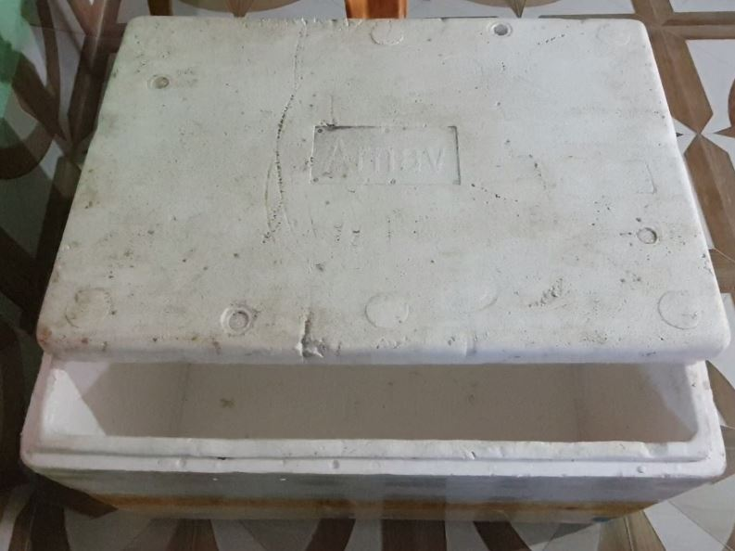 | 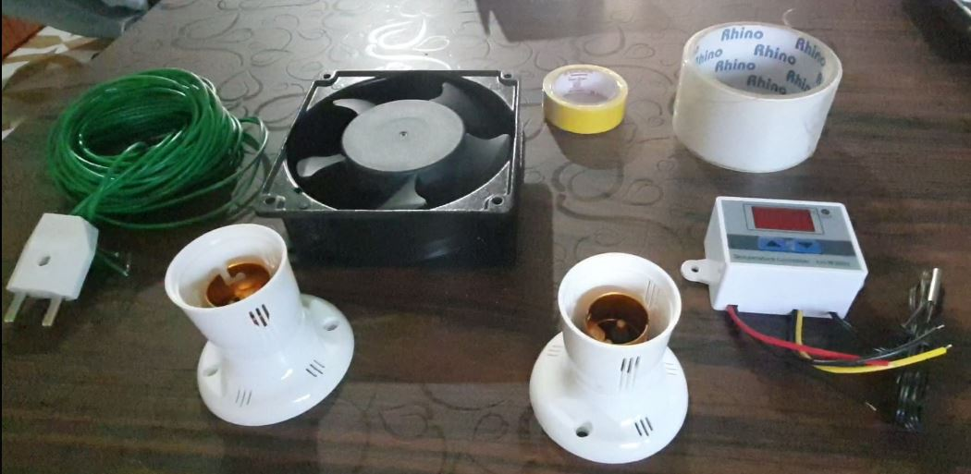
Pic. No.1. Thermocol, Fish box | Pic. No.2. Fan, Thermostat, holder, electric wire and cello/black tape
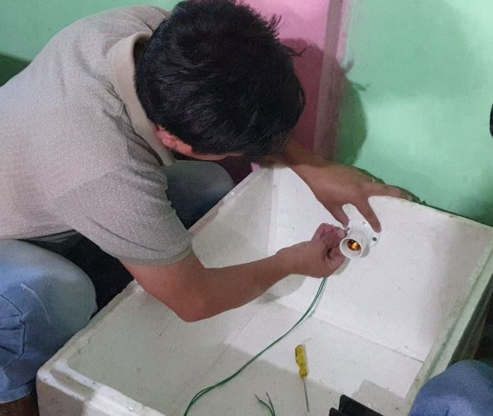 | 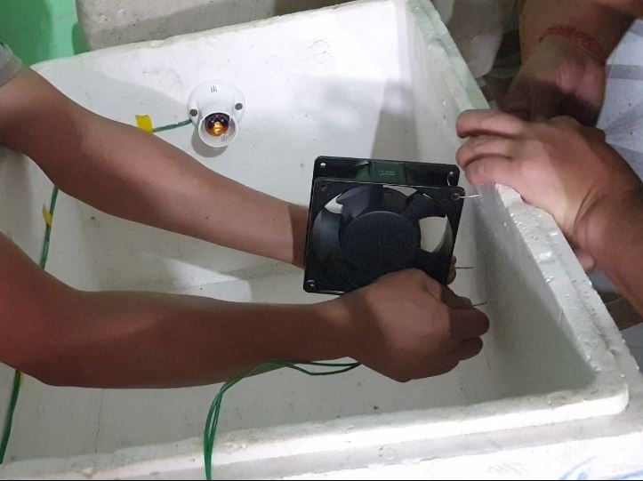
Pic. No.3. Fixing holder in both the side | Pic. No.4. Fixing exhaust fan
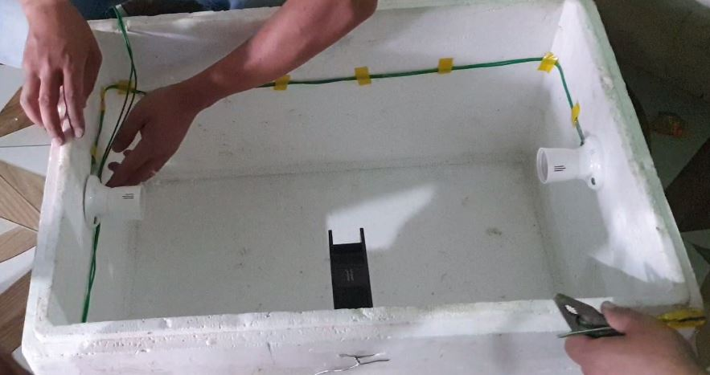 | 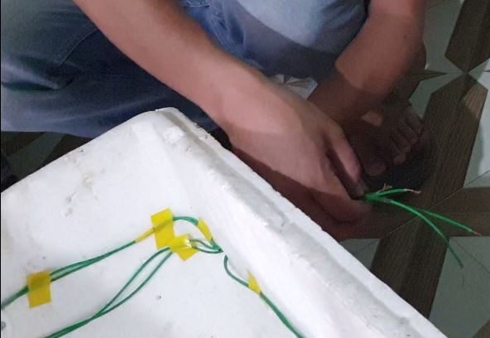
Pic. No.5. Assembling the wire and fixing with balck tape | Pic. No.6. Brining all the other end of wire through single hole outside the incubator
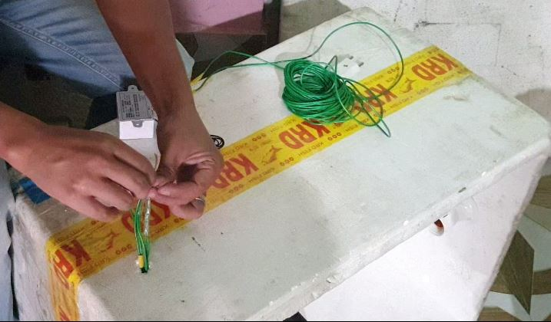 | 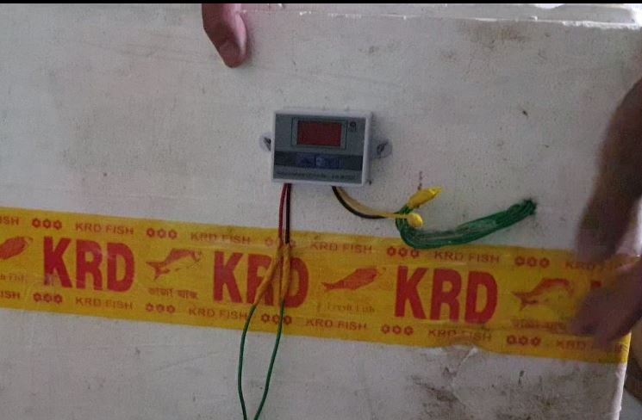
Pic.No.7. Connecting the thermostat positive output with positive end of wire and negative end with negative wire of fan and light bulb | Pic.No.8. Fix the thermostat by mounting in wall of box with help of binding wire
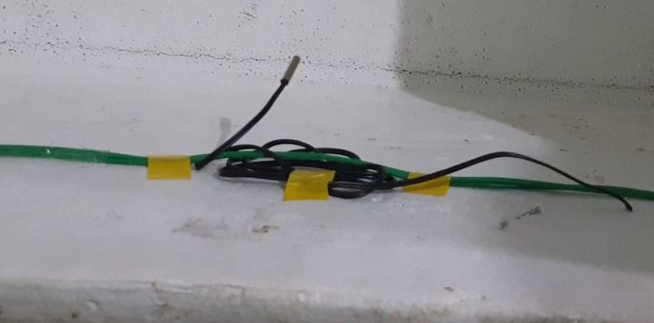 | 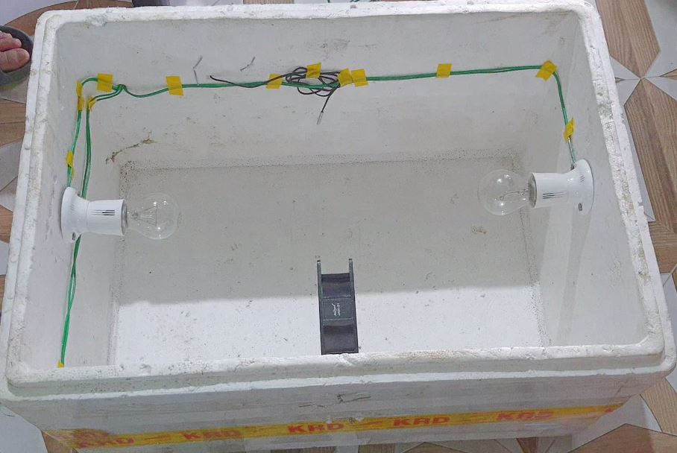
Pic.No.9. Thermostat sensor must be kept hanging | Pic. No.10. Walk eye view of complete inside setup
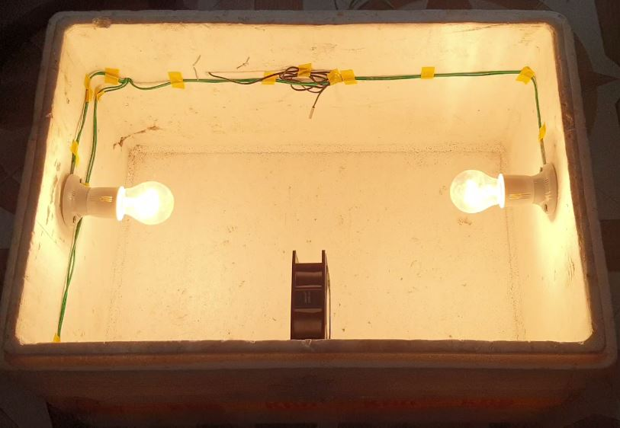 | 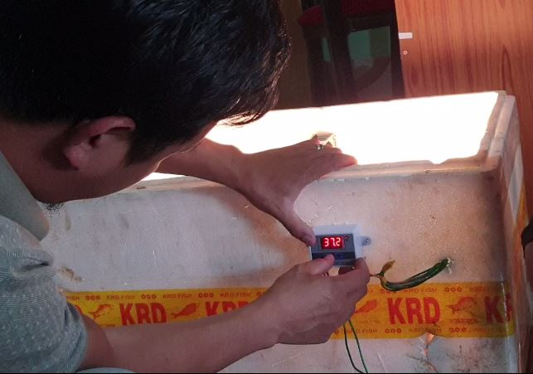
Pic.No.11. Trial for right connection | Pic.No.12. Temperature setting up (Lower & upper limits)
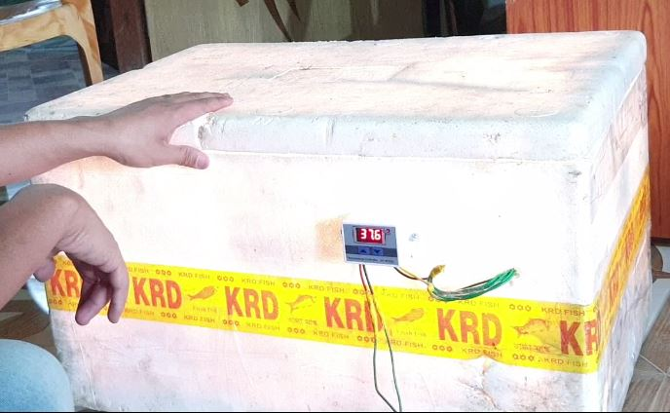 | 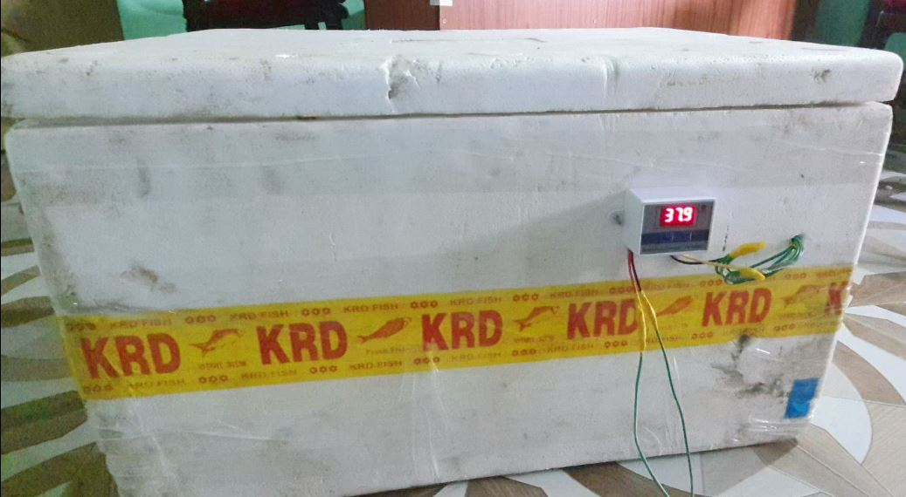
Pic.No.13. Temperature at lower range (37.5º C) light gets ON | Pic.No.14. Temperature at upper range (37.9º C) light gets OFF.
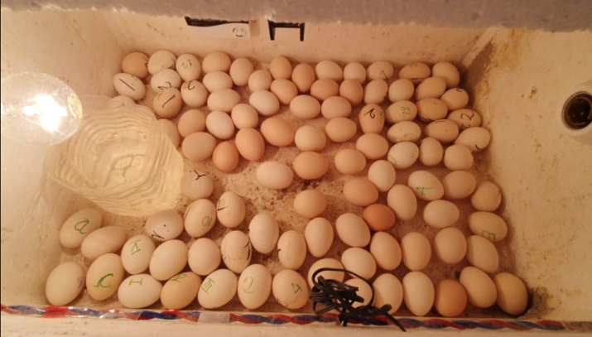 | 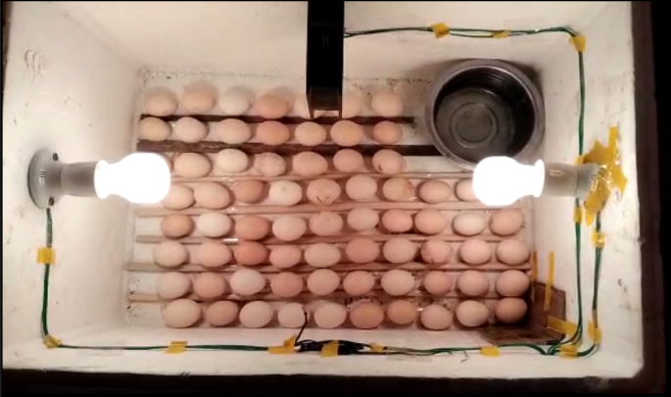
Pic. No. 15. Randomly setting of egg in incubator | Pic. No. 16. Setting of egg in row in incubator
 | 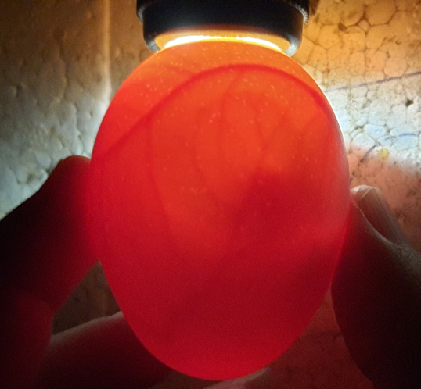
Pic.No.17. Candling of egg on 5th day | Pic.No.18. Candling of egg on 7th day
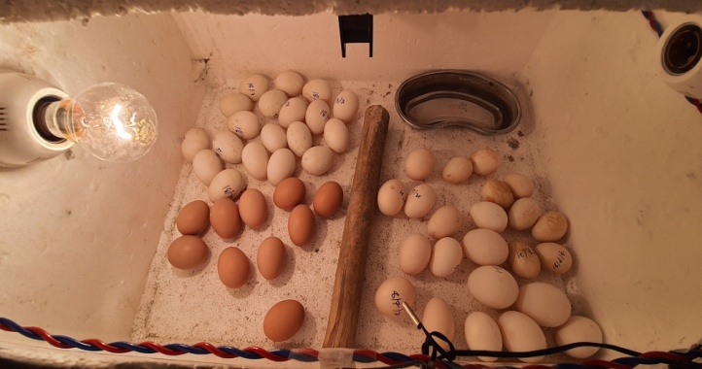 | 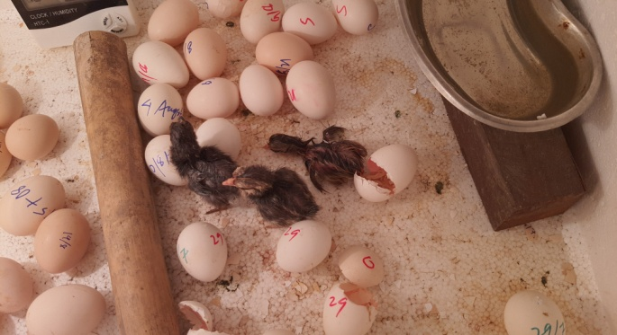
Pic.No.19. Setting eggs by partition in incubator | Pic.No.20. Chicks hatching out in 21 days of incubations
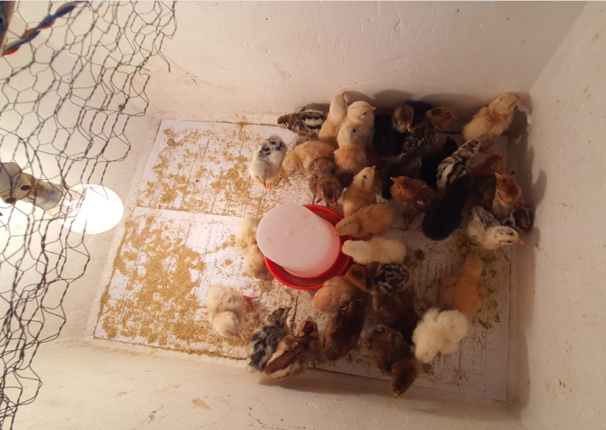 | 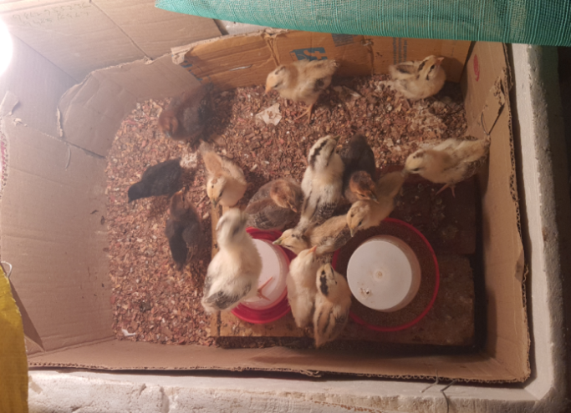
Pic.No.21. Brooding of chicks under thermocol box | Pic.No.22. Brooding of chicks under cartoon box

8. REFERENCES
- Deeming, D. C. (2002). Behaviour patterns during incubation. In D. C. Deeming (Ed.), Avian Incubation: Behaviour, Environment, and Evolution (pp. 63-87). Oxford University Press. https://global.oup.com/academic/product/avian-incubation-9780198508106
- Sonaiya, E. B., & Swan, S. E. J. (2004). Small-scale poultry production: Technical guide. FAO Animal Production and Health Manual. https://www.fao.org/3/y5169e/y5169e00.htm
- French, N. A. (1997). Modeling incubation temperature: The effects of incubator design, embryonic development, and egg size. Poultry Science, 76(1), 124–133. https://doi.org/10.1093/ps/76.1.124
- ICAR-Directorate of Poultry Research. (2019). Annual Report 2018-19 AICRP on Poultry Breeding and Poultry Seed Project. ICAR-Directorate of Poultry Research. https://pdonpoultry.org/downloads/annual-report
- King'ori, A. M. (2011). Review of the factors that influence egg fertility and hatchabilty in poultry. *International Journal of Poultry Science*, *10*(6), 483–492. https://doi.org/10.3923/ijps.2011.483.492
- Rao SVR, Radhika K, Prakash B, et al. Performance of improved strains for backyard poultry production in India.Indian J Poult Sci. 2017;52(3):291–296.
- Tona K, Bamelis F, Coucke W, et al. Factors influencing chick quality at hatch.World’s Poult Sci J.2004;60:75–86.
- Tullett, S. G. (1990). Science and the art of incubation. *Poultry Science*, *69*(1), 1–15. https://doi.org/10.3382/ps.0690001

