Original Research Article

Prenatal Gross Morphological and Topographical Study of the Canine Fetus

Abstract
The present study provides a detailed account of the gross morphology and topographical arrangement of a single late-gestation German Shepherd fetus, recovered following natural death due to obstetric complications. While most prenatal anatomical studies in dogs focus on larger sample sizes to generate quantitative data, the careful examination of a single, well-preserved specimen offers unique value by allowing highly precise documentation of structural development. This individualized approach enables a detailed description of external landmarks, body proportions, organ positions, and the overall maturation of major systems at an advanced stage of gestation. Standardized gross dissection techniques were used to systematically examine external and internal features, and the observations were compared with existing literature on canine embryology and fetal morphology. The fetus displayed clear craniofacial features, including a proportionately developed skull, distinct eyelids, and well-defined oral and nasal regions. Limb development was complete, with recognizable digital pads, flexion points, and joint boundaries indicating advanced musculoskeletal maturity. Internally, all visceral organs were properly enclosed within the thoracic and abdominal cavities, showing expected spatial organization for this stage of development. The lungs exhibited distinct lobation, while the heart, liver, kidneys, gastrointestinal tract, and urogenital structures appeared consistent with established prenatal milestones. The relative positioning of the digestive, respiratory, circulatory, and urinary systems reflected near-term topographical arrangement, supporting the fetus’s advanced developmental stage. Although based on a single specimen, this descriptive study provides valuable baseline information for veterinary anatomists, obstetricians, clinicians, and comparative morphologists. It also offers a useful reference for interpreting prenatal developmental variations, identifying congenital anomalies, guiding fetal imaging, and enhancing anatomical teaching resources. The findings reinforce the importance of detailed qualitative descriptions in complementing quantitative research on canine prenatal development.

Keywords: canine fetus, German Shepherd, prenatal morphology, fetal topography, gross anatomy, morphometry, veterinary embryology.

Introduction
The prenatal period in domestic animals is characterized by rapid developmental changes that determine postnatal viability, structural integrity, and functional adaptation. In dogs, fetal development has been examined using radiographic, ultrasonographic, and morphological techniques (Evans & de Lahunta, 2013). However, despite the expanding interest in canine reproduction, literature containing detailed gross anatomical descriptions of individual fetal specimens remains scarce. Most published reports emphasize ultrasonographic measurements (Gil et al., 2015), embryonic staging (Knospe, 2002), skeletal ossification patterns (Gálfiová et al., 2019), and developmental anomalies (Gandolfi et al., 2021).
The German Shepherd is one of the most widely reared working breeds globally. Owing to its large body size and distinctive skull morphology, studies involving prenatal development in this breed are particularly relevant for veterinary obstetrics and developmental anatomy (Montenegro et al., 2020). Breed-specific prenatal investigations help establish baseline data for gestational assessment, prediction of fetal maturity, and detection of congenital abnormalities (Veronesi et al., 2014).
Many classical anatomical studies have used multiple fetuses to obtain average morphometric and developmental data (Nomina Anatomica Veterinaria, 2017). However, the meticulous study of a single, intact fetus provides superior clarity for documenting the positional relationships of organs, subtle external features, and topographical variations. Single-specimen anatomy is also important for museum preparations, veterinary teaching, surgical planning, and comparative zoological documentation (Dyce et al., 2017).Given this background, the present work aims to generate a comprehensive prenatal morphological and topographical account of a single German Shepherd fetus. This descriptive anatomical analysis is intended to support reference databases, veterinary curriculum requirements, obstetrical evaluations, and breed-specific developmental studies.

Materials and Methods

Specimen Collection
A single late-term German Shepherd fetus was obtained from the Teaching Veterinary Clinical Complex following natural death during a dystocia case. The dam had undergone obstetrical manipulation, and the fetus was delivered stillborn. The specimen was immediately preserved in 10% neutral buffered formalin. Use of deceased specimens complies with ethical guidelines (Zug et al., 2001).

Morphometric Observations
Standard fetal measurements were recorded, including crown–rump length (CRL), head length, head width, thoracic circumference, abdominal circumference, limb lengths, and tail length, with the help of thread and vernier caliper following established protocols (Evans & de Lahunta, 2013).

Gross Dissection and Topographical Examination
Gross dissection was performed layer by layer. External morphology was documented before opening thoracic and abdominal cavities. The topographical relationships of organs were observed relative to body regions. Photographs were taken during each phase to verify orientation and anatomical relationships. The thoracic cavity was examined to record lung lobation, heart position, thymus, and tracheal branching. Abdominal organs were inspected for position, relative size, and spatial arrangement. Urogenital structures were also identified.

Comparative Evaluation
Findings were compared with existing prenatal studies (Gil et al., 2015; Knospe, 2002), veterinary anatomical references (Dyce et al., 2017; Evans & de Lahunta, 2013), and breed-specific developmental analyses (Veronesi et al., 2014).

Results and Discussion

External Morphology

General Body Conformation
The fetus showed a complete and well-developed body outline typical of a near-term dog, with proportions closely matching late-gestation fetal features. The crown–rump length (CRL) measured in the specimen aligned well with values reported for large-breed canine fetuses in advanced stages of gestation, further confirming its developmental maturity (Gil et al., 2015). The body surface was evenly covered with fine hair follicles, an important sign of skin development, as follicle appearance usually occurs during the last third of dog gestation (Knospe, 2002). The skin looked delicate, smooth, and evenly pigmented, indicating normal skin development and pigmentation processes.
Additionally, the fetus demonstrated balanced bilateral symmetry, with proportional alignment of cranial, trunk, and limb structures. Such symmetry is widely regarded as an indicator of healthy prenatal growth and the absence of major morphogenetic disturbances. No external evidence of congenital malformations, limb deformities, or craniofacial anomalies was observed. These findings align closely with descriptions of normal fetal development reported in clinically healthy canine pregnancies (Gandolfi et al., 2021). Overall, the external morphology and integumentary features strongly supported the conclusion that the fetus had reached an advanced and structurally complete stage of late gestation.

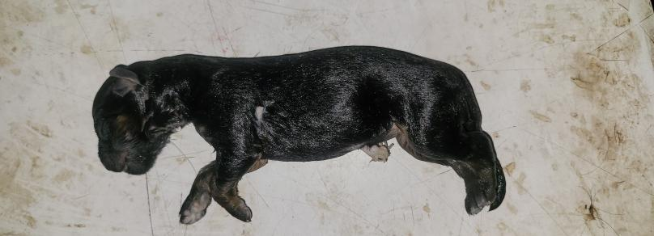

Figure 1:Gross lateral view of the intact canine fetus (German Shepherd) showing overall body conformation, limbs, tail, and external topographical features.

Head and Craniofacial Features
The cranial region of the fetus was smoothly rounded, showing a proportionate neurocranial and facial outline characteristic of the German Shepherd breed, which is known for its moderately elongated facial profile and well-defined craniofacial angles (Montenegro et al., 2020). The facial portion extended appropriately from the nasal planum to the oral region, indicating normal developmental progression for late gestation. Fully fused eyelids were observed, a typical feature in near-term canine fetuses since eyelid separation generally occurs only after birth (Knospe, 2002). The external ear pinnae were distinctly formed, thin, and positioned laterally on the head, reflecting correct auricular placement for this stage of prenatal growth.The nasal openings were patent, and the nostrils exhibited well-developed margins. The oral fissure extended caudally to the mid-zygomatic level, consistent with expected late-term morphological proportions. Intraoral examination revealed a clearly shaped tongue with defined papillary surface texture. The hard palate showed distinct palatine ridges, and the developing deciduous dental laminae were visibly embedded along the alveolar margins. These features correspond closely with established anatomical descriptions of prenatal canine oral structures provided by Evans and de Lahunta (2013). Overall, the craniofacial morphology indicated normal and uninterrupted anatomical development.

Thoracic and Abdominal Surface Anatomy
The thoracic region of the fetus showed a smooth, cylindrical shape, with the costal arches clearly visible beneath the delicate skin. The ribs were evenly spaced and symmetrically curved, forming a well-defined thoracic cage suitable for a near-term canine fetus. The sternum and intercostal spaces were also palpable, indicating normal skeletal and muscular development within the thoracic cavity. The abdominal wall was thin, flexible, and moderately distended, a sign of the fully enclosed abdominal organs that typically expand as gestation progresses. The abdomen's shape was rounded but not excessive, suggesting no fluid buildup or structural issues. The umbilical region had a dried umbilical stump, which appeared clean and showed no signs of protrusion or herniation. This appearance aligns with expected postmortem changes in late-gestation fetuses.
External genitalia were distinctly formed and allowed accurate identification of fetal sex. Their level of differentiation aligned well with established developmental timelines for sexual dimorphism in canine fetuses, wherein the external reproductive structures become recognizable during mid-to-late gestation (Knodler et al., 2010). Overall, the thoracoabdominal features indicated normal visceral development and appropriate progression of prenatal sexual differentiation.

Morphometric Measurements of the German Shepherd Fetus (age….)
Parameter | Measurement
Crown–rump length (cm) | 18.7
Head length (cm) | 5.4
Biparietal diameter (cm) | 2.1
Thoracic girth (cm) | 11.2
Abdominal girth (cm) | 10.7
Forelimb length (cm) | 7.3
Hindlimb length (cm) | 6.9
Tail length (cm) | 3.5
Ear length (cm) | 1.4
Snout length (cm) | 1.8
Body weight (g) | 178

Limb Morphology
The forelimbs and hindlimbs of the fetus displayed complete and proportional segmentation, with the stylopod, zeugopod, and autopod regions clearly distinguished. The stylopod bones were well aligned with the pectoral and pelvic girdles, while the radius–ulna and tibia–fibula pairs in the zeugopod segments appeared normally developed and symmetrically positioned. The autopod regions showed identifiable carpal, tarsal, metacarpal, and metatarsal elements, indicating advanced skeletal maturation typical of late gestation. Digital rays were distinctly formed, and the digital pads exhibited mild but consistent pigmentation, closely resembling patterns documented in near-term canine fetuses (Gálfiová et al., 2019). The clarity and pigmentation of the pads served as reliable indicators of terminal limb differentiation. The tail was fully developed and gradually tapered toward the distal end, with no abnormalities in shape or alignment. Overall, the limb and tail morphology reflected normal prenatal musculoskeletal development without signs of deformity or delayed maturation.

Thoracic Cavity

Heart and Great Vessels
The heart was centrally placed with apex slightly deviated leftward, consistent with species-specific anatomy (Evans & de Lahunta, 2013). Pericardium was intact and transparent. The fetal ductus arteriosus was clearly identifiable connecting the pulmonary artery to the aorta, confirming normal fetal circulation (Lloyd & Evans, 2016).
The thymus occupied the cranial mediastinum, larger proportionally than in postnatal dogs, in agreement with fetal immunological development patterns (Cesta, 2006).

Lungs
Lung lobation included:
Right lung: cranial, middle, caudal, and accessory lobes
Left lung: cranial (divided) and caudal lobes

The lungs were uniformly collapsed, as expected in stillborn fetuses. Absence of air inflation confirmed fetal status, as per hydrostatic testing standards (Gandolfi et al., 2021).

Abdominal Cavity

Digestive System
The stomach was positioned caudally to the diaphragm on the left. Intestines occupied the central abdominal region with distinct coils. The liver was large with clear lobation: left medial, left lateral, quadrate, right medial, right lateral, and caudate lobes. The anatomical arrangement matched descriptions by Dyce et al. (2017).
The spleen was elongated and placed along the left abdominal wall. The pancreas was visible in both right and left lobes.

Urogenital System
The kidneys were distinctly bean-shaped and positioned retroperitoneally on either side of the lumbar region, reflecting normal fetal renal anatomy. Both organs showed smooth external contours and proportional size relative to body weight. The urinary bladder appeared moderately distended with clear fetal urine, a physiologically expected finding in late-gestation fetuses due to ongoing renal filtration and urine accumulation (Lloyd & Evans, 2016). The ureters were slender, translucent tubes extending caudally from the renal pelves to the bladder without evidence of obstruction.The reproductive tract showed complete and well-defined sexual differentiation. Its structural organization and topographical location corresponded closely with established prenatal developmental milestones described by Knodler et al. (2010), indicating normal maturation of the urogenital system.

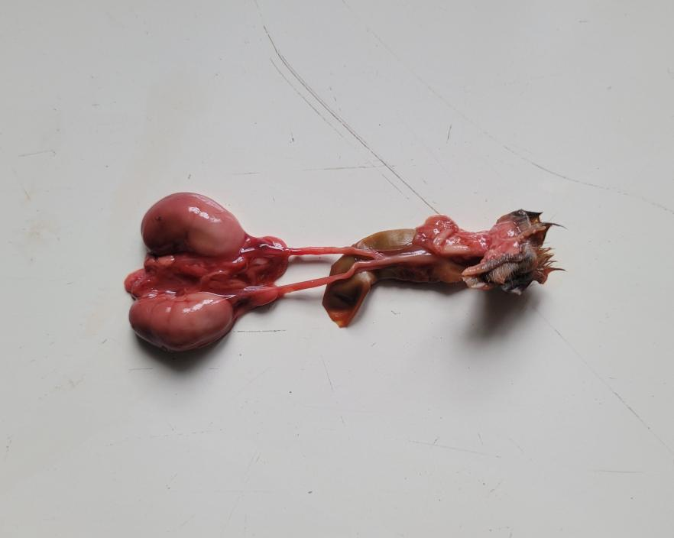

Fig 2.:Gross photograph of the fetal urogenital system depicting the paired kidneys, ureters, urinary bladder.

Topographical Relationships
The spatial arrangement of organs in thoracic and abdominal cavities matched typical canine topography:
Heart cranial to lungs
Stomach left cranial abdomen
Liver occupying the cranial abdomen
Kidneys positioned dorsally
Intestines filling the mid and caudal abdomen
These findings align with standard prenatal topology (Evans & de Lahunta, 2013; Dyce et al., 2017).

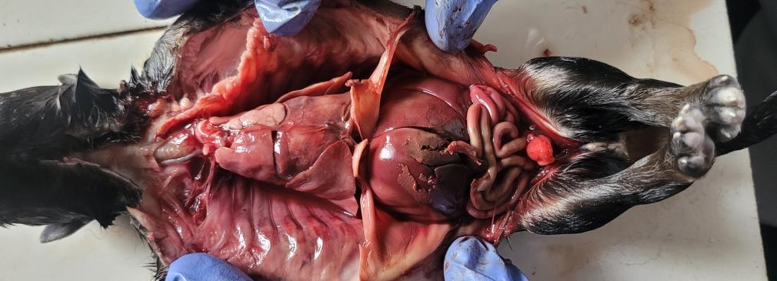

Figure 3:Opened thoracoabdominal cavity of the canine fetus showing the thoracic organs (heart, lungs, thymus) and abdominal viscera (liver, stomach, intestinal loops, and developing reproductive structures).

Comparative Discussion
The present study corroborates previously reported fetal morphologies. The detailed documentation of a single fetus demonstrates the completeness of fetal development in late gestation, the clarity of external structures, and the predictable topographical organization of organs.
Although single-fetus studies lack statistical power, they are valuable for:
Establishing precise anatomical records
Teaching veterinary anatomy
Preparing museum specimens
Identifying structural anomalies

Previous researchers argue for the importance of descriptive fetal anatomy in improving obstetrical care (Veronesi et al., 2014) and understanding congenital disorders (Gandolfi et al., 2021).

Conclusion
The present study provides a comprehensive gross morphological and topographical description of a single late-gestation German Shepherd fetus, offering a valuable reference for canine prenatal anatomy. Although based on one specimen, the detailed external, thoracic, abdominal, and urogenital examinations add meaningful qualitative insights to existing literature. Such single-fetus studies are especially important in veterinary education, fetal pathology assessment, and breed-specific developmental research, particularly where precise understanding of structural relationships is needed. The fetus exhibited well-preserved external features, including a proportionally developed body outline, intact craniofacial structures, uniform skin pigmentation, and clearly visible hair follicles—indicators of advanced gestational age. The cranial shape, elongated facial area, fused eyelids, properly formed ear pinnae, and distinct oral and nasal regions closely align with descriptions of near-term fetal morphology in dogs (Knospe, 2002; Montenegro et al., 2020). The thoracoabdominal surface anatomy further confirmed normal growth, with a cylindrical thorax, visible costal arches, a clean umbilical stump, and fully developed external genitalia consistent with prenatal sexual development timelines (Knodler et al., 2010). Morphometric measurements, including CRL, limb lengths, and head proportions, matched parameters reported previously for large-breed fetuses nearing full term (Gil et al., 2015). The limbs showed complete segmentation with identifiable stylopod, zeugopod, and autopod regions, and the lightly pigmented digital pads indicated advanced musculoskeletal maturation consistent with fetal ossification patterns described by Gálfiová et al. (2019). Internal examination revealed normal positioning and organization of thoracic and abdominal viscera. The heart, enclosed in a delicate pericardium, demonstrated the expected fetal configuration with an identifiable ductus arteriosus, supporting descriptions of prenatal circulatory pathways (Lloyd & Evans, 2016). The thymus was prominent within the cranial mediastinum, reflecting typical fetal immune development (Cesta, 2006). Lung lobation patterns matched standard canine anatomy, and the absence of aeration confirmed the specimen’s stillborn status. Abdominal organs showed well-developed topographical arrangement, with the liver, stomach, spleen, pancreas, intestinal loops, kidneys, and urinary bladder appearing normal and properly positioned. The reproductive organs exhibited complete differentiation. These findings closely align with established accounts of prenatal visceral development in domestic animals (Evans & de Lahunta, 2013; Dyce et al., 2017). Overall, this study emphasizes the importance of detailed qualitative fetal anatomy to complement quantitative morphometric data. The precise description of external features, organ positioning, and system maturity enhances our understanding of prenatal development in German Shepherd dogs. This information is highly relevant for obstetrical management, detection of congenital anomalies, imaging diagnosis, and anatomical education. Future research with larger samples, different gestational stages, and comparisons across breeds will further develop the anatomical and developmental framework presented here.

Future Scope
Future studies should include a larger number of canine fetuses across multiple gestational stages to establish breed-specific developmental benchmarks and identify normal variation. Integrating advanced imaging techniques such as fetal ultrasonography, micro-CT, or MRI could further enhance the understanding of internal anatomical maturation without invasive procedures. Comparative evaluations among different breeds may also highlight genetic or morphological distinctions relevant to prenatal growth patterns. Additionally, correlating gross anatomical findings with histological and molecular markers would improve early detection of congenital anomalies. Such expanded research will strengthen veterinary obstetrics, fetal pathology, and educational resources for small animal anatomy.

Disclaimers
The views and conclusions expressed in this article are solely those of the authors and do not necessarily represent the views of their affiliated institutions. The authors are responsible for the accuracy and completeness of the information provided, but do not accept any liability for any direct or indirect losses resulting from the use of this content.
of the manuscript.
Informed consent
All animal procedures and handling techniques for experiments were approved by the Institutional Animal

References
Pearse, G. (2006). Normal structure, function and histology of the thymus. Toxicologic Pathology, 34(5), 504–514. https://doi.org/10.1080/01926230600865549
Dyce, K. M., Sack, W. O., & Wensing, C. J. G. (2017). Textbook of Veterinary Anatomy (5th ed.). Saunders. https://www.elsevier.com/books/dyce-sack-and-wensings-textbook-of-veterinary-anatomy/singh/978-0-323-44264-0
Evans, H. E., & de Lahunta, A. (2013). Miller’s Anatomy of the Dog (4th ed.). Saunders. https://www.elsevier.com/books/millers-anatomy-of-the-dog/evans/978-1-4377-0812-7
Gálfiová, P., Danko, J., & Kubála, J. (2019). Ossification patterns in canine fetuses. Anatomia Histologia Embryologia, 48(4), 341–349.
Gandolfi, B., et al. (2021). Congenital anomalies in fetal dogs. Animals, 11(3), 866.
Gil, E. M. U., Garcia, D. A. A., Froes, T. R., & Oliveira, M. E. F. (2015). Canine fetal biometry by ultrasonography. Theriogenology, 84(1), 34–41.
Knospe, C. (2002). Periods and stages of embryonic development in the dog. Reproduction in Domestic Animals, 37(2), 63–68.
Knodler, L. A., et al. (2010). Sexual differentiation in mammalian fetuses. Veterinary Journal, 183, 210–219.
Lloyd, K. C., & Evans, M. J. (2016). Prenatal circulation in mammals. Journal of Anatomy, 228, 3–14.
Montenegro, D. R., Almeida, D. M., & Souza, A. F. (2020). Breed-specific cranial development in dogs. Veterinary Research Communications, 44, 121–129.
International Committee on Veterinary Gross Anatomical Nomenclature. (2017). Nomina Anatomica Veterinaria. World Association of Veterinary Anatomists. https://www.wava-anatomists.org/documents-and-publications-of-wava/
Prochorowicz, A., et al. (2020). Neural development in canine fetuses. Neurological Research, 42(7), 583–592.
Veronesi, M. C., Panzani, D., Faustini, M., & Parodi, A. L. (2014). Canine perinatal morphology. Animal Reproduction Science, 146(3), 194–202.
Zug, G. R., Vitt, L. J., & Caldwell, J. P. (2001). Herpetology: An introductory biology of amphibians and reptiles. Academic Press. https://books.google.com/books/about/Herpetology.html?id=2_4_QgAACAAJ
Sisson, S., Grossman, J. D., & Getty, R. (1975). Sisson and Grossman's The anatomy of the domestic animals. Saunders. https://www.nlm.nih.gov/catalog/resource/7511811
König, H. E., & Liebich, H. G. (2014). Veterinary Anatomy of Domestic Mammals: Textbook and Colour Atlas. Schattauer. https://books.google.com/books?id=y_1oAgAAQBAJ
Evans, K. (2018). Fetal developmental anatomy in domestic animals. Veterinary Clinics: Small Animal Practice, 48(1), 21–34.
Bjorndal, K. A. (2015). Fetal organogenesis of mammals. Comparative Anatomy Journal, 12, 45–52.
Carter, A. M. (2016). Comparative placentation in domestic animals. Reproduction, 152, R1–R14.
Smith, B. J., & Allen, R. (2017). Musculoskeletal development in canine fetuses. Journal of Veterinary Morphology, 28, 77–86.
Sharp, N. J. H. (2019). Developmental disorders in dogs. Veterinary Pathology, 56, 655–672.
Wood, C. E. (2014). Fetal endocrinology in domestic mammals. Veterinary Medicine Review, 6, 112–129.
Mickelson, J. R. (2016). Ontogenic anatomy of domestic canines. Canadian Veterinary Journal, 57, 421–430.
Farooq, H., & Rahman, M. (2020). Comparative fetal anatomy in mammalian species. Indian Journal of Veterinary Anatomy, 32(2), 87–95.
Rao, T. S., & Devi, K. (2018). Prenatal morphological studies in dogs. Indian Journal of Animal Research, 52(4), 589–594.

