Identification of sources of resistance against Fusarium wilt of safflower

Abstract
A comprehensive field experiment, comprising three replications, was executed at the All India Coordinated Research Project (AICRP) on safflower, situated at the Agricultural Research Station in Annigeri, UAS, Dharwad, during the Rabi season of 2021-22 &2022-23, aimed at the assessment of various genotypes in relation to their susceptibility to the predominant wilt disease. In the context of evaluating wilt resistance against F. oxysporum f. sp. carthami, a total of forty-one genotypes or elite materials were subjected to rigorous testing alongside a susceptible control within a wilt affected plot. Among the forty-one genotypes assessed, twenty six exhibited a highly susceptible response, while the susceptible check, Nira, demonstrated a wilt incidence of 56.78% at 30 days after sowing (DAS), which escalated to 88.60% at 90 DAS. Twelve genotypes were categorized as having a susceptible reaction, including ISF-123-Sel-15 and GMU-1815. Furthermore, three genotypes displayed a moderately resistant reaction, namely PYT 10-4 and A-2020, whereas DSAF was identified as exhibiting a resistant reaction. This study elucidates that the screening of genotypes for disease resistance constitutes a critical phase in the development of cultivars or hybrids endowed with enhanced resistance to wilt disease.
Introduction
Safflower (Carthamus tinctorius L.) constitutes an oilseed crop primarily cultivated during the post-monsoon season, predominantly within the Vertisol soils of the Deccan region in India. Globally, India holds the distinction of being the foremost producer of safflower, encompassing an area of 0.56 lakh hectares with an average yield of 640 kg ha⁻¹ Safflower is classified as a rabi crop and possesses resilience to drought, salinity and saline irrigation. In India, safflower is cultivated for its vegetable oil and fodder applications, in addition to the extraction of the orange-red dye (carthamin) from its florets.
Safflower is susceptible to a variety of fungal pathogens, including leaf spot/blight (Alternaria carthami), wilt (Fusarium oxysporum f.sp.carthami), root rot (Rhizoctonia bataticola), powdery mildew (Erysiphe cichoracearum DC), anthracnose (Colletotrichum capsici), and charcoal rot (Macrophomina phaseolina (Tassi) Goid), as well as bacterial (leaf blight/spot (Pseudomonas syringae van Hall)) and viral diseases (Mosaic (cucumber mosaic virus), necrosis (tobacco streak virus)) at various developmental stages of crop growth (Bhale et al., 1998).
Seed and soil-borne pathogens, particularly fungi, directly and indirectly impact both the quality and quantity of oilseed crops by causing deterioration and reducing oil content, germination rates, seed viability and overall yield potential. A primary concern is that seed-borne plant pathogens can introduce diseases into regions that were previously unaffected by such pathogens. In safflower cultivation, known seed-borne fungi such as Fusarium wilt, Macrophomina root rot, and Alternaria blight lead to significant losses for this crop.
Wilt of safflower caused by Fusarium oxysporum f. sp. carthami Klisiewicz and Houston is an important soil borne disease occurring mainly in poor drained areas of Karnataka and Maharashtra leading to yield losses as high as 80% (Kalpana Sastry et al., 1997). The disease is reported to be seed transmitted upto 10-40% and the fungus perpetuates as mycelium and spores on the seed and seed coat or as chlamydospores in plant debris in soil (Chakrabarti et al., 1980). Wilt of safflower is a soil and seed borne disease and therefore, efforts were made to control the disease and to reduce the yield losses.
Breeding for disease resistance is the most economical and convenient method for controlling major diseases of safflower. Though, germplasm lines or cultivars showing partial or full resistance to some of the major diseases have been identified, the availability of genetic resistance is found to be rare. Though number of resistance sources identified against wilt across the globe, as mentioned above, continuous change in the genetic makeup of pathogen warrants continuous search for host resistance. To overcome this problem, the present study was carried out with an objective to find out genotypes with resistance to wilt.
Material and methods
The experimental study was conducted at the Agricultural Research Station in Annigeri, UAS, Dharwad during the Rabi season of 2021-22 & 2022-23. The research was executed utilizing a randomized block design methodology. Each genotype line was planted in a length of 3 meters in a two-row arrangement with spacing of 30 × 20 cm, as a reduced distance is conducive to the proliferation of diseases.
Safflower genotypes from various institutions, including the Indian Institute of Oilseed Research in Hyderabad, ARS Tandur, ARS Solapur, and ARS Annigeri, were evaluated for their susceptibility to wilt within a wilt sick plot, which was maintained at the Agricultural Research Station in Annigeri during the rabi season of 2021-22 &2022-23. Recommended agronomic practices and integrated pest management strategies were adhered to and the disease intensity was systematically recorded under field conditions. Approximately 41 safflower genotypes were assessed within the wilt sick plots for their resistance to wilt. The disease incidence was quantified utilizing a modified 0-9 disease scale, as delineated by Mayee and Datar (1986), with observations recorded at intervals of 30, 60, and 90 days post-sowing.
The per cent incidence of wilt was calculated using the following formula:
Number of wilted plants
Percentage wilt incidence (%) = × 100
Total plant population
Table 1. Disease scale and reactions
(0-9) scale | Particulars | Reactions
0 | 0 (%) no wilting symptoms on plant | HR (Highly resistant)
3 | 0.1- 10 (%) plants wilted | R (Resistant)
5 | 10.1- 20 (%) plants wilted | MR (Moderately resistant)
7 | 20.1- 30 (%) plants wilted | S (Susceptible)
9 | More than 30.1 (%) plants wilted | HS (Highly susceptible)

Result and Discussion
The results revealed that the safflower genotypes exhibited the considerable variation towards diseasese reaction (Table 2). Entries were differentiated into five groups in relation to their resistance reaction (Table 3). Out of 41 entries, no entry has shown the highly resistant reaction with zero wilting, one genotype (DSAF) exhibited resistant reaction with 0.1 - 10 (%) wilted plants, two genotypes (PYT -10 -4, A2020) were recorded moderately resistant reaction with 10.1-20(%) wilted plants, twelve genotypes (ISF-123-Sel-15, SSF-18-72, SAF -P -1911, 1902, 19 -20, SAF -1906, 2002, 1911, PBNS -208, 210, TSF -88, GMU -1815) recorded susceptible reaction with 20.1 - 30 (%) wilted plants and remaining genotypes were highly susceptible with more than 30.1 (%) wilted plants (Table 3).
It was noticed that majority of the genotypes recorded susceptible and highly susceptible reaction to Fusarium wilt. The susceptible check (Nira) exhibited the mean per cent wilt incidence of 73.92 per cent (Table 2). Phad and Jagtap (1990), Sastry and Ramachandram (1994), shinde et al. (1994), Anon. (2001), Sastry and Chattopadhyay (2003), Murumkar et al. (2013), Rupesh and Aarshit (2014), Reddy et al. (2017) and Rajendra prasad et al. (2021) evaluated the safflower genotypes against Fusarium wilt and recorded the differential responses. It is also observed in earlier studies of Murumkar et al. (2008) who evaluated nine safflower varieties against wilt under sick plot conditions. They reported that none of the popular varieties (Bhima, Phule Kusuma, Sharada, Manjira, PBNS-12, A-l, JSI-7) were immune or resistant to wilt disease. Only two hybrids NARI-NH-1, DSH129 and one non-spiny variety NARI6 recorded least disease intensity. Similar a screening trail conducted by Kalpana Sastry and Chattopadhyay (2003) screen with 51 promising safflower germplasm lines in Fusarium wilt infested plot resulted in identification of highly wilt resistant selections viz., 86-93-36A, 237550, VI-92-42 and II-13-2A, with moderate resistance in HUS-305. These findings suggest that, it is possible to improve an existing genotype/ elite line through further selection and screening of the progenies of the parental line.
Conclusion
In the context of evaluating wilt resistance against F. oxysporum f. sp. carthami, a total of forty-one genotypes or elite materials were subjected to testing alongside a susceptible control in a wilt-infested plot. Among the forty-one genotypes assessed, twenty-six entries exhibited a highly susceptible response, while the susceptible control, Nira, recorded a wilt incidence of 56.78% at 30 days after sowing (DAS), which further escalated to 88.60% at 90 DAS. Additionally, twelve genotypes demonstrated a susceptible response, notably including ISF-123-Sel-15 and GMU-1815. Furthermore, three genotypes were identified as exhibiting a moderately resistant response, specifically PYT 10-4 and A-2020, whereas DSAF displayed a resistant reaction. The severity of disease incidence was observed to escalate from 30 to 60 days post-sowing.
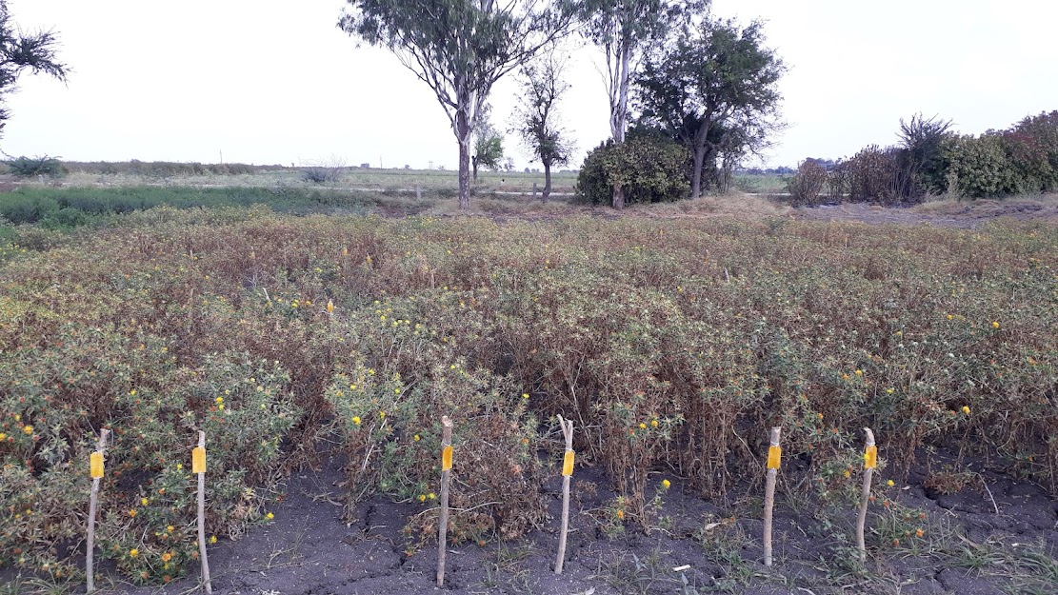
Fig .1 Field view of Wilt Sick plot

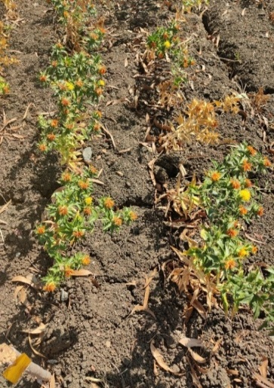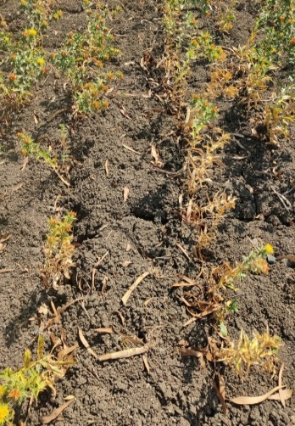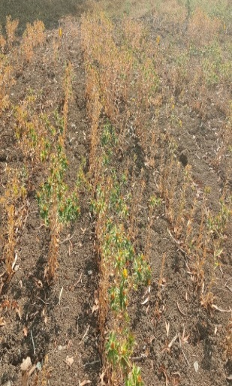
Fig.2 Genotypes resistant (R) and moderately resistant (MR) and highly susceptible (HS) to wilt
Nira : HS
A-2020: MR
A-18-01(DSAF): R

References
Anonymous, 2001, Annual progress report, safflower 2000 - 2001. Directorate of Oilseeds Research, Rajendranagar, Hyderabad, p. 117 - 131.
Chakrabarthi D K and Basuchaudhary K C, 1980, Correlation between virulence and fusaric acid production in by Fusarium oxysporum f. sp. carthami.
Phytopatholologische Zeitschirft, 99(1): 43 - 46. https://www.cabidigitallibrary.org/doi/full/10.5555/19811376015
Mayee C D and Datar V V, 1986, Phytopathometry Technical Bulletin No 1, Marathwada Agricultural University, Parbhani, Maharashtra, India. https://www.cabidigitallibrary.org/doi/full/10.5555/19861318793
Murumkar D R, Gud M A, Indi D V and Kadam J R, 2008, Variability among the isolates of Fusarium oxysporum f. sp. carthami from Maharashtra state. Journal of Plant Disease Sciences, 3(1): 24-28.
Murumkar D R, Shinde S K and Kadam J R, 2013, In vitro screening of safflower genotypes for resistance towards Fusarium wilt using fusaric acid.
Bioinfolet, 10: 1a.
Phad H B and Jagtap V S, 1990, Field resistance against safflower wilt. Indian Phytopathology, 43(2): 312.
Rajendraprasad M, Sagar B V, Devi G, Reddy C N and Triveni S, 2021, Screening of germplasm lines against safflower wilt caused by Fusarium Oxysporum f. Sp. carthami. The J. Res. Pjtsau Vol. Xlix No. 4 Pp 1-111, p.108. https://pjtau.edu.in/files/publications/2021/Journal-of-Research-PJTSAU-49-4-1.pdf#page=112
Reddy T R, Pushpavalli S, Sudhakar C and Sudharani S, 2017, Screening of safflower elite material for resistance to Fusarium wilt. Life Science International Research Journal, 4(1): 106 - 109.
Rupesh A and Aarshit V, 2014, Screening major diseases of safflower over elite
material under field conditions. International Journal of Mycology and Plant Pathology, 1(9): 85 - 87. https://www.internationalscholarsjournals.com/articles/screening-major-diseases-of-safflower-over-elite-material-under-field-conditions.pdf
Sastry K R and Chattopadhyay C, 2003, Development of Fusarium wilt
resistant genotypes in safflower. European Journal of Plant Pathology, 109(2): 147-151. https://link.springer.com/article/10.1023/A:1022502618887
Sastry K R and Ramachandram M, 1994, Effect of wilt on yield attributes of safflower. Indian Phytopathology, 42: 80-84. https://epubs.icar.org.in/index.php/IPPJ/article/view/21010
Sastry K R, 1997, Managing pests of safflower. In: Proceedings IVth International safflower conference, June 2 - 7, 1997, Bari, Italy.
Sastry, R.K and Chattopadhyay, C. 2003. Development of Fusarium wilt resistant genotypes in safflower (Carthamus tinctorius). European Journal of Plant Pathology. 109: 147-151. https://link.springer.com/article/10.1023/A:1022502618887
Shinde P B, Zope R E and Ghorpode D S, 1994, Screening of safflower cultivars aginst Fusarium wilt. Sesame and Safflower Newsletter, 9: 51 – 53

Table 2: Disease incidence on safflower genotypes against wilt caused by Fusarium oxysporum f. sp. carthami
Sl no | Entry | Per cent wilt incidence |  |  | Mean PDI | Reaction
Sl no | Entry | 30 DAS | 60 DAS | 90 DAS | Mean PDI | Reaction
1 | A2020 | 8.73  (17.19)* | 14.32  (22.24) | 19.03  (25.86) | 14.03  (21.76) | MR
2 | Nira (SC) | 56.78  (48.89) | 76.38  (60.92) | 88.60  (70.27) | 73.92  3(60.03) | HS
3 | DSAF | 5.24  (13.23) | 7.43  (15.82) | 9.47  (17.92) | 7.38  (15.66) | R
4 | PYT -10 -4 | 11.78  (20.07) | 16.41  (23.90) | 18.72  (25.64) | 15.64  (23.20) | MR
5 | PYT -10 -3 -10 | 30.81  (33.71) | 41.73  (40.24) | 52.85  (46.63) | 41.79  (40.19) | HS
6 | PYT -10 -6 | 38.82  (38.54) | 50.12  (45.07) | 70.50  (57.10) | 53.15  (46.90) | HS
7 | ISH -413 | 33.01  (35.06) | 45.39  (42.35) | 66.86  (54.85) | 48.42  (44.09) | HS
8 | ANG -18 -02 | 44.48  (41.83) | 56.53  (48.75) | 67.52  (55.25) | 56.17  (48.61) | HS
9 | RVS -18-1 | 34.88  (36.20) | 47.82  (43.75) | 68.63  (55.94) | 50.44  (45.29) | HS
10 | PBNS -198 | 40.86  (39.73) | 52.79  (46.60) | 73.61  (59.09) | 55.75  (48.47) | HS
11 | PBNS -12 | 35.75  (36.72) | 46.50  (42.99) | 68.19  (55.67) | 50.15  (45.13) | HS
12 | ISH -400 | 30.60  (33.58) | 41.64  (40.18) | 52.46  (46.41) | 41.57  (40.06) | HS
13 | RVS -18-3 | 33.80  (35.55) | 44.46  (41.82) | 65.86  (54.25) | 48.04  (43.87) | HS
14 | ISF -123-Sel-15 | 21.57  (27.67) | 25.62  (30.41) | 28.43  (32.22) | 25.21  (30.10) | S
15 | SSF -18-72 | 23.78  (29.19) | 26.57  (31.03) | 29.12  (32.66) | 26.49  (30.96) | S
16 | PBNS -183 | 30.87  (33.75) | 43.11  (41.04) | 63.67  (52.93) | 45.88  (42.57) | HS
17 | PBNS -201 | 35.14  (36.35) | 46.99  (43.27) | 67.50  (55.24) | 49.87  (44.95) | HS
18 | SAF –P -1906 | 37.47  (37.74) | 48.78  (44.30) | 69.73  (56.62) | 51.99  (46.22) | HS
19 | SAF –P -1911 | 20.46  (26.89) | 25.01  (30.00) | 27.29  (31.49) | 24.25  (29.46) | S
20 | PBNS -203 | 38.46  (38.33) | 49.48  (44.70) | 70.60  (57.16) | 52.85  (46.73) | HS
21 | SAF -1906 | 22.45  (28.28) | 25.51  (30.34) | 26.35  (30.89) | 24.77  (29.83) | S
22 | SAF -2003 | 41.86  (40.32) | 52.91  (46.67) | 74.43  (59.62) | 56.40  (48.87) | HS
23 | PBNS 208 | 23.12  (28.74) | 26.47  (30.96) | 28.73  (32.41) | 26.11  (30.71) | S
24 | TSF 88 | 21.45  (27.59) | 24.02  (29.34) | 27.21  (31.44) | 24.22  (29.46) | S
25 | SAF -2001 | 31.41  (34.09) | 43.06  (41.01) | 64.24  (53.27) | 46.24  (42.79) | HS
26 | SAF -2002 | 20.75  (27.10) | 24.68  (29.78) | 29.48  (32.88) | 24.97  (29.92) | S
27 | SAF -200 | 32.21  (34.58) | 43.85  (41.47) | 64.48  (53.42) | 46.85  (43.15) | HS
28 | GMU 7874 | 38.87  (38.57) | 50.37  (45.21) | 71.83  (57.94) | 53.69  (47.24) | HS
29 | SAF –P -1902 | 20.53  (26.94) | 25.29  (30.19) | 28.27  (32.12) | 24.69  (29.75) | S
30 | SAF –P -1901 | 40.06  (39.27) | 51.89  (46.08) | 72.84  (58.59) | 54.93  (47.98) | HS
31 | GMU 3624 | 32.03  (34.47) | 46.09  (42.76) | 66.87  (54.86) | 48.33  (44.03) | HS
32 | SAF –P -19 -20 | 21.37  (27.51) | 24.56  (29.70) | 28.92  (32.53) | 24.95  (29.92) | S
33 | SAF -1921 | 30.20  (33.34) | 41.63  (40.18) | 62.20  (52.06) | 44.68  (41.86) | HS
34 | SAF -1902 | 35.83  (36.77) | 47.92  (43.81) | 68.47  (55.84) | 50.74  (45.47) | HS
35 | GMU 1815 | 23.79  (29.19) | 27.41  (31.57) | 29.94  (33.17) | 27.04  (31.31) | S
36 | TSF -83 | 33.52  (35.37) | 45.49  (42.41) | 52.26  (46.30) | 43.75  (41.36) | HS
37 | PBNS -210 | 24.33  (29.55) | 27.65  (31.72) | 29.07  (32.63) | 27.02  (31.30) | S
38 | GMU -7960 | 31.70  (34.27) | 42.74  (40.82) | 63.79  (53.00) | 46.07  (42.70) | HS
39 | SAF -1911 | 20.57  (26.97) | 24.28  (29.52) | 28.16  (32.05) | 24.34  (29.51) | S
40 | SAF -P -1882 | 48.90  (44.37) | 56.34  (48.64) | 76.93  (61.29) | 60.72  (51.43) | HS
41 | PBNS -199 | 33.79  (35.54) | 44.02  (41.56) | 64.54  (53.45) | 47.45  (43.52) | HS
 | S. Em. ± | 1.22 | 1.53 | 2.29 | - | -
 | C. D. at 5% | 3.51 | 4.40 | 6.55 | - | -
 | C. V. (%) | 5.30 | 5.71 | 7.06 | - | -

* Figures in parenthesis indicate arc sine values

Table 3. Disease incidence and disease reaction of genotypes or elite materials against wilt of safflower caused by Fusarium oxysporum f. sp. carthamiContro
Disease reaction | Disease incidence | Genotype name | Total no. of genotypes
HR -Highly resistant | 0 (%) No wilting symptoms | - | -
R -Resistant | 0.1- 10 (%) plants wilted | D-SAF | 1
MR -Moderately resistant | 10.1- 20 (%) plants wilted | PYT -10 -4, A2020 | 2
S -Susceptible | 20.1- 30 (%) plants wilted | ISF-123-Sel-15, SSF -18-72, SAF -P -1911, 1902, 19 -20, SAF -1906, 2002, 1911, PBNS -208, 210, TSF -88, GMU -1815 | 12
HS -Highly susceptible | >30.1 (%) plants wilted | Nira (SC), PYT -10 -3 -10, PYT -10 -6, ISH -413, PBNS -198, PBNS -201, PBNS-183, SAF -P -1906, 1901, 1882, PBNS -203, 199, SAF -2003, 2001, 200, 1921, 1902, GMU -7874, 3624, TSF -83, GMU -7960, ANG -18 -02, RVS-18-1, PBNS -12, ISH-400, RVS-18-3, | 26
Total |  |  | 41

SC: SC: 1 2 3 4 5 6
SC: Susceptible check

