Original Research Article
Assessment of spatial variability and mapping of cultivated soils in southern region of Kaithal district, Haryana

Abstract: Soil nutrient deficiencies are a key driver of land degradation globally, leading to substantial reductions in crop productivity. Understanding the spatial distribution of soil properties is essential for implementing site-specific nutrient management strategies. This study was carried out in the Kaithal district of Haryana, covering the Kalayat, Rajound and Pundri blocks. A total of 107 geo-referenced soil samples were collected, and spatial variability maps were generated using ArcGIS. The soils in all three blocks exhibited with alkaline pH (7.00-8.80), low to high organic carbon content (0.15-1.05%) and non-saline nature with pockets of high salinity soils. Textural classes ranged mainly from loam to clay loam, reflecting moderate variability in soil physical characteristics. Available nitrogen levels were consistently low (91–210 kg ha⁻¹), whereas phosphorus (6–61 kg ha⁻¹) and potassium (80–440 kg ha⁻¹) showed low to high variability. Among the micronutrients, manganese deficiency was detected only in limited areas, while most other micronutrients were present in moderate to high concentrations. A positive relationship was observed between soil organic carbon and available nutrient levels, highlighting the role of organic matter in nutrient retention and supply. The spatial variability maps effectively illustrated nutrient distribution patterns and can support improved crop productivity, enhanced nutrient use efficiency, sustainable resource management and increased farm profitability.
Keywords: ArcGIS, available nutrient, geo-referenced, spatial distribution, variability.
1. Introduction
Soil constitutes one of the most fundamental natural resources sustaining terrestrial life, underpinning the production of food, fodder, fibre, and fuel essential for human and animal well-being. As global population growth continues to intensify demands on agricultural systems, pressure on soil resources has correspondingly increased (Gyawali et al., 2024). Ensuring the long-term sustainability of soil resources therefore remains a critical challenge for scientists, planners, administrators, and farmers, particularly in the context of rising food security demands and shrinking per capita land availability (Sharma et al., 2024).
Assessing soil fertility is central to informed land-use planning and sustainable crop production. Fertility evaluation enables quantification of macro-, secondary-, and micronutrient concentrations, guiding decisions on nutrient management, crop selection, and planting strategies to optimize yields while maintaining soil health (Arumugam et al., 2025). Soil testing thus forms the basis for site-specific nutrient management, supporting precise fertilizer application and reducing both input costs and environmental degradation. Recent decades have witnessed major advancements in understanding the spatial and temporal variability of soil properties. Numerous studies have demonstrated that most soil attributes, including nutrient status, behave as continuous variables exhibiting gradual variation across landscapes, influenced by complex interactions among climate, parent material, topography, land use, and management practices (Srinivasan et al., 2022; Shashikumar et al., 2023; Salem et al., 2024; Keshavarzi et al., 2025). This recognition has catalysed the development of digital soil mapping (DSM), an approach that integrates traditional soil survey techniques with advanced geostatistical, machine learning, and remote sensing methodologies (Shukla et al., 2025). DSM facilitates the prediction of soil properties at fine spatial resolutions by establishing quantitative relationships between observed soil data and environmental covariates (Poggio et al., 2021). Its application has significantly improved the accuracy and scalability of soil fertility assessment, particularly in heterogeneous agroecosystems.
Haryana, one of the major agricultural states in north-west India, supports extensive cultivation of cereals, oilseeds, and fodder crops. Despite their inherent fertility, continuous cropping with high-yielding varieties, imbalanced fertilizer application, and limited organic matter inputs have progressively depleted essential nutrients (Sharma et al., 2025). Recent soil health card data and regional surveys indicate widespread deficiencies of N, P, Zn, and S across several districts of the state. Kaithal district, located in northern Haryana, exemplifies this trend, with intensive rice–wheat systems accelerating nutrient mining from soils. Considering these challenges, the present study was undertaken to evaluate the fertility status of soils across southern blocks of Kaithal district using integrated soil analysis and spatial assessment techniques.
2. Materials and methods
2.1 Study Area
This study was conducted in the Kaithal district of Haryana, India (Fig. 1), focusing on the Kalayat, Rajound and Pundri blocks. The district lies between 29°31' N to 30°12’ N latitude and 76°10' E to 76°42' E longitude. The region is characterized by a tropical steppe climate with semi-arid conditions, marked by hot summers, cool winters, and a humid monsoonal period influenced by oceanic air masses. The mean annual rainfall is approximately 512 mm, largely associated with the south-west monsoon that commences in late June. The predominant soils are sierozems, with desert soils occurring in the northern parts. Increased irrigation has facilitated a shift from traditional crops such as mungbean, gram, and maize to high-water-demand crops including cotton, wheat, and rice.
2.2 Soil Sampling and Analysis
A total of 107 surface soil samples (0–15 cm) were collected from arable fields across the district based on topography, soil association maps, and variability in soil type. Geographic coordinates for each sampling point were recorded using a handheld GPS device (Fig. 1). Samples were air-dried at room temperature, gently crushed using a wooden mortar and pestle, passed through a 2 mm sieve, and stored in labelled cloth bags for laboratory analysis. Electrical conductivity (EC) of the 1:2.5 soil–water extract was measured using a conductivity meter following the standard procedure (Jackson, 1973). After EC determination, the suspension was stirred using a glass rod, and pH was measured with a calibrated pH meter (Jackson, 1973). Soil organic carbon (OC) and available nitrogen (AN) was estimated following wet digestion method (Walkley and Black, 1934) and Kjeldahl distillation (Subbiah and Asija, 1956), respectively. Available phosphorus (AP) and potassium (AK) were determined by NaHCO₃ extraction (Olsen et al., 1954) and NH₄OAc extraction (Jackson, 1973), respectively. Available micronutrients, i.e. zinc (Zn), iron (Fe), manganese (Mn), and copper (Cu), were extracted using the DTPA method described by Lindsay and Norvell (1978).
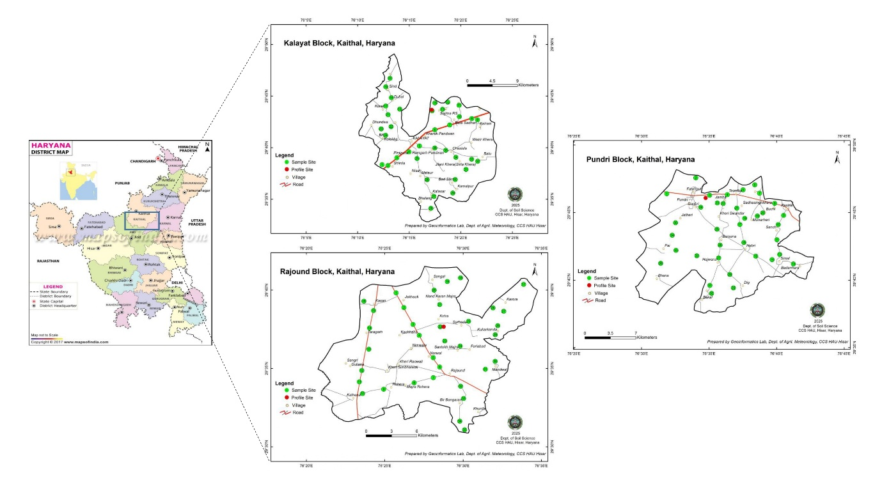
Fig. 1. Location map of the study area (Kalayat, Rajound and Pundri blocks in Kaithal district) with sampling points
2.3 Statistical and Spatial Analysis
Descriptive statistical parameters and correlation analysis were performed using SPSS 26.0 software. Spatial distribution maps were generated using ArcGIS 10.5 across the three blocks.
3. Results and discussion
3.1 Soil texture class
Soil texture class across the three blocks ranged from sandy loam to clay loam (Table 1). This textural gradient reflects the geomorphic setting of northern Haryana, which occupies the alluvial plains shaped by the Yamuna and Ghaggar river systems. As the distance from active river channels increases, the decline in hydraulic energy favours the deposition of finer particles such as silt and clay, resulting in progressively loam to clay loam soils. This pattern corresponds to the well-established “textural fining” trend reported for Indo-Gangetic alluvial deposits (Pal et al., 2009).
3.2 Soil pH and electrical conductivity (EC)
Soil pH values indicated that all samples were alkaline, with values ranging from 7.00 to 8.80 and an overall mean of 8.05 ± 0.62 (Table 2). The alkaline reaction is primarily attributed to the presence of basic alluvial parent materials and the accumulation of exchangeable basic cations generated through interactions among soil colloids, irrigation water, and fertilizer inputs (Sharma et al., 2024). EC values showed distinct spatial variability: Pundri soils were entirely non-saline (0.13–0.43 dS m⁻¹), while Kalayat and Rajound exhibited pockets of salinity with EC reaching 2.20 and 2.92 dS m⁻¹, respectively. EC showed very high variability throughout the region, as suggested by CV value of 87.50%. According to Singh et al. (2025a), enhanced leaching under well-drained and intensively cultivated conditions can promote salt removal through percolation and drainage flows.
Table 1. Physico-chemical properties and nutrient status of three blocks of Kaithal district
Soil property/ Block | Kalayat | Rajound | Pundri
Texture class | Loam to Clay loam | Sandy clay loam- Clay loam | Sandy loam- Clay loam
pH_{(1:2)} | 7.00-8.60 | 7.00-8.70 | 7.20-8.80
EC_{(1:2)} (dS m⁻¹) | 0.25-2.20 | 0.11-2.92 | 0.13-0.43
OC (%) | 0.22-0.90 | 0.15-1.05 | 0.15-0.90
Available N (kg ha⁻¹) | 91-166 | 131-168 | 119-210
Available P (kg ha⁻¹) | 06-61 | 10-47 | 4-50
Available K (kg ha⁻¹) | 80-440 | 120-280 | 90-194
Available Zn (mg kg⁻¹) | 0.50-1.68 | 0.62-2.50 | 0.74-1.40
Available Fe (mg kg⁻¹) | 2.00-18.36 | 2.16-16.80 | 2.08-13.20
Available Cu (mg kg⁻¹) | 0.88-2.20 | 0.60-2.10 | 0.85-1.54
Available Mn (mg kg⁻¹) | 1.70-9.00 | 2.84-5.80 | 1.80-3.62
Table 2. Descriptive statistics of selected soil properties
Soil Properties | Range | Mean | Std. Deviation | CV (%) | Skewness | Kurtosis
pH_{(1:2)} | 7.00-8.80 | 8.05 | 0.62 | 7.70 | -1.19 | 1.31
EC_{(1:2)} (dS m⁻¹) | 0.11-2.92 | 0.64 | 0.56 | 87.50 | 1.52 | 2.02
OC (%) | 0.15-1.05 | 0.54 | 0.22 | 40.74 | 0.15 | -0.77
AN (kg ha⁻¹) | 91-210 | 138.44 | 21.83 | 15.77 | -0.62 | 0.93
AP (kg ha⁻¹) | 6-61 | 27.42 | 20.19 | 73.63 | 0.97 | 0.10
AK (kg ha⁻¹) | 80-440 | 154.86 | 80.50 | 51.98 | 2.41 | 8.21
Zn (mg kg⁻¹) | 0.50-2.50 | 1.14 | 0.31 | 27.19 | 1.16 | 2.64
Fe (mg kg⁻¹) | 2.00-18.36 | 8.14 | 3.48 | 42.75 | 0.71 | 0.72
Cu (mg kg⁻¹) | 0.60-2.20 | 1.27 | 0.27 | 21.26 | 0.77 | 1.30
Mn (mg kg⁻¹) | 1.70-9.00 | 3.70 | 1.17 | 31.62 | 1.16 | 2.81
3.3 Soil organic carbon (OC)
Soil organic carbon (OC) ranged from 0.15 to 1.05%, with a mean of 0.54 ± 0.22%. Spatial maps showed that Kalayat and Pundri were dominated by medium OC levels (Fig. 2a and 2c), whereas Rajound exhibited medium to high OC content (2b). These values are relatively elevated compared to the drier tracts of Haryana, likely due to continuous rice cultivation, regular incorporation of organic amendments, and higher proportions of silt and clay that promote OC stabilization (Sahoo et al., 2020).
3.4 Available macronutrients
Available nitrogen (AN) was consistently low throughout the study area (Fig. 3a-3c), with values ranging from 91 to 210 kg ha⁻¹ and a mean value of 138.44 ± 21.83 kg ha⁻¹. This widespread deficiency may stem from losses through volatilization, runoff, microbial immobilization, and denitrification, combined with rapid organic matter decomposition under high temperatures characteristic of the region. Comparable trends were reported by Gyawali et al. (2016). Available phosphorus (AP) showed predominantly high fertility status (Fig. 4a-4c), supported by a mean value of 27.42 ± 20.19 kg ha⁻¹; this enrichment is likely linked to the intensive use of phosphatic fertilizers (Sharma et al., 2024). Available potassium (AK) ranged from 80 to 440 kg ha⁻¹ having a mean value of 154.86 kg ha⁻¹, with most soils falling within the medium fertility class (Fig. 5a-5c). The adequate potassium levels may be due to the presence of K-bearing minerals such as feldspar and illite in the alluvial parent material (Singh et al., 2025b). Overall among macronutrients, AP and AK showed very high variability (CV: 73.63 and 51.98%, respectively), whereas AN had medium variability (CV: 15.77%).
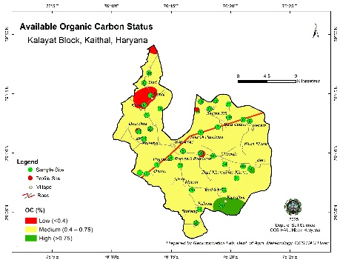
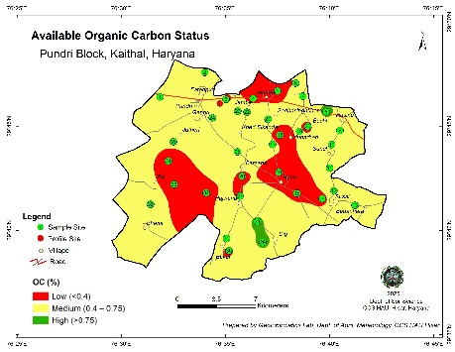
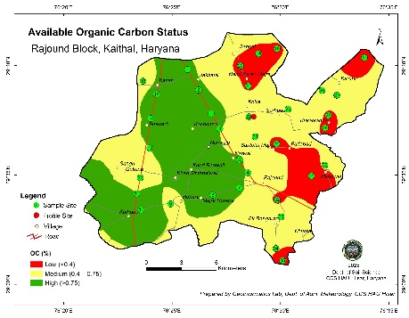
(a)
(b)
(c)

Fig. 2. Spatial distribution of soil organic carbon in (a) Kalayat, (b) Rajound and (c) Pundri blocks of Kaithal district
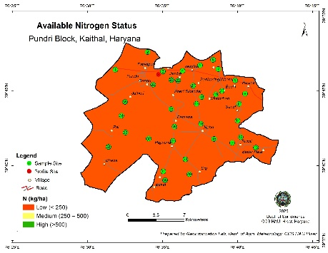
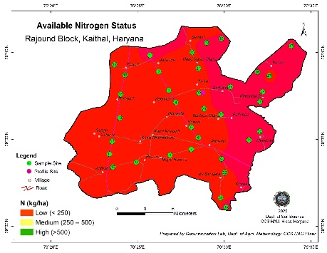
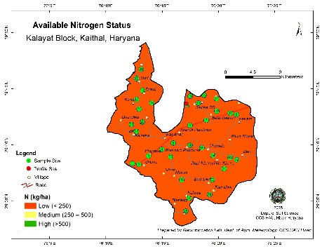
(c)
(b)
(a)

Fig. 3. Spatial distribution of available nitrogen in (a) Kalayat, (b) Rajound and (c) Pundri blocks of Kaithal district
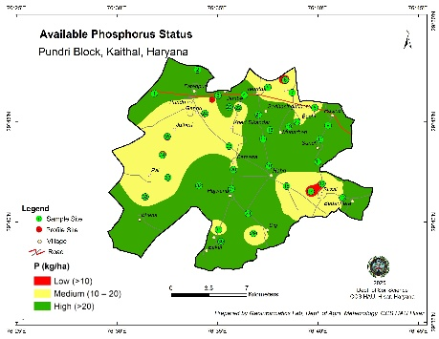
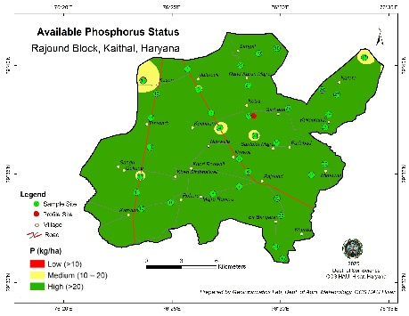
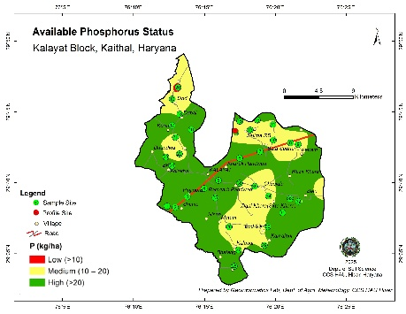
(c)
(b)
(a)

Fig. 4. Spatial distribution of available phosphorus in (a) Kalayat, (b) Rajound and (c) Pundri blocks of Kaithal district

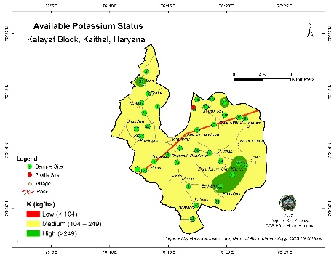
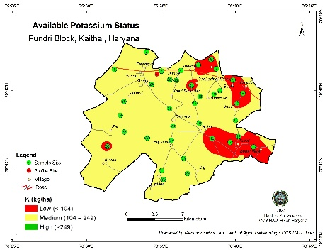
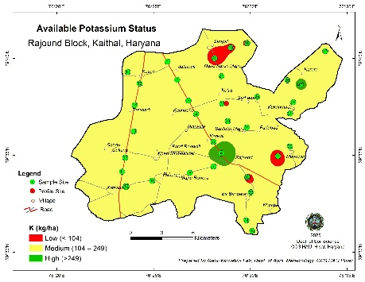
(a)
(c)
(b)

Fig. 5. Spatial distribution of available potassium in (a) Kalayat, (b) Rajound and (c) Pundri blocks of Kaithal district
3.5 Available micronutrients
Available Zn concentrations of the soils of Kalayat block varied from 0.50-1.68 mg kg⁻¹, Rajound from 0.62-2.50 mg kg⁻¹ and Pundri from 0.74-1.40 mg kg⁻¹ (Table 1), with an average of 1.14 ± 0.31 mg kg⁻¹ (Table 2). Overall, the sampled sites showed sufficient Zn levels (sufficient + high) (Fig. 6a-6c). Devraj et al. (2020) reported higher Zn levels in Kaithal soils under rice–wheat and sugarcane systems, attributed to the routine application of 25 kg ZnSO₄.7H₂O ha⁻¹ annually. Available Fe concentrations of the soils varied from 2.00-18.36 mg kg⁻¹, having a mean of 8.14 mg kg⁻¹ (Table 2). Majority of the soils were moderate to sufficient in Fe, with few samples in low (deficient) category (Fig. 7a-7c). These findings are in line with those reported in the Kaithal region of Haryana by Sharma et al. (2025). DTPA-extractable Cu content ranged from 0.60 to 2.20 mg kg⁻¹ and entire study area was sufficient (high) in Cu. The available Mn concentrations in soils of Kalayat block varied from 1.70 to 9.00 mg kg⁻¹, Rajound from 2.84 to 5.80 mg kg⁻¹, and Pundri from 1.80 to 3.62 mg kg⁻¹, with average concentration of 3.70 mg kg⁻¹. Majority of the soils were moderate to sufficient in DTPA-Mn (Fig. 8a-8c), except some areas in the eastern part of Pundri block (Fig. 8c). Adequate Mn levels likely result from its release under waterlogged rice conditions, while deficiencies at some sites may reflect continuous crop uptake without corresponding external supplementation (Devraj et al., 2020). Among micronutrients, Fe exhibited highest spatial variability (CV: 42.75%) and Cu showed lowest variability (CV: 21.26%).
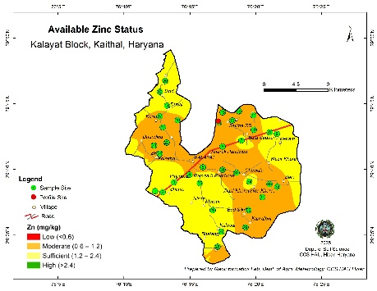
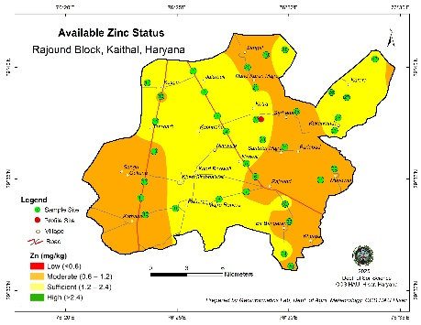
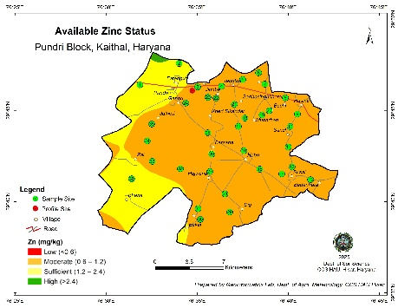
(a)
(b)
(c)

Fig. 6. Spatial distribution of available zinc in (a) Kalayat, (b) Rajound and (c) Pundri blocks of Kaithal district

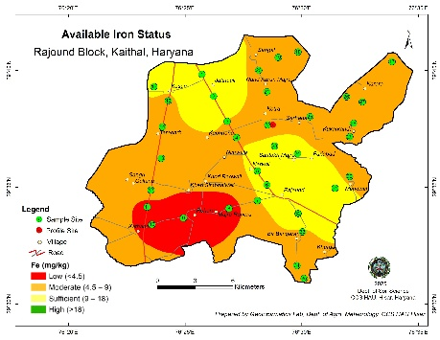
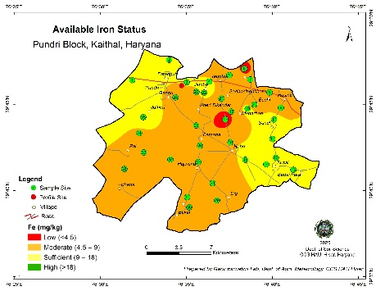
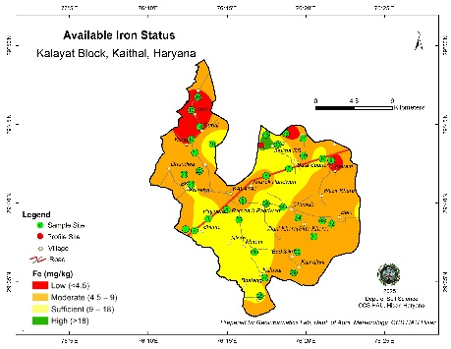
(b)
(c)
(a)

Fig. 7. Spatial distribution of available iron in (a) Kalayat, (b) Rajound and (c) Pundri blocks of Kaithal district
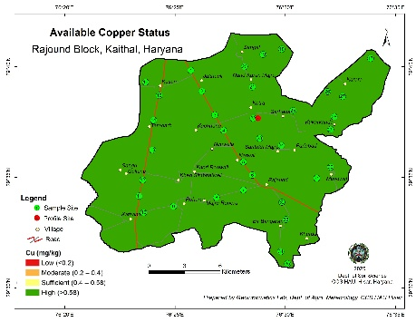
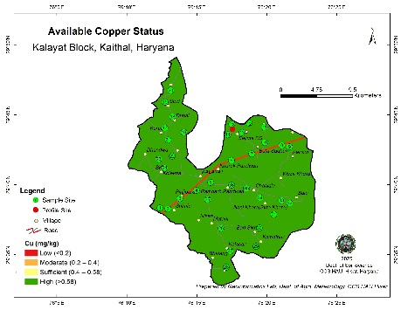
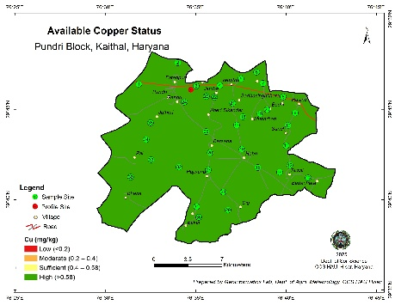
(b)
(a)
(c)

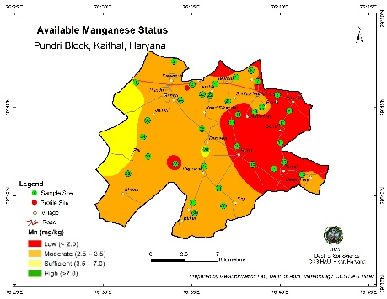
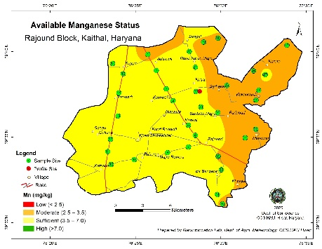
Fig. 8. Spatial distribution of available copper in (a) Kalayat, (b) Rajound and (c) Pundri blocks of Kaithal district
(c)
(b)
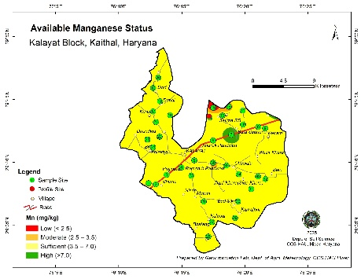
(a)

Fig. 9. Spatial distribution of available manganese in (a) Kalayat, (b) Rajound and (c) Pundri blocks of Kaithal district
3.6 Correlation among the soil properties
Pearson’s correlation coefficients for the analyzed soil properties are summarized in Table 3. OC exhibited a positive correlations with AN (r=0.101), AP (r=0.083) and AK (r=0.204). The positive OC–N relationship reflects the contribution of organic matter to mineralizable nitrogen, making OC a useful indicator of N availability. In the case of phosphorus, organic matter can enhance P availability by displacing H₂PO₄⁻ from adsorption sites through anion exchange and by contributing organic P that subsequently mineralizes into inorganic forms (Singh et al., 2025a). Soil pH exhibited a negative correlation with OC (r = –0.159), likely due to the release of organic acids during decomposition processes. AP also showed a negative correlation with pH (r = –0.261), indicating the tendency for greater P fixation under alkaline conditions. All micronutrients displayed positive correlations with OC, consistent with the findings of Ray and Banik (2016).

Table 3. Pearson’s correlation among soil properties
 | pH | EC | OC | AN | AP | AK | Zn | Fe | Cu | Mn
pH | 1.000
EC | -0.202* | 1.000
OC | -0.159 | 0.337** | 1.000
AN | 0.108 | -0.119 | 0.101 | 1.000
AP | -0.261** | -0.032 | 0.083 | -0.066 | 1.000
AK | -0.010 | 0.343** | 0.204* | 0.015 | 0.128 | 1.000
Zn | -0.048 | 0.294** | 0.122 | -0.139 | -0.069 | -0.014 | 1.000
Fe | -0.072 | -0.052 | 0.066 | 0.065 | -0.091 | -0.143 | 0.031 | 1.000
Cu | 0.064 | 0.145 | 0.276** | -0.030 | 0.143 | 0.127 | -0.110 | 0.111 | 1.000
Mn | -0.066 | 0.526** | 0.341** | -0.175 | 0.084 | 0.339** | 0.305** | 0.032 | 0.103 | 1.000
* Significant at 0.05 level of significance; ** significant at 0.01 level of significance
4. Conclusion
A wide variation in soil parameter values (with CV values of 7.70 to 87.50%) in southern blocks of Kaithal district was recorded from the present study. In general, the soils in all three blocks exhibited with alkaline pH, medium to high organic carbon content and non-saline nature with pockets of high salinity soils. Dominant soil texture varied across the region from loam to clay loam range. Soils were categorized as low in available N content, low to high in P and K content. Among micronutrients, only a small region exhibited Mn deficiency, otherwise it was moderate to high range. Spatial variability maps rightly captured the distribution of soil nutrients and can be further utilized to achieve optimal crop production, higher nutrient use efficiency, better environmental conservation and higher farm profit.
Disclaimer (Artificial Intelligence)
Authors hereby declare that no generative AI technologies such as ChatGPT, COPILOT etc. and text-to-image generators have been used during writing or editing of this manuscript.
Acknowledgements
The authors express their sincere appreciation to Department of Soil Science and Department of Agricultural Meteorology, Chaudhary Charan Singh Haryana Agricultural University, Hisar for providing the critical infrastructure and resources that enabled the successful execution of this research.

References:
Arumugam, T., Kinattinkara, S., Vellingiri, K., Arumugam, M., Rajamani, J., & Jayaseelan, A. (2025). Assessment of agricultural soil quality in macro and micronutrient analysis of Kasargod, Kerala, India, using GIS techniques. Journal of Hazardous Materials Advances, 19, 100846. https://doi.org/10.1016/j.hazadv.2025.100846
Devraj, Antil, R.S., Garg, R., Dahiya, D. S., Arora, V. K., Yadav, S. S., & Singh, J. P. (2020). Impact of intensive cropping systems on crop productivity and changes in soil fertility: A case study on benchmark sites of Haryana. Indian Journal of Fertilisers, 16, 988-996.
Gyawali, C., Dahiya, D. S., Devraj, B. M., & Bhandari, R. (2016). Spatial distribution of physico-chemical properties and macronutrients in rice growing soils of Haryana. The Ecosan, 10, 365–370.
Gyawali, C., De, N., Koley, S., Golui, K., Khanna, C., & Mahinda, A. J. (2024). Defining Framework for Soil Health Assessment for Regenerative Agriculture under Different Land Uses. In A. K. Mishra, S. Sharma & A. Mishra (Eds.), Key Drivers and Indicators of Soil Health Management (pp. 73-84). Singapore: Springer Nature Singapore. https://doi.org/10.1007/978-981-97-7564-4_4
Jackson, M. L. (1973). Soil Chemical Analysis. Prentice Hall of India Private Ltd., New Delhi.
Keshavarzi, A., De Caires, S. A., Sintim, H. Y., Kaya, F., Kusi, N. Y. O., Gyasi-Agyei, Y. & Kumar, V. (2025). Spatial variability and management zones: leveraging geostatistics and fuzzy clustering. Journal of Soil Science and Plant Nutrition, 25, 3633–3651. https://doi.org/10.1007/s42729-025-02357-4
Lindsay, W. L., & Norvell, W. A. (1978). Development of DTPA soil test for zinc, iron, manganese and copper. Soil Science Society of America Journal, 42(3), 421–428. https://doi.org/10.2136/sssaj1978.03625995004200030009x
Olsen, S. R., Cole, C. V., Watanabe, F. S., & Dean, L. A. (1956). Estimation of available phosphorus in soils by extraction with sodium bicarbonate (USDA Circular No. 939). U.S. Government Printing Office.
Pal, D. K., Bhattacharyya, T., Srivastava, P., Chandran, P., & Ray, S. K. (2009). Soils of the Indo-Gangetic Plains: their historical perspective and management. Current Science, 96(9), 1193-1202. https://www.jstor.org/stable/24105408
Poggio, L., De Sousa, L. M., Batjes, N. H., Heuvelink, G. B., Kempen, B., Ribeiro, E. & Rossiter, D. (2021). SoilGrids 2.0: producing soil information for the globe with quantified spatial uncertainty. SOIL, 7(1), 217–240. https://doi.org/10.5194/soil-7-217-2021
Ray, S. K., & Banik, G. C. (2016). Available micronutrient status in relation to soil properties in some villages under four agro-climatic features of West Bengal. Journal of the Indian Society of Soil Science, 64(2), 169–175. https://doi.org/10.5958/0974-0228.2016.00022.0
Sahoo, J., Dinesh, Bhat, M. A., Anil, A. S., & Raza, M. B. (2020). Nutrient distribution and relationship with soil properties in different watersheds of Haryana. Indian Journal of Agricultural Sciences, 90(1), 172–7. https://doi.org/10.56093/ijas.v90i1.98666
Salem, H. M., Schott, L. R., Piaskowski, J., Chapagain, A., Yost, J. L., Brooks, E., Kahl, K., & Johnson-Maynard, J. (2024). Evaluating intra-field spatial variability for nutrient management zone delineation through geospatial techniques and multivariate analysis. Sustainability, 16(2), 645. https://doi.org/10.3390/su16020645
Sharma, M., Garhwal, R. S., Bhardwaj, K. K., Singh, C., Kumar, S., Kumar, A., & Yadav, S. (2024). Assessment of Soil Variation in Kaithal District using GIS and GPS. Indian Journal of Ecology, 51(6), 1514-1521. https://doi.org/10.55362/IJE/2024/4434
Sharma, M., Garhwal, R. S., Kumar, A., Dubey, S. K., Kumar, A., & Sheoran, J. (2025). Comprehensive Analysis of Micronutrients in Different Blocks of Kaithal District, Haryana. Journal of the Indian Society of Soil Science, 73(1), 72-81. https://doi.org/10.5958/0974-0228.2025.00007.6
Shashikumar, B. N., Kumar, S., George, K. J., & Singh, A. K. (2023). Soil variability mapping and delineation of site-specific management zones using fuzzy clustering analysis in a Mid-Himalayan Watershed, India. Environmental Development and Sustainability, 25(8), 8539–8559. https://doi.org/10.1007/s10668-022-02411-6
Shukla, A. K., Behera, S. K., Kumar, P., Mishra, R., Shukla, V., Pachauri, S. P., Sikaniya, Y., Srivastava, P. C., Sikarwar, A., Kumar, D., & Datta, S. P. (2025). Delineation of management zones for site‐specific soil nutrient management for sustainable crop production. Land Degradation and Development, 36(1), 231–248. https://doi.org/10.1002/ldr.5357
Singh A, Narender, Dinesh, Golui K, Phogat P, Rajrana Y and Kumar S. (2025a). Characterization and classification of soils under organic farming in Hisar, Haryana, India. Eurasian Soil Science, 58(5), 70. https://doi.org/10.1134/S1064229324603275
Singh, A., Yadav, N., Tomar, D., Golui, K., Phogat, P., Jangra, S., Rajrana, Y., Kumar, S., Gujral, P., & Kumar, S. (2025b). Vertical stratification of nutrients and their relation with soil properties under organic cultivation. Egyptian Journal of Soil Science, 65(2), 799–816. https://doi.org/10.21608/ejss.2025.355907.1978
Srinivasan, R., Shashikumar, B. N., & Singh, S. K. (2022). Mapping of soil nutrient variability and delineating site-specific management zones using fuzzy clustering analysis in eastern coastal region, India. Journal of the Indian Society of Remote Sensing, 50(3), 533–547. https://doi.org/10.1007/s12524-021-01473-9
Subbiah, B. V., & Asija, G. L. (1956). A rapid procedure for the determination of available nitrogen in soil. Current Science, 25, 259–260.
Walkley, A., & Black, I. A. (1934). An examination of the degtjareff method for determining soil organic matter and a proposed modification of the chromic acid titration method. Soil Science, 37, 29–38. https://doi.org/10.1097/00010694-193401000-00003

