Original Research Article
COMPARATIVE ASSESSMENT OF CONCRETE, RUBBER MAT AND SOIL FLOORING ON WELFARE AND ECONOMICS OF MURRAH BUFFALO CALVES

ABSTRACT
A controlled experimental study was performed to evaluate how different flooring materials influence cleanliness, behavioural patterns and cost economics in Murrah Buffalo calves. Eighteen healthy calves of either sex (6-8 months old), were randomly assigned to three flooring systems — concrete (T1), rubber mat (T2), and soil (T3) for a period of 3 months, from August 2022 to October 2022, at Buffalo Research Station (BRS), Venkataramannagudem, Behaviour was continuously monitored throughout the study. The overall mean cleanliness score of T3 was significantly higher (p < 0.01) than T1 followed by T2. The overall mean standing time (min/day) was higher in T1 and lower in T3. The overall mean lying time and rumination time of T2 was significantly higher (p < 0.01) than T3 followed by T1. The overall mean eating time of T1 was significantly higher (p < 0.01) than T3 followed by T2. The overall mean social licking time (sec/day) and sleeping time of T3 was significantly higher (p < 0.01) than T2 and T1. The cost per kg body weight gain was highest in T1 and was lowest in T3. This indicates that the best economical flooring used can be soil flooring which also gave positive results in terms of welfare aspect, despite poor hygiene. Rather rubber mat flooring gave best results in overall performance and welfare aspects, given if the farmer can afford.
Key words: Behaviour, Calves, Cleanliness, Economics, Flooring, Murrah.
INTRODUCTION
Due to business motives, the feeding of buffalo has transitioned from extensive conditions with pastures and sources of water, which allow some species-specific natural behaviours especially wallowing, to intensive rearing conditions, which give unique challenges for comfort regarding bedding and welfare in terms of exhibiting their natural behaviours and less space allowance than necessary, suggested by the dairy animal standards. (De Rosa et al. 2009).
Animal welfare is an intricate matter that involves several scientific ideas. Due to its impact on the health and productivity acquired from them, which is a significant public health concern, the welfare of dairy animals these days involves a significant subject of public interest growing across most of the countries. The health and wellbeing of dairy calves during the early stages of life are majorly impacted by housing and managemental strategies. Of such strategies, which influence the dairy animal welfare, cleanliness and hygiene are some of the major ones. The type of bedding used in calf housing affects the calf cleanliness (Panivivat et al., 2004) and behaviour. The comfort of the animal in the pen majorly depends on type and quality of bedding material, due to which the properties of floor in animal houses is of utmost importance.
Dairy cows reared on rubber floor rested more during the morning hours than cows reared on concrete floors. Even though concrete flooring is sanitary and involves minimal attention, it has the potential for injuries due to unsteady standing, lying, and transitional motions in addition to reduced traction (Cozzi et al. 2013). Cattle prefer various flooring substrates to concrete when given alternatives, like straw, wood chips, or rubber mats (Schutz and Cox 2014).
Growing cattle have been observed to have a positive correlation between time spent lying and their growth rates. Since, soil floor is naturally softer than concrete, calves reared on them often demonstrated playful behaviour considering that they enjoy playing on it. But it seemed that calves raised on soil floor were dirtier compared to those raised on other types of flooring. Apart from causing irritation and harm to the skin, a soiled coat elevates the chances of meat contamination during the slaughter process. Certain types of floors can also help in mitigation strategies of ammonia production (Leskovec et.al., 2022), which is a major concern now a days. However, there is lack of scientific evidence in buffaloes which paved the way to conduct the present study with the objective of effect of type of flooring on cleanliness, behaviour of Murrah calves & their cost benefit analysis.
MATERIALS AND METHODS
Location of the experiment
The current study was carried at Buffalo Research Station., Sri Venkateswara Veterinary University, Tirupati. The research station is located at 16°53'08.8" N longitude and 81° 27'35.8" E latitude, situated in the village of Venkataramannagudem, Tadepalligudem mandal, West Godavari district of Andhra Pradesh.
Selection of experimental animals
A total of 18 healthy Murrah buffalo calves of either sex aged 6-8 months were randomly selected and housed in three separate pens such that the average body weights (kgs) of the three treatments were almost equal i.e.,121.67 ± 0.99, 121.50 ± 1.12, 121.17 ± 0.95 for concrete, rubber mat, and soil floorings respectively, for a period of 3 months from August 2022 to October 2022. Calves of first, second and third groups were reared on concrete (T1), rubber mat (T2) and soil floorings (T3), respectively.
Housing management
They were maintained under similar managemental practices like feeding, watering, cleaning etc, which was normally practiced in the research station. Each pen had dimensions of 4 m X 9 m with total area of 36 square meters with a provision of covered floor area of 2 m² for each calf as per BIS (1968) housing standards (Sastry and Thomas).
Feeding, watering and general management
The weighed quantities of concentrate mixture was fed twice daily, scheduled at early morning and late in the evening. Fresh and pure water was provided ad lib to all the experimental animals twice daily, scheduled at early morning and late evening. The cleaning of the pens was done regularly and the soil in the soil flooring calves group was changed regularly from time to time. Rubber mats were arranged in such a way that the urine can be easily drained into the gutter and cleaning of the pen would be easy for the workers. Calves were also washed regularly.

Parameters studied.
Cleanliness score or Hygiene score
Calf cleanliness scores were recorded fortnightly for all experimental animals in the three groups using hygiene score card as per Panivivat et al (2004).
The hygiene of the calf was scored on a scale of 1 to 4 on an increasing rate of measure of poor hygiene from 1 to 4. The score is given as follows:
Scale of 1 : The calf appears clean (not soiled around the thighs or body), but faecal contamination at legs distal ends.
2 : Hind quarters and base of the calf’s tail are soiled with faecal material.
3 : Base of the tail, thighs or legs are soiled with faecal material.
4 : Thighs, legs, and base of the tail are soiled with faecal material.
The scores had been given by various research scholars and scientists at the research station as per the scoring method mentioned above, for an unbiased and reliable scoring. The average of the scores given by the scorers was further used for the analysis.
Behavioural parameters
The behaviour was recorded using 3 Dahua 2 MP HDCVI Infrared eyeball cameras (DH-HAC-T1A21P), positioned approximately 10 - 12 ft above the experimental pens in such a way that the view clearly covers the entire pen area. These cameras were attached to a Dahua HDCVI 8 Channel digital video recorder (DH-XVR4B08-V2), Dahua Technology India Private Limited company, for video recording. The calves were continuously filmed 24 hrs for the entire study period. The Digital video recording system attached to a monitor helped in observing the behaviour during the entire study period. Later the observations were noted by observing the entire video recordings. Various behavioural parameters studied were standing behaviour, lying behaviour, rumination behaviour, social licking behaviour and sleeping behaviour.

Definitions of various behavioural activities observed in this study as per Sorathiya et al (2019), Hepola et al (2006) and Elmore et al (2015) are as follows:
List 1: Definitions of behaviours
S. No | Name of the activity | Definition
1. | Standing | Calves that stand on at least one leg without translocating their bodies.
2. | Lying | Calves rested on sternum.
3. | Feeding / eating | Head in or above feed bunk / feed manger.
4. | Rumination | Continuous lateral motions of the lower jaw.
5. | Social licking | A calf touching any surface of a different calf using its tongue.
6. | Sleeping | The span of time spent sleeping, whether that is by slow wave sleep or by rapid eye movement while sleeping with closed eyelids.

Cost economics of different floor types
The total cost of raising buffalo calves and cost/kg body weight gain were calculated for cost benefit analysis.
Statistical analysis of data
The data obtained in the present study, effect of different flooring type on cleanliness and behaviour of Murrah buffalo calves were evaluated and analysed by statistical methods which include Analysis of variance for cleanliness score and behavioural parameters by the formula of David. B. Duncan (1955) with IBM Statistical Package for the Social Sciences (SPSS) Statistics Version 22 and plot using R Studio Version 2025.09.2+418.

Results and discussion
Cleanliness score
In almost all the fortnights the mean cleanliness score of T3 was higher than T1 followed by T2. The initial mean cleanliness or hygiene score of the treatment groups T1, T2 and T3 were 1.25 ± 0.17, 1.33 ± 0.17 and 1.50 ± 0.22, respectively, as presented in Table 1 and Figures 1-3. There was an increase in the cleanliness score or hygiene score of the calves steadily up to the 2nd fortnight and then suddenly the score was decreased in the 3rd fortnight and again increased gradually. This might be due to thorough washing of the animals during the third fortnight. The overall mean cleanliness scores of the Murrah buffalo calves of three treatment groups T1, T2 and T3 were 2.26 ± 0.10, 1.95 ± 0.07 and 2.54 ± 0.11 respectively, which were statistically significant (p < 0.01), indicating that, type of flooring influenced cleanliness score of the calves and appeared to be dirtier on the soil floor. The present findings are consistent with those reported by Shutz and Cox (2014), Magrin et al. (2019), and Niu et al. (2023). However, they do not concur with the observations of Earley et al. (2017), Lowe et al. (2019), Wolfe et al. (2018), and Sutherland et al. (2013).

Standing behaviour

The initial mean standing time of treatment groups T1, T2 and T3 were 659.50 ± 6.31, 655.17 ± 10.87 and 542.67 ± 11.10 (min/day), respectively, as presented in Table 2 and Figure 4. The highest standing time was recorded in the calves reared on concrete floor (T1), since the start of the experiment. The T1 was significantly higher (p < 0.01) in all the fortnights. This could be due to comfort and cushioning factors provided by the other floors than concrete floor. These results clearly indicate poor comfort on concrete floor. The current results were in line with the research observations of Norring et al. (2010), Earley et al. (2015), Archana et al (2022), Mousa-Balabel et al. (2023) and Niu et al. (2023), who reported that standing time was more in concrete indicating reluctance to sit or lie. The results of this study were not in line with the research findings of Calamari et al (2009) and Graunke et al. (2011). This may be due to usage of different floors in their study.
Lying behaviour
The initial mean lying time of treatment groups T1, T2 and T3 were 508.67 ± 7.38, 626.17 ± 7.43 and 607.00 ± 6.04 (min/day), respectively, as presented in Table 3 and Figure 5. The highest lying time was recorded in T2, since the start of the experiment. The mean lying time was significantly higher (p < 0.05) in the calves reared on rubber mats (T2) in all the fortnights. This was may be due to the comfort provided by the floor to the animals. These research outcomes supported the research observations of Gultepe et al. (2019), Archana et al. (2022), Mousa-Balabel et al. (2023) and Niu et al. (2023). The current findings were not in line with the research observations of Tucker et al. (2006). This could be due to different reasons like type of flooring, location of the study, duration of the study, managemental techniques etc.
Eating/feeding behaviour
The initial mean eating time of treatment groups T1, T2 and T3 were 523.33ª ± 3.74, 440.17^{b} ± 3.44 and 446.33^{b} ± 4.98 (min/day), respectively, as presented in Table 4 and Figure 4. The highest eating time was recorded in the calves reared on concrete floor (T1), since the start of the experiment. The overall mean eating time of T1(440.29 ± 16.13) was significantly higher (p < 0.01) than T3 (399.07 ± 13.78) followed by T2 (355.24 ± 13.51). This was may be due to calves standing more time rather than lying on the concrete floor, which was believed that they have utilized most of the standing time for eating. These observations were in line with the findings of Mousa-Balabel et al. (2023). These observations were not in accordance with the research findings of Panivivat et al (2004), Leskovec et al. (2022), who reported that there is no influence of flooring on eating time of the calves. On the other hand, these results contradict the research observations of Tucker et al. (2006).
Rumination behaviour
The initial mean rumination time of treatment groups T1, T2 and T3 were 337.83 ± 4.89, 409.33 ± 11.81 and 423.17 ± 6.04 (min/day), respectively, as presented in Table 5 and Figure 5. The highest rumination time was recorded in T2, since the start of the experiment. The overall mean rumination time of T2 (383.57 ± 16.08) was significantly higher (p < 0.01) than T3 (306.98 ± 12.31) followed by T1 (268.36 ± 8.19). The calves on the rubber mats have spent more time lying, which was believed that they utilized that lying time for rumination. These observations were in accordance with the research findings of Archana et al (2022). These findings were inconsistent with the observations of Leskovec et al. (2022), who reported that there is no difference in rumination time between the groups.
Social licking behaviour
The initial mean social licking time of treatment groups T1, T2 and T3 were 180.33 ± 6.69, 379.83 ± 6.82 and 458.33 ± 7.56 (sec/day), respectively, , as presented in Table 6 and Figure 6, which showed a clear significant difference between the treatments since the start of the experiment. The mean social licking time of calves reared on soil floor (T3) was significantly higher (p < 0.01) than calves reared on rubber mat floor (T2) followed by calves reared on concrete floor (T1). The overall mean social licking time (sec/day) of T3 (734.31 ± 51.08) was significantly higher (p < 0.01) than T2 (409.67 ± 30.27) followed by T1 (174.02 ± 12.10). The more social licking was observed in soil floor than other floors. This was may be due to the dirt present on the bodies of the fellow calves. Also, the playfulness behaviour was observed more on soil floor. This was may be due to the comfort and softness provided by the floor, they tend to exhibit their natural behaviours, indicating good welfare of the calves. These results were in corroboration with the findings of Sutherland et al. (2013), Earley et al. (2015) and Archana et al (2022). These research observations were not in support with the results of Sorathiya et al (2019).
Sleeping behaviour
The initial mean sleeping time of treatment groups T1, T2 and T3 were 125.67 ± 3.47, 241.67 ± 5.63 and 229.17 ± 4.85 (min/day), respectively, as presented in Table 7 and Figure 7. The mean sleeping time was lower in the calves reared on the concrete floor (T1) compared to the calves reared on rubber mats (T2) and soil floor (T3). The overall mean sleeping time of T1 (154.26 ± 6.85) was significantly lower (p < 0.01) than T2 (224.19 ± 8.92) and T3 (228.90 ± 10.84) but no significant difference between T2, T3. The sleeping time indicates the better welfare of the animal, which was better in soil floor followed by rubber mat flooring and was least in the concrete floor. These observations were in accordance with the findings of Archana et al (2022), who reported that rubber mats and concrete floors had the highest and lowest average sleeping times, respectively.
Comparative Behavioural Radar
The behavioural data has been normalized and plotted comparative behavioural radar plot. It has demonstrated the clear differences in exhibition of different behaviours among calves in different floorings. The plot reflects the relative behavioural performance rather than absolute duration. The rubber mat (T2) flooring has shown overall most balanced and welfare-oriented behavioural profile as it has showed the highest relative values for rumination and lying, indicating lying comfort and better relaxation. In contrast soil flooring (T3) showed higher relative expression of social licking and sleeping, both of which are positive welfare indicators. The strong expansion of the T3 polygon along these axes highlights its ability to promote natural social behaviours. Concrete flooring consistently showed elevated standing and eating values but reduced sleeping, rumination and social licking. This provides evidence that due to harder surface the concrete can limit the behaviours associated with good welfare.
Cost economics of different floor types
Any mode of housing system should ultimately lead to economic raising of dairy animals. The cost of rearing buffalo calves in terms of total cost, cost of raising one calf and cost per kg body weight gain have been presented in Table 8.
The total cost of raising a buffalo calf was Rs. 5043.33, 4843.33 and 3843.33 in T1, T2 and T3, respectively and corresponding values of cost per kg body weight gain were Rs. 168.90, 112.69 and 109.62, respectively. The cost per kg body weight gain was highest in T1 and was lowest in T3 and it was because of higher total body weight gain in T2 group calves as compared to other two groups.
The total cost of raising a calf was highest in concrete floor due to more construction cost of cement concrete but can be maintained for more than 4-5 generations unlike rubber mat flooring, which can be utilised for only 2-3 generations. While the cost-effective bedding with the best results was observed in the soil floor. The results were in line with findings of Niu et al. (2023). The current results were not in support with the observations of Sorathiya et al (2019).
CONCLUSION
The study's findings revealed a considerable impact on the cleanliness score of Murrah buffalo calves, and the calves were found to be cleaner on rubber mat floor followed by soil floor. Different flooring materials had a considerable impact on the lying, feeding/eating, rumination, social licking, and sleeping behaviors of Murrah buffalo calves and the values were ideal in rubber mat floor followed by soil and concrete floor. Provision of proper flooring like, rubber mat or soil floor can improve the comfort of the dairy calves which subsequently will enhance the hygiene and behavior of the animals. Hence for better economic reasons, a mixed flooring can be followed like lying area can be installed with rubber mat flooring, open area with soil floor.

References
Archana K, Rathod S, Chandra A S and Alexander G (2022) A study on behaviour of Sahiwal calves reared on different flooring material. The Pharma Innovation Journal. SP-11: 141-144.

Calamari L, Calegari F and Stefanini L (2009) Effect of different free stall surfaces on behavioural, productive and metabolic parameters in dairy cows. Applied Animal Behaviour Science. 120: 9-17.

De Rosa G, Grasso F, Braghieri A, Bilancione A, Di Francia A & Napolitano F (2009) Behavior and milk production of buffalo cows as affected by housing system. Journal of Dairy Science, 92(3): 907-912.
Duncan D. B (1955) Multiple range and multiple F tests. Biometrics. 11: 1-42.

Earley B, McDonnell B and O’Riordan E G (2015) Effect of floor type on the performance, physiological and behavioural responses of finishing beef steers. Acta Veterinaria Scandinavica. 57: 1-11.

Earley B, McNamara J D, Jerrams S J and O’Riordan E G (2017) Effect of concrete slats, three mat types and out-wintering pads on performance and welfare of finishing beef steers. Acta Veterinaria Scandinavica. 59: 1-14.

Elmore M R P, Elischer M F, Claeys M C and Pajor E A (2015) The effects of different flooring types on the behaviour, health and welfare of finishing beef steers. Journal of Animal Science. 93: 1258-1266.

G Cozzi, Tessitore E, Contiero B, Ricci R, Gottardo F and Brscic M (2013) Alternative solutions to the concrete fully slatted floor for the housing of finishing beef cattle: effects on growth performance, health of the locomotor system and behaviour. The Veterinary Journal. 197: 211-215.

Graunke, Telezhenko E, Hessle A. K and Bergsten C (2011) Does rubber flooring improve welfare and production in growing bulls in fully slatted floor pens? Animal Welfare. 20: 173-183.

Gultepe E E, Çetingul IS, Bayram I, Kandir H, Kenar B, Bulbul T, Uyarlar C and Ozcinar U (2019) Effects of rubber flooring on feeding and lying behaviour of dairy buffalo and cows. Kocatepe Veterinary Journal.12: 378-383.

Hepola H P, Hänninen L T, Raussi S M, Pursiainen P A, Aarnikoivu A M & Saloniemi H S (2008) Effects of providing water from a bucket or a nipple on the performance and behaviour of calves fed ad libitum volumes of acidified milk replacer. Journal of dairy science. 91: 1486-1496.

Leskovec J, Voljc M and Zgur S (2022) Effect of a High Welfare Floor and a Concrete Slatted Floor on the Growth Performance, Behaviour and Cleanliness of Charolais and Limousin Heifers: A Case Study. Animals. 12: 859.

Lowe D E, Lively F O and Gordon A W (2019) The effect of diet and covering fully slatted concrete floors with rubber strips on the intake, performance and cleanliness of dairy-origin bulls. Animal. 13: 2092-2100.

Magrin L, Gottardo F, Brscic M, Contiero B and Cozzi G (2019) Health, behaviour and growth performance of Charolais and Limousin bulls fattened on different types of flooring. Animal. 13: 2603-2611.

Mousa-Balabel T M, Farg E M & Elkot A A (2023) Effect of Various Flooring Types on the Growth, Some Behavioural Characteristics and Hematological Parameters of Friesian Calves.

Niu K, An Z, Yao Z, Chen C, Yang L & Xiong J (2023) Effects of Different Bedding Materials on Production Performance, Lying Behavior and Welfare of Dairy Buffaloes. Animals, 13(5), 842.

Norring M, Manninen E, de Passille A M, Rushen J and Saloniemi H (2010) Preferences of dairy cows for three stall surface materials with small amounts of bedding. Journal of Dairy Science. 93: 70-74.

Panivivat R, Kegley E B, Pennington J A, Kellogg D W and Krumpelman S L (2004) Growth performance and health of dairy calves bedded with different types of materials. Journal of Dairy Science. 87: 3736-3745.

Sastry N S R and Thomas C K (2021) Livestock production management, 6th revised and enlarged edition, Kalyani publishers, Noida.

Schutz K E and Cox N R (2014) Effects of short-term repeated exposure to different flooring surfaces on the behaviour and physiology of dairy cattle. Journal of Dairy Science. 97: 2753-2762.

Sorathiya L M, Raval A P, Kharadi V B, Tyagi K K and Patel M D (2019) Effect of flooring on growth performance, behaviour, health and economics in Surti buffalo calves during winter. Indian Journal of Animal Science. 89: 1246-1250.

Sutherland M A, Stewart M and Schutz K E (2013) Effects of two substrate types on the behaviour, cleanliness and thermoregulation of dairy calves. Applied Animal Behaviour Science. 147: 19-27.

Wolfe T, Vasseur E, DeVries T J and Bergeron R (2018) Effects of alternative deep bedding options on dairy cow preference, lying behaviour, cleanliness and teat end contamination. Journal of Dairy Science. 101: 530-536.

Table 1: Effect of type of flooring on fortnightly cleanliness score of Murrah buffalo calves.
Fortnights | cleanliness score
 | T1 | T2 | T3
Initial | 1.25 ± 0.17 | 1.33 ± 0.17 | 1.50 ± 0.22
1 | 2.33 ± 0.25 | 2.00 ± 0.13 | 2.33 ± 0.17
2 | 2.58^{b} ± 0.24 | 2.17^{b} ± 0.11 | 3.25ª ± 0.21
3 | 2.08 ± 0.15 | 1.67 ± 0.21 | 1.92 ± 0.15
4 | 2.58ª ± 0.15 | 2.00^{b} ± 0.13 | 2.83ª ± 0.17
5 | 2.58^{ab} ± 0.15 | 2.25^{b} ± 0.11 | 2.92ª ± 0.15
6 | 2.42^{b} ± 0.15 | 2.25^{b} ± 0.11 | 3.00ª ± 0.13
Mean ± S.E | 2.26^{b} ± 0.10 | 1.95^{c} ± 0.07 | 2.54ª ± 0.11

Means bearing the different superscript within a row differ significantly (p < 0.01).
T1: Concrete flooring
T2: Rubber Mat flooring
T3: Soil flooring

Fortnights | standing time (min/day) |  |  | lying time (min/day) |  |  | feeding / eating time (min/day)
 | T1 | T2 | T3 | T1 | T2 | T3 | T1 | T2 | T3
Initial | 659.50ª ± 6.31 | 655.17ª ± 10.87 | 542.67^{b} ± 11.10 | 508.67 ^{b} ± 7.38 | 626.17 ª ± 7.43 | 607.00 ª± 6.04 | 523.33ª ± 3.74 | 440.17^{b} ± 3.44 | 446.33^{b} ± 4.98
1 | 763.33ª ± 8.06 | 684.67^{c} ± 9.28 | 725.00^{b} ± 10.29 | 510.00^{c} ± 9.04 | 671.83ª ± 7.19 | 597.33^{b} ± 5.70 | 538.33ª ± 3.74 | 463.17^{b} ± 3.44 | 464.33^{b} ± 4.98
2 | 865.33ª ± 9.10 | 639.33^{c} ± 9.30 | 725.33^{b} ± 6.09 | 404.00^{b} ± 8.90 | 439.33ª ± 6.84 | 429.33ª ± 7.86 | 325.33ª ± 4.30 | 223.83^{c} ± 3.20 | 271.83^{b} ± 3.70
3 | 769.83ª ± 7.67 | 611.33^{c} ± 10.46 | 695.50^{b} ± 6.83 | 411.67^{b} ± 9.57 | 515.50ª ± 7.08 | 352.17^{c} ± 5.90 | 275.50ª ± 3.94 | 243.50^{b} ± 3.61 | 251.17^{b} ± 4.12
4 | 739.00ª ± 9.73 | 738.33ª ± 10.55 | 679.17^{b} ± 10.66 | 427.67^{b} ± 5.30 | 542.67ª ± 5.71 | 549.33ª ± 7.05 | 530.50ª ± 3.37 | 410.00^{c} ± 2.90 | 470.83^{b} ± 3.24
5 | 667.83ª ± 7.41 | 556.50^{c} ± 8.81 | 636.17^{b} ± 10.18 | 599.83^{c} ± 10.04 | 695.17ª ± 5.14 | 632.00^{b} ± 8.78 | 457.83ª ± 3.61 | 341.00^{c} ± 3.27 | 436.50^{b} ± 2.62
6 | 675.83ª ± 7.99 | 658.17ª ± 11.39 | 482.17^{b} ± 4.61 | 516.17^{c} ± 8.41 | 657.17ª ± 9.70 | 553.00^{b} ± 6.74 | 455.50ª ± 2.49 | 365.00^{b} ± 4.77 | 452.50ª ± 3.52
Mean ± S.E | 662.90 ± 6.08 | 649.07 ± 8.96 | 640.86 ± 14.00 | 576.71ª ± 14.39 | 592.55ª ± 13.94 | 531.45^{b} ± 15.07 | 440.29ª ± 16.13 | 355.24^{c} ± 13.51 | 399.07^{b} ± 13.78
Table 2: Effect of type of flooring on standing, lying and eating behaviours of Murrah buffalo calves.

Means bearing the different superscript within a row differ significantly (p < 0.01).
T1: Concrete flooring
T2: Rubber Mat flooring
T3: Soil flooring

Fortnights | rumination time (min/day) |  |  | social licking time (sec/day) |  |  | sleeping time (min)
 | T1 | T2 | T3 | T1 | T2 | T3 | T1 | T2 | T3
Initial | 337.83^{b} ± 4.89 | 409.33ª ± 11.81 | 423.17ª ± 6.04 | 180.33^{c} ± 6.69 | 379.83^{b} ± 6.82 | 458.33ª ± 7.56 | 125.67^{b} ± 3.47 | 241.67ª ± 5.63 | 229.17ª ± 4.85
1 | 339.17^{c} ± 12.66 | 559.67ª ± 4.88 | 370.50^{b} ± 4.81 | 312.50^{c} ± 6.56 | 412.83^{b} ± 11.56 | 637.17ª ± 4.48 | 96.83^{c} ± 5.57 | 124.33^{b} ± 5.21 | 154.67ª ± 5.57
2 | 212.67^{b} ± 6.24 | 236.00ª ± 7.64 | 213.33^{b} ± 7.19 | 232.67^{c} ± 5.48 | 643.17^{b} ± 6.43 | 1206.00ª ± 12.50 | 205.17^{b} ± 10.42 | 290.50ª ± 9.99 | 225.50^{b} ± 10.23
3 | 221.67^{b} ± 7.15 | 316.00ª ± 8.58 | 223.00^{b} ± 6.37 | 51.17^{c} ± 2.79 | 96.83^{b} ± 6.58 | 167.67ª ± 11.76 | 200.00^{c} ± 4.72 | 259.17^{b} ± 8.33 | 355.67ª ± 5.52
4 | 271.83^{c} ± 4.92 | 420.17ª ± 8.49 | 360.83^{b} ± 4.49 | 164.83^{c} ± 8.27 | 266.67^{b} ± 7.08 | 866.83ª ± 7.80 | 194.83^{b} ± 4.50 | 211.67^{b} ± 10.05 | 289.83ª ± 6.86
5 | 221.33^{b} ± 7.06 | 293.83ª ± 5.69 | 232.67^{b} ± 6.14 | 151.67^{c} ± 5.01 | 701.50^{b} ± 9.39 | 1046.50ª ± 17.76 | 145.83^{c} ± 4.70 | 269.50ª ± 4.65 | 193.83^{b} ± 5.26
6 | 274.00^{c} ± 5.43 | 450.00ª ± 8.40 | 325.33^{b} ± 8.32 | 125.00^{c} ± 5.89 | 366.83^{b} ± 7.34 | 757.67ª ± 7.75 | 111.50^{b} ± 3.98 | 172.50ª ± 7.77 | 153.67ª ± 6.46
Mean ± S.E | 268.36^{c} ± 8.19 | 383.57ª ± 16.08 | 306.98^{b} ± 12.31 | 174.02^{c} ± 12.10 | 409.67^{b} ± 30.27 | 734.31ª ± 51.08 | 154.26^{b} ± 6.85 | 224.19ª ± 8.92 | 228.90ª ± 10.84
Table 3: Effect of type of flooring on rumination, social licking and sleeping behaviours of Murrah buffalo calves.

Means bearing the different superscript within a row differ significantly (p < 0.01).
T1: Concrete flooring
T2: Rubber Mat flooring
T3: Soil flooring

Table 4: Cost economics of various flooring

S. No | Particulars | T1 (Concrete floor) | T2 (Rubber mat floor) | T3 (Soil floor)
1. | Cost of flooring material | 7200 | 6000 | 1000
2. | Cost of labour | 4500 | 4500 | 4500
3. | Cost of medicine | 200 | 200 | 200
4. | Total Cost of feed and fodder | 18360 | 18360 | 18360
a. | Green fodder | 5400 | 5400 | 5400
b. | Dry fodder | 2160 | 2160 | 2160
c. | Concentrate mixture | 10800 | 10800 | 10800
5. | Total Cost of raising six calves (group) | 30260 | 29060 | 23060
6. | Total cost / calf | 5043.33 | 4843.33 | 3843.33
7. | Total body weight gain (kg)/calf | 29.86 | 42.98 | 35.06
8. | Cost / kg body weight gain | 168.90 | 112.69 | 109.62

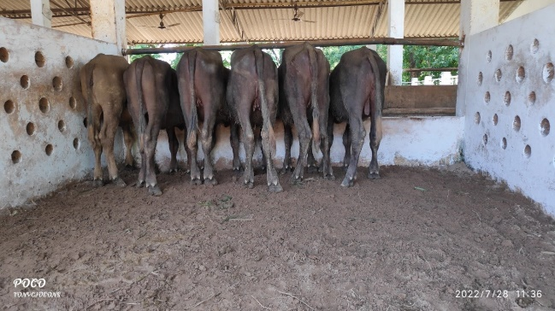
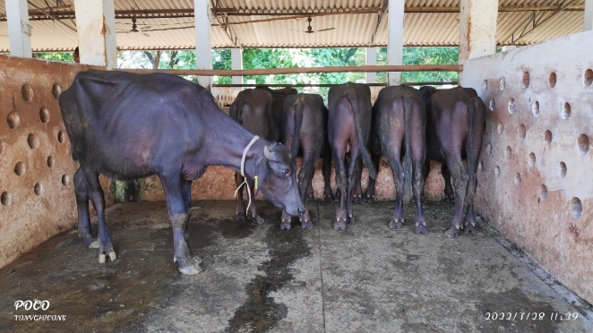
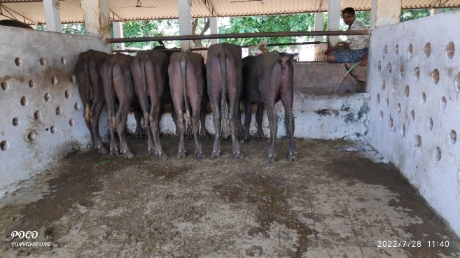

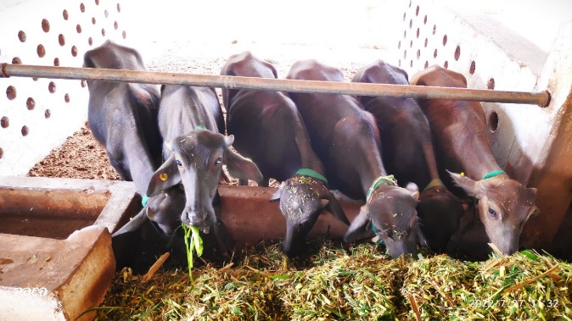
Fig.1.Cleanliness in concrete floor Fig.2.Cleanliness in rubber mat floor Fig.3.Cleanliness in soil floor
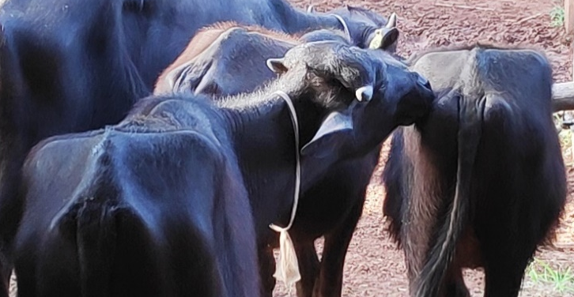
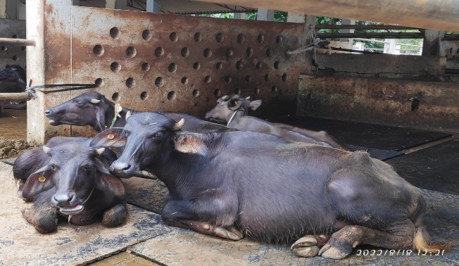

Fig.4.Standing and eating behaviour Fig.5.Sitting and ruminating behaviour Fig.6.Social licking behaviour
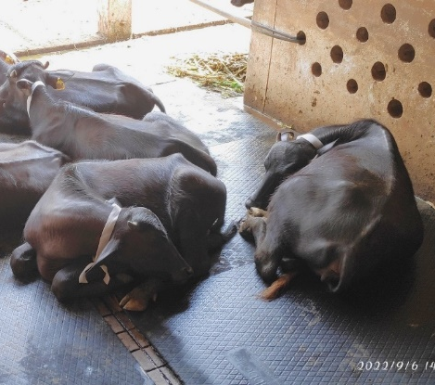
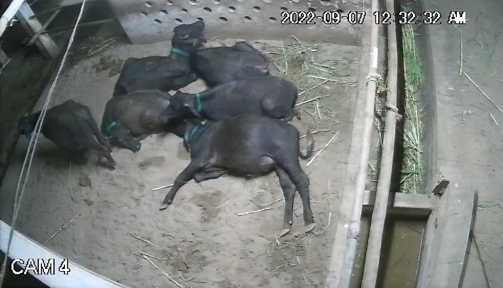

Fig.7.Sleeping behaviour
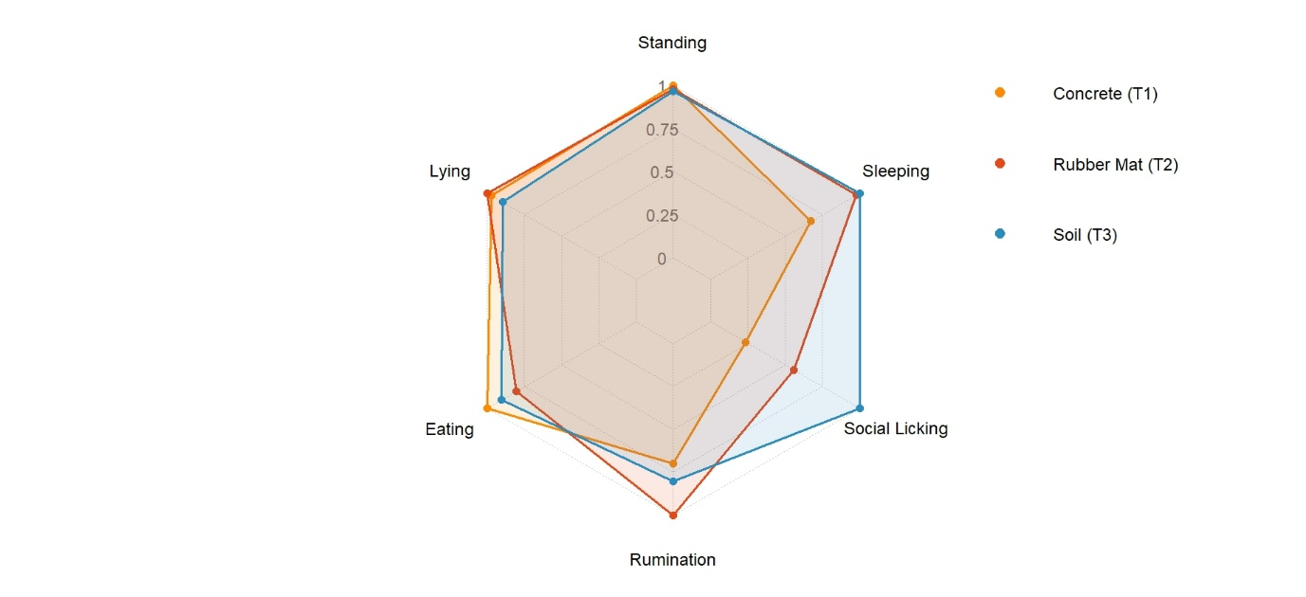
Fig 8. Comparative Behavioural Radar (Normalized per behaviour)

- Added some recent references

