Spatio-Temporal Assessment of Wheat Water Footprints under Agroforestry-Based Treatments

Abstract

Understanding the water footprint of wheat cultivation is essential for ensuring sustainable water resource management in semi-arid regions. This study presents a spatio-temporal assessment of green, blue, grey, and total water footprints of wheat grown under different agroforestry-based land use treatments during the cropping years 2017–18 and 2018–19. Five treatments were evaluated: 100% Dalbergia sissoo (T1), 75% Emblica officinalis + 25% D. sissoo (T2), 25% E. officinalis + 75% D. sissoo (T3), 50% E. officinalis + 50% D. sissoo (T4), and 100% E. officinalis (T5). Results revealed significant variation in water footprint components across treatments and years. The total water footprint of wheat ranged from 1.73 to 1.88 m³/kg, with T5 (100% E. officinalis) showing the lowest mean value and T3 (25% E. officinalis + 75% D. sissoo) the highest. Among components, the blue water footprint dominated, followed by grey and green contributions. Statistical analysis confirmed that treatment effects were significant (p < 0.05) for most components, while inter-annual variation reflected climatic influences. The findings indicate that agroforestry-based treatments can substantially influence water use efficiency in wheat production. Adoption of E. officinalis-based systems appears promising for reducing the total water footprint, thereby supporting sustainable intensification of wheat cultivation under water-limited conditions.

Keywords: Wheat, Water footprint, Agroforestry, Dalbergia sissoo, Emblica officinalis, Sustainable water management

Introduction

Agroforestry, the deliberate integration of trees with crops and/or livestock, has long been recognized as a scientifically sound, ecologically sustainable, and socially acceptable land-use system (Bijalwan et al., 2020; Verma et al., 2017). By combining biological and ecological synergies, agroforestry enhances land productivity, promotes biodiversity, and provides ecological stability, especially in regions where shrinking landholdings and declining yields from monocropping threaten livelihoods. The Green Revolution of the mid-20th century enabled India to achieve self-sufficiency in food grain production through intensive input-driven practices; however, it also increased pressure on natural resources, particularly water. Given the mounting pressures on natural resources, a similar ‘tree-based revolution’ is required in agroforestry to harmonize productivity with ecological sustainability..

In addition to yield benefits, agroforestry systems provide multiple ecosystem services. Trees within these systems help regulate microclimates by moderating temperature extremes and reducing evapotranspiration losses. Permanent tree cover also plays a crucial role in soil and water conservation, reducing runoff, enhancing infiltration, and maintaining soil fertility through nutrient cycling. Moreover, agroforestry diversifies household incomes by offering timber, fruit, fuelwood, fodder, and other tree-based products, thereby enhancing livelihood resilience. These features make agroforestry not only an agronomic strategy but also a socio-economic and environmental necessity in the face of climate change and water scarcity.

India, one of the world’s leading agricultural producers and exporters, cultivates a wide array of crops and tree species across diverse agro-ecological regions. Wheat (Triticum aestivum L.) is the country’s second most important staple crop after rice and contributes substantially to food security and rural incomes. With a 22% global share, India ranks as the world’s third largest producer of wheat (Mom, 2007). However, increasing demand for wheat is coinciding with intensifying water scarcity, raising concerns about long-term food security and the sustainability of wheat-based farming systems. Globally, agriculture consumes nearly 85% of freshwater resources (Shiklomanov, 2000; Hoekstra & Chapagain, 2007), and in India—where agriculture underpins rural livelihoods and economic stability—inefficient water use exacerbates vulnerabilities to climate variability and resource depletion.

The water footprint (WF) framework offers a robust approach to evaluate water use in agriculture by partitioning freshwater consumption into three components: green WF (effective rainfall stored in the soil), blue WF (surface and groundwater withdrawals for irrigation), and grey WF (freshwater required to dilute pollutants, particularly nutrients such as nitrogen, to acceptable standards) (Hoekstra et al., 2011; Lovarelli et al., 2016). Unlike conventional irrigation efficiency measures, the WF approach accounts for both water quantity and quality dimensions and is spatially explicit, enabling more comprehensive assessments of sustainability. By applying this framework to wheat cultivation under agroforestry systems, it becomes possible to capture the trade-offs between productivity and water-use efficiency while identifying land-use combinations that minimize environmental impacts.

Given the dual challenge of rising wheat demand and worsening water scarcity, reducing the water footprint of wheat cultivation is increasingly recognized as central to sustainable intensification strategies. Agroforestry, through its capacity to enhance resource-use efficiency and ecosystem services, provides a promising pathway for reducing the overall WF of wheat. Against this backdrop, the present study conducts a spatio-temporal assessment of green, blue, grey, and total water footprints of wheat grown under different agroforestry-based treatments during two cropping years (2017–18 and 2018–19). The aim is to identify optimal tree-crop combinations that enhance water-use efficiency while ensuring food security and supporting environmental sustainability in water-limited regions.
Materials and Methods
2. Materials and Methods

2.1 Study Site
The study was conducted at the Indira Gandhi National Tribal University (IGNTU), Amarkantak, Madhya Pradesh, India, located at 22°48′22.9″ N latitude and 81°45′03.2″ E longitude. The experimental site represents a dry tropical habitat chosen to evaluate the water footprint and carbon sequestration of wheat cultivated under Dalbergia sissoo + Emblica officinalis based agroforestry systems. The region is characterized by a subtropical climate with distinct seasonal variations. During the study period (2017–18 and 2018–19), the annual rainfall ranged from 1269 mm to 1770 mm. The mean annual maximum and minimum temperatures were 31.6°C and 18.2°C, respectively, with seasonal extremes reaching 42°C in May and dropping to 2.3°C in December. This climatic variability provides a representative setting for evaluating the sustainability of wheat-based agroforestry systems in water-limited environments. Edaphic conditions further influence the suitability of the site. The soil was found to be slightly acidic, with medium fertility status and adequate organic matter. Nutrient availability (NPK) and soil organic carbon were higher in the surface layer compared to the subsurface, reflecting a fertile profile capable of supporting wheat cultivation. Soil moisture content was monitored at regular intervals using the gravimetric method, wherein soil samples were collected from 0–20 cm and 20–40 cm depths, weighed fresh, oven-dried at 105 °C for 24 hours, and reweighed to calculate the percentage moisture content. Overall, the combination of climatic diversity and favourable soil conditions makes this site an appropriate setting to assess the spatio-temporal variation in water footprints under agroforestry-based wheat systems.
2.2 Experimental Design and Treatments
The study followed a randomized block design with five agroforestry-based treatments, replicated four times:
T1: 100% Dalbergia sissoo
T2: 75% Emblica officinalis + 25% D. sissoo
T3: 25% E. officinalis + 75% D. sissoo
T4: 50% E. officinalis + 50% D. sissoo
T5: 100% E. officinalis
Wheat (Triticum aestivum) variety JW3173 was sown in the alleys during the rabi season in both years (2017–18 and 2018–19). Standard agronomic practices were applied uniformly across treatments, including seed rate (100 kg ha-1), fertilizer application [100:60:40:: N:P:K (kg ha-1)], and pest management.
2.3 Data Collection
Meteorological data (rainfall, temperature, humidity, and reference evapotranspiration) were recorded daily from an on-site weather station. Soil moisture content was monitored using (gravimetric method). Irrigation amounts were recorded to calculate blue water use. Fertilizer applications (particularly nitrogen) were tracked for estimating grey water footprint.

2.4 Water Footprint Estimation
The water footprint (WF) of wheat under different agroforestry-based treatments was estimated using the Water Footprint Assessment (WFA) framework proposed by Hoekstra et al. (2011). The WF was expressed in cubic meters of water per kilogram of grain yield (m³/kg) and consisted of three components:
- Green WF (m³/kg): The volume of effective rainfall contributing to crop evapotranspiration (ETgreen​).
- Blue WF (m³/kg): The volume of irrigation water consumed by the crop (ETblue).
- Grey WF (m³/kg): The volume of freshwater required assimilating nitrogen leaching losses, calculated based on the maximum allowable concentration of 50 mg/L of nitrate.
The Total WF (m³/kg) was derived as the sum of green, blue, and grey components:
WF total​=WF green​+WF blue​+WF grey​
All water use values were normalized by grain yield to provide water footprint estimates per unit of production. This approach allowed for a spatially explicit and crop-specific assessment of water use efficiency under the tested agroforestry systems.
3. Data Analysis
Water footprint values were computed for each treatment and cropping year. Treatment means were compared using analysis of variance (ANOVA), and significant differences were identified at p < 0.05. Where appropriate, mean separation was performed using the least significant difference (LSD) test. Statistical analyses were conducted using (software SPSS). Graphical visualizations, including bar plots with error bars, were prepared to illustrate treatment-wise differences in green, blue, grey, and total WFs.
Results and Discussion
Yield–Water Footprint Interactions in Wheat under Agroforestry Systems
Wheat performance varied significantly across agroforestry treatments (Table 1). Grain yield was highest under the E. officinalis–based system (T5; 1639 kg ha⁻¹ yr⁻¹) and lowest under D. sissoo-dominated treatments (T3; 1436 kg ha⁻¹ yr⁻¹). Aboveground biomass followed a similar trend, confirming that tree species composition influenced overall crop growth. Harvest index values (40–42%) showed little variation among treatments, indicating stable partitioning efficiency across systems. Importantly, yield differences directly impacted water footprint (WF) performance. Higher yields in E. officinalis–based systems diluted irrigation water requirements, leading to lower blue and total WF, whereas lower productivity in D. sissoo systems raised WF despite similar irrigation inputs. These findings align with documented advantages of aonla-based agroforestry—including improved microclimate, beneficial shading, and soil moisture conservation—which enhance cereal productivity and water productivity in semi-arid contexts (Singh et al 2019).
Table 1. Mean performance of wheat yield and harvest index under different agroforestry treatments (2017–18 and 2018–19).
Land use systems | Grain yield (kg ha⁻¹ yr⁻¹)  2017–18 | 2018–19 | Mean | Straw yield (kg ha⁻¹ yr⁻¹)  2017–18 | 2018–19 | Mean | Aboveground biomass (kg ha⁻¹ yr⁻¹)  2017–18 | 2018–19 | Mean | Harvest index (%)  2017–18 | 2018–19 | Mean
100% D. sissoo (T1) | 1473.0 | 1426.0 | 1449.5 | 2212.5 | 2054.3 | 2133.4 | 3685.5 | 3480.3 | 3582.9 | 39.97 | 41.0 | 40.49
75% E. officinalis + 25% D. sissoo (T2) | 1661.0 | 1471.0 | 1566.0 | 2303.3 | 2030.0 | 2166.6 | 3964.3 | 3501.0 | 3732.6 | 41.89 | 42.03 | 41.96
25% E. officinalis + 75% D. sissoo (T3) | 1458.5 | 1413.8 | 1436.1 | 2135.5 | 2110.3 | 2122.9 | 3594.0 | 3524.0 | 3559.0 | 40.61 | 40.15 | 40.38
50% E. officinalis + 50% D. sissoo (T4) | 1593.5 | 1419.0 | 1506.3 | 2296.5 | 1988.8 | 2142.6 | 3890.0 | 3407.8 | 3648.9 | 41.01 | 41.67 | 41.34
100% E. officinalis (T5) | 1758.3 | 1519.5 | 1638.9 | 2420.0 | 2063.8 | 2241.9 | 4178.3 | 3583.3 | 3880.8 | 42.11 | 42.44 | 42.27
SEm± | 63.0 | 22.2 | 22.8 | 105.6 | 62.5 | 34.3 | 159.2 | 72.0 | 56.0 | 0.7 | 0.72 | 0.14
CD (p = 0.05) | 188.0 | 66.3 | 67.0 | 315.0 | 186.5 | 100.7 | 475.0 | 214.6 | 164.5 | 2.1 | 2.2 | 0.42
*Values are means of two years. SEm = standard error of mean; CD = critical difference at 5% significance level.*
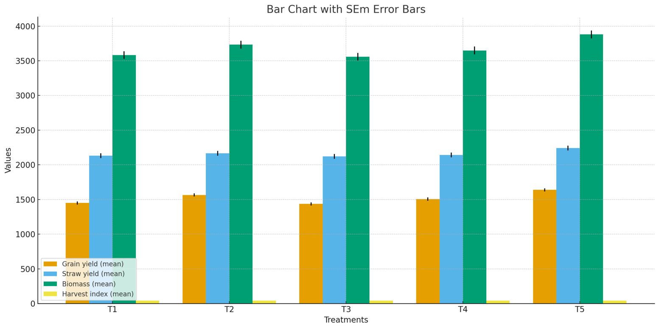

Fig:1 Mean performance of wheat yield and harvest index under different agroforestry treatments (2017–18 and 2018–19).
Spatial Variation in Water Footprints
Agroforestry treatments exhibited marked spatial differences in WF components (Table 2). Across treatments, the blue WF dominated (1.14–1.24 m³ kg⁻¹), followed by grey (0.47–0.51 m³ kg⁻¹) and green (0.12–0.14 m³ kg⁻¹). The total WF ranged from 1.73 m³ kg⁻¹ (T5) to 1.88 m³ kg⁻¹ (T3), clearly distinguishing E. officinalis-based systems from D. sissoo-dominated ones. The lowest WF under T5 reflected higher yields and efficient irrigation water use, while T3 recorded the highest WF due to yield suppression under denser canopy conditions. Mixed systems (T2, T4) showed intermediate WF values (1.80–1.84 m³ kg⁻¹), suggesting partial benefits of E. officinalis. These spatial results demonstrate that tree species selection is a decisive factor regulating crop–water relations, with aonla-based systems offering superior efficiency. The favorable phyllode-type leaf morphology of E. officinalis enhances light penetration and rainfall interception, thereby reducing irrigation dependency, whereas D. sissoo canopies intensify water demand per unit yield. Due to its thin canopy and leaf‐shedding nature in the winter season, orchards of this fruit tree species are well suited for agro-forestry ( Duve et al., 2022).

Table 2: Green, Blue, Grey and Total Water Footprint of Wheat Crop under Different Treatments Over the Years.
Land use systems | Green WF (2017-18) | Green WF (2018-19) | Green WF (Mean) | Blue WF (2017-18) | Blue WF (2018-19) | Blue WF (Mean) | Grey WF (2017-18) | Grey WF (2018-19) | Grey WF (Mean) | Total WF (2017-18) | Total WF (2018-19) | Total WF (Mean)
100% D. sissoo (T1) | 0.1 | 0.15 | 0.12 | 1.09 | 1.36 | 1.22 | 0.49 | 0.52 | 0.5 | 1.67 | 2.03 | 1.85
75% E. officinalis + 25% D. sissoo (T2) | 0.11 | 0.15 | 0.13 | 1.01 | 1.35 | 1.18 | 0.45 | 0.51 | 0.48 | 1.58 | 2.01 | 1.8
25% E. officinalis + 75% D. sissoo (T3) | 0.12 | 0.15 | 0.14 | 1.13 | 1.34 | 1.24 | 0.51 | 0.51 | 0.51 | 1.76 | 2.0 | 1.88
50% E. officinalis + 50% D. sissoo (T4) | 0.11 | 0.15 | 0.13 | 1.03 | 1.39 | 1.21 | 0.46 | 0.53 | 0.5 | 1.61 | 2.07 | 1.84
100% E. officinalis (T5) | 0.11 | 0.14 | 0.12 | 0.96 | 1.32 | 1.14 | 0.43 | 0.5 | 0.47 | 1.5 | 1.97 | 1.73
SEm± | 0.01 | 0.003 | 0.0025 | 0.05 | 0.03 | 0.02 | 0.02 | 0.01 | 0.007 | 0.07 | 0.04 | 0.02
CD at 5% (P=0.05) | 0.03 | 0.01 | 0.007 | 0.14 | 0.08 | 0.05 | 0.06 | 0.03 | 0.02 | 0.21 | 0.12 | 0.07

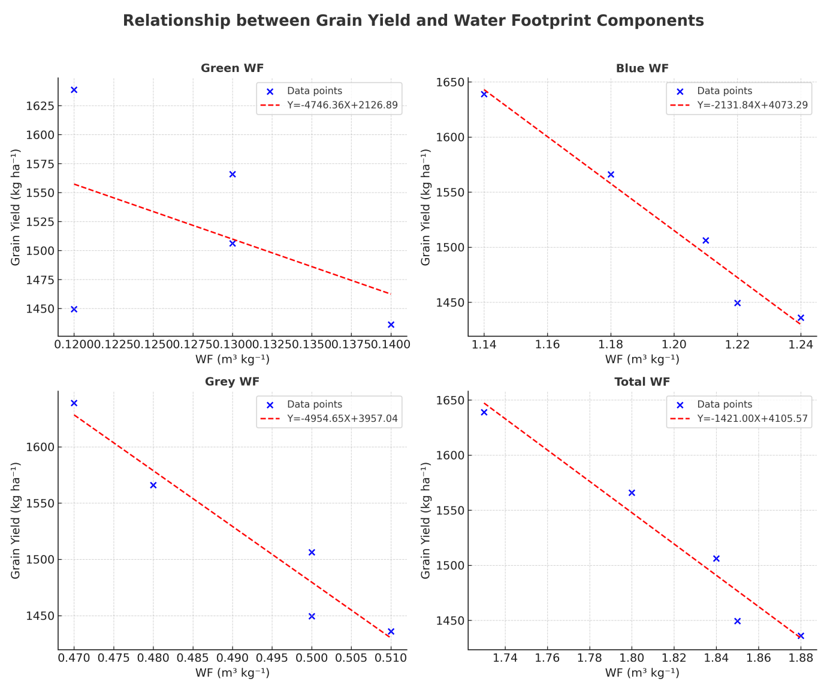
Fig:2 Green, Blue, Grey and Total Water Footprint of Wheat Crop under Different Treatments Over the Years
Temporal Dynamics in Water Footprints
Inter-annual variability in WF components highlighted the climatic sensitivity of wheat production in semi-arid systems (Table 2). Blue WF increased in 2018–19 (1.32–1.39 m³ kg⁻¹) compared with 2017–18 (0.96–1.13 m³ kg⁻¹), while green WF contributions declined slightly and grey WF values remained relatively stable. Consequently, the total WF rose from 1.50–1.76 m³ kg⁻¹ in 2017–18 to 1.97–2.07 m³ kg⁻¹ in 2018–19 within these systems. These temporal shifts align with findings that monitoring data support a strong linkage between rainfall variability and WF fluctuations, especially blue WF. For instance, Sun et al. (2013) demonstrated that climate variability significantly impacts the water footprint of spring wheat in an irrigated region of China. Similarly, Swelam et al. (2022) documented how micro-climate differences across agro-ecological zones directly affected wheat WF in Egypt. Correlation and regression analysis (Table 3) confirmed strong negative associations between yield and WF components—particularly blue WF (r = –0.99, p < 0.01) and total WF (r = –0.98, p < 0.01)—showing that higher yields reduce WF by enhancing water productivity under varying climatic conditions. Fig 3 show the Blue, Grey, and Total WF are strongly and negatively associated with yield, with highly significant regressions.
Table 3. Correlation and regression analysis between wheat yield and water footprint (WF) components across treatments and years (2017–19).
WF Component | Correlation (r) | Regression Equation | R² | Significance (p)
Green WF | –0.47 | Y = 2126.89 – 4746.36X | 0.22 | 0.423 (ns)
Blue WF | –0.99** | Y = 4073.29 – 2131.84X | 0.97 | 0.002 (***)
Grey WF | –0.97** | Y = 3957.04 – 4954.65X | 0.93 | 0.008 (**)
Total WF | –0.98** | Y = 4105.57 – 1421.00X | 0.95 | 0.005 (**)
ns = not significant (p > 0.05); * = significant at 5% level (p < 0.05); ** = highly significant at 1% level (p < 0.01); *** = very highly significant at 0.1% level (p < 0.001).
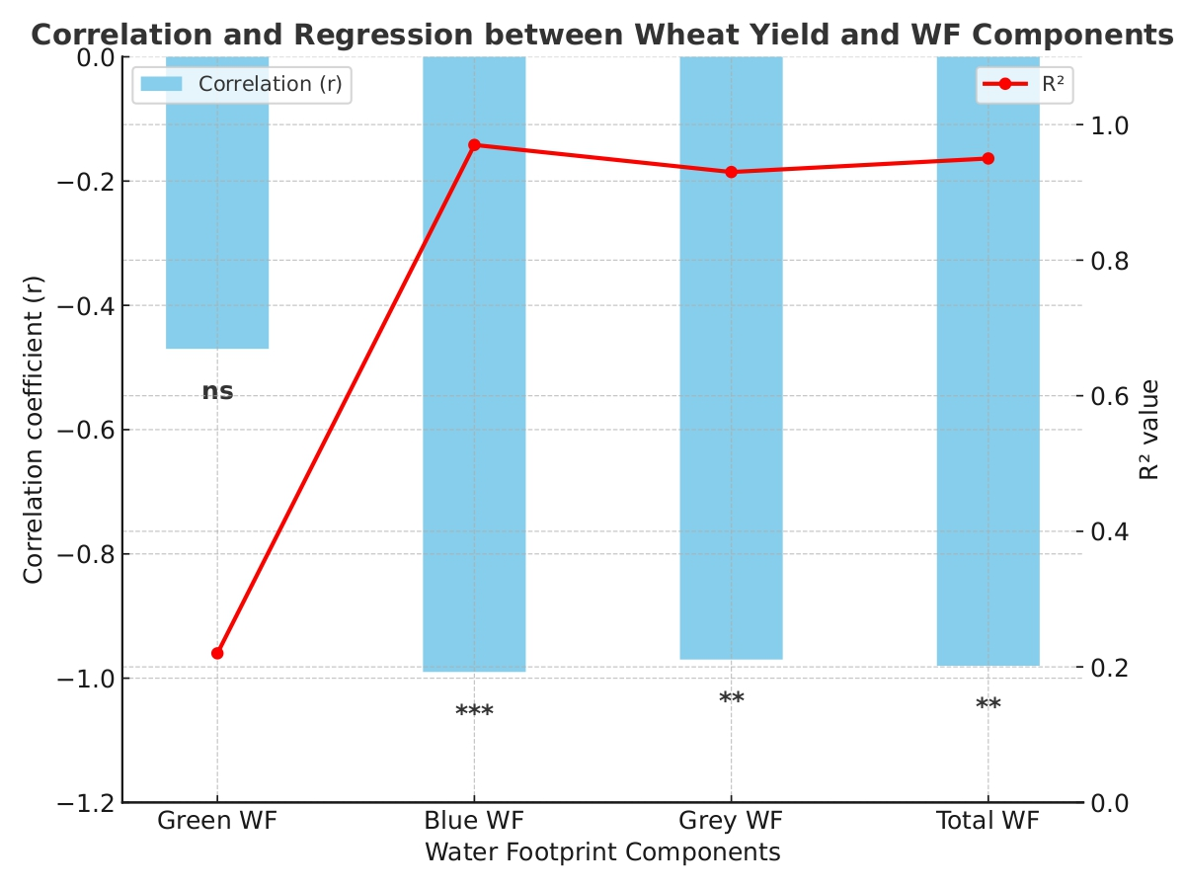
Fig:3 Correlation and regression analysis between wheat yield and water footprint (WF) components across treatments and years (2017–19).

Benchmarking Against Conventional and Global Systems
When benchmarked against conventional and global systems, the water footprints of agroforestry treatments in our study remained competitive (Table 4). Notably, wheat under the E. officinalis-based system (T5) recorded a total WF of 1.73 m³ kg⁻¹, which lies within the range reported for conventional surface-flood irrigation in Punjab (0.98–1.57 m³ kg⁻¹; Choudhary et al., 2025). Furthermore, state-level farm survey data indicate even lower average WFs (~0.87 m³ kg⁻¹) for wheat in Punjab (Kashyap & Agarwal, 2021). On a global scale, Mekonnen and Hoekstra (2010) reported an average wheat WF of approximately 1.83 m³ kg⁻¹, closely aligning with the values obtained in our agroforestry treatments.
These comparisons demonstrate that adopting E. officinalis-based agroforestry can deliver water use efficiencies on par with conventional irrigation practices and global benchmarks, even without advanced irrigation technologies. This emphasizes the potential of agroforestry as a climate-resilient and resource-efficient production system for semi-arid regions.

Table 4. Comparison of water footprints (m³ kg⁻¹) of wheat under agroforestry treatments versus conventional and global benchmarks
System / Source | Green WF | Blue WF | Total WF | Notes
T1 (Mean, Agroforestry) | 0.12 | 1.22 | 1.85 | Agroforestry treatment 1 (2017–18 & 2018–19 avg)
T2 (Mean, Agroforestry) | 0.13 | 1.18 | 1.80 | Agroforestry treatment 2
T3 (Mean, Agroforestry) | 0.14 | 1.24 | 1.88 | Agroforestry treatment 3
T4 (Mean, Agroforestry) | 0.13 | 1.21 | 1.84 | Agroforestry treatment 4
T5 (Mean, Agroforestry) | 0.12 | 1.14 | 1.73 | Agroforestry treatment 5 (lowest WF)
Punjab (Conventional, Flood Irrigation)¹ | – | – | 0.98–1.57 | Experimental study under surface irrigation
Punjab (Farm Survey Mean)² | – | – | 0.87 | Average WF from farm-level survey
Global Wheat Average³ | – | – | ~1.83 | Global benchmark across wheat systems

Conclusion
This study demonstrates that both tree species composition and inter-annual climatic variability significantly influence wheat water footprints in semi-arid agroforestry systems. Among the treatments, E. officinalis-based systems (T5) consistently achieved higher yields and lower total WF (1.73 m³ kg⁻¹), primarily through reductions in blue WF, whereas D. sissoo-dominated systems (T3) recorded lower yields and the highest total WF (1.88 m³ kg⁻¹). Temporal analysis highlighted that reduced rainfall in 2018–19 increased irrigation dependence, raising blue and total WF by ~14% compared with 2017–18. These findings confirm that tree–crop interactions not only shape spatial differences in water productivity but also buffer or amplify the effects of climatic variability.
Benchmarking against conventional and global systems further underscored the potential of agroforestry-based wheat production. The water footprints of E. officinalis systems were comparable to, or lower than, values reported under advanced irrigation technologies in Punjab and aligned with global wheat benchmarks. This indicates that tree-mediated microclimatic regulation can provide substantial water-saving benefits even in the absence of technological interventions.
Management Implications
Adoption of aonla (E. officinalis)-based agroforestry in semi-arid regions offers a viable strategy to improve wheat water use efficiency, reduce irrigation demand, and enhance yield stability under rainfall variability. Future scaling of such systems could play a critical role in sustainable intensification of wheat production, particularly in water-scarce regions of South Asia. Integrating species selection with modern irrigation practices may further optimize both yield and water productivity, contributing to climate-resilient agriculture.

References
Choudhary, S., Mishra, S. K., Singh, K., Pal, R. K., & Prabhjot-Kaur. (2025). Water footprint of wheat under different irrigation practices at Faridkot, Punjab. Journal of Agrometeorology, 27(1), 22–26. https://journal.agrimetassociation.org/index.php/jam/article/view/2844
Dubey, K., & Dubey, K. P. (2022). Emblica officinalis orchard-based agroforestry for augmented productivity. In Handbook of Research on Principles and Practices for Orchards Management (pp. 174–184). IGI Global. https://doi.org/10.4018/978-1-6684-2423-0.ch010
Hoekstra, A. Y., Chapagain, A. K., Mekonnen, M. M., & Aldaya, M. M. (2011). The water footprint assessment manual: Setting the global standard. Routledge. https://doi.org/10.4324/9781849775526
Hoekstra, A. Y., & Chapagain, A. K. (2007). The water footprints of Morocco and the Netherlands: Global water use as a result of domestic consumption of agricultural commodities. Ecological Economics, 64(1), 143–151. https://doi.org/10.1016/j.ecolecon.2007.02.023
Kashyap, D., & Agarwal, T. (2021). Carbon footprint and water footprint of rice and wheat production in Punjab, India. Agricultural Systems, 186, 102959. https://doi.org/10.1016/j.agsy.2020.102959
Lovarelli, D., Bacenetti, J., & Fiala, M. (2016). Water footprint of crop productions: A review. Science of the Total Environment, 548, 236–251. https://doi.org/10.1016/j.scitotenv.2016.01.022
Mekonnen, M. M., & Hoekstra, A. Y. (2010). A global and high‐resolution assessment of the green, blue and grey water footprint of wheat. Hydrology and Earth System Sciences, 14(7), 1259–1276. https://doi.org/10.5194/hess-14-1259-2010
Mom, R. J. C. (2007). A high spatial resolution analysis of the water footprint of global rice consumption (Master’s thesis). University of Twente.
Shiklomanov, I. A. (2000). Appraisal and assessment of world water resources. Water International, 25(1), 11–32. https://doi.org/10.1080/02508060008686794
Singh, A., Singh, S., Saroj, P. L., Mishra, D. S., Singh, P., & Singh, R. (2019). Aonla (Emblica officinalis) in India: A review of its improvement, production and diversified uses. Indian Journal of Agricultural Sciences, 89(11), 1773–1781. https://doi.org/10.56093/ijas.v89i11.95288
Sun, S., Wu, P., Wang, Y., Zhao, X., Liu, J., & Zhang, X. (2013). The impacts of interannual climate variability and agricultural inputs on water footprint of crop production in an irrigation district of China. Science of the Total Environment, 444, 498–507. https://doi.org/10.1016/j.scitotenv.2012.12.016
Swelam, A., Farag, A., Ramasamy, S., & Ghandour, A. (2022). Effect of climate variability on water footprint of some grain crops under different agro-climatic regions of Egypt. Atmosphere, 13(8), 1180. https://doi.org/10.3390/atmos13081180
Verma, P., Bijalwan, A., Dobriyal, M. J. R., Swamy, S. L., & Thakur, T. K. (2017). A paradigm shift in agroforestry practices in Uttar Pradesh. Current Science, 112(3), 509–516.
Bijalwan, A., Dobriyal, M., & Thakur, T. K. (2020). Silviculture and agroforestry: Why merger in the era of super specialization? Biodiversity International Journal, 4(3), 138–139. https://doi.org/10.15406/bij.2020.04.00180

