Modeling Toolkit: An Education Research Tool in Adapting Innovation

ABSTRACT
The subject of this article is education research, but its focus is on its instrument the toolkit and more specifically in modeling it, in order to provide stakeholders a tool that encouraged them to integrate innovations, as well as incorporate technology, reform curricula, and foster inclusion of new educational approaches that lead to develop best practices from/to students and improve their education. To achieve these goals the paper examines three complementary educational research approaches: first, how a toolkit can become a modeling mechanism of educational research; second, what theoretical considerations or conceptual backgrounds are required to justify a toolkit modeling; and third, how innovations, utilizing a generalized framework can create, through learning and teaching adjustments, new educational processes. As a result, the paper presents a toolkit modeling approach that proceeds abductively, combining theoretical constructs and conceptual reasoning with practical applications to yield a coherent explanatory educational process adapting innovation, among others, to education.

Keywords: Educational research, toolkit, toolkit modeling, toolkit conceptual issues, learning adjustments.

1 INTRODUCTION

1.1 Background and Rationale
Across contemporary education systems, innovation has become both an expectation and a challenge. Educational stakeholders (e.g., institutional educators and administrators, policymakers, and decision makers) are expected and encouraged to reform curricula, integrate technology, and foster inclusion of new educational approaches, yet such efforts rarely consolidate into enduring change. Despite extensive investment in pilot programs and externally funded initiatives, improvements often remain localized and temporary. The gap between educational innovation and teaching and learning transformation persists as one of the most significant systemic issues in the field [1].
At the center of this challenge lies the function of educational research accommodating innovation, whose main goal is to develop educational practices in order improve students’ education and enrich the school learning ecosystem. However, in most educational systems, such research is conceived as an external academic activity, or something produced for use by the educational institutions rather than by and within them. Consequently, innovation is often produced but seldom internalized. That is, information from research that leads to policy documents, rarely alters the daily classroom activities or long-term strategies of educational institutions.
This paper argues that such a disharmony stems from a conceptual fundamental limitation, the failure to treat educational research as an intrinsic system mechanism, in the form of a well-defined progression of necessary steps, which should be a process of how education learns, adapts, and renews itself. That is, within this educational situation, it is obvious that the necessary mechanism to correct that disharmony, should be a process allowing researcher to be involved in a common research tool, which is utilizing instruments, such as toolkits.
As a result, the paper pursues three interconnected toolkit objectives that leads to a methodological framework to: model the process of educational research, utilizing toolkits, as a mechanism of education operating across multiple educational system levels; conceptualize educational research as an intrinsic function of a system governing education, rather than an external evaluative activity; and propose a set of theoretical and practical propositions describing how a research processes, utilizing the instrument of a toolkit, generate organizational learning and policy adaptation.

1.2 Basic Concepts

For a meaningful presentation of the contents of the paper it is considered appropriate to refer to some basic concepts, which are fundamental components of it, and therefore are directly related to this paper. More specifically:

1.3.1 Education Research: Education research is a multidisciplinary field concerned with the systematic investigation of teaching, learning, and other educational aspects that support the educational process. As a result, it should generate information that can improve educational practice, policy, and theoretical understandings of how students acquire knowledge. There are several methodological approaches utilized in educational research, among which are those related to: its nature (e.g., quantitative, qualitative and mixed-methods); its topics (e.g., teaching, learning, and curriculum design); its educational level (e.g., primary, secondary and higher education); and its role due to demographic shifts, technological advancements, and socioeconomic conditions. Despite all these valid differentiations, education research should be concerned, among others, with understanding how technology mediates learning, how educators can effectively integrate digital tools, and how technology can support more personalized, equitable educational experiences. All of these, however should create the condition for creating and adapting educational innovation, the goal of this paper
1.3.2 Education Models: Educational models serve as conceptual frameworks that guide the design, implementation, and evaluation of educational processes. They offer structured ways, mainly a set of discrete steps, to understand how teaching and learning adjustments to new conditions can lead into new educational processes. The development of educational models is closely linked to theoretical concepts of learning and teaching development, of the theoretical foundation of educational model (e.g., behavioral, cognitive, or constructivist), but mainly the utilization of models (articulate how schools or educational systems should be structured), which are utilized in a direct or indirect way in this paper. Moreover, in bridging the gap between theoretical models and the complexities of real-world educational settings demands an easily understood and applied instrument such as a toolkit
1.3.3 Toolkit: Toolkits, which are structured collections of conceptual frameworks, practical resources, digital tools, and strategies have become central to contemporary education. They synthesize theoretical foundations, key functions of educational processes, information of their impact on teaching and learning, and education research recommendations for design and implementation. Toolkits, properly designed and implemented are powerful instruments for incorporating innovation to educational process in a practical way. Grounded in socio-cultural and activity theory, they mediate learning, and scaffold practice, as well as foster the distribution of the expertise gained from educational research. That is, toolkits when combined with professional learning and a commitment to innovation adaptation, help make the systemic education sustainable. As a result, well-designed toolkits substantiate the systemic nature of education, increase teacher participation, learner autonomy, adaptability to changing contexts, and mainly sustained innovation in classroom practice.

1.3.4 Systemic View of Educational Research: Traditional educational research frequently narrows its focus to discrete elements such as classroom practices, learner outcomes, or institutional policies. Although this approach allows methodological control, it often overlooks the broader societal, and technological conditions in which education occurs. As a result, educational research has long grappled with the complexity of teaching and learning, which historically has relied on fragmented approaches that isolate variables, populations, or instructional techniques. While such studies generate valuable insights, they often fail. That is, they ignore that education is an evolving, dynamic ecosystem shaped by multiple actors, structures, and contextual factors. In other words, the appropriate way to address educational research should be the recognition that education functions as a complex adaptive system. Moreover, a systemic function of educational research has direct implications for educational policy and practice. Policy initiatives designed without systemic insight risk creating misalignments as opposed to policy informed by systemic research, which is more likely to support sustainable and equitable improvements by acknowledging the interaction of resources, school culture, policy constraints, and cultural norms.
In sum, the challenges facing contemporary education and are considered in this paper are that learning and teaching adjustments transformation to new educational processes cannot be dealt with through isolated, non-systemic efforts. In general, a systemic approach of educational research is essential for capturing the multifaceted nature of educational ecosystems, which generates knowledge that bridges the divide between research, policy, and practice. As education systems continue to evolve, systemic approaches offer a robust framework for producing meaningful, contextually grounded insights that can utilize instruments, such as toolkits, that can explain nowadays educational processes.
1.4 Paper’s Goals
The paper following an integrative synthesis logic [2] is combining three complementary toolkit goals: Modeling, which reconfigure the educational research into a modeling mechanism, aligning its stages with the functions of organizational teaching and learning; Theoretical considerations, which refer to the identification and classification of key theoretical concepts producing the conceptual background linking educational research with a toolkit modeling approach; and Analytical Generalization, which delivers propositions describing how the modeling mechanism transforms through learning and teaching adjustments into new educational processes. As a result, the presented approach proceeds abductively, iterating between theoretical constructs and conceptual reasoning to yield a coherent explanatory educational model adapting innovation to education.

1.5 Paper’s Approach

The paper’s approach or modelling educational research expressed as a toolkit is essentially a process of interpreting observed educational phenomena and making decisions related to achieving learning and teaching adjustments to incorporate innovations in education. The main procedures/steps are: Abstraction, which denotes the creation of a simplified image of the complex real education. In this step, any data or concepts that are not considered necessary are removed; Conceptualization, which expresses the theoretical underpinnings, or a choice between various theoretical constructions, underpinning the simplified version of education and theoretically substantiated the proposed approach; Practical transformation, which is the transitional step where the simplified version of education is transformed into a practical instrument, in the form of a toolkit, for incorporating innovation to the educational process; Toolkit theoretical positioning, which reflects the theoretical approaches that contribute in understanding of how certain theoretical underpinnings support toolkits’ function; Toolkit characteristics, which provides a structured three-stage framework (determination of research; data to information; and application of results), accompanied with feedback processes and a systems-level mechanism; Learning ecosystem, which refers to the interconnected network of people, environments, technologies, practices, and institutional structures that collectively enable and shape learning; and Adjustments, which represent the drawing conclusions about the adjustments of teaching and learning in creating a new educational process that accommodates the produced innovations (Fig. 1). In addition, the paper includes an introduction, a theoretical justification of the papers’ approach and a final section on the implication of the proposed concept.

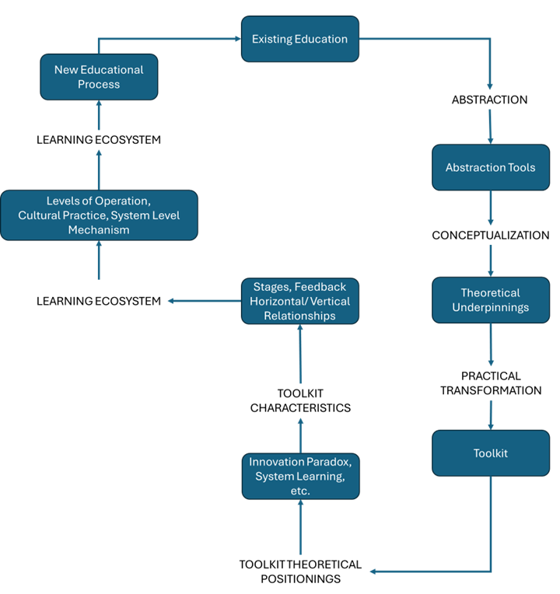

Fig. 1. Modeling Educational Research using Toolkit

- CONCEPTUAL AND METHODOLOGICAL APPROACH

A widely endorsed conceptual and methodological approach in educational research and consequently in the use of toolkits, is an integrated approach for investigating learning as a relational, and socially mediated process. It not only provides a rich conceptual lens for understanding educational phenomena, but also offers a rigorous methodological pathway for generating trustworthy and context-sensitive educational innovations. Such a conceptual and methodological approach in order to be fully understood there is a need to examine its: approach, context, transforming pathway (innovation adaption), and design.

2.1 Conceptual Approach

This paper is Conceptual and Desk-based, rather than presenting new empirical data. Basically, it synthesizes existing theories of systems thinking [3] organizational learning [4], and knowledge creation [5] with the procedural logic of the educational research, in the form of a toolkit. Through this synthesis, the paper develops a theoretical as well as a practical model (toolkit) that explains how educational research functions as a mechanism of educational change by incorporating innovation.
The methodological approach of the toolkit model is based on four interrelated dimensions: Horizontal, which represent the feedback progression among the toolkit’s stages; Vertical, which represent the circulation of learning across the levels of the educational system; Horizontal and vertical Connection, which represent how the continuous feedbacks that drives systemic learning are interconnected; and a System approach of all.

2.2 Research Context

The basis of any methodological approach is the content of the educational research and consequently of the toolkit, which, including this paper, is delimited by the international agendas for information-based education and school innovation. The reports by OECD [6] on schools as learning organizations framework, and the European Commission [7] on information-based policy and practice in education, both emphasize the need for a systematic (e.g., following specific steps) learning and teaching. Moreover, parallel developments in research–practice partnerships [8] and design-based implementation research [9] reflect a growing consensus that sustainable educational reforms depend less on experience and more on modelling educational research and instruments that connect with innovations in learning and teaching processes. That is, within this context, educational research, transformed into a toolkit, provides an operational tool for embedding such processes into education.

2.3 Interpreting the Transformation Pathway

The paper’s methodological approach affirm that educational research can be understood as a systemic function analogous to metabolism in living organisms. Like biological systems, educational ecosystems maintain vitality through continuous cycles of different processes, responding to feedbacks. Moreover, the educational research toolkit provides the procedural structure for this metabolism, ensuring that inquiry and adaptation become routine rather than sporadic.
From a theoretical standpoint, the paper’s transformation pathway or modeling unites several strands of research efforts shown next to achieve its objectives (table 1).
Table 1 Main Theoretical Contributions to the Modeling approach
Theoretical Efforts | Contribution to the Modelling
Systems Thinking (Senge, 1990; Davis & Sumara, 2006) | Explains how feedback and interdependence generate systemic learning.
Organizational Learning (Argyris & Schön, 1978) | Clarifies how horizontal and vertical feedbacks learning is achieved following the toolkit’s components.
Knowledge Creation (Nonaka & Takeuchi, 1995) | Describes the conversion of research data into information or explicit institutional knowledge.

This synthesis establishes a multi-theoretical foundation for understanding how research, when embedded institutionally, functions as a mechanism of adjustments and changes within an educational system.

2.4 Methodological institutional Design

One of the paper’s most important methodological approaches concerns the institutional design. That is, for educational research to act as a system-function mechanism, it must be supported by structures that ensure innovation applicability. These include:
- Strategic Alignment: Research must be integrated into the school’s vision and improvement strategy rather than treated as an ancillary activity.
- Leadership Commitment: Institutional leaders need to allocate resources, and mainly to recognize that their operation should be research-based or constant application of innovations.
- Data: Specific toolkit’s processes, such as data collection, processing, analysis and interpretation must be considered as ethical considerations and responsiveness to local contexts, in order to achieve inclusive, adaptive and sustainable teaching and learning changes.
- Professional Learning Communities: Cross-disciplinary teams should engage in collective analysis, transforming individual reflection into organizational knowledge.
- Feedback Governance: Routine structures, such as information-sharing forums deciding on the iterative planning cycles, should be based on feedbacks that can connect educational inquiry with policy decisions.
When these components are institutionalized, the toolkit evolves from a set of processes into a permanent system capability, creating an institutional mechanism for distributing knowledge within an educational institution.
Moreover, this study adopts a desk-based, conceptual research design, intended to generate a theoretical model rather than collect primary data. Its purpose is to synthesize and reinterpret existing knowledge on educational research, organizational learning, and system change to conceptualize the educational research toolkit as a mechanism of systemic learning. Following Jaakkola [10], conceptual research contributes by integrating existing constructs into new explanatory frameworks and its validity derives from coherence, theoretical saturation, and pragmatic applicability rather than statistical inference.

2.5 A Systemic View of Educational Research

2.5.1 Defining Educational Research in Systemic Terms: Educational research traditionally serves as a means of generating information to improve teaching and learning. Yet in most institutional contexts, it remains Sporadic, Fragmented, and Externally driven. Research projects are often appended to innovation-centered initiatives rather than forming an integral part of how educational systems evolve. As a result, findings indeed proposed improvements, but rarely reshape the broader organizational or policy structures that govern learning. The literature suggests that Systemic improvement requires embedding research as a structural process within educational governance [11], [3]. In complex adaptive systems such as education, change does not progress linearly from design to implementation, but it evolves Continuous feedback to satisfy sense-making, and collective learning [12]. This paper outlines the conceptual underpinnings for reframing educational research as the very mechanism in the form of a toolkit through which systems generate, interpret, and apply knowledge and mainly innovation to new educational processes.
Moreover, the term educational research encompasses diverse epistemological traditions, from experimental studies and ethnography to design-based inquiry and action research. However, the educational research toolkit clarifies that research in education is not only a methodological activity, but mainly a systemic functional process comprising of interdependent stages that will examined later. As a result, viewed systemically, these stages represent feedbacks of learning and teaching through which educational organizations convert research outcomes into structured information or knowledge that in turn produce educational innovations.

2.3.2 Systems Thinking and Educational Change: Systems thinking offers a theoretical lens to understand how learning organizations evolve. Senge’s [3] concept of the learning organization, one that continually expands its capacity to create its future, positions feedback and reflection as core organizational processes. Similarly, Argyris and Schön [4] distinguish between Single-loop learning (doing things better) and Double-loop learning (doing better things). Educational systems, when viewed through this lens, operate as learning ecosystems. Their capacity for self-improvement depends on how effectively they process feedback and transform information into action. The educational research toolkit translates these abstract theories into a procedural mechanism or a practical structure through which educators and leaders enact systemic learning cycles.

2.5.3 The Missing Middle in Educational Research: The literature on educational research reveals a bifurcation between two dominant orientations: Academic research, focused on theoretical knowledge production, and Action research, concerned with classroom-level improvement. Between these lies a “missing middle”, the organizational and policy zone where information must circulate to generate system coherence [13], [6]. In this middle level, innovations are either too local to scale or too abstract to guide practice. By framing educational research as a System-level mechanism, the missing middle is directly addressed. As a result, the toolkit becomes a connecting device, aligning micro-level teaching and learning with meso-level organizational approaches and macro-level policy development. Its value is thus structural because it coordinates information flow, and sustains innovation learning

2.6 Organizational Learning
Organizational learning theory provides the bridge between individual development and system-wide improvement. Argyris and Schön [4] emphasized that organizations learn when information or knowledge becomes an instrument that allows the embedment of specified operational approaches. In, teaching and learning this means transforming research education into institutional processes, in the form of a toolkit, that aligns with a three-stage logic perspective, namely: Determination of results, which institutionalizes collective sense-making and shared goal setting; From data to information, which formalizes data stewardship and evaluative reasoning; and Application of results, which embeds implementation and reflection within governance structures
That is, by bringing together systems theory, organizational learning, and research methodology, it should be clear that the educational research toolkit is a System-level mechanism of learning. It provides both the methodological and conceptual infrastructure through which education systems can transform scattered institutional knowledge or information into sustainable educational innovations. This argument, therefore indicates that the persistent fragmentation of educational innovation results from the absence of such systemic feedback mechanisms

3 ABSTRACTION
In modeling educational research, the first and very important step is that of abstraction. The purpose of that process is simply to create a simplified and manageable version of the very intrigant existing education system. That is, in order to transform the multifactor and multidimensional educational reality into a manageable and simplified version, which researchers can work with, they need to remove all the not pertinent information and concepts. To achieve this task of concentrating in the examination and the resolution of the issues of interest, they can be helped by utilizing the following tools.

3.1 Functional definition

The functional definitions are a very powerful research tool, although they are arbitrary and of course they do not express the ultimate truth and therefore, cannot be considered as been right or wrong, as well as true or not [14], [15], [16], [17]. For example, by defining a school as a point in a map of schools to examine their spatial distribution is such a functional definition, because a school occupies an area (a set of buildings). Their role is very simple, namely to introduce an operational tool to help researchers to deal exclusively with the educational issue of interest ignoring all the other information and concepts.

3.2 Assumptions

Assumptions are also an important and necessary tool to address the issue that researchers are facing, when they deal with the complex educational reality. Assumptions are concerned with accepting some ideas, concepts, procedures or rules, which however cannot be substantiated, but simplify the education process and greatly help and facilitate educational research. For example, the person-to-person interaction is the only way to deal with teaching and learning.

3.3 Defining the content.

The last helping tool to educational research is the concise and precise delineation of its content, for the simple reason that most educational issues requiring research attention are manifested differently due to their context. For example, educational research is different when considering K–12 vs. higher education, global approaches vs local, or resources in developed countries vs developing, etc. Indeed, it has been shown [15] [16] that at least for issue such as: equity, access, validity, technology, practices and policies a clear content determination is imperative for a successful research outcome. In sum, researchers should be aware that that a precise content definition can help them not only in discovering “what works?” but “for whom, and how sustainable is it?”

- CONCEPTUALIZATION
Conceptualization occupies a central position in educational research, serving as the intellectual foundation upon which inquiry is built. It refers to the systematic process of defining, clarifying, and structuring the key ideas, constructs, and relationships that shape the research. Far from being a preliminary formality, conceptualization is a rigorous scholarly activity that: provides theoretical clarity (delineates clear conceptual boundaries); guides research design and methodological decisions (ensures alignment between research questions, methods, and analyses); enables interpretive power (elevates research from descriptive reporting to meaningful explanation); contributes in ensuring transparency and rigor (safeguard against ambiguity and interpretive drift); and fosters innovation and theoretical advancement (challenge dominant paradigms and open pathways for fresh perspectives). Conceptualization is therefore not merely a technical step, but also a creative and reflective act that in addition contributes in the following theoretical ways to incorporating innovation in education.

4.1 Conceptual Orientation
Contemporary policy discourse increasingly emphasizes information decision-making (European Commission, [7]; OECD, [18]), yet information use is often sporadic, and fragmented. Conceptualizing educational research as it reframes information (the term used is evidence, which we suggest they do not automatically produced information that leads to knowledge), as part of the educational system available to all stakeholders. Each of the three toolkit stages functions as a transaction that transfers knowledge between subsystems. When institutionalized, these transactions yield organizational knowledge creation [5], where tacit expertise becomes explicit, shared, and reintegrated into practice. That is, information is not just an output of research, but the medium through which the system learns and renews itself, which is an essential condition for adaptive, high-reliability educational process.

4.2 Conceptual Gap and Research Aim
While extensive scholarship exists on school improvement [11],[19] and research–practice partnerships [8], few frameworks explain how research functions as a mechanism that generates systemic adaptation. Most research models describe collaboration, feedback, and alignment, but rarely articulate the underlying architecture that enables them to bridge conceptual gap and research aim. It is suggested that this gap can be addressed by treating a toolkit as a minimal systemic architecture, which by using a feedback loop converts localized inquiry into organizational and policy learning. That is, the importance of bridging the gap lies in conceptual integration rather than empirical validation, uniting methodological, organizational, and governance perspectives into one coherent systems framework.

5. PRACTICAL TRANSFORMATION: THE TOOLKIT

The emergence of the “toolkit” as a methodological and conceptual instrument that exemplifies a major transformation in contemporary educational research. Traditionally, educational inquiry has been based on rigid methodological frameworks that prescribe how researchers should approach education. The toolkit approach, by contrast, conceptualizes research not as adherence to a singular epistemological pathway, but as an adaptive process in which researchers select and integrate approaches to address complex educational questions. As a result, the fundamental contribution of this paper is that educational research, when transformed into a toolkit, which among other contributions offer institutionalized feedback mechanisms, transforms schools from information or knowledge consumers into information or knowledge-producing ecosystems, leading towards an adaptive, information-driven education process.

5.1 Description of a Toolkit
At their core, toolkits are understood as structured assemblages of methods, resources, and procedural guides that support users in navigating complex educational tasks. In addition, a toolkit as an educational research transformation instrument is not only focused on examining and providing technical knowledge for specific contents, but in enhancing all educational activities. That is, the toolkit is addressing the need for an effective, efficient, and inclusive teaching and learning instrument by providing structured help, derived from educational research, to all educational stakeholders. Therefore, a toolkit can be described as a stakeholder-oriented instrument, which provides a step-by-step guideline. In addition, a toolkit by bringing together systems theory, organizational learning, and research methodology, represents a systemic mechanism of learning. That is, it provides both the procedural and conceptual infrastructure through which education systems can transform scattered innovations into sustainable educational knowledge. Moreover, while basically is as a methodological guide, a toolkit possesses a deeper significance. When viewed through the lens of systems theory and organizational learning, its cyclical structure functions as a mechanism of systemic feedback, which is a dynamic process through which schools, networks, and educational authorities convert inquiry into sustained innovation improvement.
5.2 Importance of the Toolkit
The importance of the toolkit approach stems from: its responsiveness to the multifaceted nature of educational problems (allows the combination of theoretical perspectives and methodological strategies that align with real-world educational environments); represents a practical turn in educational research (prioritizes the development of actionable knowledge that can inform policy and practice); contributes to methodological democratization and innovation (facilitates experimentation, interdisciplinary borrowing, and the emergence of new research innovations); supports conceptual integration (align conceptual frameworks with operational tools); and embodies a transformative perspective (It positions researchers not merely as observers but as designers who actively construct the means of inquiry).

- TOOLKITS’ THEORETICAL POSISIONINGS
The conceptualization of toolkits within educational and organizational contexts is grounded in several interrelated theoretical traditions. Their theoretical positionings reflect a synthesis of society-derived, design-based, and systems-oriented perspectives, each contributing to understanding of how toolkits function as a practice instrument of education research. More specifically, from a society- derived standpoint, toolkits are positioned as scaffolding instruments that facilitate knowledge construction responding to societal needs. Within a design-based theoretical framework, toolkits operate as modular design support that promote iterative feedback inquiry and adaptive implementation. As a systems-theoretical perspective further situates toolkits as components within broader socio-technical ecosystems. In this view, toolkits are not isolated sets of instruments, but operate as nodes within dynamic networks of human actors, institutional structures, and technological resources. In addition, the theory of practice frameworks view toolkits as stabilizing structures within an educational practice architecture.
In sum, these theoretical positionings underscore that a toolkit is not merely a collection of processes, but is the epistemic and practical bridges between theory and action. Its value lies in their capacity to mediate theoretical issues such as those presented next.
6.1 Organizational Learning
The theory of organizational learning [4] provides a critical lens for understanding educational research and consequently toolkits, as a mechanism, which is differentiated as: single-loop learning, indicating that organizations correct learning errors within existing norms; and double-loop learning, which lead to question and redesign of those norms. Within this theoretical approach, most educational reforms remain in a single-loop mode by optimizing performance in a framework of fixed parameters, whereas sustainable transformation demands as double-loop learning, where research information challenges underlying assumptions and values. The educational research toolkit operationalizes both forms: The stage “from data to information” supports evidence-based refinement (single-loop), while the stage “application of results” enables reflection that reshapes institutional purpose and practice (double-loop). Finally, when enacted as feedback, these stages establish a self-referential system capable of observing, critiquing, and redesigning itself.

6.The Paradox of Educational Innovation
Contemporary education systems display a persistent paradox. On one hand, educational institutions, networks, and governments agencies invest heavily in innovation (e.g., curriculum reform, digital transformation, inclusion of frameworks, etc.), as well as EU-funded projects such as: Erasmus, Strategic Partnerships, Erasmus+ Teacher Academies, Forward Looking, etc. However, in those efforts sustainable transformation remains elusive. More specifically, innovations often dissipate once the research effort (usually a funded project) is completed, producing what Fullan and Quinn [1] termed innovation fatigue, or an accumulation of initiatives without systemic consolidation.
This phenomenon reveals a deeper structural weakness, namely the absence of mechanisms that convert sporadic innovation into institutional learning. That is, educational research results, though extensive and ubiquitous across institutions, are rarely considered and embedded as a necessary helping tool in schools or networks. Unfortunately, educational research often operates externally by evaluating, auditing, or validating, rather than internally as an engine of ongoing adaptation. Addressing this limitation requires reframing research not as a discrete academic activity, but as an intrinsic system function through which education learns about itself. Systemic change in education requires coordinated efforts across multiple levels and sustained engagement, as demonstrated by Bryk et.al [19] frameworks, which emphasize the importance of interconnected school improvement practices.

6.3 From Evaluation to Systemic Learning

Traditional reform logic tends to follow a linear sequence: from innovation to implementation to evaluation to scaling. However, decades of empirical evidence show that such models fail to sustain change in the complex educational systems. As Davis & Sumara [12] and Biesta [13] have argued, lasting transformation depends on recursive feedback, distributed learning, and self-regulation, but mainly on systemic learning. Within this context, the educational research toolkit indeed provides a foundational structure for systemic feedback, which expresses the functions required for continuous systematic learning, namely problem definition, evidence generation, and adaptive action. Yet without institutional embedding, these cycles remain fragmented. As a result, a toolkit has to be conceptualized as a systemic mechanism, translating research processes into research evaluation, but mainly as systemic learning architectures that support sustainable improvement.

6.4 Systems Architecture

While extensive bibliography exists on school improvement [1], [19] and research–practice partnerships [8], few frameworks explain how research functions as a mechanism that generates system-level adaptation. Current models describe collaboration, feedback, and alignment, but rarely articulate the underlying architecture that enables them. Toolkits represent the theoretical underpinning of a systems architecture to overcome this conceptual gap. That is, a toolkit’s contribution lies in conceptual integration rather than empirical validation, uniting methodological, organizational, and administrative perspectives into one coherent systems framework.

- TOOLKIT CHARACTERISTICS
Koutsopoulos & Economou [20] in their paper “Educational Research Toolkit” suggested a structured, framework for a toolkit, which clearly shows the application of the basic concepts, as well as a mechanism required to bring to a successful conclusion any educational research. The main characteristics of a toolkit are.

  - Stages
The educational toolkit can be presented in the form of three stages: Stage 1 (determination of research), which institutionalizes collective sense-making and shared goal setting; Stage 2 (from data to information), which formalizes data stewardship and evaluative reasoning; and Stage 3 (application of results), which, embeds implementation and reflection within governance structures. Each one of these stages includes several steps, executing different activities (e.g., the activity of data collection method, part of the step data collection, referred to the stage from data to information) and which satisfy the necessary set of toolkit concepts (e.g., the presence of feedbacks) that begins with the determination of research, proceeds through data to information, and culminates in the application of results. (Fig. 2).
7.2 Feedbacks
Another significant characteristic is the existence of feedback mechanisms. That is, these stages constitute a Self-regulating feedback mechanism that strengthens institutional coherence and adaptive capacity. As a result, while a toolkit was designed as a methodological guide, when viewed through the lens of systems theory and organizational learning, its feedback functions are operating as a mechanism of systemic consideration of education. In other words, represent a dynamic process through which schools, networks, and educational authorities convert research information into sustained educational process. Therefore, educational research, when institutionalized as a feedback mechanism, transforms schools from knowledge -consumers into knowledge-producing ecosystems, thereby enabling adaptive, information-driven operation (Fig, 2).
  - Horizontal and Vertical Relationships
Another principal characteristic of an educational research toolkit is that the feedback interaction between its three stages re-enters the system, by forming an iterative feedback cycle of learning and teaching across micro (classroom), meso (institutional), and macro (policy) levels. That is, the arrows in figure 2 represent not only horizontal progression and vertical feedback, but an interrelationship between them, depicting research as the engine of organizational self-renewal.
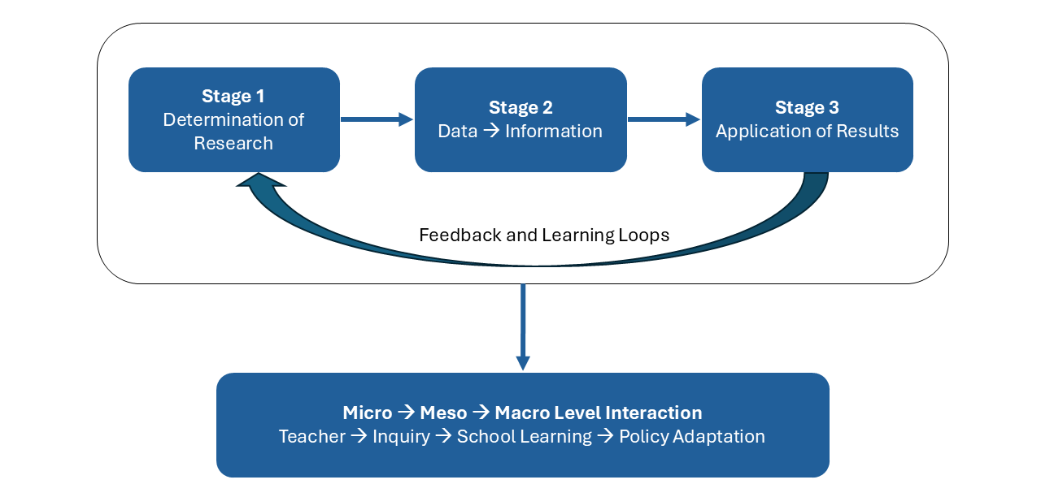
Fig.2 Horizontal and Vertical feedback in Toolkits

7.4 Systems Multilevel Mechanism
Another toolkit characteristic is its multilevel approach. That is, a toolkit in order to follow scientific ethics, by necessity, constitute a system. As a result, any educational research whose aim is to examine the education process in order to resolve teaching and learning issues, should be considered as a system where: stages, steps, activities and interconnections represent the components of the toolkit system. In addition, to the horizontal (stage-to-stage) and vertical (level-to-level) dimensions of systemic learning there is a multilevel mechanism (Table 2). That is, the operation of the two dimensions results in an analytical model mechanism, which clarifies how micro-level inquiries aggregate into meso-level routines and macro-level adaptations form a recursive feedback engine for system change.

Table 2 Educational Research Toolkit as a System-Level Mechanism
Toolkit Stage | System Function | Micro (Teacher/Student) | Meso (School/Network) | Macro (System/Policy) | Feedback Output
1. Determination of Research | Sensemaking & Agenda-Setting | Identify learning problems, formulate questions | Aggregate priorities, align with school goals | Translate into policy themes or strategic plans | Research agenda coherence
2. From Data to Information | Evidence Production & Reflection | Collect classroom data, reflect on outcomes | Establish data standards, ethics, and analytics | Develop indicators and evaluation frameworks | Shared evidence repository
3. Application of Results | Adaptive Response & Innovation | Modify instruction and assessment | Redesign programs, allocate resources | Adjust curricula, funding, regulations | Institutional learning and re-entry into Stage 1

In sum, the three toolkit stages, form a continuous feedback loop that drives systemic learning across educational levels. Any feedback step indicates how outcomes from each stage allow the feedback loops not only to adjust learning and teaching, but to enable schools and systems to self-adapt. That is, the feedback loops are critical mechanisms through which educational organizations learn and adapt. Moreover, current principles emphasize that the continuous, transparent, and collaborative information can be used to inform practice and policy [21].

- LEARNING ECOSYSTEMS
The learning ecosystem of a toolkit expressing educational research refers to providing an interconnected network of stakeholders, environments, technologies, practices, and institutional structures that collectively enable and shape learning. As a result, the main characteristic of a learning ecosystem in a toolkit is that rather than viewing education as a linear transmission of knowledge from teacher to student, the ecosystem perspective emphasizes the dynamic relationships and flows of information, resources, and interactions that support learning across all forms of settings.
At the core of the learning ecosystem in a toolkit are three components: the learners, whose needs, prior knowledge, motivations, and cultural backgrounds influence how they engage with educational opportunities; the learning environment, which encompass both physical spaces, such as classrooms, laboratories, community centers, and digital spaces that include online platforms, virtual classrooms, and adaptive learning systems; and the theoretical framework, which is based on differentiated instruction, universal design for learning, and adaptive teaching that allow toolkits to modify content, process, product, and learning environment in order to align with learner variability [22]. The main factors influencing these components are the following
8.1 factors influencing Learning Ecosystems
In toolkits formative assessment is a particularly important factor, as it generates continuous feedback loops that inform instructional decisions and guide learners toward improvement [23]. A second factor is the technological developments, which further expand the capacity for responsive instructional adjustment. In addition, teaching and learning adjustments can operate at a systemic level. Finally, effective teaching and learning adjustments emerge from an iterative cycle of information, reflection, and instructional redesign.
8.2 School Learning Ecosystem
The OECD’s “Schools as Learning Organizations” [6] framework identifies seven dimensions that characterize sustainable learning ecosystems (shared vision, continuous learning, team collaboration, system connection, inquiry culture, knowledge exchange, and supportive leadership). Each of these presupposes structured mechanisms for collecting, interpreting, and applying evidence, which are the exact functions embedded in the educational research toolkit. Thus, the toolkit can be seen as the operational grammar of the learning-organization model, providing the procedural logic through which schools enact their capacity to learn.
Conceptually, the school operates simultaneously at three levels: the Micro-level, where in the classroom teachers and students co-construct knowledge; the Meso-level, where the school or network of professional communities aggregate and interpret data; and the Macro-level, where the policy environment, through its findings, influences regulation, funding, and reform. In addition, feedback from micro-level inquiries informs meso-level learning, which in turn shapes macro-level policy, completing the vertical learning feedback shown in Figure 3.

Fig. 3 Nested Levels of School Learning
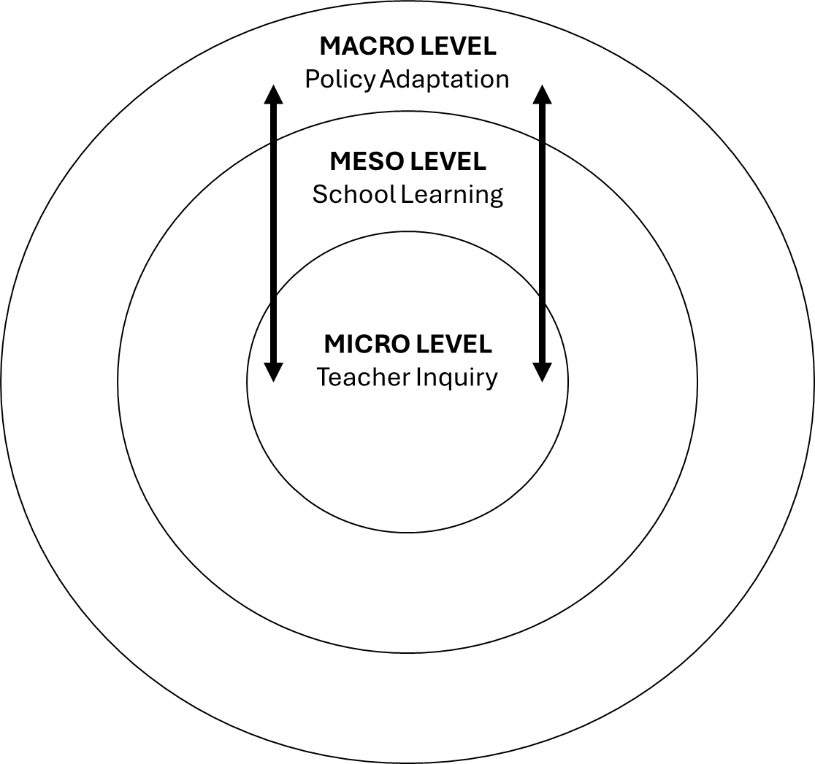

Fig. 3 Nested Levels of School Learning

8.3 Cultural Processes

Beyond structures and routines, system change requires a shift in culture, from compliance to curiosity, from data collection to data interpretation, from accountability to learning. When educators view research as part of their professional identity, schools become knowledge-producing organizations [24]. The Toolkit supports this cultural transformation by providing a common language for inquiry and fostering confidence in information-based reasoning. Over time, this educational shift embeds research as a normative expectation, a cultural mechanism for continuous renewal.

8.4 Research Questions
Based on these factors and other minor ones, the following questions can be explored in a toolkit learning ecosystem:
- How can educational research be understood and operationalized as a mechanism of system-level change within contemporary learning ecosystems?
- What theoretical foundations justify treating educational research as a systemic function rather than an external evaluative process?
- How do the stages of the educational research toolkit correspond to the feedback architecture of organizational learning and system adaptation?
- What enabling conditions allow this mechanism to operate across micro, meso, and macro levels of education systems?

8.5 Systems Level Learning Mechanism

Bringing together systems theory, organizational learning, and research methodology, the position suggested is that the educational research toolkit is a system-level mechanism of learning. That is, it provides both the procedural and conceptual infrastructure through which education systems can transform scattered innovations into sustainable institutional knowledge.
This conceptual foundation supports the argument presented earlier that the persistent fragmentation of educational innovation results from the absence of such a systemic feedback mechanism. The next section, therefore formulates the problem statement and theoretical justification for reconceptualizing educational research or adjusting teaching and learning as the educational process through which schools and systems learn, adapt, and evolve.

- TEACHING AND LEARNING ADJUSTMENTS

Teaching and learning adjustments refer to the planned and responsive modifications made in an educational process due to innovation, addressing learners’ needs, changes in subject contexts, new teaching and learning developments, etc. These adjustments may occur at multiple levels such as in: curriculum design, instructional strategies, assessment practices, learning environments, and technology integration, all of which aim in enhancing equitable access and meaningful learner engagement [25] It is argued that educational research toolkits, can provide the theoretical and practical frameworks for achieving these adjustments. That is, toolkits by including various issue in its instructions can: modify content, process, product, and learning environment to align with learner variability [22] and thus implement teaching and learning adjustments. Among the most important factors in this process are:

9.1 Differentiated Instruction
Toolkits can provide differentiated instruction for modifying teaching and learning processes. Tomlinson [25] has suggested that teachers can adjust content, process, and product, which certainly can achieve teaching and learning adjustments. In addition, Black & Wiliam [23] have explained that formative assessment plays a critical role in enabling such adjustments by providing feedback that supports instructional planning and helps teachers align pedagogical strategies with learner needs. Both of them are part of a toolkit role.

9.2 Technology-Enhanced Learning and Digital Adaptation
The rise of digital technologies has expanded the scope of teaching and learning adjustments. Research on technology-enhanced learning highlights the role of learning analytics, adaptive learning systems, and artificial intelligence in personalizing learning pathways [26]. These tools, part of the guides of a toolkit, enable educators to adjust interpreting data on student interactions, identifying learning gaps, and intervening with targeted supports. Digital platforms included as instructions in a toolkit can also facilitate multimodal learning environments that align with varied cognitive preferences [27].

9.3. Learner-Centered and Inquiry-Based Pedagogies
Another significant dimension of instructional adjustment is the shift toward learner-centered pedagogies. Indeed, constructivist and sociocultural theories have been arguing that meaningful knowledge emerges through active engagement and social interaction [28],[29]. In addition, teaching approaches such as project-based learning, inquiry-driven activities, and experiential learning require educators to adjust the structure and flow of lessons to support deeper conceptual engagement. However, all these methods can be part of an educational research toolkit, which can enhance motivation, critical thinking, and metacognitive skills [30],[31].

9.4 Socio-Emotional and Cultural Responsiveness
Educational research emphasizes the importance of socio-emotional and culturally responsive adjustments. Culturally sustaining pedagogy positions students’ identities, experiences, and cultural assets as integral components of the learning process [32]. Moreover, social–emotional learning frameworks help educators create supportive environments that address students’ emotional wellbeing [33]. A toolkit can accomplish what Gay [34] and Pianta et al., [35] proposed, namely link teacher–student relationships and culturally responsive instruction with improved academic outcomes, motivation, and classroom engagement.

9.5 Structural and Organizational Enablers
Research has shown [36] that teaching and learning adjustments are not solely matters of individual teacher practice; they are influenced by larger institutional structures such as: school leadership, professional learning opportunities, assessment policies, and resource availability. In addition, professional learning communities and collaborative inquiry models support teachers in reflecting on practice, interpreting information, and sustaining instructional change [37]. Moreover, sustainable instructional adjustments require alignment across organizational levels to ensure coherence between policy, curriculum, and classroom practice [1]. It is suggested that toolkits, can enhance structural and organizational efforts and act as another instrument in teaching and learning adjustments. In addition to the toolkits justification as a teaching and learning adjustments it offers a set of characteristics, which can be considered as out of the box contributions of research education toolkits

  - Multilevel Framework
A toolkit can achieve the conceptual validity of an educational research through the: Inclusion of diverse theoretical and policy sources; Internal coherence among stages, feedback loops, and system levels; Explanatory adequacy, gauged by alignment with prior empirical observations of school improvement systems; and Transferability, supported by congruence with international frameworks [18] [7].

  - Analytical Propositions

A synthesis of the previous adjustments capabilities of toolkits leads into three analytical, interdependent propositions related to educational processes, namely the: Mechanistic Proposition where toolkits function as a cyclical feedback engine converting individual inquiry into systemic learning and in this way its recursive loops constitute the operating mechanism of system adaptation; Institutional Proposition where toolkit guides are incorporated into the institution’s leadership and governance structures, producing institutional learning, whose importance is the project funding-independence.; and Cultural Proposition where Sustained engagement with the toolkit engagement forces stakeholders to become co-producers of knowledge that embeds research in everyday decision-making. In sum, these propositions delineate a transformation pathway through which educational systems evolve from Research-consuming to Research-producing ecosystems. In addition, the evolution from a Research-Consuming ecosystem to a research-producing ecosystem is possible through the intermediate stage of adaptive ecosystem (Figure, 4). That is, knowledge-generation processes, enabling conditions, feedback mechanisms, and embedded inquiry, drive this transformation. Arrows indicate continuous feedback through which the system renews itself.

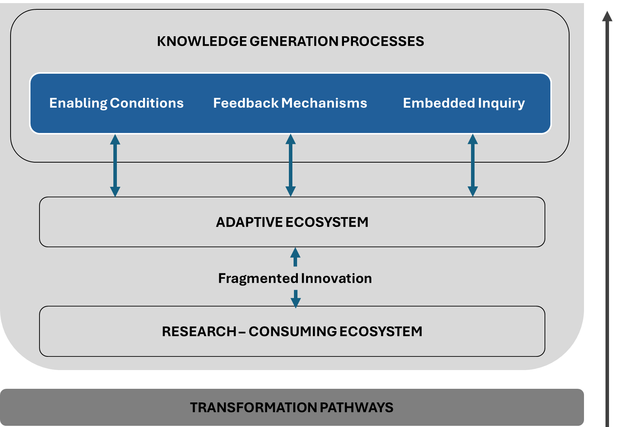
Fig. 4. Transformation Pathway of the Educational Research Toolkit

  - Research Results
Summarizing the previous sections, it is suggested that a toolkit contributes by: Bridging paradigms that integrate methodological, organizational, and policy literature through a unified systems mechanism; Providing a reproducible process, by providing a four-step synthesis procedure applicable to other conceptual frameworks; and advancing conceptual rigor in desk research, which demonstrate that non-empirical designs can yield structured, valid, and practically useful models. The next section, Discussion and Implications, interprets the significance of this transformation pathway for educational governance, professional culture, and future empirical validation.

- DISCUSSION AND IMPLICATIONS

This paper presents a fully documented educational research toolkits not only in the way educational research can assist, utilizing them, in teaching and learning, but most importantly by offering a list of research approaches for consideration. As a result, its major conclusions are:

  - Contributions

The implications or contributions of a toolkit, in the form of conceptual inquiry, is situated at the intersection of three overlapping fields as shown In Table 3.

Table 3. Toolkit Contributions

Fields | Contribution
Educational Systems Theory | Provides a mechanistic account of system learning through feedback.
Organizational Learning & Knowledge Management | Extends Argyris & Schön and Nonaka’s frameworks to the education sector.
Educational Policy and Governance | Offers a structural model for evidence-informed, adaptive decision-making.

That is, a toolkit, by remaining desk-based, avoids the constraints of single-site case research, while offering a generalizable theoretical model for understanding educational research as a self-sustaining mechanism of system renewal.

  - Synthesis and Transition

In general, the central problem in transforming innovation into a permanent part of the educational process lies not in a shortage of innovation, resulting from educational research, but in a deficit of systemic feedback mechanisms capable of transforming innovation into institutional learning. The educational research toolkit provides the procedural scaffolding for such feedback through its cyclical three-stage design, the mechanism of feedback and its function as a systemic mechanism. As a result, toolkits’ characteristics supports innovation inclusion into the teaching and learning adjustments into a coherent conceptual framework, illustrating educational research toolkit as a system-level change mechanism.

  - Policy Implications

A toolkit carries significant implications for policy and governance. Ministries, inspect agencies, and accreditation bodies increasingly call for information-based decision-making, yet these efforts often rely on data extraction rather than information utilization. The transformation pathway proposed here reframes policy as participatory sense-making, where policy actors become integral participants in the same feedback cycles that operate at educational institution level.
Policy design, under this approach, should therefore:
- Recognize schools as knowledge nodes within a distributed evidence network.
- Support long-term research-practice partnerships which can build institutional research capacity.
- Shift evaluation frameworks from compliance metrics to indicators of learning culture, such as feedback frequency, teacher inquiry participation, and knowledge-sharing intensity.
- Incentivize mechanisms for bottom-up evidence flow, allowing school-generated insights to influence system-level reform.
Toolkit contribution moves education governance from policy-driven information toward information-driven policy, fulfilling the aims articulated by OECD [6] and the European Commission [7].

  - Conceptual Contribution

A toolkit contributes to the broader field of educational process by offering a mechanistic explanation of how research enables system learning and adaptation. Its key contributions can be summarized as follows:
- Theoretical Integration: It unifies methodological, organizational, and policy perspectives under one feedback-based model.
- System Mechanism Identification: It identifies the educational research toolkit as a minimal functional architecture for system learning.
- Multi-Level Coherence: It explains how micro-level inquiry, meso-level organizational routines, and macro-level governance interact in a single learning ecosystem.
- Cultural Redefinition: It advances a paradigm shift from research as evaluation to research as participation.
Together, these contributions provide a foundation for rethinking how educational systems sustain innovation over time.

10.6 Conclusion
This paper identifies a persistent paradox, namely that despite abundant innovation, education systems often fail to sustainably include them in the educational process. As a result, the papers’ main contribution is the re-conceptualization of educational research, as expressed in the form of toolkits, as a system-level change mechanism. In addition, by proposing a solution grounded in continuous learning and feedback the educational research toolkit offers a procedural and cultural infrastructure for operationalizing that approach. Moreover, by embedding research into the governance, culture, and daily routines of educational institutions evolve into self-renewing ecosystems capable of adapting to new challenges, while maintaining coherence of purpose. In doing so, they realize the ultimate aspiration of modern educational reform, not merely to improve, but to learn how to improve continuously.

  - Future Research

As a desk-based conceptual analysis instrument, a toolkit does not test only theoretical concepts empirically. Its validity lies in theoretical coherence and alignment with existing frameworks. Future research could extend and validate the toolkit approach through:
  - Design-Based Implementation Studies in schools or networks applying the toolkit to measure changes in practice, collaboration, and outcomes.
  - Comparative Case Analyses across different educational systems to examine how structural and cultural contexts affect mechanism operation.
  - Quantitative Indicators of Systemic Learning, such as evidence-flow density, frequency of feedback cycles, or persistence of research routines.
- Policy Evaluations assessing how evidence produced at school level informs decision-making at ministerial or network levels.
Such toolkit applications would empirically ground the conceptual propositions advanced here, contributing to the formation of a new subfield, educational systems learning research.

REFERENCES
- Fullan, M., & Quinn, J. (2016). Coherence: The right drivers in action for schools, districts, and systems. Corwin. https://us.corwin.com/en-us/nam/coherence/book243907
2. Torraco, R. J. (2005). Writing integrative literature reviews: Guidelines and examples. Human Resource Development Review. https://doi.org/10.1177/1534484305278283
3. Senge, P. M. (1990). The fifth discipline: The art & practice of the learning organization. New York: Doubleday
4. Argyris, C., & Schön, D. A. (1978). Organizational learning: A theory of action perspective. London: Addison-Wesley.
5. Nonaka, I., & Takeuchi, H. (1995). The knowledge-creating company: How Japanese companies create the dynamics of innovation. Oxford University Press. https://global.oup.com/academic/product/the-knowledge-creating-company-9780195092691 .
6. OECD. (2016). Innovating education and educating for innovation: The power of digital technologies and skills. Paris: OECD Publishing. https://doi.org/10.1787/9789264265097-en
7. European Commission. (2021). Key competences for lifelong learning. Brussels: Publications Office of the European Union. https://doi.org/10.2766/291008
8. Coburn, C. E., & Penuel, W. R. (2016). Research–practice partnerships in education: Outcomes, dynamics, and open questions. Educational Researcher, 45(1), 48–54. https://doi.org/10.3102/0013189X16631750
9. Fishman, B. J., Penuel, W. R., Allen, A.-R., Cheng, B. H., & Sabelli, N. (2013). Design-based implementation research: An emerging model for transforming the relationship of research and practice. Yearbook of the National Society for the Study of Education, 112(2), 136–156. https://doi.org/10.1177/016146811311501415
10. Jaakkola, E. (2020). Designing conceptual articles: Four approaches. AMS Review, 10(1), 18–26. https://doi.org/10.1007/s13162-020-00161-0
11. Fullan, M. (2015). The new meaning of educational change (5th ed.). Teachers College Press. https://www.tcpress.com/the-new-meaning-of-educational-change-9780807756805
12. Davis, B., & Sumara, D. (2006). Complexity and education: Inquiries into learning, teaching, and research. Routledge. https://doi.org/10.4324/9780203764015 .
13. Biesta, G. (2007). Why “what works” won't work: Evidence-based practice and the democratic deficit in educational research. Educational Researcher, 36(7), 23–29. https://doi.org/10.3102/0013189X07332768
14. Halliday, M. A. K., & Matthiessen, C. M. I. M. (2014). Halliday’s introduction to functional grammar (4th ed.). New York: Routledge. https://doi.org/10.4324/9780203431269 .
15. Kerlinger, F. N., & Lee, H. B. (2000). Foundations of behavioral research. Wadsworth. https://openlibrary.org/books/OL3567890M/Foundations_of_behavioral_research .
16. Mitchell, T. M. (1997). Machine learning. McGraw-Hill. https://www.cs.cmu.edu/~tom/mlbook.html 17. Parsons, T. (1951). The social system. California: Free Press.
18. Schlicht-Schmälzle, R., Hill, J., Folkvord, K. A., Tharaldsen, K. B., Wargo, J., Hartmann, U., & Révai, N. (2024). Bridging the research-practice gap in education: Initiatives from 3 OECD countries (OECD Education Working Papers, No. 319). OECD Publishing. https://doi.org/10.1787/c0d3f781-en .
19. Bryk, A. S., Gomez, L. M., Grunow, A., & LeMahieu, P. G. (2015). Learning to improve: How America's schools can get better at getting better. Harvard Education Press. https://eric.ed.gov/?id=ED568744 .
20. Koutsopoulos, K., & Economou, T. (2025). Education research: A toolkit proposal. International Journal of Education and Learning. https://doi.org/10.31763/ijetl.v7i1.1000
21. Baker, A. (2023). Principles for building effective feedback loops. Digital Promise. https://digitalpromise.org/2023/12/07/principles-for-building-effective-feedback-loops/
22. Tomlinson, C. A., & Imbeau, M. B. (2010). Leading and managing a differentiated classroom. ASCD. https://eric.ed.gov/?id=ED516357
23. Black, P., & Wiliam, D. (2010). Inside the Black Box: Raising Standards through Classroom Assessment. Phi Delta Kappan, 92(1), 81–90. https://doi.org/10.1177/003172171009200119 .
24. Hargreaves, A., & Fullan, M. (2012). Professional capital: Transforming teaching in every school. Teachers College Press. https://www.tcpress.com/professional-capital-9780807753323 .
25. Tomlinson, C. A. (2017). How to differentiate instruction in academically diverse classrooms (3rd ed.). Alexandria, VA: ASCD. https://www.ascd.org/books/how-to-differentiate-instruction-in-academically-diverse-classrooms-3rd-edition .
26. Holmes, W., Bialik, M., & Fadel, C. (2019). Artificial intelligence in education: Promises and implications for teaching and learning. Center for Curriculum Redesign. https://circls.org/primers/artificial-intelligence-in-education-promises-and-implications-for-teaching-and-learning .
27. Mayer, R. E. (2021). Multimedia learning (3rd ed.). Cambridge University Press. https://doi.org/10.1017/9781316941355

28. Vygotsky, L. S. (1978). Mind in society: The development of higher psychological processes. Harvard University Press. https://doi.org/10.2307/j.ctvjf9vz4

29. Bruner, J. (1996). The Culture of Education. Harvard University Press. https://doi.org/10.4159/9780674251083 .
30. Barron, B., & Darling-Hammond, L. (2008). Teaching for meaningful learning: A review of research on inquiry-based and cooperative learning. In L. Darling-Hammond (Ed.), *Powerful learning: What we know about teaching for understanding*. Jossey-Bass. https://www.wiley.com/en-us/Powerful+Learning%3A+What+We+Know+About+Teaching+for+Understanding-p-9780470276679
.
31. Hmelo-Silver, C. E., Duncan, R. G., & Chinn, C. A. (2007). Scaffolding and achievement in problem-based and inquiry learning: A response to Kirschner, Sweller, and Clark (2006). Educational Psychologist, 42(2), 99–107. https://doi.org/10.1080/00461520701263368 .
32 Paris, D., & Alim, H. S. (Eds.). (2017). Culturally sustaining pedagogies: Teaching and learning for justice in a changing world. Teachers College Press. https://www.tcpress.com/culturally-sustaining-pedagogies-9780807758335
33. Brunzell, T., Stokes, H., & Waters, L. (2016). Trauma-informed flexible learning: Classrooms that strengthen regulatory abilities. International Journal of Child, Youth & Family Studies, 7(2), 218–239. https://doi.org/10.18357/ijcyfs72201615719 .
34. Gay, G. (2018). Culturally responsive teaching: Theory, research, and practice (3rd ed.). Teachers College Press. https://www.tcpress.com/culturally-responsive-teaching-9780807758762
35. Pianta, R. C., Hamre, B. K., & Allen, J. P. (2012). Teacher-student relationships and engagement: Conceptualizing, measuring, and improving the capacity of classroom interactions. In S. L. Christenson, A. L. Reschly, & C. Wylie (Eds.), Handbook of research on student engagement (pp. 365–386). Springer. https://doi.org/10.1007/978-1-4614-2018-7_17

36. Hargreaves, D. H. (1999). The knowledge-creating school. British Journal of Educational Studies, 47(2), 122–144. https://doi.org/10.1111/1467-8527.00107
37. Timperley, H. (2011). Realizing the power of professional learning. McGraw-Hill.

