Original Research Article

Pyrolysis Behaviour Of Chestnut Fruit Shells By Thermogravimetric Analysis

.
ABSTRACT

Chestnut fruit shells are waste lignocellulosic biomass and therefore it is important to evaluate in terms of pyrolysis. In the current study, structural characterization, pyrolysis by thermogravimetric analysis and kinetic analysis of chestnut fruit shells were investigated. The structure of the shells was examined by ultimate and proximate analyses, SEM and FTIR spectra, X-Ray diffraction analysis. Pyrolysis was carried out at different heating rates of 10, 20, 30 and 40 °C/min up to 750 °C in a nitrogen atmosphere. It was observed that pyrolysis occurred in three stages. The effect of the heating rate on each stage of pyrolysis, such as maximum pyrolysis temperature, maximum pyrolysis rate, and total mass loss, was observed. The Coats&Redfern kinetic model was used determining the activation energy for each stage at different reaction degrees. The highest correlation value was accepted as the reaction degree for that stage. The calculated reaction degrees and activation energies of the pyrolysis stages were not related to the heating rate. The presence of a kinetic compensation effect was determined in the pyrolysis of shells.

Keywords: Lignocellulosic biomass; chestnut fruit shell; thermogravimetric analysis; pyrolysis; kinetic analysis

1. INTRODUCTION

Fossil fuels are a good source of energy. However, due to economic and environmental factors, the trend towards clean energy technologies is accelerating. These technologies are renewable energies, for example biomass, solar energy, hydroelectricity. One of the most important issues today, from a biomass perspective, is the efficient conversion of biomass into various types of energy, bioproducts, or biochemicals. This conversion specifically includes chemical kinetic and energy conversion and thermochemical processes (Serra, 2014). Pyrolysis is a thermochemical process. It is a technique used to convert organic and inorganic-based materials into more valuable products such as liquids, solids and gases by heating biomass, fossil fuels, etc. in an oxygen-reduced environment (Al-Haj Ibrahim, 2020). When pyrolysis is performed at different heating rates with the thermogravimetric analysis method, information about the pyrolysis kinetics can be obtained as well as the decomposition characterization of the biomass.

Biomass is one of the natural sources of renewable energy, which includes organic matter from plants (Yadav et al., 2019). When biomass is used for the production of biofuels, biofuels are generally classified as either first or second generations. The first biofuels are obtained from food or oil crops while the second biofuels are gained from lignocellulosic biomass. The most abundant types of biomass, such as household waste, commercial waste, wood, and agricultural waste, are lignocellulosic in structure (URL1). And lignocellulosic biomass is a potential raw material for conversion into high value-added products or energy.

Chestnut is an extremely important agricultural product in terms of tree and fruit, with its properties and the substances it contains. Apart from being consumed as a fruit, chestnut is also used in the production of candied chestnut throughout the year in Türkiye. Thus, the shells removed after cleaning are classified as lignocellulosic biomass and the evaluation of this waste is mostly done by burning (Karadaş, 2019). This is a significant amount, considering that the weight of the shells constitutes 10 % of the total weight of the chestnut fruit. (Erdoğdu, 2021; Barreira et al., 2008; Kasımoğlu et al., 2016; Ribeiro et al., 2007; Hwang et al., 2001). According to the data of the Turkish Statistical Institute in 2018, Türkiye ranks third in the world with 63.580 tons of chestnut fruit production (Karadaş, 2019; Temiz, 2020; URL2; URL3; Dönmez et al. 2016). According to the 2019 data of the Turkish Statistical Institute, chestnut fruit is produced in Türkiye (Fig.1). Showing the locations of chestnut trees on the map of Türkiye constitutes 2.7 % of the chestnut production in the world. Although there is no current data, the amount of chestnut production in Zonguldak in 2019 was 1307 tons (URL3).

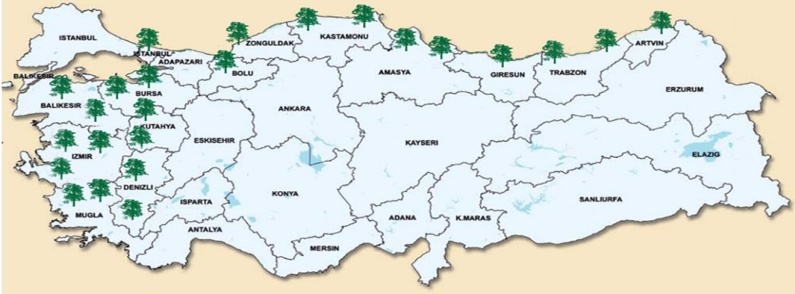
Fig. 1. Showing the locations of chestnut trees on the map of Türkiye (URL4)

Although there are studies in the literature in which the thermal analysis of chestnut tree and its kinetic analysis are available (Vecchio et al., 2006; Várhegyi et al., 2004), there is no study in this direction on fruit shells.

This study is on the investigation of chestnut fruit shells as an energy source, which have been structurally characterized by proximate and ultimate analyses, SEM, FTIR spectra, X-ray diffraction, thermogravimetric analysis, kinetic calculation.

2. Methodlogy

2.1 Preparation of chestnut fruit shells

Chestnut fruits were collected from the forests of Zonguldak province in the Western Black Sea region of Türkiye. For pyrolysis experiments, air dried shells were ground to 250 μm size. Proximate analysis of shells was performed according to ASTM, ultimate analysis was performed on CHN-600 analyzer and LECO SC-132 analyzer.

2.2 Characterization of chestnut fruit shells

SEM imaging was provided with Jeol JSM model 5410 LV. FTIR spectra were obtained using Perkin Elmer Spectrum One. X-Ray diffraction analysis was carried out on Philips Panalytical X'Pert PRO Model diffraction meter using CuKα radiation at a diffraction angle of 0-80°.

Thermogravimetric analyses experiments were performed in Perkin Elmer Pyris 1 TGA device at heating rates of 10, 20, 30 and 40 °C/min, from ambient temperature to 750 °C, under nitrogen flow rate of 100 ml/min.

3. results and discussion

3.1 Structural characterization

The results of the proximate and ultimate analysis of the shells are given in Table 1. Fig. 2 and 3 show the SEM and the XRD images, respectively. The diffraction ranges of the XRD pattern indicate cellulose formation. Similar to other studies (Cheng et al., 2011; Kumar et al., 2009; Öztürk et al., 2022; Vassilev et al., 2012; Sahay, 2022; Ferrer et al., 2016).

Table 1. Analyses results of shells (on dry free basis).

Ash (%) | Volatile matter (%) | Fixed carbon (%)
1.69 | 76.80 | 21.51

C  (%) | H  (%) | N  (%) | S  (%) | O  (%, by difference) | H/C  (molar) | O/C  (molar)
47.38 | 5.38 | 0.21 | 0.11 | 46.92 | 1.36 | 0.74

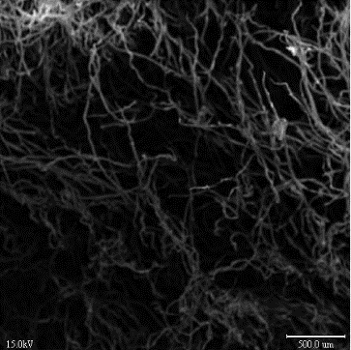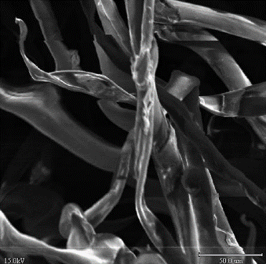
Fig. 2. SEM images of chestnut fruit shells

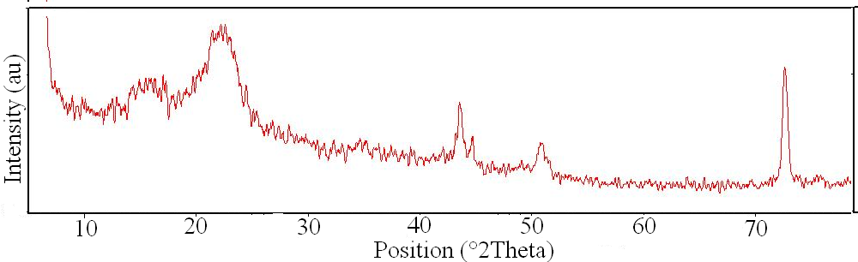
Fig. 3. XRD pattern of chestnut fruit shells

Fig. 4 gives the FTIR spectrum of the shells. The band seen in the range of 3600-3000 cm⁻¹ indicates hydroxyl groups. Bands between 3000 and 2800 cm⁻¹ also indicate C-H stretching. The frequency region at 1730 cm⁻¹ expresses the C=O vibration, those at 1600 cm⁻¹ and 1400 cm⁻¹ express the C=C stretching vibration and the C-OH and O-H stretching vibration of phenolic groups at 1250 cm⁻¹. 1050 cm⁻¹ also represents the stretching of C-O in holocellulose.

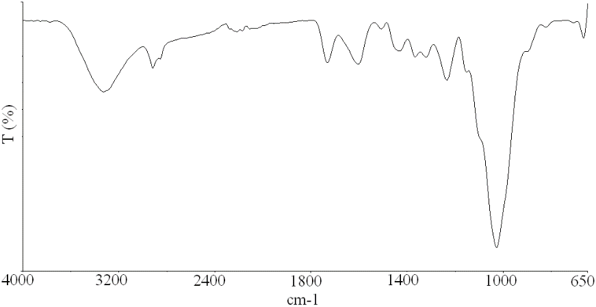
Fig. 4. FTIR spectrum of chestnut fruit shells

3.2 Pyrolysis behaviour

Fig. 5 shows TG-DTG graphs of pyrolysis of chestnut fruit shells performed at heating rates of 10, 20, 30 and 40 °C/min. The numerical data obtained by the interpretation of these graphics are also given in Fig. 6 and 7.

A lignocellulosic biomass contains the components cellulose, hemicellulose and lignin (Sahay, 2022). Pyrolysis consists of three stages that show the degradation of the lignocellulosic structure. The first stage of pyrolysis of chestnut fruit shell refers to the drying of moisture, the stage up to about 150-200 °C. Other stages involve the initiation and degradation of cellulose. The second stage, the stage of about 150-360 °C, indicates the degradation of phenolic, carboxyl, carbonyl groups. The last stage, higher than 360 °C, indicates the breakdown of more complex structures such as aromatic structures.

In each stage of pyrolysis, the initial and final decomposition temperatures increase as the heating rate increases. The lowest initial temperature is 158 °C and final is 318 °C at heating rate 10 °C/min, for second stage. That temperatures are 318°C and 417 °C for third stage, respectively. The highest decomposition temperatures for the second and third stages are in the ranges of 194–359 °C and 359–429 °C at a heating rate of 40 °C/min.

Fig. 5. TG-DTG curves of chestnut fruit shells

Fig. 5: Continued

Fig. 6. Curves of the initial and final temperatures of the all pyrolysis stages

Max pyrolysis temperature is in the range of 294-311 °C and 362-386 °C for both stages. Max pyrolysis rates are between 3.5-16%/min and 7.5-28.54%/min. By increasing the heating rate, maximum pyrolysis temperatures shifted to higher temperatures. In addition, an increase in max pyrolysis rates was also detected.

Fig. 7. Curves for max. pyrolysis temperature and max. pyrolysis rate

The average second and third stages of the pyrolysis of the chestnut fruit shells take place in the temperature range of 175-336 and 336-422°C, respectively. The average max. pyrolysis temperature is 303 and 338°C for stage II and III, respectively. For the same stages, the average maximum pyrolysis rate was 9.80 and 18.60 %/min, respectively.

In Fig. 8, the variation of the char yields obtained depending on the heating rate of the pyrolysis is given. The char yield decreased and mass loss increased with the increase at the heating rate. Accordingly, the maximum and minimum char yields belong to 19 and 21 %, for heating rates of 40 and 10 °C/min, respectively. The average total mass loss for the pyrolysis is 80 %.

Fig. 8. Variation of char yield depending on heating rate

3.3 Pyrolysis kinetics

The kinetic parameters of depending the reaction degree (n) of pyrolysis were calculated by the Coats&Redfern kinetic model (Coats and Redfern, 1964). For this, the equation given below is used.

for (n≠1) (1)

The n value was changed by increasing by 0.1 from 0.1 to 2.0 and curves were drawn between the left side of the equation and 1/T. Graphs were drawn between the R² of each curve and n (Fig. 9). Activation energy (E, kj/mol) and pre-exponential factor (A, 1/min) were calculated from the equation that gave the highest correlation value (R²) according to the heating rate (a, °C/min) (Table 2). This was accepted as the reaction degree of pyrolysis at that stage.

Fig. 9. R²-n curves depending on heating rates

Table 2. Kinetic parameters calculated by applying Coats&Redfern kinetic model.
Heating rate (°C/min) | Pyrolysis stage | n | E (kj/mol) | A  (1/min) | R²
10 | II | 0.47 | 81.82 | 2.30*10⁸ | 0.9865
10 | III | 1.90 | 270.52 | 6.63*10²³ | 0.9749
20 | II | 0.67 | 92.92 | 2.15*10⁹ | 0.9792
20 | III | 1.77 | 294.40 | 3.20*10²⁵ | 0.9800
30 | II | 0.84 | 95.23 | 3.50*10⁹ | 0.9813
30 | III | 1.59 | 261.00 | 2.40*10²² | 0.9763
40 | II | 1.27 | 105.30 | 2.20*10¹⁰ | 0.9836
40 | III | 1.85 | 382.43 | 7.60*10³¹ | 0.9806
Average | II n= 0.81 E= 93.82 kj/mol A= 7.00*10⁹  III n= 1.78 E= 302.10 kj/mol A= 1.90*10³¹

For the second stage, the heating rate and the reaction rate are interrelated. As the heating rate increases, the reaction rate also increases. It was calculated at the lowest heating rate of 10 °C/min with 0.47 and the highest heating rate of 40 °C/min with 1.27.

Heating rate had no effect on reaction degrees for the third pyrolysis stage. There is a decrease from 10 to 30 °C/min, an increase to 40 °C/min. For the 3rd stages, the lowest and highest reaction degree is at heating rates of 30 and 10 °C/min, respectively.

There is a relationship between the heating rate and activation energy for the second stage, but not for the third stage. The highest and lowest activation energy values for the second pyrolysis stage were calculated as 105,30 and 81,82 kj/mol for heating rates of 40 and 10 °C/min, respectively. For the third stage, these highest and lowest values belong to the heating rates of 40 and 30 °C/min and are 382.43 and 261 kj/mol, respectively.

The average values of activation energy of the chestnut fruit shells for pyrolysis II and III stages, were calculated as 93,82 and 302,10 kj/mol. The average n values are 0.81 and 1.78, respectively.

Fig. 10 shows the kinetic compensation effect curves for all heating rates for the second and third stages of pyrolysis. It is clear from the R² values ​​of these curves that there is a kinetic compensation effect in both stages.

Fig. 10. Kinetic compensation effect for all stages

Thermodynamic parameters such as enthalpy (ΔH), Gibbs free energy (ΔG), and entropy (ΔS) were calculated using the equations given below (Das et al., 20222). The results are given in Table 3.

$A=\frac{aEe^{\frac{E}{RT}}}{RT_{m}^{2}}$ (2)

$ΔH=E-RT_{m}$ (3)

$∆G=E+RT_{m}ln⁡(\frac{k_{B}T_{m}}{hA}$) (4)

$∆HS= \frac{∆H- ∆G}{T_{m}}$ (5)

If ΔH is positive, it represents the energy required for the decomposition of biomass. An increase in enthalpy change was observed as the heating rate increased in both stages of pyrolysis of shells. This also indicates that pyrolysis is endothermic. The enthalpy values ​​in the third stage are higher, indicating that more complex pyrolysis reactions occur in this stage (Lomada et al., 2024; Mishra et al., 2023; Vasudev, 2020). ΔG describes equilibrium, or the tendency for a reaction to proceed in a particular direction. These values ​​for the shells are inversely proportional to the heating rate for both stages. As the heating rate increases, ΔG values ​​decrease. Positive values ​​indicate that the reactions in these stages are not spontaneous (Lomada et al., 2024; Jagtap and Kalbande, 2022). Entropy indicates the disorder of the system. Negative or positive ΔS values ​​indicate the complexity of the reactions (Lomada et al., 2024; Ali et al., 2017). In the second stage of pyrolysis, negative ΔS values ​​decrease as the heating rate increases. In the third stage, they increase with positive values.
For the second and third stages, the average ΔH values ​​were calculated as 89.30 and 296.72 kJ/mol, respectively. ΔG values ​​were 148.40 and 159.73 kJ/mol, while ΔS values ​​were -0.11 and 0.21 kJ/mol.

Table 3. Thermodynamic parameters.
Heating rate (°C/min) | Pyrolysis stage | ΔH  (kj/mol) | ΔG  (kj/mol) | ΔS  (kj/mol)
10 | II | 78.16 | 147.50 | -0,12
10 | III | 255.72 | 160.82 | 0.15
20 | II | 88.15 | 156.50 | -0,12
20 | III | 265.14 | 160.25 | 0.16
30 | II | 90.42 | 145.00 | -0.10
30 | III | 289.00 | 160.00 | 0.20
40 | II | 100.44 | 144.40 | -0.08
40 | III | 377.00 | 157.83 | 0.33
Average | II ΔH=89.30 kj/mol ΔG=148.40 kj/mol ΔS=-0.11 kj/mol  III ΔH=296.72 kj/mol ΔG=159.73 kj/mol ΔS= 0.21 kj/mol

4. Conclusion

In this study, structural characterization, pyrolysis by thermogravimetric analysis and pyrolysis kinetics of chestnut fruit shells was investigated by using Coats and Redfern kinetic model. The pyrolysis of chestnut fruit shells occurs in three stages. Increasing the heating rate increased both the initial and final temperatures of the pyrolysis stages, as well as the max pyrolysis temperature and max pyrolysis rate. That is, the heating rate has an effect on both the temperature steps and the char yield of the pyrolysis. However, the heating rate has no significant effect on the reaction degree and activation energy calculated by the Coats&Redfern kinetic model.

Chestnut fruit shells, which are lignocellulosic biomass, are a waste material that can be used in the field of energy by blending it with fossil fuels at different rates, using methods such as pyrolysis, producing activated carbon, and adsorption.

COMPETING INTERESTS DISCLAIMER:
Authors have declared that they have no known competing financial interests OR non-financial interests OR personal relationships that could have appeared to influence the work reported in this paper.

References

Al- Haj Ibrahim, H. (2020). Introductory chapter:Pyrolysis. In: Al- Haj Ibrahim H (ed), Recent Advances in Pyrolysis, Intech Open, London. https://www.intechopen.com/chapters/70273
Ali, I., Bahaitham, H. and Naebulharam, R. (2017). A comprehensive kinetics study of coconut shell waste pyrolysis. Bioresource Technology.235:1-11. https://doi.org/10.1016/j.biortech.2017.03.089
Barreira, J. C. M., Ferreira, I. C. F. R., Oliveira, M.B.P.P. and Pereira, J. A. (2008). Antioxidant Activities of the Extracts from Chestnut Flower, Leaf, Skins and Fruit, Food Chemistry. 107: 1106-1113. doi: https://doi.org/10.1016/j.foodchem.2007.09.030
Cheng, G., Varanasi, P., Li, C., Liu, H., Melnichenko, Y.B., Simmons, B.A., Kent, M.S. and Singh, S. (2011). Transition of Cellulose Crystalline Structure and Surface Morphology of Biomass as a Function of Ionic Liquid Pretreatment and Its Relation to Enzymatic Hydrolysis. Biomacromolecules 12(4): 933-941. https://doi.org/10.1021/bm101240z
Coats, A. W. and Redfern, J. P. (1964). Kinetic Parameters from Thermogravimetric Data, Nature 201:68-69. https://doi.org/10.1038/201068a0
Das, S.K. and Ghosh, S.K. (2022). Thermodynamic analysis of biomass and plastic feedstock circulation using pyrolysis technology. Circular Economy. 1: 100006. https://doi.org/10.1016/j.cec.2022.100006
Dönmez, İ.E., Selçuk, S., Sargın, S. and Özdeveci, H. (2016). Kestane, Fındık ve Antep Fıstığı Meyve Kabuklarının Kimyasal Yapısı, Türkiye Ormancılık Dergisi 17(2): 174-177. https://dergipark.org.tr/tr/download/article-file/252913
Erdoğdu, Ö. (2021). Toros Sediri, Sığla Ağacı ve Kestane Kabukları İçin Optimum Ekstraksiyon Koşullarının Belirlenmesi ve Elde Edilen Ekstraktların Biyoaktif Özelliklerinin İncelenmesi, Aydın Adnan Menderes Üniversitesi Yüksek Lisans Tezi.
Ferrer, A., Alciaturi, C., Faneite, A. and Ríos, J. (2016). Analyses of Biomass Fibers by XRD, FT-IR, and NIR, In: Vaz Jr, S. (eds) Analytical Techniques and Methods for Biomass, Springer, 45-83.
https://doi.org/10.1007/978-3-319-41414-0_3
Hwang, J.Y., Hwang, I.K. and Park, J.B. (2001). Analysis of Physicochemical Factors Related to the Automatic Pellicle Removal in Korean Chestnut (Castanea crenata). Journal of Agricultural and Food Chemistry. 49(12), 6045-6049. https://doi.org/10.1021/jf010744b
Jagtap A, Kalbande S.R. (2022). Investigation on pyrolysis kinetics and thermodynamic parameters of soybean straw: A comparative study using model-free methods. Biomass Conversion and Biorefinery. 02228-9. https://doi.org/10.1007/s13399-021-02228-9
Karadaş, K. (2019). Çeşitli Atıklardan Elde Edilen Kompozit Malzemelerin Adsorpsiyon ve Fotokatalitik Uygulamaları, İnönü Üniversitesi Yüksek Lisans Tezi.
Kasımoğlu, Z., Yıldırım, A., Alkan, S., Topuz, A. and Nadeem, H.S. (2016). Microencapsulation of chestnut seed coat’s water extract by spray drying. Journal of Ongoing Chemical Research. 2(2) 34-44. https://scimatic.org/storage/journals/1/pdfs/1_Zehra_JO_1547289536.pdf
Kumar, P., Barrett, D.M., Delwiche, M.J. and Stroeve, P. (2009). Methods for Pretreatment of Lignocellulosic Biomass for Efficient Hydrolysis and Biofuel Production. Industrial&Engineering Chemistry Reserach. 48(8):3713-3729. https://doi.org/10.1021/ie801542g
Lomada, K., Poyilil, S., Palatel, A. and Chandrasekharan, M. (2024). Investigations on the pyrolysis behavior of Sapindus mukorossi based on kinetic and thermodynamic parameters. Journal of Thermal Engineering. 10(6):1480-1493. 10.14744/thermal.0000889
Mishra, A., Nanda, S., Ranjan Parida, M., Jena, P.K., Dwibedi, S.K., Manjari Samantaray, S., Samantaray, D., Mohanty, M.K. and Dash, M. (2023). A comparative study on pyrolysis kinetics and thermodynamic parameters of little millet and sunflower stems biomass using thermogravimetric analysis. Bioresource Technology. 367:128231. https://doi.org/10.1016/j.biortech.2022.128231
Öztürk, F. S., Önal, Y. and Gökbulut, İ. (2022). Alıç (Crataegus orientalis subsp.) Çekirdeğinin Bazı Karakteristik Özellikleri ve Çekirdek Yağının Yağ Asidi Bileşen Karakterizasyonu. European Journal of Science and Technology. 41:79-84. https://doi.org/10.31590/ejosat.1113941
Ribeiro, B., Rangel, J., Valentão, P., Andrade, P.B., Pereira, J.A., Bölke, H. and Seabra, R.M. (2007). Organic Acids in Two Portuguese Chestnut (Castanea Sativa Miller) Varieties, Food Chemistry. 100(2): 504-508. https://doi.org/10.1016/j.foodchem.2005.09.073
Sahay, S. (2022). Deconstruction of Lignocelluloses: Potential Biological Approaches. In: Sahay S(ed), Handbook of Biofuels, Academic Press, 207-232. https://doi.org/10.1016/B978-0-12-822810-4.00010-5
Serra, L.M. (2014). Foreword, In: Tannous K (ed), Innovative solutions in fluid-particle systems and renewable energy management, IGI Global, USA, pp xiv-xix.
Temiz, Ü.İ. (2020). Farklı Biyokütle-Atık Karışımlarının TGA Yöntemiyle Birlikte Pirolizi, Bilecik Şeyh Edebali Üniversitesi, Yüksek Lisans Tezi.
URL1: https://www.celignis.com/feedstocks.php (20 March 2025).
URL2: https://geka.gov.tr/uploads/pages_v/aydin-ili-kestane-yatirim-raporu-basili_1992017142633.pdf (20 March 2025)
URL3: https://www.yatirimadestek.gov.tr/pdf/assets/upload/fizibiliteler/kastamonu-ili-kestane-isleme-tesisi-on-fizibilite-raporu2021.pdf (20 March 2025)
URL4: file:///C:/Users/hales/OneDrive/Desktop/BAZI%20KESTANE%20H%C4%B0BR%C4%B0TLER%C4%B0N%C4%B0N%20ANA%C3%87LIK%20POTANS%C4%B0YELLER%C4%B0%20VE%20UYU%C5%9EAB%C4%B0L%C4%B0RL%C4%B0KLER%C4%B0.pdf (20 March 2025)
Várhegyi, G., Grønli, M.G. and Di Blasi, C. (2004). Effects of Sample Origin, Extraction, and Hot-Water Washing on the Devolatilization Kinetics of Chestnut Wood, Industrial&Engimeering Chemistry Research. 43(10): 2356- 2367. https://doi.org/10.1021/ie034168f
Vasudev, V., Ku, X. and Lin, J. (2020). Pyrolysis of algal biomass: Determination of the kinetic triplet and thermodynamic analysis. Bioresource Technology. 317:124007. https://doi.org/10.1016/j.biortech.2020.124007
Vassilev, S. V., Baxter, D., Andersen, L.K., Vassileva, C.G. and Morgan, T.J. (2012). An Overview of the Organic and Inorganic Phase Composition of Biomass. Fuel 94:1-33. https://doi.org/10.1016/j.fuel.2011.09.030
Vecchio, S., Luciano, G. and Franceschi, E. (2006). Explorative Kinetic Study on the Thermal Degradation of Five Wood Species for Applications in the Archaelogical Field, Annali di Chimica. 96(11-12): 715-725. https://doi.org/10.1002/adic.200690074
Yadav, K. and Jagadevan, S. (2019). Influence of Process Parameters on Synthesis of Biochar by Pyrolysis of Biomass: An Alternative Source of Energy. In: Al- Haj Ibrahim H (ed), Recent advances in pyrolysis, Intech Open, London. https://www.intechopen.com/chapters/68186

