Original Research Article

Assessment of Diversity in parental and F1 populations of Pearl Millet (Pennisetum glaucum (L.) R. Br.) in Burkina Faso

.
ABSTRACT

Aims: Pearl millet (Pennisetum glaucum (L.) R. Br.) is one of the cross-pollinated cereals in West Africa. It is cultivated for its grains. However, to date, strategies for selecting pearl millet populations and hybrids are low in West Africa. The objective of this study is to characterize the genetic bases of parental and F1 populations of pearl millet derived from Burkina Faso and ICRISAT gene bank.
Place and Duration of Study: A Fisher block design with three replicates was implemented at the Gampéla, Burkina Faso experimental site during March 2025.
Methodology: The material plant provides partial diallel crosses that were carried out between three groups of pearl millet from Burkina Faso, Niger, and India. Measurements were taken on 14 quantitative traits and 11 qualitative traits, and analyses were performed using R and XLSTAT software.
Results: The analyses reveal coefficients of variation superior to 30% for number tillers of traits, number of productive tillers , weight of 100 seeds, and plant height for both the parental accessions and their F1 offspring. When comparing the two generations, the variation coefficient for the traits in the parents was significantly higher than in the offspring. The correlation matrices showed that the 50% flowering trait is positively correlated with plant height and number of leaves on the stem. Most variables are positively correlated. As for the organization of the groups, the dendrograms showed three distinct groups for the parental accessions and two distinct groups for the descendants. These different population groups can be used to develop population varieties or hybrids with high heterogeneity.

Keywords: Heterogeneity, F1 populations, genetic base, Burkina Faso, ICRISAT

1. INTRODUCTION

Pearl millet (Pennisetum glaucum (L.) R. Br.) is one of allogamous cereals in West Africa. It is mainly cultivated in the semi-arid regions of Africa and Asia, as reported by several authors (Harlan, 1971; Upadhyaya et al., 2016). Several studies place the origin of pearl millet in sub-Saharan Africa because this crop was domesticated 4000 to 5000 years ago in sub-Saharan Africa (Munson, 1975; Brunken et al., 1977; Yadav and Rai, 2013; Manning et al., 2011). Indeed, Africa contributes around 40% of global pearl millet production (Saidou, 2011). According to FAOSTAT (2021), cited by Bastos et al. (2022), six African countries, Nigeria, Niger, Mali, Burkina Faso, Chad, and Senegal, are the main producers of pearl millet. This correlates with the countries that deliberate on improved pearl millet varieties in the West African catalog (ECOWAS-UEMOA-CILSS, 2016, 2018, 2021; Sattler & Haussmann, 2020).
Pearl millet is recognized among the cereals the most tolerant to climate variability and capable of growing in poor soils (Yadav and Rai, 2013; Oumar et al., 2008). In terms of nutrition, authors have also demonstrated its high organoleptic quality, particularly its high protein and mineral content compared to other cereals (Amadou et al., 2013; Bashir et al., 2013). This gives it significant market value (Kouressy et al.. 2013).
However, one of the major problems of pearl millet in West Africa is low yields compared to other cereals. Yet in Asia, India has increased pearl millet yields by 20 to 30% over the last few decades (Pucher et al., 2016). The most recognized methods for improving the pearl millet yields are the hybrids. The use of hybrids in India has successively increased pearl millet yields from around 305 kg ha⁻¹ between 1951 and 1955 to 998 kg ha⁻¹ between 2008 and 2012, an improvement of around 200% (Dave, 1986; Yadav and Rai, 2013). Generally, high mixtures of pearl millet in West Africa reduce heterotic groups (Pucher et al., 2016). Several authors have revealed the low diversity of pearl millet groups cultivated (Haussmann et al. 2007; Lakis et al. 2012). Recent work reported by authors such as Bashir et al. (2015), Hu et al. (2015), and Pucher et al. (2016) has shown that there are no clear genetically distinct groups for pearl millet genetic material in West Africa. However, other authors have found subgroups of pearl millet cultivated in West Africa (Gemenet et al., 2014; Bougma et al. 2023). Some crosses between accessions from Niger/Nigeria and Senegal were outstanding (Pucher et al., 2016).
It is clear that predictability of heterosis performance is based on midparent values but efficient breeding programs require a geographic differentiation of material. So, the quantitative genetic parameters must be studied before any genetic improvement program. To study the potential of pearl millet of parents and F1 populations, the aim objectives were is to (i) assess the distribution of parental populations and offspring, (ii) identify the correlations between traits, and (iii) to assess the level of structuring of each population.

2. material and methods

2.1 Experimental site

The study of the F1 population was conducted at the experimental station of the Institute for Rural Development (IDR) in Gampéla during the 2024-2025 dry season to be compared with the parental population. The geographical coordinates of the experimental site are 12°5' north latitude and 1°12' west longitude. The site's maximum and minimum annual temperatures range from 31 to 36°C and 18 to 19°C, respectively. The soil of the test plot is sandy loam. Before the test was set up, the site had been used for millet crops in 2021, sesame in 2022, and sweet sorghum in 2023.

2.2 Plant material

During the 2022-2023 campaign, the F1 population was developed through a partial diallel crosses between different parental accessions from Burkina Faso, India, and Togo. A total of 49 F1 populations were obtained. The description and plant material source are presented in Table 1.

Table 1. Profiles of pearl millet germplasm outcrossing
Country | Material genetic code | Number | Outcrossing type
Burkina Faso | MS 14 -24 x Mog1-14; Nafagnon xMog1-14; MS14-7 x MC13 -6; MS14-24 x Nafagnon; MO10-3 x MC12 -5; MO10-3 x MC13-6 | 6 | Non-reciprocal diallel
India and Burkina Faso | ISP2496 x MO10-3; ISP1894 x MCN20; ISP1982 x MCN-2;  ME 12-5 x ISP 1919; MS14-7 x ISP1994 | 5 | Non-reciprocal diallel
Togo and Burkina Faso | ISP172 x MO12 -1; ISP285 x Nafagnon; ISP205 x Somkiéta ; ISP205 x MN13-15;ISP219 x ME12-5 ; ISP205 x Doumoukafa; MN13-15 x Laada; ISP285 x MN13-15; ISP205 x MN13-15; ISP217 x MO-3; ISP205 x Somkiéta; ISP285 x MC13-14; ISP177 x Nafagnon  MC 13-6 x ISP 379 ;MS14-7 x ISP199; MO12-1 x ISP167; | 16 | Non-reciprocal diallel
India | ISP1847 x ISP1992 ; ISP1906 x ISP1980;ISP1975 x ISP1919;ISP1506 x H10-13-3;ISP1599 x IS 1114;ISP1751 x ISP1930 | 6 | Non-reciprocal diallel
India and Togo | ISP1977 x ISP178 ; ISP1956 x ISP199; ISP1847x ISP199;ISP1990 x ISP202;ISP1894 x ISP178 | 5 | Non-reciprocal diallel
Togo | ISP386 x ISP219; ISP177 x ISP190;ISP172 x ISP230; ISP178 x ISP211; ISP286 x ISP167 ;ISP177 x ISP190 | 6 | Non-reciprocal diallel
Togo and India | ISP182 x ISP1819 ;ISP292 x ISP2067;ISP203 x ISP1930;ISP182 x ISP1932;ISP379 x ISP1586 | 5 | Non-reciprocal diallel

2.3 Design and Treatments

A randomized Fisher block with three replicates has been used. In each replicate, the accession was sown in a 6 m row. The spacing between pots was 0.6 m and between rows 0.8 m. One plant per pot was carried out on 14th day after sowing. Sowing took place on March 21th, 2025, with six pots in each row. All recommended practices were followed to ensure plant development.

2.4 Measured parameters

Each variation has been studied for 50% flowering, vegetative cycles plant height (cm), plant diameter (mm), number of tillers, productive tillers, panicle long (cm), panicle width (cm) and 100 seeds weight (g). These parameters were chosen because of their contribution to millet yield.

2.4 Statistical analysis

R software was used to assess the distribution of F1 and parental populations. Analysis of variance (ANOVA) using calculations of means, standard deviations, variances, and coefficients of variation was used to characterize each measured variable. XLSTAT software was used to analyze the correlation between variables for each crop generation. CAH based on Euclidean method were used to structure the two populations studied.

3. results

3.1 Distribution of 50% flowering

Figure 1 shows the distribution of 50% flowering frequency obtained in F1 and parental accessions. The distribution F1 accessions is unimodal. The majority of F1 accessions have a flowering date between 60 and 65 days after sowing but parental accessions have a bimodal distribution. The analysis reveals a parental population divided into several classes for the 50% flowering variable.

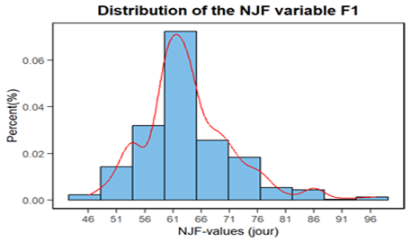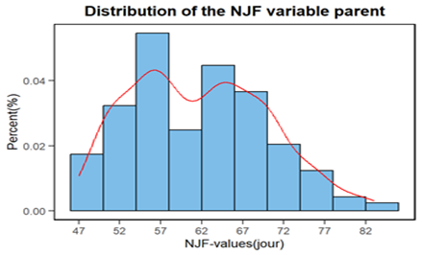
Figure 1 Frequency distribution of 50% flowering trait

3.2 Plant height distribution

The plant height distribution among F1 accessions shows a single peak, with most accessions ranging in height from 210 to 240 cm. Among the parents, this distribution shows several peaks. This distribution is a huge genetic basic with plant heights ranging from 160 cm to 295 cm (Figure 2).

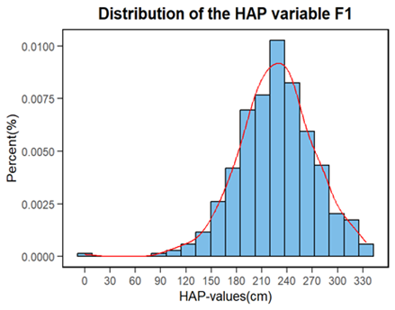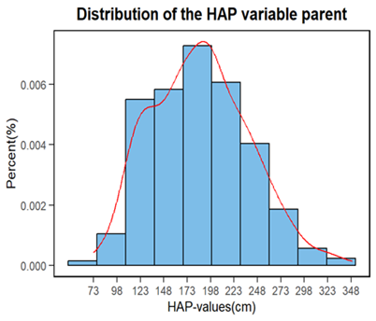
Figure 2 : Frequency distribution of plant height trait

3.3 Distribution of total number of shoots

Among all the variables of F1 accessions, only the total number of shoots showed several peaks and parental accessions has a single peak in the. The majority of F1 accessions fall into the 5 to 15 shoot class. The average number of shoots in the parental accessions is 3 to 7 (Figure 3).

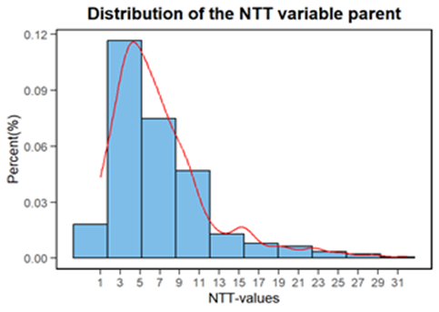
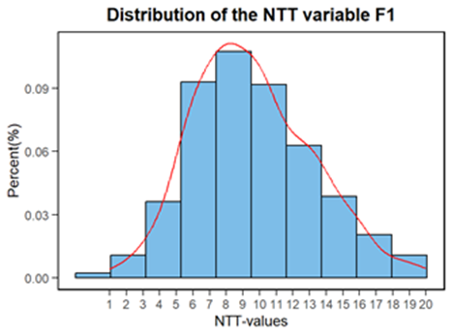

Figure 3 : Frequency distribution of total number shoots trait

3.4 Distribution of physiological maturity duration

Trait associated with number day of maturation of F1 accessions has presented one peak but parental accessions showed a single unimodal distribution. In fact, in F1 accessions, it ranges from 63 to 90 days after sowing, whereas the physiological maturity of the parents ranges from 73 to 113 days after sowing (Figure 4).

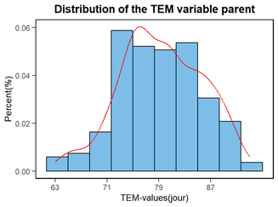
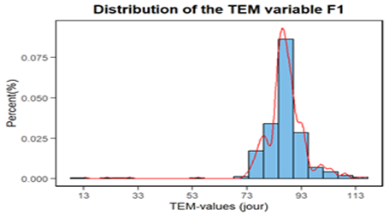

Figure 4: Frequency of physiological maturity duration trait

3.5 Weight distribution of 100 seeds

The 100 seed weight distribution is less variable in F1 accessions than in parental accessions. This distribution ranges from 0.3 g to 1.6 g in F1 accessions and from 0.6 g to 2.1 g in parental accessions (Figure 5).
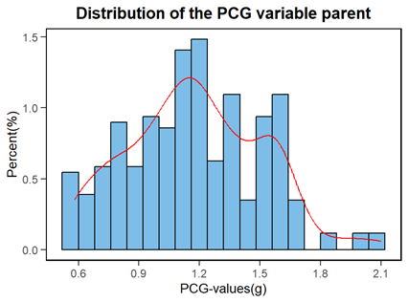
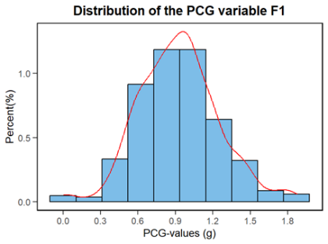

Figure 5: Frequency distribution of 100 seeds trait

3.6 Variance in quantitative traits

The minimum, maximum, mean, and coefficient of variation for parental accessions and their offspring are presented in Table 2. It should be noted that most of the variables derived from the offspring have low coefficients of variation compared to the variables derived from the parents. The analysis shows variation coefficient superior to 30% for the traits such total number of tillers, number of productive tillers, panicle length and 100 grains weight.

Table 2: performance of the population pearl millet of two generations

Traits | Minimum |  | Maximum |  | Mean |  | Coefficient of variation (%)
 | F1 | P | F1 | P | F1 | P | F1 | P
NJF | 46,00 | 47 | 97,00 | 83,00 | 63,86 | 61,72 | 12,72 | 11,11
DPV | 42,00 | 37,00 | 94,00 | 77,00 | 60,59 | 53,17 | 13,28 | 12,77
HAP | 12,00 | 73,00 | 330,00 | 321 | 225 | 173,83 | 19,85 | 26,37
DIT | 1,47 | 3,06 | 22,68 | 20,42 | 14,34 | 10,87 | 17,85 | 26,81
NTT | 1,00 | 1,00 | 20,00 | 32,00 | 9,55 | 7,08 | 37,20 | 72,41
NTP | 1,00 | 1,00 | 14,00 | 30,00 | 3,51 | 5,40 | 67,87 | 79,71
LOC | 10,60 | 9,00 | 50,70 | 288,0 | 31,99 | 28,01 | 22,29 | 60,54
LAC | 3,4 | 13,41 | 49,86 | 42,50 | 25,73 | 25,71 | 21,68 | 20,22
LOF | 20,45 | 10,00 | 90,00 | 66,00 | 43,34 | 35,19 | 24,20 | 29,72
LAF | 2,500 | 1,20 | 6,900 | 7,120 | 4,62 | 3,37 | 18,38 | 29,28
NFT | 6,00 | 3,00 | 18,00 | 12,00 | 11,40 | 6,62 | 17,82 | 25,14
TEM | 13,26 | 63,00 | 117,00 | 93,00 | 86,85 | 79,38 | 10,21 | 7,26
PCG | 0,005 | 0,58 | 1,87 | 2,10 | 0,92 | 1,18 | 34,22 | 27,68
POE | 0,80 | 1,92 | 103,15 | 399,32 | 45,03 | 30,66 | 68,63 | 87,99

Legend: NJF: number of days to flowering; DPV: duration of the vegetative period; HAP: plant height; DIT: stem diameter; NTT: total number of tillers; NTP: number of productive tillers; LOC: length of the candle; LAC: ear width; LOF: leaf length; LAF: leaf width; NFT: number of leaves on the stem; TEM: time to maturity; PGG: weight of 100 grains; POE: panicle length

3.7 Analysis of the correlation between the two generations of populations
Pearson's correlation matrix highlights numerous correlations at the 5% threshold (Tables 3 and 4). In fact, in parents (Table 3), the number of days to 50% flowering is strongly and positively correlated with variables relating to the length of the vegetative period (r=0.887). It is moderately and positively correlated with plant height (r=0.536), the number of leaves on the main stem, and the time to maturity (r=0.581). The length of the growing season is strongly correlated with the time to maturity (r=0.713) and moderately and positively correlated with plant height (r=0.516) and the number of leaves on the main stem (r=0.556).

Table 3: Parent correlation matrix

Variables | NJF | DPV | PCG | HAP | DIT | NTT | NTP | LOC | LAC | LOF | LAF | NFT | TEM | POG | POE
NJF | 1
DPV | 0,887** | 1
PCG | 0,037 | 0,002 | 1
HAP | 0,536* | 0,516* | 0,057 | 1
DIT | 0,436* | 0,374* | 0,162 | 0,558* | 1
NTT | 0,038 | -0,005 | 0,048 | 0,291 | 0,250 | 1
NTP | -0,020 | -0,062 | 0,033 | 0,236 | 0,211 | 0,930** | 1
LOC | 0,347* | 0,286 | 0,012 | 0,424 | 0,359 | 0,102 | 0,063 | 1
LAC | -0,069 | -0,086 | 0,220 | 0,265 | 0,426* | 0,111 | 0,116 | 0,052 | 1
LOF | 0,287 | 0,258 | 0,035 | 0,442 | 0,423* | 0,188 | 0,148 | 0,347 | 0,196 | 1
LAF | 0,228 | 0,201 | 0,077 | 0,432 | 0,469* | 0,209 | 0,164 | 0,311 | 0,370 | 0,675* | 1
NFT | 0,581* | 0,556 | 0,050 | 0,795* | 0,496* | 0,231 | 0,186 | 0,305 | 0,238 | 0,342 | 0,363 | 1
TEM | 0,581* | 0,713 | 0,087 | 0,396 | 0,286 | -0,037 | -0,088 | 0,204 | -0,018 | 0,175 | 0,116 | 0,427 | 1 | 1
POE | 0,150 | 0,114 | 0,015 | 0,385 | 0,312 | 0,135 | 0,086 | 0,188 | 0,316 | 0,227 | 0,319 | 0,276 | 0,026 |  | 1

Legend: NJF: number of days to flowering; DPV: duration of the vegetative period; HAP: plant height; DIT: stem diameter; NTT: total number of tillers; NTP: number of productive tillers; LOC: length of the candle; LAC: ear width; LOF: leaf length; LAF: leaf width; NFT: number of leaves on the stem; TEM: time to maturity; PGG: weight of 100 grains; POE: panicle length, *, ** significant at probability levels of 5% and 1%, respectively

Table 4: Descendant correlation matrix

Variables | NJF | DPV | PCG | HAP | DIT | NTT | NTP | LOC | LAC | LOF | LAF | NFT | TEM | POG | POE
NJF | 1
DPV | 0,996** | 1
PCG | -0,216 | -0,218 | 1
HAP | 0,466* | 0,467 | 0,041 | 1
DIT | -0,019 | -0,017 | 0,090 | 0,011 | 1
NTT | -0,044 | -0,053 | 0,047 | 0,029 | 0,226 | 1
NTP | -0,194 | -0,193 | 0,058 | -0,031 | 0,113 | 0,468* | 1
LOC | 0,188 | 0,191 | 0,003 | 0,431 | 0,258 | 0,121 | 0,074 | 1
LAC | -0,397 | -0,397 | 0,273 | -0,052 | 0,316 | 0,077 | 0,032 | -0,052 | 1
LOF | 0,444* | 0,447 | -0,143 | 0,128 | 0,109 | 0,102 | -0,096 | 0,218 | -0,139 | 1
LAF | 0,164 | 0,170 | -0,078 | 0,105 | 0,310 | 0,074 | -0,010 | 0,255 | 0,094 | 0,474 | 1
NFT | 0,422 | 0,423 | -0,025 | 0,528* | 0,207 | 0,071 | 0,023 | 0,219 | -0,046 | 0,048 | 0,067 | 1
TEM | 0,614** | 0,614* | -0,111 | 0,313 | 0,084 | -0,072 | -0,068 | 0,169 | -0,189 | 0,179 | 0,037 | 0,293 | 1
POE | -0,165 | -0,157 | 0,197 | 0,222 | 0,346 | 0,127 | 0,188 | 0,321 | 0,420 | -0,071 | 0,150 | 0,166 | -0,008 | 0,024 | 1

Legend: NJF: number of days to flowering; DPV: duration of the vegetative period; HAP: plant height; DIT: stem diameter; NTT: total number of tillers; NTP: number of productive tillers; LOC: length of the candle; LAC: ear width; LOF: leaf length; LAF: leaf width; NFT: number of leaves on the stem; TEM: time to maturity; PGG: weight of 100 grains POE: panicle length, *, ** significant at probability levels of 5% and 1%, respectively

3.8 Populations organization

The parental and offspring populations revealed respectively three distant groups and two groups at the F1 accession level (Figures 6 and 7). The structure of the dendrogram of parental accessions showed an unstructured within each group. Each group represents a mixture of accessions providing different countries. The accessions grouping together were linked on the characters 50% flowering, plant height, and cycle. In contrast, the dendrogram of F1 populations shows a similarity between groups based on 50% flowering and the number of tillers. The level of dissimilarity between groups remains high among parental populations and low among F1 populations.

Figure 6: Clustering pattern of parental populations based on morphological traits

Figure 7: Clustering pattern of F1 populations based on morphological traits

4. DISCUSION

Analysis of variance, distribution frequency, and dendrogram showed that parents and offspring are heterogeneous. This apparent heterogeneity may be linked to the fact that accessions come from diverse origins. Pucher et al. (2016) found that the accessions from Niger/Nigeria and Senegal were outstanding. On the other hand, pearl millet's allogamous nature could increase variability across cultivation generations. This corroborates the work of Mather (1941, 1942) and Spiess and Allen (1961), which suggested genetic variance would increase when recombination is favored. The wide range of performance for all traits constitutes an opportunity to select populations with different traits in breeding programs. These morphological variants with distinct phenotypic expression can be used to develop pearl millet variability. Significant variation due to genotypes was observed for all traits indicating that the populations were evaluated in one environment. The high variability obtained both parents and offspring reflect the extent of variability used to create the offspring. The phenotypic constitution in F1 has been less distribution compared parental population. Following the same reason, we postulated that Mendelian first low is verified. Several types of offspring could be used for the test-cross with parental populations. Knowledge of the relationships between variables remains a useful tool for breeders in genetic improvement programs. Generally, the correlation of genetic diversity depends on the geographical distance between genotypes. The positive correlation between the number of days to 50% flowering and plant height was also found by Yadav et al. (2011), who showed a strong correlation between these two variables. Similar results have shown that the traits most influenced by the additive effects of the gene can be improved by simple selection methods (Fofana, 1987). Highly significant correlations justify good indicators for selection traits. However, the number of productive shoots contrasts with plant height. This confirms that productive shoots generally originate from small accessions. The presence of different cycle of plant reveals that the collection can be used in several stages of variety selection such OPVs and hybrids. However, early cycle in F1 populations were due the crosses between India parental populations and West Africa parental populations. Others findings indicated that Asian populations were early in flowering having short plant height, more tillering, smaller and thinner panicles, smaller seeds and low yielding as compared to the African origin and bred populations (Patil et al., 2022). Manga (2015) cited by Patil et al. (2022) also reported that landrace from African regions such as Benin, Burkina Faso, Ghana and Togo were utilized to breed for bold seeded and early-maturing germplasms in India which led to the release of promising OPVs such as ICTP 8203 and ICMV 221.

5. Conclusion

This study evidences the great potential of parental and F1 populations for breeding programs. It showed the existence of a significant amount of diversity among parental and F1 populations for different traits like days to 50% flowering, plant height, panicle traits, and 1000-grain. Parental populations of diverse origin were allowed to develop a wide range of diversity uses for selection. For F1 populations, performance for majority traits can be used as base populations to derive new breeding lines. Further studies could look at on the development of F2 populations and back-cross to evaluate the aptitude in combination.

Consent

All authors declare their consent for publication

Ethical approval

Nil

References
- Harlan, J. R. (1971). Agricultural origins: Centers and noncenters. Science, 174(4008), 468-474. https://doi.org/10.1126/science.174.4008.468
- Upadhyaya, H. D., Reddy, K. N., Ramachandran, S., Kumar, V., & Ahmed, M. I. (2016). Adaptation pattern and genetic potential of Indian pearl millet named landraces conserved at the ICRISAT genebank. Indian Journal of Plant Genetic Resources, 29(2), 97-113. https://doi.org/10.5958/0976-1926.2016.00015.2
- Munson, P. J. (1976). Archaeological data on the origins of cultivation in the southwestern Sahara and their implications for West Africa. In J. R. Harlan, J. M. J. DeWet, & A. B. L. Stemler (Eds.), The origins of African plant domestication (pp. 187–210). Mouton Press.
- Brunken, J. N., De Wet, J. M. J., & Harlan, J. R. (1977). The morphology and domestication of pearl millet. Economic Botany, 31, 163–174. https://doi.org/10.1007/BF02866587
- Yadav, O. P., & Rai, K. N. (2013). Genetic improvement of pearl millet in India. Agricultural Research, 2(4), 275-292. https://doi.org/10.1007/s40003-013-0089-z
- Manning, K., Pelling, R., Higham, T., Schwenniger, J.-L., & Fuller, D. Q. (2011). 4500-Year old domesticated pearl millet (Pennisetum glaucum) from the Tilemsi Valley, Mali: New insights into an alternative cereal domestication pathway. Journal of Archaeological Science, 38(2), 312–322. https://doi.org/10.1016/j.jas.2010.09.007
- Saïdou, A. (2011). Etude moléculaire, évolution et caractérisation de gènes impliqués dans l’adaptation du mil (Pennisetum glaucum [L.] R. Br.) aux changements climatiques (Thèse de doctorat, Montpellier SupAgro). https://agritrop.cirad.fr/561000/1/SAIDOU_AA_Manuscrit_th%C3%A8se_final.pdf
- FAO (Food and Agriculture Organization). (2021). FAOSTAT. http://www.fao.org/faostat/en/#home
- Bastos, L. M., Faye, A., Stewart, Z. P., Akplo, T. M., Min, D., Prasad, P. V. V., & Ciampitti, I. A. (2022). Variety and management selection to optimize pearl millet yield and profit in Senegal. European Journal of Agronomy, 139, 126565. https://doi.org/10.1016/j.eja.2022.126565
- CEDEAO-UEMOA-CILSS. (2016). Catalogue Régional des Espèces et Variétés Végétales. CILSS. https://issuu.com/coraf/docs/regional_catalogue
- CEDEAO-UEMOA-CILSS. (2018). Catalogue Régional des Espèces et Variétés Végétales Variétés homologues (2016-2018). http://www.coraf.org/paired/wp-content/uploads/2019/11/Catalogue-Re%CC%81gional-des-Espe%CC%80ces.pdf
- CEDEAO-UEMOA-CILSS. (2021). Catalogue Régional des Espèces et Variétés Végétales (2018-2021). https://www.coraf.org/regional-catalogue-2021/
- Sattler, F. T., & Haussmann, B. I. G. (2020). A unified strategy for West African pearl millet hybrid and heterotic group development. Crop Science, 60(1), 1-13. https://doi.org/10.1002/csc2.20033
- Oumar, I., Mariac, C., Pham, J. L., & Vigouroux, Y. (2008). Phylogeny and origin of pearl millet (Pennisetum glaucum [L.] R. Br) as revealed by microsatellite loci. Theoretical and Applied Genetics, 117, 489-497. https://doi.org/10.1007/s00122-008-0793-4
- Amadou, I., Gounga, M. E., & Le, G. W. (2013). Millets: Nutritional composition, some health benefits and processing—A review. Food Science and Human Wellness, 2(1), 19–23. https://doi.org/10.1016/j.fshw.2013.05.003
- Bashir, K., Takahashi, R., Nakanishi, H., & Nishizawa, N. K. (2013). The road to micronutrient biofortification of rice: progress and prospects. Frontiers in Plant Science, 4, 15. https://doi.org/10.3389/fpls.2013.00015
- Kouressy, M., Vaksmann, M., & Soumaré, M. (2013). Importance socio-économique des céréales traditionnelles au Sahel. Cahiers Agricultures, 22(1), 32–40.
- Pucher, A., Sy, O., Sanogo, M. D., Angarawai, I. I., Zangre, R., Ouedraogo, M., Boureima, S., Hash, C. T., & Haussmann, B. I. G. (2016). Combining ability patterns among West African pearl millet landraces and prospects for pearl millet hybrid breeding. Field Crops Research, 195, 9-20. https://doi.org/10.1016/j.fcr.2016.04.035
- Haussmann, B. I. G., Boureima, S. S., Kassari, I. A., Moumouni, K. H., & Boubacar, A. (2007). Mechanisms of adaptation to climate variability in West African pearl millet landraces – a preliminary. Journal of SAT Agricultural Research, 3(1), 1-3. http://oar.icrisat.org/2212/
- Hu, Z., Mbacké, B., Perumal, R., Guèye, M. C., Sy, O., Bouchet, S., Prasad, P. V. V., & Morris, G. P. (2015). Population genomics of pearl millet (Pennisetum glaucum (L.) R. Br.): Comparative analysis of global accessions and Senegalese landraces. BMC Genomics, 16(1), 1048. https://doi.org/10.1186/s12864-015-2255-0
- Bashir, E. M., Ali, A. M., Ali, A. M., Mohamed, E. T. I., Melchinger, A. E., Parzies, H. K., & Haussmann, B. I. (2015). Genetic diversity of Sudanese pearl millet (Pennisetum glaucum (L.) R. Br.) landraces as revealed by SSR markers, and relationship between genetic and agro-morphological diversity. Genetic Resources and Crop Evolution, 62(4), 579-591. https://doi.org/10.1007/s10722-014-0183-5
- Dave, H.R. (1987). Pearl millet hybrids. In *Proceedings of the International Pearl Millet Workshop, 7–11 April 1986* (pp. 121–126). ICRISAT Center, Patancheru. http://oar.icrisat.org/id/eprint/873
- Lakis, G., Navascués, M., Rekima, S., Simon, M., Remigereau, M. S., Leveugle, M., Takvorian, N., Lamy, F., Depaulis, F., & Robert, T. (2012). Evolution of neutral and flowering genes along pearl millet (Pennisetum glaucum) domestication. PLoS One, 7(5), e36642. https://doi.org/10.1371/journal.pone.0036642
- Gemenet, D. C., Hash, C. T., Sy, O., Zangre, R. G., Sanogo, M. D., Leiser, W. L., Parzies, H. K., & Haussmann, B. I. G. (2014). Pearl millet inbred and testcross performance under low phosphorus in West Africa. Crop Science, 54(6), 2574-2585. https://doi.org/10.2135/cropsci2014.04.0277
- Bougma, A. L., Ouédraogo, M. H., Zerbo, C., Sawadogo, N., & Sawadogo, M. (2023). ASSESSMENT OF THE DIVERSITY OF PEARL MILLET OF WEST AFRICA AND INDIA BASED ON AGROMORPHOLOGIC TRAITS. Journal of Applied Biological Sciences, 17(2), 359–374. https://doi.org/10.71336/jabs.1200
- Mather, K. (1942). The balance of polygenic combinations. Journal of Genetics, 43(3), 309-336. https://doi.org/10.1007/bf02982906
- Mather, K. (1941). Variation and selection of polygenic characters. Journal of Genetics, 41(2), 159-193. https://www.ias.ac.in/article/fulltext/jgen/041/02-03/0159-0193
- Spiess, E. B., & Allen, A. C. (1961). Release of genetic variability through recombination. VII. Second and third chromosomes of Drosophila melanogaster. Genetics, 46(11), 1531–1553. https://doi.org/10.1093/genetics/46.11.1531
- Fofana A., 1987. Amélioration du mil au Sénégal : Synthèse des résultats acquis, analyse d’un croisement diallèle et perspectives. Rapport de titularisation, 40p.
- Patil, K. S., & Gupta, S. K. (2022). Geographic patterns of genetic diversity and fertility restoration ability of Asian and African origin pearl millet populations. The Crop Journal, 10(2), 468-477.
- Manga, V. K. (2015). Diversity in pearl millet [Pennisetum glaucum (L) R BR] and its management. Indian J Plant Sci, 4(1), 38-51.
- Yadav, O.P., Rai, K.N., Khairwal, I.S., Rajpurohit, B.S., and Mahala, R.S. (2011) Breeding pearl millet for arid zone of north-western India: constraints, opportunities and approaches. All India Coordinated Pearl Millet Improvement Project, Jodhpur, India, 28 p.

