The Role of Mini-Implants in Paediatric Oral Rehabilitation: A Review with a Case Report

ABSTRACT
Background- The loss of anterior permanent teeth in children can significantly affect their quality of life leading to functional, aesthetic and psychological challenges. Restoring missing teeth in growing patients presents unique difficulties due to ongoing craniofacial development. Dental implants are widely recognized for their ability to restore function and appearance, but conventional implants pose concerns in young patients and may interfere with maxillary growth, affecting both sagittal and transverse development. As an alternative, Mini Dental Implants are being used for their potential to support oral rehabilitation in growing patients without disrupting craniofacial growth.
Case Report- A 15-year-old patient presented with anterior tooth loss due to trauma requiring rehabilitation. A mini-implant (2 mm diameter) was selected based on anatomical suitability and functional needs. The implant was placed to restore aesthetics and maintain space for future dental development. This case underscores the potential of mini-implants as an effective and accessible solution for adolescent patients requiring prosthetic rehabilitation.
Key words- Aesthetics, Mini-implants, Trauma
- INTRODUCTION
A significant number of children experience tooth loss due to congenital hypodontia, oligodontia, or trauma, impacting both function and aesthetics. Total anodontia is the congenital absence of all the teeth in the primary or the permanent dentition¹. Hypodontia or oligodontia is the absence of one or a few teeth that may manifest in several genetic and syndromic conditions². Congenitally missing teeth are commonly found in healthy individuals and may occur without the association of any developmental disorders³. Maxillary and Mandibular incisors are one of the most frequently missing teeth, necessitating prosthetic intervention for optimal function and appearance⁴.
Trauma is another frequent cause of tooth loss in children particularly in cases of maxillary proclination and incompetent lips which increases the risk of anterior tooth trauma, commonly resulting in avulsion of maxillary incisors. According to Stockwell et al reported incidence of anterior tooth trauma in the permanent teeth in 6–12‑year‑old children to be 1.7 patients per 100 children per year, whereas Hamilton et al. stated it to be 34% ^{5, 6}.
Beyond the functional limits, loss of teeth leads to loss of function and lack of normal alveolar growth, along with unpleasant aesthetics that hamper the psychosocial development of the young child. Traditionally, the management of single tooth loss in the young child is done by conservative means including removable prosthetics, resin-bonded restorations and partial coverage prostheses⁷. But all these methods are not satisfactory and have their own drawbacks. Partial dentures are dependent on the child’s compliance. They increase the rate of decay and may cause gingival disease leading to bone resorption. Furthermore, there is the need to refabricate a new prosthesis from time to time to compensate for craniofacial growth⁷.
Given these challenges and with advancements in science and technology, mini-implants revolutionized which have emerged as a promising option, particularly in paediatric dentistry. Mini-implants are small, minimally invasive fixtures designed to address tooth loss while accommodating the anatomical and developmental constraints of children⁸. These are specialized implants designed with a reduced diameter (less than 3 mm) and shorter length, while maintaining the same biocompatible material as standard implants. Unlike conventional implants, which exceed 3 mm in diameter, mini-implants are ideal for cases where bone thickness is limited. Their compact design facilitates less-invasive surgical techniques, making them advantageous in patients with inadequate bone volume⁹.
By minimizing surgical complexity, mini-implants offer a reliable and efficient solution for restoring function and stability in dental rehabilitation⁸. Unlike traditional implants, they offer greater adaptability, requiring less bone density and ensuring faster healing. Their application extends beyond simple tooth replacement, contributing to orthodontic anchorage and space maintenance⁸. Mini-implants have gained traction in paediatric dentistry due to their minimally invasive nature and suitability for growing patients. Their small diameter and simplified placement make them ideal for cases where traditional implants may not be feasible due to limited bone volume. Children experiencing premature tooth loss are at risk of altered occlusion, speech impairment, and psychological distress. Mini-implants present an opportunity to restore aesthetics and functionality while minimizing discomfort. Their introduction into paediatric dentistry allowed for single-visit procedures, reduced surgical complexity, and enhanced patient comfort.
This review and case report explores the evolution, benefits, challenges and future directions of mini-implants in paediatric dentistry.

- HISTORY
Dental implants are not a modern discovery; their origins trace back to ancient civilizations. Throughout history, various methods have been used to replace missing teeth, from rudimentary materials like shells and animal bones to early metal prostheses like gold, silver. Today, dental implants have evolved into the most advanced and reliable solution for tooth loss, offering superior functionality, aesthetics, and long-term success.
Modern implantology took shape in the 1970s with Dr. Per-Ingvar Branemark’s discovery of osseointegration, which demonstrated titanium’s ability to integrate with bone, revolutionizing dental rehabilitation¹⁰.
In the 1980s, implantologists saw a need to try to accommodate the desire of patients for more immediate implant support. Thus narrow-diameter, mini dental implants came into use- initially as a provisional treatment during healing/integration periods of traditional endosteal root-form implants. However, during this period, while utilizing mini dental implants for provisionalization, it was noted that these immediately loaded mini-implants were often difficult to remove and appeared to have become clinically integrated. This led to an ongoing development of applications and current use for long-term restorative cases. The initial concept was developed and tested by Dr. Victor Sendax. His work was further refined by Dr. Burton Balkin, who demonstrated their stability and immediate loading potential. Dr. Anthony Ricciardi contributed to advancing clinical applications, ensuring mini-implants could be used for long-term restorative cases¹⁰.
The need for a minimally invasive alternative led to the introduction of mini-implants, initially designed for orthodontic anchorage. Mini-implants revolutionized paediatric dentistry by providing minimally invasive and adaptable alternatives for young patients with anatomical constraints. Today, they serve as an essential tool for early intervention in tooth loss, promoting aesthetic harmony, optimal occlusion, and long-term oral health.

- COMPARISON OF MINI IMPLANTS WITH CONVENTIONAL IMPLANTS
Mini-implants consist of a single-piece titanium screw, whereas conventional implants are composed of two separate components: implant body and abutment. Unlike conventional implants, which are placed beneath the gingival surface, mini-implants protrude above it when embedded into the bone. They feature either a ball-shaped head for denture stabilization or a square prosthetic head for fixed applications, eliminating the need for a separate abutment¹¹. Figure 1 shows the difference between conventional and Mini-Implants.
According to study done by Gleiznys et al. (2012), some differences between both types of implants are: -
- Size: Mini-implants, due to their smaller dimensions, are well-suited for replacing teeth in areas with limited space and for securing full or partial dentures. Conventional implants, being larger, are preferred for replacing molars or supporting dental bridges.
- Durability: Both mini and conventional implants are made from high-grade titanium alloy. While implant strength primarily depends on post length rather than diameter, mini-implants are narrower and less capable of withstanding high occlusal forces. As a result, conventional implants are recommended for load-bearing teeth, such as molars.
- Cost-effectiveness: Mini-implants are more affordable than conventional implants due to their smaller size and the relatively simple surgical procedure required for placement.
- Longevity and Success Rate: Conventional implants, when properly placed and maintained, exhibit a high success rate and can last for decades or even a lifetime. In contrast, mini-implants are a more recent innovation with fewer long-term studies evaluating their success¹¹.
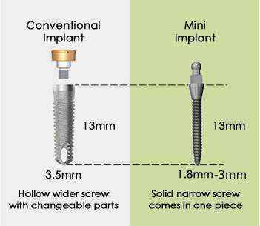
Figure 1: Comparison of Mini-Implants and Conventional Implants

- PARTS OF MINI-IMPLANTS
It is a miniature sized titanium implant acting like the root of tooth. They have a diameter of 1.8 mm to 2.7 mm. Height and anatomic structures of the bone determine the length, shape, and thickness of mini-implants. Figure 2 shows appropriately parts of mini-implant.
- Head: Exposed portion of mini-implant, designed to accommodate attachments such as elastics or wires for orthodontic and prosthetic applications. Square, rectangular or o- ball heads are common.
- Neck: Connecting section between head and body, available in three different heights—1mm, 2mm and 3mm—to accommodate varying soft-tissue thicknesses across different implant sites.
- Body: A parallel-shaped structure that may be either self-drilling or self-tapping. It features threads and grooves that enhance interlocking with the bone, ensuring stability and optimal load distribution.
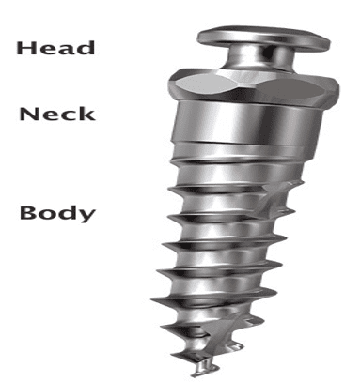
Figure 2: Parts of Mini-Implant

- INDICATIONS
Mini-implants play a significant tool in paediatric dentistry, offering reliable solutions for a range of clinical scenarios. Here are some key indications for their use:
- Prosthetic Rehabilitation- Serve as temporary supports for prosthetic restorations in young patients with dental agenesis or traumatic tooth loss¹².
- Orthodontic Anchorage- They provide stable anchorage for orthodontic movements, especially in cases where traditional anchorage methods are insufficient¹³.
- Skeletal Malocclusions- Used in cases of severe malocclusions to aid in controlling skeletal discrepancies and guided orthopaedic treatment¹⁴.
- Palatal Expansion Assistance- Enhance the effectiveness of rapid maxillary expansion by providing additional anchorage¹⁵.
- Space Maintenance- They help preserve space for erupting permanent teeth when premature loss of primary teeth occurs¹⁶.
- Management of Congenitally Missing Teeth- They serve as interim prosthetic solutions for children with missing teeth due to congenital conditions¹⁶.
- Intrusion of Over-erupted Teeth- Particularly useful in managing anterior open bite cases or correcting over erupted molars¹⁵.
- Correction of Asymmetries- Assist in modifying unilateral dental discrepancies without extensive surgical intervention¹⁷.
- Adjunct in Cleft Palate Cases – Provide orthodontic support and aid in prosthetic stabilization for cleft palate patients¹⁷.
- Indicated for bridge repair and fixed replacement of the single or multiple teeth in a narrow ridge¹⁷

- CONTRAINDICATIONS
Mini implants should be avoided for patients who are medically unfit for the treatment. Before mini-implant placement, a thorough evaluation is essential to identify risk factors affecting surgical success and healing.
Some of the conditions as described by Upendran et al in 2019 in children may contraindicate their use⁹:
- Systemic Health Concerns: Children with vascular disorders, uncontrolled diabetes, metabolic bone diseases or chronic systemic conditions that impair wound healing.
- Medication-Related Risks: Use of anticoagulants, chemotherapy, radiation therapy or pharmaceuticals that disrupt natural bone remodelling.
- Oral and Behavioural Limitations: Chronic periodontal inflammation, inadequate soft tissue coverage, poor oral hygiene and parafunctional habits that compromise implant stability.
- Anatomical Constraints: Insufficient bone height or width, inadequate inter-arch space, or unfavourable alveolar ridge conditions limiting placement feasibility.
- Paediatric Growth Considerations: Mini-implant placement is discouraged in children until skeletal maturity is reached and epiphyseal closure is completed.
- Children undergoing Chemotherapy or radiation therapy⁹

- ADVANTAGES
Mini-implants offer several advantages in paediatric dentistry, making them a valuable tool for various clinical applications. Here are some key benefits:
- Minimally Invasive Procedure: Their small size allows for placement with minimal surgical intervention, reducing discomfort and healing time.
- Immediate Loading Potential: They can often be used immediately after placement, enhancing treatment efficiency.
- Preservation of Bone Structure: They help maintain alveolar bone integrity by providing functional stimulation, preventing resorption.
- Ideal for Space-Limited Areas: Their compact design makes them suitable for cases where conventional implants may not fit due to anatomical constraints.
- Enhanced Stability for Orthodontic Anchorage: They provide reliable anchorage for controlled tooth movement, improving orthodontic outcomes.
- Cost-Effective Alternative: They are more affordable than conventional ones due to simpler placement techniques.
- Reduced Healing Time: Their placement requires less invasive surgery, leading to faster recovery and minimal post-operative complications.
- Lower Risk of Surgical Complications: Their smaller diameter reduces the likelihood of nerve damage or excessive bone removal.
- True innovations for children who are reluctant to have dental surgery.
- Biocompatible¹⁸

- DISADVANTAGES
Mini-implants comes with certain unavoidable disadvantages which are
- Requirement for Adequate Vertical Bone: These necessitate sufficient vertical bone for successful placement, making them unsuitable in cases of severe bone loss.
- Higher Quantity for Stability: Due to their smaller size, a greater number of mini-implants are required for denture stabilization—typically four for the lower jaw and up to twelve for the upper jaw, where bone density is lower ⁹.
- One-Piece Design Constraint: Consist of a single-unit structure, meaning the entire implant must be replaced if the head undergoes wear.
- Fracture Risk During Placement: Their narrow diameter increases susceptibility to structural failure when subjected to high occlusal forces.
- Precision-Dependent Parallelism: The one-piece design requires exact parallel placement for optimal function, making deviations less forgiving ⁹.
- Reduced Resistance to Occlusal Loading: Mini-implants demonstrate lower tolerance to heavy chewing forces compared to conventional implants⁹.

- OPTIMIZING SITE SELECTION FOR MINI-IMPLANT PLACEMENT
Selecting an appropriate placement site for mini-implants in children requires careful consideration of several key factors to ensure safety, stability and treatment effectiveness.
Jong Suk Lee et al in 2007 described in their book- Applications of Orthodontic Mini- Implants, the following factors that are considered for site selection for Mini-Implants¹⁹.
- Risk Avoidance: High-risk areas near vital anatomical structures should be excluded to prevent irreversible damage.
- Surgical Accessibility: The site should allow for precise implant placement while ensuring adequate stability for long-term success.
- Bone Quality and Quantity: Sufficient cortical bone thickness is essential for immediate mechanical stabilization post-implantation.
- Soft Tissue Compatibility: Healthy attached gingiva is necessary for proper soft tissue sealing and minimizing complications.
- Biomechanical Efficiency: Implants should be positioned strategically to facilitate optimal force application.
- Patient Comfort: Placement should prioritize minimizing discomfort, ensuring better compliance and post-operative experience.
In figure 3, diagram of the maxilla and mandible are shown. Safe zones (marked in blue) are ideal for implantation while high-risk areas (marked in red) indicate potential complications.
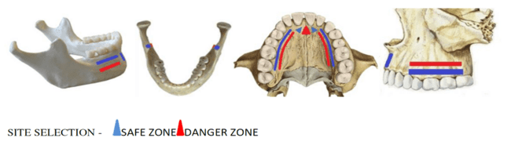
Figure 3- Site Selection for Mini-Implant

- MINI-IMPLANT PLACEMENT PROCEDURE
Important factors to be considered when treating a child with missing tooth, apart from growth, are dentition present, residual space between the teeth present in the arch, amount of alveolar bone, and the timing of implant placement. Treatment planning should be done precisely with study models and radiographs.
Following procedural steps are to be followed while placing mini-implants: -
- Local Anaesthesia: A mild anaesthetic is administered at the implant site to ensure patient comfort during the procedure.
- Flapless or Minimal Flap Technique: In most cases, a flapless approach is used for minimal invasiveness. But, if the ridge is narrow or soft tissue coverage is excessive, small crestal incision is made to expose the bone for precise implant positioning.
- Pilot Drilling: A small hole is drilled into the cortical bone to facilitate the insertion of the implant and reduce placement resistance.
- Implant Insertion: The mini-implant is gradually screwed into its designated position using a winged wrench to ensure optimal primary stability. The process requires careful angulation to prevent unnecessary stress on adjacent structures.
- Transmucosal Positioning: The implant is placed at an occluso-gingival level, ensuring proper integration with surrounding soft tissues while maintaining accessibility for orthodontic forces or prosthetic attachments.
Proper postoperative care, including maintaining oral hygiene and avoiding excessive forces on the implant during the initial healing period, is crucial for long-term success.

Case Report
A 15-year-old boy came along with his parents to the Department of Paediatric and Preventive Dentistry, K.D. Dental College and Hospital, Mathura, Uttar Pradesh, India on 12th January 2025 at 1 PM. The primary complaint was missing teeth and pain in the upper left anterior teeth region. The patient also had concern about aesthetics, seeking a solution that provided natural-looking results. While taking history of the patient, it was told that the child had fallen off from the stairs 5 years ago. There was no evidence of a head injury or other bodily injuries. The patient was fully immunized against tetanus. At the time of trauma, when the patient consulted dentist in his village, dentist performed extraction of permanent upper left central incisor without reimplantation attempt.
Extraoral examination revealed no abnormality. The intraoral examination revealed that edentulous region with respect to 21 and tender on percussion wrt 22 and intact mucosa, no apparent bony defect, and satisfactory vertical dimension of occlusion and correct maxillomandibular sagittal relationship (figure 4).
IOPAR scan of the left maxillary anterior area revealed absence of tooth wrt 21 and chronic irreversible pulpitis wrt 22. (figure 5).
The treatment goal was to promote good oral health and acceptable aesthetics and phonetics. The treatment plan consisted of Root Canal Treatment followed by crown wrt 22 and installation of one mini-implant in the remaining alveolar ridge for immediate support of provisional crown wrt 21.
The executed treatment consisted of the following steps: -
  - Root Canal Treatment Procedure was done wrt 22 (figure 6)
  - Mini-implant Placement wrt 21: Armamentarium used is shown in Figure 7
    - Selection of mini-implant- Single mini-implant was chosen based on clinical requirements. It was self-tapping and self-drilling type, designed for precise insertion with minimal surgical intervention. Implant fabricated from titanium alloy with a diameter of 2 mm and length of 12 mm was chosen.
    - Adequacy of the oral environment was checked. Prophylaxis of oral cavity with chlorhexidine gluconate 0.12% was done.
    - Local anaesthesia in the edentulous region (topical-lidocaine 5%) was applied. Infra-orbital and Naso palatine nerve block was delivered using 2% lignocaine hydrochloride, combined with a 1:1,000,000 adrenaline vasoconstrictor. The injection was precisely administered at the concerned site, targeting the infra-orbital nerve to achieve regional analgesia providing a stable operative field.
    - An incision was carefully made at the designated site to facilitate implant placement. Depending on the anatomical constraints, a crestal incision was used to ensure adequate exposure. The flap was then raised, revealing the underlying bone structure for precise implant positioning. The extent of flap elevation was controlled to preserve vascular integrity and promote rapid healing post-surgery (figure 8).
    - William's probe and indelible pencil were used to identify and mark the arbitrary insertion point for the mini-implant. The probe ensured accurate measurement and assessment of soft tissue depth, while the pencil provided a clear visual reference for precise placement. This preliminary marking aids in aligning the implant with the intended angulation, optimizing biomechanical stability and ensuring minimal surgical deviation (figure 9).
    - Implant screw was carefully positioned at the designated site. The placement was executed with precise angulation and depth control, ensuring optimal engagement with the surrounding bone. The implant was gradually tightened to achieve primary stability while minimizing unnecessary stress on adjacent structures using Mini-implant Driver. Proper alignment was verified to support long-term functional and aesthetic outcomes (figure 10).
    - Following placement, only the head of implant screw remained visible, emerging through soft tissue while the rest of the fixture was securely embedded within the bone. This transmucosal positioning ensures accessibility for prosthetic attachment (figure 11).
    - After implant placement, Coe Pack dressing was carefully mixed and applied to the surgical site, providing protection and facilitating healing. Patient was instructed on post-operative care, including maintaining oral hygiene and avoiding excessive force at the implant site. Analgesics and antibiotics were prescribed to manage pain and prevent infection. A follow-up appointment was scheduled after one week, allowing for clinical assessment of healing progress and ensuring optimal recovery (figure 12).

  - Crown Preparation- One week postoperatively, an RVG scan was performed, confirming that the mini-implant remained stable and non-mobile.
- Core Build-Up (wrt 21): A hybrid composite was used to reinforce the structural integrity of the tooth, ensuring optimal support for the final restoration (figure 13).
- Crown Preparation (wrt 22): Precision crown cutting was performed to shape the tooth for a PFM (Porcelain-Fused-to-Metal) crown, ensuring both durability and aesthetics.
- Impression Procedure: An alginate impression was taken for both crowns, allowing for accurate prosthetic fabrication.
- PFM Crown Fabrication and Delivery: The crowns were fabricated and successfully delivered, ensuring functional and aesthetic restoration and radiograph was taken (figure 14, 15).
After this step, occlusal adjustment was executed in order to promote physiological contacts in maximum intercuspation and eccentric movements. Patient and family were informed about the hygiene of the oral cavity with emphasis on flossing the peri-implant region. They were also advised about restrictions in food apprehension especially bread, nuts and fruits which should be divided into small pieces to minimize axial forces action on mini-implants.

RESULTS
After 3 months, the treatment yielded satisfactory aesthetic and functional results, demonstrating successful integration of the mini-implant. Monthly clinical evaluations and radiographic examinations were conducted to monitor progress. Throughout the follow-up period, the adjacent periodontium remained free of inflammation, ensuring optimal tissue health. Additionally, the prosthetic crown remained stable without signs of mobility, while radiographic assessments confirmed healthy alveolar bone maintenance. Both the patient and family members expressed satisfaction with the treatment, highlighting its effectiveness in restoring function and aesthetics in young children.

DISCUSSION
The primary objective of this case report is to assess the effectiveness of prosthetic-implant rehabilitation using mini-implants in a growing patient. Clinical and radiographic evaluations demonstrated successful treatment outcomes, confirming implant stability, functional integration and aesthetic restoration. These findings align with previous research done by Thilander B et al in 2001 and Bernard JP et al in 2004 and reinforce expectations regarding the adaptability of osteo-integrated mini-implants in paediatric cases^{20, 21} .
According to Christensen GJ et al in 2006, the relatively lower cost of mini-implants compared to conventional implants makes them a more accessible option for a broader range of patients, facilitating wider adoption in pediatric oral rehabilitation ²². Their affordability widens treatment options, allowing for early intervention and improved quality of life during crucial developmental years.
Giannetti et al. in 2010 demonstrated that implant prosthetic rehabilitation using mini-implants can be a viable approach for growing patients. Their two-year case report indicated that the procedure did not interfere with sagittal or transversal maxillary growth, supporting the long-term stability and adaptability of mini-implants in pediatric oral rehabilitation ²³.
Rahate I et al in 2025 discusses in their case report about the use of implants for congenitally missing lateral incisors in a pediatric patient. The study highlights the minimally invasive nature of these mini-implants and their ability to preserve esthetics and function while awaiting full skeletal growth ²⁴.
Sathyaprasad S et al in 2021 explored the use of mini-implants as space maintainers in pediatric patients with congenitally missing teeth. The study emphasized on the psychological benefits of mini-implants with biocompatible solution for crown anchorage and provide a natural-feeling prosthetic replacement, enhancing both aesthetics and function²⁵.
Ferreira et al in 2018 reported that mini-implant are a viable alternative for patients in the growing phase and improves functional aspects such as speech, mastication, swallowing and aesthetics²⁶. Melsen B et al. in found that the mini-implant stimulates alveolar ridge and thus helps prevent ridge atrophy and the adjacent roots from drifting into the edentulous space ²⁷.
In this case, the patient demonstrated rapid adaptation, with no reported complications or post-placement distress, which reinforces the growing body of evidence supporting their use in adolescents. From an aesthetic and functional standpoint, patient reported satisfaction in multiple domains, including phonetics, mastication and social confidence. The successful integration of the mini-implant contributed to a more natural occlusion, fostering better speech articulation and aesthetics, both critical components of overall oral well-being.
Despite these positive outcomes, long-term considerations must be acknowledged. Continuous monitoring is necessary to ensure the implant remains stable as the patient progresses through skeletal maturation. Future studies should further investigate the long-term biomechanical behaviour of mini-implants in paediatric patients to establish definitive guidelines regarding timing, selection criteria, and adaptation strategies.

CONCLUSION
This case underscores the potential of mini-implants as an effective and accessible solution for adolescent patients requiring prosthetic rehabilitation. Mini-implants have emerged as a promising solution, offering both temporary and long-term benefits. Their simple insertion process allows for quick intervention, often completed in a single appointment and providing cost-effectiveness over conventional methods. The technique ensures functional stability, supporting proper occlusion and long-term oral health. Aesthetically, mini-implants help restore a natural appearance, improving self-confidence, enhancing patient comfort, reducing post-operative complications. Additionally, they promote social integration, enabling young patients to interact without hesitation. The procedure requires minimal surgical intervention, making it suitable for children and adolescents. With proper case selection, mini-implants contribute to successful oral rehabilitation serving as an efficient, affordable and impactful option in paediatric dentistry.

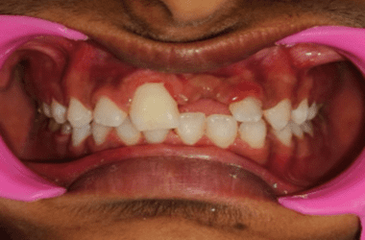
Figure 4: Extra Oral Examination
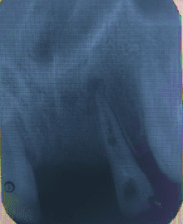
Figure 5: IOPAR scan
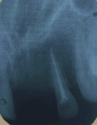
Figure 6: RCT done wrt 22

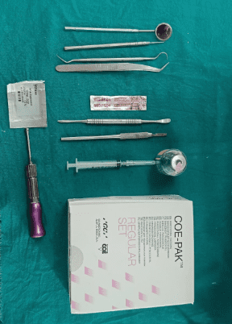
Figure 7: Armamentarium

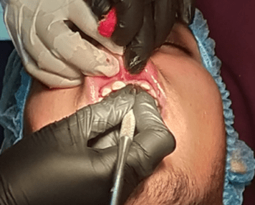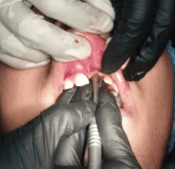
Figure 8: Incision made and Flap raised
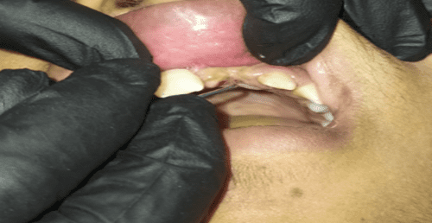
Figure 9: Marking for placement of Implant Screw w.r.t 21

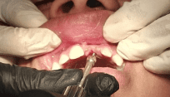
Figure 10: Placement of Mini-Implant using Implant Driver
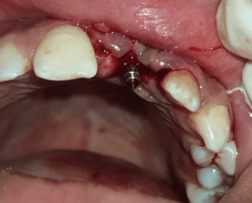
Figure 11: Implant Placed
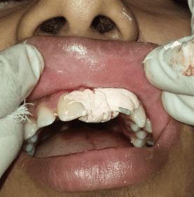
Figure 12: COE Pack Dressing given
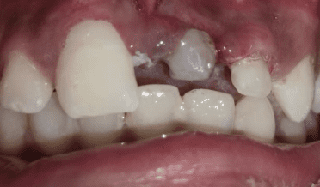
Figure 13: Core Build Up of Mini-Implant
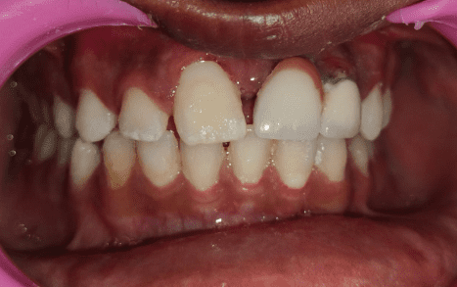
Figure 14: Post-Operative View
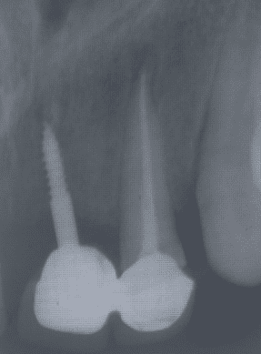
Figure 15: Post-Operative Radiograph
References
- Rajendran R. Developmental disturabances of oral and paraoral structures. In: Shafer’s Textbook of Oral Pathology. 5th ed. India: Elseviers Publications; 2006. p. 6.
- Egermark‑Eriksson I, Lind V. Congenital numerical variation in the permanent dentition. D. Sex distribution of hypodontia and hyperodontia. Odontol Revy 1971; 22:309‑15.
- Larmour CJ, Mossey PA, Thind BS, Forgie AH, Stirrups DR. Hypodontia – A retrospective review of prevalence and etiology. Part I. Quintessence Int 2005; 36:263‑70.
- Cameron J, Sampson WJ. Hypodontia of the permanent dentition. Case reports. Aust Dent J 1996;41:1‑5.
- Stockwell AJ. Incidence of dental trauma in the Western Australian school dental service. Community Dent Oral Epidemiol 1988; 16:294‑8.
- Hamilton FA, Hill FJ, Holloway PJ. An investigation of dento‑alveolar trauma and its treatment in an adolescent population. Part 1: The prevalence and incidence of injuries and the extent and adequacy of treatment received. Br Dent J 1997; 182:91‑5.
- Agarwal N, Kumar D, Anand A, Bahetwar SK. Dental implants in children: A multidisciplinary perspective for long-term success. National journal of maxillofacial surgery. 2016 Jul 1;7(2):122-6.
- Ahn MR, An KM, Choi JH, Sohn DS. Immediate loading with mini dental implants in the fully edentulous mandible. Implant Dent. 2004 Dec;13(4):367-72.
- Upendran A, Gupta N, Salisbury HG. Dental Mini-Implants. 2018.
- Balkin BE. Background of Mini Dental Implants. InMini Dental Implants 2013 Jan 1 (pp. 19-33). Mosby.
- Gleiznys A, Skirbutis G, Harb A, Barzdziukaite I, Grinyte I. New approach towards mini dental implants and small-diameter implants: an option for long-term prostheses. Stomatologija. 2012 Jan 1;14(2):39-45.
- Vigolo P., Givani A. 2000. Clinical evaluation of single-tooth mini-implant restorations: a five-year retrospective study. The Journal of prosthetic dentistry. Jul 1;84(1):50-4.
- Umehara K., Tsunoda M., Yamada S. 2002. A case report of orthoperio treatment with mandibular transitional implant. J Jpn Soc Periodontol., 44:188.
- Bulard RA. 2001. Mini dental implants: enhancing patient satisfaction and Jul;20(7):82. practice income. Dentistry today.
- Nagata M., Nagaoka S. 2002. Mini-implant is effective as a transitional fixation anchorage for transplantation of teeth. Jpn J Conserv Dent., 45:69.
- Dr. Savitha Sathyaprasad, Dr. Krishnamoorthy S.H. and Dr. Vinisha Vinod 2020. “Mini implants in pediatric dentistry- A review”, International Journal of Current Research, 12, (02), 10416-10420.
- Bryant SR, MacDonald-Jankowski D, Kim K. Does the type of implant prosthesis affect outcomes for thecompletely edentulous arch? Int J Oral Maxillofac Implants. 2007;22 Suppl:117-39.
- Dixit S, Srivastava B, Gupta N, Gambhir N, Singh R. Mini-Implants in Pediatric Dentistry.
- Jong Suk Lee, Jung Kook Kim, Young-Chel Park, Robert L Vanarsdall, Jr: Applications of Orthodontic Mini- Implants, TREATMENT PLANNING (ch4) Quintessence Publishing Co, Inc pg. 53-54.
- Thilander B, Odman J, Lekholm U. Orthodontic aspects of the use of oral implants in adolescents: A 10-year follow-up study. Eur J Orthod 2001; 23:715-31.
- Bernard JP, Schatz JP, Christou P, Belser U, Kiliaridis S. Long-term vertical changes of the anterior maxillary teeth adjacent to single implants in young and mature adults: A retrospective study. J Clin Periodontol 2004;31: 1024-8
- Christensen GJ. The mini-implant has arrived. J Am Dent Assoc 2006; 137:387–390.
- Giannetti L, Murri Dello Diago A, Vecci F, Consolo U. Mini-implants in growing patients: A case report. Pediatr Dent 2010; 32: 239-44.
- Rahate, I., Fulzele, P., Mundada, B. et al. Early intervention with transitional implants for congenitally missing lateral incisors in a pediatric patient: a case report. J Med Case Reports 19, 238 (2025).
- Sathyaprasad S, Krishnamoorthy SH, Anjana V, Vinod V. Contemporary approach for space maintainers: A case report.
- Ferreira NL, Viana FS, Menezes LF, França EC, Pretti H, Zarzar PM. Temporary rehabilitation with mini-implants in achild with ectodermal dysplasia. Revista Brasileira de Odontologia. 2018.
- Melsen B. What influence has skeletal anchorage had on orthodontics? In: McNamara JA Jr, ed. Microimplants as Temporary Orthodontic Anchorage. Craniofacial Growth Series. Vol 45. Ann Arbor, Mich: University of Michigan Center for Human Growth and Development; 2008; 15–19.

