Treatment of Bacteria Isolated From Abattoir Wastewater with Bacteriocins

.
ABSTRACT

Aims: The research investigated the bacterial composition and the effect of bacteriocin treatment on bacteria in abattoir wastewater.
Place and Duration of Study: Department of Microbiology, Michael Okpara University of Agriculture,Umudike.
Methodology: Bacteria were isolated using standard microbiological methods and their identity confirmed using 16S rRNA method. Purified bacteriocins produced from lactic acid bacteria were assayed for antibacterial activity using the agar well diffusion method and used for treatment of abattoir wastewater samples. Abattoir wastewater samples were sterilized and inoculated with three isolated bacteria respectively. Plate counts were determined before treatment with bacteriocin extracts after which plate counts were read to determine if there were reductions in bacterial counts.
Results: Bacteria isolated from abattoir wastewater include Escherichia coli, Enterobacter aerogenes, Staphylococcus aureus, Klebsiella oxytoca, Salmonella sp, and Bacillus cereus. Lactobacillus plantarum bacteriocin and Lactobacillus fermentum bacteriocin were assayed against Escherichia coli, Enterobacter aerogenes and Staphylococcus aureus and both exhibited inhibition against Staphylococcus aureus with zones of inhibition of 16mm and 15mm, respectively. The bacteriocins displayed highest antagonistic effect on Staphylococcus aureus counts when used to treat abattoir wastewater. There was a decrease of 3.48 log cycles in Staphylococcus aureus counts after two hours of treatment with Lactobacillus fermentum bacteriocin in abattoir wastewater while there was a decrease of 2.97 log cycles in Staphylococcus aureus counts after two hours of treatment with Lactobacillus plantarum bacteriocin in abattoir wastewater. The bacteriocins exhibited least antagonistic effect on Enterobacter aerogenes with a decrease of 2.54 log cycles and 2.30 log cycles after two hours of treatment with . plantarum bacteriocin and L. fermentum bacteriocin, respectively. Treatment with consortium of the bacteriocins revealed higher activity with a decrease of 3.70 log cycles in Staphylococcus aureus counts after two hours of treatment. There was a decrease of 3.35 log cycles in Escherichia coli counts in the wastewater when treated with consortium of the bacteriocins.
Conclusion: The results of this study indicate that bacteriocins have significant inhibitory activity against bacterial strains in abattoir wastewater and can be used as alternatives in the treatment of abattoir wastewater.

Keywords: Bacteriocin, Abattoir, Wastewater, Bacteria

1. INTRODUCTION

Abattoirs are facilities designed for the slaughter, processing, and inspection of animals for meat production. Modern abattoirs usually have a multi-floor layout over a single-floor design, as this arrangement improves hygiene by separating different processing stages vertically and facilitating movement of carcasses and waste. A typical abattoir has features such as holding areas for animals, stunning boxes, separate rooms for carcass and offal processing, refrigeration and laboratories to ensure hygiene and product uniformity (Yimana and Hassen, 2024). Key equipment used in abattoirs include restraining devices, stunning tools, hoisting mechanisms, evisceration tables, cold storage rooms, and specialized sections for by-product processing (Malik, 2024). Modern abattoirs also utilize advanced equipment to ensure efficient, hygienic, and environmentally responsible operations. Abattoirs in Nigeria are generally plagued with poor drainage systems, lack of proper education of the butchers and workers, poor waste management, inadequate storage facilities, lack of proper inspection and monitoring of animals and meat product, inadequate power supply amidst other anomalies (Ekpunobi et al., 2024). However, many abattoirs, especially in developing countries such as Nigeria, lack essential infrastructure such as isolation pens for sick animals, holding areas and waste management systems, leading to increased risks of contamination and disease transmission (Kalio and Ali-Uchechukwu, 2020). The absence of these facilities often leads to unhygienic practices, such as slaughtering on bare floors, inadequate handwashing, and improper waste disposal, which compromise meat safety and public health (Nwaoma et al., 2025).
Abattoir waste contaminate the environment directly or indirectly from several operations and may be responsible for the cause of river deoxygenation, groundwater contamination, and climate change (Gutu et al., 2021; Williams et al., 2019). These pose environmental safety concerns and reflect a public health concern. Abattoir wastewater contains high concentrations of blood and other organic waste. Release of such waste into surface water is the most common path for industrial waste to contaminate drinking water (Adamu and Dahiru, 2020). The wastewater is highly contaminated with organic matter quantified as biochemical oxygen demand (BOD) and chemical oxygen demand (COD). It also contains high nitrogen and phosphorous constituents, including blood, fats, oil, grease, and proteins. Hence, discharging untreated abattoir wastewater has a high risk of polluting freshwater sources. It can also cause serious environmental and health concerns such as de-oxygenation of rivers, groundwater contamination, eutrophication, and the spread of water-borne diseases (Baker et al., 2020). Wastewater from abattoirs have been major sources of environmental pollution. Pathogenic bacteria such as Clostridium perfringes, Vibrio cholera, Pseudomonas aeruginosa, Proteus sp, Escherichia coli, Klebsiella pneumoniae, Salmonella sp., Staphylococcus aureus and fungi such as Penicillium sp., Saccharomyces sp., and Aspergillus sp have been isolated and identified previously from abattoir effluents in Nigeria (Ekpunobi et al., 2024).
Abattoir wastewater is treated by physical, chemical and biological methods before release or reuse. These methods have high costs and the use of chemicals has adverse effects on the environment and human health. A novel treatment model could consist of the use of extracellular metabolites such as bacteriocins for wastewater treatment. Bacteriocins are antimicrobial peptides produced by some bacteria, predominantly lactic acid bacteria. Bacteriocins from lactic acid bacteria may have a large range of inhibitory action, inhibiting a diverse spectrum of Gram-positive microorganisms, or a narrow range of inhibitory activity, inhibiting only those strains that are closely related to the producer organism (Duraisamy et al., 2020).
2. material and methods / experimental details / methodology
2.1 Collection of Samples
Abattoir wastewater samples were aseptically collected in sterile bottles from Ubakala abattoir in Umuahia, Abia State, Nigeria. Samples were collected at the exit points along the drainage using sterile wide mouthed bottles. The sample bottles were placed on ice box and transported to the laboratory for analysis.
2.2 Isolation and Purification of Bacteria from Abattoir Wastewater Samples
Ten-fold serial dilution of the abattoir wastewater samples was carried out after which they were inoculated onto Nutrient agar, MacConkey agar, Salmonella Shigella agar and Eosin Methylene Blue agar. Culture plates were incubated at 37 ºC. Distinct colonies were sub-cultured for purity and subsequently identified.
2.3 Identification of Bacterial Isolates
The presumptive identification of bacteria isolates was based on morphological characteristics and biochemical tests. Morphological characteristics were observed from each bacterial colony after 24 hours of growth. Gram staining, endospore staining, motility tests and biochemical tests were carried out for the presumptive identification of bacteria isolates. The biochemical tests included Catalase test, Coagulase test, Methyl red test, Indole test, Citrate test, Voges-Proskauer test, Oxidase and Sugar fermentation tests (Whitman, 2022).
2.4 Molecular Identification of Isolated Bacteria
Isolated Bacteria from abattoir wastewater and isolated lactic acid bacteria were identified using prokaryotic 16S rRNA universal primers 27F (50 -AGAGTTTGATCCTGGCTCAG-30) and 1492R (50 -GGTTACCTTGTTACGACTT-30). performed with the following PCR procedure: 3 min at 95◦C for pre-deformation; 35 cycles of 95◦C for 15 s, 60◦C for 15 s, and 72◦C for 90 s; and a final step of 72◦C for 5 min. The PCR products were sequenced by the Inqaba Biotech Company. The homologies between the gained sequences and those in GenBank were evaluated using BLAST analysis on the NCBI website. A bootstrap phylogenetic tree was generated based on the neighbor-joining method with MEGA 7 software (Wang et al., 2020).

2.5 Antibacterial assay of bacteriocins
The antibacterial activity of the purified bacteriocin extracts was assayed against three isolated bacteria using the agar well diffusion method. 0.1ml of bacteriocin was put in 10mm wells on Mueller Hinton agar previously inoculated with 0.1ml of isolated bacteria suspensions. The plates were incubated at 37ºC for 48 hours and the zones of inhibition examined afterwards (Afrin et al., 2021).

2.6 Treatment of Abattoir Wastewater with Bacteriocins
Three flasks of sterile abattoir wastewater samples of 10ml each and the control samples, were separately inoculated with a 1% inoculum of 3 isolated bacteria (Escherichia coli, Enterobacter aerogenes and Staphylococcus aureus). Sterility of the abattoir wastewater was done by filtration and boiling and it was confirmed by plating 0.1ml of the samples onto nutrient agar. All samples were incubated in a shaking water bath at 37ºC, for 24 hours. Bacteriocin extracts (100µl) were added to the experimental samples in the early logarithmic growth phase of the indicator organisms (after 4 hours of incubation). Sampling was performed after 4, 5, 6, 8 and 24 hours. Enumeration of the total counts of contaminant bacteria, as well as their surviving cell count was checked by plating of relevant dilutions from experimental samples as well as from control samples onto nutrient agar and incubating at 37ºC (Laukova et al., 2000).

3. results and discussion

3.1 Identification of Bacteria in Abattoir wastewater
Bacteria isolated were identified and confirmed as Escherichia coli B1-O-2, Enterobacter aerogenes N38, Klebsiella oxytoca pKOX3, Salmonella sp. S2, Staphylococcus aureus A1 and Bacillus cereus TJ-1-5. using 16S rRNA method. Idu et al. (2023) and Ijah et al. (2022) had previously reported the isolation of pathogenic bacteria from abattoir wastewater in different areas in Nigeria.
3.2 Antimicrobial Activity of Bacteriocins
Purified bacteriocin extracts of Lactobacillus plantarum and Lactobacillus fermentum were assayed for antibacterial activity against three test organisms. Lactobacillus plantarum bacteriocin exhibited highest inhibitory activity against Staphylococcus aureus with an inhibition zone of 16mm and least inhibitory activity against Escherichia coli (11mm). Lactobacillus fermentum bacteriocin also exhibited highest inhibitory activity against Staphylococcus aureus with an inhibition zone of 15mm and least antibacterial activity was against Enterobacter aerogenes (12mm). This is displayed in Figure 1.
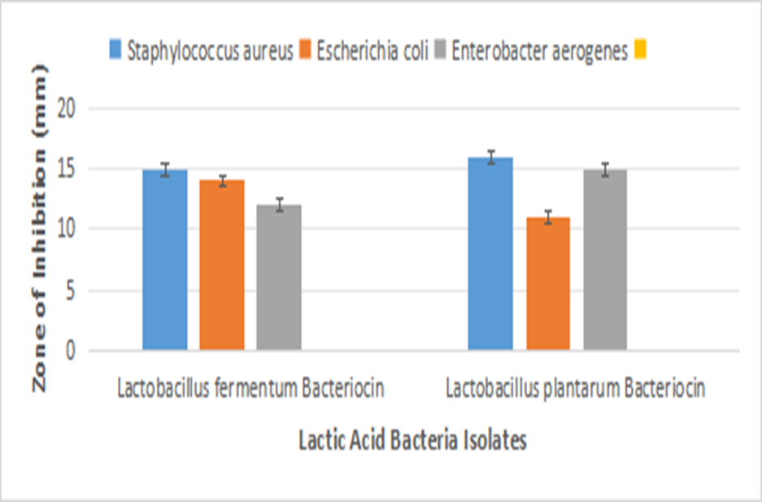
Figure 1. Antibacterial Assay of Purified Bacteriocins
3.3 Treatment of Abattoir Wastewater Inoculated with Isolated Bacteria with Bacteriocins
The effectiveness of the purified bacteriocins against isolated bacteria in abattoir wastewater was determined. Escherichia coli, Enterobacter aerogenes and Staphylococcus aureus were inoculated onto sterile abattoir wastewater (10⁵cfu/ml) and subsequently treated with purified Lactobacillus plantarum and Lactobacillus fermentum bacteriocins after four hours of inoculation using a bacteriocin concentration of 100µl. Total plate counts were enumerated at the start of the experiment and after several hours up to 24 hours. There was significant statistical decrease (P=0.05) in E.coli counts after 6 hours of Lactobacillus plantarum bacteriocin treatment. Two hours after the addition of Lactobacillus plantarum bacteriocin, there was a difference of 2.78 log cycles in the count of E. coli. After 4 hours of incubation the count was 5.68 cfu/ml (log10) while after 6 hours the count was 2.90 cfu/ml (log10). There was significant statistical decrease (P=.05) in Enterobacter aerogenes counts after 6 hours of Lactobacillus plantarum bacteriocin treatment. Two hours after addition of Lactobacillus plantarum bacteriocin, there was a difference of 2.54 log cycles in the count of Enterobacter aerogenes. After 4 hours of incubation the count was 5.48 cfu/ml (log10) while after 6 hours the count was 2.94 cfu/ml (log10). There was significant statistical decrease (P=.05) in Staphylococcus aureus counts after 6 hours of incubation. There was a difference of 3.48 log cycles in Staphylococcus aureus counts between the time of addition of the bacteriocin (after 4 hours of incubation) and after 6 hours of incubation. After 4 hours of incubation the count was 6.00 cfu/ml (log10) while after 6 hours the count was 2.52 cfu/ml (log10).
Lactobacillus fermentum bacteriocin treatment significantly reduced Escherichia coli, Enterobacter aerogenes and Staphylococcus aureus counts after 6 hours of incubation. There was a difference of 2.40 log cycles in Escherichia coli counts between the time of addition of the bacteriocin (after 4 hours of incubation) and after 6 hours of incubation. After 4 hours of incubation the count was 5.51 cfu/ml (log10) while after 6 hours the count was 3.11 cfu/ml (log10). There was a difference of 2.30 log cycles in Enterobacter aerogenes counts between the time of addition of the bacteriocin (after 4 hours of incubation) and after 6 hours of incubation. After 4 hours of incubation, the count was 5.31 cfu/ml (log10) while after 6 hours the count was 3.01 cfu/ml (log10). There was a difference of 2.97 log cycles in Staphylococcus aureus counts between the time of addition of the Lactobacillus fermentum bacteriocin (after 4 hours of incubation) and after 6 hours of incubation. After 4 hours of incubation, the count was 5.95 cfu/ml (log10) while after 6 hours the count was 2.98 cfu/ml (log10).
The combined use of the bacteriocins in a consortium for the treatment of isolated bacteria in sterile abattoir water showed a higher reduction in bacterial counts. There was a difference of 3.30 log cycles in Enterobacter aerogenes counts between the time of addition of the bacteriocin consortium (after 4 hours of incubation) and after 6 hours of incubation. After 4 hours of incubation the count was 5.31 cfu/ml (log10) while after 6 hours the count was 2.01 cfu/ml (log10). There was a difference of 3.35 log cycles in Escherichia coli counts between the time of addition of the bacteriocin consortium (after 4 hours of incubation) and after 6 hours of incubation. After 4 hours of incubation the count was 5.51 cfu/ml (log10) while after 6 hours the count was 2.16 cfu/ml (log10). There was a difference of 3.70 log cycles in Staphylococcus aureus counts between the time of addition of the bacteriocin consortium (after 4 hours of incubation) and after 6 hours of incubation. After 4 hours of incubation the count was 5.95 cfu/ml (log10) while after 6 hours the count was 2.25 cfu/ml (log10). These results are shown in figures
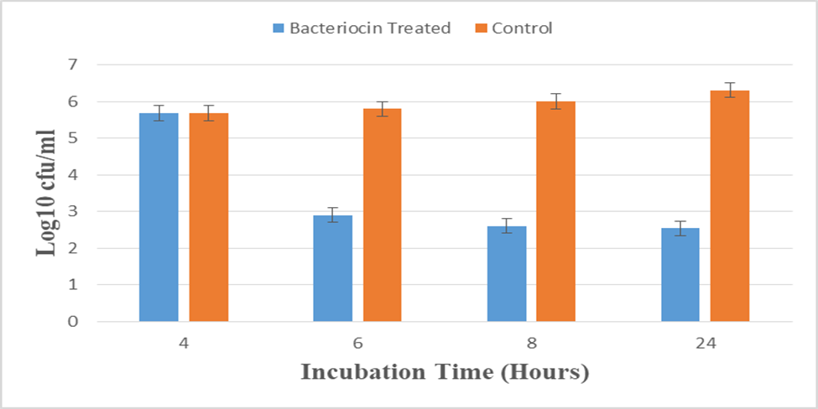
Figure 2. Treatment of Escherichia coli by Lactobacillus plantarum bacteriocin in Abattoir wastewater

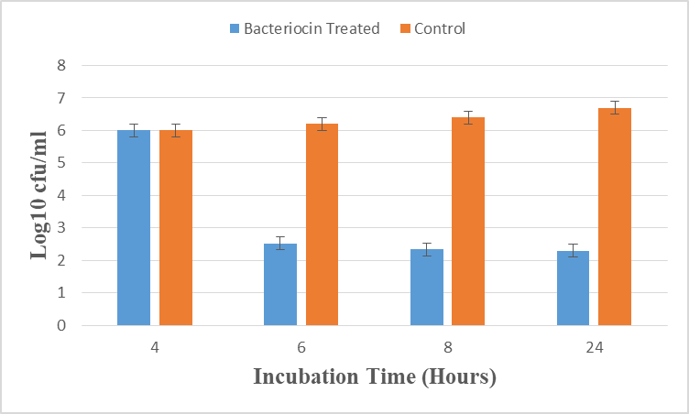
Figure 3. Treatment of Staphylococcus aureus by Lactobacillus plantarum bacteriocin in Abattoir wastewater.

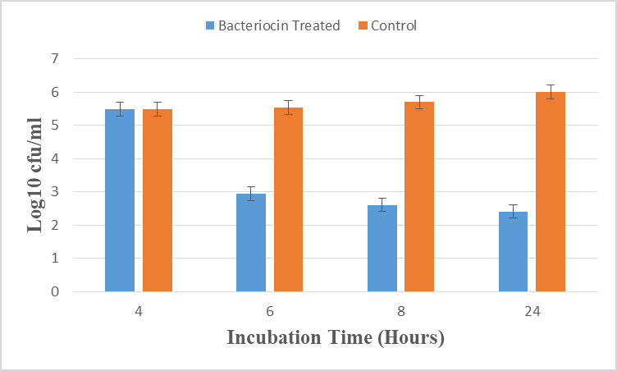
Figure 4 Treatment of Enterobacter aerogenes by Lactobacillus plantarum bacteriocin in Abattoir wastewater.

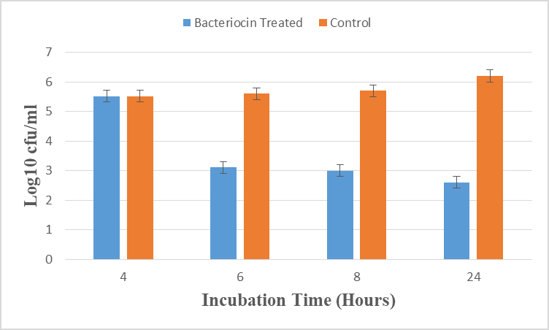
Figure 5. Treatment of Escherichia coli by Lactobacillus fermentum bacteriocin in Abattoir wastewater.

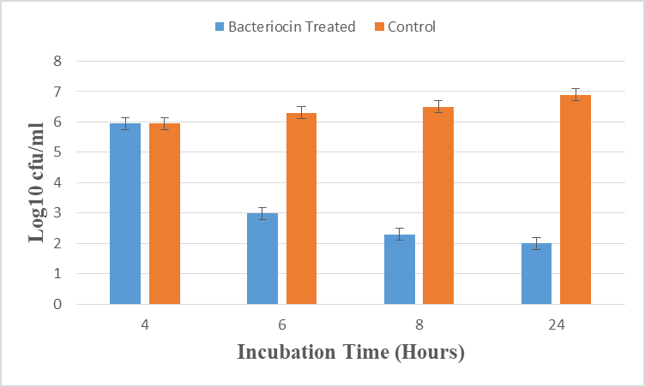
Figure 6. Treatment of Staphylococcus aureus by Lactobacillus fermentum bacteriocin in Abattoir wastewater.

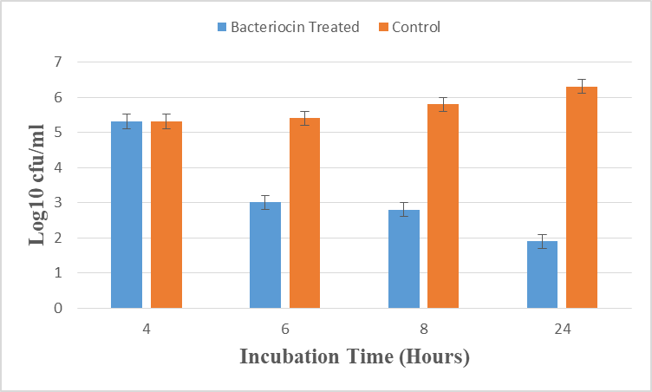
Figure 7. Treatment of Enterobacter aerogenes by Lactobacillus fermentum bacteriocin in Abattoir wastewater.

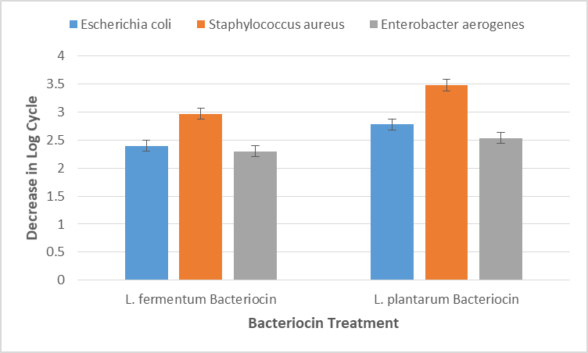
Figure 8. Comparative Reduction in Bacterial Counts of Wastewater Samples Treated with L.fermentum Bacteriocin and L. plantarum Bacteriocin After 2 Hours of Treatment.

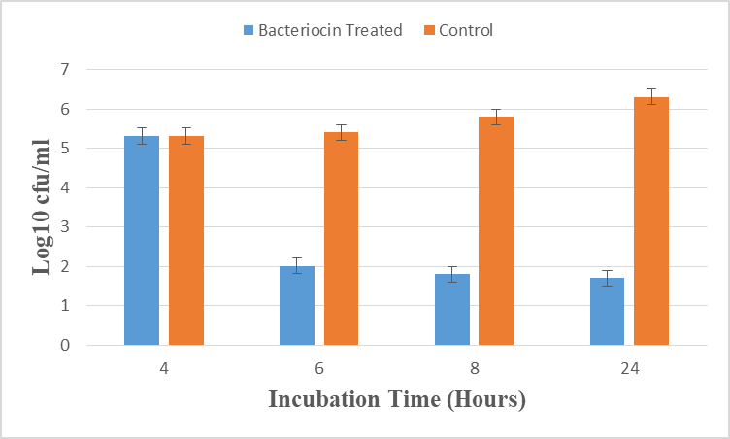
Figure 9. Treatment of Enterobacter aerogenenes in Abattoir Wastewater using Bacteriocin Consortium

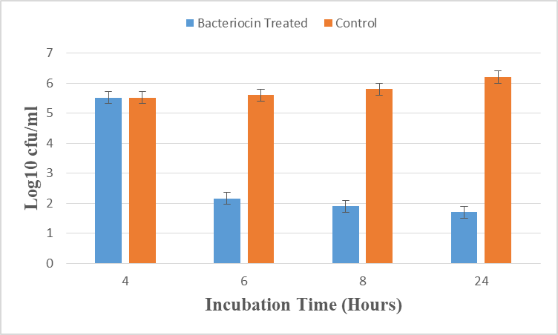
Figure 10. Treatment of Escherichia coli in Abattoir Wastewater using Bacteriocin Consortium

Figure 11. Treatment of Staphylococcus aureus in Abattoir Wastewater using Bacteriocin Consortium

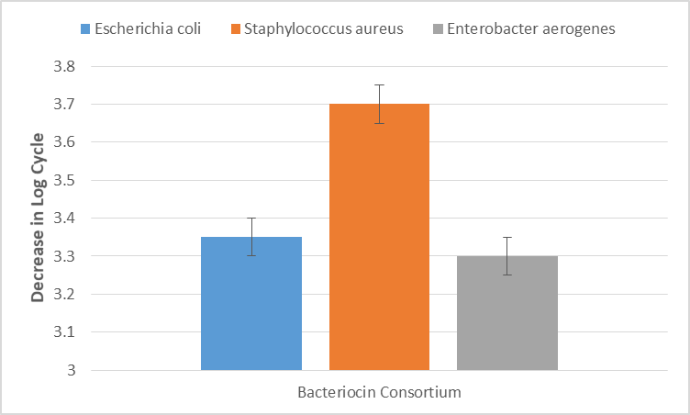
Figure 12. Comparative Decrease in Bacterial Counts in Abattoir Wastewater using Bacteriocin Consortium after Two Hours of Treatment

4. Conclusion

The study showed the presence of pathogenic bacteria in abattoir wastewater. The presence of these microorganisms presents a high risk of disease outbreaks and increased infections. The danger posed by these organisms to the nearby population is intensified by the increased resistance of pathogens to antibiotics. All these point to the need for effective wastewater management to limit the discharge of pathogens into the soil, water bodies and farmlands. Results of this research reveal that bacteriocins produced from lactic acid bacteria have the capacity to inhibit microbial growth. The bacteriocins significantly reduced bacterial counts in the abattoir wastewater. Bacteriocins could be incorporated into the biological stage of wastewater treatment. The applicability of these antimicrobial peptides in reducing pathogenic strains in abattoir wastewater should be further assessed, evaluated to determine its possibility. To achieve this, it is recommended that extra studies be carried out on the characterization of producer strains including their mechanisms of action and optimized conditions for optimum activity.

References

1. Yimana, M., & Hassen, A. (2024). Assessment of the operational facilities and hygienic practices of abattoirs and butcher shops in Ethiopia. Discover Food, 4, Article 88. https://doi.org/10.1007/s44187-024-00163-y
2. Malik, D. A. M. (2024). OPERATIONAL FACILITIES AND SANITARY PRACTICES IN ABATTOIR : A CASE STUDY OF HYDERABAD , PAKISTAN. Journal of Arts & Social Sciences, 11(2), 69-78. https://doi.org/10.46662/jass.v11i2.478

3. Ekpunobi, N. F., Adesanoye, S., Orababa, O., Adinnu, C., Okorie, C., & Akinsuyi, S. (2024). Public health perspective of public abattoirs in Nigeria, challenges and solutions. GSC Biological and Pharmaceutical Sciences, 26(2), 115–127. https://doi.org/10.30574/gscbps.2024.26.2.0527

4. Kalio, G. A., & Ali-Uchechukwu, A. (2020). Assessment of abattoirs operations and hygiene practices in Obio-Akpor Local Government Area, Rivers State, Nigeria. Nigerian Journal of Animal Production, 46(3), 73–81. https://doi.org/10.51791/njap.v46i3.858

5. Nwaoma, I. E., Okorie, E. A., Dike, C. C., Chinwemadu, N. M., Nwoko, S. O., & Ebele, A. H. (2025). Assessment of Sanitary Status and Practices in the Selected Abattoirs and Slaughter Houses in Anambra State, Nigeria. International Journal of Innovative Science and Research Technology, 10(3), 393-401. https://doi.org/10.38124/ijisrt/25mar201

6. Gutu, L., Basitere, M., Harding, T., Ikumi, D., Njoya, M., & Gaszynski, C. (2021). Multi-Integrated Systems for Treatment of Abattoir Wastewater: A Review. Water https://doi.org/10.3390/w13182462

7. Williams, Y., Basitere, M., Ntwampe, S. K. O., Ngongang, M., Njoya, M., & Kaskote, E. (2019). Application of response surface methodology to optimize the COD removal efficiency of an EGSB reactor treating poultry slaughterhouse wastewater. Water Practice & Technology, 14, 507–514. https://doi.org/10.2166/wpt.2019.032

8. Adamu, M., & Dahiru, M. (2020). A Review on Abattoir Wastewater Treatment for Environmental Health Improvement. Journal of Environmental Bioremediation and Toxicology, 3(2), 26–31. https://doi.org/10.54987/jebat.v3i2.548

9. Baker, B. R., Mohamed, R., Al-Gheethi, A. A., & Aziz, H. A. (2020). Advanced Technologies for Poultry Slaughterhouse Wastewater Treatment: A Systematic Review. Journal of Dispersion Science and Technology, 42(6), 880–899. https://doi.org/10.1080/01932691.2020.1721007

10. Duraisamy, S., Balakrishnan, S., Ranjith, S., Husain, F., Sathyan, A., Peter, A. S., Prahalathan, C., & Kumarasamy, A. (2020). Bacteriocin—a potential antimicrobial peptide towards disrupting and preventing biofilm formation in the clinical and environmental locales. Environmental Science and Pollution Research, 27(36), 44922–44936. https://doi.org/10.1007/s11356-020-10989-5

11. Whitman, W. B. (Ed.). (2022). Bergey’s manual of systematics of Archaea and Bacteria. John Wiley & Sons. https://doi.org/10.1002/9781118960608

12. Wang, W., Ma, H., Yu, H., Qin, G., Tan, Z., Wang, Y., & Pang, H. (2020). Screening of Lactobacillus plantarum Subsp. plantarum with Potential Probiotic Activities for Inhibiting ETEC K88 in Weaned Piglets. Molecules, 25(19), 4481. https://doi.org/10.3390/molecules25194481

13. Afrin, S., Hoque, M., Sarker, A., Satter, M., & Bhuiyan, M. (2021). Characterization and profiling of bacteriocin-like substances produced by lactic acid bacteria from cheese samples. Access Microbiology. https://doi.org/10.1099/acmi.0.000234
14. Lauková, A., Juris, P., Vasilková, Z., & Papajová, I. (2000). Treatment of sanitary-important bacteria by bacteriocin substance V24 in cattle dung water. Letters in Applied Microbiology, 30(5), 402–405. https://doi.org/10.1046/j.1472-765x.2000.00725.x
15. Idu, E. G., Omidele, B. O., Nwaubani, D. A., Okwara, C. O. A., & Okpanachi, V. U. (2023). Bacteriological Survey of Abattoir Wastewater in Aba, Abia State, Nigeria. Bioremediation Science and Technology Research, 11(1), 1–4. https://doi.org/10.54987/bstr.v11i1.793

16. Ijah, U. J. J., Musa, I. O., Amao, F., Maude, A. M., & Victor-Ekwebelem, M. O. (2022). Wastewater quality and unhygienic practices in Minna abattoir, North Central Nigeria. Science World Journal, 17(2). https://www.scienceworldjournal.org/archives/vol-17-no-2-2022.

