Drought-Adaptive Grouping of Black Pepper (Piper nigrum L.) Genotypes Using Hierarchical Clustering on Principal Components (HCPC)

ABSTRACT

Aims: Application of Hierarchical Clustering on Principal Components (HCPC) to identify drought-tolerant genotypes of black pepper (Piper nigrum L.) based on important morpho-physiological characteristics.
Study design: Field observation supported by multivariate statistical analysis (HCPC) for genotype classification.
Place and Duration of Study: The investigation was conducted across major black pepper-growing regions of Kerala, India, part of the Western Ghats. Trait measurements were performed during the peak summer drought period (March–May 2023) of the study year under in situ farmer-field conditions.
Methodology: In the present study, sixty-two black pepper genotypes were evaluated for various key morpho-physiological characteristics such as specific leaf area (SLA), relative water content (RWC), leaf thickness, stomatal density, epicuticular wax content, leaf area, leaf angle, leaf length, leaf width, petiole length, no. of nodes per lateral branch and lateral branch length. HCPC was employed to classify the genotypes into clusters. The pattern of genotype groupings was further visualized through factor maps (2D & 3D).
Results: HCPC classified the 62 genotypes into two significant clusters: Cluster 1, containing drought-resilient genotypes (e.g., G-38, G-61, G-25, G-36, G-50, G-56), showed significantly higher leaf thickness, wax deposition and RWC (v values: leaf thickness = 5.97; wax = 6.21; RWC = 6.20). Cluster 2, comprising drought-susceptible genotypes (e.g., G-60, G-1, G-12, G-55, G-27), exhibited higher SLA (v = 6.01) and stomatal density (v = 6.33). HCPC factor maps confirmed strong separation between clusters along Dim1 (34.9%) and Dim2 (24.6%).
Conclusion: HCPC effectively differentiated the drought-tolerant and drought-sensitive black pepper genotypes based on morpho-physiological adaptation. Leaf thickness, epicuticular wax and RWC showed the most positive indicators of drought tolerance, while high SLA and stomatal density were characteristic features of susceptibility. The identified drought-resilient genotypes can be used as promising candidates for climate-smart breeding and targeted conservation programs.

Keywords: Specific leaf area, epicuticular wax, germplasm conservation, genetic diversity, black pepper

1. INTRODUCTION

Black pepper (Piper nigrum L.) is a commercially and economically important spice crop cultivated widely in Kerala, India, where its productivity is increasingly threatened by drought stress during dry summer months (Anuradha, 2004). The plant is grown as a crop which prefers an average rainfall of 2000-3000 mm for its optimum growth (Gopakumar, 2011). Drought adversely affects physiological and morphological traits critical for growth, such as leaf water content, stomatal conductance, and photosynthetic efficiency, leading to significant yield reductions (Ferreira et al., 2024). Drought stress can lead to reduced growth, poor yield, and increased susceptibility to diseases (Kaur et al., 2020). Understanding and identifying drought-tolerant genotypes is crucial for targeted breeding programs to enhance resilience in the face of climate variability.
Drought tolerance in plant varieties can fluctuate depending on growth stages and environmental factors (Farooq et al., 2012). Previous studies have revealed considerable variability among black pepper genotypes in drought adaptive traits including leaf thickness, relative water content (RWC), stomatal density, and epicuticular wax deposition, which are physiological indicators of tolerance (Negi et al., 2021; Reshma et al., 2024). For instance, tolerant genotypes maintain higher RWC and exhibit biochemical and morphological adjustments such as osmotic regulation and antioxidant enzyme activity that mitigate drought effects (Anuradha, 2004; Ferreira et al., 2024). Moreover, multivariate statistical approaches have proven effective in classifying germplasm based on complex trait interactions relevant to drought response (Long et al., 2024; Theertha et al., 2025). Hierarchical clustering has been a powerful method for developing classification systems (Murtagh & Contreras, 2011). The Hierarchical Clustering on Principal Components (HCPC) method combines 3 main multivariate data analysis methodologies, namely PCA, hierarchical clustering, and K-means. PCA is used to reduce the dimensionality of data by extracting continuous variables encompassing the most significant information. The findings of the PCA are then subjected to cluster analysis as a noise removal phase, which ensures robust clustering (Husson et al., 2010; Maugeri et al., 2021).
This study aims to evaluate morphological and physiological traits of 62 black pepper genotypes during peak drought periods in situ from major growing regions of Kerala. We apply HCPC to identify distinct clusters of drought-resilient and susceptible genotypes, thus facilitating the selection of promising candidates for climate-smart breeding and conservation initiatives.
2. material and methods
Sixty‑two black pepper genotypes selected from major black pepper‑growing regions of Kerala, India, were evaluated under natural farmer‑field conditions during the peak summer drought period of March–May. Drought-related morpho-physiological traits were recorded on fully expanded, healthy mature leaves from representative vines in each genotype. Specific leaf area (SLA), relative water content (RWC), leaf thickness, stomatal density, epicuticular wax content, leaf area, leaf angle, leaf length, leaf width, petiole length and lateral branch length and number of nodes per lateral branch were recorded.
Through the application of multivariate analysis, such as hierarchical clustering on principal components (HCPC) using Ward's minimum-variance method, genotypes were classified into distinct groups based on their profiles of drought-adaptive traits. The combination of an initial dimensionality-reduction step with hierarchical clustering on the resulting components increases the discrimination of traits while reducing noise due to correlated variables. The partition obtained from this study was visualized through dendrograms and two- and three-dimensional factor maps showing the relative position and separation of genotypes in the reduced multivariate space.
Statistical tests within the HCPC framework allowed refinement of cluster characterization, identifying which traits contributed most to cluster discrimination and enabling the interpretation of trait complexes associated with drought resilience and susceptibility. A chord diagram was also constructed to show the strength and direction of associations between each HCPC‑derived cluster and the major discriminating traits. The optimal number of clusters was determined jointly from the dendrogram structure, by looking for marked jumps in fusion levels between successive nodes, and from the inertia criterion, by considering the gain in between-cluster inertia relative to total inertia. To assist visualization, genotypes were projected onto the principal dimensions, while cluster membership was superimposed to display group boundaries as a function of inter‑genotype distances.

3. results and discussion

Inertia statistics were employed to evaluate the quality of the HCPC partition (Table 1), following established applications of HCPC in biological datasets. The total sum of squares (Total SS = 632.23) represented the overall multivariate variability among genotypes in the PCA-reduced space, while the within- and between-cluster inertia components quantified cluster compactness and centroid separation, respectively. The resulting between-to-total inertia ratio of 0.33 indicated that approximately one third of the total variation was explained by differences between clusters, a proportion consistent with genotype clustering studies under abiotic stress and supportive of a biologically meaningful separation between drought-resilient and drought-susceptible groups. The use of inertia statistics in this manner aligns with clustering methodologies across diverse biological datasets, where partition quality is assessed through total, between- and within-cluster inertia and validated by visual inspection of cluster separation (Styka et al., 2025). As noted by Argüelles et al. (2014), the number of clusters can be guided by examining inertia gains, with higher inertia reflecting improved clustering performance; accordingly, the suggested cut-off based on inertia gain was applied, and the tree was automatically partitioned into three groups.

The HCPC separated the genotypes into two well-separated clusters (Figure 1), indicating a distinctive multivariate divergence in their drought response profiles. Cluster 1 (blue) included genotypes clustered at relatively low linkage distances, thereby showing greater internal resemblance in combinations of traits associated with drought adaptation. In contrast, Cluster 2 (yellow) grouped at higher linkage levels, implying a contrasting combination of traits that may further characterize drought susceptibility. In addition, similar studies have proven that drought-tolerant genotypes maintain better biomass, mineral status, or water-use efficiency under water deficit conditions (Chaturvedi et al., 2021), consistent with the traits observed in our tolerant cluster. The dendrogram showed that the studied black pepper genotypes from Cluster 1 possess morpho-physiological traits consistent with drought-resilient behaviour, such as thicker leaves, higher relative water content and greater epicuticular wax deposition. These traits were reported in earlier black pepper drought studies (Theertha et al., 2023; (Ferreira et al., 2024; Reshma et al., 2024). On the contrary, Cluster 2 genotypes form subgroups characterized by higher SLA and stomatal density, matching previously described drought-sensitive profiles in which expansive foliage and dense stomata predispose plants to greater transpiration water loss (Theertha et al., 2023; Reshma et al., 2024). HCPC has been advocated as a robust extension of PCA for deriving biologically meaningful clusters from complex trait datasets (Crossay et al., 2019; Koh et al., 2022). From a breeding and conservation perspective, the HCPC‑derived clusters provide a practical framework to prioritize genotypes for downstream evaluation and climate‑resilient cultivar development. Genotypes embedded deeply within Cluster 1 can be considered core candidates for drought‑resilient ideotypes since their consistent grouping implies stable combinations of adaptive traits under field drought conditions.
The HCPC analysis generated both a two dimensional factor map and a three dimensional representation of the hierarchical clustering in the reduced multivariate space (Figures 2 and 3). The factor map displayed two non overlapping clusters along Dim1 (34.9%), with Cluster 1 genotypes occupying negative scores and Cluster 2 positive scores, underscoring strong multivariate divergence in drought adaptive traits. The first two dimensions (Dim1 = 34.9%, Dim2 = 24.6%) jointly explained 59.5% of total trait variation, so genotypes positioned close together on the plot share similar morpho-physiological profiles, whereas those far apart are distinctly different. The use of PCA factor maps to visualise cluster separation, often supported by ellipse-based cluster validation, is a standard approach in biological datasets and reinforces the reliability of the observed separation (Vidal et al., 2024). Cluster 1 (blue polygon) occupied the negative side of Dim1, where most genotypes (e.g. G 38, G 50, G 56, G 61) were tightly grouped, indicating a homogeneous complex of traits associated with thicker leaves, higher RWC and enhanced wax deposition, in agreement with earlier reports on tolerant black pepper accessions (Prakash et al., 2024). Cluster 2 (yellow polygon) lay on the positive side of Dim1, with genotypes such as G 60, G 57, G 17 and G 27 more widely dispersed along Dim2, reflecting contrasting combinations of higher SLA and stomatal density characteristic of drought susceptible types. Evidence for effectiveness in trait-based classification of germplasm by HCPC also comes from a study by Marcos-Barbero et al. (2021) in wheat, where 60 genotypes were distinctly separated into three clusters based on yield and biomass attributes.

Cluster profiling based on HCPC identified five morpho-physiological variables that significantly discriminated between the two clusters: stomatal density, SLA, epicuticular wax content, RWC and leaf thickness (Table 2). All five traits showed highly significant v.test statistics (|v.test| ≥ 5.97, p < 0.001), indicating strong contributions to cluster separation, and their cluster means differed markedly from the overall population means. Cluster 1 was characterized by reduced stomatal density and SLA together with increased epicuticular wax, RWC and leaf thickness. Negative v.test values for stomatal density (-6.33) and SLA (-6.01) indicate substantially lower values of these traits, whereas positive v.test values for epicuticular wax (6.21), RWC (6.20) and leaf thickness (5.97) indicate thicker, more wax-covered leaves with superior water status. Such a constellation of traits is consistent with reduced transpiration water loss and better maintenance of tissue hydration mechanisms frequently linked to drought tolerance in black pepper and related species. However, Cluster 2 presented the opposite pattern, with higher stomatal density (v.test = 6.33) and SLA (v.test = 6.01) and lower epicuticular wax, RWC and leaf thickness (v.test < –5.97) than the overall means, indicating thinner, less protected leaves with greater stomatal abundance and increased evaporative demand under moisture deficit. The near‑symmetric v.test values between clusters highlight the fact that the same set of characteristics underpins both the tolerant and susceptible syndromes of drought, but with the effect reversed. The role of epicuticular wax in modulating drought tolerance has also been emphasized in other crops. In wheat, high-wax mutants exhibited markedly reduced water loss, enhanced antioxidant protection and lower oxidative damage under drought stress (Wen et al., 2025). Faba bean studies showing wide, genetically controlled variation in epicuticular wax independent of stomatal traits align with our findings, where wax content and stomatal density contributed separately to drought-response differentiation (Khazaei et al., 2019). Studies comparing plants with contrasting stomatal densities show that individuals with fewer stomata reduce transpiration more effectively, conserve soil moisture and exhibit markedly higher drought tolerance (Hepworth et al., 2015). Studies in Leymus chinensis show that stomatal density changes with water availability, rising under moderate stress but declining under severe drought, and is closely linked to stomatal conductance, photosynthesis and water use efficiency. A negative relationship with SLA was also observed (Xu & Zhou, 2008). These patterns support our findings that variation in stomatal density and SLA contributes significantly to drought response differences among black pepper genotypes. The relationships between key traits and clusters were further elucidated by the chord diagram, Figure 4, in order to visualize the relative strength of each trait-cluster association. Thick ribbons linked epicuticular wax, leaf thickness and RWC to Cluster 1, while SLA and stomatal density dominated Cluster 2, confirming that structural and water-status traits underpin the tolerant group and expansive, highly stomatous leaves characterize the susceptible genotypes. This graphical summary is consistent with the HCPC v.test statistics and with previous morpho‑physiological studies of black pepper drought responses.

Table 1. Inertia statistics for HCPC partition of 62 black pepper genotypes

Metric | Value
Within-Cluster Sum of Squares (Within SS)  Between-Cluster Sum of Squares (Between_SS)  Between / Total Ratio | 632.23  421.38  210.85  0.33

Table 2. Key morpho physiological traits discriminating HCPC clusters in black pepper genotypes

Cluster | Variable | v.test | Mean in  category | Overall  mean | SD in  Category | Overall  SD | p.value
1 | Stomatal density (mm⁻²) | -6.33 | 33.97 | 49.56 | 13.18 | 25.05 | 0.00
1 | Epicuticular wax (mg10cm⁻²) | 6.21 | 0.47 | 0.39 | 0.09 | 0.14 | 0.00
1 | Relative water content (%) | 6.20 | 91.53 | 89.90 | 1.25 | 2.68 | 0.00
1 | specific leaf area (cm²g⁻¹) | -6.01 | 134.95 | 180.99 | 44.19 | 77.87 | 0.00
1 | Leaf thickness (mm) | 5.97 | 0.47 | 0.39 | 0.10 | 0.14 | 0.00
2 | Stomatal density (mm⁻²) | 6.33 | 76.01 | 49.56 | 16.90 | 25.05 | 0.00
2 | Epicuticular wax (mg10cm⁻²) | -6.21 | 0.24 | 0.39 | 0.08 | 0.14 | 0.00
2 | Relative water content (%) | -6.20 | 87.13 | 89.90 | 2.12 | 2.68 | 0.00
2 | specific leaf area (cm²g⁻¹) | 6.01 | 259.05 | 180.99 | 57.82 | 77.87 | 0.00
2 | Leaf thickness (mm) | -5.97 | 0.25 | 0.39 | 0.07 | 0.14 | 0.00

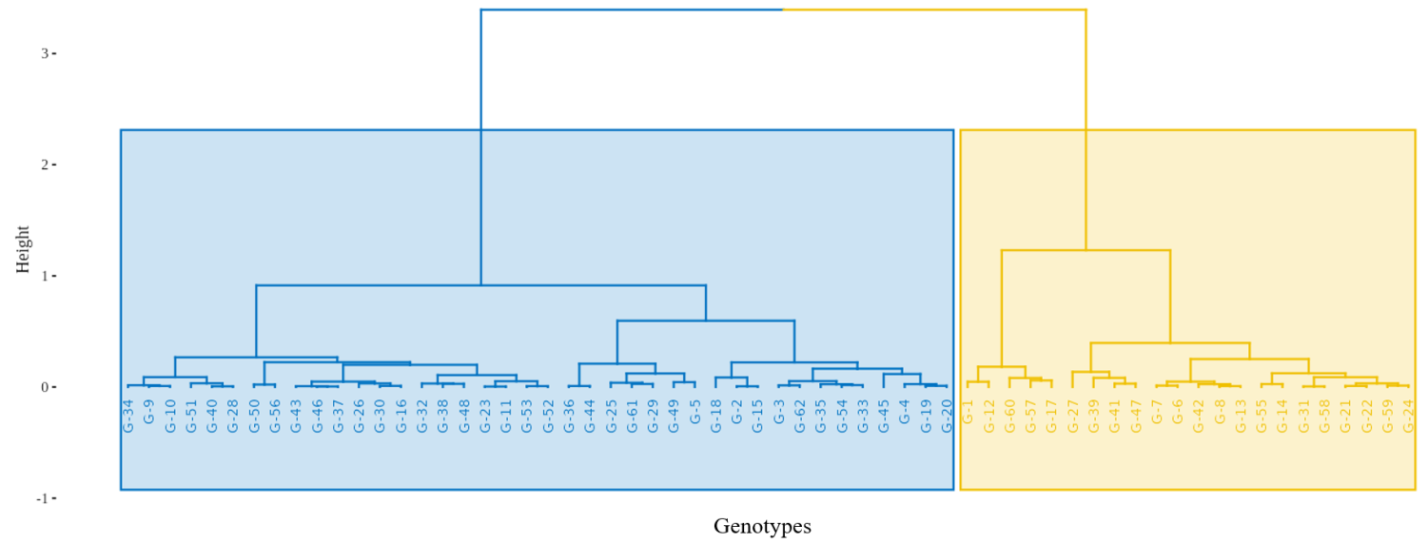

Fig. 1. Hierarchical clustering on principal components showing the grouping of black pepper genotypes based on multivariate trait patterns

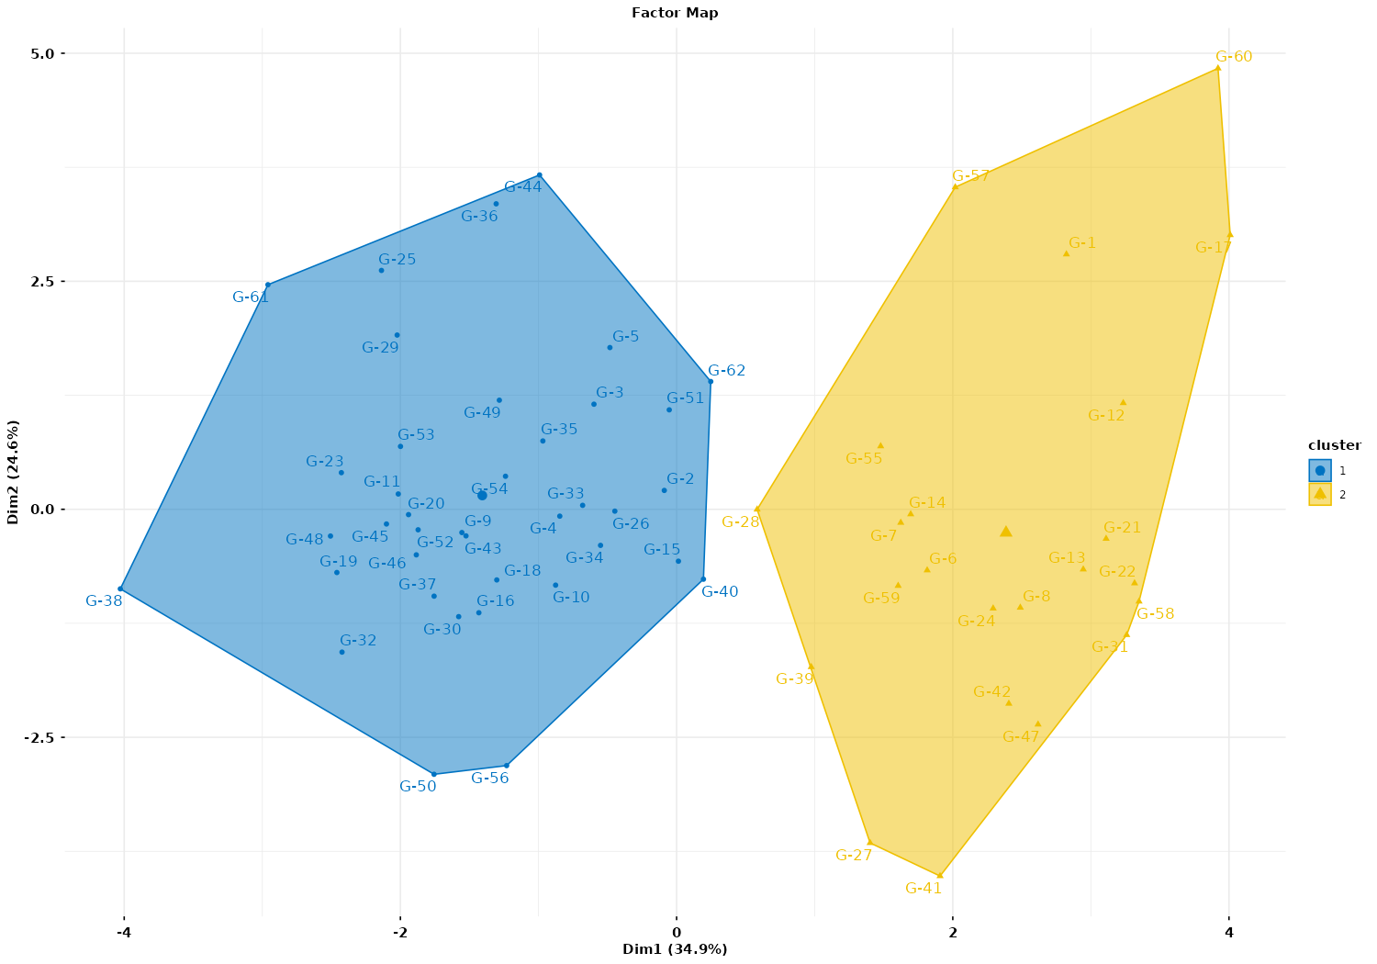

Fig. 2. Two-dimensional HCPC factor map showing the distribution of black pepper genotypes along the first two principal components
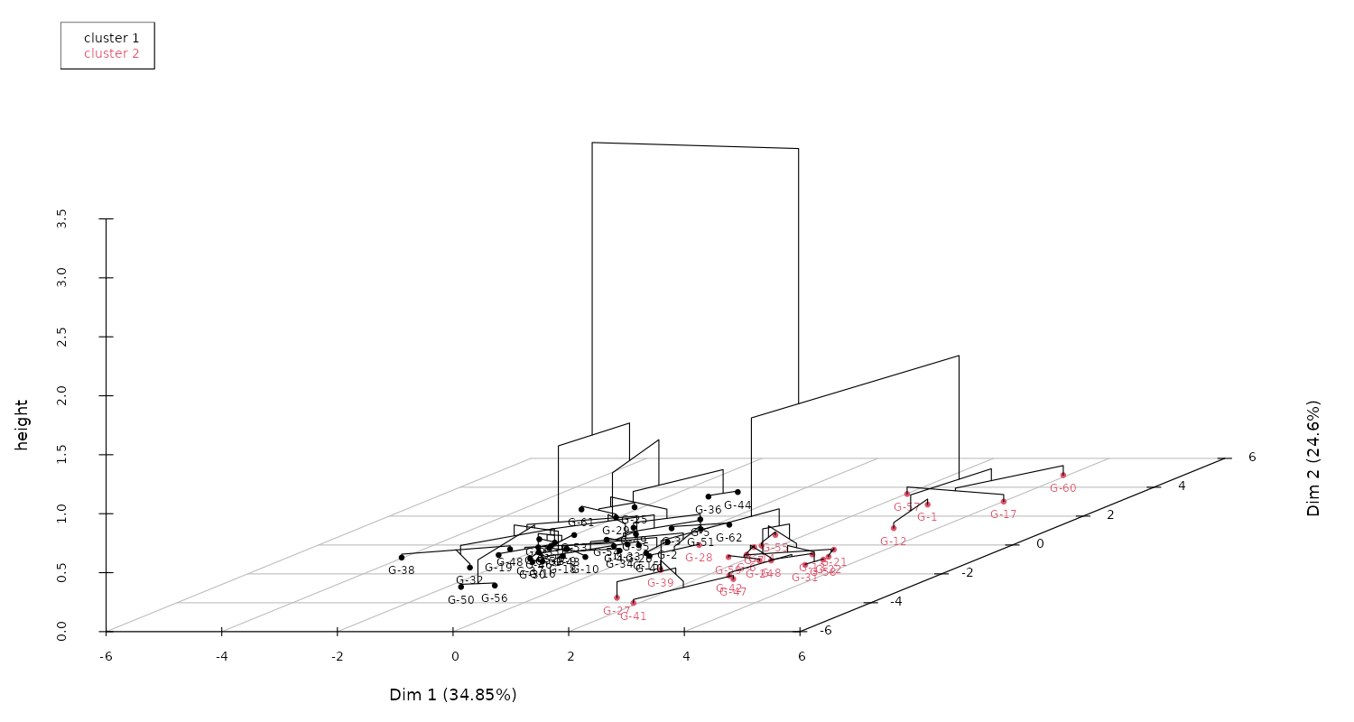
Fig. 3. Three-dimensional HCPC factor map showing the distribution of black pepper genotypes along the first two principal components

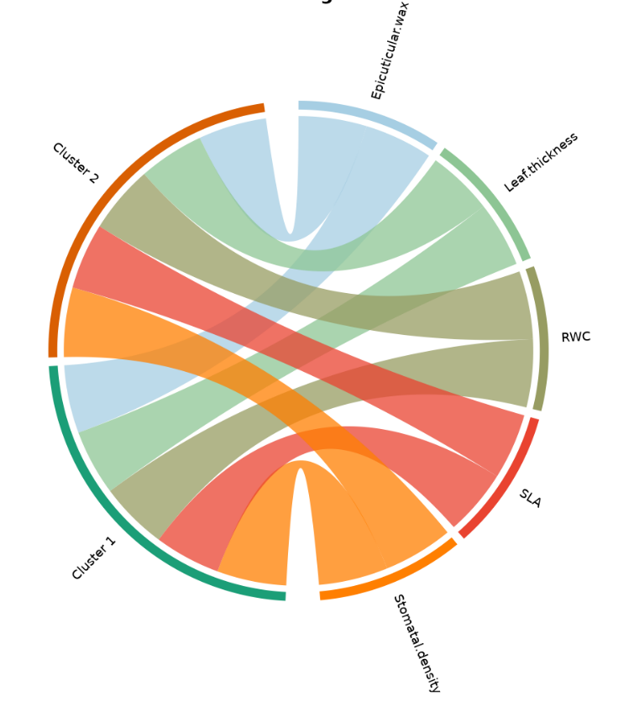
Fig. 4. Chord diagram illustrating the association between key morpho-physiological traits and the two HCPC-derived clusters

4. Conclusion

The HCPC analysis provided a clear and statistically robust delineation of drought resilient and drought susceptible black pepper genotypes, with inertia statistics demonstrating a stable and biologically meaningful partitioning of the germplasm. The distinct separation of clusters within the PCA factor map further substantiated the multivariate structure. Cluster differentiation was driven primarily by five traits: stomatal density, specific leaf area, epicuticular wax content, relative water content and leaf thickness. Genotypes aggregated within Cluster 1 expressed a coherent set of adaptive characteristics associated with reduced transpirational water loss and improved maintenance of tissue hydration. These findings are consistent with established drought tolerance mechanisms in black pepper and other crop species, particularly those involving wax deposition, leaf structural modifications and stomatal regulation. Collectively, the HCPC outcomes provide a rigorous framework for identifying drought tolerant genotypes and offer valuable guidance for the selection of superior candidates in climate resilient black pepper breeding and conservation programs.

References
Anuradha, Y. (2004). Improvement of black pepper (Piper nigrum L.) through induction of stress tolerance in vitro (Ph.D. thesis). Calicut University, Kerala. https://hdl.handle.net/20.500.12818/2760
Ayala, A., Muñoz, M. F., & Argüelles, S. (2014). Lipid peroxidation: Production, metabolism, and signaling mechanisms of malondialdehyde and 4-hydroxy-2-nonenal. Oxidative Medicine and Cellular Longevity. https://doi.org/10.1155/2014/360438
Beers, M. H., Porter, R. S., Jones, T. V., Kaplan, J. L., & Berkwits, M. (Eds.). (2006). The Merck manual of diagnosis and therapy (18th ed.). Merck Research Laboratories. https://www.merckmanuals.com/
Chaturvedi, R. K., Tripathi, A., Raghubanshi, A. S., & Singh, J. S. (2021). Functional traits indicate a continuum of tree drought strategies across a soil water availability gradient in a tropical dry forest. Forest Ecology and Management, 482, 118740. https://doi.org/10.1016/J.FORECO.2020.118740
Crossay, T., Majorel, C., Redecker, D., Gensous, S., Medevielle, V., Durrieu, G., Cavaloc, Y., & Amir, H. (2019). Is a mixture of arbuscular mycorrhizal fungi better for plant growth than single-species inoculants? Mycorrhiza. https://doi.org/10.1007/s00572-019-00898-y
Farooq, M., Hussain, M., Wahid, A., & Siddique, K. H. M. (2012). Drought stress in plants: An overview. In R. Aroca (Ed.), Plant responses to drought stress: From morphological to molecular features (pp. 1-33). Springer. https://doi.org/10.1007/978-3-642-32653-0_1
Ferreira, T. R., Sallin, V. P., Cerri Neto, B., Crasque, J., Pires, A., Rodrigues, P. S., Chisté, H., Lima, A. B. P., Machado Filho, J. A., Arantes, L. O., Lira, J. M. S., Falqueto, A. R., & Dousseau-Arantes, S. (2024). Morphophysiological responses of black pepper to recurrent water deficit. Photosynthetica, 62(3), 292-301. https://doi.org/10.32615/ps.2024.030
Gopakumar, C. S. (2011). Impacts of climate variability on agriculture in Kerala (Ph.D. thesis). Cochin University of Science and Technology. https://dyuthi.cusat.ac.in/xmlui/bitstream/handle/purl/2940/Dyuthi-T0931.pdf;sequence=1
Hepworth, C., Doheny-Adams, T., Hunt, L., Cameron, D. D., & Gray, J. E. (2015). Manipulating stomatal density enhances drought tolerance without deleterious effect on nutrient uptake. New Phytologist, 208(2), 336-341. https://doi.org/10.1111/nph.13598
Husson, F., Josse, J., & Pagès, J. (2010). Principal component methods - hierarchical clustering - partitional clustering: why would we need to choose for visualizing data. Applied Mathematics Department. http://www.sthda.com/english/upload/hcpc_husson_josse.pdf
Kaur, G., Singh, G., Motavalli, P. P., Nelson, K. A., Orlowski, J. M., & Golden, B. R. (2020). Impacts and management strategies for crop production in waterlogged or flooded soils: A review. Agronomy Journal, 112(3), 1475–1501. https://doi.org/10.1002/agj2.20093
Khazaei, H., Santanen, A., Street, K., & Stoddard, F. L. (2019). Genotypic variation in leaf epicuticular wax quantity in a large faba bean (Vicia faba L.) germplasm collection. Plant Genetic Resources, 17(3), 298–300. https://doi.org/10.1017/S1479262118000461
Koh, K. Y., Ahmad, S., Lee, J. I., Suh, G. H., & Lee, C. M. (2022). Hierarchical clustering on principal components analysis to detect clusters of highly pathogenic avian influenza subtype H5N6 epidemic across South Korean poultry farms. Symmetry, 14(3), 598. https://doi.org/10.3390/sym14030598
Long, N. V., Phommalueza, D., Minh, L. N., Phan, T. H. N., Ha, C. D., & Van, L. N. (2024). The effects of water regimes on morphological and physiological traits of black pepper (Piper nigrum). Journal of Ecological Engineering, 25(11), 327–334. https://doi.org/10.12911/22998993/193409
Marcos-Barbero, E. L., Pérez, P., Martínez-Carrasco, R., Arellano, J. B., & Morcuende, R. (2021). Screening for higher grain yield and biomass among sixty bread wheat genotypes grown under elevated CO2 and high-temperature conditions. Plants, 10(8), 1596. https://doi.org/10.3390/plants10081596
Maugeri, A., Barchitta, M., Basile, G., & Agodi, A. (2021). Applying a hierarchical clustering on principal components approach to identify different patterns of the SARS-CoV-2 epidemic across Italian regions. Scientific Reports, 11, 7082. https://doi.org/10.1038/s41598-021-86703-3
Murtagh, F., & Contreras, P. (2011). Methods of Hierarchical Clustering. arXiv. https://doi.org/10.48550/arXiv.1105.0121
Negi, A., George Kokkat, J., Jasrotia, R. S., Madhavan, S., Jaiswal, S., Angadi, U. B., Iquebal, M. A., Rai, A., & Kumar, D. (2021). Drought responsiveness in black pepper (Piper nigrum L.): Genes associated and development of a web-genomic resource. Physiologia Plantarum, 172(2), 669–683. https://doi.org/10.1111/ppl.13308
Prakash, K. M., Joseph, J., Santhoshkumar, A. V., Saji, K. V., Puthiamadom, N., & Ramachandran, A. (2023). Drought response of biotic-stress tolerant accessions of black pepper (Piper nigrum L.). Journal of Tropical Agriculture, 61(2), 189–195. https://journaloftropicalagriculture.in/index.php/jta/issue/view/61
Rang, H. P., Dale, M. M., Ritter, J. M., & Moore, P. K. (2003). Pharmacology (5th ed.). Churchill Livingstone.
Reshma, P., Sreekala, G. S., Deepa, S. N., & Roy, S. (2024). Genetic diversity assessment of black pepper (Piper nigrum L.) cultivars of Western Ghats. Plant Science Today, 12(3). https://doi.org/10.14719/pst.4816
Saha, M., Adams, M. L., & Nelson, S. C. (2009). Review of digit fusion in the mouse embryo. Journal of Embryology and Experimental Morphology, 49(3), (In press).
Styka, B., Ręka, G., Ozygała, A., Janiszewska, M., Stelmach, M., Skowera, P., Urbańska, Z., & Lejman, M. (2025). Loss of heterozygosity in pediatric acute lymphoblastic leukemia and its prognostic impact: A retrospective study. Cancers, 17(15), 2500. https://doi.org/10.3390/cancers17152500
Theertha, A. P., Shivakumar, M. S., & Krishnamurthy, K. S. (2023). Genetic variability analysis in elite black pepper genotypes using morpho-physiological and yield-attributing traits. Journal of Spices and Aromatic Crops, 32(2), 107–119. https://doi.org/10.25081/josac.2023.v32.i2.8742
Theertha, A. P., & Krishnamurthy, K. S. (2025). Gene expression under different soil moisture regimes and its correlation with physiological parameters in black pepper (Piper nigrum L.) genotypes. South African Journal of Botany, 187, 134–144.
Vidal, A. K. F., Daher, R. F., Freitas, R. S., Santana, J. G. S., Stida, W. F., Ambrósio, M., Silva, V. B., Souza, A. G., Nascimento, M. R., Santos, R. M., Leite, C. L., & Farias, J. E. C. (2024). Genetic diversity based on multivariate techniques in elephant grass genotypes for bioenergy. Brazilian Journal of Biology, 84, e278601. https://doi.org/10.1590/1519-6984.278601
Wen, H., Meng, X., Shan, H., Wang, Y., Wang, S., Zhang, M., Fan, H., Zheng, J., Yang, B., & Zhang, J. (2025). Integrated lipidomics and physiological analyses reveal the critical role of leaf sheath wax remodeling in wheat (Triticum aestivum L.) drought resistance. BMC Plant Biology, 25(1), 1657. https://doi.org/10.1186/s12870-025-07697-y
Xu, Z., & Zhou, G. (2008). Responses of leaf stomatal density to water status and its relationship with photosynthesis in a grass. Journal of Experimental Botany, 59(12), 3317–3325. https://doi.org/10.1093/jxb/ern185

