Journal Name: | Journal of Advance s in Biology & Biote chnology
Manuscript Number: | Ms_JABB_149221
Title of the Manuscript: | STUDIES ON GENETIC DIVERSITY FOR YIELD AND YIELD ATTRIBUTING TRAITS IN ADBANCED LINES OF RICE (Oryza sativa L.)
Type of the Article | Original Research Article

PART 1: Comments

 | Reviewer’s comment  Artificial Intelligence (AI) generated or assis ted review comments are s trictly prohibited during peer review. | Author’s Feedback (It is mandatory that authors should write his/her  feedback here)
Please write a few s entences regarding the importance  of this manuscript for the s cientific community. A minimum of 3-4 s entences may be required for this part. | The s ubject of the study pres ented by the authors is interesting and topical, with s cientific and practical importance.
Is the title of the article s uitable?  (If not please s ugges t an alternative title) | The title of the article is appropriate, in relation to the topic address ed .
Is the abs tract of the article comprehensive? Do you  s ugges t the addition (or deletion) of s ome points in this section? Please write your s ugges tions here. | The article Abs tract is comprehens ive and the keywords are representative of the article topic .
Is the manus cript scientifically, correct? Pleas e write  here. | The s ubsections and s tructure of the manuscript are appropriate, in accordance with the General Guideline for  Authors , Journal of Advances in Biology & Biotechnology . Scientifically, the article has a correct approach.  Dis cuss ion of the results in relation to other s tudies in the field is recommended
Are the references s ufficient and recent? If you have  s ugges tions of additional references , please mention them in the review form. | The s cientific literature, to which the reporting was made, is recent and representative in the field.

Is the language/English quality of the article s uitable  for scholarly communications ? | The English language and the quality of the article are suitable for academic co mmunications , and the article is access ible to readers .
Optional/General comments | 1.  Family Name  “Poaceae” instead of “poaceae”  2.  The introduction could be more extens ive.  3.  It is recommended to see the s ymbol for the cluster number. There are different symbols .  Example in print s crees from the document  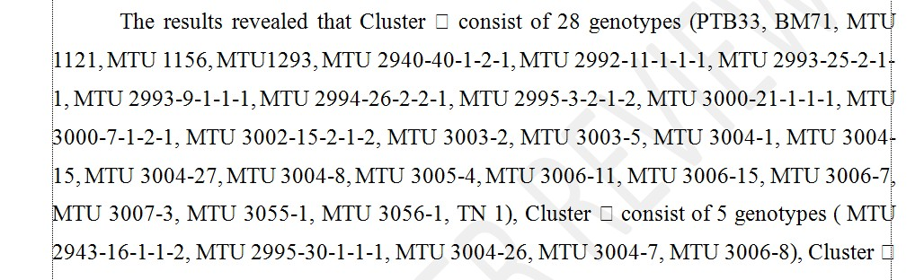  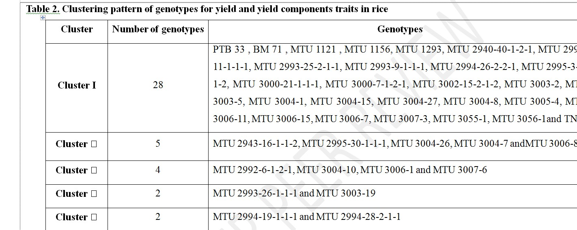  It is recommended to check the entire article.  4.  Dis cuss ion of the results in relation to other s tudies in the field is recommended.  5.  It is recommended to check the bibliographic s ources in the References chapter against the original source for  accuracy.  The s ubject of the study is interesting and topical, with high scientific and practical importance. The introduction is pres ented correctly, in accordance with the subject.  Methodology of the s tudy was clearly pres ented, and appropriat e to the proposed objectives .  The obtained res ults are important and have been analyzed and interpreted correctly, in accordance with the current methodology.  Dis cuss ion of the results in relation to other s tudies in the field is recommended.  The s cientific literature, to which the reporting was made, is recent and representative in the field.

Created by: DR Checked by: PM Approved by: MBM Version: 3 (07-07-2024)

PART 2:

 | Reviewer’s comment | Author’s Feedback (It is mandatory that authors should write his/her feedback here)
Are there ethical issues in this manuscript? | (If yes, Kindly please write down the ethical issues here in details)

Reviewer details:

Florin SALA, Univers ity of Life Sciences “King Mihai I” from Timis oara, ROMANIA

