Original Research Article
Cross-Tolerance and Stress Memory in Rice: Evaluating Drought-Tolerant Genotypes for Salinity Tolerance and Priming Effects

Abstract
Rice, the staple food for over half the world’s population, is particularly vulnerable to drought and salinity—two stresses that often overlap and trigger similar physiological challenges. Salinity, in fact, creates a “physiological drought,” making it a valuable proxy for studying drought resilience. Salinity stress severely limits rice productivity, with responses varying by growth stage and genotype. This study examined stress memory and cross-tolerance mechanisms in four rice genotypes exposed to either a single reproductive-stage stress (T3) or repeated stress across the vegetative-reproductive stages (T4). T3 plants maintained superior morphological traits (height 105.3 vs. 93.4 cm; tillers 17.33 vs. 14.33), while T4 plants accumulated enhanced biochemical defenses (protein: 70.72 vs. 66.39 µg/50 µl; POX: 39.43 vs. 33.32 µg/min/mg; proline: 306.49 vs. 166.31 mg/100 g; flavonoids: 281.05 vs. 217.19 mg/100 g). Despite morphological disadvantages, T4 plants yielded marginally higher grain (Dhaksha: 4.01 vs. 3.12 g), demonstrating that stress memory-mediated biochemical preparedness outweighs vegetative vigour in reproductive-stage tolerance. Drought-tolerant genotypes Dhaksha and GEN_214 substantially outperformed susceptible genotypes across all parameters, revealing cross-tolerance linking drought and salinity pathways. Dhaksha showed the highest water retention (65.90%), protein (84.72 µg/50 µl), and proline (398.47 mg/100 g). However, both treatments caused >82% yield loss, indicating reproductive vulnerability transcends priming protection. Cross-tolerance between drought and salinity tolerance mechanisms was mediated by shared osmolyte biosynthesis and antioxidant defense. This study demonstrates that salinity screening is not only useful for identifying salt-tolerant rice but also a powerful surrogate for breeding drought-resilient cultivars in the face of climate change.
Keywords: Salinity tolerance, stress priming, stress memory

- Introduction
Abiotic stresses such as drought and salinity represent pressing challenges to global agriculture, significantly curbing crop productivity and undermining food security. Rice (Oryza sativa L.), the staple food for over half the world's population, is particularly vulnerable to both stresses, especially in arid, semi-arid, and coastal areas where salinisation and water scarcity co-occur (IRRI, 2025). Remarkably, salinity often induces a condition akin to physiological drought, where osmotic imbalance caused by high salt concentrations limits water uptake. As a result, plants under both stresses exhibit overlapping adaptive responses: stomatal closure to conserve water, accumulation of compatible solutes such as proline for osmotic adjustment, and activation of antioxidant systems to mitigate reactive oxygen species (ROS) damage (Li et al., 2024; Zhu et al., 2022).
At the biochemical level, recent reviews have detailed shared mechanisms in rice’s responses to salt and drought stresses. Similarly, the antioxidant machinery (e.g., SOD, POX) and osmolyte synthesis pathways (e.g., proline) highlight the convergence between salinity and drought tolerance (Li et al., 2024; Zhu et al., 2022). Li et al. (2024) further emphasised that ion homeostasis, osmotic regulation, antioxidant defences, and signal transduction pathways collectively enable rice to cope with both stresses.
Moreover, the phenomenon of stress priming, i.e., pre-exposure of plants to stress, has been demonstrated to effectively confer plant resistance to later severe stress episodes (Bruce et al., 2007; Pastor et al., 2012). It is widely accepted that plants can develop a type of "stress memory,” which is defined as the ability of plants subjected to a first exposure to stress to store this information so that they can respond with higher degree of tolerance when they are again challenged, often triggering an improved more efficient and/or faster response (Avramova, 2015, Crisp et al., 2016; Fleta-Soriano and Munné-Bosch, 2015).
These insights have been practically harnessed in breeding programs. As a result, breeding salt-tolerant rice varieties such as water-saving and drought-resistant rice (WDR) has emerged as a promising strategy to improve resilience under both salinity and drought stresses, owing to shared genetic and physiological traits like robust root architecture and efficient stress signalling pathways (Zhang et al., 2023).
This study attempts to understand whether drought-tolerant rice genotypes, viz., Dhaksha, GEN_RIC_214, also exhibit salinity stress tolerance and whether exposure to one round of salinity stress induces priming for subsequent stress encountered.
To accomplish this, physiological and biochemical parameters were recorded at multiple time points across vegetative and reproductive stages. This integrative approach aims to elucidate the shared mechanisms of salinity and drought tolerance, informing more efficient breeding strategies for climate-resilient rice. The practical implications of research on cross-tolerance and stress memory are substantial for crop improvement programs. If drought-tolerant genotypes can be confirmed to also possess salinity tolerance, breeding programs could more efficiently develop varieties suitable for multiple stress environments. Furthermore, if priming treatments can be developed that enhance stress tolerance without yield penalties, these could be implemented as agronomic practices to precondition crops for anticipated stress periods. Thus, this integrative approach aims to elucidate the shared mechanisms of salinity and drought tolerance, informing more efficient breeding strategies for climate-resilient rice.
2. Materials and Methods
2.1 Plant material and stress treatment
An experiment was conducted in the greenhouse at the Department of Plant Biotechnology, University of Agricultural Sciences, GKVK, Bangalore (13°05′N, 77°34′E), to assess acquired tolerance and priming mechanisms in rice under salinity stress. Four contrasting rice genotypes, previously characterised for their drought response, namely the drought-tolerant Dhaksha and GEN_RIC_214 and the drought-susceptible GEN_RIC_790 and GEN_RIC_85, were selected for evaluation under four treatments with three replications. Seeds were sown in 30 × 30 cm pots containing 13 kg of a soil: FYM mixture (1:1).
2.1.1 Salinity Imposition Protocol
Salinity stress was applied gradually by irrigating pots with 500 ml NaCl solution, starting at 5 mM L⁻¹ and increasing every two days to 10, 20, 30, 40, and 50 mM L⁻¹ (Fig. 1). Stress was maintained at 50 mM L⁻¹ for 10 days, after which plants were irrigated to field capacity to allow salt leaching and recovery. Four treatments were taken up, namely control, gradual stress during the vegetative stage, gradual stress during the reproductive stage, and gradual stress at both vegetative as well as reproductive stages to study the effect of salinity stress during primed and non-primed conditions (Fig. 2).
Leaf samples were collected at three time points: before stress imposition, seven days after stress imposition, and seven days after recovery. These samples were analysed for physiological and biochemical traits to capture differences between primed and non-primed responses.

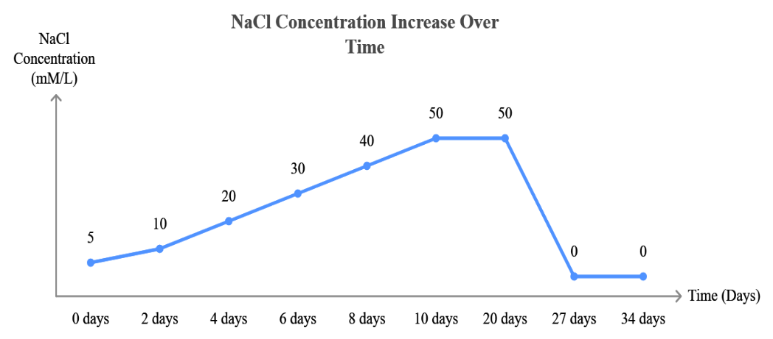

Fig. 1: Representation of salinity stress protocol, arrows indicating the point at which samples were collected from the treatments.

2.2 Observations recorded
The following observations were recorded from each treatment at different time points, viz., before, during, and after inducing salinity stress to understand acquired tolerance and priming mechanisms.
2.2.1 Morphological Traits
Plant height (PH) was measured at 35 DAS, 70 DAS, and harvest from the soil surface to the tallest leaf blade, flag leaf, or panicle tip. The total number of tillers (NT) and productive tillers (with visible panicle initiation) was counted at the same time points. Seed yield per plant was determined after threshing and cleaning the grains, and 100-seed weight was recorded in grams.
2.2.2 Physiological Traits
Relative water content (RWC) was estimated according to Barrs and Weatherly (1962) using fresh (FM), turgid (TM), and dry weights (DM) of leaf discs. The relative water content (RWC) of a plant tissue was expressed by
$$Relative water content (RWC \%)=\frac{FM-DM}{TM-DM} x 10$$
2.2.3 Biochemical Parameters
Protein extraction: Fresh leaves were homogenised in phosphate buffer with PMSF and PVP, centrifuged, and the supernatant was used for assays. Protein concentration was estimated by the Lowry method (1951).
Defense enzymes: Peroxidase (POX): Activity was assayed spectrophotometrically at 470 nm (Castillo et al., 1984). Isoenzyme profiles were visualised using native PAGE (Davis, 1964). Superoxide dismutase (SOD): Activity was measured based on inhibition of NBT reduction at 560 nm (Dhindsa et al., 1981), and isoenzymes were resolved via native PAGE.
Phenolics and flavonoids: Leaf extracts in 80% ethanol were used. Total phenolics were estimated by the Folin-Ciocalteu method (Bray and Thrope, 1954) and expressed as mg gallic acid equivalents (GAE). Flavonoids were quantified using the aluminium chloride colourimetric method (Woisky and Salatino, 1988) and expressed as mg Rutin equivalents (RE).
Proline: Extracted with ethanol (Cross et al., 2006) and quantified using the ninhydrin-based method of Carillo and Gibon (2011).
2.3 Statistical analysis
The pot experiment was conducted using a factorial completely randomised design (CRD) with four treatments and three replications.
3. Results
3.1 Analysis of Variance
Analysis of variance revealed significant variability among four genotypes across growth, biochemical, and physiological traits under salinity stress (Fig. 3). During stress, namely the Vegetative stage stress (DVS) and Reproductive stage stress (DRS), traits such as PH, NT, RWC, SOD, POX, phenol, and proline showed significant differences, highlighting the impact of salinity on growth, water status, and antioxidative defense. Moreover, salinity treatment produced the strongest effects during and after stress application at both vegetative and reproductive stages, and significant interactions (p < 0.01 to p < 0.05) between genotype and treatment were observed for most traits, indicating genotype-specific stress responses.

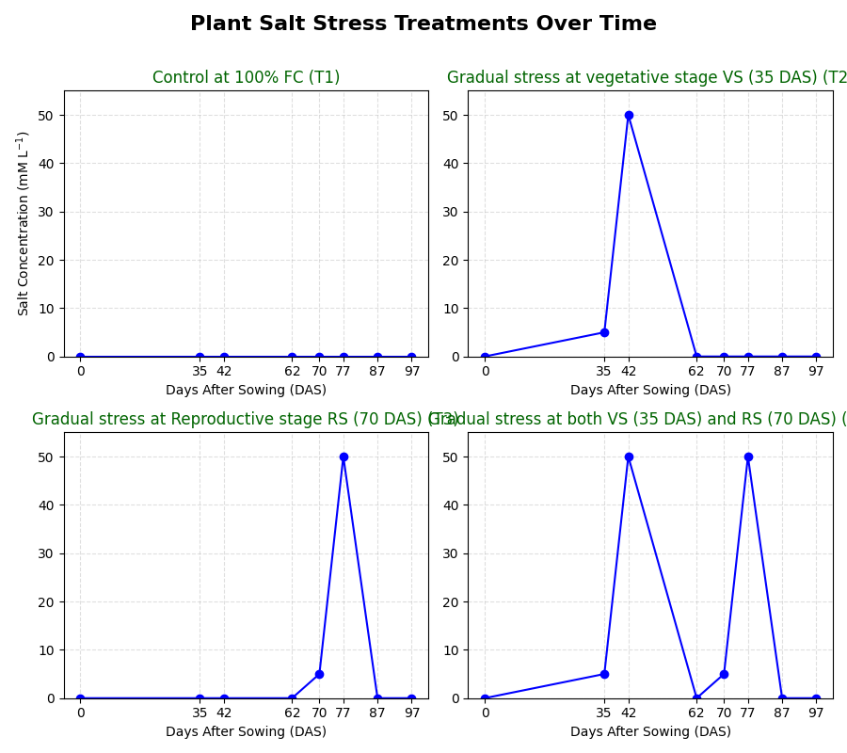
Control at 100 % FC (T1)
Gradual stress at vegetative stage VS (35 DAS) (T2)
Gradual stress at Reproductive stage RS (70DAS) (T3)
Gradual stress at both VS (35 DAS) and RS (70 DAS) (T4)

Fig 2. Salinity stress protocol with different treatments and sampling points in rice genotypes.

Fig. 2: Salinity stress protocol with different treatments viz., control (T1), GSV (T2), GSR (T3), and GSVR (T4) and sampling points in rice genotypes
High treatment effects and significant genotype × treatment interactions underscored contrasting adaptive responses. In contrast, traits such as protein content, SOD, POX, and flavonoids showed non-significant variation before stress (BVS) and during recovery (after vegetative stage stress (AVS) and after reproductive stage stress (ARS)), indicating trait stability and post-stress recovery mechanisms. These findings emphasise that salinity stress exerts its strongest effects during active stress phases, while recovery depends on genotype resilience.
3.2 Growth Parameters
3.2.1 Plant Height
Plant height, a vital indicator of plant vigour, was significantly influenced by salinity stress during both vegetative (VSS) and reproductive stress stages (RSS) (Fig. 4 a). Plant height indicated that genotypes subjected to single salinity stress at the reproductive stage (T3) maintained higher plant heights compared to those exposed to two rounds of stress at both vegetative and reproductive stages (T4). Specifically, after vegetative salinity stress recovery, plants under T3 reached mean heights (~105.3 cm) comparable to unstressed controls (T1), while T4 plants remained significantly reduced (~93.4 cm), demonstrating cumulative growth inhibition due to repeated stress exposure. This trend was consistent across all genotypes, highlighting that a second salinity stress event at the reproductive stage imposed additional burdens limiting growth recovery.
During stress periods, T3 plants often exhibited intermediate height reductions compared to T1 and T4, reflecting the impact of a single stress event. The genotype Dhaksha showed relatively better maintenance of height across treatments, suggesting superior tolerance mechanisms. The genotype × treatment interaction was significant, underscoring variability in growth responses and recovery between single and repeated stress exposures. These results demonstrated that single reproductive-stage salinity stress (T3) results in less growth penalty than combined vegetative and reproductive stress (T4), emphasising the additive or synergistic inhibitory effects of recurrent stress events.
3.2.2 Number of Tillers
Tiller production varied significantly with genotype, treatment, and their interaction (Fig. 4 b). The number of tillers in four rice genotypes showed significant differences under various salinity stress

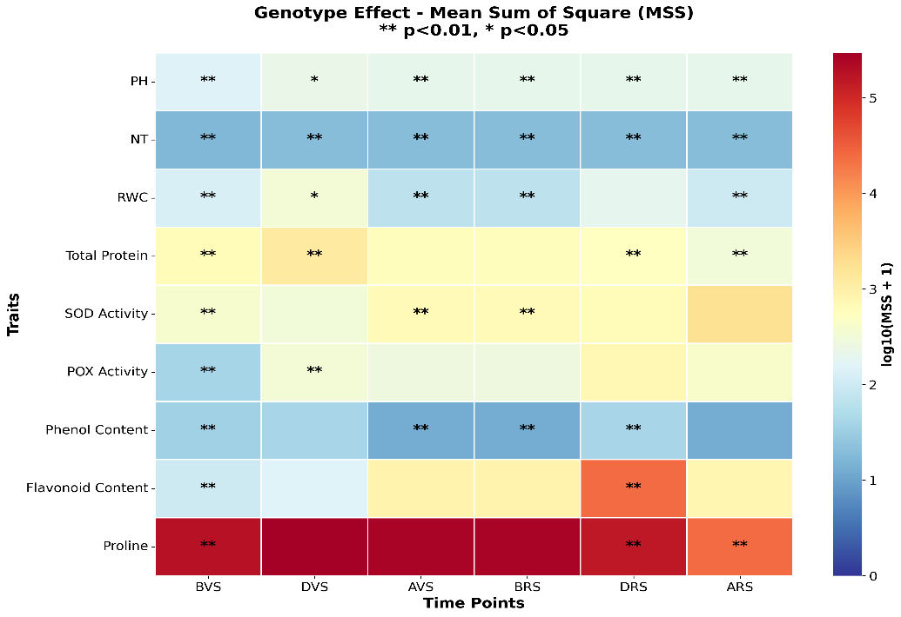
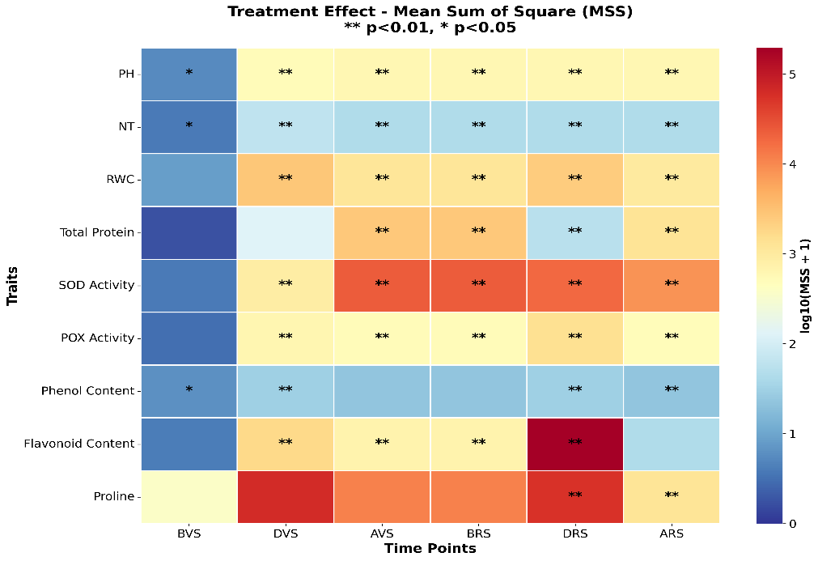
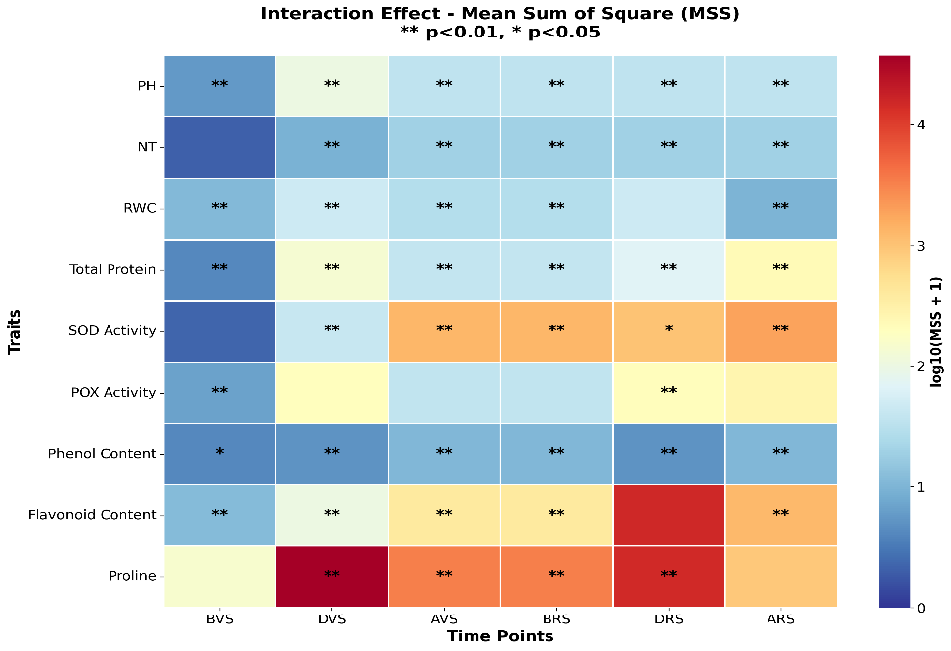

Fig. 3: Heatmap Representation of ANOVA Results for Multiple Plant Traits (Plant Height (PH), Number of Tillers (NT), Relative Water Content (RWC), SOD (Superoxide Dismutase) Activity, POX (Peroxidase) Activity, Phenol Content, and Proline Accumulation) under Salinity Stress Conditions (before vegetative and reproductive salinity stress (BVS, BRS), during vegetative and reproductive salinity stress (DVS, DRS), and after vegetative and reproductive salinity stress (AVS, ARS)
regimes, with marked contrasts between single (T3) and repeated (T4) stress exposures. Before stress application, tiller numbers were relatively uniform across genotypes and treatments, ranging between 7.0 and 10.0 tillers per plant. During the vegetative salinity stress phase, control plants (T1) maintained an average of 13.0 tillers, whereas the T2 and T4 treatments, representing vegetative stress only and combined vegetative plus reproductive stress, showed reduced tiller numbers averaging 9.42 and 9.33, respectively. This represents a substantial suppression of tillering activity under stress.
After recovery from the vegetative stress phase, plants subjected only to reproductive stress (T3) produced 17.33 tillers on average, closely matching the control plants, indicating that a single late-stage salinity event had limited impact on tiller development. In contrast, the T4 group, exposed to stress at both vegetative and reproductive stages, showed significantly lower tiller production (14.33), emphasising the cumulative inhibitory effect of repeated salinity stresses.
This data showed that a single exposure to salinity during the reproductive stage (T3) imparts minimal lasting damage to tiller production compared to two sequential stress events (T4) that cumulatively inhibit tillering and growth.
3.3 Physiological parameters
Salinity stress significantly affected relative water content (RWC) across genotypes, treatments, and growth stages, indicating impaired osmotic balance (Figure 4).
3.3.1 Relative Water Content
The relative water content (RWC) exhibited clear genotypic variation and treatment effects across all stages of stress exposure. Treatments involving a single salinity exposure at the reproductive stage (T3) showed higher RWC than treatments involving two consecutive stress events at both vegetative and reproductive stages (T4), confirming the cumulative negative impact of repeated salinity exposure.
During the vegetative salinity stress (VSS) phase, mean RWC under T3 was 86.38%, while under T4 it dropped to 61.80%. Among genotypes, Dhaksha maintained the highest hydration (89.93% in T3; 65.90% in T4), followed by GEN_214 (89.57% → 61.04%), GEN_85 (82.13% → 68.26%), and GEN_790 (83.87% → 52.01%). After the reproductive stress (RSS) phase, the decline pattern persisted, with average values of 71.58% (T3) and 68.00% (T4) across genotypes. Dhaksha again retained higher post-stress RWC (71.43% under T3; 68.00% under T4) than other genotypes, while GEN_790 recorded the lowest (67.40% vs. 64.00%).
Thus, a single salinity event (T3) imposed a moderate reduction in leaf water content, while repeated stress exposures (T4) caused substantial dehydration in all genotypes. The data highlight that early-stage salinity exposure compromised later stress tolerance, and Dhaksha stood out as the most resilient genotype due to its superior water retention under both single and repeated salinity stress.
3.4 Biochemical Parameters

3.4.1 Total Protein Content
The effect of salinity stress on total protein content in four genotypes showed distinct differences between treatments with single stress exposure at the reproductive stage (T3) and repeated stress exposure at both vegetative and reproductive stages (T4) (Fig.5). Before vegetative salinity stress, protein levels were comparable across treatments, averaging about 58 µg/50 µl.
However, during the vegetative stress phase, T4 induced higher protein accumulation than T3, with the mean protein content in T4 reaching 70.72 µg/50 µl compared to 66.39 µg/50 µl in T3. For instance, the Dhaksha genotype recorded protein content of 84.72 µg/50 µl under T4 versus 74.23 µg/50 µl under T3 during this phase, indicating an enhanced protein synthesis response under repeated stress. After experiencing vegetative stress, protein content decreased in all genotypes, but remained generally higher in T4 than in T3. During and after reproductive stress, T4 continued to exhibit relatively higher protein levels, as seen in Dhaksha, which maintained 55.86 µg/50 µl after reproductive stress in T4, compared to 49.31 µg/50 µl in T3, indicating higher protein synthesis under stress.
3.4.2 Antioxidant Defense
3.4.2.1 Superoxide dismutase (SOD)
A stage-wise comparison of Superoxide Dismutase (SOD) values across four genotypes—in phases before, during, and after salinity stress at both vegetative and reproductive stages — revealed how priming influences tolerance (Fig. 5 b). In Dhaksha, SOD activity increased sharply

Fig.4: Effect of Salinity Stress Treatments on a. Plant height, b. Number of Tillers, c. Relative Water Content in Four Rice Genotypes Across Vegetative and Reproductive Stages

during stress (T4: 8.13 μg protein for 50 per cent inhibition), but declined during its recovery (T4: 44.48 μg protein for 50 per cent inhibition). Similarly, during reproductive stress, SOD activity in Dhaksha was 87.00 μg protein for 50% inhibition. (T3) whereas SOD activity was 33.30 μg protein for 50 per cent inhibition) in T4 treatment.
It was noted that there was sustained SOD activity before RSS in T4 (44.48 μg protein for 50 per cent inhibition). The elevated level of SOD before the RSS stage shows the priming effect, which eventually protects the plant during the RSS stage. A genotypic and treatment comparison of SOD activity reveals the crucial role of priming in enhancing salinity tolerance, particularly under T4 (combined vegetative and reproductive stress. This could be attributed to a robust antioxidant defence system capable of mitigating oxidative damage. Dhaksha consistently exhibited the highest SOD activity under both stress conditions, indicating robust antioxidant defence and superior tolerance. GEN_214 and GEN_85 exhibited intermediate tolerance, with relatively stable SOD levels across stages. GEN_790, characterised by consistently lower SOD activity, was the most susceptible genotype, suggesting an inadequate antioxidant response under salinity stress.
3.4.2.2 Peroxidase (POX)
Peroxidase (POX) activity in four rice genotypes (Dhaksha, GEN_214, GEN_790, and GEN_85) under salinity stress at vegetative (VSS) and reproductive (RSS) stages showed significant genotypic and treatment variations. During VSS, POX activity increased sharply under stress conditions, with T4 showing higher mean activity (25.43 μg/min/mg protein) compared to T3 (13.08 μg/min/mg protein). Among genotypes, Dhaksha exhibited 13.21 μg/min/mg protein under T3 and 25.62 μg/min/mg protein under T4, while GEN_214 showed similar trends (11.21 μg/min/mg protein in T3 vs. 31.25 μg/min/mg protein in T4). GEN_790 recorded 19.21 μg/min/mg protein (T3) and 28.45 μg/min/mg protein (T4), whereas GEN_85 maintained lower activity levels (8.70 μg/min/mg protein in T3; 16.38 μg/min/mg protein in T4).
Before reproductive stress, POX activity under T4 remained elevated (mean 27.81 μg/min/mg protein) compared to T3 (13.12 μg/min/mg protein), suggesting sustained antioxidant defence priming from prior vegetative stress. During RSS, T4 continued to show higher POX activity (mean 39.43 μg/min/mg protein) than T3 (33.32 μg/min/mg protein). Dhaksha recorded the highest activity during RSS under T4 (59.32 μg/min/mg protein) compared to T3 (51.00 μg/min/mg protein), followed by GEN_214 (41.24 μg/min/mg protein in T4 vs. 36.39 μg/min/mg protein in T3). GEN_790 and GEN_85 showed moderate increases under T4 (34.66 and 22.50 μg/min/mg protein, respectively). After RSS, POX activity stabilised across treatments, with mean values of 23.38 μg/min/mg protein (T3) and 22.05 μg/min/mg protein (T4).
The consistently higher POX activity under T4 (two rounds of stress) compared to T3 (single stress at reproductive stage) demonstrated the priming effect induced by early vegetative stage salinity exposure. Priming triggered enhanced synthesis and activation of antioxidant enzymes, enabling plants to better scavenge reactive oxygen species (ROS) during subsequent stress events. Peroxidase plays a critical role in detoxifying hydrogen peroxide (H₂O₂) and maintaining cellular redox homeostasis under oxidative stress conditions.​
The sustained elevated POX activity before and during RSS in T4-treated plants reflects the establishment of a "stress memory," where prior exposure to salinity at the vegetative stage prepares the antioxidant defence system for more efficient responses upon re-exposure. This priming-induced enhancement in POX activity likely contributes to reduce oxidative damage, better membrane stability, and improved overall stress tolerance in genotypes like Dhaksha and GEN_214, which maintained the highest POX activities under repeated stress.​
Genotypic differences were evident, with Dhaksha and GEN_214 demonstrating superior POX responses under both single and repeated stress, suggesting robust antioxidant machinery and better stress resilience. GEN_85, despite lower POX activity, showed moderate adaptive capacity, while GEN_790 exhibited intermediate responses. These findings underscore that priming enhances the coordinated activation of antioxidant enzymes like POX, enabling plants to maintain cellular homeostasis and mitigate oxidative damage more effectively under cumulative salinity. Dhaksha showed consistently higher protein accumulation and POX activity, coupled with higher SOD activity, indicating its strong tolerance and efficient antioxidant defense under salinity. GEN_214 exhibited moderate responses across all parameters, suggesting partial tolerance. In contrast, GEN_790 and GEN_85 displayed relatively low SOD activity and weaker POX responses, coupled with moderate protein levels, indicating sensitivity to salinity stress.
3.4.3 Phenol content
Phenol content in four rice genotypes under salinity stress showed that both single reproductive stress (T3) and combined vegetative and reproductive stress (T4) induced phenol accumulation, with T4 generally exhibiting slightly higher values during stress periods (Fig. 6a). During vegetative stress, T4 induced higher phenol accumulation (58.55 mg GAE/g) compared to T3 (55.34 mg GAE/g), particularly evident in Dhaksha (61.66 vs. 58.21 mg GAE/g) and GEN_214 (58.55 vs. 55.14 mg GAE/g). After vegetative stress, phenol levels declined but remained comparable between treatments. Before and during reproductive stress, elevated phenol content persisted in T4 (58.55 mg GAE/g) relative to T3 (55.34 mg GAE/g). Post-reproductive stress phenol content declined to baseline in both treatments.
The enhanced phenol accumulation in T4 reflects priming, where initial vegetative stress exposure conditions plants for a more robust phenolic antioxidant response during subsequent stress. Genotypes like Dhaksha and GEN_214 benefit from priming by sustaining higher phenol levels, correlating with improved stress tolerance. These findings affirm priming as a critical mechanism enabling plants exposed to repeated salinity stress to fortify their antioxidant defenses through increased phenol accumulation.
3.4.4 Flavonoid content
Flavonoid content in four rice genotypes under salinity stress at vegetative (VSS) and reproductive (RSS) stages revealed significant genotypic and treatment effects (Fig. 6 b). During VSS, T4 induced substantially higher flavonoid accumulation (37.24 mg/100 g) compared to T3 (15.89 mg/100 g), mainly because in T3, at this stage, the plants did not experience any stress and were comparable to the control T1. Dhaksha exhibited remarkable increases under T4 (44.85 mg/100 g vs 12.12 mg/100 g in T3), while GEN_214 showed 42.00 mg/100 g in T4 and 17.15 mg/100 g in T3. GEN_790 and GEN_85 had moderate increases. After VSS, flavonoid content remained higher under T4 (34.20 mg/100 g) versus T3 (19.86 mg/100 g).
During RSS, flavonoid content dramatically surged under both treatments, but was greater in T4 (281.05 mg/100 g) than in T3 (217.19 mg/100 g). Dhaksha and GEN_214 notably accumulated higher flavonoids in T4 (268.21 and 390.21 mg/100 g, respectively) compared to T3. Post-RSS, flavonoid levels declined but remained elevated in T4 (142.07 mg/100 g) relative to T3 (111.40 mg/100 g).
The pronounced accumulation of flavonoids under the dual stress treatment (T4) compared to single reproductive stress (T3) highlighted a priming effect induced by early vegetative salinity

Fig. 5: Effect of Salinity Stress Treatments on a. Total Protein Content, b. Superoxide dismutase (SOD) activity and c. Peroxidase Activity in Four Rice Genotypes Across the Vegetative and Reproductive Stage
exposure. This priming enhanced flavonoid biosynthesis, key non-enzymatic antioxidants that scavenged reactive oxygen species and stabilised cellular structures, thereby mitigating oxidative damage during subsequent stress events. The elevated flavonoid content, particularly in Dhaksha and GEN_214 under T4, indicated robust activation of stress memory and metabolic pathways, conferring superior salinity tolerance. Overall, priming facilitated enhanced antioxidant defence through sustained flavonoid synthesis, essential for plant survival under recurrent salinity stress.
3.4.5 Proline accumulation
The proline content in four rice genotypes under different salinity stress treatments (Fig. 6c) showed marked differences between single reproductive stress (T3) and combined vegetative and reproductive stress (T4). Across the measured phases of salinity stress, proline levels varied both between genotypes and across treatments. For Dhaksha and GEN_214, the highest proline accumulation was observed during stress exposure, with T3 (unprimed, single stress) typically reaching around 400–500 mg/100g during “During VSS” and “During RSS.” In contrast, T4 (primed, two rounds of stress) showed moderate proline levels of approximately 250–350 mg/100g during the same phases. GEN_790 and GEN_85 demonstrated similar trends but with lower overall levels: T3 ranged between 250–300 mg/100g, and T4 was often between 120–200 mg/100g. After stress (post-RSS phase), the proline content declined in all treatments, but remained higher in T3 than in T4.
The direct comparison of T3 (unprimed) and T4 (primed) treatments revealed an intriguing physiological adaptation: proline accumulation in unprimed plants (T3) was consistently higher than in primed plants (T4) across all genotypes. This pattern underscored the nature of the acute stress response, where unprimed exposure triggered maximal osmoprotectant synthesis as the plants confronted salinity for the first time. By contrast, primed plants (T4), having already survived an initial round of stress, mount a subdued proline response during subsequent exposures. This was indicative of metabolic acclimation and physiological memory, where repeated stress primes the plant to deploy a more efficient, less resource-intensive tolerance strategy. Rather than amplifying proline production, priming calibrated stress signalling and reinforced alternative protective systems, such as enhanced antioxidant activity and improved ion homeostasis, thereby reducing the reliance on proline alone.

3.5 Grain yield
Grain yield was significantly affected by salinity stress treatments, with notable differences between single reproductive stage stress (T3) and combined vegetative and reproductive stage stress (T4) (Fig. 6d). Among genotypes, Dhaksha yielded the highest under control conditions (T1: 88.94 g) but exhibited a severe yield reduction under T3 (3.12 g) and T4 (4.01 g). Similarly, GEN_214 and GEN_85 showed higher yields under T1 (78.05 and 68.20 g, respectively) but declined markedly under T3 (5.40 and 11.70 g) and T4 (7.75 and 8.62 g). Although yields under T4 were slightly higher than T3 across genotypes (e.g., Dhaksha: 4.01 g vs. 3.12 g; GEN_214: 7.75 g vs. 5.40 g), both treatments caused substantial grain yield loss compared to the control. GEN_790 consistently showed lower yields overall, with minimal difference between T3 (7.28 g) and T4 (8.77 g).
These data indicate that salinity stress at the reproductive stage (T3) severely diminishes grain yield, while combined stress at vegetative and reproductive stages (T4) causes similar, though slightly less drastic, yield reductions, likely due to marginal priming effects during the initial stress exposure. The priming induced by vegetative stage stress may partially alleviate reproductive stress damage, enabling T4 plants to maintain a marginally higher yield than T3. However, the severe yield reduction in both T3 and T4 treatments underlines the critical impact of salinity stress during reproductive development on rice productivity.
3.5.1 Per cent reduction in yield in different treatments
The graph clearly demonstrated that salinity stress at both the reproductive stage (T3) and the combined vegetative plus reproductive stages (T4) caused a severe reduction in grain yield across all four rice genotypes when compared to the unstressed control. Dhaksha experienced the greatest yield loss, with reductions of 96.5% in T3 and 95.5% in T4, indicating extreme sensitivity to both types of salinity stress treatments. GEN_214 also showed substantial yield reductions of 93.1% (T3) and 90.1% (T4), while GEN_790 recorded slightly lower losses, at 87.9% in T3 and 85.4% in T4. GEN_85 differed from the other genotypes by showing a greater reduction under T4 (87.4%) than T3 (82.8%), suggesting possible cumulative or additive effects of dual stress rather than a priming benefit.
Overall, the data revealed that single reproductive stage stress (T3) generally caused marginally higher percentage reductions in grain yield compared to combined stress (T4), except for GEN_85. This slight advantage under T4 in most genotypes may be attributed to physiological

Fig 6. Effect of Salinity Stress Treatments on a. Phenol Content, b. Flavonoid content, and c. Proline Content in Four Rice Genotypes Across Vegetative and Reproductive Stages

Fig. 7: Effect of Salinity Stress Treatments on a. Grain Yield b. Per cent reduction in grain yield in T3 and T4 treatment with respect to control in Four Rice Genotypes

priming, where early stress exposure triggers adaptive mechanisms that help mitigate the adverse effects of subsequent stress. However, the absolute yield penalties under both treatments remained extremely high, underscoring the vulnerability of the reproductive phase to salinity and the limited extent of priming protection under repeated severe stress. These findings emphasise the importance of genotype selection and stage-specific stress management to mitigate yield loss in saline environments.
4. Discussion
Salinity stress significantly limits rice productivity, with effects varying by growth stage, genotype, and stress frequency. This study systematically compared single reproductive-stage stress (T3) to repeated vegetative and reproductive stress (T4) across four rice genotypes, revealing a fundamental trade-off viz., T3 plants maintained superior morphological characteristics, whereas T4 plants exhibited enhanced biochemical defenses and marginally better yield outcomes. These contrasting responses underscore the complex balance between growth maintenance and stress defense activation under salinity stress.​
Plants subjected to single reproductive-stage stress (T3) maintained significantly better growth parameters than those exposed to repeated stress (T4). After vegetative stress recovery, T3 plants achieved mean heights (~105.3 cm) comparable to controls, while T4 plants remained substantially reduced (~93.4 cm), demonstrating cumulative growth inhibition from sequential stress exposure. Similarly, tiller production was higher in T3 (17.33 tillers) than in T4 (14.33 tillers), indicating a less severe growth penalty under single stress. This morphological advantage in T3 reflects the absence of early vegetative stress, allowing uninterrupted resource allocation to growth and development. These results align with a previous study by Qados (2011) where he found that the long-term application of salinity stress revealed an inverse relationship between salt concentrations and plants’ productivity.
However, this morphological superiority did not translate to better stress tolerance or yield. T4 plants showed enhanced biochemical defenses across all measured parameters despite experiencing two rounds of stress. Total protein content was significantly higher in T4 than T3 during reproductive stress, indicating priming-enhanced synthesis of stress-responsive proteins. This enhanced protein response reflects metabolic reprogramming whereby early stress exposure activates defense gene networks, enabling stronger protective responses upon subsequent stress.​
The trade-off between growth and defense is well-documented in plant stress biology, where resource allocation to defensive pathways diverts energy from growth processes. T4 plants exemplify this trade-off: reduced vegetative vigour but enhanced biochemical preparedness. Conversely, T3 plants prioritised growth maintenance in the absence of early stress but lacked priming-induced defensive capacity, leaving them vulnerable to severe reproductive-stage damage.​
The reproductive stage was highly sensitive to salinity, as evidenced by extreme yield losses across all genotypes (82.8–96.5% reduction). Salinity disrupts pollen fertility, stigmatic receptivity, and spikelet development, reducing grain set. Critically, T4 showed marginally lower yield losses than T3 for most genotypes (e.g., Dhaksha: 95.5% vs. 96.5%; GEN_214: 90.1% vs. 93.1%), suggesting that biochemical priming partially mitigated reproductive stress damage despite morphological disadvantages.​
This yield advantage in T4 correlated with substantially enhanced antioxidant defenses (Nasrallah et al., 2022). Superoxide dismutase (SOD) and peroxidase (POX) activities were consistently higher in T4, reflecting priming-enhanced ROS scavenging capacity. POX activity during reproductive stress reached 39.43 µg/min/mg protein in T4 compared to 33.32 µg/min/mg protein in T3, demonstrating sustained enzymatic preparedness from prior vegetative stress exposure. Thus, the "stress memory" enabled faster defense activation upon re-exposure, minimising oxidative damage to reproductive tissues.​ The role of priming in ameliorating salinity-accompanied oxidative stress was also documented in Faba Beans (Nasrallah et al., 2022), sweet sorghum (Yan et al., 2013) and wheat (Maswada et al., 2018; Alzahrani et al., 2021).
Non-enzymatic antioxidants also showed priming effects. It was found that in T4 treatment, phenol content increased compared to T3 by approximately 5.74%, with phenol levels at 58.55 mg GAE/g in T4 versus 55.34 mg GAE/g in T3 before and during reproductive stress (Qados 2011; de et al., 2017). Flavonoids surged 29% higher in T4 (281.05 mg/100 g) than in T3 (217.19 mg/100 g) during reproductive stress. Flavonoid content surged to 281.05 mg/100 g during reproductive stress in T4 versus 217.19 mg/100 g in T3, representing a 29% enhancement. Proline accumulation under salinity stress was highest in unprimed plants (T3), reflecting an acute response to a first-time stress challenge. In contrast, primed plants (T4) showed consistently lower proline levels during subsequent stress, demonstrating physiological adaptation and efficient stress memory. These results suggest that priming enables rice genotypes to optimise stress responses without excessive proline synthesis, supporting tolerance through multiple protective mechanisms. These elevated antioxidants provided T4 plants with superior cellular protection, enabling marginally better yield retention despite cumulative growth penalties.​ An increase in proline accumulation was documented under salt stress in faba bean (Nasrallah et al., 2022), wheat (Alzahrani et al., 2021), Pisum sativum (Ahmad et al., 2020), and pearl millet (Khan et al., 2020).
The decline in RWC under salinity reflects osmotic stress and ion toxicity disrupting water uptake and transport (Garg and Singla, 2009). Tolerant genotypes like Dhaksha exhibited superior water retention across treatments, suggesting intrinsic advantages including better root hydraulic conductivity and aquaporin activity. The partial recovery of RWC in T4 during reproductive stress demonstrates that biochemical priming can partially compensate for prior stress damage, though not sufficiently to restore growth to T3 levels.​
The contrasting outcomes between T3 and T4 highlight a fundamental resource allocation dilemma in stress responses. T3 plants allocated resources primarily to growth maintenance, achieving superior morphology but inadequate biochemical defenses when subsequently challenged during reproduction. T4 plants, conversely, invested heavily in defensive metabolism following initial stress, sacrificing growth but gaining biochemical resilience.
The marginally better yield in T4 despite inferior morphology suggests that biochemical preparedness outweighs vegetative vigor in determining reproductive-stage stress outcomes. Enhanced antioxidant capacity, osmolyte accumulation, and stress protein synthesis in T4 provided critical protection to reproductive tissues, limiting floret sterility and grain abortion. However, the absolute yield penalties remained severe in both treatments (>82%), indicating that even robust biochemical defenses offer limited protection against severe reproductive-stage salinity.​
Significant genotypic differences underscore the genetic complexity of salinity tolerance and priming responsiveness. Dhaksha consistently exhibited superior performance across physiological and biochemical parameters in both treatments, maintaining higher RWC, protein content, antioxidant activity, and osmolyte accumulation. This genotype's robust stress responses reflect favorable alleles for multiple tolerance mechanisms, positioning it as valuable germplasm for breeding programs.​
Interestingly, GEN_85 showed greater yield loss under T4 (87.4%) than T3 (82.8%), contrasting with other genotypes. This suggests limited capacity to exploit priming advantages or accumulation of irreversible damage from dual stress exposure. Such genotype-specific responses indicate that priming effectiveness depends on genetic background, with some genotypes better equipped to establish stress memory and mount enhanced secondary responses.​
These findings have important implications for rice breeding and salinity management strategies. The observation that biochemical preparedness (T4) yielded better outcomes than morphological vigour (T3) suggests that breeding should prioritise stress-responsive defence mechanisms over vegetative growth parameters when targeting reproductive-stage tolerance. However, the severe yield penalties in both treatments (~90% loss) underscore the critical need to avoid salinity exposure during sensitive reproductive stages through timing of planting, field management, or genetic improvement.​
Integrated Model of Stress Memory in Salinity Tolerance
The integration of morphological, physiological, and biochemical traits provides a comprehensive view of salinity tolerance mechanisms. Dhaksha emerged as the most primed genotype, characterised by stable growth, sustained RWC, strong POX, SOD induction, phenolic and flavonoid accumulation, and proline-based osmotic regulation. GEN_214 exhibited partial priming, balancing moderate stress tolerance with osmolyte and antioxidant accumulation. In contrast, GEN_790 showed strong initial growth but failed to retain biochemical memory, while GEN_85 lacked both priming and tolerance mechanisms, making it highly sensitive.
The stress memory established during vegetative stress persists through weeks of recovery and remains functional during subsequent reproductive stress, demonstrating somatic stress memory spanning multiple developmental stages. The sustained elevation of proline (224.73 mg/100 g before reproductive stress in T4), and antioxidant enzymes indicates active maintenance mechanisms. For crop improvement, identifying and exploiting genotypes with inherent priming capacity, such as Dhaksha, offers a promising strategy for developing resilient cultivars under increasingly saline agricultural systems.
Drought-Tolerant vs. Drought-Susceptible Genotypes under Salinity Stress
Genotypes with drought-tolerant traits (Dhaksha and GEN_214) performed markedly better under salinity stress, highlighting the overlap in adaptive mechanisms between the two stresses. Dhaksha exemplified this cross-tolerance by maintaining higher relative water content, and strong biochemical defences, including elevated proline, phenols, and flavonoids. Its antioxidant profile, characterised by strong peroxidase activity and low superoxide dismutase, indicated efficient ROS detoxification, while higher protein accumulation during stress reflected enhanced metabolic resilience. GEN_214, though less robust, showed intermediate tolerance by sustaining moderate RWC, osmolyte levels, and antioxidant activity, enabling partial protection against stress damage.
By contrast, drought-susceptible genotypes (GEN_790 and GEN_85) performed poorly under salinity. GEN_85 consistently showed severe reductions in growth, RWC, coupled with weak protein retention, poor osmolyte accumulation, and inadequate antioxidant responses. GEN_790 maintained plant height and tiller number, giving an impression of resilience, but its sharp physiological and biochemical declines—including low RWC, weak POX activity, and low secondary metabolite accumulation—revealed high susceptibility. This mismatch between morphology and internal tolerance highlights the limitations of relying solely on growth traits as indicators of stress adaptation.
The findings suggest that salinity tolerance in the tested genotypes is influenced by the integration of morphological resilience, physiological stability, and biochemical defence mechanisms. Dhaksha emerged as the most tolerant genotype, exhibiting a coordinated response involving sustained growth, higher relative water, enhanced protein retention, robust peroxidase activity, and strong accumulation of phenolics, flavonoids, and proline. GEN_214 demonstrated partial tolerance, balancing moderate growth suppression with effective responses to osmolytes and antioxidants. In contrast, GEN_790 combined high growth potential with weak biochemical defences, while GEN_85 remained highly sensitive across all parameters. These results emphasise that superior tolerance arises not from a single trait but from a synergistic interplay between water relations, antioxidant regulation, and osmolyte accumulation, providing a comprehensive model for evaluating and improving salinity tolerance in crop breeding programs.
Collectively, these results confirm that drought-tolerance traits such as osmotic adjustment, osmolyte accumulation, and effective antioxidant defence also underpin salinity tolerance. Dhaksha’s coordinated response makes it the most promising genotype for breeding salt-tolerant varieties, while GEN_85’s consistent sensitivity and GEN_790’s unstable responses identify them as poor candidates for cultivation in saline soils.

5. Conclusion
This comprehensive study compared physiological, biochemical, and agronomic responses of four rice genotypes to single reproductive-stage salinity stress (T3) versus repeated vegetative and reproductive stress (T4). The research revealed three principal findings. First, salinity stress induced severe yield penalties exceeding 82% across all genotypes and treatments, emphasising the extreme reproductive vulnerability of rice to salt stress. Second, a fundamental growth-defence tradeoff emerged where T3 plants maintained superior morphological traits while T4 plants exhibited enhanced biochemical preparedness, with defensive capacity proving more critical than vegetative vigour for reproductive-stage stress tolerance. Third, drought-tolerant genotypes Dhaksha and GEN_214 substantially outperformed susceptible genotypes, demonstrating cross-tolerance mechanisms linking drought and salinity adaptation pathways.
References
Ahmad F, Kamal A, Singh A, Ashfaque F, Alamri S, Siddiqui MH. Salicylic acid modulates antioxidant system, defense metabolites, and expression of salt transporter genes in Pisum sativum under salinity stress. J Plant Growth Regul. 2020. https://doi.org/10.1007/s00344-020-10271-5
Alzahrani O, Abouseadaa H, Abdelmoneim TK, Alshehri MA, El-Mogy M, El-Beltagi HS, Atia MAM. Agronomical, physiological and molecular evaluation reveals superior salt-tolerance in bread wheat through salt-induced priming approach. Not Bot Horti Agrobo Cluj Napoca. 2021;49(2):12310. https://doi.org/10.15835/nbha49212310
Avramova Z. Transcriptional 'memory' of a stress: transient chromatin and memory (epigenetic) marks at stress-response genes. Plant J. 2015;83(1):149–159. https://doi.org/10.1111/tpj.12832
Barrs HD, Weatherley PE. A re-examination of the relative turgidity technique for estimating water deficits in leaves. Aust J Biol Sci. 1962;15:413–428. https://doi.org/10.1071/BI9620413
Bruce TJA, Matthes MC, Napier JA, Pickett JA. Stressful “memories” of plants: Evidence and possible mechanisms. Plant Sci. 2007;173(6):603–608. https://doi.org/10.1016/j.plantsci.2007.09.002
Carillo P, Mastrolonardo G, Nacca F, Parisi D, Verlotta A, Fuggi A. Nitrogen metabolism in durum wheat under salinity: Accumulation of proline and glycine betaine. Funct Plant Biol. 2008;35(5):412–426. https://doi.org/10.1071/FP08108
Castillo FJ, Penel C, Greppin H. Peroxidase release induced by ozone in Sedum album leaves: Involvement of Ca2+. Plant Physiol. 1984;74(4):846–851. https://doi.org/10.1104/pp.74.4.846
Crisp PA, Ganguly D, Eichten SR, Borevitz JO, Pogson BJ. Reconsidering plant memory: Intersections between stress recovery, RNA turnover, and epigenetics. Sci Adv. 2016;2(2):e1501340. https://doi.org/10.1126/sciadv.1501340
Cross JM, von Korff M, Altmann T, Bartzetko L, Sulpice R, Gibon Y, Palacios N, Stitt M. Variation of enzyme activities and metabolite levels in 24 Arabidopsis accessions growing in carbon-limited conditions. Plant Physiol. 2006;142:1574–1588. https://doi.org/10.1104/pp.106.086629
Davis BJ. Disc electrophoresis–II: Method and application to human serum proteins. Ann NY Acad Sci. 1964;121(2):404–427. https://doi.org/10.1111/j.1749-6632.1964.tb14213.x
de Souza Miranda R, Paula SO, Araújo GS, Valença IN, Miranda SRN, Gomes-Filho E. NaCl-priming mitigates oxidative damage and Na+ accumulation and enhances salt tolerance in sorghum plants. Plant Physiol Biochem. 2017;118:46–53.
Dhindsa RS, Matowe W. Drought tolerance in two mosses: Correlated with enzymatic defense against lipid peroxidation. J Exp Bot. 1981;32(1):79–91. https://doi.org/10.1093/jxb/32.1.79
Fleta-Soriano E, Munné-Bosch S. Stress Memory and the Inevitable Effects of Drought: A Physiological Perspective. Front Plant Sci. 2016;7:143. https://doi.org/10.3389/fpls.2016.00143
Garg N and Singla R. Variability in the response of chickpea cultivars to short-term salinity, in terms of water retention capacity, membrane permeability, and osmo-protection. Turk J Agric For. 2009;33(1):57–63. https://doi.org/10.3906/tar-0712-41
International Rice Research Institute (IRRI). Annual report on rice research and development. IRRI; 2025. http://books.irri.org/AR2024_content.pdf
Khan I, Raza MA, Awan SA, Shah GA, Rizwan M, Ali B, Tariq R, Hassan MJ, Alyemeni MN, Brestic M, et al. Amelioration of salt induced toxicity in pearl millet by seed priming with silver nanoparticles (AgNPs): The oxidative damage, antioxidant enzymes and ions uptake are major determinants of salt tolerant capacity. Plant Physiol Biochem. 2020;156:221–232. https://doi.org/10.1016/j.plaphy.2020.09.018
Li X, Wang Y, Chen J. Mechanisms of salt and drought stress responses in rice: Integrating ion homeostasis, osmotic regulation, and antioxidant defences. Plant Physiol Biochem. 2024;205:112–123.
Lowry OH, Rosebrough NJ, Farr AL, Randall RJ. Protein measurement with the Folin phenol reagent. J Biol Chem. 1951;193:265–275. https://doi.org/10.1016/S0021-9258(19)52451-6
Maswada HF, Djanaguiraman M, Prasad P. Response of photosynthetic performance, water relations and osmotic adjustment to salinity acclimation in two wheat cultivars. Acta Physiol Plant. 2018;40:1–15. https://doi.org/10.1007/s11738-018-2684-x
Nasrallah AK, Atia MAM, Abd El-Maksoud RM, Kord MA, Fouad AS. Salt priming as a smart approach to mitigate salt stress in Faba bean (Vicia faba L.). Plants. 2022;11(3):489. https://doi.org/10.3390/plants11121610
Pastor V, Luna E, Mauch-Mani B, Ton J, Flors V. Primed plants do not forget. Environ Exp Bot. 2013;94:46–56. https://doi.org/10.1016/j.envexpbot.2012.02.013
Qados AM. Effect of salt stress on plant growth and metabolism of bean plant Vicia faba (L.). J Saudi Soc Agric Sci. 2011;10(1):7–15. https://doi.org/10.1016/j.jssas.2010.06.002
Woisky R, Salatino A. Analysis of propolis: Some parameters and procedures for chemical quality control. J Apic Res. 1998;37:99–105. https://doi.org/10.1080/00218839.1998.11100961
Yan K, Xu H, Cao W, Chen X. Salt priming improved salt tolerance in sweet sorghum by enhancing osmotic resistance and reducing root Na+ uptake. Acta Physiol Plant. 2015;37:1–10. https://doi.org/10.1007/s11738-015-1957-x
Zhang H, Liu Q, Xu Y. Breeding water-saving and drought-resistant rice (WDR): Achievements and future prospects. Front Plant Sci. 2023;14:119–130.
Zhu JK, Luo X, Yang S. Shared signaling pathways in plant responses to drought and salinity stress. Annu Rev Plant Biol. 2022;73:517–545. https://doi.org/10.1146/annurev-arplant-102820-011802

