Original Research Article
Plant-Parasitic Nematodes Associated with Rice (Oryza spp.) and Their Relationship with Rice Ecosystems in Côte d’Ivoire

.
ABSTRACT
Rice is a staple crop for the people of Africa, especially in Côte d’Ivoire. Its production is threatened by plant-parasitic nematodes, which cause root damage, stunted growth, and yield loss. This study aimed to identify the nematode populations associated with rice and to determine their distribution across rice ecosystems. Surveys were conducted in 27 rice fields within three agroecological zones in Côte d’Ivoire. A total of 185 soil and rice root samples were collected. The nematodes in these samples were extracted, identified, and counted. Ten genera of plant-parasitic nematodes were identified. The most prevalent nematode, with 100% occurrence, included Pratylenchus, Hirschmanniella, Heterodera, Meloidogyne, and Longidorus. They were abundant in upland rice samples (39 to 1748 individuals) and lowland rice samples (75 to 1367 individuals). Pratylenchus sp., Hirschmanniella sp., and Meloidogyne sp. were associated with upland rice, while Heterodera sp. and Longidorus sp. were linked to lowland and irrigated rice, respectively. Further molecular and pathological characterizations of these nematode populations are necessary to develop effective management strategies for the most pathogenic ones in rice.

Keywords: Agroecological zones; Côte d’Ivoire; Nematodes; Rice; Rice ecosystems

1. INTRODUCTION

Rice (Oryza spp.) is a Poaceae plant mainly cultivated for its high-energy grains (Fresco, 2005). It serves as the staple food for more than half of the world's population (Bridge et al., 2005). In Africa, especially in Côte d’Ivoire, rice is a key staple, ranking third after yams and cassava. Côte d’Ivoire's rice production was estimated at 1.99 million tons in 2022 (FAOSTAT, 2024).
After Nigeria and Mali, Côte d’Ivoire is the 3rd largest rice producer in the ECOWAS region. Rice is cultivated across various environments, including forest, savannah, and mountainous areas (Ouédraogo et al., 2021). Based on the agroecological potential of these areas, three main rice ecosystems are identified in Côte d’Ivoire: upland rice, lowland rice, and irrigated rice. Upland and lowland rice rely entirely on rainwater (ADERIZ, 2020), while irrigated rice is cultivated in developed lowlands with partial or total water control (ADERIZ, 2020). According to Ouédraogo et al. (2021), 675,324 households are involved in rice cultivation, with 3.94% producing irrigated rice, 55.39% practicing lowland rice, and 40.67% cultivating upland rice.
Despite favorable agroecological conditions, rice production remains below the population’s expectations. Rice consumption is growing at an annual rate of at least 3%, reaching around 1.8 million tons of polished rice. Currently, Côte d’Ivoire imports nearly 50% of its rice needs. Rapid urbanization, high population growth, and changing diets drive the increasing demand (Ouédraogo et al., 2021). However, the lack of mechanization in rice farming and limited funding discourage farmers from investing in seeds and fertilizers.
Additionally, plant-parasitic nematodes significantly contribute to production losses. Several nematode species are associated with rice, yet only a few causes major damage (Bridge et al., 2005). These nematodes are classified into foliar and root parasites. Foliar parasites, mainly Aphelenchus angustus and Aphelenchoides besseyi, feed on stems, leaves, and panicles (Bridge et al., 2005). Root parasites, including species from the genera Meloidogyne, Pratylenchus, Hirschmanniella, Heterodera, and Criconemella, cause developmental dysfunctions such as stunted growth, root reduction, and significant yield losses (Bridge et al., 2005).
In Côte d’Ivoire, studies on plant-parasitic nematodes related to rice are scarce and date back to the late 1980s. During that period, rice fields often exhibit patches of dwarfed, stunted plants with yellowing leaves. Their root systems are frequently necrotic, galled, and reduced. Several nematode populations, including Pratylenchus spp., Meloidogyne spp., Heterodera spp., and Hirschmanniella spp., may be responsible. Increasing rice cultivation by expanding rice perimeters can lead to higher nematode populations. If no control measures are taken, such pest populations could expand and worsen the rice production deficit. Therefore, the study aimed to identify the nematode populations associated with rice and assess their distribution within rice ecosystems.

2. material and methods

2.1 Description of Study Areas

The study was conducted in 27 rice fields across three agroecological zones of Côte d’Ivoire: the southern rainforest zone, the western rainforest zone, and the semi-deciduous rainforest zone. Rice farming systems in these areas remain traditional, although some regions have been developed for irrigated rice cultivation. The agroecological characteristics of these zones are summarized below.
The southern rainforest zone has a humid tropical climate marked by two rainy seasons (May to June and September to November) and two dry seasons (December to April and July to August). Rainfall ranges from 1400 to 2500 mm per year. The average annual temperature is 29 ± 5.6 °C (Bolou et al., 2016). Relative humidity is high, fluctuating between 80% and 90%.
The western rainforest zone also has a humid tropical climate, characterized by two rainy seasons (March to July and September to November) and two dry seasons (August and December to February). Rainfall in this zone ranges from 1300 to 1750 mm annually. The mean annual temperature is 23.5 ± 13.4 °C (Bolou et al., 2016). Relative humidity remains high, ranging from 80% to 90%.
The semi-deciduous dense forest zone has a transitional, equatorial-type climate characterized by two rainy seasons (March to June and September to October) and two dry seasons (July to August and November to February) (Bla et al., 2015). Rainfall here ranges from 1200 to 1600 mm per year. The average annual temperature is approximately 26 °C. Relative humidity in this zone typically exceeds 70% and varies considerably throughout the year (Kouassi et al., 2010).

2.2 Survey and Sampling

The survey and sampling took place in July and August 2024 across nine rice production areas within three agroecological zones. Three rice fields were chosen in each locality. Before sampling, data on field size, previous crop, rice cultivar, rice ecosystem, and applied phytosanitary treatments were gathered from farmers.
In each rice field, patches of dwarf and stunted rice plants were identified. Symptoms on rice plants were described. Depending on the patch size, five to ten rice plants were randomly selected. These plants were uprooted, and their root systems, along with adhering soil, were individually packed into labelled plastic bags. A total of 185 soil and rice root samples were collected and sent to the laboratory for analysis.

2.3 Extraction of Nematodes

Soil samples from each rice field were homogenized to create a composite sample. The same procedure was applied to the root samples. Nematodes in the soil samples were extracted using the Whitehead tray method. Meanwhile, those in the root samples were extracted using the Baermann maceration method (Coyne et al., 2010). Nematodes were extracted from 100 ml of soil samples and 5g of root samples. Five replicates were conducted per composite soil or root sample.

2.4 Identification of Nematodes

Nematodes from the composite soil or root samples were suspended in 100 ml of water. Three 5-ml aliquots of the nematode suspension were collected and placed on a counting plate under a light microscope for nematode identification. Nematodes were identified at the genus level using the morphological identification keys of Hunt et al. (2005), Castillo and Vovlas (2007), and Mekete et al. (2012).

2.5 Quantification of Nematodes

The density of nematodes in 100 ml of soil or 5g of roots was calculated using the formula from Kouakou et al. (2020). The occurrence of nematodes in soil and root samples was also calculated following Triviño et al. (2016). According to Fortuner and Merny (1973), a taxon is considered abundant and frequent if its occurrence and density are at least 30% and 200 individuals per liter of soil or 20 individuals per gram of dry roots. Below these values, it is not frequent and not abundant. However, a taxon may be categorized as frequent but not plentiful, or vice versa.

2.6 Data Analysis

Nematode densities were transformed using the Log10 (x+1) function, where x represents the density. The transformed data were analyzed using a one-way analysis of variance at the 5% significance level. If significant differences were found, Fisher's LSD test was applied. Factorial correspondence analysis (FCA) and agglomerative hierarchical clustering (AHC) were employed to examine the relationship between nematode populations and rice ecosystems and to identify groups of nematodes based on their association with these ecosystems. Analyses were performed using Statistica 7.1 software (StatSoft, France).

3. results

3.1 Symptoms of Infested Plants

Rice fields exhibited patches of stunted plants (Fig. 1A), with the number and size of these patches differing across fields. Stunted plants displayed leaf chlorosis and necrosis (Fig. 1B), and their root systems were reduced and necrotic (Fig. 1C).

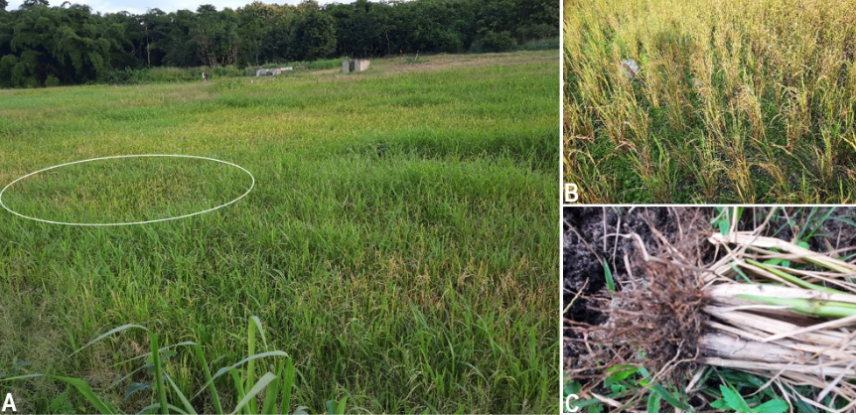

Fig. 1: Symptoms of stunted rice plants
A. Rice field with a patch of stunted plants; B. Chlorosis and necrosis on the leaves of stunted plants; C. Rice plant with reduced root system

3.2 Cropping Practices in Rice Fields

Rice farmers used different cropping practices in the surveyed rice fields. Three rice ecosystems were identified: irrigated, lowland, and upland rice. About 38% of the farmers cultivated either lowland or upland rice. However, irrigated rice was grown in 24% of the fields. Around 89% of the rice fields had rice as a previous crop, with multiple cropping cycles. Meanwhile, 11% of the fields remained fallow for 3 to 5 years.
Twelve rice cultivars were grown, including local varieties such as Kawan, Dozi, 3 months, 4 months, and Sangaré. The improved cultivars included Bouaké 189, CY2, C10, C26, Orylux 4, Orylux 6, and Wab 638-1. Among these, C26 was the most common, present in 15.38% of the surveyed fields. It is cultivated in lowland and upland ecosystems. Phytosanitary treatments applied included herbicides such as Oxadiazon, Oxadiargyl, Triclopyr, and Propanil.

3.3 Nematodes in Rice Fields

A diversity of plant-parasitic nematode populations was found in the cultivated rice fields of Côte d’Ivoire. Ten nematode genera, classified into eight families, were extracted from soil and rice root samples from the surveyed fields (Fig. 2). These included Pratylenchus and Hirschmanniella (Pratylenchidae), Heterodera (Heteroderidae), Meloidogyne (Meloidogynidae), Xiphinema and Longidorus (Longidoridae), Helicotylenchus (Hoplolaimidae), Trichodorus (Trichodoridae), Criconemella (Criconematidae), and Hemicycliophora (Hemicycliophoridae).



Fig. 2. Nematodes extracted from soil and rice root samples in Côte d’Ivoire
Pratylenchus (a), Hirschmanniella (b), Longidorus (c), Meloidogyne (d), Helicotylenchus (e), Criconemella (f), Heterodera (g), Trichodorus (h), Xiphinema (i) et Hemicycliophora (j)

3.4 Occurrence and Density of Nematodes in Rice Fields

All identified nematode populations were frequent in rice fields. They were found in at least 30% of the soil samples collected from these fields (Table 1). Only Pratylenchus sp., Hirschmanniella sp., Meloidogyne sp., Heterodera sp., Criconemella sp., and Longidorus sp. were present in all collected soil samples, indicating a 100% occurrence. The most abundant populations were Pratylenchus sp., Hirschmanniella sp., and Heterodera sp., with densities of 151, 35, and 23 individuals per 100 ml of soil samples, respectively. Other nematode populations were less abundant, with 1 to 10 individuals per 100 ml of soil samples.
Most nematode populations were frequent (occurring in at least 30% of the root samples), except for Hemicycliophora sp., which was not frequent (Table 1). Five nematode populations were present in all root samples collected from rice fields (100% occurrence). These included Pratylenchus sp., Hirschmanniella sp., Heterodera sp., Meloidogyne sp., and Longidorus sp. Additionally, Pratylenchus sp., Hirschmanniella sp., and Heterodera sp. were abundant in the roots, with densities of 1109, 241, and 160 individuals, respectively, in 5g of rice root samples. Although frequent, Meloidogyne sp. (65 individuals), Longidorus sp. (15 individuals), Criconemella sp. (11 individuals), Trichodorus sp. (4 individuals), Helicotylenchus sp. (39 individuals), and Xiphinema sp. (25 individuals) were not abundant in rice root samples. Hemicycliophora sp. was neither frequently nor abundantly found in rice root samples.
Table 1. Occurrence and density of nematodes in rice fields in Côte d’Ivoire

Nematodes | Soil |  |  | Roots
Nematodes | Occurrence (%) | Density  (100 ml soil) |  | Occurrence (%) | Density  (5g roots)
Pratylenchus sp. | 100 | 151 ± 11a |  | 100 | 1109 ± 41a
Hirschmanniella sp. | 100 | 35 ± 8b |  | 100 | 241 ± 21b
Heterodera sp. | 100 | 23 ± 5b |  | 100 | 160 ± 16b
Meloidogyne sp. | 100 | 10 ± 2c |  | 100 | 65 ± 5c
Longidorus sp. | 100 | 3 ± 1c |  | 100 | 15 ± 2c
Criconemella sp. | 100 | 2 ± 1c |  | 95,24 | 11 ± 2c
Helicotylenchus sp. | 76,19 | 6 ± 1c |  | 47,62 | 39 ± 4c
Xiphinema sp. | 61,90 | 4 ± 1c |  | 23,81 | 25 ± 3c
Trichodorus sp. | 57,14 | 1 ± 1c |  | 47,62 | 4 ± 1c
Hemicycliophora sp. | 52,38 | 1 ± 1c |  | 23,81 | 5 ± 1c
P | - | .000 |  | - | .003
Values with the same letter in each column are statistically identical at the 5% level; P is the probability value.

3.5 Nematode Density Based on the Agroecological Zones

Nematode population densities varied across agroecological zones (Table 2). Agroecological zones significantly affected nematode densities (P < 0.05), except for Trichodorus sp. and Criconemella sp., for which the effect was not significant (P ≥ 0.05). Nematode numbers were higher in rice fields within the southern dense forest zone (12 to 1756 individuals) and the semi-deciduous dense forest zone (10 to 1072 individuals) compared to other zones. Conversely, Heterodera sp. was most abundant in rice fields in the southern dense forest zone, with 292 individuals.

Table 2. Density of nematodes in rice fields based on the agroecological zones in Côte d’Ivoire

Nematodes | Southern Dense  Rainforest Zone | Western Dense  Rainforest Zone | Semi-Deciduous Rainforest Zone | P
Pratylenchus sp. | 1756 ± 101a | 70 ± 8b | 1072 ± 82a | .000
Hirschmanniella sp. | 336 ± 30a | 150 ± 33b | 316 ± 30a | .011
Heterodera sp. | 292 ± 24a | 70 ± 21b | 36 ± 9c | .000
Meloidogyne sp. | 72 ± 9b | 17 ± 9c | 114 ± 16a | .003
Xiphinema sp. | 22 ± 4b | 17 ± 2b | 44 ± 11a | .016
Trichodorus sp. | 4 ± 1a | 0 | 4 ± 2a | .212
Criconemella sp. | 12 ± 4a | 0 | 12 ± 6a | .083
Helicotylenchus sp. | 49 ± 6a | 34 ± 7b | 38 ± 10b | .034
Longidorus sp. | 14 ± 4b | 0 | 44 ± 12a | .002
Hemicycliophora sp. | 3 ± 1b | 0 | 10 ± 3a | .000
Values with the same letter in each line are statistically identical at the 5% level; P is the probability value.

3.6 Nematode Density Based on Rice Ecosystems

The nematode density varied across different rice ecosystems (Table 3). Nematodes were found in all rice ecosystems except for Xiphinema sp., Trichodorus sp., Criconemella sp., and Hemicycliophora sp., which were not reported in the irrigated rice samples. Conversely, Pratylenchus sp. was present in both upland and lowland rice samples, with 1748 and 1367 individuals, respectively. Hirschmanniella sp. was more abundant in upland and lowland rice samples (374 and 267 individuals, respectively) than in irrigated rice (81 individuals). Heterodera sp. showed higher abundance (432 individuals) in lowland rice samples compared to upland and irrigated rice (8 and 38 individuals, respectively). Meloidogyne sp. was more prevalent in upland rice samples (102 individuals) than in irrigated and lowland rice samples.

Table 3. Density of nematodes based on the rice ecosystems in Côte d’Ivoire

Nematodes | Upland Rice | Lowland Rice | Irrigated Rice | P
Pratylenchus sp. | 1748 ± 156a | 1367 ± 127a | 2 ± 1b | .000
Hirschmanniella sp. | 374 ± 28a | 267 ± 19b | 81 ± 7c | .000
Heterodera sp. | 39 ± 7b | 432 ± 33a | 8 ± 1c | .000
Meloidogyne sp. | 106 ± 16a | 75 ± 21b | 12 ± 3c | .000
Xiphinema sp. | 47 ± 5a | 26 ± 6b | 0 | .000
Trichodorus sp. | 9 ± 2a | 2 ± 1b | 0 | .000
Criconemella sp. | 23 ± 5a | 8 ± 1b | 0 | .000
Helicotylenchus sp. | 63 ± 6a | 48 ± 5a | 4 ± 1c | .000
Longidorus sp. | 3 ± 2b | 2 ± 2b | 39 ± 3a | .000
Hemicycliophora sp. | 10 ± 2a | 3 ± 1b | 0 | .000
Values with the same letter in each line are statistically identical at the 5% level; P is the probability value.

3.7 Nematode Distribution Based on Rice Ecosystems

The test of independence between nematode populations (rows) and rice ecosystems (columns) in the contingency table showed a p-value (P = .000) lower than the significance level (P = .050). Therefore, the null hypothesis was rejected in favor of the alternative hypothesis, indicating that the distribution of nematode populations was significantly associated with rice ecosystems. Additionally, the FCA revealed a total inertia value of 0.209.
The first and second axes of the FCA accounted for 100% of the data's variability, with axis 1 explaining 58.81% of the total variability. Two variables contributed to its formation: lowland and irrigated ecosystems (Table 4). The lowland ecosystem (.124) and irrigated ecosystem (0.984) had the highest cosine squared values. As a result, axis 1 contrasted the irrigated ecosystem on the left and the lowland ecosystem on the right (Fig. 3).
However, axis 2 accounted for 41.19% of the total data variability, influenced by two variables: upland and lowland ecosystems (Table 4). The upland ecosystem (0.999) and the lowland ecosystem (0.876) yielded the highest cosine squared values. Thus, axis 2 distinguished the lowland ecosystem at the top and the upland ecosystem at the bottom (Fig. 3).
Projection of the variables (rice ecosystems) and individuals (nematode populations) onto the biplot formed by axes 1 and 2 revealed three nematode population groups based on rice ecosystems in Côte d’Ivoire (Fig. 3). The AHC confirmed this result (Fig. 4). Pratylenchus sp., Hirschmanniella sp., Meloidogyne sp., Xiphinema sp., Helicotylenchus sp., Trichodorus sp., Criconemella sp., and Hemicycliophora sp., forming group 1, are significantly associated with the upland ecosystem. Meanwhile, Heterodera sp. (group 2) and Longidorus sp. (group 3) are associated with the lowland and irrigated ecosystems, respectively.
Table 4. Coordinates, squared cosine values, and the contribution of variables to principal factors

Variables | Coordinates |  |  | Squared cosine |  |  | Contributions (%)
Variables | Factor 1 | Factor 2 |  | Factor 1 | Factor 2 |  | Factor 1 | Factor 2
Upland | 0.009 | -0.534 |  | 0.000 | 0.999 |  | 0.014 | 49.300
Lowland | 0.190 | 0.552 |  | 0.123 | 0.876 |  | 4.804 | 48.510
Irrigated | -3.566 | 0.495 |  | 0.984 | 0.016 |  | 95.182 | 2.190

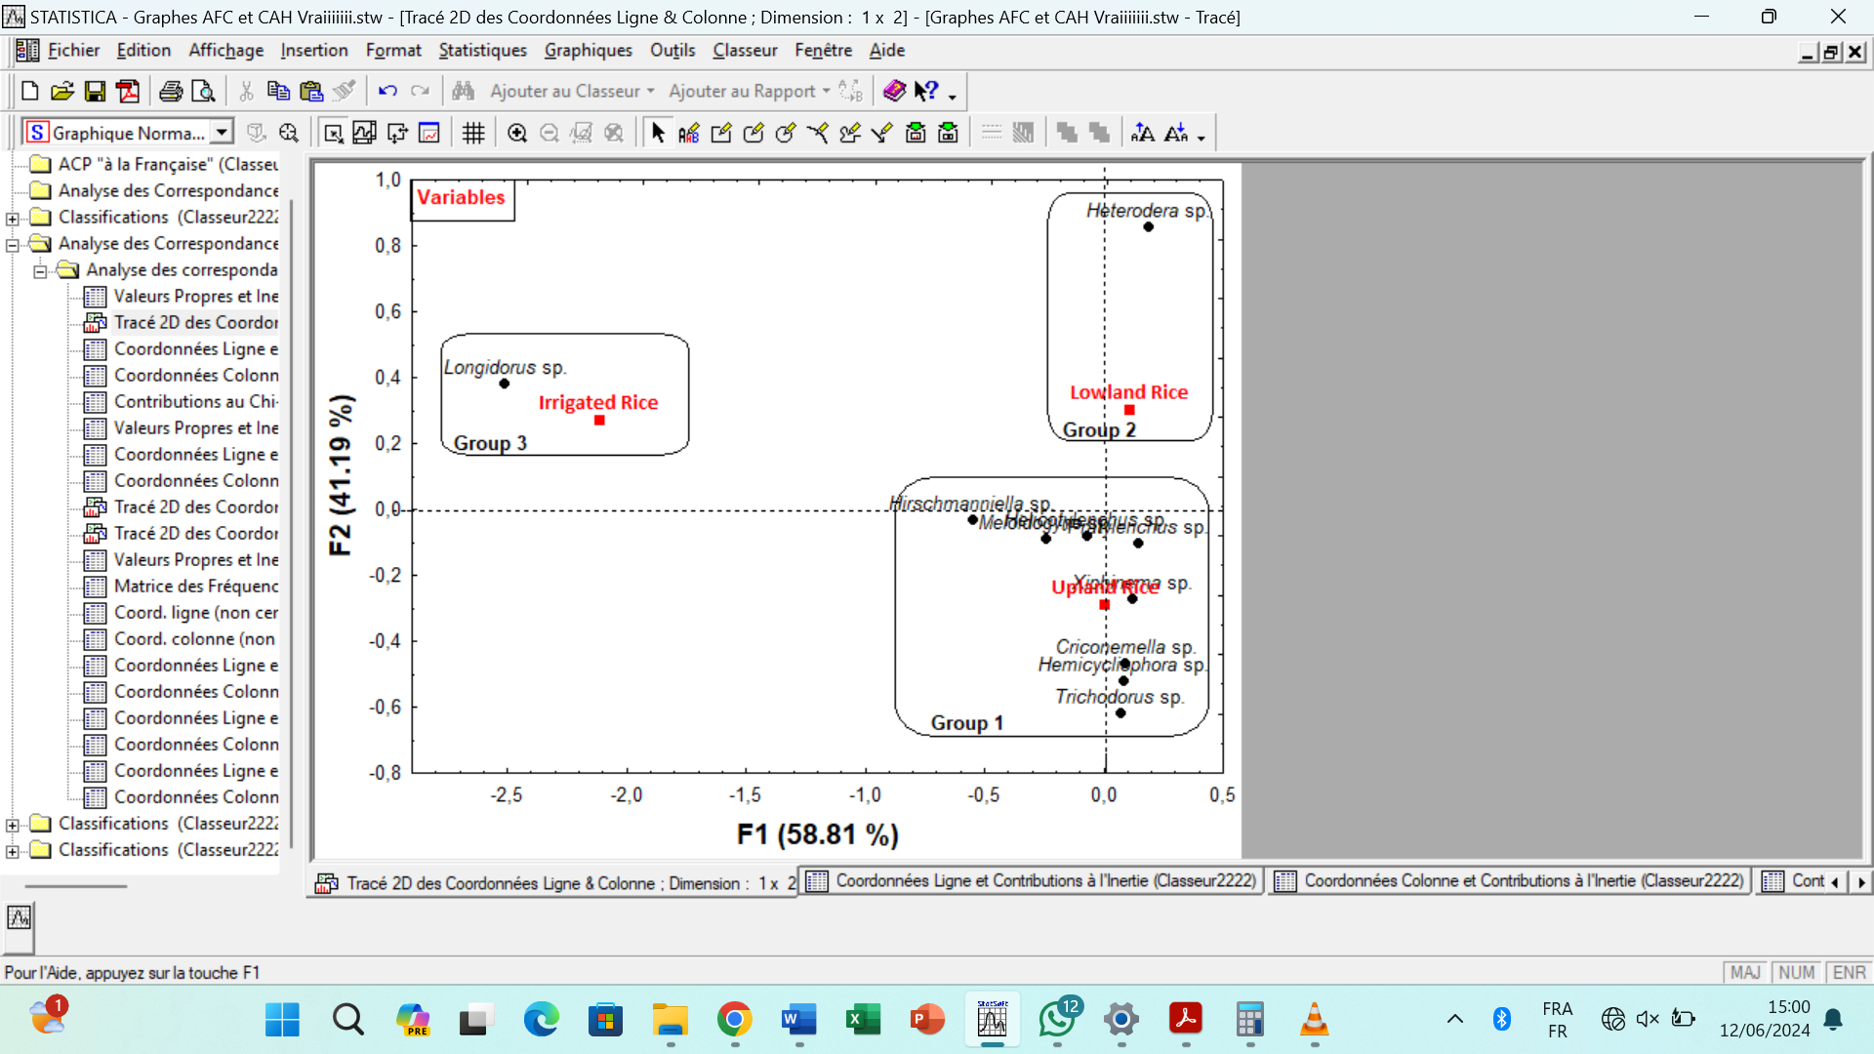

Fig. 3. Factorial plan with nematode groups
F1: Factor 1, F2: Factor 2

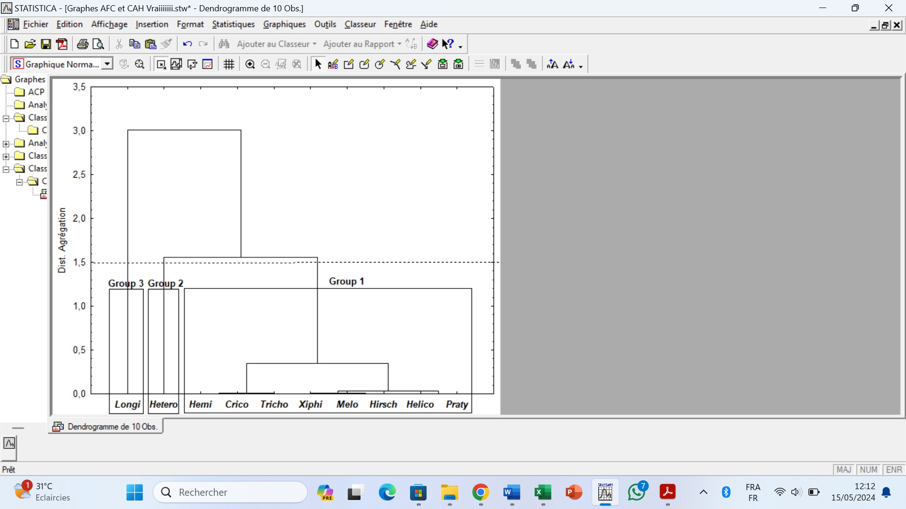

Fig. 4. Similarity dendrogram of nematode populations to rice ecosystems in Côte d’Ivoire
Longi: Longidorus sp., Hetero: Heterodera sp., Hemi: Hemicycliophora sp., Crico: Criconemella sp., Tricho: Trichodorus sp., Xiphi: Xiphinema sp., Melo: Meloidogyne sp., Hirsch: Hirschmanniella sp., Helico: Helicotylenchus sp., Praty: Pratylenchus sp.

4. discussion

This study revealed a variety of cropping practices in rice fields across three agroecological zones in Côte d’Ivoire. This variety of practices may result from several factors, including the diversity of rice cultivars and the suitability of ecosystems for rice cultivation. Côte d'Ivoire has three rice ecosystems: upland, lowland, and irrigated systems (ADERIZ, 2020). These ecosystems were documented during the current phytosanitary surveys. This finding underscores the significant agricultural potential of Côte d’Ivoire. According to the FAO (2012), Côte d’Ivoire has key advantages for advancing rice cultivation. These include a favorable climate for agriculture, particularly in terms of rainfall (800 to 1900 mm, depending on the season and zone). With political support, developing these ecosystems could enable Côte d’Ivoire to reach its goal of rice self-sufficiency by 2025 (Le Monde, 2019).
Côte d’Ivoire’s rice fields are ecosystems rich in plant-parasitic nematodes. Ten genera of these nematodes were extracted from soil and rice root samples, including Criconemella, Helicotylenchus, Hemicycliophora, Heterodera, Hirschmanniella, Longidorus, Meloidogyne, Pratylenchus, Trichodorus, and Xiphinema. The results support those of Triviño et al. (2016) and Gnamkoulamba et al. (2018), who extracted about ten plant-parasitic nematode genera from soil and rice roots in Ecuador and Togo, respectively. Nematode diversity is influenced by several factors, including vegetation, soil type, moisture, and temperature (Adediran et al., 2005). According to Wallace (1971) and Tiyagi et al. (1987), agricultural intensification can lead to continuous changes and instability in ecosystems, creating favorable conditions for certain plant-parasitic nematode species. Gnamkoulamba et al. (2018) identified similar nematode genera in Togo. Their findings suggest that these nematodes are linked to rice cultivation, and their presence could pose a threat to rice production.
In addition, Pratylenchus sp., Hirschmanniella sp., and Heterodera sp. were predominant in the rice fields. The dominance of these nematode populations in the surveyed fields may be attributed to the region's long-standing tradition of rice cultivation. Since rice is a staple food for the local population, it is cultivated in the same areas for multiple consecutive seasons. Farmers confirmed that the surveyed fields had been previously used for rice cultivation. Rice farming is prevalent in these regions, and traditional cropping practices have been passed down through generations. Consequently, there is co-evolution between rice and its associated populations of Pratylenchus sp., Hirschmanniella sp., and Heterodera sp. Because rice serves as a host for these nematodes, they were found to be very abundant in the roots across different production zones (Haougui and Basso, 2008; Pascual et al., 2014; Triviño et al., 2016; Thio et al., 2017; Nyaku et al., 2021). Several species of Pratylenchus, Hirschmanniella, and Heterodera are known pathogens of rice in West Africa (Coyne et al., 2001). According to De Deyn et al. (2004), cultivating a plant species can increase the abundance of nematode species specific to that plant.
Moreover, rice-associated nematode populations were more abundant in upland ecosystems than in other types of ecosystems. This abundance is attributed to several factors, including soil type, soil moisture, and agricultural practices (Pascual et al., 2014). Hydrology also significantly influences nematode population density and species composition (Coyne et al., 2001). In the study fields where upland rice was cultivated, rice was the previous crop. According to WARDA (1994), upland rice depends on in situ rainfall for moisture. It also relies on the rainfall distribution, the soil's water retention capacity, and the soil's root penetration ability, all of which depend on water supply (Raunet, 1985). Under these conditions, soils in upland rice fields tend to be less disturbed, which could facilitate the development of parasitic nematode communities in rice. This situation explains the predominance of nematodes in rice fields in the southern rainforest zone. Upland rice is more prevalent in this zone than in other areas, where irrigated and lowland rice are more common.
In the irrigated ecosystem, however, the fields are constantly flooded. As a result, rice roots develop under anaerobic conditions. Despite the presence of hosts, such conditions are unfavorable for the development of most plant-parasitic nematodes. Netscher and Erlan (1993) reported that in an irrigated ecosystem, the roots of rice plants were free of M. graminicola. Additionally, M. graminicola populations did not increase in irrigated rice fields (Win et al., 2013). Depending on the season, the soil in a lowland ecosystem may not be flooded (Raunet, 1985). This intermittent soil flooding can disrupt nematode communities in this soil type. Populations unable to tolerate the anaerobic conditions would die off. Such factors help explain the low abundance of nematodes in lowland and irrigated ecosystems.
Furthermore, a relationship exists between nematode populations associated with rice and rice ecosystems in Côte d’Ivoire. This result indicates that plant-parasitic nematodes occupy a diverse range of ecological niches. Keçici et al. (2022) reported that nematode species can be found in different soil ecosystems. According to Hunt et al. (2005), although they occupy different ecological niches, nematodes are essentially aquatic animals; they require at least a film of water to move around. All species of plant-parasitic nematodes spend most of their lives in the soil. The water content of the soil is therefore an important ecological factor. Although many species of plant-parasitic nematodes die in dry soils, others can survive in an anhydrobiotic environment. Conversely, too much water in the soil can cause a lethal oxygen deficit. However, some nematodes, including Hirschmanniella sp., can thrive under such conditions. Keçici et al. (2022) noted that various factors, including climatic conditions and the presence of hosts, influence the diversity of nematodes in ecosystems.
Factorial correspondence analysis showed that populations of Pratylenchus sp., Hirschmanniella sp., and Meloidogyne sp. were abundant in the upland ecosystem. This pattern is likely related to the soil, microclimate, and rice cultivars grown. Several of these nematode species are pathogenic to rice, causing yield losses of 13-29%. These include M. graminicola, M. oryzae, H. oryzae, and P. zeae (Bridge et al., 2005). The dominance of Meloidogyne sp. in the upland ecosystem contrasts with Bridge et al. (2005), who indicated that M. graminicola is well adapted to irrigated rice systems. Hirschmanniella sp. was also frequent in the upland ecosystem, though its presence in the lowland ecosystem is not insignificant. This observation contradicts Pascual et al. (2014) and Bridge et al. (2005), who found Hirschmanniella sp. was more abundant in lowland and irrigated ecosystems, respectively. Pratylenchus sp. was more prevalent in both upland and lowland ecosystems than in irrigated areas. This supports Pascual et al. (2014), who reported P. zeae as frequent and abundant in the upland ecosystems of the Philippines.
Conversely, the lowland ecosystem favors the development of Heterodera sp. populations, including H. oryzae, which was identified in Côte d’Ivoire's lowland regions (Fortuner and Merny, 1979). However, H. sacchari was found in upland and irrigated ecosystems across several West African countries, including Côte d’Ivoire, Ghana, Guinea, Benin, Togo, Nigeria, and Liberia (Coyne and Plowright, 2000). Rice plants infected with these nematodes exhibited stunted growth, with roots turning black or brown, and an increase in secondary root growth (Bridge et al., 2005). In Côte d’Ivoire, H. sacchari populations increased rapidly with the intensification of rice cultivation during the rainy season, resulting in yield losses of 50% (Coyne and Plowright, 1998). Besides rice, these nematodes also infest several weeds as alternative hosts, such as Cynodon dactylon, Mariscus umbellatus, and Kyllinga monocephala (Charles and Venkitesan, 1990).
Additionally, Longidorus sp. appears to prefer irrigated ecosystems, as supported by Bridge et al. (2005), who reported that Longidorus sp. and Paralongidorus sp. are frequently found in irrigated rice fields. They can survive in microaerobic or anaerobic conditions (Bridge et al., 2005). These nematodes cause stunted growth in rice planted during the summer. The primary roots develop necrotic and curved tips, while the secondary roots are shorter than normal, resulting in a significantly reduced root system (Stirling and Shannon, 1986). During this period, plants become stunted and form patches across the field. Ultimately, the risk of their spread remains low because nematodes are confined to irrigated ecosystems within a specific zone and have no other known hosts (Bridge et al., 2005).

5. Conclusion

Several plant-parasitic nematodes infect cultivated rice plants in the southern and western rainforest zones, as well as the semi-deciduous rainforest zone of Côte d’Ivoire. The most frequent and abundant populations in rice fields include Pratylenchus sp., Hirschmanniella sp., Heterodera sp., and Meloidogyne sp. The upland ecosystem promotes the development of a diverse range of nematodes, including populations of Pratylenchus sp., Meloidogyne sp., and Hirschmanniella sp. In contrast, the lowland and irrigated ecosystems favor the growth of Heterodera sp. and Longidorus sp. populations, respectively. Molecular and pathological characterizations of nematodes associated with rice in Côte d’Ivoire are necessary for improved management.

References

Adediran, J. A., Adegbite, A. A., Akinlosotu, T. A., Agbaje, G. O., Taiwo, L. B., Owolade, O. F. & Oluwatosin, G. A. (2005). Evaluation of fallow and cover crops for nematode suppression in three agroecologies of southwestern Nigeria. African Journal of Biotechnology, 4, 1034-1039.

ADERIZ (Agency for the Development of the Rice Sector) (2020). https://www.aderiz.ci/fr/index-classic.

Bla, K. B., Trébissou, J. N. D., Bidié, A. P., Assi, Y. J., Zirihi-Guédé, N. & Djaman, A. J. (2015). Ethnopharmacological study of antimalarial plants used by the Baoulé-N’Gban of Toumodi in central Côte d’Ivoire. Journal of Applied Biosciences, 85, 7775–7783. http://dx.doi.org/10.4314/jab.v85i1.4

Bolou, B. B. A., Abo, K., Doumbouya, M., Kouamé, K. G., Kassi, K. F., Tuo, S., Nahoua, K., Kouassi, N. P., & Koné, D. (2016). Analysis of Sclerotinia expression due to the fungus Sclerotium rolfsii in market gardening crops in the different agroecological zones of Côte d’Ivoire. Journal of Agriculture and Ecology Research International, 6(3), 1–12. https://doi.org/10.9734/JAERI/2016/23681

Bridge, J., Plowright, R.A. & Peng, D. (2005). Nematode parasites of rice, In M. Luc, R. A. Sikora, & J. Bridge (Eds.), Plant parasitic nematodes in subtropical and tropical agriculture (2nd ed., pp. 87-130). Wallingford: CAB International.

Castillo, P. & Vovlas, N. (Eds.). (2007). Pratylenchus (Nematoda: Pratylenchidae): Diagnosis, biology, pathogenicity and management, (6th ed.). Shine.

Charles, J.S.K. & Venkitesan, T.S. (1990). Host records of the rice cyst nematode, Heterodera oryzicola. Indian Journal of Nematology, 20, 222-224.

Coyne, D., Smith, M. & Plowright, R. (2001). Plant parasitic nematode populations on upland and hydromorphic rice in Côte d’Ivoire: relationship with moisture availability and crop development on a valley slope. Agriculture, Ecosystems and Environment, 84(1), 31-43. https://doi.org/10.1016/S0167-8809(00)00193-6

Coyne, D. L. & Plowright, R. A. (1998). Use of solarization to control Heterodera sacchari and other plant parasitic nematodes in the field: a modified technique for experimental purposes. International Journal of Nematology, 8, 81-84.

Coyne, D. L. & Plowright, R. A. (2000). Heterodera sacchari: field population dynamics and damage to upland rice in Côte d’Ivoire. Nematology, 2(5), 541-550. https://doi.org/10.1163/156854100509466

Coyne, D.L., Nicol, J.M. & Claudius-Cole, B. (Eds.). (2010). Practical Plant Nematology: A Field and Laboratory Guide. International Institute of Tropical Agriculture.

De Deyn, G. B., Raaijmakers, C. E., Van Ruijven, J., Berendse, F. & Van der Putten, W. H. (2004). Plant species identity and diversity effects on different trophic levels of nematodes in the soil food web. Oikos, 106(3), 576-586. https://doi.org/10.1111/j.0030-1299.2004.13265.x

FAO. 2012. https://www.fao.org/ag/aprao/projet-aprao/apercu-de-la-riziculture/cote-divoire/fr.

FAOSTAT. 2024. https://www.fao.org/faostat/en/#data/QCL.

Fortuner, R. & Merny, G. (1973). Root-parasitic nematodes associated with rice in Lower Casamance (Senegal) and Gambia. Cahiers ORSTOM, 21, 4-43.

Fortuner, R. & Merny, G. (1979). Root-parasitic nematodes of rice. Revue Nématologie, 2(1), 79-102.

Fresco, L. (2005). Rice is life. Journal of Food Composition and Analysis, 18(4), 249-253, https://doi.org/10.1016/j.jfca.2004.09.006

Gnamkoulamba, A., Tounou, A. K., Tchabi, A., Kolombia, Y.A., Agboka, K., Tchao, M., Adjevi, A. K. M. & Batawila, K. (2018). Occurrence, abundance, and distribution of plant-parasitic nematodes associated with rice (Oryza spp.) in different rice agroecosystems in Togo. International Journal of Biological and Chemical Sciences, 12(2), 618-635. https://dx.doi.org/10.4314/ijbcs.v12i2.1

Haougui, A. & Basso, A. 2008. Parasitic nematodes of irrigated rice in Niger. Science et technique, Sciences naturelles et agronomie, 30(2), 7-25.

Hunt, D. J., Luc, M. & Manzanilla-López, R. H. (2005). Identification, morphology, and biology of plant parasitic nematodes. In M. Luc, R. A. Sikora, & J. Bridge (Eds.), Plant parasitic nematodes in subtropical and tropical agriculture (2nd ed., pp. 11-52). Wallingford: CAB International.

Keçici, A. I., Bozbu˘ga, R., Öcal, A., Yüksel, E., Özer, G., Yildiz, S., Lahlali, R., Slaats, B., Dabbat, A. A. & ˙Imren, M. (2022). Diversity and identification of plant-parasitic nematodes in wheat-growing ecosystems. Microorganisms, 10(1534); 1-13. https://doi.org/10.3390/microorganisms10081534

Kouakou, Y. Y. F. R., Kra, K. D. & Atta, D. H. (2020). Distribution and dynamics of nematodes associated with cassava (Manihot esculenta Crantz) cultivation in two main production areas in Côte d’Ivoire. International Journal of Advanced Research, 8(11), 226-238. http://dx.doi.org/10.21474/IJAR01/12001

Kouassi, A. M., Kouamé, K. F., Koffi, Y. B., Dje, K. B., Paturel, J. E. & Oulare, S. (2010). Analysis of climate variability and its influences on rainfall patterns seasonal tricks in West Africa: the case of the N’zi (Bandama) catchment in Côte d’Ivoire. Cybergeo: European Journal of Geography, https://doi.org/10.4000/cybergeo.23388

The World. (2019). https://www.lemonde.fr/africa/article/2019/12/16/the-ivory-coast-long-road-to-rice-self-sufficiency_6023093_3212.html.

Mekete , T. , Dababat , A. , Sekora , N. , Akyazi , F. & Abebe , E. (Eds.). (2012). Identification key for agriculturally important plant-parasitic nematodes prepared for the International Nematode Diagnosis and Identification Course 2012. CIMMYT.

Netscher , C. & Erlan , X. (1993). A root-knot nematode, Meloidogyne graminicola, parasitic on rice in Indonesia. Asian Journal of Nematology, 3, 90-95.

Nyaku , S. T. , Lutuf , H. , Honger , J. O. , Dede , A. , Brentu , F. C. , Benissan , R. , Osabutey , S. , Labri , V. , Koranteng , E. , Afun , C. , Okyere , M. & Ablormeti , F. K. (2021). Prevalence of plant-parasitic nematodes in rice fields in Ghana. African Crop Science Journal, 29(4), 471-482. https://dx.doi.org/10.4314/acsj.v29i4.4

Ouédraogo , S. A. , Bockel , L. , Arouna , A. , Fatognon , I. & Gopal , P. (2021). Rice Value Chain Analysis in Côte d’Ivoire: Optimizing the Socio-Economic and Environmental Impact of a Self-Sufficiency Scenario to Horizon 2030. FAO. https://doi.org/10.4060/cb1506fr

Easter , M. L. D. , Decraemer , W. , Tandingan , De Ley , I. , Vierstraete , A. , Steel , H. & Bert , W. (2014). Prevalence and characterization of plant-parasitic nematodes in lowland and upland rice agroecosystems in Luzon, Philippines. Nematropics, 44, 166-180.

Raunet , M. ( 1985 ). Lowland and rice cultivation in Africa, a comparative structural approach. Tropical Agronomy, 40(3), 181-201.

Stirling , G. R. & Shannon , E. (1986). Needle nematodes. A potential problem for the Burdekin rice industry. Queensland Agricultural Journal, 112, 258-261.

Thio , B. , Ouédraogo , L. S. , Sanon , E. , Sankara , P. & Kiemde , S. (2017). Rice-associated parasitic nematodes in the three main rice ecologies in Burkina Faso. International Journal of Biological and Chemical Sciences, 11(3), 1178-1189. https://dx.doi.org/10.4314/ijbcs.v11i3.20

Tiyagi , S. A. , Bano , M. & Anver , S. (1987). Population build-up of phytonematodes associated with pearl millet. International Nematology Network Newsletter, 4, 19-20.

Triviño , C. , Navia-Santillan , D. & Velasco , L. (2016). Plant-parasitic nematodes associated with rice in Ecuador. Nematropics, 46, 45-53.

Wallace , H. R. ( 1971 ). The influence of the density of nematode populations on plants. Nematologica, 17, 154-166. https://doi.org/10.1163/187529271X00503

WARDA (West African Rice Development Association) (1994). Annual Report. West African Rice Development Association.

Win , P. P. , Kyi , P. P. , Maung , Z. T. Z. & De Waele , D. (2013). Population dynamics of Meloidogyne graminicola and Hirschmanniella oryzae in a double rice-cropping sequence in the lowlands of Myanmar. Nematology, 15; 795-8 http://dx.doi.org/10.1163/15685411-00002719

