Journal Name: | Journal of Advances in Biology & Biotechnology
Manuscript Number: | Ms_JABB_148442
Title of the Manuscript: | INVESTIGATION ON GENETICS CONTROLLING THE HIGH HEAD RICE RECOVERY UNDER HIGH-TEMPERATURE CONDITIONS
Type of the Article | Original Research Article

PART 1: Comments
 | Reviewer’s comment  Artificial Intelligence (AI) generated or assisted review comments are strictly prohibited during peer review. | Author’s Feedback (It is mandatory that authors should write his/her  feedback here)
Please write a few sentences regarding the importance  of this manuscript for the scientific community. A minimum of 3-4 sentences may be required for this part. | The subject of the study presented by the authors is interesting and topical, with scientific and practical importance.
Is the title of the article suitable?  (If not please suggest an alternative title) | The title of the article is appropriate, in relation to the topic addressed.
Is the abstract of the article comprehensive? Do you  suggest the addition (or deletion) of some points in this section? Please write your suggestions here. | The article Abstract is comprehensive and the keywords are representative of the article topic.
Is the manuscript scientifically, correct? Please write here. | The subsections and structure of the manuscript are appropriate, in accordance with the General Guideline for Authors, Journal of Advances in Biology & Biotechnology.  Scientifically, the article has a correct approach.  However, the Conclusions chapter is missing. It is recommended that this chapter be presented.
Are the references sufficient and recent? If you have suggestions of additional references, please mention them in the review form. | The scientific literature, to which the reporting was made, is recent and representative in the field. More extensive documentation would have been appropriate.

Is the language/English quality of the article suitable for scholarly communications? | The English language and the quality of the article are suitable for academic communications, and the article is accessible to readers.
Optional/General comments | 1.  It is recommended to present an equivalent term in English in parentheses, for better understanding by the readers.  e.g. "lakh acres"  2.  Some text portions are outside the page settings.  e.g. page 2 to page 4. Revision is recommended  3.  It is recommended to number the equations, to make reference in the text before presenting them.  e.g. page 3  4.  Citing bibliographic sources in the text. In most cases "et al." was written in regular text, and in some cases "et al." was written in Italic font style.  e.g.  page 5, “Abdelsatar et al., 2021”  5.  Presentation of tables.  Most tables are written appropriately on the page.  Table 4, page 7, is written differently, with a numerical field on the left. It is superimposed on Figure 1. Revision is needed.  e.g. (print screen)  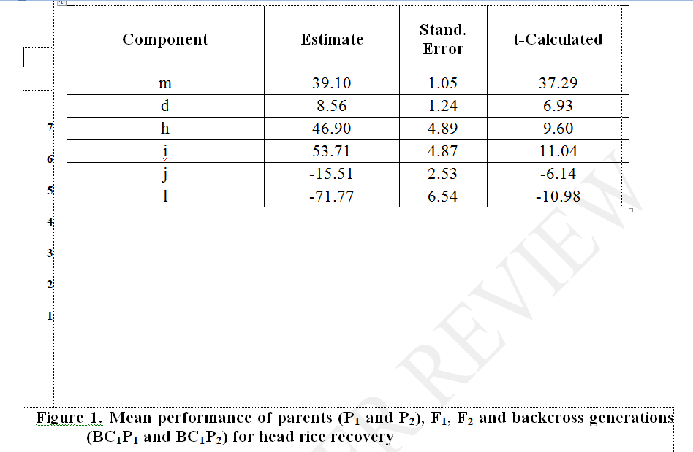  6.  Figure 1 is not visible. Document revision required.  7.  The Conclusions chapter is missing. It is recommended to present this chapter.

8.
It is recommended to revise the References chapter to be in line with the recommendations for Authors.

The subject of the study is interesting and topical, with high scientific and practical importance. The introduction is presented correctly, in accordance with the subject.
Methodology of the study was clearly presented, and appropriate to the proposed objectives.
The obtained results are important and have been analyzed and interpreted correctly, in accordance with the current methodology. The discussions are appropriate, in the context of the results, and was conducted compared to other studies in the field.
The Conclusions chapter is missing. It is recommended that authors present this chapter.
The scientific literature, to which the reporting was made, is recent and representative in the field. I appreciate that the article can be accepted for publication after minor corrections.

PART 2:
 | Reviewer’s comment | Author’s Feedback (It is mandatory that authors should write his/her  feedback here)
Are there ethical issues in this manuscript? | (If yes, Kindly please write down the ethical issues here in detail)  Not identified, not the case.

Reviewer details:

Florin SALA, University of Life Sciences “King Mihai I” from Timisoara, Romania

