Review Article

Bhut Jolokia and beyond-Exploring the genetic diversity of Northeast Indian capsicum species: A Review

ABSTRACT
Northeast India is recognized as a biodiversity hotspot for capsicum species, harbouring unique landraces such as Bhut Jolokia, Dalle Khursani, Mizo chilli and Hathei Chilli. This region, sustains an extraordinary range of chilli varieties, many carrying geographical indications. These capsicum landraces represent not only culinary treasures but also powerful genetic reservoirs, exhibiting remarkable capsaicinoids concentrations, phytochemical richness, and pronounced trait diversity. In the face of rising climatic and biotic stresses, their inherent resilience, nutritional value, and broad-spectrum bioactivity make them invaluable for future breeding programs, nutritional innovation, and therapeutic research. Recent molecular and morphological studies reveal significant intra- and interspecific variations among these landraces, highlighting their potential as sources of important alleles for tolerance to drought, pests, and diseases. Furthermore, the diverse metabolite profiles and distinctive fruit morphologies of North Eastern Indian capsicum support their industrial, pharmaceutical, and nutraceutical applications, promising enhanced global food security and sustainable agriculture. However, many of these resources remain underexplored due to limited research coverage, conservation efforts, and technical know-how. Emphasis is thus placed on systematic conservation and molecular exploitation of these capsicum genetic resources to ensure their sustainable use and to unlock novel traits for crop improvement worldwide. This review synthesizes current advances in the genetic, biochemical, and morphological characterization of these regional resources, underscoring their critical importance as a foundation for global chilli improvement and agricultural resilience
Keywords: Northeast India, Bhut Jolokia, genetic diversity, capsaicinoids, climate resilience breeding, nutraceutical potential, Geographical Indication
1. INTRODUCTION
Capsicum species, belonging to the family Solanaceae, are globally significant crops valued for their culinary, cultural, and industrial uses. In India, both green and red fruits are staple ingredients, while industrially, chillies are processed for value-added products such as powders, oleoresins, and pharmaceutical extracts (Bhavani et al., 2020). The crop originated in South America, where its cultivation dates back to around 7000 B.C. Of nearly 30 recognised species, five, viz., C. annuum, C. chinense, C. frutescens, C. baccatum, and C. pubescens, have been domesticated and are widely cultivated worldwide (Roy et al., 2024); (Naseem et al., 2024).
The word ‘chile,’ from the Nahuatl terms chilli or xilli, underscores its ethnobotanical and cultural roots in Mesoamerica. Chilli has over 200 common names worldwide, including ‘capsicum’ in Indian and Australian english, ‘chilli pepper’ or ‘sweet pepper’ in the UK, ‘bell pepper’ in North America, and ‘paprika’ in parts of Europe (Madala & Nutakki, 2020). According to De (2003), India’s multilingual context, C. annuum is known by numerous vernacular names, with early Sanskrit references such as Katuvira, Bruchi, Mairichi phalam, and Ujjvala.
Chillies (Capsicum spp.) were first domesticated in the tropical and subtropical regions of the Americas, especially present-day Mexico, Bolivia, and Peru, where they played a vital role in early civilisations’ diets and cultures. Their global spread began when Christopher Columbus introduced chilli seeds to Spain in 1493, after which Portuguese and Arabian traders carried them to Asia, particularly India. Shortly after 1498, Vasco da Gama’s arrival on the Malabar coast marked a key point in this transfer, while Christian missionaries later introduced capsicum species to Northeast India, adding to its diversity (Swamy, 2023). Northeastern India, spanning the plains of Assam and Tripura to the hills of Sikkim and Arunachal Pradesh, is considered an important centre of speciation for capsicum. The region harbours a wide diversity of domesticated landraces, including C. chinense (ghost pepper or Bhut Jolokia), noted for its distinctive aroma and extreme pungency (Baruah et al., 2023a). Pungency in chillies arises from capsaicinoids, secondary metabolites synthesised in the placental tissue. Beyond their role in flavour, these compounds exhibit pharmacological properties such as analgesic, antioxidant, and antimicrobial activities, contributing to their importance in both food and pharmaceutical sectors (Swamy, 2023)
Despite their significance, chilli cultivation is constrained by unstable yields, variation in pungency, pest susceptibility, and climate-related stresses. Addressing these challenges requires insights into the crop’s evolutionary history, economic role, genetic and biochemical diversity, and modern breeding prospects. Accordingly, this review discusses the morphological, molecular, and biochemical characterisation of capsicum species from Northeast India, highlighting their genetic richness, adaptive diversity, and breeding potential.
2. Economic importance and global standing of Indian chilli
India's long history of capsicum domestication and cultivation has culminated in its dominance of the global market. The nation is the world's leading producer of dry chillies, accounting for approximately 36% of the global supply. This position is fortified by India's diverse agroclimatic conditions and the rich genetic variety of its regional landraces. This leadership extends to the economic realm, with chilli exports generating a significant export revenue in 2023-2024, accounting for 48% of India's total spice export revenue and surpassing other major spices like cumin and turmeric. The high global demand for Indian chilli is primarily driven by its consistent quality, pungency, and high capsaicin content (Spices Board, 2024).
3. Capsicum species and their diversity: India
Chiltepín (Capsicum annuum var. glabriusculum) is recognised as a significant wild progenitor of chilli, serving as a crucial genetic resource for crop improvement (Votava et al.,2002). The concentration of capsaicinoids in chiltepín fruits varies significantly based on geographic location and environmental conditions. Some regions in northeastern Mexico, like Tamaulipas state, produce up to 84 tons of wild chilli annually. The variability in capsaicinoid levels is a key factor for breeding programs aiming to enhance flavour and marketability in cultivated varieties (Martínez-Ávalos et al., 2018).
The most popular species in India is C. annuum, are well-known for its pungent and non-pungent fruit varieties. Conversely, C. frutescens, C. chinense, and C. baccatum are less widely grown and are often limited to farmhouse gardening in various places. The majority of capsicum species are diploid with 24 chromosomes (2n = 2x = 24); however, variations in chromosome numbers, such as 2n = 32 and 2n = 48, have also been reported in certain species, like Dalle Khursani. Although most species are self-pollinating, cross-pollination does occur and contributes to species variation (Bhutia et al., 2019). Reported rates of natural cross-pollination in chilli are relatively low, typically ranging from 4% to 5% under normal field conditions (Maulani et al., 2023). Over time, India's native ethno-agricultural practices and the country's current climate have promoted the expansion and diversity of capsicum species (Swetha et al., 2023). According to Kishorkumar et al. (2024) India is considered a secondary hub for chilli diversity. As a result, several unique chilli landraces have emerged in different regions, with notable differences in characteristics such as size, shape, colour and heat levels. The classification and relationships among the major domesticated Capsicum species, along with the key cultivars of C. annuum exhibiting distinct fruit morphology and pungency levels, are illustrated in Fig. 1, providing a visual overview of their taxonomic diversity and agronomic relevance.
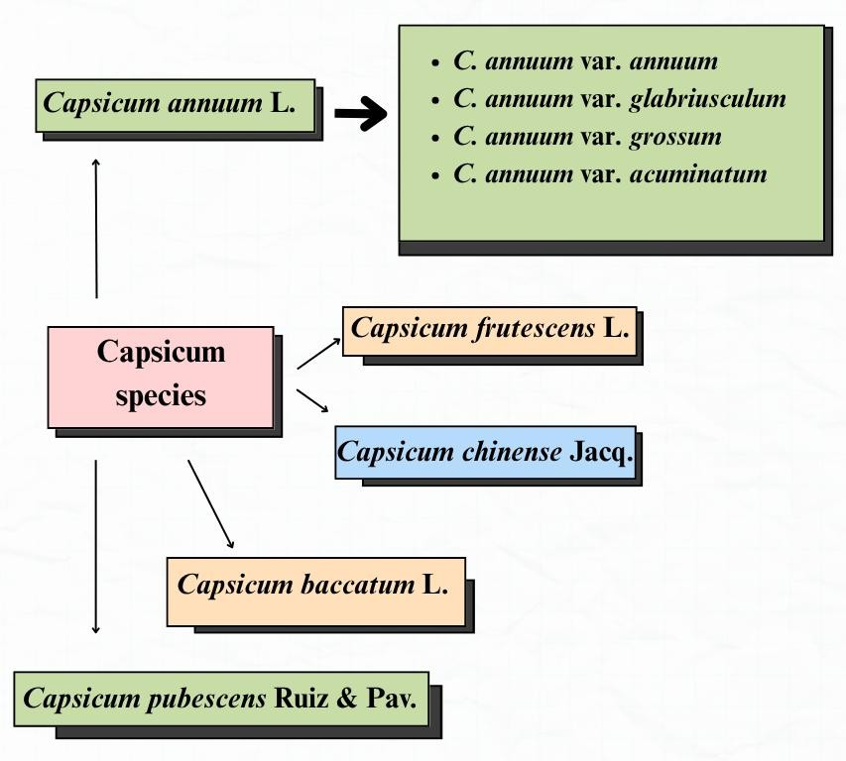
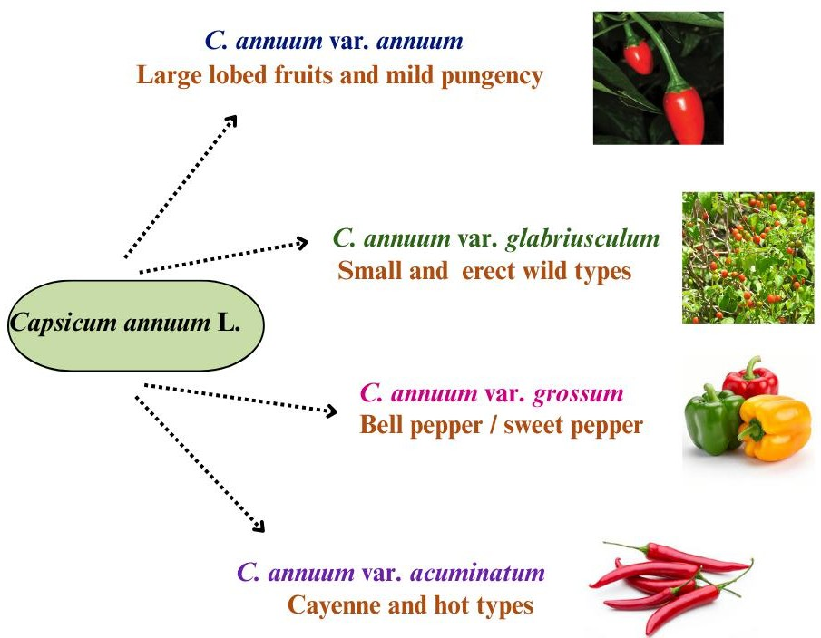
Fig. 1 Domesticated species of Capsicum spp. and major cultivars of C. annuum L.

3.1 Regional diversity of capsicum landraces in the Northeastern India
The primary cultivated species in this region are C. annuum, C. chinense, and C. frutescens, which collectively exhibit considerable genetic, morphological, and biochemical variation. These taxa constitute the main components of chilli cultivation and represent significant diversity within the genus (Dutta et al., 2025).
Capsicum annuum L. is the most widely cultivated capsicum species across India, including the Northeastern Himalayan region, showing extensive diversity in fruit shape, size, colour, and pungency, from hot chillies to sweet bell peppers (Naseem et al., 2024). C. frutescens L. (Bird’s eye chilli) is widely cultivated in Northeast India and is exemplified by landraces such as Dhani chilli in West Bengal. It is characterised by small yet intensely pungent fruits, erect and upright, with perennial growth and consistent cytogenetic features, including two pairs of satellite-bearing chromosomes (Jha & Bhowmick, 2021). C. chinense Jacq., particularly the Bhut Jolokia or Naga King chilli, stands out for its exceptional pungency and unique aroma. Bhut Jolokia gained international recognition after being certified by Guinness world records as the world's hottest chilli, with a Scoville Heat Unit (SHU) exceeding 1,000,000 (Sarwa et al., 2014). According to Baruah et al. (2024), Bhut Jolokia, distributed mainly across Assam, Nagaland, Manipur, and Mizoram, is notable for its unusually high capsaicin content compared to other Indian varieties
4. Breeding for agronomic and qualitative traits
Capsicum species in Northeast India exhibit extensive diversity, reflected in their morphological traits, biochemical profiles, and genetic makeup, which collectively enable the identification and conservation of valuable landraces. Integrating these characterisation approaches assists in understanding evolutionary relationships, supports breeding efforts, and promotes the development of cultivars suited to specific ecological niches and agricultural needs.
4.1 Pungency and associated phytochemical diversity in north-east capsicum landraces
Capsaicin, the compound responsible for chilli pungency, varies among types and determines each chilli’s heat level. The North Eastern region of India serves as a crucial centre of Capsicum diversity, harbouring highly pungent landraces such as Bhut Jolokia and Dalle Khursani (Colney et al., 2018; Baruah et al., 2023; Meitei et al., 2025). According to Baruah et al. (2023) and Meitei et al.(2025), the extreme pungency of these cultivars, driven by elevated capsaicinoid levels, enhances their economic importance for industrial extraction. Molecular characterization using SSR markers and sequencing of key pungency genes like Acs1, Kas1, and pAmt/Pun1 revealed that Dalle Khursani accessions are genetically closer to pungent C. annuum (Colney et al., 2018). Furthermore, large-scale genetic evaluation of C. chinense (ghost pepper) identified high variability and demonstrated that capsaicin content, fruit yield per plant, fruit length, and fruit girth exhibits high heritability with substantial genetic advance, indicating that direct selection is an effective breeding strategy (Baruah et al., 2023). Complementary untargeted metabolomic profiling of four heirloom North Eastern landraces representing C. chinense, C. annuum, and C. frutescens genotypes identified 2,702 putative metabolites, showing greater variation among species than within species, and confirming significant variability in capsaicin content that provides molecular biomarkers and targets for chilli improvement programs (Meitei et al., 2025)
The selection of elite lines for pungency, stress resistance, and nutritional enhancement in India has relied heavily on biochemical profiling of capsicum genotypes. Byadgi and Arka lines were among the 22 genotypes evaluated according to JC & SC (2017), in the hilly region of Uttarakhand. The biochemical superiority of Pant C-1 and Byadgi Kaddi × Arka Lohit was established after they found a wide range in ascorbic acid and capsaicin. C. annuum's ascorbic acid (vitamin C) and capsaicin levels vary significantly among fruit colours based on pigment composition, maturity stage, and genetic factors (Choi et al., 2023). Patel et al., (2024), also demonstrated diversity in protein, carbohydrate, and ascorbic acid among Indian chilli varieties, using PCA to identify clusters with superior nutritional quality. Complementing this profile, these peppers contain abundant carotenoids; total carotenoid content varied significantly across genotypes, registering values up to 7.72 mg/100 g dry weight (Dubey et al., 2015), with carotene levels reaching 4.45 mg/L in some accessions (Mena et al., 2018). The key biochemical constituents, such as capsaicin, ascorbic acid, carotenoids, and flavonoids are summarised in Fig. 2, which illustrates their physiological roles in determining pungency, antioxidant capacity, and overall therapeutic potential.

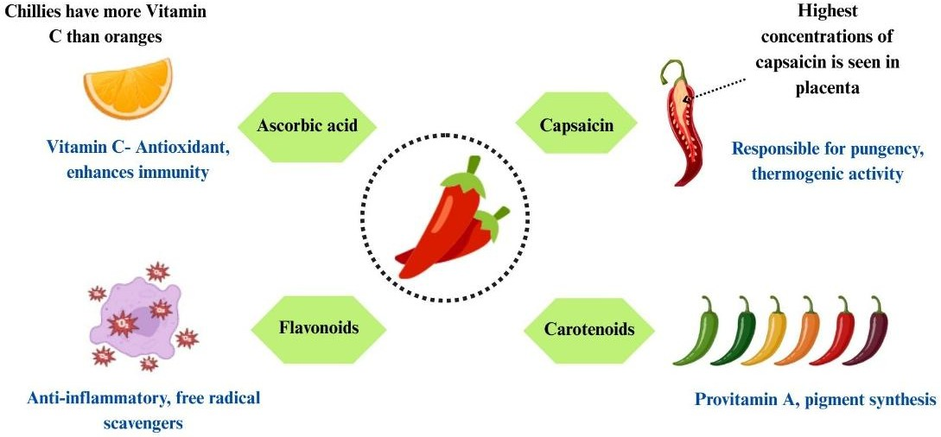

Fig.2 Major biochemical compounds of chilli

4.2 Therapeutical value of northeast Indian capsicum species
According to Phairong et al. (2020), capsicum species endemic to Northeast India, such as Bhut Jolokia (C. chinense) and Mizo chilli (C. frutescens), serve as rich natural repositories of capsaicinoids, the key bioactive compounds responsible for their medicinal and ethnopharmacological significance. The exceptionally high capsaicin content in Bhut Jolokia, often exceeding 3% compared to less than 1% in other Indian chillies, enhances its pharmaceutical potential (Tiwari et al., 2005; Baruah & Lal, 2020). As reported by Phairong et al. (2020) and (Prasad et al., 2004), capsaicin functions as a potent analgesic, effective against inflammation and arthritis. Traditional applications of Bhut Jolokia include treatments for gastrointestinal ailments, asthma, toothache, and muscle pain (Bhagowati & Changkija, 2009; Baruah & Lal, 2020). Sarwa et al. (2014), demonstrated that semi-purified capsaicinoids from Bhut Jolokia, when formulated in nanovesicle carriers, exhibit significant anti-arthritic efficacy with reduced irritant effects. Furthermore, capsaicin displays anticancer and antioxidant properties, inhibiting malignant cell growth, inducing apoptosis, and offering superior oxidative stress protection compared to garlic and ginger (Surh, 2002); (Shobana & Akhilender Naidu, 2000); Phairong et al., 2020). Collectively, these findings emphasize the therapeutic potential of Northeast Indian Capsicum species for novel drug development (Phairong et al., 2020).
4.3 North eastern capsicum species: A source for climatic and biotic resilient breeding
According to Roy et al. (2024), capsicum species across Northeast India, a major center of diversity, exhibit diverse adaptive responses to abiotic and biotic stresses crucial for climate resilience. C. chinense (Naga King Chilli) thrives in mildly warm and humid conditions (12.2°C–28.6°C) but remains highly susceptible to extreme heat and submergence, showing low recovery rates. However, its accumulation of high proline content under drought stress indicates inherent tolerance mechanisms (Roy et al., 2024). Rai et al. (2014), identified Naga King Chilli as a novel source of resistance to pepper leaf curl virus, while certain C. chinense genotypes (Bhut Jolokia) were found symptomless or resistant to anthracnose caused by Colletotrichum capsici (Garg et al., 2013). In contrast, the Dalle chilli (C. annuum) landrace serves as a valuable winter hardy resource, adapted to cool and humid conditions suitable for breeding frost-tolerant varieties (Verma et al., 2024). Shin & Yun, (2010), reported increasing vulnerability of endemic chilli cultivation due to rising incidences of thrips-transmitted tospoviruses, whitefly-transmitted begomoviruses, and bacterial diseases intensified by elevated temperature and CO₂ levels. To counter such climate-induced stresses, the use of protected cultivation systems like low-cost polyhouses has been suggested as an effective intervention (Verma et al., 2018).
5.Geographical Indication (GI) tagged northeastern Chilli landraces
5.1 Bhut Jolokia
Native to Assam, Nagaland, and Manipur in northeast India, Bhut Jolokia is a landrace of Capsicum chinense, also known as Ghost Pepper. It’s extremely high capsaicin content has earned its place in the Guinness book of world records (2006) as the world's hottest chilli, with a Scoville Heat Unit (SHU) exceeding 1,000,000 SHU units (Sarwa et al., 2012). This unique genotype is an interspecific hybrid of C. chinense and C. frutescens, with strong pungency and stable genetic homogeneity, according to molecular and morphological analysis (Purkayastha et al., 2012). In recognition of its regional and ecological significance, Bhut Jolokia was officially designated as a Geographical Indication (GI) in 2008 (Swamy, 2023). It has long been used to treat ailments like sore throats, arthritis, gastritis, and respiratory disorders, and it has significant cultural and medicinal value (Baruah et al., 2023b). M et al. (2016), conducted a comprehensive metabolite and gene expression profiling study and found that Bhut Jolokia exhibits significantly higher expression of metabolites such as dihydrocapsaicin and tocopherols, as well as pungency-related genes like Pun1 and Acs1.
2. Dalle Khursani
Dalle Khursani, a landrace predominantly cultivated in the mid-hill zones of Sikkim and Darjeeling, possesses distinctive characteristics such as perennial growth and winter hardness, enabling its resilience in mountainous temperate climates (Verma et al., 2024). Furthermore, analyses have confirmed high concentrations of capsaicinoids and other secondary metabolites, which account for its notable pungency, robust flavour, and potential nutraceutical applications (Ghimiray et al., 2024). While genetic studies classify it within the Capsicum annuum species, this landrace maintains significant intra-landrace diversity. This genetic variation makes it a valuable resource for breeding programs seeking to enhance heat and stress tolerance in chilli crops (Colney et al., 2018).
3. Mizo chilli
The Mizo Chilli (Hmarcha te), a highly pungent Capsicum frutescens landrace indigenous to the hills of Mizoram, was granted Geographical Indication (GI) status in 2021. This designation recognises the unique characteristics imparted by the region's specific agro-climatic conditions (Spices Board, 2023). The landrace is distinguished by its exceptional pungency; studies report that Grade A fruits may contain capsaicin levels as high as 607.9 mg per 100 g dry weight (Dutta et al., 2025). Beyond its culinary applications, the Mizo Chilli holds significant ethnopharmacological value, traditionally employed by Mizo communities as an analgesic and anti-inflammatory agent (Phairong et al., 2020)
4. Hathei Chilli
The Hathei Chilli (Capsicum annuum L.), locally known as “Sirarakhong Hathei”, is an indigenous landrace cultivated exclusively in Sirarakhong village, Ukhrul district of Manipur. This chilli is recognised for its deep natural red colour, moderate pungency, and rich pigment content, characteristics that make it highly valued both for culinary uses and as a natural colorant (Spices board, 2023).
The distribution of GI tagged chilli landraces across the Northeastern states such as Bhut Jolokia (Assam, Nagaland, and Manipur), Dalle Khursani (Sikkim and Darjeeling), Mizo Chilli (Mizoram), and Hathei Chilli (Manipur) is depicted in Fig. 3
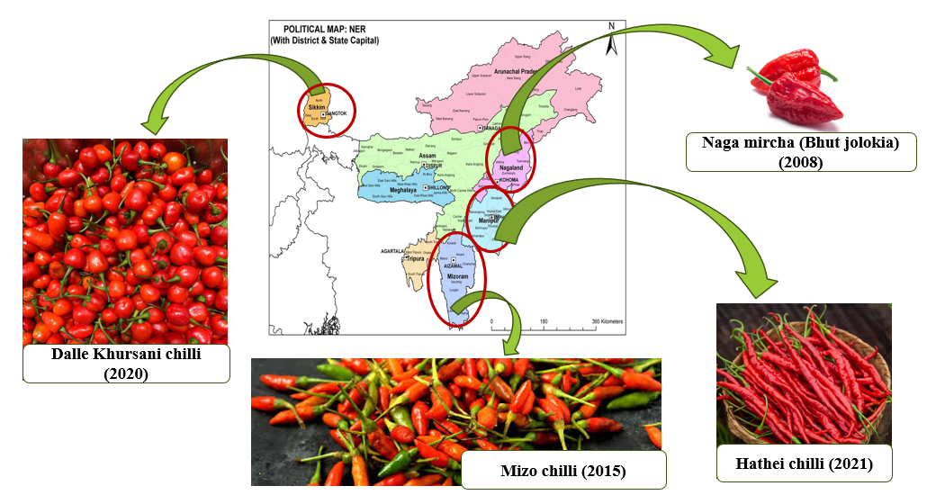

Fig.3 Geographical indication tagged chillies of North east India

CONCLUSION AND FUTURE PROSPECTS
Northeast India holds an unparalleled repository of Capsicum genetic resources, encompassing an extraordinary range of landraces distinguished by their unique phytochemical compositions, morphological diversity, and notable adaptive traits. In particular, landraces such as Bhut Jolokia, Dalle Khursani, Mizo chilli, and Hathei Chilli serve as vital genetic reservoirs contributing to enhanced resilience, nutritional value, and multifaceted utility in breeding, nutrition, and therapeutic innovation. Comprehensive morphological, biochemical, and molecular characterisations have substantially advanced our understanding of these resources, illuminating their significance not only in regional agriculture but also within the global context of chilli improvement programs.
However, substantial gaps remain in both research intensity and systematic conservation efforts, leaving many valuable genetic resources underutilised. To harness the full breeding potential and ensure sustainable utilisation, future research should emphasise high-throughput genomic and metabolomic profiling, functional validation of adaptive and quality-related alleles, and participatory on-farm conservation strategies. Integrating advanced biotechnological approaches with traditional knowledge can unlock novel traits conferring tolerance to emerging biotic and abiotic stresses. Strengthened regional, national, and international collaborations, coupled with policy support for germplasm protection and equitable benefit-sharing, will be essential to safeguard and leverage Northeast India’s Capsicum diversity for food security, climate resilience, and the development of next-generation nutraceutical and pharmaceutical products.
DISCLAIMER (ARTIFICIAL INTELLIGENCE)
The author(s) hereby declare that generative AI technologies and language assistance tools were used during the writing and editing of this manuscript. The following tools were employed exclusively for grammar correction, language refinement, and structural clarity. All intellectual content, interpretation, and scientific conclusions are entirely the author’s own.
Details of AI usage are as follows:
- Grammarly – Used for grammar, punctuation, and style correction.
- ChatGPT (GPT-5, OpenAI) – Used for improving sentence flow, paraphrasing, and ensuring academic tone consistency.
- NotebookLM (Google) – Used for organizing references, summarizing sections, and ensuring logical coherence.

REFERENCES
Baruah, J., Begum, T., & Lal, M. (2024). Estimation of environment stability for fruit yield and capsaicin content by using two models in Capsicum chinense Jacq. (Ghost pepper) with multi-year evaluation. PeerJ, 12, e17511. https://doi.org/10.7717/peerj.17511
Baruah, J., Munda, S., Sarma, N., Begum, T., Pandey, S. K., Chanda, S. K., Sastry, G. N., & Lal, M. (2023). Estimation of genetic variation in yield, its contributing characters and capsaicin content of Capsicum chinense Jacq. (Ghost pepper) germplasm from Northeast India. PeerJ, 11, e15521. https://doi.org/10.7717/peerj.15521
Bhagowati, R. R., & Changkija, S. (2009). Genetic variability and traditional practices in Naga King Chilli landraces of Nagaland. Asian Agri-History, 3, 171–180.
Bhavani, B., Anilkumar, C., Rao, A. M., & Ramesh, S. (2020). Genetics of fruit oleoresin and capsaicin contents in chilli inter-species (Capsicum annuum × C. chinense) cross. Plant Genetic Resources: Characterization and Utilization, 18(1), 28–30. https://doi.org/10.1017/S1479262119000418
Bhutia, K. L., Bhutia, N. D., & Khanna, V. (n.d.). Rich genetic diversity of Capsicum species in Northeast India as a potential source for chilli crop improvement.
Choi, M.-H., Kim, M.-H., & Han, Y.-S. (2023). Physicochemical properties and antioxidant activity of colored peppers (Capsicum annuum L.). Food Science and Biotechnology, 32(2), 209–219. https://doi.org/10.1007/s10068-022-01177-x
Colney, L., Tyagi, W., & Rai, M. (2018). Morphological and molecular characterization of two distinct chilli cultivars from North Eastern India with special reference to pungency-related genes. Scientia Horticulturae, 240, 1–10. https://doi.org/10.1016/j.scienta.2018.05.045
De, A. K. (Ed.). (2003). Capsicum: The genus Capsicum. Taylor & Francis.
Dubey, R. K., Singh, V., Upadhyay, G., Pandey, A. K., & Prakash, D. (2015). Assessment of phytochemical composition and antioxidant potential in some indigenous chilli genotypes from North East India. Food Chemistry, 188, 119–125. https://doi.org/10.1016/j.foodchem.2015.04.088
Dutta, D., Das, S. K., Haider, I., Sony, S. K., & Mitra, S. (2025). Evaluation of genetic diversity among Naga chili (Capsicum chinense Jacq.) samples available in Bangladesh. Plant Tissue Culture and Biotechnology, 34(2), 133–140. https://doi.org/10.3329/ptcb.v34i2.78828
Garg, R., Kumar, S., Kumar, R., Loganathan, M., Saha, S., Kumar, S., Rai, A. B., & Roy, B. K. (2013). Novel source of resistance and differential reactions on chilli fruit infected by Colletotrichum capsici. Australasian Plant Pathology, 42(2), 227–233. https://doi.org/10.1007/s13313-012-0194-7
Ghimiray, T. S., Majumdar, B., & Man, S. (2024). Determination of capsaicin content and pungency levels in Dalle Khursani accessions, a polyploid Capsicum species specific to Darjeeling–Sikkim Himalaya, India. Plant Biology. https://doi.org/10.1101/2024.09.25.614886
JC, T., & SC, P. (2017). Biochemical evaluation of chilli (Capsicum annuum L. var. Acuminatum Fingerh.) genotypes under hill zone of Bharsar, Pauri Garhwal, Uttarakhand, India.
Kishorkumar, G. K., Ajjappalavara, P. S., Jawadagi, R. S., Satish, D., Nishani, S., Ravikumar, B., Patil, H. B., & Vinaykumar, M. M. (2024). Character association and path analysis studies for yield and yield attributes in industrially valued elite dry chilli (Capsicum annuum L.) genotypes. Plant Archives, 25(1). https://doi.org/10.51470/PLANTARCHIVES.2025.v25.supplement-1.072
M, S., Gaur, R., Sharma, V., Chhapekar, S. S., Das, J., Kumar, A., Yadava, S. K., et al. (2016). Comparative analysis of fruit metabolites and pungency candidate gene expression between Bhut Jolokia and other Capsicum species. PLOS ONE, 11(12), e0167791. https://doi.org/10.1371/journal.pone.0167791
Madala, N., & Nutakki, M. K. (2020). Hot pepper: History, health and dietary benefits & production.
Martínez-Ávalos, J. G., Venegas-Barrera, C. S., Martínez-Gallegos, R., Torres-Castillo, J. A., Olazarán Santibáñez, F. E., Mora-Olivo, A., Guerra-Pérez, A., et al. (2018). A review on the geographical distribution, fruit production and concentration of capsaicinoids in Capsicum annuum var. Glabriusculum in the northeastern region of Mexico. Chemistry. https://doi.org/10.20944/preprints201811.0517.v1
Maulani, R., Murti, R. H., & Purwantoro, A. (2023). Molecular diversity in populations of chili (Capsicum annuum L.). SABRAO Journal of Breeding and Genetics, 55(1), 15–24. https://doi.org/10.54910/sabrao2023.55.1.2
Meitei, A. L., Yogendra, K., Sanivarapu, H., Meetei, N. T., Rai, M., & Tyagi, W. (2025). Metabolite profiling reveals differential accumulation of secondary metabolites related to flavour and colour across four heirloom chilli landraces. Physiology and Molecular Biology of Plants, 31(3), 477–491. https://doi.org/10.1007/s12298-025-01576-4
Mena, E., Warade, S., & Ansari, M. T. (n.d.). Evaluation of capsaicin, ascorbic acid, α-carotene and β-carotene in Bhut Jolokia (Capsicum chinense Jacq.) genotypes from North East India.
Naseem, M., Rana, R. M., Mahmood Ul Hassan, Khan, M. A., Binobead, M. A., Elsadek, M. F., Elsalahy, H. H., & Iqbal, R. (2024). High-performance liquid chromatography (HPLC)-based genetic diversity profiling of chilli germplasm for fruit pungency and phytochemical contents. BMC Plant Biology, 24(1), 368. https://doi.org/10.1186/s12870-024-05055-y
Patel, J. S., Prajapati, K. N., Tiwari, K., Chaudhari, M. K., Gondaliya, S. B., Joshi, V. A., & Vyas, S. R. (2024). Assessing chilli genotypes: A study of morphological and nutritional traits. Asian Journal of Research in Biochemistry, 14(4), 84–94. https://doi.org/10.9734/ajrb/2024/v14i4296
Phairong, M. M., Lalbiaknunga, J., & Lalnunmawia, F. (2020). Mizo chilli (Capsicum frutescens): A potential source of capsaicin with broad-spectrum ethnopharmacological applications. Journal of Pharmacognosy and Phytochemistry, 9(5), 670–672. https://doi.org/10.22271/phyto.2020.v9.i5j.12306
Prasad, N. S., Raghavendra, R., Lokesh, B. R., & Naidu, K. A. (2004). Spice phenolics inhibit human PMNL 5-lipoxygenase. Prostaglandins, Leukotrienes and Essential Fatty Acids, 70(6), 521–528. https://doi.org/10.1016/j.plefa.2003.11.006
Purkayastha, J., Alam, S., Gogoi, H., Singh, L., & Veer, V. (2012). Molecular characterization of “Bhut Jolokia,” the hottest chilli. Journal of Biosciences, 37(4), 757–768. https://doi.org/10.1007/s12038-012-9249-8
Rai, V. P., Kumar, R., Singh, S. P., Kumar, S., Kumar, S., Singh, M., & Rai, M. (2014). Monogenic recessive resistance to pepper leaf curl virus in an interspecific cross of Capsicum. Scientia Horticulturae, 172, 34–38. https://doi.org/10.1016/j.scienta.2014.03.039
Roy, S. J., Regon, P., & Tanti, B. (2024). Morpho-physiochemical responses of Capsicum chinense Jacq. (Bhut Jolokia) under different abiotic stresses. Vegetos, 37(5), 1817–1832. https://doi.org/10.1007/s42535-024-00825-3
Sarwa, K. K., Das, P. J., & Mazumder, B. (2014). A nanovesicle topical formulation of Bhut Jolokia (hottest Capsicum): A potential anti-arthritic medicine. Expert Opinion on Drug Delivery, 11(5), 661–676. https://doi.org/10.1517/17425247.2014.891581
Shin, J.-W., & Yun, S.-C. (2010). Elevated CO₂ and temperature effects on the incidence of four major chili pepper diseases. The Plant Pathology Journal, 26(2), 178–184. https://doi.org/10.5423/PPJ.2010.26.2.178
Shobana, S., & Naidu, K. A. (2000). Antioxidant activity of selected Indian spices. Prostaglandins, Leukotrienes and Essential Fatty Acids, 62(2), 107–110. https://doi.org/10.1054/plef.1999.0128
Spices Board, Ministry of Commerce & Industry, Government of India. (2023, March 31). List of Geographical Indication (GI) tags registered for spices [PDF]. Spices Board India. https://www.indianspices.com/sites/default/files/List_of_GItags_for_spices_BJ.pdf
Spices Board, Ministry of Commerce & Industry, Government of India. (n.d.). Spices Board India. https://www.indianspices.com/
Surh, Y.-J. (2002). Anti-tumor promoting potential of selected spice ingredients with antioxidative and anti-inflammatory activities: A short review. Food and Chemical Toxicology, 40(8), 1091–1097. https://doi.org/10.1016/S0278-6915(02)00037-6
Swamy, K. R. M. (2023). Origin, distribution, taxonomy, botanical description, genetic diversity and breeding of Capsicum (Capsicum annuum L.). International Journal of Development Research, 13(3), 61956–61977.
Swetha, B. (2023). Variability studies and genetic divergence in chilli (Capsicum spp.) genotypes using multivariate analysis. Electronic Journal of Plant Breeding, 14(3). https://doi.org/10.37992/2023.1403.105
Tiwari, A., Kaushik, M. P., Pandey, K. S., & Dangi, R. S. (2005). Adaptability and production of hottest chilli variety under Gwalior agro-climatic conditions. Current Science, 88(10), 1545–1546.
Verma, V. K., Pandey, A., Thirugnanavel, A., Rymbai, H., Dutta, N., Kumar, A., Bhutia, T. L., et al. (2024). Ecology, genetic diversity, and population structure among commercial varieties and local landraces of Capsicum spp. grown in northeastern states of India. Frontiers in Plant Science, 15, 1379637. https://doi.org/10.3389/fpls.2024.1379637
Votava, E. J., Nabhan, G. P., & Bosland, P. W. (n.d.). Genetic diversity and similarity revealed via molecular analysis among and within an in situ population and ex situ accessions of chiltepin (Capsicum annuum var. Glabriusculum).

