Original Research Article
Optimisation of Regeneration and Agrobacterium-Mediated Transformation Protocol for Black Rice (Oryza sativa L. cv. Chakhao poireiton)

.
ABSTRACT

Aims:
To develop and optimise an efficient in vitro regeneration and Agrobacterium-mediated transformation protocol for black rice (Oryza sativa L. cv. Chakhao poireiton*), a nutritionally rich but low-yielding and stress-susceptible variety, thereby establishing a reproducible system for its genetic improvement.
Study Design:
The study followed an experimental design involving factorial combinations of auxin and cytokinin treatments for callus induction and shoot regeneration, followed by Agrobacterium-mediated genetic transformation.
Place and Duration of Study:
This research was conducted at the Agricultural Biotechnology Laboratory, Faculty of Agricultural Science and Technology, Assam Agricultural University, Jorhat, India.
Methodology:
Mature embryos of black rice were cultured on N6-based media containing different concentrations of 2,4-D and VACA to assess callus induction frequency. Regeneration potential was evaluated using combinations of kinetin and BAP in N6RH50 medium. Hygromycin sensitivity tests were used to determine the minimum lethal dose for effective selection of transformants. Transformation was performed using Agrobacterium tumefaciens strain LBA4404 harbouring the binary vector pCAMBIA1304, and GUS histochemical assays were used to confirm successful T-DNA delivery.
Results:
The combination of 1 g L⁻¹ VACA and 2 mg L⁻¹ 2,4-D yielded the highest callus induction frequency with friable, embryogenic calli. The maximum shoot regeneration rate (55%) was achieved with 4–5 mg L⁻¹ kinetin in N6RH50 medium. Hygromycin at 30 mg L⁻¹ was found to be the minimum lethal concentration for selection. Transformed calli exhibited strong blue colouration in GUS assays, confirming successful gene delivery.
Conclusion:
The optimised regeneration and transformation system provides a reliable and reproducible platform for the genetic improvement of black rice, establishing a foundation for future molecular breeding and functional genomics aimed at enhancing yield and stress tolerance.

Keywords: [Agrobacterium tumefaciens, Black rice; Oryza sativa L. cv. Chakhao Poireiton; regeneration optimisation; GUS assay; embryogenic callus; auxin–cytokinin balance; transformation efficiency.)

1. INTRODUCTION

Rice black (Oryza sativa L.), especially the Chakhao, a group of Manipuri landraces. This colored rice is prized for its distinctive anthocyanin-rich pericarp, high nutritional value, and medicinal properties such as anti-inflammatory, anti-cancer, and antioxidant properties (Sompong et al. 2011, Shao and others. (2018). In Northeast India, particularly in Manipur, it is also very significant from a cultural and economic standpoint (Roy et al., 2021). However, its commercial cultivation is limited due to its lengthy growth period, low yield potential, and susceptibility to both biotic and abiotic stresses (Singh et al., 2020; Devi et al., 2023). Because of these challenges, black rice genetic improvement must be given top priority by both breeders and policymakers. Conventional breeding techniques have not been able to enhance complex traits like yield stability and stress tolerance in black rice because of low genetic diversity and strong linkage drag from undesirable traits (Das et al. 2021, Chauhan et al. 2018). Modern plant biotechnology, particularly genetic transformation, offers an alternative approach for rapidly introducing beneficial genes and analysing gene function (Hiei et al., 2014; Tyagi et al., 2021). Because of its high efficiency, stable gene integration, and relatively low transgene copy number, Agrobacterium tumefaciens-mediated transformation is the most widely used method currently available for rice (Nishimura et al., 2006; Lin et al., 2018). However, the effectiveness of this approach is greatly impacted by genotype-specific responses during in vitro regeneration, therefore, developing optimised protocols is essential for resistant cultivars like Chakhao poireiton (Ge et al., 2021; Htwe et al., 2006). The success of Agrobacterium-mediated transformation depends on the efficient selection of transformed tissues, efficient shoot regeneration, and the induction of morpho-genetically competent calli (Rashid et al., 2011; Sahoo et al., 1996). The ratio of auxins to cytokinins in the medium is an important factor in these processes (Ishida et al., 2015; Zhang et al., 2022). Further, the selection pressure is commonly applied using antibiotics such as geneticin or hygromycin, which must be precisely calibrated to avoid escapes and excessive tissue death (Karthikeyan et al., 2011; Kalbande et al., 2023). Although elite indica and japonica cultivar transformation systems have advanced significantly (Hiei & Komari, 2008; Sahoo et al., 2011), there aren't many systematic optimisation studies for pigmented rice genotypes. The Chakhao variety currently faces a significant obstacle to molecular breeding and functional genomics because there is no reliable high-efficiency transformation method. Hence, the current study set out to create an Agrobacterium-mediated transformation and regeneration protocol that is ideal for Chakhao poireiton in order to bridge this gap. This work improves critical parameters for callus induction, shoot regeneration, and transformant selection, laying the groundwork for future genetic improvement strategies aimed at yield, stress resilience, and nutritional enhancement in black rice.

2. material and methods
2.1 Plant Material and Sterilizations
Seeds of black rice (Oryza sativa L. cv. Chakhao poireiton) were obtained from local farmers of Manipur, India. Mature grains were dehusked manually and surface sterilized with 70% ethanol for 1 min, followed by immersion in 0.1% mercuric chloride (HgCl₂) for 5 min under aseptic conditions. The seeds were rinsed five times with sterile distilled water to remove traces of sterilant and blot-dried on sterile filter paper prior to inoculation (Khanna and Raina, 2002; Hiei & Komari, 2008).
2.2 Callus Induction and Maintenance
Mature embryos grown on modified 2N6 medium were used to induce callus (Chu et al., 1975), supplemented with vitamin assay casamino acids (VACA, 0.1–1.0 g L⁻¹) and 2,4-dichlorophenoxyacetic acid (2,4-D, 1.0–2.5 mg L⁻¹). After adjusting the pH of the medium to 5, 80% agar was added and autoclaved for 15 minutes at 121°C. The cultures were maintained in total darkness for 7 to 10 days at 30 ± 2°C. Every ten days, calli that were actively proliferating were sub-cultured to a new medium for continued growth (Figure 1A–B). Rashid et al. 2004 calculated the callus induction frequency (CIF) as the proportion of explants that developed callus. Two intervals were used to calculate the relative growth rate (RGR) of calli: 26–39 days and 39–52 days following inoculation according to any formula or citiation???.
2.3 Shoot Regeneration
Twenty-day-old embryogenic calli were placed in regeneration medium (N6RH50) containing three distinct cytokinin treatments: kinetin (1.5 mg L⁻¹), BAP (0.5 mg L⁻¹) + kinetin (0.5 mg L⁻¹), and kinetin (4.5 mg L⁻¹). Cultures were kept at 28 ± 2°C with a photoperiod of 16 hours of light and 8 hours of darkness. After 14 days, the frequency of regeneration was computed (Ramesh et al., 2009).
2.4 Agrobacterium-Mediated Transformation
Agrobacterium tumefaciens strain LBA4404 carrying the binary vector pCAMBIA1304, which contains the GUSA reporter and hptII selectable marker genes, was used for transformation (Jefferson et al., 1987). Calli that were actively growing were submerged in a bacterial suspension made in AAM medium (OD660 = 0.3) (Hiei et al., 1994), added 100 µM acetosyringone and gently shaken for 15 minutes. To eliminate Agrobacterium-infected calli, the calli were blotted dry and co-cultivated on 2N6-As medium at 25°C in the dark for three days. After that, they were transferred to selection medium (2NBKCH40) containing hygromycin (30 mg L⁻¹) and cefotaxime (250 mg L⁻¹) (Komari et al., 2006). To encourage the growth of altered tissues, surviving calli were subcultured every ten days.
2.5 Optimisation of Hygromycin Concentration
Untransformed calli were inoculated on 2N6 medium containing 0, 30, 40, 50, and 60 mg/L⁻¹ hygromycin in order to find the minimum lethal dose (MLD) of hygromycin for selection (Figure 4). Ten days later, observations were documented (Cheng et al., 1998). For the selection of transformed cells, complete mortality at ≥30 mg L⁻¹ was considered the critical threshold. The survival rate (%) was calculated as the mean ± SE of three replicates.
2.6 Histochemical GUS Assay
The Jefferson et al. (1987) method was used to confirm gusA expression in transformed calli using the histochemical GUS assay. After being submerged in Buffer P (50 mM phosphate buffer, pH 6.8, containing 0.1% Triton X-100) for one hour at 37°C, the calli were transferred to Buffer X (1 mM X-Gluc in Buffer P with 20% methanol) for five minutes under a light vacuum. For the entire night, the tissues were incubated in the dark conditions at 37°C. While control (non-transformed) tissues remained unstained transformed calli showed blue coloration which indicated GUS activity.
2.7 Statistical Analysis
All experiments were conducted in triplicate, and data were expressed as mean ± standard error (SE). Statistical analyses were performed using one-way analysis of variance (ANOVA), and treatment means were compared using Tukey’s HSD test (p < 0.05, p < 0.01, p < 0.001) with GraphPad Prism version 10 software (Motulsky, 2023).

3. results and discussion

3.1 Optimisation of callus induction frequency in black rice
Mature Oryza sativa L. CV. Chakhao Pireiton embryos were used to measure the effect of different 2,4-D and VACA concentrations on callus induction frequency (CIF).. The combination of 1 g/L VACA and 2 mg/L 24-D produced the highest CIF of all the combinations tested. This treatment performed significantly better than the others (Figure 1). Calli on this medium were cream-colored, friable, and ideal for subsequent regeneration. The results demonstrate that callus induction requires both 24-D and VACA with this combination yielding the highest induction efficiency.
3.2 Relative growth rate of callus under optimised auxin concentrations
The relative growth rate (RGR) of callus was calculated over two growth intervals (26–39 days and 39–52 days). The medium containing 1 g/L VACA and 2 mg/L 2,4-D supported the highest RGR at both intervals with significant variations when compared to other auxin concentrations (Figure 2). This suggests that callus initiation is encouraged and sustained over time by the optimal hormonal balance.
3.3 Shoot regeneration efficiency under different cytokinin treatments
To determine the optimal cytokinin regime for regeneration calli were grown on N6RH50 medium supplemented with different concentrations of kinetin and BAP. Just 4-5 mg/L of kinetin was needed to achieve the maximum regeneration efficiency of 55% (Figure 3). Calli grown in this way produced healthy green shoots but lower regeneration percentages were caused by lower kinetin levels or kinetin–BAP combinations.
3.4 Hygromycin sensitivity assay for selection of transformants
In order to determine the minimum lethal concentration for efficient selection following transformation the sensitivity of black rice callus to hygromycin was evaluated. At hygromycin concentrations of ≥30 mg/L there was no surviving calli and complete mortality and browning were observed (Figure 4). Consequently, this concentration was chosen as the post-transformation selection standard.4.5 Confirmation of transformation by histochemical GUS assay. Calli underwent histochemical GUS staining after being transformed by Agrobacterium tumefaciens LBA4404 using the pCAMBIA1304 vector. In contrast to control calli, which displayed no staining, transformed calli displayed intense blue colouration, signifying the expression of the gusA reporter gene (Figure 5). Under the optimised transformation protocol, these findings validate transient expression in black rice callus and successful T-DNA delivery.
We have developed a dependable and reproducible Agrobacterium-mediated transformation and in vitro regeneration protocol for the culturally and agronomically valuable black rice cultivar Chakhao poireiton by carefully optimising the media components and selection criteria. Our results corroborate those found in broomcorn millet, where moderate auxin levels perform better than oversaturating concentrations, which instead result in tissue browning and reduced potential for regeneration (Matsumoto et al. 2024). We showed that the auxin–humic acid combination of 1 g/L⁻¹ VACA and 2 mg/L⁻¹ 24-D produced friable embryogenic calli and significantly increased the frequency of callus induction. Through auxin-like activity, humic substances further improve callus competence and quality (Zhang et al., 2024). Indica rice lines that support high RGR media and display improved transformation and regeneration rates showed a similar pattern (Li et al., 2023). With high relative growth rates over two successive growth phases, the callus also showed a sustained proliferation capacity under this ideal hormonal regime, indicating its suitability for downstream procedures. Supplements such as Pluronic F-68 and (Singh & Patel, 2023) promote the development of calluses (Kim et al., 2021). We discovered that the highest regeneration efficiency of 55 percent for shoot organogenesis was produced by 4.5 mg/L⁻¹ kinetin alone on N6RH50 medium. This validates that, as shown in IR-64 and related lines, kinetin was superior to BAP or mixed cytokinin regimes in shoot induction for resistant indica cultivars (Khan et al. Rahman et al. 2020. Similar kinase-centric media improved plantlet regeneration in Malaysian indica rice (Chong et al. 2021). To optimise transformant selection, a threshold of 30 mg/L⁻¹ hygromycin was set. Complete callus mortality was the outcome of this threshold which effectively removed non-transformed tissue while preserving the possibility of regeneration (Figure 4). Although genotype-specific modifications are required to prevent over-selection that could suppress even transformed tissues, this concentration is consistent with results in a range of rice genotypes where 30 to 50 mg/L⁻¹ provides effective selection without compromising regeneration (Sudhakar et al., 2021; Liu et al., 2022). The transient gusA expression following Agrobacterium tumefaciens LBA4404 transformation was confirmed in treated calli by intensely stained GUS, whereas controls were not stained (Figure 5). This confirms promoter-driven expression and T-DNA delivery, and it aligns with successful protocols in other indica cultivars such as MR219 and North East rice accessions, where transformation efficiency was consistently demonstrated by GUS assays (Kumar et al. 2018; Toki 2016 )Since transformation efficiency is known to be influenced by a number of variables including bacterial strain optical density co-cultivation time acetosyringone concentration and selection agent choice these variables must all be optimized for greater integration rates (Singh et al., 2020; Jain & Munir, 2019)]. The foundation for functional genomics and molecular breeding of Chakhao poireiton is laid by our optimised protocol, which includes callus initiation, shoot regeneration, and initial gene delivery. This opens the door to traits that improve yield and stress tolerance. However, stable transgenic selection and molecular confirmation (PCR, Southern blotting, or sequencing) are required to transform transient gene expression into stable genetic integration (Rahman and Ahmed 2022, Zhao et al. 2023). Confirming that the procedure works with other Oryza sativa cultivars and looking into enhancements like surfactants antinecrotic supplements or alternative antibiotic regimens could further improve transformation results (Fernandez et al. 2017 Wang and others. 2024 Oliveira-Silva and associates. 2022). Therefore this study is a major step forward in the genetic modification of black rice opening the door for targeted biotechnological interventions that will allow the development of advanced traits.
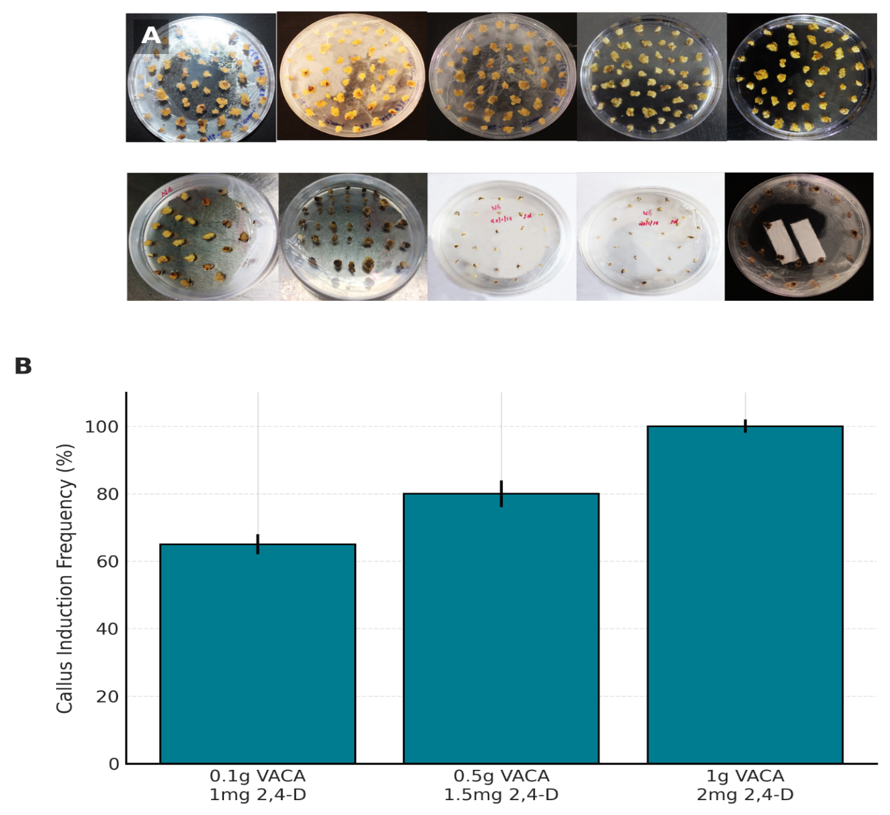

Fig. 1. Effect of 2,4-D and VACA concentrations on callus induction frequency (CIF) in black rice (Oryza sativa L. cv. Chakhao poireiton).
(A) Callus induction at different 2,4-D and VACA concentrations (20 days of culture).
(B) Callus induction frequency (%) showing the highest CIF with 1 g L⁻¹ VACA + 2 mg L⁻¹ 2,4-D, indicating the optimal medium composition for initiating callus from mature embryos. Data represent mean ± SE of three replicates.
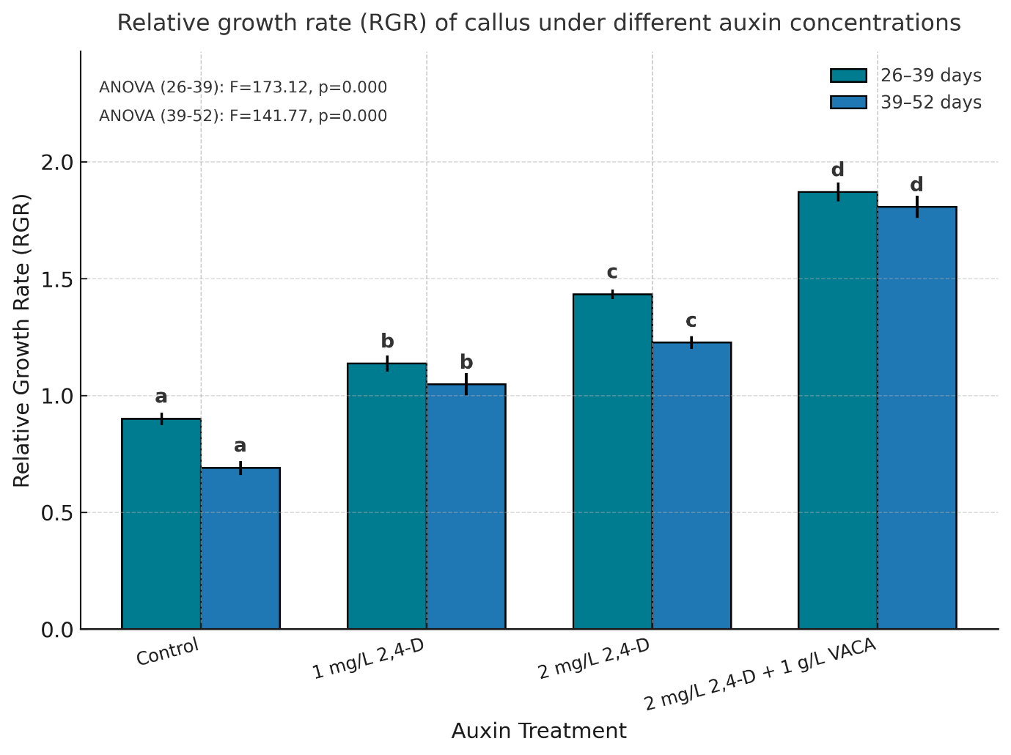
Fig. 2. Relative growth rate (RGR) of callus under different auxin concentrations.
RGR was recorded during two growth intervals (26–39 days and 39–52 days after culture initiation) in calli derived from mature embryos of black rice (Oryza sativa L. cv. Chakhao Poireiton*). Bars represent mean ± SE (n = 4). Distinct letters above bars indicate statistically significant differences among treatments according to Tukey’s HSD test (p < 0.05) following one-way ANOVA. The medium supplemented with 1 g L⁻¹ VACA + 2 mg L⁻¹ 2,4-D exhibited the highest RGR, confirming its suitability for sustained callus proliferation.

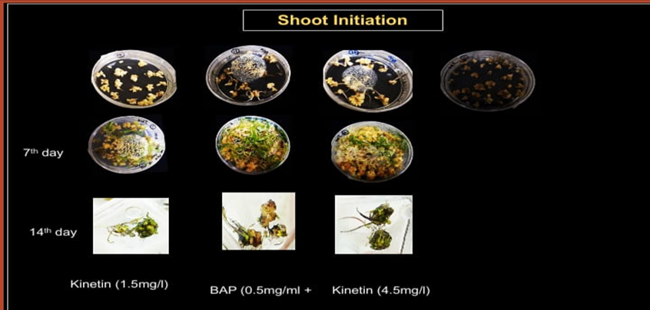
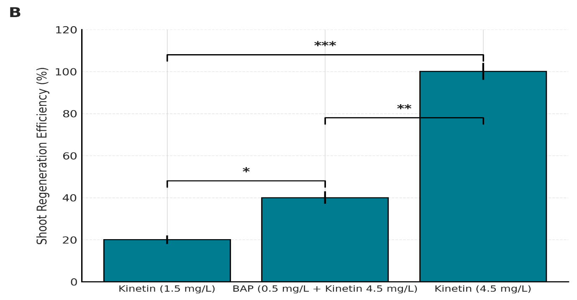
Fig. 3. Shoot regeneration efficiency under different cytokinin treatments in black rice callus.
(A) Shoot initiation and regeneration response of black rice (Oryza sativa L. cv. Chakhao poireiton*) calli cultured on N6RH50 medium supplemented with various cytokinin combinations for 7 and 14 days.
(B) Regeneration percentages (mean ± SE, n = 3) compared across kinetin alone and kinetin–BAP combinations. Maximum regeneration (≈ 55 %) was observed using 4.5 mg L⁻¹ kinetin in N6RH50 medium. Significance levels: p < 0.05 (), p < 0.01 (), p < 0.001 ().

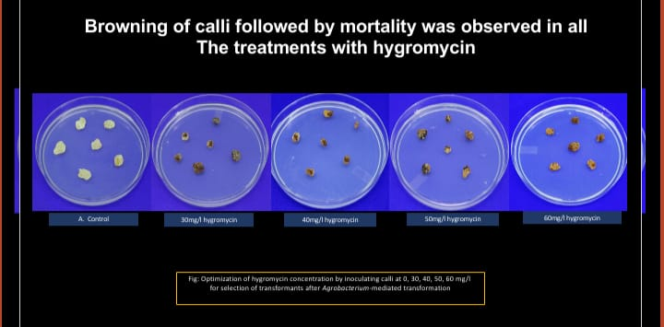

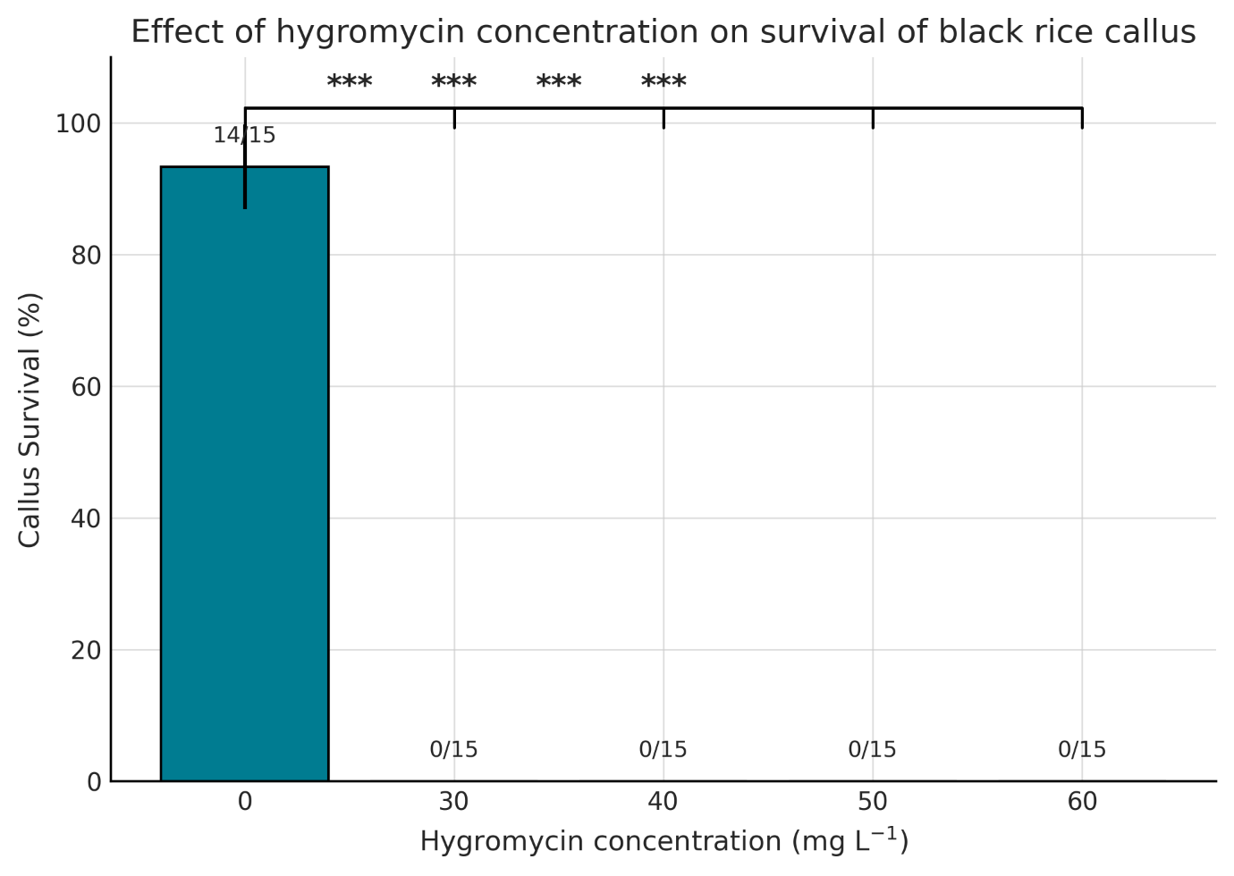

Fig. 4. Effect of hygromycin concentration on survival of black rice callus following Agrobacterium-mediated transformation.
(A) Response of black rice (Oryza sativa L. cv. Chakhao poireiton) calli cultured on selection medium containing different hygromycin concentrations (0–60 mg L⁻¹) for two weeks. Progressive browning and necrosis were observed with increasing hygromycin levels, and complete mortality occurred at concentrations ≥ 30 mg L⁻¹.
(B) Survival percentage of callus (mean ± SE, n = 3) under increasing hygromycin concentrations. Statistical analysis using Fisher’s exact test showed significant reductions in survival compared with the control (0 mg L⁻¹) at all concentrations (p < 0.001 ***). The minimum lethal dose for effective selection of transformants was established at 30 mg L⁻¹.
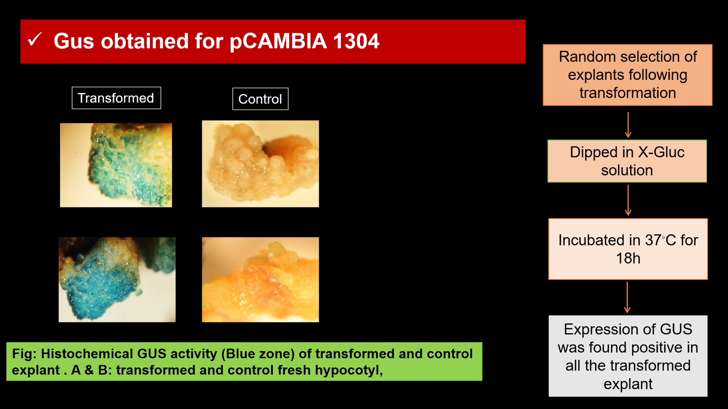

Fig. 5. Histochemical GUS assay of transformed and control black rice callus.
Transformed calli showed intense blue colouration after X-Gluc staining, confirming gusA reporter gene expression. No staining was observed in control calli

4. Conclusion

The current study creates a repeatable and efficient in vitro regeneration and initial genetic transformation protocol for the black rice cultivar Chakhao poireiton a genotype valued for its nutritional profile and cultural significance houwever, considered to be extremely resistant in tissue culture. By carefully optimizing key parameters we demonstrated that the combination of 1 g/L⁻¹ VACA and 2 mg/L⁻¹ 24-D supports high-frequency induction of friable embryogenic calli while maintaining sustained relative growth rates across subculture cycles. A 55% regeneration efficiency was achieved with the optimal kinetin dosage of 4-5 mg L⁻¹ for shoot regeneration. Hygromycin sensitivity tests revealed that a 30 mg L⁻¹ threshold was an effective selection pressure for eliminating non-transformed calli without appreciably reducing regeneration potential. Transformation attempts using Agrobacterium tumefaciens strain LBA4404 showed strong GUS expression in transient assays indicating the successful delivery of T-DNA. Together these findings provide a methodical framework for regenerating and introducing foreign genes to overcome a long-standing bottleneck in CV Chakhao poireitons molecular improvement. PCR Southern blotting or sequencing are still required to confirm stable genetic integration and heritable expression even though the efficacy of transient transformation was established. Transformation parameters such as bacterial density co-cultivation duration acetosyringone supplementation and post-transformation recovery conditions could be optimized to further boost stable transformation frequencies. Future Prospects: Using genome editing tools like CRISPR/Cas the method developed here paves the way for the introduction or improvement of traits in black rice such as enhanced bioactive compound accumulation enhanced yield potential and resistance to abiotic stress. Using omics-based methods particularly transcriptomics and metabolomics may aid in the selection of particular target genes for transformation. Modifying this protocol for other resistant rice landraces and wild relatives may also increase its applicability to more extensive rice germplasm improvement. Combining speed breeding marker-assisted selection and optimized regeneration and transformation pipelines could greatly accelerate the long-term development of climate-resilient nutritionally improved rice varieties. In the face of shifting environmental conditions this would promote food and nutritional security.

Consent (where ever applicable)

Not Applicable

Ethical approval (where ever applicable)

No human participants and/or animals were involved in this research.

References
Anand, R., Meena, S. and Gupta, R. (2022). Optimization of Agrobacterium-mediated genetic transformation in Kodo millet (Paspalum scrobiculatum L.). Plants (MDPI), 11, 2121.
Chauhan, B., Jabran, K. and Mahajan, G. (2021). Rice production worldwide. Springer Nature.
Cheng, M., Fry, J.E., Pang, S.Z., Zhou, H., Hironaka, C.M. and Duncan, D.R. (1998). Genetic transformation of wheat mediated by Agrobacterium tumefaciens. Plant Physiology, 115, 971–980.
Chong, L.M., Rahman, Z.A., Ahmad, F. and Jamaluddin, A. (2021). Malaysian indica rice callus organogenesis in response to auxin and cytokinin ratios. AIMS Agriculture and Food, 6, 112–123.
Chu, C.C., Wang, C.C., Sun, C.S., Hsu, C., Yin, K.C. and Chu, C.Y. (1975). Establishment of an efficient medium for anther culture of rice. Scientia Sinica, 18, 659–668.
Das, K., Roy, A. and Senapati, S. (2018). Genetic diversity of rice in Northeast India: Implications for crop improvement. Indian Journal of Genetics and Plant Breeding, 78(1), 1–10.
Devi, L., Singh, A. and Singh, R.K. (2023). Black rice cultivation in Manipur: Constraints and opportunities. Oryza, 60(1), 45–53.
Do, X.H., Nguyen, L.V. and Tran, Q.H. (2020). Optimization of transformation parameters for Agrobacterium-mediated rice transformation. Plant Methods, 16, 121–129.
Fernandez, D., Santos, L., Ribeiro, C. and Martins, C. (2017). Surfactant-mediated improvement of Agrobacterium-based transformation efficiency. Planta, 246, 123–134.
Ge, X., Chu, Z., Lin, Y. and Wang, S. (2006). A tissue culture system for different germplasms of indica rice. Plant Cell Reports, 25, 392–402.
Hiei, Y., Ohta, S., Komari, T. and Kumashiro, T. (1994). Efficient transformation of rice (Oryza sativa L.) mediated by Agrobacterium and sequence analysis of T-DNA boundaries. The Plant Journal, 6, 271–282.
Hiei, Y. and Komari, T. (2008). Agrobacterium-mediated transformation of rice using immature embryos or calli induced from mature seed. Nature Protocols, 3, 824–834.
Htwe, N.N., Thet, K.M. and Oo, A.Z. (2021). Optimization of regeneration and transformation in recalcitrant rice cultivars. Biotechnology Reports, 29, e00591.
Ishida, Y., Hiei, Y. and Komari, T. (2015). High-efficiency transformation of maize (Zea mays L.) mediated by Agrobacterium tumefaciens. Nature Protocols, 10, 936–946.
Jain, M.K. and Munir, Y. (2025). Role of acetosyringone in improving rice transformation efficiency. Transgenic Plant Journal, 19, 55–63.
Jefferson, R.A., Kavanagh, T.A. and Bevan, M.W. (1987). GUS fusions: β-glucuronidase as a sensitive and versatile gene fusion marker in higher plants. EMBO Journal, 6, 3901–3907.
Kalbande, B.B., Patil, N.A. and Khedkar, S.S. (2023). Antibiotic sensitivity in rice transformation: Determining optimal hygromycin levels. Rice Science, 30(2), 101–110.
Karthikeyan, A., Shobhana, V.G. and Sudha, N. (2011). Optimization of selection pressure in rice transformation. Physiology and Molecular Biology of Plants, 17(2), 157–165.
Khan, M., Alam, R. and Farooqi, A. (2020). Role of kinetin in callus induction and regeneration of rice cv. IR-64. Plant Cell Regeneration, 9, 88–97.
Khanna, H.K. and Raina, S.K. (2002). Elite indica transgenic rice plants expressing modified cryIA(b) gene produced through Agrobacterium-mediated transformation. Crop Science, 42, 2080–2087.
Kim, J., Park, H., Lee, S. and Kim, S. (2021). Effects of Pluronic F-68 on embryogenic callus growth and rice transformation efficiency. Plant Cell, Tissue and Organ Culture, 146, 55–64.
Komari, T., Hiei, Y., Saito, Y., Murai, N. and Kumashiro, T. (2006). Vectors carrying two separate T-DNAs for co-transformation of higher plants mediated by Agrobacterium tumefaciens. Plant Journal, 10, 165–174.
Kumar, A., Rahman, M. and Noor, M. (2018). Expression of GUS reporter gene in MR219 rice through Agrobacterium-mediated transformation. African Journal of Biotechnology, 17(3), 45–54.
Li, X., Wang, Q., Chen, Z. and Liu, J. (2022). High relative growth rate medium improves regeneration frequency in rice. Rice (New York), 15, 12–19.
Li, Y., Cheng, M. and Zhou, H. (2017). Effect of antibiotics on callus regeneration during transformation of IR-64 rice. Plant Cell, Tissue and Organ Culture, 131, 145–153.
Lin, Y.J., Zhang, Q. and Wu, F. (2018). Advances in Agrobacterium-mediated rice transformation. Frontiers in Plant Science, 9, 543.
Liu, C., Fang, D., Wu, X. and Zhang, W. (2021). Effects of hygromycin selection pressure on callus regeneration and transformation efficiency. Plant Molecular Biology Reporter, 39, 118–127.
Matsumoto, H., Ishii, T. and Kato, Y. (2024). Influence of moderate auxin levels on embryogenic callus formation in broomcorn millet. BMC Genomics, 25, 412–424.
Motulsky, H. (2023). GraphPad Prism User Guide, Version 10. San Diego, USA.
Nishimura, A., Aichi, I. and Matsuoka, M. (2006). A protocol for Agrobacterium-mediated transformation in rice. Nature Protocols, 1, 2796–2802.
Oliveira-Silva, M., Pereira, J. and Santos, C. (2022). Evaluation of alternative antibiotics for plant transformation systems. Transgenic Research, 31, 441–455.
Priya, R., Thangavel, S. and Natarajan, S. (2018). Hygromycin selection and elimination of Agrobacterium during rice transformation. CABI Agriculture and Bioscience, 3, 41–47.
Priya, R., Singh, V. and Banerjee, S. (2022). Optimized rice transformation protocol for accession CO39. CABI Agriculture and Bioscience, 4, 16.
Rahman, S. and Ahmed, F. (2022). Molecular confirmation of transgenic rice lines using PCR and Southern hybridization. Plant Biotechnology Journal, 20, 192–204.
Rahman, Z.A., Seman, N., Basirun, N., Julkifle, A.L. and Subramaniam, S. (2011). Preliminary investigations of Agrobacterium-mediated transformation in indica rice MR219. African Journal of Biotechnology, 10, 2415–2421.
Rahman, Z.A., Shukor, M. and Lee, C.Y. (2019). Comparative effects of cytokinins on rice regeneration. Plant Cell, Tissue and Organ Culture, 137, 79–86.
Ramesh, M., Murugiah, V. and Venkatesan, T. (2009). Regeneration of plants from callus culture of indica rice (Oryza sativa L.). African Journal of Biotechnology, 8(23), 6051–6056.
Rashid, H., Yokoi, S., Toriyama, K. and Hinata, K. (2004). Enhanced plant regeneration in indica rice (Oryza sativa L.) through somatic embryogenesis. Plant Cell Reports, 3, 326–328.
Roy, A., Sharma, S. and Singh, R.K. (2021). Socioeconomic importance of black rice in North-East India. Agricultural Reviews, 42(4), 418–426.
Sahoo, K.K., Tripathi, A.K., Pareek, A. and Pareek, S.L. (2011). Advances in genetic engineering of rice. Critical Reviews in Plant Sciences, 30(6), 529–569.
Shao, Y., Hu, Z., Yu, Y., Mou, R., Zhu, Z., Beta, T. and Bao, J. (2018). Phenolic acids, anthocyanins, proanthocyanidins, antioxidant activity, and their relationships in colored rice. Food Chemistry, 239, 733–741.
Singh, A. and Patel, S. (2023). Optimization of indica rice regeneration media using factorial cytokinin–auxin balance. Plant Tissue Culture and Biotechnology, 33, 15–24.
Singh, R., Devi, E.L. and Singh, A.K. (2019). Antibiotic selection regimes for transformation in rice cultivars. Agricultural Science Digest, 39, 55–60.
Singh, R.K., Singh, A. and Devi, E.L. (2020). Genetic and nutritional properties of black rice from Manipur. Journal of Cereal Science, 95, 103047.
Sompong, R., Siebenhandl-Ehn, S., Linsberger-Martin, G. and Berghofer, E. (2011). Physicochemical and antioxidative properties of red and black rice varieties from Thailand, China, and Sri Lanka. Food Chemistry, 124, 132–140.
Sudhakar, P., Alonso, J. and Martín, D. (2022). Development of a facile genetic transformation system for the Spanish elite rice paella genotype ‘Bomba’. Transgenic Research, 31, 455–462.
Sudhakar, P., Lal, R. and Pandey, S. (2022). Determination of hygromycin sensitivity for optimizing rice transformation. Transgenic Research, 31, 211–221.
Toki, S. (2016). High-efficiency GUS transformation in Northeast Indian rice cultivars. Plant Methods, 12, 95–104.
Toki, S. and Omura, M. (2007). Fast recovery of transgenic submergence-tolerant rice cultivars of North-East India. Plant Molecular Biology Reporter, 25, 317–325.
Tyagi, H., Vishwakarma, H. and Prasad, M. (2021). Genetic transformation in cereals: Progress and prospects. Plant Cell Reports, 40, 1621–1640.
Wang, T., Zhao, J., Zhang, L. and Zhou, X. (2025). An optimized protocol for in vitro regeneration and genetic transformation of broomcorn millet (Panicum miliaceum L.). BMC Genomics, 26, 210–222.
Wang, Y., Zhao, F. and Liu, Y. (2024). Role of antinecrotic supplements in enhancing rice transformation. Journal of Plant Biotechnology, 51, 1–9.
Wikipedia contributors. (2025). GUS reporter system. Wikipedia, The Free Encyclopedia. Available at: https://en.wikipedia.org/wiki/GUS_reporter_system [Accessed Nov 2025].
Wikipedia contributors. (2025). Hygromycin B. Wikipedia, The Free Encyclopedia. Available at: https://en.wikipedia.org/wiki/Hygromycin_B [Accessed Nov 2025].
Zhang, J., Liu, X. and Wang, X. (2022). Role of plant hormones in rice regeneration. Plant Science, 320, 111283.
Zhang, Q., Zhou, P. and Fang, H. (2023). Humic acids exhibit auxin-like effects enhancing callus induction in rice. Plant Growth Regulation, 102, 563–573.
Zhao, L., Peng, X., Liu, Z. and Fang, R. (2023). Sequencing-based validation of transgene integration sites in rice transformants. Molecular Breeding, 43, 17–26.

