Geographical Influence on Quercus robur L.: Evaluating Tree and Seed Traits for Superior Genetic Propagation

Abstract
The study titled “Geographical influence on Quercus robur L.: evaluating tree and seed traits for superior genetic propagation” was conducted during 2022-23. It aimed to evaluate the influence of location on key tree and seed morphological traits viz: tree height, diameter at breast height (DBH), crown height, crown width, seed aspect ratio (seed length:seed diameter), average seed weight, and average kernel weight with an emphasis on identifying superior plant genetics for propagation. Eighteen randomly selected trees were analyzed, with Rajbagh showing the most promising results. The tallest tree (T6) from Rajbagh reached 26 m, while the shortest (T1) measured 23 m. DBH ranged from 82.3 cm (T1) to 88.5 cm (T6), with T6 also exhibiting the largest crown height (2.5 m) and crown width (11.5 m). The highest seed aspect ratio (2.42) was recorded in T2, while T9 exhibited the lowest (1.94). The greatest average seed weight was observed in T6 (9.05 g), followed by T4 (8.85 g), whereas the lowest occurred in T1 (7.86 g). Kernel weight followed a similar trend, peaking in T6 (7.95 g) and reaching a minimum in T1 (5.63 g). Across all traits, the phenotypic coefficient of variation (PCV) exceeded the genotypic coefficient of variation (GCV), with kernel weight demonstrating the highest PCV (10.75) and GCV (9.61), followed by aspect ratio (PCV: 8.84; GCV: 7.78). The lowest PCV (6.11) and GCV (5.10) were also recorded for kernel weight. The close correspondence between PCV and GCV values suggests strong genetic control with limited environmental influence. Overall, trees from Rajbagh consistently displayed superior phenotypic traits, indicating their potential for use in future genetic improvement programs.

Key words: Quercus robur, Phenotypic variation, Genotypic control, Tree morphometric traits, seed and kernel quality, Genetic improvement

INTRODUCTION
Quercus robur L. (European oak), belongs to genus Quercus and family Fagaceae. Its alternative names include English oak and Pedunculate oak. Quercus robur L. is a large, broadleaved deciduous tree characterized by its wide-spreading crown, gray-brown bark that is deeply fissured, and a short, sturdy trunk. It has the potential to live for up to 1,000 years (Iqbal et al., 2014). Its leaves are alternately arranged, lobed with very short stalks or sessile, and exhibit pinnate venation. The leaves remain deep green until autumn, when they turn brown and fall. The male flowers are slender catkins that are brownish-yellow, while the female flowers are pale brown and appear as solitary spikes or in clusters of two to three in the axils of leaves or bracteoles on new growth. Approximately one-third of the acorn (fruit) of Quercus robur L. is enclosed by a half-round cup known as a cupule, and they are borne in clusters on long stalks called peduncles, which is why Quercus robur L. is also referred to as Pedunculate Oak. Each acorn contains a single seed and is initially green, turning light brown upon maturation (Iqbal et al., 2017).
Quercus robur L. primarily thrives in riparian zones and is distributed across temperate regions of the northern hemisphere. Its range extends into subtropical and tropical areas of the Americas and Asia at higher elevations, as well as parts of North Africa. Various oak species (Quercus spp.) dominate the Himalayan forests at different altitudes (Singh et al., 2016). In Kashmir valley it is found between the altitudinal range of 1600-1900 m amsl (Dar and Khuroo, 2020). Oaks, as vital forest tree species, play a key role in sustaining rural ecosystems. They are crucial for soil and water conservation and aid in recharging the mountain springs (Valdia, 1998). Oaks are also well-suited for the successful rearing as well as harvesting of high-quality oak tasar cocoons (Pandey and Tamta, 2014). These trees offer habitat to numerous plants and animals, with their trunks and branches often supporting a dense layer of epiphytic plants. Additionally, oaks foster rich faunal diversity and are essential for biodiversity conservation and watershed protection (Tashi, 2004). Natural dye extracted from the cupules of Quercus robur L., combined with a mordant made from wood ash of Salix alba L. and Populus deltoides Bartram ex Marsh., produces various shades on fabrics such as pashmina, silk, and wool (Geelani et al., 2016). Additionally, extracts from its acorns, when prepared with methanol, ethanol, acetone, acetonitrile, and chloroform, exhibit antimicrobial properties (Kaynar, 2017). Oak trees have long been used for medicinal purposes. The seeds of Quercus robur L. are noted for their high energy content of 17.38 MJ kg⁻¹ and contain 97.66% oleic acid, a monounsaturated fatty acid, along with 28.71% cis-linoleic acid, a polyunsaturated fatty acid. They also have low levels of phytate-phosphate and fiber, making them a potentially energy-rich and highly nutritious supplement (Ayayee and Chivandi, 2018). Despite its significance, there is insufficient data regarding the tree and seed measurements and geographical coordinates of Quercus robur L. in the Srinagar district. The aim of this study was to gather detailed data on these aspects for Quercus robur L. in that region.
MATERIALS AND METHODS
The experimental field for this study was situated at 34°16′4″ N latitude and 74°46′31″ E longitude on a southern aspect. It was located at an elevation of 1,783 meters (5,850 feet) above sea level. The terrain was hilly, featuring varied elevations and a slope towards the southeast. To evaluate genetic variability, six sites were chosen for the study.
Tree morphological traits 1. Tree Height (m): The height of each chosen tree was recorded in meters with the help of Ravi’s multimeter. 2. Tree DBH (cm): The diameter at breast height (1.37 m) was recorded in centimeters for each tree using a diameter tape. 3. Tree Crown Height (m): The height of the tree crown was measured in meters with Ravi’s multimeter. 4. Tree Crown Width (m): The width of the tree crown was measured in meters using a standard measuring tape. Aspect ratio: The aspect ratio of a seed refers to the ratio of its length to its width. It is a key morphological parameter used in seed classification, identification, and quality assessment. Average seed weight (g): The average seed weight was determined using a digital weighing balance by individually weighing each seed. Measurements were conducted in three replicates per tree, with each replicate consisting of 10 seeds. Average kernel weight (g): The average kernel weight was determined using a digital weighing balance by individually weighing each kernel. Measurements were conducted in three replicates per tree, with each replicate consisting of 10 seeds.
RESULTS AND DISCUSSION
Table 1 displays the tree heights of the selected Quercus robur L. specimens, ranging from 23.0 m to 26.0 m. The tallest tree (T6) measured 26.0 m, followed by tree (T5) at 25.8 m, while the shortest (T1) stood at 23.0 m. The diameter at breast height (DBH) ranged from 82.3 cm to 88.5 cm, with the largest DBH (88.5 cm) recorded for tree (T6), followed by tree (T4) at 87.8 cm. The smallest DBH (82.3 cm) was noted for tree (T1). Crown height varied between 1.5 m and 2.5 m, with the highest (2.5 m) observed in tree (T6), and the lowest (1.5 m) in tree (T1). Crown width ranged from 9.6 m to 11.5 m, with the widest crown (11.5 m) on tree (T6), followed by trees (T4) and (T5) at 11.3 m, and the narrowest (9.6 m) on trees (T1) and (T2). In summary, tree height among the eighteen randomly selected trees ranged from 23.0 m to 26.0 m, with the tallest (26.0 m) recorded for tree (T6) from Rajbagh. The DBH ranged from 82.3 cm to 88.5 cm, with the maximum (88.5 cm) also observed in tree (T6) from Rajbagh. Crown height ranged from 1.5 m to 2.5 m, with the highest measurement (2.5 m) again in tree (T6) from Rajbagh. Crown width ranged from 9.6 m to 11.5 m, with the widest (11.5 m) recorded for tree (T6) from Rajbagh. The maximum measurements of height, diameter at breast height, crown height, and crown width may be influenced by favorable local factors such as topography, soil conditions, and climate. According to Dar and Khuroo (2020), Quercus robur L. is found between the altitudinal range of 1600-1900 m amsl in Kashmir valley. Since, Quercus robur L. has a broad range of distribution, and its extensive ecological range coupled with relatively small, isolated populations can lead to significant population differentiation. In progeny studies of Quercus robur L., the genetic variation within populations may be greater than the variation observed between populations for growth characteristics (Baliuckas and Pliura, 2003).
Table 1: Tree morphometric taits of Quercus robur L. in different geographical coordinates of District Srinagar
Location | Trees | Altitude  (m) | Latitude | Longitude | Tree  height (m) | DBH  (cm) | Tree crown  height (m) | Tree crown  width (m)
Lalchowk | T1 | 1609 | 34º04'19.46''N | 74º49'36.25''E | 23.0 | 82.3 | 1.5 | 9.6
Lalchowk | T2 | 1599 | 34º04'20.52''N | 74º49'38.49''E | 23.2 | 82.8 | 1.5 | 9.6
Lalchowk | T3 | 1587 | 34º04'23.29''N | 74º49'27.49''E | 23.3 | 83.2 | 1.5 | 9.7
Rajbagh | T4 | 1601 | 34º04'07.97''N | 74º49'02.83''E | 25.6 | 87.8 | 2.4 | 11.3
Rajbagh | T5 | 1598 | 34º04'11.61''N | 74º49'17.59''E | 25.8 | 86.0 | 2.3 | 11.3
Rajbagh | T6 | 1594 | 34º04'10.46''N | 74º48'57.05''E | 26.0 | 88.5 | 2.5 | 11.5
Harwan | T7 | 1697 | 34º09'45.70''N | 74º54'34.21''E | 25.4 | 86.7 | 2.0 | 10.7
Harwan | T8 | 1690 | 34º09'42.80''N | 74º54'32.65''E | 25.3 | 87.0 | 2.1 | 10.8
Harwan | T9 | 1707 | 34º09'50.43''N | 74º54'37.49''E | 25.1 | 87.2 | 2.1 | 11.0
Hazratbal | T10 | 1611 | 34º07'51.19''N | 74º50'00.99''E | 24.7 | 86.0 | 1.8 | 10.5
Hazratbal | T11 | 1630 | 34º07'06.81''N | 74º50'05.05''E | 24.6 | 86.3 | 1.9 | 10.5
Hazratbal | T12 | 1598 | 34º07'53.32''N | 74º49'59.41''E | 24.9 | 85.8 | 1.9 | 10.3
Jawaharlal Nehru  Memorial Botanical  Garden | T13 | 1620 | 34º05'24.80''N | 74º53'00.32''E | 24.0 | 85.4 | 1.7 | 10.0
Jawaharlal Nehru  Memorial Botanical  Garden | T14 | 1621 | 34º05'26.75''N | 74º52'59.25''E | 24.4 | 84.7 | 1.7 | 10.0
Jawaharlal Nehru  Memorial Botanical  Garden | T15 | 1618 | 34º05'26.47''N | 74º52'57.88''E | 24.2 | 85.0 | 1.8 | 10.1
Cheshmashahi | T16 | 1730 | 34º04'46.75''N | 74º52'49.19''E | 23.7 | 84.0 | 1.6 | 9.8
Cheshmashahi | T17 | 1729 | 34º04'47.91''N | 74º52'46.95''E | 23.5 | 83.7 | 1.6 | 9.8
Cheshmashahi | T18 | 1702 | 34º04'49.61''N | 74º52'44.62''E | 23.8 | 84.5 | 1.7 | 9.9

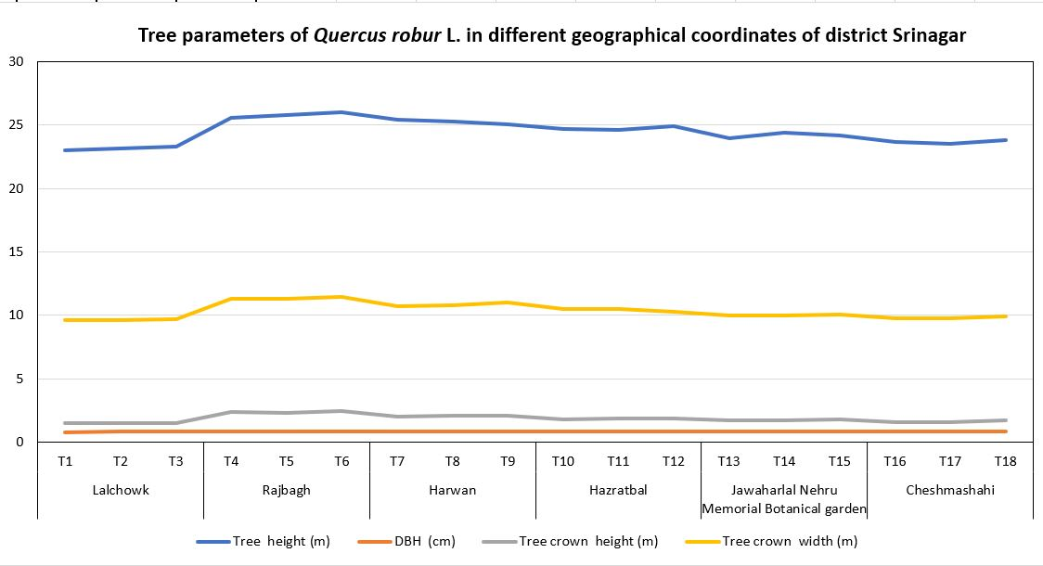
FIG 1. Tree parameters of Quercus robur L. in different geographical coordinates of district Srinagar
Table 2: Average values of seed morphological parameters of different tree genotypes of Quercus robur L.
Sites | Trees | Aspect  ratio | Seed weight  (g) | Kernel weight  (g)
Lal chowk | T₁ | 2.25 | 7.86 | 5.63
Lal chowk | T₂ | 2.42 | 7.94 | 5.74
Lal chowk | T₃ | 2.41 | 7.97 | 5.87
Rajbagh | T₄ | 1.97 | 8.85 | 7.77
Rajbagh | T₅ | 1.95 | 8.83 | 7.71
Rajbagh | T₆ | 2.03 | 9.05 | 7.95
Harwan | T₇ | 2.01 | 8.54 | 7.32
Harwan | T₈ | 2.01 | 8.58 | 7.33
Harwan | T₉ | 1.94 | 8.78 | 7.53
Hazratbal | T₁₀ | 2.06 | 8.45 | 7.03
Hazratbal | T₁₁ | 2.02 | 8.48 | 7.08
Hazratbal | T₁₂ | 2.12 | 8.42 | 6.91
Jawaharlal Nehru Memorial Botanical garden | T₁₃ | 2.17 | 8.32 | 6.64
Jawaharlal Nehru Memorial Botanical garden | T₁₄ | 2.28 | 8.26 | 6.50
Jawaharlal Nehru Memorial Botanical garden | T₁₅ | 2.22 | 8.31 | 6.58
Parimahal-Cheshmashahi | T₁₆ | 2.36 | 8.13 | 6.23
Parimahal-Cheshmashahi | T₁₇ | 2.38 | 8.08 | 6.09
Parimahal-Cheshmashahi | T₁₈ | 2.29 | 8.20 | 6.31
C.D (p≤ 0.05) |  | 0.02 | 0.02 | 0.05

The examination of the data presented in Table 2 reveals the aspect ratio (seed length :seed diameter) was recorded maximum (2.42) for tree (T2) which was at par with (2.41) tree (T3) while as minimum aspect ratio (seed length :seed diameter) (1.94) was recorded for tree (T9) which was at par with (1.95) tree (T5). Regarding the average seed weight, the average seed weight was recorded maximum (9.05 g) for tree (T6), followed by (8.85 g) tree (T4) which was at par with (8.83 g) tree (T5) while as minimum average seed weight (7.86 g) was recorded for tree (T1). Also, the kernel weight was recorded maximum (7.95 g) for tree (T6), followed by (7.77 g) tree (T4), whereas the minimum kernel weight (5.63 g) was recorded for tree (T1).
From the data presented in Table 3, it is evident that there was variation in the seed aspect ratio, seed weight (g) and kernel weight (g). Notably, for all the parameters under study, the phenotypic coefficient of variation (PCV) exceeded the GCV. The highest PCV (10.75) was observed for kernel weight (g), followed by (8.84) aspect ratio and lowest PCV (6.11) was observed for kernel weight (g). The GCV values reflected a similar trend, indicating a close correspondence between PCV and GCV estimates. The highest GCV was recorded for (9.61) was observed for kernel weight (g), followed by (7.78) aspect ratio and lowest GCV (5.10) was observed for kernel weight (g).
Table 3: Genetic variability estimation for seed morphological parameters of Quercus robur L.
Characters | PCV | GCV
Aspect  ratio | 8.84 | 7.78
Seed weight  (g) | 6.11 | 5.10
Kernel weight  (g) | 10.75 | 9.61
The widespread distribution and broad ecological adaptability of Quercus robur L., in conjunction with its relatively fragmented and spatially isolated populations, may drive significant genetic divergence among populations. Baliuckas and Pliura (2003) elucidated that progeny analyses suggest intra-population genetic variability in Quercus robur L. can surpass inter-population variability, particularly with regard to growth characteristics.
Numerous factors underpin the variability in tree growth and seed characteristics across distinct geographical regions. Principal determinants include: fertile, well-aerated soils enriched with balanced nutrients fostering superior growth relative to nutrient-deficient or excessively compacted substrates; climatic conditions wherein optimal temperature regimes and sufficient precipitation facilitate robust development, whereas extreme weather conditions or climate stress impede it; hydrological consistency, wherein regions with stable and adequate water availability exhibit enhanced growth potential. Areas with ample sunlight typically support more vigorous growth. Locations with reduced susceptibility to pests and pathogens engenders more favorable growth outcomes. Genetic differences among tree populations or individuals can result in varied growth performance across different locations. Locations with less competition might see better growth rates. A comprehensive understanding of these variables is imperative for the strategic management and optimization of tree development across diverse geographical landscapes.
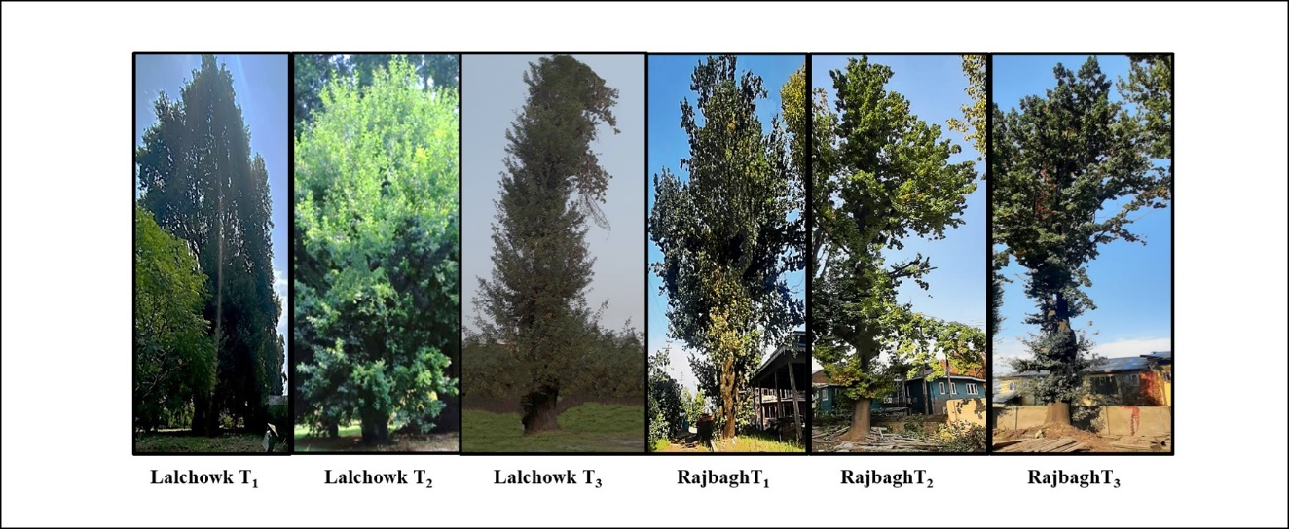
Fig. 2. Some of the trees from selected sites.
CONCLUSIONS The present study represents a pioneering investigation into the tree parameters and geographical coordinates of Quercus robur in the Srinagar district. The tree height ranged from 23.0 m to 26.0 m. Height was recorded maximum (26.0 m) for tree (T6), followed by (25.8 m) tree (T5) while as minimum height (23.0 m) was recorded for tree (T1). DBH of trees ranged between 88.5 cm to 82.3 cm. DBH was recorded maximum (88.5 cm) for tree (T6), followed by (87.8 cm) tree (T4), whereas the minimum DBH (82.3 cm) was recorded for tree (T1). Crown height varied between 1.5 m and 2.5 m, with the highest (2.5 m) observed in tree (T6), and the lowest (1.5 m) in tree (T1). Crown width ranged from 9.6 m to 11.5 m, with the widest crown (11.5 m) on tree (T6), followed by trees (T4) and (T5) at 11.3 m, and the narrowest (9.6 m) on trees (T1) and (T2). The seed aspect ratio ranged from 2.42 to 1.94. The highest was aspect ratio was observed in tree T2 (2.42), closely followed by T3 (2.41), while the lowest was recorded in T9 (1.94) and T5 (1.95). Average seed weight ranged from 9.05 g to 7.86 g. The maximum average seed weight was found in T6 (9.05 g), followed by T4 (8.85 g) and T5 (8.83 g), whereas the minimum was in T1 (7.86 g). Average kernel weight varied between 7.95 g to 5.63 g. The highest kernel weight was recorded for T6 (7.95 g), followed by T4 (7.77 g), while the lowest was noted in T1 (5.63 g). Tree height among the eighteen randomly selected trees ranged from 23.0 m to 26.0 m, with the tallest (26.0 m) recorded for tree (T6) from Rajbagh. The DBH ranged from 82.3 cm to 88.5 cm, with the maximum (88.5 cm) also observed in tree (T6) from Rajbagh. Crown height ranged from 1.5 m to 2.5 m, with the highest measurement (2.5 m) again in tree (T6) from Rajbagh. Crown width ranged from 9.6 m to 11.5 m, with the widest (11.5 m) recorded for tree (T6) from Rajbagh. Fig. 2. Aspect ratio among the eighteen randomly selected trees ranged from 2.42 to 1.94, with the maximum (2.42) recorded for tree (T2) from Lalchowk. The average seed weight ranged from 9.05 g to 7.86 g, with the maximum (9.05 g) also observed in tree (T6) from Rajbagh. Average kernel weight ranged from 7.95 g to 7.77 g, with the highest measurement (7.95 g) again in tree (T6) from Rajbagh. The analysis revealed that for all the traits examined, the phenotypic coefficient of variation (PCV) consistently surpassed the genotypic coefficient of variation (GCV). Kernel weight (g) exhibited the highest PCV (10.75), followed by the aspect ratio (8.84), whereas the lowest PCV (6.11) was also recorded for kernel weight. A similar trend was observed in GCV values, with kernel weight again showing the highest GCV (9.61), followed by aspect ratio (7.78), and the lowest GCV (5.10) also for kernel weight. The narrow gap between PCV and GCV across these traits indicates limited environmental influence and highlights strong genetic control, making them promising candidates for genetic improvement through selection.
FUTURE SCOPE Studying Quercus robur L. in the Srinagar district will provide a foundation for propagating superior plant genetics on a large scale.

REFERENCES
Ayayee, E. and Chivandi, E. 2018. Quercus robur (English oak) seed: A potential energy, oleic and cis-linoleic acid rich nutritional supplement in South Africa. Pakistan Journal of Botany. 50(5):1907-1912.
Baliuckas, V., & Pliura, A. 2003. Genetic Variation and Phenotypic Plasticity of Quercus robur Populations and Open-pollinated Families in Lithuania. Scandinavian Journal of Forest Research. 18(4): 305–319.
Dar, G. H. and Khuroo, A. A. 2020. Biodiversity of the Himalaya: Jammu and Kashmir State. Springer Nature Singapore Pte Ltd. Singapore. 1100p.
Geelani, S. M., Ara, S., Mir, N. A., Bhat, S. J. A. and Mishra, P. K. 2016. Dyeing and fastness properties of Quercus robur with natural mordants on natural fibre. Textiles and Clothing Sustainability. 2(8): 1-10.
Iqbal, J., Dutt, V., Ahmad, H. Bhat, G.M. and Khan, P. A. 2014. Propagation of Quercus robur L. (English Oak) by stem cuttings in Western Himalayas (Kashmir). Environment Conservation Journal. 15(1&2): 185-189.
Iqbal, J., Dutt, V., Ahmad, H., Bhat, G.M., Ganie, M.A., Wagay, S.A., Mir, R.A., Parray, P.A. and Ahmad, S. 2017. Status, distribution and utilization of Oak (Quercus spp.) in Western Himalayan (Kashmir Valley). Indian Forester. 143 (1): 1-5.
Kaynar, P. 2017. Antimicrobial activity of Quercus robur L. (Acorn). Fresenius Environmental Bulletin. 26: 6992-6995.
Pandey, A. and Tamta, S. 2014. In vitro propagation of the important tasar oak (Quercus serrata Thunb.) by casein hydrolysate promoted high frequency shoot proliferation. Journal of Sustainable Forestry. 33:590-603.
Singh, S., Malik, Z. A. and Sharma, C. M. 2016. Tree species richness, diversity, and regeneration status in different oak (Quercus spp.) dominated forests of Garhwal Himalaya, India. Journal of Asia-Pacific Biodiversity. 9: 293-300.
Tashi, S. 2004. Regeneration of Quercus semecarpifolia Sm. in an Old Growth Forest Under Gidakom FMU- Bhutan. M.Sc. Thesis. Wageningen University and Research Centrum, The Netherlands, pp. 1-65.
Valdia, K. S. 1998. Dynamic Himalaya. Haidarabad: University Press Ltd. 178p.

