Original Research Article
Correlation Between Gastrointestinal Bleeding in Pediatric Age and Endoscopic Findings

Abstract
Background: Gastrointestinal (GIT) bleeding in children is a common but potentially serious condition with diverse etiologies that vary between regions. Endoscopy remains the cornerstone for diagnosis and management. This study evaluates the epidemiological characteristics, etiologies, and endoscopic findings of pediatric GIT bleeding in Baghdad Medical City.
Methods: A combined retrospective and prospective study was conducted on 100 children aged from birth to 18 years admitted with upper or lower GIT bleeding between January and December 2024. Data included demographics, clinical presentation, associated conditions, bleeding characteristics, endoscopic findings, histopathology, interventions, and outcomes. Patients underwent either esophagogastroduodenoscopy (OGD), colonoscopy, or both.
Results: Of the 100 patients, 48 underwent OGD, 52 underwent colonoscopy, and 4 underwent both. Bleeding per rectum (hematochezia) was the most common presentation (49%), followed by hematemesis (27%). Children <5 years constituted the largest age group (46%). Upper GIT bleeding was most frequently caused by esophageal varices (12%) and gastritis (12%), while colonic polyps (16%) represented the most common cause of lower GIT bleeding. Normal endoscopic findings were seen in 19% of patients, often associated with short bleeding duration, mild bleeding, and younger age. Histopathology confirmed juvenile polyps, gastritis, ulcerative colitis, and Crohn’s disease among biopsied cases. Formula-fed infants showed a higher rate of gastritis and nonspecific colitis. Endoscopic interventions—including variceal banding, sclerotherapy, hemoclips, and polypectomy—successfully controlled bleeding in most cases. Overall, 97% of patients had favorable outcomes, while three deaths were attributed to severe, uncontrolled bleeding associated with advanced liver disease or obscure bleeding sources.
Conclusion: Most pediatric GIT bleeding cases in this cohort were due to benign and treatable conditions. Lower GIT bleeding predominated, with colonic polyps being the leading cause. Endoscopy demonstrated high diagnostic and therapeutic value. Early evaluation, adequate bowel preparation, and improved access to advanced diagnostic modalities can further enhance outcomes.

Keywords: Pediatric gastrointestinal bleeding, hematemesis, hematochezia, endoscopy, colonic polyps, esophageal varices.
Introduction
Upper gastrointestinal bleeding is defined as a source of bleeding proximal to the ligament of Treitz (between duodenum and jejunum), whereas lower GIT bleeding is defined as a source of bleeding distal to the ligament (small bowel and colon)⁽¹⁾.
Hematemesis refers to vomiting bright red blood, usually indicating fairly brisk bleeding. Coffee ground emesis usually occurs with slower bleeding and coagulation of blood after exposure to gastric acid.
Melena refers to black and tarry stool. It usually indicates a relatively slow bleed proximal to the cecum.
Hematochezia refers to bright red or maroon blood in stools, usually from a colonic bleed but can also occurs with high-volume UGI bleeding with rapid transit time⁽²⁾.
Gastrointestinal bleeding in infants and children is one of the most alarming conditions encountered in pediatrics. It is nonetheless an anxiety-provoking complaint. Most etiologies are self-limited, benign, and ceases spontaneously, but some are potentially serious leading to hemodynamic compromise that requires aggressive resuscitation and intervention⁽³⁾.
Gastrointestinal bleeding during infancy and childhood is common and accounts for up to 20% of referrals to pediatric gastroenterologists⁽²⁾.
The gastrointestinal tract is a highly vascularized organ with a large surface area. Thus any pathology involving the mucosa and the vasculature of the GI tract can lead to bleeding.
Despite its often dramatic clinical presentation, the mortality of GIT bleeding in children is low, which contrasts sharply with the significant mortality observed in elderly patients⁽²⁾.
Gastrointestinal bleeding is a serious health problem worldwide, particularly during childhood. GIB can cause anxiety in children, caregivers, and healthcare providers and can be an alarming sign of an underlying disease.
Experience in different countries indicates the variation in the frequency of different causes of GIB in children, and this can be attributed to many factors including lifestyle, quality of health, nutritional habits, and geographical conditions.
Etiology of GIT bleeding are many including the following:
Vascular anomalies (e.g., arteriovenous malformations or hemangiomas), Collateral vessel formation (e.g., esophageal varices), Erosion of the intestinal mucosa (e.g., inflammation, ulceration, sloughing, and perforation), Mallory–Weiss tears, Inflammatory bowel disease (Crohn’s disease and ulcerative colitis), Meckel’s diverticulum, Intussusception, Henoch–Schoenlein purpura, Juvenile polyp, Colitis (infection, allergy), Anal fissure, and Coagulopathy^{(1,2)}.
Clinical Manifestations
Severe bleeding can be symptomatic leads to dizziness, syncope, pallor, tachycardia, and hypotension. Less severe bleeding can present as postural hypotetion. It can also be occult, that is, not visible to the patient or physician, leading to either a positive fecal occult blood test or iron-deficiency anemia⁽¹⁻³⁾.
Investigations
Initial blood work should include type and cross to expedite transfusion if necessary.Other laboratory data include: Hemoglobin, platelets, coagulation studies, and complete metabolic profile.
Radiography includes plain radiography is appropriate in most cases of significant GI bleeding. It may identify some foreign bodies, obstructive processes, and perforation, and give clues to other diagnoses. Contrast studies are not appropriate first-line investigations as they may delay evaluation by other means (endoscopy, colonoscopy, and nuclear medicine scans) and lead to complications (perforation if done in setting of obstruction).
Ultrasound is very helpful if certain diagnoses are suspected e.g. intussusception (almost 100% sensitive and specific), portal hypertension (hepato-splenomegaly and portal vein flow), and vascular anomalies or duplication cysts.
Angiography A bleeding rate of 0.5 mL/min is required to identify a bleeding site. It may also diagnose vascular abnormalities and can be therapeutic by embolization of the feeding vessel.
Endoscopy It is the best method to evaluate upper and lower GIT bleeding and will yield a diagnosis in most cases. Many therapeutic techniques have advanced greatly allowing hemostasis via coagulation (e.g., heater probe or argon plasma coagulation), injection (e.g., epinephrine or sclerosing agents), and mechanical occlusion (e.g., variceal banding, hemostatic clips, and detachable loops).
Obscure sites of bleeding can be detected by: Wireless capsule endoscopy or RBC can also be tagged with the radionuclide and re-injected into the blood stream, rough localization of the bleeding site can be made using a gamma camera⁽¹⁻³⁾.
Wormscope, a new innovative small automated endoscope which is designed by the author and now under manufacturing and release in the near future, may also resolve this issue because it can examine the whole GIT including the area between second part of dudenum until terminal ileum which cannot be reached by the traditional endoscope⁽⁴⁾.
Management
The unstable or actively bleeding patient should be resuscitated. Venous access is secured with two large-bore IV catheters or central venous access. If the bleeding is significant by history or the patient is hemodynamically unstable, an NG saline lavage can determine if there is still active bleeding.
Surgical consultation should be obtained early for patients who are hemodynamically unstable, especially if they have abdominal tenderness, distension, fever, or signs of obstruction on upright or decubitus abdominal films.
Surgical exploration is indicated for signs of obstruction or ongoing blood loss (i.e., patient remains unstable requiring frequent blood transfusion, >85 mL/kg).
Medical Therapy for Minor Upper GI Bleeding
If there is a history of reflux symptoms (regurgitation, acid brash, heartburn, and epigastric pain) or suspected Mallory–Weiss tear, then a trial of acid suppression is reasonable. PPIs tend to be cleared faster by children, so they tend to need higher doses than adults per body weight.
Sucralfate is a cytoprotective agent that binds to injured tissue creating a protective barrier and promoting tissue healing. It is enhanced in an acidic environment, thus concurrent therapy with PPI is not recommended.
Octreotide is the most useful vasoconstrictive medication for patients with active, hemodynamically significant bleeding. It reduces splanchnic blood flow and has minimal side effects (hyperglycemia).
Endoscopic Therapy for Active GI Bleeding
Gastric lavage before endoscopy may clear blood and clots that otherwise make endoscopic therapy challenging. Metoclopramide or Erythromycin given IV may also enhance gastric emptying clearing blood from the stomach.
Injection of epinephrine (1:10,000) into the tissue surrounding a non-variceal bleeding lesion may slow or stop bleeding but it is not thrombogenic.
Contact probes (heater probes or bipolar probes) allow direct pressure to be applied to a bleeding vessel.
Endoscopic clip placement achieves hemostasis by grasping and compressing tissue surrounding a bleeding vessel. Mechanical ligation (loops and bands) works similarly. Other hemostatic therapies are used less commonly in children (argon plasma coagulation, fibrin glue injection, and laser photocoagulation) ⁽¹⁻³⁾.

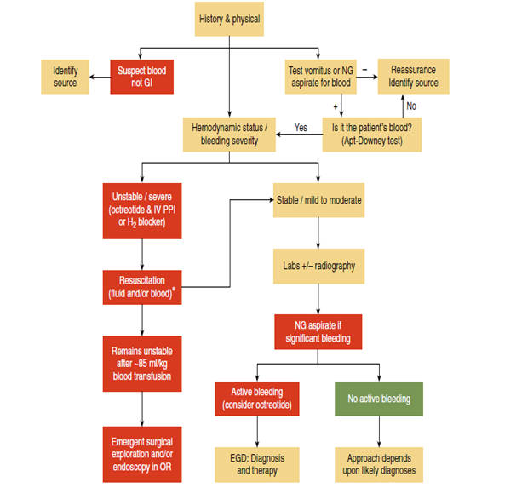

Fig. 1. Approach to Hematemesis⁽³⁾
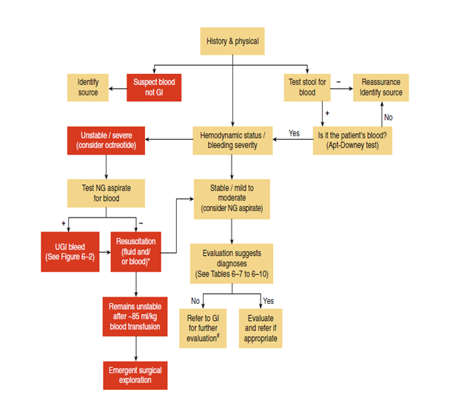

Fig. 2. Approach to hematochezia or melena⁽³⁾

Aim of study
This study is to determine the epidemiological and demographic characteristics of children admitted to our hospitals in Baghdad city and to find out whether the causes of upper and lower GI bleeding in Iraq is differed from that of GI centers in different countries. Regional epidemiological data can also assist Pediatriciens to better management of these patients. In addition, our aim is to evaluate the diagnostic yield of endoscopy in GIT bleeding in children.

Methods
This study is a retrospective and prospective study that done on 100 children with upper and lower gatrointestinal tract (GIT) bleeding from birth up to 18 years adolescents taken randomly according to their attendence to our hospitals in Baghdad Medical City from 1st of January until 31st of December, 2024.
A retrospective study was done on 68 patients admitted to Welfare Teaching Hospital in Baghdad between 1st of January until 31st of October, 2024. Their data are retrieved from their medical records from the Statistical department in the hospital after obtaining the name and date of admission from patient’s endoscopical report from the endoscopy unit.
Exclusion criteria in our research include: Patients who only underwent endoscopy without admission to our hospitals, patients with incomplete data, and patients who are treated conservatively (without endoscopy) are also excluded.
The prospective study was done on 32 patients with GIT bleeding referred to Baghdad hospital, Tertiary GIT center, and to Welfare Teaching Hospital between 1st of November until 31st of December, 2024. A full hitory, clinical examination, and investigations were done, management recieved including endoscopy with follow up of outcome until discharge from hospital.
During endoscopy procedure, patients below 14 years of age are underwent general anesthesia, while older childern and adolescents are sedated with Medozolam or without anesthesia or sedation. Informed written consent was obtained from the parents or caregivers before endoscopy session.
Patients are analyzed according to the following variables: age, sex, residence, type of feeding (for infants < 2 yr), type of bleeding (upper vs lower), duration, amount, investigations, associated medical conditions, endoscopic findings (and interventions if applicable), histopathologial result of biopsy (if obtained), final diagnosis, and outcome of patients.
The information are collected according to a questionnaire involving the following variables of enrolled patients in the study.
These varibles include: sex (male vs female), residence (urban vs rural), age is divided into 3 groups (< 5 yr, 5-10 yr, and > 10 yr), type of feeding (for infants < 2 yr): breast milk, formula milk, or mixed.
Type of GIT bleeding: upper bleeding is indicated by hematemesis (fresh blood or coffee-ground), hematemesis and melena, or melena, whereas lower bleeding is indicated by bleeding per rectum (hematochezia) and bloody diarrhea.
Other variables of bleeding are also determined, these include duration of bleeding (days, weeks, or months), this does not entails contineous bleeding but rather intermittent bleeding. The amount of bleeding is also determined, the amount described by parents is not sufficient because the same amount of bleeding which is considered insignificant in older children may be significant in young infants due to variation in body size and blood volume.
Therefore, amount of bleeding is estimated by hemodynamic instability e.g. tachycardia, hypotension, degree of anemia, need for blood transfusion, prolonged capillary refill time (CRT), and shock state. Patients with pulse rate >2 SD, blood pressure <2 SD, Hb <2 SD of the standered appropriate charts (according to age and sex)⁽⁵⁾, also CRT > 2 seconds or shock state are considered to have significant blood loss, as do patients who recieved blood transfusion.
Also the history involves previous medical conditions e.g. failure to thrive, chronic liver disease, chronic diarrhea, NSAI drugs ingestion, previous endoscopy, and biopsy result.
Clinical examination was done including vital signs (especially pulse rate and blood pressure), assessment of pallor (including CRT for infants < 2yr), examination of abdomen to assess for abdominal pain, hepatosplenomegaly, and ascitis.
Investigations were done including CBC, liver and renal funcion tests, PT/INR, ultrasound and doppler of abdomen...etc to determine the associated medical conditions e.g. anemia, chronic liver diseases, signs of portal hypertension, and bleeding tendency.
Endoscopical findings are recorded, for patients with multiple finding, we take the most significant one; for example, patient with peptic ulcer and GERD grade A, we considered only the peptic ulcer because it is relevant with bleeding. Interventions to stop bleeding are also addressed including: adrenaline or sclerosant injection, hemoclip, variceal banding, or polypectomy.
The result of biopsy (histopathology) was obtained and the source of bleeding / final diagnosis were determined and finally the outcome of patient whether recovery or unfortunately death is also determined.
The relationship between variables are addresed according to thier significance in the form of numbers and percentages (which are approximated to the nearest correct number), then illustrated as tables and diagrams.

Results
The total number of cases were 100; 48 of them undewent OGD and 52 underwent colonoscopy, whereas 4 patients of them underwent both OGD and colonoscopy.
- Regading sex, there is almost no difference between males and females because the result is 51% and 49% respectively.
- Regarding Residence, there is more prevelence of urban areas than rural areas, the result is 75% and 25% respectively.
- Age is divided into 3 groups (< 5 yr, 5-10 yr, and > 10 yr), (Table-1) the number of patients in each group is 46 cases, 29 cases, and 25 cases respectively.

Table 1. A correlation between sex and residence with age groups
Age group | < 5 yr no.(%) | 5-10 yr no.(%) | >10 yr no.(%)
Male | 24(52%) | 15(52%) | 12(48%)
Female | 22(48%) | 14(48%) | 13(52%)
Urban | 36(78%) | 22(76%) | 17(68%)
Rural | 10(22%) | 7(24%) | 8(32%)
Total no. | 46 | 29 | 25

- The type of GIT bleeding (Table-2) is indicated as upper bleeding including: hematemesis (fresh blood or coffee-ground) (27 cases), hematemesis and melena (12 cases), or melena (6 cases), whereas lower bleeding is indicated by bleeding per rectum (hematochezia) (49 cases) and bloody diarrhea (6 cases).

Table 2. A correlation between type of bleeding with age groups
Type of bleeding | < 5 yr  no.(%) | 5-10 yr no.(%) | >10 yr  no.(%) | Total No.
Hematemesis | 10(21%) | 8(27%) | 9(36%) | 27
Hematemesis+Melena | 5(11%) | 3(10%) | 4(16%) | 12
Melena | 3(6%) | 2(7%) | 1(4%) | 6
Hematochezia | 24(52%) | 14(48%) | 11(44%) | 49
Bloody diarrhea | 4(9%) | 2(7%) | 0 | 6
Total no. | 46 | 29 | 25 | 100

- (Table-3) correlate between type of bleeding with endoscopical findings.

Table 3. A correlation between type of bleeding with endoscopical findings
Endoscopical findings | Hematem-esis  no.(%) | H+M  no.(%) | Melena  no.(%) | Hemato-chezia  no.(%) | Bloody diarrhea  no.(%) | Total  No.
Eophageal varices (grade ll, lll) | 7(26%) | 4(33%) | 1(16%) | 0 | 0 | 12
Gastritis (moderate, severe) | 8(30%) | 3(25%) | 1(16%) | 0 | 0 | 12
Esophagitis/GERD | 5(18%) | 1(8%) | 0 | 0 | 0 | 6
D.U./Dudenitis | 3(11%) | 1(8%) | 1(16%) | 0 | 0 | 5
Gastric ulcer/erosion | 2(7%) | 1(8%) | 0 | 0 | 0 | 3
Dieulafoy lesion | 0 | 1(8%) | 0 | 0 | 0 | 1
Colonic polyps | 0 | 0 | 1(16%) | 15  (31%) | 0 | 16
Non-specific colitis | 0 | 0 | 0 | 4(8%) | 2(33%) | 6
Proctitis/rectal ulcer | 0 | 0 | 0 | 5(10%) | 0 | 5
Anal fissure/piles | 0 | 0 | 0 | 5(10%) | 0 | 5
Ulcerative colitis | 0 | 0 | 0 | 1(2%) | 2(33%) | 3
Crohn’s disease | 0 | 0 | 0 | 3(6%) | 0 | 3
Nodular hyperplasia | 0 | 0 | 1(16%) | 2(4) | 0 | 1
HSP | 0 | 0 | 1(16%) | 0 | 0 | 1
Normal finding | 2(7%) | 1(8%) | 0 | 14  (28%) | 2(33%) | 19
Total no. | 27 | 12 | 6 | 49 | 6 | 100

- Duration of bleeding (Table-4): days (32 cases), weeks (38 cases), and months (30 cases).
Duration of bleeding with was mainly associated with normal findings, gastritis, and esophagitis/GERD. Weeks durations are mainly associated with normal findings, gastritis, and colonic polyps. Months duration are mainly associated with colonic polyps and esophageal varices.

Table 4. A correlation between duration of bleeding with endoscopical findings
Endoscopical findings | Days  no.(%) | Weeks  no.(%) | Months  no.(%) | Total no.
Eophageal varices (grade ll, lll) | 1(3%) | 4(10%) | 7(23%) | 12
Gastritis (moderate, severe) | 6(19%) | 5(13%) | 1(3%) | 12
Esophagitis/GERD | 3(9%) | 2(5%) | 1(3%) | 6
Dudenal ulcer/Dudenitis | 2(6%) | 2(5%) | 1(3%) | 5
Gastric ulcer/erosion | 1(3%) | 2(5%) | 0 | 3
Dieulafoy lesion | 1(3%) | 0 | 0 | 1
Colonic polyps | 2(6%) | 5(13%) | 9(30%) | 16
Non-specific colitis | 2(6%) | 4(10%) | 0 | 6
Proctitis/rectal ulcer | 1(3%) | 3(8%) | 1(3%) | 5
Anal fissure/piles | 1(3%) | 1(7%) | 3(10%) | 5
Ulcerative colitis | 0 | 1(7%) | 2(7%) | 3
Crohn’s disease | 0 | 0 | 3(10%) | 3
Nodular hyperplasia | 1(3%) | 1(7%) | 1(3%) | 3
HSP | 1(3%) | 0 | 0 | 1
Normal finding | 10(31%) | 8(21%) | 1(3%) | 19
Total no. | 32 | 38 | 30 | 100

- Amount of bleeding (Table-5): significant (42 cases), not significant (58 cases).
Significant amount of bleeding was mainly associated with esophageal varices, gastritis, and non-specific colitis. While non-significant bleeding was mainly associated with colonic polyps, normal findings, and anal fissure/piles.

Table 5. A correlation between amount of bleeding with endoscopical findings
Endoscopical findings | Significant(%) | Not significant(%)
Eophageal varices (grade ll, lll) | 9(21%) | 3(5%)
Gastritis (moderate, severe) | 8(19%) | 4(7%)
Esophagitis/GERD | 2(5%) | 4(7%)
Dudenal ulcer/Dudenitis | 4(9%) | 1(2%)
Gastric ulcer/erosion | 2(5%) | 1(2%)
Dieulafoy lesion | 1(2%) | 0
Colonic polyps | 3(7%) | 13(33%)
Non-specific colitis | 5(12%) | 1(2%)
Proctitis/rectal ulcer | 1(2%) | 4(7%)
Anal fissure/piles | 0 | 5(9%)
Ulcerative colitis | 1(2%) | 2(3%)
Crohn’s disease | 1(2%) | 2(3%)
Nodular hyperplasia | 1(2%) | 2(3%)
HSP | 0 | 1(2%)
Normal finding | 4(9%) | 15(26%)
Total no. (%) | 42 | 58

- Associated medical conditions (Table-6) and Diagram-1: although some patients have more than one associated medical condition, we take the most significant one: anemia (26 cases), failure to thrive (FTT) (12 cases), chronic liver disease (CLD) (8 cases) and 5 of them with history of recurrent bleeding due to esophageal varices, history of chronic diarrhea (CD) (5 cases), signs of portal hypertension (3 cases) with 1 case aged 1 year with history of umbilical catheterization during neonatal period, history of juvenile polyposis (JP) (documented by biopsy) (3 cases), history of constipation (2 cases), history of NSAI drug (Ibuprofin) ingestion (1 case), no associated medical conditions (40 cases).

Diagram-1 shows the prevelance of medical conditions associated with pediatric GIT bleeding

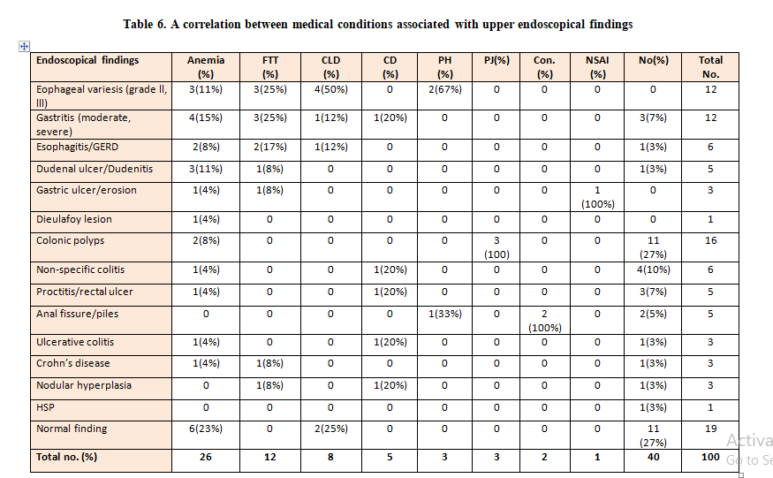

- Endoscopical findings including source of bleeding / final diagnosis (after reading the biopsy result if available). The findings are devided into the following: Upper lesions diagnosed by OGD (Table-7) and Diagram-2 include: esophageal varices grade 2 and 3 (12 cases), gastritis (ranging from moderate to severe) with or without nodularity (12 cases), esophagitis/GERD (6 cases), dudenal ulcer/dudenitis (5 cases), gastric ulcer/erosion (3 cases), dieulafoy lesion of stomach (1 case), normal findings (9 cases).

Diagram-2 shows the upper endoscopical findings in GIT bleeding by OGD

Table 7. A correlation between age groups with upper endoscopical findings by OGD
Endoscopic finding by OGD | < 5 yr  no.(%) | 5-10 yr  no.(%) | >10 yr  no.(%) | Total no.
Eophageal varices  (grade ll, lll) | 4(18%) | 5(36%) | 3(25%) | 12
Gastritis  (moderate, severe) | 7(32%) | 2(14%) | 3(25%) | 12
Esophagitis/GERD | 4(18%) | 1(7%) | 1(8%) | 6
Dudenal ulcer  /Dudenitis | 2(9%) | 1(7%) | 2(17%) | 5
Gastric ulcer/erosion | 0 | 1(7%) | 2(17%) | 3
Dieulafoy lesion | 0 | 1(7%) | 0 | 1
Normal finding | 5(23%) | 3(21%) | 1(8%) | 9
Total no. | 22 | 14 | 12 | 48

Lower lesions diagnosed by colonoscope (Table-8) and Diagram-3 include: colonic polyps (16 cases), non-specific colitis (6 cases), proctitis/rectal ulcer (5 cases), anal fissure/piles (5 cases), ulcerative colitis (3 cases), Crohn’s disease (3 cases), nodular hyperplasia of terminal ileum (3 cases), Henoch-Schonlein purpura (1 case), normal findings (10 cases).
Diagram-3 shows the lower endoscopical findings in GIT bleeding by Colonoscope

Table 8. A correlation between age groups with lower endoscopical findings by Colonoscope
Endoscopic finding by Colonoscopy | < 5 yr  no.(%) | 5-10 yr  no.(%) | >10 yr  no.(%) | Total no.
Colonic polyps | 9(37%) | 5(33%) | 2(15%) | 16
Non-specific colitis | 4(17%) | 1(7%) | 1(8%) | 6
Proctitis/rectal ulcer | 2(8%) | 2(13%) | 1(8%) | 5
Anal fissure/piles | 1(4%) | 2(13%) | 2(15%) | 5
Ulcerative colitis | 0 | 2(13%) | 1(8%) | 3
Crohn’s disease | 0 | 1(7%) | 2(15%) | 3
Nodular hyperplasia | 2(8%) | 1(7%) | 0 | 3
HSP | 1(4%) | 0 | 0 | 1
Normal finding | 5(21%) | 2(13%) | 3(23%) | 10
Total no. | 24 | 16 | 12 | 52

Many patients with normal findings of colonoscopy (5 of 10) were associated with fair to bad preparation of the colon before endoscopy. However, the total number of normal endoscopical findings were 19 cases; 9 by OGD and 10 by colonoscope which were associted with following variables (Table-9).
Table 9. Variables associated with normal endoscopical findings (OGD and colonoscope)
Type of bleeding | Hemate-mesis |  |  | Hematemesis + Melena |  |  | Hemato-chezia |  |  | Bloody diarrhea | Total no.
Type of bleeding | 2 |  |  | 1 |  |  | 14 |  |  | 2 | 19
Duration of bleeding | Days |  |  |  | Weeks |  |  | Months
Duration of bleeding | 10 |  |  |  | 8 |  |  | 1 |  |  | 19
Associated diseases | Anemia |  |  |  | CLD |  |  | Nil
Associated diseases | 6 |  |  |  | 2 |  |  | 11 |  |  | 19
Amount of bleeding | Significant |  |  |  |  | Not significant
Amount of bleeding | 4 |  |  |  |  | 15 |  |  |  |  | 19
 | M | F | < 5 yr |  |  | 5-10 yr |  |  | >10 yr
OGD | 3 | 6 | 5 |  |  | 3 |  |  | 1 |  | 9
Colonoscopy | 5 | 5 | 5 |  |  | 2 |  |  | 3 |  | 10

Note: the patient with Henoch-Schonlein purpura is 5 yr old male child presents with melena, colonoscopy has done and was normal (although with bad preparation of colon), in the second day he develop the typical rash of Henoch-Schonlein purpura.
The histopathological results of biopsies were obtained from only 35 patients which document the macroscopical finding of the endoscopy, these inculde: 8 cases of gastritis with lymphocytic infiltration of mucosa and submucosa, 2 of them are associated with H. pylori infection (was associated with nodular mucosa macroscopically), 1 case with dudenitis, 8 cases was consistent with juvenile hamartomatous polyps, 3 cases with ulcerative colitis, 3 cases with Crohn’s disease, 1 case proctitis, 1 case nodular hyperplasia, and 4 cases normal findings.
Six patients who present with bloody diarrhea, the biopsy results reveal 3 cases associated with non-specific colitis, and 2 case with normal histopathological findings.
- Regarding the type of feeding (for infants < 2 yr) (Table-10) their total number was 15; 7 males (47%) and 8 females (53%).
Table 10. Variables associated with infants below 2 yr
Type of Feeding | Type of Bleeding | Endoscopic Findings
Breast feeding:
Case #1 | Hematochezia | Non-specific colitis
Case #2 | Hematemesis | Gastritis
Formula feeding:
Case #3 | Hematemesis | GERD
Case #4 | Hematemesis | Gastritis
Case #5 | Hematemesis+Melena | Esophageal varices
Case #6 | Hematochezia | Normal
Case #7 | Hematemesis | Gastritis
Case #8 | Hematemesis+Melena | GERD
Case #9 | Bloody diarrhea | Normal
Case #10 | Hematemesis | Gastritis
Case #11 | Hematochezia | Non-specific colitis
Case #12 | Hematemesis | Gastritis
Mixed feeding:
Case #13 | Bloody diarrhea | Non-specific colitis
Case #14 | Hematochezia | Normal
Case #15 | Hematochezia | Non-specific colitis

- Interventions used to stop bleeding Diagram-4 include: 8 cases with esophageal varices grade 2 and 3 are controlled with banding and 1 case infant with bleeding esophageal varices controlled by sclerotherapy (ethanol) (because banding is not applicable in a small size endoscope), 1 case with active bleeding from dudenal ulcer and 1 case with Dieulafoy lesion of stomach underwent hemoclip deployment, and 10 cases with pedunculated large polyps underwent hot or cold snare polypctomy with or without adrenaline injecton before excision.

Diagram-4 shows the interventions performed in pediatric GIT bleeding

Four patients underwent both OGD and colonoscopy, 3 of them was nomal finding of both OGD and colonoscopy despite contineous bleeding due to hidden bleeding or bleeding beyond the reach of endoscope (one of them had pisitive Meckle’s scan), the other case was 9 yr female with juvenile polyposis syndrome because both OGD and colonoscopy reveal multiple polyps in stomach and colon.
- Outcome of patients: All patients present with upper and lower GIT bleeding in our hospitals received appropriate management including IV fluid therapy for shock, packed RBC for anemia, platelets for thrombocytopenia, Fresh Frozen Plasma for clotting factors deficiency, octeriotide and Proton Pump Inhibitor for upper GIT bleeding, in addition to the interventions used during endoscopy to control active bleeding as described above.
Most patient (97 cases) had good outcome with stop of bleeding on discharge, although some require follow-up after discharge especially those with esophageal varices, gastric/dudenal ulcer, colonic polyps, ulcerative colitis, and Crohn’s disease.
However, unfortunately 3 cases in this study have fatal outcome due to severe bleeding. First case was 11 month female infant with biliary atresia and portal hypertention present with severe bleeding from esophageal and fundal varices, although initially before several days it is controlled by sclerotherapy (ethanol) because banding is not applicable in a small size endoscope.
Second case was 17 yr old adolescent male with chronic liver disease dut to badly managed Wilson disease present with recurrent attacks of bleeding from esophageal varices, although initially on admission, bleeding is controlled by variceal banding deployment, but after two days after banding the bleeding was so severe and uncontrolled and associated with hepatic encephalopthy.
Third case was 2 yr old male present with severe hematemesis, melena, and hematochezia (obviously due to rapid transit time), he underwent OGD and colonoscope and were normal.
He planned to do Meckle’s scan because enteroscopy in not applicable in this age (small size enteroscope is not availale), Scintigraphy and angiography with embolization was also not available. However, the child was dead because he was unfit to transfer to another hospital for Meckle’s scan because he was shocked due to massive bleeding.

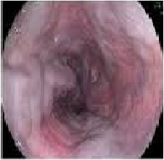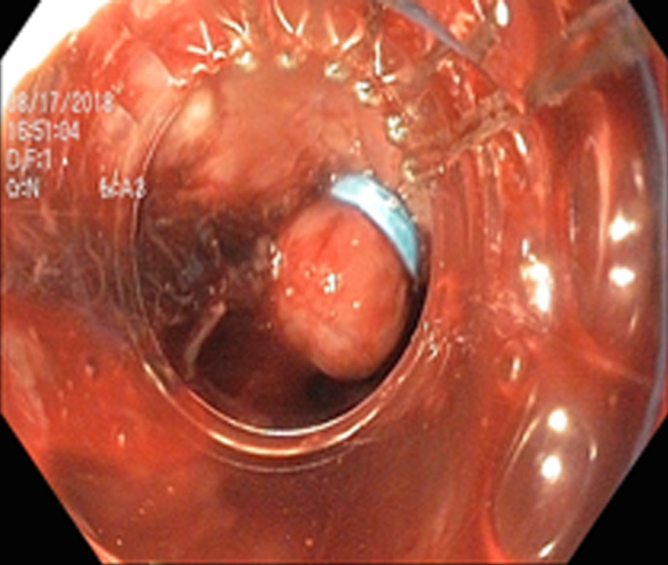
Esophageal varices Banding of E.V.

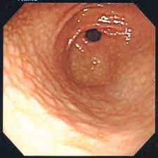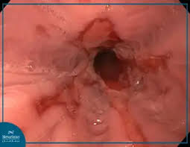
Noduler Gastritis GERD

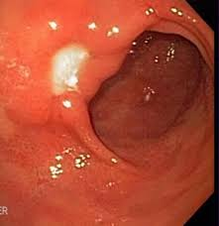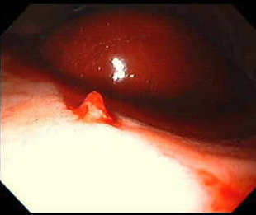
Peptic ulcer Dieulafoy lesion

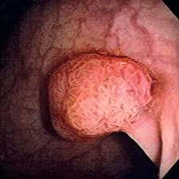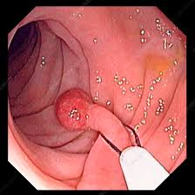
Colonic polyp Colonic polyp with snaring

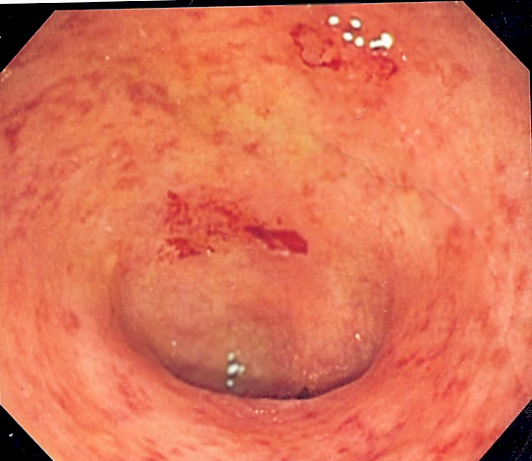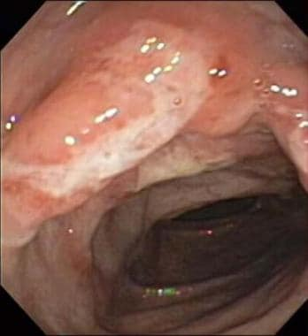
Ulcerative colitis Crohn’s disease

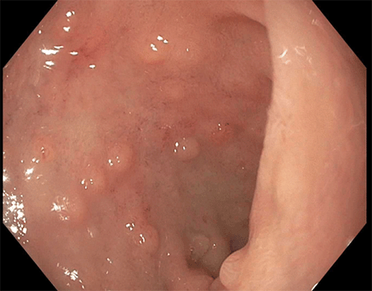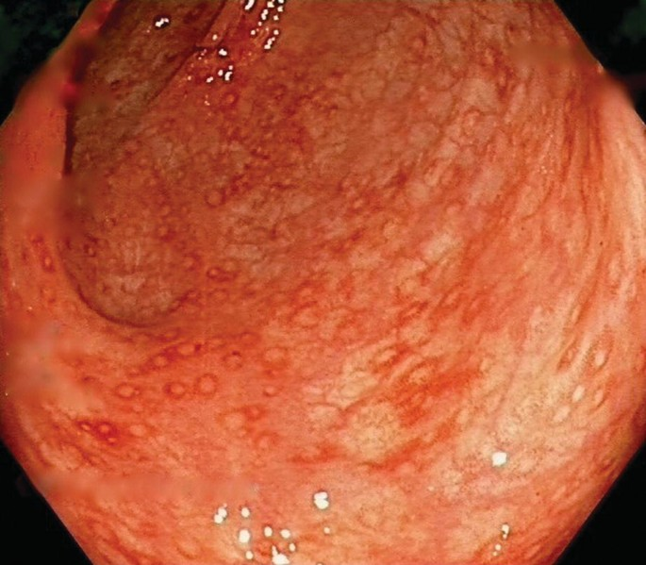
Nodular hyperplasia Non-specific colitis

Discussion
Endoscopy is the standard method for the diagnosis and treatment of GIT bleeding. Establishing an etiology is important for determining the risk of re-bleeding, yet timing of endoscopy is dictated by the severity of bleeding and need for therapeutic intervention⁽²⁾.
It is worthy to mention that this is the first study in Iraq which deals with both upper and lower GIT bleeding in pediatric patients admitted to the hospitals of Baghdad Medical City, most previous studies reported only one type of bleeding.
In Iraq and Middle East, the incidence of GIB in children is not well established. However, in the United States, it accounts for 1% of all pediatric hospitalizations⁽⁶⁾ , whereas in Italy, Romano et al reported a higher incidence reaching up to 6.4%⁽⁷⁾. In a study conducted in France, UGB was reported to be seen in 1-2 of 10,000 children per year⁽⁸⁾.
In our study, there is nearly no difference in GIT bleeding incidence between male and female because the ratio is 1.04:1. This result is similar to study conducted in Iraq by Al Azzawi et al⁽⁹⁾ and USA by Cleveland et al⁽⁶⁾ both of which showed a nearly equal male to female ratio of 1:1.04 and 1.1:1 respectively. In other sudy in Iraq by Hasson et al⁽¹⁰⁾ and in Iran by Dehghani et al⁽¹¹⁾, have showed male predominance with a male to female ratio of 1.4 : 1 and 1.3: 1 respectively. In contrast a study conducted in Saudi Arabia by El Mouzanet al showed a reversed male/female ratio of 1:1.5⁽¹²⁾.
In our study, there was more prevelence of patients from urban areas over rural areas, the ratio is 3:1. This may reflects the more easier access to health facilities in urban areas than rural areas. However, there is no clear previous study to compare this issue.
In our study, the age distribution according to age groups (< 5 yr, 5-10 yr, and > 10 yr) were 46 %, 29 %, and 25 % respectively. This result slightly similar to study in Iraq by Hasson et al⁽¹⁰⁾ which revealed higher prevalence of GIT bleeding in early life, because most patients presented in the age groups of > 1 year to 6 years and 6 years to 12 years (36.2%) and (24%) respectively. In Bahrain by Isa et al⁽¹³⁾, the median age at the time of endoscopic diagnosis was 9 years, with no significant difference according to the type of bleeding. Whereas in USA by Cleveland et al⁽⁶⁾ reported a median age of 10.1 years with a mean age of 9.3 ± 5.7 years. However, Gimiga et al⁽¹⁴⁾, Rafeey et al⁽¹⁵⁾, and Kalyoncu et al⁽¹⁶⁾ reported GIB in younger children (1.3, 6.1 ± 3.9, and 7.6 ± 2.4 years, respectively). However, Jafari et al⁽¹⁷⁾, Gimiga et al⁽¹⁴⁾ and Zahmatkeshan et al⁽¹⁸⁾ reported that the 2–10 and 3–10 years age groups were the most commonly affected, representing 63.7% and 55.1% of their patient samples, respectively. This variation in age at diagnosis could be attributed to the differences in the study settings, inclusion criteria, and site and etiology of bleeding in each study.
The presence of bloody stool is common in pediatrics. It can cause stress and panic in parents, babysitters, and even physicians. Previous studies have demonstrated that rectal bleeding in most infants and children is a benign and self-limiting condition usually requiring no treatment or can be managed by supportive care only.
In our study, bleeding per rectum (hematochezia) was the most common presentation of GIT bleeding (49%), followed by hematemesis (27%), then hematemesis and melena (12%), and the least melena (6%) and bloody diarrhea (6%). These results is agree with Isa et al⁽¹³⁾ study in Bahrain, when bleeding per rectum was the most frequent presenting symptom. Gimiga et al⁽¹⁴⁾ and Zahmatkeshan et al⁽¹⁸⁾ reported similar findings, with hematochezia as the most common symptom.
In our study, hematemesis was the most common cause of upper GI bleeding. This result agrees with other studies such as Hasson et al, Dehghani et al⁽¹¹⁾, Al Azzawi et al⁽⁹⁾, Altay et al⁽¹⁹⁾, and Huang IF et al⁽²⁰⁾. The reason for this could be explained by the fact that hematemesis is a bright red color of blood that usually alarms the patient and the family to seek medical advice earlier.
Melena in this study had a lower rate in presentation. This finding was nearly similar to that observed by Dehghani et al and Huang IF et al.This can be explained because melena is usually not noticed by the patient and the family especially in older children, so there was a delay in the presentation .
However, Jafari et al determined that UGIB was more common than LGIB. Apart from this study, all the other published studies tackled either UGIB or LGIB separately. Thus, our findings cannot be compared with those of other studies.
In Germany, Frank et al⁽²¹⁾ found that only 2.5% of children with hematochezia had upper gastrointestinal bleeding and only 4.5% with hematemesis suffered from lower gastrointestinal bleeding. Melena was more frequent in upper gastrointestinal bleeding (47.6%) than in lower gastrointestinal bleeding (23.8%).
In our study, the correlation between type of bleeding with endoscopical findings.
Hematemesis was mainly associated with gastritis (30%), esophageal varices (26%), Esophagitis/GERD (18%), and less frequently with D.U./Dudenitis (11%) and Gastric ulcer/erosion (7%). Hematemesis and melena was mainly associated with esophageal varices (33%) and gastritis (25%). Similar results by Hasson et al who conduct that the most common causes of upper GI bleeding among all patients were esophageal varices, followed by gastric erosions. In USA, the two conditions associated with the most significant UGIBs are duodenal ulcers and esophageal varices. In Saudi, gastritis was the commonest cause of hematemesis, followed by esophagitis.
In our study, hematochezia was mainly associated with colonic polyps (31%) and normal finding (28%), then much less with proctitis/rectal ulcer (10%), anal fissure/piles (10%), and non-specific colitis (8%). Whereas bloody diarrhea was mainly associated with non-specific colitis (33%), ulcerative colitis (33%), and normal finding (33%).
In our study, duration of bleeding with only days was mainly associated with normal findings (31%), gastritis (19%), and esophagitis/GERD (9%). Weeks durations are mainly associated with normal findings (21%), gastritis (13%), and colonic polyps (13%). Months duration are mainly associated with colonic polyps (30%) and esophageal varices (23%).
In our study, Significant amount of bleeding was mainly associated with esophageal varices (21%), gastritis (19%), and non-specific colitis (12%). While non-significant bleeding was mainly associated with colonic polyps (33%), normal findings (26%), and anal fissure/piles (9%).
According to Chaibou et al⁽²²⁾, (10.2%) of hospitalised children were diagnosed with UGIB, while 16 of them (1.6%) had clinically severe GI bleeding and were in a paediatric intensive care unit. In a study by Lacroix et al⁽²³⁾ (6.4%) of children admitted to the paediatric intensive care unit had UGIB.
In our study, GIT bleeding was mainly associated with no associated medical conditions (40%), anemia (26%), failure to thrive (12%), and less with chronic liver disease (8%), and history of chronic diarrhea (5%). These findings was similar to a study in Bahrain by Isa et al⁽¹³⁾ who show that physical examination was unremarkable in most of the patients (87.2%). However, pallor was documented in (4.4%) patients. Pallor might be related to the severity of bleeding and amount of blood loss. Cleveland et al found that esophageal varices and duodenal ulcers are the most common conditions leading to anemia. Persistent or recurrent iron-deficiency anemia is a sign of obscure bleeding. Zahmatkeshan et al reported iron deficiency anemia in 1.4% of the patients. However, Gimiga et al reported a much higher incidence of hypochromic microcytic anemia (61.9%).
Ojuawo and colleagues⁽²⁴⁾ reported that diarrhea, vomiting, abdominal pain, anorexia, and failure to thrive were the most common accompanying symptoms of bloody diarrhea and rectal bleeding. In another case-control study, Arvola and coworkers⁽²⁵⁾ reported that loose and mucous stools, abdominal pain, and vomiting were frequently detected in those children with bloody stools. It is believed that rectal bleeding in children should not affect the growth pattern negatively, because of the mild and transient nature of the disorder. However some other studies found that (10.2%) of patients suffered from weight loss and (1.4%) had iron deficiency anemia, suggesting chronic nature of underlying disease. Lower GI bleeding in children is usually an acute condition that rarely results in hemodynamic or hemoglobin changes. Pasricha and colleagues⁽²⁶⁾ have found that most children with iron deficiency anemia suffer from low iron intake rather than GI bleeding.
In our study, upper lesions diagnosed by OGD include: esophageal varices grade 2 and 3 (12 %), gastritis (ranging from moderate to severe) with or without nodularity (12 %), esophagitis/GERD (6 %), dudenal ulcer/dudenitis (5 %), gastric ulcer/erosion (3 %), Dieulafoy lesion of stomach (1 %), and normal findings (9 %).
Whereas lower lesions diagnosed by colonoscope include: colonic polyps (16 %), non-specific colitis (6 %), proctitis/rectal ulcer (5 %), anal fissure/piles (5 %), ulcerative colitis (3 %), Crohn’s disease (3 %), nodular hyperplasia of terminal ileum (3 %), Henoch-Schonlain purpura (1 %), normal findings (10 %).
These findings are nearly similar to that observed in a previous study conducted in Iraq by Hasson and his colleguas who found that most common cause of UGIB is oesophageal varices (39%) and to another study in Iraq by Al Azzawi (34.2%) and India by Mittal SK et al⁽²⁷⁾ (39.4%). In contrast other studies revealed that gastric erosions were the most common including El Mouzanet al ( 44% ) and also those conducted in Taiwan by Huang IF et al ( 44.6%).
The age distribution of oesophageal varices is related to chronic liver disease and in our study there is no specific age distribtion, whereas gastritis was more common in younger age (<5yr) which is similar to other study in Iraq by Hasson et al which showed that erosive gastritis was a more common cause of UGIB in the younger age group (83%) versus (10%) in adolescents. These finding were nearly similar to that observed by Dehghani et al, which showed gastritis in younger age group and adolescents (71.4%) versus (24%) respectively. An explanation might be that younger age group were more vulnerable to stressful conditions that play a role in developing gastritis. In contrast the opposite finding were reported by El Mouzan et al which reported that erosive gastritis were more common in adolescents (56%) versus (30%) in younger age group.
In another sudy conducted in Iraqi Kurdstan by Chalabi DA⁽²⁸⁾ showed that gastritis whether erosive or congestive was the dominant finding and this reflected in many reports and rate may be even higher if nodular gastropathy was added, but similar studies consider peptic ulcer among main causes, especially duodenal, and this may be justified by older age group sample in these literatures. Another review in Sudan⁽²⁹⁾ has the same preceding results (19% esophageal varices and gastritis 7%).
Esophagitis was the third most common cause of upper GIT bleeding in our study (6%), which is similar to a study by Hassoon et al was observed in (4.9%), Isa et al⁽¹³⁾ (6%) patients, and also to that seen in Khan et al (4%).
In Turkey, a study by Altay et al showed that oesophagitis was found in (30.3%) of patients and pangastritis was found in (63.2%) patients. Barrett's oesophagus was reported in two patients (10 and 13 years old) who had oesophagitis in their pathological evaluations.
In our study, only one case has history of nonsteroidal anti-inflammatory drug (Ibuprofin) ingestion, Grimaldi-Bensouda et al detected at least one use history in 83 out of a total of 177 paediatric patients who were admitted with UGIB. 15.3% of the patients had previous medication use histories and 12 patients were using NSAIDs.
In our study, the most common cause of lower GIT bleeding was colonic polyps (16%), which is similar to a study by Zahmatkeshan et al, Jafari et al, and Gimiga et al who reported polyps as the most common cause of LGIB, representing 23.1%, 32.5%, and 33% of their study population, respectively.
However, a study in Bahrain revealed that the most common cause of GIB was inflammatory bowel diseases. Gimiga et al reported ulcerative colitis (22%) as the second-most common cause of GIB. In contrast, Jafari et al and Zahmatkeshan et al reported IBD to be a rare cause of GIB, accounting for only 4% and 5.8% of the study population, respectively.
In Egypt, a study results conducted by Mustafa et al⁽³¹⁾ showed that gastritis (31%), esophagitis (15%), varices (4%), duodenitis (3%), gastro-duodenitis (3%), and duodenal ulcer (2%), while gastric ulcer, gastric vascular ectasia, accidentally discovered foreign body, and Crohn’s disease represented 1% each.
In Western countries, the most common causes of UGIB are gastric and duodenal ulcers, esophagitis, gastritis, and varices, whereas in India, variceal bleeding is reported to be the most important cause of UGIB (reaching 31.7%).
In China⁽³²⁾, erosive gastritis and duodenal ulcers represented the first and second important causes of bleeding, respectively. The most common causes of upper GI bleeding among patients from Iran were gastric erosions (28%), followed by esophageal varices (16%) in one study, while another study showed that erosive esophagitis was the most common diagnosis (40%).
Age-related analysis for our patients placed reflux esophagitis at the second place in children less than 5 years (after esophageal varices). Whereas in Egypt, place reflux esophagitis at the first place in children less than 4 years and gastritis for those more than 4 years (which in contrary to our study). Similarly, age-related analysis shows that esophagitis was a more common cause of hematemesis in the younger age group (45%) than gastritis in adolescents (30%). In another study⁽³³⁾, in infants, the most common reasons were esophagitis and Mallory-Weiss syndrome, and in older children, esophagitis, esophageal varices, Mallory-Weiss, gastric ulcers, and gastritis were common.
In Iran, colorectal polyps are the most common cause of LGIB in children with painless bleeding symptoms. For example, Zahmatkeshan et al found that 25.3% of 363 paediatric patients had polyps in their sigmoid colons, and that the most common pathological diagnosis was juvenile polyps. IBD in school age children is an important cause of LGIB. IBD was detected in 24 (30%) of the 80 patients admitted with LGIB complaints in thier study. Nonspecific inflammation was detected in 5 patients, and one patient had Peutz-Jeghers syndrome.
In Karachi⁽³⁴⁾, the most common causes of lower GI bleeding were rectal polyps, infectious colitis, ulcerative colitis and non-specific colitis. In Egyptian children the most common cause of rectal bleeding was infectious enterocolitis. In Germany, colorectal polyps and inflammatory bowel disease were the most common causes of gastrointestinal bleeding.They accounted for 40% of the identified conditions for gastrointestinal bleeding.
Although palpable purpura, which is a characteristic rash of Henoch-Schönlein purpura (HSP), was seen in every patient, it may not always be the initial manifestation. GI bleeding and other GI findings are seen 7-10 days before the skin lesions in 15% of the cases. Our patient with Henoch-Schonlain purpura is 5 yr old male child presents with melena, colonoscopy has done and was normal, in the second day he develop the typical rash of Henoch-Schonlain purpura.
In our study, the total numbers of patients with normal finding of endoscope are 19 of 100 cases (19%), OGD 9 cases and colonoscope 10 cases. They were mainly associated with following varibles: hematochezia (although 5 of 10 cases were associated with fair to bad preparation of the colon before colonoscopy), bleeding within days only, no associated medical conditions, no significant bleeding, and < 5 yr of age.
The duration between recent bleeding and time of endoscopy may also play a role as the longer duration may affect healing of the a transient lesion before endoscopic examination.
In the study of Hasson et al, (14.7%) patients who underwent endoscopy had negative findings, similar finding were also reported in Al Azzawi when the cause of bleeding could not be ascertained in 17 (30%) of cases and in Dehghani et al., the results revealed (20.5%).
In other study done in Uganda approximately 51% of the upper GI endoscopy done in children was negative. This is important because a reliable negative finding relieves anxiety of patients and may prove cost effective by reducing drug prescription and number of consultations. On the other hand the endoscopy in these patients were not done in the first 24 hours after presentation of bleeding which might carry false negative results.
In Turkey, the patients who reached a final diagnosis by EGD were only 62%. This diagnostic yield is much variable between studies ranging from 51% to 90% , while in Gimiga et al. and Cleveland et al. a certain bleeding source was found in 34.95% and 57% of cases, a possible one in 39.81% and 29.7% of the patients, and no source was found in 25.24% and 11.4% and of cases, respectively.
In a Chinese multicenter study, the diagnostic yield was 71.9% . Another study also was conducted in Saudi Arabia and showed that the overall yield of endoscopy was 75%; however, the yield was higher (91%) in children below 12 years of age.
In our study, the number of GIT bleeding among those infants <2 yr of age was 15 of 100 patients. These are mainly associated with no specific sex, formula feeding (66%), hematemesis (40%), and gastritis (33%) was the most endoscopic finding.
The explanation of high prevalence of gastritis (some are confirmed by histopathology) among formula fed infants is mainly due to cow milk allergy which cause lymphocytic infiltration of mucosa and bleeding.
A study in Iran, they found that lymphoid nodular hyperplasia was the most common cause of bleeding in infants. It results in GI infections or protein allergies characterized by multiple, yellowish lymphoid follicles. Food allergy is also recognized as one of the most common causes of lower GI bleeding in neonates and infants.

Conclusion
This study analyzed 100 pediatric patients presenting with gastrointestinal bleeding. The findings showed an almost equal sex distribution and a predominance of urban residency. Most cases occurred in children under 5 years of age. Lower GIT bleeding—particularly hematochezia—was more common than upper GIT bleeding.
Endoscopic evaluation identified the most frequent upper-tract causes as esophageal varices and gastritis, whereas colonic polyps were the leading lower-tract cause. A considerable portion of patients (19%) had normal endoscopic findings, frequently associated with short bleeding duration, mild bleeding, anemia, or poor colon preparation. Histopathology confirmed the endoscopic impressions in the majority of biopsied cases, with juvenile polyps, gastritis, ulcerative colitis, and Crohn’s disease being the most common diagnoses.
Infants under two years showed varied bleeding etiologies, largely influenced by feeding type, with gastritis and non-specific colitis being the most frequent findingsMost patients (97%) achieved good clinical outcomes after appropriate medical and endoscopic management.
Overall, the study highlights the importance of early endoscopic evaluation, proper preparation, and availability of interventional and diagnostic tools in improving outcomes for pediatric GIT bleeding.

Limitations
1- Small sample size (100 cases) which necessitate a larger sample for future studies.
2- Poor colon preparation quality impacted normal findings in colonoscopy.
3- Normal endoscopic findings highlight challenges in diagnosing obscure bleeding sources (e.g., Meckel’s diverticulum).
4. Endoscopy may be delayed in hemodynamically stable children with GIT bleeding, decreasing the diagnostic success.

Recommendations
1- Improve colon preparation protocols to reduce false-normal findings..
2- Prioritize early intervention in high-risk groups (CLD, polyposis).
3- Expand diagnostic tools (e.g., enteroscopy, Meckel’s scan) for hidden bleeding sources
4- Unlike with suspected upper gastrointestinal bleeding, in the presence of hematochezia, emergency endoscopy is not feasible due to the bowel preparation needed prior to colonoscopy. Careful assessment of hemodynamic stability thus is necessary to determine if bowel preparation can be performed in the presence of hematochezia.
5- In the rare case of peracute bleeding and hemodynamic instability, other diagnostic tools such as angiography or surgical exploration seem warranted.

References
- Kliegman, R. M. (2011). Liver Abscess. In R. M. Kliegman, B. F. Stanton, J. W. St. Geme III, N. F. Schor, & R. E. Behrman (Eds.), Nelson textbook of pediatrics (19th ed.). Saunders. https://doi.org/10.1016/B978-1-4377-0755-7.00351-X
- Kleinman, R. E., Goulet, O.-J., Mieli-Vergani, G., Sanderson, I. R., Sherman, P. M., & Shneider, B. L. (Eds.). (2018). Walker's pediatric gastrointestinal disease (6th ed.). People's Medical Publishing House—USA. https://www.pmph-usa.com/books/walkers-pediatric-gastrointestinal-disease/
- Bishop, W. P. (2010). Gastrointestinal bleeding. In W. P. Bishop (Ed.), Pediatric practice gastroenterology (1st ed.). McGraw-Hill Inc. https://accesspediatrics.mhmedical.com/content.aspx?bookid=524
- Al-sabawi, M. H. (2024). Wormscope: A New Generation of Small Automated Endoscope: Why It Can Be Gamechanger?. Japanese Journal of Gastroenterology and Hepatology, 10(12), 1-6.
- WHO Multicentre Growth Reference Study Group. (2006). WHO Child Growth Standards: Methods and development. World Health Organization. https://www.who.int/childgrowth/standards/technical_report/en/
- Cleveland, K., Ahmad, N., Bishop, P., & Nowicki, M. (2012). Upper gastrointestinal bleeding in children: an 11-year retrospective endoscopic investigation. World Journal of Pediatrics, 8(2), 123-128. https://doi.org/10.1007/s12519-012-0350-8
- Romano, C., Oliva, S., Martellossi, S., Miele, E., Arrigo, S., Graziani, M. G., Cardile, S., Gaiani, F., de'Angelis, G. L., & Torroni, F. (2017). Pediatric gastrointestinal bleeding: Perspectives from the Italian Society of Pediatric Gastroenterology. World Journal of Gastroenterology, 23(8), 1328-1337. https://doi.org/10.3748/wjg.v23.i8.1328
- Grimaldi-Bensouda, L., Abenhaim, L., Michaud, L., Mouterde, O., Jonville-Béra, A. P., Giraudeau, B., David, B., & Autret-Leca, E. (2010). Clinical features and risk factors for upper gastrointestinal bleeding in children: A case-crossover study. European Journal of Clinical Pharmacology, 66(8), 831-837. https://doi.org/10.1007/s00228-010-0832-3
- AL Azzawi. Sawsan I. the role of endoscopy in the differential diagnosis of upper gastrointestinal bleeding in children .Iraq.2004 IPMJ Vol.3,No.4;393
- Hassoon, A. J., AlMaeeni, A. A., & Matloub, H. Y. (2012). Upper gastrointestinal bleeding in children. Journal of the Faculty of Medicine Baghdad, 54(3), 223–227. https://doi.org/10.32007/jfacmedbagdad.543722
- Dehghani, S. M., Haghighat, M., Imanieh, M. H., & Tabebordbar, M. R. (2009). Upper gastrointestinal bleeding in children in Southern Iran. Indian Journal of Pediatrics, 76(6), 635-638. https://doi.org/10.1007/s12098-009-0092-3
- El Mouzan, M. I., Abdullah, A. M., & Al-Mofleh, I. A. (2004). Yield of endoscopy in children with hematemesis. Tropical Gastroenterology, 25(1), 44-46. https://pubmed.ncbi.nlm.nih.gov/15303474/
- Isa, H. M., Alkharsi, F. A., Ebrahim, H. A., Walwil, K. J., Diab, J. A., & Alkowari, N. M. (2023). Causes of gastrointestinal bleeding in children based on endoscopic evaluation at a tertiary care center in Bahrain. World Journal of Gastrointestinal Endoscopy, 15(4), 297-308. https://doi.org/10.4253/wjge.v15.i4.297
- Gimiga, N., Olaru, C., Diaconescu, S., Miron, I., & Burlea, M. (2016). Upper gastrointestinal bleeding in children from a hospital center of Northeast Romania. Minerva Pediatrica, 68(3), 189–195. https://pubmed.ncbi.nlm.nih.gov/27125439/
- Rafeey, M., Shoaran, M., & Majidy, H. (2013). Diagnostic endoscopy and clinical characteristics of gastrointestinal bleeding in children: a 10-year retrospective study. Iranian Red Crescent Medical Journal, 15(9), 794-797. https://doi.org/10.5812/ircmj.7075
- Kalyoncu, D., Urganci, N., & Cetinkaya, F. (2009). Etiology of upper gastrointestinal bleeding in young children. Indian Journal of Pediatrics, 76(9), 899-901. https://doi.org/10.1007/s12098-009-0195-x
- Jafari, S. A., Kiani, M. A., Kianifar, H. R., Mansooripour, M., Heidari, E., & Khalesi, M. (2018). Etiology of gastrointestinal bleeding in children referred to pediatric wards of Mashhad hospitals, Iran. Electron Physician, 10(2), 6341-6345. https://doi.org/10.19082/6341
- Zahmatkeshan, M., Fallahzadeh, E., Najib, K. S., Geramizadeh, B., Haghighat, M., & Imanieh, M. H. (2012). Etiology of lower gastrointestinal bleeding in children: A single center experience from Southern Iran. Middle East Journal of Digestive Diseases, 4(4), 216-223. https://www.ncbi.nlm.nih.gov/pmc/articles/PMC3990129/
- Altay, D., Özkan, T. B., Özgür, T., & Şahin, N. Ü. (2020). Paediatric Patients with Gastrointestinal Bleeding: 4-year Experience of a Single Centre. Hong Kong Journal of Paediatrics, 25(3), 166-171 https://www.hkjpaed.org/current-issue/
- Lin, K. H., Lin, D. T., Lin, K. S., Huang, I. F., Hsieh, Y. L., Chen, R. L., Lin, C. Y., Lin, M. T., Lin, C. C., & Lin, K. H. (2002). Clinical features of children with acute lymphoblastic leukemia in Taiwan: A single institution experience. Acta Paediatr Taiwan, 43(3), 144-148. https://pubmed.ncbi.nlm.nih.gov/12908568/
- Franke, M., Geiß, A., Greiner, P., Wellner, U., Richter-Schrag, H.-J., Bausch, D., & Fischer, A. (2016). The role of endoscopy in pediatric gastrointestinal bleeding. Endoscopy International Open, 4(9), E1011–E1016. https://doi.org/10.1055/s-0042-109264
- Chaïbou, M., Tucci, M., Dugas, M. A., Farrell, C. A., Proulx, F., & Lacroix, J. (1998). Clinically significant upper gastrointestinal bleeding acquired in a pediatric intensive care unit: A prospective study. Pediatrics, 102(4 Pt 1), 933-938. https://doi.org/10.1542/peds.102.4.933
- Lacroix, J., Nadeau, D., Laberge, S., Gauthier, M., Lapierre, G., & Farrell, C. A. (1992). Frequency of upper gastrointestinal bleeding in a pediatric intensive care unit. Critical Care Medicine, 20(1), 35-42. https://doi.org/10.1097/00003246-199201000-00013
- Ojuawo, A., St Louis, D., Lindley, K. J., & Milla, P. J. (1997). Non-infective colitis in infancy: evidence in favour of minor immunodeficiency in its pathogenesis. Archives of Disease in Childhood, 76(4), 345–348. https://doi.org/10.1136/adc.76.4.345
- Arvola, T., Ruuska, T., Keränen, J., Hyöty, H., Salminen, S., & Isolauri, E. (2006). Rectal bleeding in infancy: clinical, allergological, and microbiological examination. Pediatrics, 117(4), e760–e768. https://doi.org/10.1542/peds.2005-1069
- Pasricha, S. S., Flecknoe-Brown, S. C., Allen, K. J., Gibson, P. R., McMahon, L. P., Olynyk, J. K., Roger, S. D., Savoia, H. F., Tampi, R., Thomson, A. R., Wood, E. M., & Robinson, K. L. (2010). Diagnosis and management of iron deficiency anaemia: a clinical update. Medical Journal of Australia, 193(9), 525-532. https://doi.org/10.5694/j.1326-5377.2010.tb04038.x
- Mittal, S. K., Kalra, K. K., & Aggarwal, V. (1994). Diagnostic upper GI endoscopy for hemetemesis in children: Experience from a pediatric gastroenterology centre in north India. *Indian Journal of Pediatrics*, *61*(6), 651-654. https://doi.org/10.1007/BF02751973
- Chalabi, D. A. (2020). Upper gastrointestinal endoscopic findings in children at rapareen teaching hospital in Erbil, Iraq. Medical Journal of Babylon, 17(4), 337-340. https://doi.org/10.4103/MJBL.MJBL_61_20
- Mudawi, H. M. Y., El Tahir, M. A., Suleiman, S. H., Eltaybe, N. H., Gamer, N. M., Abdallha, F. A., & Ibrahim, S. Z. (2009). Paediatric gastrointestinal endoscopy: Experience in a Sudanese university hospital. *East Mediterranean Health Journal*, *15*(4), 1027–1031. https://doi.org/10.26719/2009.15.4.1027
- Khan, M. R., Ahmed, S., Ali, S. R., Maheshwari, P. K., & Jamal, M. S. (2014). Spectrum of Upper GI Endoscopy in Pediatric Population at a Tertiary Care Centre in Pakistan. Open Journal of Pediatrics, 4, 180-184. https://doi.org/10.4236/ojped.2014.43025
- Elhodhod, M. A., Hamdy, A. M., Fahmy, P. O., & Awad, Y. M. (2023). Diagnostic yield of esophagogastroduodenoscopy in upper gastrointestinal bleeding in pediatrics: a cross-sectional study at a tertiary center. Egyptian Pediatric Association Gazette, 71, Article number: 6. https://doi.org/10.1186/s43054-022-00153-8
- Yu, Y., Wang, B., Yuan, L., Yang, H., Wang, X., Xiao, Y., Mei, H., & Xu, C. (2016). Upper gastrointestinal bleeding in Chinese children: A multicenter 10-year retrospective study. Clinical Pediatrics (Phila), 55(9), 838–843. https://doi.org/10.1177/0009922815611642
- Mrad, S. M., Boukthir, S., Brini, I., Hachicha, S., & Samoud, A. (2013). Endoscopic diagnosis in a Tunisian paediatric population with upper gastrointestinal bleeding (uGIB). *La Tunisie Médicale*, *91*(11), 655–660. https://www.latunisiemedicale.com/index.php/article/view/1000
- Wajeehuddin, AR. Per rectal bleeding in children. J Surg Pakistan 2008;13:47-50.
- Okello, T. R. (2006). Upper gastrointestinal endoscopic findings in adolescents at Lacor Hospital, Uganda. African Health Sciences, 6(1), 39–42. https://doi.org/10.5555/afhs.2006.6.1.39

