Original Research Article
AssessmentofSoilFertilityStatusinGomatiandSouthTripuraDistrict,Tripura,India

ABSTRACT
Aims:Geo-referencingoftheimportantphysico-chemicalandnutrientparametersofGomatiandSouthTripuraistheprimeobjectiveofthisstudy.
StudyDesign:Randomsamplingfollowedbylaboratorytestsofimportantpropertiesofsoilwerederivedtoconductacross-sectionalsurveyofsoilfertility.
PlaceandDurationofStudy:ThisexperimentwascarriedoutinGomatiandSouthTripuradistrictsofTripura,India.TheentireworkwascommencedattheCollegeofAgriculture,TripuraduringNovember,2024toJune2025.
Methodology:Usingrandomsamplingmethod,geo-referencedsoilsamples(0-15cmdepth)werecollectedfollowedbydried(air-drying),sieved(2mm)andinspectedwithregardtotexture,bulkdensity,water-holdingcapacity,soilpenetration,pH,electricalconductivity,soilorganiccarbonandavailableN,P₂O₅,K₂O,Ca+Mg,SandCECusingstandardmethodsofanalysis.Correlationanalysisanddescriptivestatisticswerecarriedout.
Results:Primarilymostsoiltexturedassandyloamwithbulkdensityrangingwithin1.10-1.60mgm⁻³;pHwasrangedextremelyacidictostronglyacidic(4.14-5.70)andOrganiccarbonrangedfrom0.45-2.65%.Availablenutrientswerediversified:Nitrogen(87.81-225.79kgha⁻¹),Phosphate(7.70-43.63kgha⁻¹),Potash(60.58-451.89kgha⁻¹),Calcium&Magnesium(157.01-753.67kgha⁻¹)andSulphur(0.07-18.92kgha⁻¹)butCEChadameanof12.29-20.84cmolkg⁻¹.CorrelationcoefficientiscloselyrelatedbetweenSOCandavailableN(r=0.574)andbetweenCECandCa+Mg(r=0.999).
Conclusion:GomatiandSouthTripuraaremostlymadeupofsandsandloamsoilsthatarehighlyacidicwithloweravailabilityofnitrogen,phosphate,calcium,magnesiumandsulphur;butpossessmediumCECduetomoderatetohighSOClevels.Sustainablecropproductioninthesedistrictscanbeadvocatedtobedoneusingsoilacidity-tolerantlegumessite-specificnutrientmanagementandGIS-basedmappingofsoilfertility.
Keywords:Acidicsoils;Cationexchangecapacity;Geo-referencedsampling;Nutrientstatus;Soilfertility;Soilorganiccarbon;Soilphysico-chemicalproperties;Tripura
1.INTRODUCTION
Thebasicprerequisitetodevelopasoilinformationsystem(SIS)istohavebigdatasets.Presentdayinformationsystemofanyresourcesrequiresphysicalexistenceintermsoflatitudeandlongitude,exactreferencingcanonlybepossiblewithGISandthegeo-referencedsoilinformationsystem(GeoSIS)canbeprojected(Salehetal.,2023).TripuraisoneoftheadvancestatesofNorthEastIndiaandthedatasetsofitssoilhasbeenpreparedandstoredwithNationalBureauofSoilSurvey&landUsePlanningduringpastdecadewithoutuseofnewsurveyingtechniqueslikeGlobalPositioningSystem(GPS)andGeographicInformationSystem(GIS).
Soilfertilityevaluationisthe‘fundamentaldecisionmakingtool’forefficientlyplanningofaspecificlandusesystem(Havlinetal.,2010).Soiltestingoffersinformationaboutnutrientstatus-availability,whichisprecursortomakefertilizerrecommendationsforsustainablecropproductivity.Soilanalysiscomprisesphysicalfeatures(texture,bulkdensity,waterholdingcapacityandsoon)aswellaschemicalproperties(pH,SOC,availablemacronutrientsandsoon),whicharerequiredforlong-termsoilmanagement(Patiletal.,2010).AccordingtoWilding&Lin(2006)soilcontainsvariousamountsofair,water,minerals,organicmaterials,untoldnumbersofcreaturesandotherelementsthatarenecessaryforlife.Theavailabilityofnutrientstogrowingcropplantsaswellasthetotalamountofnutrientspresentdisturbstheoverallcropgrowthanddevelopment(Shreekanthetal.,2018).Therefore,systematicallyregularexamineisveryimportantforthesufficiencyofmajor,secondaryandmicronutrientsaswellasnutrientdeficits.Therefore,thedatafromsoiltestsshouldbemostaccurate,collectedfromreliableauthenticsourceofinformationontheavailabilityofplantnutrientsandhowtomodifyfertilizerrecommendationsfordifferentcrops.Forthepurposeofcreatingthematicsoilfertilitymaps,olddatabasehasbeenprivilegedtocollectsoilsamplesusingGPS(Mishraetal.,2016).Soilfertilityisassessedusingthephysicalandchemicalparameters:BD,waterholdingcapacity,texture,penetration,slope,pH,SoilOrganicCarbon,availablenitrogen(N),phosphate(P₂O₅),potash(K₂O),Calcium(Ca),Magnesium(Mg)andSulphur(S).Fortheaforementionedfertilityindicators,theaverageweighteddatafromtopsoilsamplestakenatdepthsrangingfrom0to15cm(Khakietal.,2017)areconsideredforpreparingfertilitymappingofGomatiandSouthTripuraDistrictandsuggestingbestcroppingpatternalongwithmanagementofsoilfortheyieldsustainabilityofthismildsub-tropicalclimaticzone.
2.MATERIALSANDMETHODS
2.1SiteDescription
ThepresentinvestigationwasconcededintheGomatiandSouthTripuradistrictwhichissituatedbetweenlatitude22°75′to23°50′Northandlongitude91°20′to91°50′East(Table1;Figure1).Theexistingcropsinthedistrictsarerice,seasonalvegetablesinplain-lowlyingregionsalongwithriverbeds;rubber,tea,cashewnutetc.plantationinareashavinglessthan33%slopeandforestsinhighaltitudewith>33%slope.Thedaytemperaturehoversaround30.8°Cwhilenighttemperatureis19.4°CformostofNovember,oftendroppingto12°CduringJanuary.Monsoonisexpectedtooccur&extendinJune-Septemberwithaverageannualrainfalldistributionof1851mminGomatiand2869mminSouthTripura.Thetemperaturevariesfrom38.4°Cto4.3°C.
Table1:LocationofSoilsamplescollectedfromGomatiandSouthTripura
Sl.No. | District | Range | BeatName | Latitude | Longitude
S₁ | Gumati | Amarpur | Bampur | 23.55658 | 91.63606
S₂ | Gumati | Ampi | Dhanlekha | 23.67377 | 91.62537
S₃ | Gumati | Karbook | BairagiDokan | 23.38958 | 91.76004
S₄ | Gumati | Silachari | Suknachari | 23.20871 | 91.78044
S₅ | Gumati | Udaipur | Paratia | 23.45346 | 91.49557
S₆ | Gumati | Udaipur | Udaipur | 23.55232 | 91.45794
S₇ | Gomati | Silachari | Ghorakappa | 23.16618 | 91.72865
S₈ | South | Kakulia | Manirambari | 23.22483 | 91.51569
S₉ | South | Bankul | Bankul | 23.11821 | 91.69498
S₁₀ | South | Satchand | ManuBazar | 23.04284 | 91.66868
S₁₁ | South | Rajnagar | AnandapurWL | 23.19595 | 91.36649
S₁₂ | South | Rangamura | NidayaWL | 23.30189 | 91.33939
S₁₃ | South | Bankul | Rupaichari | 23.04575 | 91.72915
S₁₄ | South | AbhoyaWL | MaicherraWL | 23.30785 | 91.48072

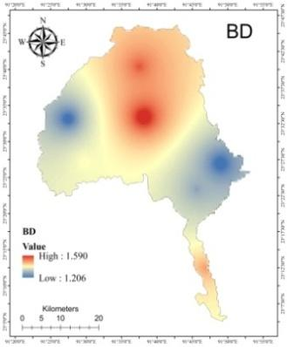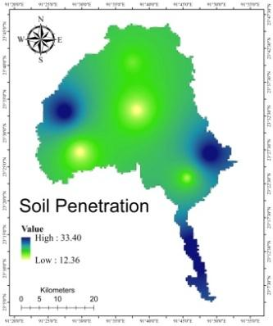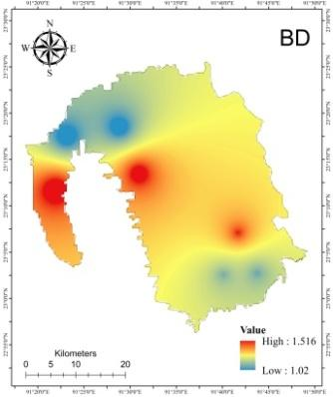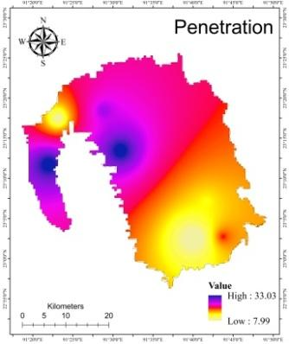
(a) (a) (b) (b)
Figure1:SpatialvariabilityofBulkdensityandpenetrationof(a)Gomatiand(b)SouthTripura
2.2SoilSamplingandAnalysis
Sampling(0-15cmdepth)wasconductedduringNovember,2024followingrecommendedmethodsandstoredinthepolythenebag.Thesampleswerecollectedalongwiththegeo-coordinatesandrecordedfromeachlocationbyusingglobalpositioningsystem(GPS)tool.Samplesweredriedatroomtemperatureandpulverizedwithawoodenrollonwoodenplankfollowedbysievedat2mm.Then,soilsamplesthathadbeenhomogenizedwereplacedinmarkin-clothbagsforfurtheranalysistodeterminethephysico-chemicalpropertiesofthesoil.Thestandardprotocolsfortheanalysingparametersaretabulatedintable2.
Table 2: Procedure used for physico-chemical analysis of soil
Sl. No. | Properties | Method applied | References
a) Physical Properties
1 | Particle size analysis | International Pipette method | Black (1965)
2 | Bulk Density (BD) | Core sampler | Black (1965)
3 | Water Holding Capacity (WHC) | Keen Raczkowski Box | Black (1965)
4 | Soil penetration (N value) | SPT method | Selvam (2020)
b) Chemical Properties
1 | Soil reaction (pH) | pH meter | Jackson et al. (1973)
2 | Electrical Conductivity (dS m⁻¹) | EC bridge | Jackson et al. (1973)
3 | Organic Carbon (%) | Wet oxidation method | Walkley & Black (1934)
c) Available nutrient
1 | Available N (kg ha⁻¹) | Alkaline KMnO₄ method | Subbiah &Asija (1956)
2 | Available P (kg ha⁻¹) | Bray &Kurz Method | Bray &Kurz (1945)
3 | Available K (kg ha⁻¹) | Ammonium acetate method | Hanway&Heidel (1952)
4 | Available Ca+Mg (kg ha⁻¹) | EDTA Method | Cheng & Bray (1951)
5 | Available S (kg ha⁻¹) | Calcium chloride method | Chesnin&Yien (1950)
6 | CEC | Ammonium acetate method | Lewis (1949)

2.3StatisticalAnalysis
ThetechniquesmodelledbySnedecorandCochran’s(1967)arefoundsuitablefordoingthissimplestatisticalanalysis.Theseanalysesincludedcommonstatisticalalgorithmsviz.maximum,minimum,mean,coefficientofvariationandcorrelation.TheCoefficientvariationwasdeterminedbyusingformula:
C.V.=StandardDeviationMean×100
Andthecorrelationcoefficientwasdeterminedbyusingtheformula:
$$r=\frac{n\left(\sum{xy}\right)-\left(\sum{x}\right)\left(\sum{y}\right)}{\sqrt{\left[n\sum{x^{2}}-{\left(\sum{x}\right)}^{2}\right]\left[n\sum{y^{2}}-{\left(\sum{y}\right)}^{2}\right]}}$$
Where,
r=Correlationcoefficient
SP(xy)=Sumproductofx,yvariables
SS(x)=Sumofsquareofxvariable
SS(y)=Sumofsquareofyvariable.
3.RESULTSANDDISCUSSION
3.1PhysicalProperties
InbothGomatiandSouthTripura,thesand,siltandclaycontentofsamplesrangedfrom8-61,5-63and4-47(Table3)respectivelyfollowingnodefinitetrend.Thebulkdensity(BD)rangedfrom1.10to1.60mgm⁻³;whereaswaterholdingcapacitywasmostlyatnearlyintheoptimumrange.TheratioofSand-Silt-clayreflectedmostsitesweresandyloamtype.TheCVvalueofBD,WHCandSandwereinacceptablerangeandreflectedthebasicparentsoiltypeofthestudyarea(Gökbulak&Özcan,2008).Topographicalvariabilityaffectedtheformationandrangeofsiltandclay,reflectedathigherrangeofCVvalue(Khanetal.,2013).TheBDexhibitedpositivesignificantcorrelation(r=0.662**)withsand;whereassiltandclayarenegativelycorrelated(r=-0.644*).SimilarresultwasexperiencedbyWangetal.(2024).
Table3:PhysicalpropertiesofsoilsofGomatiandSouthTripura
Sl.No. | BeatName | BD  (mgm⁻³) | WaterHoldingCapacity(%) | SoilPenetration(Nvalue) | Sand(%) | Silt(%) | Clay(%)
S₁ | Bampur | 1.60 | 37.00 | 12 | 60 | 5 | 35
S₂ | Dhanlekha | 1.50 | 47.54 | 17 | 52 | 44 | 4
S₃ | BairagiDokan | 1.30 | 76.00 | 15 | 54 | 41 | 5
S₄ | Suknachari | 1.45 | 45.00 | 34 | 51 | 39 | 10
S₅ | Paratia | 1.39 | 65.00 | 12 | 47 | 34 | 19
S₆ | Udaipur | 1.21 | 33.00 | 32 | 37 | 31 | 32
S₇ | Ghorakappa | 1.20 | 76.00 | 32 | 56 | 39 | 5
S₈ | Manirambari | 1.51 | 65.21 | 34 | 61 | 35 | 4
S₉ | Bankul | 1.43 | 76.45 | 18 | 49 | 11 | 40
S₁₀ | ManuBazar | 1.22 | 67.45 | 7 | 42 | 42 | 16
S₁₁ | AnandapurWL | 1.54 | 71.00 | 34 | 48 | 41 | 11
S₁₂ | NidayaWL | 1.10 | 73.76 | 12 | 8 | 63 | 29
S₁₃ | Rupaichari | 1.21 | 43.34 | 23 | 44 | 9 | 47
S₁₄ | MaicherraWL | 1.11 | 54.23 | 27 | 41 | 49 | 10
 | SD | 0.16 | 14.99 | 9.54 | 12.61 | 15.54 | 14.21
 | mean | 1.26 | 56.40 | 21.24 | 44.17 | 34.50 | 18.75
 | CV | 12.79 | 26.57 | 44.90 | 28.55 | 45.03 | 75.80

3.2ChemicalProperties
ThepHrangeofsamplingarearangesfrom4.14to5.70withameanvalueof4.59(Table4).TheresultindicatedextremelyacidicpHwithsafelimitofelectricalconductivityinentirestudyarea.IntensiverainfallfollowedbyerosionandleachingandorpercolationwerethereasonsforacidityandlowEC(Makinecietal.,2015).ECisnegativelycorrelatedwithavailableN(r=-0.690**)duetoeffectoflowpHonnutrientdynamixwherehighaciditylimitstheavailabilityofNH₄⁺evenwhenECiselevated(Kim&Park,2024).Theleveloforganiccarbonfrom0.45to2.65existedinthestudyareawhichcoveredexhaustivefarmingtovirginorforestorplantationarea(Kaushiketal.,2018).TripuraissecondhighestinrubberproductioninIndiaandtheageofrubberfieldmightberesponsibleforhighrangeofSOCatManirambari,Dhanlekha,MaicherraWLareas.SOCwaslowerinyoungplantationbutgraduallyincreasedwithrubberplantationageasequivalentwithnaturalforest(Nguyenetal.,2020).
3.3NutrientStatus
Thesoilintheresearchregionunveiledtherangeofavailablenitrogencontent,spanningfrom37.63to225.79kgha⁻¹,whilemeanvalueis137.98kgha⁻¹(Table4).Amongthesites,highestlevel(225.79kgha⁻¹)wasfoundatno.S₈Manirambariwhichalsoreflectedhighestrangeof2.65%SOC.DenserubbercultivationalongwithsyntheticfertilisationmightbethereasonforthisresultasobservedbyJinetal.(2024).TheuniversaltruthofpositivecorrelationbetweenSOCandavailableNwasre-establishedinsuchacidicsoilrepresentingtheresponsesofBharteeyetal.(2023).ThewidevariationsofavailableP2O5(7.70to43.63kgha⁻¹)withmeanvalueof22.31,resultedhigherCV(44.34)andpositivecorrelationwithpH.Suknachari(7.70kgha⁻¹)reflectedlowestP2O5withapHlevelof4.30.ThiswasestablishedthetruthofnegativerelationbetweenacidityandavailableP2O5(Bharteeyetal.,2017).Thestatusofavailablepotassiumrangedfrom60.58-451.89kgha⁻¹,havingameanvalueof173.93kgha⁻¹.No.S₈Kakuliahasthemaximumpotassiumcontent,whileNo.S₅Paratiahasthelowestpotassiumcontent.57%ofthesoilsampleshadmedium,28%lowand14%hadhighpotassiumcontent.SuchtrendinhillyhighrainfallsubtropicalareashadbeencontrolledbySOCandpotassiumbufferingcapacitytookleadroleonavailabilityofpotash(Grandoetal.,2025).TherangeofavailableCa+Mgwas157.01to753.67kgha⁻¹havingameanvalueof441.47.ThisrangeexistedinlowerrangeofCa+MgasperthelimitproposedbyTisdaleetal.(1995).SubtropicalclimatewithhighrainfallmightbereasonoflowbasesaturationasalsoobservedbyGrandoetal.(2025).AlsotherangeofavailableS(0.07to18.92kgha⁻¹)wasalsoexistedatlowerrangemightbeduetoparentsoilcharacteristicsalongwithhighrainfall.PaulandMukhopadhyay(2015)provedthatorganicSisthemostpredominantfractionofSandoccursasmajornativeSreserve.CECrangesfrom12.29to20.84cmol(p+)kg⁻¹wherethemeanvalueis15.66cmol(p+)kg⁻¹.OnlyMaicherraWLno.S₁₄reflectedlowerrangeandrestareasrepresentedmediumrangeofCECwithCVvalueof13.72.CECwassignificantlycorrelatedwithCa+Mg(r=0.999**)asre-assessedbyGrandoetal.(2025)(Table5).
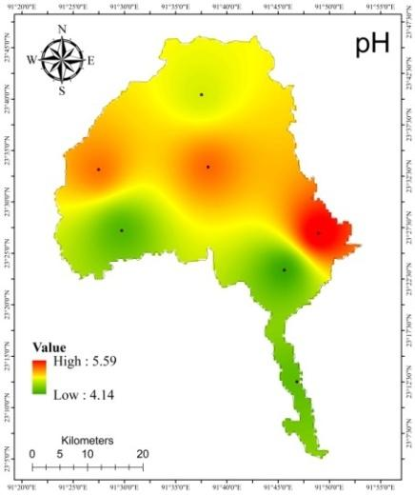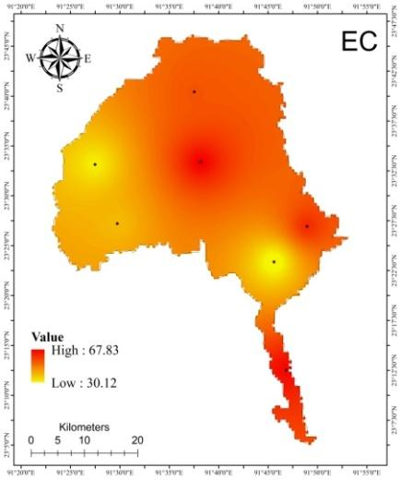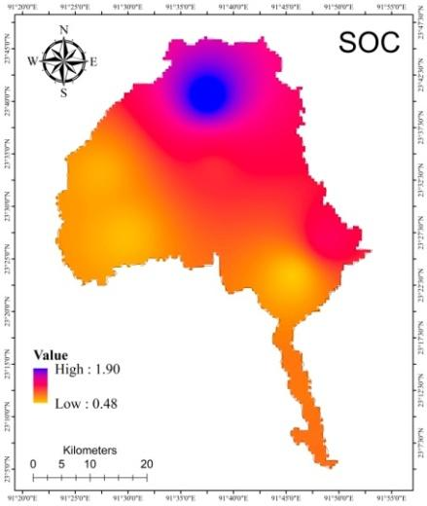
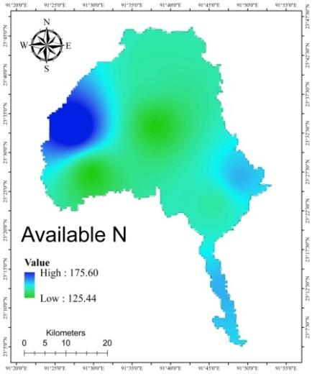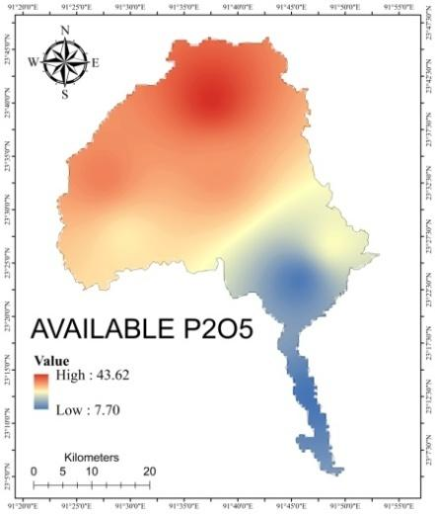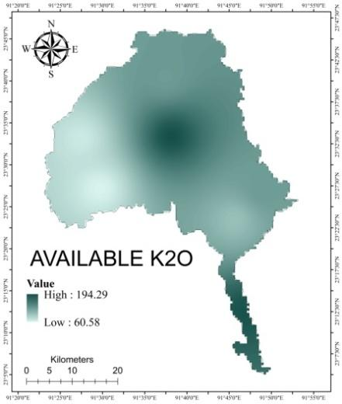
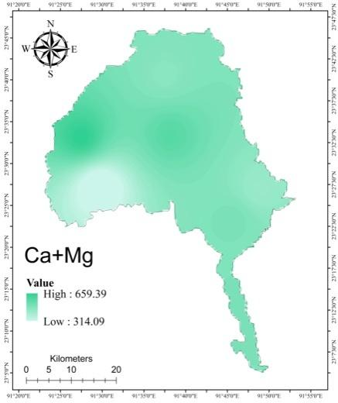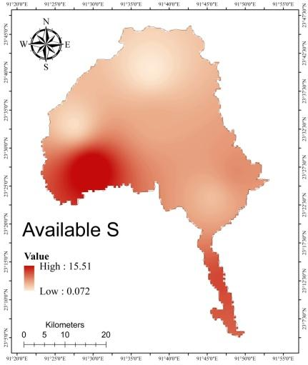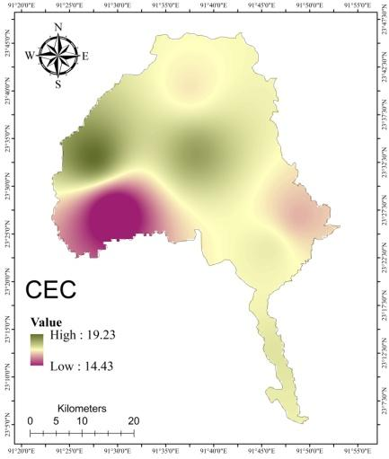
Figure 2: Spatial variability maps of pH, EC, SOC, available N, P₂O₅, K₂O, Ca+Mg, S & CEC of Gomati
Amongvariousgeostatisticalanalyticaltools,InverseDistanceWeighting(IDW)ismostcommonandthistechniqueisusedforcreatingmapsofthephysico-chemcalpropertiesofGomatiandSouthTripuradistricts,depictedasfigures2andfigure3,respectively.
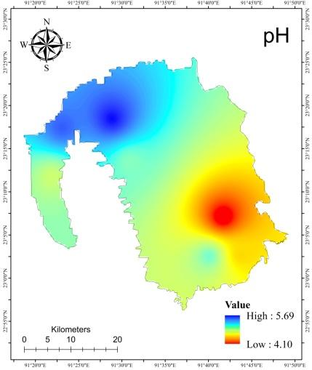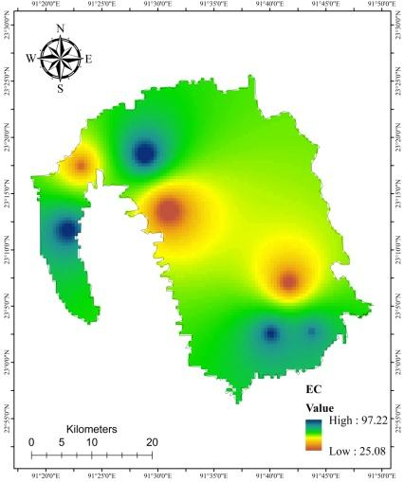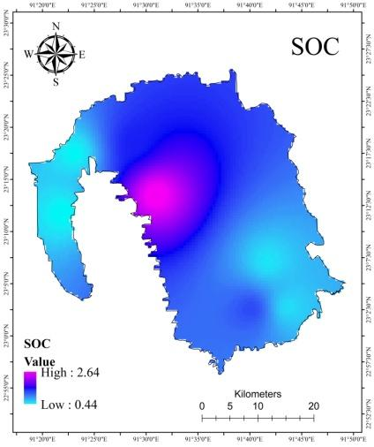
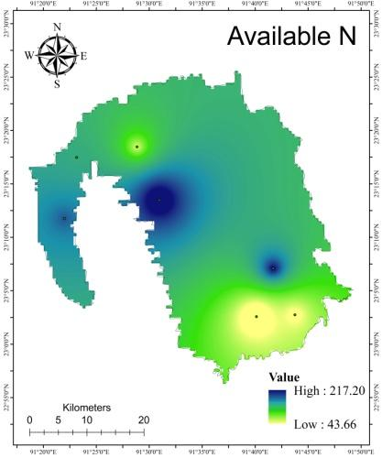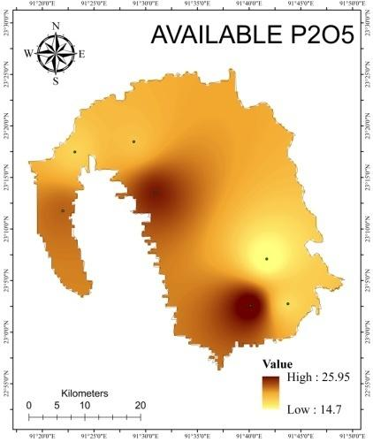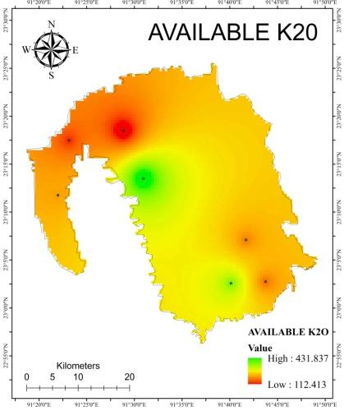
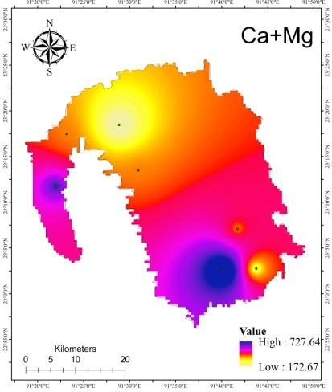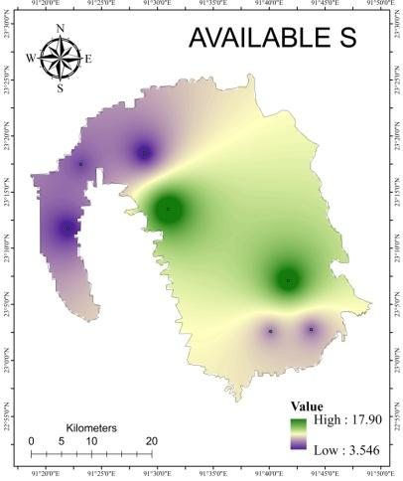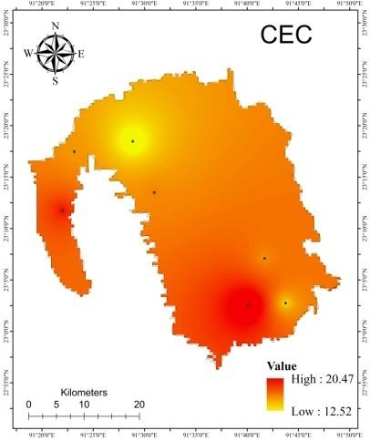
Figure 3: Spatial variability maps of pH, EC, SOC, available N, P₂O₅, K₂O, Ca+Mg, S & CEC of South Tripura

Table4:Chemicalandnutrientpropertiesofanalyticalsoilsamples
Sl.No. | BeatName | EC  (µScm⁻¹) | pH | SOC% | Avail.N  (kgha⁻¹) | Avail.P₂O₅  (kgha⁻¹) | Avail.K₂O  (kgha⁻¹) | Avail.(Ca+Mg)  (kgha⁻¹) | Avail.S  (kgha⁻¹) | CEC  (cmolkg⁻¹)
S₁ | Bampur | 67.90 | 5.20 | 0.98 | 125.44 | 34.66 | 194.32 | 596.65 | 4.17 | 18.51
S₂ | Dhanlekha | 55.90 | 4.70 | 1.91 | 137.98 | 43.63 | 125.43 | 502.45 | 0.07 | 17.12
S₃ | BairagiDokan | 29.90 | 4.14 | 0.49 | 137.98 | 8.62 | 97.29 | 533.85 | 3.21 | 17.52
S₄ | Suknachari | 66.70 | 4.30 | 0.78 | 150.53 | 7.70 | 191.13 | 533.85 | 9.68 | 17.63
S₅ | Paratia | 41.50 | 4.26 | 0.53 | 125.44 | 27.38 | 60.58 | 314.03 | 15.52 | 14.43
S₆ | Udaipur | 34.00 | 5.17 | 0.59 | 175.62 | 36.62 | 67.50 | 659.46 | 1.00 | 19.23
S₇ | Ghorakappa | 61.90 | 5.60 | 1.17 | 150.53 | 25.28 | 125.43 | 471.04 | 5.92 | 16.68
S₈ | Manirambari | 20.80 | 5.06 | 2.65 | 225.79 | 24.24 | 451.89 | 376.83 | 18.92 | 15.75
S₉ | Bankul | 28.70 | 4.10 | 0.55 | 188.16 | 14.72 | 196.82 | 376.83 | 17.30 | 15.46
S₁₀ | ManuBazar | 88.90 | 5.10 | 1.25 | 37.63 | 25.97 | 330.33 | 753.67 | 6.57 | 20.84
S₁₁ | AnandapurWL | 93.40 | 4.88 | 0.45 | 163.07 | 21.99 | 217.12 | 533.85 | 3.55 | 17.66
S₁₂ | NidayaWL | 38.70 | 5.54 | 0.47 | 137.98 | 17.72 | 161.28 | 376.83 | 5.42 | 15.42
S₁₃ | Rupaichari | 81.70 | 4.62 | 0.59 | 75.26 | 17.46 | 188.39 | 282.63 | 5.92 | 14.14
S₁₄ | MaicherraWL | 100.20 | 5.70 | 1.44 | 87.81 | 18.70 | 99.64 | 157.01 | 3.12 | 12.29
 | SD | 25.35 | 0.53 | 0.63 | 45.84 | 9.89 | 101.80 | 153.12 | 5.77 | 2.15
 | mean | 55.70 | 4.59 | 0.96 | 137.09 | 22.31 | 173.93 | 441.47 | 7.08 | 15.66
 | CV | 45.51 | 11.45 | 65.15 | 33.44 | 44.34 | 58.53 | 34.68 | 81.52 | 13.72

Table5:Correlationbetweenphysico-chemicalandnutrientpropertiesofGomatiandSouthTripura
PearsonCorrelations
 | BD | WHC | Nvalue | Sand | Silt | Clay | EC | pH | SOC | N | P₂O₅ | K₂O | Ca+Mg | S | CEC
BD | 1 | -0.144 | 0.093 | 0.662** | -0.416 | -0.133 | -0.134 | -0.445 | 0.228 | 0.454 | 0.234 | 0.325 | 0.241 | 0.283 | 0.256
WHC |  | 1 | -0.163 | -0.103 | 0.38 | -0.324 | -0.21 | -0.083 | -0.079 | 0.141 | -0.438 | 0.174 | -0.148 | 0.371 | -0.137
Nvalue |  |  | 1 | 0.26 | 0.047 | -0.283 | 0.07 | 0.163 | 0.206 | 0.531 | -0.129 | 0.114 | -0.132 | 0.036 | -0.125
Sand |  |  |  | 1 | -0.507 | -0.334 | -0.009 | -0.33 | 0.407 | 0.242 | 0.121 | 0.24 | 0.14 | 0.234 | 0.152
Silt |  |  |  |  | 1 | -0.644* | 0.044 | 0.362 | 0.138 | -0.05 | -0.098 | -0.091 | -0.031 | -0.254 | -0.036
Clay |  |  |  |  |  | 1 | -0.04 | -0.102 | -0.513 | -0.161 | 0.000 | -0.113 | -0.09 | 0.07 | -0.095
EC |  |  |  |  |  |  | 1 | 0.343 | -0.055 | -0.690** | -0.001 | -0.01 | -0.012 | -0.451 | -0.013
pH |  |  |  |  |  |  |  | 1 | 0.315 | -0.159 | 0.332 | 0.08 | -0.043 | -0.38 | -0.038
SOC |  |  |  |  |  |  |  |  | 1 | 0.192 | 0.372 | 0.574* | -0.084 | 0.194 | -0.052
N |  |  |  |  |  |  |  |  |  | 1 | 0.013 | 0.162 | -0.041 | 0.407 | -0.032
P2O5 |  |  |  |  |  |  |  |  |  |  | 1 | -0.079 | 0.306 | -0.309 | 0.298
K2O |  |  |  |  |  |  |  |  |  |  |  | 1 | 0.165 | 0.481 | 0.218
Ca+Mg |  |  |  |  |  |  |  |  |  |  |  |  | 1 | -0.319 | 0.999**
S |  |  |  |  |  |  |  |  |  |  |  |  |  | 1 | -0.29
CEC |  |  |  |  |  |  |  |  |  |  |  |  |  |  | 1
**Correlationissignificantatthe0.01level(2-tailed).
*Correlationissignificantatthe0.05level(2-tailed).

4.CONCLUSION
ItcanbeconcludedthatGomatiandSouthTripuradistrictsoilcanbeclassifiedassandyloamandclayloamwithanextremetostronglyacidicpH.50%soilsampleshadhighorganiccarbon,28%medium,22%lowand100%lowavailablenitrogen,phosphate,calciumsulphurandmagnesium.AllthesitesreflectedmediumCECrangeduetohigherlevelofSOC.Intensiveplantationaswellasrice-fellowcroppingpatterninthisregioncreatedsuchresult.Consideringsoiltexturalclasses,policymakerscanintroduceacidicsoilsuitableleguminouscropsinrice-fellowcroppingpattern.Applicationofcropspecificbio-fertilizerwillincreasetheproductivityandmakeadditionalreturntothefarmers.SoilmappingusingGISmaygenerateanideaaboutthesoilfertilitystateanditcouldbeveryusefulforfertilizermanagementforaspecificareasimplybyapplyingpreviouslyanalyzedsoildata,leadingtosite-specificsmartnutrientmanagement.Atplantationsiteatleast2-tiercroppingsystemlikeSal/Segun-blackpepper,Sal-pineappleetc.canbeestablishedtoupliftsocio-economicstatusoftheforestdwellers.
Consent(whereapplicable): Notapplicableasnopersonaldatawereinvolvedinthisstudy.
EthicalApproval(whereapplicable): Notapplicable.SoilsamplingwascarriedoutwithpermissionandsupportfromtheForestDepartment,GovernmentofTripuraundertheSCATFORM,JICAproject.

COMPETING INTERESTS DISCLAIMER:
Authors have declared that they have no known competing financial interests OR non-financial interests OR personal relationships that could have appeared to influence the work reported in this paper.

6.REFERENCES
- Bharteey, P. K., Singh, Y. V., Sharma Sukirtee, P. K., Kumar, M., & Rai, A. K. (2017). Available Macro Nutrient Status and their Relationship with Soil Physico-Chemical Properties of Mirzapur District of Uttar- Pradesh, India. International Journal of Current Microbiology and Applied Sciences, 6(7), 2829-2837. https://doi.org/10.20546/ijcmas.2017.607.394
- Bharteey, P. K., Deka, B., Dutta, M., Goswami, J., &Saikia, R. (2023). Geospatial variability of soil physico-chemical properties of Moridhal watershed in Dhemaji district of Assam, India using remote sensing and GIS. Annals of Plant and Soil Research, 25(1), 99-109. https://doi.org/10.47815/apsr.2023.10242
- Black, C. A. (Ed.). (1965). Methods of Soil Analysis: Part 1 Physical and Mineralogical Properties, Including Statistics of Measurement and Sampling. American Society of Agronomy. https://doi.org/10.2134/agronmonogr9.1
- Bray, R. H., & Kurtz, L. T. (1945). Determination of total, organic, and available forms of phosphorus in soils. Soil Science, 59, 39-45. https://doi.org/10.1097/00010694-194501000-00006
- Cheng, K. L., & Bray, R. H. (1951). Determination of calcium and magnesium in soil and plant material. Soil Science, 72(6), 449-458. https://doi.org/10.1097/00010694-195112000-00005
- Chesnin, L., &Yien, C. H. (1951). Turbidimetric determination of available sulfates. Soil Science Society of America Journal, 15, 149-151. https://doi.org/10.2136/sssaj1951.036159950015000C0032x
- Gökbulak, F., &Özcan, M. (2008). Hydro-physical properties of soils developed from different parent materials. Geoderma, 145(3-4), 376-380. https://doi.org/10.1016/j.geoderma.2008.04.006
- Grando, D. L., Martins, C. G., Deponti, L. P., Rodrigues, M. L., Mumbach, G. L., Schmitt, D. E., Moterle, D. F., Tiecher, T. L., Garlet, L. P., Dunker, L. S., Papalia, D. G., &Brunetto, G. (2025). Potassium buffer capacity in subtropical soils with high organic matter content. Revista Sociedade Brasileira de Ciência do Solo (Brazilian Society of Soil Science), 49, e0240201. https://doi.org/10.36783/18069657rbcs20240201
- Hanway,J.J.&Heidel,H.(1952).SoilanalysismethodsasusedinIowastatecollegesoiltestinglaboratory.IowaAgriculture,57,1-31.
- Havlin,H.L.,Beaton,J.D.,Tisdale,S.L.&Nelson,W.L.(2010).Soilfertilityandfertilizers:Anintroductiontonutrientmanagement(7thedition).PHILearningPrivateLimited,NewDelhi.India.p.516.
- Jackson, M. L. (1973). Soil Chemical Analysis. Prentice Hall of India, Pvt. Ltd.
- Jin, D., Cha, Z., Li, J., Huang, Y., Yang, H., Liu, H., Luo, W., & Lin, Q. (2024). Reinforcing nitrogen nutrition through partial substitution with organic nitrogen enhances the properties of natural rubber. Forests, 15(11), 1897. https://doi.org/10.3390/f15111897
- Kaushik, U., Raj, D., Rani, P., & Bhardwaj, K.K. (2018). Effect of cultivation on organic carbon pools and nutrient availability in soil under different land use system: A review. International Journal of Current Microbiology and Applied Sciences. https://doi.org/10.20546/ijcmas.2018.708.180
- Khaki, B. D., Honarjoo, N., Davatgar, N., Jalalian, A., &Golsefidi, H. T. (2017). Assessment of two soil fertility indexes to evaluate paddy fields for rice cultivation. Sustainability, 9(8), 1299. https://doi.org/10.3390/su9081299
- Khan, F., Hayat, Z., Ahmad, W., Ramzan, M., Shah, Z., Sharif, M., Mian, I. A., & Hanif, M. (2013). Effect of slope position on physico-chemical properties of eroded soil. *SoilEnvironment*, *32*(1), 22-28. https://www.researchgate.net/publication/259295824_Effect_of_slope_position_on_physico-chemical_properties_of_eroded_soil
- Kim, H. N., & Park, J. H. (2024). Monitoring of soil EC for the prediction of soil nutrient regime under different soil water and organic matter contents. Applied Biological Chemistry. https://doi.org/10.1186/s13765-023-00849-4
- Lewis,D.R.(1949).Analyticaldataonreferenceclaymaterials.Section3,Base-ExchangeData,ReferenceClayMinerals.A.P.I.ResearchProject49,PreliminaryReportNo.7,ColumbiaUniversity,NewYork.p.91.
- Makineci, E., Demir, M., &Kartaloglu, M. (2015). Acidity (pH) and electrical conductivity changes in runoff water from ditches of paved and unpaved forest roads. Baltic Forestry, 21(1), 170-175. https://www.balticforestry.mi.lt/bf/PDF_Articles/2015-21[1]/Acidity%20and%20Electrical%20Conductivity%20Changes%20in%20Runoff%20Water%20from%20Ditches%20of%20Paved%20and%20Unpaved%20Forest%20Roads.pdf
- Mishra, A., Das, D., Saren, S., & Dey, P. (2016). GPS and GIS based soil fertility maps of Nayagarh district, Odisha. Annals of Plant and Soil Research, 18(1), 23-28. http://www.gkvsociety.com/index.php
- Nguyen, T. T., Do, T. T., Harper, R., Pham, T. T., Linh, T. V. K., Le, T. S., Thanh, L. B., &Giap, N. X. (2020). Soil health impacts of rubber farming: The implication of conversion of degraded natural forests into monoculture plantations. Agriculture, 10(8), 357. https://doi.org/10.3390/agriculture10080357
- Patil, P. L., Kuligod, V. B., Gundlur, S. S., Katti, J., Nagaral, I. N., Shikrashetti, P., Geetanjali, H. M., &Dasog, G. S. (2016). Soil fertility mapping in Dindur sub-watershed of Karnataka for site specific recommendations. Journal of the Indian Society of Soil Science, 64(4), 381-390. https://doi.org/10.5958/0974-0228.2016.00050.5
- Paul, S. C., & Mukhopadhyay, P. K. (2015). Distribution and Availability of Sulphur in some Terai Soils under Subtropical Zone of Eastern India. International Journal of Agriculture, Environment and Biotechnology, 8(2), 347-357. https://doi.org/10.5958/2230-732X.2015.00043.1
- Saleh, T. M., Jubeir, A. R., & Al-Tememe, M. S. O. (2023). The role of Geographic Information Systems (GIS) in soil surveying and classification. IOP Conference Series Earth and Environmental Science, 1158(2), 022028. https://doi.org/10.1088/1755-1315/1158/2/022028
- Selvam, S., Mukundan, M., & Alagirisamy, S. (2020). Standard Penetration Test (SPT) Pitfalls and Improvements. In C. N. V. S. Reddy (Ed.), Ground Characterization and Foundations: Proceedings of Indian Geotechnical Conference 2020 Volume 1 (pp. 391-400). Springer Singapore. https://doi.org/10.1007/978-981-16-3383-6_35
- Shreekanth, S., Anita, E.K., Rekha, M.V., Champa, B.V., &Nagaraja, M.S. (2018). Secondary and micronutrient status in soils of grape orchards of Vijayapura Taluka in Northern Karnataka, India. International Journal of Current Microbiology and Applied Sciences, 7(5), 1393-1401. https://doi.org/10.20546/ijcmas.2018.705.165
- Snedecor,G.W.&Cochran,W.G.(1967).StatisticalMethods(6thEdition).IowaStateUniversityPress,Ames.Iowa,USA.p.593.
- Subbiah, B.V., &Asija, G.L. (1956). A rapid procedure for the estimation of available nitrogen in soils. Current Science, 25, 259-260.
- Tisdale,S.L.,Nelson,W.L.,Beaton,J.D.&Havlin,J.L.(1995).SoilFertilityandFertilizers(5thEdition).Prentice-HallofIndia,NewDelhi.p.684.
- Walkley, A., & Black, I. A. (1934). An examination of the Degtjareff method for determining soil organic matter and a proposed modification of the chromic acid titration method. Soil Science, 37(1), 29–38. https://doi.org/10.1097/00010694-193401000-00003
- Wang,X.,Sun,H.,Wang,C.,Liu,J.,Guo,Z.,Gao,L.,Ma,H.,Yuan,Z.,Yao,C.&Pan,X.(2024).PredictingthesoilbulkdensityusinganewspectralPTFbasedonintactsamples.Geoderma,449,117005.DOI:https://doi.org/10.1016/j.geoderma.2024.117005
- Wilding, L. P., & Lin, H. (2006). Advancing the frontiers of soil science towards a geoscience. Geoderma, 131(3-4), 257-274. https://doi.org/10.1016/j.geoderma.2005.03.028

