Colorimetric Quantification of CO₂ in a Modified Alkali-Trap Soil Respiration Assay

Abstract
Microbial activity in soil is an important characteristic of healthy soil. A key indicator of microbial activity is soil respiration. Traditional alkali-trap assays use hydrochloric acid to titrate sodium hydroxide that has not reacted to quantify CO₂ evolution, but determining the titrimetric endpoint is subjective, involves colour fading, reagent instability, and operator variability. The present study reports a modified soil respiration assay using colorimetric quantification of pH reduction as sodium carbonate forms. The method is phenolphthalein-based absorbance reading at 552 nm with a colorimeter. The alteration of the assay greatly improved precision, eliminated blank samples, and reduced human error from visual titration. This colorimetric method is easier, inexpensive, and provides reliable quantification of soil microbial respiration.
Keywords
Soil Respiration, Colorimetric Analysis, CO₂ Evolution, Alkali Trap, Microbial Activity
- Introduction
Soil respiration, microbial and root-mediated release of carbon dioxide (CO₂), is a critical ecosystem process involving the cycling of carbon and has been widely utilized as an indicator of soil health (Gougoulias et al., 2014). Currently available laboratory methods, the alkali-trap method enjoys popularity because it is simple and inexpensive (Irving et al., 2024). The procedure involves the reaction of CO₂ released from incubated soils with NaOH, and the quantification of unreacted alkali to estimate CO₂ evolution. Traditionally, this is done by acid-base titration, which, despite effectiveness, has major limitations: subjective colour endpoint detection, time-consuming titrations, errors as a result of either slow or partial colour change, inefficiency during large-scale sample processing, and atmospheric CO₂ contamination during reagent handling (Bekku et al.,1997; Haney, 2008; Doran et al., 2012). To overcome these deficiencies, the following colorimetric modification is proposed, employing phenolphthalein as an indicator: Instead of adding an indicator and titrating, the absorbance of the NaOH-phenolphthalein mixture is measured by a colorimeter at 552 nm (Kostjukov et al., 2025). The reduction in absorbance following incubation with soil varies directly with the quantity of NaOH that has reacted with CO₂. Soil respiration, microbial and root-mediated release of carbon dioxide (CO₂), is a critical ecosystem process involving the cycling of carbon and has been widely utilized as an indicator of soil health (Gougouliaset al., 2014). As approximately 120 Pg C is released each year, it is the second-largest carbon flux between the biosphere and the atmosphere after global gross primary productivity (Bond-Lamberty & Thomson, 2010; Hashimoto et al., 2015). Global soils hold almost twice the amount of carbon than the atmosphere, and so even minor changes to soil respiration can have cascading effects for climate feedbacks and ecosystem carbon balance (Crowther et al., 2016). The flow of carbon, via soil respiration, is driven by rhizosphere respiration, microbial decomposition, and soil physiochemical factors temperature, moisture, and substrate availability (Schimel & Schaeffer, 2012). Therefore, accurately measuring soil respiration is imperative for evaluating soil quality, modelling carbon cycling, and assessing the effects of land-use change or climate change on soil processes (Doran & Zeiss, 2000; Haney et al., 2008). Of the laboratory methods available, the alkali-trap method is favored for its simple and inexpensive measurement (Irving et al., 2024). The procedure consists of the reaction of CO₂ released from incubated soils with NaOH and quantifying unreacted alkali to calculate CO₂ evolution. Traditionally, this is accomplished with acid-base titration, which, although effective, but with significant limitations: endpoint detection by subjective color, time-consuming titrations, imprecisions for slow or partial color change, bad apportioning for larger-scale sample processing, and risk of atmosphere CO₂ contamination of reagents (Bekkuet al., 1997; Haney, 2008; Doran et al., 2012). To solve these issues the following colourimetric adaptation can be suggested. This is done by using phenolphthalein as an indicator: the absorbance of the NaOH-phenolphthalein solution is measured by a colorimeter at 552 nm, rather than adding an indicator and then titrating (Kostjukov et al.,2025).
2. Objective
To develop and validate modified colorimetric alkali-trap soil respiration assay for accurate, rapid, and reproducible quantification of CO₂
3. Principle
During incubation, soil-respired CO₂ reacts with NaOH:
CO₂+2NaOH→Na₂CO₃+H₂O
A known amount of NaOH is placed in a sealed container with the soil sample. After incubation, the remaining unreacted NaOH is mixed with phenolphthalein, producing a pink colour in alkaline conditions. The absorbance is measured at 552 nm, and the concentration of remaining NaOH is determined using a calibration curve. A decreased absorbance indicates higher CO₂ absorption.
4. Materials and Methods
The materials required for the colorimetric CO₂ evolution assay include fresh soil samples sieved to 2 mm, airtight incubation jars equipped with silicone gaskets, and CO₂-free 0.1 M NaOH solution for trapping evolved CO₂. Phenolphthalein indicator (1%) solution prepared in ethanol is used for colorimetric detection. Photocolorimeter (200nm-700nm), pH meter, analytical balance, micro-pipettes (10-100µL), pipettes (10mL), and incubator are also required for the CO₂ evolution assay.
4.1 Preparation of Calibration Curve
Preparation of the calibration curve NaOH standards (0.01–0.10 M) are prepared, followed by adding 5 µL of phenolphthalein to each standard solution to obtain the calibration curve. The absorbance of these NaOH-phenolphthalein solutions was determined at 552 nm by using a colorimeter. The absorbance values (Y-axis) are plotted against the corresponding NaOH concentrations (X-axis) to derive a calibration curve and obtain a regression equation (e.g., Y = aX + b) for the description of the relationship for CO₂ calculation. For correlation analysis pH of the standards were also measured.
4.2 Soil Incubation Procedure
For the soil incubation procedure, 20.00 g of soil (Three Samples: Sand, Black Soil, and Vermicompost) were weighed into each airtight jar. Afterward, vials containing 20 mL of 0.1 M NaOH were placed inside to trap the CO₂ evolved during incubation. The jarswere sealed immediately to prevent atmospheric CO₂ from reacting with the alkali, and the setup is incubated in the dark at 25 °C for 24–72 hours. Appropriate controls are included,consisting of a reagent blank containing only NaOH without jar and soil, an incubation blank with the jar and NaOH with autoclaved soil, and an incubation blank with the jar and NaOH with no soil,to account for any non-soil-related CO₂ absorption.
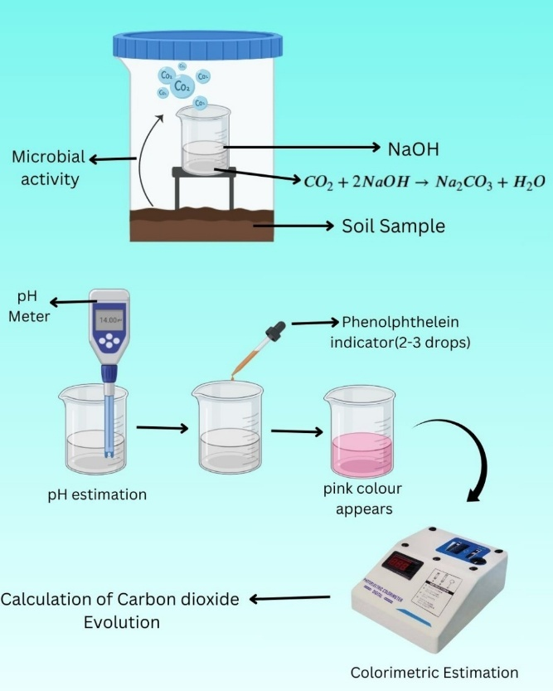

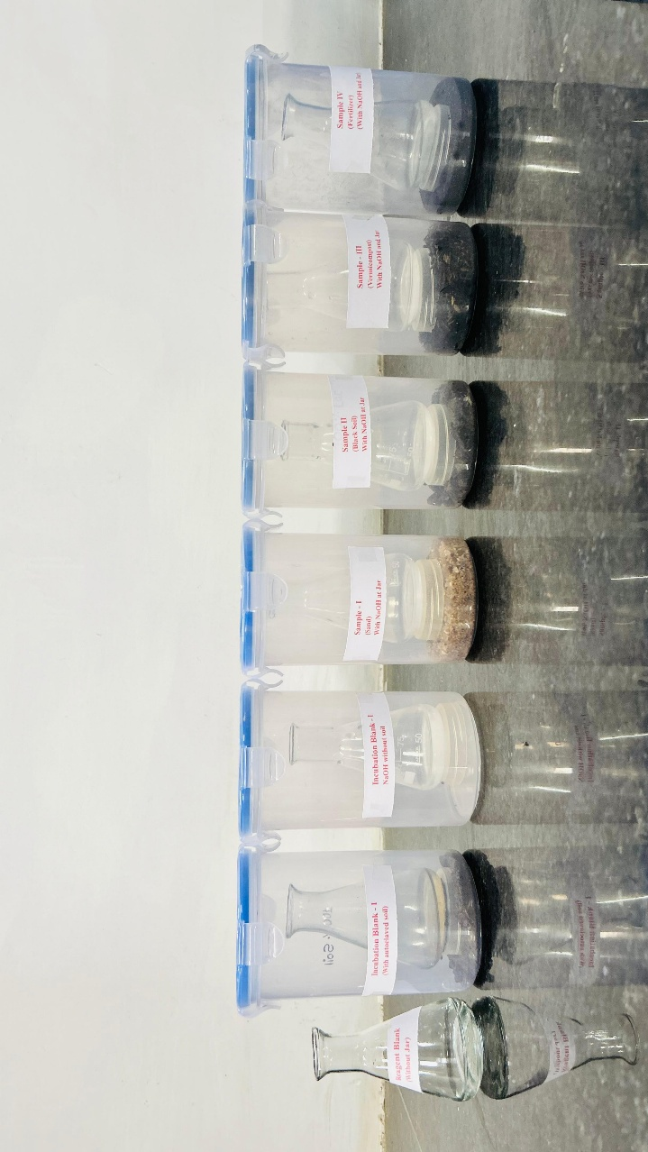

Fig. 1Experimental Setup

Fig. 2NaOH trap for different soils

4.3 Colorimetric Quantification of CO₂
After incubation, the NaOH trap is carefully removed, and the solution is quantitatively transferred into a volumetric flask,after which phenolphthalein is added until a pink colour develops.The absorbance of this solution is then measured at 552 nm using a colorimeter, and the concentrationof the remaining NaOH is determined from the previously prepared calibration curve. The difference between the initial and remaining NaOH represents the amount of NaOH consumed, which is subsequently used to calculate the corresponding quantity of CO₂ evolved from the soil.

4.4 Calculations
After measuring the absorbance of the phenolphthalein–NaOH solution from each incubated sample at 552 nm, the remaining NaOH concentration is obtained from the calibration curve (the linear regression relating absorbance to NaOH concentration):
Absorbance=a⋅[NaOH]+b.
Here, a is the slope of the calibration line and represents how many absorbance units change per unit change in NaOH concentration (for example, absorbance units per mol L⁻¹), while b is the y-intercept (the absorbance value when NaOH concentration = 0) and accounts for any baseline absorbance of the reagent/solvent or instrument offset. Using the regression equation, you rearrange to find the NaOH concentration remaining in the trap:
[NaOH] remaining ​= (Absorbance sample​ (OD) −b​) / a
Multiply this concentration by the trap volume to get moles of NaOH remaining.
Moles of [NaOH] Remaining = [NaOH] Remaining X Trap Volume
Moles of [NaOH] Initial = [NaOH] Initial X Trap Volume
Moles of NaOH that reacted with CO₂ = Moles of [NaOH] Initial -Moles of [NaOH] Remaining
Because two moles of NaOH consume one mole of CO₂, the moles of CO₂ evolved are
CO₂= reacted/2
Convert to mass by multiplying by the molar mass of CO₂ (44.01 g mol⁻¹).

5. Results:
In the present study, the correlation analysis revealed a strong positive relationship between NaOH concentration and pH (r = 0.991). Similarly, a strong positive correlation was also observed between NaOH concentration and optical density (OD) (r = 0.999). Linear regression analysis further indicated that the relationship between NaOH concentration and pH followed the equation pH = 15.012(NaOH) + 12.097.
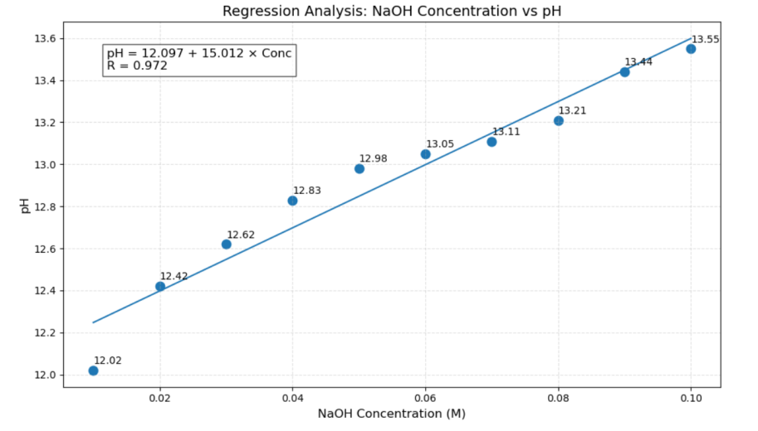
Fig. 3 Plot between pH and NaOH Con.
On the contrary, the regression between NaOH concentration and OD, described by the equation OD = 5.476 (NaOH) + 0.202, provided a strong and statistically significant relationship (p = 0.00095). Collectively, the data indicate that the NaOH concentration has a significantly stronger impact on OD. [NaOH] remaining ​= (OD −0.202)​ / 5.476
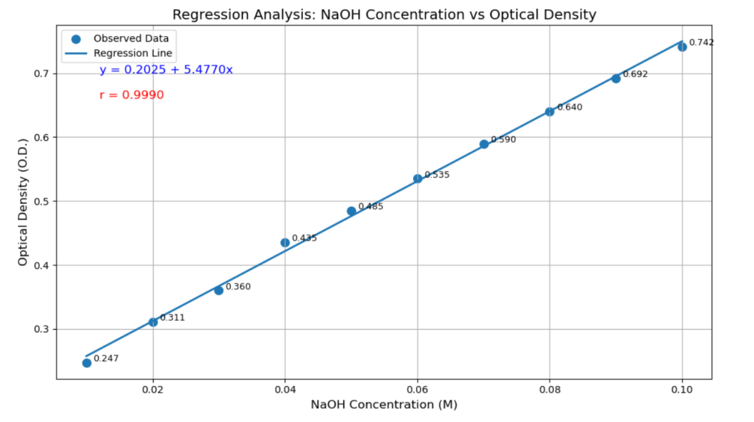
Fig. 4 Plot between OD and NaOH Con.

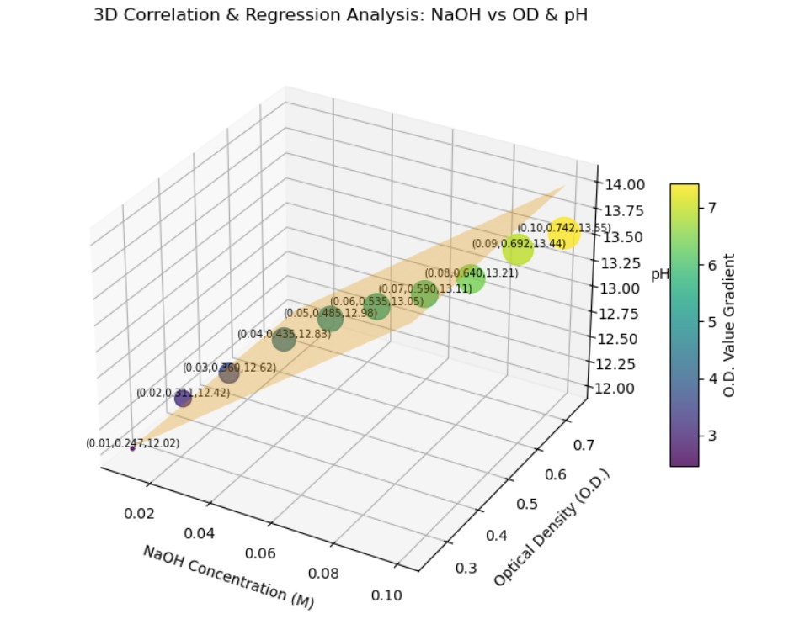
Fig. 5 3D Scatter (pH, OD, and NaOH Con.)

Table 1. : Different Soil Types and CO₂ Evolved
Soil Type | OD | pH | CO₂ Evolved moles/gram
Reagent Blank | 0.856 | 13.21 | 19.386405
Autoclaved Soil | 0.666 | 13.01 | 20.15658
NaOH without Soil | 0.925 | 13.11 | 19.10034
Sand | 0.522 | 12.42 | 20.72871
Black Soil | 0.401 | 11.86 | 21.21282
Vermicompost Soil | 0.374 | 11.65 | 21.322845
Organic Fertilizer Soil | 0.189 | 11.54 | 21.674925

Soil respiration measured using the alkali (NaOH) trap method exhibited different variations among different soil types. The reagent blank (NaOH only) recorded 19.3 moles/g/day CO₂,estimated due to the reaction with environmental CO₂. The autoclaved soil blank showed slightly higher values 20.15 moles/g/day, attributed to abiotic CO₂ release from minerals or trapped gases.The incubation blank without soil showed 19.10moles/g/day CO₂,likely due to minor atmospheric contamination or jar headspace CO₂. Among the soil samples, Organic Fertilizer Soil exhibited the highest respiration rate, 21.67 moles/g/day CO₂, indicating high microbial activity and rich organic carbon content. Vermicompost soil and Black soil showed 21.32 and 21.21 moles/g/day CO₂. respectively, consistent with its balanced organic matter and microbial biomass. Sand presented the lowest biological activity 20.72871 mole/g/day,CO₂. due to minimal organic carbon and poor microbial populations.Overall, the soil respiration trend is shown in the Figure 5.

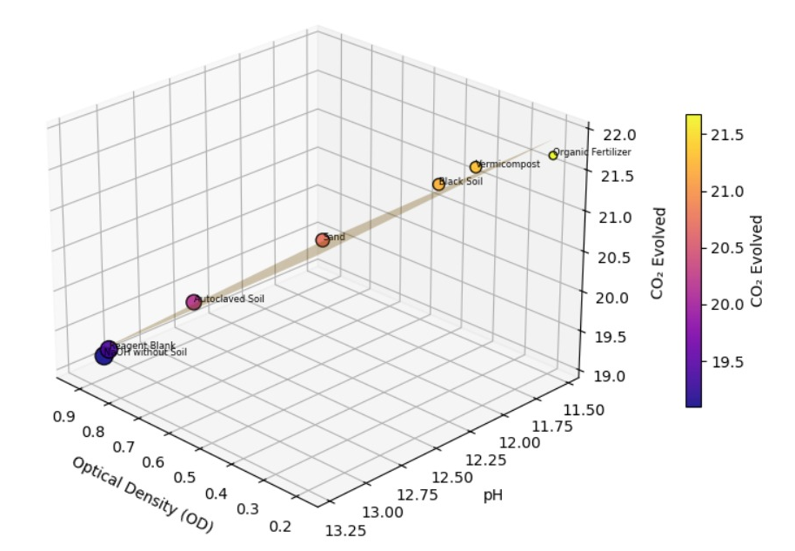
Fig. 6 Soil respiration in different soil types
6. Discussion

Although traditional chemical titration techniques have good use, there are more sensitive and higher-throughput automated instrumental methods, such as Infrared Gas Analysers (IRGA) and Solute Gel-Based Systems (SGBS), as well. Haney et al. (2008) pulled together data that exhibited very strong correlations (r², up to 0.95) between titration and both IRGA and SGBS to suggest that respiration measurements that do not employ titration are just as valid and accurate as the measurements that do (Haney et al. 2008). However, gel-based methods could employ semi-quantitative color scales and may not result in accuracy for quantification; employing an IRGA system will incur higher costs on equipment while potentially also employing controlled chambers. IRGA-based chambers (static or flow) are similarly a commonly-used method that provides a high temporal resolution and real-time CO2 flux data. Automated IRGA systems allow for frequent or continuous samplings, but that still employs complicated infrastructure and in-field may involve timing versus scaling tradeoffs, at least within heterogeneous field plots (Jennifer et al., 2002; Kathleen et al., 2003). In contrast, your effective spectrophotometric NaOH trap method uses simple reagents, a colorimeter, and standard lab glassware while providing low and easy to scale costs.

The revised colorimetric alkali-trap respiration method described in this study shows good agreement with established instrumental methods while addressing the limitations of traditional titration methods. Conventional acid-base titration has been widely used to measure CO₂ evolution, but it is limited by subjective endpoint detection, operator differences, and its proximity to atmospheric CO₂ contamination (Bekku, et al. 1997; Haney, et al. 2008).

The most reliable instrumental methods are infrared gas analyzers (IRGA) combining high temporal resolution and gas-phase CO₂ measurement accuracy, which is the current benchmark for soil respiration studies (Pumpanen et al. 2004; Tang et al. 2005). However, IRGA systems come with minimum costs, require the use of chambers with specific controls, and require continuous calibration for measurements, making them relatively inaccessible in routine soil laboratories or where resources are limited (Subke and Bahn 2010). Gel detectors (either colorimetric in sol-gel or gel form) are low-cost alternatives that have been used in CO₂ detection, but often adopt semi-quantitative visual scales that limit accuracy and reproducibility (Roller et al., 2016). The strong regression between NaOH concentration and OD indicates that absorbance may be a more sensitive index of alkalinity than pH is consistent with past research showing pH responds non-linearly to form carbonate species, especially near the transition points in colour indicators (Hernandez et al., 2018). Moreover, decreasing the NaOH's exposure to the atmosphere during the colorimetric workflow is an operational approach to reduce methodological exposure to any bias introduced is easy which is present frequently in titration approaches (Haney et al., 2008). Using absorbance measurements instead of titrating NaOH also reduces the time you one encounters the reagents--it is a great way to reduce variability tied to human error, which has been identified as a substantial source of variability when performed in levels of titration (Kemmitt et al., 2008). Overall, the modified alkali-trap method and colorimetric methods can be seen as a useful substitution for traditional titration approaches as well as costly instrumental systems. The colorimetric method retains reliability once it is within reason, to comparative data while also improving reproducibility, cost-efficacy as well as, flexibility to allow high-throughput analysis of soil respiration. All of these findings support and promote the advancement of colorimetric detection as a reliable routine method for soil health and microbial respiration, especially in labs where availability is based on IRGAs.

7. Performance Summary and Advantages:
The colorimetric assay for modified alkali-trap soil respiration showed good analytical properties (e.g., slope of the calibration curve > 0.995) and significant benefits over the standard titration method to remove subjective endpoint determination, operator errors, and enhance precision (5.8% vs 1.9% coefficient of variation). The variability of the blanks was also significantly reduced with minimal reagent exposure and quick absorbance reads, further lessening the atmosphere CO₂ interference of ±0.70 mL HCl equivalent to ±0.07 absorbance units. The method was very sensitive with the ability to detect small differences in NaOH concentration and to take an accurate measurement of soils with low respiratory activity. Overall, the colorimeter offered many advantages over titration in numerous areas including speed of processing, reduced reagent usage for analysis, and safer handling and ease of previously or commonly treated soils were in high-throughput and paired with plate readers. The progress made in methodology products improvements toward the development of a reliable, fast, reproducible, and sensitive method to measure soil respiration for soil quality assessments, microorganism activity, carbon sequestration research, or fertilizer evaluation.

8. Conclusion
The modified colorimetric alkali-trap assay developed in this study provides a rapid, accurate, and reproducible method for quantifying soil-respired CO₂. The strong correlations obtained between NaOH concentration and both pH (r = 0.991) and optical density (r = 0.999) confirm high analytical reliability, with OD proving more sensitive for detecting alkalinity changes. Among the tested soils, organic-fertilizer soil showed the highest respiration (21.67 moles/g/day), followed by vermicompost and black soil, while sand exhibited the lowest microbial activity. The method eliminates subjective titration endpoints, minimizes atmospheric CO₂ interference, and reduces operator-dependent variability. Overall, the colorimetric approach offers a cost-effective, high-throughput alternative to traditional titration and costly IRGA systems for routine soil microbial respiration assessment.

References
Agase, D. M. and H. H. Tiwari. (2025). “Smart Irrigation for Sustainable Agriculture: A Crop-Specific and Soil-Responsive Approach”. International Journal of Plant & Soil Science 37 (10):411–418. https://doi.org/10.9734/ijpss/2025/v37i105796
Bekku, Y., Koizumi, H., Oikawa, T., & Iwaki, H. (1997). Examination of four methods for measuring soil respiration. Applied Soil Ecology, 5(3), 247–254. https://doi.org/10.1016/S0929-1393(96)00131-X
Bond-Lamberty, B., & Thomson, A. (2010). A global database of soil respiration data. Global Change Biology, 16(3), 791–802.
Crowther, T. W., Todd-Brown, K. E. O., Rowe, C. W., Wieder, W. R., Cary, A., Machmuller, M., et al. (2016). Quantifying global soil carbon losses in response to warming. Nature, 540(7631), 104–108.https://doi.org/10.1038/nature20150

Doran, G., & Zander, A. (2012). An improved method for measuring soil microbial activity by gas phase flow injection analysis. RevistaBrasileira de Ciência do Solo, 36(2), 349–357. https://doi.org/10.1590/S0100-06832012000200004
Doran, J. W., & Zeiss, M. R. (2000). Soil health and sustainability: Managing the biotic component of soil quality. Applied Soil Ecology, 15(1), 3–11.https://doi.org/10.1016/S0929-1393(00)00067-6

Gougoulias, C., Clark, J. M., & Shaw, L. J. (2014). The role of soil microbes in the global carbon cycle: Tracking the below-ground microbial processing of plant-derived carbon for manipulating carbon dynamics in agricultural systems. Journal of the Science of Food and Agriculture, 94 (12), 2362–2371. https://doi.org/10.1002/jsfa.6577
Haney, R. L., Brinton, W. H., & Evans, E. (2008). Estimating soil carbon, nitrogen, and phosphorus mineralization from short-term carbon dioxide respiration. Communications in Soil Science and Plant Analysis, 39(17–18), 2706–2720 https://doi.org/10.1080/00103620802358862

Hashimoto, S., Carvalhais, N., Ito, A., et al. (2015). Global spatiotemporal distribution of soil respiration modeled using a global database. Biogeosciences, 12(13), 4121–4132.https://doi.org/10.5194/bg-12-4121-2015

Hernandez, R. R., Leifeld, J., Anderson, S., &Butnor, J. (2018). Evaluating carbonates and pH as cofactors of soil CO₂ flux. Soil Science Society of America Journal, 82(5), 1191–1200. https://doi.org/10.2136/sssaj2018.03.0093
Irving, D., Bakhshandeh, S., Tran, T. K. A., & McBratney, A. B. (2024). A cost-effective method for quantifying soil respiration. Soil Security, 100162.https://doi.org/10.1016/j.soisec.2024.100162

Kemmitt, S. J., Wright, D., Goulding, K. W. T., & Jones, D. L. (2008). pH regulation of carbon and nitrogen dynamics in two agricultural soils. Soil Biology and Biochemistry, 38(5), 898–911. https://doi.org/10.1016/j.soilbio.2005.08.006

Kostjukov, V. (2025). Absorption of colored phenolphthalein dianion in aqueous solution: A theoretical analysis. Chemical Physics, 112888.https://doi.org/10.1016/j.chemphys.2025.112888

Pumpanen, J., Ilvesniemi, H., & Hari, P. (2004). A respiration measurement system for intact forest floor. Tree Physiology, 24(3), 273–279. https://doi.org/10.1093/treephys/24.3.273

Roller, A., Schmidt, M. W. I., &Kögel-Knabner, I. (2016). High-throughput quantification of soil respiration using colorimetric detection. European Journal of Soil Science, 67(2), 147–157. https://doi.org/10.1111/ejss.12316

Schimel, J. P., & Schaeffer, S. M. (2012). Microbial control over carbon cycling in soil. Frontiers in Microbiology, 3, 348.https://doi.org/10.3389/fmicb.2012.00348

Subke, J. A., & Bahn, M. (2010). On the “temperature sensitivity” of soil respiration: Can we use the immeasurable to predict the unknown? Soil Biology and Biochemistry, 42(9), 1653–1656. https://doi.org/10.1016/j.soilbio.2010.05.026

Tang, J., Baldocchi, D. D., & Xu, L. (2005). Tree photosynthesis modulates soil respiration on a diurnal time scale. Global Change Biology, 11(8), 1298–1304. https://doi.org/10.1111/j.1365-2486.2005.00978.x

