Original Research Article

Comparative Assessment of Carbon Footprint from Trawler Fisheries in India and the Global Context

ABSTRACT
This study compares the carbon footprint of trawler operations in India with that of other global regions and identifies management and technological interventions that can reduce emissions. Secondary data on fuel use and greenhouse-gas emissions were compiled from published assessments of trawlers operating in Kerala and along India’s northwest coast, and from studies covering trawlers in the Mediterranean, Europe, North America and Oceania. To aid comparison, emission intensities reported as kilogram carbon dioxide equivalents per tonne of fish (kg CO₂-eq t⁻¹ fish) were converted to kilogram carbon dioxide equivalents per kilogram of fish (kg CO₂-eq kg⁻¹ fish) by dividing by 1000. Likewise, total emissions reported in million tonnes CO₂-eq were expressed in kilograms CO₂-eq. Across all datasets, bottom-contact gears (e.g. otter and beam trawls) produced markedly higher emissions per unit catch than mid-water or pelagic trawls due to greater fuel consumption and the release of stored carbon from seabed sediments. In India, very large multi-day trawlers emitted more kg CO₂-eq kg⁻¹ fish than medium or single-day vessels, highlighting a positive correlation between vessel size, engine power and carbon intensity. The findings indicate that optimizing vessel speed, downsizing engines, and adopting energy-efficient harvesting technologies could reduce emissions by 20 40 %. Recent innovations such as pulse trawling, selective gear and artificial-intelligence-enabled monitoring offer promising pathways to lower the carbon footprint of trawl fisheries. While trawl-caught fish generally have a smaller carbon footprint than many terrestrial animal proteins, bottom trawling remains one of the most carbon-intensive fishing methods once seafloor disturbance is accounted for. Aligning operational practices with life-cycle assessment (LCA) insights, spatial management and eco-labelling schemes will be essential for achieving carbon-efficient fisheries and securing long-term food and ecosystem security.
Keywords: carbon footprint; trawl fisheries; fuel consumption; life-cycle assessment; India; global comparison
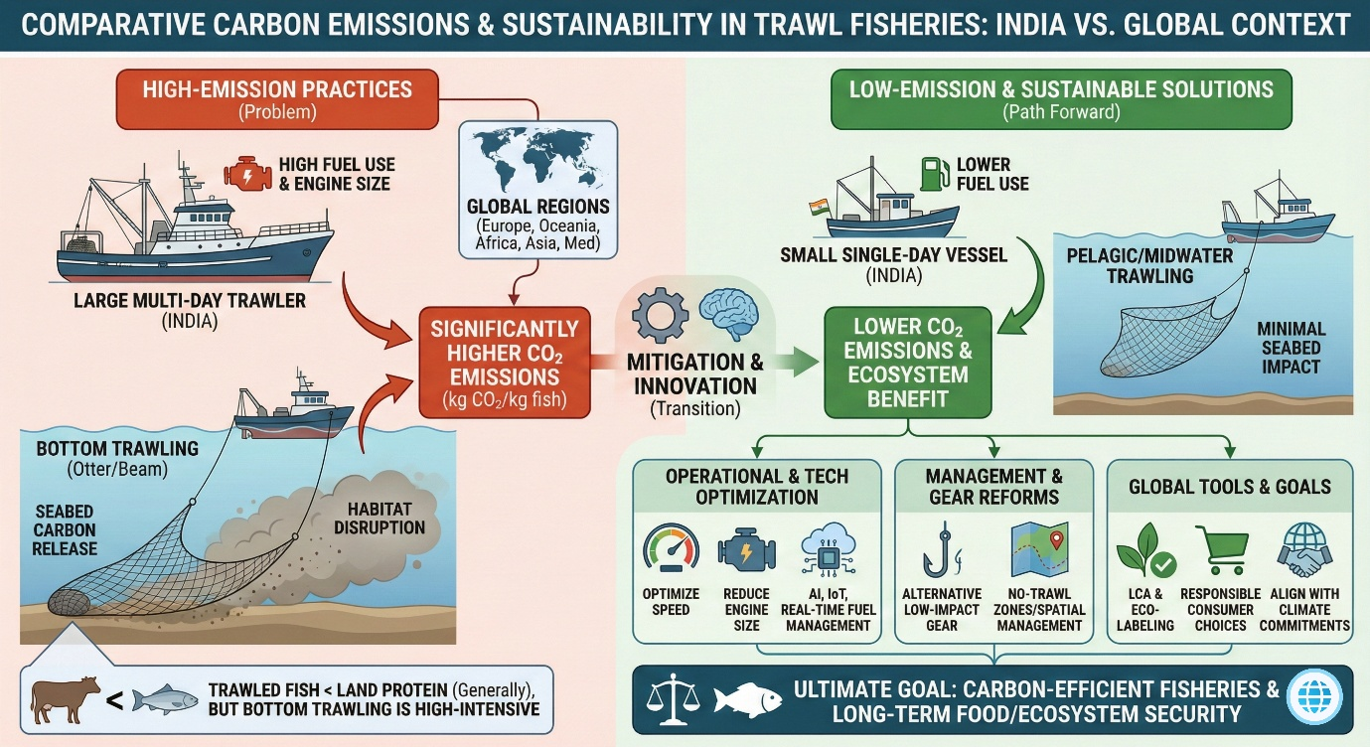
Graphical Abstract

1. Introduction
Trawling is among the most widespread and industrialised fishing methods, comprising bottom-contact gears (e.g. otter and beam trawls) and mid-water or pelagic gears. Large nets are towed through the water column or along the seabed to capture fish and other marine life. Although highly productive in terms of catch volume, trawling is also one of the most energy-intensive fishing methods: powerful engines and heavy gear must be towed over considerable distances. Fuel combustion generates greenhouse gases mainly carbon dioxide (CO₂), nitrous oxide (N₂O) and methane (CH₄) that form the largest share of the sector’s carbon footprint screenshot. Bottom trawling further disturbs carbon stored in marine sediments, potentially releasing additional CO₂ into the water column. Consequently, trawling has attracted increasing scrutiny due to its ecological effects (Watling & Norse 1998; Pérez Roda et al. 2019) and its contribution to climate change (Tyedmers 2004; Sala et al. 2022). Previous studies have shown that the energy demand of trawling exceeds that of purse seining by roughly fifteen times (Sainsbury 1971), underscoring the need for targeted mitigation measures. Several frameworks have been developed to assess the climate impacts of fisheries. Life-cycle assessment (LCA) quantifies emissions associated with the entire supply chain of a product, from fuel combustion to vessel construction and gear manufacture (Ziegler & Valentinsson 2008; Ravi et al. 2020). Recent global analyses by Parker et al. (2018) and Hilborn et al. (2023) reveal that demersal (bottom) fisheries account for a disproportionately large share of carbon emissions, principally due to the high fuel requirements of bottom trawling. In India, trawler emissions have been estimated for select fleets (Sayana & Remesan 2020; Devi et al. 2021), but there has been little synthesis of these data in a comparative global context. This paper addresses that gap by harmonising emission units and exploring how Indian trawl fleets compare to those elsewhere.

2. Materials and Methods
This comparative analysis relies exclusively on published secondary data. Fuel consumption and carbon emissions were compiled for three fleets in the Mediterranean single-boat bottom otter trawlers (OTB), mid-water pair trawlers (PTM) and Rapido beam trawlers (TBB) (Sala et al. 2022) and for bottom and pelagic trawlers operating in Europe, North America and Oceania (Hilborn et al. 2023). Emissions data for Indian trawlers were taken from assessments of vessels operating out of Munambam and Cochin harbours in Kerala between 2014 and 2016 (Sayana & Remesan 2020) and from surveys of trawlers along the north-west coast (Devi et al. 2021). Carbon emissions from the global fishing sector in 2011 were obtained from Parker et al. (2018). Units reported as million tonnes of CO₂ equivalents (Mt CO₂-eq) were converted to kilograms (kg CO₂-eq) by multiplying by 10⁹. Emission intensities expressed as kilogram CO₂ per tonne of fish (kg CO₂ t⁻¹ fish) were converted to kg CO₂ kg⁻¹ fish by dividing by 1000 to allow direct comparison across fleets. The resulting dataset enables qualitative comparisons of carbon intensity among gear types and regions.

3. Results and Discussion

3.1 Global carbon emissions and the role of demersal fisheries

On a global scale, carbon emissions from motorised fishing fleets are several orders of magnitude higher than those from non-motorised fleets(Figure 1). When expressed in a common unit, emissions from motorised fleets in 2011 exceeded those of non-motorised fleets by several billion kilograms of CO₂ equivalents, as reported by Parker et al. (2018). Demersal fisheries were identified as a major contributor to these emissions because the capture of demersal species typically involves continuous bottom trawling, a highly fuel-intensive activity. The resulting CO₂ emissions reflect not only the energy required to tow heavy fishing gear but also the disturbance and resuspension of carbon stored in seabed sediments. These findings emphasize that the climate impact of trawling cannot be assessed solely on the basis of catch volume; rather, fishing gear type and its interaction with the seafloor are critical drivers of carbon intensity(Figure 2).

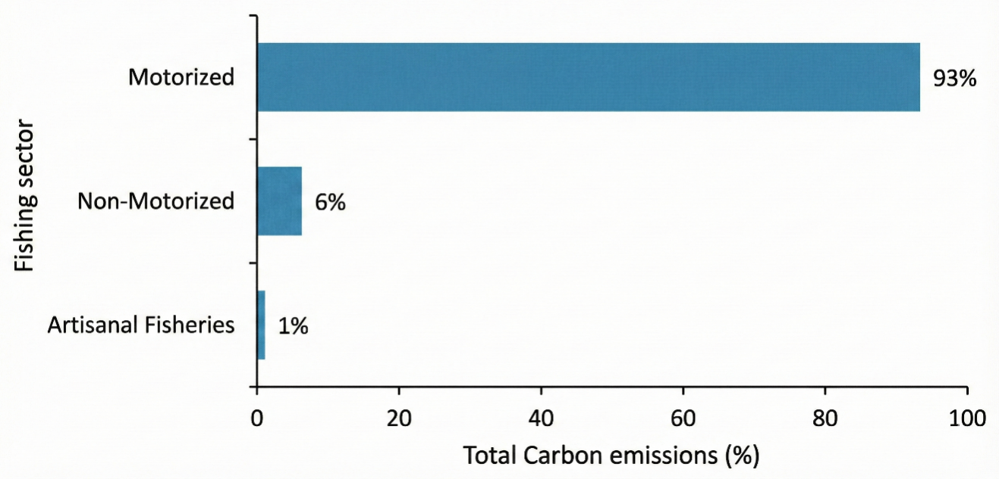

Figure:1 Global caebon emission from fishing

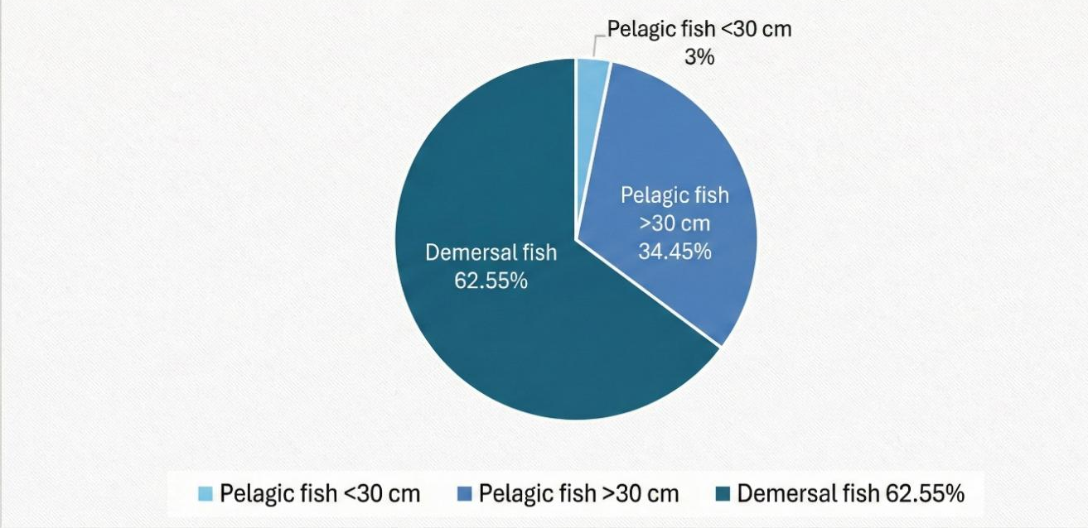

Figure:2 Global caebon emission from fishing areas

3.2 Mediterranean fleets: bottom versus mid-water gears
A comparison of Mediterranean trawl fleets illustrates the influence of gear type on emissions. Sala et al. (2022) measured emission intensities for three gear types: OTB and TBB (both bottom-contact gears) and PTM (a mid-water pair trawl). The original study reported emissions in kg CO₂ t⁻¹ fish. To harmonise units, those values are converted here to kg CO₂ kg⁻¹ fish by dividing by 1 000. After conversion, bottom-contact gears exhibited values roughly an order of magnitude greater than the mid-water gear. For example, if an OTB emitted 600 kg CO₂ per tonne of fish (original units), this corresponds to 0.6 kg CO₂ per kilogram of fish. In contrast, a PTM emitting 150 kg CO₂ per tonne equates to 0.15 kg CO₂ per kilogram. The discrepancy reflects the greater fuel requirements of bottom trawling and the additional CO₂ released from disturbed sediments. Consequently, bottom trawling in the Mediterranean likely has a higher carbon footprint per kilogram of fish than mid-water trawling, despite similar catch rates(Figure 3).
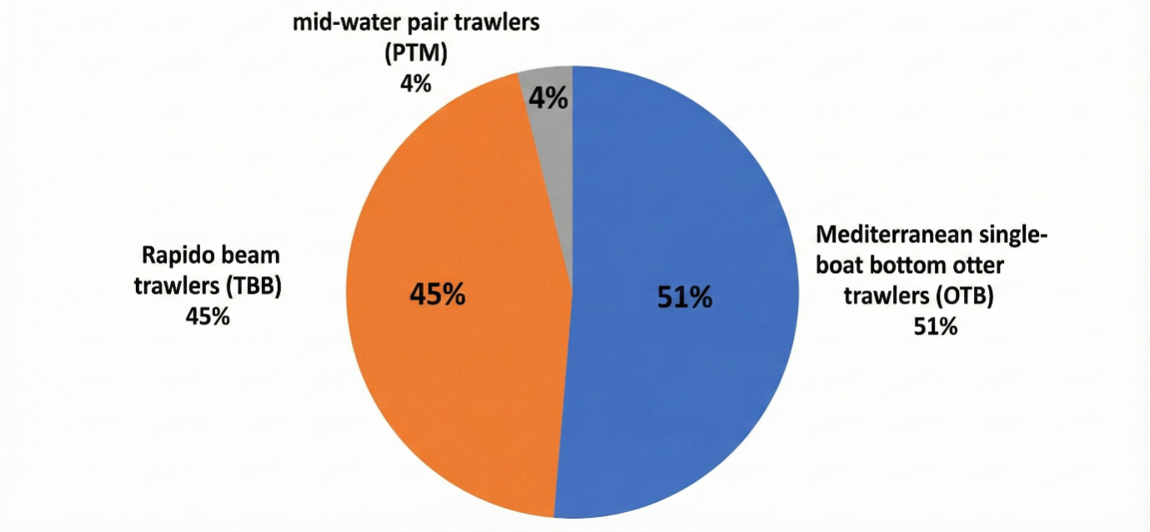
Figure:3 Average carbon footprint of single boat bottom otter trawler (OTB), Midwater pai trawler (PTM), and Rapido beam trawler (TBB) in Mediterranean fishing

3.3 Cross-regional comparisons: bottom versus pelagic trawlers

Emission data synthesised for trawlers operating across Europe, North America and Oceania indicate clear differences between bottom and pelagic trawl fisheries (Hilborn et al., 2023). When standardised as kg CO₂ kg⁻¹ of fish landed, bottom trawlers consistently showed higher carbon intensities than pelagic trawlers across all regions examined. Although data for African and Asian fleets were limited, the available evidence still revealed the same trend of elevated emissions from bottom trawlers compared to pelagic trawlers. These results align with conclusions drawn from Mediterranean fisheries, reinforcing that bottom trawling is more carbon intensive than mid-water or pelagic trawling, largely due to higher fuel requirements and the added impact of seafloor disturbance(Figure 4).

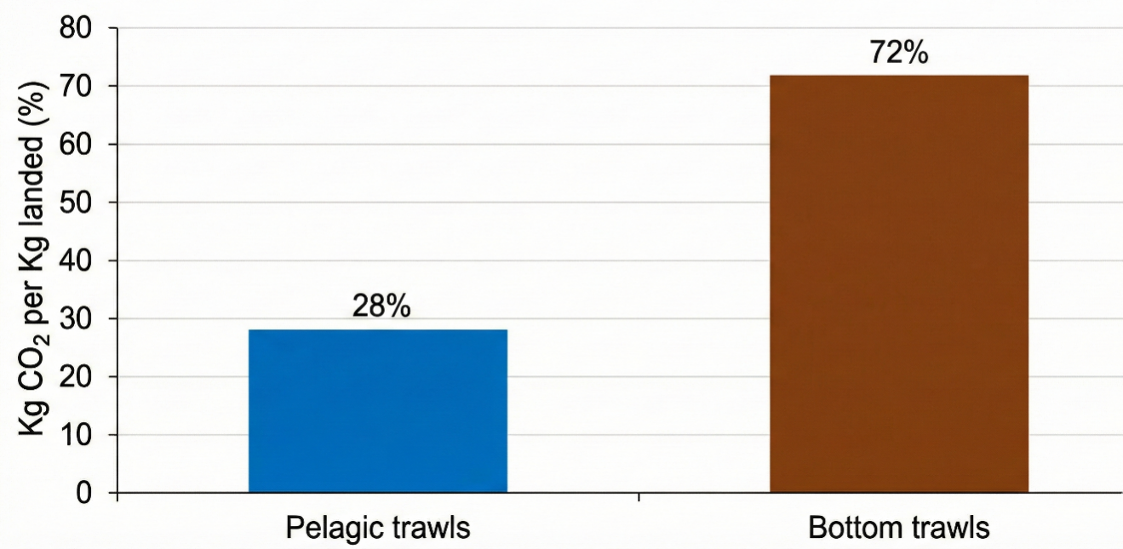

Figure:4 Carbon emission from bottom and pelagic trawler in Europe, North America, Oceania, Africa and Asia

3.4 Indian case studies: vessel size and carbon intensity
Data from Kerala and north-west India reveal strong correlations between vessel size and carbon emissions per unit catch. Sayana and Remesan (2020) documented emissions from trawlers operating out of the Kerala coast. After converting emissions to kg CO₂ kg⁻¹ fish, the authors found that very large trawlers had significantly higher carbon footprints than smaller vessels(Figure 5). Similarly, Devi et al. (2021) evaluated multi-day large (MDL), multi-day medium (MDM) and single-day (SD) trawlers along the north-west coast. Carbon intensities were highest for MDL trawlers, intermediate for MDM trawlers and lowest for SD trawlers. These patterns arise because larger vessels typically use high-powered engines and travel longer distances at greater speeds, resulting in higher fuel consumption. The results suggest that reducing vessel size or engine capacity and optimising trip length could yield significant emissions reductions for Indian trawler fleets(Figure 6).
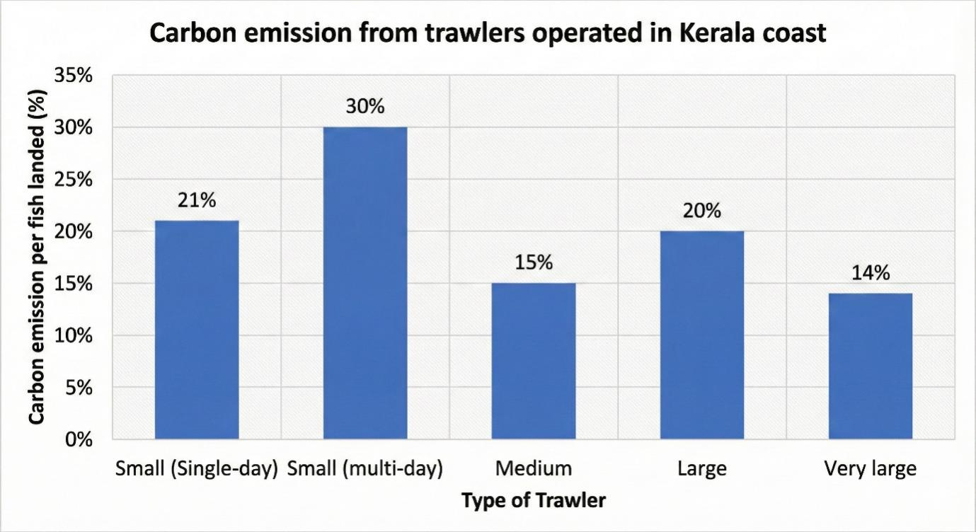
Figure:5 Carbon emission from trawlers operated in kerala coast
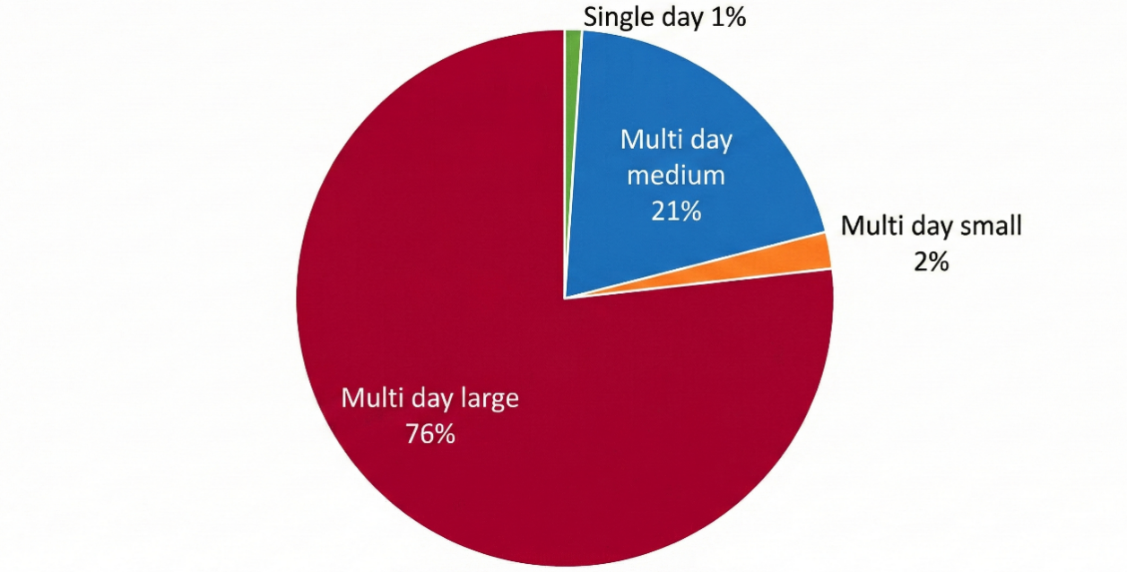
Figure:6 Carbon emission from trawlers operated in North-West coast of India

3.5 Carbon footprint of trawled fish compared with other proteins
Bottom trawling is carbon intensive relative to other fishing methods, its carbon footprint remains lower than that of many terrestrial animal proteins. Sandström et al. (2018) showed that beef, lamb and farmed fish have substantially higher carbon footprints per kilogram of edible product than wild-caught fish. Munoz et al. (2023) compared fuel-based emissions from bottom trawlers with those from pork, lamb and beef. When only fuel combustion is considered, trawl-caught fish emit less CO₂ per kilogram than most land-based meats. However, when the release of carbon from disturbed seabed sediments is included, bottom-trawled fish become the animal protein with the highest CO₂ footprint in the comparison. Even the most efficient bottom trawling fleets exhibit higher emissions per kilogram of food produced than mid-water trawling or many other animal proteins. These findings emphasise the need to reduce seafloor contact in bottom trawling to lower both fuel consumption and sediment-derived emissions.

3.6 Mitigation strategies and management considerations
3.6.1. Improving operational efficiency. Reducing engine revolutions per minute (rpm) by 10–20 % can lead to fuel savings of 20–40 % (Gulbrandsen, 2012). Operating vessels at their economic cruising speeds, installing appropriately sized engines and carrying out preventive maintenance such as cleaning or replacing engine components are low-cost measures that can effectively reduce emissions without requiring major changes to fishing practices. The adoption of energy-efficient harvesting technologies tailored to specific target species can further enhance fuel savings. In the present analysis, implementation of such measures could substantially lower kg CO₂ kg⁻¹ of fish across both Indian and global fishing fleets.
3.6.2. Alternative gears and gear modifications. Switching from bottom trawls to pots, longlines or bottom seines can reduce seafloor impact and fuel consumption. However, these alternatives may not be economically or operationally viable for all target species (Suuronen et al. 2012). For example, pots and longlines work well for cod and sablefish in Alaska but may not be suitable for flatfish or scallops. Nonetheless, gear innovations show promise: electric pulse trawls and illuminated trawls encourage fish to lift off the seabed, reducing both bottom contact and fuel use (Soetaert et al. 2015; Lomeli et al. 2021). Pulse trawling has been shown to reduce mortality of benthic megafauna and lower discards compared with traditional tickler-chain trawls (ICES 2018; Bergman & Meesters 2020). Despite subsequent regulatory bans in some jurisdictions, continued research and refinement of such technologies could provide viable low-impact alternatives in the future.
3.6.3. Spatial management and bycatch reduction. Effective management of trawl fisheries must balance environmental, social and economic objectives. Spatial measures such as no-trawl zones protect vulnerable habitats (e.g. coral reefs, sponge beds and nurseries), while move-on rules combined with tradable quotas can reduce unwanted bycatch (Groenbaek et al. 2023). Territorial use rights and area-based management strategies have shown that focusing effort on dense aggregations of target species increases catch efficiency and reduces the benthic footprint (Bloor et al. 2021). Technologies such as turtle-excluder devices and marine-mammal exclusion devices have drastically reduced bycatch of protected species (Magnuson et al. 1990; Hamilton & Baker 2015), but adoption remains limited due to perceived inconvenience and cost (Suuronen 2022). Broader uptake of these devices would further reduce the collateral impacts of trawling and potentially improve fuel efficiency by reducing gear resistance.
3.6.4. Smart technologies and life-cycle assessments. Recent advances in artificial intelligence (AI), the Internet of Things (IoT) and remote sensing allow real-time monitoring of vessel movements, fuel consumption and bycatch hotspots. AI-based analyses can classify fishing behaviours, optimise routes and improve safety (Cheng et al. 2023). Life-cycle assessment (LCA) tools help identify emission hotspots across gear types and regions, providing the basis for eco-labelling schemes that inform consumers and reward low-impact practices (Ravi et al. 2020). Harmonised LCA studies across different fisheries—and the incorporation of sediment-disturbance emissions—are essential for guiding sustainable dietary choices and policy interventions.

4. Conclusion
The comparative analysis presented here reveals that bottom trawling produces the highest carbon emissions per kilogram of catch among trawling methods due to its heavy fuel requirements and the release of stored carbon from the seabed. These emissions far exceed those associated with mid-water or pelagic trawls when expressed uniformly in kg CO₂ kg⁻¹ fish. In India, large multi-day trawlers operating along the Kerala and north-west coasts have particularly high carbon intensities. Although trawl-caught fish still have a lower carbon footprint than most land-based meats when only fuel combustion is considered, the inclusion of sediment-disturbance emissions places bottom-trawled fish among the most carbon-intensive animal proteins. Reducing the climate impact of trawl fisheries will require a multipronged approach: optimising vessel speed and engine size, adopting energy-efficient and selective gears, protecting sensitive benthic habitats through spatial management, deploying bycatch-reduction devices and leveraging AI-enabled monitoring systems. Life-cycle assessments and eco-labelling schemes can encourage market-driven conservation by empowering consumers to choose low-carbon seafood. Ultimately, aligning trawl operations with global climate commitments and sustainable diet transitions will be essential for ensuring food security and the long-term health of marine ecosystems.

5. Future Scope
The findings highlight several avenues for future work:
- Technological innovations. Development of lightweight, low-resistance trawl designs that minimise seafloor contact; wider adoption of selective gear (e.g. pots, longlines, pulse trawls) to reduce fuel use and bycatch; and exploration of hybrid or electric propulsion systems and renewable fuels.
- Integration of smart technologies. Deployment of AI, IoT and remote-sensing tools for optimising fishing routes, reducing idle time and monitoring fuel use, bycatch and benthic impacts in real time.
- Ecosystem-based and spatial management. Expansion of no-trawl zones in ecologically sensitive habitats; implementation of territorial use rights and area-based management to concentrate effort on dense stocks while limiting habitat damage.
- Policy and market incentives. Strengthening eco-labelling and carbon-footprint labelling to reward sustainable practices and enable low-impact consumer choices; creating carbon credit schemes and financial incentives for fleets adopting fuel-efficient technologies and reduced-impact gear; and fostering international cooperation to harmonise carbon-reduction standards in fisheries.
- Socio-economic transitions. Providing subsidies, training and risk-sharing mechanisms to help fishers transition to alternative gear; diversifying livelihood options for coastal communities to reduce dependence on high-impact bottom trawling.
- Research and LCA. Expanding life-cycle assessments across regions and gear types; conducting comparative studies of carbon footprints across fisheries, aquaculture and terrestrial proteins to guide sustainable diet transitions; and monitoring benthic carbon release under varying trawling intensities to refine climate-impact estimates.
- Global food security and climate synergies. Integrating fisheries research with climate-change adaptation strategies to ensure the resilience of marine food systems and exploring low-carbon seafood and plant-based alternatives as complementary strategies to reduce protein-related emissions.

6. References
Bergman, M. J., & Meesters, E. H. (2020). First indications for reduced mortality of non-target invertebrate benthic megafauna after pulse beam trawling. ICES Journal of Marine Science, 77(2), 846–857. https://doi.org/10.1093/icesjms/fsz250
Bloor, I. S. M., Duncan, P. F., Dignan, S. P., Emmerson, J. A., Beard, D., Gell, F. R., McHarg, K., & Kaiser, M. J. (2021). Boom not bust: Cooperative management as a mechanism for improving the commercial efficiency and environmental outcomes of regional scallop fisheries. Marine Policy, 132, 104649. https://doi.org/10.1016/j.marpol.2021.104649
Cheng, X., Zhang, F., Chen, X., & Wang, J. (2023). Application of artificial intelligence in the study of fishing vessel behavior. Fishes, 8(10), 516. https://doi.org/10.3390/fishes8100516
Devi, M. S., Xavier, K. M., Singh, A. S., Edwin, L., Singh, V. V., & Shenoy, L. (2021). Environmental pressure of active fishing method: A study on carbon emission by trawlers from north-west Indian coast. Marine Policy, 127, 104453. https://doi.org/10.1016/j.marpol.2021.104453
Gilman, E., Perez Roda, A., Huntington, T., Kennelly, S., Suuronen, P., Chaloupka, M., & Medley, P. (2020). Benchmarking global fisheries discards. Scientific Reports, 10, 14017. https://doi.org/10.1038/s41598-020-63695-w
Grønbæk, L., Lindroos, M., Munro, G., Pintassilgo, P., & Turris, B. (2023). The avoidance of unwanted catch and cooperation: The case of the British Columbia groundfish trawl fishery. ICES Journal of Marine Science, 80(3), 483–491. https://doi.org/10.1093/icesjms/fsac005
Gulbrandsen, O. (2012). Fuel savings for small fishing vessels – A manual. FAO, Rome. https://www.fao.org/4/i2461e/i2461e.pdf
Hamilton, S., & Baker, G. B. (2015). Review of research and assessments on the efficacy of sea lion exclusion devices in reducing the incidental mortality of New Zealand sea lions Phocarctos hookeri in the Auckland Islands squid trawl fishery. Fisheries Research, 161, 200–206. https://doi.org/10.1016/j.fishres.2014.07.010
Hilborn, R., Amoroso, R., Collie, J., Hiddink, J. G., Kaiser, M. J., Mazor, T., McConnaughey, R. A., Parma, A. M., Pitcher, C. R., Sciberras, M., & Suuronen, P. (2023). Evaluating the sustainability and environmental impacts of trawling compared to other food production systems. ICES Journal of Marine Science, 80(6), 1567–1579. https://doi.org/10.1093/icesjms/fsad115
ICES. (2018). Report of the Working Group on Electric Trawling (WGELECTRA). ICES Report WGELECTRA 2018. https://doi.org/10.17895/ices.pub.8160
Lomeli, M. J., Wakefield, W. W., Herrmann, B., Dykstra, C. L., Simeon, A., Rudy, D. M., & Planas, J. V. (2020). Use of artificial illumination to reduce Pacific halibut bycatch in a U.S. West Coast groundfish bottom trawl. Fisheries Research, 233, 105737. https://doi.org/10.1016/j.fishres.2020.105737
National Research Council. (1990). Decline of the sea turtles: Causes and prevention. National Academies Press. https://doi.org/10.17226/1536
Muñoz, M., Reul, A., Guijarro, B., & Hidalgo, M. (2023). Carbon footprint, economic benefits and sustainable fishing: Lessons for the future from the Western Mediterranean. Science of the Total Environment, 865, 160783. https://doi.org/10.1016/j.scitotenv.2022.160783
Parker, R. W. R., Blanchard, J. L., Gardner, C., Green, B. S., Hartmann, K., Tyedmers, P. H., & Watson, R. A. (2018). Fuel use and greenhouse gas emissions of world fisheries. Nature Climate Change, 8(4), 333-337. https://doi.org/10.1038/s41558-018-0117-x
Ravi, R., Das, P. H., & Edwin, L. (2020). Life cycle assessment-based identification of environmental hotspots in commercial trawl fisheries of Kerala and mitigation strategies. International Journal of Life Cycle Assessment, 25(10), 1952–1966. https://doi.org/10.1007/s11367-020-01774-4
Sainsbury, J. C. (1971). Commercial fishing methods. Fishing News (Books) Ltd.
Sala, A., Damalas, D., Labanchi, L., Martinsohn, J., Moro, F., Sabatella, R., & Notti, E. (2022). Energy audit and carbon footprint in trawl fisheries. Scientific Data, 9(1), 428. https://doi.org/10.1038/s41597-022-01478-0
Sandström, V., Valin, H., Krisztin, T., Havlík, P., Herrero, M., & Kastner, T. (2018). The role of trade in the greenhouse gas footprints of EU diets. Global Food Security, 19, 48–55. https://doi.org/10.1016/j.gfs.2018.08.007
Sayana, K. A., & Remesan, M. P. (2020). Assessment of fuel consumption rate of mechanised trawlers in Kerala, South India. Agro-Economist, 7(1), 51–56. https://agroeconomistjournal.com/
Soetaert, M., Decostere, A., Polet, H., Verschueren, B., & Chiers, K. (2015). Electrotrawling: a promising alternative fishing technique warranting further exploration. Fish and Fisheries, 16(1), 104–124. https://doi.org/10.1111/faf.12047 .
Suuronen, P. (2022). Understanding perspectives and barriers that affect fishers’ responses to bycatch reduction technologies. ICES Journal of Marine Science, 79(3), 1015–1023. https://doi.org/10.1093/icesjms/fsac045
Suuronen, P., Chopin, F., Glass, C., Løkkeborg, S., Matsushita, Y., Queirolo, D., & Rihan, D. (2012). Low impact and fuel efficient fishing: Looking beyond the horizon. Fisheries Research, 119–120, 135–146. https://doi.org/10.1016/j.fishres.2011.12.009
Tyedmers, P. (2004). Fisheries and energy use. In C. J. Cleveland (Ed.), Encyclopedia of energy (Vol. 2, pp. 683–693). Elsevier. https://www.elsevier.com/books/encyclopedia-of-energy/cleveland/978-0-12-176480-7
Watling, L. (2013). Deep-sea trawling must be banned. Nature, 501(7465), 7. https://doi.org/10.1038/501007a
Ziegler, F., & Valentinsson, D. (2008). Environmental life cycle assessment of Norway lobster (Nephrops norvegicus) caught along the Swedish west coast by creels and conventional trawls—LCA methodology with case study. International Journal of Life Cycle Assessment. https://doi.org/10.1007/s11367-008-0002-8

