Original Research Article

Asymmetric Warming and Intensified Extremes Dominate Ugandan Crop Yield Variability (1995–2024): The Primacy of Nocturnal Heat Over Precipitation

Abstract
This study investigates spatiotemporal trends in temperature and precipitation extremes across Uganda (1995–2024) and their impacts on national crop yields, using ERA5-Land reanalysis and FAOSTAT data. Eight core ETCCDI indices were calculated at 0.25° resolution. Monotonic trends were assessed with the Mann-Kendall test and Sen’s slope estimator; relationships with yields of 29 major crops were evaluated via Spearman’s rank correlation with Benjamini-Hochberg false discovery rate correction. Uganda experienced rapid asymmetric warming, with national mean temperature rising 0.90 °C (0.033 °C/year, P = .0001), extreme maximum temperature (TXx) increasing 0.89 °C, and tropical nights (TR) rising by more than 40 days across most of the country. Minimum temperatures warmed faster than maxima, driving a widespread decline in diurnal temperature range. Precipitation extremes intensified without significant change in annual totals: maximum 5-day rainfall (Rx5day) and heavy precipitation days increased significantly in southwestern and northeastern regions, while consecutive dry days (CDD) lengthened markedly in central and northern areas, producing a higher frequency of compound hot-dry events. After stringent multiple-testing correction, temperature extremes, especially nocturnal warmth, emerged as the dominant driver of interannual yield variability, outperforming precipitation indices for most crops. Thermally sensitive staples (cassava, beans, pigeon peas) and coffee exhibited strong negative responses to elevated TNn and TR, whereas seed cotton, cocoa, and pepper benefited from warmer nights. Intense wet events (Rx5day) exerted additional significant penalties, particularly on groundnuts. Central and southwestern Uganda emerged as critical hotspots of concurrent warming, drying, and heavy rainfall intensification. These findings demonstrate that climate extremes already constrain productivity in this predominantly rainfed agricultural system and underscore the urgent need for heat- and drought-tolerant varieties, expanded small-scale irrigation, agroforestry-based heat mitigation, and improved early-warning systems. The study confirms the value of ERA5-derived ETCCDI indices for robust regional climate-impact assessment in data-sparse environments and provides empirical guidance for climate-smart agricultural policy in East Africa.
Keywords: ERA5 reanalysis, FAOSTAT, ETCCDI Indices, Mann-Kendall trend, Spearman’s correlation.

Introduction
Climate change poses one of the most pressing environmental challenges globally (Nandozi et al., 2012), with high confidence that extreme climate events, such as floods, droughts, and heat waves, will become more frequent and/or intense during the 21st century (Shiferaw et al., 2018). Sub-Saharan Africa (SSA) and the Greater Horn of Africa (GHA), where Uganda is located, are profoundly vulnerable to these risks (Nandozi et al., 2012; Omondi et al., 2014; Shiferaw et al., 2018). This vulnerability is largely attributed to the reliance of regional economies and livelihoods on predominantly rain-fed agricultural systems (Shiferaw et al., 2018). Climate extremes often drive changes in natural and human systems much more significantly than changes in average climate (Omondi et al., 2014). For seasonally dry and tropical areas like Uganda, crop productivity is projected to decrease significantly (20-40%) even with relatively small local temperature increases (1-2°C), thereby increasing the risk of hunger and poverty for subsistence farmers (Iwadra et al., 2019). The escalating severity and frequency of these extremes necessitate improved, localized analyses to inform disaster preparedness and policy making across the region (Owoyesigire et al., 2016; Shiferaw et al., 2018).
Uganda, situated astride the equator, experiences complex climate dynamics governed by factors including the Intertropical Convergence Zone (ITCZ), monsoonal winds, topography, and large inland water bodies (Nsubuga & Rautenbach, 2018). Recent observations confirm significant shifts in both temperature and rainfall patterns across the country (Nsubuga & Rautenbach, 2018; Obubu et al., 2021). Temperature trends reveal clear, rapid, asymmetric warming, with evidence showing that nights are warming faster than daytime temperatures (Owoyesigire et al., 2016). For instance, the mean temperature anomaly in the Lake Kyoga basin increased from 0.2°C –0.6°C (1981-1990) to 1.0°C –1.6°C(2011-2020) (Obubu et al., 2021), with minimum temperatures rising faster than maximum temperatures (Iwadra et al., 2019; Obubu et al., 2021). Concurrently, changes in precipitation extremes are intensifying despite findings of little significant change in annual total rainfall over the long term (Nsubuga & Rautenbach, 2018; Omondi et al., 2014). Regional climate models project intensifying precipitation extremes characterized by both heavier short-duration events (increased maximum one- and five-day totals) and longer maximum Consecutive Dry Days (Shiferaw et al., 2018). This simultaneous occurrence of higher intensity rainfall and prolonged dry spells poses a severe, dualistic threat to rainfed agriculture (Nsubuga & Rautenbach, 2018). Furthermore, preliminary studies suggest that highly productive agricultural zones in central and southwestern Uganda are emerging as critical compound hot-dry hotspots where unstable rainfall and rising temperatures jeopardize food stability (Owoyesigire et al., 2016; Sridharan et al., 2019).
Analyzing these localized, high-impact climate extremes in Uganda is severely challenged by sparse and scarce ground-based hydro-climatic data (Omondi et al., 2014). The historical monitoring network has been plagued by inadequate coverage and discontinuity, undermining efforts to quantify climate impacts at the local scale needed for effective adaptation strategies (Omondi et al., 2014). TO overcome these limitations, climate research increasingly relies on the use of high-resolution satellite-derived and model reanalysis datasets to supplement intermittent station records and capture local variability across complex terrains (Iwadra et al., 2019). High-quality reanalysis products, such as the European Centre for Medium-Range Weather Forecasts (ECMWF) Re-Analysis products (e.g., ERA-Interim), have demonstrated utility in characterizing rainfall and temperature over the GHA region, where in-situ data is insufficient for individual country analysis (Omondi et al., 2014). Employing such validated gridded data is essential for providing the detailed, localized information required by resource managers and policy makers (Stampone et al., 2011).
Despite documented regional climate signals, a systematic assessment quantifying the precise influence of recent extreme shifts (1995-2024) on national crop yield stability is lacking. Crucially, preliminary analysis indicates that temperature extremes are highly influential, often dominating the explanation of interannual yield variability for crops like banana, showing correlations comparable to or stronger than precipitation variations (Geoffrey et al., 2016). To address this critical knowledge gap, we analyze standardized ETCCDI indices derived from high-resolution reanalysis data spanning 1995-2024 and rigorously link these metrics to national FAOSTAT crop yield time series (FDR-corrected). The study seeks two primary objectives: (1) to quantify the magnitude and spatial distribution of temperature and precipitation extremes across Uganda; (2) to statistically determine the relative influence of temperature and precipitation extremes on interannual yield variability across major Ugandan crops. These rigorous results will provide policy-relevant information for guiding climate-smart adaptation measures (Geoffrey et al., 2016; Obubu et al., 2021), enhancing national food security planning, and strengthening the resilience of vulnerable agricultural communities against the accelerating impacts of climate variability (Obubu et al., 2021)

Materials and methods

Study area
Uganda is a landlocked East African country located between 1.5° S–4.3° N and 29.5°–35.1° E, covering roughly 241,000 km². Its climate is predominantly tropical but varies sharply with elevation, topography, and proximity to major water bodies, particularly Lake Victoria (Epule et al., 2018; Kansiime et al., 2013; Mwaura et al., 2014; Owoyesigire et al., 2016). Temperatures range from about 15 °C in highland regions to 25–30 °C in low-lying areas. Most of the country experiences a bimodal rainfall pattern, with rainy seasons during March–May and September–November, while the northern region follows a unimodal regime driven by the seasonal migration of the Intertropical Convergence Zone. Rainfall distribution is highly heterogeneous, spanning semi-arid conditions in the northeast to some of the wettest climates in the southwest. Uganda’s strong reliance on rainfed agriculture and its complex climate system, shaped by ITCZ dynamics, monsoonal winds, and lake–land interactions, makes it particularly sensitive to climate extremes and an important setting for assessing climate–agriculture linkages (Ngoma et al., 2021; Nsubuga et al., 2018; Nuwagira et al., 2022; Sridharan et al., 2019).
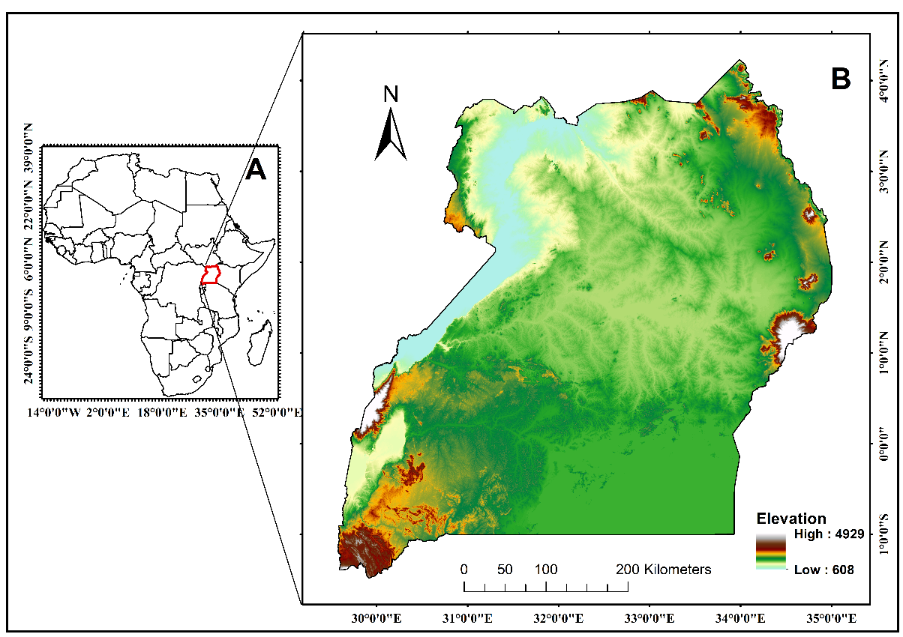
Figure 1 Study Area.

Datasets
Hourly 2-m air temperature and total precipitation for 1995-2024 were obtained from ERA5 Single Level reanalysis (Hersbach et al., 2020) at 0.25°×0.25° resolution via the Copernicus Climate Data Store (https://cds.climate.copernicus.eu). ERA5-Land was selected for its high resolution, physical consistency through 4D-Var assimilation, and validated strong performance over East Africa (r > 0.85 with station observations (Alexandridis et al., 2023; Hersbach et al., 2020; Liu et al., 2024). National annual crop yield data (kg/hectare) for 29 major food and cash crops (Table A1) spanning from 1995 to 2023 were sourced from the FAOSTAT database (https://www.fao.org/faostat/), a branch of Food and Agriculture Organization of the United Nations responsible for collecting, recording, and outsourcing crop yield data worldwide with the help of different governments of the different nations. Only records flagged as “official” or “NOFLAG” with complete, uninterrupted series were retained to ensure temporal consistency and comparability with climate indices (Herridge et al., 2022).

Calculation of climate extreme indices
Eight agronomically relevant extreme climate indices were selected from the Expert Team on Climate Change Detection and Indices (ETCCDI) core set (Zhang et al., 2011), described in Table 1. These eight indices were computed annually for each 0.25° grid cell over Uganda for the period 1995–2024. The calculation was performed directly from hourly ERA5-Single Level 2m air temperature and total precipitation data by first aggregating to daily series (daily maximum and minimum temperature, and daily precipitation totals) and then applying the standard ETCCDI definitions. All processing was implemented using custom Python workflows, leveraging the xclim library to ensure algorithmic consistency with the ETCCDI standards.
Table 1 Summary of temperature and precipitation indices used in the study.
Index | Long name | Definition | Unit
TXx | Annual maximum of daily maximum temperature | The highest temperature in a day/Hottest day in a year | °C
TNn | Annual minimum of daily minimum temperature | The lowest temperature in a day/Coldest night | °C
DTR | Mean diurnal temperature range | The mean difference between the highest temperature and the lowest temperature in a day | °C
TR | Number of tropical nights (days with T_{min} > 20 °C) | Days with the lowest minimum temperature above 20°C in a day | days
Rx5day | Maximum consecutive 5-day precipitation | The maximum amount of rain that falls in five consecutive days | mm
PRCPTOT | Annual total precipitation from wet days (PR ≥ 1mm) | Sum of daily PR that is greater than or equal to 1.0 mm | mm
CDD | Maximum number of consecutive dry days (PR<1mm) | The maximum count of days when the PR is less than 1.0 mm | days
R20mm | Annual count of days with PR ≥ 20mm | Number of days when PR is greater than or equal to 20 mm | days

Trend analysis of climate extremes
We quantified monotonic trends in the annual time series of each ETCCDI index using the non-parametric Mann-Kendall test (Mann, 1945) and Sen’s slope estimator (Sen, 1968). This approach was selected for its robustness to non-normally distributed data and outliers, which are inherent in climate extreme indices (Gilbert, 1987; Hirsch et al., 1982). Sen’s slope provides a resilient estimate of the trend magnitude (change per year), from which the total change over the 30-year study was derived. Before trend analysis, we assessed the time series for the presence of significant serial autocorrelation using the Durbin-Watson statistic, which can inflate the Type 1 error rate of the Mann-Kendall test. No significant autocorrelation was detected at the 5% significance level for the national average series. Statistical significance of trends was evaluated at α = 0.05.

Climate-crop correlation
To evaluate the influence of climate extremes on interannual yield stability, we computed pairwise associations between the national yield time series of each of the 29 crops and the eight national-average climate extreme indices, resulting in 232 statistical tests. We employed Spearman’s rank correlation coefficient (ρ) due to its non-parametric nature and robustness to outliers, making it ideal for detecting monotonic relationships in variables like crop yields and climate extremes, which are often non-normally distributed (Mei et al., 2023; Zhang et al., 2019). The large number of tests substantially increases the risk of identifying false positives. To control this, we applied the Benjamini-Hochberg procedure(Benjamini & Hochberg, 1995) to control the False Discovery Rate (FDR) at 5% across all 232 p-values. Only relationships with an FDR-adjusted p-value (q-value) < 0.05 were deemed statistically robust. For correlations that survived FDR correction, we reported the coefficient of determination (R²) from simple linear regression as a complementary measure of the effect size, representing the proportion of interannual yield variance explained by the climate extreme. It is acknowledged that this linear R² may be a conservative estimate for the potentially non-linear relationships captured by the non-parametric Spearman’s ρ

Results

Climatology 1995 to 2024 period
Uganda’s climate over the past three decades has been characterized by significant warming amid stable total precipitation but shifting rainfall patterns (Figures 2, A2). The annual mean temperature showed a substantial increase of 0.9 °C (Sen’s slope = 0.033 °C/year, p < 0.0001), equivalent to a 4.1% relative change (Figure A2). This warming was remarkably robust and widespread, with 79.9% of the country experiencing statistically significant warming and 96.7% of grid cells showing a positive trend. The spatial pattern revealed the strongest warming signals in the western and central regions, with no areas of significant cooling. Mean temperatures averaged 23.2 ± 0.4 °C with low interannual variability (CV = 1.7%), ranging spatially from 15.2 °C in the highlands to 26.9 °C in the lowlands (Figure 2a, c, e). In contrast, annual total precipitation exhibited no significant trend at the national level (-62.2 mm over 30 years, P = 0.65), but showed high interannual variability (CV = 9.2%) and pronounced spatial heterogeneity. The mean precipitation was 1618.3 ± 149.0 mm, ranging from semi-arid conditions in the northeast (454.2 mm) to much wetter regimes in the southwestern highlands (4549.7 mm). Spatially, trends were mixed, with 64.8% of the country showing decreasing trends, 17.1% of these significant predominantly in central regions, while only 2.2% of the country showed significant increases (Figures 2b, d, f). This establishes a critical context of rapid warming without a commensurate change in total rainfall, setting the stage for the more nuanced analysis of climate extremes that follows.
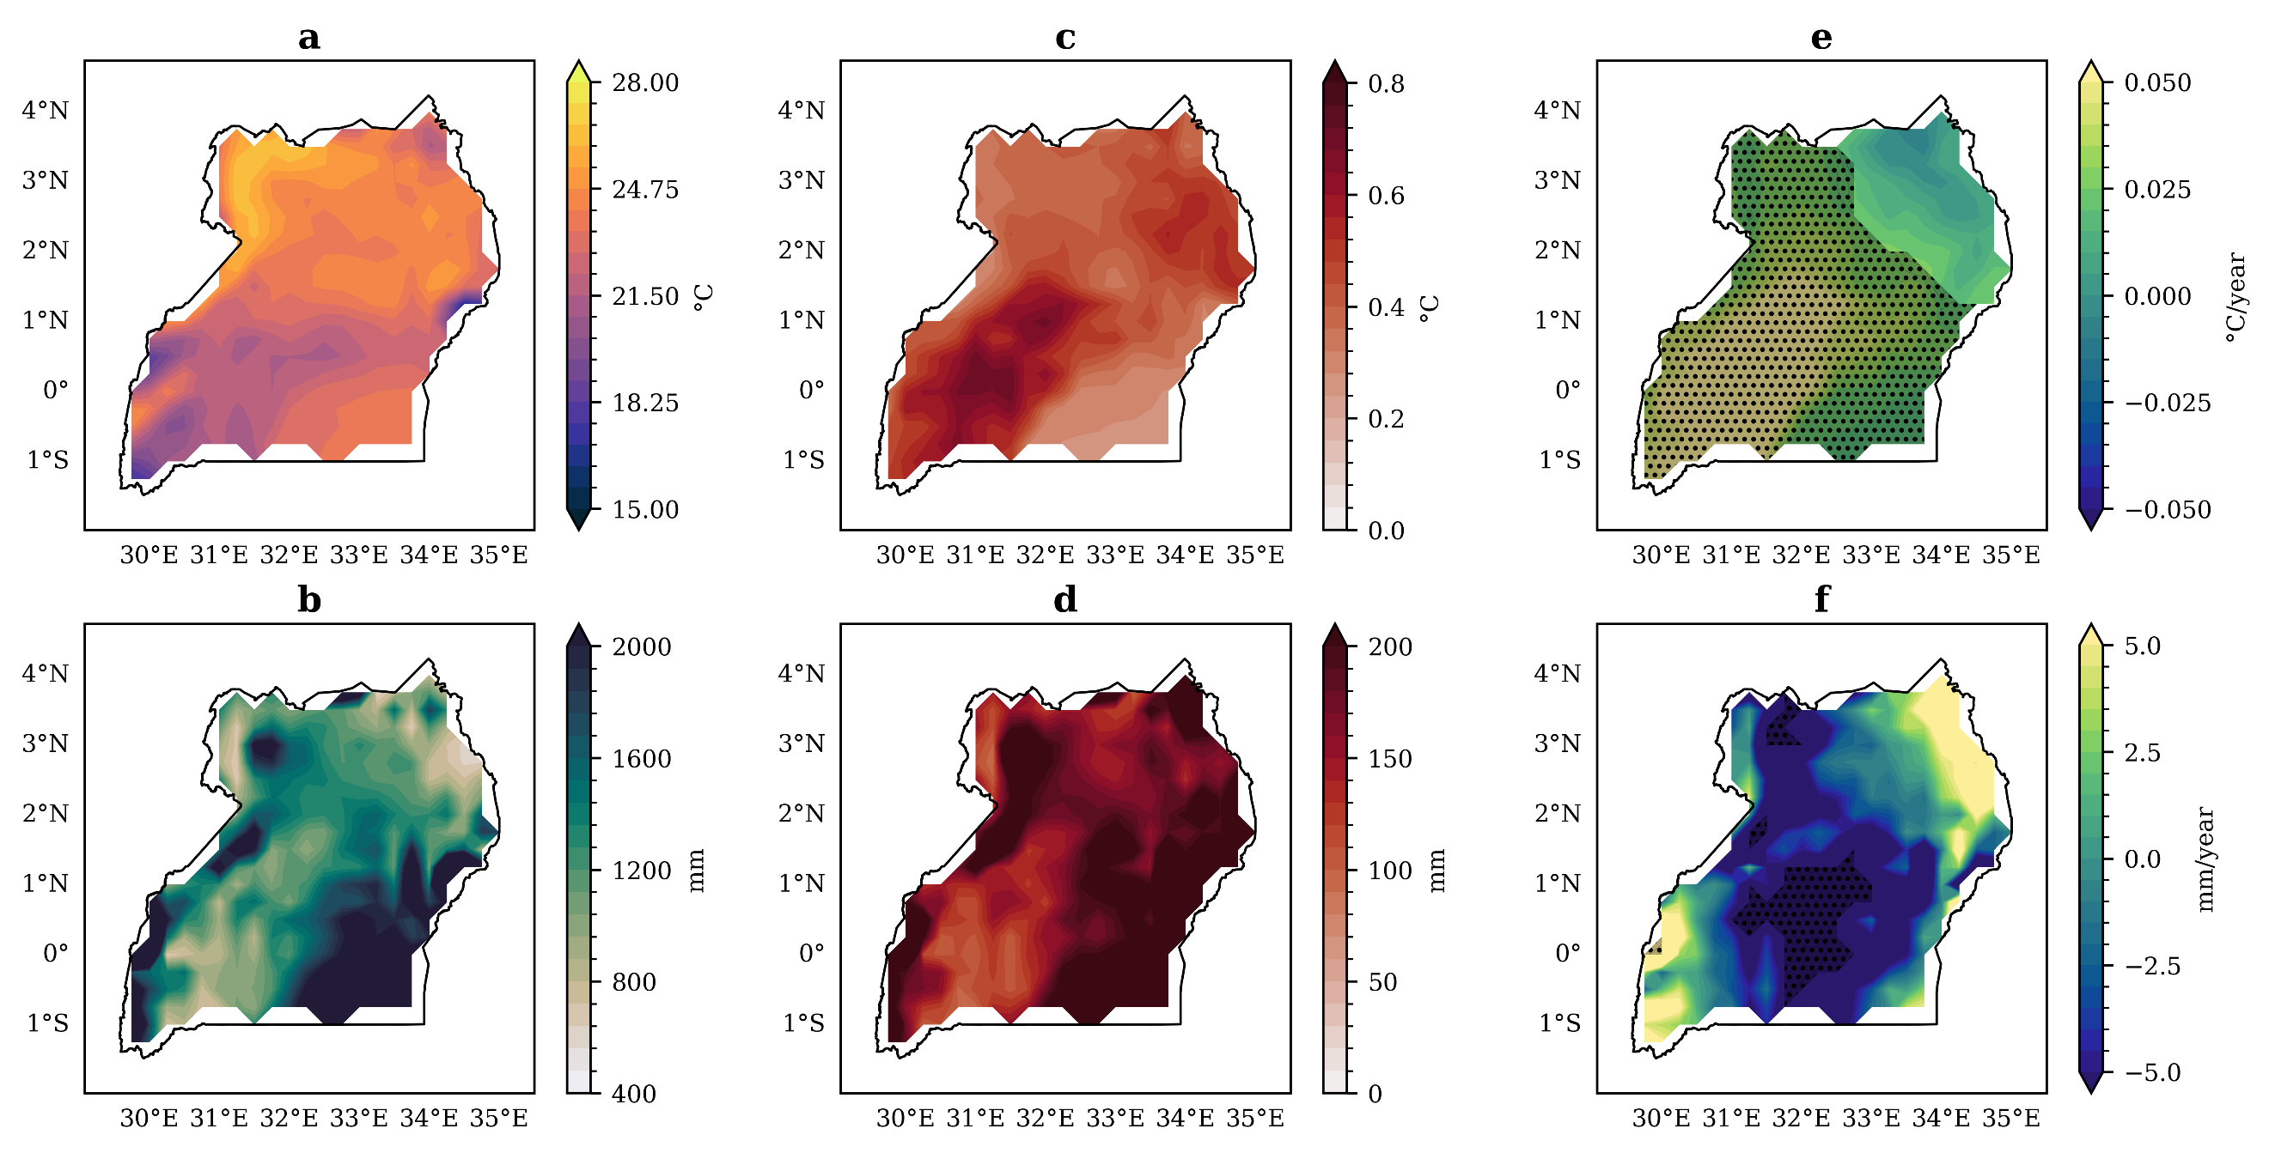
Figure 2 Spatial distribution of (a) mean annual temperature, (b) mean annual precipitation, (c) Standard deviation (Std Dev) of annual temperature, (d) Standard deviation (Std Dev) of annual precipitation, (e) annual temperature trends, and (f) annual precipitation trends of Uganda from 1995 to 2024. Hatched contours are significant (P < 0.05:Mann-Kendall).

Trends in temperature extremes
Analysis of temperature extremes confirms rapid warming across Uganda, with particularly strong intensification of nocturnal heat (Figures 3 and A3). The most dramatic change occurred in tropical nights (TR), which increased by over 40 days nationally, a 29.8% relative increase (Sen’s slope = 1.41 days/year, p < 0.0001) (Figure A3). This trend was both widespread and intense, affecting 67.5% of the country with significant increases, particularly in the central, eastern, and southern regions (Figure 3h). The rise in TR indicates a substantial expansion of conditions conducive to nighttime heat stress. Nocturnal warming is unequivocally demonstrated by the significant rise in minimum temperatures, which increased consistently across much of the country. The TNn warmed significantly (0.58 °C over 30 years, P = 0.004), (Figure A3), with over half of Uganda (50.8%) experiencing significant increases, concentrated in central, southern, and western regions (Figure 3f). Concurrently, maximum temperatures also rose, with the hottest days (TXx) increasing by 0.89 °C (P = 0.02). Significant TXx increases were slightly less extensive (38.9% of the country) but showed a similar spatial pattern, affecting western, southwestern, and central Uganda (Figure 3e). The combination of stronger warming in minimum versus maximum temperatures drove a consistent decline in the diurnal temperature range (DTR) across most of the country (78.8% of grid cells). While the national DTR trend was not statistically significant (P = 0.36), significant local decreases of up to -0.184 °C occurred in the southeastern and northeastern regions (Figure 3g). This narrowing DTR pattern underscores the predominance of nighttime warming in Uganda’s recent climate.
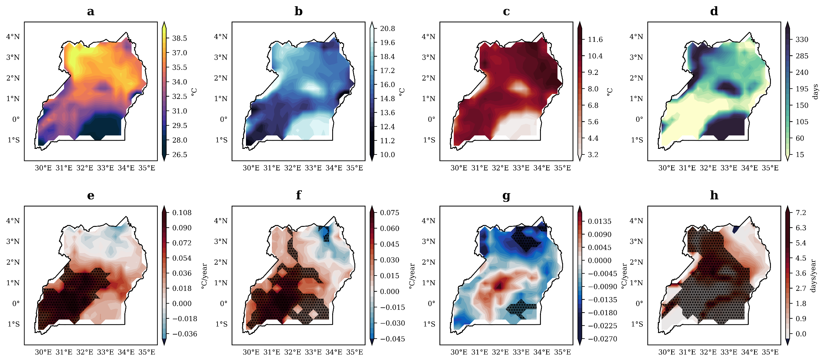
Figure 3 Spatial distribution of annual temperature extreme indices (a) mean TXx, (b) mean TNn, (c) mean DTR, (d) mean TR, (e) TXx trends, (f) TNn trends, (g) DTR trends, and (h) TR trends in Uganda from 1995 to 2024. Hatched contours are significant at P < 0.05, as determined by the Mann-Kendall test.

Trends in precipitation extremes
While annual rainfall totals remained statistically unchanged, Uganda experienced a marked intensification of precipitation extremes characterized by heavier downpours and longer dry spells, a pattern with critical implications for rainfed agriculture (Figures 4 and A4). The most intense rainfall events strengthened significantly across the country. The maximum 5-day precipitation (Rx5day) increased by 12.6 mm (13.2% relative change, P = 0.02) (Figure A4), with 18.4% of the country, particularly the southwestern and northeastern regions, experiencing significant intensification (Figure 4h). Similarly, heavy rainfall days (R20mm) showed substantial increases of 2.1 days (19.4% relative change), with significant trends affecting 28.5% of the country, again concentrated in the southwest and northeast (Figure 4g). Concurrently, dry spells lengthened considerably. Consecutive dry days (CDD) increased by 6.0 days nationally (22.1% relative change), with significant prolongation affecting 13.3% of the country, predominantly in central regions (Figure 4e). This combination of heavier downpours separated by longer dry periods occurred despite minimal change in total annual precipitation (PRCPTOT), which showed a non-significant decrease of 52.7 mm (-3.6%) with mixed spatial trends (Figures 4f and A4). The spatial pattern revealed distinct regional vulnerabilities: the southwestern and northeastern regions face compound stress from both heavier downpours and longer dry spells, while central Uganda emerges as a hotspot for drying, experiencing the most significant increases in CDD alongside declining total precipitation.
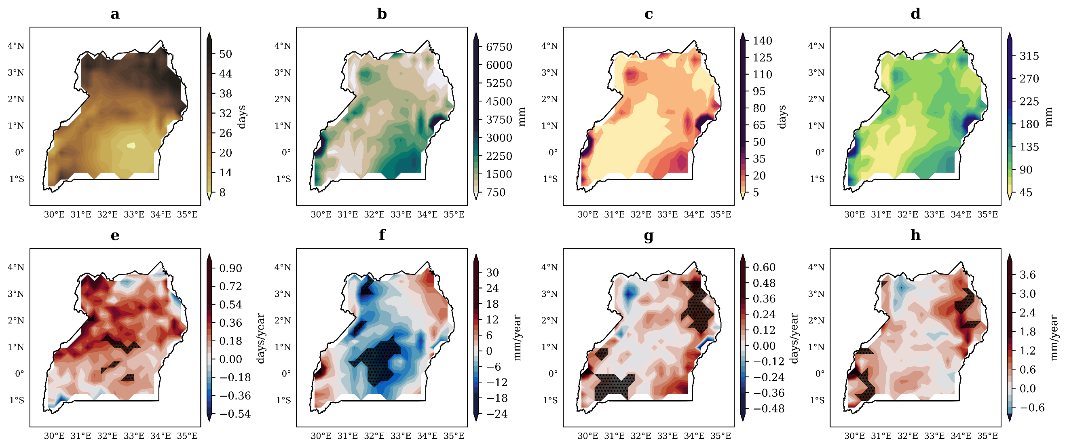
Figure 4 Spatial distribution of annual precipitation extreme indices (a) mean CDD, (b) mean PRCPTOT, (c) mean R20mm, (d) mean Rx5day, (e) CDD trends, (f) PRCPTOT trends, (g) R20mm trends, and (h) Rx5day trends in Uganda from 1995 to 2024. Hatched contours are significant at p < 0.05, as determined by the Mann-Kendall test.

Climate extremes and crop yield correlation patterns
A 5 percent false discovery rate adjustment was applied to the 232 climate–yield correlation tests and just 14 of those relationships stood the test of statistical robustness. The ones that remain consist of quite a good share, showing that temperature extremes are more predominant than rainfall indices in explaining the interannual variability in national crop yields in Uganda (Figures 5, 6, and 7).
The temperature-based indices, particularly those describing the nighttime conditions, had the strongest and most consistent impact. Most notable among these is the effect of tropical nights (TR), which appeared as the most influential extreme, with yield correlations involving those of seed cotton, cocoa beans, and pepper yielding positively. Seed cotton recorded the highest sensitivity to warming at night (ρ about .61, R² 0.37), closely followed by cocoa beans and pepper. It is likely, therefore, that these crops would benefit from warmer nocturnal environments, a phenomenon that has expanded across much of the country in recent decades. TNn also contributed positively to seed cotton yield, reinforcing the wider thermal tolerance of this crop group.
On the contrary, several food-security crops responded very sensitively to increased temperature. The cassava, pigeon pea, and groundnut were negatively correlated with TNn, where cassava further had a negative coefficient with TR. Results from this study suggest that increased nighttime temperatures could enhance respiration losses, thereby reducing assimilates in these crops with subsequent yield reductions. The yield response of groundnut was highly sensitive to precipitation extremes, registering a strong negative correlation with Rx5day. This is likely because the groundnut systems get easily waterlogged, saturate the soil during long rainfall spells, and result in disease epidemics due to high moisture conditions after heavy rainfalls.
Annual total precipitation (PRCPTOT) did not correlate strongly with yields after adjusting for error, but still counted isolated precipitation extremes. Therefore, the negative response of groundnut to Rx5day confirms the effect that short-duration, high-intensity rainfall events can have, even without reliance on long-term trends in total rainfall. The majority of significant relationships presented by the whole crop set were attributable to temperature extremes, whereby 12 out of 14 FDR-adjusted correlations were drawn from thermal indices. The trend indicates that warming, and mainly nocturnal warming, is now the primary driver of crop performance from year to year in Uganda's predominantly rainfed agricultural system.
The findings reveal a contrasting climate sensitivity profile in Uganda's agriculture: a small cluster of cash crops profits from warmer nights, but several staples crucial for food security sustain losses under such conditions. This necessitates identifying target-specific adaptation strategies, viewing crop physiology with respect to exposure to extreme temperature and rainfall conditions.
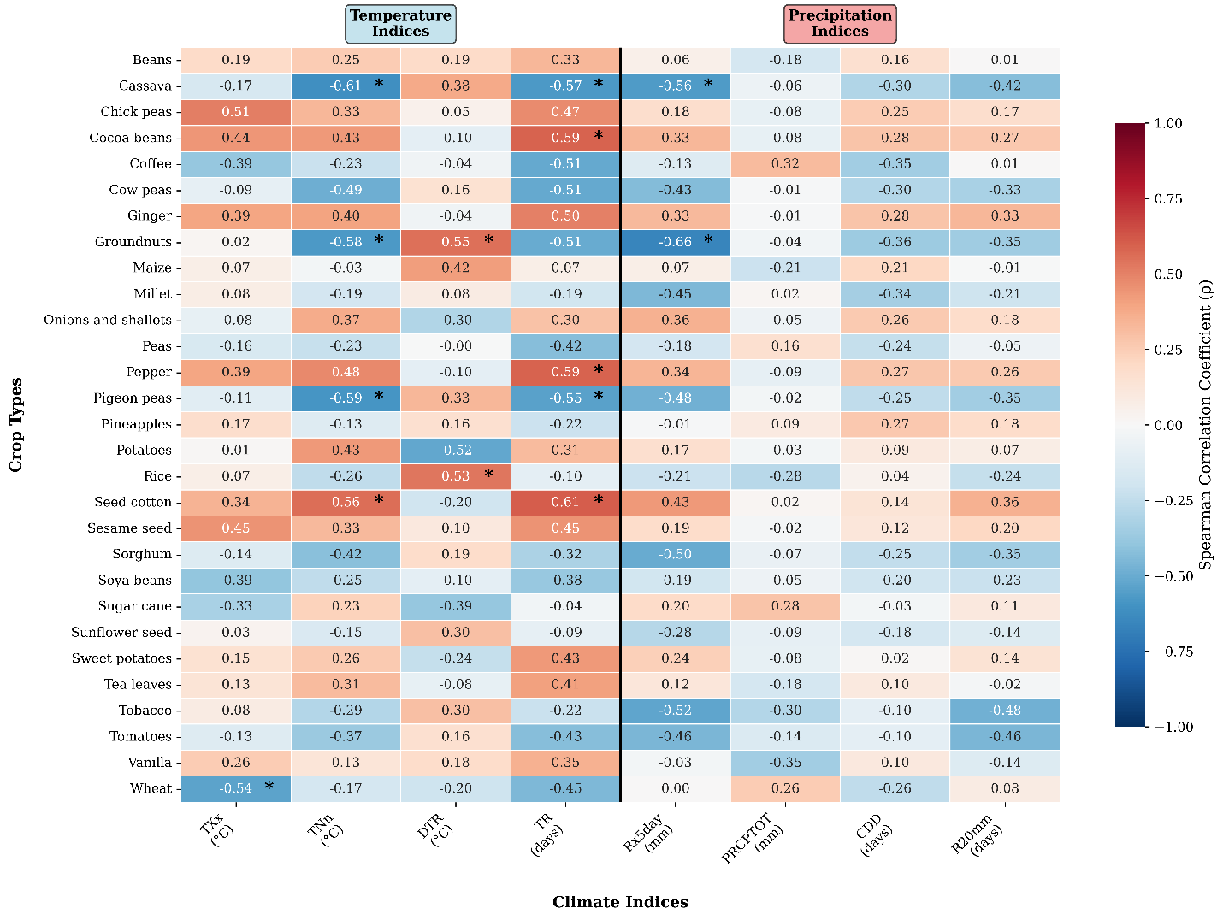
Figure 5 Spearman’s correlation heatmap for crop yields and climate extremes in Uganda from 1995 to 2024 (number of years, n=29). *Significant after FDR correction (p < 0.05).
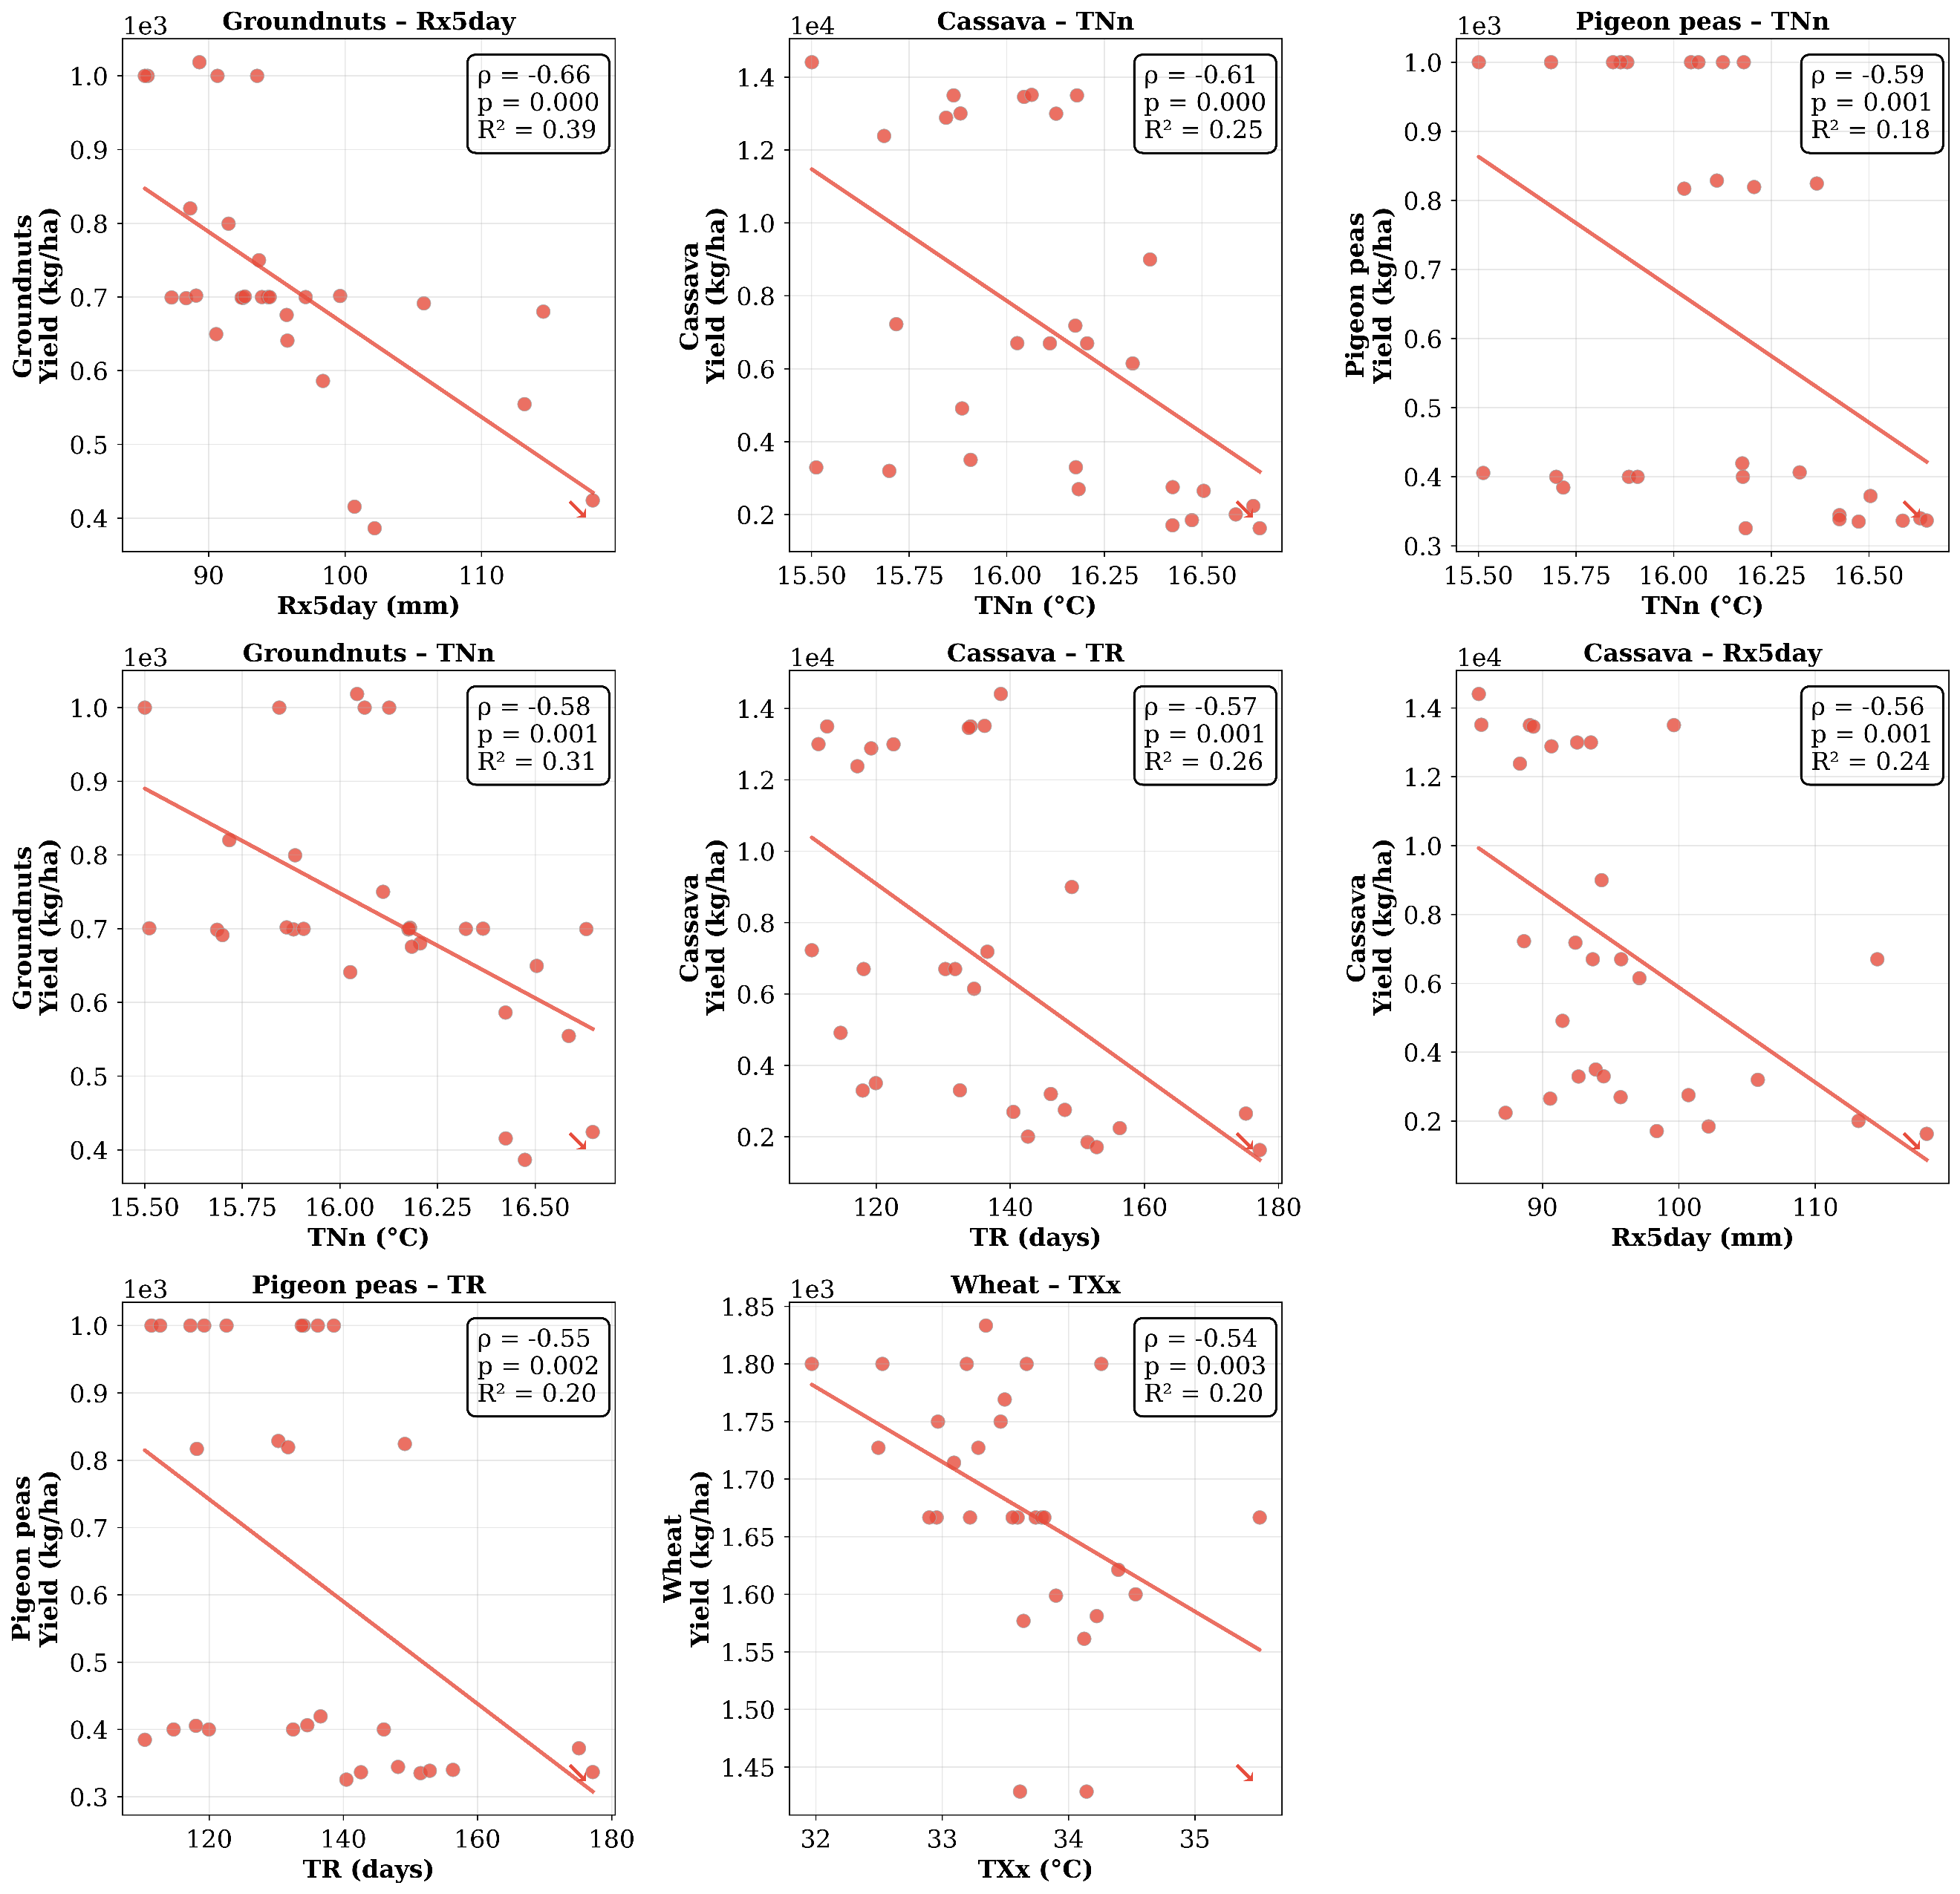
Figure 6 Strongest negative linear regressions between selected climate indices and different crop type yields at FDR-corrected significance (p < 0.05) in Uganda from 1995 to 2024.

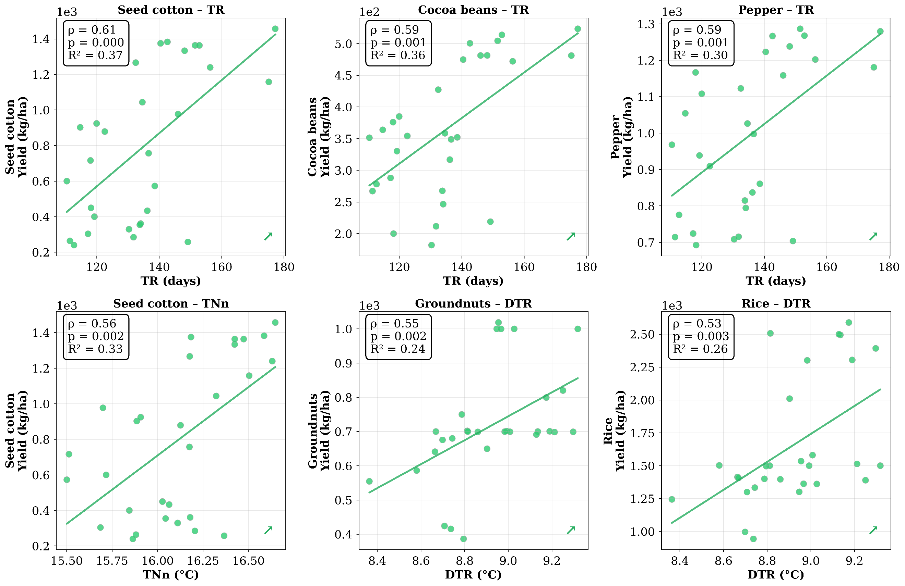
Figure 7 Strongest positive linear regressions between climate extremes and different crop type yields at FDR-corrected significance (p < 0.05) in Uganda from 1995 to 2024.

Discussion
The 1995–2024 record reveals an unequivocal intensification of climate extremes across Uganda, characterized by rapid asymmetric warming and a shift toward more intense and irregular precipitation. The annual mean temperature rose by 0.9 °C, with extreme temperature indices exhibiting particularly pronounced trends. Critically, minimum temperatures warmed faster than maxima, reflected in a 0.58 °C rise in TNn and a dramatic 41-day increase in tropical nights (TR) across most of the country. This asymmetric nocturnal warming, coupled with a widespread decline in the diurnal temperature range, is especially pronounced in the agriculturally vital central and southwestern regions. These warming rates substantially exceed the global land average (IPCC, 2021) and rank among the highest documented in East Africa (Ayugi et al., 2021; Ongoma et al., 2018), a pattern consistent with enhanced greenhouse forcing and local amplification from land-use change (Gabiri et al., 2020; Kamukama et al., 2025; Rangel-Peraza et al., 2024).
Concurrently, precipitation extremes intensified despite a non-significant decline in annual totals. The observed pattern of fewer but heavier rainfall events (increases in Rx5day, R20mm) separated by longer dry spells (lengthened CDD) is a hallmark thermodynamic response to warming widely reported across the Greater Horn of Africa (Ayugi et al., 2021). The spatial coupling of heat extremes and prolonged dry spells in central and northern Uganda signals an emerging regime of compound hot-dry events that amplify agricultural stress through accelerated soil-moisture depletion and elevated evaporative demand (Zscheischler et al., 2018).
Our most significant finding is that after stringent FDR correction across 232 tests, temperature extremes, particularly nocturnal warmth, emerged as the primary climatic driver of interannual yield variability for most crops, surpassing precipitation indices (Xu et al., 2025). The stark contrast in crop responses provides the clearest and most compelling evidence of this phenomenon. Seed cotton, cocoa beans, and pepper benefited from more tropical nights (ρ = 0.56–0.61, R² = 0.31–0.37), consistent with their broader optimal temperature envelopes (Correa et al., 2024; Thenveettil et al., 2025). In contrast, key food security staples such as cassava, pigeon peas, and groundnuts exhibited sharp yield penalties from elevated TNn and TR (ρ = -0.57 to -0.62), likely driven by accelerated nighttime respiration and impaired assimilate partitioning (Hatfield & Prueger, 2015; Li et al., 2024). Extreme precipitation imposed additional penalties, most notably the detrimental effect of Rx5day on groundnut yields (ρ = -0.66, R² = 0.40), likely through waterlogging and disease proliferation.
These results identify central and southwestern Uganda as critical climate risk hotspots, where the convergence of rapid nocturnal warming, lengthening dry spells, and intensification of heavy rainfall threatens both heat-sensitive staples and high-value export crops. Without accelerated adaptation, these compound extremes threaten to erode the substantial technological yield gains observed for crops like pepper (+69.5%) and cocoa beans (+93.2%) (Jang et al., 2025). Priority interventions must therefore include fast-tracking heat- and drought-tolerant varieties, expanding small-scale irrigation and water-harvesting infrastructure, and promoting agroforestry-based systems to mitigate nocturnal heat stress in perennial crops (Bohidar & Senapati, 2025). The positive response of some cash crops to warmer nights also highlights opportunities for strategic diversification, though this must be balanced against food security needs (Cheng et al., 2017; Giménez et al., 2025).
We acknowledge several limitations in this study. Our national-scale analysis inevitably smooths sub-national heterogeneity in both climate and agricultural management. Furthermore, while the correlation-based approach identifies robust statistical relationships, it cannot alone establish direct physiological causation. Future research should therefore integrate high-resolution, station-blended climate products with sub-national yield statistics and process-based crop modeling to derive detailed exposure-response functions. This will be crucial to move beyond correlation, quantify the efficacy of specific adaptation interventions, and provide localized guidance for farmers and policymakers across Uganda’s diverse agro-ecological zones.

Conclusion
From 1995 to 2024, Uganda experienced rapid climatic intensification, characterized by a 0.9 °C rise in annual mean temperature (Sen’s slope 0.033 °C/year), stronger warming in extremes (TXx: 0.89 °C, TNn: 0.58 °C), and a nationally widespread increase of more than 40 tropical nights per year. Nocturnal warming, amplified by both greenhouse forcing and local land-use change, now dominates the climate signal in the agriculturally vital southwestern, central, and Lake Victoria regions. Precipitation has simultaneously become more extreme: maximum 5-day totals and heavy rain days have increased significantly in 18–29 % of the country, while consecutive dry days have lengthened, producing longer dry spells between more intense wet events. The spatial overlap of severe heat and prolonged dryness heralds a rising frequency of compound hot–dry conditions with disproportionately large agricultural impacts. After rigorous statistical control, temperature extremes, especially elevated minimum temperatures and tropical nights, emerged as the primary driver of interannual yield variability for most crops, outranking total rainfall. Thermally sensitive staples (cassava, beans, pigeon peas) and coffee exhibit clear yield suppression, whereas a few cash crops (seed cotton, cocoa, pepper) benefit from warmer nights. Intense wet events (notably Rx5day) impose additional strong penalties, particularly on groundnuts. These changes are already constraining productivity in a predominantly rainfed, smallholder system. Central and southwestern Uganda constitutes emerging hotspots where the convergence of rapid nocturnal warming, lengthening dry spells, and heavier downpours threatens both food security and export revenues. Without accelerated adaptation, including heat and drought-tolerant varieties, expanded small-scale irrigation, agroforestry for microclimate regulation, and enhanced early-warning systems, warming will push many staple and high-value crops beyond viable thermal limits. This study demonstrates that high-resolution reanalysis products such as ERA5 can reliably quantify climate extremes and their agricultural impacts even in data-sparse regions. Sustained integration of such tools into national planning is essential to safeguard Uganda’s agricultural future in an increasingly extreme climate.
Data Availability Statement
All datasets used in this study are publicly available. 2m air temperature and total precipitation were retrieved from ERA5 hourly data on single levels reanalysis data from the Copernicus Climate Change Service (C3S) Climate Data Store (CDS). DOI:10.24381/cds.adbb2d47 (http://cds.climate.copernicus.eu) (Accessed on 23-Oct-2025) and nationwide annual crop yield data from FAOSTAT (https://www.fao.org/faostat/; accessed on 25 October 2025). No proprietary or restricted-access data were used.

References

Alexandridis, V., Stefanidis, S., & Dafis, S. (2023). Evaluation of ERA5 and ERA5-Land Reanalysis Precipitation Data with Rain Gauge Observations in Greece. Environmental Sciences Proceedings, 26(1), 104. https://doi.org/10.3390/environsciproc2023026104

Ayugi, B., Dike, V., Ngoma, H., Babaousmail, H., Mumo, R., & Ongoma, V. (2021). Future Changes in Precipitation Extremes over East Africa Based on CMIP6 Models. Water, 13(17), 2358. https://doi.org/10.3390/w13172358

Benjamini, Y., & Hochberg, Y. (1995). Controlling the False Discovery Rate: A Practical and Powerful Approach to Multiple Testing. Journal of the Royal Statistical Society Series B: Statistical Methodology. https://doi.org/10.1111/j.2517-6161.1995.tb02031.x

Bohidar, S., & Senapati, A. K. (2025). Assessing agricultural vulnerability to climate extremes in Rayalaseema and KBKK regions of India: A panel ARDL approach. Discover Agriculture, 3(1), 79. https://doi.org/10.1007/s44279-025-00230-7

Cheng, A., Mayes, S., Dalle, G., Demissew, S., & Massawe, F. (2017). Diversifying crops for food and nutrition security - a case of teff. Biological Reviews, 92(1), 188–198. https://doi.org/10.1111/brv.12225

Correa, J., Dorta, P., López‐Díez, A., & Díaz‐Pacheco, J. (2024). Analysis of tropical nights in Spain (1970–2023): Minimum temperatures as an indicator of climate change. International Journal of Climatology, 44(9), 3006–3027. https://doi.org/10.1002/joc.8510

Epule, T. E., Ford, J. D., Lwasa, S., Nabaasa, B., & Buyinza, A. (2018). The determinants of crop yields in Uganda: What is the role of climatic and non-climatic factors? Agriculture & Food Security, 7(1), 10. https://doi.org/10.1186/s40066-018-0159-3

Gabiri, G., Diekkrüger, B., Näschen, K., Leemhuis, C., Van Der Linden, R., Majaliwa, J.-G. M., & Obando, J. A. (2020). Impact of Climate and Land Use/Land Cover Change on the Water Resources of a Tropical Inland Valley Catchment in Uganda, East Africa. Climate, 8(7), 83. https://doi.org/10.3390/cli8070083

Giménez, V. D., Serrago, R. A., Kettler, B., García, G. A., Impa, S. M., Krishna Jagadish, S. V., Prasad, P. V. V., Miralles, D. J., & Ciampitti, I. A. (2025). Nighttime warming affects yields of major grain crops: A global meta-analysis. Field Crops Research, 334, 110142. https://doi.org/10.1016/j.fcr.2025.110142

Hatfield, J. L., & Prueger, J. H. (2015). Temperature extremes: Effect on plant growth and development. Weather and Climate Extremes https://doi.org/10.1016/j.wace.2015.08.001

Herridge, D. F., Giller, K. E., Jensen, E. S., & Peoples, M. B. (2022). Quantifying country-to-global scale nitrogen fixation for grain legumes II. Coefficients, templates and estimates for soybean, groundnut and pulses. Plant and Soil, 474(1–2), 1–15. https://doi.org/10.1007/s11104-021-05166-7

Hersbach, H., Bell, B., Berrisford, P., Hirahara, S., Horányi, A., Muñoz-Sabater, J., Nicolas, J., Peubey, C., Radu, R., Schepers, D., Simmons, A., Soci, C., Abdalla, S., Abellan, X., Balsamo, G., Bechtold, P., Biavati, G., Bidlot, J., Bonavita, M., ... Thépaut, J.-N. (2020). The ERA5 global reanalysis. Quarterly Journal of the Royal Meteorological Society, 146(730), 1999–2049. https://doi.org/10.1002/qj.3803

Hirsch, R. M., Slack, J. R., & Smith, R. A. (1982). Techniques of trend analysis for monthly water quality data. Water Resources Research https://doi.org/10.1029/WR018i001p00107

IPCC. (2021). Climate Change 2021: The Physical Science Basis. Cambridge University Press. https://doi.org/10.1017/9781009157896

Iwadra, M., Odirile, P. T., Parida, B. P., & Moalafhi, D. B. (2019). Evaluation of future climate using SDSM and secondary data (TRMM and NCEP) for poorly gauged catchments of Uganda: The case of Aswa catchment. Theoretical and Applied Climatology, 137(3–4), 2029–2048. https://doi.org/10.1007/s00704-018-2726-8

Jang, Y., Schafleitner, R., Barchenger, D. W., Lin, Y., & Lee, J. (2025). Evaluation of heat stress response in pepper (Capsicum annuum L.) seedlings under controlled environmental conditions using a high-throughput 3D multispectral phenotyping. Scientia Horticulturae, 345, 114136. https://doi.org/10.1016/j.scienta.2025.114136

Kamukama, E. G., Okrah, A., Genesis, M., Mensah, C., Donnata, A., Prempeh, N. A., Yeboah, E., & Sarfo, I. (2024). Comprehensive analysis and quantitative assessment of land use/land cover dynamics in Wakiso and Kampala, Uganda: A multi-decadal remote sensing study. Acta Scientiarum Polonorum. Formatio Circumiectus, 23(4), 77–98. https://doi.org/10.15576/ASP.FC/195540

Li, D., Xiao, Y., Guo, L., Shan, B., Liu, X., Duan, X., Rehman, A.-U., Guo, C., Zhang, W., Li, H., Liu, J., Gao, X., & Cao, X. (2024). Effect of High Nighttime Temperatures on Growth, Yield, and Quality of Two Wheat Cultivars During the Whole Growth Period. Plants, 13(21), 3071 https://doi.org/10.3390/plants13213071

Liu, R., Zhang, X., Wang, W., Wang, Y., Liu, H., Ma, M., & Tang, G. (2024). Global-scale ERA5 product precipitation and temperature evaluation. Ecological Indicators, 166, 112481. https://doi.org/10.1016/j.ecolind.2024.112481

Mann, H. B. (1945). Nonparametric Tests Against Trend. Econometrica, 13(3), 245–259. https://doi.org/10.2307/1907187

Mei, Y., Xu, L., & Li, Z. (2023). Study on Emotional Perception of Hangzhou West Lake Scenic Area in Spring under the Influence of Meteorological Environment. International Journal of Environmental Research and Public Health, 20(3), 1905. https://doi.org/10.3390/ijerph20031905

Mwaura, F. M., & Okoboi, G. (2014). Climate Variability and Crop Production in Uganda. Journal of Sustainable Development, 7(2), 159. https://doi.org/10.5539/jsd.v7n2p159

Ngoma, H., Wen, W., Ojara, M., & Ayugi, B. (2021). Assessing Current and Future Spatiotemporal Precipitation Variability and Trends over Uganda, East Africa, Based on CHIRPS and Regional Climate Model Datasets. Meteorology and Atmospheric Physics. https://doi.org/10.1007/s00703-021-00784-3

Nsubuga, F. W., & Rautenbach, H. (2018). Climate change and variability: A review of what is known and ought to be known for Uganda. International Journal of Climate Change Strategies and Management, 10(5), 752–771. https://doi.org/10.1108/IJCCSM-04-2017-0090

Nuwagira, U., & Yasin, I. (2022). Review of the Past, Current, and the Future Trend of the Climate Change and its Impact in Uganda. East African Journal of Environment and Natural Resources https://doi.org/10.37284/eajenr.5.1.605

Obubu, J. P., Mengistou, S., Fetahi, T., Alamirew, T., Odong, R., & Ekwacu, S. (2021). Recent Climate Change in the Lake Kyoga Basin, Uganda: An Analysis Using Short-Term and Long-Term Data with Standardized Precipitation and Anomaly Indexes. Climate, 9(12), 179. https://doi.org/10.3390/cli9120179

Omondi, P. A., Awange, J. L., Forootan, E., Ogallo, L. A., Barakiza, R., Girmaw, G. B., Fesseha, I., Kululetera, V., Kilembe, C., Mbati, M. M., Kilavi, M., King’uyu, S. M., Omeny, P. A., Njogu, A., Badr, E. M., Musa, T. A., Muchiri, P., Bamanya, D., & Komutunga, E. (2014). Changes in temperature and precipitation extremes over the Greater Horn of Africa region from 1961 to 2010. International Journal of Climatology, 34(4), 1262–1277. https://doi.org/10.1002/joc.3763

Ongoma, V., Chen, H., & Omony, G. W. (2018). Variability of extreme weather events over the equatorial East Africa, a case study of rainfall in Kenya and Uganda. Theoretical and Applied Climatology, 131(1), 295–308. https://doi.org/10.1007/s00704-016-1973-9

Owoyesigire, B., Mpairwe, D., Ericksen, P., & Peden, D. (2016). Trends in variability and extremes of rainfall and temperature in the cattle corridor of Uganda. Uganda Journal of Agricultural Sciences, 17(2), 231. https://doi.org/10.4314/ujas.v17i2.8

Rangel-Peraza, J. G., Sanhouse-García, A. J., Flores-González, L. M., Monjardín-Armenta, S. A., Mora-Félix, Z. D., Rentería-Guevara, S. A., & Bustos-Terrones, Y. A. (2024). Effect of land use and land cover changes on land surface warming in an intensive agricultural region. Journal of Environmental Management, 371, 123249. https://doi.org/10.1016/j.jenvman.2024.123249

Sen, P. K. (1968). Estimates of the Regression Coefficient Based on Kendall’s Tau. Journal of the American Statistical Association, 63(324), 1379–1389. https://doi.org/10.1080/01621459.1968.10480934

Shiferaw, A., Tadesse, T., Rowe, C., & Oglesby, R. (2018). Precipitation Extremes in Dynamically Downscaled Climate Scenarios over the Greater Horn of Africa. Atmosphere, 9(3), 112. https://doi.org/10.3390/atmos9030112

Sridharan, V., Pereira Ramos, E., Zepeda, E., Boehlert, B., Shivakumar, A., Taliotis, C., & Howells, M. (2019). The Impact of Climate Change on Crop Production in Uganda—An Integrated Systems Assessment with Water and Energy Implications. Water, 11(9), 1805. https://doi.org/10.3390/w11091805

Thenveettil, N., Allam, M. K. R., Anapalli, S. S., Reddy, K. N., Gao, W., & Reddy, K. R. (2025). Impacts of varying day and night environmental conditions on cotton flowering, yield, and fiber quality. Frontiers in Plant Science, 16, 1616982. https://doi.org/10.3389/fpls.2025.1616982

Xu, Y., Li, T., Xu, M., Shen, S., & Tan, L. (2025). Model-Based Assessment of Phenological and Climate Suitability Dynamics for Winter Wheat in the 3H Plain Under Future Climate Scenarios. Agriculture, 15(15), 1606. https://doi.org/10.3390/agriculture15151606

Zhang, P., Ren, G., Xu, Y., Wang, X., Qin, Y., Sun, X., & Ren, Y. (2019). Observed Changes in Extreme Temperature over the Global Land Based on a Newly Developed Station Daily Dataset. Journal of Climate. https://doi.org/10.1175/JCLI-D-18-0733.1

Zhang, X., Alexander, L., Hegerl, G. C., Jones, P., Tank, A. K., Peterson, T. C., Trewin, B., & Zwiers, F. W. (2011). Indices for monitoring changes in extremes based on daily temperature and precipitation data. WIREs Climate Change, 2(6), 851–870. https://doi.org/10.1002/wcc.147
Zscheischler, J., Westra, S., van den Hurk, B. J. J. M., Seneviratne, S. I., Ward, P. J., Pitman, A., AghaKouchak, A., Bresch, D. N., Leonard, M., Wahl, T., & Zhang, X. (2018). Future climate risk from compound events. Nature Climate Change, 8(6), 469–477. https://doi.org/10.1038/s41558-018-0156-3

Appendix:
Table A1 List of Agricultural Items and FAO Item Codes used to Represent Crop Categories in Uganda for Vulnerability Assessment.
Item Code | Crop types
176 | Beans
125 | Cassava
191 | Chick peas
661 | Cocoa beans
656 | Coffee
195 | Cow peas
720 | Ginger
242 | Groundnuts
56 | Maize
79 | Millet
403 | Onions and shallots
187 | Peas
687 | Pepper
197 | Pigeon peas
574 | Pineapples
116 | Potatoes
27 | Rice
328 | Seed cotton
289 | Sesame seed
83 | Sorghum
236 | Soya beans
156 | Sugar cane
267 | Sunflower seed
122 | Sweet potatoes
667 | Tea leaves
388 | Tomatoes
826 | Tobacco
692 | Vanilla
15 | Wheat

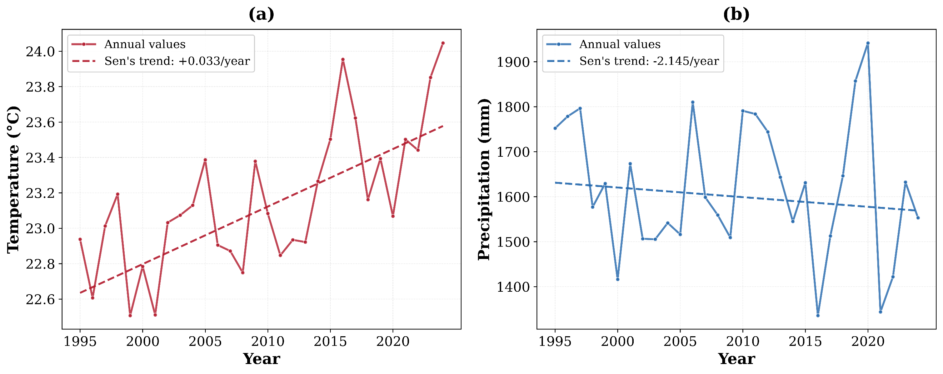
Figure A2 Annual mean time series of (a) 2m air temperature and (b) precipitation in Uganda from 1995 to 2024.
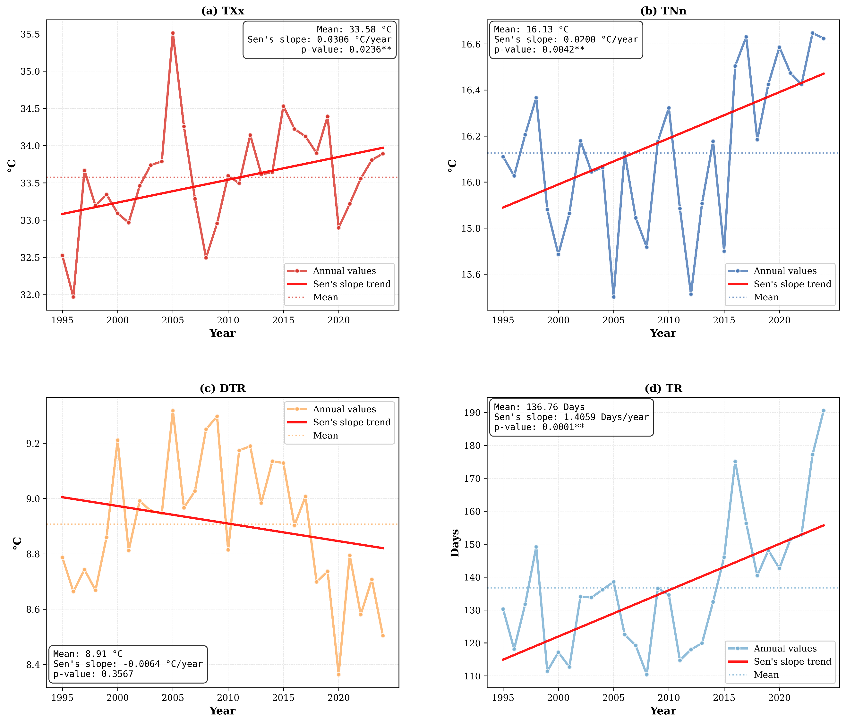
Figure A3 Annual mean time series for temperature extremes for Uganda from 1995 to 2024. ** Significant at p-value < 0.05 Mann-Kendall test
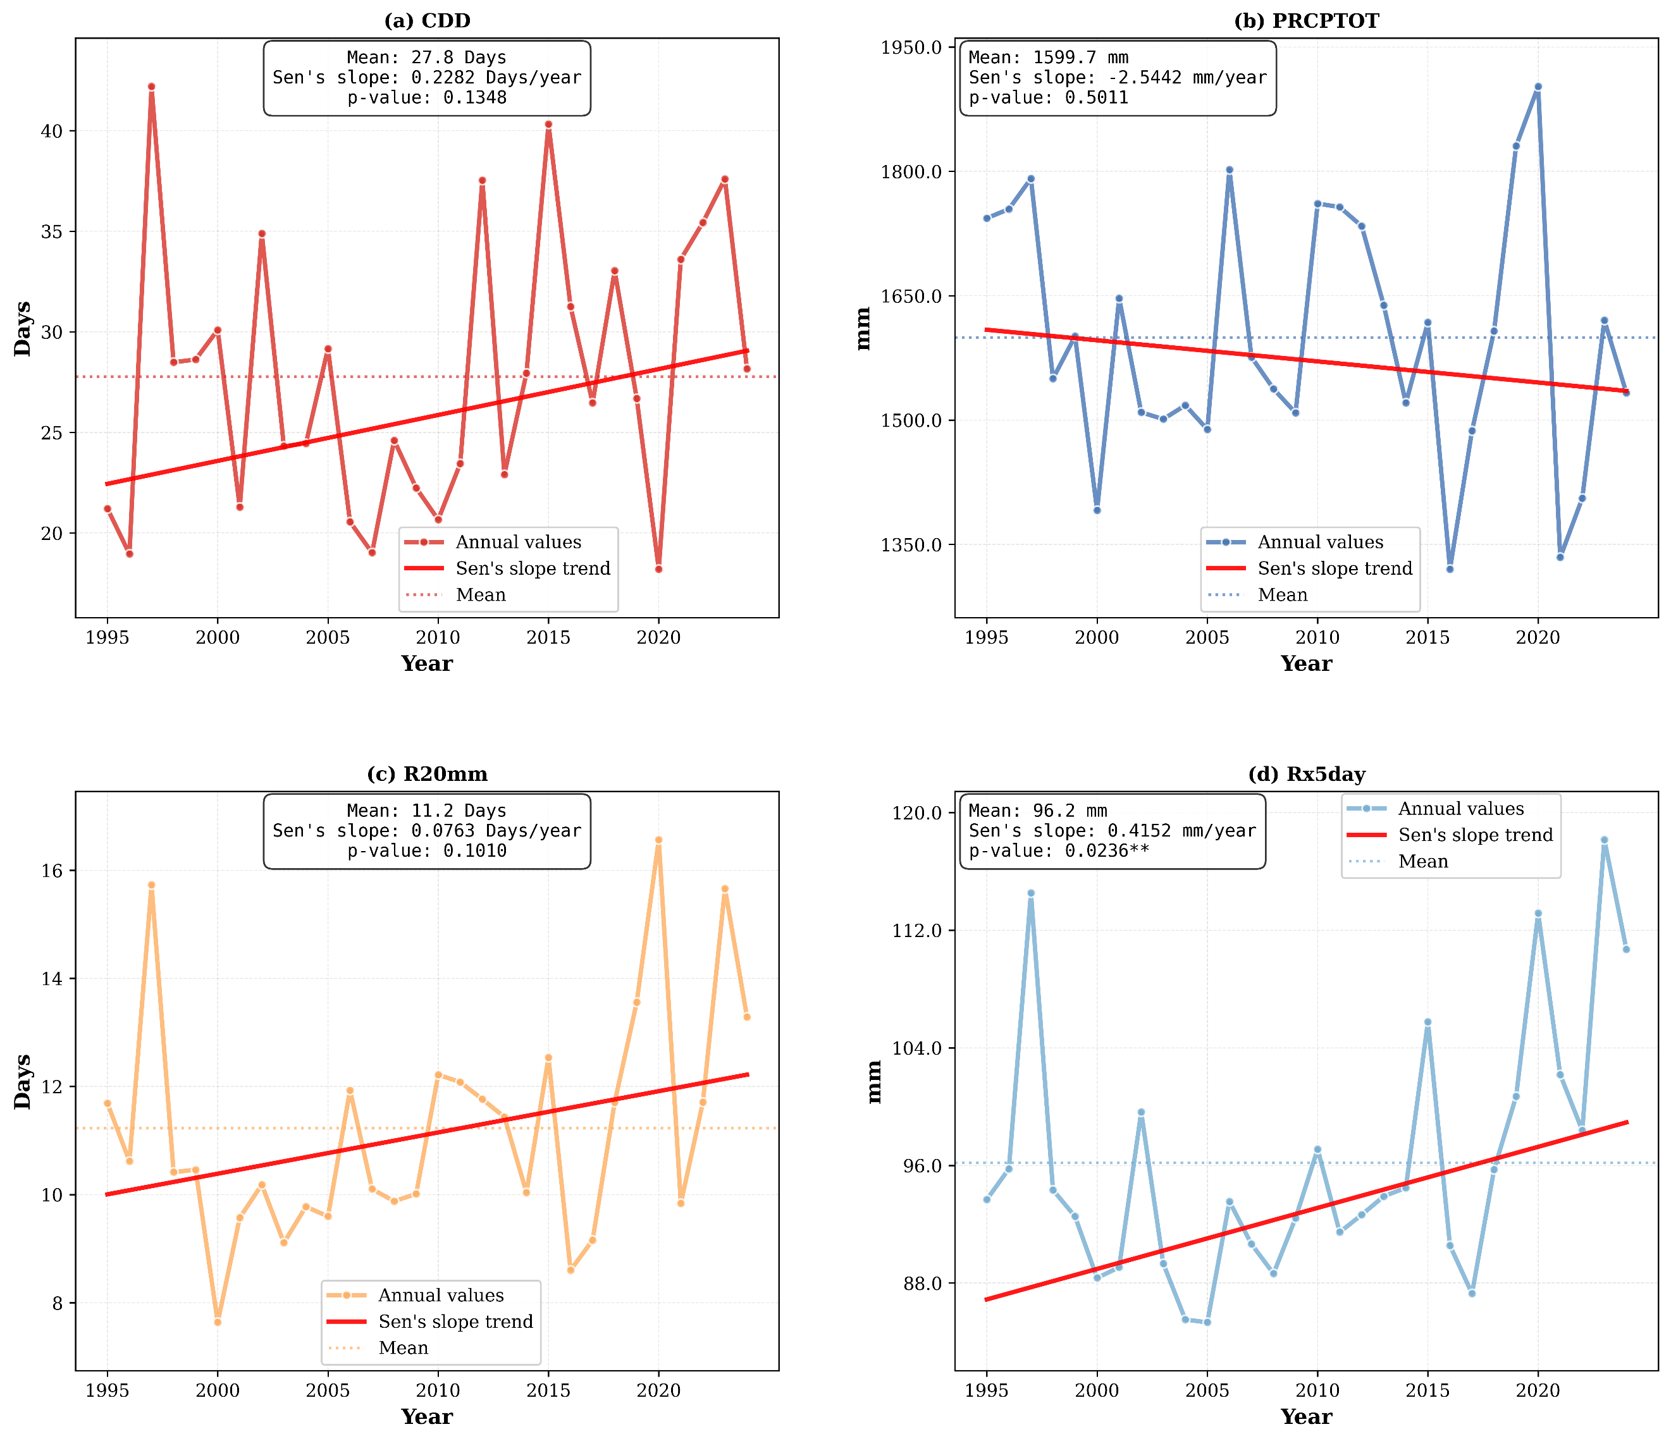
Figure A4 Annual mean time series of precipitation extremes in Uganda from 1995 to 2024. ** Significant at p-value < 0.05 Mann-Kendall

