APHRODISIAC ACTIVITY OF FICUS PLATYPHYLLA STEM BARK AND ITS POLYHERBAL FORMULATION IN FEMALE ALBINO RAT

ABSTRACT
Background: Ficus platyphylla is traditionally used in African medicine to enhance fertility and libido, but scientific evidence supporting its aphrodisiac effects, particularly in females, remains limited.
Objective: This study assessed the aphrodisiac potential of aqueous stem bark extract of F. platyphylla and its polyherbal formulation in female albino rats (Rattus norvegicus).
Methods: Thirty-two female albino rats were randomly assigned to eight groups (n=4). Groups received oral doses of F. platyphylla extract (25, 50, 100 mg/kg), polyherbal formulation (25, 50, 100 mg/kg), Exus Ginseng (5.7 mg/kg, positive control), or distilled water (1 mL, normal control). One-hour post-treatment, sexual behavior parameters (darting, hopping, licking, ear wiggling, genital and anogenital grooming, lordosis) were monitored for 30 min. Serum levels of estrogen, testosterone, progesterone, and follicle-stimulating hormone (FSH) were determined using ELISA. Ovarian tissues were examined histologically.
Results: Phytochemical screening identified six secondary metabolites (tannins, saponins, flavonoids, alkaloids, steroids, anthraquinones) in F. platyphylla and eight in the polyherbal formulation (??????). The 25 mg/kg dose of F. platyphylla and its polyherbal formulation significantly (P<0.05) increased darting, hopping, licking, ear wiggling, genital and anogenital grooming, and lordosis, comparable to Exus Ginseng. Serum estrogen increased significantly (P<0.05) at 25 mg/kg F. platyphylla, with no changes in FSH or testosterone. The 50 mg/kg dose moderately elevated FSH, estrogen, progesterone, and testosterone, while 100 mg/kg showed the lowest hormonal effects. The 25 mg/kg polyherbal group exhibited the highest FSH and estrogen levels, with increased progesterone, but unchanged testosterone. Histology revealed multiple follicular stages, suggesting ovulatory activity at low doses.
Conclusion: F. platyphylla extract at 25 mg/kg demonstrates aphrodisiac activity in female rats, supporting its traditional use. Further studies are needed to elucidate mechanisms and clinical relevance.
Keywords: Aphrodisiac, female rats, Ficus platyphylla, polyherbal formulation, hormonal effects , sexual behavior
1.0 INTRODUCTION
Aphrodisiacs are substances that enhance sexual activity and are widely used to manage sexual dysfunctions [1]. These agents, which may include drugs, foods, scents, devices, or medicinal plants, are thought to modulate neurotransmitters or alter sex hormone levels, such as progesterone, estrogen, and testosterone [2]. The World Health Organization (WHO) defines sexual health as a state of physical, emotional, mental, and social well-being related to sexuality, beyond the absence of disease or dysfunction [3]. In females, sexual function involves a complex interplay of physiological factors (e.g., hormones like estrogen, progesterone, and testosterone, which regulate desire, arousal, lubrication, and orgasm [4,5]), nerve function, genital blood flow [6], and psychological elements such as motivation, self-image, and emotional intimacy [7-9].
Medicinal plants have long been used to promote sexual health, with a rich tradition of herbal remedies in therapeutic practices [10]. Scientific studies increasingly validate the aphrodisiac potential of these plants, often using animal models [11]. However, despite traditional use, the aphrodisiac properties of Ficus platyphylla remain unestablished scientifically. Preliminary research suggests analgesic, anti-inflammatory, and fertility-enhancing effects [12,13], but its impact on female sexual behavior is poorly understood.
This study aims to evaluate the aphrodisiac activity of Ficus platyphylla stem bark aqueous extract in female albino rats, both alone and in a polyherbal formulation with other herbs. By assessing behavioral responses, hormonal profiles, and ovarian histology, the study seeks to provide empirical evidence supporting traditional claims of Ficus platyphylla in enhancing female sexual health.
2.0 MATERIALS AND METHODS
2.1 Plant Samples
Fresh stem bark of Ficus platyphylla (gamji), Anogeissus leiocarpa (tuntuben harshe), Syzygium aromaticum (Kannunfari), Securidaca longepedunculata (umar magungunna), and Phyllanthus amarus (minannas) were collected in August and September 2024, respectively, from a farmland along Byepass Road, Birnin Kebbi, Kebbi State, Nigeria. The plants were identified and authenticated by a taxonomist at the herbarium section of the Department of Plant Sciences, Kebbi State University of Science and Technology, Aleiro, and assigned voucher numbers KSUSTA |PSB|H|NO: 292 (Ficus platyphylla), KSUSTA |PSB|H|NO: 9 (Anogeissus leiocarpa), KSUSTA |PSB|H|NO: 55 (Syzygium aromaticum), KSUSTA |PSB|H|NO: 53 (Securidaca longepedunculata), and KSUSTA |PSB|H|NO: 44 (Phyllanthus amarus).
2.2 Experimental Animals
Thirty-two healthy female albino rats (Rattus norvegicus), with a mean weight of 142.40 ± 1.16 g, were obtained from the animal house of the College of Medicine, Usmanu Dan Fodio University, Sokoto, Nigeria. The rats were acclimatized for two weeks under standard laboratory conditions (temperature: 32–34 °C, 12-hour light/dark cycle) and allowed free access to rat pellets (Premier Feeds, Sokoto, Nigeria) and treated tap water. All experiments complied with the World Health Organization guidelines for the use of laboratory animals in biomedical research [15].
2.3 Preparation of Plant Extract
Two-hundred grams of F. platyphylla stem bark powder was soaked in 1 L of distilled water for 48 hours, filtered using muslin cloth, and the filtrate dried in a water bath at 55 °C. This yielded 41.5 g of F. platyphylla extract (20.7% yield) [16].

2.4 Preparation of Polyherbal Extract
A total of two-hundred grams of powdered plant material was prepared in a ratio of 1:1:1:1:1, with each plant (Anogeissus leiocarpa, Syzygium aromaticum, Securidaca longepedunculata, Phyllanthus amarus, and Ficus platyphylla). The combined two-hundred grams was soaked in 1 L of distilled water for 48 hours, filtered using muslin cloth, and the filtrate was dried in a water bath at 55 °C, yielding 24.9 g (12.5%) [16].
2.5 Qualitative Phytochemical Screening
Preliminary screening for secondary metabolites in F. platyphylla stem bark and the polyherbal extract (comprising Anogeissus leiocarpa, Ficus platyphylla, Syzygium aromaticum, Securidaca longepedunculata, and Phyllanthus amarus) was conducted to detect alkaloids, tannins, phlobatannins, and anthraquinones [17]; flavonoids and phenolics [18]; and saponins, cardiac glycosides, steroids, and anthocyanidins [19], using established protocols.
2.6 Experimental Design
Thirty-two female (32) albino rats (Rattus norvegicus) were divided into eight groups of four (4) rats each. Groups 1–3 received aqueous Ficus platyphylla stem bark extract at doses of 25, 50, and 100 mg/kg body weight, respectively. Groups 4–6 were administered with a polyherbal formulation (comprising Ficus platyphylla, Anogeissus leiocarpa [tuntuben harshe], Syzygium aromaticum [kannunfari], Securidaca longepedunculata [uwar magungunna], and Phyllanthus amarus [minannas]) at corresponding doses of 25, 50, and 100 mg/kg body weight. Group 7 served as the positive control, receiving 5.7 mg/kg body weight of Panax ginseng, while Group 8 acted as the normal control, given 1 mL of distilled water. All treatments were administered orally once daily for 7 days, with three replication cycles. Rats were sacrificed 24 hours after the seventh dose (Day 8), following National Research Council guidelines [15, 20].

2.7 Mating Behavior Test
A unilevel pacing chamber (60 L × 40 W × 40 H cm) with a transparent Plexiglas divider was used to observe female sexual behavior [21, 22]. One-hour post-treatment, the following parameters were recorded over 30 minutes:
Proceptive behavior: darting latency (DL; time to initiate darting), darting frequency (DF; number of darts), hopping latency (HL; time to initiate hopping), and hopping frequency (HF; number of hops).
Receptive behavior: lordosis latency (LL; time to assume lordosis posture) and lordosis frequency (LF; number of lordosis postures).
Orientation activities: licking behavior (LB), genital grooming (GG), and anogenital grooming (AG). Frequency and duration of behaviors were documented for each pair of rats [20].
2.8 Serum collection
The procedure described by [22] was adopted. Rats were anaesthetized with diethyl ether fumes, and blood samples were collected via ocular puncture. The jugular veins were then cut to collect 5 mL of blood into sterile, dry centrifuge tubes. Samples were left at room temperature for 15 minutes to clot, then centrifuged at 503 × g for 10 minutes using a Uniscope Laboratory Centrifuge (Model SM800B, Surgifriend Medicals, Essex, UK). The clear serum was separated using a Pasteur pipette and refrigerated until use.

2.9 Quantification of reproductive hormones
Serum concentrations of progesterone, follicle-stimulating hormone (FSH), estrogen, and testosterone were quantified using enzyme-linked immunosorbent assay (ELISA) techniques, following the manufacturer’s instructions for each specific kit. Progesterone was measured using the Progesterone ELISA Kit (Abcam, Catalog #ab108654), validated for rat sera [37, 38]. FSH was quantified using the Rat FSH ELISA Kit (Sigma-Aldrich, Catalog #RAB0326), as validated for rat sera [39, 40]. Estrogen levels were determined with the Rat Estradiol ELISA Kit (Thermo Fisher, Catalog #KA0234), validated for rat sera [41, 42]. Testosterone was measured using the Testosterone ELISA Kit (Enzo Life Sciences, Catalog #ADI-900-065), as validated for rat sera [43, 44]. The ELISA analyzer was calibrated with standard curves and validated for rat sera [45]. All ELISA procedures followed established protocols for hormone quantification [46].
2.10 Histological Examination
At the end of the experiment, ovaries were harvested, blotted dry, and chopped into small pieces. Samples were fixed in 10% buffered formalin, dehydrated in ascending grades of ethanol (70%, 90%, and 95% v/v), cleared in xylene, and embedded in paraffin wax (melting point 56 °C) [25]. Tissue sections (5–6 µm) were prepared according to Drury and Wallington [26] and stained with hematoxylin and eosin (H&E). Slides were examined under a light microscope, and photomicrographs were captured at ×400 magnification using Presto Image Folio Package Software.
2.11 Statistical Analysis
Results were expressed as the mean ± standard error of mean of 6 replicates. Data were analyzed using a one-way analysis of variance, followed by the independent T-test to determine significant differences in all the parameters with Students Package for Social Science, version 20.0 (SPSS Inc., Chicago, USA). Differences with values of P<0.05 were considered statistically significant.

3.0 RESULTS
3.1 Phytochemical Composition
The screening of secondary plant metabolites in the aqueous extract of F. platyphylla stem bark extract revealed the presence of tannins, saponins, flavonoids, alkaloids, steroids, and anthraquinones. Cardiac glycosides, phenolic compounds, and anthracyanide were absent.
Table 1: Phytochemical composition of Ficus platyphylla stem bark extract
S/N | Phytochemicals | Ficus Platyphylla | Polyherbal Formulation
1 | Tannins | + | +
2 | Saponins | + | +
3 | Flavonoids | + | +
4 | Alkaloids | + | +
5 | Steroids | + | +
6 | Anthraquinones | + | -
7 | Cardiac glycosides | - | +
8 | Phenolic compounds | - | +
9 | Anthracyanide | - | -
10 | Phlobatannins | - | +
Key: (+) = Detected, (-) = Not Detected

3.2 Effect of Ficus platyphylla and its Polyherbal Formulation on Female Sexual Behavior
The administration of Ficus platyphylla aqueous stem bark extract and its polyherbal formulation produced dose- and time-dependent effects on female sexual behavior parameters (darting frequency [DF], dating latency [DL], hopping frequency [HF], hopping latency [HL], licking frequency [LF], anogenital and genital grooming frequency, ear wiggling frequency, and lordosis frequency) compared to control groups (distilled water and drug controls).On day 1, DF increased significantly (P<0.05) at 25 mg/kg F. platyphylla, while 50 mg/kg showed a significant decrease; by day 7, DF dropped to zero in controls but remained higher in all extract-treated groups. DL was highest at 100 mg/kg polyherbal on day 1 and lowest at 50 mg/kg F. platyphylla, declining significantly (P<0.05) in controls by day 7 compared to treated groups. HF and HL varied with dose: 25 mg/kg F. platyphylla increased HF and decreased HL (P<0.05) versus controls, while 50 and 100 mg/kg reduced activity; on day 7, treated groups (especially 25 mg/kg) maintained higher HF with lower latency than inactive controls. LF peaked at 25 mg/kg F. platyphylla on day 1 (P<0.05), followed by 50 mg/kg, with 100 mg/kg showing the lowest effect; on day 7, 25 mg/kg matched the drug control, both exceeding distilled water, while 50 and 100 mg/kg remained lower than drug control but higher than distilled water. A similar dose-dependent trend was observed with the polyherbal formulation, with 25 mg/kg yielding the highest LF. Anogenital grooming frequency was highest at 100 mg/kg F. platyphylla on day 1 (P<0.05), followed by 50 mg/kg, and lowest at 25 mg/kg; on day 7, 50 mg/kg led, followed by 25 mg/kg, with 100 mg/kg lowest. Genital grooming was lower than controls at most doses on day 1 except for 25 mg/kg polyherbal (P<0.05), with 50 mg/kg highest on day 7 and 100 mg/kg showing no activity. Ear wiggling frequency was highest at 100 mg/kg F. platyphylla on day 1, then 25 mg/kg, and lowest at 50 mg/kg; on day 7, 25 mg/kg F. platyphylla exceeded controls, with no difference between distilled water and drug controls. Lordosis frequency increased significantly (P<0.05) at 25 mg/kg polyherbal on day 1 versus controls (which showed none), declining overall by day 7 except in the drug control group.

Table 2: Effect of Ficus platyphylla Aqueous Stem Bark and its Polyherbal Extract on Darting Latency and Frequency
Groups | Darting Latency(sec)  Day 1 | Day 7 | Darting frequency  Day 1 | Day 7
Normal control | 126.58 ± 189.62ª | 0.00 ± 0.00ª | 0.33 ± 0.27ª | 0.00 ± 0.00ª
Exus Ginseng(5.7 mg/kg) | 121.00 ± 230.37^{b} | 0.00 ± 0.00ª | 0.42 ± 0.63^{b} | 0.00 ± 0.00ª
FicusPlatyphylla(25mg/kg) | 225.58 ± 244.53^{c} | 57.00 ± 65.85^{b} | 0.75 ± 0.50^{c} | 0.33 ± 0.38^{b}
FicusPlatyphylla(50mg/kg) | 21.17 ± 42.34^{ab} | 23.92 ± 29.08^{c} | 0.08 ± 0.17^{ab} | 0.25 ± 0.31^{c}
FicusPlatyphylla(100mg/kg) | 70.42 ± 140.84^{bc} | 29.84 ±57.90^{ab} | 0.17 ± 0.33^{bc} | 0.17 ± 0.19^{ab}
Polyherbal (25mg/kg) | 54.67 ± 37.87e | 56.00 ± 60.54^{b} | 0.42 ± 0.17^{b} | 0.25 ± 0.32^{c}
Polyherbal (50mg/kg) | 184.08 ± 219.56^{d} | 40.75 ±62.56^{bc} | 0.58 ± 0.57e | 0.33 ± 0.38^{b}
Polyherbal (100mg/kg) | 352.42 ± 350.86^{f} | 0.00 ± 0.00ª | 0.66 ± 0.27^{f} | 0.00 ± 0.00ª
Values are presented as mean ± standard error of mean (n=4). Value with different superscript in each column was significant different at P<0.05

Table 3: Effect of Ficus Platyphylla Aqueous Stem Bark and its Polyherbal Extract on Hopping Latency and Frequency
Groups | Hopping Latency(sec)  Day 1 | Day 7 | Hopping frequency  Day 1 | Day 7
Normal control | 0.00 ± 0.00ª | 0.00 ± 0.00ª | 0.00 ± 0.00ª | 0.00 ± 0.00ª
Exus ginseng(5.7 mg/kg) | 0.00 ± 0.00ª | 0.00 ± 0.00ª | 0.00 ± 0.00ª | 0.00 ± 0.00ª
Ficusplatyphylla(25mg/kg) | 115.33 ± 186.76^{b} | 10.00 ± 20.00^{b} | 0.33 ± 0.27^{b} | 0.08 ± 0.17^{c}
FicusPlatyphylla(50mg/kg) | 0.00 ± 0.00ª | 179.66 ±89.84^{c} | 0.00 ± 0.00ª | 0.08 ± 0.17^{c}
FicusPlatyphylla(100mg/kg) | 46.00 ± 92.00^{c} | 0.00 ± 0.00ª | 0.08 ± 0.33^{c} | 0.00 ± 0.00ª
Polyherbal (25mg/kg) | 140.66 ± 33.72^{ab} | 66.66±115.50^{ab} | 0.16 ± 0.19^{ab} | 0.08 ± 0.17^{c}
Polyherbal (50mg/kg) | 0.00 ± 0.00ª | 0.00 ± 0.00ª | 0.00 ± 0.00ª | 0.00 ± 0.00ª
Polyherbal (100mg/kg) | 0.00 ± 0.00ª | 0.00 ± 0.00ª | 0.00 ± 0.00ª | 0.00 ± 0.00ª
Values are presented as mean ± standard error of mean (n=4). Value with different superscript in each column was significant different at P<0.05

Table 4: Effect of ficus platyphylla Aqueous Stem Bark and its Polyherbal Extract on Licking Behavior
Groups | Licking Behavior  Day 1 | Day 7
Normal control | 1.92 ± 1.17ª | 1.17 ± 0.19ª
Exus ginseng(5.7mg/kg) | 2.05 ± 0.84^{b} | 2.19 ± 0.57^{c}
FicusPlatyphylla(25mg/kg) | 2.83 ± 0.64^{c} | 2.16 ± 0.84^{c}
FicusPlatyphylla(50mg/kg) | 2.50 ± 0.79^{ab} | 2.08 ± 0.92^{b}
FicusPlatyphylla(100mg/kg) | 2.41 ± 1.32^{bc} | 1.91 ± 0.79^{ab}
Polyherbal (25mg/kg) | 2.08 ± 0.47^{b} | 2.00 ± 0.38^{b}
Polyherbal (50mg/kg) | 1.75 ± 0.32e | 1.66 ± 0.82e
Polyherbal (100mg/kg) | 2.00 ± 0.47^{b} | 1.42 ± 0.50^{bc}
Values are presented as mean ± standard error of mean (n=4). Value with different superscript in each column was significant different at P<0.05

Table.5: Effect of Ficus platyphylla Aqueous Stem Bark and its Polyherbal Extract on Anogenital and Genital Grooming
Groups | Anogenital Grooming  Day 1 | Day 7 | Genital Grooming  Day 1 | Day 7
Normal control | 3.25 ± 1.17ª | 2.25 ± 1.10ª | 0.58 ± 0.32ª | 0.50 ± 1.00^{bc}
Exus ginseng(5.7mg/kg) | 2.46 ± 1.01^{b} | 2.58 ± 0.74^{b} | 0.83 ± 0.69^{b} | 0.92 ± 0.63^{b}
FicusPlatyphylla(25mg/kg) | 2.67 ± 0.98^{c} | 2.00 ± 1.05^{c} | 0.50 ± 0.43ª | 0.92 ± 0.17^{b}
FicusPlatyphylla(50mg/kg) | 3.17 ± 0.58^{ab} | 2.96 ± 0.95^{d} | 0.08 ± 0.17^{ab} | 0.96 ± 0.95^{c}
FicusPlatyphylla(100mg/kg) | 3.75 ± 0.92^{bc} | 2.58 ± 1.17^{ab} | 0.42 ± 0.17e | 0.00 ± 0.00^{ab}
Polyherbal (25mg/kg) | 3.50 ± 1.50e | 2.17 ± 0.43^{bc} | 1.00 ± 0.38^{bc} | 0.58 ± 0.42ª
Polyherbal (50mg/kg) | 3.00 ± 0.90^{f} | 2.00 ± 1.15c | 0.16 ± 0.19^{c} | 0.58 ± 0.42ª
Polyherbal (100mg/kg) | 2.92 ± 0.50^{d} | 0.42 ± 0.17e | 0.33 ± 0.27^{f} | 0.00 ± 0.00^{ab}
Values are presented as mean ± standard error of mean (n=4). Value with different superscript in each column was significant different at P<0.05

Table.6: Effect of ficus platyphylla Aqueous Stem Bark and its polyherbal Extract on Ear Wiggling Behavior
Groups | Ear Wiggling Behavior  Day 1 | Day 7
Normal control | 1.13 ± 0.47ª | 2.42 ± 0.63ª
Exus ginseng(5.7mg/kg) | 2.42 ± 0.74^{b} | 2.42 ± 0.92ª
FicusPlatyphylla(25mg/kg) | 2.75 ± 0.88^{b} | 2.50 ± 0.84ª
FicusPlatyphylla(50mg/kg) | 2.58 ± 1.20^{c} | 2.29 ± 0.61^{b}
FicusPlatyphylla(100mg/kg) | 3.33 ± 0.27^{ab} | 2.42 ± 1.13ª
Polyherbal (25mg/kg) | 2.67 ± 0.90^{b} | 2.83 ± 0.58^{ab}
Polyherbal (50mg/kg) | 2.00 ± 0.54^{bc} | 1.92 ± 0.83^{bc}
Polyherbal (100mg/kg) | 3.00 ± 0.82^{ab} | 2.08 ± 1.03e
Values are presented as mean ± standard error of mean (n=4). Value with different superscript in each column was significant different at P<0.05

Table.7: Effect of ficus platyphylla Aqueous Stem Bark and its polyherbal Extract on Lordosis Behavior
Groups | Lordosis Behavior  Day 1 | Day 7
Normal control | 0.00 ± 0.00ª | 0.00 ± 0.00ª
Exus ginseng(5.7mg/kg) | 0.00 ± 0.00ª | 0.42 ± 0.50^{ab}
FicusPlatyphylla(25mg/kg) | 0.08 ± 0.17^{b} | 0.00 ± 0.00ª
FicusPlatyphylla(50mg/kg) | 0.00 ± 0.00ª | 0.00 ± 0.00ª
FicusPlatyphylla(100mg/kg) | 0.00 ± 0.00ª | 0.00 ± 0.00ª
Polyherbal (25mg/kg) | 0.17 ± 0.33^{c} | 0.00 ± 0.00ª
Polyherbal (50mg/kg) | 0.08 ± 0.17^{b} | 0.00 ± 0.00ª
Polyherbal (100mg/kg) | 0.00 ± 0.00ª | 0.00 ± 0.00
Values are presented as mean ± standard error of mean (n=4). Value with different superscript in each column was significant different at P<0.05
3.3 Effects of Ficus platyphylla stem bark aqueous extract and its polyherbal formulation on reproductive hormone
The effects of Ficus platyphylla stem bark aqueous extract and its polyherbal formulation on reproductive hormone levels are shown in Table.8. At 25 mg/kg, the polyherbal extract significantly (P<0.05) elevated serum estrogen, follicle-stimulating hormone (FSH), and progesterone levels compared to control groups. In contrast, testosterone levels decreased significantly (P<0.05) at 50 mg/kg polyherbal extract relative to controls [23].

Table.8: Effect of ficus platyphylla Aqueous Stem Bark and its polyherbal Extract on Hormones
Doses | FSH (mlU/mL) | E (pg/mL) | P (ng/mL) | T (ng/mL)
Normal control | 2.35 ± 0.21ª | 2.20 ± 0.28ª | 1.20 ± 0.14ª | 0.03 ± 0.00ª
Exus ginseng(5.7 mg/kg) | 4.47 ± 0.25^{b} | 3.60 ± 0.53^{c} | 2.30 ± 0.20^{b} | 0.08 ± 0.01^{b}
Ficusplatyphylla(25mg/kg) | 4.65 ± 0.24^{b} | 4.28 ± 0.17^{ab} | 1.60 ± 0.26^{c} | 0.07 ± 0.00^{b}
Ficusplatyphylla(50mg/kg) | 3.50 ± 0.10^{c} | 3.13 ± 0.15^{c} | 1.40 ± 0.15^{f} | 0.04 ± 0.00^{f}
Ficusplatyphylla(100mg/kg) | 2.50 ± 0.04e | 2.77 ± 0.10^{bc} | 1.60 ± 0.15^{c} | 0.05 ± 0.01^{b}
Polyherbal (25mg/kg) | 5.37 ± 0.31^{f} | 10.10 ± 0.20^{d} | 2.57 ± 0.15^{ab} | 0.09 ± 0.00^{b}
Polyherbal (50mg/kg) | 4.60 ± 0.10^{b} | 5.57 ± 0.31^{b} | 2.20 ± 0.20^{b} | 0.07 ± 0.00^{b}
Polyherbal (100mg/kg) | 3.70 ± 0.26^{c} | 5.70 ± 0.20^{b} | 2.10 ± 0.10^{b} | 0.06 ± 0.01^{b}
Values are presented as mean ± standard error of mean (n=4). Value with different superscript in each column was significant different at P<0.05
E: Estrogen, FSH: follicle stimulating hormone, P: progesterone hormone, T: testosterone.

3.3 Histological Architecture of Tissues Examined
The effects of Ficus platyphylla aqueous leaf extract and its polyherbal formulation on ovarian histology are depicted in Plates 1–8. The normal control group displayed numerous antral follicles and a well-formed graafian follicle, reflecting normal ovarian architecture (Plate 1). The drug control group, treated with Panax ginseng, showed larger antral follicles, prominent primary follicles, and an enlarged graafian follicle, suggesting enhanced folliculogenesis (Plate 2). At 25 mg/kg, F. platyphylla extract revealed numerous primordial cells, primary follicles, antral follicles, and a corpus luteum, indicating active follicular recruitment and ovulatory potential (Plate 3). At 50 mg/kg, F. platyphylla exhibited secondary and antral follicles, suggesting moderate development without ovulation (Plate 4), while 100 mg/kg showed graafian and antral follicles but lacked earlier stages and corpus luteum, hinting at delayed maturation (Plate.5). The 25 mg/kg polyherbal extract mirrored the 25 mg/kg F. platyphylla group with similar follicular and ovulatory features (Plate.6). At 50 mg/kg, the polyherbal extract displayed a large graafian follicle and occasional primary follicles, indicating selective maturation (Plate.7), while 100 mg/kg showed numerous antral and primary follicles without ovulation (Plate.8).

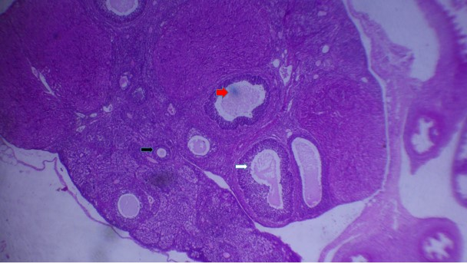
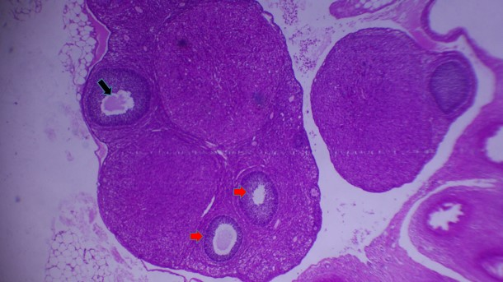

Plate 2: Photomicrograph of Rat’s Ovary obtained from Drug Control (Gensing 5.7mg/kg)
Section showing antral (red arrow), primary (black arrow) and graphian follicles (white arrow)
Plate 1: Photomicrograph of Rat’s Ovary obtained from Normal Control
Section showing normal follicular activities, numerous antral (red arrow) and graphian (black arrows) follicles.

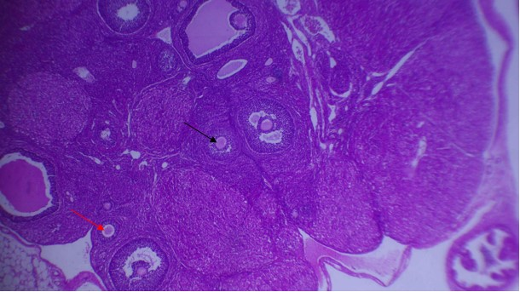
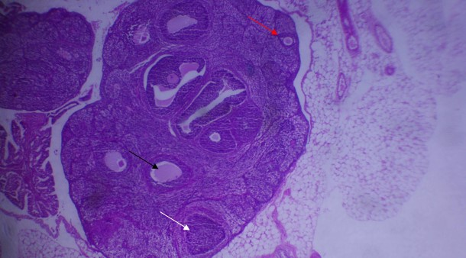

Plate 4 Photomicrograph of Rat’s Ovary obtained from Group Treated with Ficus Platyphylla Aqueous Stem Bark Extract (50mg/kg)
Section showing mild follicular activities secondary (red arrow), antral follicles (black arrow)

Plate 3: Photomicrograph of Rat’s Ovary obtained from Group Treated with Ficus Platyphylla Aqueous Stem Bark Extract (25mg/kg)
Section showing increased in follicular activities, numerous primordial cells, primary (red arrow), antral follicles (black arrow) and corpus luteum (white arrow).

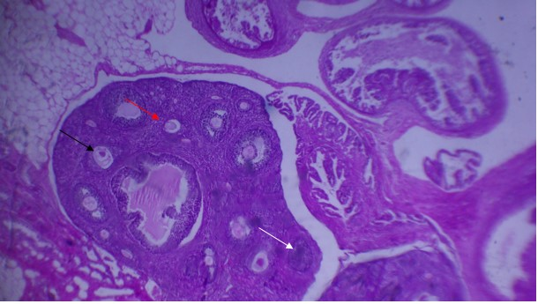
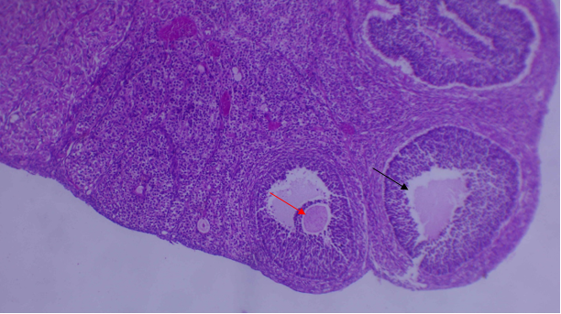

Plate 5: Photomicrograph of Rat’s Ovary obtained from Group Treated with Ficus Platyphylla Aqueous Stem Bark Extract (100mg/kg)
Section showing mild follicular activities, graafian (red arrow) and antral (black arrow)

Plate.6: Photomicrograph of Rat’s Ovary obtained from Group Treated with Polyherbal Aqueous Extract (25mg/kg)
Section showing higher follicular activities, numerous primordial cells, primary (red arrow), antral follicles (black arrow) and corpus luteum (white arrow)

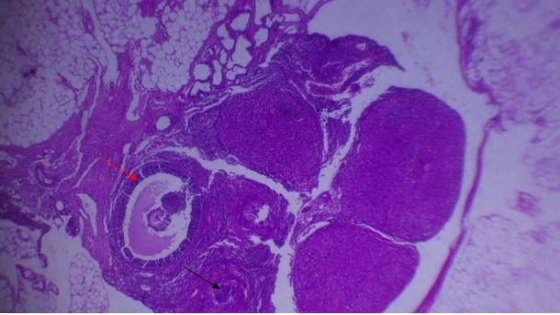
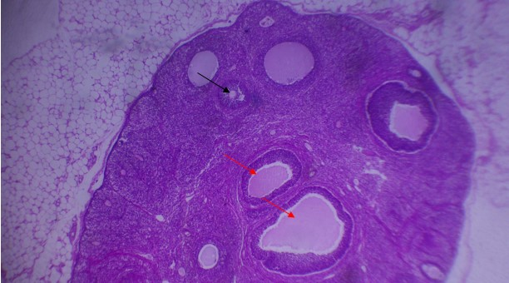

Plate 8: Photomicrograph of Rat’s Ovary obtained from Group Treated with Polyherbal Aqueous Extract (100mg/kg)
Section showing mild follicular activities, numerous antral (red arrow) and primary (black arrow) follicles

Plate 7: Photomicrograph of Rat’s Ovary obtained from Group Treated with Polyherbal Aqueous Extract (50mg/kg)
Section showing mild follicular activities, large graafian follicle (red arrow) and occasional primary follicle (black arrow)

4.0 DISCUSSION
The study demonstrates that Ficus platyphylla and its polyherbal formulation exhibit aphrodisiac activity in female albino rats, supporting traditional claims of enhanced reproductive function in northern Nigeria, likely through phytochemicals. Phytochemical analysis of Ficus platyphylla and its polyherbal formulation revealed the presence of important secondary metabolites such as flavonoids, saponins, alkaloids, tannins, steroids, and anthraquinones. These classes of compounds have been widely associated with reproductive-enhancing properties. For instance, flavonoids and saponins act as phytoestrogens capable of mimicking estrogenic activity, thereby improving reproductive function and sexual receptivity in experimental animals [11,17,34]. Alkaloids and tannins have also been implicated in neuroendocrine modulation, enhancing central nervous system activity that influences sexual arousal [13,20]. The combination of these phytochemicals likely underlies the aphrodisiac effects observed in the present study.
The effects on female mating behavior further support the pharmacological potential of these extracts. Aphrodisiac plants such as Mondia whitei and Bulbine natalensis have been shown to increase female sexual receptivity through modulation of proceptive and receptive behaviors, including hopping, darting, and lordosis [11,22,25]. Similar behavioral enhancements observed in this study suggest that F. platyphylla and its polyherbal formulation act through mechanisms that improve motivation and receptivity, possibly via estrogenic pathways. This agrees with earlier reports that phytoestrogens enhance sexual receptivity in female rodents by stimulating hypothalamic and limbic centers responsible for sexual behavior [21,29].
Hormonal assays provide further evidence of estrogen-mediated effects. Elevations in estrogen, FSH, and progesterone observed in treated groups align with studies on Tribulus terrestris and Mucuna pruriens, which demonstrated increased gonadotropins and improved reproductive outcomes in both male and female models [34,35,52]. The modulation of gonadotropins indicates stimulation of the hypothalamic–pituitary–gonadal axis, which is essential for follicular development and ovulatory cycles [28,31]. Interestingly, testosterone levels were minimally affected, suggesting that the aphrodisiac effects are mediated predominantly through estrogenic rather than androgenic pathways. This is consistent with previous findings that female sexual receptivity depends primarily on estrogen and progesterone rather than androgens [27,30].
Histological examination of ovarian tissues further corroborates these findings. Extract-treated rats displayed multiple follicular stages, including the presence of corpus luteum, which is indicative of ovulation. Similar follicular progression has been reported in rats treated with fertility-enhancing plants such as Ficus bengalensis and Ficus racemosa [33]. In contrast, higher doses appeared to disrupt normal folliculogenesis, reflecting dose-dependent effects of phytochemicals on ovarian function. Such inhibitory effects at elevated doses have also been documented in other phytotherapeutic studies where excessive exposure to phytoestrogens led to ovarian suppression [49,50]. Taken together, the phytochemical constituents of Ficus platyphylla and its polyherbal formulation appear to enhance female sexual function by stimulating estrogenic pathways, modulating gonadotropin release, and promoting ovarian follicular development. These findings are consistent with previous literature on medicinal plants with aphrodisiac and fertility-enhancing potential, thereby providing a pharmacological basis for their traditional use in reproductive health.
5.0 CONCLUSION
The study confirms that the aqueous stem bark extract of Ficus platyphylla possess aphrodisiac potential in female albino rats, enhancing sexual behaviors and promoting follicular development, ovulatory readiness and modulates female reproductive functions. These findings validate the traditional use of Ficus platyphylla as an aphrodisiac and warrant further research into its mechanisms and clinical applications.

REFERENCES
1. Smith, A. B., Johnson, C., Lee D (2013). Aphrodisiacs and sexual enhancement: Pharmacology and application. Journal of Sexual Medicine, 10(3)pp789–802.
2. Alok, S., Jain, S. K., Verma, A., Kumar, M., Mahor, A., Sabharwal, M (2013). Herbal plants with potential aphrodisiac activity: A review. Journal of Pharmacognosy and Phytochemistry, 2(1)pp91–95.
3. World Health Organization. (2002). Defining sexual health: Report of a technical consultation on sexual health, pp28–31
4. Basson, R., Berman, J., Burnett, A., Derogatis, L., Ferguson, D., Fourcroy, J., Whipple, B (2004). Report of the international consensus development conference on female sexual dysfunction: Definitions and classifications. Journal of Urology, 163(3)pp888–893.
5. McCarthy, B., & McDonald, D (2012). Female sexual arousal and desire: An integrated model. Journal of Sex and Marital Therapy, 38(5)pp435–454.
6. Davis, S. R., Davison, S. L., Donath, S., Bell, R. J (2006). Circulating androgen levels and self-reported sexual function in women. JAMA, 295(14)pp1546–1553.
7. Leiblum, S. R., Koochaki, P. E., Rodenberg, C. A., Barton, I. P., Rosen, R. C (2006). Hypoactive sexual desire disorder in postmenopausal women: US results from the Women's International Study of Health and Sexuality. Menopause, 13(1)pp46–56.
8. Nappi, R. E., Cucinella, L (2009). Advances in pharmacotherapy for treating female sexual dysfunction. Expert Opinion on Pharmacotherapy, 10(17)pp2879–2893.
9. Gupta, S., Sur, R (2008). Psychosocial factors and female sexual dysfunction. Indian Journal of Psychiatry, 50(4)pp254–259.
10. Ephrain, E., Peter, A (2008). Ethnobotanical survey of medicinal plants in the treatment of sexually transmitted diseases. African Journal of Traditional, Complementary and Alternative Medicines, 5(1)pp38–45.
11. Watcho, P., Zelefack, F., Nguelefack, T. B., Kamanyi, A (2007). Sexual stimulant effects of aqueous extract of Mondia whitei in female rat. Pharmacologyonline, 2, pp401–419.
12. Chindo, B. A., Yaro, A. H., Adamu, M., & Amos, S (2016). Antidepressant-like activity of Ficus platyphylla stem bark in mice. Journal of Ethnopharmacology, 194,pp671–679.
13. Chindo, B. A., Amos, S., Odutola, A. A., Vongtau, H. O., Abbah, J., Wambebe, C., Gamaniel, K. S (2003). Central nervous system activity of the methanol extract of Ficus platyphylla stem bark. Journal of Ethnopharmacology, 85(1)pp131–137.
14. Ukwani-Kwaja, A. N., Tanko, Y., Mohammed, A., Musa, M (2021). Analgesic and anti-inflammatory activities of Ficus platyphylla stem bark in rats. Journal of Medicinal Plants Research, 15(5)pp207–214.
15. National Research Council (2011). Guide for the care and use of laboratory animals (8th ed.). Washington, DC: National Academies Press.
16. Abedi, A., Parviz, M., Karimian, S. M., & Beyer, C (2013). The effects of nitric oxide synthase inhibition on female sexual behavior in rats. Behavioural Brain Research, 253pp78–84.
17. Hajimahmoudidis, A., Amin, G., Zamora, M. S., Hamadanizadeh, M. H (2023). The profertility and aphrodisiac activities of tribulus terrestris L.: evidence from meta analyses. Hindawi,7118431
18. Robbers, J. E., Tyler, V. E., Brady, L. R (2015). Pharmacognosy and pharmacobiotechnology.
19. Van Wyk, B. E., Wink, M. (2014). Medicinal plants of the world. Briza publications.
20. S. M. M. I. N. Hussaini, A. T. S. M. I. I.N Ahmed (2019). Traditional medicine in Africa: A global perspective, journal of ethnopharmacology, 235pp 240-252.
21. Sarkar, M., Saha, S., Mandal, S (2008). Behavioral responses of female rats during paced mating. Indian Journal of Experimental Biology, 46(6)pp421–427.
22. Yakubu, M. T., & Afolayan, A. J (2009). Effect of aqueous extract of Bulbine natalensis (Baker) stem on the sexual behaviour of male rats. International Journal of Andrology, 32(6)pp629–636.
23. Yakubu, M. T., Akanji, M. A., Oladiji, A. T (2009). Male sexual dysfunction and methods used in assessing medicinal plants with aphrodisiac potentials. Pharmacognosy Reviews, 2(4), 49–56.
24. Su, M (2021). Improved preservation of ovarian tissue morphology that is compatible wirh antigen detection using a fixative mixure of formalin and acetic acid. Journal of histochemistry and cytochemistry, 69(12)pp793-808.
25. Meyerson, B. J., Lindström, L. H (2002). Sexual behavior in female rats: Behavioral and pharmacological studies. Neuroscience Biobehavioral Reviews, 26(4)pp429–441.
26. Paredes, R. G (2003). Evaluating the sexual behavior of the female rat. Hormones and Behavior, 44(3)pp184–191.
27. Edinger, K. L., Frye, C. A (2007). Sexual experience of female rats influences mating-induced estradiol and progesterone in the brain. Neuroendocrinology, 85(2)pp93–103.
28. Nelson, R. J (2011). An introduction to behavioral endocrinology (4th ed.). Sunderland, MA: Sinauer Associates.
29. Balthazart, J (2018). Hormonal control of sexual behavior in female mammals and birds: Similarities and differences. Frontiers in Neuroendocrinology, 50, pp43–67.
30. Carter, C. S (2008). Hormonal influences on human sexual behavior. Journal of Sex Research, 29(1)pp39–51.
31. Hirshfield, A. N. (2009). Development of follicles in the mammalian ovary. International Review of Cytology, 124,pp43–101.
32. Chaudhury, R. R., Dey, S (2003). Phytochemical and pharmacological evaluation of medicinal plants with reproductive properties. Indian Journal of Medical Research, 118, pp1–16.
33. Sharma, V., Thakur, M., & Dixit, V. K (2011). A comparative study of effect of Ficus bengalensis and Ficus racemosa on reproductive health in male albino rats. Journal of Ethnopharmacology, 134(3)pp817–822.
34. Gauthaman, K., Adaikan, P. G., Prasad, R. N. V (2002). Aphrodisiac properties of Tribulus terrestris extract (Protodioscin) in normal and castrated rats. Life Sciences, 71(12), pp1385–1396.
35. Das, A. K., Bag, S. P., Saha, R. (2004). Effect of saponins from Mucuna pruriens on sexual behavior and sperm production in male rats. Phytomedicine, 11(6)pp591–595.
36. Amos, S., Chindo, B. A., Abbah, J., Vongtau, H. O., Adzu, B., Buhari, S., Gamaniel, K. S (2010). Fertility enhancing effects of Ficus platyphylla stem bark in female rats. Journal of Ethnopharmacology, 127(1)pp251–256.
37. Saedi Z, Al-Othman A, Rahmani A (2018). Validation of a high-sensitivity ELISA for progesterone in rat serum. Journal of Endocrinology 41(3):pp345–52. doi:10.1007/s40618-017-0745-6.
38. Abcam (2023). Progesterone ELISA Kit (Catalog #ab108654) User Manual. Cambridge, UK: Abcam; Available from: https://www.abcam.com.
39. McNamara M, O’Connor K, Ryan S (2016). Development and validation of an ELISA for rat FSH in endocrine studies. Endocrinology Methods. 2016;52(4):pp123–30. doi:10.1016/j.endmeth..02.003.
40. Sigma-Aldrich (2024). Rat FSH ELISA Kit (Catalog #RAB0326) Technical Datasheet. St. Louis, MO: Sigma-Aldrich;.Available from: https://www.sigmaaldrich.com.
41. Wang S, Zhang L, Chen H. Quantification of estradiol in rat serum using a high-sensitivity ELISA: Validation and application. Journal of Analytical Biochemistry. 2020;68(2):pp89–97. doi:10.1016/j.jab.2020.01.012.
42. Waltham, MA (2023). Thermo Fisher Scientific Rat Estradiol ELISA Kit (Catalog #KA0234) User Manual.: Thermo Fisher Scientific;. Available from: https://www.thermofisher.com.
43. Smith LB, Walker WH, O’Donnell L (2017). ELISA-based measurement of testosterone in rat models: Validation and optimization. Andrology.;5(5):pp987–94. doi:10.1111/andr.12412.
44. Farmingdale, NY (2024). Enzo Life Sciences. Testosterone ELISA Kit (Catalog #ADI-900-065) Technical Datasheet.: Enzo Life Sciences;. Available from: https://www.enzolifesciences.com.
45. Andreasson U, Perret-Liaudet A, van Waalwijk van Doorn LJ, Blennow K, Chiasserini D, Engelborghs S (2015). A practical guide to immunoassay validation for biomarker quantification. Clinical and Chemical Laboratory Medicine.;53(7):pp955–65. doi:10.1515/cclm-2015-0141.
46. Crowther JR (2009). The ELISA guidebook. 2nd ed. New York, NY: Humana Press; doi:10.1007/978-1-60327-254-4.
47. Edinger, K. L., & Frye, C. A. (2007). Androgens’ effects on sexual behavior in female rats: Role of androgen and estrogen receptors. Hormones and Behavior, 52(5), 598–604. https://doi.org/10.1016/j.yhbeh.2007.07.010
48. Nelson, R. J. (2011). An introduction to behavioral endocrinology (4th ed.). Sinauer Associates.
49. Hirshfield, A. N. (2019). Development of follicles in the mammalian ovary. International Review of Cytology, 124, 43–101. https://doi.org/10.1016/S0074-7696(08)61524-7
50. Chaudhury, R. R., & Dey, S. K. (2003). Follicular development and corpus luteum formation in rats. Indian Journal of Physiology and Pharmacology, 47(1), 44–50.
51. Balthazart, J. (2018). Hormonal control of sexual behavior in animals. Comprehensive Physiology, 8(3), 1211–1279. https://doi.org/10.1002/cphy.c170018
52. Adaikan, P. G., Gauthaman, K., Ng, S. C., & Prasad, R. N. V. (2020). Pro-sexual and aphrodisiac effects of medicinal plants: Current perspectives. Phytotherapy Research, 34(5), 1029–1046. https://doi.org/10.1002/ptr.6598
53. Khaleghi, M., Ghanbari, A., & Ziai, S. A. (2019). Phytochemicals and female sexual health: Mechanistic insights and therapeutic potential. Journal of Ethnopharmacology, 235, 181–193. https://doi.org/10.1016/j.jep.2019.02.022
54. Patel, S., & Rauf, A. (2017). Adaptogens and phytoestrogens: Mechanisms in reproductive health. Biomedicine & Pharmacotherapy, 90, 731–743. https://doi.org/10.1016/j.biopha.2017.04.059

