Journal Name: | Chemical Science International Journal
Manuscript Number: | Ms_CSIJ_149207
Title of the Manuscript: | Thermodynamics parameters of Green Corrosion Inhibitor Capacity of African Cherry (Chrysophyllum albidum) seed Extract on Mild steel in Acidic medium
Type of the Article

PART 1: Comments
 | Reviewer’s comment  Artificial Intelligence (AI) generated or assisted review comments are strictly prohibited during peer review. | Author’s Feedback (It is mandatory that authors should write his/her feedback here)
Please write a few sentences regarding the importance of this manuscript for the scientific community. A minimum of 3-4 sentences may be required for this part. | This research is original in terms of concept, because it addresses the problem of corrosion, which is a problem faced in one way or another by various industries. The added value of the research lies in its treatment of corrosion using a green chemical method through the use of plant extracts as an alternative to environmentally polluting chemicals.  Green corrosion inhibitors are becoming increasingly popular amongst industrial professionals because of their ability to impart superior corrosion resistance while having a minimum impact on the environment. In recent years, plant based products such as tannins, alkaloids, amino acids and organic dyes have shown promising corrosion inhibition properties.  Some of the main features of these corrosion inhibitors include their high adsorption ability, low cost and toxicity, biodegradability and sustainability as well as being available and renewable. They have been used in numerous fields, including metallurgical, chemical, and oil and gas industries as well as in surface treatment for cultural heritage.
Is the title of the article suitable?  (If not please suggest an alternative title) | The title clearly and concisely expresses the contents of the research.
Is the abstract of the article comprehensive? Do you suggest the addition (or deletion) of some points in this section? Please write your suggestions here. | The research abstract is clear, and the reader can deduce its content.
Is the manuscript scientifically, correct? Please write here. | The Manuscript is scientifically correct, but the researcher was content with following the old traditional methodology in studying corrosion, which is currently insufficient.
Are the references sufficient and recent? If you have  suggestions of additional references, please mention them in the review form. | Since this topic is currently being studied intensively, there is a lot of relevant research that can be included in the research.

Is the language/English quality of the article suitable for scholarly communications? | The language English quality of the article is suitable for scholarly communications.
Optional/General comments | Please find below the comments:  - The researcher did not mention the types of chemical compounds present in the extracts, although they are known in the literature. To understand the nature of the bond to the metal surface, it is necessary to know the type of compounds, which the researcher mentioned in the body of his study. quote from the research textas below:  - In this study, a chemical adsorption mechanism is proposed due to the Ea values that ranged between 100 and 150 kJ/Mol or < 200KJ/Mol.  - Metals have been found to form complex with inhibitors  The researcher was required, at a minimum, to write the following: African Cherry (Chrysophyllum albidum) seed extract contains a variety of chemical compounds, including saponins, flavonoids, carbohydrates, and terpenoids. Other compounds present are fatty acids, cardiac glycosides, quinones, alkaloids, tannins, and phenols.  The compounds such as saponins, flavonoids, carbohydrates, terpenoids, quinones, alkaloids, tannins, and phenols are good ligands capable of forming complexes with the metal surface.  - The researcher was supposed to provide a diagram illustrating the mechanism of corrosion inhibitor assembly.  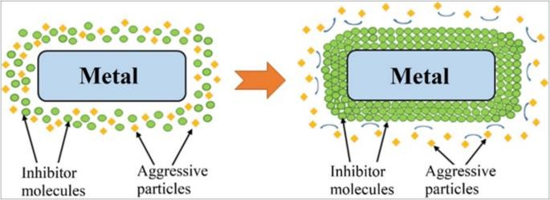  - The traditional research method used to study corrosion is important but insufficient; modern methods must be used in parallel, such as:  Potentiostats: These are instruments used and related to electrochemical techniques like Electrochemical Impedance Spectroscopy (EIS) to precisely monitor corrosion rates.  - Most modern studies are now accompanied by computational Study.

PART 2:
 | Reviewer’s comment | Author’s Feedback (It is mandatory that authors should write his/her feedback here)
Are there ethical issues in this manuscript? | (If yes, Kindly please write down the ethical issues here in detail)

Reviewer details:

Kamal Fared Almokhalelati, Syria

