PHYSICAL AND CHEMICAL CHARACTERIZATION OF THE WATER IN THE LAKE OF THE KOSSOU HYDROELECTRIC DAM (Ivory Coast).

ABSTRACT

The quality of lake Kossou is compromised by agricultural and mining activities carried out in its watershed. The objective of this study is to characterize the physicochemical parameters of lake Kossou's waters in order to assess its biological potential. Sampling was carried out from May 2017 to February 2018 over three seasons (the heavy rainy season, the flood season, and the heavy dry season). Physical parameters such as temperature, pH, and dissolved oxygen (O₂) were measured in situ using the HANNA HI 9828 multi-parameter meter. Chemical parameters, namely ammonium (NH₄⁺), orthophosphate (PO₄³⁻) and total phosphorus, were analyzed in the laboratory with a KONTRON UV visible UVIKON 810 spectrophotometer, in conformity with French AFNOR standards. Statistical data processing was performed using STATISTICA 7.1 software. The values for temperature, pH, dissolved oxygen, ammonium ions, orthophosphate ions and total phosphorus ranged from 28.02 to 29.9 °C, 5.75 to 7.21, 4.23 to 7.23 mg/L, 0.04 to 0.56 mg/L, 0.06 to 0.64 mg/L, and 0.08 to 8 mg/L, with respective medians of 29.16 °C, 6.28, 6.24 mg/L, 0.17 mg/L, 0.13 mg/L, and 2.75 mg L. Seasonal variations in temperature, pH, orthophosphate ions, ammonium ions, and total phosphorus were statistically significant (P < 0.05). Nutrient concentrations were generally higher during the dry season. The Water Quality Assessment System for Watercourses (SEQ-Eau) indicates that, with the exception of total phosphorus, the lake's waters are suitable for biological activity. Total phosphorus appears to be the downgrading parameter. These results indicate a risk of eutrophication of the lake waters. Monitoring of the lake waters is necessary to protect the organisms that live there.

Keywords: Lake Kossou, Physicochemical characteristics, Seasonal variation, Biological potential.

1. INTRODUCTION
Artificial lakes created by hydroelectric dams are of major socio-economic importance. They drive the development of several activities, including trade, agriculture, and fishing. These lakes are the focus of major inland fishing activities (Tah et al., 2009) because they are home to a rich and diverse fauna. As a result, they attract large numbers of people, which in turn puts significant anthropogenic pressure on these reservoirs. Human activities such as industrial, mining, and agricultural activities can have adverse effects on natural ecosystems (Dedjiho et al., 2013).
In Côte d'Ivoire, following the construction of the Kossou hydroelectric dam and numerous other small dams for hydro-agricultural use upstream, the human impact has increased considerably. The development of intensive farming (cash crops and food crops) over large areas in the watershed has led to a very significant increase in the use of fertilizers and pesticides (MEDD, 2010 ; Ducroquet et al., 2017). The agrochemicals (fertilizers and pesticides) used are potential sources of nutrient enrichment (phosphorus, nitrogen) in the lake through the phenomenon of rainwater leaching from the soil. The proliferation of invasive aquatic plants in various parts of lake Kossou is evidence of the presence of nutrients in high concentrations. According to Halle et Bruzon (2006), lake Kossou is experiencing an invasion of aquatic plants such as water hyacinth and water lettuce (Pistia stratiotes). Under these conditions, certain physicochemical parameters, such as dissolved oxygen and phosphorus, vary, imposing interactions between the major functions of the aquatic ecosystem, particularly primary production, photosynthesis, and nutrition (Benzha, 2017). This can compromise water quality and the survival of aquatic wildlife.
In addition, mining activities, particularly gold mining in the lake Kossou basin, have intensified. This activity causes deforestation and the transfer of contaminants into lakes via erosion, contributing to the eutrophication of these lakes. In addition, the discharge of wastewater from artisanal gold mining on the shores of lake Kossou makes the lake water cloudy and muddy. These discharges are factors that are also likely to degrade the quality of the lake water. Taking into account these alterations caused by human activities on this watercourse is therefore a major concern. This study aims to characterize the physicochemical parameters of the Kossou hydroelectric dam reservoir in order to monitor its waters.
2. MATERIALS AND METHODS
2.1 STUDY AREA
Lake Kossou is located in central Côte d'Ivoire, between 6°58'-8°08' north latitude and 5°25'-5°45' west longitude (Figure 1). It is located 296 km from the mouth of the river and at an altitude of 203 m. This lake was created following the construction of a hydroelectric dam on the Bandama River, specifically on the White Bandama. This body of water covers an area of 600 km² and has a catchment area of 32,400 km² (FAO, 2008). It is bordered to the north by the departments of Béoumi and Sakassou, to the south by the departments of Yamoussoukro and Bouaflé, to the west by the departments of Zuénoula and Kounahiri, and to the southeast by the department of Tiébissou. The lake's hydrological regime is of the attenuated transitional equatorial type, subject to the baoulé climate. This climate has four seasons, including two dry seasons (long dry season and short dry season) and two rainy seasons (long rainy season and short rainy season).

Figure 1 : Geographic location of Lake Kossou
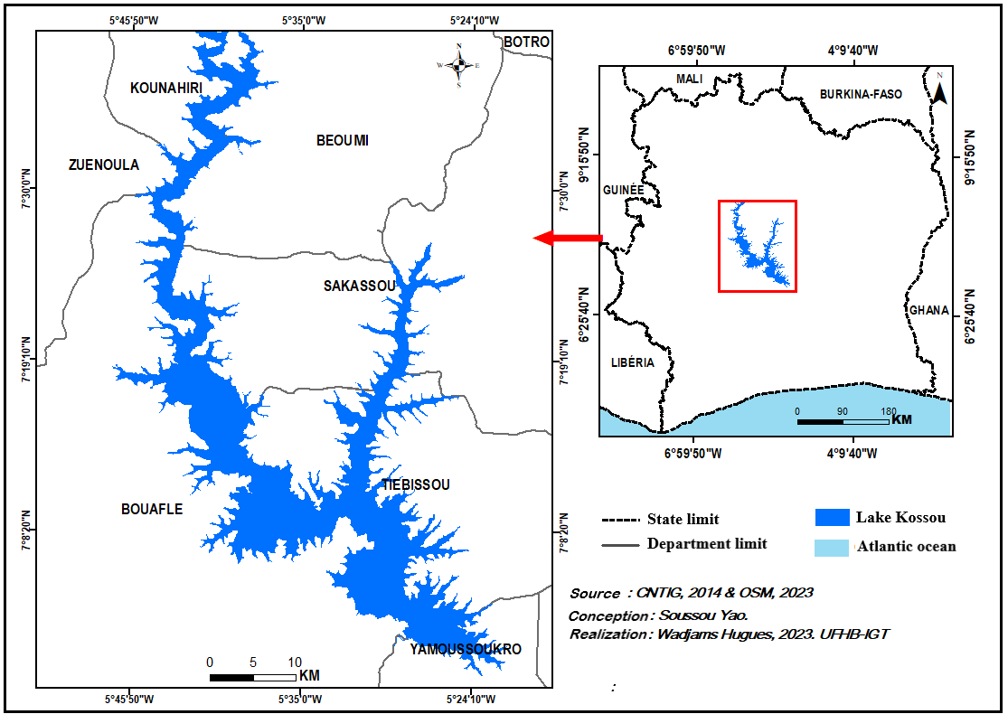
2.2 SELECTION OF SAMPLING SITES
Water samples were taken at ten sites shown in Figure (2). The GPS (Global Positioning System) coordinates of these sites were obtained using a GARMIN GPS map 76 and are listed in Table (1). These sites were chosen based on their accessibility and/or proximity to possible sources of contamination, such as landing stages, fishermen's dwellings, and a few gold panning areas.
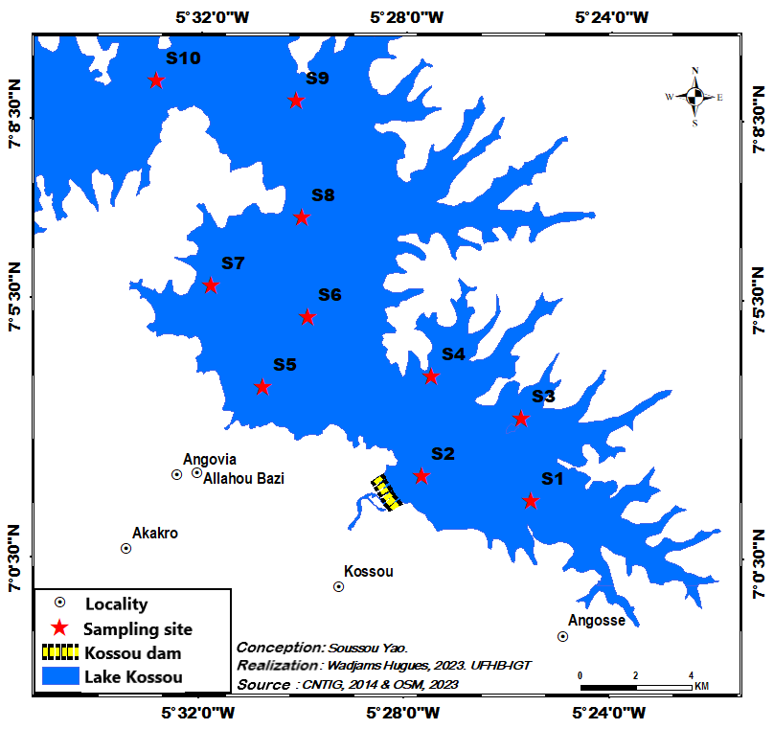
Figure 2 : Sampling sites on lake Kossou
Sites | Latitude | Longitude
S1 | 7° 01' 27,02" N | 5° 24' 33,78" W
S2 | 7° 01' 21,64" N | 5° 26' 38,24" W
S3 | 7° 02' 54,41" N | 5° 25' 25,21" W
S4 | 7° 03' 17,71" N | 5° 26' 40,03" W
S5 | 7° 01' 48,46" N | 5° 27' 59,00" W
S6 | 7° 03' 02,74" N | 5° 29' 02,23" W
S7 | 7° 04' 27,32" N | 5° 27' 31,38" W
S8 | 7° 04' 46,93" N | 5° 29' 11,08" W
S9 | 7° 03' 31,70" N | 5° 31' 04,50" W
S10 | 7° 05' 03,77" N | 5° 32' 03,10" W
Table 1 : GPS coordinates of sampling sites

2.3 WATER SAMPLE COLLECTION AND STORAGE
Water samples were collected between May 2017 and February 2018 during three campaigns. The first was carried out during the heavy rainy season, the second during the flood season (October to November), and the third during the dry season.
Samples were taken approximately 50 cm below the water surface using a Niskin bottle. The collected water was then poured into 250 mL plastic bottles. These bottles were first decontaminated with nitric acid, washed and rinsed in the laboratory with distilled water, then rinsed again in the field with the water to be analyzed, so that it retained the same characteristics as the lake water. Each bottle is labeled with a number corresponding to the sampling site. The bottles were filled completely and sealed tightly to prevent any gas leakage. They were then stored in a cooler containing ice to keep them in the dark and at a temperature of around 4°C until they reached the analysis laboratory. A total of 30 water samples were collected. The various sampling points were reached using a motorized canoe.
2.4 MEASUREMENT OF PHYSICAL AND CHEMICAL PARAMETERS
During sampling, the HANNA HI 9828 multi-parameter meter was used to measure physical parameters such as temperature, pH, and dissolved oxygen (O₂) in situ. In the laboratory, nutrients such as ammonium (NH₄⁺), orthophosphate (PO₄³⁻) and total phosphorus (TP) were measured using a KONTRON UV visible UVIKON 810 spectrophotometer, using the spectrophotometry method in accordance with French standards AFNOR NF T 90-015 for ammonium, AFNOR NF T 90-023 for orthophosphate, and AFNOR NF T 90-023 for total phosphorus.
2.5 PHYSICAL AND CHEMICAL QUALITY OF WATER IN RELATION TO BIOLOGY
The biological potential of lake Kossou was assessed using the Water Quality Assessment System for Watercourses (SEQ-Eau). The biological function of the Water Quality Assessment System for Watercourses covers a large number of physical and chemical parameters, including pH, dissolved oxygen, ammonium, orthophosphate, and total phosphorus. These parameters are used to assess the water's ability to promote the conditions necessary for the survival of various aquatic organisms (biological balance, biodiversity, etc.). The definition of quality classes makes it possible to identify the most degrading parameter(s) (Souchu et Aminot, 2001). Five classes of biological suitability are defined. These range from “very good” to “poor” and are listed in Table (2).
Table 2 : Threshold values and quality classes for pH, dissolved oxygen, and nutrients (NH₄⁺, PO₄³⁻, TP) in relation to the “biological potential” function (MEDD et Water Agencies, 2003).
 | Très bon | Bon | Moyen | Médiocre | Mauvais
pH minimum | 6,5 | 6 | 5,5 | 4,5
pH maximum | 8,2 | 9 | 9,5 | 10
O₂ (mg/L) | 8 | 6 | 4 | 3
NH₄⁺ (mg/L) | 0,1 | 0,5 | 2 | 5
PO₄³⁻ (mg/L) | 0,1 | 0,5 | 1 | 2
TP (mg/L) | 0,05 | 0,2 | 0,5 | 1

2.6 STATISTICAL ANALYSIS OF DATA
To compare the values of the physicochemical parameters of the water between the different seasons, Kruskal-Wallis and Mann-Whitney tests were performed. For these tests, statistical differences with a P value < 0.05 are considered significant. These statistical tests were performed using STATISTICA 7.1 software. This software was also used to perform Pearson correlation tests between the variables studied and to construct box plots.
3. RESULTS AND DISCUSSION
3.1 RESULTS
3.1.1 SEASONAL VARIATION IN THE PHYSICAL AND CHEMICAL PARAMETERS OF THE WATER
The results of the analysis of physicochemical data (temperature, pH, dissolved oxygen, ammonium, orthophosphate, and total phosphorus) obtained during the three seasons (rainy season, flood season, dry season) are presented in Figure (3). The results of the Kruskal-Wallis tests are also shown. The maximum values for temperature (29.90°C), dissolved oxygen (7.23 mg/L), ammonium (0.56 mg/L), orthophosphate (0.64 mg/L), and total phosphorus (8.00 mg/L) were obtained during the dry season, while the maximum pH value was observed during the flood season (7.21). The minimum values are observed during the flood period for temperature (28.02°C), ammonium (0.04 mg/L), orthophosphate (0.05 mg/L) and total phosphorus (0.08 mg/L). In contrast, the minimum values for dissolved oxygen (4.23 mg/L) and pH (5.75) are obtained during the dry season. The median values for temperature, pH, dissolved oxygen, ammonium, orthophosphate, and total phosphorus during the study period were 29.16 °C, 6.28, 6.24 mg/L, 0.17 mg/L, 0.13 mg/L, and 2.75 mg/L, respectively. The Kruskal-Wallis test shows that, with the exception of dissolved oxygen, there are statistically significant differences (P < 0.05) in the seasonal variation of temperature, pH, orthophosphate ions, ammonium ions, and total phosphorus. The Mann-Whitney test shows significant differences between seasons (P < 0.05) in terms of temperature and ammonium. This test also shows that the variations recorded in pH and total phosphorus are highly significant (P < 0.001) between the flood period and the dry season, as well as between the rainy season and the dry season. However, for pH, no statistically significant difference between the rainy season and the dry season is observed (P > 0.05). As for orthophosphate ions, the Mann Whitney test reveals significant differences between the rainy season and the flood period or the dry season, and homogeneous values between the flood and the dry season.
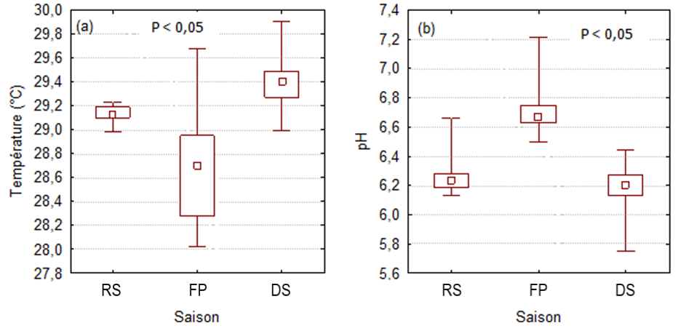
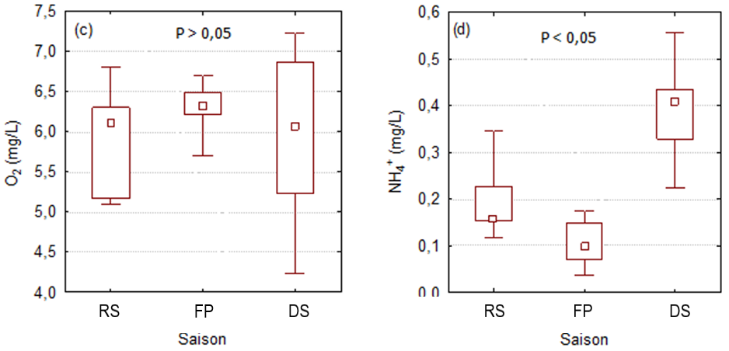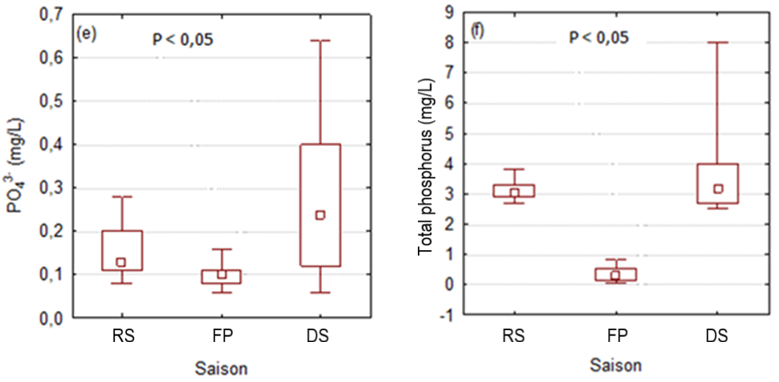
Figure 3 : Seasonal variations in physicochemical parameters (a : Temperature ; b : pH ; c : Dissolved oxygen (O₂) ; d : Ammonium (NH₄⁺) ; e : Orthophosphate (PO₄³⁻⁾ ; f : Total phosphorus).
RS : Rainy Season, FP : Flood Period, DS : Dry Season
3.1.2 CORRELATIONS BETWEEN PHYSICAL AND CHEMICAL PARAMETERS
Table (3) provides information on the correlation matrix between the variables taken into account during the study period. This matrix indicates a very significant positive correlation between total phosphorus (TP) and ammonium (r = 0.72) and a strong negative correlation between total phosphorus and pH (r = -0.83). In addition, there are also moderate negative correlations between pH and temperature (r = -0.59) and between pH and ammonium (r = -0.67). Dissolved oxygen and orthophosphate ions are not significantly correlated with any of the other parameters.
Table 3 : Pearson correlation matrix of the physicochemical parameters studied.
 | Température | pH | O₂ | NH₄⁺ | PO₄³⁻ | PT
Température | 1,00
pH | -0,59 | 1,00
O₂ | -0,22 | 0,17 | 1,00
NH₄⁺ | 0,41 | -0,67 | -0,01 | 1,00
PO₄³⁻ | 0,38 | -0,39 | -0,27 | 0,49 | 1,00
TP | 0,46 | -0,83 | -0,16 | 0,72 | 0,38 | 1,00
In bold, significant values at the α = 0.05 threshold
3.1.3 WATER SUITABILITY FOR BIOLOGICAL POTENTIAL
The grids of the Water Quality Assessment System for Watercourses (SEQ-Eau) were used to assess the suitability of the surface water of lake Kossou for biological balance. Table (4) below presents the results of this assessment during the study period.
Analysis of the table shows that the suitability of lake Kossou's surface waters for biology is good for dissolved oxygen (concentration between 6 and 8 mg/L), ammonium (concentration between 0.1 and 0.5 mg/L), and orthophosphate (concentration between 0.1 and 0.5 mg/L). In terms of pH, the suitability of the water for biological potential varies from average (minimum value between 5.5 and 6.0) to good (maximum value between 8.2 and 9.0). As for total phosphorus, this water has poor suitability (concentration > 1 mg/L) for biology.

Table 4 : Values for pH, dissolved oxygen, ammonium, orthophosphate, and total phosphorus, used for the “biological potential” function of water.
 | Très bon | Bon | Moyen | Médiocre | Mauvais
pH minimum | 6,5 | 6 | 5,75 5,5 | 4,5
pH maximum | 8,2 | 7,21 9 | 9,5 | 10
O₂ (mg/L) | 8 | 6,24 6 | 4 | 3
NH₄⁺ (mg/L) | 0,1 | 0,17 0,5 | 2 | 5
PO₄³⁻ (mg/L) | 0,1 | 0,13 0,5 | 1 | 2
TP (mg/L) | 0,05 | 0,2 | 0,5 | 1 | 2,75

3.2 DISCUSSION
The pH values of the lake water range from 5.75 to 7.21, with a median of 6.28. These data show that the lake water is slightly acidic. The acidity of the lake could be due to the leaching of granite rocks, rich in silica (SiO₂) (an acidic oxide), and the ferruginous tropical soils that dominate the Kossou lake region. Indeed, pH depends on the origin of the water, the geological nature of the substrate, and the watershed crossed (Bermond et Vuichard, 1973). Similarly, Korfali et Davies (2003) indicated that the presence in continental waters of humic acids from soil leaching is the primary cause of the acidity of these waters. The results obtained are comparable to those of Adou et al. (2018), who found pH values ranging from 5.0 to 7.9 in the waters of the Ayamé 2 dam lake. Gbocho et al. (2015) also found pH values between 6.7 and 7 in the waters of lake Taabo-village, similar to those in the present study. Comparative analysis of physicochemical parameters indicates significant seasonal variations. pH values are high during flood periods, with a median of 6.68, and low during dry seasons, with a median value of 6.21. These differences in seasonal pH variations are thought to be linked primarily to physicochemical processes, but also to biological processes. According to Ekou et al. (2011), the decomposition of aquatic plants by microorganisms leads to an increase in oxygen consumption by these microorganisms, causing a drop in pH as the environment becomes reductive. On the other hand, an increase in dissolved oxygen, resulting from the absence of aquatic plant decomposition, causes an increase in pH. The pH is a limiting factor in aquatic ecosystems, as it becomes toxic to living organisms if its value is below 4.5 or above 10. (Hounkpè et al., 2017). According to the Water Quality Assessment System for Watercourses (SEQ-Eau), the pH values obtained during this study (5.75 to 7.21) indicate that the water is suitable for aquatic life.
The temperatures recorded during the study fall within the range tolerated by warm-water aquatic species (25°C to 30°C) (Dimon et al., 2014). The lake's water temperature is therefore favorable to the life of various species. The median and even extreme values of surface water temperature promote metabolic exchanges and allow for good growth of living organisms. However, high temperatures promote the proliferation of microorganisms, which decompose organic matter by consuming the oxygen dissolved in the water. This situation causes a drop in the pH of the water, resulting in the negative correlation (r = -0.59) observed between pH and temperature. The temperatures measured are consistent with those obtained by Gbocho et al. (2015) in lake Taabo Dam and by Adou et al. (2018) in lake Ayamé 2. These authors found temperature values ranging from 25°C to 33°C. The highest median temperature value in lake Kossou (29.40°C) is obtained during the dry season. This value is consistent with that of Adou et al. (2018), who obtained an average temperature of 29.70°C in lake Ayamé 2 during the same season. The factors that influence surface water temperature variations in tropical areas are largely related to climatic conditions (degree of insolation, wind, precipitation, vegetation cover, latitude) (Makhoukh et al., 2011). Indeed, in these latitudes, the air temperature linked to solar radiation is at its maximum during the dry season. The high temperature of the lake's waters could be explained by strong sunlight and the absence of vegetation cover over this body of water.
The surface waters of lake Kossou are generally well oxygenated, with dissolved oxygen concentrations ranging from 4.23 mg/L to 7.23 mg/L, with a median of 6.24 mg/L. These values reflect the water's ability to support good biological development within the lake. According to Monkolo et al. (1993), a dissolved oxygen content above 5 mg/L is generally considered beneficial for the aquatic ecosystem. This does not vary significantly from one season to another (P > 0.05). However, its highest median value (6.33 mg/L) was obtained during the flood period corresponding to the lowest temperature, while its lowest value (6.11 mg/L) was recorded during the dry season when the temperature is highest. This situation could be due to the increase in water temperature during the dry season, because according to Hebert et Légaré (2000), warm water contains less dissolved oxygen than cold water. This reason could also explain why dissolved oxygen levels are higher during flood periods than during the rainy season. The seasonal variations in dissolved oxygen in this study are in accordance with those reported by Makhoukh et al. (2011) in the surface waters of the Oued Moulouya in Morocco. The dissolved oxygen levels in lake Kossou (4.23 to 7.23 mg/L) are higher than those recorded by Adou et al. (2018) in lake Ayamé 2, with values ranging from 0.5 mg/L to 3.6 mg/L. According to Villeneuve et al. (2006), variations in dissolved oxygen levels are influenced by a number of factors, including wind, water depth, water flow velocity, and the presence of reducing deposits. Thus, this difference in dissolved oxygen levels could be explained by the higher hydraulicity of lake Kossou compared to lake Ayamé 2, whose waters are slowly renewed due to its location between two hydroelectric dams (Ayamé 1 and Ayamé 2).
The same applies to ammonium and orthophosphate, whose concentrations in lake Kossou are generally lower than those obtained in lake Ayamé 2 by Adou et al. (2018). These authors obtained ammonium and orthophosphate concentrations ranging from 0.017 to 1.090 mg/L and 0.100 to 0.460 mg/L, respectively. In addition, the Water Quality Assessment System for Watercourses (SEQ-Eau) used in this study reveals that the waters of lake Kossou have good biological potential in terms of ammonium and orthophosphate. These parameters therefore allow for good growth of aquatic biota. However, this system indicates that the water in lake Kossou is unsuitable for biology in terms of total phosphorus, with a median content of 2.75 mg/L. The concentrations of this parameter reflect the water's inability to support biological balance within the lake environment, i.e., the water's inability to promote the good living conditions necessary for various aquatic organisms. This situation could be explained mainly by the leaching of agricultural land containing phosphate fertilizers, pastoral activities along the shores, and domestic waste and wastewater from residents discharged directly into the lake. In addition, the spreading of nutrients linked to the repetitive fish farming activities of the lake's fish farm is another potential source of total phosphorus in the fish farm. The combined effects of these different sources could be responsible for the appearance of invasive aquatic plants in certain areas of the lake. The results obtained corroborate the observations made by Diarra (2020), which state that lake Kossou is prone to invasion by aquatic plants. In waterways, excess phosphorus leads to accelerated growth of algae, phytoplankton, and aquatic plants and contributes to the eutrophication of the water body (Curry et Labelle, 2010). Halle et Bruzon (2006) indicated, on the one hand, that the invasion of water bodies by water hyacinth has spread from coastal areas to the continental waters of the Bandama, Comoé, and Sassandra rivers, and on the other hand, that water lettuce (Pistia stratiotes) occupies all surface waters in Ivory Coast. This eutrophication phenomenon could lead to a decrease in oxygenation of this aquatic environment and cause a decline in the lake's fish productivity. Dimon et al. (2014) found total phosphorus concentrations in lake Ahémé in Benin that were similar to the results of this study.
Furthermore, nutrient concentrations (ammonium, orthophosphate, and total phosphorus) are higher during the dry season than during the rainy and flood seasons. The positive correlations between temperature and each of these variables reflect this relationship. This situation could be explained by the phenomenon of dilution and evaporation of lake water. Agricultural fertilizers, which are generally spread during the rainy season, are carried away by precipitation and then drained by runoff into the lake. Their concentrations therefore decrease when the water level rises (dilution phenomenon) and increase during periods characterized by a significant drop in the water level. Consequently, the dry season corresponds to the period of high availability of nutrients in the lake. This observation corroborates the work of Dabbadié (1996), who notes that an increase in the concentration of nutrients in water leads to rapid phytoplankton proliferation during the dry season.
The significant negative correlations between pH and ammonium (r = -0.67) and between pH and total phosphorus (r = -0.83) indicate that a decrease in pH leads to an increase in nutrient salts. The decomposition of organic matter by microorganisms could be the cause. There is also a very significant positive correlation between ammonium and total phosphorus (r = 0.72). This correlation demonstrates the affinity between these two elements and reveals that they originate from identical anthropogenic activities, namely agricultural activities. Consequently, the low ammonium content could be explained by its oxidation into nitrites and then nitrates by microorganisms.
4. CONCLUSION
The temperature of the lake water is influenced by sunlight and allows for good growth of living organisms in the lake, as it is within the range tolerated by warm-water aquatic species (25°C to 33°C). According to the Water Quality Assessment System for Watercourses (SEQ-Eau), the lake water has good biological potential in terms of pH, dissolved oxygen, ammonium, and orthophosphate. In other words, the concentrations of these parameters are conducive to the healthy growth of aquatic species in the lake. However, the poor suitability of the water for total phosphorus does not promote optimal biological development within the lake. In this regard, total phosphorus appears to be the most degrading parameter. In addition, significant seasonal variations are observed in most of the physicochemical parameters studied. Thus, nutrient concentrations (ammonium, orthophosphate, and total phosphorus) are higher in the dry season than during the flood and rainy seasons. For this reason, the appearance of floating aquatic plants is more noticeable during the dry season, which is characterized by a decrease in dissolved oxygen concentration.

COMPETING INTERESTS DISCLAIMER:
Authors have declared that they have no known competing financial interests OR non-financial interests OR personal relationships that could have appeared to influence the work reported in this paper.

REFERENCES
[1] Tah, L., Da Costa, K. S., Kouassi, J. N., & Moreau, J. (2009). Fishing effort and fish production at Lake Ayamé I (Bia Basin; Côte d’Ivoire) after the departure of the “Bozo” fishermen. African Agronomy, 21(1), 103–115.

[2] Dedjiho, C. A., Mama, D., Tometin, L., Nougbode, I., Chouti, W., Sohounhloue, D. C. K., et al. (2013). Evaluation of the physicochemical quality of certain wastewater tributaries of Lake Ayamé in Benin. Journal of Applied Biosciences, 70, 5608–5616. https://doi.org/10.4314/jab.v70i1.98763

[3] MEDD (Ministry of the Environment and Sustainable Development) (2010). Survey on pesticide use in cotton farming in the Korhogo region (Côte d'Ivoire), 64 p.

[4] Ducroquet, H., Tillie, P., Louhichi, K., & Gomez-Y-Paloma, S. (2017). Agriculture in Côte d'Ivoire under scrutiny: Overview of plant and animal production sectors and review of agricultural policies. European Commission, Joint Research Centre, EUR 28754 FR, 242 p. https://doi.org/10.2760/126254

[5] Halle, B., & Bruzon, V. (2006). Environmental Profile of Côte d'Ivoire; Final Report. European Commission, Lot 6: Environment, Contract Letter No. 2006/119741/1, 128 p.

[6] Benzha (2017). Hydrogeochemistry of an aquatic ecosystem: the case of reservoir lakes: Imfout, Daourat, and Sidi Said Maachou on the Oum Rbia River, impact of sediment on eutrophication. Doctoral thesis, Hassan II University Casablanca Ain Chock, 234 p.

[7] Diarra A. (2020). Kossou: A declining fisheries production hub. Côte d’Ivoire. Espace, Territoires, Sociétés et Santé Review, 3 (5), 79-91. https://www.retssa-ci.com/index.php?page=detail&k=85

[8] FAO (2008). Fisheries and aquaculture profiles by country; Overview of the national fisheries sector in Côte d’Ivoire, 42 p.

[9] Souchu, P., & Aminot, A. (2001). Towards an operational definition of the term “eutrophication.” In Eutrophication of marine and brackish waters in Europe, particularly in France. Ifremer Report DEL/EC/01.02-January 2001, 59 p. http://archimer.ifremer.fr/doc/2001/rapport-22.pdf

[10] MEDD, & Water Agencies (2003). Water Quality Assessment System for Watercourses. Seq-eau Assessment Grids (Version 2). Ministry of the Environment and Sustainable Development; Water Agencies: 40 p. https://vertexaisearch.cloud.google.com/grounding-api-redirect/AUZIYQEIhHe_guZU5UqfYIw67k9lcGBTwZEw9cq3INDagVC88ejDtKddPfMtJW43dXklhI2cmUEuukC_Ubx4wFiVChuAXh7SnKndoGvmmY2cF-5UriSQsdplwZHjsfdH6syhZ-8x1ZOWML6D3gNrduLseAPM3JY91dZthte4GHT2nj51t2tI1WgnmWj8H_s2srR_RwP8R15gxvOkkFRqE7b5dc7sK-w==

[11] Bermond, R., & Vuichaard, R. (1973). Water Quality Parameters. Documentation Française, Paris, 179 p.

[12] Korfali, S., & Davies, B. (2003). A comparison of metals in sediment and water in the River Nahr-Ibrahim. In Bacteriological study of surface waters of the Nahr Ibrahim River, Lebanon, Journal of Water Science, 20 (4), 341-352. https://doi.org/10.1023/a:1021284126632

[13] Adou, Y. E., Blahoua, K. G., Gogbé, Z. M., & N’Douba, V. (2018). Physico-chemical characterization of the waters of a lake located between two hydroelectric dams: Lake Ayamé 2 (Côte d’Ivoire). European Journal of Scientific Research, 149, 451-461.

[14] Gbocho, Y. F., Diakité, N. R., Akotto, O. F., & N’Goran, K. E. (2015). Population dynamics of intermediate host molluscs of Schistosoma haematobium and Schistosoma mansoni in Taabo-village (southern Côte d’Ivoire). Journal of Animal & Plant Sciences, 25(3), 3939-3953. https://elewa.org/journals/journal-of-animal-and-plant-sciences-japs-issn-2071-7024/

[15] Ekou, L., Ekou, T., N’Da, K. J., & Dje, T. (2011). Temporal variations of the physicochemical and biotic parameters of two aquatic ecosystems in the Ebrié Lagoon, Côte d’Ivoire. European Journal of Scientific Research, 58 (3), 414-422.

[16] Hounkpè, J. B., Kélomè, N. C., Adèchina, R., & Lawani, R. N. (2017). Assessment of heavy metal contamination in sediments at Lake Ahémé in southern Benin (West Africa). Journal of Materials and Environmental Sciences, 8 (12), 4369-4377. https://doi.org/10.26872/jmes.2017.8.12.460

[17] Dimon, F., Dovonou, F., Adjahossou, N., Chouti, W., Mama, D., Alassane, A., et al. (2014). Physico-chemical characterization of Lake Ahémé (Southern Benin) and highlighting of sediment pollution by lead, zinc, and arsenic. Journal of the West African Chemical Society, 37, 36-42.

[18] Makhoukh, M., Sbaa, M., Berrrahou, A., & Clooster, M. V. (2011). Contribution to the physico-chemical study of surface waters of the Moulouya River (Eastern Morocco). Larhyss.Journal, 8 (2), 149-169.

[19] Hebert, S., & Légaré, S. (2000). Monitoring the water quality of rivers and small streams. Environmental Monitoring Branch. Ministry of the Environment. Government of Quebec, 5 p. https://www.bielsp.ca/sites/default/files/pdf/H%C3%A9bert%20et%20al_2000_Suivi_qualit%C3%A9_eau_A.pdf

[20] Monkolo, J., Laraque, A., Olivry, J. C., & Briquet, J. P. (1993). Transport solution and suspension by the Congo (Zaire) River and its main tributaries of the right bank. Hydrological Sciences, 38(2,4), 133-145. https://doi.org/10.1080/02626669309492651

[21] Villeneuve, V., Legare, S., Painchaud, J., & Vincent, W. (2006). Dynamics and modeling of dissolved oxygen in rivers. Revue des Sciences de l’eau, 19(4), 259-2274. https://doi.org/10.7202/014414ar

[22] Curry, D., & Labelle, C. (2010). Sampling program for tributaries of the Memphrémagog RCM, Analyses and recommendations 2009. Quebec, 137 p.

[23] Dabbadie, L. (1996). Study of the viability of low-input rural fish farming in the Centre-West of Côte d’Ivoire: A trophic network approach. Doctoral thesis dissertation, University of Paris VI, France, 208 p. http://tel.archives-ouvertes.fr/tel-00321419

