EVALUATION OF THE INFLUENCE OF A GROWTH HORMONE ON THE GERMINATION PARAMETERS OF MAIZE (Zea mays L.)

Abstract
Maize (Zea mays L. ), an annual herbaceous plant of the Poaceae family, plays a significant role in the agricultural systems of Côte d'Ivoire, where it is a strategic crop for food, trade, and socio-cultural purposes. However, its production remains limited by climatic constraints, soil degradation, and extensive farming methods that require vast areas of land. To address these challenges, improving maize agronomic performance requires optimizing production techniques, particularly during the critical germination stage. This study was initiated to evaluate the effect of different doses of chemical treatments on the germination and initial growth of maize seedlings. The overall objective is to contribute to the sustainable production of this crop by improving yields. To this end, germination trials were conducted in the laboratory using an experimental design comprising six treatments: an untreated control (T0), distilled water (T1), three concentrations of SomRE (2 ppm, 0.2 ppm, and 0.02 ppm), and a 0.1 µM indoleacetic acid (IAA) solution. In each cup, 50 seeds were fully immersed in the corresponding solution before incubation under controlled conditions for seven days. The parameters monitored included the germination rate (Tg), germination velocity (Vg), germination time (Dg), and root and stem length measured on day seven. The results show that the SomRE treatments at concentrations of 2 ppm, 0.2 ppm, and 0.02 ppm significantly improved germination and seedling growth compared to the control. SomRE, a synthetic hormone derived from indole, particularly stimulated root elongation, promoting greater adaptability to abiotic stress. These results suggest that the controlled use of SomRE could be an effective approach to boosting maize productivity in at-risk agricultural areas.

INTRODUCTION
Maize ( Zea mays L. ) is an annual tropical herbaceous plant belonging to the grass family (Poaceae) and the subfamily Panicoideae (Barrière, 2000). Its center of origin and diversity is located in Central America and Mexico (Fukunaga et al., 2005), before its introduction to Europe, and then to Africa, by colonists from the 16th century onwards. Maize is widely cultivated for its starch-rich grains and is the most produced cereal in the world, ahead of wheat ( Triticum aestivum L. subsp. aestivum ). In 2013, global maize production amounted to 839 million tons, compared to 653 million tons for wheat. France ranks 7th among the world's producers, after the United States, China, Brazil, Mexico, Argentina, and India. In Côte d'Ivoire, maize plays a major role as a subsistence, commercial, and socio-cultural crop. It is found in all rural areas and is consumed in various forms: fresh ears in coastal regions, and semolina in the north, where it is a staple food. It is also used for animal feed and in modern livestock farming (Doffangui, 1997). Considered the most energy-rich cereal due to its nutritional and economic qualities, its cultivation is currently experiencing strong growth in Côte d'Ivoire. In 2007, national maize production reached 531,940 tons, making it the second most cultivated cereal after rice (606,310 tons) (DSDI/MINAGRI, 2008). However, this shifting cultivation, which is very land-intensive, thrives in an unfavorable climatic context, marked by insufficient and uneven rainfall. Persistent drought limits yields, which often plateau at 0.7–1 tonne/ha in smallholder farming areas (Hema, 1994). Striga parasitic weed infestation also poses a major constraint, potentially leading to the abandonment of certain varieties. To overcome these obstacles and improve productivity in at-risk agricultural areas, it is necessary to promote optimal use of production factors and responsible resource management at the farmer level. It is within this framework that the present study was initiated, aiming to improve maize yield through laboratory germination trials. The overall objective is to contribute to sustainable maize production by evaluating the effect of various chemical treatments on germination parameters, as well as on the root and stem length of seedlings.
MATERIALS AND METHODS
MATERIAL
BIOLOGICAL MATERIAL
The biological material used consisted of mature maize (Zea mays L.) seeds, all from the same "run-of-the-mill" variety (Figure 1). These seeds were subjected to chemical treatments of varying concentrations to evaluate their evolution according to the treatment applied.
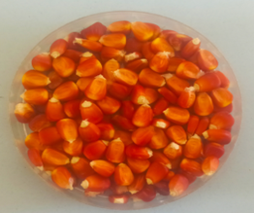
Figure 1 : Mature maize (Zea mays L) seeds
TECHNICAL EQUIPMENT
The technical equipment used for this study included several essential elements. Plastic Petri dishes were used for sowing maize (Zea mays L.) seeds. The dishes were sterilized with bleach to prevent contamination. Blotting paper was used as a culture medium to maintain moisture and ensure proper seed development. A magnetic stirrer with a magnetic bar was used to homogenize the SomRE solutions for 15 minutes before use. The treatment solutions included indoleacetic acid (IAA), various concentrations of SomRE, and distilled water, which were used to treat the maize seeds before incubation.
METHOD S
Seed treatment
A total of 300 maize (Zea mays L.) seeds were used, divided into six batches of 50 seeds each. Each batch was soaked for 24 hours in 100 mL of solution, contained in disposable cups. The untreated batch served as a control (T0). The treatments applied were as follows:
- T0: untreated control lot
- T1: Distilled water solution
- T2: Sommere solution at 2 ppm
- T3: Sommere solution at 0.2 ppm
- T4: Sommere solution at 0.02 ppm
- T5: 0.1 µM indoleacetic acid (IAA) solution
In each cup, the 50 seeds were completely immersed in the specific solution corresponding to their treatment. This protocol allowed us to evaluate the effect of different concentrations of SomRE and IAA on germination and initial seedling growth .
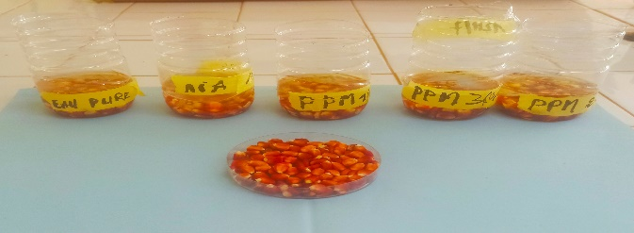
Figure 02 : Seeds soaked in different treatment solutions for 24 hours
Preparing the petri dishes
The Petri dishes used for the germination test were sterilized by soaking them in soapy water containing bleach for 24 hours. A layer of blotting paper was placed at the bottom of each Petri dish (Figure 3). The blotting paper was then soaked with 4 ml of sterile distilled water before the seeds were added (Kameswara et al., 2006 ).
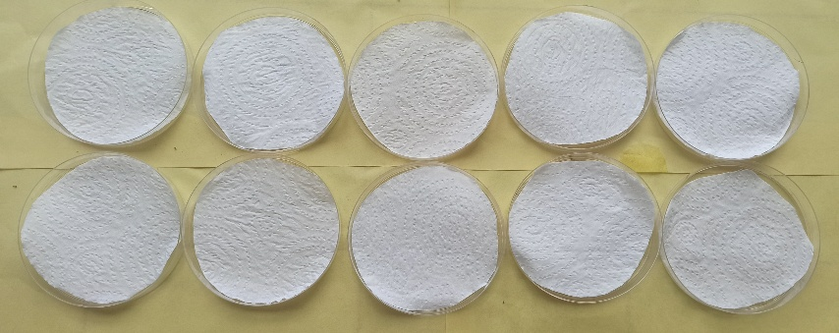
Figure 03: Arrangement of blotting paper in the bottom of the petri dishes
EXPERIMENTAL DEVICE
The maize seeds underwent six treatments, including a control (T0) that was not soaked before sowing. Each treatment was replicated 10 times. First, for each trial, we prepared 10 Petri dishes labeled with the treatment name and the trial date. Next, we placed 5 seeds per dish on a piece of blotting paper. These seeds were spread evenly so that they did not touch (Figure 4). Finally, these dishes were placed in a transparent container in the laboratory (Kameswara Rao et al., 2006 ).
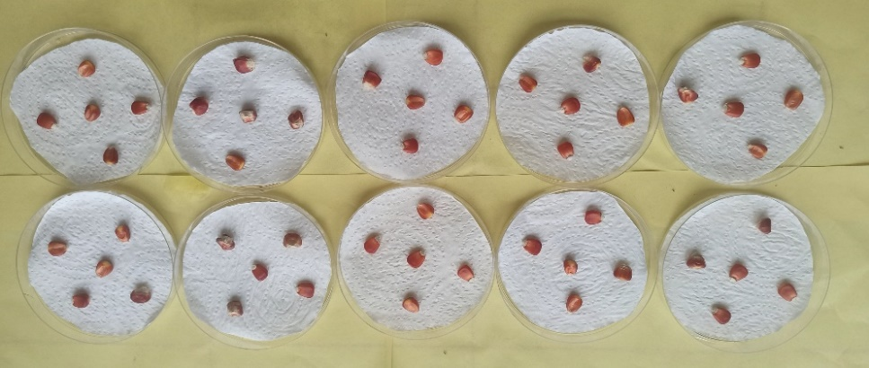
Figure 04: Arrangement of seeds inside the petri dishes
TRIAL MONITORING AND DATA COLLECTION
Trial follow-up
Incubation and monitoring of germination
After sowing, the Petri dishes were incubated under controlled temperature and photoperiod conditions. To maintain substrate moisture, a 4 mL volume of the solution used for seed soaking was taken and applied to each batch every two days, including the control (T0), which was watered with distilled water. The germination trial lasted 7 days. The seeds were examined daily to monitor germination and substrate condition. In accordance with Baskin & Baskin (1998), a seed is considered germinated when its radicle reaches at least 2 mm in length. However, given the small size of the seeds used in this study, a seed was counted as germinated as soon as the radicle appeared.
Data collection
Data collection was carried out daily by visual observation. For each day of the trial, the date and number of germinated seeds were carefully recorded. To evaluate growth parameters, three seedlings per box, for a total of 30 seedlings per treatment, were taken on the seventh day of the trial. Stem height and root length were individually measured using a ruler graduated in centimeters. The collected data allowed the following parameters to be determined:
- Germination rate (Tg): proportion of seeds that have germinated out of the total sown.
- Germination rate (Vg): the speed at which seeds germinate.
- Germination time (Dg): time required for seeds to begin to germinate.
- Root and stem length: direct indicators of initial seedling growth.
These parameters were used to evaluate the effect of different chemical treatments on the germination and growth of maize seedlings (Zea mays L.).
Germination rate (Tg)
The germination rate according to COME (1970) corresponds to the maximum percentage of germinated seeds relative to the total number of seeds sown. The mathematical expression for calculating the germination rate is written as follows: $Tg=\frac{ni}{N}×$100
In this expression, Tg denotes the germination rate of treatment (i), ni is the number of seeds germinated at date (i) and N the total number of seeds subjected to treatment (i).
Germination Rate (Vg)
The germination rate (Vg) is the number of seeds that have germinated per third of the day allowed for germination; in other words, it is one-third of the germination rate. Its mathematical formula is: Vg$=\frac{1}{3}×Tg$ with Vg = germination rate and Tg = germination rate
Germination time (Dg)
The germination period, or latency period, is the time between sowing and the first germination. The germination period for each batch of seeds was determined according to this formula:
Dg = start date of germination - sowing date
DATA ANALYSIS
The data collected was processed using STATISTICA 7.1 software. An ANOVA was used to highlight the effect of the treatments studied. In the event of a significant treatment effect, the Newman-Keuhls test for comparison of means was used to distinguish between the different homogeneous groups of treatments compared.
RESULTS
INFLUENCE OF TREATMENTS ON GERMINATION PARAMETERS
Germination rate
The germination rate of maize seeds exhibits two classic phases (Figure 5). An exponential acceleration is followed by a plateau corresponding to a cessation of germination after reaching maximum germination capacity. The same trend in germination rate evolution was observed in almost all treatments. Germination began as early as day 0 after sowing and reached its maximum on day 3 in treatments T1, T2, T3, T4, and T5, with the exception of the control, which began on day 1 and also reached its maximum on day 3.

Untreated seed (T0) A distilled water solution (T1); A somRE solution with a concentration of 2 ppm (T2); A somRE solution with a concentration of 0.2 ppm (T3); A somRE solution with a concentration of 0.02 ppm (T4) and A 0.1 µM IAA solution (T5).
Figure 5 : Germination evaluation according to treatments
Germination time at 50%
The germination curves show a difference in the rate of emergence between the treatments. From day 1 (J1), treatments T1, T2, T3, and T5 show germination rates between 70% and 80%, indicating rapid germination. The control (T0) only reaches 50% at the same time, revealing a slower start. Treatment T4 shows no germination on J1 but catches up with the other treatments on J2, reaching a similar rate (80%). From J3 to J7, all treatments, including the control, reach a germination rate close to or equal to 100%.

Untreated seed (T0) A distilled water solution (T1); A somRE solution with a concentration of 2 ppm (T2); A somRE solution with a concentration of 0.2 ppm (T3); A somRE solution with a concentration of 0.02 ppm (T4) and A 0.1 µM IAA solution (T5).
Figure 6 : Waiting time for germination rate to reach 50% depending on the treatment
GERMINATION RATE
Germination rate as a function of the day of cultivation
The results show a progression in the germination rate over time. On day 1, the germination rate is around 60%. From day 3 onwards, a clear increase is observed, with a rate close to 95%. Between days 4 and 7, the values remain stable and close to 100%, indicating that germination is complete from day 3 onwards and that no significant variation is recorded thereafter .

Untreated seed (T0) A distilled water solution (T1); A somRE solution with a concentration of 2 ppm (T2); A somRE solution with a concentration of 0.2 ppm (T3); A somRE solution with a concentration of 0.02 ppm (T4) and A 0.1 µM IAA solution (T5).
Figure 7 : Germination rate as a function of the day of cultivation
Germination rates depending on treatments
The values presented show a variation in germination rate depending on the treatments applied. The control (T0) shows the lowest rate, close to 80%. All other treatments (T1 to T5) show rates above 85%, with values ranging from 90% to 100%. Treatment T5 recorded the best germination rate, followed by T2 and T3. Overall, the treatments improve germination compared to the control, with the most pronounced performance for T5.

Untreated seed (T0) A distilled water solution (T1); A somRE solution with a concentration of 2 ppm (T2); A somRE solution with a concentration of 0.2 ppm (T3); A somRE solution with a concentration of 0.02 ppm (T4) and A 0.1 µM IAA solution (T5).
Figure 8 : Germination rates according to treatments
INFLUENCE OF TREATMENTS ON GROWTH PARAMETERS
Seedling stem height
The results show a variation in average stem length depending on the treatment. Untreated seed (T0) exhibited the least growth, with an average length of 5.30 ± 1.40 cm. The application of distilled water (T1) resulted in a significant increase, reaching 10.85 ± 3.32 cm. Treatments with somRE at different concentrations (T2, T3, and T4) showed varying effects. Concentrations of 2 ppm (T2) and 0.2 ppm (T3) resulted in similar lengths (10.84 ± 2.78 cm and 10.92 ± 3.03 cm, respectively), indicating strong growth promotion. In contrast, the concentration of 0.02 ppm (T4) led to decreased growth (7.62 ± 2.48 cm). Treatment with AIA (T5) gives an average length of 7.37 ± 2.92 cm, greater than the control but less than high concentrations of somRE.
TREATMENTS | Length (cm)
Untreated seed (T0) | 5.30±1.40
Distilled water solution (T0) | 10.85±3.32
sumRE solution of concentration 2 ppm (T1) | 10.84±2.78
sumRE solution concentration 0.2 ppm (T2) | 10.92±3.03
sumRE solution concentration 0.02 ppm (T3) | 7.62±2.48
AIA solution with a concentration of 0.1 µM (T4). | 7.37±2.92
Table 1 : Average stem length of seedlings

(Make the highlighted parts normal)
Untreated seed (T0) A distilled water solution (T1); A somRE solution with a concentration of 2 ppm (T2); A somRE solution with a concentration of 0.2 ppm (T3); A somRE solution with a concentration of 0.02 ppm (T4) and A 0.1 µM IAA solution (T5).
Figure 9 : Maize plants according to treatments from T0 to T5
SEEDLING ROOT LENGTH
Average root lengths varied depending on the treatment. The 2 ppm somRE solution (T1) exhibited the greatest root length at 15.59 ± 4.54 cm , followed by the 0.2 ppm treatment (T2) at 14.16 ± 4.33 cm . Untreated seed (T0) showed an intermediate value of 13.04 ± 4.89 cm , close to the overall average. The low-concentration somRE (T3) and 0.1 µM IAA (T4) treatments resulted in slightly shorter lengths ( 12.68 ± 5.34 cm and 11.90 ± 3.52 cm , respectively), while distilled water (initial T1) showed the least growth at 10.05 ± 3.85 cm .
Table 2 : Average root length of seedlings
TREATMENTS | ROOT LENGTH
Untreated seed (T0) | 13.04±4.89
Distilled water solution (T0 ) | 10.05±3.85
sumRE solution of concentration 2 ppm (T1) | 15.59±4.54
sumRE solution concentration 0.2 ppm (T2) | 14.16±4.33
sumRE solution concentration 0.02 ppm (T3) | 12.68±5.34
AIA solution with a concentration of 0.1 µM (T4). | 11.90±3.52
 | 13.88±5.75

Untreated seed (T0) A distilled water solution (T1); A somRE solution with a concentration of 2 ppm (T2); A somRE solution with a concentration of 0.2 ppm (T3); A somRE solution with a concentration of 0.02 ppm (T4) and A 0.1 µM IAA solution (T5).
(Make the highlighted parts normal)

Figure 10: Presentation of roots according to treatments from T0 to T5
IV-DISCUSSIONS
Germination is the series of events that begin with the absorption of water by the seed and end with the elongation of the embryonic axis and the emergence of the radicle through the structures surrounding the embryo ( Mihoub et al., 2005; Pernollet and (Ferault, 2008) (NOT SEEN IN THE REFERENCE ). In our work, the results showed that hormones induce increases in the germination rates of maize seeds as well as the growth of morphometric parameters (stem and roots). The results obtained in this study justified that IAA promotes maize seed germination at a concentration of 0.1 µM. At concentrations below or above this level, the hormone can cause a reduction in morphometric parameters. These results show that the use of hormones must respect a number of biological and chemical criteria to avoid catastrophic results. Similar observations have already been reported by Musatenko et al . (1995 ) on Acer saccharinum , Gray et al . ( 1998) on Arabidopsis thaliana , and Vissenberg et al . ( 2001) (NOT SEEN IN THE REFERENCE) on tobacco. The work of Ali et al ., Studies conducted in 2009 on olive cells also led to the same conclusions. In terms of growth, the modes of action of auxin are now fairly well understood. It acts primarily by inducing cell elongation in plant tissues ( Zhao et al ., 2002; Heller et al ., 2006 ), by binding to proton-ATPase membrane protein receptors that regulate intermembrane ion exchange. This binding causes an efflux of protons, offset by an influx of K+ cations and water molecules, resulting in acidification of the turgid plant cells. Such physiological conditions destroy acidolabile cell wall compounds and lead to softening of the cell wall, which stretches due to turgor pressure ( Heller et al ., 2006 ). This impact induces plastic (and therefore irreversible) extension: this is cell wall growth leading to cell elongation. According to various authors, it is through this type of mechanism that auxin stimulates plant growth in plants exposed to its action ( Chen, 2001; Compani and Nick, 2005 (NOT SEEN IN THE REFERENCE). In our case, even though cellular physiological studies were not conducted, it is possible (given the non-specificity of hormonal action) that auxin acts similarly to stimulate cell elongation in the maize seed, resulting in the observed increases in morphometric parameters. Regarding the somRE treatment, compiling the results above, stem height and root length for the somRE treatments were greater than those of the control, attributable to the growth-stimulating factor. Plant hormones are not nutrients, but chemicals that promote and influence the growth, development, and differentiation of cells and tissues in small quantities ( Pilet and Saugy, 1987 ). SomRE, being a synthesized indole hormone derivative, has the aforementioned effect on seedlings that it controls. According to Saini et al. (2013), the biosynthesis and transport of auxin play a crucial role in controlling root growth and development. The role of auxin in root development unequivocally establishes it as a key regulator. This auxin phytohormone is involved in the development of lateral roots ( Chhun et al., 2004 ). Somei (2008) and Somei (2014) reported faster root growth and elongation promoted by IAA at low concentrations (Somei et al., 2007 ). In this study, SomRE, an IAA derivative, stimulated root and stem length compared to other applied treatments. Studies have suggested that SomRE application may be an effective approach to improving crop growth and productivity.
CONCLUSION
The IAA treatment was less effective compared to the SomRE treatment, which proved highly effective throughout the germination trial. By maintaining the various major determinants of growth and well-being, the SomRE treatments of 2 ppm, 0.2 ppm, and 0.02 ppm significantly promoted a high germination rate and thus increased root and stem length compared to the control. As a synthesized hormone derived from indole, SomRE stimulated root length, enabling the plant to resist abiotic stress. This study therefore suggests that treating seeds with SomRE could ensure plant well-being and thus improve growth; it would therefore be important to promote this hormone to farmers to improve crop growth and yield.
References
Ali A, Ahmad T, Akhtar N. and Hafiz I: 2009. Effect of different concentrations of auxins on in vitro rooting of olive cultivar
Barrière Y, 2000. "Forage maize. Origin, evolution, genetic resources and selection methods", Forages 162: 107-119.
Baskin, CC, and JM Baskin. 1998 . Seeds : Ecology, Biogeography, and Evolution of dormancy and Germination. Pages 1-666. Academic Press. San Diego. THAT. USA
Come D., (1970) : Obstacles to germination. Ed. Masson et Cie, Paris, p. 162
Chen JG: 2001 . Dual auxin signaling pathways control cell elongation and division. J. Plant Growth Regul . 20:255–264.
Chhun, T., Taketa, S., Tsurumi, S., & Ichii, M. (2004). Different behavior of indole-3-acetic acid and indole-3-butyric acid in stimulating lateral root development in rice (Oryza sativa L.). Plant Growth Regulation, 43(2), 135–143
Doffangui K, 1997. Maize Technical Data Sheet. Agricultural Institute of Bouaké (IAB), Ivory Coast. 40 pp
DSDI/MINAGRI, 2008. Yearbook of agricultural statistics, the stat'Agri series. Ministry of Agriculture (MINAGRI), Directorate of Statistics, Documentation and Information Technology (DSDI), Ivory Coast. 107pp.
Fukunaga K, Hill J, Vigouroux Y, Matsuoka Y, Sanchez GJ., Liu K, Buckler ES, Doebley J, 2005 . Genetic Diversity and Population Structure of Teosinte. Genetics 169:2241-2254.
Gray WM, Ostin A., Sandberg G., Romano CP., and Estelle M.: 1998 . High temperature promotes auxin mediated hypocotyl elongation
Hema D. (1994). Study of drought resistance in maize (Zea mays L.). Analysis of the genetic variability of some agrophysiological traits . Doctoral thesis, National University of Côte d'Ivoire, 151 p.
Heller R, Esnault R. and Lance C: 2006. Plant Physiology. Development. 6th ^{edition} of the Abridged Textbook, Dunod Publishers, Paris, 294 p.
Kameswara RN, Hanson J, Ehsan DM., Kakoli G, Nowell D. and Larinde M: 2006 . Manual of seed handling in gene banks No 8. 166p.
Mihoub A, Chaoui A, El Ferjani E. 2005. Biochemical changes induced by cadmium and copper during the germination of pea seeds ( Pisum sativum L.). Comptes Rendus Biologies
Musatenko LI, Berestetsky VA, Vedenicheva NP, Generalova VN, Martyn GI. and Sytnik KM : 1995. Phytohormones and structure of cells of Acer saccharinum seed embryo.
Biologia Plantarum 37 (4): 553-559.
Pilet, PE, & Saugy, M. (1987). Effect on root growth of endogenous and applied IAA and ABA: A critical reexamination. Plant Physiology, 83(1), 33–38
Saini, S., Sharma, I., Kaur, N., & Pati, P. K. (2013). Auxin: A master regulator in plant root development. Plant Cell Reports, 32(6), 741–757
Somei, M., Sayama, S., Naka, K., Shinmoto, K., & Yamada, F. (2007). Creation of new promoters for plant's root growth: Its application for the syntheses of vulcanine and borrellin, and for combating desertification at Gobi Desert in Inner Mongolia. Heterocycles, 73, 537–554
Somei, M. (2008). Imagination and creation: 1-Hydroxyindole chemistry and the dream challenge. Journal of the Pharmaceutical Society
Somei, M. (2014). ''SOMRE'', a growth regulator 'medicine' for the earth to increase food production and to stop global warming. Japan Sea Research, 45, 105–120.
Zhao H, Hertel R, Ishikawa H. and Evans ML: 2002. Species in ligand specificity of auxin-controlled elongation and auxin transport: comparing Zea and Vigna. Planta 216:293–301.

