Integration of pre-emergence herbicide and mechanical weeding for efficient weed management in jute (Corchorus olitorius L.)

Abstract
A field experiment was conducted for two consecutive years during the jute season (April to July) of 2022 and 2023 at the research farm of ICAR-Central Research Institute for Jute and Allied Fibres Nilganj, Barrackpore, West Bengal, India with 10 treatment combinations namely, T₁: Manual weeding (nirani) two time (at 7 DAS and at 21 DAS), T₂: Nail weeder two times (at 7 DAS and at 21 DAS), T₃: Single wheel jute weeder two times (at 10 DAS and at 21 DAS), T₄: Nail weeder (at 7 DAS) + single wheel jute weeder (at 21 DAS), T₅: Ipfencarbazone @ 90 g ha⁻¹, T₆: Ipfencarbazone @ 120 g ha⁻¹, T₇: Ipfencarbazone @ 90 g ha⁻¹ + nail weeder at 21 DAS, T₈: Ipfencarbazone @ 120 g ha⁻¹ + nail weeder at 21 DAS, T₉: Ipfencarbazone @ 90 g ha⁻¹ + single wheel jute weeder at 21 DAS, and T₁₀: Ipfencarbazone @ 120 g ha⁻¹ + single wheel jute weeder at 21 DAS. Besides uneconomical two manual weeding producing the highest fibre yield in jute (38.46 q ha⁻¹), application of ipfencarbazone @ 90 g ha⁻¹ (PE) + nail weeder at 21 DAS produced higher fibre yield (36.25 q ha⁻¹) closely followed by and at par with the fibre yield recorded with ipfencarbazone @ 90 g ha⁻¹ (PE) + single wheel jute weeder at 21 DAS (36.13 q ha⁻¹) and the NRPRI were higher, 2.17 and 2.16, respectively. Deployment of nail weeder as a mechanical method of weed management in jute gave additional benefit of higher soil moisture content by about 18.64 to 21% at 5 cm depth, and by about 3.76 to 5.20% at 10 cm depth at 3 DAA. Moreover, at 7 DAA also, the soil moisture contents were higher at 5 cm (34,34 to 37.92%) and at 10 cm (10.01 to 15.95%). The soil enzyme activities such as FDHA, dehydrogenase, β-glucosidase was initially reduced by the application of ipfencarbazone 90 g ha⁻¹, but the same was increased to its initial levels at 120 DAS (at harvest of jute).

Key words: Jute (Corchorus olitorius), weed management, pre-emergence herbicide, ipfencarbazone, mechanical weeding, fibre yield.

Jute (Corchorus olitorius, Tossa Jute and Corchorus capsularis, White Jute; Family: Malvaceae) is a stupendously important commercial fibre crop of eastern India especially for West Bengal, Assam, Bihar, Jharkhand, Meghalaya, Odisha, parts of Nagaland, and Tripura. In India about 0.8 million ha is covered annually by this crop with an annual average production of 1.5 million tonnes of fibre. Jute farming involves four million farm families and generates employment to the tune of 10 million paid man-days. In the national level, jute fibre productivity has increased from mere 1138 kg ha⁻¹ in 1947-48 to around 2700 kg ha⁻¹ in 2023-24, indicating a rise of 237%. However, the difference between the realisable potential yield and farmers’ yield has remained as much as 14-15 q ha⁻¹. The yield gap can be narrowed down through adoption of improved package of practices which include sound weed management for jute (Sarkar et al., 2023). From the time immemorial, weed control has been one of the major concerns in successful crop husbandry. Weed management in jute is very important as the vigorous crop-weed competition leads to more than 80% loss of jute productivity (Ghorai et al., 2013). The critical period of weed competition in tossa jute is between 10 and 34 days after sowing (DAS) (Kumar et al., 2015). Moreover, it was reported that weeds in jute field at 45 DAS removed 16.6 kg N, 3.7 kg P₂O₅ and 33.9 kg K₂O ha⁻¹. Removal of nutrients were much higher by the sedge weeds (189.4% more P₂O₅ and 64.7% more K₂O) than the grasses (Sarkar and Majumdar, 2013). Manual weeding is always costly (≥ 35% of total cost of production), tedious and time consuming which sharply reduce the profitability by increasing cost of production in jute (Ghorai et al., 2013; Sarkar and Bhattacharya, 2005). Several reports on pre-emergence and / pre-plant soil incorporation herbicidal weed management in jute by pendimethalin, pretilachlor, butachlor (Ghorai et al., 2013; Ghorai and Sarkar, 2006), trifluralin (Sarkar et al., 2005), s-metolachlor (Ghorai et al., 2013; Sarkar and Majumdar, 2013) have been published. In post emergence herbicides, it was reported that quizalofop ethyl (Ghorai et al., 2004; Bhattacharya et al., 2004; Ghorai et al., 2013), fenoxaprof-p-ethyl, cyhalofop butyl (Sarkar, 2006), haloxafop-R-methyl (Ghorai et al., 2017) controlled annual/biennial grass weeds. However, the method of employing only herbicide for weed management in jute is not a wise choice. In general, mechanical weed management (using simple implements) sounds promise. It needs to ponder also that use of only mechanical weed controlling implements require specific sets of congenial field condition (especially soil moisture status and certain soil structure at the point of operation) which may not always be available in practical field situations. So, to develop some more practical solution to the weed menace in jute, a rational combination of mechanical and herbicidal methods of weed management needs to be considered. Therefore, there are still scope and need of more research and development on weed management in jute encompassing especially mechanical means separately or in combination and in complementary approach with herbicidal method. Therefore, it is of prime importance to find out an effective, easy, economical weed management strategy (in combination of methods) for the small and marginal jute farmers.

Materials and methods
Field experiment was conducted for two consecutive years (2022 and 2023) at the research farm of ICAR-Central Research Institute for Jute and Allied Fibres Nilganj, Barrackpore, West Bengal, India (22.7574°N, 88.4277°E, 9 m AMSL). Ten treatment combinations namely, T₁: Manual weeding (nirani) twice at 7 DAS and at 21 DAS, T₂: Nail weeder twice at 7 DAS and at 21 DAS, T₃: Single wheel jute weeder twice at 10 DAS and at 21 DAS, T₄: Nail weeder (at 7 DAS) + single wheel jute weeder (at 21 DAS), T₅: Ipfencarbazone @ 90 g ha⁻¹, T₆: Ipfencarbazone @ 120 g ha⁻¹, T₇: Ipfencarbazone @ 90 g ha⁻¹ + nail weeder at 21 DAS, T₈: Ipfencarbazone @ 120 g ha⁻¹ + nail weeder at 21 DAS, T₉: Ipfencarbazone @ 90 g ha⁻¹ + single wheel jute weeder at 21 DAS, and T₁₀: Ipfencarbazone @ 120 g ha⁻¹ + single wheel jute weeder at 21 DAS were laid in the field in RBD with 3 replications with 6 m x 4 m each plot size having a total of 30 plots under the experiment. The soil of the concerned experimental field belongs to Typic Ustochrept with sandy load texture having general characteristics: pH (1:1.25 w/v) in water 7.1, organic carbon 5.83 g kg⁻¹, available N 292, P₂O₅ 36 and K₂O 155 kg ha⁻¹. The chemical formula of Ipfencarbazone is C₁₈H₁₄Cl₂F₂N₄O₂, and the IUPAC Name is 1-(2,4-dichlorophenyl)-2′,4′-difluoro-1,5-dihydro-N-isopropyl-5-oxo-4H-1,2,4-triazole-4-carboxanilideFor mechanical weeding ‘CRIJAF nail weeder’ with 5 nails (Ghorai et al., 2018) and ‘Single wheel jute weeder’ with attachment of sharp edge scrapper of 2.5 cm flat width (Naik et al., 2017; 2018, and 2019) were used for weeding in line sown jute crop. Certified jute seed of cv. JRO 204 (Suren) was used in the field experiment. Standard agronomic crop management practices and plant protection measures were followed as recommended for olitorius jute crop. The soil samples collected for microbiological studies were analysed for microbial changes due to treatments in the soil microbiology laboratory using serial dilution plate technique. Weed biomass were measured after appropriate drying for calculating weed parameters.

Results and discussion
Effect of different weed management methods on weeds
Dry weight of weeds differed significantly with different weed management treatments (Table 1). At 45 DAS, the lowest dry weight of weeds was recorded with two manual weeding (32.18 g m⁻²) followed by the dry weight of weeds observed with deployment of nail weeder two times (41.56 g m⁻²). The pre-emergence herbicide, ipfencarbazone alone at 90 g ha⁻¹ or 120 g ha⁻¹ could not suppress weeds efficiently as the dry weight of weeds were 64.35 g m⁻² and 58.64 g m⁻², respectively. At 60 DAS, the lowest dry weight of weeds was recorded with two manual weeding (18.14 g m⁻²), followed by the dry weight of weeds with nail weeder two times (21.23 g m⁻²) or deployment of nail weeder at 7 DAS and single wheel jute weeder at 21 DAS (23.55 g m⁻²). Ipfencarbazone 90 g ha⁻¹ or 120 g ha⁻¹ along with nail weeder at 21 DAS also controlled the weeds as the dry weight of weeds were 27.16 g m⁻² and 25.46 g m⁻², respectively.

Effect of different weed management methods on jute crop
The highest tossa jute (cv. JRO 204) plant height (PH) at harvest (120 DAS) was recoded with two manual weeding treatments (362.9 cm). Among the herbicidal and mechanical weed management treatments, it was observed that, ipfencarbazone @ 90 g ha⁻¹ (PE) + nail weeder at 21 DAS produced the tallest jute pants (341.7 cm) closely followed by and at par with the plant height obtained with ipfencarbazone @ 90 g ha⁻¹ (PE) + single wheel jute weeder at 21 DAS (338.6 cm) (Table 1). Like PH, similar trends were observed in case of jute basal diameter (BD) at harvest. The highest jute fibre yield was obtained with two manual weeding (38.46 q ha⁻¹). Among the herbicidal and mechanical weed management methods considered, application of ipfencarbazone @ 90 g ha⁻¹ (PE) + nail weeder at 21 DAS produced higher fibre yield (36.25 q ha⁻¹) closely followed by and at par with the fibre yield recorded with application of ipfencarbazone @ 90 g ha⁻¹ (PE) + single wheel jute weeder at 21 DAS (36.13 q ha⁻¹). Earlier Ghorai et al., (2018), and Naik et al., (2018) reported that mechanical weeding by nail weeder and single wheel jute weeder efficiently controlled weeds in jute. In both the efficacious combination treatments (herbicide and mechanical weeder), the fibre yield reduction, due to competition from surviving weeds (i.e., Weed Index), was only 6.5 and 6.7%, respectively, as compared to the fibre yield obtained in manual weeding treatment. The stick yield of jute also followed the same pattern of fibre yield with the different weed management treatments. In general, the obtained jute fibre was very good in terms of colour, strength and fineness.

Effect of different weed management methods on soil moisture content
Deployment of nail weeder alone or in combination of other methods of weed management in jute significantly influenced soil moisture content at different soil depths at 3 and 7 days after application of nail weeder (Table 2). At 3 days after application (DAA), nail weeder retained 21% more soil moisture at 5 cm depth as compared to two manual weeding. Nail weeder also retained 18.64% more soil moisture at 5 cm depth as compared to single wheel jute weeder. Similar effect of more soil moisture was observed at 10 cm depth also between nail weeder and manual weeding (+ 5.20%); between nail weeder and single wheel jute weeder (+ 3.76%). At 7 DAA of nail weeder also given similar benefit of more soil moisture at 5 cm and 10 cm soil depth. Nail weeder vs manual weeding gave more soil moisture retainment at 5 cm (34.34%) and 10 cm (15.95%). Similarly, between nail weeder treatment and single wheel jute weeder, soil moisture was more with nail weeder deployment by 37.92% (at 5 cm) and 10.01% (at 10 cm). Similar benefit of nail weeder was reported earlier by Ghorai et al., (2018).

Effect of different weed management methods on soil enzymes
The soil enzyme activities at different days after application of herbicide (herbicide was applied on the soil just after sowing on the same day) were also studied. It was recorded that the Fluorescein diacetate hydrolyzing activity (FDHA) was initially reduced by about 44.8%, 26.4% and 10.9% at 7, 15 and 30 DAS, respectively in ipfencarbazone 90 g ha⁻¹ treatment. But the same enzyme activity was increased to about initial value (1.508 µg fluorescein g h⁻¹) in the 90 g ha⁻¹ treatment. However, in ipfencarbazone 120 g ha⁻¹ treatment, the same enzyme value was 18.7% less at 120 DAS (Fig 1). The dehydrogenase activity was reduced by 58.9%, 53.0% and 49.3% at 7, 15 and 30 DAS, respectively. At harvest (120 DAS) the said enzyme activity reached to its normal level (5.195 µg TPF g d⁻¹) both in 90 and 120 g ha⁻¹ herbicide treatments (Fig 2). Due to the application of ipfencarbazone at 90 and 120 g ha⁻¹, the β-glucosidase activity was reduced initially. In 90 g ha⁻¹ treatment the reduction was 34.1%, 31.6% and 28.7% at 7, 15 and 30 DAS, respectively. The same enzyme value reached to its initial value (12.92 µg pNP g h⁻¹) at 120 DAS (Fig 3). Similar effects of other herbicides used in jute were reported by Majumdar et al., (2008), Majumdar et al., (2010) and, Sarkar and Majumdar (2013). The urease activity was not much affected by the application of ipfencarbazone at 90 or 120 g ha⁻¹ (Fig 4) at 7, 15 and 30 DAS but increased at harvest of jute (at 120 DAS).
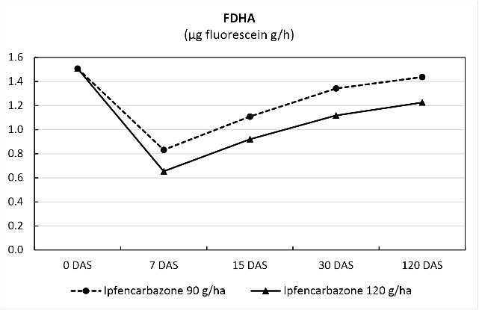 | 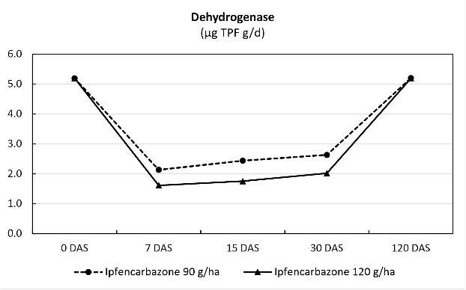
Fig 1 :Effect of Ipfencarbazone Rate on Fluorescein Diacetate Hydrolysis (FDHA) Activity | Fig 2 : Temporal Changes in Dehydrogenase Activity Following Ipfencarbazone Application

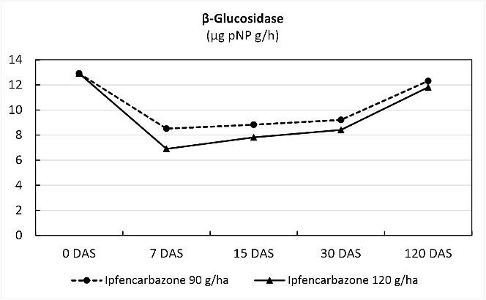 | 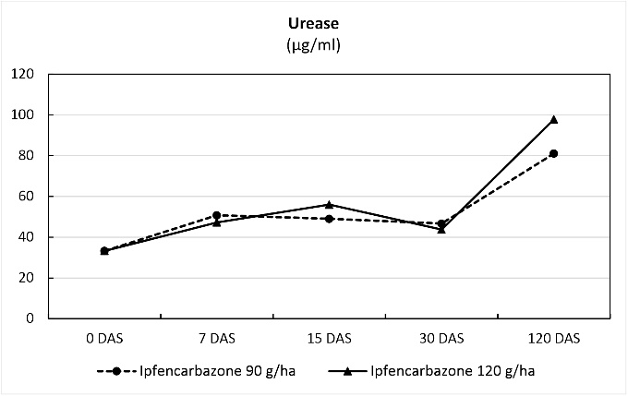
Fig 3 :β-Glucosidase Enzyme Activity Following Ipfencarbazone Application at Different Doses | Fig 4 : Effect of Ipfencarbazone Dose on Urease Activity Over Time (DAS)

Effect of different weed management methods on economics of jute cultivation

The weeding cost was 90% (₹21,660/-) less in case of mechanical weeding either by nail weeder or single wheel jute weeder along with herbicide (ipfencarbazone 90 g ha⁻¹). In case of mechanical weeding alone, the weeding cost was about 88% less as compared to the cost of weeding by manual weeding twice. The highest net return per rupee investment (NRPRI) was obtained either with ipfencarbazone 90 g ha⁻¹ + nail weeder (2.17) or with ipfencarbazone 90 g ha⁻¹ + single wheel jute weeder (2.16). The NRPRI was the lowest in case of manual weeding (1.55) due to high price of manual labour (Table 3). Earlier Sarkar and Bhattacharya (2005) also reported similar findings in jute weed management with other herbicides.

Conclusion
The highest fibre yield of jute was obtained with two manual weeding (38.46 q ha⁻¹). But the net return per rupee investment (NRPRI) was the lowest (1.55) in this treatment. Whereas, application of ipfencarbazone @ 90 g ha⁻¹ (PE) + nail weeder at 21 DAS produced higher fibre yield (36.25 q ha⁻¹) closely followed by and at par with the fibre yield recorded with ipfencarbazone @ 90 g ha⁻¹ (PE) + single wheel jute weeder at 21 DAS (36.13 q ha⁻¹) and the NRPRI were higher values of 2.17 and 2.16, respectively. Deployment of nail weeder as a mechanical method of weed management in jute given additional benefit of higher soil moisture content by about 18.64 to 21% at 5 cm depth, and by about 3.76 to 5.20% at 10 cm depth at 3 DAA. Moreover, at 7 DAA also, the soil moisture contents were higher at 5 cm (34.34 to 37.92%) and at 10 cm (10.01 to 15.95%). The soil enzyme activities such as FDHA, dehydrogenase, β-glucosidase was initially reduced by the application of ipfencarbazone 90 g ha⁻¹, but the same was increased to its initial levels at 120 DAS (at harvest of jute). The urease activity was not much affected by the application of ipfencarbazone at 90 and 120 g ha⁻¹ at 7, 15 and 30 DAS.

Table 1. Effect of different weed management methods on weed growth, crop growth and yield of jute (Pooled data of two years)
 | Dry weight of weeds (g m⁻²) |  | Plant height (cm) | Basal diameter (cm) | Fibre yield (q ha⁻¹) | Stick yield (q ha⁻¹)
 | 42 DAS | 60 DAS
T₁ | 32.18 | 18.14 | 362.9 | 1.99 | 38.46 | 92.74
T₂ | 41.56 | 21.23 | 321.4 | 1.76 | 31.17 | 75.00
T₃ | 58.45 | 24.47 | 317.4 | 1.70 | 30.98 | 74.55
T₄ | 49.15 | 23.55 | 317.1 | 1.73 | 31.22 | 75.14
T₅ | 64.35 | 38.33 | 311.3 | 1.75 | 29.17 | 70.22
T₆ | 58.64 | 29.19 | 309.8 | 1.67 | 29.88 | 71.93
T₇ | 54.37 | 27.16 | 341.7 | 1.89 | 36.25 | 87.25
T₈ | 44.25 | 25.46 | 327.6 | 1.75 | 33.16 | 79.79
T₉ | 61.17 | 31.55 | 338.6 | 1.90 | 36.13 | 86.97
T₁₀ | 48.65 | 29.87 | 326.7 | 1.80 | 33.19 | 79.89
CD (5%) | 4.35 | 2.98 | 17.797 | 0.121 | 1.506 | 3.604

Table 2. Effect of different weed management methods on soil moisture content at different depths (Pooled data of two years)

Tr. | Treatments | Soil moisture content (%)
Tr. | Treatments | 1 DAA |  | 3 DAA |  | 7 DAA
Tr. | Treatments | 5 cm | 10 cm | 5 cm | 10 cm | 5 cm | 10 cm
T₁ | Manual weeding twice | 19.54 | 27.24 | 14.52 | 23.85 | 11.56 | 20.37
T₂ | Nail weeder twice | 17.65 | 26.82 | 17.57 | 25.09 | 15.53 | 23.62
T₃ | Single wheel jute weeder twice | 19.70 | 28.37 | 14.81 | 24.18 | 11.26 | 21.47
T₄ | Nail weeder + Single wheel jute weeder | 20.11 | 28.99 | 17.59 | 25.11 | 15.77 | 23.87
T₅ | Ipfencarbazone 90 g | 17.84 | 27.03 | 14.70 | 23.60 | 11.83 | 19.82
T₆ | Ipfencarbazone 120 g | 19.78 | 27.45 | 15.11 | 22.95 | 11.68 | 20.14
T₇ | Ipfencarbazone 90 g + Nail weeder | 18.11 | 25.89 | 14.80 | 23.83 | 11.91 | 19.79
T₈ | Ipfencarbazone 120 g + Nail weeder | 18.54 | 26.02 | 14.65 | 23.77 | 12.88 | 20.44
T₉ | Ipfencarbazone 90 g + Single wheel jute weeder | 18.42 | 25.53 | 15.51 | 23.90 | 13.23 | 21.52
T₁₀ | Ipfencarbazone 120 g + Single wheel jute weeder | 19.31 | 26.30 | 15.77 | 24.01 | 13.91 | 21.49
CD at 5% |  | NS | NS | 1.852 | 1.299 | 1.492 | 1.074
DAA: day/s after application of nail weeder

Table 3. Effect of different weed management methods on economics of jute cultivation (Pooled data of two years)

Tr. | FY (q ha⁻¹) | SY (q ha⁻¹) | Total return | Weeding cost | Total cost | Net return | NRPRI
T₁ | 38.46 | 92.74 | ₹ 2,26,573 | ₹ 24,000 | ₹ 89,000 | ₹ 1,37,573 | 1.55
T₂ | 31.17 | 75.00 | ₹ 1,83,611 | ₹ 2,800 | ₹ 67,800 | ₹ 1,15,811 | 1.71
T₃ | 30.98 | 74.55 | ₹ 1,82,492 | ₹ 2,800 | ₹ 67,800 | ₹ 1,14,692 | 1.69
T₄ | 31.22 | 75.14 | ₹ 1,83,907 | ₹ 2,800 | ₹ 67,800 | ₹ 1,16,107 | 1.71
T₅ | 29.17 | 70.22 | ₹ 1,71,833 | ₹ 940 | ₹ 65,940 | ₹ 1,05,893 | 1.61
T₆ | 29.88 | 71.93 | ₹ 1,76,015 | ₹ 1,120 | ₹ 66,120 | ₹ 1,09,895 | 1.66
T₇ | 36.25 | 87.25 | ₹ 2,13,538 | ₹ 2,340 | ₹ 67,340 | ₹ 1,46,198 | 2.17
T₈ | 33.16 | 79.79 | ₹ 1,95,333 | ₹ 2,520 | ₹ 67,520 | ₹ 1,27,813 | 1.89
T₉ | 36.13 | 86.97 | ₹ 2,12,832 | ₹ 2,340 | ₹ 67,340 | ₹ 1,45,492 | 2.16
T₁₀ | 33.19 | 79.89 | ₹ 1,95,513 | ₹ 2,520 | ₹ 67,520 | ₹ 1,27,993 | 1.90
FY= fibre yield; SY= stick yield; NRPRI= Net return per rupee investment

References
Bhattacharya, S.P., Mondal, L., Pal, D. and Saha, M. (2004). Bio-efficacy of Targa Super (quizalofop ethyl 5% EC) in controlling weeds of jute. Pestology, 28: 32-35.
Ghorai, A.K. and Sarkar, S. (2006). Weed eradication in jute. ICAR News, 12 (3): 6.
Ghorai, A.K., Chakraborty, A.K., Pandit, N.C., Mandal, R.K. and Biswas, C.R. (2004). Grass weed control in jute by Targa Super (quizalofop ethyl 5% EC). Pestology, 28 (2): 31-34.
Ghorai, A. K., De, R., Chowdhury, H., Majumdar, B., Chakraborty, A., & Kumar, M. (2013). Integrated management of weeds in raw jute. *Indian Journal of Weed Science*, *45*(1), 47-50. https://www.isws.org.in/IJWSn/Journal.aspx?Volume=45&Issue=1&Year=2013
Ghorai, A.K., Kumar, M. and Roy, S. (2018). Modification in nail weeder assembly for higher weed control efficiency. CRIJAF Annual Report 2017-18, p 40.
Ghorai, A.K., Kumar, M., Roy, S. and Majumdar, B. (2017). Low-cost eco-friendly technologies for weed management in jute and mesta. CRIJAF Annual Report 2016-17, p 41.
Kido, T., Okita, H., Okamura, M., Takeuchi, T., & Morita, K. (2016). Development of a rice herbicide, ipfencarbazone. Journal of Pesticide Science, 41(3), 113-119. https://doi.org/10.1584/jpestics.J16-06
Kumar, M., Ghorai, A.K., Singh, A., & Kundu, D.K. (2015). The critical period for weed competition in relation to yield of jute. Journal of Agri Search, 2(3), 225-228. https://doi.org/10.5958/2348-8808.2015.00040.X
Majumdar, B., Saha, A. R., Sarkar, S., Maji, B., & Mahapatra, B. S. (2010). Effect of herbicides and fungicides application on fibre yield and nutrient uptake by jute (Corchorus olitorius), residual nutrient status and soil quality. Indian Journal of Agricultural Sciences, 80(10), 878–883. https://doi.org/10.56093/ijas.v80i10.1300
Majumdar, B., Sarkar, S., Saha, A. R., Maitra, D. N., & Maji, B. (2008). Effect of herbicides and fungicides applied to jute (Corchorus olitorius L.) on fibre yield and nutrient uptake by jute and changes in microbial dynamics of soil. Environment and Ecology, 26(4), 1613-1618.
Naik, R.K., Ghorai, A.K., Sarkar, S. and Jha, S.K. (2019). Single wheel jute weeder with modified scraper. CRIJAF Annual Report 2018-19, p 47.
Naik, R. K., Jha, S. K., Sarkar, S., & Ghorai, A. K. (2018). Performance evaluation of manual operated single wheel weeder for jute crop. International Journal of Agricultural Engineering, 11(1), 49-53. https://doi.org/10.15740/HAS/IJAE/11.1/49-53

Sarkar, S. (2006). Weed management in jute (Corchorus olitorius L.) by post emergence herbicides. Journal of Tropical Agriculture, 44(1-2), 71-73. https://jtropag.kau.in/index.php/ojs2/article/view/156
Sarkar, S., & Bhattacharya, S.P. (2005). Economics of different weed management methods in both the species of jute. *Journal of Crop and Weed*, *1*(1), 57-60. http://cropandweed.com/archives/
Sarkar, S., & Majumdar, B. (2013). Herbicidal effect on weed growth, crop yield and soil microbes in olitorius jute (Corchorus olitorius L.). Journal of Tropical Agriculture, 51(1-2), 23-29. https://journaloftropicalagriculture.in/index.php/jta/issue/view/51
Sarkar, S., Bhattacharjee, A.K., & Mitra, S. (2006). Weed management in jute by Trifluralin (48% EC) in the early jute-weed competition phase. Journal of Crop and Weed, 2(1), 30-33. https://cropandweed.com/archives/volume-2-issue-1/ .
Sarkar, S., Majumdar, B., Naik, R.K., Kar, G., Saha, S., Ghosh, S. and Datta, D. (2023). Weed management in jute for economically viable and sustainable production system. Technical Bulletin No. 02/2023, ICAR-Central Research Institute for Jute and Allied Fibres, Barrackpore, Kolkata, pp 30.

