Original Research Article
Symptomatology of Soybean Yellow Mosaic Virus (YMV) in the Marathwada Region of Maharashtra

ABSTRACT

Soybean Yellow Mosaic Virus (YMV) is one of the most destructive viral pathogens affecting soybean production across Asia, including India. The virus causes Yellow Mosaic Disease (YMD), characterized by foliar discoloration, mosaic patterns, and severe reductions in plant vigor and yield. Understanding the symptomatology of YMV is essential for accurate diagnosis, early detection, and the development of effective management strategies. The present study was undertaken to document and characterize the symptom expression of YMV under controlled inoculation conditions in the Marathwada region of Maharashtra.
Soybean plants (cv. MAUS-612) were grown in sterilized soil and inoculated at the 2–3 leaf stage using viruliferous whiteflies maintained in rearing cages. Inoculated plants were observed periodically in a screen house, and symptoms were documented based on colour, pattern, distribution, and severity. Initial symptoms appeared during the 24th Standard Meteorological Week, beginning with bright yellow specks and diffused green-yellow mottling on young leaves. As the disease progressed, infected plants showed extensive mosaic, chlorosis, puckering, blistering, leaf curling, and a significant reduction in leaf size. Advanced symptoms included stunting, shortened internodes, premature leaf drop, flower abortion, malformed pods, and shriveled or mottled seeds. Severe infection resulted in complete yellowing of young leaves and failure of pod formation.
The observations align with earlier reports describing similar symptom progression in YMD-affected soybean. The study provides a detailed account of YMV symptomatology in a region where soybean cultivation is expanding rapidly. These findings will aid in field-level diagnosis, disease surveillance, and future epidemiological and resistance-breeding programs.

Keywords: Soybean Yellow Mosaic Virus, Symptomatology, Soybean, Marathwada region

- INTRODUCTION
Soybean (Glycine max (L.) Merrill) is an economically important legume cultivated globally for its high protein and oil content, making it a key crop in food, feed and industrial sectors (Clemente & Cahoon, 2009). Despite its significance, soybean productivity is frequently constrained by several biotic stresses, of which viral diseases constitute a major challenge. Among the reported viruses infecting soybean worldwide, Yellow Mosaic Disease (YMD) caused by Soybean Yellow Mosaic Virus (YMV) has emerged as one of the most destructive, particularly in Asian soybean-growing regions (Bhattacharyya et al., 1999; Gibbs et al., 2008).
YMV belongs to the Potyviridae family and is transmitted primarily through insect vectors, especially aphids. The virus was first documented in the United States in the mid-20th century (Pierce, 1953) and subsequently reported from India in the 1960s (Nariani, 1960). Today, YMV is widespread across the Indian subcontinent, Sri Lanka, Pakistan, Bangladesh, Thailand and parts of Southeast Asia, where it continues to cause substantial yield losses (Bhattacharyya et al., 1999). The disease has become increasingly important due to continuous soybean expansion into diverse agro-climatic zones, which favour virus survival and vector proliferation.
The symptom expression of YMV varies with plant age, viral strain, environment, and host genotype. Typical symptoms begin with chlorotic or yellow specks on young leaves, followed by mosaic patterns, yellow mottling, and irregular patches of green and yellow tissue (Malathi, 2007). As infection advances, leaves may become entirely yellow, plants exhibit stunted growth, and pod formation diminishes severely. In severe epidemics, yield losses may range from 30% to 70%, and under conducive conditions, losses may reach up to 80% (Nene, 1972). Such variability in symptom severity necessitates accurate characterization of symptomatology, especially for early diagnosis and surveillance programs.
Understanding disease symptoms is fundamental because symptomatology helps differentiate YMV from similar viral infections such as soybean mosaic virus or mungbean yellow mosaic virus, which often co-occur in soybean fields. Precise symptom description is also essential for field-level diagnosis, determining disease onset, assessing severity, and planning effective management strategies (Malathi, 2007). Moreover, variation in symptom expression across regions suggests possible virus strain diversity, environmental influence, and host sensitivity—factors that emphasize the need for localized studies.
Given the increasing incidence and emerging hotspots of YMV in soybean-growing regions of India, systematic documentation of disease symptoms is crucial. A clear understanding of symptomatology forms the basis for further epidemiological studies, vector management, host resistance breeding, and integrated disease management strategies. Therefore, the present study was undertaken to document and characterize the symptomatology of Soybean Yellow Mosaic Virus disease, aiming to support accurate field diagnosis and contribute to broader research efforts on YMV epidemiology and control.
2. MATERIAL AND METHODS
2.1 To study Symptomatology of Yellow mosaic disease of soybean
To study the Symptomatology of yellow mosaic virus of soybean, seeds of soybean (Var.MAUS-612) were sown in earthen pots filled with steam sterilized soil and FYM (2:1) and watered regularly. After germination, seedlings at the 2-3 leaf stage were inoculated with viruliferous white fly kept in a rearing cage. The inoculated plants were maintained in a screen house and observed regularly for the development of symptoms. Observations were recorded on different types of symptoms and the time taken for symptom development. The description of symptoms was based on the shape, color and distribution pattern of the disease on the plot.
3. RESULTS AND DISCUSSION
3.1 Symptomatology of yellow mosaic virus disease in soybean (YMV)
The symptoms of YMV disease at different growth stages are depicted.
The first symptom of YMV was observed during the 24th SMW after sowing during Kharif, 2023-24 and 2024-25. The healthy soybean plants did not show any disease symptoms. During observations, it was found that at the initial stage of disease cycle, all the plants of soybean cv. MAUS-612 inoculated with the virus and developed characteristic symptoms of YMV viz., bright yellow, irregular and green diffused dapples on surface of leaves, curling, blistering, extensive mosaic and mottling of leaves, puckering and raised green areas on leaves, Chlorosis and reduction in leaf size, defoliation and flower drop. An infected plant bears few immature and small sized seeds. In later stages, as the disease progresses, YMV causes Irregular yellow and green patches on older leaves and complete yellowing of young leaves of susceptible varieties and in severe cases, Chlorosis, stunting and fewer branches and premature shedding of leaves of beans. Plants were found stunted without any flowering or pod formation. Affected plants produce fewer flowers and pods often develop mottling, remain small and contain fewer and smaller seeds. Soybean plant produced shortening of internodes, mosaic on leaves and deformed pods, which produced small, immature, shriveled seeds. Mottled soybean seeds, meaning they will have a patchy, uneven coloration. Infected seeds may fail to germinate.
Gill and Rataul (1986) reported that the symptoms of soybean yellow mosaic virus appeared at the first trifoliate leaf as slightly scattered small yellow spots alternating with yellow patches. It sped to the next trifoliate leaf and the size of yellow spots gradually increased till the entire leaf became yellow. In cases, necrotic centers developed in most of the yellow spots and the yellow color gradually changed into white.
Nariani (1960) reported the first symptoms of the disease on the young leaves in the form of mild scattered yellow specks or spots. The next trifoliate leaf emerging from the growing apex showed irregular yellow and green patches. The leaf size is generally not much affected but sometimes the green areas were slightly raised and the leaves showed slight puckering and a size reduction. The size of yellow areas increases in the new growth and ultimately, some of the apical leaves turn completely yellow. The diseased plants usually matured late and bore very few flowers and pods. The size of the pod was reduced and more frequently, immature and small sized seeds were obtained from such pods. On Phaseolus mungo, symptoms were essentially similar to those in moongbean. Bright yellow and green patches appear on young leaves after 12-15 days and continue to appear on new growth. Singh (1979) observed yellow mosaic, puckering and a reduction in size symptoms of MYMV on bean leaves. Early infected plants usually died without forming pods; later infection delayed maturity and reduced yields. Previously similar symptoms of the yellow mosaic disease were reported by Nair and Nene, (1973), Gautam (1990), Varma et al. (1992), Varma and Malathi (2003), Bashir et al. (2006), Qazi et al. (2007), Akhtar et al. (2009), and Gazala et al. (2013).

4. CONCLUSIONS
The present investigation clearly demonstrated the typical symptomatology of Soybean Yellow Mosaic Virus (YMV) infecting soybean under the Marathwada conditions of Maharashtra. Symptoms first appeared around the 24th SMW after sowing and progressively intensified with plant growth. Characteristic features included bright yellow and green mosaic mottling, curling and blistering of leaves, chlorosis, reduced leaf size and premature defoliation. As the disease advanced, plants exhibited stunting, shortened internodes, poor branching and complete suppression or weakening of flowering and pod formation. Pods that did develop were deformed and contained small, immature and shrivelled seeds, many of which showed mottling and poor germination. These observations confirm that YMV infection adversely affects soybean at both vegetative and reproductive stages, ultimately reducing yield potential and seed quality. The present findings align with previous descriptions of YMV symptom expression reported by earlier workers and highlight the destructive nature of YMV in susceptible soybean cultivars grown in the region. Continued monitoring of symptom development and disease spread is essential for early detection and timely management to safeguard soybean productivity.

COMPETING INTERESTS
Authors have declared that no competing interests exist.

COMPETING INTERESTS DISCLAIMER:
Authors have declared that they have no known competing financial interests OR non-financial interests OR personal relationships that could have appeared to influence the work reported in this paper.

REFERENCES
- Akhtar, K. P., Wasim, M., Ishaq, W., Ahmad, M., & Haq, M. A. (2009). Short communication. Deterioration of cotton fibre characteristics caused by cotton leaf curl disease. Spanish Journal of Agricultural Research, 7(4), 913-918. https://doi.org/10.5424/sjar/2009074-1110
- Bashir, M., Z. Ahmad and S. Mansoor. (2006). Occurrence and Distribution of Viral Diseases of Mungbean and Mash bean in Punjab, Pakistan. Pakistan Journal of Botany, 38(4): pp. 1341.
- Bhattacharyya, A., Roy, S. and Murthy, G. S. (1999). Yellow mosaic virus disease of soybean in India. Indian Journal of Virology, 15(1): 45–49.
- Clemente, T. E., & Cahoon, E. B. (2009). Soybean Oil: Genetic Approaches for Modification of Functionality and Total Content. Plant Physiology, 151(3), 1030–1040. https://doi.org/10.1104/pp.109.146282
- Gautam, H. C. (1990). Identification of Soybean Diseases and Their Integrated Control. Farmer and Parliament, 15–22.
- Gazala, I. F. S., Sahoo, R. N., Pandey, R., Mandal, B., Gupta, V. K., Singh, R., & Sinha, P. (2013). Spectral reflectance pattern in soybean for assessing yellow mosaic disease. Indian Journal of Virology, 24(2), 242–249. https://doi.org/10.1007/s13337-013-0161-0 .
- Gibbs, A. J., Ohshima, K., Phillips, M. J., & Gibbs, M. J. (2008). The prehistory of potyviruses: Their initial radiation was during the dawn of agriculture. PLoS ONE, 3(6), e2523. https://doi.org/10.1371/journal.pone.0002523
- Gill, C. K. and Rataul, H. S. (1986). A Note on the Incidence, Estimation of Losses and Symptomatology of Yellow Mosaic Virus on Soybean, Glycine Max L. Indian Journal of Entomology, 48(4): 524–526.
- Malathi, V. G. (2007). Viral diseases of soybean and their management. Journal of Mycology and Plant Pathology, 37(2): 157–165.
- Nariani, T. K. (1960). Yellow mosaic of Mung (Phaseolus aureus L.). Indian Phytopathology, 13(1), 24–29. https://www.cabidigitallibrary.org/doi/10.5555/19610500001 .
- Nene, Y. L. (1972). A survey of viral diseases of pulse crops in Uttar Pradesh. Research Bulletin, G.B. Pant University of Agriculture and Technology, 4: 24–30.
- Pierce, W. H. (1953). A new mosaic disease of soybeans. Plant Disease Reporter, 37(9): 517–518.
- Qazi, J., Ilyas, M., Mansoor, S., & Briddon, R. W. (2007). Legume yellow mosaic viruses: genetically isolated begomoviruses. Molecular Plant Pathology, 8(4), 343–348. https://doi.org/10.1111/j.1364-3703.2007.00402.x
- Singh, B.R., Singh, O.K. and Saxena, H.K.(1976) A yellow Mosaic disease of Soybean at Kanpur,. Crop Research Hisar, 16(1): 112–114.
- Varma, A., Dhar, A. K., & Mandal, B. (1992). MYMV transmission and control in India. In S. K. Green & D. H. Kim (Eds.), Mungbean Yellow Mosaic Disease (pp. 8-27). Asian Vegetable Research and Development Centre. https://avrdc.org/publications/mymv-transmission-and-control-in-india/
- Varma, A., & Malathi, V. G. (2003). Emerging Geminivirus Problems: A Serious Threat to Crop Production. Annals of Applied Biology, 142(2), 145–164. https://doi.org/10.1111/j.1744-7348.2003.tb00240.x
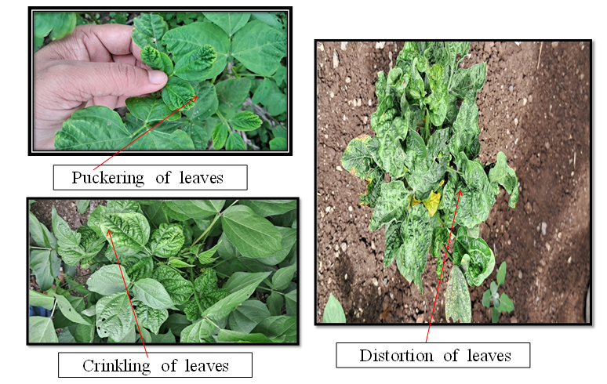
Figure 1A Symptoms expressed especially in the early stages of infection by YMV in soybean (field condition)

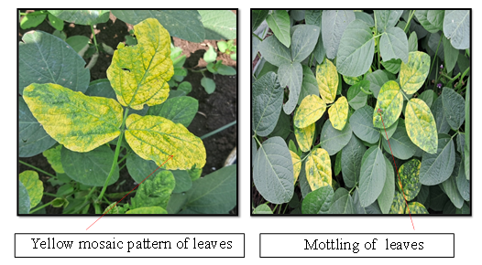
Figure 1B Symptoms expressed especially in the early stages of infection by YMV in soybean (field condition)
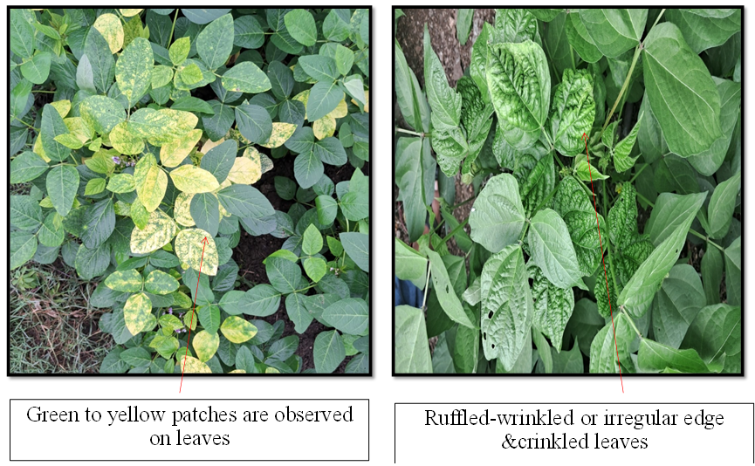
Figure.1C Symptoms expressed especially in the early stages of infection by YMV in soybean (field condition)

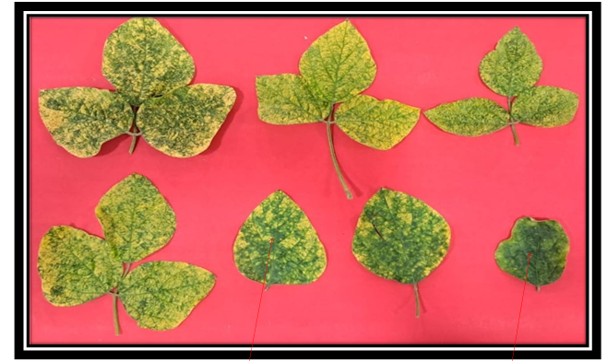
Figure.1D Affected plants showed a yellow mosaic or mottling pattern with light to dark green patches, distorted and puckering of leaves. (Suteri, 1974; Maramorosch and Muniyappa, 1981)
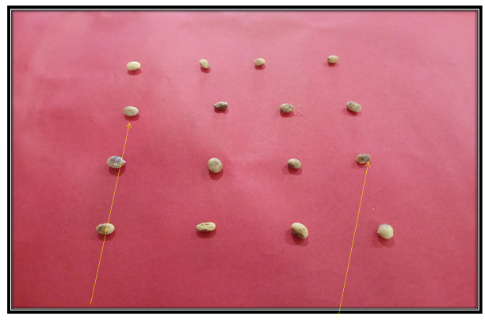
Figure 1E Mottled soybean seeds, meaning they will have a patchy, uneven coloration.
Infected seeds may fail to germinate

