Bio-Efficacy and Phytotoxicity Analysis of SV FRUITER for Tomato Production

.
ABSTRACT

Aims: To evaluate the bio-efficacy of the new Biostimulant SV FRUITER on the growth, yield and quality of tomato and to determine its possible unintended effects (Phytotoxicity) on the crop. ​
Study design: Field experiment, randomized design with five treatments including an untreated control.
Place and Duration of Study: Zonal Agricultural and Horticultural Research Station (ZAHRS), Navile, Keladi Shivappa Nayaka University of Agricultural and Horticultural Sciences (KSNUAHS), Shivamogga, Karnataka, India, from December 2023 to May 2024.
Methodology: The study was conducted on the tomato hybrid ‘Arka Rakshak’, which is high yielding and resistant to multiple diseases. Four soil-applied doses of SV FRUITER (50, 100, 150 and 200 kg per acre) and an untreated control were evaluated. SV FRUITER was applied once as a soil application at 20-25 days after transplanting (DAT). Morphological parameters (plant height, number of branches, leaf area and leaf area index), physiological parameters (chlorophyll a, chlorophyll b and total chlorophyll content) and yield attributes (fruit weight, number of fruits per plant, fruit yield per plant and fruit yield per hectare) were recorded. Chlorophyll content was estimated by the dimethyl sulfoxide (DMSO) method and data were analysed statistically at P = 0.05. Phytotoxicity was visually assessed on a 0-100 scale for symptoms such as wilting, chlorosis, necrosis and epinasty/hyponasty.
Results: SV FRUITER significantly increased leaf area and leaf area index at 60 and 90 DAT, with highest values at 200 kg per acre (T4). Total chlorophyll was higher in treated plots at 30 and 90 DAT. T4 produced maximum fruits per plant (53.0) and yield (63.09 tonnes per hectare; 15.68% over control). No phytotoxicity observed.
Conclusion: SV FRUITER at 200 kg per acre is highly effective and safe for tomato, recommended with fertilizers.
Conclusion: Non-invasive independent predictors for screening esophageal varices may decrease medical as well as financial burden, hence improving the management of cirrhotic patients. These predictors, however, need further work to validate reliability.

Keywords: Tomato, Biostimulant, SV FRUITER, yield, phytotoxicity, chlorophyll and leaf area index.

1. INTRODUCTION

Tomato (Solanum lycopersicum L.) is a major solanaceous vegetable crop cultivated worldwide due to its wide adaptability and diverse uses in fresh consumption and processing industries. It constitutes an important source of income for small and marginal farmers and is recognized as a rich dietary source of vitamin C, carotenoids (Particularly lycopene) and other health-promoting phytonutrients.
Despite its economic and nutritional importance, tomato production is constrained by several factors. Rising costs of chemical fertilizers, coupled with improper and imbalanced fertilizer use, frequently result in nutrient deficiencies and suboptimal nutrient use efficiency. Intensive cultivation and continuous cropping lead to deterioration of soil health and declining productivity. In addition, tomato is highly vulnerable to biotic stresses such as insect pests and diseases, often necessitating frequent and costly plant protection measures. These constraints cumulatively cause reduced yields, inferior fruit quality and shortened shelf life.
To overcome these challenges, there is a growing emphasis on integrated and sustainable production strategies that can enhance nutrient availability, improve plant tolerance to abiotic and biotic stresses and strengthen plant defense and metabolic efficiency. Within this context, plant biostimulants have emerged as promising tools. Du Jardin (2015) defined plant biostimulants as substances or microorganisms applied to plants with the aim of enhancing nutrient use efficiency, tolerance to abiotic stress and/or crop quality traits, irrespective of their nutrient content. Biostimulants can therefore complement conventional fertilizers by improving the efficiency of nutrient uptake and utilization while potentially reducing overall fertilizer requirements.
A wide range of biostimulant materials has been documented, including humic and fulvic substances, seaweed extracts, protein hydrolysates, chitosan and microbial inoculants. These products, even at low application rates, can positively influence plant physiological processes such as root growth, photosynthesis, hormonal balance and stress tolerance, leading to improved growth and productivity. Numerous studies have reported yield and quality benefits of biostimulants in tomato and other horticultural crops (Calvo et al., 2014; Anbukkarasi et al., 2018; Ricci et al., 2019). Seaweed extracts and humic substances, for example, have been shown to increase chlorophyll content, enhance enzymatic activity and improve translocation of photosynthates, which ultimately contribute to higher yields and better fruit quality.
SV FRUITER is a newly formulated granular biostimulant intended for soil application in horticultural crops, including tomato. Although multi-location biostimulant trials in tomato have been reported from various research stations in India, product-specific field data under local conditions are essential to support scientific recommendations. Therefore, the present study was undertaken to evaluate the performance of SV FRUITER in tomato under the conditions of ZAHRS, Navile, Shivamogga, with the following specific objectives:
- To study the bio-efficacy of SV FRUITER on the vegetative growth of tomato.
- To assess the possible unintended effects (phytotoxicity) of SV FRUITER on tomato.
- To evaluate the influence of SV FRUITER on yield and yield-contributing characters and on the quality of tomato fruits.

2. material and methods

2.1 Experimental site
The field experiment was conducted at the C-6 block of the Zonal Agricultural and Horticultural Research Station (ZAHRS), Navile, under Keladi Shivappa Nayaka University of Agricultural and Horticultural Sciences (KSNUAHS), Shivamogga, Karnataka, India. The station is geographically located at 13°58′ North latitude and 75°34′ East longitude, at an altitude of 650 meters above mean sea level.
2.2 Soil characteristics
The experimental field soil was classified as red sandy loam in texture and belongs to the Typic Haplustalf soil order. The initial soil analysis indicated a slightly acidic reaction (pH 6.25), normal electrical conductivity (0.17 deciSiemens per meter) and medium organic carbon content. Available nitrogen and phosphorus were in the low category, whereas available potassium was in the medium range, typical of many tomato-growing soils in southern India.
2.3 Climatic conditions
The experiment was carried out during the rabi-summer season from December 2023 to May 2024. During the crop growth period, the site received a total rainfall of 288.8 millimeters in 13 rainy days, which was 124.9 millimeters higher than the 30-year average for the same period. The experiment thus experienced a relatively wetter season compared with the long-term normal, but irrigation scheduling ensured that water supply remained non-limiting.
2.4 Treatments and experimental design
The test crop was tomato hybrid ‘Arka Rakshak’, which is known for its high yield potential and resistance to multiple diseases. The experiment was laid out in a randomized design (specify completely randomized design or randomized complete block design as per original design) with five treatments and an appropriate number of replications (insert number of replications used). The treatments consisted of four doses of SV FRUITER and an untreated control:
Table 1. Treatment Details
Tr. No. | Treatment & Dosage | Method of application | Stage of application
T1 | SV FRUITER @ 50 kg acre⁻¹ | Soil application | 20-25 DAT*
T2 | SV FRUITER @ 100 kg acre⁻¹ | Soil application | 20-25 DAT
T3 | SV FRUITER @ 150 kg acre⁻¹ | Soil application | 20-25 DAT
T4 | SV FRUITER @ 200 kg acre⁻¹ | Soil application | 20-25 DAT
T5 | Untreated control | - | -
DAT* - Days after transplanting

SV FRUITER was applied once as a soil application on 11 January 2024 at 20-25 days after transplanting. All plots received the recommended dose of fertilizers for tomato as per university package of practices and standard agronomic and plant protection measures were adopted uniformly in all treatments.
2.5 Observations on growth and yield parameters
Three uniform plants were randomly selected and tagged in each treatment plot for recording observations on growth and yield parameters. The following parameters were recorded at specified growth stages (30, 60 and 90 days after transplanting and at harvest):
- Plant height (centimetres) and number of branches per plant
- Leaf area (square centimetres) and leaf area index
- Days to 50% flowering and average number of flowers per cluster
- Number of fruits per plant and average fruit weight (grams)
- Fruit yield per plant (kilograms per plant)
- Fruit yield per hectare (tonnes per hectare)
Leaf area was measured using standard destructive sampling procedures and converted to leaf area index using the formula: leaf area index = leaf area divided by ground area occupied by the plant.
2.6 Chlorophyll estimation
Chlorophyll content (chlorophyll a, chlorophyll b and total chlorophyll) was estimated from leaf samples collected at 30 and 90 days after transplanting using the dimethyl sulfoxide (DMSO) extraction method described by Shoaf and Lium (1976). Absorbance readings were taken using a spectrophotometer and chlorophyll content was expressed as milligrams per gram fresh leaf weight.
2.7 Phytotoxicity assessment
Phytotoxicity of SV FRUITER was assessed visually using a 0-100 scale, where 0 indicates no injury and 100 indicates complete plant death. Observations for symptoms such as wilting, chlorosis or yellowing, necrosis and epinasty or hyponasty were recorded at 1, 3, 5 and 10 days after application.
2.8 Soil analysis after harvest
Soil samples from the 0-15-centimeter depth were collected from each plot after harvest and analyzed for pH, electrical conductivity, organic carbon and available nitrogen, phosphorus and potassium using standard procedures. The initial and final values were compared to assess changes in soil fertility status over the cropping period.
2.9 Statistical analysis
The data generated from the field experiment were subjected to analysis of variance (ANOVA) following the procedures described by Gomez and Gomez (1984). Treatment means were compared at the 5% level of significance (P = 0.05) using the appropriate post-hoc test as per the design of the experiment.

3. results and discussion

3.1 Morphological parameters
Plant height and number of branches per plant did not differ significantly among treatments at 30, 60, or 90 days after transplanting (Table 2). However, plants in plots receiving SV FRUITER generally recorded numerically higher values than the untreated control, indicating a favorable but statistically non-significant trend in vegetative growth.
Leaf area and leaf area index showed a clear positive response to SV FRUITER application and were significantly influenced at 60 and 90 days after transplanting. At 90 days after transplanting, the maximum leaf area (7898 square centimetres) and leaf area index (1.463) were recorded in T4 (SV FRUITER at 200 kg per acre), followed by T3 and T2, all of which were significantly superior to the control (leaf area 7010 square centimetres, leaf area index 1.298). The improvement in canopy development under higher doses of SV FRUITER suggests enhanced root activity, nutrient uptake and photosynthetic surface area, which are consistent with the reported effects of biostimulants containing humic substances and seaweed derivatives on tomato and other crops.
3.2 Physiological parameters
SV FRUITER application significantly influenced chlorophyll content, which is a key determinant of photosynthetic efficiency and biomass production (Table 3). At 30 days after transplanting, chlorophyll b and total chlorophyll contents were significantly higher in SV FRUITER-treated plots than in the control. T3 (150 kg per acre) and T4 (200 kg per acre) recorded the highest total chlorophyll values of 1.720 and 1.711 milligrams per gram fresh leaf weight, respectively.
At 90 days after transplanting, chlorophyll a, chlorophyll b and total chlorophyll were all significantly higher in T4, which recorded a total chlorophyll content of 2.652 milligrams per gram fresh leaf weight compared with 2.307 milligrams per gram in the untreated control. The increase in chlorophyll content under higher doses of SV FRUITER aligns with previous reports on biostimulant-induced improvements in pigment content and photosynthetic capacity in tomato, especially with seaweed extracts and humic substances. The enhanced chlorophyll content in the present study likely contributed to the improved vegetative growth and yield attributes observed in the SV FRUITER treatments.
3.3 Yield and yield attributes
Days to 50% flowering and the average number of flowers per cluster were not significantly affected by SV FRUITER application, indicating that the product did not markedly alter the onset of reproductive development. However, SV FRUITER had a pronounced and significant effect on yield-determining parameters.
Average fruit weight was significantly higher in T3 (91.5 grams) and T4 (90.7 grams) than in the untreated control (87.8 grams). The number of fruits per plant was maximized in
Table 2. Morphological parameters as influenced by application of SV FRUITER (soil application) at 20 DAT⁺ on tomato
Treatment & Dosage | Plant height (cm) |  |  | Number of Branches (no.) |  |  | Leaf area (cm²) |  |  | LAI
Treatment & Dosage | 30 | 60 | 90 | 30 | 60 | 90 | 30 | 60 | 90 | 30 | 60 | 90
Treatment & Dosage | Days after transplanting
T₁: SV FRUITER @ 50 kg acre⁻¹ | 36.7 | 74.4 | 95.2 | 6.3 | 20.3 | 22.3 | 598 | 3935 | 7153 | 0.111 | 0.729 | 1.325
T₂: SV FRUITER @ 100 kg acre⁻¹ | 40.6 | 77.1 | 107.3 | 6.7 | 21.7 | 24.7 | 642 | 4371 | 7584 | 0.119 | 0.809 | 1.404
T₃: SV FRUITER @ 150 kg acre⁻¹ | 41.5 | 71.4 | 101.6 | 7.0 | 21.3 | 24.3 | 680 | 4453 | 7626 | 0.126 | 0.825 | 1. 412
T₄: SV FRUITER @ 200 kg acre⁻¹ | 40.0 | 73.4 | 106.8 | 7.0 | 22.0 | 25.3 | 665 | 4408 | 7898 | 0.123 | 0.816 | 1.463
T₅: Untreated control | 38.8 | 70.6 | 92.6 | 7.0 | 18.7 | 22.7 | 626 | 3725 | 7010 | 0.116 | 0.690 | 1.298
S. Em. ± | 1.57 | 2.83 | 3.95 | 0.27 | 0.78 | 0.91 | 35 | 177 | 189 | 0.008 | 0.029 | 0.035
C.D. (5%) | NS | NS | NS | NS | NS | NS | NS | 508 | 543 | NS | 0.083 | 0.102
DAT⁺ - Days after transplanting

Table 3. Physiological parameters as influenced by application of SV FRUITER (soil application) at 20 DAT⁺ on tomato
Treatment & Dosage | 30 DAT |  |  | 60 DAT |  |  | 90 DAT
Treatment & Dosage | Chl ‘a’ | Chl ‘b’ | Total Chl | Chl ‘a’ | Chl ‘b’ | Total Chl | Chl ‘a’ | Chl ‘b’ | Total Chl
Treatment & Dosage | (mg⁻¹g leaf fr.wt.)
T₁: SV FRUITER @ 50 kg acre⁻¹ | 1.178 | 0.398 | 1.576 | 1.455 | 0.541 | 1.996 | 1.747 | 0.635 | 2.382
T₂: SV FRUITER @ 100 kg acre⁻¹ | 1.191 | 0.443 | 1.634 | 1.432 | 0.516 | 1.948 | 1.773 | 0.649 | 2.422
T₃: SV FRUITER @ 150 kg acre⁻¹ | 1.236 | 0.483 | 1.720 | 1.557 | 0.569 | 2.125 | 1.865 | 0.693 | 2.558
T₄: SV FRUITER @ 200 kg acre⁻¹ | 1.252 | 0.460 | 1.711 | 1.625 | 0.591 | 2.216 | 1.926 | 0.727 | 2.652
T₅: Untreated control | 1.141 | 0.347 | 1.488 | 1.423 | 0.527 | 1.95 | 1.686 | 0.621 | 2.307
S. Em. ± | 0.038 | 0.017 | 0.062 | 0.067 | 0.026 | 0.089 | 0.071 | 0.024 | 0.095
C.D. (5%) | NS | 0.048 | 0.171 | NS | NS | NS | 0.219 | 0.069 | 0.277
DAT⁺ - Days after transplanting

Table 4. Days to 50 per cent flowering, flowers per cluster, yield and yield components as influenced by application of SV FRUITER (soil application) at 20 DAT⁺ on tomato
Treatment & Dosage | Days to  50 per cent flowering | Flowers per cluster | Fruit length | Fruit diameter | Fruit weight | Fruits per plant | Fruit yield per plant | Net plot yield | Fruit yield
Treatment & Dosage | (days) | (Number) | (mm) | (mm) | (gm) | (number) | (kg) | (kg) | (t ha⁻¹)
T₁: SV FRUITER @ 50 kg acre⁻¹ | 39.0 | 3.5 | 47.6 | 41.2 | 89.5 | 48.7 | 4.35 | 50.5 | 58.40
T₂: SV FRUITER @ 100 kg acre⁻¹ | 40.7 | 3.5 | 49.3 | 42.2 | 90.2 | 51.5 | 4.55 | 52.3 | 60.56
T₃: SV FRUITER @ 150 kg acre⁻¹ | 40.0 | 3.9 | 50.7 | 42.8 | 91.5 | 50.3 | 4.62 | 52.7 | 60.96
T₄: SV FRUITER @ 200 kg acre⁻¹ | 40.3 | 3.8 | 52.3 | 43.9 | 90.7 | 53.0 | 4.74 | 54.5 | 63.09
T₅: Untreated control | 39.7 | 3.2 | 45.6 | 39.8 | 87.8 | 48.2 | 4.17 | 47.1 | 54.54
S. Em. ± | 0.74 | 0.31 | 2.35 | 1.52 | 0.82 | 0.71 | 0.12 | 1.62 | 1.58
C.D. (5%) | NS | NS | NS | NS | 2.40 | 1.98 | 0.35 | 4.95 | 4.87
DAT⁺ - Days after transplanting

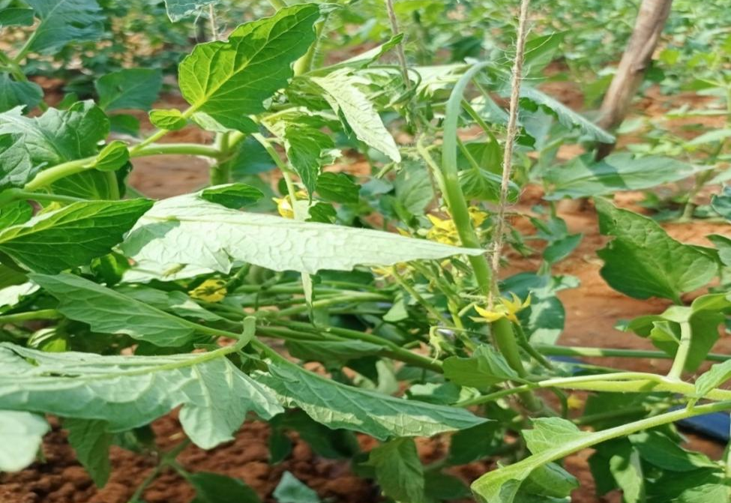
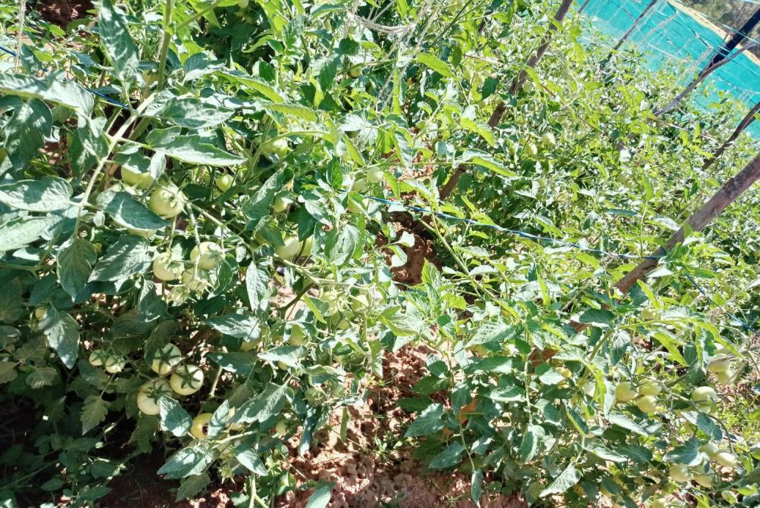
Figure 1. a) Flowering and b) Fruit setting
T4, which produced 53.0 fruits per plant. Consequently, fruit yield per plant was also highest in T4 (4.74 kilograms per plant). The combined effect of higher fruit number and marginally heavier fruits translated into a significant increase in fruit yield per hectare. T4 (SV FRUITER at 200 kg per acre) recorded the maximum fruit yield of 63.09 tonnes per hectare, representing a 15.68% increase over the control yield of 54.54 tonnes per hectare (Table 4).
The improved yield performance with SV FRUITER can be attributed to the synergistic effects of enhanced leaf area, higher leaf area index and increased chlorophyll content, which together improve photosynthetic efficiency and assimilate production. These responses are characteristic of biostimulant action, where phytohormone-like compounds, humic substances and other bioactive constituents stimulate root growth, nutrient uptake and metabolic activity, leading to improved source-sink relationships and better fruit set and development. The yield increases recorded in this study agree with other reports documenting significant improvements in tomato yield and quality following biostimulant application.
3.4 Phytotoxicity
Across all observation intervals (1, 3, 5 and 10 days after application), no phytotoxic symptoms such as wilting, chlorosis, necrosis, or epinasty/hyponasty were observed in any of the SV FRUITER treatments (Table 5). The phytotoxicity score remained at 0% for all doses, indicating that SV FRUITER is biologically safe to tomato when applied as a single soil application at rates up to 200 kg per acre.
3.5 Soil properties after harvest
A comparison of initial and final soil test values indicated a slight decline in available nitrogen, phosphorus and potassium across treatments, reflecting nutrient removal by the crop (Table 6). However, the relative decline was modest, suggesting that the improved growth and yield observed with SV FRUITER were achieved primarily through enhanced nutrient use efficiency and better exploitation of native soil reserves rather than excessive nutrient mining. This is consistent with the recognized role of biostimulants in improving nutrient uptake and utilization efficiency, thereby supporting higher productivity with a more sustainable nutrient balance in the soil-plant system.

Table 5. Phytotoxicity effects of application of SV FRUITER (soil application) at 20 DAT⁺ on tomato crop (1, 3, 5 & 10 days after test product application)
Treatment & Dosage | Wilting |  |  |  | Chlorosis/ Yellowing |  |  |  | Necrosis |  |  |  | Epinasty/Hyponasty
Treatment & Dosage | 1 | 3 | 5 | 10 | 1 | 3 | 5 | 10 | 1 | 3 | 5 | 10 | 1 | 3 | 5 | 10
Treatment & Dosage | Days after test product application
T₁: SV FRUITER @ 50 kg acre⁻¹ | 0 | 0 | 0 | 0 | 0 | 0 | 0 | 0 | 0 | 0 | 0 | 0 | 0 | 0 | 0 | 0
T₂: SV FRUITER @ 100 kg acre⁻¹ | 0 | 0 | 0 | 0 | 0 | 0 | 0 | 0 | 0 | 0 | 0 | 0 | 0 | 0 | 0 | 0
T₃: SV FRUITER @ 150 kg acre⁻¹ | 0 | 0 | 0 | 0 | 0 | 0 | 0 | 0 | 0 | 0 | 0 | 0 | 0 | 0 | 0 | 0
T₄: SV FRUITER @ 200 kg acre⁻¹ | 0 | 0 | 0 | 0 | 0 | 0 | 0 | 0 | 0 | 0 | 0 | 0 | 0 | 0 | 0 | 0
T₅: Untreated control | 0 | 0 | 0 | 0 | 0 | 0 | 0 | 0 | 0 | 0 | 0 | 0 | 0 | 0 | 0 | 0

DAT⁺ - Days after transplanting Scale: (0-10): 0=00, 1= 1-10%, 2= 11-20%, 3= 21-30%, 4=31-40%, 5=41-50%, 6=51-60%, 7=61-70%, 8=71-80%, 9= 81-90%, 10= 91-100%

Table 6. Effect of application of SV FRUITER (soil application) at 20 DAT⁺ on soil chemical properties and nutrient status after tomato crop harvest
Sl.No. | Particulars | Initial | Final
1. | Soil pH | 6.25 | 6.40
2. | EC (dSm⁻¹at 25ºC) | 0.17 | 0.16
3. | Organic Carbon (g kg⁻¹) | 3.62 | 3.60
4. | Available Nitrogen (kg ha⁻¹) | 219.52 | 208.35
5. | Available Phosphorus (kg ha⁻¹) | 80.54 | 72.17
6. | Available Potassium (kg ha⁻¹) | 225.79 | 210.80
7 | Exchangeable Calcium [cmol(p⁺)kg⁻¹] | 1.80 | 1.65
8 | Exchangeable Magnesium [cmol(p⁺)kg⁻¹] | 0.92 | 0.78
9 | Available Sulphur (ppm) | 17.1 | 16.5
10 | Zinc (ppm) | 1.44 | 1.17
11 | Iron (ppm) | 14.48 | 12.26
12 | Copper (ppm) | 0.84 | 0.65
13 | Manganese (ppm) | 8.27 | 7.89
DAT⁺ - Days after transplanting

4. Conclusion

The present field study demonstrated that soil application of the biostimulant SV FRUITER significantly improves vegetative growth, chlorophyll content, yield attributes and fruit yield of tomato hybrid ‘Arka Rakshak’ under the conditions of ZAHRS, Navile, Shivamogga. A dose of 200 kg per acre (T4) consistently outperformed the lower doses and the untreated control, recording the highest leaf area, leaf area index, total chlorophyll content at 90 days after transplanting and maximum fruit yield of 63.09 tonnes per hectare, which was 15.68% higher than the control.
No phytotoxic effects were observed at any of the tested doses, confirming that SV FRUITER is safe for soil application in tomato. The improvements in growth and yield can be attributed to the biostimulant’s ability to stimulate nutrient uptake, enhance chlorophyll synthesis and promote efficient translocation of photosynthates from source to sink. On the basis of these findings, SV FRUITER at 200 kg per acre, applied once as soil application at 20-25 days after transplanting along with the recommended dose of fertilizers, can be recommended for enhancing tomato productivity under similar agro-climatic conditions.

Ethical approval

This article does not contain any studies with human participants or animals performed by any of the authors.

References

Anbukkarasi, V., Prabu, M., Paramaguru, P., Pugalendhi, L., & Jeyakumar, P. (2018). Effect of nutrients and biostimulants on growth, yield and quality of tomato. International Journal of Current Microbiology and Applied Sciences, Special Issue 6, 49-55. https://www.ijcmas.com/special-issue-6/V.%20Anbukkarasi,%20et%20al.pdf
Calvo, P., Nelson, L., & Kloepper, J. W. (2014). Agricultural uses of plant biostimulants. Plant and Soil, 383(1-2), 3-41. https://doi.org/10.1007/s11104-014-2131-8
Crouch, I. J., & Van Staden, J. (1994). Cytokinins in seaweed extracts: Their effect on lateral branching in tomato seedlings. Plant Growth Regulation, 14(3), 209-217.
Dhanasekaran, K., & Bhuvaneswari, R. (2005). Effect of nutrient enriched humic acid on growth and yield of tomato. International Journal of Agricultural Sciences, 1(1), 80-83.
Du Jardin, P. (2015). Plant biostimulants: Definition, concept, main categories and regulation. Scientia Horticulturae. https://doi.org/10.1016/j.scienta.2015.09.021
Fawzy, Z. F., El-Nemr, M. A., & Badr, M. A. (2007). Effect of humic acid and chitosan on the growth, yield and quality of strawberry. Journal of Applied Sciences Research, 3(10), 1632-1640.
Gomez, K. A., & Gomez, A. A. (1984). Statistical procedures for agricultural research (2nd ed.). John Wiley & Sons. https://www.wiley.com/en-us/Statistical+Procedures+for+Agricultural+Research%2C+2nd+Edition-p-9780471879312
Kanimozhi, T. (2004). Studies on biofertilizers and bioactive substances on growth, yield and quality of tomato. Unpublished Ph.D. thesis, Tamil Nadu Agricultural University, Coimbatore, India.
Liu, X., Jin, Z., & Chen, J. (1998). Effects of humic substances on growth of rice. Journal of Southeast Asian Agricultural Sciences, 2(1), 47-52.
Nour, V., Tureşchi, E., Voda, R., & Puiu, S. (2010). The effect of seaweed extract application on vegetative growth and productivity of tomato. Romanian Biotechnological Letters, 15(5), 5621-5627.
Ricci, M., Tilston, E. L., & Morris, T. (2019). Plant Biostimulants: A New Paradigm for Enhancing Plant Growth and Stress Tolerance. Frontiers in Plant Science. https://doi.org/10.3389/fpls.2019.01215
Shoaf, W. T., & Lium, B. W. (1976). Improved extraction of chlorophyll a and b from algae using dimethyl sulfoxide. Limnology and Oceanography, 21(6), 926-928. https://doi.org/10.4319/LO.1976.21.6.0926
Yakhin, O. I., Lubyanov, A. A., Yakhin, I. A., & Brown, P. H. (2017). Biostimulants in Plant Science: A Global Perspective. Frontiers in Plant Science, 7, 2049. https://doi.org/10.3389/fpls.2016.02049

