Case report

Kaposi's Sarcoma in HIV patients, Integrating Cryotherapy and HIV Management: Report of case

ABSTRACT

Kaposi's sarcoma is a neoplasm associated with human herpesvirus type 8 (HHV-8), which commonly affects HIV-positive patients due to their immunosuppression. Since the introduction of combination antiretroviral therapy, its incidence has decreased significantly. This therapy is the mainstay of treatment, as controlling the HIV viral load reduces immunosuppression, which in turn slows the progression of the sarcoma. Furthermore, cryotherapy, a technique that employs extreme cold to destroy tumor cells with minimal adverse effects, is used for localized skin lesions. Reducing immunosuppression has also proven effective, achieving tumor regression in up to 50% of cases. We present the case of a male patient recently diagnosed with HIV who presented with generalized dermatosis as the initial manifestation of the sarcoma, highlighting the importance of an early therapeutic approach to improve quality of life.

Keywords: Cryotherapy, Virus, Sarcoma, Kaposi´s

1. INTRODUCTION

Kaposi's sarcoma (KS) is a tumor commonly associated with human herpesvirus 8 (HHV-8) infection. It was first described in 1872 by a Hungarian dermatologist named Moritz Kohn Kaposi, who presented his observations in an article titled "Multiple Pigmented Sarcomas of the Skin." This neoplasm was initially described in elderly Jewish or Mediterranean individuals, with the highest incidence occurring in men (15:1) in their sixth and eighth decades of life. Another group of patients in Africa (Uganda, Zaire) suffers from this pathology at younger ages (twenty-five to forty years). This is known as endemic Kaposi's sarcoma. In the 1960s, an increased frequency of this neoplasm was observed in organ transplant recipients and immunosuppressed patients.

Since 1981, there has been a dramatic increase in the incidence of this pathology in patients with acquired immunodeficiency (AIDS). (Chimenos Küstne 1992)

Kaposi's sarcoma (KS) remains one of the most relevant AIDS-defining neoplasms in the context of HIV infection, despite a marked decrease in its incidence thanks to the impact of highly active antiretroviral therapy (HAART). In immunocompetent individuals, the virus remains latent; however, in patients with advanced immunosuppression, such as those with uncontrolled HIV, it can trigger the disease. Initial manifestations are usually localized to the skin, with erythematous macules that progress to characteristic violaceous lesions, facilitating early diagnosis and improving the clinical prognosis. (Pérez Abad Laura., 2025)

The management of Kaposi's sarcoma has evolved in recent decades. Antiretroviral therapy not only controls viral replication but also promotes immune reconstitution, which in many cases leads to spontaneous regression of the lesions. In advanced cases, the combination of antiretrovirals with chemotherapy is necessary, while in localized cutaneous lesions, cryotherapy has demonstrated efficacy and safety as a less invasive alternative. Reducing immunosuppression has also shown benefits, achieving tumor regression in approximately 50% of cases. (Tukeni KN et al., 2025)

2. case presentation

We present the case of a 52-year-old male patient with a history of HIV, who began experiencing symptoms in April 2024, characterized by facial swelling, multiple violaceous lesions, weight loss, and generalized weakness, which prompted his visit to the clinic. Physical examination revealed skin phototype IV according to the Fitzpatrick scale. He presented with a bilateral and symmetrical generalized dermatosis characterized by well-defined, irregularly bordered, smooth, infiltrative erythematous-violaceous plaques of varying size and number, predominantly on the face and trunk, without involvement of mucous membranes, palms, or soles, and with a duration of four months. Dermatoscopy showed an erythematous background in a rainbow pattern.

Paraclinical tests were performed, which reported the following results: Complete blood count: Hb: 13.3 g/dL, Hct: 40%, CBC: 5,900/mm³, Neutrophils: 32%, Lymphocytes: 68%. Blood smear: normal, C-reactive protein: 48 mg/L (Dilution: 1/8). HIV PCR (quantitative): 1,829 copies/mL. Lymphocyte immunophenotyping: Leukocytes: 3,700/mm³, Lymphocyte count: Total lymphocytes: 1,073 (29%), CD3 T lymphocytes: 837 (78%), CD4 T lymphocytes: 75 (7%), CD8 T lymphocytes: 761 (71%), CD4/CD8 ratio: 0.10.

Skin biopsy: A localized lesion in the dermis consisted of numerous irregular vascular spaces lined with varying degrees of spindle cell proliferation. Scattered lymphocytes and plasma cells were also present. Extravasated erythrocytes and a few siderophages were observed in other areas. Findings consistent with Kaposi's sarcoma.
Multidisciplinary treatment was initiated with the infectious disease service for HIV management. This began with combined antiretroviral therapy: dolutegravil (50 mg), Chart

lamivudine (300 mg), and tenofovir (300 mg) (DTL) daily. The skin lesions were treated with cryosurgery in bi-weekly sessions, showing satisfactory progress after 12 weeks.

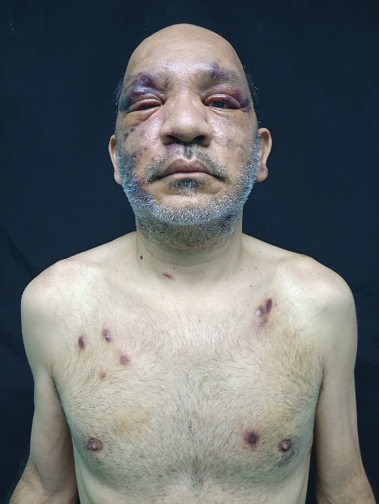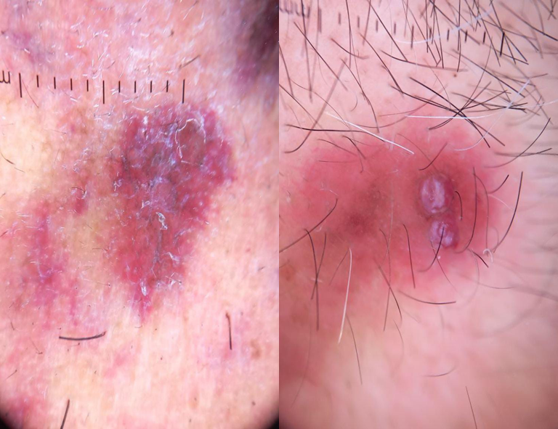

Fig 1 Fig 2

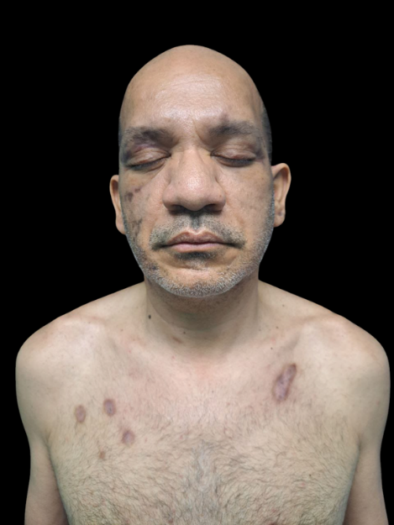

Fig 3

3. discussion

Kaposi's sarcoma (KS) remains one of the most relevant AIDS-defining neoplasms in the clinical context of HIV, although its incidence has decreased significantly thanks to highly active antiretroviral therapy (HAART). This multifocal vascular neoplasm was first described in 1872 by Moritz Kaposi, who documented five cases in men over forty years of age. The etiological agent of KS is human herpesvirus 8 (HHV-8), which remains latent in immunocompetent individuals but can trigger the disease in patients with severe immunosuppression, such as those with advanced HIV. Initial manifestations usually appear in the skin, where erythematous macular lesions evolve into a characteristic violaceous hue, allowing for early diagnosis and improving the prognosis. The progression of KS depends on the degree of immunosuppression; the five-year survival rate is estimated at 69%, while in cases with exclusively cutaneous involvement, the one-year survival rate can reach 90%.

Therapeutic advances have transformed the management of Kaposi's sarcoma (KS). Antiretroviral therapy (ART) not only controls HIV replication but also allows for immune reconstitution, which in many cases leads to spontaneous tumor regression. However, this process can trigger immune reconstitution inflammatory syndrome (IRIS), a paradoxical complication in which latent opportunistic infections, such as KS, are activated or worsen after immune improvement. The incidence of KS associated with IRIS is around 7%, and its treatment requires maintaining ART and adding chemotherapy in advanced cases. Furthermore, cryotherapy has proven effective in treating localized skin lesions, offering a less invasive alternative with a lower adverse effect profile. Reducing immunosuppression has also shown therapeutic benefits, achieving tumor reduction in approximately 50% of cases, especially in cutaneous forms.

The therapeutic approach to Kaposi's sarcoma (KS) must be comprehensive and personalized, considering the extent of the disease, the patient's immune status, and clinical condition. The combination of antiretroviral therapy (ART), local treatments such as cryotherapy, and continuous clinical monitoring is essential to improve prognosis, control tumor progression, and optimize the quality of life of patients with HIV. Although KS has lost some of its clinical impact thanks to medical advances, it remains a relevant condition, especially in regions with limited access to ART. Therefore, early diagnosis and a multidisciplinary approach continue to be fundamental pillars in its management.

4. Conclusion

Kaposi's sarcoma remains an AIDS-defining neoplasm with clinical relevance in HIV-positive patients, especially in contexts of advanced immunosuppression and regions with limited access to antiretroviral therapy. The progression of Kaposi's sarcoma is closely linked to the degree of immunosuppression, underscoring the importance of virological control and immune reconstitution. Therefore, the therapeutic approach must be comprehensive and personalized, combining antiretrovirals with local treatments such as cryotherapy. In this regard, reducing immunosuppression and optimizing immune status have demonstrated substantial benefits in tumor regression, thus improving patients' quality of life.

Consent (where ever applicable)

Clinical images are available in the manuscript and are published with the patient's informed consent.

Ethical approval

All authors declare that ‘written informed consent was obtained from the patient (or other approved parties) for publication of this case report and accompanying images.

DISCLAIMER (ARTIFICIAL INTELLIGENCE)

Author(s) hereby declare that no generative ai technologies such as large language models (chatgpt, copilot, etc) and text-to-image generators have been used during writing or editing of this manuscript.

REFERENCES.

Tukeni, K. N., Kebede, M. L., Abadiko, E. A., Woyimo, T. G., Abafogi, A. K., Ashine, A. H., & Gudina, E. K. (2025). Kaposi sarcoma in an HIV-infected patient with high CD4 count: a case report and literature review. Frontiers in Medicine, 12, 1496863. https://doi.org/10.3389/fmed.2025.1496863
Pérez Abad, L., Juárez Mayor, P., & Ramón y Cajal Calvo, J. (2025). Progresión de sarcoma de Kaposi asociado a VIH en contexto de un síndrome de reconstitución inmune. Acta Médica Grupo Ángeles, 23(2), 192-194. https://doi.org/10.35366/119491
Pérez Abad, L., Juárez Mayor, P., & Ramón y Cajal Calvo, J. (2025). Progresión de sarcoma de Kaposi asociado a VIH en contexto de un síndrome de reconstitución inmune. Acta Médica Grupo Ángeles, 23(2), 192-194. https://doi.org/10.35366/119491
Lasso, B. M., Pérez, G. J., Noriega, R. L., Malebrán, R. A., & Espinoza, V. S. (2003). Sarcoma de Kaposi y VIH: Tratamiento antirretroviral y quimioterapia en 32 pacientes. Revista Médica de Chile, 131(5), 483-490. https://doi.org/10.4067/S0034-98872003000500002
Hernández Dimas, E., Muci-Mendoza, R., & Comegna, M. (2011). Sarcoma de Kaposi asociado a VIH: Uso de doxorrubina loposomal terapia antirretroviral de alta eficicencia. *Revista Venezolana de Oncología*, *23*(1), 14-20. https://www.scielo.org.ve/scielo.php?script=sci_arttext&pid=S0798-05822011000100003

Uriarte-Mayorga, D. F., Gómez-González, B. A., García-Silva, M. C., Rodríguez-Castellanos, M. A., & Hernández-Torres, M. M. (2018). Sarcoma de Kaposi clásico variedad linfangiomatosa tratada con criocirugía: a propósito de un caso. Revista Argentina de Dermatología, 99(2), 1-10. https://www.scielo.org.ar/scielo.php?script=sci_arttext&pid=S1851-300X2018000200001

Alsina, M. M., et al. (1999). Influencia de la terapia antirretroviral de gran actividad en la evolución del sarcoma de Kaposi asociado al VIH. Medicina Clínica, 115(19), 736–737.

Uriarte-Mayorga, D. F., Gómez-González, B. A., García-Silva, M. C., Rodríguez-Castellanos, M. A., & Hernández-Torres, M. M. (2018). Sarcoma de Kaposi clásico variedad linfangiomatosa tratada con criocirugía: a propósito de un caso. Revista Argentina de Dermatología, 99(2), 1–10. https://www.scielo.org.ar/scielo.php?script=sci_arttext&pid=S1851-300X2018000200001

Mendoza Mori, L. M., Valenzuela Medina, J. B., Gotuzzo Herencia, J. E., Bravo Puccio, F. G., Mejía Cordero, F. A., Mohanna Barrenechea, S., & González Lagos, E. V. (2022). Sarcoma de Kaposi en personas que viven con VIH-SIDA en un hospital público de referencia en Perú. Revista Peruana de Medicina Experimental y Salud Pública, 39(3), 352–356. https://doi.org/10.17843/rpmesp.2022.393.10883

Vicente Baz, D., & Fernández Delgado, C. (2005). Infección VIH y sarcoma de Kaposi: a propósito de un caso. Oncología (Barcelona), 28(10), 37-40. http://scielo.isciii.es/scielo.php?script=sci_arttext&pid=S0378-48352005001000005&lng=es&nrm=iso

López, L., Corte Casarreal, L. A., & Navarrete Franco, G. (2007). Sarcoma de Kaposi en paciente VIH. Presentación de un caso. Revista del Centro Dermatológico Pascua, 16(2). https://www.medigraphic.com/cgi-bin/new/resumen.cgi?IDARTICULO=13900

