Review Article
HUMIC ACID: AN ALTERNATIVE TO ANTIBIOTICS IN BROILERS

ABSTRACT
The increasing demand for safe and sustainable poultry production has accelerated the search for natural alternatives to antibiotic growth promoters. Humic acid, a major component of humic substances formed through the decomposition of organic matter, has gained attention for its multifunctional role in poultry nutrition. Dietary supplementation of humic acid improves gut health by enhancing intestinal barrier function, binding pathogens and toxins, and promoting nutrient absorption. It also exhibits strong antioxidant activity through free radical scavenging, metal chelation, and stimulation of endogenous antioxidant enzymes, thereby reducing oxidative stress and improving meat quality. Studies consistently report positive effects of humic acid on growth performance, feed conversion efficiency, nutrient digestibility, carcass yield, immune response, gut microbial balance, and economic efficiency in broiler chickens, with optimal responses observed at moderate inclusion levels. Overall, humic acid represents a cost-effective and promising natural feed additive for antibiotic-free poultry production. However, further research is required to elucidate its metabolic mechanisms, evaluate its performance under diverse climatic conditions, and develop standardized commercial formulations for poultry feeds.
KEY WORDS: Broiler, Antibiotics, Humic
INTRODUCTION
India, with a population of 1.44 billion, has seen rising incomes and improved nutrition, driving a significant increase in demand for eggs and poultry over the past two decades. The total poultry population reached 851.81 million, with backyard and commercial poultry at 317.07 million and 534.74 million, respectively (DAHD, 2019). India produced 142.77 billion eggs in 2023–24, ranking second globally, with per capita availability of 103 eggs, and 10.25 million tonnes of meat, including 5.018 million tonnes of poultry meat (BAHS, 2024).
Poultry farming is a vital global sector, providing high-quality protein efficiently and sustainably. Its adaptability, low carbon footprint, and role in supporting livelihoods make it an important choice for meeting growing protein demand. Enhancing feed and nutritional management, strengthening supply chains, and adopting sustainable practices—including natural feed additives and antibiotic-free farming—are key strategies to bridge the gap between ICMR recommendations and actual per capita availability. While antimicrobial feed additives have historically improved growth and feed efficiency, concerns over bacterial resistance have led to regulatory restrictions, such as the EU phasing out antimicrobial growth promoters (Islam et al.., 2005).
WHAT IS A HUMIC SUBSTANCE?
Organic matter in the soil exists in 3 different forms: (1) Living plant and animal matter, (2) Dead plant and animal matter and (3) decomposed plant and animal matter (humic substances). So, humic substances are the most common forms of organic carbon in the natural environment (Islam et al.., 2005).
Humic substances (HS) are soil-derived substances that form one of the vast reservoirs of organic carbon in nature. HS are primarily produced by physical, chemical and microbial degradation and transformation of plant and animal tissues (humification process) over millions of years. They constitute the bulk of organic matter of the soil – humus, peat, lignites and also brown coal. HSs may also be produced as a by-product of the synthetic oxidation reactions of phenolic compounds. Humic substances contain carbon, hydrogen, oxygen and nitrogen with small amounts of sulfur and phosphorus. They are a mixture of acids that can be fractionated on the basis of differences in their solubility into humic acid (HA), fulvic acid (FvA) and humin fractions, beside ulmic acid, and some microelements (Goel and Dhingra, 2021).
Table 1: SOURCES OF HUMIC SUBSTANCES
Source | Origin | HA (%) | Key Characteristics
Lignite (Brown Coal) | Low-rank coal from decomposed plant material | 40-75% | -Rich in humic & fulvic acids  -Higher carbon content than peat  -Forms under moderate pressure & temperature
Leonardite | Oxidized lignite, found near the earth’s surface | 60-90% | -Highly oxidized (more active than lignite)  -High carboxyl & phenolic groups -Best commercial humic acid source
Peat | Partially decomposed plant material in wetlands | 20-40% | -Intermediate stage between compost & lignite  -Contains humic & fulvic acids  -Found in bogs & wetlands
Compost & Organic Waste | Decomposed plant material & manure | 10-30% | -Rich in microbial activity  -Lower humic acid concentration  -Composition varies by feedstock
Vermicompost | Organic waste processed by earthworms | 10-25% | - Biologically active humic acids  -More bioavailable than compost  -Contains earthworm enzymes
Sapropel (Lacustrine Sediments) | Organic-rich lake sediments | 30-60% | - High in fulvic acids  -Contains aquatic organic residues  -Forms under low-oxygen conditions
(Nsengumuremyi et al.., 2022)
KEY HISTORICAL MILESTONES IN HUMIC ACID RESEARCH
1786 – Franz Karl Achard
- Isolation of Humic Substances from Peat: Franz Karl Achard, a German chemist, was the first to extract humic substances from peat using an alkaline solution. This pioneering work laid the foundation for understanding humic acids.
19th Century – Recognition of Humic Acid's Role in Soil and Plant Growth
- Justus von Liebig (1803–1873) Known as the "father of the fertilizer industry," Liebig challenged the prevailing humus theory, which posited that plants derived their carbon from soil humus. Instead, he demonstrated that plants absorb carbon dioxide from the atmosphere and nutrients from the soil, emphasizing the role of mineral nutrients in plant growth.
Mid-20th Century – Medicinal and Veterinary Applications
- Eastern European and Soviet Research: Researchers in Russia and Eastern Europe began exploring the medicinal properties of humic substances. Studies investigated their antimicrobial and immune-boosting properties, leading to applications in traditional medicine and animal nutrition.


Late 20th Century – Application in Poultry and Livestock Nutrition
Pic 2: Justus von Liebig
Pic 1 Franz Karl Achard
- Detoxification and Immune Enhancement: Scientific studies evaluated humic acids for their ability to bind toxins and enhance immune responses in livestock. Positive outcomes in poultry, swine, and cattle led to the commercial adoption of humic acid supplements in animal feed (International Humic Substances Society, 2012).

Image 1: Extraction of Humic Acid as described by Achard in 1786

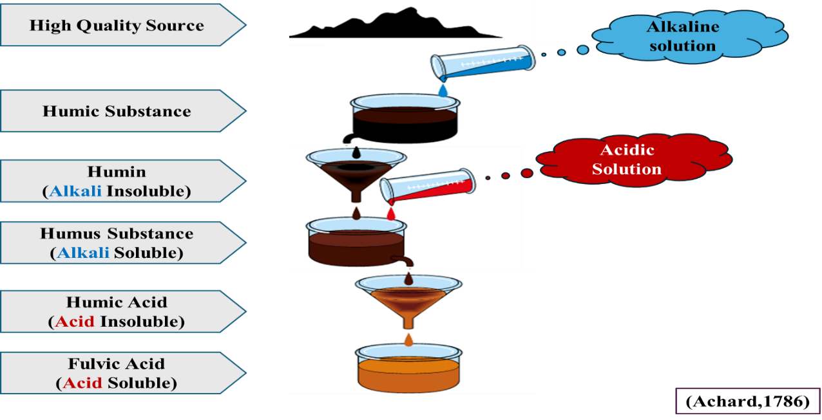
EXTRACTION OF HUMIC ACID
The extraction of humic substances begins with treating a high-quality organic source with an alkaline solution, such as sodium hydroxide or potassium hydroxide. This process dissolves humic substances while leaving behind humin, which is insoluble under alkaline conditions and is subsequently filtered out. The resulting solution contains both humic acid and fulvic acid. To separate these components, an acidic solution, such as hydrochloric acid, is added. This acidification causes humic acid to precipitate, as it is insoluble in acidic conditions, while fulvic acid remains dissolved in the solution. The final separation is achieved through filtration, where the solid fraction collected is humic acid, and the liquid portion contains fulvic acid (Achard,1786).
Fig 1: CHEMICAL PROPERTIES OF HUMIC SUBSTANCES (Stevenson, 1982)
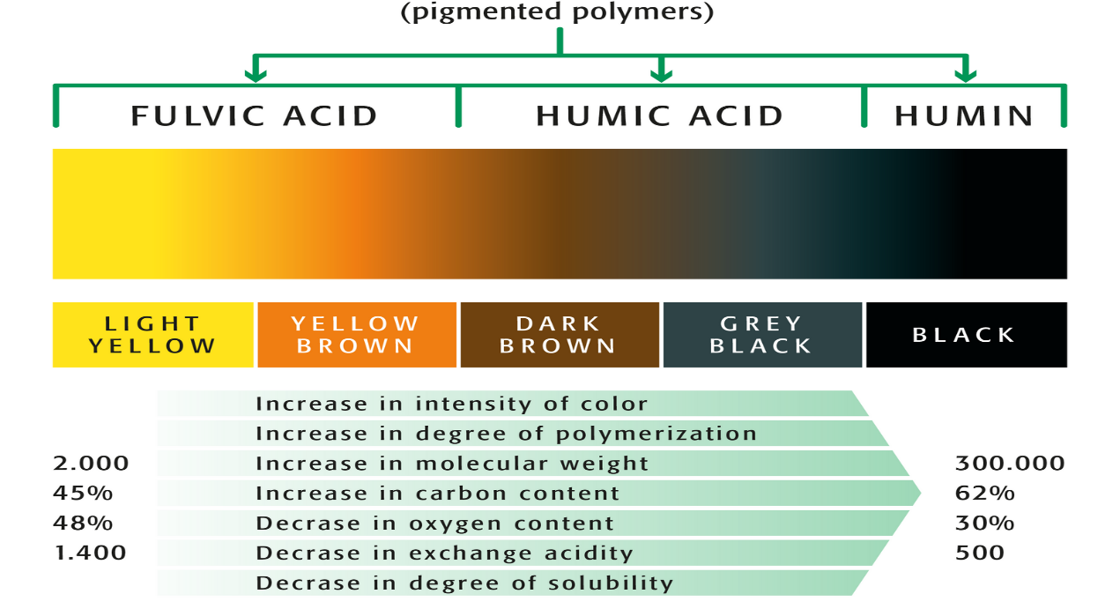
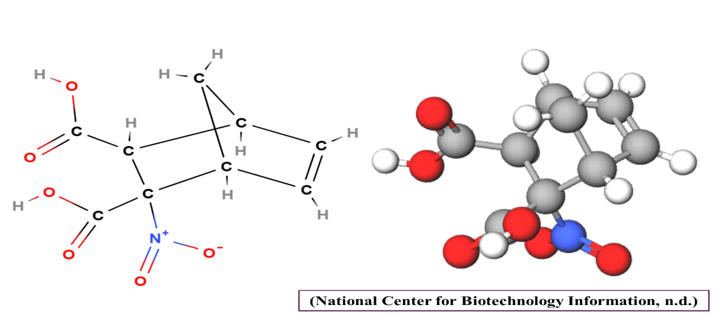
Fig 2: CHEMICAL STRUCTURE OF HUMIC ACID (C₉H₉NO₆)

FUNCTIONS OF HUMIC ACID
- Gut Health
- Colloidal Aggregation and Barrier Formation
HS molecules exhibit colloidal properties due to their large molecular size and surface charge. In aqueous environments (such as the intestinal lumen), HS particles aggregate and adhere to the epithelial surface. In slightly alkaline intestinal pH, HS undergoes polymerization, forming a viscous gel-like protective film. This physical barrier reduces direct contact between intestinal epithelial cells and pathogens/toxins (Gonzalez et al.., 2018; Cozzolino et al.., 2001).
- Viscosity Modification
Development of gels causes increased viscosity in the small intestine. Increased viscosity slows down digesta transit time, allowing longer exposure of nutrients to digestive enzymes. This optimizes enzymatic hydrolysis and nutrient absorption efficiency (Yasar, 2003). HS lowers paracellular permeability, inhibit bacterial translocation from the intestine to the liver, and lower the serum levels of an intestinal permeability marker, fluorescein isothiocyanate dextran (Gonzalez et al.., 2018).
- Collagen Crosslinking and Structural Reinforcement
HS directly interacts with collagen fibers within the intestinal matrix. This enhances collagen fiber maturation and crosslinking, improving villus structural integrity. The strengthened villi are more resistant to mechanical damage and environmental stressors (Yasar et al.., 2002).
- Microbial Adsorption and Toxin Binding
HS possesses negatively charged functional groups (carboxyl, phenolic). These groups bind positively charged microbial adhesins, preventing bacterial attachment to epithelial cells. HS also binds bacterial toxins (e.g., enterotoxins, LPS), reducing their bioavailability. Reduces translocation of endotoxins from the gut into the portal blood and inflammatory damage to the liver is reduced (Vetvicka et al.., 2015).
This protection is evident from: Lower serum ALT, AST, ALP (hepatic stress markers). Higher hepatic glutathione (GSH), SOD, and CAT activity, preserving liver cell function and mitochondrial integrity.
- Mucin Regulation and Goblet Cell Stimulation
HS interacts with mucosal receptors and regulatory pathways, stimulating goblet cell proliferation. HS upregulates MUC-2 gene expression, increasing mucin production. Mucin forms the primary component of intestinal mucus, enhancing mucosal lubrication and pathogen exclusion. By enhancing mucin production and increasing IgA storage within mucus, HS indirectly supports mucosal immunity (Lopez-Gracia et al.., 2023).
- Antioxidant Status
- Redox Buffer System
Humic substances (HS) contain quinones and phenolic groups. Quinones act as electron acceptors, while phenols act as electron donors. This dual system forms a redox buffering mechanism. This allows HS to continuously neutralize reactive oxygen species (ROS) and interrupt oxidative chain reactions in the digestive tract, blood, and liver (Aeschbacher et al.., 2012).
- Free Radical Scavenging
HS directly bind and neutralize free radicals, including Superoxide anion (O₂•⁻), Hydroxyl radicals (OH•), Peroxides (ROOH). This reduces lipid peroxidation, Lower malondialdehyde activity (MDA) (Marker of lipid peroxidation) in serum, liver, and muscle tissues (Aeschbacher et al.., 2012).
- Enzyme – Secondary Antioxidant Defence
Beyond direct scavenging, HS upregulate endogenous antioxidant enzymes.
  - Superoxide Dismutase (SOD): Converts superoxide to hydrogen peroxide.
  - Glutathione Peroxidase (GSH-Px): Detoxifies peroxides into water.
  - Glutathione Reductase (GSH-Rx): Regenerates reduced glutathione.
  - Catalase (CAT): Converts hydrogen peroxide into water and oxygen.
Enzymes activation is due to increase in the concentration of trace minerals (Zn, Se, Cu, Mn) in the liver, which are part of the active centers of metal proteins (Zatko et al.., 2015). HA are able to chelate metals, especially iron and copper, inhibiting the formation of free radicals via transition metal catalysis, thereby controlling lipid peroxidation and DNA fragmentation (Melo et al.., 2016).
- Meat Quality & Shelf-Life Improvement
HS supplementation reduces lipid oxidation in meat, particularly during post-slaughter storage. In breast meat and thigh muscle: Lower MDA formation indicates better oxidative stability. Color stability (lightness, yellowness) is better preserved. HS also reduce muscle fat content, which indirectly enhances oxidative stability by lowering susceptibility to lipid oxidation. This dual effect (lower fat + higher antioxidant reserves) extends shelf life and improves meat quality (Aksu et al.., 2005).
- Immune Response and Inflammation
- Direct Interaction with Immune Cells (Cell Signaling)
HS form complexes with carbohydrates which allow the formation of glycoproteins with the ability to bind to natural killer cells and T lymphocytes and allow subsequent communication between these cells. This mechanism enhances early immune recognition and faster activation of immune defense mechanisms (Schepetkin et al.., 2003).
- Lymphoid Organ Development and Immunocompetence
HS supplementation promotes the development of primary lymphoid organs by Increase lymphoid tissue density and size in bursa of Fabricius and thymus. This indicates enhanced maturation and proliferation of immune cells (B and T lymphocytes), critical for strong adaptive immunity in poultry (Disetlhe et al.., 2017).
- Humoral Immunity Enhancement (Antibody Production)
In HS-fed broilers, higher antibody titers are found against common poultry pathogens: Infectious Bursal Disease (IBD), Newcastle Disease Virus (NDV), Avian Influenza (AI). HS also increase serum immunoglobulin levels (IgG, IgM), indicating stronger systemic humoral immunity in laying hens (Zhang et al.., 2020).
- Cellular Immunity Enhancement (Phagocytosis & Leukocyte Function)
HS supplementation increases lymphocyte, leukocyte counts, phagocytic index and phagocytic activity of immune cells (macrophages, neutrophils). This reflects enhanced innate immune function, critical for first-line defense against infections. Stronger cellular immunity also supports faster clearance of pathogens in HS-fed birds (Salah et al.., 2015).
EFFECT OF HUMIC ACID ON DIFFERENT PARAMETERS
Humic acid has gained considerable attention as a natural feed additive in poultry nutrition due to its multifaceted effects on growth performance, feed efficiency, gut health, antioxidant status, carcass traits and economic returns. A detailed evaluation of the available literature clearly indicates that humic acid supplementation exerts its beneficial effects primarily through improved nutrient utilization, modulation of gut microflora, enhancement of antioxidant defense mechanisms, and optimization of metabolic efficiency. However, the magnitude of response largely depends on the inclusion level, source of humic substances and the age and genetic background of the birds.
Effect of Humic Acid on Feed Intake
The collective findings from the reviewed studies indicate that humic acid supplementation exerts a neutral to moderately reducing effect on feed intake, depending on the inclusion level. Naik et al.. (2024) demonstrated that supplementation at 0.02% and 0.04% humic substance did not significantly alter cumulative feed intake when compared with the control diet, while the 0.04% level produced feed intake values comparable to the antibiotic-supplemented group. This observation is important, as it confirms that humic acid does not negatively influence feed palatability. Similarly, Ghazalah et al.. (2022) reported no significant variation in cumulative feed intake across inclusion levels ranging from 1 to 4 g/kg, further supporting the notion that humic acid supplementation does not disrupt voluntary feed consumption in broilers.
In contrast, Domínguez-Negrete et al.. (2021) observed a significant reduction in feed intake at higher inclusion levels of 0.30% and 0.45% humic substance. Comparable trends were reported by Asmaa ElNaggar and El-Kelawy (2018), who recorded the lowest feed intake at 0.1% humic acid, and by Arif et al.. (2016), who observed reduced feed intake at 2.25 and 3 g/kg humic acid. When these reductions are evaluated alongside improvements in body weight gain and feed conversion ratio reported in the same studies, it becomes evident that reduced feed intake reflects improved feed utilization efficiency rather than impaired appetite. Therefore, humic acid supplementation appears to enable broilers to achieve improved growth performance while consuming less feed, particularly at optimal inclusion levels.
Effect of Humic Acid on Body Weight
Growth performance, as measured by body weight and body weight gain, consistently improved with humic acid supplementation across multiple studies. Naik et al.. (2024) reported significantly higher average body weight in broilers receiving 0.04% humic substance, with performance comparable to birds fed antibiotic growth promoters. Ghazalah et al.. (2022) similarly demonstrated significant improvements in body weight gain across all humic acid-supplemented groups, with the highest response observed at 2 g/kg. These findings suggest that humic acid can effectively enhance growth performance when included at moderate levels.
Further support is provided by Hammod et al.. (2021), who reported significantly higher body weight and weight gain in broilers supplemented with 1 ml/kg (concentration of humic acid ?) humic acid compared to control birds. Asmaa ElNaggar and El-Kelawy (2018) identified 0.1% humic acid as the most effective level for maximizing live body weight and weight gain, while Arif et al.. (2016) observed the highest weight gain at 2.25 g/kg humic acid. Although higher inclusion levels continued to show improvements over the control, the most pronounced growth responses were consistently observed at low to moderate inclusion levels, indicating the presence of an optimal supplementation range.
Effect of Humic Acid on Feed Conversion Ratio (FCR)
Feed conversion ratio (FCR) is a critical indicator of production efficiency, integrating both feed intake and growth performance. Naik et al.. (2024) reported significantly improved FCR in broilers supplemented with 0.04% humic substance, with values comparable to those achieved using antibiotic supplementation. Ghazalah et al.. (2022) observed significant improvements in FCR across all humic acid inclusion levels, with the best efficiency recorded at 2 g/kg. Similarly, Domínguez-Negrete et al.. (2021) documented improved FCR at all humic substance levels, with the most efficient response at 0.15%. Asmaa ElNaggar and El-Kelawy (2018) reported the best FCR at 0.1% humic acid, while Arif et al.. (2016) observed the most favorable FCR values at 2.25 and 3 g/kg. These consistent improvements across studies highlight the ability of humic acid to enhance nutrient utilization efficiency. Importantly, although higher inclusion levels improved FCR relative to the control, the most efficient and economically favorable responses were achieved at moderate supplementation levels.
Effect of Humic Acid on Nutrient Digestibility
Enhanced nutrient digestibility represents a key mechanism through which humic acid improves broiler performance. Ghazalah et al.. (2022) reported significant improvements in crude protein and ether extract digestibility at inclusion levels of 1–3 g/kg, while crude fiber, dry matter, and ash retention were not significantly affected. Asmaa ElNaggar and El-Kelawy (2018) similarly observed significant enhancements in crude protein, ether extract, and dry matter digestibility, with the best responses at 0.1% humic acid. These findings indicate that humic acid primarily enhances the digestibility of nutrients directly involved in growth and energy supply. Improved protein digestibility supports muscle deposition, while enhanced ether extract digestibility contributes to increased metabolizable energy availability. The limited effects on crude fiber and ash retention suggest that humic acid acts selectively on nutrient utilization rather than broadly altering all digestive processes.
Effect of Humic Acid on Carcass Characteristics
Carcass evaluation results further support the beneficial effects of humic acid supplementation. Naik et al.. (2024a) reported a significantly higher dressing percentage in broilers supplemented with 0.04% humic substance, while breast yield showed a non-significant improvement and organ weights remained unaffected. Ghazalah et al.. (2022) observed increased carcass yield at 1–3 g/kg humic acid and a significant reduction in abdominal fat at 4 g/kg. Jaduttova et al.. (2019) reported non-significant changes in overall carcass yield but observed significant improvements in breast and thigh yield at 1.0% humic substance. Asmaa ElNaggar and El-Kelawy (2018) demonstrated improved dressing percentage and reduced abdominal fat at 0.1–0.2% humic acid. Collectively, these findings suggest that humic acid supplementation promotes lean tissue deposition while reducing excessive fat accumulation.
Effect of Humic Acid on Antioxidant Capacity
Oxidative stress is a major concern in fast-growing broilers, and humic acid supplementation has been shown to enhance antioxidant defense mechanisms. Ghazalah et al.. (2022) reported significant increases in total antioxidant capacity, GSH, GPX, and SOD at inclusion levels of 1–4 g/kg, along with a reduction in malondialdehyde at 1 g/kg. Asmaa ElNaggar and El-Kelawy (2018) observed significant improvements in GPX and SOD at 0.1% and 0.2% humic acid, while TAC and GSH remained unaffected. These findings indicate that humic acid supplementation strengthens endogenous antioxidant systems, thereby reducing oxidative stress and supporting improved growth and health.
Effect of Humic Acid on Bacterial Count
Gut microbial modulation is another important benefit of humic acid supplementation. Domínguez-Negrete et al.. (2021) observed increased lactic acid bacteria counts at 0.45% humic substance during early growth stages, suggesting enhanced colonization of beneficial bacteria. Asmaa ElNaggar and El-Kelawy (2018) reported significant reductions in total bacterial count, Salmonella, E. coli, and Proteus at 0.1–0.4% humic acid. These results indicated that humic acid contributes to a healthier gut microbial balance, which is closely linked to improved nutrient utilization and immune status.
Effect on Blood Biochemistry
The reviewed studies clearly demonstrate that dietary supplementation of humic acid exerts a significant influence on blood biochemical parameters in broiler chickens, reflecting improved metabolic, hepatic, renal, and endocrine functions. Ghazalah et al.. (2022) reported a marked increase in blood glucose concentration in humic acid–supplemented groups across all inclusion levels compared to the control. Elevated glucose levels indicate enhanced carbohydrate metabolism and improved energy availability, which is critical for rapid growth in broilers. This improvement may be attributed to enhanced intestinal absorptive capacity and improved nutrient utilization associated with humic acid supplementation, as reported in performance and digestibility studies.
In addition to glucose, significant increases in thyroid hormones (T3 and T4) were observed with humic acid supplementation. Thyroid hormones play a vital role in regulating basal metabolic rate, protein synthesis, lipid metabolism, and growth. The increased levels of T3 and T4 indicate stimulation of metabolic activity, which supports higher growth rates and improved feed efficiency. Importantly, the T3/T4 ratio remained unchanged, suggesting that humic acid supplementation enhances thyroid activity without disturbing hormonal homeostasis. This balanced endocrine response indicates physiological adaptation rather than stress-induced hormonal changes.
Findings from Asmaa Sh. ElNaggar and El-Kelawy (2018) further support these observations. The significant increase in serum glucose at 0.1% humic acid inclusion reinforces the role of humic acid in improving energy metabolism. Moreover, significant reductions in serum urea and creatinine levels at higher inclusion levels suggest improved kidney function and more efficient nitrogen metabolism. Lower urea concentration reflects reduced protein breakdown and enhanced amino acid utilization, while reduced creatinine indicates improved renal clearance and reduced muscle protein degradation.
Liver enzymes such as ALT and AST were significantly reduced, particularly at 0.1% humic acid inclusion, indicating improved liver health and hepatoprotective effects. Since the liver is central to nutrient metabolism, detoxification, and hormone conversion, improved liver enzyme profiles further explain the enhanced growth performance and feed efficiency reported in humic acid–supplemented broilers. Thyroid hormone T4 was significantly elevated across humic acid treatments, supporting increased metabolic activity. The absence of changes in ALP levels suggests that humic acid did not negatively affect bone metabolism.
Jaduttova et al.. (2019) also observed beneficial effects of humic substances on blood enzymes. A significant reduction in AST at 0.8% humic substance inclusion further confirms hepatoprotective effects. The observed reduction in serum calcium and phosphorus concentrations was attributed to the chelating properties of humic substances, facilitating mineral deposition in bone tissue rather than remaining in circulation. This redistribution reflects improved mineral utilization rather than deficiency.
Effect on Protein Profile
Protein profile analysis provides valuable insight into nutritional status and immune competence. Ghazalah et al.. (2022) reported significant improvements in total protein and globulin concentrations with humic acid supplementation. Increased total protein levels indicate enhanced protein synthesis and improved nutrient assimilation. The rise in globulin concentration, particularly β-globulin and γ-globulin fractions, suggests enhanced immune function, as these proteins are closely associated with antibody production and immune defense mechanisms. The absence of significant changes in albumin concentration indicates that humic acid selectively enhanced immune-related protein synthesis without disturbing osmotic balance or transport functions. The reduced albumin-to-globulin ratio further confirms immune stimulation rather than pathological protein alteration.
Similarly, Asmaa Sh. ElNaggar and El-Kelawy (2018) reported significant increases in total protein and globulin concentrations in humic acid–supplemented birds. The pronounced increase in γ-globulin concentration strongly indicates enhanced humoral immunity. Variations in albumin and β-globulin levels suggest dose-dependent modulation of protein metabolism. Collectively, these findings demonstrate that humic acid supplementation improves protein utilization efficiency and immune protein synthesis, contributing to improved disease resistance and overall performance.
Effect on Lipid Profile
Lipid metabolism is a critical determinant of carcass quality and metabolic health. Ghazalah et al.. (2022) reported significant reductions in total lipid, cholesterol, and LDL concentrations with humic acid supplementation. Reduced cholesterol and LDL levels indicate improved lipid metabolism and reduced fat deposition, which may explain the reduced abdominal fat observed in carcass studies. The non-significant changes in HDL and VLDL suggest that humic acid selectively reduces harmful lipid fractions without compromising beneficial lipoproteins. Jaduttova et al.. (2019) also reported significant reductions in cholesterol levels, particularly at 1.0% humic substance inclusion. Asmaa Sh. ElNaggar and El-Kelawy (2018) further confirmed significant reductions in total lipids, triglycerides, cholesterol, LDL, and HDL levels. These consistent findings indicate that humic acid improves lipid utilization, reduces lipogenesis, and promotes healthier lipid profiles in broilers.
Effect on Immunity
Naik et al.. (2024b) reported a non-significant numerical increase in antibody titers against Newcastle disease and Infectious bursal disease in humic substance–supplemented groups. Although the differences were not statistically significant, the numerical improvement indicates a supportive effect of humic substances on immune responsiveness without overstimulation. Ahfeethah et al.. (2023) demonstrated that prolonged humic acid supplementation maintained higher antibody titers at later growth stages. This suggests that humic acid enhances immune persistence and long-term humoral immunity rather than inducing a short-term immune response. The absence of significant differences at early stages confirms homogeneity of maternal immunity, while improved titers at later stages highlight the immunomodulatory role of humic acid.
Effect of Humic Acid on Economy
Economic evaluations consistently demonstrated the cost-effectiveness of humic acid supplementation. Ghazalah et al.. (2022) reported the highest economic efficiency at 2 g/kg humic acid, while Asmaa ElNaggar and El-Kelawy (2018) identified 0.1% humic acid as the most economically favorable inclusion level. These findings indicate that moderate supplementation levels provide the best balance between improved performance and feed cost.
Overall, the reviewed literature clearly demonstrates that humic acid supplementation, particularly at low to moderate inclusion levels, consistently enhances broiler performance, feed efficiency, nutrient utilization, carcass quality, antioxidant status, gut health, and economic returns.
SUMMARY & CONCLUSIONS
Humic acid supplementation in poultry feed reduces dependency on antibiotics and serves as a cost-effective natural alternative for commercial production, as it significantly improves feed conversion efficiency and body weight gain, with an effective supplementation level reported around 2 g/kg feed. It enhances crude protein, ether extract, and dry matter digestibility by improving nutrient absorption through modulation of intestinal viscosity. In addition, humic acid improves antioxidant capacity, increases dressing percentage with a positive effect on muscle deposition, and reduces abdominal fat content, thereby enhancing oxidative stability, meat quality, and shelf life. It also promotes beneficial gut microbiota during early broiler growth and effectively lowers total bacterial count, including E. coli and Salmonella, thus contributing to better gut health and overall performance.
FUTURE PROSPECTS
- Further research is required to assess the effects of humic acid under Indian climatic conditions.
- The precise metabolic mechanism of humic acid in poultry remains unclear.
- Humic acid is not commercially available in a pure form for poultry feed; it is typically found in combination with amino acids.
Note- Text in blue fonts may be added in manuscript and in red fonts may be deleted from manuscript
REFRENCES
Aeschbacher, M., Graf, C., Schwarzenbach, R. P., & Sander, M. (2012). Antioxidant properties of humic substances. Environmental Science & Technology, 46(9), 4916-4925. https://doi.org/10.1021/es300039h
Ahfeethah, F., Elazomi, A., & Kammon, A. (2023). Effect of humic acid and probiotics on immunity of broiler chickens. Open Veterinary Journal, 13(7), 839-845. https://doi.org/10.5455/OVJ.2023.v13.i7.5
Aksu, M. İ., Karaoǧlu, M., Kaya, M., Esenbuǧa, N., & Maci̇t, M. (2005). Effect of dietary humate on the pH, TBARS and microbiological properties of vacuum‐ and aerobic‐packed breast and drumstick meats of broilers. Journal of the Science of Food and Agriculture, 85(9), 1485-1491. https://doi.org/10.1002/jsfa.2143
Arif, M., Rehman, A., Saeed, M., Abd El-Hack, M. E., Arain, M. A., Arshad, M. H., Zakria, H. M., & Abbasi, I. H. (2016). Impacts of dietary humic acid supplementation on growth performance, some blood metabolites, and carcass traits of broiler chicks. Indian Journal of Animal Sciences, 86(9), 1073–1078. https://doi.org/10.56093/ijans.v86i9.61586
BAHS (2024). Department of Animal Husbandry and Dairying, Ministry of Fisheries, Animal Husbandry & Dairying, Government of India. Retrieved from https://dahd.gov.in/sites/default/files/2024-11/BAHS-2024.pdf
Cozzolino, A., Conte, P., & Piccolo, A. (2001). Conformational changes of humic substances induced by some hydroxy-, keto-, and sulfonic acids. Soil Biology and Biochemistry, 33(4-5), 563-571. https://doi.org/10.1016/S0038-0717(00)00196-6
DAHD (2019). 20th Livestock Census of Department of Animal Husbandry and Dairying. Retrieved from https://ruralindiaonline.org/en/library/resource/20th-livestock-census-2019-all-india-report/
Disetlhe, A. R. P., Marume, U., Mlambo, V., & Dinev, I. (2017). Humic acid and enzymes in canola-based broiler diets: Effects on bone development, intestinal histomorphology and immune development. South African Journal of Animal Science, 47(6), 914-922. https://doi.org/10.4314/sajas.v47i6.19
Domínguez-Negrete, A., Gómez-Rosales, S., Angeles, M. D. L., López-Hernández, L. H., Reis de Souza, T. C., Latorre-Cárdenas, J. D., & Téllez-Isaias, G. (2021). Addition of different levels of humic substances extracted from worm compost in broiler feeds. Animals, 11(11), 3199. https://doi.org/10.3390/ani11113199
ELnaggar, A. S., & El-Kelawy, M. I. (2018). Effect of humic acid supplementation on productive performance, blood constituents, immune response and carcass characteristics of sasso chicken. Egyptian Journal of Animal Production, 55(1), 75-84. https://doi.org/10.21608/ejap.2018.93258
Ghazalah, A., El-Tahawy, W. S., Ghalwash, A. A., & ELnaggar, A. S. (2022). Productive and physiological response of broiler chicks to dietary humic acid. Egyptian Poultry Science Journal, 42(II), 157–170.
Goel, P., & Dhingra, M. (2021). Humic substances: Prospects for use in agriculture and medicine. In Humic substances. https://doi.org/10.5772/intechopen.99651
Hammod, A. J., Zeny, Z. A. H., Mahdi, A. S., & Alfertosi, K. A. (2021). Probiotic and humic acid as feed additives and their effects on productive and economic traits of broiler. Indian Journal of Ecology, 48(13), 35-37.
International Humic Substances Society. (2012). 30 years of IHSS. International Humic Substances Society. https://humic-substances.org/wp-content/uploads/30-years-of-IHSS-1982-2012.pdf
Islam, K. M. S., Schuhmacher, A., & Gropp, J. M. (2005). Humic acid substances in animal agriculture. Pakistan Journal of Nutrition, 4(3), 126-134. https://doi.org/10.3923/pjn.2005.126.134
Jaďuttová, I., Marcinčáková, D., Bartkovský, M., Semjon, B., Harčárová, M., Nagyová, A., Váczi, P., & Marcinčák, S. (2019). The effect of dietary humic substances on the fattening performance, carcass yield, blood biochemistry parameters and bone mineral profile of broiler chickens. Acta Veterinaria Brno, 88(3), 307-313. https://doi.org/10.2754/avb201988030307
López-García, Y. R., Gómez-Rosales, S., Angeles, M. d. L., Jiménez-Severiano, H., Merino-Guzman, R., & Téllez-Isaias, G. (2023). Effect of the Addition of Humic Substances on Morphometric Analysis and Number of Goblet Cells in the Intestinal Mucosa of Broiler Chickens. Animals, 13(2), 212. https://doi.org/10.3390/ani13020212
Maguey-Gonzalez, J. A., Michel, M. A., Baxter, M. F. A., Tellez Jr, G., Moore Jr, P. A., Solis-Cruz, B., Hernández-Patlan, D., Merino-Guzman, R., Hernandez-Velasco, X., Latorre, J. D., Hargis, B. M., Gomez-Rosales, S., & Tellez-Isaias, G. (2018). Effect of humic acids on intestinal viscosity, leaky gut and ammonia excretion in a 24 hr feed restriction model to induce intestinal permeability in broiler chickens. Animal Science Journal, 89(7), 1002-1010. https://doi.org/10.1111/asj.13011
Melo, B. A. G., Motta, F. L., & Santana, M. H. A. (2016). Humic acids: Structural properties and multiple functionalities for novel technological developments. Materials Science and Engineering: C, 62, 967–974. https://doi.org/10.1016/j.msec.2015.12.001
Naik, V. D., Indresh, H. C., Krishnamurthy, T. N., & Ruban, W. (2024). Effect of supplementing humic substance on growth performance in broilers. International Journal of Advanced Biochemistry Research, 8(5), 228-232. https://doi.org/10.33545/26174693.2024.v8.i5c.1074
Naik, V. D., Indresh, H. C., Krishnamurthy, T. N., Handige, S., & Dakshith, P. L. (2024). Effect of supplementing humic substance on carcass characteristics in broilers. International Journal of Veterinary Sciences and Animal Husbandry, 9(3), 26-29. https://www.veterinarypaper.com/journal/vol-9-issue-3-part-a-2024/812-effect-of-supplementing-humic-substance-on-carcass-characteristics-in-broilers
National Center for Biotechnology Information. (n.d.). Humic Acids. PubChem Compound Summary. https://pubchem.ncbi.nlm.nih.gov/compound/Humic-acid
Nsengumuremyi, D., Havugimana, S., & Barakova, N. V. (2022). The Contribution of Humic Substances in Improving Agriculture and Livestock Sector in African Great Lakes Region: A Review. In A. Makan (Ed.), Humus and Humic Substances - Recent Advances. IntechOpen. https://doi.org/10.5772/intechopen.107526
Salah, H., Mansour, E., & Abd El Hamid, E. S. (2015). Study on the effect of humic acid on growth performance, immunological, some blood parameters and control intestinal closterdium in broiler chickens. Zagazig Veterinary Journal, 43(1), 102-109. https://doi.org/10.21608/zvjz.2015.29352
Schepetkin, I. A., Khlebnikov, A. I., Ah, S. Y., Woo, S. B., Jeong, C. S., Klubachuk, O. N., & Kwon, B. S. (2003). Characterization and biological activities of humic substances from mumie. Journal of Agricultural and Food Chemistry, 51(18), 5245-5254. https://doi.org/10.1021/jf021101e
Stevenson, F. J. (1982). Humus chemistry: genesis, composition, reactions. John Wiley & Sons.
Vetvicka, V., Garcia-Mina, J. M., & Yvin, J. C. (2015). Prophylactic effects of humic acid-glucan combination against experimental liver injury. Journal of Intercultural Ethnopharmacology, 4(3), 249-255. https://doi.org/10.5455/jice.20150519103113
Von Berzelius, J. J. F. Franz Karl Achard (1753–1821).

Yasar, S. (2003). Performance, Gut Size and Ileal Digesta Viscosity of Broiler Chickens Fed with a Whole Wheat Added Diet and the Diets with Different Wheat Particle Sizes. International Journal of Poultry Science, 2(1), 75-82. https://doi.org/10.3923/ijps.2003.75.82
Yasar, S., Gokcimen, A., Altuntas, I., Yonden, Z., & Petekkaya, E. (2002). Performance and ileal histomorphology of rats treated with humic acid preparations. Journal of Animal Physiology and Animal Nutrition, 86(7‐8), 257-264. https://doi.org/10.1046/j.1439-0396.2002.00383.x
Žatko, D., Vašková, J., Vaško, L., & Patlevič, P. (2014). The effect of humic acid on the content of trace element in mitochondria. American Journal of Animal and Veterinary Sciences, 9(4), 315-319. https://doi.org/10.3844/ajavssp.2014.315.319
Zhang, A. R., Pirzado, S. A., Liu, G. H., Chen, Z. M., Chang, W. H., Cai, H. Y., Bryden, W. L., & Zheng, A. J. (2020). Dietary supplementation with sodium humate improves egg quality and immune function of laying hens. Journal of Applied Animal Nutrition, 8(2), 93-100. https://doi.org/10.3920/JAAN2020.0009

