Original Research Article
Cow-level production traits and their association with mastitis and metabolic disorders in dairy cows raised in an intensive farming system under tropical weather

ABSTRACT
Aims: This study aimed to assess farm and cow-level production characteristics and identify factors associated with milk yield and mastitis occurrence in dairy cows managed under intensive systems in Dhaka, Bangladesh.
Study design: A cross-sectional observational study.
Place and Duration of the study: Five dairy farms located in different regions of Dhaka district, Bangladesh, and data collected from 1 January to 31 December 2023.
Methodology: Data was collected through face-to-face interviews with farmers and by reviewing farm register books. A structured, pretested questionnaire was used to record farm-level variables (roughage and concentrate quantities, number of lactating cows, daily milk yield) and cow-level characteristics (breed, age, body weight, BCS, parity, lactation stage, feed intake, and disease frequency). Twenty-five cows (five per farm) were randomly selected. Descriptive statistics were performed, and categorical variables were expressed as percentages. Univariable linear regression was conducted using milk yield as the outcome variable, with significance set at p ≤ 0.20.
Results: The farms averaged 45 lactating cows producing 670 L/day, with mean daily roughage and concentrate intake of 934.4 kg and 475.4 kg, respectively. Most cows were crossbred (96%), aged ≤6.4 years (52%), and had good BCS (60%). Milk fever (96%), acidosis (72%), and mastitis (60%) were common. Body weight (β=1.4) and roughage intake (β=1.5) showed positive associations with milk yield, whereas BCS and mastitis showed negative trends. Mastitis was more frequent among cows with higher milk yield, higher parity, and roughage intake of 21.1–30 kg/day.
Conclusion: Cow-level traits, nutritional intake, and lactation factors influence milk yield and mastitis risk in intensive dairy systems, indicating the need for improved feeding management and targeted health interventions.

- INTRODUCTION
Dairy production in tropical regions is increasingly shifting toward intensive and semi-intensive farming systems to meet rising demand for milk and to improve productivity per animal (Apdini et al., 2024; Clay et al., 2020). In order to continue profitable and sustainable operations, dairy production systems around the world mostly depend on maximizing cow-level performance metrics such milk yield, body condition score (BCS), parity, and feed intake (Evers et al., 2023; Lee and Kim, 2006; Wattiaux, 2023). In low- and middle-income countries (LMICs), including Bangladesh, the expanding dairy sector faces critical challenges related to disease burden, inadequate nutritional management, and limited farm-level monitoring systems (FAO, 2014; Islam et al., 2020; Salauddin et al., 2025; Balehegn et al., 2020; Birhan et al., 2023). In Bangladesh, crossbred Holstein- and Jersey-derived cows now dominate commercial herds due to their superior genetic potential for milk yield compared with indigenous cattle (Islam et al., 2010; Islam et al., 2019). Although genetic improvement programs and crossbreeding have increased milk yield across many South Asian dairy farms, these high-producing crossbreds are physiologically more sensitive to heat stress, metabolic strain, and nutritional imbalances commonly occurring in tropical climates which leads to the disproportionately high prevalence of production-limiting diseases such as mastitis, metabolic acidosis, and hypocalcemia (milk fever) (Das et al., 2016; Oliveira et al., 2o25; Becker et al., 2020; Ghasemi et al., 2024). These diseases not only reduce milk productivity but also compromise animal welfare, increase treatment costs, and lead to premature culling (Seegers et al., 2003)
Mastitis remains the costliest disease in dairy cattle worldwide, responsible for substantial milk loss, reduced udder function, increased treatment cost, and premature culling effects that are especially severe in high-yielding cows (Seegers et al., 2003). Multiparous and higher-yielding cows experience greater metabolic load, udder tissue strain, and cumulative teat-end damage, predisposing them to intramammary infections (Riekerink et al., 2007). Environmental factors also contribute, as intensive systems often generate increased manure accumulation and bedding contamination, heightening exposure to environmental mastitis pathogens (Nogara et al., 2023; Zehner et al., 1986).
Metabolic disorders such as subacute ruminal acidosis (SARA) and milk fever are also prevalent in poorly balanced intensive feeding systems. High feed intake, excessive concentrate supplementation, and inconsistent forage quality disrupt rumen fermentation and calcium metabolism, impair immune function, and increase disease susceptibility (Tufarelli et al., 2024; Elmhadi et al., 2022; Fan et al., 2024; Hou et al., 2025). These disorders are common in tropical climates, where heat stress further compromises feed intake, energy balance, and endocrine responses (Martens et al., 2023).
Despite the relevance of these issues, limited research in Bangladesh has simultaneously evaluated cow-level production traits, feeding patterns, and disease occurrence within intensive systems. Existing studies primarily describe disease prevalence or general production constraints but lack integrated assessment of how traits such as body condition, parity, lactation stage, and feed intake relate to mastitis and metabolic morbidity in tropical dairy herds.
The present study addresses this knowledge gap by examining cow-level production characteristics and their associations with mastitis, acidosis, and milk fever in intensive dairy farms in Dhaka, Bangladesh. By analyzing a combination of herd-level feeding practices, cow-level demographics, nutritional traits, and disease frequency, this study provides essential insights into the interplay between production, nutrition, and health under tropical intensive management. These findings have important implications for improving herd performance, reducing disease risk, and guiding targeted interventions.

- MATERIALS AND METHODS
The study was conducted at the different regions of the Dhaka district of Bangladesh. The farms were maintaining an intensive dairy management system. A cross-sectional observational study design was used. Data was collected for the period 1 January to 31 December 2023 through face-to-face interviews with farmers and also from farm register books. The questionnaire contained breed, age, sex, BCS, milk production, and disease frequency etc. A total of 25 cattle were randomly selected from five different farms.
2.1. Statistical evaluation:
2.1.1. Questionnaire and data management: A well-structured close ended questionnaire was preformed using the variables denoted in peer reviewed scientific studies. The questionnaire was reviewed and finally pretested for response of the farmers. Data was included at farm level ( Roughage, concentrated, milk yield etc.) and animal level (age, sex, breed etc.). After collection of all the data that were entered into MS excel (Microsoft office excel-2007, USA) and sorted for data integrity checking. Data analysis was performed using STATA-13.0 (StataCorp, 4905 Lakeway Drive, College Station, Texas 77845 USA)
2.1.2. Descriptive analysis: Variables at herd and cow levels were identified and checked. Farm level quantitative variables were roughages, concentrated, milk yield, and number of milking cows which were represented in terms of mean, median, minimum and maximum. The retrieved cow level quantitative factors (age, sex, body weight, BCS etc.) were recoded into categories and finally frequency distribution of categorical factors were presented in percentages. Effect of lactation stage with milk yield and number of parity with milk yield causing mastitis were separately illustrated graphically using box plot.
2.1.3. Univariable linear regression: Factors were selected for univariable analysis using milk yield as the response variable. Univariate model was constructed without any random effects at farm level. Linear relationship between the significant factors with response variable was concluded using univariable linear regression model. The results were expressed in terms of co-efficient value (β), standard error and p-value. The accepted level of significance was 0.2.

- RESULTS
  - Farm level characteristics
Among five farms, the average number of lactating cows are 45 and their daily average milk yield is 670 litre, the average daily roughage and concentrate intake is 934.4 kg and 475.4 kg respectively.
Table 1. Fram level characteristics (n=5)
Variable name | Mean | Median | Minimum | Maximum
Number of lactating cows | 45 | 46 | 38 | 50
Roughage /day (kg) | 934.4 | 920 | 640 | 1200
Concentrate /day (kg) | 475.4 | 460 | 357 | 600
Milk yield/ day (Litre) | 670.0 | 670.0 | 580 | 750

  - Cow level characteristics
In case of cow level data, there have mostly cross breed (96%) cows whereas local breed are few in number (2%). 52% cows are at the age of 6.4 years or less and 48% are the 6.5 to 15 years age old. The majority of the cows (60%) having 351 to 500 kg body weight whereas 40% cows having 350 kg or less body weight. 60 % cows are in good BCS (Body Condition Score) condition whereas only 12% cows are cachectic. Cows with 1st parity is more (36%) than 4th or more parity. 56% cow gives 11 litre or less milk daily whereas 44% cows give 11.1 to 16 litre milk daily. Most of the cows(60%) are in late lactation,24% in mid lactation and 16% in early lactation. Daily 9.1 to 15 kg concentrate feed required for 72% cows and only 28% cows required 9 or less concentrate feed. 56% cows required 21.1 to 30 kg roughages feed daily whereas 44% required 21 or less concentrate feed. Among diseases, milk fever, acidosis, mastitis, lameness occur at 96%,72%,60%,16% respectively. The mostly used (36%) antibiotics Gentamycin and combination of Amoxycillin and Cloxacillin .Penicillin and Renamycin used 18.2%, 9.1% respectively.

Table 2. Cow level characteristics (n=25)
Variable name | Categories | Frequency (%)
Breed | Cross | 23 (96.0)
Breed | Local | 2 (4.0)
Age (Years) | 6.4 or less | 13 (52.0)
Age (Years) | 6.5 to 15 | 12 (48.0)
Body weight (Kg) | 350 or less | 10 (40.0)
Body weight (Kg) | 351 to 500 | 15 (60.0)
BCS | Good | 15 (60.0)
BCS | Moderate | 7 (28.0)
BCS | Cachectic | 3 (12.0)
Number of parity | 1 | 9 (36.0)
Number of parity | 2 | 6 (24.0)
Number of parity | 3 | 5 (20.0)
Number of parity | 4 or more | 5 (20.0)
Milk yield (Litre) | 11 or less | 14 (56.0)
Milk yield (Litre) | 11.1 to 16 | 11 (44.0)
Lactation stage | Early (0-3) months | 4 (16.0)
Lactation stage | Mid (3-6) months | 6 (24.0)
Lactation stage | Late (7-9) months or more | 15 (60.0)
Concentrate feeding per day (kg) | 9 or less | 7 (28.0)
Concentrate feeding per day (kg) | 9.1 to 15 | 18 (72.0)
Roughage feeding per day (kg) | 21 or less | 11 (44.0)
Roughage feeding per day (kg) | 21.1 to 30 | 14 (56.0)
Diseases | Acidosis | 18 (72.0)
Diseases | Milk fever | 24 (96.0)
Diseases | Lameness | 4 (16.0)
Diseases | Mastitis | 15 (60.0)
Antibiotics usage | Amoxycillin and cloxacillin | 4 (36.4)
Antibiotics usage | Penicillin | 2 (18.2)
Antibiotics usage | Gentamycin | 4 (36.4)
Antibiotics usage | Renamycin | 1 (9.1)

  - Association between milk yield and various cow level factors
There have significant relation between body weight with milk yield and roughage intake with milk yield. Body weight, number of parity and roughage intake have positive correlation with the milk yield. Mastitis and BCS have negative correlation with the milk yield.

Table 3. Association between milk yield and various cow level factors
Univariate linear regression model (Accepted level of significance ≤ 0.2)
Variable | β (Co-efficient) | Standard error | P
Body weight | 1.4 | 1.2 | 0.2
Number of parity | 0.4 | 0.5 | 0.4
Roughage intake | 1.5 | 1.2 | 0.2
BCS | -0.97 | 0.8 | 0.26
Mastitis | -0.3 | 1.2 | 0.8

  - Relationship of milk yield against mastitis and various lactation stages
Cows in the first lactation with lower milk yield have less frequency of mastitis than cows in second and third lactation with higher milk yield. Cows in second lactation with 12- 14 litre milk yield have the highest risk of mastitis.
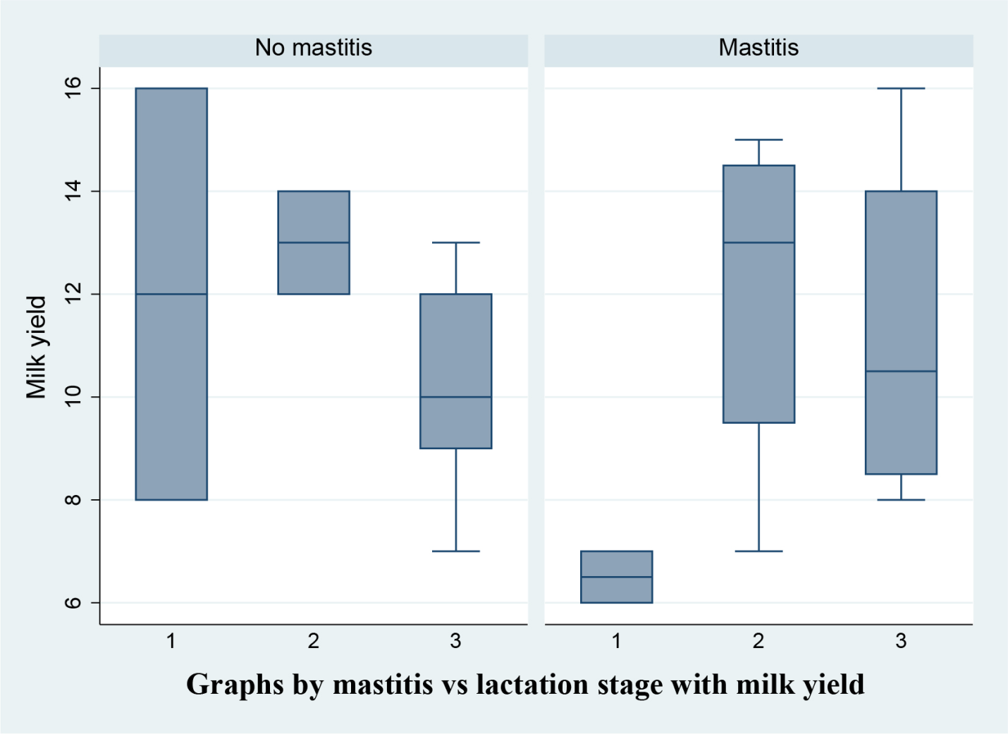
Figure 1. Relationship of milk yield against mastitis and various lactation stages
  - Relationship of milk yield against mastitis and various categories of parity
Cows in first parity with 6 to 12 litre milk yield are prone to mastitis than 8 to 13 litre milk yield in same parity. During second parity ,cows having 7 to 15 litre milk yield have the more risk of occurring mastitis than 9 to 11 litre milk yiled in same parity. Mastitis occurs more at third parity with 12 to 16 litre milk yield than 12 to 14 litre milk yiled. At 4th paritycows having 7 to 14 litre milk yield occurs mastitis more than 12 to 14 litre milk yield.
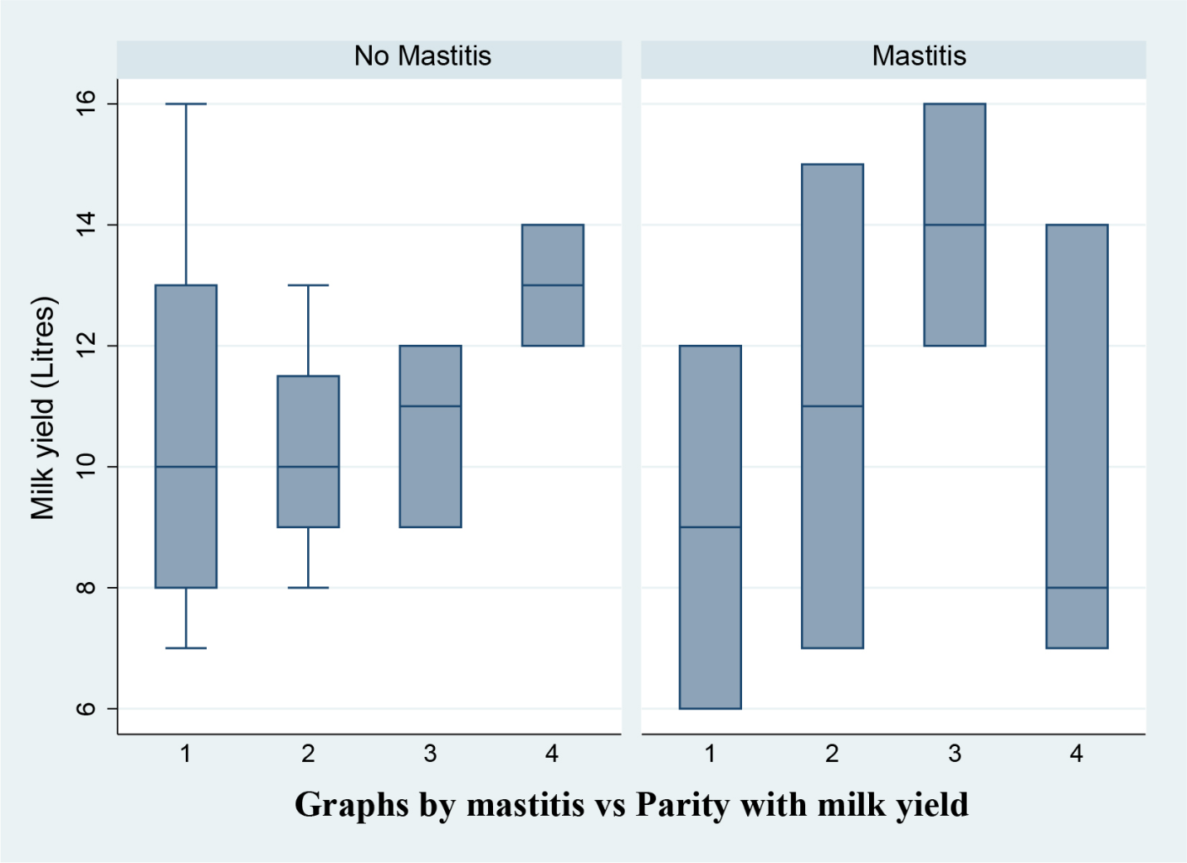
Figure 2. Relationship of milk yield against mastitis and various categories of parity
  - Relationship of milk yield against mastitis with roughages intake
Cow who intake 21.1 to 30 kg roughages with 9 to 14 milk yield have the more risk of occurring mastitis than the cows who intake 21 or less roughages with 7 to 12 litre milk yield.
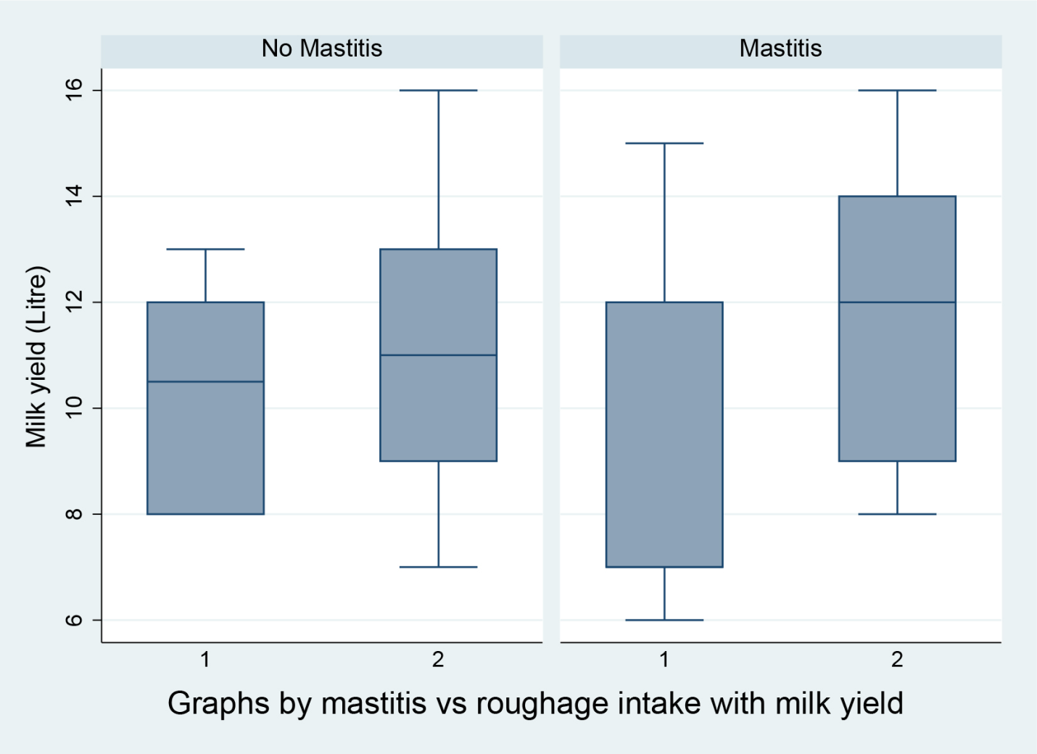
Figure 3: Relationship of milk yield against mastitis with roughage intake

- DISCUSSION
This cross-sectional study provides a farm-level characterization of production traits and major health disorders in dairy cows managed under intensive conditions in Bangladesh.
The mean daily milk yield of 670 L for 45 cows means that around 18 liters per cow aligns with production levels commonly reported from South Asia, where crossbred (Holstein × local) cows predominate which are in agreement with (Islam et al.,2017). This suggests that the farm in this study is performing within the expected productivity range for crossbred herds under tropical conditions. The farms supplied approximately 934.4 kg roughage and 475.4 kg concentrate per day, suggesting an average per-cow allowance of ~20.8 kg roughage and ~10.5 kg concentrate daily. These values fall within the feeding ranges recommended for crossbred cows producing 10–16 L/day in tropical climates (FAO Dairy Production Guide, 2020). The high amount of concentrate provided indicates an energy-dense diet, which is often necessary to support productivity in crossbred cows. The predominance of crossbred cows (96%) aligns with national dairy development strategies that promote Holstein- and Jersey-based crossbreeding to increase milk production in tropical systems. Crossbreds typically yield more milk than indigenous breeds due to higher genetic merit for lactation performance, although they also exhibit heightened sensitivity to heat stress, metabolic disorders, and feed imbalances. More than half of the cows were ≤6.4 years of age, which corresponds to the peak productive period of dairy cattle. The majority (60%) weighed 351–500 kg, which is consistent with expected phenotypes of Holstein × local crossbred cows in South Asia (Islam et al., 2017). Body condition scoring showed that 60% of cows were in good BCS, while 12% were cachectic. Cachectic cows are particularly vulnerable to infectious and metabolic disorders due to impaired energy balance and immune compromise. Parity distribution indicated that 36% of cows were primiparous and 44% were in their third or later lactations. Increasing parity is a major risk factor for mastitis, lameness, and metabolic diseases due to cumulative udder and musculoskeletal stress. The high proportion of multiparous cows may partly explain the elevated mastitis (60%) and metabolic disease levels observed. Milk production levels were moderate, with 56% of cows producing ≤11 L/day and the remaining 44% producing 11.1–16 L/day. These yields fall within expected ranges for crossbred cows in tropical climates (Islam et al.,2017). However, milk production is tightly linked to nutrition: 72% of cows consumed 9.1–15 kg concentrate per day, reflecting a high-energy diet needed to sustain lactation. Excessive concentrate feeding, particularly if not paired with adequate effective fiber. The roughage intake data showed that 56% of cows consumed 21.1–30 kg/day of roughage. While high roughage intake usually supports rumen health and milk fat synthesis, the presence of both high concentrate and high roughage intake suggests inconsistencies in feed mixing or ration balancing. Imbalanced diets often contribute to digestive disorders, reduced production, and compromised immune function (Brown et al.,2012). The disease burden in this herd is striking. Milk fever affected 96% of cows, far exceeding the typical clinical prevalence of 5–10% and subclinical prevalence of 20–50% in dairy herds. This suggests inadequate mineral balance or lack of dietary cation-anion difference (DCAD) management during the transition period. Acidosis (72%) and mastitis (60%) were also common, consistent with findings that crossbred cows in tropical systems are susceptible to metabolic stress, ruminal pH fluctuations, and intramammary infections (Ruegg, 2017). Lameness, though lower (16%), is linked to both mastitis and rumen acidosis, since metabolic disorders predispose cows to hoof lesions and inflammation (Lean et al., 2013). Antibiotic usage patterns reflect the high disease burden. Gentamicin and amoxicillin–cloxacillin were the most used antibiotics (36.4% each), consistent with common treatment regimens for mastitis and systemic infections in South Asia (Islam et al., 2020). However, such recurrent use of broad-spectrum antibiotics raises antimicrobial resistance (AMR) concerns. International guidelines now emphasize selective dry cow therapy, culture-based mastitis treatment, and improved hygiene to reduce antibiotic dependency.
Positive associations between body weight and milk yield are biologically expected, as larger cows typically have greater mammary tissue capacity and higher intake potential; this has been confirmed in several studies examining body weight and production curves across lactations (Sejrsen et al., 2000). Likewise, the positive relationship between roughage intake and milk yield suggests that cows consuming more roughage were better able to meet their energy needs and maintain adequate rumen function. Adequate physically effective fiber is essential for stimulating rumination and saliva buffering, thereby supporting rumen health and milk fat synthesis (Allen et al., 2006). The observed negative trend between BCS and milk yield aligns with the typical pattern where high-yielding cows mobilize body reserves in early lactation and therefore present lower BCS despite higher milk output (Rodríguez et al., 2020). Studies on negative energy balance (NEB) in dairy cows have shown that cows with high production often lose substantial body condition in early lactation, reflecting the gap between energy demand and intake. The results also showed negative relationship between mastitis and milk yield which is supported by the findings of (Koop et al., 2010).
The study found that mastitis occurred in 60% of the sampled cows, with frequency highest in second and third lactation animals producing moderate to high milk yields. This is in agreement with extensive literature showing that mastitis risk increases with parity and milk yield: multiparous cows have higher cumulative exposure of the mammary gland, more pendulous udders, and more teat-end damage, all of which predispose them to intramammary infections (Cheng et al., 2020; Litwińczuk et al., 2015; Kashoma, 2020; Seegers et al., 2003; Riekerink et al., 2007). Studies have also reported that mastitis-associated losses are particularly severe in high-producing cows, where each case results in substantial milk loss (Borş et al., 2024), greater treatment costs, and increased culling risk (Yanga et al., 2021). Clinical mastitis can cause milk losses in the early stages of lactation that range from 348 to over 600 pounds, and in extreme cases, the total losses during a lactation can surpass 2,500 pounds. The financial impact is highest during periods of peak milk yield, making high-yielding cows particularly vulnerable (Borş et al., 2024; Fahim et al., 2025). Figures 1 and 2 showed higher mastitis frequency in cows with 12–16 L/day yield, especially in third parity supports the view that mastitis is tightly linked with production intensity (Lee and Kim, 2006; Lean et al., 2023; Krogstad et al., 2025). This suggests that prevention programs (e.g., milking hygiene, dry cow therapy, teat disinfection, proper housing) should particularly target mid- to high-parity cows with higher yields, which represent the core of herd productivity but are also most vulnerable to udder health problems.
Figure 3 showed that the higher mastitis frequency in cows consuming 21.1–30 kg of roughage per day and producing 9–14 L/day compared with those consuming less roughage and producing lower milk yields. A larger daily intake of roughage (and hence dry matter) usually indicates a better nutritional plane and promotes higher milk production, which are linked to a higher prevalence of mastitis (Bareille et al., 2003; Mramba and Mohamed, 2024). While roughage itself does not cause mastitis, these cows likely represent a subset with higher overall feed intake (both roughage and concentrate) and higher metabolic load, which is consistent with evidence that high-yielding cows experience greater metabolic load and immunosuppression (Ruegg, 2017; Wankhade et al.,2017). The rapid increase in milk output exceeds dry matter intake, resulting in a negative energy balance (NEB). In high-producing animals, cows mobilize a lot of body fat, which raises NEFA and BHBA in the blood (Martens, 2023). First-line udder defenses are directly weakened by ketone bodies and NEFA, which decrease neutrophil chemotaxis, phagocytosis, oxidative burst, and migration into the diseased gland (O'Rourke, 2009). In intensively fed cows, imbalanced diets with high fermentable carbohydrates and insufficient effective fiber can predispose to subacute ruminal acidosis (SARA), which impairs immune function and increases susceptibility to infectious diseases, including mastitis and lameness (Hou et al., 2025; Abdela, 2016).
- CONCLUSION
This study provides a detailed characterization of production traits and major health disorders among dairy cows managed under an intensive system in Bangladesh. Body weight, number of parity and roughage intake were positively associated with milk yield, while mastitis and lower body condition tended to depress production. Mastitis, acidosis, and milk fever were highly prevalent, particularly among higher-producing and multiparous cows, suggesting that metabolic and nutritional stress may contribute to health challenges in this herd. The findings highlight the need for improved nutritional balance, structured transition-cow management, enhanced udder health programs, and more judicious antimicrobial use. Strengthening these management areas has the potential to improve productivity, reduce disease burden, and enhance the profitability and sustainability of intensive dairy farms in tropical environments.

LIMITATIONS
- Small sample size (n = 25 cows) limited statistical power and prevented multivariable regression modeling.
- Disease diagnoses were based on farm clinical records, without standardized diagnostic criteria (e.g., CMT, rumen pH testing, serum calcium tests).

FUTURE RESEARCH DIRECTIONS
- Larger-scale epidemiological studies consisting of more farms and other regions of Bangladesh with standardized diagnostic tools to confirm patterns observed in this study.
- Multivariable logistic regression and mixed-effects modeling to assess cow-level and farm-level determinants of mastitis, acidosis, and milk fever.

COMPETING INTERESTS DISCLAIMER:
Authors have declared that they have no known competing financial interests OR non-financial interests OR personal relationships that could have appeared to influence the work reported in this paper.

REFERENCES

- Apdini, T., van Middelaar, C. E., & Oosting, S. J. (2024). Developing sustainable dairy farms in the tropics: From policy to practice. Agricultural Systems, 220, 104097. https://doi.org/10.1016/j.agsy.2024.104097
- Clay N, Garnett T, Lorimer J. (2020). Dairy intensification: Drivers, impacts and alternatives. Ambio. 2020 Jan;49(1):35-48. https://doi.org/10.1007/s13280-019-01177-y
- Evers, S. H., Delaby, L., Pierce, K. M., McCarthy, B., Coffey, E. L., & Horan, B. (2023). An evaluation of detailed animal characteristics influencing the lactation production efficiency of spring-calving, pasture-based dairy cattle. Journal of Dairy Science, 106(2), 1097-1109. https://doi.org/10.3168/jds.2022-21815
- Lee JY, & Kim IH. (2006). Advancing parity is associated with high milk production at the cost of body condition and increased periparturient disorders in dairy herds. J Vet Sci. 2006 Jun;7(2):161-6. https://doi.org/10.4142/jvs.2006.7.2.161
- Wattiaux, M. A. (2023). Sustainability of dairy systems through the lenses of the sustainable development goals. Frontiers in Animal Science, 4, 1135381. https://doi.org/10.3389/fanim.2023.1135381
- FAO. 2014. Impact of mastitis in small scale dairy production systems. http://www.fao.org/3/a-i3377e.pdf
- Islam MA, Sharma A, Ahsan S, Mazumdar S, Rudra KC, Phillips CJC. Welfare Assessment of Dairy Cows in Small Farms in Bangladesh. Animals (Basel). 2020 Feb 28;10(3):394. https://doi.org/10.3390/ani10030394
- Salauddin M, Khan MAA, Rahmati A, Hossain MG, Shimada M, Saha S. Impact of Viral Diseases on the Livestock Sector in Bangladesh. Vet Med Int. 2025 Nov 6;2025:5492206. https://doi.org/10.1155/vmi/5492206
- Balehegn, M., Duncan, A., Tolera, A., Ayantunde, A. A., Issa, S., Karimou, M., ... & Adesogan, A. T. (2020). Improving adoption of technologies and interventions for increasing supply of quality livestock feed in low-and middle-income countries. Global food security, 26, 100372. https://doi.org/10.1016/j.gfs.2020.100372
- Birhan M, Mekuriaw Y, Tassew A, Tegegne F. Monitoring of dairy farm management determinants and production performance using structural equation modelling in the Amhara region, Ethiopia. Vet Med Sci. 2023 Jul;9(4):1742-1756. https://doi.org/10.1002/vms3.1140
- Islam, K. M. A., Uddin, M. M., Sultana, M. N., Assaduzzaman, M., & Islam, M. N. (2010). Distribution pattern and management practices of cross bred dairy cows in cooperative dairy production system in Bangladesh. Livestock Research for Rural Development, 22(12), 2010. http://www.lrrd.org/lrrd22/12/amin22219.htm
- Islam, M. N., Bari, M. S., Habib, M. R., Sarkar, M. M., & Islam, M. A. (2019). Comparative economic analysis of dairy characteristics focused on repeat breeding losses in selected milk pocket areas of Bangladesh. Bangladesh Journal of Animal Science, 48(2), 145-154. https://doi.org/10.3329/bjas.v48i2.46769
- Das R, Sailo L, Verma N, Bharti P, Saikia J, Imtiwati, Kumar R. Impact of heat stress on health and performance of dairy animals: A review. Vet World. 2016 Mar;9(3):260-8. https://doi.org/10.14202/vetworld.2016.260-268
- Oliveira CP, Sousa FC, Silva ALD, Schultz ÉB, Valderrama Londoño RI, Souza PAR. Heat Stress in Dairy Cows: Impacts, Identification, and Mitigation Strategies-A Review. Animals (Basel). 2025 Jan 17;15(2):249 https://doi.org/10.3390/ani15020249
- Becker, C. A., Collier, R. J., & Stone, A. E. (2020). Invited review: Physiological and behavioral effects of heat stress in dairy cows. Journal of dairy science, 103(8), 6751-6770. https://doi.org/10.3168/jds.2019-17929
- Ghasemi N, Amanlou H, Maheri-Sis N, Salamatdoust-Nobar R, Jozghasemi S. Relationship between hypocalcemia immediately after calving with metabolic disorders and body condition score in Holstein cows. Open Vet J. 2024 Mar;14(3):805-813. https://doi.org/10.5455/OVJ.2024.v14.i3.7
- Seegers, H., Fourichon, C., & Beaudeau, F. (2003). Production effects related to mastitis and mastitis economics in dairy cattle herds. Veterinary research, 34(5), 475-491. https://doi.org/10.1051/vetres:2003027
- Riekerink, R. O., Barkema, H. W., Veenstra, W., Berg, F. E., Stryhn, H., & Zadoks, R. N. (2007). Somatic cell count during and between milkings. Journal of Dairy Science, 90(8), 3733-3741. https://doi.org/10.3168/jds.2007-0001
- Nogara KF, Busanello M, Tavares QG, De Assis JA, Freu G, Dos Santos MV, Vieira FMC, Zopollatto M. Factors Influencing Milk Quality and Subclinical Mastitis in Dairy Herds Housed in Compost-Bedded Pack Barn System. Animals (Basel). 2023 Nov 24;13(23):3638. https://doi.org/10.3390/ani13233638
- Zehner MM, Farnsworth RJ, Appleman RD, Larntz K, Springer JA. Growth of environmental mastitis pathogens in various bedding materials. J Dairy Sci. 1986 Jul;69(7):1932-41. https://doi.org/10.3168/jds.S0022-0302(86)80620-8
- Tufarelli V, Puvača N, Glamočić D, Pugliese G, Colonna MA. The Most Important Metabolic Diseases in Dairy Cattle during the Transition Period. Animals (Basel). 2024 Mar 6;14(5):816. https://doi.org/10.3390/ani14050816
- Elmhadi ME, Ali DK, Khogali MK, Wang H. Subacute ruminal acidosis in dairy herds: Microbiological and nutritional causes, consequences, and prevention strategies. Anim Nutr. 2022 Mar 11;10:148-155. https://doi.org/10.1016/j.aninu.2021.12.008
- Fan S, Zheng M, Ren A, Mao H, Long D, Yang L. Effects of High-Concentrate-Induced SARA on Antioxidant Capacity, Immune Levels and Rumen Microbiota and Function in Goats. Animals (Basel). 2024 Jan 15;14(2):263. https://doi.org/10.3390/ani14020263
- Hou G, Wang J, Liu S, Gao D, Xu Y, Zhuang Y, Dong W, Yue Y, Bai J, Li S, Ma J, Li M, Wang W, Wang Y, Li S, Cao Z. Integrating Subacute Ruminal Acidosis, Lipopolysaccharide, and Trained Immunity: A Comprehensive Review. Int J Biol Sci. 2025 Mar 31;21(6):2806-2823 https://doi.org/10.7150/ijbs.104074
- Martens H. Invited Review: Increasing Milk Yield and Negative Energy Balance: A Gordian Knot for Dairy Cows? Animals (Basel). 2023 Oct 4;13(19):3097. https://doi.org/10.3390/ani13193097
- Islam, A., Ahmed, A. B. M. T., Hasan, M., Islam, S., Shuvo, M. A., Islam, M. R., ... & Islam, K. M. (2017). Productive and reproductive performance of different breed and cross breds dairy cattle at central cattle breeding and dairy farm, Savar, Dhaka, Bangladesh. https://www.researchgate.net/publication/317600000_Productive_and_Reproductive_performance_of_different_breed_and_cross_breds_dairy_cattle_at_Central_Cattle_Breeding_and_Dairy_Farm_Savar_Dhaka_Bangladesh
- FAO. (2020). Dairy production and nutrition guidelines for tropical systems. (Online manual) https://www.fao.org/3/cb0004en/cb0004en.pdf
- Brown, K., DeCoffe, D., Molcan, E., & Gibson, D. L. (2012). Diet-induced dysbiosis of the intestinal microbiota and the effects on immunity and disease. Nutrients, 4(8), 1095-1119. https://doi.org/10.3390/nu4081095
- Ruegg, P. L. (2017). A 100-year review: Mastitis detection, management, and prevention. Journal of Dairy Science, 100, 10381–10397. https://doi.org/10.3168/jds.2017-13023
- Lean, I. J., Westwood, C. T., Golder, H. M., & Vermunt, J. J. (2013). Impact of nutrition on lameness and claw health in cattle. Livestock Science, 156(1-3), 71-87. https://doi.org/10.1016/j.livsci.2013.06.006
- Sejrsen, K., Purup, S., Vestergaard, M., & Foldager, J. (2000). High body weight gain and reduced bovine mammary growth: physiological basis and implications for milk yield potential. Domestic animal endocrinology, 19(2), 93-104. https://doi.org/10.1016/s0739-7240(00)00070-9
- Allen, M. S., Voelker, J. A., & Oba, M. (2006). Physically effective fiber and regulation of ruminal pH: More than just chewing. In Production diseases in farm animals (pp. 269-278). Wageningen Academic. https://doi.org/10.3920/978-90-8686-571-0
- Rodríguez, A., Mellado, R., & Bustamante, H. (2020). Prepartum fat mobilization in dairy cows with equal body condition and its impact on health, behavior, milk production and fertility during lactation. Animals, 10(9), 1478. https://doi.org/10.3390/ani10091478
- Koop, G., Van Werven, T., Schuiling, H. J., & Nielen, M. (2010). The effect of subclinical mastitis on milk yield in dairy goats. Journal of Dairy Science, 93(12), 5809-5817. https://doi.org/10.3168/jds.2010-3544
- Cheng WN, Han SG. Bovine mastitis: risk factors, therapeutic strategies, and alternative treatments - A review. Asian-Australas J Anim Sci. 2020 Nov;33(11):1699-1713. https://doi.org/10.5713/ajas.20.0156
- Litwińczuk, Z., Król, J., & Brodziak, A. (2015). Factors determining the susceptibility of cows to mastitis and losses incurred by producers due to the disease-a review. https://doi.org/10.1515/aoas-2015-0035
- Kashoma, I. P. (2023). Udder and teat morphometry and its relationship with occurrence of intramammary infections in dairy cattle. East African Journal of Science, Technology and Innovation, 4(2). https://doi.org/10.37425/eajsti.v4i2.602
- Borş A, Borş SI, Floriștean VC. Mastitis impact on high-yielding dairy farm's reproduction and net present value. Front Vet Sci. 2024 Jan 8;10:1345782. https://doi.org/10.3389/fvets.2023.1345782
- Yanga DS, Jaja IF. Culling and mortality of dairy cows: why it happens and how it can be mitigated. F1000Res. 2021 Oct 6;10:1014. https://doi.org/10.12688/f1000research.55519.2
- Fahim NH, Ibrahim MAM, Sadek RR. Lifetime performance traits of Holstein cows: implications of first-lactation milk yield and culling causes. Trop Anim Health Prod. 2025 Oct 27;57(8):454. https://doi.org/10.1007/s11250-025-04670-7
- Lean, I. J., LeBlanc, S. J., Sheedy, D. B., Duffield, T., Santos, J. E. P., & Golder, H. M. (2023). Associations of parity with health disorders and blood metabolite concentrations in Holstein cows in different production systems. Journal of dairy science, 106(1), 500-518. https://doi.org/10.3168/jds.2021-21673
- Krogstad, K. C., & Bradford, B. J. (2025). Associations of body condition score, body condition score change, and hyperketonemia with mastitis, reproduction, and milk production. Journal of Dairy Science, 108(3), 2808-2819. https://doi.org/10.3168/jds.2024-25387
- Bareille, N., Beaudeau, F., Billon, S., Robert, A., & Faverdin, P. (2003). Effects of health disorders on feed intake and milk production in dairy cows. Livestock production science, 83(1), 53-62. https://doi.org/10.1016/S0301-6226(03)00040-X
- Mramba RP, Mohamed MA. The prevalence and factors associated with mastitis in dairy cows kept by small-scale farmers in Dodoma, Tanzania. Heliyon. 2024 Jul 4;10(13):e34122. https://doi.org/10.1016/j.heliyon.2024.e34122
- Wankhade PR, Manimaran A, Kumaresan A, Jeyakumar S, Ramesha KP, Sejian V, Rajendran D, Varghese MR. Metabolic and immunological changes in transition dairy cows: A review. Vet World. 2017 Nov;10(11):1367-1377. https://doi.org/10.14202/vetworld.2017.1367-1377
- O'Rourke D. Nutrition and udder health in dairy cows: a review. Ir Vet J. 2009 Apr 1;62 Suppl 4(Suppl 4):S15-20. https://doi.org/10.1186/2046-0481-62-S4-S15
- Abdela, N. (2016). Sub-acute ruminal acidosis (SARA) and its consequence in dairy cattle: A review of past and recent research at global prospective. Achievements in the life sciences, 10(2), 187-196. https://doi.org/10.1016/j.als.2016.11.006

