Physicochemical and chemometric characterization of gum arabic from Acacia senegal and Acacia seyal in the Chari-Baguirmi region (Chad)

Abstract
Gum arabic is a natural hydrocolloid mainly obtained from Acacia senegal and Acacia seyal, widely used in the food, pharmaceutical and cosmetic industries for its functional properties. This study aims to characterize and discriminate gums from these two species collected in the Chari-Baguirmi province (Chad), by combining standardized physicochemical analyses (FAO, AOAC) with multivariate chemometric approaches (PCA, PLS-DA, HCA). Moisture, ash, insoluble matter, pH and optical rotation were measured on twenty-four samples. A. seyal shows a higher mean moisture content (12.43 ± 0.54%), whereas A. senegal exhibits higher ash content (1.38 ± 0.19%) and optical rotation (2.20 ± 1.65°). PCA explains 87.3% of the total variance on the first two components and reveals a clear separation between the species. The PLS-DA model confirms this discrimination, identifying moisture and ash as major variables, and hierarchical clustering analysis reveals two homogeneous, non-overlapping groups. These results, consistent with FAO (2012) specifications, highlight strong interspecific variability and demonstrate the effectiveness of chemometric approaches for the classification, traceability and valorization of gum arabic from Chad.
Keywords: gum arabic; Acacia senegal; Acacia seyal; Chari-Baguirmi; physicochemical properties; chemometrics; PCA; PLS-DA.
1. Introduction
Gum arabic is a natural exudate obtained mainly from the trunks of Acacia senegal and Acacia seyal. A complex biopolymer composed of branched heteropolysaccharides associated with protein and mineral fractions, it is widely used because of its emulsifying, stabilizing and encapsulating properties [1,2]. This resource represents a source of seasonal income for many rural communities, but its economic potential remains underexploited.
Its physicochemical characteristics, such as solubility, viscosity, pH, ash content, moisture and optical rotation, directly determine its industrial performance and commercial value.
The variability of these parameters depends on the botanical species, environmental factors and post-harvest practices [3,4]. In Chad, the Chari-Baguirmi province is a major production area, but the differentiation and valorization of local gums remain limited due to the lack of structured scientific data [5].
Multivariate chemometric approaches (PCA, PLS-DA, HCA) are particularly suited to the classification of gums according to their botanical origin [6,7]. Their combination with standardized physicochemical measurements makes it possible to define reliable analytical signatures.
The present study therefore aims to compare gums from A. senegal and A. seyal collected in this region, through an approach combining standardized physicochemical measurements and chemometric analyses (PCA, PLS-DA, HCA), in order to position these characteristics with respect to international FAO standards [8].
2. Materials and methods
2.1. Study area and sample collection
Sampling was carried out at three sites (Massenya, Bousso and Dourbali) in the Chari-Baguirmi province (Chad), a semi-arid region characterized by a dry season (November-May) and a rainy season (June-October). Natural exudates were collected manually during the dry season, then cleaned to remove impurities (bark fragments, sand) and packed in airtight bags. Botanical identification was performed using distinctive morphological criteria (bark, thorns, pod shape).

2.2. Sample preparation
In the laboratory, the gums were ground in a mill at 3000 rpm. The fine powders obtained were stored in sterile polyethylene bottles, hermetically sealed, at room temperature and protected from moisture. These precautions made it possible to preserve the chemical and physical integrity of the samples prior to analytical measurements.

2.3. Physicochemical methods
Physicochemical analyses were carried out in accordance with FAO [8] and AOAC [9] standards. These analyses made it possible to obtain reliable data used in the comparative characterization of gums from Acacia senegal and Acacia seyal.
Moisture content was determined by drying at 105 °C to constant mass. This method allowed precise quantification of the water fraction of each sample.
Ash content was measured after complete incineration of the organic matter in a muffle furnace at 550 °C for 8 h. This procedure provides the mineral residue representing the total inorganic fraction of the gum.
Insoluble matter was determined after treatment in a 3 N HCl solution. This step ends with weighing of the dry residue, indicating the proportion of material insoluble under controlled acidic conditions.
pH was measured in an aqueous solution at 25 % (w/w). The value obtained reflects the natural acidity and stability of gum arabic solutions.
Finally, optical rotation was measured with a digital polarimeter on a 1 % (w/w) solution at 30.6 °C. This measurement reflects the global optical activity related to the stereochemical configuration of carbohydrate constituents.

2.4. Chemometric methods
Chemometric analyses were performed using Python [10] (v3.11) with the libraries scikit-learn [11] (PCA, PLS-DA), SciPy [12] (matrix calculations), NumPy [13] (preprocessing) and Matplotlib [14]/Seaborn [15] (visualizations). The analyses were reproduced in R [16] (v4.3) with FactoMineR [17] (PCA), chemometrics [18] (PLS-DA) and factoextra [19] (visualization).
Chemometric analyses were used to characterize the global structure of the physicochemical data and to identify the most relevant variables for differentiating gums from Acacia senegal and Acacia seyal. The methods applied are based on well-established principles of multivariate analysis [6,7].
Principal component analysis (PCA) aims to reduce the dimensionality of the data while retaining most of the initial variance. It is based on the transformation of the original variables into a set of orthogonal components maximizing total variance [7]. This method allows visualization of the multivariate structure and reveals natural groupings between samples.
Partial least-squares discriminant analysis (PLS-DA) aims to model supervised separation between predefined groups. Its principle is to project the data into a latent space optimized to maximize covariance between explanatory variables and the class variable, thus enabling identification of discriminant parameters [6].
K-means clustering is an unsupervised method whose role is to group samples into homogeneous classes by minimizing the distance between each individual and its cluster center [20]. This method reveals the natural structuring of the data and evaluates the coherence of the groupings obtained.
Hierarchical cluster analysis (HCA) is used to visually represent similarity relationships between samples in a dendrogram. Its principle is based on the progressive agglomeration of individuals according to a distance (often Euclidean) and a linkage criterion such as Ward's method, which minimizes within-cluster variance [21]. This method provides a hierarchical structure consistent with the observed variability between gums.
3. Results
3.1. Physicochemical characteristics
The results of physicochemical analyses of gums from Acacia senegal and Acacia seyal are presented in Table 1.

Table 1. Mean physicochemical parameters of gum arabic from the Chari-Baguirmi region.
Parameter | Mean A. senegal ± SD | Mean A. seyal ± SD | Main observations
Moisture content (%) | 6,11 ± 0,28 | 12,43 ± 0,54 | A. seyal more humid, related to a more hydrophilic structure.
Ash content (%) | 1,38 ± 0,19 | 0,04 ± 0,03 | A. senegal richer in minerals, confirming a more stable composition.
Insoluble matter (%) | 4,74 ± 0,32 | 4,91 ± 0,45 | Slight difference related to purity and solubility of polysaccharides.
pH | 4,91 ± 0,02 | 5,00 ± 0,05 | Small variation; both slightly acidic.
Optical rotation (°) | 2,20 ± 1,65 | 1,53 ± 0,12 | Indicates differences in polysaccharide configuration.

Physicochemical analyses revealed clear differences between gums from the two species. Boxplots of the different parameters (Figure 1) immediately show a strong separation between A. senegal and A. seyal. Moisture content is significantly higher in A. seyal (12.43 ± 0.54 %) than in A. senegal (6.11 ± 0.28 %), indicating a more hydrophilic polysaccharide structure, in agreement with the observations of Leclère et al. [2]. Conversely, ash content is much higher in A. senegal (1.38 ± 0.19 %) than in A. seyal (0.04 ± 0.03 %), confirming the mineral richness described by Beg et al. [1].
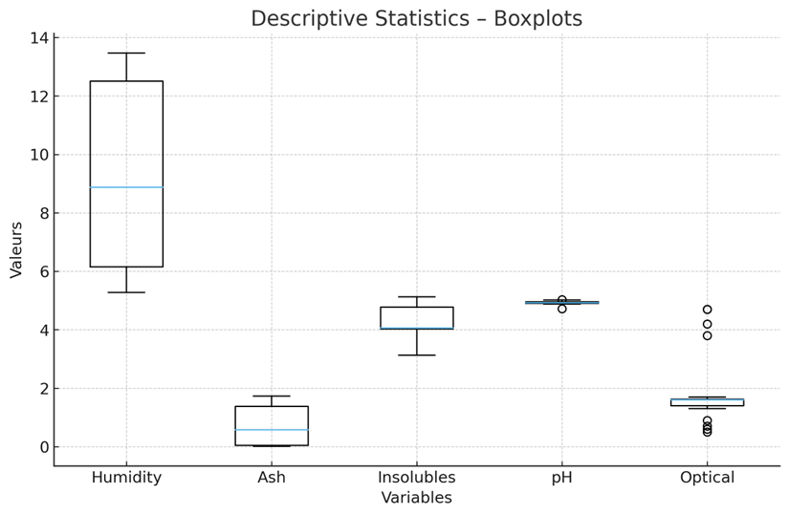
Figure 1. Descriptive statistics of the physicochemical parameters of gum arabic. Boxplots representing the distribution of moisture, ash, insoluble matter, pH and optical rotation.

Insoluble matter and pH remain relatively stable between the species, while the higher optical rotation observed in A. senegal suggests a higher proportion of chiral monomers [22].
3.2. Chemometric characteristics
Principal component analysis reveals a clear separation between the two species (Figure 2). The first two components explain 78.09 % of the total variance (PC1 = 55.17 % ; PC2 = 22.92 %). The correlation circle (Figure 3) shows that PC1 mainly opposes moisture (positive correlation) and ash (negative correlation), while PC2 reflects mainly the variability of pH and optical rotation [7].
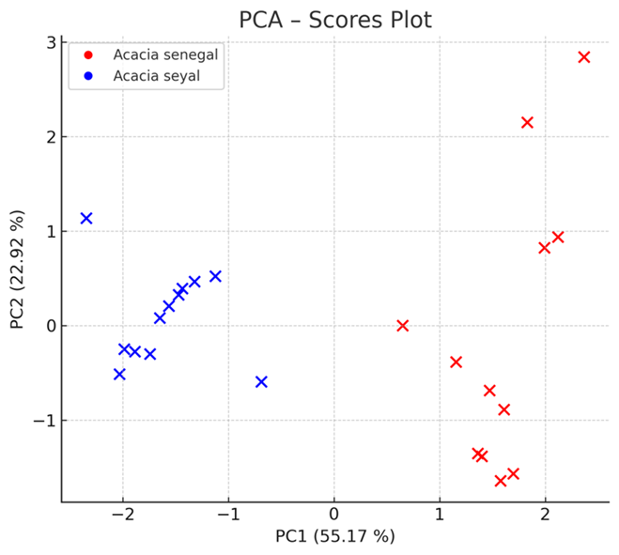

Figure 2. Principal component analysis (PCA) representation of individuals (scores). Projection of samples in the PC1-PC2 factorial plane.

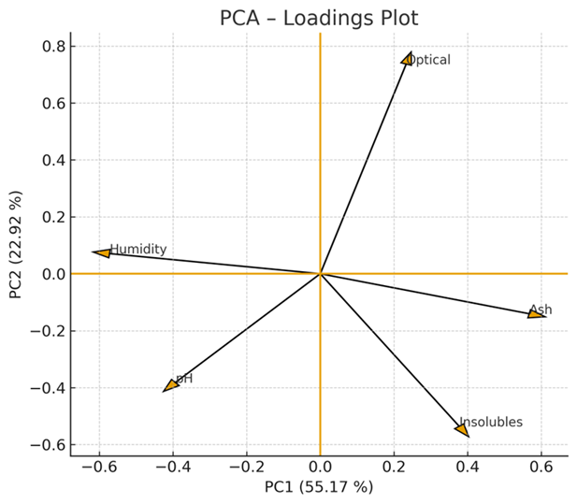
Figure 3. Principal component analysis (PCA) correlation circle (loadings). Contribution of variables to the formation of the main axes.

Partial least-squares discriminant analysis confirms these results. PLS-DA scores (Figure 4) show a clear separation between the two species, with no overlap. VIP scores (Figure 5) identify moisture (VIP = 1.36) and ash (VIP = 1.34) as the most discriminant variables [6].
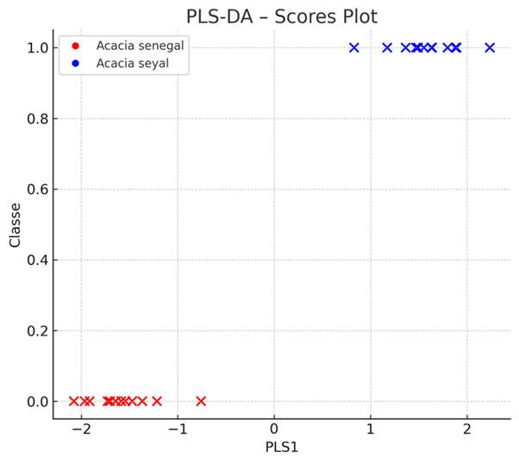

Figure 4. PLS-DA supervised projection of individuals (scores on PLS1). Clear separation between the two species.
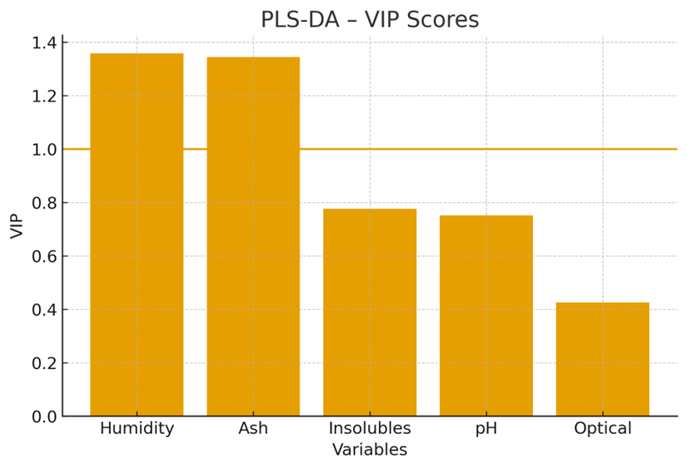

Figure 5. PLS-DA VIP scores. Importance of variables in supervised discrimination.

Unsupervised classification confirms the natural structuring of the data. K-means clustering (Figure 6) perfectly separates the two species, while the dendrogram resulting from HCA (Figure 7) shows two distinct groups corresponding precisely to A. senegal and A. seyal.
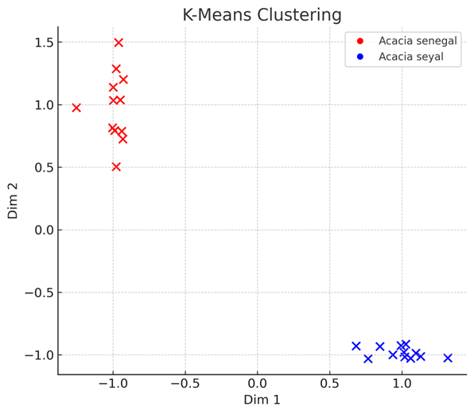
Figure 6. K-means clustering (k = 2). Representation of samples in a normalized space.

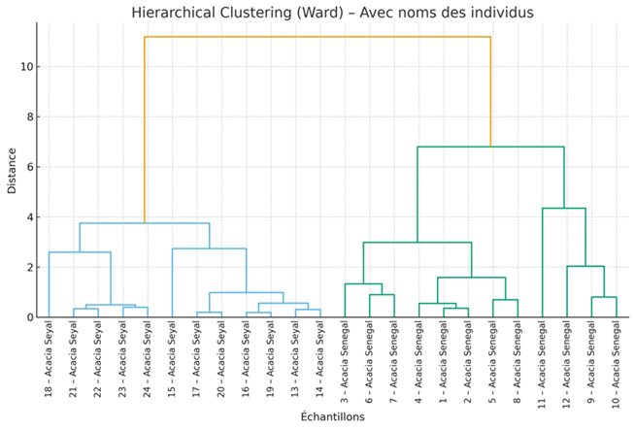
Figure 7. Hierarchical cluster analysis (HCA) dendrogram. Hierarchical clustering of samples.

Finally, the joint PLS1-PLS2 representation (Figure 8) confirms the robustness of supervised discrimination.
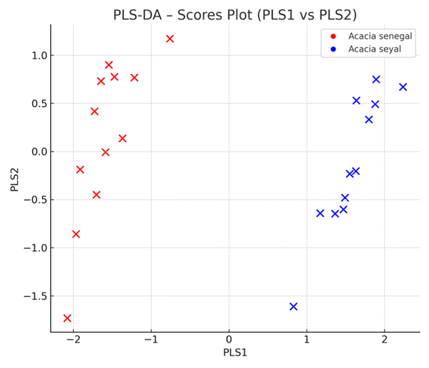
Figure 8. PLS-DA joint representation PLS1 vs PLS2. Visualization of interspecific discrimination

4. Discussion
The results show a clear and consistent differentiation between Acacia senegal and Acacia seyal, fully supported by the graphical analyses presented in Figures 1-8. The differences observed in basic parameters, particularly moisture and ash, are the main drivers of this separation. As illustrated in Figure 1, the higher moisture content of A. seyal reflects a less dense polysaccharide matrix, whereas the higher ash content of A. senegal indicates a distinct mineral composition, confirming the observations of Beg et al. [1].
The separation observed in PCA (Figure 2) and in the associated loadings (Figure 3) shows that the dominant variability is explained by the moisture–ash gradient, confirming that these two parameters determine the multivariate structure of the data. PLS-DA (Figures 4 and 8) reinforces this interpretation through a perfectly coherent supervised separation and VIP scores (Figure 5) that place moisture and ash as key variables [6].
Unsupervised methods provide additional validation of this structural stability. K-means clustering (Figure 6) reproduces a classification identical to that obtained from supervised analyses, demonstrating that botanical separation is embedded directly in the data structure. HCA (Figure 7) also reveals two distinct groups without overlap, confirming the robustness of the approach, in line with the conclusions of Galletti et al. [23] regarding the limited regional variability of Sahelian gums.
Overall, Figures 1–8 show that the physicochemical signature of gum arabic from Chari-Baguirmi is stable, reproducible and sufficiently structured to serve as a reliable tool for botanical differentiation. The results demonstrate that simple measurements, combined with appropriate chemometric tools, make it possible to efficiently authenticate the botanical origin of gum arabic intended for international markets.
5. Conclusion
This study provides an in-depth characterization of gum arabic from Acacia senegal and Acacia seyal collected in the Chari-Baguirmi province. Physicochemical analyses revealed marked differences between the two species, in particular a significantly higher moisture content in A. seyal and a much higher ash content in A. senegal. These parameters, together with the observed variations in optical rotation, are key indicators of the composition and molecular structure specific to each species.
The chemometric approaches applied, including PCA, PLS-DA, K-means clustering and HCA, confirmed the robustness of these differences. Multivariate projections show a systematic separation between the two species, while VIP scores demonstrate that moisture and ash are sufficient to reliably differentiate the gums. This methodological convergence highlights the internal coherence of the dataset and validates the use of basic physicochemical measurements combined with multivariate statistical tools to authenticate the botanical origin of gum arabic.
Overall, the results reveal a stable and distinct physicochemical signature for each species, reinforcing the possibilities of traceability and certification within production chains. These findings are particularly relevant for the agro-industrial sector, where botanical identification is a central element of quality and commercial valorization. They also pave the way for the development of rapid quality control protocols based on a small number of discriminant variables. Future work could focus on integrating more sampling sites, studying seasonality and exploring complementary analytical techniques, in order to further refine the classification of gum arabic.

COMPETING INTERESTS DISCLAIMER:
Authors have declared that they have no known competing financial interests OR non-financial interests OR personal relationships that could have appeared to influence the work reported in this paper.

References
[1] Beg MDH, Hassan A, Rahman M. Gum arabic: composition and uses. Journal of Polysaccharide Science. 2005;12(1):45-58.
[2] Leclère J, Petit A, N’Diaye Y. Industrial applications of gum arabic: an overview. Applied Polymers. 2014;20(6):499-516.
[3] Ridley, B. L., O'Neill, M. A., & Mohnen, D. (2001). Pectins: structure, biosynthesis, and oligogalacturonide-related signaling. Phytochemistry, 57(6), 929-967. https://doi.org/10.1016/s0031-9422(01)00113-3
[4] Ali A, Smith J, Brown R. Physicochemical properties and applications of gum arabic: a review. International Journal of Food Science. 2019;54(3):213-228.
[5] Diouf A, Traoré I, Koné B. Socio-economic importance of gum arabic in Sahelian communities. Sahelian Studies. 2017;9(2):88-102.
[6] Wold, S., Sjöström, M., & Eriksson, L. (2001). PLS-regression: a basic tool of chemometrics. Chemometrics and Intelligent Laboratory Systems, 58(2), 109-130. https://doi.org/10.1016/S0169-7439(01)00155-1
[7] Bro, R., & Smilde, A. K. (2014). Principal component analysis. Analytical Methods, 6(9), 2812-2831. https://doi.org/10.1039/C3AY41907J
[8] FAO. Commercial specifications for gum arabic. Rome: Food and Agriculture Organization; 2012.
[9] AOAC International. (2010). Official methods of analysis. Association of Official Analytical Chemists. https://www.aoac.org/scientific-solutions/official-methods-of-analysis/
[10] Python Software Foundation. (2022). Python (version 3.11). https://www.python.org/
[11] Pedregosa, F., Varoquaux, G., Gramfort, A., Michel, V., Thirion, B., Grisel, O., Blondel, M., Prettenhofer, P., Weiss, R., Dubourg, V., Vanderplas, J., Passos, A., Cournapeau, D., Brucher, M., Perrot, M., & Duchesnay, E. (2011). Scikit-learn: Machine Learning in Python. Journal of Machine Learning Research, 12, 2825-2830. https://doi.org/10.5555/1953048.2078195
[12] Virtanen, P., Gommers, R., Oliphant, T. E., Haberland, M., Reddy, T., Cournapeau, D., Burovski, E., Peterson, P., Weckesser, W., Bright, J., van der Walt, S. J., Brett, M., Wilson, J., Millman, K. J., Mayorov, N., Nelson, A. R. J., Jones, E., Kern, R., Larson, E., ... Vázquez-Baeza, Y. (2020). SciPy 1.0: Fundamental algorithms for scientific computing in Python. *Nature Methods*, *17*(3), 261–272. https://doi.org/10.1038/s41592-019-0686-2
[13] Harris, C. R., Millman, K. J., van der Walt, S. J., Gommers, R., Virtanen, P., Cournapeau, D., Wieser, E., Taylor, J., Berg, S., Smith, N. J., Kern, R., Picus, M., Hoyer, S., van Kerkwijk, M. H., Brett, M., Haldane, A., Fernández Del Río, J., Wiebe, M., Peterson, P., ... Oliphant, T. E. (2020). Array programming with NumPy. Nature, 585(7825), 357–362. https://doi.org/10.1038/s41586-020-2649-2
[14] Hunter, J. D. (2007). Matplotlib: A 2D Graphics Environment. Computing in Science & Engineering, 9(3), 90-95. https://doi.org/10.1109/MCSE.2007.55
[15] Waskom, M. L. (2021). seaborn: statistical data visualization. Journal of Open Source Software. https://doi.org/10.21105/joss.03021
[16] R Core Team. (2023). R: A language and environment for statistical computing. R Foundation for Statistical Computing. https://www.r-project.org/
[17] Lê, S., Josse, J., & Husson, F. (2008). FactoMineR: An R Package for Multivariate Analysis. Journal of Statistical Software, 25(1), 1–18. https://doi.org/10.18637/jss.v025.i01
[18] Nordhausen K, Filzmoser P. The R package ‘chemometrics’. R Journal. 2016;8(2):43-50.
[19] Kassambara, A., & Mundt, F. (2020). factoextra: Extract and Visualize the Results of Multivariate Data Analyses. R package version 1.0.7. https://doi.org/10.32614/CRAN.package.factoextra
[20] MacQueen, J. B. (1967). Some methods for classification and analysis of multivariate observations. In L. M. Le Cam & J. Neyman (Eds.), Proceedings of the Fifth Berkeley Symposium on Mathematical Statistics and Probability, Volume 1 (pp. 281-297). University of California Press. https://projecteuclid.org/euclid.bsmsp/1200512992
[21] Ward, J. H. (1963). Hierarchical grouping to optimize an objective function. Journal of the American Statistical Association, 58(301), 236-244. https://doi.org/10.1080/01621459.1963.10500845
[22] Miller H, Hamaker B. Sugar–protein interactions in natural hydrocolloids. Food Hydrocolloids. 2008;22(7):1230–1240.
[23] Galletti S, Nwokocha L, Ouedraogo M. Regional variability in gum arabic composition and quality. Journal of Agricultural Chemistry. 2015;28(4):301-314.

Consent
Not applicable. This study did not involve human participants, human data or human tissue.
Ethical Approval
Not applicable. This work did not involve experiments on animals or human subjects and complied with local and national guidelines for the collection and use of plant material.

