The Effect Of Bacillus sp. Probiotic Bacteria In Feed On The Growth And Survival Rate Of Vaname Shrimp (Litopenaeus vannamei) In Floating Net Cages

.
ABSTRACT

Vaname shrimp (Litopenaeus vannamei) is an introduced shrimp species originating from America, with demand continuing to increase, reaching 36.92%. This increase is still below global demand, so the use of marine areas for vaname shrimp farming has great potential, namely through the use of floating net cages. This study aims to analyze the effect of adding Bacillus sp. probiotic bacteria to feed on the growth and survival rate of vaname shrimp (Litopenaeus vannamei). This study was conducted from August to September 2025 in Ekas Bay, Ekas Buana Village, Jerowaru District, East Lombok Regency, West Nusa Tenggara. The research method used was an experimental method using a completely randomized design (CRD), with 5 treatments and 3 replicates, namely without probiotic bacteria administration (A), administration of Bacillus sp. probiotics at 1.5 g/kg of feed (B), administration of Bacillus sp. probiotics at 3.0 g/kg feed (C), administration of Bacillus sp. probiotic 4.5 g/kg feed (D), and administration of Bacillus sp. probiotic 6.0 g/kg feed (E). Vaname shrimp were raised in 1x1x1m floating net cages at a density of 50 shrimp/1m³ for 60 days. The parameters observed in this study included weight and length growth, survival rate, and blood profile. The results showed that the addition of Bacillus sp. probiotic bacteria to the feed had a significant effect (<0.05) on absolute growth, specific growth rate, and survival rate, while it had no significant effect on blood profile. The administration of Bacillus sp. probiotics at 6.0 g/kg of feed resulted in the highest values for absolute weight growth (10.00±0.08 g), absolute length growth (6.85±0.07 cm), specific growth rate (3.17±0.07 %/h), and survival rate (85.33±5.03%).
Keywords: Floating Net Cage, Vaname Shrimp, Probiotics, Bacillus sp.
1. INTRODUCTION

Vaname shrimp (Litopenaeus vannamei) is a highly valuable aquaculture commodity, both for domestic consumption and export (Islami & Madyowati, 2024). Vaname shrimp (Litopenaeus vannamei) is an introduced shrimp species originating from America, with demand continuing to increase in the global market (FAO GLOBEFISH, 2015). Based on this, the government continues to strive to increase production in order to compete in the global market. From 2015 to 2017, production increased by 36.92% (Esa et al., 2022). This increase is still below global demand, so the use of marine areas for vaname shrimp farming has great potential, namely through the use of floating net cages (Esa et al., 2022).
Vaname shrimp (Litopenaeus vannamei) farming using floating net cages (FNC) is currently not widely practiced, making it an environmentally friendly alternative for vaname shrimp farming with the potential to become an applicable technology for vaname shrimp farming in the future (Witoko et al., 2018). In vaname shrimp farming, the availability of suitable feed, both in terms of quality and quantity, is an absolute requirement to support growth, which ultimately increases production (Barung et al., 2023).
In addressing these issues, one of the efforts made is the administration of probiotics. Probiotics are live bacteria that are beneficial to the host by modifying the bacterial community or associating with the host. Probiotics can accelerate growth, provide protection against disease, aid in the digestion of food, and ensure that feed is well digested and absorbed (Oktamalia et al., 2023).
Probiotics are additives that can improve feed quality, making them ideal for mixing into manufactured feed. One such probiotic is Bacillus sp. Bacillus sp. is a beneficial probiotic that can increase growth rates, feed nutritional value, host resistance to disease, and improve water quality. The addition of Bacillus sp. bacteria to feed enables the production of vitamins that stimulate appetite through vitamin synthesis by Bacillus bacteria, thereby improving feed digestibility and inhibiting the growth of pathogenic bacteria in the digestive tract of vaname shrimp (Litopenaeus vannamei) (Basir et al., 2022).
The addition of probiotics containing Bacillus sp. bacteria to feed has been proven to increase the growth of vaname shrimp (Litopenaeus vannamei). The higher the dose used, the better the growth rate of vaname shrimp (Litopenaeus vannamei) (Islami & Madyowati, 2024). Kasmi et al. (2024) also stated that the administration of Bacillus sp. probiotics at a dose of 1.5 grams in feed resulted in optimal growth. Both studies were conducted in controlled environments. However, to date, the use of Bacillus sp. probiotics in feed to improve the growth and survival rate of farmed vaname shrimp (Litopenaeus vannamei) using floating net cage systems has not been implemented. Based on this, further research is needed on the effect of administering Bacillus sp. probiotic bacteria in feed to analyze the growth and survival rate of vaname shrimp (Litopenaeus vannamei) in floating net cages. This study aims to analyze the effect of adding Bacillus sp. probiotic bacteria to feed on the growth and survival rate of vaname shrimp (Litopenaeus vannamei) in floating net cages (FNC).

2. material and methods

This study was conducted in August-September 2025 in Ekas Bay, Ekas Buana Village, Jerowaru Subdistrict, East Lombok Regency, West Nusa Tenggara. The research method used was an experimental method using a completely randomized design (CRD), with 5 treatments and 3 replicates, namely without probiotic bacteria administration (A), administration of Bacillus sp. probiotics 1.5 g/kg feed (B), administration of Bacillus sp. probiotics 3.0 g/kg feed (C), administration of Bacillus sp. probiotic 4.5 g/kg feed (D), and administration of Bacillus sp. probiotic 6.0 g/kg feed (E).
The containers used in this study were 15 floating net cages (FNC) measuring 1 x 1 x 1 m3, placed in two KJA plots at a depth of 15 meters. The randomization system used a lottery system to obtain the research container layout design as shown in (Figure 1).
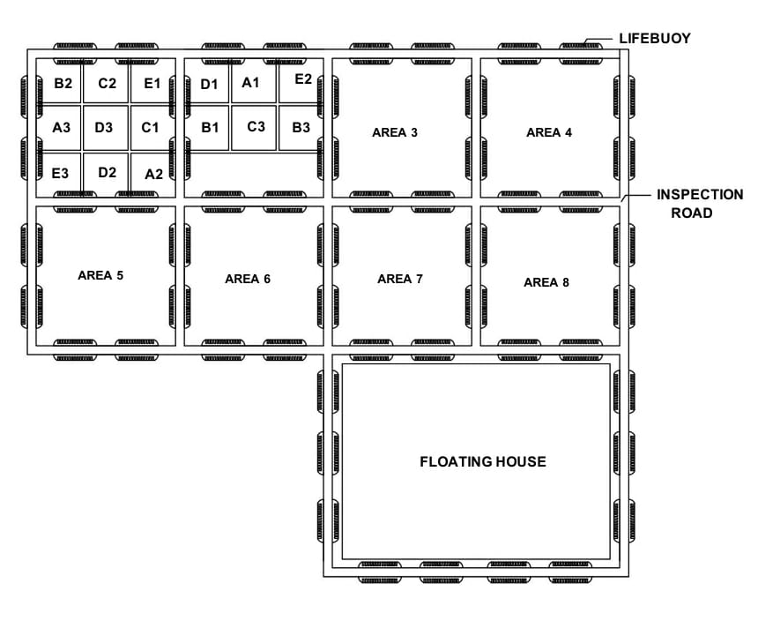
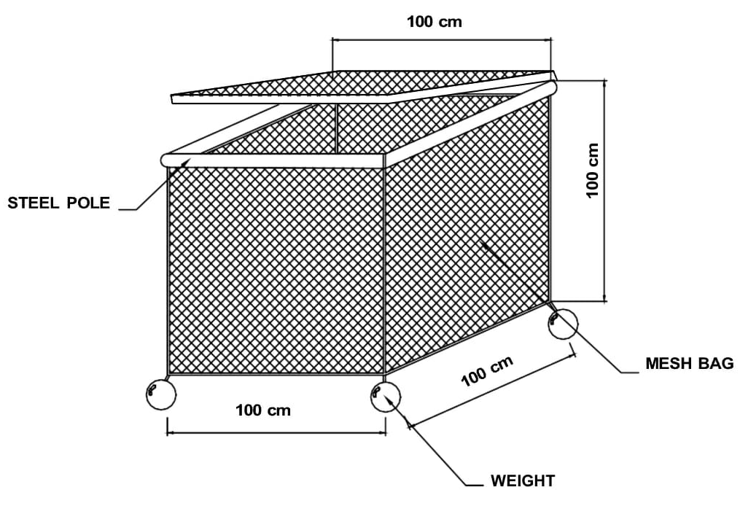
Figure 1. Layout and containers for vaname shrimp cultivation in floating net cages.

2.1 Research Procedures

The study began with the preparation of 15 maintenance tanks measuring 1 x 1 x 1 m3. Vaname shrimp were then stocked at a density of 50 shrimp/1m3. During the cultivation period, the vaname shrimp were fed pellets mixed with Bacillus sp. probiotics three times a day, namely in the morning (07:00), afternoon (13:00), and evening (19:00). The amount of feed given was calculated based on biomass weight, namely 5% of the total biomass weight.

2.2 Data Collection

The parameters observed in this study were absolute weight growth, absolute length growth, specific growth rate (SGR), survival rate (SR), total haemocyte count (THC), differential haemocyte count (DHC), and water quality such as temperature, pH, dissolved oxygen (DO), and salinity, which were measured once a week. Data collection for vaname shrimp growth analysis was conducted every two weeks by taking samples of five shrimp per container, then measuring the length and weight of the vaname shrimp. Data collection for Total Haemocyte Count (THC) and Differential Haemocyte Count (DHC) was conducted at the end of the cultivation period and observed in the fish health laboratory, aquaculture study program, faculty of agriculture, Mataram University.

2.2 Data analysis

The data obtained from the research results were then analyzed using analysis of variance (ANOVA) at a 5% level, meaning that the results of the confidence analysis were believed to be 95% accurate. This analysis aimed to determine whether the treatment had a significant effect on production parameters. If the results obtained were significant, they would be followed up with a Duncan test.

3. results and discussion

3.1 Results

3.1.1. Absolute Weight Gain

The results of the analysis of variance (ANOVA) and follow-up test of the effect of Bacillus sp. probiotic bacteria in feed on the absolute weight growth of vaname shrimp (Litopenaeus vannamei) can be seen in (Figure 2).

Figure 2. Absolute weight growth of vaname shrimp with different doses of Bacillus sp. probiotic treatment (A = control, B = 1.5 g Bacillus sp. probiotic, C = 3 g Bacillus sp. probiotic, D = 4.5 g Bacillus sp. probiotic, E = 6 g Bacillus sp. probiotic)

Based on variance analysis at the 5% level, it was found that the administration of Bacillus sp. probiotics in feed had a significant effect on the absolute weight growth of vaname shrimp (Figure 2). The control treatment (A) differed significantly from the administration of Bacillus sp. probiotics 1.5 g (B), Bacillus sp. probiotics 3 g (C), Bacillus sp. probiotics 4.5 g (D), and Bacillus sp. probiotics 6 g (E). Treatment B was significantly different from all other treatments, as were treatments C, D, and E, where the administration of 6 g of Bacillus sp. probiotics in feed resulted in the highest absolute weight gain of 10.00±0.08 g/shrimp.

3.1.2. Absolute Length Growth

The results of the analysis of variance (ANOVA) and follow-up test of the effect of Bacillus sp. probiotic bacteria in feed on the absolute length growth of vaname shrimp (Litopenaeus vannamei) can be seen in (Figure 3).

Figure 3. Absolute length growth of vaname shrimp with different doses of Bacillus sp. probiotic treatment (A = control, B = 1.5 g Bacillus sp. probiotic, C = 3 g Bacillus sp. probiotic, D = 4.5 g Bacillus sp. probiotic, E = 6 g Bacillus sp. probiotic)

Based on variance analysis at the 5% level, it was found that the administration of Bacillus sp. probiotics in feed had a significant effect on the absolute length growth of vaname shrimp (Figure 3). The control treatment (A) differed significantly from the administration of 1.5 g of Bacillus sp. probiotics (B), 3 g of Bacillus sp. probiotics (C), 4.5 g of Bacillus sp. probiotics (D), and 6 g of Bacillus sp. probiotics (E). Treatment B was significantly different from all other treatments, as were treatments C, D, and E, where the administration of 6 g of Bacillus sp. probiotics in feed resulted in the highest absolute length growth of 6.85±0.07 cm/shrimp.

3.1.3. Specific Growth Rate (SGR)

The results of the analysis of variance (ANOVA) and follow-up test of the effect of Bacillus sp. probiotic bacteria in feed on the specific growth rate of vaname shrimp (Litopenaeus vannamei) can be seen in (Figure 4).

Figure 4. Specific growth rate of vaname shrimp with different doses of Bacillus sp. probiotic treatment (A = control, B = 1.5 g Bacillus sp. probiotic, C = 3 g Bacillus sp. probiotic, D = 4.5 g Bacillus sp. probiotic, E = 6 g Bacillus sp. probiotic)

Based on variance analysis at the 5% level, it was found that the administration of Bacillus sp. probiotics in feed had a significant effect on the specific growth rate of vaname shrimp (Figure 4). The control treatment (A) differed significantly from the administration of Bacillus sp. probiotics 1.5 g (B), Bacillus sp. probiotics 3 g (C), Bacillus sp. probiotics 4.5 g (D), and Bacillus sp. probiotics 6 g (E). Treatment B was significantly different from all treatments, as were treatments C, D, and E, where the administration of Bacillus sp. 6 g probiotics in feed resulted in the highest specific growth rate of 3.17±0.07 %/h.

3.1.4. Survival Rate (SR)

The results of the analysis of variance (ANOVA) and follow-up test of the effect of Bacillus sp. probiotic bacteria in feed on the survival rate of vaname shrimp (Litopenaeus vannamei) can be seen in (Figure 5).

Figure 5. Survival rate of vaname shrimp treated with different doses of Bacillus sp. probiotics (A = control, B = 1.5 g Bacillus sp. probiotics, C = 3 g Bacillus sp. probiotics, D = 4.5 g Bacillus sp. probiotics, E = 6 g Bacillus sp. probiotics)

Based on variance analysis at the 5% level, it was found that the administration of Bacillus sp. probiotics in feed had a significant effect on the survival rate of vaname shrimp (Figure 5). The control treatment (A) differed significantly from the treatment with 4.5 g of Bacillus sp. probiotic (D) and the treatment with 6 g of Bacillus sp. probiotic (E), but did not differ significantly from the treatment with 1.5 g of Bacillus sp. probiotic (B) and the treatment with 3 g of Bacillus sp. probiotic (C). The treatment with Bacillus sp. 6 g (E) probiotic in the feed resulted in the highest survival rate of 85.33±5.03%.

3.1.5. Total Haemocyte Count (THC)

The results of the analysis of variance (ANOVA) and follow-up test of the effect of Bacillus sp. probiotic bacteria in feed on the total haemocyte count of vaname shrimp (Litopenaeus vannamei) can be seen in (Figure 6).

Figure 6. Total haemocyte count of vaname shrimp treated with different doses of Bacillus sp. probiotics (A = control, B = 1.5 g Bacillus sp. probiotics, C = 3 g Bacillus sp. probiotics, D = 4.5 g Bacillus sp. probiotics, E = 6 g Bacillus sp. probiotics)

Based on variance analysis at the 5% level, it was found that the addition of Bacillus sp probiotics to feed had no significant effect on the total haemocyte count of vaname shrimp (Figure 6).

3.1.6. Differential Haemocyte Count (DHC)

The results of the analysis of variance (ANOVA) and follow-up test of the effect of Bacillus sp. probiotic bacteria in feed on the differential hemocyte count of vaname shrimp (Litopenaeus vannamei) can be seen in (Figure 7).

Figure 7. Differential haemocyte count of vaname shrimp treated with different doses of Bacillus sp. probiotics (A = control, B = 1.5 g Bacillus sp. probiotics, C = 3 g Bacillus sp. probiotics, D = 4.5 g Bacillus sp. probiotics, E = 6 g Bacillus sp. probiotics).

Based on variance analysis at the 5% level, it was found that the administration of Bacillus sp. probiotics in feed had no significant effect on the DHC of vaname shrimp, which includes hyaline (H), granular (G), and semi-granular (SG) values.

3.1.7 Water Quality

Water quality measurements show that all water quality parameters during the vaname shrimp maintenance period are still within the optimal range and suitable to support the growth and survival of vaname shrimp (Table 1).

Table 1. Results of water quality measurements for vaname shrimp with different doses of Bacillus sp. probiotic treatment (A = control, B = 1.5 g Bacillus sp. probiotic, C = 3 g Bacillus sp. probiotic, D = 4.5 g Bacillus sp. probiotic, E = 6 g Bacillus sp. probiotic).

Parameters | Observations | References
Temperature | 28-31ºC | 28-32⁰C  (Islami & Madyowati, 2024).
pH | 7-8 | 6-9  (Islami & Madyowati, 2024).
Dissolved Oxygen | 4-6 mg/L | >4 mg/l  (Islami & Madyowati, 2024).
Salinity | 29-33 ppt | 15-35 ppt  (Islami & Madyowati, 2024).

3.2. Discussion

3.2.1. Absolute Weight Gain

Absolute weight is the increase in biota weight during cultivation from the beginning to the end of cultivation (Figure 2) shows the absolute weight data of vaname shrimp cultivated for 56 days, with the highest absolute weight value found in the treatment with Bacillus sp. probiotic 6 g (E) treatment at 10.00±0.08 g/shrimp and the lowest in the treatment without Bacillus sp. probiotic administration or control (A) at 4.65±0.05 g/shrimp. The absolute weight values obtained in this study were higher than the absolute weight values of vaname shrimp obtained in the study by Maulana et al. (2024), which obtained absolute weight values of vaname shrimp ranging from 2.82-5.61 g reared for 56 days.
The absolute weight growth of vaname shrimp in the treatment with Bacillus sp. probiotics and without Bacillus sp. probiotics or control shows that probiotics have a significant effect on increasing the absolute weight growth of vaname shrimp. This is due to the effect of Bacillus sp. probiotics in the feed. This is in line with the statement by Agustama et al., (2021), who said that the administration of probiotic bacteria containing Bacillus sp. in feed resulted in higher weight growth of vaname shrimp compared to without probiotics or with other probiotic bacteria. This is also in line with the statement by Won et al., (2020), who stated that feeding enriched with Bacillus subtilis significantly increased the growth of vaname shrimp compared to regular feed. This increase was evident in weight gain through increased digestive enzyme activity, which allowed for more optimal nutrient utilization. According to Aswinto & Dhengi (2023), the addition of probiotic bacteria to feed causes an increase in enzyme activity in the digestive tract, which can help the absorption process of consumed food, resulting in optimal growth and feed efficiency.

3.2.2. Absolute Length Growth

Absolute length is the increase in length experienced by biota from the beginning to the end of cultivation (Figure 3) shows the absolute length data of vaname shrimp reared for 56 days, with the highest absolute length value obtained in the treatment with 6 g of Bacillus sp. probiotic (E) at 6.85±0.07 cm/shrimp and the lowest value obtained in the treatment without Bacillus sp. probiotic or control (A) at 3.83±0.10 cm/shrimp. This value can be considered quite good when referring to the study by Maulana et al., (2024), which obtained absolute length values in the range of 6.15-8.82 cm when reared for 56 days in a controlled environment.
Based on the results of the study, it is known that the absolute length growth of vaname shrimp fed with Bacillus sp. probiotics tends to be higher than that of shrimp fed without Bacillus sp. probiotics (control). This is thought to be influenced by the higher feed digestibility in the treatment with Bacillus sp. probiotics in the feed. This is in line with the statement by Agustama et al., (2021), who stated that the addition of Bacillus sp. probiotics to feed can increase the ability of bacteria in the digestive tract to secrete digestive enzymes such as protease and amylase. Increased digestive enzyme activity improves feed digestibility, allowing nutrients to be easily digested by vaname shrimp, resulting in good growth. According to Won et al., (2020), feed enriched with Bacillus subtilis bacteria significantly increased trypsin, amylase, and lipase activity in shrimp intestines compared to regular feed.

3.2.3. Specific Growth Rate (SGR)

Specific growth rate (SGR) is one of the parameters used to assess how rapidly biota grow in cultivation, expressed as a percentage per day (Figure 4) shows the specific growth rate data for vaname shrimp cultivated for 56 days, which obtained the highest specific growth rate in the treatment with Bacillus sp. probiotic 6 g (E) treatment at 3.17±0.07 %/h, while the lowest value was obtained in the treatment without Bacillus sp. probiotic administration or control (A) at 2.15±0.07 %/h. The specific growth rate obtained in this study is still categorized as quite good when referring to the study by Sarmin et al. (2025), which obtained a specific growth rate of 2.74-5.08 %/h when cultivated in a controlled environment for 60 days. The growth of vaname shrimp was not very fast, presumably due to the presence of pests such as fish, crabs, and barnacles in the floating net cages (FNC). This is in line with the statement by Witoko et al., (2018), who stated that pests in the cultivation media, such as wild fish and sea snails, can inhibit shrimp growth. This is because the feed provided is eaten by several competitors in the form of wild fish and sea snails. In addition, the density in the medium also increased, so that the shrimp had competitors in the cultivation medium.
Based on the results of the study, it was found that the specific growth rate of vaname shrimp fed with Bacillus sp. probiotics tended to be higher than that of shrimp fed without Bacillus sp. probiotics (control). This shows that feeding Bacillus sp. probiotics to vaname shrimp can increase their specific growth rate. This is in line with the research by Eissa et al., (2022), which found that the addition of Bacillus subtilis to feed significantly increased the specific growth rate (SGR) of shrimp. This is because Bacillus subtilis can increase feed utilization efficiency and intestinal health, thereby supporting optimal nutrient absorption for faster growth. The addition of Bacillus sp. probiotics to vaname shrimp feed can increase the specific growth of vaname shrimp through various mechanisms, such as balancing intestinal microbes, stimulating the immune system, increasing feed efficiency, and maintaining water quality, thereby increasing the growth of vaname shrimp. This is in line with the statement by Zubaidah et al., (2025), who stated that the mechanism of growth enhancement by probiotics is carried out through improved nutrient absorption and by increasing digestive enzyme activity, improving nutrient utilization and intestinal health, which further stimulates feeding behavior. According to Yaqub et al., (2021), adding probiotics to shrimp feed has been proven to improve growth, nutrient digestibility, and protein efficiency.

3.2.4. Survival Rate (SR)

The survival rate (SR) is the percentage of fish that are still alive at the end of the cultivation period. Based on the results of the study, it was found that the control treatment (A) differed significantly from the treatment with Bacillus sp. probiotics at 4.5 g (D) and 6 g (E), but did not differ significantly from the treatment with Bacillus sp. probiotics at 1.5 g (B) and 3 g (C). This indicates that the addition of Bacillus sp. probiotics at high doses (4.5-6 g/kg feed) can have a significant effect on increasing the survival rate of vaname shrimp, while at low doses (1.5-3 g/kg feed) there is no significant difference compared to the control. This is thought to be related to the Bacillus sp. probiotic dose being inappropriate or too low. According to Islami & Madyowati (2024), the administration of probiotics in low doses in feed affects the growth and survival of vannamei shrimp because the dose is not effective enough. If the probiotic dose administered is not appropriate, the performance of the bacteria will be poor. Additionally, the high or low survival rate of vannamei shrimp is due to molting activity, where shrimp undergoing molting are easily preyed upon by other shrimp because they are in a weakened state during molting. This is in line with the statement by Pakaya et al., (2022), which states that the molting process between shrimp that does not occur simultaneously causes shrimp that are in a weak condition during molting to be eaten by other shrimp, resulting in death.
The treatment of feeding Bacillus sp. 4.5 g (D) and Bacillus sp. 6 g (E) probiotics in the feed resulted in the highest survival rates of 80.67±3.06% - 85.33±5.03%. The increase in the survival rate of vaname shrimp that occurred in the treatment of Bacillus sp. 4.5 g (D) and 6 g (E) probiotic administration is thought to be due to the addition of Bacillus sp. probiotics. According to research by Won et al., (2020), probiotic administration in shrimp feed has been shown to reduce mortality rates compared to control feed. The addition of probiotics helps maintain shrimp health, thereby increasing survival. This is in line with the statement by Monier et al., (2023), who stated that Bacillus subtilis probiotics play an important role in developing innate immunity in shrimp, thereby reducing susceptibility and mortality rates. In addition, Bacillus sp. bacteria act as inhibitors of interbacterial communication, known as Anti Quorum Sensing. This is in line with the statement by Permanti et al., (2018) that Bacillus sp. can produce the enzyme AHL-lactonase. This enzyme is a form of survival strategy in stressful environments, such as changes in physical conditions and limited nutrient availability. Based on research conducted by Agustama et al., (2021), adding Bacillus sp. probiotics to artificial feed can increase the growth and survival rate of post-larvae of vaname shrimp.

3.2.5. Total Haemocyte Count (THC)

Hemocytes are a non-specific cellular defense system in shrimp. Observation of the Total Haemocyte Count (THC) is an important indicator in determining the state of the immune system or the health level of shrimp. This is in line with Kasembukan's (2019) statement that hemocytes can be used as a quantitative parameter in measuring stress response in shrimp. In Figure 4.5, the Total Hemocyte Count (THC) data for vaname shrimp fed with Bacillus sp. probiotics in their feed is not significant. This can be interpreted as meaning that there was no significant difference in the total haemocyte count between the treatment with Bacillus sp. probiotics in the feed and the control. The THC values obtained in this study ranged from 20,47 x 10⁶ to 26,03 x 10⁶ cells/ml, indicating that the vaname shrimp were in a healthy condition. This is in line with the statement by Hapizah et al. (2024), who stated that the THC range for penaeid shrimp is 20 x 10⁶ - 40 x 10⁶ cells/ml.
Based on the results of observations of the Total Haemocyte Count (THC) of vaname shrimp obtained in this study, which were within the normal range, this indicates that the vaname shrimp were in a healthy condition and not stressed due to pathogen infection. This is thought to be because the vaname shrimp were raised with sufficient nutrition and in an optimal cultivation environment for vaname shrimp. This is in line with the statement by Hermawan & Satyantini (2016), who stated that hemocytes are a cellular defense system in vaname shrimp that is responsible for phagocytosis, nodulation, and encapsulation. A high number of hemocytes indicates the health status of vaname shrimp. Environmental factors can cause changes in the total number of hemocytes in vaname shrimp. The total number of hemocytes is used to determine the health status of shrimp. According to Navianda (2020), the number of hemocytes in shrimp shows different responses to environmental stress and disease, so environmental conditions can be used as an indicator to determine the health status of shrimp. Poor water quality can cause a decrease in the number of hemocytes because vaname shrimp experience stress.

3.2.6. Differential Haemocyte Count (DHC)

The differential haemocyte count (DHC) is one indicator that shows the immune response in addition to THC. Prastowo et al., (2020) state that haemocyte cells are divided into three types, namely hyaline (H), granular (G), and semi-granular (SG) cells. These three types of haemocyte cells play an important role in the defense system of vaname shrimp against pathogen attacks. Based on Figure 7 it can be seen that the differential haemocyte count (DHC) value of vaname shrimp fed with Bacillus sp. probiotics in their feed did not show a significant effect. The hyaline values obtained in this study ranged from 61.33% to 68.33%. These hyaline values are still within the normal range for vaname shrimp. This is in line with the statement by Kurniawan et al., (2018), who stated that the percentage of hyaline in normal shrimp ranges from 60% to 90% of the total hemocytes. An increase in the amount of hyalin in the body of vaname shrimp can be an indicator of an immune response to pathogens or an attempt by vaname shrimp to defend themselves. Hyalin acts as an innate defense system that can trigger and support phagocytosis activity. This is in line with the statement by Febrianti et al., (2025) which states that if the amount of hyalin increases, it will have an impact on increasing phagocytosis activity. If there is an external threat such as bacteria or foreign objects, the shrimp's immune system will be activated.
Based on the results of granular cell observations obtained in this study, the values ranged from 16.33% to 20.67%. These values are still within the normal range according to the study by Apsani et al., (2022), which states that the percentage of granulocytes in normal vaname shrimp ranges from 17% to 40% of the total hemocytes. Normal granular cell values indicate a good immune response and a cultivation environment that supports cultivation health. Granular cells play a role in the process of producing phenoloxidase enzymes that function in the non-specific defense system. This is in line with the statement by Himzanah et al., (2023), which states that granulocytes play a role in the encapsulation process and activate the proPO system. The activation process of prophenoloxidase (proPO) in granulocytes will result in the release of enzymes; the greater the number of granulocytes, the greater the phagocytosis process in shrimp.
Based on the results of observations, the semi-granular values obtained in this study ranged from 15.33% to 18.33%. These values are still within the normal range according to the study by Apsani et al., (2022), which states that the percentage of semi-granulocytes in normal vaname shrimp ranges from 13% to 49% of the total hemocytes.

3.2.7 Water Quality

Water quality is an important aspect in aquaculture activities and is one of the factors that determine the success of vaname shrimp farming. The results of water quality parameter measurements during the study were within the optimal range. The results obtained from temperature measurements ranged from 28-31oC, pH ranged from 7-8, dissolved oxygen ranged from 4-6 mg/L, and salinity ranged from 29-33 ppt. Based on the research by Islami & Madyowati (2024), the water quality measurement results are still considered optimal for the growth and survival of vaname shrimp.

4. Conclusion

Based on the research conducted, it can be concluded that the administration of Bacillus sp. probiotic bacteria in feed has a significant effect (<0.05) on absolute growth, specific growth rate, and survival, while it has no significant effect on blood profiles, including Total Haemocyte Count (THC) and Differential Haemocyte Count (DHC). The administration of Bacillus sp. probiotics at 6.0 g/kg of feed resulted in the highest values for absolute weight growth (10.00±0.08 g), absolute length growth (6.85±0.07 cm), specific growth rate (3.17±0.07 %/h), and survival rate (85.33±5.03%).

DISCLAIMER (ARTIFICIAL INTELLIGENCE)

The author hereby declares that NO generative AI technology such as Large Language Models (ChatGPT, COPILOT, etc.) has been used. And text-to-image generators have been used during the writing or editing of this manuscript.

REFERENCES

Agustama, Y., Lestari, T. A., Verdian, A. H., Witoko, P., & Marlina, E. (2021). Addition of EM4 Probiotics and Bacillus sp. to Artificial Feed on the Growth and Survival of Vaname Shrimp Post-Larvae. Journal of Applied Fisheries, 2(1), 39-44.
Apsani, W. P., Azhar, F., & Lestari, D. P. (2020). The Effect of Feeding White Turmeric Extract (Curcuma zedoaria) at a 1% Dose with Different Frequencies on the Immune System of Vaname Shrimp (Litopenaeus vannamei) Infected with Vibrio parahaemolyticus Bacteria. Unram Repository
Aswinto, Y. D., & Dhengi, S. (2023). Study of the Application of Probiotic Bacteria in Feed for the Growth of Vaname Shrimp (Litopenaeus vannamei) at BPBAP Takalar, South Sulawesi. Aquanipa-Journal of Marine Science and Fisheries, 5(4).
Barung, B. P. D. B., Zainuddin, Z., & Fujaya, Y. (2023). The Effect of Vitomolt Plus Dosage in Feed on the Growth and Survival of Vaname Shrimp Juveniles (Litopenaus vannamei). Journal of Aquaculture Studies and Development, 1(1), 37-49.
Basir, B., Nursyahran, N., Jufiyati, J., & Apriliani, I. (2022). Optimasi Kinerja Udang Vaname (Litopenaeus vannamei) dengan Suplementasi Daun Kelor dan Probiotik pada Pakan. Jurnal Ilmu-ilmu Perikanan Dan Budidaya Perairan, 17(1), 78-87. https://doi.org/10.31851/jipbp.v17i1.8333
Eissa, E. S. H., Ahmed, N. H., El‐Badawi, A. A., Munir, M. B., Abd Al‐Kareem, O. M., Eissa, M. E., & Sakr, S. E. S. (2022). Assessing the influence of the inclusion of Bacillus subtilis AQUA‐GROW® as feed additive on the growth performance, feed utilization, immunological responses and body composition of the Pacific white shrimp, Litopenaeus vannamei. Aquaculture Research, 53(18), 6606-6615. https://doi.org/10.1111/are.16129
Esa, M. F. D., Krisnamurthi, B., & Suharno. (2022). Analisis Kelayakan Usaha Udang Vaname (Litopenaeus Vannamei) Keramba Jaring Apung Laut di Kepulauan Seribu. *Jurnal Agribisnis Indonesia*, *10*(2), 280-288. https://doi.org/10.29244/jai.2022.10.2.280-288
Febrianti, B. Y., Azhar, F., & Mukhlis, A. (2025). The Effect of Kappa-Carrageenan Administration Frequency on the Immune Response and Survival of Vannamei Shrimp (Litopenaeus vannamei) Infected with Vibrio parahaemolyticus. Journal of Tropical Biology, 25(3), 3115-3124. https://doi.org/10.29303/jbt.v25i3.9825
Hapizah, I., Junaidi, M., & Azhar, F. (2024). Effectiveness of Use of UV Lamp in Disinfection of Additioned Vaname Shrimp (Litopenaeus vannamei) Cultivation Media Bacteria Vibrio Harveyi. Jurnal Biologi Tropis, 24(2), 954–965. https://doi.org/10.29303/jbt.v24i2.6889
Himzanah, S. S., Rudi, M., Prasetiyo, H., & Hartana, N. S. (2023). Comparison of Different Immunostimulants on the Blood Profile of Vaname Shrimp (Litopenaeus vannamei) in PT Suri Tani Pemuka's Supported Ponds. Journal of Indonesian Tropical Fisheries, 6(2), 110-122.
Hermawan, O., Satyantini, W. H., & Prayogo. (2016). Effect of Addition Chitosan to Total Haemocyte Count Changes and Salinity Stress Tolerance of White Shrimp (Litopenaeus vannamei). Journal of Aquaculture and Fish Health, 5(3), 100-107. http://repository.unair.ac.id/id/eprint/123337
slami, A. S., & Madyowati, S. O. (2024). The Effect of Adding Different Doses of Bacillus sp. Probiotics to Feed on the Absolute Weight Growth of 30-Day-Old Vannamei Shrimp (Litopanaeus vannamei). Soetomo Jurnal Pertanian AgroPro, 2(3), 307-320.
Ismawati, I., Destryana, R. A., & Huzaimah, N. (2019). Imunitas Udang Vanname (Litopenaeus vannamei) yang Diberi Pakan Tambahan Daun Kasembukan (Paederia foetida Linn.). Jurnal Kelautan, 12(2), 201-206. https://doi.org/10.21107/jk.v12i2.5998
Kasmi, K., Syawaluddin, S., Wahyu, F., & Ummu Kaltsum SC. (2024). PENGARUH PEMBERIAN PROBIOTIK PADA PAKAN TERHADAP PERTUMBUHAN DAN SINTASAN UDANG VANAME (Litopenaeus vanamei). Jurnal Sains dan Teknologi Perikanan, 4(1), 73-83. https://doi.org/10.55678/jikan.v4i1.1416
Kurniawan, F. A., Abidin, Z., & Setyowati, D. N. A. (2023). Effectiveness of Kawista Leaf Extract (Limonia acidissima) on the Immune System of Vaname Shrimp (Litopenaeus vanamei) Injected with Vibrio harveyi Bacteria. Universitas Mataram. https://repository.unram.ac.id/19000/
Maulana, R., Diniarti, N., & Affandi, R. I. (2024). The Effect of Probiotic Administration with Different Time Intervals on Water Quality in Shrimp Cultivation Vaname (Litopenaeus vannamei) Biofloc System. Jurnal Biologi Tropis, 24(3), 1002–1013. https://doi.org/10.29303/jbt.v24i3.7537
Monier, M. N., Kabary, H., Elfeky, A., Saadony, S., El-Hamed, N. N. A., Eissa, M. E., & Eissa, E. S. H. (2023). The Effects of Bacillus Species Probiotics (Bacillus subtilis and B. licheniformis) on the Water Quality, Immune Responses, and Resistance of Whiteleg Shrimp (Litopenaeus vannamei) Against Fusarium Solani Infection. Aquaculture International, 31(6), 3437-3455. https://doi.org/10.1007/s10499-023-01136-1
Navianda, M. A. (2020). Profile of Vaname Shrimp Hemocytes (Litopenaeus vannamei) to Predict Water Quality in Ponds in Probolinggo Regency, East Java. Doctoral Dissertation, Brawijaya University.http://repository.ub.ac.id/id/eprint/183001
Oktamalia, O., Dewanto, R. H., Novitasari, H., Warman, I., Parwito, P., & Susilo, E. (2023). PELATIHAN PEMBUATAN DAN PENGGUNAAN PROBIOTIK DALAM BUDIDAYA IKAN AIR TAWAR DI DESA MARGA SAKTI KECAMATAN PADANG JAYA KABUPATEN BENGKULU UTARA. PAKDEMAS : Jurnal Pengabdian Kepada Masyarakat. https://doi.org/10.58222/pakdemas.v2i3.166
Pakaya, D., Tuiyo, R., & Lamadi, A. (2022). The Effect of Probiotic Supplementation in Feed on the Growth of Vaname Shrimp (Litopenaeus vannamei) Seedlings. Vocational Science and Technology Journal, 2(1), 13-20.
Permanti, Y. C., Julyantoro, P. G. S., & Pratiwi, M. A. (2018). The effect of adding Bacillus sp. on the survival rate of post-larvae of Vannamei shrimp (Litopenaeus vannamei) infected with vibriosis. *Aquatic Sci*, *1*(1), 91–97. https://doi.org/10.24843/CTAS.2018.v01.i01.p12
Sarmin, S., Setyastuti, A., & Yudistira, D. (2025). Pertumbuhan Dan Sintasan Udang Vaname Yang Diberi Probiotik Dengan Persentase Yang Berbeda. Journal of Marine Research, 14(3), 623-630. https://doi.org/10.14710/jmr.v14i3.53418
Witoko, P., Purbosari, N., Noor, N. M., Hartono, D. P., Barades, E., & Bokau, R. J. (2018). Vaname Shrimp (Litopenaeus vannamei) Cultivation in Floating Net Cages. In Proceedings of the National Seminar on Agricultural Technology Development.http://jurnal.polinela.ac.id/index.php
Won, S., Hamidoghli, A., Choi, W., Bae, J., Jang, W. J., Lee, S., & Bai, S. C. (2020). Evaluation of Potential Probiotics Bacillus subtilis WB60, Pediococcus pentosaceus, and Lactococcus lactis on Growth Performance, Immune Response, Gut Histology and Immune-Related Genes in Whiteleg Shrimp, Litopenaeus vannamei. Microorganisms, 8(2), 281. https://doi.org/10.3390/microorganisms8020281
Yaqub, A., Awan, M. N., Kamran, M., & Majeed, I. (2022). Evaluation of Potential Applications of Dietary Probiotic (Bacillus licheniformis SB3086): Effect on Growth, Digestive Enzyme Activity, Hematological, Biochemical, and Immune Response of Tilapia (Oreochromis mossambicus). Turkish Journal of Fisheries and Aquatic Sciences, 22(5). https://doi.org/10.4194/TRJFAS19882
Zubaidah, A., Lasmi, H., & Hariyadi, H. (2025). Evaluation of growth and survival of vannamei shrimp (Litopenaeus vannamei) in an intensive system with probiotic supplementation in feed. Acta Aquatica: Aquatic Sciences Journal, 1(1), 35-39. https://doi.org/10.29103/aa.v1i1.18602

