Reconstruction of the Van Meter & Van Horn Policy Implementation Model through the Integration of Public Participation in the Implementation of Public Information Disclosure Policies in Gorontalo Province

.
ABSTRACT

Aims: Public information disclosure is an important instrument in realizing government transparency and accountability. However, the implementation of this policy in Gorontalo Province still faces a gap between regulation and implementation. This study aims to reconstruct Van Meter & Van Horn's policy implementation model by integrating public participation as an external variable that influences the effectiveness of information disclosure policies.
Methodology: Public information disclosure is an important instrument in realizing government transparency and accountability. However, the implementation of this policy in Gorontalo Province still faces a gap between regulation and implementation. This study aims to reconstruct Van Meter & Van Horn's policy implementation model by integrating public participation as an external variable that influences the effectiveness of information disclosure policies.
Results: The results show that internal bureaucratic factors such as resources, inter-organizational coordination, and the disposition of implementers are not yet optimal, while public participation is still low, so that social control is not effective.
Conclusion: This research produced a new conceptual model that places public participation as a driver of policy implementation accountability. This model offers theoretical contributions and practical recommendations for strengthening open government governance.

Keywords: Policy Implementation; Public Information Disclosure; Public Participation; Van Meter & Van Horn; Governance

1. INTRODUCTION

Public information disclosure is a key pillar in realizing transparent (Wang & Zhang, 2023), accountable (Greiling & Spraul, 2010), and responsive governance that serves the interests of the community (Hess, 2008). The application of this principle of openness is increasingly important in an era of information democratization and digital technology development, which requires the government to provide access to information quickly, accurately, and easily (Hanna, 2010). In Indonesia, the enactment of Law No. 14 of 2008 on Public Information Disclosure (KIP) is a manifestation of the state's commitment to guaranteeing the public's right to know about the process of governance, as well as a public oversight instrument to minimize abuse of power (Ferdaus & Zaimasuri, 2023). However, the implementation of KIP policies in various regions still faces structural and cultural challenges that affect their effectiveness, including in Gorontalo Province.
The province of Gorontalo, as a region with strong institutional development dynamics (Arsana & Olilingo, 2021), has shown an increase in its information disclosure index from year to year. However, there are still a number of fundamental issues, such as the low quality of public information services provided by the Information and Documentation Management Officer (PPID), limited technological resources (Pakpahan, 2023) and human resources (Fitriany et al., 2024), suboptimal communication between implementing organizations, and high variation in the level of compliance of public agencies in providing information proactively (Isana & Sompa, 2022). In addition, public complaints regarding slow access to information, the continued existence of exempted information that has not undergone proper consequence testing, and an increase in information disputes at the Information Commission indicate that this policy has not been effectively implemented at the operational level.
Various policy implementation theories have been used to analyze the success or failure of public policy implementation. One of these is the policy implementation model developed by Donald Van Meter and Carl Van Horn (Van Meter & Van Horn, 1975). This model emphasizes six key variables: the scope and objectives of the policy, resources, interorganizational communication, the characteristics of the implementing agency, the attitudes of the implementers, and the social, economic, and political conditions. This model is generally oriented towards a bureaucratic perspective and has been widely used in policy implementation studies in Indonesia, including public information disclosure. However, the rights-based nature of KIP policies, which place the community in an active role in assessing and controlling the effectiveness of implementation, requires broader variables beyond the internal structure of the bureaucracy.
The phenomenon in Gorontalo shows that the success rate of implementing information disclosure policies is not only determined by bureaucratic capacity, but also by the extent to which the public is able and willing to participate in accessing information, providing input, and monitoring the fulfillment of these rights. Thus, public participation is no longer merely as beneficiaries, but as important actors who influence and drive the implementation of policies. This shows the need to adjust and enrich the Van Meter & Van Horn model to better suit the context of information disclosure in the era of democratization and digitization of public services.
Based on this urgency, this study offers a reconstruction of the Van Meter & Van Horn policy implementation model through the integration of public participation variables as a new conceptual element. This approach is expected to produce a more comprehensive understanding of the factors determining the success of KIP policy implementation in Gorontalo Province. In addition to contributing to improving the quality of information governance at the regional level, this study also has significant novelty value in the development of public administration science, particularly in the study of policy implementation with a collaborative and participatory governance paradigm.
Thus, this study not only aims to assess the extent to which the implementation of public information disclosure policies in Gorontalo Province has complied with the mandate of Regulation No. 19 of 2009 on Public Information Disclosure, but also seeks to develop a more adaptive and contextual implementation model by strengthening the role and participation of the community as an integral element in the success of public policy.
...
2. material and methods

This study uses a qualitative approach with a case study design (Alam, 2021), as the main objective of the study is to gain an in-depth understanding of the process of implementing public information disclosure policies in the institutional context of Gorontalo Province. This approach allows researchers to explore the meaning, dynamics, and factors that influence the effectiveness of policy implementation, as carried out by the Communication and Information Agency together with the Information and Documentation Management Officer (PPID) within the Gorontalo Provincial Government. The research location was selected purposively because Gorontalo Province is one of the regions that is promoting the acceleration of public transparency through the optimization of information services.
The researchers' presence in this study was direct and served as the main instrument. The researchers were involved in the entire process, from data collection and interpretation of phenomena to interpretation of findings. The researchers' interactions with informants were conducted in a naturalistic manner, enabling them to capture the reality of policy implementation as it actually occurred in the field.
The research subjects consisted of stakeholders involved in the implementation of public information disclosure policies, including the Head of the Communication, Informatics and Statistics Office, structural and functional officials handling information services, the Gorontalo Provincial Information Commission, and PPIDs in several Regional Apparatus Organizations. In addition, the study also involved public information requesters and local media representatives to obtain a balanced perspective on the level of transparency of information services in the province. Informants were selected purposively based on the relevance of their knowledge and direct involvement in policy implementation.
Data collection was carried out using three main techniques, namely observation, interviews, and document studies. Observations were conducted in a non-participatory manner by observing the public information service processes carried out in OPDs and digital service channels. In-depth semi-structured interviews were conducted so that researchers could explore more broadly the various experiences, perceptions, and challenges faced by policy implementers. Meanwhile, document studies were used to examine various policy products, annual public information service reports, the results of monitoring and evaluation by the Information Commission, and other administrative and digital information disclosure data.
Data analysis uses the Miles and Huberman Interactive Model, namely through the process of data reduction, data presentation, and conclusion drawing and verification. These three activities took place simultaneously and repeatedly until a complete understanding of the phenomenon under study was obtained. To ensure the validity of the findings, the researchers applied source triangulation and technique, checked credibility through confirmation with informants, and maintained consistency of interpretation based on the empirical evidence found.

3. results and discussion

The alignment between targets and actual results in the implementation of public information disclosure in Gorontalo Province remains low. The targets for the Public Information Disclosure Index (IKIP) and the Service Quality Index (SKM) have not been achieved, services remain reactive, and budget implementation and human resource performance do not yet support the objectives of the Public Information Disclosure Law. This is consistent with the view of Van Meter and Van Horn (1975) that policy implementation will be considered successful if the established standards and objectives can be realized in practice (Van Meter & Van Horn, 1975). In the context of Gorontalo, the gap between targets and realization proves that policy effectiveness is still far from optimal and requires strengthening in terms of politics, institutions, and public participation.
The infrastructure and technology used in the implementation of KIP in Gorontalo Province show a gap between the availability of facilities and their utilization. Digital infrastructure has indeed been provided, but weak management, lack of integration between OPDs, and low digital literacy among the public have prevented technology from playing its full role as an instrument of information disclosure. Thus, although this indicator has been structurally fulfilled, it is still far from the expectation of realizing proactive, participatory public information services that meet the needs of the community.
Coordination with the Information Commission or external agencies shows that the implementation of the KIP Law in Gorontalo still faces serious obstacles in the form of weak coordination, slow dispute resolution mechanisms, budget constraints, and low public literacy regarding the functions of the Information Commission. When viewed from the perspective of Van Meter & Van Horn and Goggin et al., this weak external coordination underscores the need for improved communication, consistent coordination, strengthened institutional legitimacy, and active public participation so that information disclosure can proceed in accordance with the principles of good governance.
The work culture and procedures within the Gorontalo Provincial OPD still face dualism: on the one hand, there is a move towards transparency through formal SOPs and leadership commitment, but on the other hand, it is still hampered by inconsistency, bureaucratic culture, and limited resources. This highlights the need to strengthen human resource capacity, harmonize procedures between OPDs, and reinforce leadership commitment so that the implementation of a culture of openness can truly be effective in accordance with the principles of the KIP Law.
Inter-organizational communication and resources, where coordination between OPDs is weak. In Mazmanian & Sabatier, this response reflects the dependent variables, namely object compliance and actual policy outcomes. The PPID's response to information requests in Gorontalo has not fully complied with the provisions of the KIP Law, which regulates time limits and proactive obligations in the provision of information. A positive response is only found in certain OPDs, while the majority are still slow, bureaucratic, and dependent on internal limitations.
Although regional regulations are in place, the lack of political support in the form of budget allocations has prevented public information disclosure from being implemented effectively. This contradicts the mandate of the Public Information Disclosure Law, which requires public agencies to be proactive in providing information openly, quickly, and continuously.
Theory Development
The novelty of this dissertation research lies in its attempt to integrate public participation as an additional variable in the policy implementation framework of Donald Van Meter and Carl Van Horn (Van Meter & Van Horn, 1975), which previously focused more on internal bureaucratic factors, namely policy size and objectives, resources, interorganizational communication, implementing agency characteristics, implementer attitudes, and social, economic, and political conditions. Previous studies in the context of public information disclosure in Indonesia have generally highlighted the institutionalization of the Information and Documentation Management Officer (PPID), regulations derived from Law No. 14 of 2008 on Public Information Disclosure, and human resource capacity in providing services. However, the dimension of public participation as an external factor that determines the effectiveness of policies has not received adequate attention. The dimension of public participation that is not yet optimal in public information disclosure policies, namely the data from the Gorontalo Province PPID website in 2025, found that the statistical data on the number of information applicants was 54, the number of documents is 788, and the number of downloads is 109,414, which can illustrate the response of the implementers to information requests.
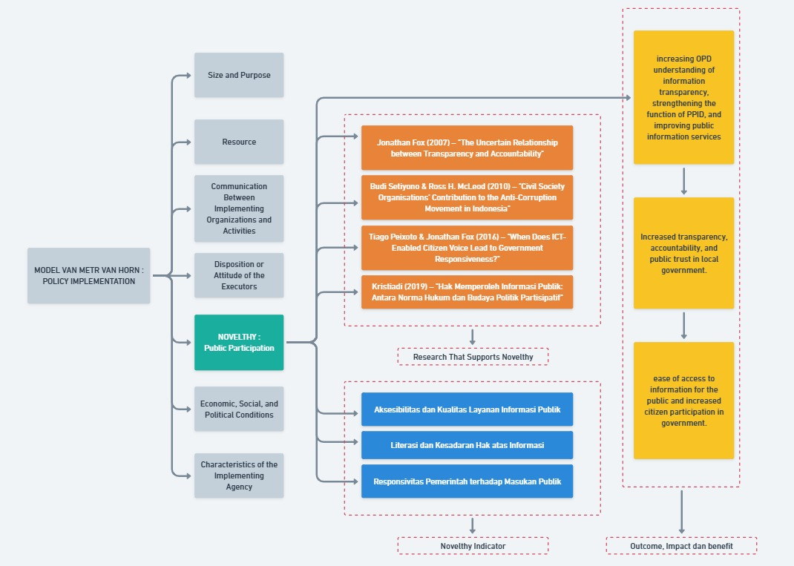
Source: Researcher Analysis (2025)
Figure 1. Theory Development

Theoretically, the addition of this variable is supported by Habermas' deliberative democracy theory, which emphasizes the importance of communication between the state and citizens to generate policy legitimacy, as well as Arnstein's ladder of public participation (1969), which classifies participation from manipulation to citizen control. On the other hand, the UNDP's (1997) principle of good governance places participation as one of the main pillars of good governance, alongside accountability and transparency. This means that public information disclosure does not only stop at the availability of data, but must also ensure that the public has the capacity and opportunity to use this information in the decision-making process and public oversight.
Previous studies have shown significant gaps. Fox (2007) distinguishes between transparency for accountability and transparency without accountability, where openness will only have an impact if there is public participation to oversee its implementation (Fox, 2007). Peixoto & Fox (2016) in a global comparative study also emphasize that transparency programs without real channels for participation tend not to result in improvements in accountability (Peixoto, Tiago; Fox, 2016).
Good practices in various countries confirm the significance of public participation in strengthening information disclosure policies. India, through the Right to Information (RTI) Act 2005, records more than 4 million requests for information each year (data from the Central Information Commission of India, 2022), where the use of information rights by the public has contributed to the uncovering of various corruption cases. The Philippines, through the People's FOI Initiative, has successfully encouraged civil society and media participation in monitoring the use of public budgets. Estonia has even made its e-government system a means of digital participation, with more than 99% of public services being online, allowing citizens to be directly involved in the process of service delivery, oversight, and even electronic elections. Meanwhile, in Indonesia, based on data from the Central Information Commission (KIP, 2022), the national average for public information requests is still below 0.5% of the population, indicating that public participation is relatively low compared to its potential.
By incorporating public participation into the Van Meter and Van Horn framework, this study presents a more comprehensive analysis, as the success of public information disclosure policy implementation is determined not only by bureaucratic capacity, but also by public awareness, literacy, and active involvement as democratic actors. Thus, the novelty of this research is not merely adding new variables, but also offering a more balanced perspective between the state and citizens, as well as providing empirical contributions to the development of policy implementation studies in the field of transparency and democracy in Indonesia. The indicators that influence increased public participation are: (1) Accessibility and Quality of Public Information Services. This indicator covers the extent to which the public can access public information through PPID, official websites (ppid.gorontaloprov.go.id), and digital applications such as e-PPID and Ointha. In Gorontalo, even though digital channels are available, technical constraints (outdated websites, offline applications) and low digital literacy among the public reduce their effectiveness. The availability of easy, fast, and accurate information greatly determines whether the public is willing to participate or not. (2) Literacy and Awareness of the Right to Information. Public participation depends not only on the availability of information, but also on public awareness that they have the legal right to access information in accordance with Law No. 14 of 2008. In Gorontalo, based on interview findings, many members of the general public still do not understand the procedures for requesting information. The lack of socialization from the government has resulted in low literacy, so that only certain groups such as journalists, NGOs, or content creators actively exercise this right. (3) Government Responsiveness to Public Input: The public will be more encouraged to participate if their input, complaints, or criticism are responded to quickly and transparently. However, in Gorontalo, differences in the quality of responses between OPDs were found: the Communication and Information Agency was relatively responsive, but technical OPDs such as the Social Agency tended to be slow and bureaucratic. The government's consistency in following up on public input is key to building trust, which in turn determines the level of public participation.

4. Conclusion

The implementation of public information disclosure policies in Gorontalo Province has not been effective due to the gap between the normative objectives of Law No. 14/2008 and the reality of public services. The main obstacles stem from weak bureaucratic capacity, minimal responsiveness from regional government agencies, and limited budgetary and technological support. Meanwhile, low levels of public literacy and engagement have resulted in public control not functioning as a mechanism for accountability. The research findings confirm that the effectiveness of information disclosure policies is not only determined by internal bureaucratic variables as formulated by Van Meter & Van Horn, but is also greatly influenced by public participation as an external factor. Therefore, the classic implementation model needs to be reconstructed through the integration of participatory dimensions to be more adaptive to public rights-based policies. The theoretical contribution of this research presents a policy implementation model with a participatory democracy paradigm that enriches the study of government transparency. In practical terms, this research recommends strengthening cross-agency coordination, public literacy, digital service modernization, and consistent political support to realize open and accountable governance. Despite its conceptual contributions, this study has limitations in terms of its scope, which focuses only on Gorontalo Province, and its reliance on the perspectives of bureaucratic informants and a limited number of information requesters. In addition, the absence of quantitative measurements limits the level of generalization of the findings. Therefore, further research is recommended to expand the object to cross-provincial levels, combine quantitative-comparative approaches, and explore the socio-political factors that influence the dynamics of public participation in open government regimes. This approach is expected to strengthen the validity of the reconstructed policy implementation model and increase the relevance of policies for strengthening local democracy in Indonesia.

COMPETING INTERESTS DISCLAIMER:
Authors have declared that they have no known competing financial interests OR non-financial interests OR personal relationships that could have appeared to influence the work reported in this paper.

REFERENCES

- Alam, M. K. (2021). A systematic qualitative case study: questions, data collection, NVivo analysis and saturation. Qualitative Research in Organizations and Management: An International Journal, 16(1), 1–31. https://doi.org/10.1108/QROM-09-2019-1825
- Arsana, I. K. S., & Olilingo, F. Z. (2020). Economic Shift And Inequality Between Provinces In Sulawesi Island, Republic Of Indonesia. Proceedings of International Interdisciplinary Conference on Sustainable Development Goals (IICSDGs), 3(2), 40–47. https://ejournal.ubmg.ac.id/index.php/IICSDGs/article/view/100
- Ferdaus, F., & Zaimasuri, Z. (2023). Implementation of public information disclosure policy in the house of Representatives of the Republic of Indonesia. Journal of Governance and Accountability Studies (JGAS), 3(1), 29–50. https://doi.org/10.35912/jgas.v3i1.1771
- Fitriany, D., Sari, Y., & Oktarina, Y. (2024). The Influence of Education Level and Competence on The Performance of Information and Documentation Manage-Ment Officials (PPID) Within The Government of Ogan Komering Ulu District. Jurnal Manajemen STIE Muhammadiyah Palopo, 10(2), 385–392. https://doi.org/10.35906/jurman.v10i2.2230
- Fox, J. (2007). The uncertain relationship between transparency and accountability. Development in Practice, 17(4–5), 663–671. https://doi.org/10.1080/09614520701469955
- Greiling, D., & Spraul, K. (2010). Accountability and the challenges of information disclosure. Public Administration Quarterly. https://doi.org/10.2307/41288352
- Hanna, N. K. (2010). Transforming government and building the information society: Challenges and opportunities for the developing world. Springer. https://doi.org/10.1007/978-1-4419-1506-1
- Hess, D. (2008). The three pillars of corporate social reporting as new governance regulation: Disclosure, dialogue, and development. Business Ethics Quarterly, 18(4), 447–482. https://doi.org/10.5840/beq200818434
- Isana, W., Jamaluddin, & Sompa, A. T. (2022). Service quality of information and documentation management officers (PPID) at the communication, informatics and cryptography office of North Barito Regency. *International Journal Political, Law, and Social Science*, *3*(3). https://ijpls.org/index.php/IJPLS/issue/view/3
- Pakpahan, R. T. (2023). Implementation of public information disclosure through information and documentation management officer at public broadcasting institutions. Moestopo International Review on Social, Humanities, and Sciences, 3(2), 118–126. https://doi.org/10.32509/mirshus.v3i2.60
- Peixoto, T., & Fox, J. (2016). When Does ICT-Enabled Citizen Voice Lead to Government Responsiveness?. WDR 2016 Background Paper. https://doi.org/10.1596/23650
- Van Meter, D. S., & Van Horn, C. E. (1975). The policy implementation process: A conceptual framework. Administration & Society, 6(4), 445–488. https://doi.org/10.1177/009539977500600404
- Wang, G., & Zhang, Q. (2023). Transparency, Governance, and Innovation: Unveiling the Impact of Environmental Information Disclosure on Corporate Value and Green Innovation Capabilities. International Journal of Operations and Quantitative Management, 29(4), 54–70. https://www.ijoqm.org/index.php/ijoqm/article/view/102

