Original Research Article

Ecological Observation of a Trichodesmium Bloom in the Lagoon Waters of Minicoy Island, Lakshadweep Archipelago

Abstract
A widespread bloom of the filamentous cyanobacterium Trichodesmium was observed in the lagoon waters of Minicoy Island, Lakshadweep Archipelago. This genus is widely distributed in tropical and subtropical oceans and is known for forming dense, yellowish-brown, mat-like surface aggregations commonly referred to as “sea sawdust.” The bloom event in Minicoy Lagoon was notable due to its extensive surface coverage and the visible discoloration of lagoon waters, a phenomenon seldom reported from the Lakshadweep Islands. Hydrographic and nutrient analyses indicated that the prevailing environmental conditions were conducive to bloom development, with warm temperatures (28–30°C), high salinity (35–36.5 psu), and a stable water column. A marked reduction in nitrate concentration (0.04–0.28 µM) during the bloom period suggested active nitrogen fixation by Trichodesmium, while relatively high phosphate levels (up to 0.35 µM) supported its continued growth. Silicate concentration ranged from 2.1 to 3.3 µM, consistent with oligotrophic lagoon environments. Microscopic observations revealed that Trichodesmium erythraeum dominated the phytoplankton assemblage, comprising about 67% of the total community, with cell densities reaching 3.09 × 10⁵ cells L⁻¹ and filament counts ranging between 75 and 4,808 filaments L⁻¹. The findings suggest that the combination of warm, saline, and nutrient-modified conditions within the lagoon facilitates Trichodesmium proliferation, emphasizing its ecological role in nitrogen fixation and primary productivity within tropical coral reef-associated environments like the Minicoy Lagoon.
- Introduction
The marine cyanobacterium Trichodesmium spp. (Ehrenberg, 1830) is one of the most ecologically significant diazotrophic phytoplankton groups in the world’s oceans. These filamentous cyanobacteria typically form colonies that aggregate near the sea surface, appearing as visible patches or streaks often described as “sea sawdust” (Capone et al., 1997; Westberry & Siegel, 2006). Trichodesmium thrives predominantly under oligotrophic (nutrient-poor) conditions due to its unique ability to fix atmospheric nitrogen and efficiently produce organic carbon through photosynthesis (Carpenter, 1983; Sellner, 1997). This dual role makes it a crucial primary producer in tropical and subtropical marine ecosystems, significantly contributing to global nitrogen and carbon cycling (Capone et al., 1997).
Ecologically, Trichodesmium serves as an important food source for marine copepods, larval fish, and other microzooplankton, thus playing a pivotal role in the marine food web (Carpenter, 1983). Its blooms are frequently observed in nutrient-depleted tropical oceans during periods of high temperature, intense solar radiation, and elevated salinity (Sellner, 1997; Lugomela et al., 2002). Globally, massive blooms of Trichodesmium have been reported from the Arabian Sea, Bay of Bengal, Red Sea, and other warm oceanic regions (Devassy et al., 1978; Qasim, 1970; Ramamurthy et al., 1972).Along the Indian coast, Trichodesmium blooms typically occur during the pre-monsoon months (February–May) when hydrographic stability, high salinity (>33 psu), and strong solar irradiance prevail (Santhanam et al., 1994; Anoop et al., 2006; Sarangi et al., 2004). The Arabian Sea is particularly recognized as a hotspot for Trichodesmium proliferation, where dense surface mats have been frequently observed extending over vast areas of coastal and offshore waters (Ramamurthy et al., 1972; Jyothibabu et al., 2003; Padmakumar et al., 2010).
Since Trichodesmium preferentially grows in nitrate-depleted waters, it often dominates primary productivity during nitrogen-limited periods, enriching the marine environment with bioavailable nitrogen through fixation processes (Capone et al., 1997; Krishnamurthy et al., 2007). In this context, the present study aims to investigate the appearance, spatial distribution, hydrographic characteristics, and ecological implications of Trichodesmium blooms observed in the lagoon waters of Minicoy Island, Lakshadweep, during the pre-monsoon season.
- Materials and Methods
Minicoy Island located at 08 ̊ 17’N and 73 ̊ 04’ E is the southernmost Island in the Lakshadweep group with a land area of 4.4Km² and length of 9.5Km. The lagoon occupies about 30.5Km² area with an average depth of 4m. The Atoll of Minicoy is situated on the South Western side of Peninsular India and is about 400Km from the main land (fig.1). In the month of April 2018, bloom of Trichodesmium spp. were observed in the lagoon waters. A pale-yellow brown color surface spread over the lagoon (fig.4). To understand the bloom area environment, analyzing the physico chemical parameters, such as temperature, salinity, pH and nutrients. The surface water samples were collected using Niskin water sampler with the help of a motorized boat. The temperature in the atmosphere and surface water was measured using a portable thermometer at the time of sample collection. The salinity was measured using DIGI AUTO, TS salinometer (MODEL 5; accuracy ± 0.001). Samples for nutrient concentrations (nitrate, phosphate and silicate) were analyzed following standard methods (Grasshoff et al.,1983; Zhang and Fischer,2006). For quantitative and qualitative studies of phytoplankton, 1 L of water samples was taken and also accumulation of Trichodesmium at the surface water were sampled using a clean plastic bucket ~10L filtered through 60µ bolting silks and fixed with few drops of Lugol’s iodine solution. After the settling and siphoning procedure, 1ml of the aliquot of the sample were taken in a Sedgwick – Rafter counting cell in duplicate under the inverted microscope (Leica DFC- 450), for identifying and counting the phytoplankton cells (Tomas 1997, Devassy et al.,1978). The graphical representation of data is portrayed using Ocean Data View (ODV) software developed by Alfred-Wegener-Institute for Polar and Marine Research (AWI).
- Results
The bloom of filamentous cyanobacteria Trichodesmium was observed in the lagoon waters of Minicoy Island under hydrographic conditions typical of tropical pre-monsoonal environments, characterized by high temperature, elevated salinity, and strong solar irradiance. The surface water temperature ranged between 28°C and 30°C, showing negligible variation among the sampling stations (Fig. 2a). Salinity values ranged from 35 to 36.5 psu (Fig. 2b), reflecting a stable and high-saline environment conducive to Trichodesmium proliferation. Such salinity conditions (>33 psu) are known to support the optimal growth of Trichodesmium, as the species is stenohaline and unable to tolerate lower salinity levels (Krishnamurthy et al., 2007; Satpathy et al., 2007).
The pH and dissolved oxygen (DO) concentrations did not exhibit significant spatial variation, indicating overall stability in the lagoonal environment. However, nutrient concentrations revealed patterns corresponding to bloom intensity. Nitrate concentrations ranged between 0.04 and 0.28 µM (Fig. 2c), with minimum values recorded during the bloom phase, indicative of active nitrogen fixation by Trichodesmium. A similar decline in nitrate levels has been reported during bloom events in the Arabian Sea and Bay of Bengal (Jyothibabu et al., 2003; Santhanam et al., 1994).
Phosphate concentrations displayed spatial variability, with maximum levels (0.35 µM) recorded at Station 4 (Fig. 2d). Elevated phosphate concentrations likely supported bloom persistence, as Trichodesmium requires sufficient phosphorus for metabolic and nitrogen-fixing processes (Capone et al., 1997). Silicate concentrations varied from 2.1 to 3.3 µM (Fig. 2e), typical of oligotrophic coral lagoon environments.
Microscopic analysis confirmed Trichodesmium erythraeum as the dominant species, accounting for approximately 67% of the total phytoplankton biomass, while diatoms, dinoflagellates, and unidentified taxa made up the remaining 33% (Fig. 3). The bloom formed dense, interwoven surface mats that appeared as yellow-brown discolorations on the lagoon surface (Fig. 4). Cell density reached 3.09 × 10⁵ cells L⁻¹, reflecting an intense bloom event.
- Discussions
The occurrence of a Trichodesmium bloom in Minicoy Lagoon during the pre-monsoon period aligns with the established seasonal patterns observed across tropical and subtropical regions. Previous studies have shown that Trichodesmium blooms typically develop in warm, stratified, nutrient-poor waters, especially when nitrate concentrations are depleted and phosphate remains available (Sellner, 1997; Capone et al., 1997). The recorded environmental conditions in the present study high temperature (28–30°C), elevated salinity (35–36.5 psu), and low nitrate concentration (0.04–0.28 µM) closely match the optimal parameters reported for bloom development in the Arabian Sea (Devassy et al., 1978; Padmakumar et al., 2010).
The dominance of T. erythraeum observed here is consistent with earlier findings that this species frequently forms dense surface blooms in Indian coastal and offshore waters (Ramamurthy et al., 1972; Jyothibabu et al., 2003). The low nitrate concentrations recorded during the bloom confirm the diazotrophic nature of Trichodesmium, which compensates for nitrogen limitation by fixing atmospheric nitrogen. This ability enables Trichodesmium to outcompete other phytoplankton groups under oligotrophic conditions, thereby influencing nitrogen cycling and enhancing local primary productivity (Capone et al., 1997; Westberry & Siegel, 2006).
The absence of fish mortality during this event contrasts with earlier reports of Trichodesmium-induced fish kills along the Indian coast (Chacko, 1942; Devanesen, 1942). Certain strains of Trichodesmium have been shown to produce neurotoxins such as β-N-methylamino-L-alanine and anatoxin (Bhat & Verlencar, 2006), but their occurrence and toxicity vary geographically and are often influenced by bloom density and environmental factors (Satpathy et al., 2007). In Minicoy Lagoon, environmental stability and moderate bloom intensity may have prevented the accumulation of toxic concentrations.
Overall, the bloom in Minicoy Lagoon appears to have been driven by warm temperature, high salinity, and low nitrate availability, creating conditions ideal for diazotrophic cyanobacteria. These results support earlier findings that pre-monsoonal hydrographic stability and nutrient imbalance promote Trichodesmium dominance in tropical oceans (Suvapepant, 1992; Krishnamurthy et al., 2007). The event underscores the ecological importance of Trichodesmium in nitrogen fixation, nutrient enrichment, and sustaining productivity in coral reef–associated lagoon systems such as Minicoy.

- Conclusions
The present investigation documents a rare occurrence of a Trichodesmium bloom in the lagoon waters of Minicoy Island, Lakshadweep, highlighting its ecological significance in a coral reef–associated ecosystem. Although Trichodesmium blooms are common along the southwest coast of India, reports from the Lakshadweep Archipelago are limited. The observed bloom was characterized by high cell densities of T erythraeum under hydrographic conditions typical of pre-monsoonal periods warm temperature, elevated salinity, and low nutrient availability, particularly nitrate depletion coupled with moderate phosphate levels. These parameters collectively provided an optimal environment for bloom proliferation and sustained surface aggregation. Unlike some previously reported Trichodesmium events that resulted in fish mortality along the Indian coast, no adverse biological effects or mass mortalities were recorded during the Minicoy bloom. This suggests that the bloom was non-toxic or that environmental concentrations of any potential toxins were below harmful thresholds. The absence of negative impacts on local fisheries indicates that the bloom was part of a natural ecological process rather than a harmful algal event.
The findings underscore that Trichodesmium blooms, while sometimes associated with deleterious effects, play an important ecological role in marine biogeochemical cycling. Through nitrogen fixation, Trichodesmium enriches nutrient-poor tropical waters, enhancing primary productivity and supporting the microbial and planktonic food webs. The present study thus emphasizes the dual role of Trichodesmium as both a natural contributor to oceanic productivity and a potential ecological indicator of nutrient and climatic variations in tropical lagoon ecosystems such as Minicoy.

Conflicts of Interest
The authors declare that they have no known competing financial interests or personal relationships that could have appeared to influence the work reported in this paper.

Literature Cited
Anoop, A. K., Krishnakumar, P. K., & Rajagopalan, M. (2007). Trichodesmium erythraeum (Ehrenberg) bloom along the southwest coast of India (Arabian Sea) and its impact on trace metal concentrations in seawater. Estuarine, Coastal and Shelf Science, 71, 641–646. https://doi.org/10.1016/j.ecss.2006.09.012.
Capone, D. G., Zehr, J. P., Paerl, H. W., Bergman, B., & Carpenter, E. J. (1997). Trichodesmium, a globally significant marine cyanobacterium. Science, 276, 1221–1229. https://doi.org/10.1126/science.276.5316.1221 .
Bhat ,S.R and Verlencar, X.N. 2006. Some enigmatic aspects of marine cyanobacterial genus, Trichodesmium. Curr. Sci. 91:18-19.
Capone, D. G., Zehr, J. P., Paerl, H. W., Bergman, B., & Carpenter, E. J. (1997). Trichodesmium, a globally significant marine cyanobacterium. Science, 276(5316), 1221-1229. https://doi.org/10.1126/science.276.5316.1221 .
Carpenter, E.J .1983. Physiology and ecology of the marine plankton Oscillatoria (Trichodesmium). Mar. Biol. Lett. 4: 69-85.
Chacko, P. I. (1942). An unusual incidence of mortality of marine fauna. *Current Science*, *11*, 404. https://www.currentscience.ac.in/ (Official Journal Archive)
Devanesen, D.W. (1942). Plankton studies in the fisheries branch of the Department of Industries and Commerce, Madras. Current Science, 11, 142-143. https://www.currentscience.ac.in/Volumes.html
Devassy, V. P., Bhattathiri, P. M. A., & Qasim, S. Z. (1978). Trichodesmium phenomenon. Indian Journal of Marine Sciences, 7, 168-186. http://drs.nio.org/drs/handle/2264/5374
Ehrenberg, C. G. (1830). Neue Beobachtungen über blutartige Erscheinungen in Aegypten, Arabien und Sibirien, nebst einer Uebersicht und Kritik der früher bekannten. Annalen der Physik und Chemie, 8, 477–514. https://doi.org/10.1002/andp.18300940402 .
Grasshoff, K., Ehrhardt,M. and Kremling, K .1983. Methods of seawater analysis. WileyVCH, New York.
Zhang, J.-Z., & Fischer, C. J. (2006). A simplified resorcinol method for direct spectrophotometric determination of nitrate in seawater. Marine Chemistry, 99(1-4), 220-226. https://doi.org/10.1016/j.marchem.2005.09.008 .
Jyothibabu, R., Madhu, N. V., Murukesh, N., Haridas, P. C., Nair, K. K. C., & Venugopal, P. (2003). Intense blooms of Trichodesmium erythraeum (Cyanophyta) in the open waters along east coast of India. Indian Journal of Marine Sciences, 32, 165–167. http://nopr.niscpr.res.in/handle/123456789/4266 .
Lugomela, C., Lyimo, T. J., Bryceson, I., & Semesi, A. K. (2002). Trichodesmium in coastal waters of Tanzania: diversity, seasonality, nitrogen and carbon fixation. Hydrobiologia, 477, 1–13. https://doi.org/10.1023/A:1021017125376 .
Krishnamurthy, A., Moore, J. K., Zender, C. S., & Luo, C. (2007). Effects of atmospheric inorganic nitrogen deposition on ocean biogeochemistry. Journal of Geophysical Research: Biogeosciences, 112(G2), G02019. https://doi.org/10.1029/2006JG000334 .
Lugomela, C., Lyimo, T. J., Bryceson, I., Semesi, A. K., & Bergman, B. (2002). Trichodesmium in coastal waters of Tanzania: diversity, seasonality, nitrogen and carbon fixation. Hydrobiologia, 477, 1-13. https://doi.org/10.1023/A:1021017125376
Padmakumar, K. B., Smitha, B. R., Thomas, L. C., Fanimol, C. L., SreeRenjima, G., Menon, N. R., & Sanjeevan, V. N. (2010). Blooms of Trichodesmium erythraeum in the South Eastern Arabian Sea during the onset of 2009 Summer Monsoon. Ocean Science Journal, 45(3), 151-157. https://doi.org/10.1007/s12601-010-0013-4 .
Padmakumar, K. B., Smitha, B. R., Thomas, L. C., Fanimol, C. L., SreeRenjima, G., Menon, N. R., & Sanjeevan, V. N. (2010). Blooms of Trichodesmium erythraeum in the South Eastern Arabian Sea during the onset of 2009 summer monsoon. Ocean Science Journal, 45(3), 151–157. https://doi.org/10.1007/s12601-010-0013-4 .
Qasim, S. Z. (1970). Some characteristics of a Trichodesmium bloom in the Laccadives. Deep-Sea Research and Oceanographic Abstracts, 17, 655–660. https://doi.org/10.1016/0011-7471(70)90077-X .
Qasim, S. Z. (1970). Some characteristics of a Trichodesmium bloom in the Laccadives. Deep Sea Research, 17(3), 655-660. https://doi.org/10.1016/0011-7471(70)90077-X
Ramamurthy, V. D., Selvakumar, R. A., & Bhargava, R. M. S. (1972). Studies on the blooms of Trichodesmium erythraeum (EHR.) in the waters of the Central west coast of India. Current Science, 41, 803-805. https://drs.nio.org/drs/bitstream/2268/1000/1/Curr_Sci_41_803.pdf .
Santhanam, R., Srinivasan, A., Ramadhas, V., & Devaraj, M. (1994). Impact of Trichodesmium bloom on the plankton and productivity in Tuticorin Bay, southeast coast of India. Indian Journal of Marine Sciences, 23, 27–30.
Sarangi, R. K., Prakash, C., & Nayak, S. R. (2004). Detection and monitoring of Trichodesmium blooms in the coastal waters off Saurashtra coast, India using IRS-P4 OCM data. Current Science, 86(12), 1636–1641. http://www.currentscience.ac.in/php/toc.php?vol=086&issue=12 .
Satpathy, K. K., Mohanty, A. K., Sahu, G., Natesan, U., Venkatesan, R., & Prasad, M. V. R. (2007). On the occurrence of Trichodesmium erythraeum (Ehr.) bloom in the coastal waters of Kalpakkam, east coast of India. *Indian Journal of Science and Technology*, *1*, 1-11. https://doi.org/10.17485/IJST/2007/V1I2/29204
Sellner, K. G. (1997). Physiology, ecology, and toxic properties of marine cyanobacteria blooms. Limnology and Oceanography, 42, 1089–1104 https://doi.org/10.4319/lo.1997.42.5_part_2.1089
Suvapepant, S. (1992). Trichodesmium blooms in the Gulf of Thailand. In E. J. Carpenter, D. G. Capone, & J. G. Rueter (Eds.), *Marine pelagic cyanobacteria: Trichodesmium and other diazotrophs* (pp. 343–348). Kluwer. https://doi.org/10.1007/978-94-015-7977-3_23
Tomas, C. R. (Ed.). (1997). *Identifying marine phytoplankton*. Academic Press. https://www.elsevier.com/books/identifying-marine-phytoplankton/tomas/978-0-12-693018-4
Westberry, T. K., & Siegel, D. A. (2006). Spatial and temporal distribution of Trichodesmium blooms in the world's oceans. Global Biogeochemical Cycles, 20, GB4016. https://doi.org/10.1029/2005GB002673

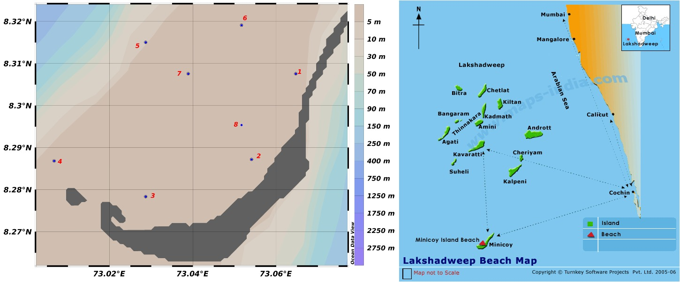
Fig.1 Study area in the Lagoon waters of Minicoy Island

Table 1. Meteorological and hydrographic parameters recorded during the Trichodesmium bloom in the lagoon waters of Minicoy Island
Parameter | Units | Range / Mean Values | Remarks / Observation
Meteorological Parameters
Mean Sea Level Pressure | hPa | 1010.1 | Stable atmospheric condition
Relative Humidity | % | 81 | Moderately high humidity
Mean Wind Speed | km h⁻¹ | 3.3 | Calm wind conditions
Rainfall | — | Nil | No precipitation during bloom
Hydrographic Parameters
Surface Water Temperature | °C | 28–30 | Warm tropical waters favorable for bloom formation
Salinity | psu | 35–36.5 | High and stable salinity supporting Trichodesmium growth
pH | — | 7.9–8.2 | No significant spatial variation
Dissolved Oxygen (DO) | mg L⁻¹ | 5.8–6.5 | Well-oxygenated surface waters
Nutrient Parameters
Nitrate (NO₃⁻) | µM | 0.04–0.28 | Low during bloom; indicates active nitrogen fixation
Phosphate (PO₄³⁻) | µM | 0.18–0.35 | Moderate levels; supports metabolic activity
Silicate (SiO₄⁴⁻) | µM | 2.1–3.3 | Typical for oligotrophic lagoon waters

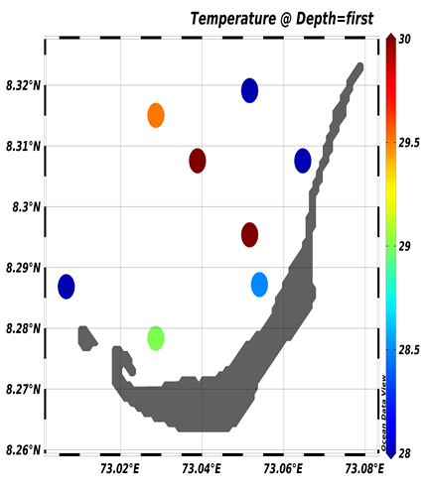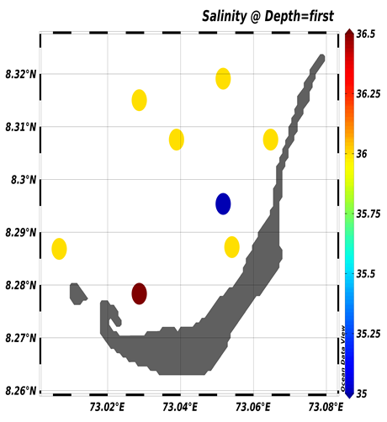
a.Temperature (̊ C) b.Salinity (psu)
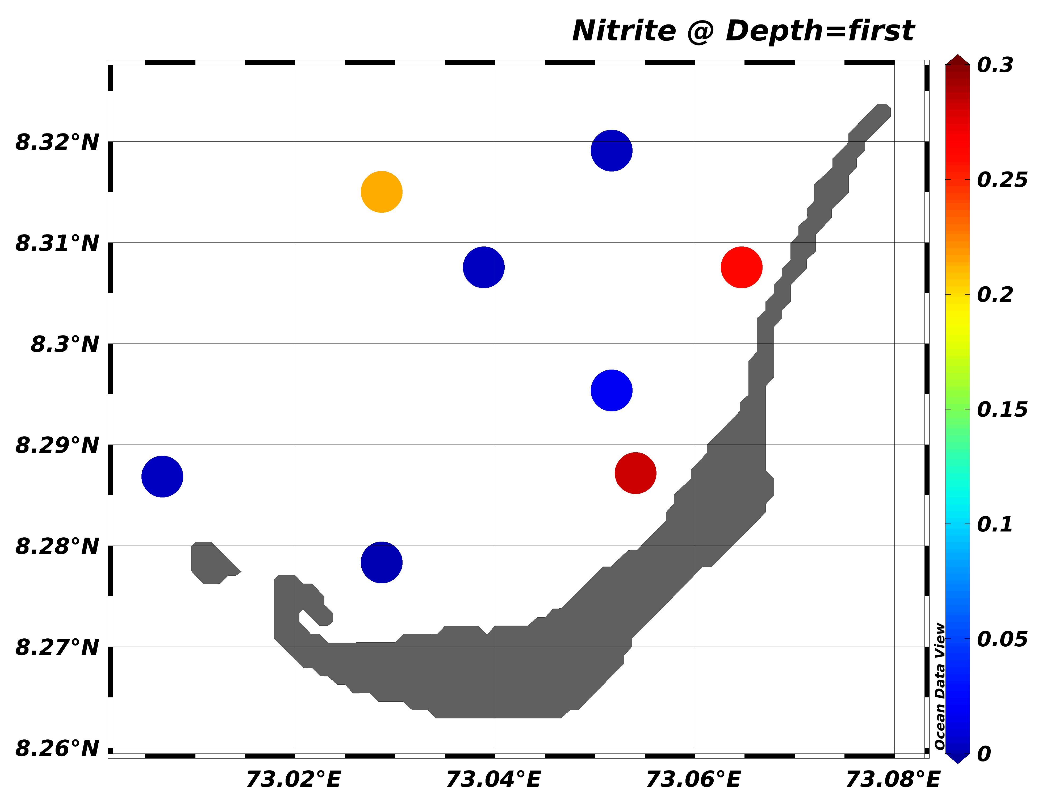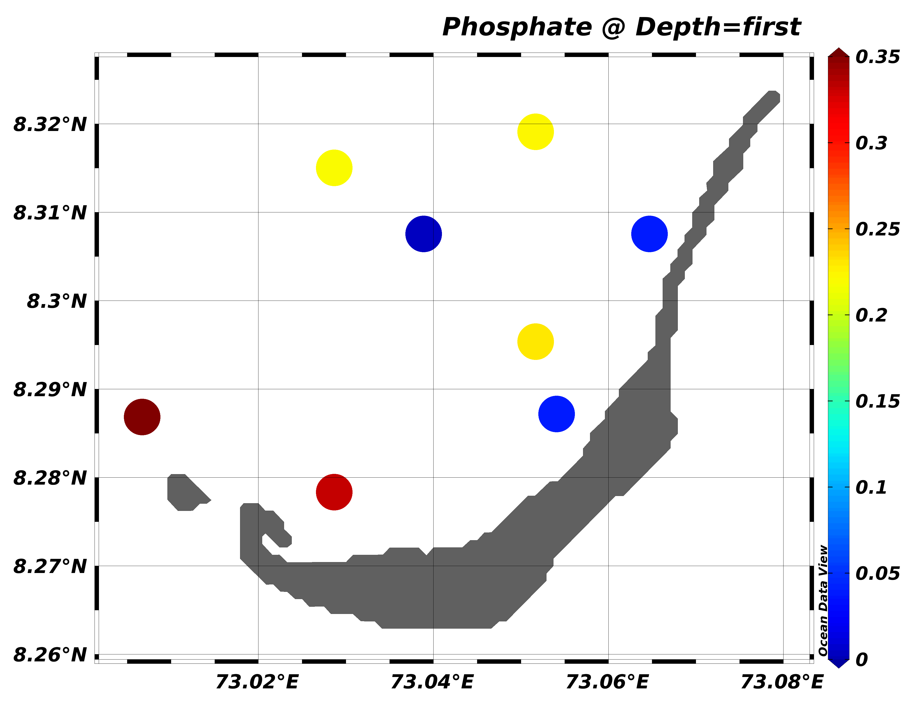
c. Nitrate (µM) d. Phosphate (µM)

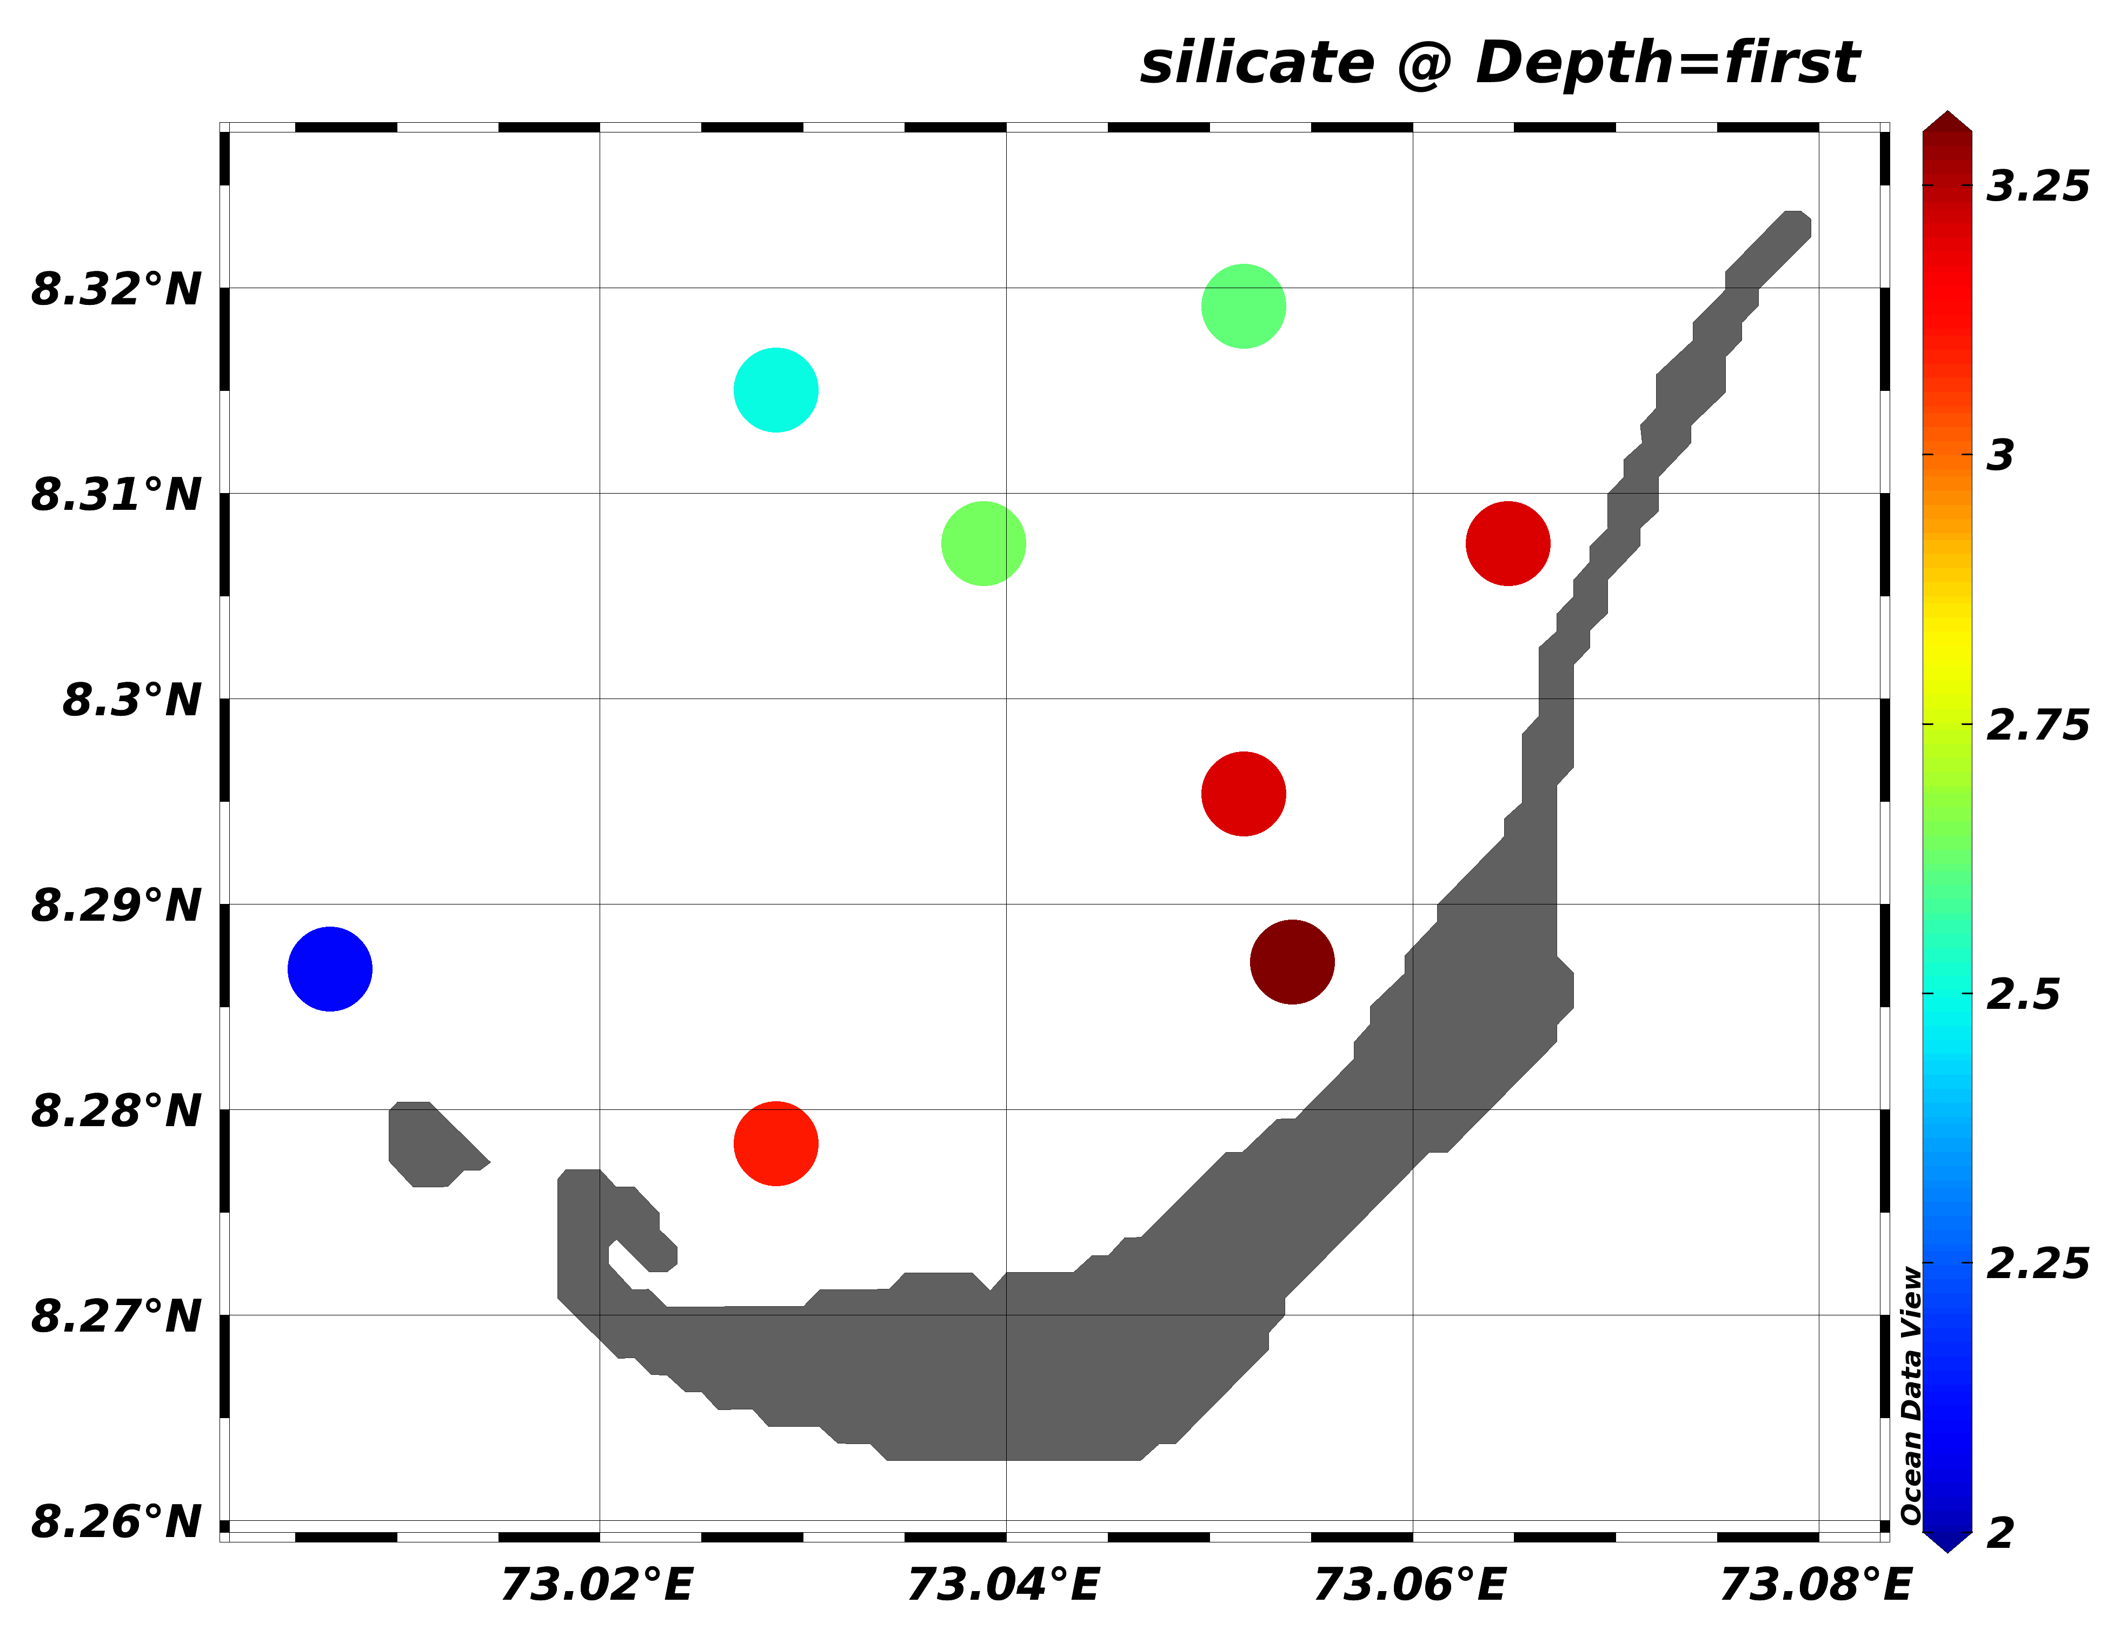
e.Silicate (µM)
Fig. 2. Water quality parameters recorded in the lagoon waters of Minicoy Island during study period

Fig.3. Cumulative Species composition of Phytoplankton
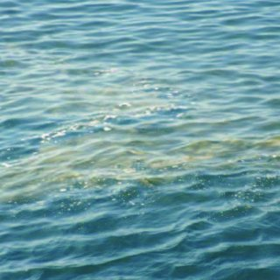
Fig. 4. Sea Sawdust (Trichodesmium erythraeum) Bloom in Lagoon Waters and Its Microscopic Observation

