Case report

Revisiting gabapentin safety: a rare case of serious angioedema

.
ABSTRACT
Angioedema is a rare adverse reaction to gabapentin, characterized by localized swelling of mucosal and submucosal tissues. A 61-year-old male developed acute facial edema within 24 hours of initiating gabapentin for post-operative neuropathic pain following lumbar decompression surgery. The swelling involved the right periorbital and malar regions, with mild dysphagia but no airway compromise. Laboratory findings defined CRP was elevated, rest all parameters were normal. Gabapentin was discontinued and replaced with pregabalin-nortriptyline. IV antihistamines and corticosteroids led to complete resolution within 36 hours. The Naranjo score indicated a probable drug reaction. This case highlights the importance of recognizing gabapentin as a potential cause of angioedema.

Keywords: Gabapentin, angioedema, adverse drug reaction, neuropathic pain.

1. INTRODUCTION

Swelling Caused From Blood Vessels Leaking Fluid Into The Surrounding Tissues And Skin Is Known As Angioedema. It Usually Affects Or Most Commonly Affecting The Face, Lips, Tongue, And Upper Airway. In Comparison With Hives Which Are Superficial And Could Lead To Swelling, Angioedema Affects The Deeper Layers of the skin [1]. Usually There Are Various Types Of Angioedema however, this Case Report Comes Under Drug Induced Angioedema And In Pathology It Is Classified As Histamine-Mediated. Usually The Common Drugs Causing Angioedema Are ACE Inhibitors And NSAIDs [2].
Gabapentin Is an Anticonslusive Medication that Belongs To A Class Of Gabapentinoids. It Blocks Α2δ (alpha-2-delta) Subunits Of The Calcium Channels And It Reduces Nerve Pain By Decreasing Calcium Mediated Release Of Excitatory Neurotransmitters,Thereby Calming The Irritated Nerve Roots [3].Here We Report A 61-Year Old Male Who Was Presented To The Orthopaedic Department With Lba And Was Subsequently Diagnosed As Ivdp And Was Operated Under Standard Operating Procedure .

2. PRESENATATION OF CASE
A 61-year-old male presented to the PESUIMSR Hospital, Bangalore with complaints of chronic low backache radiating to bilateral lower limbs since 2 months. Pain was insidious and gradually progressive in nature, he denied fever, allergies or any other symptoms. He had no known comorbidities such as hypertension or type-2 diabetes mellitus. MRI of the lumbosacral spine revealed IVDP at the L4–L5 level with nerve root compression, for which he underwent elective lumbar decompression surgery. Prior to surgery he was on medication such as thiocolchicoside (MYORIL MAX) twice daily and cholecalciferol (UPRISE D3) capsule 60,000 IU once weekly. After the surgery, he was prescribed gabapentin extended release (GABANTIN GRS) 300 mg twice daily orally for neuropathic pain and to manage postoperative pain. Within 24 hours of initiating gabapentin, the patient developed sudden-onset facial swelling involving the right periorbital and malar regions, urticaria, resulting in muffled speech and suspected airway compromise. Laboratory investigations revealed elevated C-reactive protein (CRP) at 83.2 mg/L, while liver function tests, renal profile, hematological parameters, and toxicology screening were within normal limits, with no eosinophilia or systemic abnormalities noted. He remained hemodynamically stable but required urgent nasopharyngeal intubation and was shifted to the intensive care unit (ICU). He was administered intravenous pheniramine maleate (AVIL 2ml), hydrocortisone (HYDROCORT-100) 100 mg Stat and two units of fresh frozen plasma (FFP). Gabapentin was discontinued, and the patient was transitioned to pregabalin 75 mg + nortriptyline 10 mg (MAYUPREG NT) which was well tolerated without recurrence. The angioedema and urticarial symptoms resolved completely within 36 hours of drug withdrawal and supportive therapy.

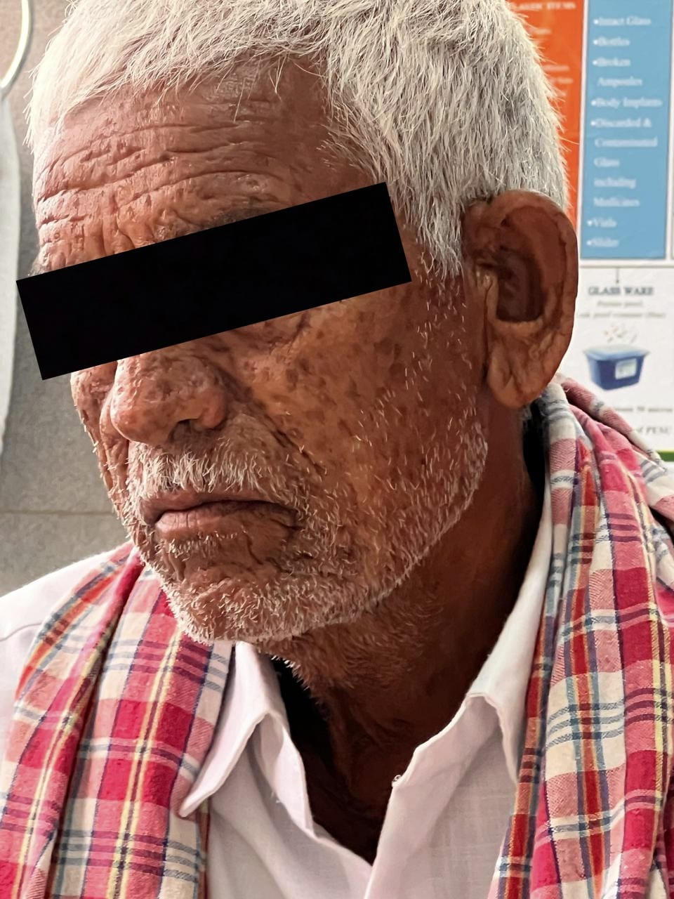

Fig 1: Clinical photograph showing facial swelling consistent with angioedema, involving the periorbital and malar regions. The edema is non-pitting and diffuse, with associated skin changes. Image captured in ambient indoor lighting for documentation. Published with informed consent for academic and educational use.

4. discussion

Angioedema is a localized or acute swelling of mucosal and submucosal tissues due to increased vascular permeability. It may present with or without urticaria and can be allergic (IgE-mediated) or non-allergic (bradykinin-mediated or idiopathic) (2). Drug-induced angioedema is a known adverse reaction, and while ACE inhibitors are common culprits, other agents like gabapentin have also been implicated in rare instances. In the present case, the temporal relationship between gabapentin initiation and the occurrence of symptoms strongly suggests that gabapentin was the most likely cause, as he was on thicolchiside for multiple weeks before the onset of symptoms, so making it not as the causative agent (4,5).
The patient developed swelling within 24 hrs of starting the Gabapentin, which provides the evidence of drug induced angioedema. After immediate discontinuation of gabapentin and initiation of antihistamines and corticosteroids, the patient developed significant clinical improvement further supporting the diagnosis. Gabapentin is often considered a safe adjuvant analgesic in postoperative pain management. Case reports of gabapentin related angioedema are limited in literature (4)
This case highlights the importance of early recognition, airway assessment, and detailed medication history. It underscores the importance of maintaining a high index suspicion for angioedema when new symptoms arise shortly after starting gabapentin and prompt withdrawal of the causative agent are essential to prevent morbidity and ensure favourable outcomes.

CONCLUSION
This case highlights the vital role of pharmacovigilance in post operative pain management, although rare, gabapentin can cause serious adverse effects such as angioedema. Prompt identification and treatment led to rapid recovery without serious complications like airway closure therefore the possibility of angioedema must always be considered when initiating gabapentin therapy.

Consent

Written informed consent for publication of their clinical details and/or clinical images was obtained from the patient.

DISCLAIMER (ARTIFICIAL INTELLIGENCE)

Author(s) hereby declares that any use of AI assistance was limited to language editing and authors retain full responsibility for the accuracy and integrity of the manuscript.

Abbreviations

ivdp –intervertebral disc prolapse
mri –magnetic resonance imaging

References

- Tarbox JA, Bansal A, Peiris AN. Angioedema. JAMA. 2018;319(19):2054. https://jamanetwork.com/journals/jama/fullarticle/2681197
- Memon RJ, Tiwari V. Angioedema. [Updated 2023 Aug 8]. In: StatPearls [Internet]. Treasure Island (FL): https://www.ncbi.nlm.nih.gov/books/NBK538489/
- Yasaei R, Katta S, Patel P, et al. Gabapentin. [Updated 2024 Feb 21]. In: StatPearls [Internet]. Treasure Island (FL): StatPearls Publishing; https://pubmed.ncbi.nlm.nih.gov/29630280/
- Valdez, C., Kim, A., & Alarcon, T. (2023). A case of gabapentin-induced angioedema in a 31-year-old female. World Journal of Advanced Research and Reviews. https://scholarlycommons.hcahealthcare.com/internal-medicine/494/
- Chong KC, Hsu TH. Gabapentin-Induced Angioedema of Tongue. J Acute Med. 2021 Jun 1;11(2):72-73. doi: 10.6705/j.jacme.202106_11(2).0005

