Livelihood security analysis of IWMP (Integrated Watershed Management Programme) beneficiaries in Kerala, India

ABSTRACT
IWMP (Integrated Watershed Management Programme) is a participatory approach for natural resource management and livelihood enhancement for rural development in rainfed tracts of India. The scheme was initially launched by the Government of India in 2009 and made as component of PMKSY (Pradhan Mantri Krishi Sinchayee Yojana = in English?) in 2015. In Kerala, IWMP is executed by the Department of Rural Development. Kerala is the only state where IWMP is being implemented exclusively through the complete involvement of local self government organizations and local population, in all stages of watershed development. In this backdrop, the study was conducted in three watersheds representing north, south and central zones of Kerala to analyze the livelihood security of beneficiaries in IWMP during 2021-2023. The livelihood assets pentagon framework proposed by FAO (Food and Agriculture Organization of the United Nations) is conceptualized for the study. A livelihood security index was computed by compiling five categories of assets, such as human capital, social capital, natural capital, physical capital and financial capital. Most of the beneficiaries had medium level of capital assets possession for livelihood creation, whereas half of them had medium livelihood security. This was highest in the Mamoodu watershed and not much variation for others was verified by Kruskal-Wallis test. Kendall’s coefficient of concordance exposed that human capital had highly influenced the livelihood security of beneficiaries in Mundyanum watershed and Allanchery padam-Kallan thodu ???? watershed, whereas financial capital had the highest contribution in the Mamood watershed.

Key words : Livelihood security, watershed, capital assets

INTRODUCTION
Soil and water are vital elements of nature that must be kept in harmony with the environment to generate sustainable agro-ecosystems. Defensible management of the agro-ecosystem is crucial for economic growth which would lead to development of a nation (Bhattacharyya et al., 2016). In developing countries, forest cover and water bodies represent a significant contribution towards the total share of households’ food, fuel and income. These natural resources are considered a precious safety net in times of catastrophes for the majority (78%) of the world’s poor who are inhabitants of rural areas. Inspite of these facts, the integrity and functionality of these natural assets are increasingly compromised. Around 60 to 70 per cent of the world’s ecosystems are degrading faster than they can recover (Rambabu, 2018). In Kerala, 67 per cent of total geographic area has already been degraded, mainly by soil erosion and soil acidity caused by anthropogenic and natural factors (NBSS&LUP, 2014). Natural Resource Management (NRM) is the judicious utilization of natural assets such as land, water, air, flora and fauna without compromising their quality and conserving them for future. Devolution of responsibilities for management of natural resources at the community level has been increasing over years at watersheds and in rainfed tracts of the country. Community based natural resource management through watersheds made a landmark in this approach. This provided a holistic approach for natural assets conservation and livelihood enhancement of rural population (Singh, 2017). The main objective of any IWMP project is the judicious utilization of every drop of rainwater received, for domestic consumption, agriculture, livestock rearing, etc. Thereby attaining self sufficiency in drinking water, increasing in employment opportunities and improving the standard of living. Unlike other watershed development projects, there is space for providing assistance to livelihood activities, enhancing production systems and microenterprises in IWMP (Rajneesh, 2014).
METHODOLOGY
The study was conducted in Kerala state by adopting a stratified two stage random sampling. From the three geographic zones of Kerala, Kasaragod, Thrissur and Pathanamthitta districts representing Northern, Central and Southern Kerala were selected respectively. Based on a preliminary survey in above districts, a list of micro-watersheds was prepared, where Integrated Watershed Management Programme (IWMP) had been implemented during the period 2010-11 to 2017-18. From this list, one micro watershed from each district was selected randomly. The micro watersheds selected were Mundyanam (Parappa block), Allanchery padam-Kallan thodu (Kodakara block), Mamoodu (Ranni block) from Kasaragod, Thrissur and Pathanamthitta districts respectively. A sample of 50 project beneficiaries of NRM component each were selected randomly from project register maintained in respective block panchayath of three watersheds. Thus the study was undertaken with a sampling frame of 150 project beneficiaries. What do you mean with the word “beneficiaries”? Did they receive special training? Advice? Or did they get some financial support? Or support for establishing cooperatives? Physical tools like seeds or fertilizer? You should Explain briefly.
Second, Please mention the books of statistical methodology which have justified your choices.
Data were collected when? Were? Who performed the interviews? Which software was used to process data? You must explain these aspects in order to justify the quality of the results. What about non-response rate?

FAO’s (2008) livelihood assets pentagon with suitable modification was employed for determining the livelihood security of respondents in the project area. Sustainable Livelihood Framework (SLF) have been selected as theoretical framework for present study. This framework demonstrates that livelihoods are the result of manifold interaction of different assets that affect people’s choice of livelihood. SLF shows that choice and adoption of livelihood strategies depend on households’ endowment of livelihood assets in a given structure of institution and vulnerability context. The shape of the pentagon can be used to show schematically the variations in peoples’ availability and access to various assets viz. human assets, social assets, natural assets, physical assets and financial assets. Are you sure? What I see in the paper is a photography of the situation, not the variation that occurred thanks to the project. The idea is that the central point of the pentagon, where the lines meet, represents zero access to assets while outer perimeter represents maximum access to assets. The pentagons of different shapes will apply to different situations and the shape may change over time. The asset pentagon is considered as a dynamic??? and diagrammatic presentation of the assets of a social group. The component parameters were selected based on dialogue with experts and intensive review of literature (MENTION SOME.. ). The component parameters selected for the study are presented in table 1 . It is not clear = it is not explained how the different types of capital were measured. Please explain briefly.
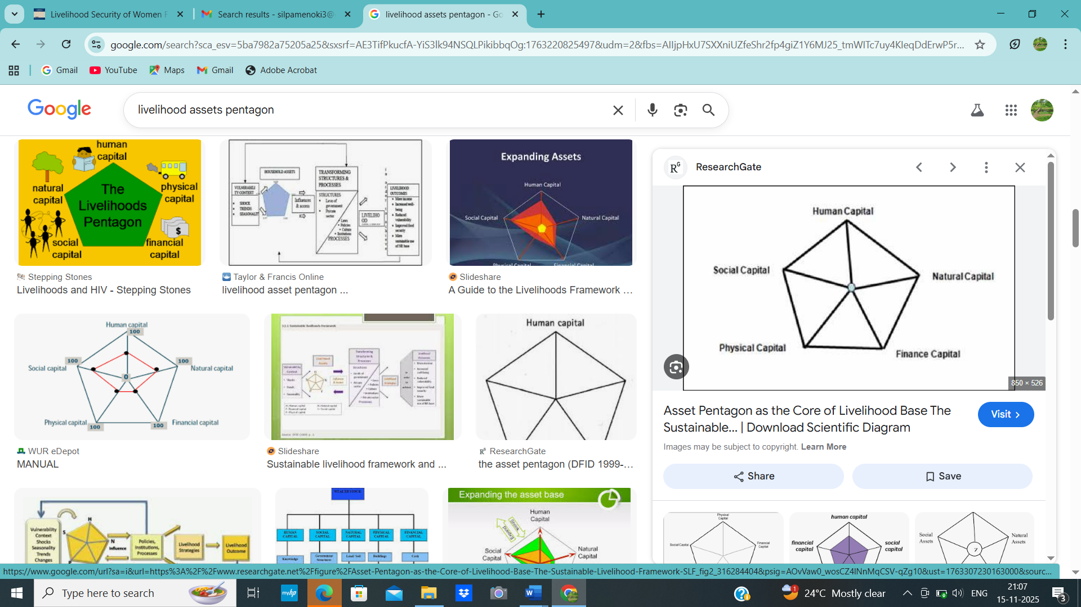
Fig. 1. Livelihood assets pentagon by FAO (2008)
Table 1. Capitals and respective parameters of livelihood security index
Capital | Parameter
- Human capital
 | - Formal education
 | - Skill acquisition
 | - Primary occupation
 | - Mass media exposure
 | - Health seeking behaviour
- Social capital
 | - Organizational participation
 | - Relation status
 | - Interdependence or networking
- Natural capital
 | - Common property resources
 | - Landholding size
 | - Source of water
- Physical capital
 | - Livestock possession
 | - Tangible assets possession
 | - Type of house
 | - Distance to nearest market
- Financial capital
 | - Average monthly household income
 | - Average monthly household expenditure
 | - Debts owed per month
 | - Family size

Computation of livelihood index
The livelihood index was assumed as aggregate of the five component capital indices such as human capital index, social capital index, natural capital index, physical capital index, and financial capital index. The detailed steps for calculation of livelihood index is given below. The variables of the capital i.e. from XA1 to XA5 were standardized by range equalisation or max-min normalization approach and the formulas are given below.
x_{i}'= x_{i -} x_{imin}
x_{max -} x_{imin}

x_{i}' = x_{max} ₋ x_{i}
x_{max -} x_{imin}

Where, x_{i =} observed value of i^{th} human capital from 1-5
x_{imax =} maximum value x_{i} can attain
x_{imin =} minimum value x_{i} can attain
By definition, x_{i}’ variable is inclusive and value ranges from 0 to 1. The first equation was used when the variable is positively correlated with livelihood and second was used when negatively correlated.
Individual capital index was calculated by the formula
1 n
Capital index = ∑$xi'$ × 100

Human capital index = $\frac{1}{5}$ $\sum_{\begin{aligned} \\ i=1\end{aligned}}^{5}{xi'×100}$
n i=1
xi’ = standardized value of i^{th} variable of capital
n = total number of variables in individual capital
Livelihood security index (LSI) is one-fifth of the sum total of all the five capital indices thus computed.
LSI = Sum total of capital indices
5
By definition, livelihood security index values ranges from 0-100. Kruskal-Wallis test was conducted to compare livelihood security indices of beneficiaries in three watershed. Further Kendall’s coefficient of concordance was administered to determine relative contribution of various capital assets towards livelihood security index.
RESULTS AND DISCUSSION
Table 2. Status of livelihood security index of IWMP beneficiaries
Livelihood security index | Mundyanum (n=50) |  | Allanchery padam-Kallan thodu  (n=50) |  | Mamoodu  (n=50) |  | Total  (N=150)
Livelihood security index | F | % | F | % | F | % | F | %
Low (<Q1) | 16 | 32.00 | 14 | 28.00 | 7 | 14.00 | 37 | 24.67
Medium (Q1-Q3) | 24 | 48.00 | 24 | 48.00 | 28 | 56.00 | 76 | 50.66
High (>Q3) | 10 | 20.00 | 12 | 24.00 | 15 | 30.00 | 37 | 24.67
Q1=54.21, Q3=67.16

The findings shown in Table 2. concluded that 50.66 per cent of beneficiaries possessed medium livelihood security index, followed by 24.67 per cent each with low and high index scores. These findings proved that livelihood security index of 75 per cent of beneficiaries were in medium and high category which in turn implied that livelihood was improved HOW can you say this? for majority of beneficiaries in three watersheds. This was attributed to fact that capital assets possession of most of beneficiaries were increased for earning livelihood. The same trend were exhibited by beneficiaries of Mundyanum and Allanchery padam-Kallan thodu watersheds. A slightly different pattern was noticed in Mamoodu.
Kruskal-Wallis test for comparing livelihood security index of IWMP beneficiaries in three watershed
The result obtained was further confirmed by conducting Kruskal-Wallis test for the sample and are shown in Table 3.
Table 3. Kruskal-Wallis test statistic for comparison of three watersheds for livelihood security index of IWMP beneficiaries
Total N | 150
Test statistic | 8.85
d.f | 2
Asymptotic Significance | .012

A detailed view of Table 3. inferred that livelihood security indexes of beneficiaries of three watersheds were significantly different. Further pairwise comparison was conducted between the watersheds and is depicted in Table 4.
Table 4. Pair-wise comparison of three watersheds for livelihood security index of IWMP beneficiaries
Watershed | Test statistic | Std. Error | Std. test statistic | Sig. | Adj. Sig.
Mundyanum-Allanchery padam-Kallan thodu | -2.270 | 8.689 | -2.61 | 0.794 | 1.00
Allanchery padam-Kallan thodu -Mamoodu | -21.170 | 8.689 | -2.436 | < 0.05 | < 0.05
Mamoodu-Mundyanum | -23.440 | 8.689 | -2.698 | < 0.05 | < 0.05

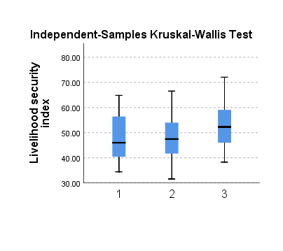
Mundyanum Allanchery padam-Kallan thodu Mamoodu

Fig. 2. Box plot comparing livelihood security index of IWMP beneficiaries in three watersheds
It is clear from Table 4. and Fig. 2. that there are no much difference in livelihood security indices of beneficiaries in Mundyanum and Allanchery padam-Kallan thodu. Unfortunately a significant difference exists between indices of Allanchery padam-Kallan thodu -Mamoodu pair and Mamoodu-Mundyanum pair. This could be due to more capital assets possession of beneficiaries in Mamoodu. There is also accordance with the results of Abbassi et al. (2020) and Dhakad (2014).
Relative contribution of capital assets towards livelihood security index of beneficiaries in watersheds
The capital assets possession of beneficiaries were ranked to determine the major asset contributing towards the livelihood security. This was made possible by undertaking Kendall’s coefficient of concordance test for individual watershed and results obtained are as follow.
Table 5. Kendall’s coefficient of concordance test for capital assets of livelihood security index of beneficiaries in Mundyanum watershed
Kendall’s coefficient of concordance |  | Dimension | Mean rank
Total N | 50 | Human capital | 4.18
Kendall’s W | 0.412 | Physical capital | 3.48
Test statistic | 82.336 | Financial capital | 3.26
d.f | 4 | Social capital | 2.58
Asymptotic Significance | < 0.01 | Natural capital | 1.50

A detailed view of Table 5. shows that there was a strong agreement among beneficiaries of Mundyanum watershed in ranking the capital assets possessed by them. The sequence obtained in decreasing order was human capital (4.18), followed by physical capital (3.48), financial capital (3.26), social capital (2.58) and natural capital (1.50). Hence, it was statistically confirmed that human capital is a major dimension contributing towards livelihood security in Mundyanum. This is the true reflection of Kerala state, as human capital assets show an increasing trend with respect to education, health seeking behaviour, mass media exposure etc. due to high literacy status in this state, in relation to other assets. Natural assets are at declining rate due to modernisation and urbanisation, which are viewed as indicators of development of Kerala. These findings are in line with results obtained by Saini et al. (2014) but contradict those of Sundaran (2012).
Table 6. Kendall’s coefficient of concordance test for capital assets of livelihood security index of beneficiaries in Allanchery padam-Kallan thodu watershed
Kendall’s coefficient of concordance |  | Dimension | Mean rank
Total N | 50 | Human capital | 4.18
Kendall’s W | 0.397 | Physical capital | 3.40
Test statistic | 79.408 | Financial capital | 3.38
d.f | 4 | Social capital | 2.44
Asymptotic Significance | < 0.01 | Natural capital | 1.60

It can be observed from Table 6. that there wwas strong consensus between the Allanchery padam-Kallan thodu beneficiaries in ranking the dimensions of livelihood security index. The sequence in decreasing order was human capital (4.18), physical capital (3.40), financial capital (3.38), social capital (2.44) and natural capital (1.60). This is more or less similar to pattern obtained in Mundyanum and same conclusions were applicable here.
Table 7. Kendall’s coefficient of concordance test for capital assets of livelihood security index of beneficiaries in Mamoodu watershed
Kendall’s coefficient of concordance |  | Dimension | Mean rank
Total N | 50 | Financial capital | 4.02
Kendall’s W | 0.403 | Human capital | 3.76
Test statistic | 80.512 | Physical capital | 3.26
d.f | 4 | Social capital | 2.34
Asymptotic Significance | < 0.01 | Natural capital | 1.62

The findings in Table 7. inferred that there were strong accordance among beneficiaries of Mamoodu in ranking the capital assets possessed by them in order of financial capital (4.02), followed by human capital (3.76), physical capital (3.26), social capital (2.34), and natural capital (1.62). In comparison with the other two watersheds, there was slight deviation in ranking order of capital assets by beneficiaries. Here financial capital was found to dominate other capitals in contrast to human capital in other two watersheds. Apart from these, the ranking order was similar to other watersheds. This was attributed to relatively high average monthly income levels of beneficiaries in Mamoodu due to more land holding size, common property resources, livestock possession and economic orientation.
CONCLUSION
The study inferred a mixed trend of livelihood security in Kerala. This is indicated by the increasing human capital accompanied by a decreasing natural capital in the watersheds under study. This contrast suggests that although people are becoming more informed and educated, the ecological foundations of their livelihoods are under stress. Natural capital is key capital that underlines long-term livelihood sustainability. Hence effective watershed management needs to focus on reversing land degradation, while leveraging the growing human capital to promote climate resilient agriculture, technological adoptions and local institution empowerment. The Kerala state Government could enforce strict regulation on land-use change, especially in wetlands, steep slopes and problematic soils. The diverse topography, acidity of soils, high rainfall and population density in Kerala demand for scientific and ecosystem based watershed planning.

COMPETING INTERESTS DISCLAIMER:
Authors have declared that they have no known competing financial interests OR non-financial interests OR personal relationships that could have appeared to influence the work reported in this paper.

REFERENCES
Abbassi, F. A., Ullas, A., Hashmi, M. S., Hussain, K., and Akther, N. 2020. The role of livelihood assets’ endowment in adoption of rural livelihood strategies: an intra-regional comparison of district Bhimber. Sarhad J. Agric. 36(1): 258-271.
Bhattacharyya, R., Ghosh, N. B., Dogra, P., and Mishra, K. P. 2016. Soil conservation issues in India. Sustainability. 8(565): 1-37.
Dhakad, R. 2014. An assessment of sustainable livelihood of rural women through income generating activities in Satna District (M.P.). M.Sc.(Ag.) thesis, Jawaharlal Nehru Krishi Vishwavidyalaya, Jabalpur, 245p.
FAO (2008)
NBSS&LUP National Bureau of Soil Survey and Land Use Planning. 2014. Soil Erosion in Kerala. Annual Report 2013-2014. National Bureau of Soil Survey and Land Use Planning, Nagpur, India. 214p.
Rajneesh, A. 2014. Impact of various rural development schemes: An Evaluation. Int. J. Manag. Res. Business Strategy 3(2): 174-177.
Rambabu, M. 2018. Environmental degradation in India: causes and effects. Int. J. Eng. Sci. Invention 3(2): 6-10.
Saini, M., Reddy, M. N., and Joshi, P. K. 2014. Measurement of the impacts of watershed management programme on livelihoods of a watershed community. Int. J. Dev. Res. 4(3): 511-514.
Singh, K. A. 2017. Participatory Watershed Management: Indian Experiences. Concept Publishing House, Delhi, 173p.
Sundaran, A. 2012. Empirical study on impact of integrated watershed development project in Mizoram state of north east India. J. Humanities Social Sciences 5(3): 7-13.

