Identification of Alternative Local Food Potentials to Support Food Security in Disaster-Prone Areas
.
ABSTRACT

Natural disasters not only disrupt food production but also affect food accessibility and distribution. Therefore, it is important to explore alternative local food sources that can be utilized as substitutes. This study aims to identify the potential of local food resources in disaster-prone areas of Sukabumi Regency, west Java, Indonesia. The research was conducted descriptively, collecting information from both primary and secondary data related to local food potential. The findings indicate that in Sukabumi Regency, particularly in disaster-prone areas, there are various alternative food sources that can serve as substitutes for staple foods, including hanjeli (Job’s tears), jawawut (foxtail millet), and taro. These three alternative food sources contain good nutritional value with high carbohydrate content, making them suitable substitutes for staple foods. Apart from that, these three alternative food sources are easy to cultivate, do not require complicated maintenance so they can be used as an alternative to meet food needs in disaster areas.
Keywords: Hanjeli, Lokal Food, Sukun, Taro

1. INTRODUCTION

The Food and Agriculture Organization (FAO) defines food security as "a condition when all people, at all times, have physical and economic access to sufficient, safe, and nutritious food that meets their dietary needs and preferences for an active and healthy life." The four pillars of food security are: 1) Food availability, 2) Food accessibility, 3) Food utilization, and 4) Food sustainability/stability. Food is a primary need for life.

According to Law No. 18 of 2012 addressing food, the government is required to actualize diverse food consumption to meet the community's dietary needs in accordance with the potential and local custom of each region. Food is a primary necessity for society. Its presence or absence can lead to various problems. Food issues are highly crucial and are strongly influenced by socio-economic factors (Apid et al., 2022). Staple foods deserves greater attention compared to other nutrient sources because they are significant source of carbohydrates

In addition to socio-economic issues, food security in a region can also be affected by disasters. Natural disasters generally occur suddenly and are unpredictable. Such events can hinder food accessibility. Disasters may take the form of landslides, droughts, floods, and others, all of which affect food security due to damaged agricultural land, decreased agricultural production, and even infrastructure destruction (L. R. E. Malau et al., 2021). Disasters also disrupt food distribution, which can ultimately lead to food insecurity. Over the past three years, Sukabumi Regency has frequently experienced disasters such as landslides, tornadoes, and floods (Sukmawani, Reny, & Endang, 2024). These disasters have occurred in various areas of the regency and have significantly affected food accessibility.

As one of the major food-producing regions in West Java, Sukabumi Regency with its vast territory cannot rely solely on staple foods to meet the food needs of its people. Alternative carbohydrate sources are also required as substitutes for staple foods. Previous studies by O. N. Falentianingrum et al. (2019) and Mojiono et al. (2020) revealed that alternative food sources with high carbohydrate content are mainly found in tubers.

Every region in Indonesia has a diverse range of local foods. According to Ula(2021)), local food can be utilized to address food security. Integrating local foods with carbohydrate sources is an alternative food diversification strategy to maintain stable food intake in the face of the threat of food insecurity due to climate change, as is the case in Sukabumi Regency. Sukabumi Regency has considerable agricultural potential, with a variety of commodities that can be utilized to overcome food accessibility constraints, particularly in disaster-prone areas. This forms the basis for the present study, which focuses on identifying locally available alternative food sources in disaster-affected regions. Sukabumi Regency is ranked 2nd in West Java Province with a score of 186.61.

2. material and methods

This research is a case study in a region with high risk of disaster. The study was conducted in Sukabumi Regency, which consists of 47 districts. Out of these, 18 districts were identified as disaster-affected areas (BPBD, 2025). These districts include Kadudampit, Curugkembar, Simpenan, Palabuhanratu, Waluran, Bantargadung, Cisaat, Cikembar, Warungkiara, Sagaranten, Lengkong, Jampangtengah, Ciemas, Cimanggu, Pabuaran, Gunungguruh, Cikakak, and Cicantayan. Sukabumi Regency is ranked 2nd in West Java Province with a score of 186.61. This research was carried out using a descriptive approach with the following stages:
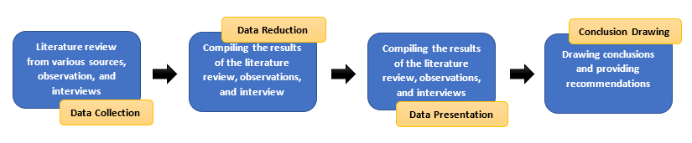
Figure 1. Research Stages

The data collection technique used in this study was a qualitative descriptive method. The aim of this descriptive method is to describe and explain the potential of some local foods as alternative food sources in disaster-affected areas. The types of data used in this study consisted of both secondary and primary data. Secondary data were obtained from literature studies and regional potential records, while primary data were collected through direct field observations. The data were analyzed descriptively with the aim of describing the research objects based on the information obtained.

3. results and discussion

Sukabumi Regency is located in West Java, geographically located at 6°57' - 7°25' South Latitude and 106°49' - 107°00' East Longitude. Sukabumi Regency covers an area of ​​4,162 km2, or 11.21% of West Java and 3.01% of Java. GURILAPS (mountains, jungle, sea, beaches, and rivers) is the motto of Sukabumi Regency, which is rich in natural resources. The agriculture (agribusiness) and tourism sectors are potential economic sectors in Sukabumi Regency. The diverse potential of tourism attractions, including 44 types of natural attractions and 8 types of special interest tourism, attracts tourists to Sukabumi Regency.
However, despite these conditions, Sukabumi Regency also faces a high disaster risk. Sukabumi Regency ranks 28th out of 514 regencies/cities in Indonesia on the disaster risk index and second in West Java Province with a score of 186.61. The disaster map of Sukabumi Regency is shown in Figure 2.

.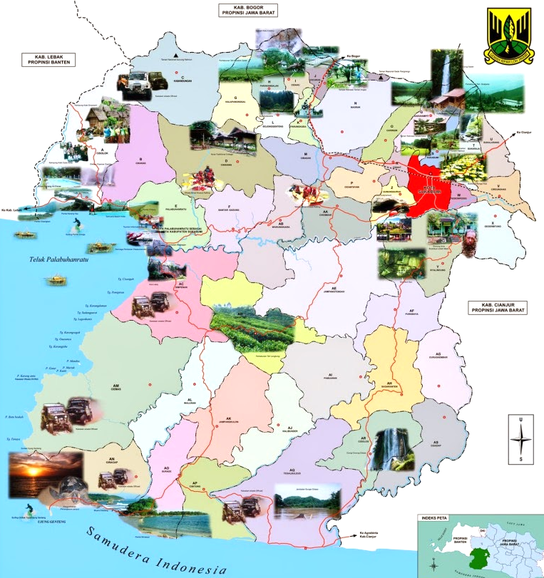
Figure 2. Disaster map of Sukabumi Regency
Source: Sukabumi Regency Disaster Management Agency, 2021

In general, Sukabumi Regency has a wide variety of plant-based resources with high carbohydrate content. However, not all areas possess the same potential. This variation is due to the vast territory of Sukabumi, which encompasses mountains, forests, seas, coastlines, and rivers, leading to different agroecological zones and, consequently, diverse commodity potentials. The same applies to the potential of alternative food sources found in disaster-prone areas.

The alternative food sources in Sukabumi Regency are identified within the groups of cereals and tubers. Specifically, this article discusses three types of alternative food sources, namely hanjeli (Job’s tears), jewawut (foxtail millet), and taro.

- Hanjeli (Coix lacryma-jobi L.)
Hanjeli, also locally known as jali, is a plant belonging to the Poaceae family, similar to rice. According to (Yusuf et al., 2021) job's tears have the potential as an alternative food because it is a type of cereal that can grow in various soil conditions, including wet and dry soils. It can adapt to various ecosystems, including marginal lands, and is tolerant to both drought and pest infestations. The plant has an indeterminate growth pattern, allowing it to be harvested multiple times after being cut back. The botanical classification of hanjeli is as follows:

Division : Spermatophyta
Subdivision : Angiospermae
Class : Monocotyledoneae
Order : Poales
Family : Poaceae
Genus : Coix
Species : Coix lacryma-jobi L.

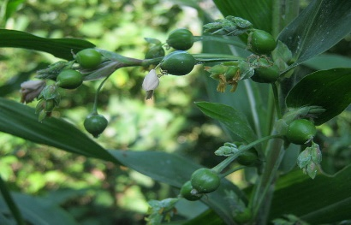
Figure 3. Hanjeli Plant
Source: commons.wikimedia.org

The most commonly cultivated variety of hanjeli is Coix lacryma-jobi var. lacryma-jobi, characterized by its oval shape with a hard white shell, often used for making beads. Another variety, Coix lacryma-jobi var. mayuen, is edible. Hanjeli is an annual tufted plant with numerous clumps, upright and robust stemsthat grow toa height of 1–3 meters, and coarse roots that are difficult to uproot. Its leaves are alternately arranged, with linear blade shapes measuring 8–100 × 1–5 cm. The leaf tips are pointed, the bases clasp the stem, and the margins are smooth. The flowers emerge from the leaf axils and branch tips in the form of spikes (Yusuf et al., 2021).

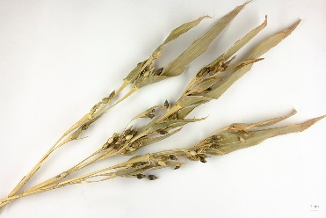

Figure 4. Hanjeli Fruit
Source: commons.wikimedia.org

Hanjeli fruit is a caryopsis with an oval-round shape. The mayuen variety is characterized by a white or bluish-purple colour and develops a hard shell when mature. Hanjeli contains relatively high nutritional value, with carbohydrates as the dominant component, making it a potential alternative carbohydrate source to rice and maize. Its nutritional composition consists of 76.4% carbohydrates, 14.1% protein, 7.9% fat, and 54.0 mg calcium.

- Jewawut (Setaria italica)
Jewawut is an annual plant with a grass-like appearance. The plant grows to a height of 150–175 cm and is characterized by its erect and branched stems. It has simple leaves arranged alternately, which are linear or strap-shaped, with pointed tips.

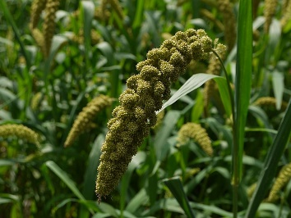

Figure 5. Jewawet Plant
Source: commons.wikimedia.org

Jewawut (Setaria italica) grows well in a wide range of soil types, including sandy and clay soils, making it a crop with high adaptability. The botanical classification of jewawut is as follows:

Kingdom : Plantae
Clade : Tracheophyta
Clade : Angiospermae
Clade : Monocotyledons
Clade : Commelinids
Order : Poales
Family : Poaceae
Subfamily : Panicoideae
Genus : Setaria
Species : Setaria italica

Millet is a type of cereal plant that has potential as an alternative food. In terms of nutritional content, the millet plant has quite good nutritional value (Ramlah et al., 2023). The nutritional content of jewawut is relatively high and comparable to major carbohydrate sources such as rice and maize (Turrahmi et al., 2021). In 100 grams, it contains 72.0–84.2% carbohydrates, 9.9–12.07% protein, 2.38–4.90% fat, 1.4–10.0% crude fiber, and several other essential minerals. Its carbohydrate content is nearly equivalent to that of rice and maize, and in fact exceeds that of wheat. The nutritional content of millet, particularly its carbohydrates, is nearly equivalent to that of rice and corn, even surpassing that of wheat. Here's a comparison of the nutritional content of millet with other food crops.
Table 1. Comparison of the nutritional content of millet with other food crops

Nutritional Composition | MIllet | Rice | Wheat
Carbohydrate (%) | 6,30 | 77,00 | 69,00
Protein (%) | 10,60 | 8,90 | 10,00
Lipid (%) | 1,90 | 2,00 | 2,00
Fiber (%) | 2,90 | 1,00 | 2,00
calcium (mg/100g) | 25,00 | 10,00 | 20,00
Riboflavin/B2 (mg/100g) | 0,33 | 0,25 | 0,10
Vit B1(mg/100g) | 3,70 | 4,00 | 4,00
Energy (KJ/100g) | 1,61 | 1,64 | 1,57
Source: Nurmala, (1998) and Harpes et al., (1965)

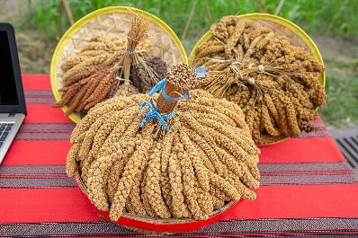

Figure 6. Jewawut Seed
Source: commons.wikimedia.org

Jewawut grows well in dry land conditions (Nuril Hidayati & Fauzia Syarif, 2019) and can be cultivated in areas with rainfall of less than 125 mm during its growth period, which generally lasts three to four months. The recommended planting time for jewawut is at the end of the rainy season.

- Taro (Colocasia esculenta L.)
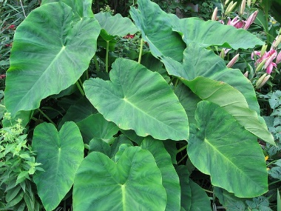
Taro is a herbaceous plant that produces tubers with a relatively high carbohydrate content, along with other essential nutrients, making it a potential alternative food source to substitute rice.

Figure 7. Taro Plant
Source: plants.ces.ncsu.edu
The botanical classification of taro is as follows:
Kingdom : Plantae
Division : Magnoliophyta
Class : Liliopsida
Order : Arales
Family : Araceae
Genus : Colocasia Schott
Species : Colocasia esculenta (L.) Schott

Taro is also recognized as a functional food crop (Aris Sudomo & Aditya Hani, 2014). Functional foods are those that not only provide basic nutrition but also contain additional compounds beneficial to health. Taro has a high nutritional content and can be made into various derivative products such as taro flour and analog rice as food alternatives (Syarifah et al., 2019). The detailed nutritional composition of taro is presented in Table 1.
Table 1. Nutritional Content of Taro (100 gr)
Nutritional Value 100 g (3,5 oz)
Energy | 108 kkal | 5.02 %
Total fat | 0.40 g | 0.60 %
Vitamin B1 | 0.06 mg | 6.00%
Vitamin B2 | 0.07 mg | 7.00 %
Vitamin B3 | 1.00 mg | 6.67 %
Vitamin C | 4.00 mg | 4.44 %
Total carbohydrates | 25.00 g | 7.69 %
Protein | 1.40 g | 2.33 %
Dietary fiber | 0.90 g | 3.00 %
Calcium | 47.00 mg | 4.27 %
Phosphorus | 67.00 mg | 9.57 %
Natrium | 10.00 mg | 0.67 %
Potassium | 448.00 mg | 9.53 %
Copper | 200.00 mcg | 25.00 %
Iron | 0.70 mg | 3.18 %
Zinc | 0.70 mg | 5.38 %
Water | 72.40 g
Ash | 0.80 g
Source: nutritional value

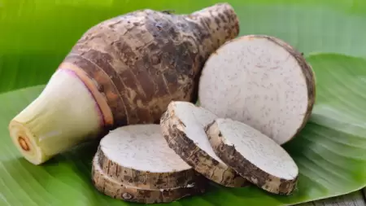

Figure 8. Taro Root
Source: nutriflakes.id

Taro (Colocasia esculenta) is a highly promising alternative food source to support food security, particularly in disaster-prone areas. It contains high levels of carbohydrates, higher protein content compared to cassava, and is also enriched with vitamins and minerals. Moreover, taro is relatively easy to cultivate under various conditions (Panggabean, 2020). The high carbohydrate content in taro makes it a great potential as a natural carbohydrate source that can support food diversification efforts and overcome food insecurity, especially in disaster areas (Avilia, 2023).

- Conclusion

- Food consumption is a multisectoral issue that is closely related to social and economic factors.
- Carbohydrate-based foods, as staple foods, require greater attention compared to other nutrient sources.
- Hanjeli, jewawut, and taro are only a few among the many local food crops that can serve as alternative carbohydrate sources to substitute staple foods.

SUGGESTIONS
- Food supply must be able to meet the demands and needs of the community, especially in disaster areas, so alternative carbohydrate sources are essential.
- The increase in food demand must be balanced with increased food crop production.
- Public awareness of food diversification activities, particularly energy sources, needs to be increased.
- Diversification of local food sources must continue to be improved, both in terms of identifying production potential, availability, and utilization within the community.

COMPETING INTERESTS DISCLAIMER:
Authors have declared that they have no known competing financial interests OR non-financial interests OR personal relationships that could have appeared to influence the work reported in this paper.

References

Apid, A., Mukson, M., & Sumekar, W. (2022). Analysis of Household Socioeconomic Factors on Food Security Levels (Case Study of the Tani Sejahtera Farmers' Group, Ujunggebang Village, Cirebon Regency). Journal of Agricultural Economics and Agribusiness (JEPA), 6(3), 892-910. https://doi.org/10.21776/ub.jepa.2022.006.03.11
Avilia, A. (2023). Utilization of Beneng Taro (Xanthosoma undipes) as an Alternative Carbohydrate Source in Strengthening Food Security. 6(2), 82–90.
Harper, L. J., Deaton, B. J., & Driskel, J. A. (1986). Food, Nutrition and Agriculture. UI Press. https://lib.ui.ac.id/detail?id=20131831&lokasi=lokal
Malau, L. R. E., Darhyati, A. T., & Suharno. (2021). The impact of climate change and natural disasters on food security in Indonesia: lessons learned on preserving forests sustainability. IOP Conference Series: Earth and Environmental Science, 886(1), 012090. https://doi.org/10.1088/1755-1315/886/1/012090
Mojiono, D. D. P., & Ubaidillah, D. M. (2021). Local Food Education Based on Alternative Carbohydrates in Tanjung and Sawahan Villages. Proceedings of the National Seminar on Community Service Programs. https://doi.org/10.18196/ppm.38.241
Hidayati, N., & Syarif, F. (2019). Growth and Production of Millet [Setaria italica (L.) P. Beauv.] Plants Under Radiation Dose Treatment with Reduced Watering Frequency for Drought Tolerance Selection. Indonesian Journal of Biology, 15(2), 177-185. https://doi.org/10.47349/jbi/15022019/177
Nurmala, T. (1998). Cereals as the Main Source of Carbohydrates. Rineka Cipta Jakarta.
Falentianingrum, O. N. (2019). Identification and Inventory of Tubers with Potential as Alternative Carbohydrate Sources in the South and West Jember Regions. Muhammadiyah University of Jember. http://repository.unmuhjember.ac.id/id/eprint/5700/
Panggabean, M. T. (2020). Potential of Taro (Colocasia esculenta L. Schott) as a Food Source. https://repository.pertanian.go.id/bitstream/handle/123456789/101225/Potensi%20Talas%20sebagai%20Sumber%20Pangan.pdf
Ramlah, R., Indrastuti, I., Haerani, H., D, N. I., & Mahful, R. (2023). Utilization of Healthy Food Diversification of Millet as a Business Opportunity for the Lego Village Community, Polewali-Mandar. Beru'-beru': Journal of Community Service. https://doi.org/10.31605/jipm.v2i2.3412

Sukmawani, R., & Astutiningsih, E. T. (2024). The Impact of Disasters on Food Security in Sukabumi Regency. Mimbar Agribisnis: Journal of Thought for the Scientific Community with an Agribusiness Perspective, 10(1), 354-368. https://doi.org/10.25157/ma.v10i1.11802
Syarifah, M., Hartanti, R. K. D., Rokhman, M. A. N., Nur'aini, S., Ningsih, S., & Atun, S. (2022). Low glycemic index analog rice. INOTEKS: Journal of Innovation in Science, Technology, and Arts, 1(2).https://doi.org/10.21831/ino.v1i2.25534
Turrahmi, M., Nurhidayani, N., Hasyimuddin, H., & Pabendon, M. B. (2021). Quality and quantity testing of millet (Setaria italic) plants at the Cereal Crops Research Center, Maros Regency. Phylogeny: Journal of Biology Students, 1(2), 57–62. https://doi.org/10.24252/filogeni.v1i2.23803
Ula, A. (2021). SUSTAINABLE DEVELOPMENT GOALS (SDGs) VISION ON LOCAL FOOD DIVERSIFICATION POLICIES IN OVERCOMING HUNGER. Indonesian Journal of Educational Science (JSEI), 3(2), 58–64. https://jurnal.uns.ac.id/jsei/article/view/70910
Law No. 18 of 2012 Concerning Food
Yusuf, A., Sugandi, W. K., & Zaida, Z. (2021). Physical and Mechanical Characteristics of Several Job's Tears Varieties as a Basis for Designing Machine Components. Agroteknika, 4(1), 20-29. https://doi.org/10.32530/agroteknika.v4i1.79

