Original Research Article

Functional Correlation Between Floral Style Length and Ovipositor Length in Ficus benghalensis – Eupristina masoni Mutualism Across South India

ABSTRACT
Aim: To quantify the functional relationship between floral style length (stigma + style) in Ficus benghalensis and the ovipositor length of its obligate pollinator Eupristina masoni across ecologically distinct populations in South India.
Methodology: Twenty-five receptive-phase flowers and 25 female pollinating wasps were measured per site. Floral style length was recorded under a stereomicroscope, while ovipositor length was measured using an ocular micrometer. Summary statistics, Pearson’s correlations, regression modelling, ANOVA, and mismatch analyses were performed.
Results: Floral style length (mean = 1.76 mm) exceeded ovipositor length (mean = 1.50 mm) in most flowers, with only 38.5% of flowers having style length ≤ ovipositor length. Individual-level correlation between style and ovipositor length was statistically significant but modest (r = 0.313, P < .001), whereas site-level mean traits were strongly correlated (r = 0.817, P < .001). Both traits varied significantly among populations, with ovipositors showing lower within-site variation compared to floral styles.
Conclusion: The Ficus benghalensis–Eupristina masoni mutualism exhibits strong but imperfect morphological matching. Geographic covariation suggests coevolution and local adaptation, but the consistent floral advantage (styles deeper than ovipositors) indicates an evolutionary balance favouring increased seed production over wasp brood success.

Keywords: Fig–wasp mutualism; floral style length; ovipositor length; functional mismatch; coevolution; Ficus benghalensis; Eupristina masoni; South India.

1. INTRODUCTION
The obligate mutualism between figs (Ficus spp.) and their pollinating wasps (Hymenoptera: Agaonidae) is one of the most iconic and well-studied examples of coevolution in plant–insect systems. Each fig species typically depends on a single specialist wasp for pollination, and the wasp in turn relies on the fig syconium as the only site for oviposition, larval development and mating (Cook and Rasplus, 2003; Herre et al., 2008). Molecular phylogenies and fossil-calibrated estimates suggest that this association has persisted for more than 60–90 million years, indicating remarkable evolutionary stability while still generating extensive species diversification (Machado et al., 2005; Cruaud et al., 2012). Because pollinating wasps cannot reproduce outside the fig inflorescence and figs cannot be pollinated without the wasps, both partners are absolute mutualists and are therefore tightly interdependent for reproductive success (Weiblen, 2002).

A central functional attribute regulating the outcome of this relationship is the correspondence between floral style length and pollinator ovipositor length. The wasp can successfully oviposit only when the ovipositor reaches the ovule, whereas seeds are typically produced in flowers where style depth exceeds ovipositor reach. Consequently, the proportional relationship between these traits determines how reproductive resources are partitioned between plant seed set and wasp offspring production (West et al., 1995; Ganeshaiah et al., 1995). Theoretical and empirical work further indicates that figs and wasps experience conflicting selection pressures: figs benefit from styles that limit oviposition and favour seed production, whereas wasps are selected to optimize ovipositor length to maximize brood success (Nefdt and Compton, 1996; Moore et al., 2021). Thus, style-ovipositor dynamics reflect a balance between mutualism and conflict rather than perfect evolutionary cooperation.

Ficus benghalensis L., the Indian banyan, is a widespread, ecologically dominant keystone species throughout the Indian subcontinent. Its pollinator, Eupristina masoni Saunders, is an obligate internal pollinator that completes its entire life cycle inside the syconia of Ficus benghalensis and is highly synchronized with host flowering phenology (Bhandari and Ram, 2005; Anandan et al., 2018). Despite the ecological and cultural prominence of this species pair, morphometric assessments of floral–pollinator trait matching across the natural geographic range of Ficus benghalensis remain limited. Spatial heterogeneity in climatic regimes, elevation and resource availability may drive divergent local selection pressures on floral architecture and pollinator morphology, potentially altering the precision of functional matching among populations (Souto-Vilarós et al., 2018; Pothasin et al., 2016).

The present study addresses this gap by analysing 16 geographically distinct populations of Ficus benghalensis across South India to (i) quantify spatial variation in floral style (stigma + style) length and , Eupristina masoni ovipositor length, (ii) assess the strength of style–ovipositor correlation at both individual and population scales, and (iii) evaluate the degree of functional matching versus mismatch across environmental gradients. By integrating fine-scale morphometric data into a biogeographical framework, this study provides new insights into how coadaptation, localized environmental pressures and potential plant–pollinator conflicts shape the evolution of trait correspondence in this ancient mutualism.

2. MATERIAL AND METHODS
2.1 Study area and sampling: Sixteen populations of Ficus benghalensis were sampled across South India, covering coastal, plateau, and semi-arid climatic zones. Five trees per site were selected, ensuring a minimum of 100 m separation to avoid pseudoreplication.
2.2 Floral morphometrics: Receptive phase syconia were collected and dissected. Floral style length (stigma + style) was measured from the stigma tip to the base of the style using a stereomicroscope (±0.01 mm).
2.3 Pollinator morphometrics: Female Eupristina masoni were collected from male-phase syconia and preserved in 70% ethanol. Ovipositors were measured from the basal plate to the distal tip.
2.4 Statistical analysis: Dataset comprised 400 flowers and 400 wasps (25 per site). Analyses included descriptive statistics, Pearson correlations, linear regression, mismatch proportion (ovipositor ≥ style), and one-way ANOVA across sites.

3. RESULTS AND DISCUSSION
3.1 Style length and ovipositor: Across the pooled dataset of 400 floral and wasp measurements, the length of the floral style (stigma + style) consistently exceeded the ovipositor length of Eupristina masoni. Mean floral style length was 1.76 ± 0.62 mm, whereas mean ovipositor length measured 1.50 ± 0.08 mm. The resulting mean difference between the two traits (ovipositor – style) was −0.25 mm, demonstrating a clear morphological advantage in favour of the plant. Rather than being an occasional mismatch, this pattern was widespread: only 38.5% of flowers had style lengths equal to or shorter than the ovipositor, meaning that in more than 60% of cases the wasp could not reach the ovule for successful oviposition.

Table 1. Overall descriptive statistics (N = 400).
Variable | Mean | SD | SE
Style length (mm) | 1.76 | 0.62 | 0.031
Ovipositor length (mm) | 1.50 | 0.08 | 0.004
Difference (Ovip – Style) (mm) | −0.25 | 0.60 | 0.030
Ratio (Ovip / Style) | 0.97 | – | –

This evidence strongly suggests that Ficus benghalensis generally maintains floral styles that extend beyond the physical reach of its pollinator. Such consistent floral predominance may reflect antagonistic coevolutionary pressures: by limiting the capacity of the wasp to oviposit in a large proportion of flowers, the plant potentially increases the relative allocation to seed production. These findings indicate that morphological matching in this mutualism is not perfectly symmetrical and instead aligns with a functional balance tilted toward plant reproductive advantage.

3.2 Spatial variation across sites: Both floral and pollinator traits exhibited substantial geographic variation across the 16 sampled populations. One-way ANOVA confirmed highly significant among-site differences for both floral style length (F = 4.65, P < .001) and ovipositor length (F = 168.61, P < .001), indicating that local environmental conditions or selective pressures shape morphological expression in both partners. However, the magnitude and pattern of variation were not equivalent: floral style length showed much broader spatial variability, whereas ovipositor length remained comparatively constrained, suggesting contrasting levels of phenotypic flexibility.

Mean trait values revealed clear geographic structuring. Populations such as Bijapur, Panaji and Trivandrum displayed the deepest floral styles, while sites such as Madurai, Mysore and Bapatla were characterised by comparatively shorter styles. Ovipositor length tended to follow the same general trend-sites with longer styles tended to host pollinators with longer ovipositors-but the disparity between the two traits frequently favoured the plant. The mean difference (ovipositor – style) ranged from moderately negative (e.g., Mysore: −0.0468 mm) to strongly negative (e.g., Bijapur: −0.7035 mm), reinforcing that Ficus benghalensis styles exceeded the reach of Eupristina masoni ovipositors at nearly all sites.

The proportion of flowers accessible to the pollinator, expressed as Prop(O ≥ S), varied markedly among sites. At sites such as Madurai and Nellore, more than half of the flowers were accessible for oviposition, whereas at Bijapur, Panaji, Trivandrum and Pune, fewer than 30% of flowers permitted successful oviposition based on the morphological threshold. These differences suggest that the balance between seed production and wasp brood success is not uniform across populations.

Table 2. Site-wise mean floral and ovipositor traits (N = 25 per site).
Site | Style mean | Style SD | Ovip mean | Ovip SD | Diff mean (O–S) | Ratio mean | Prop  (O≥S)
Bapatla | 1.4942 | 0.6467 | 1.4188 | 0.0277 | –0.0754 | 1.1093 | 0.52
Bijapur | 2.3414 | 0.7661 | 1.6379 | 0.0319 | –0.7035 | 0.7656 | 0.12
Chennai | 1.5378 | 0.3653 | 1.3632 | 0.0266 | –0.1746 | 0.9387 | 0.40
Chintamani | 1.5739 | 0.4697 | 1.4450 | 0.0283 | –0.1289 | 1.0223 | 0.40
Davanagere | 1.8176 | 0.5526 | 1.5859 | 0.0309 | –0.2317 | 0.9553 | 0.36
Hyderabad | 1.7220 | 0.5178 | 1.4686 | 0.0287 | –0.2534 | 0.9363 | 0.32
Madurai | 1.4060 | 0.4413 | 1.4198 | 0.0277 | +0.0138 | 1.1091 | 0.60
Mangalore | 1.8302 | 0.6572 | 1.5859 | 0.0309 | –0.2444 | 0.9670 | 0.36
Mysore | 1.4992 | 0.4004 | 1.4524 | 0.0282 | –0.0468 | 1.0476 | 0.44
Nellore | 1.5510 | 0.5308 | 1.4494 | 0.0282 | –0.1016 | 1.0353 | 0.60
Panaji | 2.0088 | 0.5010 | 1.5673 | 0.0305 | –0.4415 | 0.8272 | 0.24
Pondicherry | 1.8495 | 0.5524 | 1.5720 | 0.0307 | –0.2774 | 0.9372 | 0.40
Pune | 1.9261 | 0.6768 | 1.5188 | 0.0297 | –0.4073 | 0.9061 | 0.28
Salem | 1.7750 | 0.6843 | 1.5310 | 0.0298 | –0.2439 | 1.0162 | 0.44
Trivandrum | 2.0781 | 0.7740 | 1.5099 | 0.0295 | –0.5682 | 0.8608 | 0.28
Vishakhapatnam | 1.7183 | 0.5510 | 1.5475 | 0.0302 | –0.1708 | 1.0222 | 0.40

Importantly, the site-level correlation between mean floral style and mean ovipositor lengths was strong and positive (Pearson r = 0.817, P ≈ 1.1 × 10⁻⁴), indicating that populations with deeper floral styles tend to harbour pollinators with correspondingly longer ovipositors. This points toward geographic-scale coadaptation, even though floral depth still surpasses ovipositor length in most environments.

3.3 Correlation and functional matching
Variation in floral style length and ovipositor length exhibited clear distributional patterns across sites (Fig. 1 and Fig. 2). Despite the greater overall variability in floral style length compared with ovipositor length, both traits showed coordinated shifts at the population level.
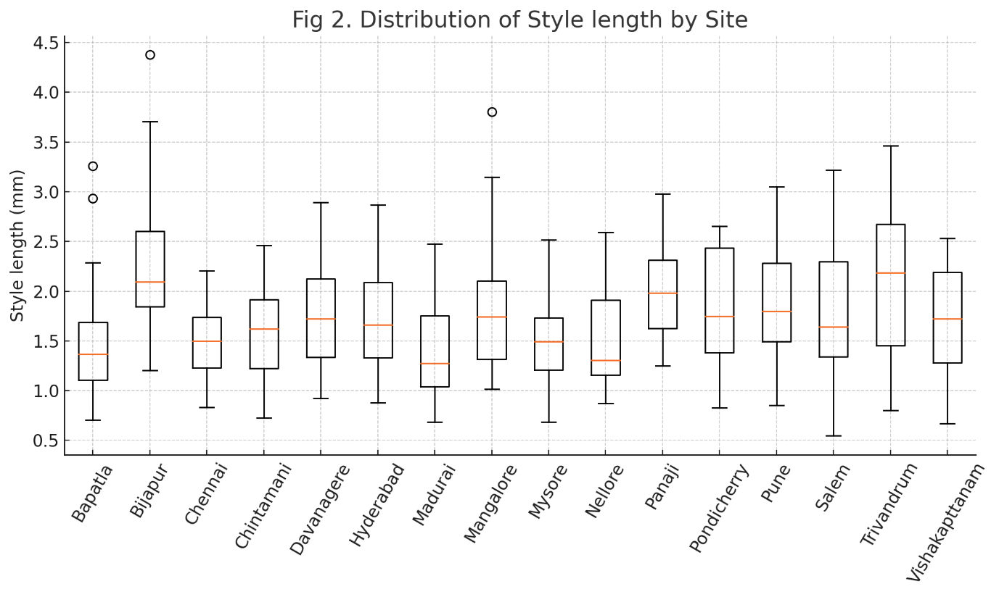
Figure.1. Distribution of style length of Ficus benghalensis by site.

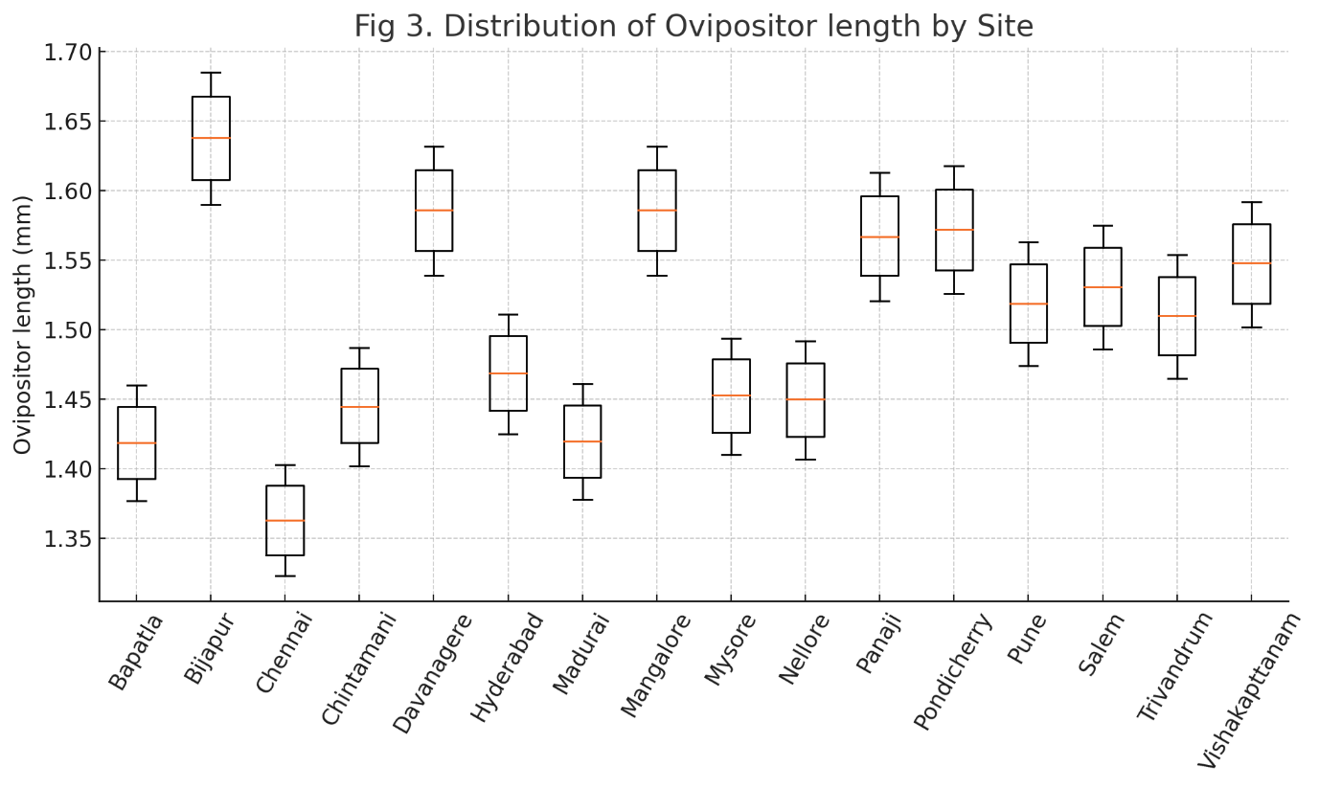
Figure.2. Distribution of ovipositor length of Eupristina masoni by site

Correlation analyses revealed two distinct scales of association. At the individual flower–wasp level, style and ovipositor lengths were significantly correlated but only modest in magnitude (r = 0.313, P < .001). This limited individual-scale coupling indicates that ovipositor length does not fully track fine-scale floral variation within populations, supporting the broader mismatch patterns reported earlier.

In contrast, when population means were compared across sites, the relationship was much stronger (r = 0.817, P < .001). Sites characterised by deeper floral styles consistently exhibited longer ovipositors in their associated pollinator populations, suggesting coordinated geographic differentiation between the two partners despite imperfect matching within individual flowers.
The fitted regression model describing the relationship between the two traits was:
$$\text{Ovipositor length}=1.434+0.040×\text{Style length}$$
Although statistically significant (P < .001), the explanatory power of the model was relatively low (R² = 0.10), reinforcing that only a small proportion of variation in ovipositor length is attributable to individual-level floral depth.
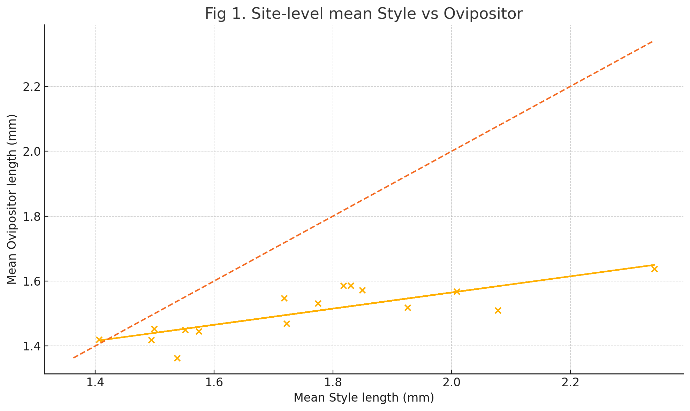
Figure.3. Scatterplot of site-level mean style vs ovipositor length (regression line + 1:1 line placeholder).

Together, these outcomes indicate that while Ficus benghalensis and Eupristina masoni remain strongly coordinated at the geographic scale, the degree of trait matching is not exact at the individual scale. This pattern aligns with a system in which coevolution promotes broad correspondence in trait means across environments, while selective asymmetry or developmental constraints maintain a consistent floral advantage within flowers.

3.4 Distribution of mismatch
To evaluate the functional consequences of morphological differences between floral styles and wasp ovipositors, we examined the distribution of the mismatch measure (ovipositor length − style length) across all sampled flowers. The resulting distribution was strongly skewed toward negative values, indicating that in the majority of cases the ovipositor was shorter than the floral style. This pattern directly reflects a predominant floral advantage, whereby style depth exceeds the reach of the pollinator in most flowers and consequently restricts oviposition opportunities.

The magnitude of mismatch varied among individuals but remained consistently biased in favour of the plant, in agreement with the negative mean difference reported in Section 3.1. Only 38.5% of flowers exhibited non-negative mismatch values (ovipositor ≥ style), confirming that more than half of the floral population was inaccessible to the pollinator based on length thresholds alone. Such skewed mismatch creates an inherent asymmetry in reproductive success: while the wasp is able to oviposit only in a subset of flowers, the plant gains seed production across the entire floral cohort.

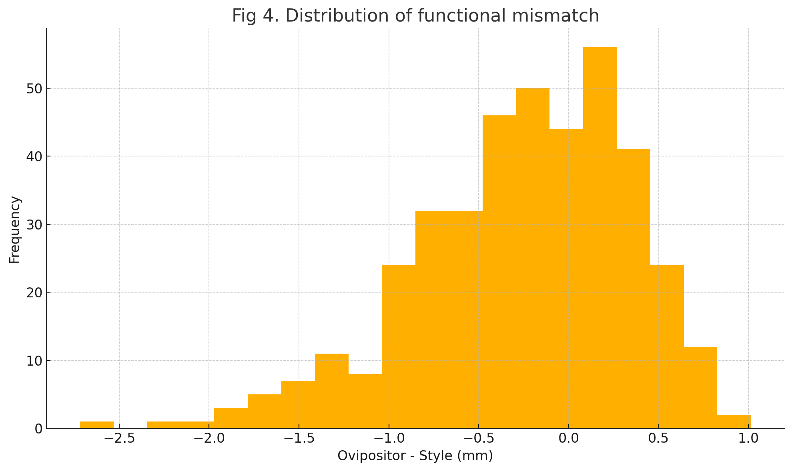
Figure 4. Histogram illustrating the distribution of functional mismatch (ovipositor length − floral style length) across all individuals.

This persistent floral advantage, even under spatially coadapted trait variation, highlights the selective tension embedded within the mutualism a system that must support both pollinator reproduction and plant seed production, yet not necessarily in equal proportions.

4. Discussion
This study provides the first spatially replicated quantitative assessment of floral style length and pollinator ovipositor morphology for the Ficus benghalensis - Eupristina masoni mutualism across South India. The results reveal a complex pattern of trait correspondence that is both coordinated and asymmetric. Although floral style and ovipositor lengths exhibit strong geographic covariation across populations indicating broad-scale coadaptation the mismatch detected within individual flowers suggests that the system does not operate under perfect morphological equivalence.

The finding that the floral style exceeds ovipositor length in most flowers aligns with theoretical predictions that figs experience indirect selective benefits from limiting pollinator reproduction (West et al., 1995). Because the wasp oviposits only within flowers where its ovipositor can reach the ovule, deeper styles can shift a greater proportion of flowers toward seed production rather than brood development. By contrast, wasps are expected to evolve ovipositor lengths that maximize oviposition success, but physical and energetic constraints on ovipositor growth, as well as trade-offs associated with structural reinforcement and manoeuvrability, may limit their evolutionary response. This tension likely contributes to the modest individual-level correlation observed in our dataset.

The strong site-level correlation between mean style and mean ovipositor lengths suggests that coadaptation has nonetheless taken place at the population scale. Populations with deeper floral styles tend to host pollinators with longer ovipositors, indicating coordinated geographic divergence. Such broad-scale matching is consistent with population-level host–pollinator genetic structure or long-term localized selection shaping both partners (Herre et al., 2008; Cruaud et al., 2012). However, this matching does not eliminate floral advantage: even in populations with relatively long ovipositors, style length typically remains greater. This may represent a coevolutionary equilibrium in which both mutualism and conflict are simultaneously maintained.

The mismatch distribution was heavily skewed toward floral advantage, with only 38.5% of flowers permitting oviposition based on length thresholds. This indicates that morphological correspondence does not necessarily optimise brood success for the pollinator. Rather, it appears to mediate a functional balance that allows both partners to reproduce without providing equal access to every floral unit. A similar pattern has been suggested for other monoecious fig species, where style-length distributions are thought to regulate the proportion of flowers set aside for pollinator development versus seed production (Nefdt and Compton, 1996; Moore et al., 2021).

Taken together, our results challenge the widespread assumption that fig–pollinator mutualisms are characterised by perfect morphological matching. Instead, the Ficus benghalensis - Eupristina masoni interaction demonstrates coevolved correspondence at the geographic scale and persistent asymmetry at the floral scale. This dynamic suggests a system stabilised by evolutionary compromise: broad-scale adaptation maintains compatibility and ensures pollination, while fine-scale mismatches reinforce reproductive interests of the plant without eliminating opportunities for the pollinator.

5. Conclusion
The Ficus benghalensis–Eupristina masoni mutualism exhibits a dual pattern of morphological matching. Floral style and ovipositor lengths are strongly coordinated across geographic populations, indicating long-term coevolutionary integration. However, the consistent floral advantage within individual flowers demonstrated by negative mismatch values and oviposition feasibility in only 38.5% of flowers reveals an asymmetric functional structure that favours plant seed production over pollinator brood success.

These findings support a balanced mutualism model, in which coadaptation ensures reproductive interdependence while controlled mismatch enables the plant to retain a selective benefit. Such a combination of cooperation and conflict may be central to the long-term evolutionary stability of fig–pollinator systems. Future work integrating genetic, developmental and behavioural data will be important to determine whether the observed geographic covariation reflects local adaptation, population-level co-structuring or dispersal limitation.

ETHICAL APPROVAL
All authors hereby declare that the research involving plant and insect specimens was conducted under institutional ethical standards and with prior approval from the Institutional Research and Ethics Committee, University of Agricultural Sciences, Bengaluru.

REFERENCES
Anandan, K., Narendran, T.C., & Varghese, A.O. (2018). Pollination biology of Ficus benghalensis and its pollinating fig wasp Eupristina masoni. Journal of Threatened Taxa, 10, 12005–12011.

Bhandari, P., & Ram, H.Y.M. (2005). Pollination ecology of Ficus benghalensis L.: Syconial biology and wasp behaviour. Current Science, 88, 2010–2014.

Cook, J.M., & Rasplus, J.Y. (2003). Mutualists with attitude: Coevolving fig wasps and figs. Trends in Ecology & Evolution, 18, 241–248. https://www.cell.com/trends/ecology-evolution/abstract/S0169-5347(03)00062-4?cc=y%3Fcc%3Dy

Cruaud, A., Ronsted, N., Chantarasuwan, B., Ho, S.Y.W., & Rasplus, J.Y. (2012). An extreme case of plant–insect codiversification: Figs and fig-pollinating wasps. Systematic Biology, 61, 1029–1047. https://academic.oup.com/sysbio/article/61/6/1029/1667297

Ganeshaiah, K.N., Kathuria, P., Shaanker, R.U., & Vasudeva, R. (1995). Conflict of interest in the fig–fig wasp mutualism: Selection for ovipositor length in the pollinator. Journal of Biosciences, 20, 57–69.

Herre, E.A., Jandér, K.C., & Machado, C.A. (2008). Evolutionary ecology of figs and their associates: Recent progress and outstanding puzzles. Annual Review of Ecology, Evolution, and Systematics, 39, 439–458. https://doi.org/10.1146/annurev.ecolsys.37.091305.110232

Machado, C.A., Jousselin, E., Kjellberg, F., Compton, S.G., & Herre, E.A. (2005). Host specificity and historical processes in the diversification of fig wasps. Proceedings of the Royal Society B, 272, 685–694.

Moore, J.C., Dunn, D.W., & Compton, S.G. (2021). Optimality and conflict in fig–pollinator mutualisms: Linking host fitness to pollinator morphology. Ecology Letters, 24, 1562–1573.

Nefdt, R.J.C., & Compton, S.G. (1996). Regulation of seed production and oviposition in the fig–fig wasp mutualism. Journal of Animal Ecology, 65, 170–182. https://www.jstor.org/stable/5720

Pothasin, P., Wiwatwitaya, D., & Compton, S.G. (2016). Elevational changes in fig traits and their pollinators: Implications for coadaptation. Biotropica, 48, 389–399.

Souto-Vilarós, D., García, C., & Leksono, A.S. (2018). Environmentally driven divergence of fig–pollinator interactions across altitudinal gradients. Oecologia, 186, 173–186.

Weiblen, G.D. (2002). How to be a fig wasp. Annual Review of Entomology, 47, 299–330. https://www.annualreviews.org/content/journals/10.1146/annurev.ento.47.091201.145213

West, S.A., Herre, E.A., & Windsor, D.M. (1995). The evolution of style-length variability in figs and optimization of ovipositor length in their pollinators. Proceedings of the Royal Society B, 259, 327–332.

