Original Research Article
THE EFFECT OF PLEUROTUS TUBERREGIUM (AN OYSTER MUSHROOM) SCLEROTIA ON THE WEIGHT, PROTEIN CONTENT AND LIPID PROFILE OF BROILER CHICKENS

ABSTRACT
Introduction: Edible mushrooms have become increasingly attractive as functional foods for their potential beneficial effects on human and animal health. This study aims to investigate the effect of sclerotia of Pleurotus tuberregium on weight, protein and lipid profile of broiler chickens.
Methods:Thirty broiler chickens were randomized and fed with feed containing different percentages of sclerotia of Pleurotus tuberregium for 8 weeks. The weight, Protein, and Standardized blood lipid profile were measured after the 8 weeks of feeding.
Results: The final body weight decreased progressively with increasing percentage of sclerotia from 0% to 25%. Chickens in the 0% group had the highest weight, while those in the 25% group had the lowest weight. There was a clear decline in mean protein content with increasing feed level supplementation. The highest cholesterol was observed in the 15% group, and the lowest was in the 25% group. The triglyceride level among the treatment groups is statistically significant (p > 0.05). The differences in HDL levels between groups are highly significant (p < 0.01), indicating a strong treatment effect of the sclerotia on HDL. There is no significant difference in LDL levels between the treatment groups (p > 0.05). This indicated that the lowering effect of the sclerotia on the LDL is not dose-dependent. There is a significant difference in VLDL levels across the treatment groups (p < 0.05), suggesting a treatment effect of the sclerotia on the VLDL.
Conclusion: This study showed that sclerotia of Pleurotus tuberregium affect the growth performance, protein content, and cholesterol of broiler chickens.
Keywords: Diet, Sclerotia, Cholesterol, Broilers

- INTRODUCTION
Mushrooms are the earliest form of fungi known to mankind. Their use in the diet in recent times is increasingly being recognized because of their significant roles in human health, nutrition, and the management of diseases. It has been reported that edible mushrooms are a valuable source of nutrients and bioactive compounds, and they have a growing appeal for humans due to their flavours and culinary feature. Recently, they have become attractive as functional foods because of their potential beneficial effects on human health (Kabir et al., 1988, Borchers et al., 1999, Eva et al., 2010). Many edible mushrooms have been reported to decrease low-density lipoprotein-cholesterol (LDL-C) in serum by increasing the expression of LDL receptor at mRNA level and LDL receptor activity (Nuhu et.al, 2009, Lisa and Sabine, 2020, Shanggong et.al. 2016). Their roles in the reduction of cholesterol and triglycerides levels in animals have been investigated and results so far appear promising (Nuhu et.al. 2010, Guillamón et al., 2010, Schneider et.al. 2011, Shanggong 2016, Nur et.al. 2018, Dong Hoon et.al. 2019, Dicks and Ellinger, 2020, Handayani et al., 2011).
Pleurotus tuberregium Fr. known as king tuber oyster or tiger milk mushroom is a tropical and subtropical edible mushroom that is highly consumed and highly priced in Nigeria and other West African sub-regions. The mushroom has been reported to possess properties that are attributable in part to its health promotion and immune surveillance (Yashvant, et.al. 2012). Reports have shown that Pleurotus tuberregium is rich in β-glucans, which enhance immune response, contains high levels of phenolics, flavonoids, and polysaccharides, that protect cells from oxidative stress and aging. It support heart health by lowering cholesterol levels, improves cardiovascular function because it contains fiber and unsaturated fatty acids, which reduce bad cholesterol (LDL) (Ying et.al. 2024). Studies suggest that oyster mushrooms can help lower triglyceride level because of the compounds in them that appear to influence lipid metabolism and reduce the triglyceride amount in the blood stream (Chorvathoba et al., 1993). Their consumption can reduce concentrations of triglycerides, cholesterol and oxidized LDL, potentially benefiting heart health and lower the risk of heart diseases.
Elevated cholesterol and triacylglycerol levels are known risk factors for cardiovascular diseases which is one of the most prominent causes of death for both men and women in most developed and developing countries (WHO, 2003). Certain conditions, such as hyperlipidemia, hypertension, obesity, diabetes mellitus, and a positive family history of Cardiovascular Heart Disease (CHD), are considered to put an individual at greater risk of CHD (Assmann et al., 2002, The International Task Force for Prevention of Coronary Heart Disease, 1998). Some of these conditions are diet-related conditions.
Poultry production is a major agricultural industry worldwide and an essential source of animal protein for human consumption. Poultry products especially chickens and eggs are a staple of many human diets. These common animal proteins are also sources of fat that can elevate human risk for high cholesterol, heart disease, and cardiovascular problems. A high-fat diet (HFD) induces obesity and for this reason, eating a low-cholesterol diet is important for anyone interested in managing their cholesterol intake. It is therefore imperative to formulate poultry diets that can reduce the cholesterol level of poultry products. This study aimed to evaluate the effect of the sclerotia of Pleurotus tuberregium supplementation with poultry feed on the weight and lipid profile of broiler chickens.
- MATERIALS AND METHODS
All experimental procedures and Animal use protocols were approved by the Ethic Committee of the National Open University of Nigeria.
2.1 Construction of poultry cage: A poultry house of 7 by 3 meters was constructed and partition into six compartments of 3 by 1.5 meters. The poultry house was netted and connected to electricity source where a bulb of 100 watt capacity was fixed into each compartment as source of heat and light for the first two weeks during the experiment.
2.2 Collection of sclerotia of Pleurotus tuberregium: Sclerotia of Pleurotus tuberregium (Plate1) were purchased from local market in Anyigba, Kogi State Nigeria. The sclerotia were sliced into pieces and dried in the oven at 40⁰C, crushed into powder form and stored at room temperature (22 ± 2⁰ C) until used.

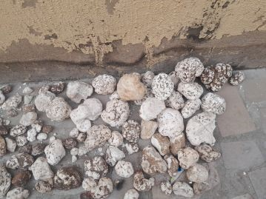
Plate 1: Sclerotia of Pleurotus tuberregium
2.3 Basic diet (Feed) composition: Commercial feed (Ultima poultry feed) with the composition as shown in Table 1 were used as the basal feed for the study.
Animals and Diet: Broiler chickens (n = 30) with each initial body weights of approximately 50g were purchased from a hatchery farm (Agritech) in Ibadan, Nigeria. The chickens were shared into six groups of five (5) chickens per group. The sclerotia powder and feed were mixed thoroughly before used. In group 1(Control), the chickens were fed with unsupplemented feed (feed without the sclerotia) while the other groups, 2, 3, 4, 5 and 6 were fed from day 1 to 8 weeks with basic feed containing the following compositions of the sclerotia 5%, 10%, 15%, 20% and 25% (w:w). The weights of the chickens were taken every week for the 8 weeks.
2.4 Determination of the body weight: The weight of the day old chickens was determined on the arrival and subsequently every week throughout the eight weeks of the experiment. A General Linear Model (GLM) was used to evaluate the impact of different feed supplementation levels on chicken weight across eight weeks of the experiment.
2.5 Determination of protein in the meat: After eight weeks of feeding, the chickens were slaughtered and the tissues were collected for crude protein analysis. The crude protein of the meat samples were determined according to the methods described by Kjeldahl Method (AOAC Official Method 984.13).
2.6 Collection of blood samples for lipid profile: Blood samples were obtained with the help of a Vet Doctor. The blood samples were taken under the wing of the chickens (Plate 2) and were collected in triplicates in ethylendiametetraacetic-acid-(EDTA-) coated tubes and taken to the laboratory for analysis.

Plate 2: Collection of blood samples from the Broiler Chickens

2.7 Determination of Total Glyceride (TG): Total glyceride was measured enzymatically using the method of Burtis and Ashwood, (2006). Glycerophosphate oxidase assay was used. Lipase catalyzed the hydrolysis of triglycerides to yield glycerol and free fatty acids. Glycerol concentration was then determined with the Trinder reaction using glycerol kinase, glycerol-3 phosphate oxidase and peroxidase. Red dye which was quinoneimine was formed. The absorbance of the product was measured at 546 nm using spectrophotometer and this was directly proportional to triglyceride concentration in the plasma.
2.8 Determination of Total Cholesterol (TC): The total cholesterol was measured using oxidase assay described by Burtis and Ashwood, (2006). Cholesterol esterase was first used to catalyze the hydrolysis of cholesterol which was then oxidized by cholesterol oxidase to yield hydrogen peroxide. Through coupled reaction catalized by peroxidase, red dye was formed from hydrogen peroxide, 4-aminoantipyrine and phenol. The absorbance of the dye was measured at 546 using spectrophotometer. The result was directly proportional to the concentration of cholesterol in the blood.
2.9 Determination of the Plasma Lipoprotein: The same method used for the measurement of cholesterol was used to measure High-density lipoprotein (HDL), Low-density lipoprotein (LDL) and Very-low density lipoprotein (VLDL). They were measured after precipitating the low-density lipoprotein and low-density lipoprotein using magnesium sulfate and phosphotungstic acid. The LDL calculation was done using the method of Burtis and Ashwood, (2006) as follows:
For LDL (LDL = TC – HDL + TG/5)
For VLDL (VLDL=TC – HDL+LDL)
The blood samples were centrifuged at 3000x rpm at 22⁰C for 25 minutes. After centrifugation, the High-density lipoprotein (HDL) was isolated from plasma with dextran sulphate and magnesium chloride as described by Sjoblom and Eklund (1989). The total plasma cholesterol (TC), TG and HDL cholesterol were measured using the Konelab 20XT with infinity reagent from Thermo Fisher Scientific (Auburn NSW, Australia).
2.10 Statistical Analysis: All results were expressed as mean ± Standard Error (SE). All parameters for inter group differences were analyzed by one way ANOVA followed by post hoc operation. The statistical programme used was SPSS 25. (P< 0.05 was considered statistically significant)
The weight of the chickens and blood lipids profiles were reported as mean and standard errors. SPSS software (version 25. SPSS Inc, Chikago, Ill, USA was used for the Statistical analysis. One-way ANOVAs were used, and it was followed by a post hoc Turkey-Kramer significant differences test for multiple comparisons among the groups. Differences were considered significant when p < 0.05.

- RESULTS
3.1 Body weight: The body weights of the chickens were affected by the addition of the mushroom in the diet. The study found significant effects of the mushroom on the body weight gain. It also suggests a possible inverse relationship between the level of treatment inclusion of the mushroom and body weight gain. The body weight decreased progressively with increasing percentage of the sclerotia from 0% to 25% (Fig. 1). The 0%, 5%, and 10% feed levels produced significantly heavier chickens than 20–25%, with 15% intermediate. Growth was linear and steep. Week 1 mean was135.6 g while week 8 mean was 2406.7 g. The differences between feed levels were minor early but became marked after Week 5. There is a possible inverse relationship between the level of treatment inclusion of the mushroom and body weight gain.
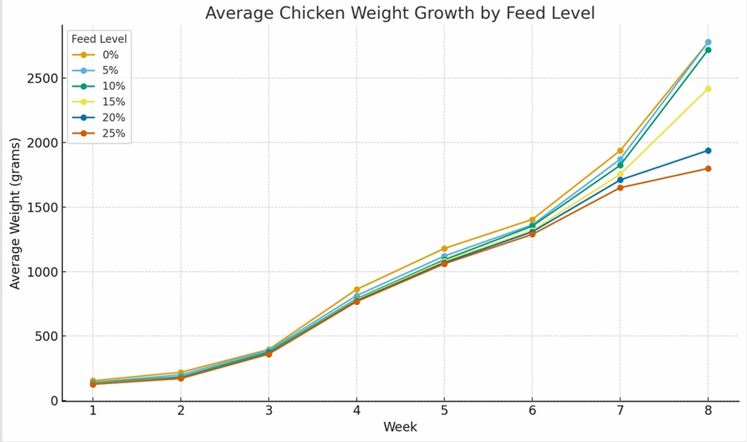
Fig 1: Weight of Chickens every week for 8 weeks
3.2 Protein Content of Meat: The results of the protein contents in the broiler chickens after the eight weeks of the experiment showed a clear decline in mean protein content in the meat with increasing feed level supplementation, from 43.07% at 0% feed additive to 26.84% at 25% (Fig 2). Statistical analysis revealed a highly significant difference in protein content across feed levels (P < .001). Turkey HSD post hoc comparisons indicated that all feed levels differed significantly from each other (P = .05), except for minor overlaps at the highest supplementation levels (20% and 25%).
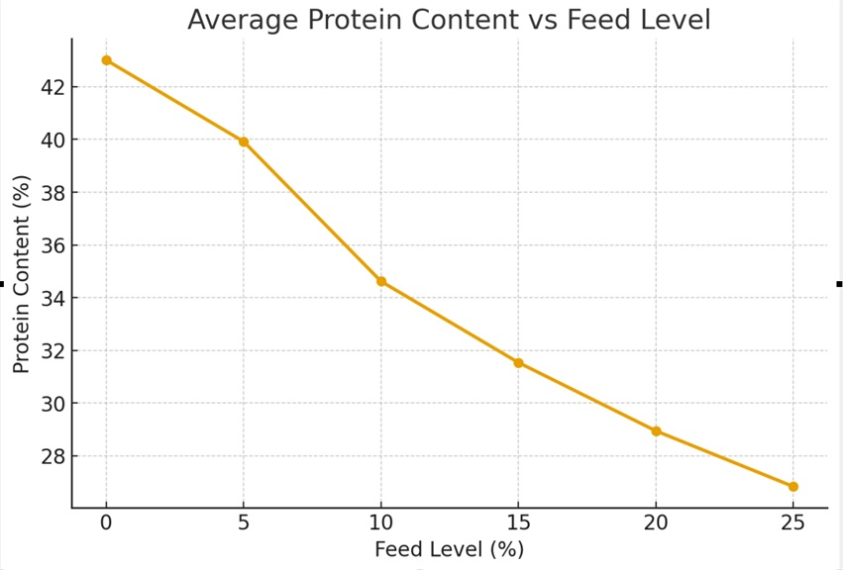
Fig 2: Protein Contents of the Chickens after 8 Weeks of Feeding
3.3 Lipid profile parameters: The lipid profile parameters after feeding the chicken for 8 weeks are presented in Table 1. The highest mean cholesterol was observed in the 15% group (4.13 ± 0.18), and the lowest was in the 25% group (3.23 ± 0.24), (Table 2). There is no statistically significant difference in cholesterol levels across the treatment groups (p > 0.05).
Table 2: Effect of Pleurotus tuberregium Sclerotia on the Lipid Profile of Broiler Chickens (Mean ± Standard Error)
Level of Supplementation % | Cholesterol | Triglycerides | High Density Lipoprotein (HDL) | Low Density Lipoprotein (LDL) | Very Low Density Lipoprotein (VLDL)
0 | 3.97±0.49 | 1.33±0.28 | 1.23±0.15 | 2.10±0.32 | 0.63±0.13
5 | 3.27±0.19 | 1.07±0.15 | 1.13±0.03 | 1.63±0.12 | 0.50±0.06
10 | 3.93±0.18 | 0.53±0.20 | 1.50±0.00 | 2.20±0.10 | 0.30±0.10
15 | 4.13±0.18 | 0.40±0.20 | 1.53±0.03 | 2.40±0.25 | 0.20±0.10
20 | 3.53±0.22 | 0.60±0.10 | 1.47±0.03 | 1.80±0.20 | 0.27±0.03
25 | 3.23±0.24 | 0.97±0.20 | 1.10±0.06 | 1.67±0.29 | 0.47±0.09
The mean triglyceride levels ranged from 0.40 ± 0.20 (15%), to 1.33 ± 0.28 (0%). The differences in triglyceride levels among groups are statistically significant (p < 0.05). This suggests that dietary treatments had a measurable effect on triglyceride levels in the chickens.
The High-Density Lipoprotein (HDL) increased with the treatment from 10% (1.50 ± 0.00) up to the 20% group (1.47 ± 0.03) before declining at 25% (1.10 ± 0.06). The differences in HDL levels between groups are highly significant (P < 0.01), indicating a strong treatment effect of the mushroom on HDL.
Low-Density Lipoprotein (LDL) peaked in the 15% group (2.40 ± 0.25) and was lowest in the 5% group (1.63 ± 0.12). There is no significant difference in LDL levels between the treatment groups (p > 0.05). This indicated that the lowering effect of the mushroom on the LDL in the chickens is not dose dependent.
Very Low-Density Lipoprotein (VLDL) was highest in control (0%) 0.63 ± 0.13 and the lowest was observed in 15% 0.20 ± 0.10 (15%). There is a significant difference in VLDL levels across the treatment groups (p < 0.05), suggesting a treatment effect of the mushroom on the VLDL.
The association between the dosage of sclerotia, body weight gain and lipid profile showed significant treatment effects on Triglycerides, HDL, and VLDL, but no significant effects were found on Cholesterol and LDL. The final weight decreased with increasing dietary treatment levels, suggesting a potential impact of the mushroom on the growth performance.
- DISCUSSION
This is the first study evaluating the effect of mushroom on weight protein and blood lipid profile in chickens. Most of the animal studies on the effect of mushrooms on the lipid profile are on hamsters, rat, minipigs and humans (Peter, 1998, Berger, et al., 2004, Handayani, et al., 2011 , Shanggong et al., 2016,). This study showed that the sclerotia of Pleurotus tuberregium reduced weight gain in broilers chickens. Chicken weights decreased significantly over time. Feed level has a robust effect on growth, with minimal or no supplementation (0–5%) yielding superior weight gain. Excessive supplementation (20–25%) reduces growth performance, suggesting an inverse relationship between supplementation level and weight. The results suggest that minimal or no feed supplementation optimized weight gain, highlighting a potentially inverse relationship between feed level and growth efficiency. Poultry farmers could consider 0–5% feed levels as optimal for maximizing growth efficiency when incorporating this mushroom during formulation of feeds.
This finding is of special significance because weight gain leads to obesity that is associated with numerous diseases like diabetes and coronary heart diseases. The results of this study supported many studies that have shown that adding mushrooms powder to diets affect body weight gain in animals (Simopoulus and Pavlou, 1997, Berger, et al., 2004, Kim et al., 2005, Nuhu et al., 2009). The findings also supported the work of Handayani et al. (2011) who reported that Lentinus edodes prevents fat deposition and lowers Triglycerides in rats.
The result of the protein contents revealed a highly significant difference in protein content across feed levels. The statistical analysis showed that protein values form six distinct groups, showing a progressive, statistically reliable decline as feed additive concentration increased. This finding suggests higher supplementation with the sclerotia reduces or lowers the protein contents in broilers, indicating moderate supplementation (5–10%) may best balance nutritional quality of feeds.
Chickens fed with control feed have higher cholesterol level while those fed with addition of mushroom have lower plasma cholesterol level. The reduction of the cholesterol is not dose dependent as there is no statistical difference in cholesterol levels across the treatment group (p < 0.05). The result showed that 25% sclerotia inclusion significantly repressed the increment of plasma cholesterol in broilers. The mechanism by which the sclerotia reduced the cholesterol levels may be due to the hypocholesterolaemic agent in the sclerotia which may be involved in decreasing the activity of the enzymes for cholesterol biosynthesis in the broilers. Addition of this mushroom into poultry feed may involve the suppression of endogenous cholesterol biosynthesis in chickens. This finding is in line with the reports that addition of oyster mushrooms in animal diet exhibit beneficial effects on cholesterol metabolismas as reported by Fukushima et al. (2001), Shanggong et al. (2016) and Handayani et al. (2011).
Our findings showed the lowering effect of the sclerotia on the triglyceride level in broiler chickens. This observation suggests that there may be compounds within the sclerotia which appear to influence lipid metabolism, and reduced the glyceride amount in the blood stream of chickens. This observation is in line with the findings of Berger et al., (2004) who observed the effects of Ganoderma lucidum on the cholesterol and glycerides in rats and minipigs.
In this study, the high-density lipoprotein (HDL) known as good cholesterol was increased by the addition of the sclerotia. The effect was significant between 10% to 20%. The study has shown that adding less than 10% and above 20% (w:w) of the sclerotia does not increase the HDL. Our findings showed that addition of 5% sclerotia to the diet did not increase the LDL in the broilers. Therefore, the ratio of the mushroom in the feed is important in improving the plasma HDL in broilers.
The result of this study suggests the lowering effect of the sclerotia on the low density lipoprotein (LDL). The low-density lipoprotein (LDL) referred to as bad cholesterol decreased at high level of the sclerotia inclusion. The observed result of the effect of the sclerotia on the LDL in this study is in agreement with the observations of Peter (1998), Berger et al., 2004, Nuhu et al. (2009), Handayani et al., (2011) and Shanggong et al., (2016).
- Conclusion: In conclusion, this study suggests that addition of sclerotia of Pleurotus tuberregium in the diet of broilers reduced the weight and lowered the cholesterol level. The mechanism involved and the components of sclerotia in the cholesterol lowering effect in broilers were not evaluated in this study and we recommend that it should be investigated in the further studies.
DISCLAIMER (ARTIFICIAL INTELLIGENCE): The authors hereby declare that NO generative AI technologies such as Large Language Models (ChatGPT, COPILOT, etc.) and text-to-image generators have been used during the writing or editing of this manuscript.

REFERENCES
Adekalu, T. B., Ojuawo, R. O. and Adekalu, O. A. (2011). Proximate and Elemental Analysis of Banana (Musa paradisiaca) During the Ripening Process. NIFOJ, 29 (1) 29-35

Berger, A., Rein, D., Kratky, E., Monnard, I., Hajjaj, H., Meirim, I., Piguet-Welsch, C., Hauser, J., Mace, K. and Niederberger, P. (2004). Cholesterol-lowering properties of Ganoderma lucidum in vitro, ex vivo, and in hamsters and minipigs. Lipid in Heaklth and Disease 3(2): 1 – 12
Borchers AT, Stern JS, Hackman RM, Keen CL, Gershwin ME (1999, ). Mush rooms, tumors, and immunity. Proc Soc Exp Biol Med. 221:281-293.
Burtis, C. A., and Ashwood, E. R. (2006). Teitz Fundamental of Clinical Chemistry, pp. 348 – 488. Reed Elsevier India Private Limited, New Delhi, India.

Chorvathoba, V., Bobek, P., Ginter, E. and Klvanova, J. (1993). Effect of oyster fungus on glycemia and cholesterolemia in rats with insulin depended diabetes. Physol. Res. 42:175-179

Dong Hoon Lee, Meng Yang, Edward L Giovannucci, Qi Sun and Jorge E Chavarro (2019). Mushroom consumption, biomarkers, and risk of cardiovascular disease and type 2 diabetes: a prospective cohort study of US women and men. Am. J. Clin. Nutr. 110:666–674

Eva, G., Ana G.L., Miguel L., Matilde D., Mauricio A. R., Ana V., José A. M. (2010). Edible mushrooms: Role in the prevention of cardiovascular diseases. Fitoterapia 81, (7): 715-723
Guillamón, E.; García-Lafuente, A.; Lozano, M.; D´arrigo, M.; Rostagno, M. A.; Villares, A.; Martínez, J. A. (2010). Edible Mushrooms: Role in the Prevention of Cardiovascular Diseases. Fitoterapia. 81(7), 715.

Handayani, D., Chen, J. , Meyer, B. J., and Huang, X. F.. (2011). Dietary Shiitake Mushroom (Lentinus edodes) Prevents Fat Deposition and Lowers Triglyceride in Rats Fed a High-Fat Diet. Journal of Obesity. https://doi.org/10.1155/2011/258051

Kabir Y, Kimura S, Tamura T (1988, ). Dietary effect of Ganoderma luci dum mushroom on blood pressure and lipid levels in sponta neously hypertensive rats (SHR). J Nutr Sci Vitaminol (Tokyo) 34:433-438

Lisa Dicks and Sabine Ellinger (2020). E ectofthe Intake of Oyster Mushrooms (Pleurotus ostreatus) on Cardiometabolic Parameters—A Systematic Review of Clinical Trials. Nutrients 12, 1134

Nuhu, A., Ruhul, A., Asaduzzaman K., Ismot, A., Mi, J. S., Min, W. L., Youn, U. L. and Tae, S. L. (2009). Comparative Effects of Oyster Mushrooms on Lipid Profile, Liver and Kidney Function in Hypercholesterolemic Rats, Microbiology 37(1): 37 – 42

Nur A. A., Nurhayati Z. A. , Noorlidah A. (2018). The potential applications of mushrooms against some facets of atherosclerosis: A review. Food Research International. 105, 517-536

Schneider, I., Kressel, G., Meyer, A., Krings, U., Berger, R.G., and Hahn, A. (2011). Lipid Lowering Effercts of Oyster Mushroom (Pleurotus ostreatus) in Humans. Journal of Functional Food 3(1): 17 - 24
Shanggong Y. Xianli, W., Mathew,F., Rosalia, C. M. S., Mario, A. C., Frank, A. S., and Nianbai, F. (2016). Diet Containing Shitake Mushroom Reduce Serum Lipids and Serum Lipophilic Antioxidant Capacity in Rats. J. Nutr 146(12(2491 - 2496
Simopoulus, A. P. and Pavlou (1997). Nutrition and Fitness, Metabolic and Behavioral Aspect in Health and Disease. World Review of Nutrition and Dietetics Karger, Basel, pp. 1-266.
Sjoblom, L. and Eklund, A. (1989). Determination of HDL2 cholesterol by precipitation with dextran sulfate and magnesium chloride: establishing optimal conditions for rat plasma. Lipids, 24 (6): 532-534

World Health Organization (WHO) (2003). WHO's World Health Report 2003: Shaping the future depends on strengthening health systems. Geneva, 2003.

Ying Zhou, Minghang Chu, Farhad Ahmadi, Osman Tuncay Agar, Colin J. Barrow, Frank R. Dunshea & Hafiz A.R. Suleria (2024). A Comprehensive Review on Phytochemical Profiling in Mushrooms: Occurrence, Biological Activities, Applications and Future Prospective, Food Reviews International, 40:3, 924-951

