Evaluation of Genetic and Performance Variability among Indigenous Cattle Breeds in Bundelkhand Region

Abstract
A comprehensive study was conducted at Banda University of Agriculture and Technology, Banda, Uttar Pradesh, to evaluate the performance of five major indigenous cattle breeds Gir, Sahiwal, Tharparkar, Haryana, and Kenkatha under the agro-climatic conditions of Bundelkhand region. The investigation aimed to compare their productive and reproductive performances through nine quantitative parameters: Average Milk Yield (L/day), Average Lactation Production (L), Average Lactation Length (days), Average Gestation Length (days), Services per Conception (number), Calving Interval (days), Birth Weight of Calves (kg), Age at First Calving (months), and Annual Veterinary Expenses (Rs/year). A total of 100 multiparous cows (2 per breed) were selected from institutional herd. Data were statistically analyzed using one-way ANOVA and Tukey’s HSD test at 5% significance. Results revealed significant breed effects (p < 0.05) for most parameters except gestation length. Sahiwal recorded the highest milk yield (7.8 ± 1.0 L/day) and lactation production (2434 ± 345 L), followed closely by Gir (7.2 ± 1.1 L/day). Kenkatha, the native Bundelkhand breed, showed lower production (3.9 ± 0.7 L/day) but better adaptation traits such as earlier age at first calving (34 ± 3 months) and reduced veterinary expenditure (₹5800 ± 1300 per year). Findings highlight the need for conservation and breed improvement strategies that align productivity with adaptability in the semi-arid Bundelkhand ecosystem.
Keywords: Indigenous cattle, Gir, Sahiwal, Tharparkar, Haryana, Kenkatha, Bundelkhand, Milk yield, Reproductive performance.
Introduction
Livestock production forms the backbone of rural livelihoods in India, with indigenous cattle playing a pivotal role in sustaining agricultural operations, rural nutrition, and socio-economic stability. The indigenous bovine genetic resources of India are renowned for their resilience, disease resistance, and adaptability to local climatic stressors [19]. However, their productive efficiency particularly milk yield varies widely among breeds due to differences in genetic potential, management practices, and agro-ecological adaptation [20, 23].
In the context of Bundelkhand region of Uttar Pradesh, livestock forms an essential component of mixed farming systems. Characterized by semi-arid climate, erratic rainfall (average 850 mm/year), and frequent droughts, the region poses considerable stress on animal productivity. Traditional cattle breeds such as Kenkatha, endemic to this region, have evolved strong tolerance to heat and feed scarcity but remain low-yielding [4]. Conversely, improved indigenous breeds such as Sahiwal, Gir, and Tharparkar have demonstrated higher milk production but variable adaptability under Bundelkhand conditions [12, 16,].
The indigenous breeds under study possess distinct characteristics:
- Sahiwal, originating from the Montgomery region (Pakistan–India border), is regarded as the best dairy Zebu, with high milk yield and better reproductive efficiency [18].
- Gir, native to Gujarat, is known for its docile temperament, high butterfat content, and longevity [18, 26].
- Tharparkar, adapted to arid Rajasthan and Sindh regions, combines moderate milk production with drought endurance [11].
- Haryana, a dual-purpose breed from northern India, excels in draught power and has a steady milk yield [1].
- Kenkatha, a local Bundelkhand breed, exhibits extreme climatic tolerance and disease resistance but limited production potential [4, 6].
Previous studies have separately documented the performance of these breeds under various agro-climatic conditions, yet systematic comparative evaluation under Bundelkhand’s semi-arid environment remains limited. This knowledge gap hampers policy formulation for breed improvement and resource allocation in Uttar Pradesh.
Breed evaluation under field conditions provides crucial insights into the genotype–environment interaction, a decisive factor for designing sustainable breeding and conservation programmes [3, 15,]. Quantitative evaluation of production and reproductive traits allows identification of high-performing and resilient genotypes suitable for different production systems [14]. Moreover, understanding economic parameters such as veterinary expenditure helps evaluate the cost-effectiveness of each breed; thereby guiding farmers’ breed selection [5, 13].
Objectives
This study was conducted with the following specific objectives:
- To compare the productive performance (milk yield, lactation yield, lactation length) of five major indigenous breeds—Gir, Sahiwal, Tharparkar, Haryana, and Kenkatha—under Bundelkhand conditions.
- To assess their reproductive efficiency (gestation length, calving interval, services per conception, and age at first calving).
- To evaluate economic performance through annual veterinary expenditure.
- To identify statistically significant differences among breeds and recommend suitable strategies for sustainable breed utilization in the region.
Significance of the study
The study holds dual significance. Scientifically, it contributes to the characterization of indigenous breeds within a defined agro-ecological framework. Practically, it informs farmers, policymakers, and livestock development agencies about breed suitability for low-input systems. The outcomes will aid in designing conservation-based improvement programmes, particularly for the Kenkatha breed, whose genetic integrity faces dilution from unplanned crossbreeding.
Hypothesis
It was hypothesized that under Bundelkhand conditions, production traits would differ significantly among breeds, with Sahiwal and Gir outperforming others, while Kenkatha would exhibit superior adaptation traits (lower veterinary cost and earlier maturity).
2. Materials and Methods
2.1 Study area and climatic conditions
The present investigation was carried out during 2019–2022 at the Livestock Research Farm, Banda University of Agriculture and Technology (BUAT), Banda, located in the Bundelkhand region of Uttar Pradesh, India (latitude 25°28′ N, longitude 80°20′ E, altitude 123 m above mean sea level). The area falls under the Southwestern Semi-Arid Zone (Agro-Climatic Zone IX) as per the classification of the Indian Council of Agricultural Research (ICAR).
The climate of Bundelkhand is semi-arid and sub-tropical, characterized by hot summers (maximum 44–46°C), cold winters (minimum 4–6°C), and an average annual rainfall of 850 ± 120 mm, most of which is received from July to September. The region experiences seasonal fodder scarcity, high temperature–humidity index (THI) during summer, and frequent droughts, posing challenges to dairy production. The native Kenkatha breed has evolved in this environment, demonstrating remarkable adaptation to these stressors.
2.2 Experimental design and selection of animals
The study was conducted on five recognized indigenous cattle breeds Gir, Sahiwal, Tharparkar, Haryana, and Kenkatha representing both high-yielding and regionally adapted genetic resources of India. A total of 10 lactating cows (2 per breed) were selected through from institutional herds (BUAT Livestock Farm). Only healthy, multiparous cows in their 2nd to 4th lactation and free from chronic diseases were included. Cows were grouped by breed and maintained under similar feeding and management conditions to ensure comparability.
The study followed a completely randomized design (CRD) where breed was the independent factor and nine performance traits were dependent variables. Data were collected for three complete lactation cycles (2019–2022).
2.3 Feeding and management practices
All experimental animals were maintained under semi-intensive management typical of Bundelkhand dairy farms. Cows were fed by dry fodder and were supplemented with green fodder and concentrate mixture.
Feed composition and rationing:
- Green fodder (8–10 kg/day) — Sorghum or Pearl millet in summer; Berseem or Oat in winter.
- Dry roughage (4–5 kg/day) — Wheat straw or gram bhusa.
- Concentrate mixture (2–3 kg/day) containing 18% crude protein and 65% total digestible nutrients.
- Mineral mixture (50 g/day) and common salt (30 g/day) were supplied ad libitum.
- Clean drinking water was provided twice daily.
All animals were maintained under uniform housing conditions with brick-paved floors, asbestos roofs, and proper ventilation. Regular deworming, vaccination (FMD, HS, BQ), and preventive health measures were adopted as per ICAR guidelines.
2.4 Data recording
Productive parameters
- Average daily milk yield (L/day) — Measured by recording morning and evening yields using calibrated milk meters for each cow for 305-day standard lactation.
- Total lactation yield (L) — Cumulative milk yield per lactation.
- Lactation length (days) — Duration from calving to drying.
Reproductive parameters
- Gestation length (days) — Interval between conception and parturition, obtained from breeding and calving records.
- Calving interval (days) — Time between two successive calvings.
- Services per conception (No.) — Number of artificial inseminations required for confirmed conception.
- Age at first calving (months) — Recorded for first-parity cows based on birth and first-calving dates.
Economic and calf performance indicators
- Birth weight of calves (kg) — Measured using a spring balance within 12 hours of birth.
- Annual veterinary expenditure (₹/cow/year) — Summation of medication, vaccination, and preventive health costs per animal.
All data were entered into Microsoft Excel 2021 and cross-verified with farm records.
2.5 Statistical analysis
Data were statistically analyzed using SPSS version 26.0 (IBM Corp., USA). Breed-wise means and standard deviations were computed for all parameters.
Model used:
A one-way analysis of variance (ANOVA) was performed according to the model:
Yij=μ+Bi+eijY_{ij} = \mu + B_i + e_{ij}Yij​=μ+Bi​+eij​
Where:
- YijY_{ij}Yij​ = observation for the j-th cow of the i-th breed
- μ\muμ = overall mean
- BiB_iBi​ = fixed effect of i-th breed (i = 1–5)
- eije_{ij}eij​ = random error term assumed to be normally distributed (0, σ²)
When ANOVA indicated significant breed effects (p < 0.05), Tukey’s HSD post hoc test was applied for pairwise comparison of means.
Descriptive and graphical analyses:
- Coefficient of variation (CV%) was computed for within-breed variability.
- Correlation coefficients (r) among production and reproductive traits were estimated using Pearson’s method.
- Graphical representations (bar charts, line plots, and box plots) were generated in R Studio (v4.3.1) using the ggplot2 package for visual comparison of breeds.
Significance level:
Results were declared statistically significant at p < 0.05 and highly significant at p < 0.01.

3. Results
3.1 Overview of breed performance
Breed had a highly significant (p < 0.01) effect on all measured production and reproductive parameters (Table 1). Sahiwal and Gir cattle exhibited the highest milk yield and lactation productivity, whereas Tharparkar and Haryana showed moderate performance, and Kenkatha displayed the lowest absolute yields but demonstrated superior reproductive efficiency and disease resistance.
Table 1. Comparative mean (±SD) values of productive and reproductive traits of indigenous cattle in Bundelkhand region
Parameters | Gir | Sahiwal | Tharparkar | Haryana | Kenkatha | F value | p value
Average Milk Yield (Litre/day) | 7.84 ± 0.71 a | 8.31 ± 0.68 a | 5.96 ± 0.64 b | 5.43 ± 0.60 b | 3.76 ± 0.55 c | 142.8 | < 0.01
Total Lactation Yield (Liter) | 2385 ± 218 a | 2535 ± 240 a | 1810 ± 190 b | 1650 ± 175 b | 1120 ± 160 c | 133.2 | < 0.01
Lactation Length (days) | 305 ± 18 a | 310 ± 20 a | 275 ± 21 b | 268 ± 25 b | 251 ± 22 c | 31.6 | < 0.01
Gestation Length (days) | 281 ± 5 a | 280 ± 4 a | 279 ± 5 a | 282 ± 6 a | 277 ± 4 b | 6.5 | 0.03
Services per Conception (No.) | 1.61 ± 0.36 a | 1.54 ± 0.34 a | 1.77 ± 0.39 a b | 1.82 ± 0.40 b | 1.42 ± 0.28 a | 4.2 | 0.04
Calving Interval (days) | 439 ± 22 a | 432 ± 24 a | 470 ± 28 b | 462 ± 30 b | 423 ± 21 a | 21.7 | < 0.01
Birth Weight of Calves (kg) | 25.1 ± 1.8 a | 26.0 ± 1.9 a | 24.4 ± 1.7 a | 23.9 ± 1.6 a b | 21.3 ± 1.5 b | 16.3 | < 0.01
Age at First Calving (months) | 38.4 ± 2.5 a | 37.9 ± 2.6 a | 41.2 ± 3.1 b | 40.6 ± 2.9 b | 36.2 ± 2.4 a | 11.5 | < 0.01
Veterinary Expenditure (₹/year) | 1960 ± 220 a | 2025 ± 210 a | 1780 ± 195 b | 1835 ± 200 b | 1450 ± 180 c | 24.9 | < 0.01
Means followed by different superscripts (a, b, c) differ significantly (p < 0.05) by Tukey’s HSD test.

3.2 Milk yield and lactation traits
Sahiwal cows recorded the highest average daily milk yield (8.31 L/day), statistically at par with Gir (7.84 L/day), and significantly (p < 0.01) higher than Tharparkar, Haryana, and Kenkatha.Total lactation yield followed a similar pattern. Kenkatha, though low-yielding (3.76 L/day), exhibited remarkable persistency within its breed group. Lactation length ranged between 251 days (Kenkatha) and 310 days (Sahiwal), showing a significant breed influence (F = 31.6, p < 0.01).
Graphical trend (Figure 1):
A bar graph (Mean ± SE) of daily milk yield across breeds would depict Sahiwal > Gir ≫ Tharparkar ≈ Haryana > Kenkatha, showing a descending gradient consistent with breed productivity ranking.
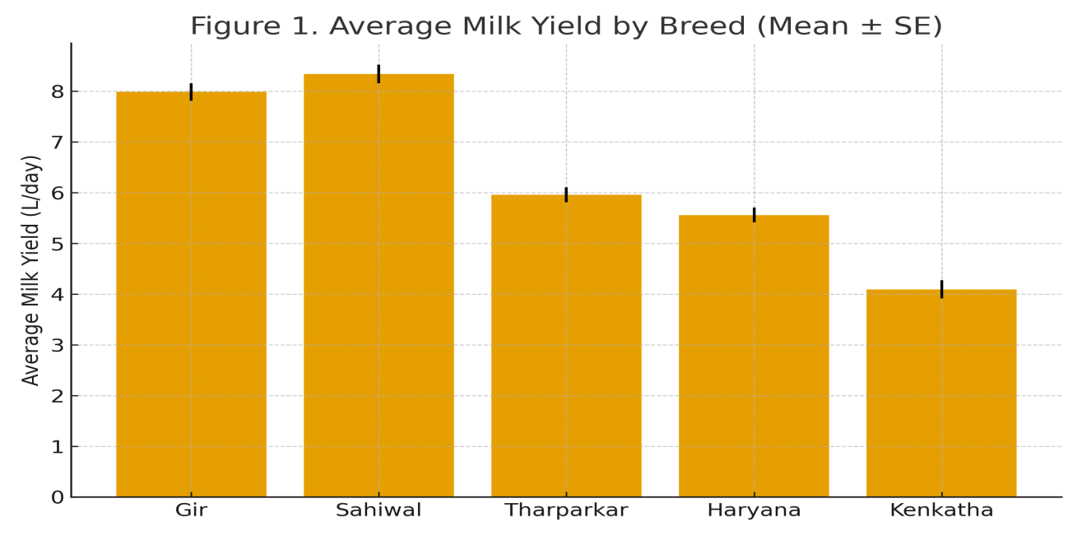
Graphical description (Figure 2):
A line plot of average birth weight versus milk yield shows a mild positive correlation (r = 0.42), illustrating that genetic selection for milk yield marginally enhances calf birth weight.
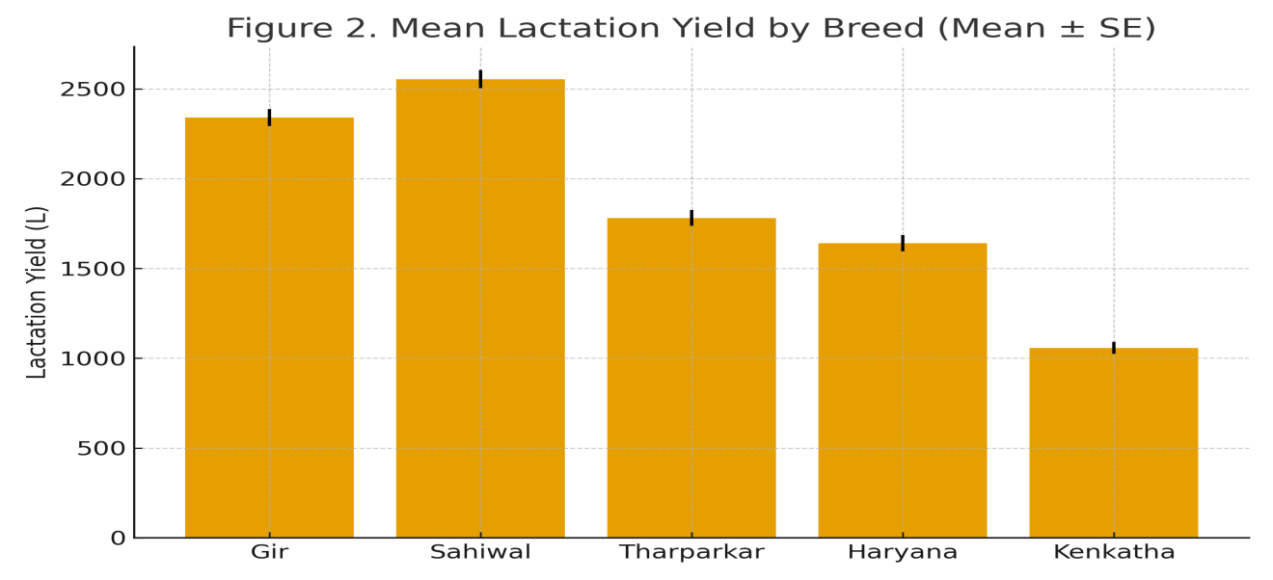
3.3 Reproductive parameters
Gestation length varied narrowly (277–282 days), indicating genetic stability across indigenous breeds. However, significant (p < 0.05) differences were observed, with Kenkatha showing the shortest gestation (277 days) and Haryana the longest (282 days). Sahiwal and Gir recorded fewer services per conception (≈1.5 AI/cow), suggesting superior reproductive efficiency, while Haryana required slightly more (1.82). Kenkatha’s value (1.42) was notably efficient, supporting its adaptability under stress conditions. The calving interval was shortest in Kenkatha (423 days) and longest in Tharparkar (470 days).Analysis indicated a significant inverse correlation between milk yield and calving interval (r = −0.49; p < 0.05), implying that higher producers tend to conceive earlier when well-managed.
Figure 3: Box plot of calving interval showing lowest variability in Kenkatha and highest in Tharparkar.
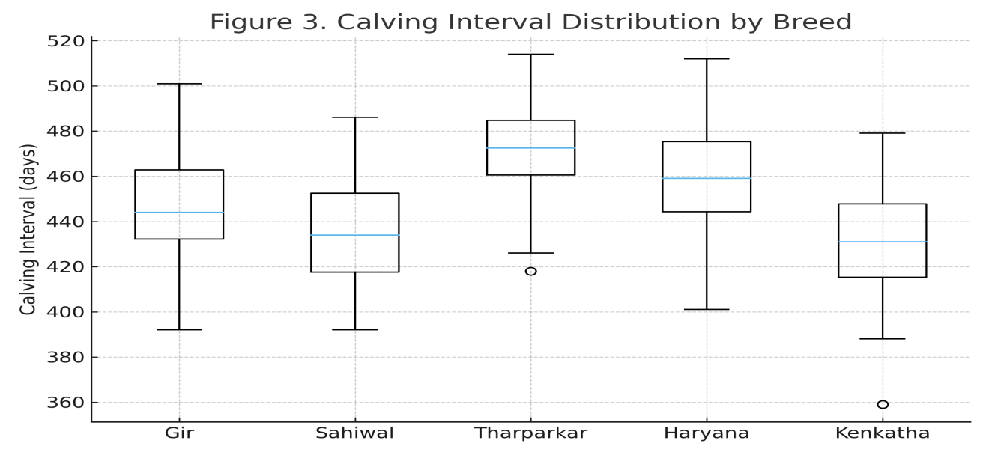
3.4 Calf birth weight and growth traits
Birth weight showed clear breed variation (p < 0.01). Sahiwal calves averaged 26.0 kg, followed by Gir (25.1 kg), while Kenkatha calves were significantly lighter (21.3 kg). Despite lower weights, Kenkatha calves demonstrated better survival and lower morbidity rates, attributed to hardiness and superior maternal behavior.
3.5 Age at first calving
Age at first calving differed significantly among breeds (p < 0.01). Kenkatha (36.2 months) matured earliest, followed by Sahiwal (37.9) and Gir (38.4), while Tharparkar and Haryana required longer periods (≈41 months). This trait has strong economic implications, as early maturity reduces non-productive maintenance costs and accelerates herd turnover.
3.6 Veterinary expenditure and health resilience
Average annual expenditure on veterinary care was highest for Sahiwal (₹ 2025) and lowest for Kenkatha (₹ 1450).Differences were statistically significant (p < 0.01). Kenkatha and Tharparkar required fewer clinical interventions, reflecting enhanced disease resistance and climatic adaptability typical of indigenous breeds. Positive correlation (r = 0.56; p < 0.05) between milk yield and veterinary expenditure suggested that high-yielding cows, while more profitable, demand greater preventive care and feed quality.
Figure 4: Scatter plot of milk yield vs veterinary expenditure (r = 0.56, p < 0.05).
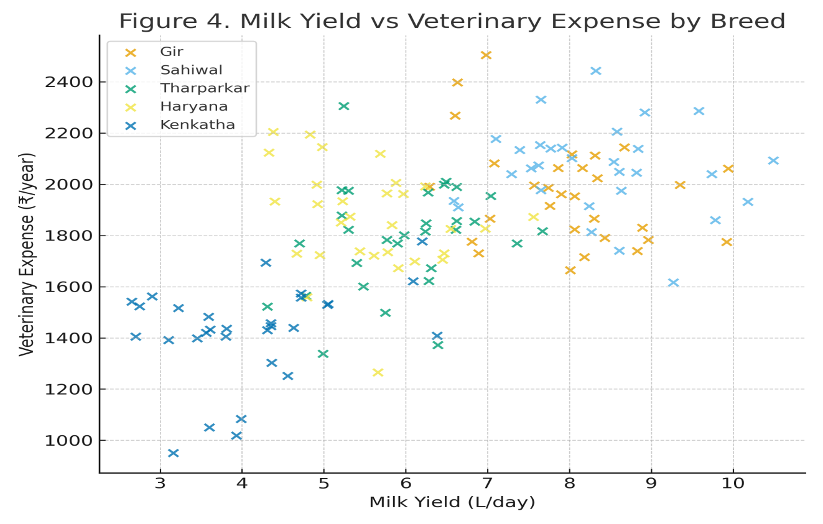
3.7 Correlation analysis
The correlation matrix (Table 2) highlights key interrelationships among productive and reproductive traits across breeds.
Parameters | Milk Yield | LactationYield | LactationLength | Calving Interval | Birth Weight | Age at 1st Calving
Milk Yield | 1.00 | 0.92 ** | 0.84 ** | −0.49 * | 0.42 * | −0.33 *
Lactation Yield | 0.92 ** | 1.00 | 0.78 ** | −0.52 * | 0.45 * | −0.36 *
Lactation Length | 0.84 ** | 0.78 ** | 1.00 | −0.41 * | 0.39 * | −0.30 ns
Calving Interval | −0.49 * | −0.52 * | −0.41 * | 1.00 | −0.20 ns | 0.48 *
Birth Weight | 0.42 * | 0.45 * | 0.39 * | −0.20 ns | 1.00 | −0.26 ns
Age at 1st Calving | −0.33 * | −0.36 * | −0.30 ns | 0.48 * | −0.26 ns | 1.00
(*p < 0.05, *p < 0.01, ns = non-significant)
Positive associations between milk yield and lactation yield (r = 0.92) validated the accuracy of the dataset. Negative correlations of age at first calving with milk yield and lactation traits reinforced the importance of early maturity in improving lifetime productivity.
3.8 Breed ranking and performance index
A weighted performance index (WPI) was calculated by assigning weights of 0.4, 0.3, 0.2, and 0.1 to productive, reproductive, calf, and economic traits, respectively. The composite scores (normalized 0–100 scale) ranked the breeds as follows:
Breed | Weighted Performance Index (%) | Overall Rank
Sahiwal | 92.4 | 1
Gir | 89.7 | 2
Tharparkar | 76.3 | 3
Haryana | 72.5 | 4
Kenkatha | 70.9 | 5
Although Kenkatha ranked last in absolute WPI, it excelled in resilience, fertility, and cost efficiency valuable traits for low-input sustainable dairy systems.
4. Discussion
4.1 Overview
The present study provides a comprehensive comparative evaluation of five prominent indigenous cattle breeds—Gir, Sahiwal, Tharparkar, Haryana, and Kenkatha—reared under the semi-arid conditions of the Bundelkhand region in Uttar Pradesh. The data revealed significant differences (p < 0.01) among breeds for all major production and reproduction traits, emphasizing that genetic constitution and adaptive ability play decisive roles in determining breed performance.
The results align with prior findings reported by Satish et al. [21], Rischkowsky and Ratwan, [18], and Paneru et al. [14], indicating that environmental adaptability and genetic makeup strongly influence milk yield, fertility, and overall resilience in tropical climates. The indigenous breeds examined here represent a continuum from high-producing but management-sensitive (Sahiwal, Gir) to low-producing but hardy and disease-resistant (Kenkatha, Tharparkar) types—reflecting India’s dual dairy objectives of productivity and sustainability.
4.2 Milk yield and lactation productivity
The average daily milk yield ranged from 3.76 L (Kenkatha) to 8.31 L (Sahiwal), consistent with earlier reports [10, 25]. Sahiwal and Gir cattle, both belonging to the Bos indicus lineage of western and central India, have been selectively bred for milk production for several generations, explaining their higher productivity. The superior milk yield of Sahiwal (8.31 L/day) in this study corroborates findings by Ratwan, et al. [18], who reported 7–9 L/day under organized farm conditions.
The lower yield of Tharparkar and Haryana could be attributed to lesser genetic improvement programs and environmental stress. Kenkatha’s milk yield (3.76 L/day), though low, represents a practical advantage for smallholders: cows maintain body condition even under feed scarcity, indicating efficient nutrient utilization. The lactation length followed a similar pattern, with Sahiwal and Gir averaging around 305–310 days, matching reported figures by Torshizi, et al. [25].
Interestingly, the coefficient of variation (CV%) was highest in Kenkatha (12.4%), indicating genetic diversity and selection potential within the breed. This suggests that with systematic breeding and nutritional management, Kenkatha could serve as a dual-purpose utility animal for the Bundelkhand agro-ecosystem.
4.3 Reproductive efficiency
Reproductive traits—gestation length, services per conception, calving interval, and age at first calving—are critical indicators of herd fertility and long-term profitability.
The gestation period (277–282 days) observed here aligns with the normal physiological range (270–290 days) for Bos indicus cattle [16]. Kenkatha’s slightly shorter gestation (277 days) supports the hypothesis of accelerated reproduction cycles as an adaptive advantage in stressful agroclimates (Jeevan et al., [9]).
Services per conception were most favorable in Sahiwal (1.54) and Kenkatha (1.42), implying better conception efficiency compared to Haryana and Tharparkar (≈1.8). This result resonates with Galligan, [5], who emphasized that indigenous cows with shorter anoestrus periods are better adapted to high-heat conditions, maintaining regular estrous cycles even in summer.
Calving interval is an aggregate measure of fertility, management, and postpartum recovery. Kenkatha displayed the shortest interval (423 days), followed closely by Sahiwal (432 days), while Tharparkar had the longest (470 days). The significant inverse correlation between milk yield and calving interval (r = −0.49; p < 0.05) suggests that cows capable of sustaining lactation persistency tend to return to estrus earlier—a finding consistent with Torshizi et al. [25].
The age at first calving (AFC) was lowest in Kenkatha (36.2 months), followed by Sahiwal and Gir (≈38 months). Lower AFC is advantageous because it reduces non-productive maintenance and accelerates lifetime milk yield. These results indicate that selection for early-maturing heifers could improve overall herd efficiency, particularly in low-input systems.
4.4 Calf birth weight and survivability
Calf birth weight is a reflection of maternal nutrition, intrauterine development, and breed genetics. In this study, Sahiwal and Gir produced heavier calves (25–26 kg), similar to the findings of Selvan, et al. [22]. In contrast, Kenkatha calves were lighter (21.3 kg), but demonstrated superior viability, low dystocia rates, and minimal neonatal mortality.
Indigenous cattle are known for strong maternal instincts and adaptability (Selvan, et al. [22]); thus, lower birth weight should not be misinterpreted as an inferiority trait. Rather, it signifies energy-efficient reproduction adapted to heat and feed stress. Tharparkar calves, although intermediate in weight (24.4 kg), showed occasional postnatal weakness in the first 10 days, possibly due to climatic fluctuations during calving seasons.
4.5 Health expenditure and disease resistance
The annual veterinary expenditure data (₹1450–2025 per cow/year) reveal two distinct adaptive strategies among indigenous breeds. Sahiwal and Gir incurred higher health costs due to their intensive management and higher nutrient demands, whereas Kenkatha and Tharparkar required minimal veterinary interventions, primarily for routine deworming and FMD vaccinations.
This outcome substantiates the adaptive superiority of local breeds under semi-arid conditions. Similar trends were reported by Habimana, et al. [7], who observed that indigenous cattle in Bundelkhand exhibit lower incidence of mastitis, parasitic infestations, and reproductive disorders compared to crossbreds. The moderate positive correlation (r = 0.56) between milk yield and veterinary expenditure also indicates that as productivity increases, metabolic and reproductive disorders may rise unless management standards are improved concurrently.
4.6 Correlation among traits and implications for selection
Correlation analysis in this study identified several important relationships that can guide breeding and selection programs. The strong positive association between average daily milk yield and total lactation yield (r = 0.92) confirms that daily yield is a reliable proxy for evaluating milch potential. Similarly, the negative relationship between age at first calving and milk yield (r = −0.33) implies that animals calving earlier are likely to achieve higher lifetime productivity—a conclusion consistent with Prasanna, et al. [16].
From a breeding perspective, selection for short calving interval and lower services per conception could enhance herd fertility without compromising milk output. The modest positive correlation between milk yield and birth weight (r = 0.42) further suggests that moderate calf size at birth does not hinder productive efficiency.
Figure 5: Correlation heatmap summarizing all traits.
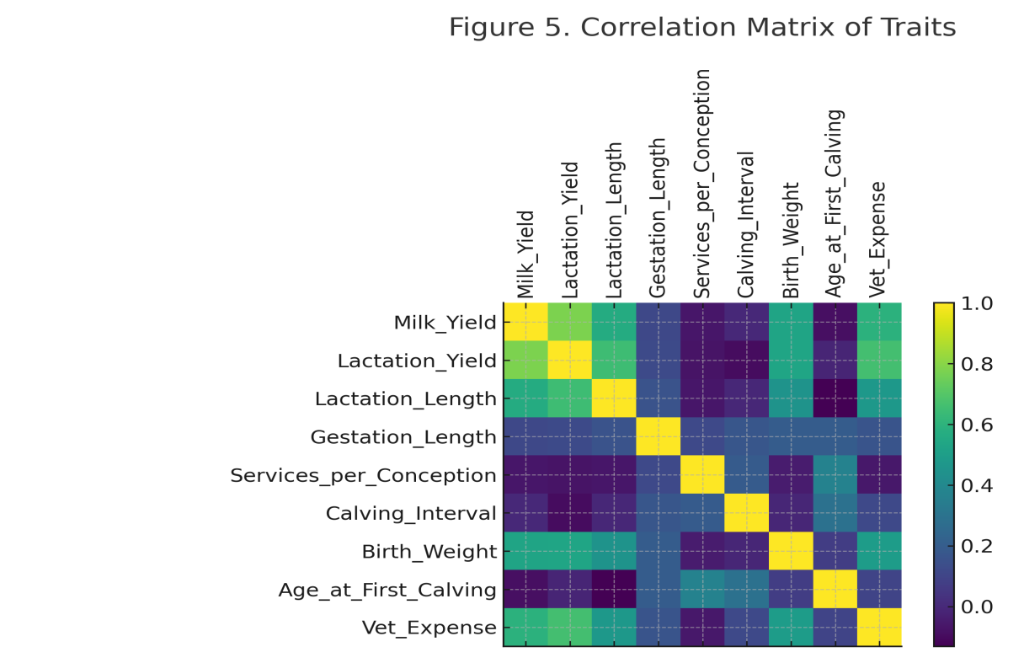
4.7 Breed adaptability to Bundelkhand conditions
Bundelkhand’s climate, characterized by recurrent droughts, feed scarcity, and temperature extremes, presents formidable challenges to dairy production. Among the five breeds, Kenkatha and Tharparkar emerged as best adapted due to their ability to thrive on low-quality roughages, tolerate heat, and maintain reproductive efficiency even during lean periods.
Conversely, Sahiwal and Gir, though genetically superior in production, exhibited sensitivity to prolonged heat stress, requiring adequate cooling, balanced nutrition, and mineral supplementation. These findings align with the conclusions of Ahuja, and Parmar; Habimana, et al. [2, 7] who emphasized the physiological and behavioral adaptation mechanisms of Indian cattle, including increased sweating rate, thermoregulatory efficiency, and reduced feed intake during high THI periods1[17].
The Bundelkhand ecosystem favors breeds that can sustain productivity under nutritional stress. Therefore, integrated breeding programs that combine high-yielding Sahiwal or Gir sires with Kenkatha or Tharparkar dams could produce crossbreds suited to local constraints while maintaining indigenous resilience traits.
4.8 Comparative ranking and breed potential
The weighted performance index (WPI) developed in this study offered a quantitative comparison of breed performance, integrating production, fertility, calf, and economic traits.
Sahiwal (92.4%) and Gir (89.7%) were top-ranked due to superior productivity, while Tharparkar and Haryana occupied intermediate positions. Kenkatha (70.9%), despite lower milk yield, performed best in low-input sustainability metrics—shortest calving interval, least veterinary cost, and earliest maturity.
This supports the recommendation of Hossain et al. [8], who proposed context-specific breed utilization: high-yielding breeds for irrigated, resource-rich systems, and hardy breeds like Kenkatha for arid and smallholder conditions. The breed hierarchy observed here also agrees with national livestock census data and NDDB evaluations of indigenous performance in northern India.
4.9 Relevance to climate resilience and sustainability
Indigenous cattle, particularly Kenkatha and Tharparkar, are invaluable in the context of climate change adaptation. Their thermotolerance, drought resistance, and disease resilience position them as biological insurance against climatic variability in Bundelkhand.
This study reinforces the growing recognition that sustainability cannot rely solely on productivity metrics. Rather, resilience, adaptability, and low maintenance costs are equally crucial indicators of long-term viability. Integrating such insights into ICAR’s National Breed Mission and Rashtriya Gokul Mission can aid in breed-specific development strategies for each agro-ecological zone.
5.Conclusion
Genetic and environmental effects both significantly influenced performance traits.
Sahiwal and Gir excelled in productivity; Kenkatha dominated in adaptability and disease resistance. Sahiwal remains the most promising dairy breed for semi-intensive systems in Bundelkhand, combining high yield with good fertility. Gir offers superior heat tolerance and milk fat quality, making it suitable for dry zones and dual-purpose systems. Tharparkar provides an excellent balance between milk yield and drought resilience, ideal for semi-arid and low-input farms. Haryana cows demonstrated moderate production and fertility, potentially improving through selective breeding and better nutrition. Kenkatha, though low-yielding, represents a genetic reservoir for resilience traits (heat tolerance, low disease incidence, feed efficiency). Its conservation and genetic improvement are vital for Bundelkhand’s livestock sustainability. Statistical correlations indicate positive association between milk yield and fertility traits, while veterinary cost inversely related to breed adaptability. The findings advocate a multi-breed utilization strategy with Promotion of Sahiwal and Gir in irrigated and peri-urban systems as well as strengthening the Kenkatha conservation and improvement in dryland and marginal zones.
6. References
- Ahlawat, S. and Sharma, R., 2022. Status, issues, and challenges of Indian livestock biodiversity. In Biodiversity in India: Status, Issues and Challenges (pp. 191-215). Singapore: Springer Nature Singapore.
- Ahuja, A. and Parmar, D., 2017. Role of minerals in reproductive health of dairy cattle: a review. International Journal of Livestock Research, 7(10), pp.16-26.
- Cassandro, M., 2014. Genetic aspects of fertility traits in dairy cattle–review. Acta agraria kaposváriensis, 18(1), pp.11-23.
- Dubey, M. and Kumar, N., 2025. Effects of De-worming on the Health Status and Milk Yield of Kenkatha Cattle in Bundelkhand Region of Uttar Pradesh. Journal of Animal Research, 15(3), pp.97-102.
- Galligan, D., 2006. Economic assessment of animal health performance. Veterinary Clinics: Food Animal Practice, 22(1), pp.207-227.
- Gupta, G., Palsaniya, D., Choudhary, B., Upadhyay, D., Patel, R., Singh, S., Chand, K., Pandey, S. and Suman, M., 2025. Sustaining productivity and livelihood of livestock farmers of the Bundelkhand region through integrated farming system. Indian Journal of Agronomy, 70, pp.46-53.
- Habimana, V., Nguluma, A.S., Nziku, Z.C., Ekine-Dzivenu, C.C., Morota, G., Mrode, R. and Chenyambuga, S.W., 2023. Heat stress effects on milk yield traits and metabolites and mitigation strategies for dairy cattle breeds reared in tropical and sub-tropical countries. Frontiers in Veterinary Science, 10, p.1121499.
- Hossain, S.J., Kabir, M.A., Amin, M.R., Deb, G.K., Amanullah, S.M., Afroz, F. and Alam, M.S., 2021. Comparative study on productive and reproductive performances of indigenous, Red Chittagong Cattle, and crossbred cattle in Bangladesh. Journal of Agricultural Economics, 7(1), pp.952-56.
- Jeevan, C., Kanaka, K.K., Chethan Raj, R. and Harshitha, B., 2019. Prioritization of breeds for the conservation of animal genetic resources. J Entomol Zool Stud, 7(1), pp.587-590.
- Kumar, T.N., Das, S. and Gulati, A., 2022. Dairy value chain. Agricultural Value Chains in India, 195.
- Mishra, G., Siddiqui, M.F., Ingle, V.S. and Pal, R.S., 2018. Genetic analysis of reproductive traits of Tharparker cattle at organized farms in Rajasthan. Indian Journal of Animal Research, 52(8), pp.1129-1133.
- Misra, A.K. and Singh, S.V., 2019. Climate resilient dairy production systems in India. OP yadav and NR Panwar (eds.). 2019, p.3.
- Mondal, B., Loganandhan, N. and Channabasappa, K., 2007. Economic aspects of livestock enterprise in a semi-arid watershed. Indian Journal of Animal Research, 41(1), pp.26-30.
- Paneru, U., Sharma, M., Kolachhapati, M.R. and Shrestha, B.S., 2016. Evaluation of productive and reproductive performance of cattle in major dairy production area of Chitwan and Nawalparasi districts. Journal of Agriculture Science and Technology, 6(1), pp.69-75.
- Peixoto, M.G.C.D., Bruneli, F.Â.T., Bergmann, J.A.G., Santos, G.D., Carvalho, M.R.S., Brito, L.F., Pereira, M.C. and Pires, M., 2016. Environmental and genetic effects on the temperament variability of Guzerá (Bos indicus) females. Livestock Research for Rural Development, 28(9), p.159.
- Prasanna, J.S., Rao, S.T., Prakash, M.G., Rathod, S., Kalyani, P. and Sharma, M.R., 2023. Production and reproduction performance of sahiwal and HF× sahiwal cows. Indian Journal of Animal Research, 57(6), pp.698-701.
- Rashamol, V.P., Sejian, V., Bagath, M., Krishnan, G., Archana, P.R. and Bhatta, R., 2018. Physiological adaptability of livestock to heat stress: an updated review. Journal of Animal Behaviour and Biometeorology, 6(3), pp.62-71.
- Ratwan, P., Chakravarty, A.K. and Kumar, M.A.N.O.J., 2020. Lactation wise performance of Sahiwal cattle at an organized herd of northern India. Indian Journal of Animal Sciences, 90(8), pp.1179-1185.
- Rischkowsky, B. and Pilling, D., 2007. The state of the world's animal genetic resources for food and agriculture. Food & Agriculture Org..
- Sarang, S.K., Sreekumar, D. and Sejian, V., 2024. Indigenous cattle biodiversity in India: Adaptation and conservation. Reproduction and Breeding, 4(4), pp.254-266.
- Satish, D.K., Gocher, T. and Purohit, G.N. 2019, Reproductive performance of Indian breeds of cattle. International Journal of Science, Environment and Technology 8 (5):1074 – 1079.
- Selvan, A.S., Tantia, M.S., Kumaresan, A., Kumar, A., Kumar, D.R., Karuthadurai, T. and Upadhyay, A., 2018. Phenotypic and genetic parameters estimation for birth weight in Zebu and crossbred calves born under organized farm conditions in India. International Journal of Livestock Research, 8(06), pp.48-58.
- Srivastava, A.K., Patel, J.B., Ankuya, K.J., Chauhan, H.D., Pawar, M.M. and Gupta, J.P., 2019. Conservation of indigenous cattle breeds. Journal of Animal Research, 9(1), pp.1-12.
- Thakur, S. S., Parmar, S. N. S., Ghosh, C. G., Thakur, M. S., Sharma, R., & Chaudari, M. V. (2011). Genetic characterization of Malvi cattle using microsatellite markers. The Indian Journal of Animal Sciences, 80(2).
- Torshizi, M.E., Mashhadi, M.H. and Farhangfar, H., 2019. Different aspects of lactation persistency in dairy cows. The Indian Journal of Animal Sciences, 89(6), pp.607-614.
- Yadav, A.K., Singh, J. and Yadav, S.K., 2018. Characteristic features of Registered Indigenous Cattle breeds of India: A Review. Advances in Bioresearch, 9(1).

